|  |  |  |
| --- | --- | --- |
| **Australian Volunteers for International Development: An evaluation of the contribution that volunteers make to development effectiveness** |  | March 2014 |

Since the 1960s, the Australian Government has, through its aid program, supported Australians to undertake voluntary work in developing countries. International volunteering promotes cultural understanding through people-to-people linkages and is a means of promoting both public diplomacy and development outcomes.

**Australian Volunteers for International Development:**

An evaluation of the contribution that volunteers make   
to development effectiveness

In 2011, the government launched the Australian Volunteers for International Development (AVID) program. AVID was designed to unite a variety of volunteer ‘streams’ into one major program.

The Office of Development Effectiveness (ODE) commissioned an independent evaluation of the AVID program in 2012 with the aim of enhancing the effectiveness of the AVID program and the contribution that volunteers make to development efforts.

*Maths whiz Bountheng (centre front) in class at Cambodian non-government organisation, Komar Pikar, with volunteer occupational therapist Emma Glenn (centre, behind Bountheng). Komar Pikar supports children with disabilities. Photo: Tiet Ho, Australian Red Cross.*

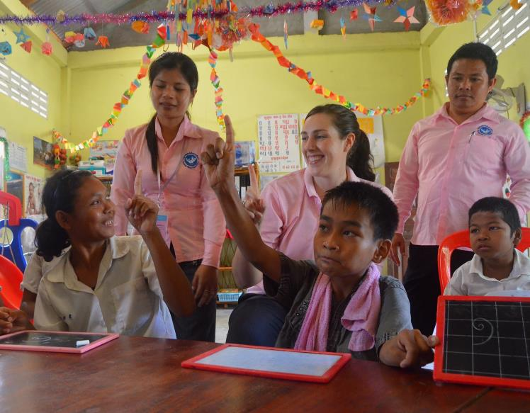

The evaluation applied a mix of methods and drew on existing program data, a literature review, a survey of returned volunteers (1361 respondents) and a survey of host organisations. Fieldwork was undertaken in three countries: Cambodia, Vietnam and Solomon Islands. Fieldwork included 123 interviews with a representative sample of host organisations, volunteers, DFAT staff and a survey of all 192 host organisations in these countries (with a 49 per cent response rate).

The evaluation report makes seven recommendations to improve what it finds is **‘a highly visible contribution to Australia’s aid effort’** and **‘a cost-effective form of capacity development assistance’.**

|  |
| --- |
| AVID Facts |
| * In 2011–12, Australia supported 1585 AVIDS (920 of them new) assigned to 1173 host organisations in more than 40 developing countries. In the same year, aid expenditure on the AVID program was $63.1 million. * Volunteers are recruited and placed by one of the three core partners: Australian Volunteers International (AVI), Austraining International (AI) and Australian Red Cross (ARC). The AVID program has two streams—the general AVID stream and the Australian Youth Ambassadors for Development (AYAD) stream. * Volunteers work in complex and often-challenging environments, most often for local non-government organisations (38 per cent) or government departments (21 per cent). In 2011–12, the majority of volunteers (84 per cent) undertook assignments in East Asia and the Pacific. * The evaluation reports that: *‘Volunteers contribute to the capacity of host organisations, develop people-to-people links and generate goodwill for domestic and foreign public diplomacy. However … the program’s operation and outcomes can be improved.’* |

|  |
| --- |
| Management response |
| DFAT is satisfied that the evaluation findings are well supported by a strong body of evidence and management has agreed to all seven recommendations. DFAT will work closely with program delivery partners to implement the recommendations. The full management response is available in the report at: [www.ode.dfat.gov.au](http://www.ode.dfat.gov.au). |

# Key findings

## Program design, policies and administration

**AVID needs a single program vision**

***‘Some of our best advisers, including Australians, have been volunteers’.***

Jose Ramos-Horta, former President of Timor Leste. Sydney Morning Herald: *Focusing aid brings forward the day we can do without it.* 11 July 2011.

DFAT and its core partners have made substantial progress in developing and continually refining a governance framework (known as the ‘shared standards’) for managing the AVID program. However, AVID’s design needs updating to become a fully integrated program with an agreed single statement of objectives and program logic. Maintaining two separate volunteer streams (AVID and AYAD) leads to confusion, and does not support the single-program, single-brand approach that AVID was intended to establish.

The evaluation recommends that AVID be fully consolidated into one stream and with an agreed single statement of objectives and a program logic. Currently, volunteers are placed in 42 countries (compared with 28 countries five years ago). AVID often places volunteers in small cohorts in host countries, with the program’s three core partners often providing similar services. This leads to duplication of services and potential administrative inefficiencies.

The evaluation found that in 2012–13, 20 countries had 10 or less volunteers. The evaluation recommends consolidating the number of countries involved in the program and exploring other options for managing and contracting service provision

*AYAD volunteer Cricket Development Officer, Ryan Lucas, coaches students at a cricket workshop in Solomon Islands. Photo: Ryan Lucas, Austraining International.*

## Australian volunteers

**Volunteers are highly valued**

Volunteers are highly regarded by their host organisations and are considered to display exceptional professionalism and expertise. They were also found to be flexible and adaptable.

**Characteristics of successful volunteers**

The evaluation found that three factors influence a successful volunteer assignment— their level of relevant professional skill and experience, the assignment’s duration, and the volunteer’s general attitude and mindset.

Host organisations believe volunteers need qualifications or expertise specific to their assignment and that core partners should recruit adequately skilled and ‘professional’ volunteers. Most host organisations reported that the personal qualities of the volunteer also contributed to a successful placement.

**Diversity**

Australian volunteers are most commonly female (65 per cent), aged 26–35 (58 per cent) and university educated. Overall, AVID over-represents females and young people and under-represents older people and males.

A wider segment of Australian society should be able to engage with the program and the report suggests that more can be done to facilitate this.

|  |
| --- |
| Case study—Solomon Islands Water Authority |
| A young Australian electrical engineer volunteering with the Solomon Islands Water Authority (SIWA) realised practical problems needed solving before he could do any capacity building work. He was soon busy checking pumping stations, working with local operators and drawing on his co-workers’ knowledge to solve mechanical problems outside his area of expertise. Over time, he learned the local pidgin language and some local customs, which helped to build effective relationships with SIWA employees. Local staff were less intimidated by the young, friendly volunteer than they were by previous technical advisers, asked him lots of questions and were impressed by his altruistic motivations.  SIWA and the volunteer agreed it was most effective for him to support a team of local workers rather than one individual because it spread new knowledge further and helped more workers gain confidence. |

## Impact of volunteering on host organisation capacity development

**Need for a shift in focus**

AVID is centrally managed by DFAT’s Volunteer Section in Canberra and supplies a fixed annual quota of volunteers within a defined budget. The evaluation found that there would be benefits in shifting the focus from supplying a fixed number of volunteers each year to taking a more demand driven approach taking account of Post needs and supporting the long-term capacity development of host organisations.

This would require core partners to develop long-term plans with host organisations that balance immediate capacity needs with long-term capacity development objectives. The evaluation also acknowledged the need to retain ‘one-off’ placements

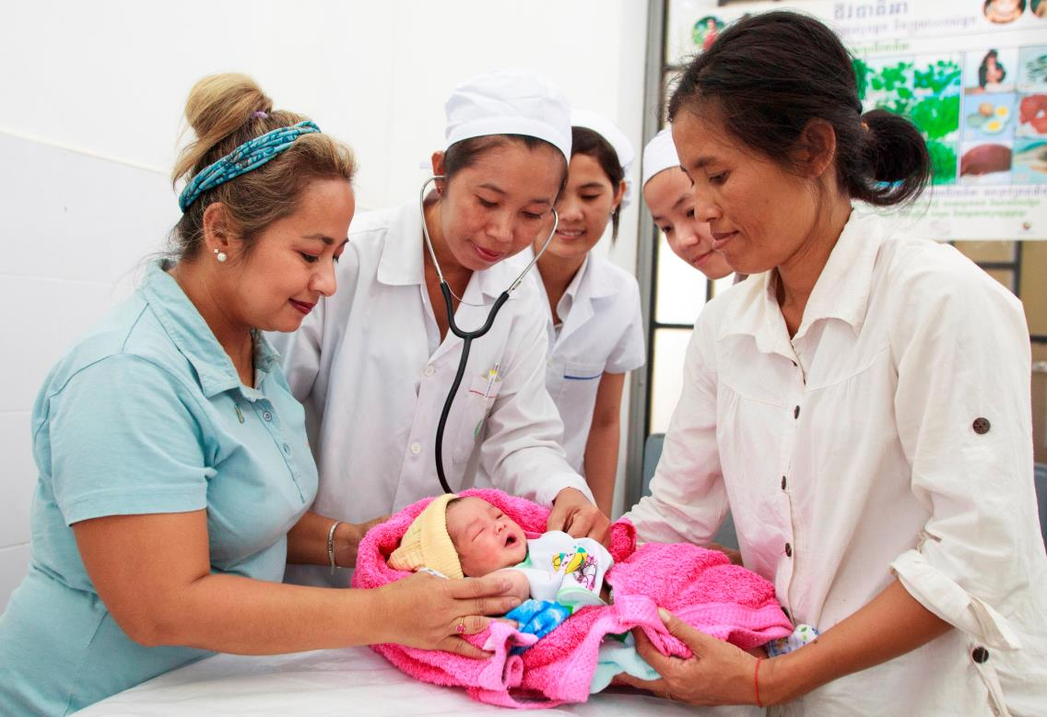

with host organisations, where appropriate, to maintain the flexibility of the program.

*AVID Midwifery Preceptor coach Dorinda Britto (left) and Dr Soun Nimol (centre) at Cambodia’s Khmer-Soviet Friendship Hospital in Phnom Penh with mother Om Sout, her newborn baby and midwifery students. Photo: Harjono Djoyobisono, Australian Volunteers International.*

**Volunteers and host organisations**

Most host organisations (88 per cent) and volunteers (85 per cent) were satisfied with their experiences as part of the AVID program as reported by DFAT’s Returned Volunteer survey.

Volunteering led to career benefits for 59 per cent of the volunteers surveyed. Approximately one-third of returned volunteers (31 per cent) are now working in international development. Host organisation satisfaction levels dropped if it had taken too long to mobilise a volunteer, or if their ability to access future volunteers was uncertain.

The main cause of volunteer dissatisfaction was being placed in a host organisation that was unprepared to host them.

**Volunteer counterpart model**

Focusing on the volunteer’s role within the host organisation rather than just an assignment position description is a more realistic approach to capacity development. It should not be assumed that the counterpart model is the most appropriate model for the long-term capacity development needs of an organisation. Host organisations exist in very different operating contexts and are at different stages of capacity development.

Although a counterpart may be effective in some circumstances, there are risks. The counterpart may leave the host organisation before the volunteer arrives, become reliant on the more ‘experienced’ volunteer or have limited time to devote to the volunteer. An alternative approach is to consider team mentoring.

**Alignment**

Just under two-thirds (63 per cent) of volunteer assignments in the case study countries were aligned with DFAT country strategies. In the countries visited by the evaluation team, there was little evidence of DFAT Posts involvement in the size and scope of volunteer operations or of volunteers being used to complement other capacity development initiatives.

The evaluation recommends that DFAT Posts become more involved in discussing numbers of volunteers appropriate to country strategies, actively identifying host organisations linked to country strategy objectives and integrating AVID more closely with other capacity development initiatives (e.g. Australia Awards and paid technical assistance).

## Monitoring and evaluation

**Need to streamline program monitoring**

The current approach to monitoring and evaluating AVID is weak, fragmented and unexplained with each core partner using different formats for the end-of-assignment process resulting in varying levels of completeness and quality.

****Monitoring needs to be streamlined and consolidated, with one agreed process implemented by all three core partners. Data needs to be used to inform decision-making at both the implementation and program levels.

*AVID Institutional Strengthening Officer with the Ministry of Natural Resource and Environment, Dr Michael Parsons, with Vic, ‘master of ceremonies’ at a Vietnamese temple. Photo: Austraining.*

## Volunteering and public diplomacy

**AVID lacks brand recognition**

The majority (82 per cent) of respondents in the returned volunteer survey agreed that volunteering contributes to public diplomacy by maintaining and building relationships with neighbouring countries. Despite its public diplomacy potential, the AVID brand is not well recognised.

Host organisations rarely identify their volunteer with AVID, associating them instead with a specific stream (e.g. AYAD) or with a core partner (AVI, ARC or AI). While most host organisations in the three case-study countries recognised AVID as an Australian Government funded program, many did not recognise the specific AVID brand.

The evaluation recommends that DFAT and core partners should seek expert advice and work together to market and promote the single AVID program.

***‘Volunteers are different to consultants because you weed out the people who are in it for the money and (who) may not have the mindset of learning about the country rather than providing advice. We don’t need narrow expertise but open-mindedness and a more strategic outlook.’***

Host organisation, Solomon Islands

|  |
| --- |
| Case study—Hue Department of Education and Training |
| The Vietnamese Government’s National Language Project, which runs to 2020, aims to help more Vietnamese people across the country’s provinces to speak English. In Central Province, the Hue Department of Education and Training (DOET) needed help restructuring the school curricula and training local teachers in English. DOET approached an Australian volunteer who was completing her volunteer assignment at the Hue University of Foreign Languages.  DOET found the volunteer to be ideal for the role, having relevant professional qualifications, experience developing and implementing curriculum and teacher training, and a deep appreciation of how to work within Vietnamese society. Just six months into the assignment, the volunteer had already made a difference, designing new training workshops to help primary school teachers upgrade and redesign their English language curriculum. |
|  |
| Office of Development Effectiveness |
| DFAT’s Office of Development Effectiveness (ODE) monitors the performance of the Australian aid program, evaluates its impact and contributes to international evidence and debate about aid and development effectiveness.  The full report, together with the management response, can be accessed at: [www.ode.dfat.gov.au](http://www.ode.dfat.gov.au) |