Australia’s Official Development Assistance Statistical Summary 2024–25
Australia’s Official Development Assistance: Statistical Summary 2024–25
ISSN 2652-0451 (Print)
ISSN 2652-0435 (Online)
Creative Commons
With the exception of the Commonwealth Coat of Arms, the Department of Foreign Affairs and Trade logo, photographs, images, signatures and where otherwise noted, this publication is provided under a Creative Commons Attribution- NonCommercialNoDerivatives 4.0 International (CC BY-NC-ND 4.0) licence, available at https://creativecommons.org/licenses/ by-nc-nd/4.0/.
The details of the relevant licence conditions are available on the Creative Commons website (accessible using the link provided), as is the full legal code for the CC BY-NC-ND 4.0 licence, available at https://creativecommons.org/licenses/by-nc-nd/4.0/legalcode.en.
Provided you have not modified or transformed the material in any way, the Commonwealth’s preference is that you attribute this publication (and any material sourced from it) using the following:
Department of Foreign Affairs and Trade, Australia’s Official Development Assistance Statistical Summary 2024–25, © Commonwealth of Australia 2025.
Licensed from the Commonwealth of Australia under a CC BY-NC-ND 4.0 licence.
Contact
Inquiries about this document should be directed to:
Department of Foreign Affairs and Trade
RG Casey Building, John McEwen Crescent,
Barton ACT 2600 Australia
+61 2 6261 1111 (Phone)
aidstatsinquiries@dfat.gov.au (Email)

Table of Contents
Introduction 5
Australian development assistance 5
Reporting Against International Guidelines 7
1 2030 Agenda: Sustainable Development Goals, Primary Intent 9
2 Development Assistance Committee Sector 11
Overview Tables 14
3 Sector Group 14
4 Sector Group by Type of Partner 18
5 Region of Benefit by Sector Group 21
6 Partner Country by Sector Group 27
7 Government Departments and Agencies 30
8 Loan Disbursements 31
9 International Development Policy 32
Type of Assistance by Region and Benefit Tables 33
10 Climate Finance 33
11 Gender Equality 35
12 Disability Equity 37
13 Education 39
14 Health 41
15 Maternal and Child Health 43
16 Family Planning 45
17 Nutrition 46
18 Water, Sanitation and Hygiene 48
19 Government and Civil Society 49
20 Humanitarian and Disaster Response 51
21 Economic Growth 53
22 Aid for Trade 55
23 Private Sector Development 57
24 Research 59
25 Amounts Mobilised from the Private Sector 61
People to People Link Tables 62
26 Long-term Australia Awards Field of Study 62
27 Long-term and Short-term Australia Awards Partner Country 65
28 Volunteers Program 68
Appendices 71
Appendix 1: Explanatory Notes 71
Appendix 2: Concepts and Definitions 72
Appendix 3: Abbreviations and Symbols 80
Appendix 4: DAC List of Aid Recipients 83
Appendix 5: Alt Texts 87

Introduction

Australian development assistance
This report, Australia’s Official Development Assistance: Statistical Summary 2024–25, presents statistical details of Australia’s development cooperation and reflects government priorities for 2024–25 with partner countries, multilateral and bilateral development agencies, civil society organisations and the private sector. It provides a range of information at the aggregate level of where Australia’s development program was delivered and the type of official development assistance (ODA) that was delivered. The Statistical Summary represents a point in time summary using the best available data at the time of publication.
This report details ODA This report details ODA expenditure and complements other reporting of the Australian development program. Users may wish to refer to the following publications, which can be downloaded from the Department of Foreign Affairs and Trade (DFAT) website:
- Foreign Affairs and Trade Portfolio Budget Statements.
- Australian Aid Budget Summary.
- Annual Report: Department of Foreign Affairs and Trade.
AusDevPortal, launched in December 2024, provides searchable comprehensive financial and performance information on Australia’s ODA investments.
This report details Australia’s ODA. Australia’s contributions to development go far beyond the ODA budget. A whole-of-nation effort across different levels of government, institutions and communities is building valuable ties in our region and beyond to deliver real impact.

Concepts and definitions
The ODA concepts and definitions used in Australia’s Official Development Assistance: Statistical Summary, 2024-25 are consistent with the Organisation for Economic Co-operation and Development (OECD) Development Assistance Committee’s (DAC) Statistical Reporting Directives. Refer to Appendix 2: Concepts and Definitions for further details.

Changes in this issue
This edition introduces a minor methodology adjustment to partner groupings, reclassifying the following partners between the Other Partners and Types of Partner categories to better align with the DAC methodology and improve data transparency and accuracy.
- Research Institutions from Other Partners to Universities and Academic Institutions
- Foreign Government – Fellow Donors from Developing Country Governments to Other Partners
- NA (non-contract expenditure) from Other Partners to Australian Public Sector Organisations

This adjustment affects Table 4 and Figures 5 and 6 only and the impact of this change on overall figures is minor. Data presented in this edition remains comparable with previous reports, subject to the caveat of minor adjustments to partner groupings in 2024-25.

Comparability with other donor countries
To facilitate comparability between donor countries, Australia reports its development assistance annually to the OECD DAC in United States dollars (USD) and on a calendar year basis. Statistical information is provided at the investment level.
This information can be accessed through the OECD DAC’s website at http://www.oecd.org/dac.
Statistics in this publication are stated in Australian dollars (AUD) and based on the Australian financial year, unless otherwise specified. This may, in some instances, limit direct comparability between Australia’s development cooperation and that of other donor countries.

Figure 1. Total Australian Official Development Assistance by Region of Benefit, 2024–25
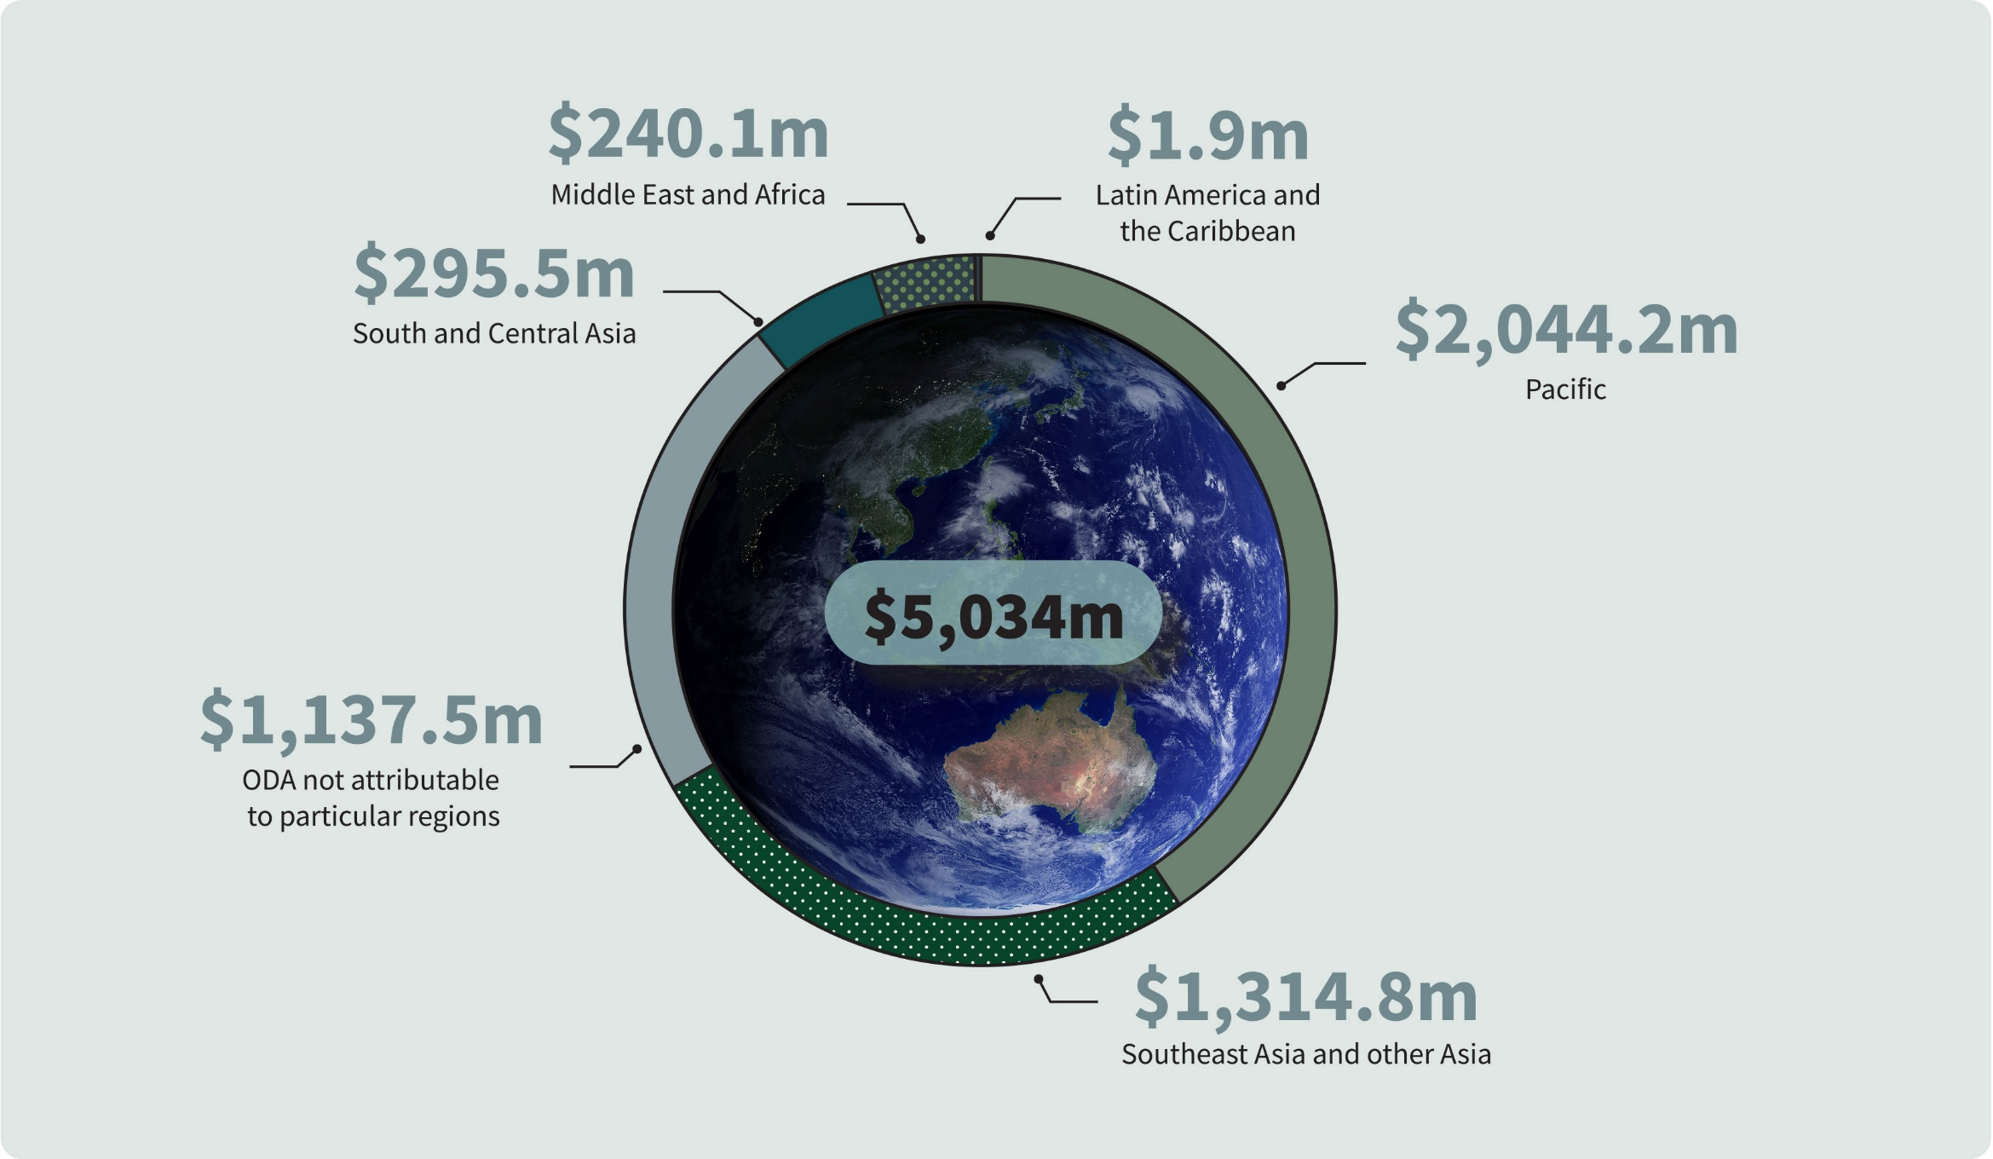

Reporting Against International Guidelines
Figure 2. Australian Official Development Assistance 2030 Agenda: Sustainable Development Goals, Primary Intent, 2024–25^{(a)}
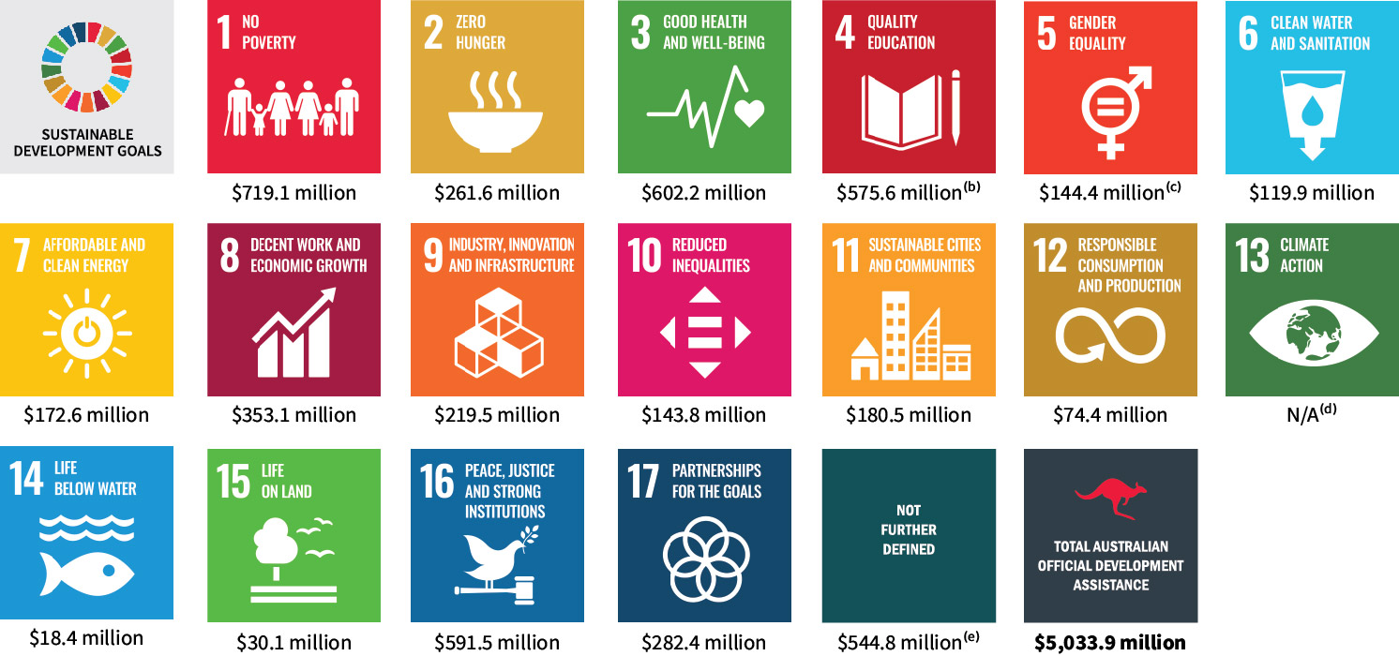

“-” denotes nil or rounded to zero (including null cells).
Due to rounding, discrepancies may occur between sums of the component items and totals.
- The Sustainable Development Goals (SDGs) are a United Nations initiative, officially known as Transforming our world: the 2030 Agenda for Sustainable Development (https://www.un.org/sustainabledevelopment/sustainable-development-goals/). For further information about the Sustainable Development Goals refer to paragraphs 53 to 55 of Appendix 2: Concepts and Definitions.
- Includes scholarships.
- Data presented for SDG5 reflects only those aid investments with a primary goal of Support for Women’s Equality Organisations and Institutions (DAC purpose code 15170) or Ending Violence Against Women and Girls (DAC purpose code 15180), and is not reflective of Australia’s total ODA contribution to gender equality which cuts across all SDGs. See Table 11 for Australia’s expenditure contributing to gender equality. As per Table 11, Australia’s total gender equality assistance for 2024–25 is $2,614 million.
- Not reported as there is no dedicated DAC sector code for climate change. Instead, the OECD DAC uses Rio Markers to promote mainstreaming of climate considerations in all sectors. In line with this, climate change is integrated across the breadth of Australia’s development assistance. A more comprehensive picture of Australia’s climate change assistance is presented in Table 10 based on Rio Marker reporting methods. As per Table 10, Australia’s total climate change assistance for 2024–25 is $918 million.
- Includes regional and global programs (including payments to multilateral organisations), departmental and other administrative expenses that cannot be attributed to a specific Sustainable Development Goal.

1 Australian Official Development Assistance, 2030 Agenda: Sustainable Development Goals, Primary Intent, 2024–25^{(a)}
Sustainable Development Goal | 2023-24  $’000 | 2024-25  $’000
1 No poverty | 669,207 | 719,067
2 Zero hunger | 236,731 | 261,580
3 Good health and well-being | 633,298 | 602,186
4 Quality education ^{(b)} | 598,378 | 575,625
5 Gender equality ^{(c)} | 118,912 | 144,412
6 Clean water and sanitation | 125,284 | 119,945
7 Affordable and clean energy | 198,482 | 172,587
8 Decent work and economic growth | 222,929 | 353,051
9 Industry, innovation and infrastructure | 163,676 | 219,485
10 Reduce inequalities | 135,534 | 143,760
11 Sustainable cities and communities | 234,847 | 180,535
12 Responsible consumption and production | 46,842 | 74,424
13 Climate action ^{(d)} | n.a. | n.a.
14 Life below water | 26,519 | 18,413
15 Life on land | 34,861 | 30,143
16 Peace, justice and strong institutions | 527,697 | 591,501
17 Partnerships for the goals | 166,352 | 282,404
Not further defined ^{(e)} | 667,425 | 544,824
Total Australian Official Development Assistance | 4,806,975 | 5,033,941

“-” denotes nil or rounded to zero (including null cells).
Due to rounding, discrepancies may occur between sums of the component items and totals.
- Sustainable Development Goals (SDGs) can cut across multiple goals and are not mutually exclusive. Data presented in this table reflects the aid investments’ primary goal intent and is not reflective of Australia’s total ODA contribution to sustainable development. For further information about the Sustainable Development Goals refer to paragraphs 53 to 55 of Appendix 2: Concepts and Definitions.
- Includes scholarships.
- Data presented for SDG5 reflects only those aid investments with a primary goal of Support for Women’s Equality Organisations and Institutions (DAC purpose code 15170) or Ending Violence Against Women and Girls (DAC purpose code 15180), and is not reflective of Australia’s total ODA contribution to gender equality which cuts across all SDGs. As per Table 11, Australia’s total gender equality assistance for 2024-25 is $2,614 million.
- Not reported as there is no dedicated DAC sector code for climate change. Instead, the OECD DAC uses Rio Markers to promote mainstreaming of climate considerations in all sectors. In line with this, climate change is integrated across the breadth of Australia’s development assistance. A more comprehensive picture of Australia’s climate change assistance is presented in Table 11 based on Rio Marker reporting methods. As per Table 10, Australia’s total climate change assistance for 2024-25 is $918 million.
- Includes regional and global programs (including payments to multilateral organisations), departmental and other administrative expenses that cannot be attributed to a specific Sustainable Development Goal.

2 Australian Development Assistance by Development Assistance Committee Sector, 2024–25^{(a)}
DAC sector | 2023–24  $’000 | 2024–25  $’000
Social infrastructure and services, Education - Primary and early childhood | 84,400 | 88,236
Social infrastructure and services, Education - Secondary education | 33,248 | 34,070
Social infrastructure and services, Education - Post-secondary education | 39,515 | 25,258
Social infrastructure and services, Education - Education policy administration, training and research | 129,111 | 144,262
Social infrastructure and services, Education - Scholarships | 312,103 | 283,800
Total education | 598,378 | 575,625
Social infrastructure and services, Health - Leadership and capacity building health service delivery | 212,284 | 254,942
Social infrastructure and services, Health - Disease control and preventable impairments | 309,845 | 256,271
Total health | 522,128 | 511,213
Social infrastructure and services, Family planning and reproductive health ^{(b)} | 111,682 | 91,439
Social infrastructure and services, Improving water supply and sanitation | 125,284 | 119,945
Social infrastructure and services, Government and civil society - Conflict prevention and resolution, peace and security | 94,778 | 86,919
Social infrastructure and services, Government and civil society - Government and civil society general | 701,659 | 794,632
Total government and civil society | 796,437 | 881,551
Other social infrastructure and services | 176,068 | 194,199
Total social infrastructure and services | 2,329,976 | 2,373,972
Economic infrastructure and services - Transport and storage | 237,608 | 227,269
Economic infrastructure and services - Communications | 37,950 | 82,472
Economic infrastructure and services - Energy generation and supply | 198,482 | 172,587
Economic infrastructure and services - Banking and financial services | 70,884 | 188,956
Economic infrastructure and services - Business and other services | 39,512 | 44,743
Total economic infrastructure and services | 584,436 | 716,027
Production sectors - Agriculture | 229,914 | 251,374
Production sectors - Forestry | 4,994 | 6,197
Production sectors - Fishing | 26,519 | 18,413
Total agriculture, forestry and fishing | 261,427 | 275,984
Production sectors - Industry | 25,832 | 16,574
Production sectors - Mineral resources and mining | 1,957 | 2,059
Production sectors - Construction | 13,179 | 10,078
Total industry, mining and construction | 40,967 | 28,711
Production sectors - Trade | 59,565 | 68,464
Production sectors - Tourism | 9,535 | 7,771
Total trade and tourism | 69,101 | 76,235
Total production sectors | 371,495 | 380,931
Multisector - General environment protection | 83,142 | 106,440
Multisector - General budget support | 136,223 | 254,241
Multisector - Other multisector | 457,004 | 321,546
Total multisector | 676,368 | 682,227
Commodity aid and general program assistance - Development food aid and food security assistance | 1,268 | 3,342
Commodity aid and general program assistance - Other general program and commodity assistance | - | -
Total commodity aid and general program assistance | 1,268 | 3,342
Humanitarian assistance - Emergency response | 480,741 | 523,455
Humanitarian assistance - Reconstruction relief and rehabilitation | 8,415 | 7,366
Humanitarian assistance - Disaster prevention and preparedness | 21,401 | 27,483
Total humanitarian assistance | 510,557 | 558,304
Action relating to debt | 285 | 4,124
Administrative costs of donors | 325,869 | 311,549
Refugees in donor countries | 28 | -
Promotion of development awareness | 6,692 | 3,465
Total Australian Official Development Assistance | 4,806,975 | 5,033,941
“-” denotes nil or rounded to zero (including null cells).
Due to rounding, discrepancies may occur between sums of the component items and totals.
- Presents Australia’s expenditure through sectors and purpose codes which identify the specific areas of the recipient’s economic or social structure that the contributions are intended to foster. This purpose code classification is maintained by the OECD and used by donors to report on their aid flows to the DAC databases. Further information on OECD DAC sectors are available from https://www.oecd.org/en/data/insights/data-explainers/2024/10/resources-for-reporting-development-finance-statistics.html
- Includes social mitigation of HIV/AIDS.

Overview Tables

3 Australian Official Development Assistance by Sector Group, 2024-25^{(a)}
Sectors | 2023–24  $’000 | 2024–25  $’000
Economic Infrastructure and services - Banking and financial services | 70,884 | 188,956
Economic Infrastructure and services - Energy | 198,482 | 172,587
Economic Infrastructure and services - Large water infrastructure | 40,362 | 42,179
Economic Infrastructure and services - Transport and storage ^{(b)} | 237,608 | 227,269
Economic Infrastructure and services - Communications | 37,950 | 82,472
Economic Infrastructure and services - Other economic infrastructure and services ^{(c)} | 72,201 | 65,851
Total economic infrastructure and services | 657,486 | 779,314
Agriculture, trade and other production services - Agriculture, fisheries and forestry | 261,427 | 275,984
Agriculture, trade and other production services - Trade policy | 59,565 | 68,464
Agriculture, trade and other production services - Industry | 25,832 | 16,574
Agriculture, trade and other production services - Mining and mineral resources | 1,957 | 2,059
Agriculture, trade and other production services - Other agriculture, trade and other production sectors | 48,811 | 51,542
Total agriculture, trade and other production services | 397,592 | 414,623
Governance - Governance, general | 855,039 | 1,065,073
Governance - Other social infrastructure and services | 180,384 | 201,905
Total governance | 1,035,424 | 1,266,978
Education - Scholarships | 231,084 | 283,800
Education - Education, general | 336,738 | 291,825
Total education | 567,822 | 575,625
Health - Health, general | 636,310 | 605,152
Health - Basic water and sanitation | 53,607 | 38,799
Total health | 689,917 | 643,950
Humanitarian - Emergency response | 475,192 | 516,591
Humanitarian - Disaster prevention and preparedness | 110,852 | 95,958
Humanitarian - Other humanitarian | 86,216 | 78,085
Total humanitarian | 672,260 | 690,634
Multisector and general support - General environment protection | 83,142 | 106,440
Multisector and general support - Action relating to debt | 285 | 4,124
Multisector and general support - Other multisector ^{(d)} | 672,492 | 552,252
Total multisector and general support | 755,919 | 662,816
Total Australian Official Development Assistance | 4,806,975 | 5,033,941
“-” denotes nil or rounded to zero (including null cells).
Due to rounding, discrepancies may occur between sums of the component items and totals.
- Sector grouping based on broad level OECD DAC Sectors. See Appendix 2, paragraph 51 for further information.
- Includes transport policy, planning and management, systems and all transport infrastructure.
- Includes business support, urban development support and industry support.
- Includes administrative costs and contributions to research and scientific institutions that are non-sector allocable, and other multisector that are not further defined.

Figure 3. Australian Official Development Assistance by Sector Group, 2024–25
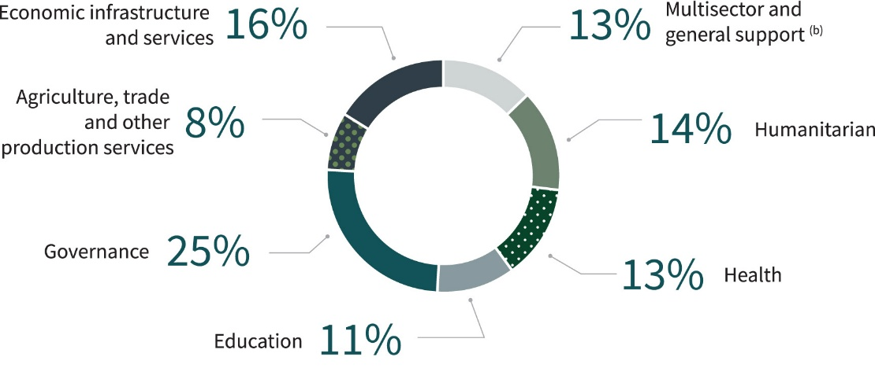

Figure 4. Australian Official Development Assistance by Sector Group, 2023–24 to 2024–25^{(a)}
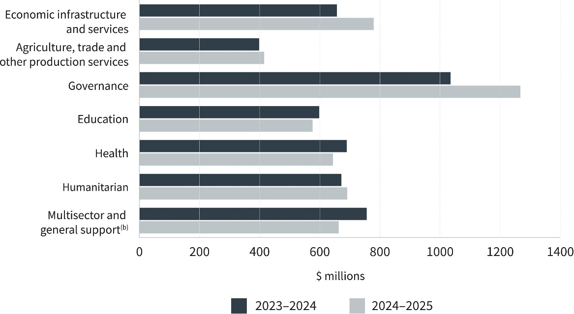
“ -” denotes nil or rounded to zero (including null cells).
Due to rounding, discrepancies may occur between sums of the component items and totals.
- Sector grouping based on broad level OECD DAC Sectors. See Appendix 2, paragraph 51 for further information.
- Includes administrative costs, contributions to research and scientific institutions that are non-sector allocable, and other multisector that are not further defined.

4 Australian Official Development Assistance, Sector Group by Type of Partner, 2024–25(a)
Sectors | Multilateral Organisations  $’000 | Commercial Suppliers  $’000 | Non-Government Organisations  $’000 | Universities, Academic and Research Institutions $’000 | Developing Country Governments  $’000 | Australian Public Sector Organisations  $’000 | Other Partners  $’000 | Total  $’000
Economic Infrastructure and Services | 220,701 | 443,095 | 16,214 | 3,607 | 74,136 | 20,493 | 1,068 | 779,314
Agriculture, Trade and other Production Sectors | 157,521 | 109,114 | 33,730 | 92,253 | 4,117 | 17,491 | 395 | 414,623
Governance | 284,358 | 383,362 | 160,660 | 23,068 | 293,465 | 119,861 | 2,203 | 1,266,978
Education | 99,267 | 196,702 | 46,803 | 203,211 | 18,198 | 10,244 | 1,200 | 575,625
Health | 321,754 | 138,110 | 92,478 | 32,611 | 17,020 | 29,246 | 12,731 | 643,950
Humanitarian | 445,589 | 81,576 | 141,797 | 3,349 | 7,143 | 10,863 | 316 | 690,634
Multisector and General Development Support ^{(b)} | 257,301 | 73,203 | 24,256 | 17,299 | 2,260 | 287,948 | 549 | 662,816
Total Australian Official Development Assistance | 1,786,491 | 1,425,162 | 515,938 | 375,398 | 416,340 | 496,147 | 18,464 | 5,033,941
“-” denotes nil or rounded to zero (including null cells).
Due to rounding, discrepancies may occur between sums of the component items and totals.
- Sector Group based on broad level OECD DAC sectors. See Appendix 2, paragraph 51 for further information.
- Includes administrative costs, and contributions to research and scientific institutions which are non-sector allocable, and other multisector not further defined.
Figure 5. Australian Official Development Assistance by Type of Partner, 2024–25
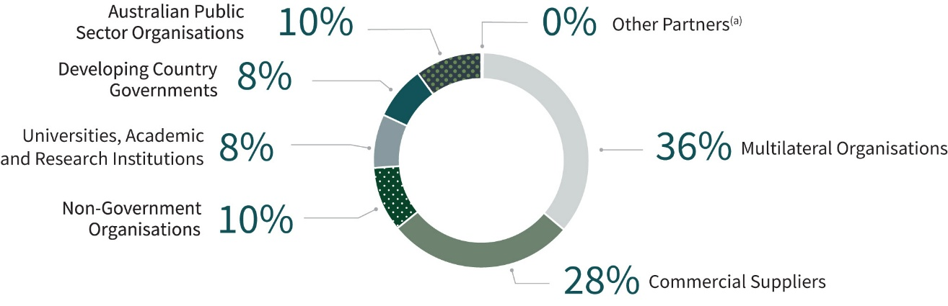
Figure 6. Australian Official Development Assistance by Type of Partner, 2012–13 to 2024–25
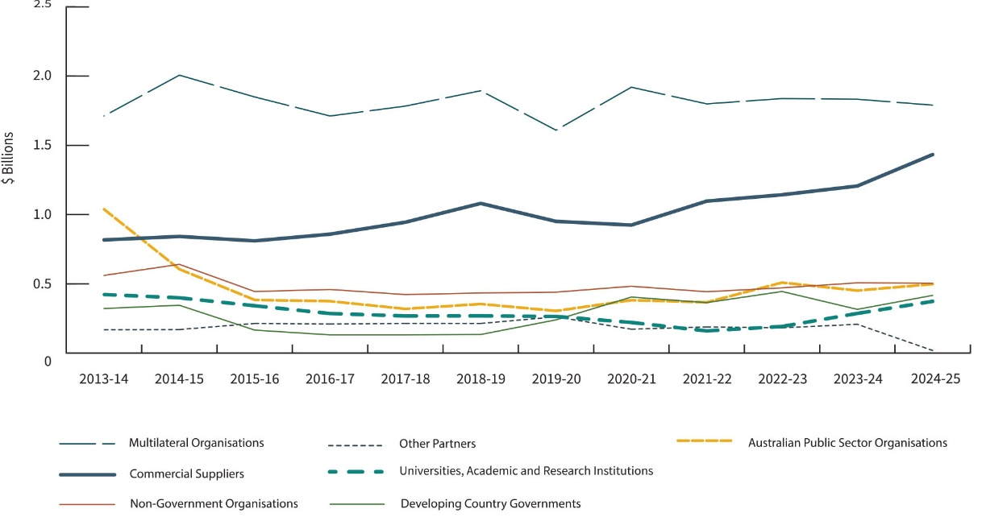
“-” denotes nil or rounded to zero (including null cells).
Due to rounding, discrepancies may occur between sums of the component items and totals.
(a) Includes public-private partnerships, networks, fellow donor governments and organisations which do not fit any other category.
(b) Data from 2024–25 onwards has an adjusted methodology for partner grouping. The data remains largely comparable because impact of this change on overall figures is minor. This adjustment did not affect Multilateral Organisations, Commercial Suppliers, or Non-Government Organisations.

5 Australian Official Development Assistance, Region of Benefit by Sector Group^{(a)}
Region of benefit | 2023–24  $’000 | 2024–25  $’000
Pacific - Economic Infrastructure and Services | 325,076 | 328,644
Pacific - Agriculture, Trade and other Production Sectors | 94,969 | 106,265
Pacific - Governance | 567,624 | 765,679
Pacific - Education | 249,389 | 247,181
Pacific - Health | 220,273 | 211,301
Pacific - Humanitarian | 78,023 | 71,561
Pacific - Multisector and General Development Support ^{(b)} | 320,384 | 313,558
Total Pacific | 1,855,737 | 2,044,189
Southeast Asia ^{(c)} - Economic Infrastructure and Services | 175,043 | 203,889
Southeast Asia ^{(c)} - Agriculture, Trade and other Production Sectors | 118,025 | 110,628
Southeast Asia ^{(c)} - Governance | 276,961 | 293,935
Southeast Asia ^{(c)} - Education | 223,583 | 202,217
Southeast Asia ^{(c)} - Health | 97,745 | 88,681
Southeast Asia ^{(c)} - Humanitarian | 94,768 | 130,965
Southeast Asia ^{(c)} - Multisector and General Development Support ^{(b)} | 163,113 | 169,451
Total Southeast Asia | 1,149,237 | 1,199,765
South and Central Asia - Economic Infrastructure and Services | 7,638 | 6,546
South and Central Asia - Agriculture, Trade and other Production Sectors | 25,113 | 18,241
South and Central Asia - Governance | 39,314 | 40,993
South and Central Asia - Education | 61,440 | 57,490
South and Central Asia - Health | 22,758 | 17,092
South and Central Asia - Humanitarian | 132,469 | 126,869
South and Central Asia - Multisector and General Development Support (b) | 28,612 | 28,243
Total South and Central Asia | 317,345 | 295,475
Other Asia ^{(d)} - Economic Infrastructure and Services | 11,543 | 66,573
Other Asia ^{(d)} - Agriculture, Trade and other Production Sectors | 16,582 | 12,347
Other Asia ^{(d)} - Governance | 4,885 | 5,087
Other Asia ^{(d)} - Education | 581 | 459
Other Asia ^{(d)} - Health | 15,809 | 15,665
Other Asia ^{(d)} - Humanitarian | 3,626 | 8,882
Other Asia ^{(d)} - Multisector and General Development Support (b) | 9,941 | 6,018
Total Other Asia | 62,968 | 115,031
Sub-Saharan Africa ^{(d)} - Economic Infrastructure and Services | 937 | 1,594
Sub-Saharan Africa ^{(d)} - Agriculture, Trade and other Production Sectors | 15,297 | 15,238
Sub-Saharan Africa ^{(d)} - Governance | 8,605 | 11,196
Sub-Saharan Africa ^{(d)} - Education | 13,937 | 14,275
Sub-Saharan Africa ^{(d)} - Health | 13,611 | 14,986
Sub-Saharan Africa ^{(d)} - Humanitarian | 71,243 | 39,244
Sub-Saharan Africa ^{(d)} - Multisector and General Development Support ^{(b)} | 14,195 | 10,048
Total Sub-Saharan Africa | 137,826 | 106,580
Middle East and North Africa - Economic Infrastructure and Services | 1,040 | 283
Middle East and North Africa - Agriculture, Trade and other Production Sectors | 2,679 | 2,297
Middle East and North Africa - Governance | 6,512 | 6,292
Middle East and North Africa - Education | 2,928 | 3,968
Middle East and North Africa - Health | 3,490 | 3,068
Middle East and North Africa - Humanitarian | 99,358 | 107,877
Middle East and North Africa - Multisector and General Development Support ^{(b)} | 8,790 | 9,707
Total Middle East and North Africa | 124,796 | 133,494
Latin America and the Caribbean - Economic Infrastructure and Services | 36 | 40
Latin America and the Caribbean - Agriculture, Trade and other Production Sectors | 146 | 186
Latin America and the Caribbean - Governance | 233 | 494
Latin America and the Caribbean - Education | 400 | 575
Latin America and the Caribbean - Health | 145 | 215
Latin America and the Caribbean - Humanitarian | 28 | 234
Latin America and the Caribbean - Multisector and General Development Support ^{(b)} | 209 | 163
Total Latin America and the Caribbean | 1,197 | 1,907
Other ^{(e)} - Economic Infrastructure and Services | 136,172 | 171,746
Other ^{(e)} - Agriculture, Trade and other Production Sectors | 124,781 | 149,422
Other ^{(e)} - Governance | 131,290 | 143,302
Other ^{(e)} - Education | 46,119 | 49,461
Other ^{(e)} - Health | 316,086 | 292,941
Other ^{(e)} - Humanitarian | 192,745 | 205,001
Other ^{(e)} - Multisector and General Development Support ^{(b)} | 210,676 | 125,627
Total Other | 1,157,868 | 1,137,500
Total Australian Official Development Assistance | 4,806,975 | 5,033,941
“-” denotes nil or rounded to zero (including null cells).
Due to rounding, discrepancies may occur between sums of the component items and totals.
- Sector Group based on broad level OECD DAC sectors. See Appendix 2, paragraph 51 for further information.
- Includes administrative costs, research and scientific institutions and other multisector not further defined. Includes administrative costs and contributions to research and scientific institutions that are non-sector allocable, and other multisector that are not further defined.
- Includes Timor-Leste.
- Includes regional programs that cannot be disaggregated to a lower geographic level.
- Includes global programs that cannot be disaggregated to a lower geographic level.

Figure 7. Pacific
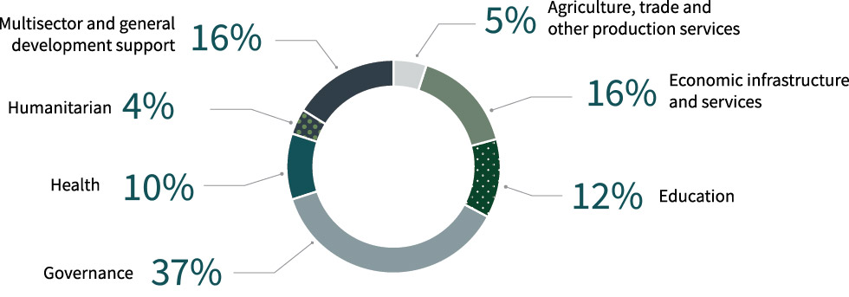
Figure 8. Southeast Asia
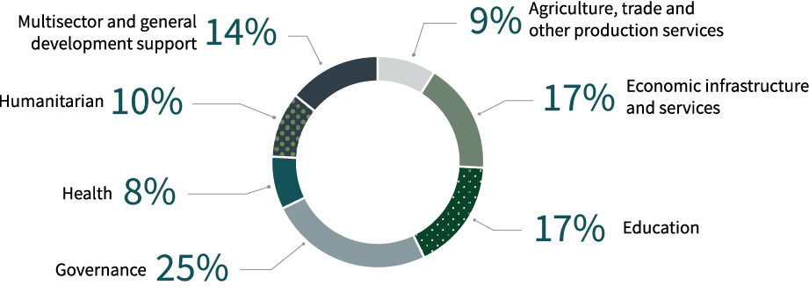

Figure 9. South and Central Asia
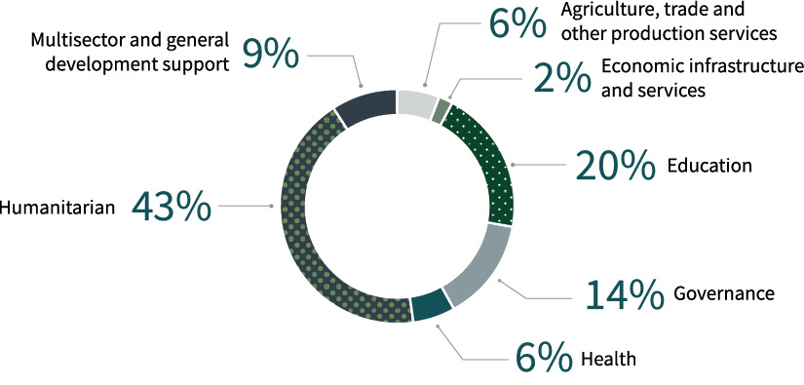

Figure 10. Sub-Saharan Africa
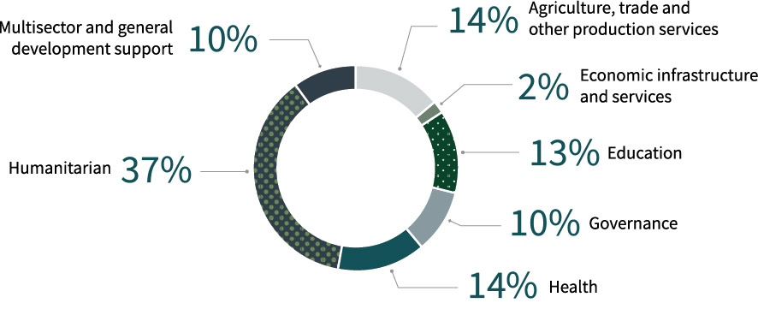
Figure 11. Middle East and North Africa
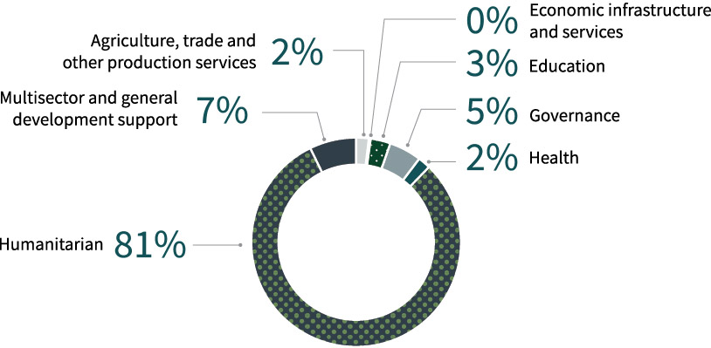

6 Australian Official Development Assistance, Partner Country by Sector Group, 2024–25^{(a)}
Partner Country | Economic Infrastructure and Services  $’000 | Agriculture, Trade and other Production Sectors  $’000 | Governance  $’000 | Education  $’000 | Health  $’000 | Humanitarian  $’000 | Multisector and General Development Support  $’000 | Total  $’000
Pacific - Federated States of Micronesia | 7,539 | 15 | 515 | 1,698 | 301 | - | 596 | 10,664
Pacific - Fiji | 3,164 | 11,010 | 79,170 | 23,148 | 25,216 | 5,706 | 7,054 | 154,468
Pacific - Kiribati | 13,022 | 1,420 | 15,739 | 10,848 | 3,142 | 1,941 | 683 | 46,795
Pacific - Nauru | 33,928 | 163 | 30,097 | 6,540 | 5,210 | 99 | 3,728 | 79,764
Pacific - Niue and Tokelau | 793 | - | 1,531 | 127 | 190 | - | 400 | 3,042
Pacific - Palau | 154 | 44 | 1,089 | 679 | 1,096 | 405 | 113 | 3,582
Pacific - Papua New Guinea | 105,416 | 25,756 | 288,673 | 93,271 | 87,868 | 18,457 | 68,705 | 688,146
Pacific - Republic of the Marshall Islands | 92 | 35 | 2,512 | 448 | 1,851 | 180 | 20 | 5,139
Pacific - Samoa | 8,864 | 3,743 | 33,834 | 10,870 | 4,421 | 268 | 3,090 | 65,091
Pacific - Solomon Islands | 54,091 | 15,871 | 61,926 | 22,388 | 9,233 | 6,828 | 11,589 | 181,927
Pacific - Tonga | 7,260 | 2,385 | 36,968 | 7,509 | 9,485 | 2,816 | 163 | 66,587
Pacific - Tuvalu | 20,864 | 118 | 24,606 | 4,282 | 5,274 | 5,091 | 595 | 60,831
Pacific - Vanuatu | 14,053 | 5,450 | 34,588 | 29,158 | 15,595 | 11,286 | 4,298 | 114,429
Pacific - Regional Pacific Island countries ^{(b)} | 59,404 | 40,254 | 154,428 | 36,217 | 42,417 | 18,484 | 212,522 | 563,725
Total Pacific | 328,644 | 106,265 | 765,679 | 247,181 | 211,301 | 71,561 | 313,558 | 2,044,189
Southeast Asia - Cambodia | 10,902 | 18,736 | 23,841 | 13,703 | 8,636 | 397 | 4,898 | 81,112
Southeast Asia - Indonesia | 119,086 | 28,852 | 116,989 | 67,548 | 12,819 | 7,590 | 14,886 | 367,769
Southeast Asia - Laos | 3,978 | 7,855 | 5,864 | 21,663 | 9,936 | 306 | 6,158 | 55,760
Southeast Asia - Myanmar | 747 | 5,245 | 15,674 | 23,639 | 11,741 | 90,078 | 5,060 | 152,183
Southeast Asia - Philippines | 3,965 | 5,151 | 28,500 | 18,998 | 6,829 | 21,824 | 9,813 | 95,079
Southeast Asia - Timor-Leste | 6,880 | 13,033 | 54,770 | 17,844 | 22,815 | 4,058 | 5,029 | 124,428
Southeast Asia - Vietnam | 15,908 | 17,180 | 17,317 | 26,893 | 5,565 | 4,247 | 14,023 | 101,133
Southeast Asia - Regional Southeast Asia ^{(b)} | 42,423 | 14,575 | 30,980 | 11,929 | 10,340 | 2,465 | 109,585 | 222,299
Total Southeast Asia | 203,889 | 110,628 | 293,935 | 202,217 | 88,681 | 130,965 | 169,451 | 1,199,765
South and Central Asia - Afghanistan | - | - | - | - | - | 55,344 | - | 55,344
South and Central Asia - Bangladesh | 1,379 | 4,330 | 18,738 | 23,189 | 2,703 | 67,107 | 4,027 | 121,473
South and Central Asia - Bhutan | 1,216 | 39 | 335 | 3,361 | 717 | - | - | 5,669
South and Central Asia - Maldives | 389 | - | 1,405 | 2,975 | 698 | - | 1,018 | 6,485
South and Central Asia - Mongolia | - | 148 | 1,539 | 6,207 | 553 | 341 | 718 | 9,505
South and Central Asia - Nepal | 1,296 | 2,909 | 8,893 | 5,982 | 4,351 | 1,070 | 1,084 | 25,585
South and Central Asia - Pakistan | 27 | 2,465 | 425 | 4,362 | 3,639 | 27 | 227 | 11,172
South and Central Asia - Sri Lanka | 1,076 | 5,928 | 6,711 | 8,828 | 746 | 2,531 | 190 | 26,010
South and Central Asia – Regional South and Central Asia ^{(b)} | 1,163 | 2,423 | 2,947 | 2,586 | 3,685 | 449 | 20,979 | 34,231
Total South and Central Asia | 6,546 | 18,241 | 40,993 | 57,490 | 17,092 | 126,869 | 28,243 | 295,475
Other Asian Countries^{(b)} | 66,573 | 12,347 | 5,087 | 459 | 15,665 | 8,882 | 6,018 | 115,031
Sub-Saharan Africa | 1,594 | 15,238 | 11,196 | 14,275 | 14,986 | 39,244 | 10,048 | 106,580
Middle East and North Africa^{(c)} | 283 | 2,297 | 6,292 | 3,968 | 3,068 | 107,877 | 9,707 | 133,494
Latin America and the Caribbean | 40 | 186 | 494 | 575 | 215 | 234 | 163 | 1,907
Other^{(d)} | 171,746 | 149,422 | 143,302 | 49,461 | 292,941 | 205,001 | 125,627 | 1,137,500
Total Official Development Assistance | 779,314 | 414,623 | 1,266,978 | 575,625 | 643,950 | 690,634 | 662,816 | 5,033,941
“-” denotes nil or rounded to zero (including null cells).
Due to rounding, discrepancies may occur between sums of the component items and totals.
- Sector Group based on broad level OECD DAC sectors. See Appendix 2, paragraph 51 for further information.
- Includes regional programs that cannot be disaggregated to the lower geographic level.
- Includes Palestine, Iraq, Syria and other flows to the region.
- Includes global programs that cannot be disaggregated to a lower geographic level.

7 Australian Official Development Assistance, Government Departments and Agencies, 2024–25^{(a) (b)}
Government Departments and Agencies | 2023–24  $’000 | 2024–25  $’000
Agriculture, Fisheries and Forestry | 17,632 | 18,769
Attorney-General's – Attorney-General's | 3,262 | 3,793
Attorney-General's – Office of the Director of Public Prosecutions | 16 | -
Climate Change, Energy, the Environment and Water – Climate Change, Energy, the Environment and Water | 3,277 | 3,269
Climate Change, Energy, the Environment and Water – Great Barrier Reef Marine Park Authority | 111 | -
Defence | 398 | 498
Education | 30 | -
Employment and Workplace Relations | 7,796 | 8,638
Finance | - | -
Foreign Affairs and Trade – Foreign Affairs and Trade | 4,522,085 | 4,702,702
Foreign Affairs and Trade – Australian Centre for International Agricultural Research | 112,793 | 116,963
Foreign Affairs and Trade – Export Finance Australia | 2,732 | 1,479
Health, Disability and Ageing | 15,020 | 15,442
Home Affairs – Home Affairs | 4,631 | 4,827
Home Affairs – Australian Federal Police | 46,190 | 42,718
Infrastructure, Transport, Regional Development, Communications, Sport and the Arts | 4,451 | 4,243
Treasury | 66,393 | 109,882
State and Territory Governments | 158 | 720
Total Official Development Assistance | 4,806,975 | 5,033,941
“-” denotes nil or rounded to zero (including null cells).
Due to rounding, discrepancies may occur between sums of the component items and totals.
- Figures are grouped at the portfolio level and will include relevant Commonwealth entities and companies within the portfolio unless a separate breakdown is provided.
- Further information on donated vaccines is available at https://indopacifichealthsecurity.dfat.gov.au/covid-19-vaccine-access. These donated vaccines are excluded in ODA figures.

8 Australian Official Development Assistance, Loan Disbursements, 2024–25^{(a) (b)}
Sector/Program | Country | Grant equivalent  of loan  disbursements  $’000
Australia Infrastructure Financing Facility for the Pacific  Connect Papua New Guinea - Roads Repair - AIFFP loan to Papua New Guinea | Papua New Guinea | 1,479
Department of the Treasury  2024 Loan Agreement between the Commonwealth of Australia and the Independent State of Papua New Guinea | Papua New Guinea | 99,602
Total ODA loan disbursement |  | 101,081
“-” denotes nil or rounded to zero (including null cells).
Due to rounding, discrepancies may occur between sums of the component items and totals.
- For further information about ODA grant equivalent of loans. Refer to Appendix 2: Concepts and Definitions, paragraph 26.
- Further detailed information is available on the Australian Infrastructure Financing Facility for the Pacific at: https://www.aiffp.gov.au.

9 Australian Official Development Assistance, International Development Policy^{(a) (b)}
Pillars | 2023–24  $’000 | 2024–25  $’000
Building effective and accountable states | 1,109,706 | 1,331,886
Enhancing state and community resilience | 1,926,499 | 1,926,672
Connecting partners with Australian and regional architecture | 589,098 | 672,726
Generating collective action on global challenges | 520,365 | 565,673
Not further defined^{(C)} | 661,307 | 536,984
Total Australian Official Development Assistance | 4,806,975 | 5,033,941

“-” denotes nil or rounded to zero (including null cells).
Due to rounding, discrepancies may occur between sums of the component items and totals.
- For further information about the International Development Policy Pillars, refer to Appendix 2: Concepts and Definitions, paragraph 27.
- Australia’s International Development Policy is available on the Department of Foreign Affairs and Trade’s website at https://www.dfat.gov.au/publications/development/australias-international-development-policy.
- Includes multisector aid, other programs, departmental and other administrative expenses that cannot be attributed to an International Development Policy pillar.
Figure 12. Australian Official Development Assistance, International Development Policy, 2024–25
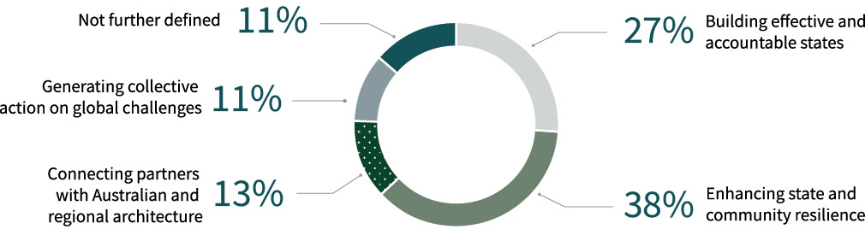

Type of Assistance by Region and Benefit Tables

10 Australian Official Development Assistance, Climate Finance, Type of Assistance by Region of Benefit, 2024–25^{(a) (b) (c)}
Type of assistance | Pacific  $’000 | Southeast Asia  $’000 | South and Central Asia  $’000 | Other Asia ^{(d)}  $’000 | Sub-Saharan Africa ^{(d)}  $’000 | Middle East and North Africa  $’000 | Latin America and the Caribbean  $’000 | Other ^{(e) (f)}  $’000 | Total  $’000
Environmental protection - Environmental policy and administrative management | 21,246 | 11,855 | 644 | - | 957 | 48 | - | 43,623 | 78,374
Environmental protection - Environmental research | 11 | 597 | 648 | - | - | - | - | 14 | 1,271
Environmental protection - Bio-diversity ^{(g)} | 2,925 | 1,104 | 259 | - | 3 | - | - | 151 | 4,443
Environmental protection - Other environmental protection | 74 | - | - | - | - | - | - | 45 | 119
Total environmental protection | 24,257 | 13,556 | 1,552 | - | 960 | 48 | - | 43,833 | 84,207
Economic infrastructure and services - Transport and storage | 35,166 | 8,047 | 134 | - | - | - | - | 12,653 | 56,001
Economic infrastructure and services - Communications | 8,440 | 1,277 | 130 | - | - | - | - | 2,242 | 12,089
Economic infrastructure and services - Energy generation and supply | 26,802 | 31,044 | 519 | 403 | 15 | - | - | 12,283 | 71,066
Economic infrastructure and services - Business, banking and financial services | 12,466 | 53,432 | 430 | 55,694 | 366 | 83 | - | 17,016 | 139,486
Total economic infrastructure and services | 82,873 | 93,800 | 1,214 | 56,096 | 380 | 83 | - | 44,195 | 278,642
Production sectors - Agriculture | 20,997 | 22,180 | 5,220 | 8,075 | 6,981 | 134 | - | 43,608 | 107,196
Production sectors - Forestry and fishing | 6,247 | 1,268 | - | 17 | 161 | - | - | 1,979 | 9,671
Production sectors - Industry | 1,468 | 48 | 50 | 461 | 28 | 16 | - | 2,840 | 4,910
Production sectors - Mining & mineral resources | 6 | - | - | - | - | - | - | 356 | 362
Production sectors - Other production sectors | 5,528 | 3,627 | 305 | 150 | - | - | - | 2,140 | 11,750
Total production sectors | 34,245 | 27,123 | 5,575 | 8,702 | 7,170 | 150 | - | 50,923 | 133,889
Humanitarian assistance - Disaster prevention and preparedness | 28,980 | 7,426 | 739 | 1,123 | 2,811 | 2 | - | 11,972 | 53,052
Humanitarian assistance - Reconstruction relief and rehabilitation | 163 | 499 | - | - | - | - | - | 621 | 1,282
Humanitarian assistance - Other humanitarian assistance | 1,814 | 782 | 1,031 | 1,910 | 7 | 2,952 | - | 31,110 | 39,606
Total humanitarian assistance | 30,957 | 8,707 | 1,769 | 3,033 | 2,819 | 2,954 | - | 43,702 | 93,940
Education | 17,111 | 1,519 | 1,409 | - | 202 | 47 | - | 15,642 | 35,931
Water and Sanitation | 8,359 | 22,537 | 4,056 | - | 589 | - | - | 20,055 | 55,597
Other sectors ^{(h)} | 106,447 | 45,564 | 3,793 | 351 | 2,418 | 299 | 1 | 77,299 | 236,171
Total Australian Climate Finance ODA | 304,249 | 212,807 | 19,370 | 68,183 | 14,538 | 3,581 | 1 | 295,648 | 918,377
“-” denotes nil or rounded to zero (including null cells).
Due to rounding, discrepancies may occur between sums of the component items and totals.
- Type of assistance based on OECD DAC Sectors.
- For further details on Climate Finance methodology and compilation refer to Appendix 2: Concepts and Definitions - paragraphs 8 to 10.
- Figures in this table represent the climate-related component of the expenditure under each sector. Total Australian climate finance equals Official Development Assistance (ODA) climate finance grants and loans (this table) plus the climate finance portion of: non-ODA grants and loans, and amounts mobilised from the private sector by Australian Official Development Finance investments. For further detail on total climate finance support by Australia and tracking against the Australian Government’s $3 billion climate finance commitment over the period 2020-2025, refer to the DFAT website (https://www.dfat.gov.au/international-relations/themes/climate-change/supporting-indo-pacific-tackle-climate-change/delivering-our-climate-commitments).
- Includes regional programs that cannot be disaggregated to a lower geographic level.
- Includes the climate finance portion of core contributions to multilateral organisations, based on OECD DAC imputed shares (https://www.oecd.org/development/financing-sustainable-development/development-finance-topics/climate-change.htm); sectoral breakdown follows the OECD DAC’s reporting standard, which applies the same sectoral split as for the entire core contribution.
- Includes global programs that cannot be disaggregated to a lower geographic level.
- Biodiversity here reflects the climate finance portion of investments that have selected the OECD DAC Biodiversity Sector. This is not equal to the total value of Australia’s biodiversity-related expenditure.
- Includes government and civil society, health, public finance and other aspects of climate finance.

11 Australian Official Development Assistance, Gender Equality, Type of Assistance by Region of Benefit, 2024–25^{(a) (b)}
Type of assistance | Pacific  $’000 | Southeast Asia  $’000 | South and Central Asia  $’000 | Other Asia  $’000 | Sub-Saharan Africa ^{(c)}  $’000 | Middle East and North Africa  $’000 | Latin America and the Caribbean  $’000 | Other ^{(d)}  $’000 | Total  $’000
Social infrastructure and services - Education | 179,089 | 160,745 | 36,577 | 359 | 10,808 | 2,534 | 171 | 1,183 | 391,466
Social infrastructure and services - Health | 143,977 | 55,893 | 8,936 | 2,969 | 10,790 | 2,739 | - | 6,598 | 231,902
Social infrastructure and services - Family planning and reproductive health | 13,871 | 5,871 | 1,232 | - | 718 | - | - | 250 | 21,942
Social infrastructure and services - Water supply and sanitation | 15,391 | 47,534 | 4,837 | - | 2,310 | 1,633 | - | 12,754 | 84,457
Social infrastructure and services - Government and civil society | 278,423 | 205,749 | 24,969 | 4,450 | 6,393 | 4,029 | - | 19,192 | 543,204
Social infrastructure and services - Other social infrastructure and services | 69,963 | 34,532 | 12,344 | 22 | 4,037 | 13 | - | 1,230 | 122,142
Total social infrastructure and services | 700,713 | 510,324 | 88,894 | 7,800 | 35,055 | 10,948 | 171 | 41,206 | 1,395,112
Economic infrastructure and services - Transport and storage | 129,820 | 25,575 | 1,343 | - | - | - | - | - | 156,739
Economic infrastructure and services - Communications | 53,322 | 7,194 | 1,304 | - | - | - | - | 225 | 62,045
Economic infrastructure and services - Energy generation and supply | 25,991 | 45,060 | 1,693 | 403 | 93 | - | - | - | 73,240
Economic infrastructure and services - Banking and financial services | 13,559 | 56,523 | 1,129 | 65,141 | 1,216 | 259 | - | 203 | 138,030
Economic infrastructure and services - Business and other services | 7,705 | 24,136 | 956 | 284 | 161 | 13 | - | 3,817 | 37,074
Total economic infrastructure and services | 230,398 | 158,489 | 6,425 | 65,828 | 1,470 | 272 | - | 4,245 | 467,127
Production sectors - Agriculture, forestry and fishing | 31,000 | 31,493 | 5,148 | 8,075 | 8,972 | 457 | - | 2,070 | 87,214
Production sectors - Industry, mining and construction | 14,454 | 434 | 108 | 1,678 | 276 | 99 | 30 | - | 17,079
Production sectors - Trade and tourism | 7,131 | 23,585 | 1,067 | 838 | - | - | - | 570 | 33,191
Total production sectors | 52,585 | 55,512 | 6,324 | 10,591 | 9,248 | 555 | 30 | 2,640 | 137,485
Humanitarian assistance | 55,976 | 111,735 | 112,474 | 8,761 | 20,125 | 78,547 | - | 43,804 | 431,422
Other sectors ^{(e)} | 119,910 | 49,960 | 4,998 | 599 | 3,448 | 184 | - | 4,215 | 183,315
Total Australian Gender Equality ODA | 1,159,582 | 886,021 | 219,115 | 93,579 | 69,346 | 90,507 | 201 | 96,111 | 2,614,461
Principal Objective | 126,881 | 113,736 | 7,110 | 12,376 | 1,499 | 136 | - | 14,582 | 276,320
Significant Objective | 1,032,702 | 772,284 | 212,004 | 81,203 | 67,847 | 90,371 | 201 | 81,529 | 2,338,141
Total Australian Gender Equality ODA | 1,159,582 | 886,021 | 219,115 | 93,579 | 69,346 | 90,507 | 201 | 96,111 | 2,614,461
“-” denotes nil or rounded to zero (including null cells).
Due to rounding, discrepancies may occur between sums of the component items and totals.
- For further details on Gender Equality methodology and compilation refer to Appendix 2: Concepts and Definitions - paragraphs 22 to 24.
- Type of assistance based on OECD DAC sectors.
- Includes regional programs that cannot be disaggregated to the lower geographic level.
- Includes global programs that cannot be disaggregated to a lower geographic level.
- Includes multisector education and training, urban and rural development projects and other multisector not further defined.

12 Australian Official Development Assistance, Disability Equity, Type of Assistance by Region of Benefit, 2024–25^{(a) (b)}
Type of assistance | Pacific  $’000 | Southeast Asia  $’000 | South and Central Asia  $’000 | Other Asia  $’000 | Sub-Saharan Africa ^{(c)}  $’000 | Middle East and North Africa  $’000 | Latin America and the Caribbean  $’000 | Other ^{(d)}  $’000 | Total  $’000
Social infrastructure and services - Education | 79,537 | 46,770 | 18,224 | 359 | 2,492 | 669 | - | - | 148,051
Social infrastructure and services - Health | 82,056 | 54,088 | 8,847 | 694 | 10,772 | 1,107 | - | 7,382 | 164,947
Social infrastructure and services - Family planning and reproductive health | 15,341 | 11,771 | 1,869 | - | 718 | - | - | 6,000 | 35,699
Social infrastructure and services - Water supply and sanitation | 17,463 | 41,365 | 4,833 | - | 2,220 | - | - | 12,754 | 78,634
Social infrastructure and services - Government and civil society | 207,433 | 190,147 | 19,002 | 2,063 | 6,832 | 800 | - | 15,575 | 441,852
Social infrastructure and services - Other social infrastructure and services | 24,555 | 34,858 | 11,014 | 22 | 996 | 13 | - | 86 | 71,543
Total social infrastructure and services | 426,385 | 378,999 | 63,787 | 3,138 | 24,030 | 2,589 | - | 41,798 | 940,726
Economic infrastructure and services - Transport and storage | 56,901 | 15,280 | - | - | - | - | - | - | 72,181
Economic infrastructure and services - Communications | 8,115 | 206 | - | - | - | - | - | - | 8,321
Economic infrastructure and services - Energy generation and supply | 26,827 | 23,298 | 299 | - | 107 | - | - | - | 50,531
Economic infrastructure and services - Banking and financial services | 4,129 | 19,884 | 1,129 | - | 1,132 | 259 | - | - | 26,534
Economic infrastructure and services - Business and other services | 4,484 | 11,331 | 177 | - | 166 | 13 | - | 2,500 | 18,672
Total economic infrastructure and services | 100,457 | 69,999 | 1,605 | - | 1,405 | 272 | - | 2,500 | 176,239
Production sectors - Agriculture, forestry and fishing | 23,286 | 13,988 | 5,123 | 8,075 | 6,257 | 457 | - | 2,070 | 59,255
Production sectors - Industry, mining and construction | 4,912 | 290 | 102 | - | 236 | 99 | - | - | 5,638
Production sectors - Trade and tourism | 4,293 | 20,129 | 942 | - | - | - | - | - | 25,365
Total production sectors | 32,491 | 34,407 | 6,167 | 8,075 | 6,493 | 555 | - | 2,070 | 90,258
Humanitarian assistance | 6,290 | 94,729 | 64,938 | - | 20,164 | 43,513 | - | 33,488 | 263,123
Other sectors ^{(e)} | 88,461 | 91,544 | 13,709 | (3) | 5,184 | 2,005 | - | 1,797 | 202,697
Total Australian Disability Inclusion ODA | 654,084 | 669,677 | 150,206 | 11,210 | 57,277 | 48,936 | - | 81,653 | 1,673,043
Principal Objective | 12,984 | 47,852 | 983 | 3 | 5 | - | - | 8,270 | 70,096
Significant Objective | 641,101 | 621,825 | 149,223 | 11,206 | 57,272 | 48,936 | - | 73,383 | 1,602,947
Total Australian Disability Inclusion ODA | 654,084 | 669,677 | 150,206 | 11,210 | 57,277 | 48,936 | - | 81,653 | 1,673,043
“-” denotes nil or rounded to zero (including null cells).
Due to rounding, discrepancies may occur between sums of the component items and totals.
- Disability equity refers to assistance provided to people with disability. Estimates in this table reflect the value of all activities that provide some level of assistance to people with disability. The level of assistance varies across all investments with some providing principal or significant focus and other activities moderate or minor focus. For further details on how disability equity data is compiled refer to Appendix 2: Concepts and Definitions - paragraphs 16 to 19.
- Type of assistance based on OECD DAC sectors.
- Includes regional programs that cannot be disaggregated to the lower geographic level.
- Includes global programs that cannot be disaggregated to a lower geographic level.
- Includes multisector education and training, seminars and other multisector not further defined.

13 Australian Official Development Assistance, Education, Type of Assistance by Region of Benefit, 2024–25^{(a)}
Type of assistance | Pacific  $’000 | Southeast Asia  $’000 | South and Central Asia  $’000 | Other Asia  $’000 | Sub-Saharan Africa ^{(b)}  $’000 | Middle East and North Africa  $’000 | Latin America and the Caribbean  $’000 | Other ^{(c)}  $’000 | Total  $’000
Basic education - Primary education | 17,060 | 28,541 | 7,938 | - | 597 | 346 | 44 | 9,660 | 64,185
Basic education - Early childhood education | 9,187 | 902 | 22 | - | 421 | 144 | - | 3,580 | 14,255
Basic education - Basic life skills for youth and adults | 6,064 | 2,230 | 644 | - | 317 | 219 | 19 | 303 | 9,796
Total basic education | 32,310 | 31,673 | 8,603 | - | 1,335 | 708 | 63 | 13,543 | 88,236
Secondary education - Secondary education | 208 | 157 | - | - | - | - | - | 9,211 | 9,575
Secondary education - Vocational education | 8,300 | 3,295 | 7,903 | - | 303 | 185 | 193 | 4,316 | 24,494
Total secondary education | 8,508 | 3,452 | 7,903 | - | 303 | 185 | 193 | 13,527 | 34,070
Post-secondary education - Higher education | 8,186 | 4,433 | 27 | - | 55 | - | - | 2,348 | 15,049
Post-secondary education - Advanced technical and managerial training | 8,356 | 340 | 373 | - | 54 | 39 | - | 1,046 | 10,209
Total post-secondary education | 16,541 | 4,773 | 400 | - | 110 | 40 | - | 3,394 | 25,258
Other education - Education policy and administrative management | 64,348 | 27,150 | 1,318 | 359 | 625 | - | - | 7,616 | 101,415
Other education - Education facilities and training | 15,908 | 1,935 | 486 | 100 | 615 | 144 | 103 | 3,578 | 22,870
Other education - Teacher training | 8,700 | 5,713 | 241 | - | 227 | - | - | 2,558 | 17,438
Other education - Education research | 1,250 | 150 | - | - | 1 | - | - | 1,137 | 2,538
Total other education | 90,206 | 34,948 | 2,044 | 459 | 1,469 | 144 | 103 | 14,889 | 144,262
Multisector education and training ^{(d)} | 99,615 | 127,370 | 38,540 | - | 11,058 | 2,892 | 216 | 4,109 | 283,800
Total Australian Education ODA | 247,181 | 202,217 | 57,490 | 459 | 14,275 | 3,968 | 575 | 49,461 | 575,625
“-” denotes nil or rounded to zero (including null cells).
Due to rounding, discrepancies may occur between sums of the component items and totals.
- Sector groups based on broad level OECD DAC Sectors.
- Includes regional programs that cannot be disaggregated to the lower geographic level.
- Includes global programs that cannot be disaggregated to a lower geographic level.
- Includes scholarships and the Global Partnership for Education.

14 Australian Official Development Assistance, Health (excluding Water supply and sanitation), Type of Assistance by Region of Benefit, 2024–25^{(a)}
Type of assistance | Pacific  $’000 | Southeast Asia  $’000 | South and Central Asia  $’000 | Other Asia  $’000 | Sub-Saharan Africa ^{(b)}  $’000 | Middle East and North Africa  $’000 | Latin America and the Caribbean  $’000 | Other ^{(c)}  $’000 | Total  $’000
Leadership and capacity building in health service delivery - Medical education and training | 341 | 338 | 118 | - | - | - | - | 217 | 1,016
Leadership and capacity building in health service delivery -Medical research | 4,492 | 5,278 | - | 1,552 | - | - | - | 16,562 | 27,884
Leadership and capacity building in health service delivery -Medical services | 2,462 | 287 | 889 | - | 488 | 311 | - | 5,210 | 9,646
Leadership and capacity building in health service delivery -Health policy and management | 111,272 | 17,363 | 2,805 | 5,870 | 947 | 1,633 | 30 | 50,929 | 190,849
Total leadership and capacity building in health service delivery | 118,567 | 23,266 | 3,813 | 7,422 | 1,435 | 1,944 | 30 | 72,918 | 229,394
Disease control and preventable impairments - Primary health care | 12,980 | 20,520 | 3,822 | - | 3,514 | 547 | - | 10,965 | 52,348
Disease control and preventable impairments - Health infrastructure | 8,437 | 189 | 150 | - | 3,104 | 25 | - | 1,277 | 13,181
Disease control and preventable impairments - Nutrition | 2,197 | 4,705 | 405 | - | 831 | - | - | 4,328 | 12,465
Disease control and preventable impairments - Infectious disease control | 10,171 | 3,627 | 362 | 1,695 | 1,692 | - | - | 100,610 | 118,157
Disease control and preventable impairments - Malaria control | 1,050 | 191 | - | 3,141 | - | - | - | 20,624 | 25,005
Disease control and preventable impairments - Tuberculosis control | 997 | - | - | 1,218 | 66 | - | - | 11,624 | 13,905
Disease control and preventable impairments - Public health education programs | 8,555 | 2,157 | 1,227 | - | 409 | 36 | 29 | 687 | 13,100
Disease control and preventable impairments - Other basic health | 17,511 | 12,676 | 2,006 | - | 581 | 517 | - | 366 | 33,657
Total disease control and preventable impairments | 61,896 | 44,065 | 7,972 | 6,054 | 10,197 | 1,125 | 29 | 150,480 | 281,819
Family planning and reproductive health programs ^{(d)} - Reproductive health care | 6,433 | 10,426 | 860 | - | 692 | - | - | 9,100 | 27,510
Family planning and reproductive health programs ^{(d)} - Family planning | 6,667 | 2,244 | 738 | - | 26 | - | 85 | 10,202 | 19,963
Family planning and reproductive health programs ^{(d)} - Sexually transmitted disease control | 2,245 | 148 | 62 | 2,192 | - | - | 23 | 38,084 | 42,754
Family planning and reproductive health programs ^{(d)} - Other population and health programs | 242 | 2,700 | 208 | - | - | - | - | 561 | 3,711
Total family planning and reproductive health programs | 15,587 | 15,518 | 1,869 | 2,192 | 718 | - | 108 | 57,947 | 93,939
Total Australian Health ODA | 196,051 | 82,849 | 13,653 | 15,668 | 12,350 | 3,068 | 167 | 281,345 | 605,152
“-” denotes nil or rounded to zero (including null cells).
Due to rounding, discrepancies may occur between sums of the component items and totals.
- Sector groups based on broad level OECD DAC Sectors.
- Includes regional programs that cannot be disaggregated to the lower geographic level.
- Includes global programs that cannot be disaggregated to a lower geographic level.
- Family planning and reproductive health data presented in this table has been compiled using DAC sectors, which differs from the methodology agreed at the 2012 London Family Planning Summit for tracking family planning expenditure. Data compiled using the Summit methodology is presented in Table 16.

15 Australian Official Development Assistance, Maternal and Child Health, Type of Assistance by Region of Benefit, 2024–25^{(a) (b)}
Type of assistance | Pacific  $’000 | Southeast Asia  $’000 | South and Central Asia  $’000 | Other Asia  $’000 | Sub-Saharan Africa ^{(c)}  $’000 | Middle East and North Africa  $’000 | Latin America and the Caribbean  $’000 | Other ^{(d)}  $’000 | Total  $’000
Leadership and capacity building in health service delivery - Medical education and training | 651 | 2,095 | 359 | - | 114 | 207 | - | 198 | 3,623
Leadership and capacity building in health service delivery - Medical research | - | - | - | - | - | - | - | - | -
Leadership and capacity building in health service delivery - Medical services | 985 | 115 | 355 | - | 195 | 124 | - | 2,084 | 3,857
Leadership and capacity building in health service delivery - Health policy and management | 44,021 | 7,008 | 970 | 2,348 | 379 | 630 | 12 | 20,372 | 75,739
Total leadership and capacity building in health service delivery | 45,656 | 9,218 | 1,684 | 2,348 | 687 | 960 | 12 | 22,653 | 83,219
Disease control and preventable impairments - Primary health care | 5,243 | 9,371 | 2,549 | - | 1,405 | 219 | - | 6,420 | 25,207
Disease control and preventable impairments - Health infrastructure | 3,375 | 111 | 23 | - | 1,241 | 10 | - | 511 | 5,271
Disease control and preventable impairments - Nutrition | 2,197 | 4,000 | 209 | - | 831 | - | - | 2,433 | 9,669
Disease control and preventable impairments - Infectious disease control ^{(e)} | 4,068 | 1,451 | 145 | 678 | 677 | - | - | 79,308 | 86,327
Disease control and preventable impairments - Public health education programs | 3,422 | 863 | 489 | - | 163 | 14 | 12 | 275 | 5,238
Disease control and preventable impairments - Water supply and sanitation | 2,242 | 820 | 496 | - | 392 | 630 | 7 | 1,697 | 6,283
Disease control and preventable impairments - Other basic health | 1 | 8 | - | - | 1 | - | - | - | 10
Total disease control and preventable impairments | 20,548 | 16,623 | 3,912 | 678 | 4,711 | 873 | 19 | 90,644 | 138,006
Family planning and reproductive health programs ^{(f)} - Reproductive health care | 3,679 | 7,259 | 575 | - | 525 | - | - | 6,665 | 18,703
Family planning and reproductive health programs ^{(f)} - Family planning | 3,913 | 2,244 | 738 | - | 26 | - | 83 | 5,982 | 12,987
Family planning and reproductive health programs ^{(f)} - Sexually transmitted disease control | - | - | - | - | - | - | - | - | -
Family planning and reproductive health programs ^{(f)} - Other population and health programs | 242 | 1,323 | 208 | - | - | - | - | 281 | 2,055
Total family planning and reproductive health programs | 7,834 | 10,827 | 1,522 | - | 552 | - | 84 | 12,928 | 33,746
Humanitarian and food aid | 727 | 7,960 | 16,867 | 247 | 837 | 12,277 | 1 | 6,001 | 44,918
Other ^{(g)} | 1,921 | 5,817 | 715 | 108 | 49 | 1,265 | 6 | 2,025 | 11,904
Total Australian Maternal and Child Health ODA | 76,687 | 50,446 | 24,699 | 3,381 | 6,835 | 15,375 | 121 | 134,250 | 311,793
“-” denotes nil or rounded to zero (including null cells).
Due to rounding, discrepancies may occur between sums of the component items and totals.
- Maternal and child health (MCH) data has been compiled using a maternal, neonatal and child health methodology “Muskoka 2”. For further information on how data is compiled please refer to Appendix 2 Concepts and Definitions - paragraphs 28 to 31.
- Sector groups based on broad level OECD DAC Sectors.
- Includes regional programs that cannot be disaggregated to a lower geographic level.
- Includes global programs that cannot be disaggregated to a lower geographic level.
- Includes Tuberculosis and Malaria Control.
- Family planning and reproductive health data presented in this table reflects investments presented in table 14 and 16 that specifically target maternal and child health.
- Includes education, governance, social infrastructure and other multisector not further defined or captured as part of the three Muskoka 2 partners.

16 Supplementary Table: Australian Official Development Assistance in Family Planning based on the methodology agreed at the 2012 London Family Planning Summit, by Region, 2024–25^{(a) (b)}
Type of assistance | Pacific  $’000 | Southeast Asia  $’000 | South and Central Asia  $’000 | Other Asia  $’000 | Sub-Saharan Africa ^{(c)}  $’000 | Middle East and North Africa  $’000 | Latin America and the Caribbean  $’000 | Other ^{(d)}  $’000 | Total  $’000
Health policy and administrative management | 5,564 | 868 | 140 | 294 | 47 | 82 | 1 | 2,546 | 9,542
Medical education/training | 17 | 17 | 6 | - | - | - | - | 11 | 51
Medical services | 123 | 14 | 44 | - | 24 | 16 | - | 260 | 482
Basic health care | 644 | 876 | 91 | - | 176 | 27 | - | 269 | 2,083
Basic health infrastructure | 422 | 9 | 7 | - | 155 | 1 | - | 64 | 659
Health education | 428 | 108 | 61 | - | 20 | 2 | 1 | 34 | 655
Health personnel development | 64 | 244 | 43 | - | 14 | 26 | - | 14 | 405
Population policy and administrative management | - | - | - | - | - | - | - | 23 | 23
Reproductive health care | 1,287 | 2,085 | 172 | - | 138 | - | - | 1,820 | 5,502
Family planning | 6,667 | 2,244 | 738 | - | 26 | - | 85 | 10,202 | 19,963
STD control including HIV/AIDS | 112 | 7 | 3 | 110 | - | - | 1 | 1,779 | 2,013
Personnel development for population and reproductive health | 12 | 135 | 10 | - | - | - | - | 5 | 162
General budget support | 1,231 | 40 | - | - | - | - | - | - | 1,271
Total Australian Family Planning ODA | 16,571 | 6,648 | 1,317 | 403 | 602 | 153 | 89 | 17,029 | 42,813
“-” denotes nil or rounded to zero (including null cells).
Due to rounding, discrepancies may occur between sums of the component items and totals.
- Family Planning data are presented in this table using the methodology agreed at the 2012 London Family Planning Summit. This narrower targeted focus differs from the standard reporting approach for presenting family and reproductive health program data using OECD DAC sectors presented in Table 14. For further details on the methodology refer to Appendix 2: Concepts and Definitions - paragraph 21.
- Sector groups based on broad level OECD DAC Sectors.
- Includes regional programs that cannot be disaggregated to a lower geographic level.
- Includes global programs that cannot be disaggregated to a lower geographic level.

17 Australian Official Development Assistance, Nutrition, Type of Assistance by Region of Benefit, 2024-25^{(a) (b) (c)}
Type of assistance | Pacific  $’000 | Southeast Asia  $’000 | South and Central Asia  $’000 | Other Asia  $’000 | Sub-Saharan Africa ^{(d)}  $’000 | Middle East and North Africa  $’000 | Latin America and the Caribbean  $’000 | Other ^{(e)}  $’000 | Total  $’000
Leadership and capacity building in health service delivery - Medical education and training | - | - | - | - | - | - | - | - | -
Leadership and capacity building in health service delivery - Health policy and management | 606 | 94 | - | - | - | - | - | 1 | 701
Total leadership and capacity building in health service delivery | 606 | 94 | - | - | - | - | - | 1 | 701
Disease control and preventable impairments - Primary health care | 300 | 2,125 | - | - | - | - | - | 557 | 2,983
Disease control and preventable impairments - Nutrition ^{(f)} | 2,197 | 4,705 | 405 | - | 831 | - | - | 2,656 | 10,793
Disease control and preventable impairments - Public health education programs | - | - | - | - | - | - | - | - | -
Disease control and preventable impairments - Reproductive health care | 375 | - | - | - | - | - | - | 1,500 | 1,875
Total other health | 2,872 | 6,830 | 405 | - | 831 | - | - | 4,713 | 15,651
Social infrastructure and services - Education | 1,243 | 77 | - | - | - | - | - | 1,298 | 2,618
Social infrastructure and services - Water supply and sanitation | 710 | 710 | 592 | - | - | - | - | 1,780 | 3,793
Social infrastructure and services - Social and welfare services | 768 | 815 | - | - | - | - | - | 627 | 2,210
Total social infrastructure and services | 2,722 | 1,602 | 592 | - | - | - | - | 3,706 | 8,622
Humanitarian Assistance - Emergency food aid | - | - | - | - | - | - | - | 40,000 | 40,000
Humanitarian Assistance - Other humanitarian assistance | - | 3,970 | 15,552 | - | 4,748 | 20,875 | - | - | 45,145
Total humanitarian assistance | - | 3,970 | 15,552 | - | 4,748 | 20,875 | - | 40,000 | 85,145
Agriculture, forestry and fishing | 644 | 4,075 | - | - | - | - | - | - | 4,719
Food aid and food security | - | 3,260 | - | - | - | - | - | - | 3,260
Other ^{(g)} | 1,838 | 178 | 59 | - | 37 | - | - | 1,285 | 3,397
Total Australian Nutrition ODA | 8,682 | 20,009 | 16,608 | - | 5,616 | 20,875 | - | 49,705 | 121,495
“-” denotes nil or rounded to zero (including null cells).
Due to rounding, discrepancies may occur between sums of the component items and totals.
- Nutrition expenditure presented in this table reflects investments identified as ‘nutrition specific’ or ‘nutrition sensitive’ based on the Scaling Up Nutrition (SUN) methodology.
- Sector groups based on broad level OECD DAC Sectors.
- For further details on how nutrition data presented in this publication has been compiled refer to Appendix 2: Concepts and Definitions - paragraphs 39 to 40.
- Includes regional programs that cannot be disaggregated to a lower geographic level.
- Includes global programs that cannot be disaggregated to a lower geographic level.
- These investments relate to direct nutrition specific feeding programs for maternal feeding, breastfeeding and weaning foods, child feeding and school feeding.
- Includes rural development, women’s organisations and other multisector aid not further defined.

18 Australian Official Development Assistance, Water, Sanitation and Hygiene, Type of Assistance by Region of Benefit, 2024–25^{(a)}
Type of assistance | Pacific  $’000 | Southeast Asia  $’000 | South and Central Asia  $’000 | Other Asia  $’000 | Sub-Saharan Africa ^{(b)}  $’000 | Middle East and North Africa  $’000 | Latin America and the Caribbean  $’000 | Other ^{(c)}  $’000 | Total  $’000
Water resources policy and management - Water sector policy and administrative management | 6,094 | 12,905 | 1,090 | (1) | - | 1,633 | - | 10,783 | 32,503
Water resources policy and management - Water resources conservation (including data collection) | 1,777 | 820 | 410 | - | 109 | - | - | 3,348 | 6,464
Total water resources policy and management | 7,870 | 13,725 | 1,500 | (1) | 109 | 1,633 | - | 14,131 | 38,967
Water supply and sanitation systems, urban | 210 | 31,263 | - | - | - | - | - | 7,646 | 39,119
Water supply and sanitation systems, rural | 14,809 | 5,369 | 3,306 | (3) | 2,605 | - | 49 | 11,314 | 37,448
Other water supply and sanitation
River basins' development | - | 883 | - | - | - | - | - | 481 | 1,363
Waste management/disposal | 70 | 133 | - | - | - | - | - | 1,494 | 1,697
Education and training in water supply and sanitation | 441 | 463 | 133 | - | 31 | - | - | 282 | 1,351
Total other water supply and sanitation | 511 | 1,479 | 133 | - | 31 | - | - | 2,256 | 4,411
Total Australian Water, Sanitation and Hygiene ODA | 23,401 | 51,836 | 4,939 | (4) | 2,745 | 1,633 | 49 | 35,347 | 119,945
“-” denotes nil or rounded to zero (including null cells).
Due to rounding, discrepancies may occur between sums of the component items and totals.
- Sector groups based on broad level OECD DAC Sectors.
- Includes regional programs that cannot be disaggregated to the lower geographic level.
- Includes global programs that cannot be disaggregated to a lower geographic level.

19 Australian Official Development Assistance, Government and Civil Society, Type of Assistance by Region of Benefit, 2024–25^{(a)}
Type of assistance | Pacific  $’000 | Southeast Asia  $’000 | South and Central Asia  $’000 | Other Asia  $’000 | Sub-Saharan Africa ^{(b)}  $’000 | Middle East and North Africa  $’000 | Latin America and the Caribbean  $’000 | Other ^{(c)}  $’000 | Total  $’000
Government and civil society, general - Public sector policy and administrative management | 123,315 | 102,276 | 3,674 | 372 | 746 | 1,633 | - | 13,335 | 245,350
Government and civil society, general - Public finance management | 32,073 | 16,826 | 2,952 | - | - | - | - | 32,038 | 83,888
Government and civil society, general - Domestic revenue mobilisation | 7,916 | 2,528 | 100 | - | - | - | - | 5,554 | 16,098
Government and civil society, general - Election management | 2,332 | 895 | - | - | - | - | - | 457 | 3,683
Government and civil society, general - Legal and judicial development | 72,442 | 28,287 | 57 | 1,369 | 1 | - | - | 618 | 102,773
Government and civil society, general - Democratic participation and civil society | 38,402 | 8,052 | 6,953 | 242 | 251 | 54 | 80 | 1,788 | 55,822
Government and civil society, general - Human rights | 16,138 | 16,987 | 2,519 | 598 | 2,213 | 246 | 24 | 17,139 | 55,864
Government and civil society, general - Women's equality organisations and institutions | 38,349 | 14,187 | 2,046 | 1,870 | 1,602 | 582 | 80 | 11,602 | 70,317
Government and civil society, general - Ending violence against women and girls | 33,150 | 27,965 | 7,699 | 615 | 1,928 | - | 191 | 2,547 | 74,095
Government and civil society, general - Other government and civil society, general ^{(d)} | 53,391 | 9,802 | 2,422 | - | - | 2,059 | - | 7,699 | 75,372
Total government and civil society, general | 417,508 | 227,805 | 28,420 | 5,065 | 6,741 | 4,573 | 375 | 92,777 | 783,262
Conflict prevention and resolution, peace and security | 16,325 | 25,402 | 2,489 | 377 | 19,577 | 4,352 | - | 18,397 | 86,919
Other government and civil society ^{(e)} | 88,802 | 43,725 | 12,333 | 22 | 1,255 | 87 | 119 | 47,857 | 194,199
Total Australian Government and Civil Society ODA | 522,635 | 296,932 | 43,242 | 5,463 | 27,574 | 9,012 | 494 | 159,030 | 1,064,381
“-” denotes nil or rounded to zero (including null cells).
Due to rounding, discrepancies may occur between sums of the component items and totals.
- Type of assistance based on OECD DAC Sectors.
- Includes regional programs that cannot be disaggregated to the lower geographic level.
- Includes global programs that cannot be disaggregated to a lower geographic level.
- Includes media and free flow of information, legislatures and political parties and decentralisation and support to subnational government.
- Includes other basic social and welfare services, institution capacity building, special programs and other multisector not further defined.
This table incorporates data previously reported in the Australian Official Development Assistance, Law and Justice table in prior years’ statistical summaries.

20 Australian Official Development Assistance, Humanitarian and Disaster Response, Type of Assistance by Region of Benefit, 2024–25^{(a)}
Type of assistance | Pacific  $’000 | Southeast Asia  $’000 | South and Central Asia  $’000 | Other Asia  $’000 | Sub-Saharan Africa ^{(b)}  $’000 | Middle East and North Africa  $’000 | Latin America and the Caribbean  $’000 | Other ^{(c)}  $’000 | Total  $’000
Emergency response - Material relief assistance | 14,415 | 68,372 | 105,090 | 5,556 | 18,994 | 104,550 | 112 | 91,670 | 408,759
Emergency response - Emergency food aid | 791 | 14,478 | 8,917 | - | - | - | - | 55,890 | 80,076
Emergency response - Relief co-ordination and support services | 703 | 12,140 | 5,785 | 139 | 57 | 596 | - | 8,336 | 27,756
Total emergency response | 15,909 | 94,990 | 119,791 | 5,696 | 19,051 | 105,146 | 112 | 155,896 | 516,591
Other humanitarian assistance - Reconstruction relief and rehabilitation | 727 | 4,991 | 16 | - | - | - | - | 1,633 | 7,366
Other humanitarian assistance - Disaster prevention and preparedness | 45,306 | 13,445 | 4,573 | 2,810 | 615 | 11 | 122 | 29,076 | 95,958
Other humanitarian assistance - Refugees in donor countries | - | - | - | - | - | - | - | - | -
Other humanitarian assistance - Land mine clearance | 182 | 1,716 | 1,300 | - | - | - | - | 1,314 | 4,512
Other humanitarian assistance - Civilian peace-building, conflict prevention and resolution | 9,438 | 15,823 | 1,189 | 377 | 554 | 36 | - | 16,502 | 43,919
Other humanitarian assistance - Participation in international peacekeeping operations | - | - | - | - | 19,024 | 2,684 | - | 220 | 21,928
Other humanitarian assistance - Reintegration and Small Arms Light Weapons control | - | - | - | - | - | - | - | 359 | 359
Other humanitarian assistance - Child soldiers prevention and demobilisation | - | - | - | - | - | - | - | 2 | 2
Total other humanitarian assistance | 55,652 | 35,975 | 7,078 | 3,187 | 20,193 | 2,731 | 122 | 49,105 | 174,043
Total Australian Humanitarian and Disaster Response ODA | 71,561 | 130,965 | 126,869 | 8,882 | 39,244 | 107,877 | 234 | 205,001 | 690,634

“-” denotes nil or rounded to zero (including null cells).
Due to rounding, discrepancies may occur between sums of the component items and totals.
- Sector groups based on broad level OECD DAC Sectors.
- Includes regional programs that cannot be disaggregated to the lower geographic level.
- Includes global programs that cannot be disaggregated to a lower geographic level.

21 Australian Official Development Assistance, Economic Growth, Type of Assistance by Region of Benefit, 2024–25^{(a)}
Type of assistance | Pacific  $’000 | Southeast Asia  $’000 | South and Central Asia  $’000 | Other Asia  $’000 | Sub-Saharan Africa (b)  $’000 | Middle East and North Africa  $’000 | Latin America and the Caribbean  $’000 | Other (c)  $’000 | Total  $’000
Economic infrastructure and services - Transport and storage | 166,010 | 27,141 | 1,343 | - | - | - | - | 32,774 | 227,269
Economic infrastructure and services - Communications | 63,863 | 9,344 | 1,304 | - | - | 10 | - | 7,951 | 82,472
Economic infrastructure and services - Energy generation and supply | 61,160 | 50,891 | 1,761 | 403 | 192 | - | 40 | 58,140 | 172,587
Economic infrastructure and services - Banking and financial services | 16,223 | 56,966 | 1,129 | 65,304 | 1,235 | 259 | - | 47,839 | 188,956
Economic infrastructure and services - Business and other services | 8,787 | 26,363 | 1,010 | 866 | 166 | 13 | - | 7,537 | 44,743
Total economic infrastructure and services | 316,045 | 170,704 | 6,546 | 66,573 | 1,594 | 283 | 40 | 154,242 | 716,027
Production sectors - Agriculture | 52,614 | 59,432 | 12,979 | 8,075 | 13,813 | 566 | 146 | 103,748 | 251,374
Production sectors - Forestry | 1,198 | 596 | 14 | - | 561 | - | 9 | 3,819 | 6,197
Production sectors - Fishing | 13,426 | 2,177 | 1,014 | 220 | 30 | - | - | 1,546 | 18,413
Production sectors - Industry | 4,952 | 543 | 108 | 3,215 | 256 | 99 | 30 | 7,371 | 16,574
Production sectors - Mineral resources and mining | 1,011 | - | - | - | 76 | - | - | 973 | 2,059
Production sectors - Construction | 10,071 | - | - | - | - | - | - | 6 | 10,078
Production sectors - Trade and tourism | 24,524 | 33,561 | 1,067 | 838 | - | - | - | 16,246 | 76,235
Total production sectors | 107,796 | 96,309 | 15,183 | 12,348 | 14,736 | 665 | 186 | 133,708 | 380,931
Other sectors - Other social and infrastructure services | 58,601 | 22,957 | 11,754 | 19 | 759 | 56 | 97 | 34,471 | 128,715
Other sectors - Environmental policy and governance | 30,221 | 17,593 | 1,956 | 616 | 3,286 | 164 | 23 | 52,581 | 106,440
Other sectors - Urban and rural development | 2,917 | 1,499 | 1,558 | - | 393 | - | - | 9,466 | 15,834
Other sectors - Food aid and food security programs ^{(d)} | - | 3,260 | - | - | - | - | - | 82 | 3,342
Total other sectors | 91,740 | 45,310 | 15,268 | 635 | 4,438 | 220 | 120 | 96,600 | 254,331
Total Australian Economic Growth ODA | 515,581 | 312,323 | 36,998 | 79,556 | 20,768 | 1,167 | 346 | 384,550 | 1,351,288
“-” denotes nil or rounded to zero (including null cells).
Due to rounding, discrepancies may occur between sums of the component items and totals.
- Type of assistance based on OECD DAC Sectors.
- Includes regional programs that cannot be disaggregated to the lower geographic level.
- Includes global programs that cannot be disaggregated to a lower geographic level.
- Food aid and food security programs exclude food aid delivered under humanitarian aid.

22 Australian Official Development Assistance, Aid for Trade, Type of Assistance by Region of Benefit, 2024–25^{(a)}
Type of assistance | Pacific  $’000 | Southeast Asia  $’000 | South and Central Asia  $’000 | Other Asia  $’000 | Sub-Saharan Africa (b)  $’000 | Middle East and North Africa  $’000 | Latin America and the Caribbean  $’000 | Other (c)  $’000 | Total  $’000
Trade policy, regulations and trade adjustment - Trade policy and administrative management | 3,618 | 11,891 | - | 390 | - | - | - | 1,918 | 17,817
Trade policy, regulations and trade adjustment - Trade facilitation | 16,636 | 796 | - | - | - | - | - | 7,146 | 24,579
Trade policy, regulations and trade adjustment - Regional trade agreements | - | 15,175 | - | - | - | - | - | 44 | 15,220
Trade policy, regulations and trade adjustment - Multilateral trade negotiations | 714 | 3,099 | 514 | 260 | - | - | - | 5,672 | 10,258
Trade policy, regulations and trade adjustment - Trade education, training and trade adjustment | 84 | 147 | 125 | 188 | - | - | - | 46 | 590
Total trade policy, regulations and trade adjustment | 21,053 | 31,108 | 639 | 838 | - | - | - | 14,827 | 68,464
Economic infrastructure - Transport and storage | 166,010 | 27,141 | 1,343 | - | - | - | - | 32,774 | 227,269
Economic infrastructure - Communications | 63,863 | 9,344 | 1,304 | - | - | 10 | - | 7,951 | 82,472
Economic infrastructure - Energy supply and generation | 61,160 | 50,891 | 1,761 | 403 | 192 | - | 40 | 58,140 | 172,587
Total economic infrastructure | 291,034 | 87,376 | 4,408 | 403 | 192 | 10 | 40 | 98,866 | 482,328
Building productive capacity - Business and other services | 8,787 | 26,363 | 1,010 | 866 | 166 | 13 | - | 7,537 | 44,743
Building productive capacity - Banking and financial services | 16,223 | 56,966 | 1,129 | 65,304 | 1,235 | 259 | - | 47,839 | 188,956
Building productive capacity - Agriculture | 52,614 | 59,432 | 12,979 | 8,075 | 13,813 | 566 | 146 | 103,748 | 251,374
Building productive capacity - Forestry | 1,198 | 596 | 14 | - | 561 | - | 9 | 3,819 | 6,197
Building productive capacity - Fishing | 13,426 | 2,177 | 1,014 | 220 | 30 | - | - | 1,546 | 18,413
Building productive capacity - Industry | 4,952 | 543 | 108 | 3,215 | 256 | 99 | 30 | 7,371 | 16,574
Building productive capacity - Mineral resources and mining | 1,011 | - | - | - | 76 | - | - | 973 | 2,059
Building productive capacity - Tourism | 3,472 | 2,452 | 429 | - | - | - | - | 1,419 | 7,771
Total building productive capacity | 101,683 | 148,529 | 16,683 | 77,681 | 16,138 | 937 | 186 | 174,251 | 536,088
Total Australian Aid for Trade ODA | 413,770 | 267,013 | 21,729 | 78,921 | 16,330 | 947 | 226 | 287,944 | 1,086,880
“-” denotes nil or rounded to zero (including null cells).
Due to rounding, discrepancies may occur between sums of the component items and totals.
- Type of assistance based on OECD DAC Sectors.
- Includes regional programs that cannot be disaggregated to the lower geographic level.
- Includes global programs that cannot be disaggregated to a lower geographic level.

23 Australian Official Development Assistance, Private Sector Development, Type of Assistance by Region of Benefit, 2024–25^{(a)}
Type of assistance | Pacific  $’000 | Southeast Asia  $’000 | South and Central Asia  $’000 | Other Asia  $’000 | Sub-Saharan Africa ^{(b)}  $’000 | Middle East and North Africa  $’000 | Latin America and the Caribbean  $’000 | Other ^{(c)}  $’000 | Total  $’000
Social infrastructure and services - Education | 16,656 | 3,636 | 8,276 | - | 357 | 224 | 193 | 5,362 | 34,703
Social infrastructure and services - Health | - | - | - | - | - | - | - | - | -
Social infrastructure and services - Government and civil society | 274,052 | 155,856 | 8,776 | 1,740 | 747 | 3,691 | - | 53,674 | 498,536
Social infrastructure and services - Other social infrastructure and services | 53,267 | 2,705 | 459 | 3 | - | 9 | - | 1,144 | 57,587
Total social infrastructure and services | 343,975 | 162,197 | 17,510 | 1,743 | 1,104 | 3,924 | 193 | 60,180 | 590,826
Economic infrastructure and services - Transport and storage | 166,010 | 27,141 | 1,343 | - | - | - | - | 32,774 | 227,269
Economic infrastructure and services - Communications | 63,863 | 9,344 | 1,304 | - | - | 10 | - | 7,951 | 82,472
Economic infrastructure and services - Energy generation and supply | 61,160 | 50,891 | 1,761 | 403 | 192 | - | 40 | 58,140 | 172,587
Economic infrastructure and services - Banking and financial services | 16,223 | 56,966 | 1,129 | 65,304 | 1,235 | 259 | - | 47,839 | 188,956
Economic infrastructure and services - Business and other services | 8,787 | 26,363 | 1,010 | 866 | 166 | 13 | - | 7,537 | 44,743
Total economic infrastructure and services | 316,045 | 170,704 | 6,546 | 66,573 | 1,594 | 283 | 40 | 154,242 | 716,027
Production sectors - Agriculture, forestry and fishing | 46,546 | 34,387 | 6,309 | 8,295 | 8,921 | 348 | 155 | 45,319 | 150,280
Production sectors - Industry, mining and construction | 5,963 | 543 | 108 | 3,215 | 332 | 99 | 30 | 8,344 | 18,633
Production sectors - Trade and tourism | 24,524 | 33,561 | 1,067 | 838 | - | - | - | 16,246 | 76,235
Total production sectors | 77,033 | 68,491 | 7,485 | 12,348 | 9,252 | 447 | 185 | 69,908 | 245,148
Other sectors ^{(d)} | 17,237 | 13,292 | 812 | - | 68 | - | - | 43,015 | 74,424
Total Australian Private Sector Development ODA | 754,290 | 414,684 | 32,354 | 80,664 | 12,018 | 4,653 | 417 | 327,346 | 1,626,425
“-” denotes nil or rounded to zero (including null cells).
Due to rounding, discrepancies may occur between sums of the component items and totals.
- Type of assistance based on OECD DAC Sectors.
- Includes regional programs that cannot be disaggregated to the lower geographic level.
- Includes global programs that cannot be disaggregated to a lower geographic level.
- Includes Environmental policy and administrative management.

24 Australian Official Development Assistance, Research, Type of Assistance by Region of Benefit, 2024–25^{(a)}
Type of assistance | Pacific  $’000 | Southeast Asia  $’000 | South and Central Asia  $’000 | Other Asia  $’000 | Sub-Saharan Africa (b)  $’000 | Middle East and North Africa  $’000 | Latin America and the Caribbean  $’000 | Other (c)  $’000 | Total  $’000
Social infrastructure and services - Education | 1,250 | 161 | 11 | - | 22 | 15 | 7 | 1,143 | 2,609
Social infrastructure and services - Health | 12,911 | 10,808 | 6 | 3,200 | 27 | 12 | 2 | 16,564 | 43,531
Social infrastructure and services - Family planning and reproductive health care | 54 | 2 | - | 542 | - | - | 4 | - | 602
Social infrastructure and services - Water supply and sanitation | - | 700 | 285 | - | 12 | - | 2 | - | 1,000
Social infrastructure and services - Government and civil society | 375 | 537 | 6 | - | 8 | 4 | 8 | 5 | 942
Social infrastructure and services - Conflict prevention and resolution | - | 234 | - | - | 3 | - | - | 590 | 827
Social infrastructure and services - Other social infrastructure and services | 1 | 12 | 6 | - | 8 | 3 | 4 | 1,006 | 1,039
Total social infrastructure and services | 14,591 | 12,453 | 314 | 3,742 | 81 | 34 | 27 | 19,308 | 50,549
Economic infrastructure and services - Transport and Storage | - | - | - | - | - | - | - | - | -
Economic infrastructure and services - Communications | 90 | 8 | - | - | - | - | - | - | 98
Economic infrastructure and services - Energy generation and supply | - | 237 | 2 | - | 3 | - | 1 | - | 244
Economic infrastructure and services - Business, banking and financial services | - | 4 | 1 | - | - | - | - | 1 | 6
Total economic infrastructure and services | 90 | 249 | 3 | - | 3 | - | 1 | 1 | 348
Production sectors - Agriculture | 17,535 | 26,205 | 7,623 | - | 6,955 | 4 | 5 | 53,372 | 111,698
Production sectors - Forestry and fishing | 3,060 | - | 14 | - | 1 | - | - | 15 | 3,090
Production sectors - Industry | 1,581 | - | - | 1,536 | 1 | - | - | 16 | 3,134
Production sectors - Mining and construction | - | - | - | - | - | - | - | - | -
Production sectors - Trade and tourism | 136 | 25 | - | - | - | - | - | - | 162
Total production sectors | 22,312 | 26,230 | 7,636 | 1,536 | 6,956 | 4 | 6 | 53,403 | 118,084
Environmental protection | 2,627 | 837 | 841 | 616 | 46 | - | 1 | 38 | 5,006
Humanitarian assistance | - | - | - | - | - | - | 4 | - | 4
Other sectors ^{(d)} | 3,945 | 9,326 | 1,187 | 764 | 2,610 | 2 | 5 | 7,406 | 25,245
Total Australian Research ODA | 43,565 | 49,095 | 9,982 | 6,659 | 9,695 | 40 | 44 | 80,156 | 199,235
“-” denotes nil or rounded to zero (including null cells).
Due to rounding, discrepancies may occur between sums of the component items and totals.
- Type of assistance based on OECD DAC Sectors.
- Includes regional programs that cannot be disaggregated to the lower geographic level.
- Includes global programs that cannot be disaggregated to a lower geographic level.
- Includes multisector research, rural development and other multisector not further defined.

25 Amounts Mobilised from the Private Sector by Australian Official Development Finance Investments, 2024-25^{(a) (b) (c)}
Sector/Program | Country | Total amount invested by Australia  $’000 | Total amount of private finance mobilised from Australian official effort  $’000
Small and medium-sized enterprises (SME) development - Australian Development Investments | Southeast Asia Region | 19,967 | 28,170
Total Small and medium-sized enterprises (SME) development |  | 19,967 | 28,170
Project finance - Private Infrastructure Development Group (PIDG) | Southeast Asia Region  South and Central Asia Region | 21,400 | 30,400
Project finance - Australian Climate Finance Partnership (ACFP) | Southeast Asia Region | 32,270 | 53,620
Project finance - Impact Private Sector Partnerships | Pacific Region  Southeast Asia Region  South and Central Asia Region | - | 3,157
Total Project finance |  | 53,670 | 87,177
Total Amounts Mobilised from the Private Sector by Australian Official Development Finance Investments |  | 73,637 | 115,347
“-” denotes nil or rounded to zero (including null cells).
Due to rounding, discrepancies may occur between sums of the component items and totals.
- Includes only programs with a primary focus on private finance mobilised.
- Amounts are calculated using agreed OECD private finance mobilised methodologies.
- For further information about Private finance mobilised by official development finance Interventions refer to paragraphs 44-45 of Appendix 2: Concepts and Definitions.

People to People Link Tables

26 Long-term Australia Awards Official Development Assistance, Field of Study by Region of Benefit, Number of Students by Gender, 2024–25^{(a) (b)}
Field of study | Pacific ^{(c)}  $’000 | Southeast Asia  $’000 | South and Central Asia  $’000 | Other Asia  $’000 | Sub-Saharan Africa  $’000 | Middle East and North Africa  $’000 | Latin America and the Caribbean  $’000 | Other  $’000 | Total  $’000
Female students - Natural and physical sciences | 35 | 29 | 4 | - | 4 | - | - | - | 72
Female students - Information technology | 9 | 16 | 7 | - | 1 | - | - | - | 33
Female students - Engineering and related technologies | 53 | 17 | 9 | - | 7 | 1 | - | - | 87
Female students - Architecture and building | 10 | 14 | 4 | - | 1 | 1 | - | - | 30
Female students - Agriculture and environmental studies | 27 | 59 | 20 | - | 13 | - | - | - | 119
Female students - Health | 285 | 67 | 8 | - | - | 1 | - | - | 361
Female students - Education | 85 | 54 | 4 | - | 2 | - | - | - | 145
Female students - Management and commerce | 81 | 91 | 24 | - | 3 | 1 | - | - | 200
Female students - Society and culture | 105 | 186 | 54 | - | 20 | 3 | - | - | 368
Female students - Other field of study ^{(d)} | 14 | 46 | 5 | - | 3 | - | - | - | 68
Total female students | 704 | 579 | 139 | - | 54 | 7 | - | - | 1,483
Male students - Natural and physical sciences | 21 | 32 | 1 | - | 6 |  | - | - | 60
Male students - Information technology | 30 | 39 | 7 | - | - | 2 | - | - | 78
Male students - Engineering and related technologies | 65 | 28 | 14 | - | 8 | 1 | - | - | 116
Male students - Architecture and building | 14 | 8 | 3 | - | - | - | - | - | 25
Male students - Agriculture and environmental studies | 25 | 43 | 12 | - | 7 | - | - | - | 87
Male students - Health | 89 | 38 | 7 | - | - | - | - | - | 134
Male students - Education | 73 | 29 | 4 | - | 1 |  | - | - | 107
Male students - Management and commerce | 46 | 73 | 23 | - | - | 3 | - | - | 145
Male students - Society and culture | 51 | 114 | 36 | - | 8 | 1 | - | - | 210
Male students - Other field of study ^{(d)} | 11 | 38 | 3 | - | 1 |  | - | - | 53
Total male students | 425 | 442 | 110 | - | 31 | 7 | - | - | 1,015
Gender not specified - Management and commerce | 1 | 4 | - | - | - | - | - | - | 5
Gender not specified - Health | - | 3 | - | - | - | - | - | - | 3
Gender not specified - Society and culture | - | 1 | - | - | - | - | - | - | 1
Gender not specified - Other field of study ^{(d)} | - | 5 | 1 | - | - | - | - | - | 6
Total students - Natural and physical sciences | 56 | 61 | 5 | - | 10 | - | - | - | 132
Total students - Information technology | 39 | 55 | 14 | - | 1 | 2 | - | - | 111
Total students - Engineering and related technologies | 118 | 45 | 23 | - | 15 | 2 | - | - | 203
Total students - Architecture and building | 24 | 22 | 7 | - | 1 | 1 | - | - | 55
Total students - Agriculture and environmental studies | 52 | 102 | 32 | - | 20 | - | - | - | 206
Total students - Health | 374 | 108 | 15 | - | - | 1 | - | - | 498
Total students - Education | 158 | 83 | 8 | - | 3 | - | - | - | 252
Total students - Management and commerce | 128 | 168 | 47 | - | 3 | 4 | - | - | 350
Total students - Society and culture | 156 | 301 | 90 | - | 28 | 4 | - | - | 579
Total students - Other field of study ^{(d)} | 25 | 89 | 9 | - | 4 | - | - | - | 127
Total Long-term Australia Awards Official Development Assistance | 1,130 | 1,034 | 250 | - | 85 | 14 | - | - | 2,513
“-” denotes nil or rounded to zero (including null cells).
- Partner region determined by citizenship of student.
- Include scholar data from multiple intakes who were on scholarship in Australia during financial year 2024-25.
- Includes DFAT managed Australia Awards Scholarships (Australia) and Australia Awards Pacific Scholarships (AAPS in Pacific and AAPNG in Papua New Guinea).
- Includes creative arts (communications, journalism, media studies and designs), tourism and hospitality and mixed field programs.

27 Long-term and Short-term Australia Awards Official Development Assistance, Partner Country by Number of Students, 2025^{(a) (b)}
Pillars | Long-term  no. | Short-term  no.
Pacific - Federated States of Micronesia | 7 | 5
Pacific - Fiji | 81 | 59
Pacific - Kiribati | 30 | 4
Pacific - Marshall Islands | 4 | -
Pacific - Nauru | 18 | 3
Pacific - Niue | 1 | -
Pacific - Palau | 3 | 4
Pacific - Papua New Guinea | 294 | 264
Pacific - Samoa | 44 | 10
Pacific - Solomon Islands | 56 | 103
Pacific - Tokelau | - | -
Pacific - Tonga | 27 | 4
Pacific - Tuvalu | 23 | 4
Pacific - Vanuatu | 52 | 21
Pacific - Wallis and Futuna | 1 | 1
Total Pacific | 641 | 482
Southeast Asia - Cambodia | 62 | 29
Southeast Asia - China | - | -
Southeast Asia - Indonesia | 275 | 458
Southeast Asia - Laos | 49 | 113
Southeast Asia - Malaysia | 12 | 6
Southeast Asia - Myanmar | 42 | -
Southeast Asia - Philippines | 62 | 125
Southeast Asia - Thailand | 12 | 33
Southeast Asia - Timor-Leste | 33 | 22
Southeast Asia - Vietnam | 92 | 189
Total Southeast Asia | 639 | 975
South and Central Asia - Afghanistan | - | -
South and Central Asia - Bangladesh | 62 | 93
South and Central Asia - Bhutan | 12 | 11
South and Central Asia - India | - | 35
South and Central Asia - Maldives | 16 | 28
South and Central Asia - Mongolia | 17 | 34
South and Central Asia - Nepal | 20 | 35
South and Central Asia - Pakistan | 18 | 36
South and Central Asia - Sri Lanka | 28 | 46
Total South and Central Asia | 173 | 318
Sub-Saharan Africa | 49 | 58
Middle East and North Africa ^{(c)} | 14 | -
Latin America and the Caribbean | - | 5
Other ^{(d)} | - | 15
Total Number of Long-term and Short-term Australia Awards Official Development Assistance | 1,516 | 1,853

“-” denotes nil or rounded to zero (including null cells).
- Partner region determined by citizenship of student.
- Refers to long-term scholarships offered in Calendar Year 2024 for 2025 commencement. Short-term refers to number of participants (including Fellows) in Calendar Year 2025.
- Includes Palestine.
- Includes Ukraine (part of Australia Awards Fellowships Round 20).

28 Australian Official Development Assistance, Volunteers Program, Partner Country by Number of Volunteers, 2024–25^{(a)}
Partner Country | 2023–24  In-country | 2023–24  Remote | 2023–24  Hybrid ^{(b)} | 2023–24  Total | 2024–25  In-country | 2024–25  Remote | 2024–25  Hybrid ^{(b)} | 2024–25  Total
Pacific - Federated States of Micronesia | 4 | 1 | - | 5 | 3 | - | - | 3
Pacific - Fiji | 15 | 2 | 4 | 21 | 20 | 1 | 17 | 38
Pacific - Kiribati | 5 | 1 | - | 6 | 6 | 1 | 3 | 10
Pacific - Marshall Islands | 4 | 3 | 3 | 10 | 4 | 1 | 2 | 7
Pacific - Palau | 1 | - | - | 1 | 9 | - | - | 9
Pacific - Papua New Guinea | 24 | 3 | 2 | 29 | 24 | 3 | 6 | 33
Pacific - Samoa | 7 | 1 | 2 | 10 | 6 | - | 3 | 9
Pacific - Solomon Islands | 31 | 6 | 5 | 42 | 23 | 5 | 5 | 33
Pacific - Tonga | 11 | 1 | 2 | 14 | 16 | - | 5 | 21
Pacific - Tuvalu | - | - | - | - | 3 | - | 2 | 5
Pacific - Vanuatu | 34 | 1 | 2 | 37 | 23 | - | 8 | 31
Total Pacific | 136 | 19 | 20 | 175 | 137 | 11 | 51 | 199
Southeast Asia - Cambodia | 13 | 8 | 7 | 28 | 8 | 6 | 19 | 33
Southeast Asia - Indonesia | 12 | 22 | 1 | 35 | 24 | 28 | 5 | 57
Southeast Asia - Laos | 5 | 5 | 3 | 13 | 8 | 3 | 5 | 16
Southeast Asia - Myanmar | - | - | - | - | - | - | - | -
Southeast Asia - Philippines | 4 | 3 | 2 | 9 | 5 | 2 | 2 | 9
Southeast Asia - Thailand | - | - | - | - | - | - | - | -
Southeast Asia - Timor-Leste | 32 | 5 | 4 | 41 | 25 | 3 | 11 | 39
Southeast Asia - Vietnam | 4 | 19 | 18 | 41 | 5 | 12 | 35 | 52
Total Southeast Asia | 70 | 62 | 35 | 167 | 75 | 54 | 77 | 206
South and Central Asia - Bangladesh | - | - | - | - | - | - | - | -
South and Central Asia - Bhutan | 5 | 3 | - | 8 | 5 | 2 | 1 | 8
South and Central Asia - Maldives | - | - | - | - | - | - | - | -
South and Central Asia - Mongolia | 4 | 14 | 10 | 28 | 2 | 12 | 16 | 30
South and Central Asia - Nepal | - | 3 | 7 | 10 | 1 | - | 10 | 11
South and Central Asia - Sri Lanka | 2 | 7 | 2 | 11 | 3 | - | 5 | 8
Total South and Central Asia | 11 | 27 | 19 | 57 | 11 | 14 | 32 | 57
Sub-Saharan Africa - Botswana | - | - | - | - | - | - | - | -
Sub-Saharan Africa - Eswatini | 1 | - | - | 1 | - | 1 | 1 | 2
Sub-Saharan Africa - Ethiopia | - | - | - | - | - | - | - | -
Sub-Saharan Africa - Ghana | - | - | - | - | - | - | - | -
Sub-Saharan Africa - Kenya | - | - | - | - | - | - | - | -
Sub-Saharan Africa - Lesotho | 1 | 7 | - | 8 | - | 7 | - | 7
Sub-Saharan Africa - Malawi | - | - | - | - | - | - | - | -
Sub-Saharan Africa - Namibia | - | - | - | - | - | - | - | -
Sub-Saharan Africa - South Africa | - | 13 | 2 | 15 | 1 | 10 | 5 | 16
Sub-Saharan Africa - Tanzania | 5 | 16 | 2 | 23 | 5 | 7 | 9 | 21
Sub-Saharan Africa - Uganda | - | - | - | - | - | - | - | -
Sub-Saharan Africa - Zambia | - | - | - | - | - | - | - | -
Total Sub-Saharan Africa | 7 | 36 | 4 | 47 | 6 | 25 | 15 | 46
Middle East and North Africa | - | - | - | - | - | - | - | -
Latin America and the Caribbean | - | - | - | - | - | - | - | -
Total Australian Official Development Assistance, Volunteers Program | 224 | 144 | 78 | 446 | 229 | 104 | 175 | 508
“-” denotes nil or rounded to zero (including null cells).
- Includes both new assignments, and assignments carried over from the previous year.
- Hybrid volunteering assignments include both in-country and remote components.

Appendices

Appendix 1: Explanatory Notes

Australia’s Official Support to Developing Countries
- Australia’s Official Development Assistance: Statistical Summary, 2024–25, incorporates total Official Development Assistance (ODA) across the Australian public sector.
- This report presents statistical details of Australia’s development cooperation with partner countries, multilateral and bilateral development agencies, civil society organisations and the private sector. It provides a range of information at the aggregate level on where Australia’s development program was delivered, and the type of development activity delivered.
The statistical data in this publication is based on data extracted in November 2025.

Official Development Assistance (ODA)
- Australia’s Official Development Assistance: Statistical Summary, 2024–25, complies with official development assistance as defined by the Organisation for Economic Co-operation and Development — Development Assistance Committee (OECD DAC). Refer to Official Development Assistance in Appendix 2: Concepts and definitions for further details.
Development Assistance Committee (DAC), Primary Purpose Classification
- Australia’s development program has been classified according to the DAC Primary Purpose classification. As stated by the DAC this classification has been ‘specifically developed to track aid flows and to permit measuring the share of each sector (e.g., health, education) or other purpose category “non-sector allocable aid” (e.g., general budget support, multisector) in total aid.’ The sector of destination is assigned by answering the question:
“Which specific area of the recipient’s economic and social structure is the transfer intended to foster?”

Accrual accounting in the development program
- All Australian Government expenditure, in accordance with the accrual accounting framework, is calculated on an expense basis for internal government budgeting and expenditure purposes.
- Refer to Accrual accounting in Appendix 2: Concepts and definitions for further details.

Rounding
- Discrepancies may occur between totals in this publication, the same totals in other sources and the sum of component items due to rounding.

Further information
- Further information about these and related statistics, including time series data, is available from the DFAT website (https://www.dfat.gov.au/).

Appendix 2: Concepts and Definitions

Accrual accounting
- Accrual accounting refers to an accounting method that records financial transactions when they are incurred regardless of when cash is exchanged, that is, it records flows at the time the economic value is created, transformed, exchanged, transferred, or extinguished.
Following accrual accounting principles:
- Flows involving change of ownership are recorded when ownership changes;
- Services are recorded when provided; and
- Distributive transactions are recorded as amounts payable accumulate.
- Accrual recording ensures that activities are recorded consistently and without distortion from leads and lags in accompanying cash flows. The Australian Government moved to an accrual accounting framework in 1999–2000.
NOTE: ODA is reported on a cash basis. DFAT applies an adjustment to these transactions to report transactions when they occurred. An exception is made for core payments to multilateral organisations which are recorded at the time the payment is made by DFAT to the multilateral organisation.
- Accrual recording ensures that activities are recorded consistently and without distortion from leads and lags in accompanying cash flows. The Australian Government moved to an accrual accounting framework in 1999–2000.
NOTE: ODA is reported on a cash basis. DFAT applies an adjustment to these transactions to report transactions when they occurred. An exception is made for core payments to multilateral organisations which are recorded at the time the payment is made by DFAT to the multilateral organisation.

Australian development programs
- The Australian development program is delivered through a number of programs, which are the major managerial, administrative and accounting frameworks within which these Australian Government development funds are deployed. There are three main types of development delivery programs: Country Programs, Regional Programs and Global Programs.

Cash payments
- ODA is measured in terms of cash payments in a given time period, rather than expenses incurred over that period. Thus, for ODA statistics, some expenditure data needs to be adjusted from the expense basis used in Australian Government financial records to a cash basis.
- In particular, adjustments from expenses to cash are required in relation to expenditure to meet major multi-year liabilities such as commitments to the Asian Development Fund (ADF) and International Development Association (IDA). For each financial year, these adjustments exclude the expenses recorded in relation to those commitments, but include the cash paid under those commitments in that year.
- Adjustments are also made for such items as movements in creditors and depreciation.

Climate Finance
- Climate finance is the financial assistance provided to developing countries in support of climate change adaptation and mitigation.
- Australia’s climate finance is estimated by assessing each development activity to determine if it promotes the objectives of the United Nations Framework Convention on Climate Change (UNFCCC). This is done in accordance with OECD DAC guidelines for use of the Rio Markers on climate change adaptation and mitigation. Refer to Counting Australia’s Climate Finance, DFAT, 2022 at: Supporting the Indo-Pacific to tackle climate change | Australian Government Department of Foreign Affairs and Trade (https://www.dfat.gov.au/publications/international-relations/counting-australias-climate-finance)
- Where climate change is the principal/primary objective – i.e., the activity would not have been funded but for that objective – 100 per cent of the activity value is counted as climate finance. Where climate change is a significant/secondary objective – i.e., it has other prime objectives but has been formulated or adjusted to help meet climate change adaptation or mitigation – an estimate is made of the amount spent on delivering climate results.

Co-financing
- An arrangement under which a development activity is funded jointly by the Australian Government and a development organisation outside Australia, such as the World Bank (WB), the Asian Development Bank (ADB) or the United Nations Development Programme (UNDP).

Core payments
- The provision of donor funds to a development organisation without specific conditions as to the use of those funds, allowing the organisation to use them for any development purpose within their mandate. The funds become part of the general financial reserves of the organisation. See also Non-core payments.

Country programs
- The Australian development program has a separate country program for each major partner country, which is planned and implemented jointly with the partner government. Each country program consists of an integrated package of mutually agreed activities, developed and implemented under an agreed country strategy.

Departmental expenditure
- For any Australian Government department or agency, departmental expenditure refers to the costs of operating the organisation concerned. Departmental expenditure in the Australian development program includes such costs as salaries, equipment costs, rent and other running expenses of the government agency responsible for administering international development cooperation. In this publication, ODA eligible departmental costs are attributed to geographic regions, in the same proportion as the amount of total ODA expensed in those regions.

Development Assistance Committee (DAC)
- The main committee of the OECD on development matters, and a key forum of major bilateral donors. The key functions of the DAC are to:
- Adopt authoritative policy guidance for DAC members;
- Conduct periodic reviews of its members’ development cooperation programs;
- Provide a forum for dialogue, exchange and the building of international consensus on development-related policy and management issues of interest to members; and
- Publish statistics and reports on development and other resource flows to developing countries and related matters, based principally on reporting by members.

Disability Equity
- Data on disability equity in Australian development programs is based on the OECD disability inclusion policy marker against which activities are screened and marked as either:
- Targeting disability inclusion as the ‘principal’ objective or a ‘significant’ objective, or
- Not targeting disability inclusion as a policy objective.
- The disability inclusion policy marker indicates policy objectives in relation to each development program. A principal objective score means that disability inclusion is the main objective of the program and is fundamental to its design and expected results. The program would not have been undertaken without this objective. The classification ‘significant objective’ means that disability inclusion is an important and deliberate objective, but not the principal reason for undertaking the program.
- In the 2023-24 edition of this report, disability expenditure data has been adjusted to align with DFAT’s approach to reporting on gender equality data and is not comparable with figures reported prior to FY 2023-24. The data generated by the marker provides an “upper bound” estimate of DAC members’ development funding in support of disability inclusion rather than an exact quantification.
- Figures published in Table 12 exclude core payments to multilateral organisations, departmental costs of running the development funding program and the Australian ODA delivered by other government agencies. Programs delivered for reducing preventable impairments target the wider population and are therefore excluded from disability equity calculations as they are not delivered specifically to people with disability.

Expenses
- See Cash payments.

Family Planning
- The 2012 London Family Planning Summit methodology was adopted by participants at the Summit implementing a common, internationally agreed basis for reporting family planning expenditure. The methodology calculates a percentage of thirteen DAC codes that have relevance to the provision of family planning services (for example, capturing percentage of health staff and health facilities relevant to the delivery of family planning services). It can include: stand-alone family planning projects; family planning-specific contributions to multilateral organisations (e.g. contributions to United Nations Population Fund (UNFPA) supplies); and, in some cases, projects that include family planning within broader reproductive health activities. This methodology also includes some funding designated for other health sectors, including HIV, reproductive health (RH), maternal health, and other areas, as well as a percentage of a donor’s core contributions to several multilateral organisations, including UNFPA, the World Bank, World Health Organization (WHO), and the Global Fund to Fight AIDS, Tuberculosis and Malaria.

Gender Equality
- Data on gender equality in Australian development programs is based on the OECD gender equality policy marker whereby activities are screened and marked as either:
- Targeting gender equality as the ‘principal’ objective or a ‘significant’ objective; or
- Not targeting gender equality as a policy objective.
- The gender equality policy marker indicates policy objectives in relation to each development program. A principal objective score means that gender equality is the main objective of the program and is fundamental to its design and expected results. The program would not have been undertaken without this objective. The classification ‘significant objective’ means that gender equality is an important and deliberate objective, but not the principal reason for undertaking the program.
- Gender equality data has been adjusted due to introduction of the 2016 OECD-DAC Minimum Requirements for the gender policy marker and is not comparable with figures reported in earlier years. Figures in Table 11 exclude core payments to multilateral organisations, departmental costs of running the development funding program and the Australian ODA delivered by other government agencies. The data generated by the marker provides an “upper bound” estimate of DAC members’ development funding in support of gender equality rather than an exact quantification. The new methodology requires investments to be designed to make a difference for gender equality and women’s empowerment, whereas the earlier method included investments where gender equality was merely considered in the design, thus technically overstating expected gender impact.

Global programs
- Global programs are specialised DFAT programs which deliver other development assistance and/or multi-country development benefits across the developing world. They include contributions to international organisations; emergency, humanitarian, and refugee programs; contributions to NGOs and volunteer programs; development education and public information and development research.

Grant equivalent of loans
- The OECD DAC Statistical Reporting Directives details the method for the calculation of the grant equivalent for loans. For the grant equivalent to be counted as ODA, the loans must be concessional and are therefore dependent on the grant element. Please refer to paragraph 41 for further details on the thresholds. The method for calculating the ODA grant equivalent has been defined for loans to the official sector, multilaterals and the private sector.

International Development Policy Pillars
- ODA expenditure has been aggregated against four pillars contained in the International Development Policy, released by the Government in August 2023, and used in Australia’s International Development Performance and Delivery Framework for Tier 2 performance measures. ODA resource flows have been mapped by OECD DAC purpose codes against each pillar. Some ODA is allocated to ‘not further defined’, which includes funding not able to be distributed to one of the four pillars, such as multisector aid. The four pillars are:
- Building effective and accountable states: Investments that build governance and civil society, economic policy reform and management, private sector development, banking and financial services, industry, social protection, and gender and disability equality.
- Enhancing state and community resilience: Investments related to infrastructure, education, health, water and sanitation, humanitarian assistance and food security, climate action, the environment, transport, biodiversity and marine security.
- Connecting partners with Australian and regional architecture: Investments related to strengthening leadership and effective governance, labour mobility, strengthening regional architecture, scholarships and trade.
- Generating collective action on global challenges: Investments related to multilateral engagement, general development support, emergency assistance and other humanitarian.

Maternal and Child Health
- Maternal and Child Health reports expenditure based on the “Muskoka2 method”. Muskoka2 is an agreed standard used by donors to report on their spending for Reproductive, Maternal, Newborn and Child Health (RMNCH). The development of Muskoka2 has been guided by a group of key stakeholders, who have participated in the Joint Countdown to 2030/PMNCH Financing Working Group.
- The Muskoka2 methodology assigns a pre-determined percentage of funding to the set of agreed DAC sector purpose codes deemed to benefit RMNCH.
- Muskoka2 excludes attributions for core payments to GAVI, UNFPA and UNICEF as these institutions apply a fixed percentage of all their disbursements to RMNCH. These derived percentages are applied to their estimates included in this publication.
- Further detailed information is available through the OECD here.

Multilateral flows
- Resources channelled through international organisations active in development such as the World Bank (WB), the Asian Development Bank (ADB), the United Nations Population Fund (UNFPA), and the World Food Programme (WFP) include core and non-core payments. Payments made to third parties for administrative purposes are channelled through multilateral and regional organisations, are also reported as multilateral flows.

Negative flows
- Development funding expenditure is usually presented as a positive cash flow to a developing country. In some situations, a negative flow may be reported. Valid negative cash flows from a developing country include:
- Official equity investments acquired for ODA development intentions and subsequently sold, that is the proceeds from the sale are reported as a negative flow; and
- Reimbursements from partners for unexpended resources.
- Negative flows presented in this publication do not necessarily reflect an outward flow of cash being returned to Australia from a developing country. In some instances, these flows may also reflect an accounting adjustment.

Negative values
- See Negative flows.

Net bilateral costs
- Additional costs of providing resources to a recipient country, for example the extra cost of assigning personnel to development activities, net of the costs of stationing them at home, and any compensation received from other parties for their relocation.

Non-core payments
- Payments to a development organisation made with specific conditions, that is where the donor specifies any aspect of how the funds are to be used. These payments are often referred to as ‘earmarked’. See Core payments.

Non-government organisations (NGOs)
- NGOs are legally constituted organisations that operate independently from any government.

Nutrition
- Although there is a DAC sector code for reporting activities aimed at direct nutrition interventions, there is no common, agreed approach to track resources for “nutrition-sensitive” development assistance. These outcomes are drawn from the nutritional conceptual framework (UNICEF 1990), the reference document Addressing Undernutrition in External Assistance (EC2011) and the SUN Movement Strategy 2012–2015.
- The various health data tables presented in this publication reflect differing methodologies and, as such, health data should not be compared from one table to another.
- Table 3, Australian Official Development Assistance by Sector Groups, presents health-specific DAC sector codes plus additional health-related DAC sector codes, specifically four additional water and sanitation codes;
- Table 14, Health by Type of Assistance, presents direct nutrition interventions data only (DAC sector code 12240) in the nutrition line of the table;
- Table 15, Maternal Child Health by Type of Assistance, presents data using a maternal child health marker and direct nutrition interventions data only (DAC sector code 12240) in the nutrition line of the table; and
- Table 17, Nutrition by Type of Assistance, presents nutrition investments identified as ‘nutrition specific’ or ‘nutrition sensitive’ defined using the Scaling Up Nutrition (SUN) methodology. The Nutrition line in this table refers to direct nutrition interventions data only (DAC sector code 12240), or ‘nutrition specific’. These investments relate to direct feeding programs for maternal feeding, breastfeeding and weaning foods, child feeding and school feeding.

Official Development Assistance (ODA)
- ODA, as defined by the DAC, consists of flows to countries and territories on the List of ODA Recipients, and to multilateral development institutions, which are provided by official agencies, including state and local government, or by their executive agencies, and:
- Are administered with the promotion of the economic development and welfare of developing countries as its main objective; and
- Are concessional in character and conveys a grant element of at least 25 per cent. In the case of non-grants finance:
- 45 per cent in the case of bilateral loans to the official sector of Least Developed Countries and other Low-Income Countries (calculated at a rate of discount of 9 per cent);
- 15 per cent in the case of bilateral loans to the official sector of Lower Middle Income Countries (calculated at a rate of discount of 7 per cent);
- 10 per cent in the case of bilateral loans to the official sector of Upper Middle Income Countries (calculated at a rate of discount of 6 per cent); and
- 10 per cent in the case of loans to multilateral institutions (calculated at a rate of discount of 5 per cent for global institutions and multilateral development).
- To ensure consistency in the application of ODA eligibility, the DAC has further delineated the boundaries of ODA in many areas, for instance:
- Peace and Security: The DAC has issued revised guidelines on peace and security assistance (2016). The reporting of peace and security-related activities is guided by the general principle that the main objective is the promotion of the economic development and welfare of developing countries.
Financing of military equipment or services is generally excluded from ODA reporting, the exception covering human rights, humanitarian law, disaster response, anti-corruption, and improved civilian oversight.
- Anti-Terrorism: Activities combatting terrorism are not reportable as ODA, as they generally target perceived threats to donor, as much as to recipient countries, rather than focusing on the economic and social development of the recipient;
- Peacekeeping: Most peacekeeping expenditures are excluded in line with the exclusion of military costs. However, the net bilateral cost of some closely defined development activities within United Nations (UN) administered or approved peacekeeping operations are included, such as: human rights; election monitoring; rehabilitation of demobilised soldiers and of national infrastructure; advice on economic stabilisation; monitoring and training of administrators; and weapons and mine removal for development purposes only;
- Social and cultural programs: Expenditure on the promotion of museums, libraries, art and music schools, and sport training facilities and venues that builds developing countries capacity are reported as ODA. One-off interventions such as sponsoring concert tours or athletes’ travel costs are not ODA eligible. Cultural programs in developing countries whose main purpose is to promote the culture and values of the donor are not reportable as ODA;
- Assistance to refugees: Assistance to refugees in developing countries is reportable as ODA. Temporary assistance to refugees from developing countries arriving in donor countries is also reportable as ODA during the first twelve months of stay, and all costs associated with voluntary repatriation to the developing country of origin are also ODA;
- Civil police work: Expenditure on some police training is reportable as ODA, unless the training relates to para-military functions or is tactical in nature. The supply of donor’s police services to control civil disobedience is not ODA eligible;
- Nuclear energy: Nuclear energy provided for developing country civilian purposes is reportable as ODA. Military applications of nuclear energy and nuclear non-proliferation activities are not ODA eligible; and
- Research: Research directly and primarily relevant to the problems of developing countries is ODA eligible.

Other government departments (OGD)
- Australia’s development program includes development activities delivered by Australian government departments other than DFAT. These organisations participate in the delivery of development activities that can be either funded by their own appropriations and/or through the Australian development program.

Private finance mobilised by official development finance Interventions
- As part of the Transforming our World: the 2030 Agenda for Sustainable Development the DAC has been working to establish an international standard for measuring the volume of private finance mobilised by official development finance interventions. In April 2021 the OECD DAC agreed methodologies for calculating amounts mobilised from the private sector through guarantees, syndicated loans, shares in collective investment vehicles (CIVs), direct investment in companies (DICs) / special purpose vehicles (SPVs), credit lines, simple co-financing arrangements and project finance schemes extended for development purposes.
- Details on Australia’s reporting on amounts mobilised from the private sector using these methodologies are presented in Table 25. As this measure includes private funds it is not included in ODA but reported as a separate and additional measure.

Partial ODA
- Some core payments to multilateral organisations are only partially reportable as ODA. The percentages can be periodically updated as the proportion of the organisation’s work which benefits developing countries change over time.
- For a complete list refer to the Development Assistance Committee Reporting Directives, List of ODA-eligible organisations (http://www.oecd.org/dac/financingsustainable-development/development-finance-standards/annex2.htm)

Partner country
- Countries that Australia collaborates with in the delivery of development assistance to achieve mutually agreed objectives. Australia collaborates with the partner country to develop a country program for each major country partner. See also Country programs.

Programs
- See Australian development programs.

Regional programs
- Regional programs are specialised development delivery programs, which deliver an integrated program of Australian government activities across a region (or regions) of interest to Australia. Activities are usually planned and delivered under a single regional program strategy, and usually benefit more than one country. For development statistics, expenditure is allocated between countries of benefit whenever identifiable.

Sectors
- From 2020–21, sectors have replaced investment priorities as the basis for aggregated ODA reporting in Tables 3–6. The attribution of DAC codes to sectors for reporting in this publication has been defined by DFAT, based on sector reporting approaches used by other donors and the OECD. The sectors are:
- Economic Infrastructure and Services: Assistance for networks, utilities and services that facilitate economic activity. Includes: production and distribution of energy; equipment or infrastructure for road, rail, water, and air transport; banking and financial services; and business and other services.
- Agriculture, Trade and other Production Sectors: Contributions to all directly productive sectors. Includes support to: agriculture, fishing and forestry; extractive and manufacturing industries; processing of food and other agricultural products; cottage industry and handicrafts; and trade and tourism.
- Governance: Investments supporting the stronger operation of the public sector and civil society. Includes public sector policy and management; public financial management; domestic revenue mobilisation; legal and judicial development; elections; media and free flow of information; human rights; ending violence against women and girls; social protection; employment creation; and housing policy, culture and recreation.
- Education: Reporting against this sector is unchanged from previous reporting against education as an investment priority. Includes basic education; secondary education; post-secondary education; and scholarships. Specialised education in particular fields, such as agriculture or energy, is reported against the sector concerned.
- Health: Reporting against this sector is unchanged from previous reporting against health as an investment priority. Includes investments in health policy; basic health, non-communicable diseases; population policies and reproductive health; mitigation of HIV/AIDS; and basic water supply and sanitation.
- Humanitarian: Investments providing humanitarian assistance in response to emergencies. Includes emergency and distress relief; emergency response; relief food aid; short-term reconstruction relief and rehabilitation; and disaster prevention and preparedness.
- Multisector and General Support: Support for projects which cut across sectors, including general environment protection. Also includes administrative costs not attributed to another sector, debt relief and research.
- Historical ODA reporting is available at:
https://www.dfat.gov.au/about-us/publications/statistical-summaries-australias-international-development-cooperation

Sustainable Development Goals (SDGs)
- The SDGs are a United Nations initiative, officially known as Transforming our World: the 2030 Agenda for Sustainable Development. They comprise 17 global goals with 169 targets. The SDGs are the blueprint to achieve a better and more sustainable future for all. They address the global challenges we face, including those related to poverty, inequality, climate, environmental degradation, prosperity, and peace and justice. The Goals interconnect and in order to leave no one behind, it is important that we achieve each Goal and target by 2030. For more information visit https://www.un.org/sustainabledevelopment/sustainable-development-goals/
- The 17 global goals are:
- No Poverty: End poverty in all its forms everywhere;
- Zero Hunger: End hunger, achieve food security and improved nutrition and promote sustainable agriculture;
- Good Health and Well-being: Ensure healthy lives and promote well-being for all at all ages;
- Quality Education: Ensure inclusive and equitable quality education and promote lifelong learning opportunities for all;
- Gender Equality: Achieve gender equality and empower all women and girls;
- Clean Water and Sanitation: Ensure availability and sustainable management of water and sanitation for all;
- Affordable and Clean Energy: Ensure access to affordable, reliable, sustainable and modern energy for all;
- Decent Work and Economic Growth: Promote sustained, inclusive and sustainable economic growth, full and productive employment and decent work for all;
- Industry, Innovation and Infrastructure: Build resilient infrastructure, promote inclusive and sustainable industrialisation and foster innovation;
- Reduce Inequalities: Reduce inequality within and among countries;
- Sustainable Cities and Communities: Make cities and human settlement inclusive, safe, resilient and sustainable;
- Responsible Consumption and Production: Ensure sustainable consumption and production patterns;
- Climate Action: Take urgent action to combat climate change and its impacts;
- Life Below Water: Conserve and sustainably use the oceans, seas and marine resources for sustainable development;
- Life on Land: Protect, restore and promote sustainable use of terrestrial ecosystems;
- Peace, Justice and Strong Institutions: Promote peaceful and inclusive societies for sustainable development; and
- Partnerships for the Goals: Strengthen the means of implementation and revitalize the Global Partnership for Sustainable Development.
- SDG data has been adjusted to reflect new methodology for monitoring resource flows that support sustainable development, specifically the mapping of OECD DAC purpose codes and policy markers against SDG targets. The work reflects the DAC’s efforts to map SDGs.

Technical assistance
- Technical assistance is classified into two categories:
- Free-standing technical assistance, comprises activities financed by a donor country whose primary purpose is to augment the level of knowledge, skills, technical know-how or productive aptitudes of the population of developing countries that is increasing their stock of human intellectual capital, and/or their capacity for more effective use of their available factor endowments; and
- Investment-related technical assistance, is defined as the financing of services by a donor country with the primary purpose of contributing to the design and/or implementation of a project or program aiming to increase the physical capital stock of a developing country. These services include consulting services, technical support, the provision of know-how linked to the execution of an investment project, and the contribution of the donor’s own personnel (managers, technicians, skilled labour etc) to the actual implementation of the project.

Technical cooperation
- See Technical assistance.

Appendix 3: Abbreviations and Symbols

Abbreviations
Abbreviation | Definition
AAPS | Australia Awards Pacific Scholarships
AAS | Australia Awards Scholarships
ACIAR | Australian Centre for International Agricultural Research
ADB | Asian Development Bank
ADF | Asian Development Fund
AIIB | Asian Infrastructure Investment Bank
AFP | Australian Federal Police
ANCP | Australian Non-Government Organisation Cooperation Program
DAC | Development Assistance Committee
FAO | Food and Agricultural Organisation
GAVI | Global Alliance for Vaccines and Immunizations
GEF | Global Environment Facility
GNI | Gross National Income
IDA | International Development Association
ILO | International Labour Organisation
ILO-RBSA | International Labour Organisation-Regular Budget Supplementary Account
ISSS | International Seminar Support Scheme
LDC | Least Developed Countries
MCH | Maternal and Child Health
NGO | Non-Government Organisation
ODA | Official Development Assistance
OECD | Organisation for Economic Co-operation and Development
OFDC | Official Resource Flows to Developing Countries
OGD | Other Government Departments
OOF | Other Official Flows
RH | Reproductive Health
RMNCH | Reproductive, Maternal, Newborn and Child Health
SDG | Sustainable Development Goals
SME | Small and medium-sized enterprises
SUN | Scaling Up Nutrition
TOSSD | Total Official Support for Sustainable Development
TTS | Temporary, Targeted and Supplementary
UN | United Nations
UNDP | United Nations Development Programme
UNESCO | United Nations Educational, Scientific and Cultural Organisation
UNFCCC | United Nations Framework Convention on Climate Change
UNHCR | United Nations High Commissioner for Refugees
UNICEF | United Nations International Children’s Emergency Fund
UNFPA | United Nations Population Fund
USD | United States Dollar
WB | World Bank
WFP | World Food Programme
WHO | World Health Organization
WHO-CVCA | World Health Organization-Core Voluntary Contributions Account

Symbols
Symbol | Definition
$m | Millions (dollars)
$’000 | Thousands (dollars)
- | nil or rounded to zero (including null cells) n.a. not available

Appendix 4: DAC List of Aid Recipients^{(a)}
Economies are divided according to Gross National Income (GNI) per capita, calculated using the World Bank Atlas method. The groups set in 2022 are: low-income, less than USD1,135; lower-middle income, USD1,136 – USD4,465; upper-middle income, USD4,466 – USD13,845; and high income, USD13,846 or more. The Least Developed Countries (LDCs) are defined by the United Nations.
Low-income and middle-income economies are referred to as developing economies. The use of the term is not intended to imply that all economies in the group are experiencing similar development or that other economies have reached a preferred or final stage of development. Classification by income does not necessarily reflect development status.

Least Developed Countries
- Afghanistan
- Angola
- Bangladesh
- Benin
- Burkina Faso
- Burundi
- Cambodia
- Central African Republic
- Chad
- Comoros
- Democratic Republic of the Congo
- Djibouti
- Eritrea
- Ethiopia
- Gambia
- Guinea
- Guinea-Bissau
- Haiti
- Kiribati
- Lao People’s Democratic Republic
- Lesotho
- Liberia
- Madagascar
- Malawi
- Mali
- Mauritania
- Mozambique
- Myanmar
- Nepal
- Niger
- Rwanda
- Sao Tome and Principe
- Senegal
- Sierra Leone
- Solomon Islands
- Somalia
- South Sudan
- Sudan
- Tanzania
- Timor-Leste
- Togo
- Tuvalu
- Uganda
- Yemen
- Zambia

(a) Effective for reporting on aid in 2024 and 2025

Other Low-income countries (per capita GNI <=USD1,135 in 2022)
- Democratic People’s Republic of Korea
- Syrian Arab Republic

Lower middle income countries and territories (per capita GNI USD1,136 – USD4,465 in 2022)
- Algeria
- Bhutan
- Bolivia
- Cabo Verde
- Cameroon
- Congo
- Côte d’Ivoire
- Egypt
- Eswatini
- Ghana
- Honduras
- India
- Iran
- Jordan
- Kenya
- Kyrgyzstan
- Lebanon
- Micronesia
- Mongolia
- Morocco
- Nicaragua
- Nigeria
- Pakistan
- Papua New Guinea
- Philippines
- Samoa
- Sri Lanka
- Tajikistan
- Tokelau
- Tunisia
- Ukraine
- Uzbekistan
- Vanuatu
- Viet Nam
- Zimbabwe

Upper middle income countries and territories (per capita GNI USD4,466 - USD13,845 in 2022)
- Albania
- Argentina
- Armenia
- Azerbaijan
- Belarus
- Belize
- Bosnia and Herzegovina
- Botswana
- Brazil
- China (People’s Republic of)
- Colombia
- Costa Rica
- Cuba
- Dominica
- Dominican Republic
- Ecuador
- El Salvador
- Equatorial Guinea
- Fiji
- Gabon
- Georgia
- Grenada
- Guatemala
- Guyana
- Indonesia
- Iraq
- Jamaica
- Kazakhstan
- Kosovo
- Libya
- Malaysia
- Maldives
- Marshall Islands
- Mauritius
- Mexico
- Moldova
- Montenegro
- Montserrat
- Namibia
- Nauru
- Niue
- North Macedonia
- Palau
- Panama
- Paraguay
- Peru
- Saint Helena
- Saint Lucia
- Saint Vincent and the Grenadines
- Serbia
- South Africa
- Suriname
- Thailand
- Tonga
- Türkiye
- Turkmenistan
- Venezuela
- Wallis and Futuna
- West Bank and Gaza Strip

Appendix 5: Alt Texts

Figure 2
Figure 2 presents the visual graphics in a tile format for each primary category of the United Nation’s Sustainable Development Goals (SDGs).
The 17 global goals comprising the SDGs are listed to be read from left to right, top to bottom: from the first goal of No Poverty in the top-left corner to 17, Partnerships for the Goals, and the last category of Target Not Further Defined. In the bottom-right of the figure is the total Australian ODA for 2024-25 of $5,033.9 million.
Within each visual graphic is the amount of Australia’s Official Development Assistance (ODA) spent towards a particular SDG for the financial year 2024-25.
The total Australian ODA for the United Nation’s SDG’s are:
- Goal 1, No Poverty: $719.1 million
- Goal 2, Zero Hunger: $261.6 million
- Goal 3, Good Health and Well-Being: $602.2 million
- Goal 4, Quality Education: $575.6 million
- Goal 5, Gender Equality: $144.4 million. Table 11 further details Australian expenditure contributing to gender equality which was $2,614.5 million in 2024-25.
- Goal 6, Clean Water and Sanitation: $119.9 million
- Goal 7, Affordable and Clean Energy: $172.6 million
- Goal 8, Decent Work and Economic Growth: $353.1 million
- Goal 9, Industry, Innovation and Infrastructure: $219.5 million
- Goal 10, Reduced Inequalities: $143.8 million
- Goal 11, Sustainable Cities and Communities: $180.5 million
- Goal 12, Responsible Consumption and Production: $74.4 million
- Goal 13, Climate Action: This goal is not reported as there is no dedicated DAC (Development Assistance Committee) sector code for climate change. Table 10 further details Australia’s total climate change assistance for 2024-25 which was $918.4 million.
- Goal 14, Life Below Water: $18.4 million
- Goal 15, Life on Land: $30.1 million
- Goal 16, Peace, Justice and Strong Institutions: $591.5 million
- Goal 17, Partnerships for the Goals: $282.4 million
For target not further defined, Australian ODA for 2024-25 totalled $544.8 million. Total ODA expenditure for 2024-25 is $5,033.9 million.

Figure 6
Figure 6 presents Australia’s Official Development Assistance (ODA) by Type of Partner for the last twelve financial years, commencing financial year 2013-14 and ending with the latest figures for 2024-25.
This figure is presented through a horizontal line chart, where:
- The financial years are listed on the horizontal x-axis, commencing in financial year 2013-14 and extending across the x-axis to financial year 2024-25.
- Total expenditure expressed in increments of $500 million up to $2.5 billion sits on the vertical Y-axis, with lines extending horizontally across the graph from each increment.
- Below the horizontal x-axis, the seven main Types of Partners are represented by individual line colourings and patterns to differentiate each partner in the chart.
Each Partner Type commences at financial year 2013-14 and moves across the x-axis, increasing or decreasing between financial years dependant on total Australian ODA expenditure for each Type of Partner, up to financial year 2024-25.
The precise total Australian ODA expenditure, by Type of Partner for 2024-25 can be found in table 4 in page 18, which can be read in conjunction with figure 6.
The movements of Australian ODA, by Type of Partner, between financial years are:
- Multilateral Organisations
- Total ODA in 2013-14 was around $1.6 billion. This expenditure remained between $1.6 billion and $1.9 billion before peaking in financial year 2014-15 at $2 billion.
- Expenditure trended downward to a low in 2019-20, before trending upward to a total ODA of over $1.8 billion.
- Commercial Suppliers
- Total ODA in 2013-14 was between $700-800 million. Expenditure has trended upwards to 2018-19, decreasing slightly before peaking in financial year 2024-25 at just over $1.7 billion.
- Non-Government Organisations
- Total ODA in 2013-14 was between $500-600 million. This expenditure rose steadily in the following financial years, reaching a peak of around $650 million in 2014-15.
- Expenditure dipped the next financial year by nearly $200 million, before maintaining a consistent range between $450 million and $550 million to the present financial year.
- Universities, Academic and Research Institutions
- Total ODA in 2013-14 was around $400 million. This expenditure increased to a peak in this financial year of over $400 million, before experiencing a decline up to 2022-23 but increased in 2024-25 to near $375 million.
- Developing Country Governments
- Total ODA in 2013-14 was over $300 million. From 2013-14 to 2014-15 ODA remained between $320 to $350 million before trending down to a low of around $130 million for three consecutive financial years 2016-17 to 2018-19, before increasing to a 2024-25 return to over $400 million.
- Australian Public Sector Organisations
- Total ODA in 2013-14 was just over $1 billion.
- Expenditure then trended downward before maintaining a consistent range between $300 to $400 million from 2015-16 to 2021-22 and increasing in 2024-25 to around $500 million.
- Other Partners
- Total ODA in Other Partners has maintained a relatively consistent trajectory of between $150 to $250 million across multiple financial years, peaking in 2019-20 at above $250 million.
- This trended down in the following financial year to the present financial year of around $18.5 million.

