Australia’s Official Development Assistance Statistical Summary 2023–24
Australia’s Official Development Assistance: Statistical Summary 2023–24
ISSN 2652-0451 (Print)
ISSN 2652-0435 (Online)
Creative Commons
With the exception of the Commonwealth Coat of Arms and where otherwise noted all material presented in this document is provided under a Creative Commons Attribution 3.0 Australia (creativecommons.org/licenses/by/3.0/au/) licence. The details of the relevant licence conditions are available on the Creative Commons website (accessible using the links provided) as is the full legal code for the CC BY 3.0 AU licence (http://creativecommons.org/licenses/by/3.0/au/legalcode).
The document should be attributed as: Commonwealth of Australia, DFAT, Australia’s Official Development Assistance, Statistical Summary, 2023–24.
Contact
Inquiries about this document should be directed to:
Department of Foreign Affairs and Trade
RG Casey Building, John McEwen Crescent,
Barton ACT 2600 Australia
+61 2 6261 1111 (Phone)
aidstatsinquiries@dfat.gov.au (Email)

Table of Contents
Introduction 4
Reporting Against International Guidelines 7
1 2030 Agenda: Sustainable Development Goals, Primary Intent 9
2 Development Assistance Committee Sector 11
Overview Tables 14
3 Sector Group 14
4 Sector Group by Type of Partner 18
5 Region of Benefit by Sector Group 20
6 Partner Country by Sector Group 27
7 Government Departments and Agencies 30
8 Loan Disbursements 32
9 International Development Policy 33
Type of Assistance by Region and Benefit Tables 34
10 Climate Finance 34
11 Gender Equality 36
12 Disability Inclusion 38
13 Education 40
14 Health 42
15 Maternal and Child Health 44
16 Family Planning 46
17 Nutrition 48
18 Water, Sanitation and Hygiene 50
19 Government and Civil Society 51
20 Humanitarian and Disaster Response 53
21 Economic Growth 55
22 Aid for Trade 57
23 Private Sector Development 59
24 Research 61
25 Amounts Mobilised from the Private Sector 63
People to People Link Tables 64
26 Long-term Australia Awards Field of Study 64
27 Long-term and Short-term Australia Awards Partner Country 67
28 Volunteers Program 70
Appendices 73
Appendix 1: Explanatory Notes 73
Appendix 2: Concepts and Definitions 74
Appendix 3: Abbreviations and Symbols 83
Appendix 4: DAC List of Aid Recipients^{(a)} 86

Introduction

Australian development assistance
This report, Australia’s Official Development Assistance: Statistical Summary 2023–24, presents statistical details of Australia’s development cooperation and reflects government priorities for 2023–24 with partner countries, multilateral and bilateral development agencies, civil society organisations and the private sector. It provides a range of information at the aggregate level of where Australia’s development program was delivered and the type of official development assistance (ODA) that was delivered. The Statistical Summary represents a point in time summary using the best available data at the time of publication.
This report details ODA expenditure and complements other reporting of the Australian development program. Users may wish to refer to the following publications, which can be downloaded from the Department of Foreign Affairs and Trade (DFAT) website:
- Foreign Affairs and Trade Portfolio Budget Statements.
- Australian Aid Budget Summary.
- Annual Report: Department of Foreign Affairs and Trade.
AusDevPortal, launched in December 2024, provides searchable comprehensive financial and performance information on Australia’s ODA investments.
This report details Australia’s ODA. Australia’s contributions to development go far beyond the ODA budget. A whole-of-nation effort across different levels of government, institutions and communities is building valuable ties in our region and beyond to deliver real impact.

Concepts and definitions
The ODA concepts and definitions used in Australia’s Official Development Assistance: Statistical Summary, 2023-24 are consistent with the Organisation for Economic Co-operation and Development (OECD) Development Assistance Committee’s (DAC) Statistical Reporting Directives. Refer to Appendix 2: Concepts and Definitions for further details.

Changes in this issue
This publication includes, for the first time, ODA reporting against Australia’s International Development Policy, replacing reporting against Partnerships for Recovery: Australia’s COVID-19 Development Response. The International Development Policy, released in August 2023, sets the long-term direction for Australia’s international development engagement.
For 2023-24 financial year, a new methodology to calculate disability inclusion expenditure was introduced, based on programs tagged as having either a principal or significant disability inclusion objective under the OECD DAC policy marker on inclusion and empowerment of persons with disabilities. Historically, DFAT calculated expenditure on disability based on an estimated proportion of program budget dedicated to disability-focused activities. This new methodology is consistent with the OECD’s application of the disability inclusion policy marker and our approach to reporting on gender equality expenditure. The new methodology provides an “upper bound” estimate of development funding in support of disability. Disability inclusion data is not comparable with figures reported prior to 2023-24.
For the first time, for both gender equality and disability inclusion, this report provides disaggregated expenditure data based on programs tagged as having either a principal or significant gender equality or disability inclusion objective under the OECD DAC policy markers. This methodology provides greater transparency and insight into the way in which our programs address gender equality and disability inclusion.
The South and Central Asia region has been introduced, replacing the South and West Asia region. ODA flowing to Mongolia is now reported against the South and Central Asia region instead of the Southeast Asia and East Asia region, and the Southeast Asia and East Asia region has been renamed to Southeast Asia region.

Comparability with other donor countries
To facilitate comparability between donor countries, Australia annually reports its development assistance to the OECD DAC, in United States dollars (USD) and on a calendar year basis. Statistical information is provided at the investment level.
This information can be accessed through the OECD DAC’s web site at http://www.oecd.org/dac.
Statistics in this publication are stated in Australian dollars (AUD) and reported on an Australian financial year basis, unless otherwise specified. This may restrict, in some instances, a direct comparison between Australia’s development cooperation and that of other donor countries.

Figure 1. Total Australian Official Development Assistance by Region of Benefit, 2023–24
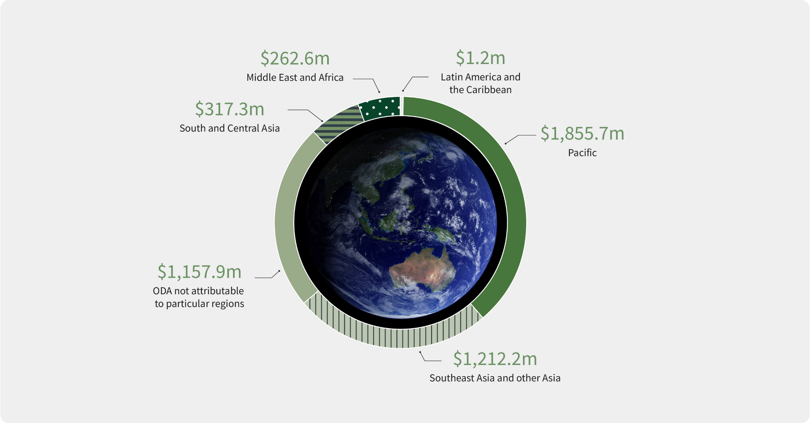

Reporting Against International Guidelines
Figure 2. Australian Official Development Assistance 2030 Agenda: Sustainable Development Goals, Primary Intent, 2023–24^{(a)}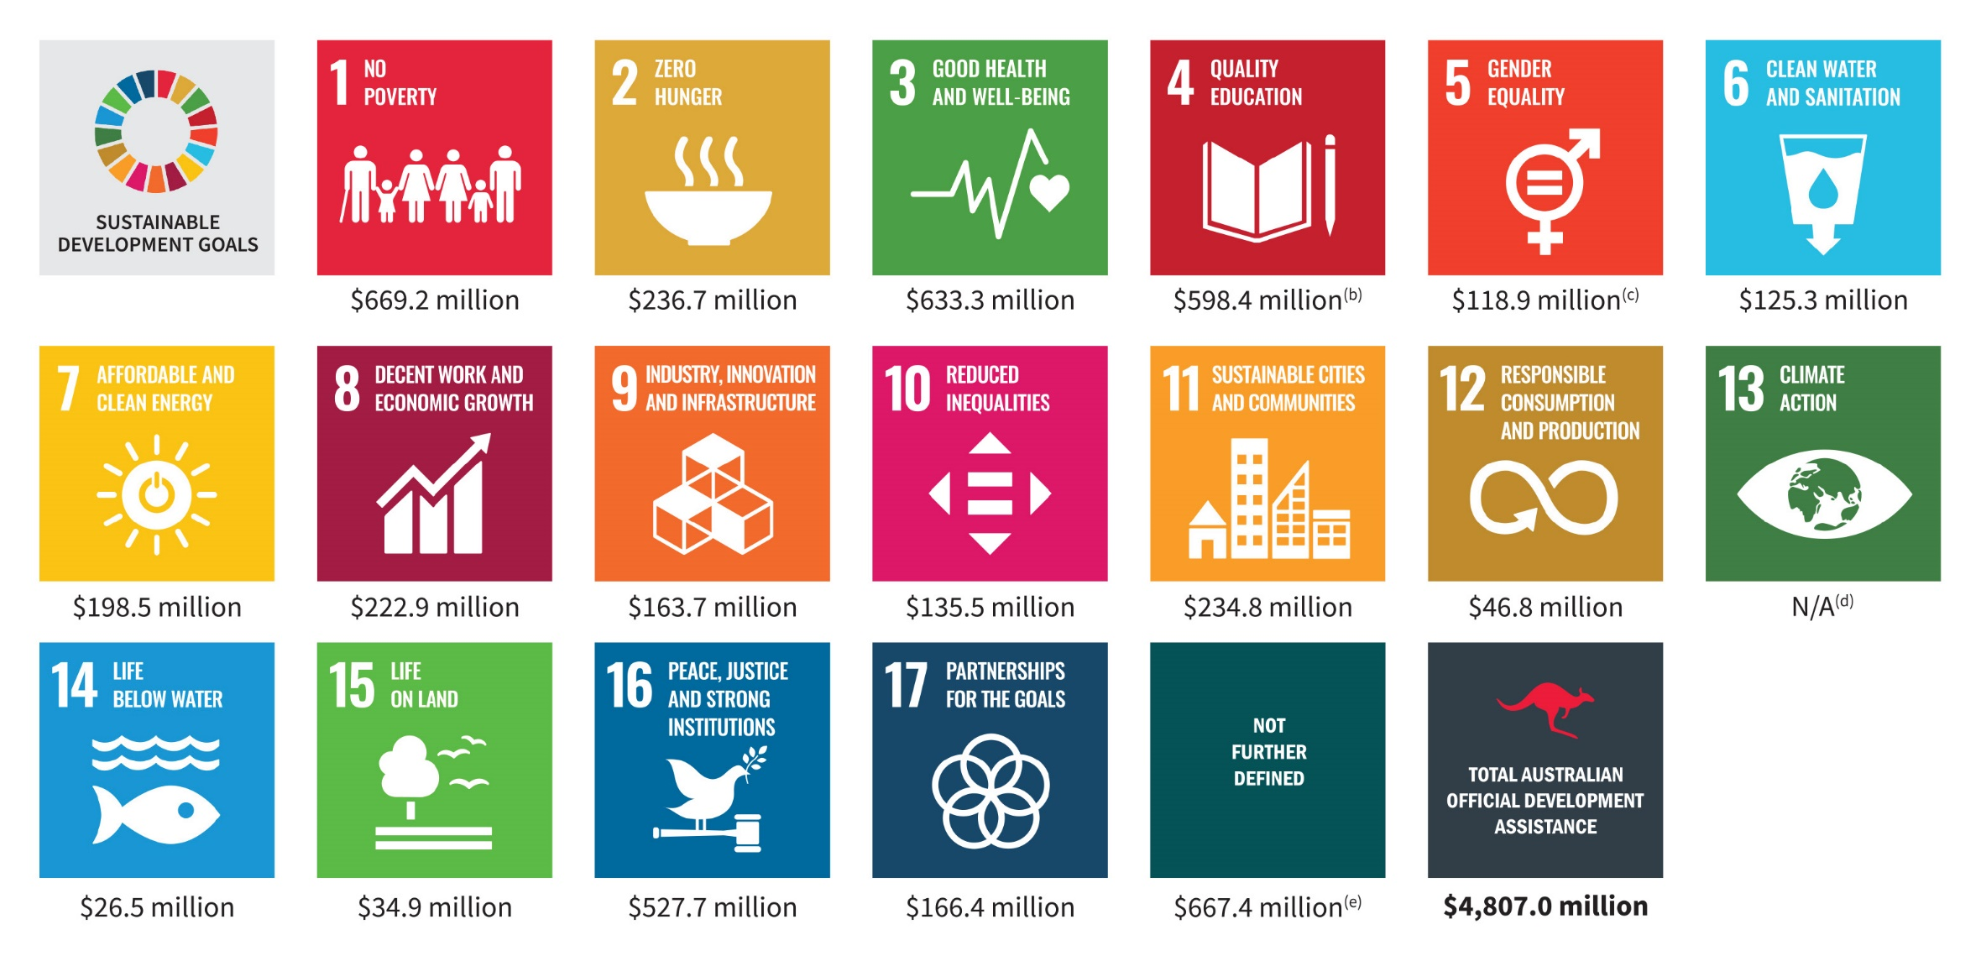

“-” denotes nil or rounded to zero (including null cells).
Due to rounding, discrepancies may occur between sums of the component items and totals.
- The Sustainable Development Goals (SDGs) are a United Nations initiative, officially known as Transforming our world: the 2030 Agenda for Sustainable Development (https://www.un.org/sustainabledevelopment/sustainable-development-goals/). For further information about the Sustainable Development Goals refer to paragraphs 52 to 54 of Appendix 2: Concepts and Definitions.
- Includes scholarships.
- Data presented for SDG5 reflects only those aid investments with a primary goal of Support for Women’s Equality Organisations and Institutions (DAC purpose code 15170) or Ending Violence Against Women and Girls (DAC purpose code 15180), and is not reflective of Australia’s total ODA contribution to gender equality which cuts across all SDGs. See Table 11 for Australia’s expenditure contributing to gender equality. As per Table 11, Australia’s total gender equality assistance for 2023–24 is $2,313 million.
- Not reported as there is no dedicated DAC sector code for climate change. Instead, the OECD DAC uses Rio Markers to promote mainstreaming of climate considerations in all sectors. In line with this, climate change is integrated across the breadth of Australia’s development assistance. A more comprehensive picture of Australia’s climate change assistance is presented in Table 10 based on Rio Marker reporting methods. As per Table 10, Australia’s total climate change assistance for 2023–24 is $783 million.
- Includes regional and global programs (including payments to multilateral organisations), departmental and other administrative expenses that cannot be attributed to a Sustainable Development Goal.

1 Australian Official Development Assistance, 2030 Agenda: Sustainable Development Goals, Primary Intent, 2023–24^{(a)}
Sustainable Development Goal | 2022-23  $’000 | 2023-24  $’000
1 No poverty | 760,956 | 669,207
2 Zero hunger | 226,799 | 236,731
3 Good health and well-being | 852,580 | 633,298
4 Quality education ^{(b)} | 567,822 | 598,378
5 Gender equality ^{(c)} | 107,685 | 118,912
6 Clean water and sanitation | 116,802 | 125,284
7 Affordable and clean energy | 155,548 | 198,482
8 Decent work and economic growth | 210,640 | 222,929
9 Industry, innovation and infrastructure | 174,891 | 163,676
10 Reduce inequalities | 140,266 | 135,534
11 Sustainable cities and communities | 236,182 | 234,847
12 Responsible consumption and production | 84,616 | 46,842
13 Climate action ^{(d)} | n.a. | n.a.
14 Life below water | 33,899 | 26,519
15 Life on land | 41,847 | 34,861
16 Peace, justice and strong institutions | 401,934 | 527,697
17 Partnerships for the goals | 156,799 | 166,352
Not further defined ^{(e)} | 509,764 | 667,425
Total Australian Official Development Assistance | 4,779,031 | 4,806,975

“-” denotes nil or rounded to zero (including null cells).
Due to rounding, discrepancies may occur between sums of the component items and totals.
- Sustainable Development Goals (SDGs) can cut across multiple goals and are not mutually exclusive. Data presented in this table reflects the aid investments’ primary goal intent and is not reflective of Australia’s total ODA contribution to sustainable development. For further information about the Sustainable Development Goals refer to paragraphs 52 to 54 of Appendix 2: Concepts and Definitions.
- Includes scholarships.
- Data presented for SDG5 reflects only those aid investments with a primary goal of Support for Women’s Equality Organisations and Institutions (DAC purpose code 15170) or Ending Violence Against Women and Girls (DAC purpose code 15180), and is not reflective of Australia’s total ODA contribution to gender equality which cuts across all SDGs. As per Table 11, Australia’s total gender equality assistance for 2023-24 is $2,313 million.
- Not reported as there is no dedicated DAC sector code for climate change. Instead, the OECD DAC uses Rio Markers to promote mainstreaming of climate considerations in all sectors. In line with this, climate change is integrated across the breadth of Australia’s development assistance. A more comprehensive picture of Australia’s climate change assistance is presented in Table 11 based on Rio Marker reporting methods. As per Table 10, Australia’s total climate change assistance for 2023-24 is $783 million.
- Includes regional and global programs (including payments to multilateral organisations), departmental and other administrative expenses that cannot be attributed to a Sustainable Development Goal.

2 Australian Development Assistance by Development Assistance Committee Sector, 2023–24^{(a)}
DAC sector | 2022–23  $’000 | 2023–24  $’000
Social infrastructure and services, Education - Primary and early childhood | 102,759 | 84,400
Social infrastructure and services, Education - Secondary education | 35,961 | 33,248
Social infrastructure and services, Education - Post-secondary education | 66,547 | 39,515
Social infrastructure and services, Education - Education policy administration, training and research | 131,471 | 129,111
Social infrastructure and services, Education - Scholarships | 231,084 | 312,103
Total education | 567,822 | 598,378
Social infrastructure and services, Health - Leadership and capacity building health service delivery | 237,172 | 212,284
Social infrastructure and services, Health - Disease control and preventable impairments | 542,184 | 309,845
Total health | 779,357 | 522,128
Social infrastructure and services, Family planning and reproductive health ^{(b)} | 73,493 | 111,682
Social infrastructure and services, Improving water supply and sanitation | 116,802 | 125,284
Social infrastructure and services, Government and civil society - Conflict prevention and resolution, peace and security | 68,865 | 94,778
Social infrastructure and services, Government and civil society - Government and civil society general | 628,620 | 701,659
Total government and civil society | 697,485 | 796,437
Other social infrastructure and services | 214,831 | 176,068
Total social infrastructure and services | 2,449,789 | 2,329,976
Economic infrastructure and services - Transport and storage | 278,977 | 237,608
Economic infrastructure and services - Communications | 30,176 | 37,950
Economic infrastructure and services - Energy generation and supply | 155,548 | 198,482
Economic infrastructure and services - Banking and financial services | 44,007 | 70,884
Economic infrastructure and services - Business and other services | 45,615 | 39,512
Total economic infrastructure and services | 554,323 | 584,436
Production sectors - Agriculture | 208,099 | 229,914
Production sectors - Forestry | 15,661 | 4,994
Production sectors - Fishing | 33,899 | 26,519
Total agriculture, forestry and fishing | 257,659 | 261,427
Production sectors - Industry | 24,819 | 25,832
Production sectors - Mineral resources and mining | 2,436 | 1,957
Production sectors - Construction | 702 | 13,179
Total industry, mining and construction | 27,956 | 40,967
Production sectors - Trade | 47,246 | 59,565
Production sectors - Tourism | 8,841 | 9,535
Total trade and tourism | 56,088 | 69,101
Total production sectors | 341,702 | 371,495
Multisector - General environment protection | 114,316 | 83,142
Multisector - General budget support | 121,626 | 136,223
Multisector - Other multisector | 309,625 | 457,004
Total multisector | 545,566 | 676,368
Commodity aid and general program assistance - Development food aid and food security assistance | 8,649 | 1,268
Commodity aid and general program assistance - Other general program and commodity assistance | - | -
Total commodity aid and general program assistance | 8,649 | 1,268
Humanitarian assistance - Emergency response | 508,369 | 480,741
Humanitarian assistance - Reconstruction relief and rehabilitation | 27,375 | 8,415
Humanitarian assistance - Disaster prevention and preparedness | 27,764 | 21,401
Total humanitarian assistance | 563,508 | 510,557
Action relating to debt | 286 | 285
Administrative costs of donors | 312,804 | 325,869
Refugees in donor countries | - | 28
Promotion of development awareness | 2,404 | 6,692
Total Australian Official Development Assistance | 4,779,031 | 4,806,975
“-” denotes nil or rounded to zero (including null cells).
Due to rounding, discrepancies may occur between sums of the component items and totals.
- Presents Australia’s expenditure on the basis of purpose codes which list codes, names and descriptions used to identify the sector of destination of a contribution. This purpose code classification is maintained by the OECD and used by donors to report on their aid flows to the Development Assistance Committee (DAC) databases. Further information on OECD DAC sectors area available from http://www.oecd.org/dac/financing-sustainable-development/development-finance-standards/dacandcrscodelists.htm
- Includes social mitigation of HIV/AIDS.

Overview Tables

3 Australian Official Development Assistance by Sector Group, 2023-24^{(a)}
Sectors | 2022–23  $’000 | 2023–24  $’000
Economic Infrastructure and services - Banking and financial services | 44,007 | 70,884
Economic Infrastructure and services - Energy | 155,548 | 198,482
Economic Infrastructure and services - Large water infrastructure | 35,980 | 40,362
Economic Infrastructure and services - Transport and storage ^{(b)} | 278,977 | 237,608
Economic Infrastructure and services - Communications | 30,176 | 37,950
Economic Infrastructure and services - Other economic infrastructure and services ^{(c)} | 70,362 | 72,201
Total economic infrastructure and services | 615,050 | 657,486
Agriculture, trade and other production services - Agriculture, fisheries and forestry | 257,659 | 261,427
Agriculture, trade and other production services - Trade policy | 47,246 | 59,565
Agriculture, trade and other production services - Industry | 24,819 | 25,832
Agriculture, trade and other production services - Mining and mineral resources | 2,436 | 1,957
Agriculture, trade and other production services - Other agriculture, trade and other production sectors | 45,116 | 48,811
Total agriculture, trade and other production services | 377,276 | 397,592
Governance - Governance, general | 765,818 | 855,039
Governance - Other social infrastructure and services | 231,032 | 180,384
Total governance | 996,850 | 1,035,424
Education - Scholarships | 150,733 | 231,084
Education - Education, general | 328,020 | 336,738
Total education | 478,754 | 567,822
Health - Health, general | 855,349 | 636,310
Health - Basic water and sanitation | 52,675 | 53,607
Total health | 908,024 | 689,917
Humanitarian - Emergency response | 498,317 | 475,192
Humanitarian - Disaster prevention and preparedness | 101,773 | 110,852
Humanitarian - Other humanitarian | 82,039 | 86,216
Total humanitarian | 682,128 | 672,260
Multisector and general support - General environment protection | 114,316 | 83,142
Multisector and general support - Action relating to debt | 286 | 285
Multisector and general support - Other multisector ^{(d)} | 517,279 | 672,492
Total multisector and general support | 631,881 | 755,919
Total Australian Official Development Assistance | 4,779,031 | 4,806,975
“-” denotes nil or rounded to zero (including null cells).
Due to rounding, discrepancies may occur between sums of the component items and totals.
- Sector group based on broad level OECD DAC Sectors. See Appendix 2, paragraph 50 for further information.
- Includes transport policy, planning and management, systems and all transport infrastructure.
- Includes business support, urban development support and industry support.
- Includes administrative costs, research and scientific institutions and other multisector not further defined.

Figure 3. Australian Official Development Assistance by Sector Group, 2023–24
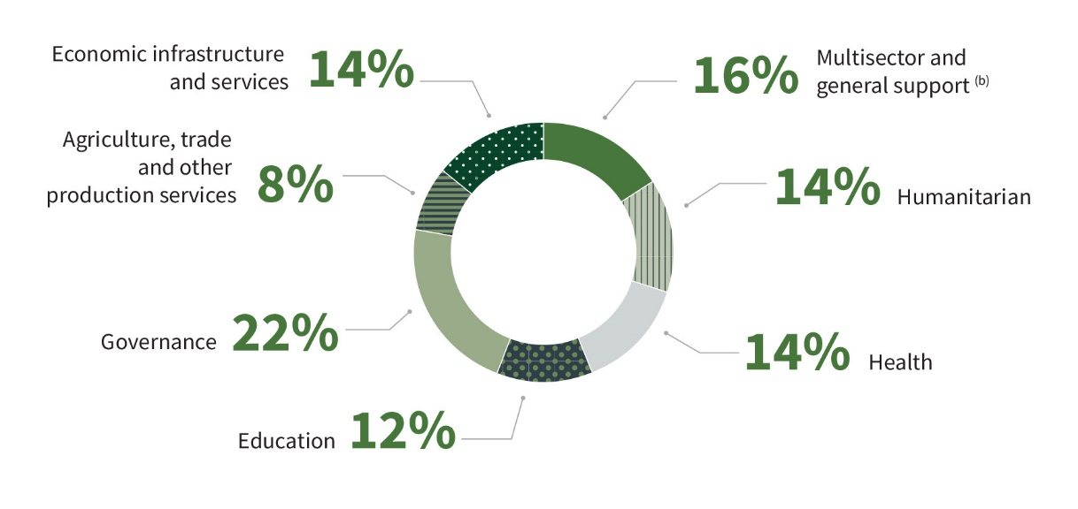

Figure 4. Australian Official Development Assistance by Sector Group, 2022–23 to 2023–24^{(a)}
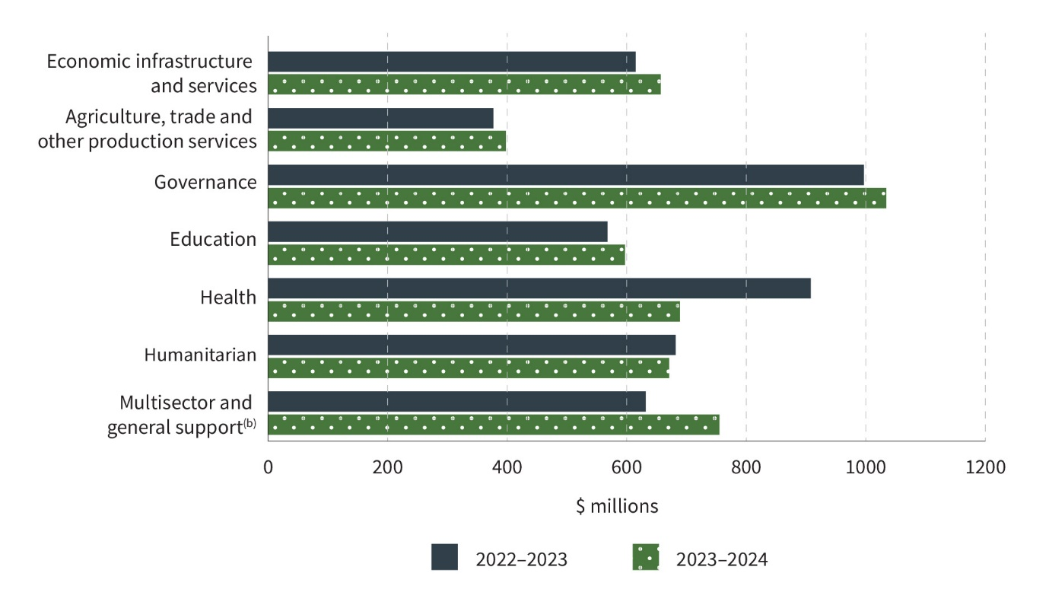
“ -” denotes nil or rounded to zero (including null cells).
Due to rounding, discrepancies may occur between sums of the component items and totals.
- Sector Group based on broad level OECD DAC sectors. See Appendix 2, paragraph 50 for further information.
- Includes administrative costs, research and scientific institutions and other multisector not further defined.

4 Australian Official Development Assistance, Sector Group by Type of Partner, 2023–24^{(a)}
Sectors | Multilateral Organisation  $’000 | Commercial Supplier  $’000 | Non-Government Organisations  $’000 | Universities and Academic Institutions  $’000 | Developing Country Governments  $’000 | Australian Public Sector Organisations  $’000 | Other Partners  $’000 | Total  $’000
Economic Infrastructure and Services | 254,259 | 274,738 | 15,665 | 1,987 | 86,151 | 18,255 | 6,431 | 657,486
Agriculture, Trade and other Production Sectors | 140,372 | 106,780 | 36,066 | 3,010 | 1,691 | 18,689 | 90,984 | 397,592
Governance | 246,952 | 353,255 | 133,878 | 11,202 | 154,018 | 118,496 | 17,624 | 1,035,424
Education | 106,391 | 178,622 | 42,028 | 229,265 | 23,382 | 5,130 | 13,559 | 598,378
Health | 333,331 | 149,379 | 93,001 | 32,934 | 34,187 | 14,598 | 32,488 | 689,917
Humanitarian | 444,729 | 57,156 | 153,228 | 1,151 | 6,049 | 6,155 | 3,793 | 672,260
Multisector and General Development Support ^{(b)} | 307,011 | 86,341 | 33,288 | 6,493 | 10,000 | 269,963 | 42,823 | 755,919
Total Australian Official Development Assistance | 1,833,043 | 1,206,271 | 507,153 | 286,042 | 315,477 | 451,286 | 207,703 | 4,806,975
“-” denotes nil or rounded to zero (including null cells).
Due to rounding, discrepancies may occur between sums of the component items and totals.
- Sector Group based on broad level OECD DAC sectors. See Appendix 2, paragraph 50 for further information.
- Includes administrative costs, research and scientific institutions and other multisector not further defined.

Figure 5. Australian Official Development Assistance by Type of Partner, 2023–24
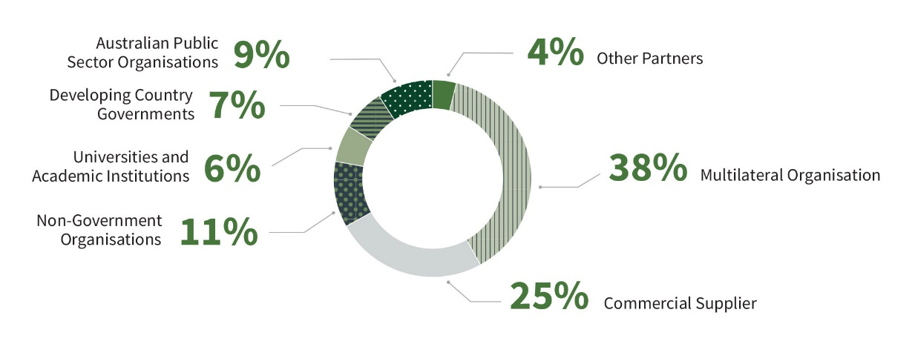
Figure 6. Australian Official Development Assistance by Type of Partner, 2012–13 to 2023–24
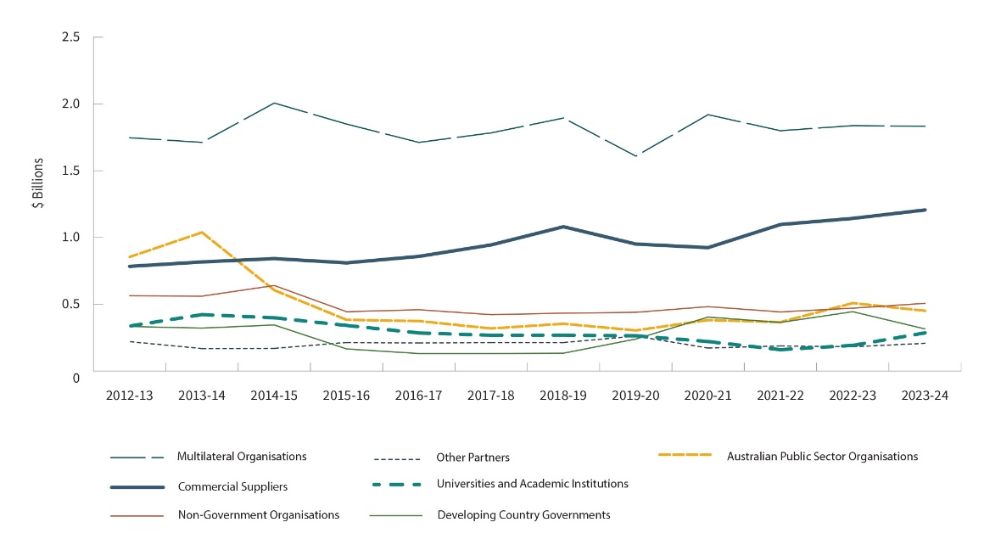

5 Australian Official Development Assistance, Region of Benefit by Sector Group^{(a)}
Region of benefit | 2022–23  $’000 | 2023–24  $’000
Pacific - Economic Infrastructure and Services | 315,689 | 325,076
Pacific - Agriculture, Trade and other Production Sectors | 103,043 | 94,969
Pacific - Governance | 515,461 | 567,624
Pacific - Education | 280,786 | 249,389
Pacific - Health | 291,501 | 220,273
Pacific - Humanitarian | 80,693 | 78,023
Pacific - Multisector and General Development Support ^{(b)} | 252,304 | 320,384
Total Pacific | 1,839,476 | 1,855,737
Southeast Asia ^{(c)} - Economic Infrastructure and Services | 155,599 | 175,043
Southeast Asia ^{(c)} - Agriculture, Trade and other Production Sectors | 110,792 | 118,025
Southeast Asia ^{(c)} - Governance | 315,457 | 276,961
Southeast Asia ^{(c)} - Education | 192,369 | 223,583
Southeast Asia ^{(c)} - Health | 140,462 | 97,745
Southeast Asia ^{(c)} - Humanitarian | 102,470 | 94,768
Southeast Asia ^{(c)} - Multisector and General Development Support ^{(b)} | 129,920 | 163,113
Total Southeast Asia | 1,147,070 | 1,149,237
South and Central Asia - Economic Infrastructure and Services | 18,383 | 7,638
South and Central Asia - Agriculture, Trade and other Production Sectors | 11,618 | 25,113
South and Central Asia - Governance | 31,910 | 39,314
South and Central Asia - Education | 48,260 | 61,440
South and Central Asia - Health | 18,716 | 22,758
South and Central Asia - Humanitarian | 162,047 | 132,469
South and Central Asia - Multisector and General Development Support (b) | 25,043 | 28,612
Total South and Central Asia | 315,978 | 317,345
Other Asia ^{(d)} - Economic Infrastructure and Services | 18,407 | 11,543
Other Asia ^{(d)} - Agriculture, Trade and other Production Sectors | 10,348 | 16,582
Other Asia ^{(d)} - Governance | 6,259 | 4,885
Other Asia ^{(d)} - Education | 80 | 581
Other Asia ^{(d)} - Health | 9,813 | 15,809
Other Asia ^{(d)} - Humanitarian | 3,776 | 3,626
Other Asia ^{(d)} - Multisector and General Development Support (b) | 6,320 | 9,941
Total Other Asia | 55,005 | 62,968
Sub-Saharan Africa ^{(d)} - Economic Infrastructure and Services | 1,668 | 937
Sub-Saharan Africa ^{(d)} - Agriculture, Trade and other Production Sectors | 20,937 | 15,297
Sub-Saharan Africa ^{(d)} - Governance | 11,761 | 8,605
Sub-Saharan Africa ^{(d)} - Education | 7,791 | 13,937
Sub-Saharan Africa ^{(d)} - Health | 15,051 | 13,611
Sub-Saharan Africa ^{(d)} - Humanitarian | 80,365 | 71,243
Sub-Saharan Africa ^{(d)} - Multisector and General Development Support ^{(b)} | 10,618 | 14,195
Total Sub-Saharan Africa | 148,191 | 137,826
Middle East and North Africa - Economic Infrastructure and Services | 157 | 1,040
Middle East and North Africa - Agriculture, Trade and other Production Sectors | 869 | 2,679
Middle East and North Africa - Governance | 877 | 6,512
Middle East and North Africa - Education | 1,457 | 2,928
Middle East and North Africa - Health | 3,862 | 3,490
Middle East and North Africa - Humanitarian | 75,995 | 99,358
Middle East and North Africa - Multisector and General Development Support ^{(b)} | 6,106 | 8,790
Total Middle East and North Africa | 89,324 | 124,796
Latin America and the Caribbean - Economic Infrastructure and Services | 93 | 2
Latin America and the Caribbean - Agriculture, Trade and other Production Sectors | 323 | 409
Latin America and the Caribbean - Governance | 718 | 877
Latin America and the Caribbean - Education | 1,505 | 1,457
Latin America and the Caribbean - Health | 2,662 | 3,862
Latin America and the Caribbean - Humanitarian | 69,066 | 75,995
Latin America and the Caribbean - Multisector and General Development Support ^{(b)} | 5,731 | 6,106
Total Middle East and North Africa | 80,930 | 89,324
Latin America and the Caribbean - Economic Infrastructure and Services | 2 | 36
Latin America and the Caribbean - Agriculture, Trade and other Production Sectors | 409 | 146
Latin America and the Caribbean - Governance | 207 | 233
Latin America and the Caribbean - Education | 497 | 400
Latin America and the Caribbean - Health | 245 | 145
Latin America and the Caribbean - Humanitarian | 2 | 28
Latin America and the Caribbean - Multisector and General Development Support ^{(b)} | 103 | 209
Total Latin American and the Caribbean | 1,465 | 1,197
Other ^{(e)} - Economic Infrastructure and Services | 105,142 | 136,172
Other ^{(e)} - Agriculture, Trade and other Production Sectors | 119,261 | 124,781
Other ^{(e)} - Governance | 114,917 | 131,290
Other ^{(e)} - Education | 36,581 | 46,119
Other ^{(e)} - Health | 428,374 | 316,086
Other ^{(e)} - Humanitarian | 176,780 | 192,745
Other ^{(e)} - Multisector and General Development Support ^{(b)} | 201,467 | 210,676
Total Other | 1,182,522 | 1,157,868
Total Australian Official Development Assistance | 4,779,031 | 4,806,975
“-” denotes nil or rounded to zero (including null cells).
Due to rounding, discrepancies may occur between sums of the component items and totals.
- Sector Group based on broad level OECD DAC sectors. See Appendix 2, paragraph 52 for further information.
- Includes administrative costs, research and scientific institutions and other multisector not further defined.
- Includes Timor-Leste.
- Includes regional programs that cannot be disaggregated to a lower geographic level.
- Includes global programs that cannot be disaggregated to a lower geographic level.

Figure 7. Pacific
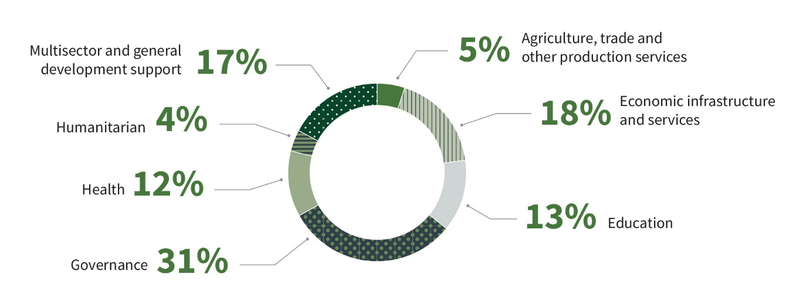
Figure 8. Southeast Asia
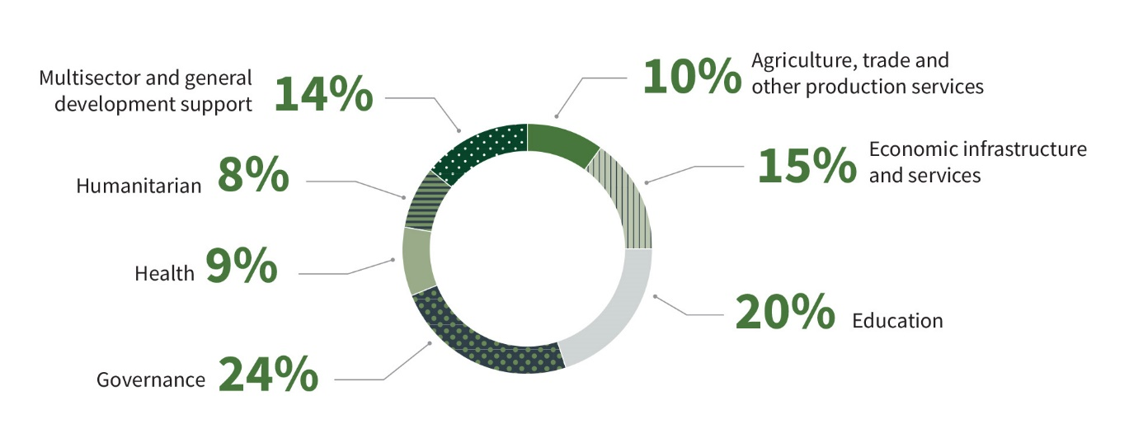
Figure 9. South and Central Asia
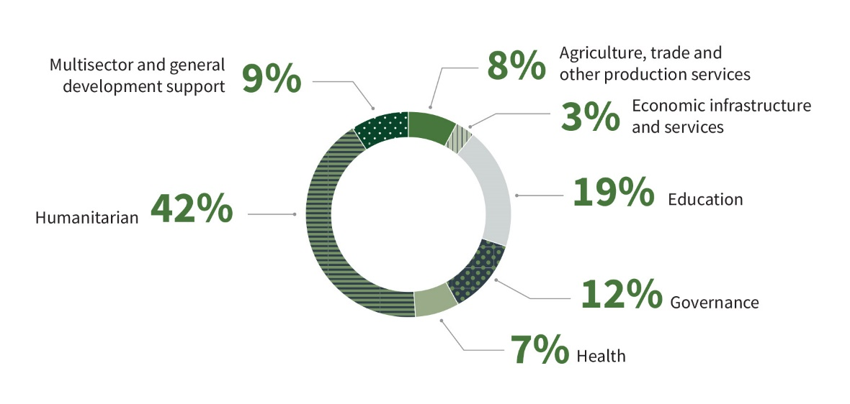

Figure 10. Sub-Saharan Africa
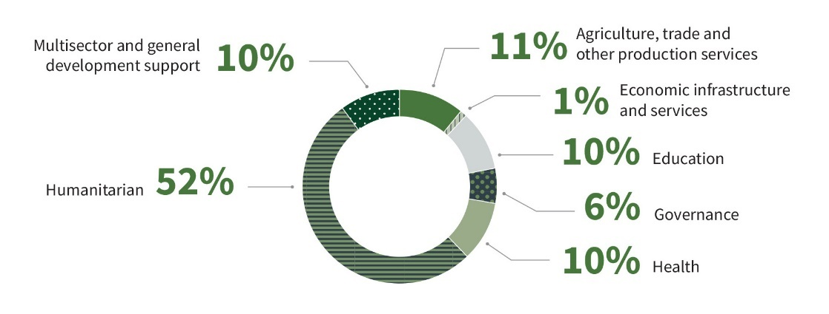
Figure 11. Middle East and North Africa
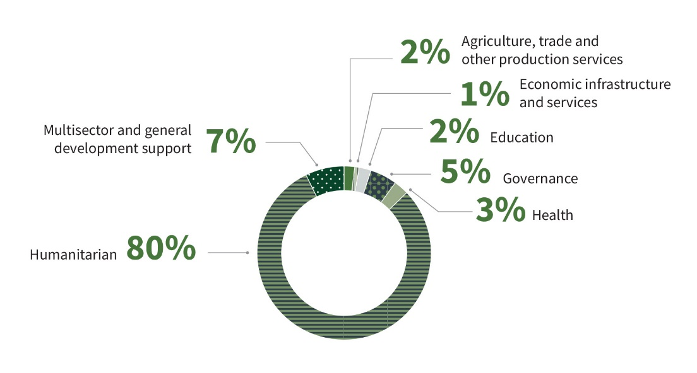

6 Australian Official Development Assistance, Partner Country by Sector Group, 2023–24^{(a)}
Partner Country | Economic Infrastructure and Services  $’000 | Agriculture, Trade and other Production Sectors  $’000 | Governance  $’000 | Education  $’000 | Health  $’000 | Humanitarian  $’000 | Multisector and General Development Support  $’000 | Total  $’000
Pacific - Federated States of Micronesia | 3,022 | 106 | 406 | 1,584 | 413 | - | 508 | 6,038
Pacific - Fiji | 6,494 | 8,333 | 78,225 | 28,720 | 32,715 | 7,360 | 9,322 | 171,170
Pacific - Kiribati | 8,980 | 1,551 | 12,077 | 11,319 | 3,748 | 3,165 | 546 | 41,385
Pacific - Nauru | 4,949 | 262 | 9,041 | 6,484 | 7,346 | 74 | 8,760 | 36,917
Pacific - Niue and Tokelau | 1,746 | 24 | 2,143 | 177 | 403 | 6 | 400 | 4,899
Pacific - Palau | 291 | 4 | 1,395 | 370 | 1,196 | 234 | 53 | 3,543
Pacific - Papua New Guinea | 116,826 | 19,486 | 174,133 | 64,898 | 86,087 | 20,325 | 97,953 | 579,708
Pacific - Republic of the Marshall Islands | 53 | 33 | 1,615 | 974 | 569 | 143 | 17 | 3,404
Pacific - Samoa | 4,966 | 3,540 | 47,143 | 14,493 | 5,490 | - | 2,026 | 77,658
Pacific - Solomon Islands | 33,771 | 13,966 | 61,164 | 21,256 | 12,968 | 5,273 | 11,471 | 159,869
Pacific - Tonga | 61,484 | 1,768 | 31,396 | 6,687 | 9,648 | 1,532 | 267 | 112,782
Pacific - Tuvalu | 31,452 | 434 | 12,536 | 4,488 | 2,437 | 8,824 | 115 | 60,285
Pacific - Vanuatu | 9,657 | 4,889 | 23,214 | 27,219 | 14,148 | 5,328 | 3,676 | 88,131
Pacific - Regional Pacific Island countries^{(c)} | 41,384 | 40,574 | 113,136 | 60,720 | 43,108 | 25,759 | 185,269 | 509,949
Total Pacific | 325,076 | 94,969 | 567,624 | 249,389 | 220,273 | 78,023 | 320,384 | 1,855,737
Southeast Asia - Cambodia | 9,941 | 18,170 | 18,117 | 19,128 | 12,032 | 359 | 4,459 | 82,206
Southeast Asia - Indonesia | 70,955 | 43,781 | 113,998 | 64,469 | 15,326 | 9,003 | 11,522 | 329,055
Southeast Asia - Laos | 6,916 | 8,547 | 7,581 | 24,904 | 10,143 | 63 | 2,779 | 60,934
Southeast Asia - Myanmar | 358 | 2,541 | 13,397 | 19,591 | 10,160 | 60,196 | 4,152 | 110,395
Southeast Asia - Philippines | 2,694 | 5,142 | 20,489 | 25,083 | 4,133 | 19,293 | 11,538 | 88,373
Southeast Asia - Timor-Leste | 6,751 | 13,608 | 51,208 | 17,439 | 24,020 | 4,681 | 4,280 | 121,988
Southeast Asia - Vietnam | 22,246 | 13,717 | 18,736 | 20,400 | 4,099 | 160 | 17,272 | 96,631
Southeast Asia - Regional Southeast Asia ^{(c)} | 55,182 | 12,518 | 33,436 | 32,567 | 17,832 | 1,012 | 107,109 | 259,656
Total Southeast Asia | 175,043 | 118,025 | 276,961 | 223,583 | 97,745 | 94,768 | 163,113 | 1,149,237
South and Central Asia - Afghanistan | - | - | 837 | - | 1,863 | 68,140 | - | 70,840
South and Central Asia - Bangladesh | 771 | 5,058 | 18,185 | 20,734 | 2,127 | 59,784 | 4,466 | 111,125
South and Central Asia - Bhutan | 5,037 | - | 231 | 3,579 | 1,195 | - | - | 10,041
South and Central Asia - Maldives | - | - | 890 | 3,092 | - | - | 12 | 3,994
South and Central Asia - Mongolia | - | 616 | 1,361 | 8,900 | 368 | 1,057 | 608 | 12,911
South and Central Asia - Nepal | 695 | 7,587 | 8,420 | 6,957 | 9,234 | 1,717 | 949 | 35,559
South and Central Asia - Pakistan | 51 | 3,150 | 433 | 3,900 | 3,290 | 4 | 235 | 11,063
South and Central Asia - Sri Lanka | 970 | 5,752 | 5,539 | 10,659 | 315 | 1,286 | 208 | 24,729
South and Central Asia – Regional South and Central Asia ^{(b)} | 114 | 2,949 | 3,419 | 3,618 | 4,366 | 481 | 22,134 | 37,082
Total South and Central Asia | 18,383 | 11,618 | 31,910 | 48,260 | 18,716 | 162,047 | 25,043 | 317,345
Other Asian Countries^{(b)} | 11,543 | 16,582 | 4,885 | 581 | 15,809 | 3,626 | 9,941 | 62,968
Sub-Saharan Africa | 937 | 15,297 | 8,605 | 13,937 | 13,611 | 71,243 | 14,195 | 137,826
Middle East and North Africa^{(c)} | 1,040 | 2,679 | 6,512 | 2,928 | 3,490 | 99,358 | 8,790 | 124,796
Latin America and the Caribbean | 36 | 146 | 233 | 400 | 145 | 28 | 209 | 1,197
Other^{(d)} | 136,172 | 124,781 | 131,290 | 46,119 | 316,086 | 192,745 | 210,676 | 1,157,868
Total Official Development Assistance | 657,486 | 397,592 | 1,035,424 | 598,378 | 689,917 | 672,260 | 755,919 | 4,806,975
“-” denotes nil or rounded to zero (including null cells).
Due to rounding, discrepancies may occur between sums of the component items and totals.
- Sector Group based on broad level OECD DAC sectors. See Appendix 2, paragraph 50 for further information.
- Includes regional programs that cannot be disaggregated to the lower geographic level.
- Includes the Occupied Palestinian Territories, Iraq, Syria and other flows to the region.
- Includes global programs that cannot be disaggregated to a lower geographic level.

7 Australian Official Development Assistance, Government Departments and Agencies, 2023–24^{(a) (b)}
Government Departments and Agencies | 2022–23  $’000 | 2023–24  $’000
Agriculture, Fisheries and Forestry | 15,939 | 17,632
Attorney-General's - Attorney-General's | 2,095 | 3,262
Attorney-General's - Australian Federal Police | 54,039 | 46,190
Attorney-General's - Commonwealth Director of Public Prosecutions | - | 16
Climate Change, Energy, the Environment and Water - Climate Change, Energy, the Environment and Water | 1,961 | 3,277
Climate Change, Energy, the Environment and Water - Great Barrier Reef Marine Park Authority | - | 111
Defence | 279 | 398
Education | 30 | 30
Employment and Workplace Relations | 33,760 | 7,796
Finance | - | -
Foreign Affairs and Trade - Foreign Affairs and Trade | 4,389,679 | 4,522,085
Foreign Affairs and Trade - Australian Centre for International Agricultural Research | 102,002 | 112,793
Foreign Affairs and Trade - Export Finance Australia | 16,732 | 2,732
Health | 89,662 | 15,020
Home Affairs | 2,395 | 4,631
Infrastructure, Transport, Regional Development, Communications and the Arts | 200 | 4,451
Treasury | 65,484 | 66,393
State and Territory Governments | 4,775 | 158
Total Official Development Assistance | 4,779,031 | 4,806,975
“-” denotes nil or rounded to zero (including null cells).
Due to rounding, discrepancies may occur between sums of the component items and totals.
- Figures are grouped at the portfolio level and will include relevant Commonwealth entities and companies within the portfolio unless a separate breakdown is provided.
- Further information on donated vaccines is available at https://indopacifichealthsecurity.dfat.gov.au/covid-19-vaccine-access. These donated vaccines are not included in ODA figures.

8 Australian Official Development Assistance, Loan Disbursements, 2023–24^{(a) (b)}
Australia Infrastructure Financing Facility for the Pacific
Sector/Program | Country | Grant equivalent  of loan  disbursements  $’000
Sasape Shipyard Redevelopment - AIFFP Loan to Sasape International Shipyard Limited | Solomon Islands | 79
Connect Papua New Guinea - Roads Repair - AIFFP loan to Papua New Guinea | Papua New Guinea | 2,653
Total ODA loan disbursement |  | 2,732
“-” denotes nil or rounded to zero (including null cells).
Due to rounding, discrepancies may occur between sums of the component items and totals.
- For further information about ODA grant equivalent equivalent of loans refer to Appendix 2: Concepts and Definitions, paragraph 25.
- Further detailed information is available on the Australian Infrastructure Financing Facility for the Pacific at: https://www.aiffp.gov.au

9 Australian Official Development Assistance, International Development Policy^{(a) (b)}
Pillars | 2023–24  $’000
Building effective and accountable states | 1,109,706
Enhancing state and community resilience | 1,926,499
Connecting partners with Australian and regional architecture | 589,098
Generating collective action on global challenges | 520,365
Not further defined^{(C)} | 661,307
Total Australian Official Development Assistance | 4,806,975
Figure 12. Australian Official Development Assistance, International Development Policy, 2023–24
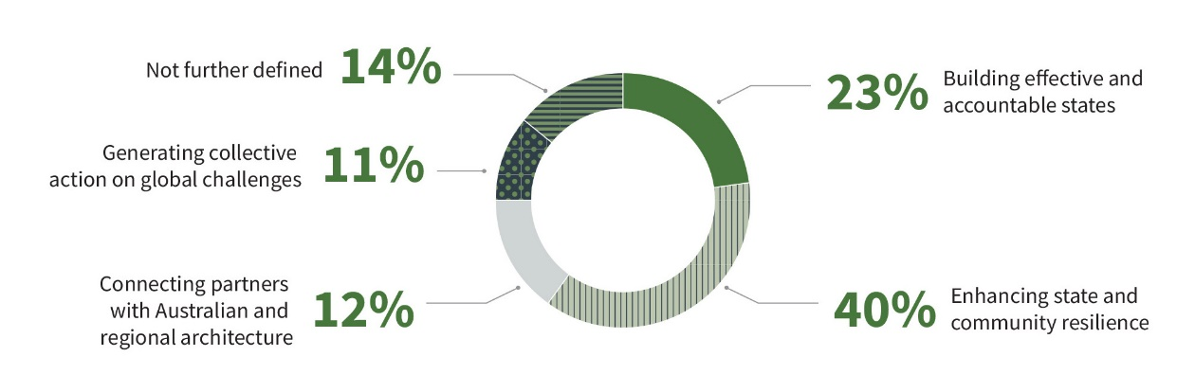
“-” denotes nil or rounded to zero (including null cells).
Due to rounding, discrepancies may occur between sums of the component items and totals.
- For further information about the International Development Policy Pillars, refer to Appendix 2: Concepts and Definitions, paragraph 26.
- The International Development Policy is available on the Department of Foreign Affairs and Trade’s website at https://www.dfat.gov.au/publications/development/australias-international-development-policy
- Includes multisector aid, other programs, departmental and other administrative expenses that cannot be attributed to an International Development Policy pillar

Type of Assistance by Region and Benefit Tables

10 Australian Official Development Assistance, Climate Finance, Type of Assistance by Region of Benefit, 2023–24^{(a) (b) (c)}
Type of assistance | Pacific  $’000 | Southeast Asia  $’000 | South and Central Asia  $’000 | Other Asia ^{(d)}  $’000 | Sub-Saharan Africa ^{(d)}  $’000 | Middle East and North Africa  $’000 | Latin America and the Caribbean  $’000 | Other ^{(e) (f)}  $’000 | Total  $’000
Environmental protection - Environmental policy and administrative management | 8,436 | 4,214 | 857 | - | 1,196 | - | 9 | 30,459 | 45,171
Environmental protection - Environmental research | 3 | 190 | 2 | - | 25 | - | - | 4 | 225
Environmental protection - Bio-diversity ^{(g)} | 6,804 | 175 | 67 | 3,784 | 6 | - | - | 93 | 10,929
Environmental protection - Other environmental protection | 28 | - | - | - | - | - | - | 70 | 98
Total environmental protection | 15,271 | 4,579 | 926 | 3,784 | 1,227 | - | 9 | 30,626 | 56,423
Economic infrastructure and services - Transport and storage | 45,603 | 6,299 | - | - | 4 | - | - | 6,111 | 58,018
Economic infrastructure and services - Communications | 3,382 | 851 | 2 | - | - | - | 6 | 1,570 | 5,810
Economic infrastructure and services - Energy generation and supply | 47,460 | 35,542 | 2,522 | - | 10 | - | - | 7,508 | 93,042
Economic infrastructure and services - Business, banking and financial services | 6,140 | 9,409 | 922 | 3,214 | 199 | 147 | - | 6,974 | 27,006
Total economic infrastructure and services | 102,585 | 52,101 | 3,446 | 3,214 | 214 | 147 | 6 | 22,163 | 183,876
Production sectors - Agriculture | 18,715 | 21,535 | 8,662 | 271 | 5,032 | 166 | 18 | 23,148 | 77,548
Production sectors - Forestry and fishing | 6,498 | 2,375 | 2 | 286 | 220 | - | - | 1,100 | 10,481
Production sectors - Industry | 1,218 | 157 | 113 | 354 | 27 | 13 | 1 | 1,302 | 3,186
Production sectors - Mining & mineral resources | - | - | - | - | 25 | - | - | 161 | 186
Production sectors - Other production sectors | 11,000 | 3,057 | 251 | 200 | 11 | - | - | 1,680 | 16,200
Total production sectors | 37,431 | 27,125 | 9,027 | 1,111 | 5,316 | 179 | 19 | 27,391 | 107,600
Humanitarian assistance - Disaster prevention and preparedness | 31,539 | 4,093 | 1,092 | 422 | 1,707 | 265 | - | 14,339 | 53,457
Humanitarian assistance - Reconstruction relief and rehabilitation | 3,143 | 1,052 | - | - | 5 | - | - | 368 | 4,568
Humanitarian assistance - Other humanitarian assistance | 5,198 | 2,391 | 1,539 | - | 510 | - | - | 23,248 | 32,887
Total humanitarian assistance | 39,880 | 7,536 | 2,631 | 422 | 2,222 | 265 | - | 37,955 | 90,912
Education | 16,491 | 662 | 1,289 | - | 411 | 95 | 24 | 10,329 | 29,301
Water and Sanitation | 12,087 | 22,444 | 12,363 | 193 | 361 | 230 | 15 | 13,882 | 61,575
Other sectors ^{(h)} | 110,410 | 41,800 | 3,409 | 890 | 2,432 | 340 | 42 | 93,575 | 252,898
Total Australian Climate Finance ODA | 334,155 | 156,247 | 33,092 | 9,613 | 12,183 | 1,256 | 115 | 235,922 | 782,583
“-” denotes nil or rounded to zero (including null cells).
Due to rounding, discrepancies may occur between sums of the component items and totals.
- Type of assistance based on OECD DAC Sectors.
- For further details on Climate Finance methodology and compilation refer to Appendix 2: Concepts and Definitions - paragraphs 8 to 10.
- Figures in this table represent the climate-related component of the expenditure under each sector. Total Australian climate finance equals Official Development Assistance (ODA) climate finance grants and loans (this table) plus the climate finance portion of: non-ODA grants and loans, and amounts mobilised from the private sector by Australian Official Development Finance investments. For further detail on total climate finance support by Australia and tracking against the Australian Government’s $3 billion climate finance commitment over the period 2020-2025, refer to the DFAT website (https://www.dfat.gov.au/international-relations/themes/climate-change/supporting-indo-pacific-tackle-climate-change/delivering-our-climate-commitments).
- Includes regional programs that cannot be disaggregated to a lower geographic level.
- Includes the climate finance portion of core contributions to multilateral organisations, based on OECD DAC imputed shares (https://www.oecd.org/development/financing-sustainable-development/development-finance-topics/climate-change.htm); sectoral breakdown follows the OECD DAC’s reporting standard, which applies the same sectoral split as for the entire core contribution.
- Includes global programs that cannot be disaggregated to a lower geographic level.
- Biodiversity here reflects the climate finance portion of investments that have selected the OECD DAC Biodiversity Sector. This is not equal to the total value of Australia’s biodiversity-related expenditure.
- Includes government and civil society, health, public finance and other aspects of climate finance.

11 Australian Official Development Assistance, Gender Equality, Type of Assistance by Region of Benefit, 2023–24^{(a) (b)}
Type of assistance | Pacific  $’000 | Southeast Asia  $’000 | South and Central Asia  $’000 | Other Asia  $’000 | Sub-Saharan Africa ^{(c)}  $’000 | Middle East and North Africa  $’000 | Latin America and the Caribbean  $’000 | Other ^{(d)}  $’000 | Total  $’000
Social infrastructure and services - Education | 156,574 | 144,151 | 28,250 | 455 | 7,021 | 1,159 | 122 | 2,172 | 339,904
Social infrastructure and services - Health | 128,904 | 48,717 | 4,162 | 2,586 | 9,393 | 2,825 | - | 25,599 | 222,186
Social infrastructure and services - Family planning and reproductive health | 10,786 | 6,083 | 316 | - | 84 | 0 | - | 0 | 17,269
Social infrastructure and services - Water supply and sanitation | 18,024 | 38,968 | 13,383 | - | 2,063 | 1,950 | - | 9,957 | 84,345
Social infrastructure and services - Government and civil society | 232,225 | 176,093 | 21,816 | 4,634 | 5,148 | 4,300 | - | 22,563 | 466,780
Social infrastructure and services - Other social infrastructure and services | 52,226 | 26,413 | 10,992 | 68 | 1,102 | 20 | - | 1,599 | 92,420
Total social infrastructure and services | 598,740 | 440,424 | 78,919 | 7,743 | 24,813 | 10,254 | 122 | 61,890 | 1,222,905
Economic infrastructure and services - Transport and storage | 124,335 | 28,608 | - | - | - | - | - | 0 | 152,943
Economic infrastructure and services - Communications | 11,900 | 7,114 | - | - | - | - | - | 225 | 19,239
Economic infrastructure and services - Energy generation and supply | 36,926 | 53,424 | 5,037 | - | 22 | - | - | 0 | 95,409
Economic infrastructure and services - Banking and financial services | 2,240 | 10,464 | 1,071 | 2,710 | 699 | 495 | - | 2,000 | 19,679
Economic infrastructure and services - Business and other services | 5,786 | 18,459 | 1,309 | 5,200 | 85 | 6 | - | 0 | 30,845
Total economic infrastructure and services | 181,187 | 118,070 | 7,417 | 7,910 | 806 | 501 | 0 | 2,225 | 318,115
Production sectors - Agriculture, forestry and fishing | 20,687 | 32,655 | 9,311 | - | 7,059 | 541 | - | 149 | 70,402
Production sectors - Industry, mining and construction | 16,000 | 1,031 | 283 | 13,851 | 111 | 50 | 30 | 0 | 31,357
Production sectors - Trade and tourism | 4,492 | 20,290 | 1,001 | 700 | 3 | - | - | 280 | 26,767
Total production sectors | 41,180 | 53,976 | 10,596 | 14,551 | 7,172 | 591 | 30 | 429 | 128,526
Humanitarian assistance | 58,722 | 78,167 | 119,945 | 3,626 | 41,619 | 82,543 | - | 34,314 | 418,934
Other sectors ^{(e)} | 147,360 | 56,653 | 6,923 | 1,074 | 7,013 | 36 | - | 5,037 | 224,097
Total Australian Gender Equality ODA | 1,027,189 | 747,291 | 223,799 | 34,904 | 81,423 | 93,924 | 153 | 103,895 | 2,312,577
Principle Objective | 78,211 | 80,832 | 3,665 | 20,572 | 1,497 | 167 | 1 | 16,086 | 201,030
Significant Objective | 948,978 | 666,459 | 220,134 | 14,332 | 79,925 | 93,757 | 152 | 87,809 | 2,111,547
Total Australian Gender Equality ODA | 1,027,189 | 747,291 | 223,799 | 34,904 | 81,423 | 93,924 | 153 | 103,895 | 2,312,577
“-” denotes nil or rounded to zero (including null cells).
Due to rounding, discrepancies may occur between sums of the component items and totals.
- For further details on Gender Equality methodology and compilation refer to Appendix 2: Concepts and Definitions - paragraphs 21 to 23.
- Type of assistance based on OECD DAC sectors.
- Includes regional programs that cannot be disaggregated to the lower geographic level.
- Includes global programs that cannot be disaggregated to a lower geographic level.
- Includes multisector education and training, urban and rural development projects and other multisector not further defined.

12 Australian Official Development Assistance, Disability Inclusion, Type of Assistance by Region of Benefit, 2023–24^{(a) (b)}
Type of assistance | Pacific  $’000 | Southeast Asia  $’000 | South and Central Asia  $’000 | Other Asia  $’000 | Sub-Saharan Africa ^{(c)}  $’000 | Middle East and North Africa  $’000 | Latin America and the Caribbean  $’000 | Other ^{(d)}  $’000 | Total  $’000
Social infrastructure and services - Education | 83,778 | 39,104 | 12,446 | 455 | 2,715 | 413 | - | 5,204 | 144,116
Social infrastructure and services - Health | 57,298 | 28,185 | 5,755 | - | 10,435 | 874 | - | 7,079 | 109,626
Social infrastructure and services - Family planning and reproductive health | 10,967 | 4,871 | 316 | - | 440 | - | - | 8,500 | 25,095
Social infrastructure and services - Water supply and sanitation | 16,347 | 34,316 | 13,434 | - | 1,950 | - | - | 5,657 | 71,704
Social infrastructure and services - Government and civil society | 140,981 | 170,274 | 17,489 | 2,338 | 5,465 | 710 | - | 18,597 | 355,854
Social infrastructure and services - Other social infrastructure and services | 13,485 | 32,718 | 11,062 | 68 | 1,073 | 20 | - | 5,177 | 63,603
Total social infrastructure and services | 322,856 | 309,469 | 60,503 | 2,861 | 22,078 | 2,016 | - | 50,214 | 769,998
Economic infrastructure and services - Transport and storage | 24,767 | 12,429 | - | - | - | - | - | - | 37,196
Economic infrastructure and services - Communications | 5,235 | 114 | - | - | - | - | - | - | 5,348
Economic infrastructure and services - Energy generation and supply | 23,690 | 12,245 | - | - | - | - | - | - | 35,934
Economic infrastructure and services - Banking and financial services | 708 | 10,274 | 1,027 | - | 592 | 495 | - | - | 13,096
Economic infrastructure and services - Business and other services | 848 | 8,558 | 59 | 5,200 | 85 | 6 | - | - | 14,756
Total economic infrastructure and services | 55,247 | 43,620 | 1,086 | 5,200 | 677 | 501 | - | - | 106,331
Production sectors - Agriculture, forestry and fishing | 8,513 | 9,544 | 7,804 | - | 6,148 | 541 | - | 149 | 32,699
Production sectors - Industry, mining and construction | 2,059 | 652 | 287 | - | 100 | 50 | - | - | 3,147
Production sectors - Trade and tourism | 3,252 | 20,023 | 127 | - | - | - | - | - | 23,402
Total production sectors | 13,824 | 30,219 | 8,218 | - | 6,248 | 591 | - | 149 | 59,248
Humanitarian assistance | 4,761 | 58,909 | 116,968 | 500 | 39,575 | 22,006 | - | 69,414 | 312,133
Other sectors ^{(e)} | 120,553 | 124,114 | 32,901 | 2,604 | 9,986 | 3,328 | - | 9,637 | 303,123
Total Australian Disability Inclusion ODA | 517,241 | 566,331 | 219,676 | 11,165 | 78,564 | 28,442 | - | 129,414 | 1,550,833
Principle Objective | 39,170 | 60,144 | 53 | 0 | 6 | 0 | 0 | 9,830 | 109,202
Significant Objective | 478,072 | 506,187 | 219,624 | 11,165 | 78,558 | 28,442 | 0 | 119,585 | 1,441,632
Total Australian Disability Inclusion ODA | 517,241 | 566,331 | 219,676 | 11,165 | 78,564 | 28,442 | 0 | 129,414 | 1,550,833
“-” denotes nil or rounded to zero (including null cells).
Due to rounding, discrepancies may occur between sums of the component items and totals.
- Disability inclusion refers to assistance provided to persons with a disability. Estimates in this table reflect the value of all activities that provide some level of assistance to disabled persons. The level of assistance varies across all activities with some activities providing principal or signification focus and other activities moderate or minor focus. For further details on how disability inclusion data are compiled refer to Appendix 2: Concepts and Definitions - paragraphs 16 to 18.
- Type of assistance based on OECD DAC sectors.
- Includes regional programs that cannot be disaggregated to the lower geographic level.
- Includes global programs that cannot be disaggregated to a lower geographic level.
- Includes multisector education and training, seminars and other multisector not further defined.

13 Australian Official Development Assistance, Education, Type of Assistance by Region of Benefit, 2023–24^{(a)}
Type of assistance | Pacific  $’000 | Southeast Asia  $’000 | South and Central Asia  $’000 | Other Asia  $’000 | Sub-Saharan Africa ^{(b)}  $’000 | Middle East and North Africa  $’000 | Latin America and the Caribbean  $’000 | Other ^{(c)}  $’000 | Total  $’000
Basic education - Primary education | 16,834 | 37,150 | 7,472 | - | 991 | 218 | 10 | 7,529 | 70,203
Basic education - Early childhood education | 1,866 | 552 | 109 | - | 460 | 197 | - | 3,789 | 6,973
Basic education - Basic life skills for youth and adults | 3,080 | 2,332 | 439 | - | 199 | 194 | - | 980 | 7,224
Total basic education | 21,780 | 40,033 | 8,020 | - | 1,650 | 608 | 10 | 12,298 | 84,400
Secondary education - Secondary education | 143 | 143 | - | - | - | - | 135 | 6,398 | 6,820
Secondary education - Vocational education | 9,521 | 4,305 | 6,360 | - | 634 | 114 | 47 | 5,449 | 26,429
Total secondary education | 9,664 | 4,448 | 6,360 | - | 634 | 114 | 182 | 11,847 | 33,248
Post-secondary education - Higher education | 13,378 | 2,695 | 0 | - | 3,761 | 102 | - | 2,653 | 22,589
Post-secondary education - Advanced technical and managerial training | 12,749 | 1,816 | - | - | 33 | - | - | 2,329 | 16,927
Total post-secondary education | 26,126 | 4,511 | 0 | - | 3,794 | 102 | - | 4,982 | 39,515
Other education - Education policy and administrative management | 63,151 | 13,323 | 684 | 485 | 394 | 63 | 19 | 10,407 | 88,525
Other education - Education facilities and training | 16,604 | 2,997 | 566 | - | 735 | 75 | 114 | 3,493 | 24,583
Other education - Teacher training | 6,731 | 5,767 | 408 | - | 186 | - | 75 | 2,345 | 15,512
Other education - Education research | - | 64 | - | - | 34 | - | - | 393 | 491
Total other education | 86,486 | 22,150 | 1,657 | 485 | 1,348 | 138 | 208 | 16,638 | 129,111
Multisector education and training ^{(d)} | 105,332 | 152,440 | 45,403 | 97 | 6,510 | 1,966 | - | 354 | 312,103
Total Australian Education ODA | 249,389 | 223,583 | 61,440 | 581 | 13,937 | 2,928 | 400 | 46,119 | 598,378
“-” denotes nil or rounded to zero (including null cells).
Due to rounding, discrepancies may occur between sums of the component items and totals.
- Sector groups based on broad level OECD DAC Sectors.
- Includes regional programs that cannot be disaggregated to the lower geographic level.
- Includes global programs that cannot be disaggregated to a lower geographic level.
- Includes scholarships.

14 Australian Official Development Assistance, Health, Type of Assistance by Region of Benefit, 2023–24^{(a)}
Type of assistance | Pacific  $’000 | Southeast Asia  $’000 | South and Central Asia  $’000 | Other Asia  $’000 | Sub-Saharan Africa ^{(b)}  $’000 | Middle East and North Africa  $’000 | Latin America and the Caribbean  $’000 | Other ^{(c)}  $’000 | Total  $’000
Leadership and capacity building in health service delivery - Medical education and training | 248 | 272 | 78 | - | 12 | - | - | 315 | 925
Leadership and capacity building in health service delivery -Medical research | - | 158 | - | - | - | - | - | 755 | 914
Leadership and capacity building in health service delivery -Medical services | 12,504 | 485 | 776 | - | 348 | 146 | - | 7,977 | 22,235
Leadership and capacity building in health service delivery -Health policy and management | 91,556 | 16,920 | 2,225 | 3,501 | 834 | 2,020 | - | 42,479 | 159,535
Total leadership and capacity building in health service delivery | 104,308 | 17,835 | 3,078 | 3,501 | 1,194 | 2,166 | - | 51,527 | 183,608
Disease control and preventable impairments - Primary health care | 12,819 | 19,010 | 2,624 | 10 | 4,513 | 548 | 12 | 16,159 | 55,694
Disease control and preventable impairments - Health infrastructure | 23,758 | 633 | 337 | - | 2,469 | 57 | - | 1,748 | 29,003
Disease control and preventable impairments - Nutrition | 2,028 | 4,262 | 402 | - | 796 | - | 26 | 3,739 | 11,253
Disease control and preventable impairments - Infectious disease control | 16,480 | 8,433 | 309 | 2,862 | 1,248 | - | - | 81,725 | 111,057
Disease control and preventable impairments - Malaria control | 1,296 | 82 | - | 3,970 | - | - | - | 31,057 | 36,406
Disease control and preventable impairments - Tuberculosis control | 603 | 83 | - | 1,908 | - | - | - | 41,915 | 44,510
Disease control and preventable impairments - Public health education programs | 8,331 | 2,450 | 1,477 | - | 327 | - | 15 | 1,526 | 14,127
Disease control and preventable impairments - Other basic health | 20,887 | 13,379 | 627 | - | 334 | 437 | - | 807 | 36,471
Total disease control and preventable impairments | 86,202 | 48,332 | 5,777 | 8,749 | 9,688 | 1,042 | 53 | 178,677 | 338,520
Family planning and reproductive health programs ^{(d)}
Family planning and reproductive health programs ^{(d)} - Reproductive health care | 5,407 | 16,533 | 2,205 | - | 410 | 38 | - | 8,878 | 33,471
Family planning and reproductive health programs ^{(d)} - Family planning | 5,532 | 2,623 | 550 | - | 30 | - | - | 10,332 | 19,067
Family planning and reproductive health programs ^{(d)} - Sexually transmitted disease control | 525 | 787 | 50 | 3,435 | - | - | - | 54,356 | 59,153
Family planning and reproductive health programs ^{(d)} - Other population and health programs | 329 | 1,629 | 190 | - | - | 4 | - | 339 | 2,491
Total family planning and reproductive health programs | 11,792 | 21,572 | 2,995 | 3,435 | 440 | 42 | - | 73,905 | 114,182
Total Australian Health ODA | 202,302 | 87,739 | 11,851 | 15,685 | 11,322 | 3,249 | 53 | 304,109 | 636,310
“-” denotes nil or rounded to zero (including null cells).
Due to rounding, discrepancies may occur between sums of the component items and totals.
- Sector groups based on broad level OECD DAC Sectors.
- Includes regional programs that cannot be disaggregated to the lower geographic level.
- Includes global programs that cannot be disaggregated to a lower geographic level.
- Family planning and reproductive health data presented in this table has been compiled using DAC sectors, which differs from the methodology agreed at the 2012 London Family Planning Summit for tracking family planning expenditure. Data compiled using the Summit methodology is presented in Table 16.

15 Australian Official Development Assistance, Maternal and Child Health, Type of Assistance by Region of Benefit, 2023–24^{(a) (b)}
Type of assistance | Pacific  $’000 | Southeast Asia  $’000 | South and Central Asia  $’000 | Other Asia  $’000 | Sub-Saharan Africa ^{(c)}  $’000 | Middle East and North Africa  $’000 | Latin America and the Caribbean  $’000 | Other ^{(d)}  $’000 | Total  $’000
Leadership and capacity building in health service delivery - Medical education and training | 379 | 2,196 | 155 | - | 110 | 175 | - | 448 | 3,464
Leadership and capacity building in health service delivery - Medical research | - | - | - | - | - | - | - | - | -
Leadership and capacity building in health service delivery - Medical services | 5,001 | 194 | 310 | - | 138 | 57 | - | 3,191 | 8,892
Leadership and capacity building in health service delivery - Health policy and management | 36,039 | 6,589 | 890 | 1,400 | 334 | 473 | - | 16,992 | 62,717
Total leadership and capacity building in health service delivery | 41,420 | 8,980 | 1,355 | 1,400 | 582 | 705 | - | 20,631 | 75,073
Disease control and preventable impairments - Primary health care | 4,565 | 8,650 | 2,070 | 4 | 1,805 | 218 | 5 | 8,218 | 25,535
Disease control and preventable impairments - Health infrastructure | 9,503 | 253 | 135 | - | 988 | 22 | - | 699 | 11,600
Disease control and preventable impairments - Nutrition | 1,947 | 4,217 | 209 | - | 796 | - | 25 | 1,844 | 9,038
Disease control and preventable impairments - Infectious disease control ^{(e)} | 6,592 | 3,373 | 124 | 1,145 | 499 | - | - | 65,324 | 77,056
Disease control and preventable impairments - Public health education programs | 3,332 | 978 | 591 | - | 131 | - | 6 | 610 | 5,648
Disease control and preventable impairments - Water supply and sanitation | 2,714 | 1,962 | 1,599 | 19 | 331 | 448 | 14 | 1,776 | 8,862
Disease control and preventable impairments - Other basic health | 2 | - | - | - | - | - | - | - | 2
Total disease control and preventable impairments | 28,656 | 19,433 | 4,727 | 1,167 | 4,548 | 689 | 50 | 78,471 | 137,741
Family planning and reproductive health programs ^{(f)} - Reproductive health care | 2,967 | 13,656 | 2,204 | - | 410 | 37 | - | 6,367 | 25,642
Family planning and reproductive health programs ^{(f)} - Family planning | 3,092 | 2,562 | 550 | - | 30 | - | - | 6,035 | 12,269
Family planning and reproductive health programs ^{(f)} - Sexually transmitted disease control | - | - | - | - | - | - | - | - | -
Family planning and reproductive health programs ^{(f)} - Other population and health programs | 311 | 773 | 190 | - | - | 4 | - | 218 | 1,495
Total family planning and reproductive health programs | 6,370 | 16,991 | 2,945 | - | 440 | 41 | - | 12,619 | 39,406
Humanitarian and food aid | 586 | 4,687 | 17,432 | 26 | 1,497 | 9,499 | - | 5,180 | 38,907
Other ^{(g)} | 785 | 4,387 | 775 | 137 | 29 | 893 | 2 | 2,040 | 9,047
Total Australian Maternal and Child Health ODA | 77,818 | 54,477 | 27,234 | 2,730 | 7,096 | 11,826 | 52 | 118,941 | 300,175
“-” denotes nil or rounded to zero (including null cells).
Due to rounding, discrepancies may occur between sums of the component items and totals.
- Maternal and child health (MCH) data has been compiled using a maternal, neonatal and child health methodology “Muskoka 2”. For further information on how data is compiled please refer to Appendix 2 Concepts and Definitions - paragraphs 27 to 30.
- Sector groups based on broad level OECD DAC Sectors.
- Includes regional programs that cannot be disaggregated to a lower geographic level.
- Includes global programs that cannot be disaggregated to a lower geographic level.
- Includes Tuberculosis and Malaria Control.
- Family planning and reproductive health data presented in this table reflects investments presented in table 14 and 16 that specifically target maternal and child health.
- Includes education, governance, social infrastructure and other multisector not further defined or captured as part of the three Muskoka 2 partners.

16 Supplementary Table: Australian Official Development Assistance in Family Planning based on the methodology agreed at the 2012 London Family Planning Summit, by Region, 2023–24^{(a) (b)}
Government Departments and Agencies
Type of assistance | Pacific  $’000 | Southeast Asia  $’000 | South and Central Asia  $’000 | Other Asia  $’000 | Sub-Saharan Africa ^{(c)}  $’000 | Middle East and North Africa  $’000 | Latin America and the Caribbean  $’000 | Other ^{(d)}  $’000 | Total  $’000
Health policy and administrative management | 4,578 | 846 | 111 | 175 | 42 | 101 | - | 2,124 | 7,977
Medical education/training | 12 | 14 | 4 | - | 1 | - | - | 16 | 46
Medical services | 625 | 24 | 39 | - | 17 | 7 | - | 399 | 1,112
Basic health care | 566 | 787 | 31 | 1 | 226 | 27 | 1 | 494 | 2,132
Basic health infrastructure | 1,188 | 32 | 17 | - | 123 | 3 | - | 87 | 1,450
Health education | 417 | 122 | 74 | - | 16 | - | 1 | 76 | 706
Health personnel development | 35 | 264 | 16 | - | 13 | 22 | - | 40 | 390
Population policy and administrative management | 2 | 14 | - | - | - | - | - | 10 | 26
Reproductive health care | 1,081 | 3,307 | 441 | - | 82 | 8 | - | 1,776 | 6,694
Family planning | 5,532 | 2,623 | 550 | - | 30 | - | - | 10,332 | 19,067
STD control including HIV/AIDS | 26 | 39 | 3 | 172 | - | - | - | 2,593 | 2,833
Personnel development for population and reproductive health | 15 | 68 | 10 | - | - | 0 | - | 7 | 99
General budget support | 594 | 86 | 1 | - | - | - | - | - | 681
Total Australian Family Planning ODA | 14,671 | 8,225 | 1,295 | 347 | 550 | 168 | 1 | 17,954 | 43,212
“-” denotes nil or rounded to zero (including null cells).
Due to rounding, discrepancies may occur between sums of the component items and totals.
- Family Planning data are presented in this table using the methodology agreed at the 2012 London Family Planning Summit. This narrower targeted focus differs from the standard reporting approach for presenting family and reproductive health program data using OECD DAC sectors presented in Table 14. For further details on the methodology refer to Appendix 2: Concepts and Definitions - paragraph 20.
- Sector groups based on broad level OECD DAC Sectors.
- Includes regional programs that cannot be disaggregated to a lower geographic level.
- Includes global programs that cannot be disaggregated to a lower geographic level.

17 Australian Official Development Assistance, Nutrition, Type of Assistance by Region of Benefit, 2023-24^{(a) (b) (c)}
Type of assistance | Pacific  $’000 | Southeast Asia  $’000 | South and Central Asia  $’000 | Other Asia  $’000 | Sub-Saharan Africa ^{(d)}  $’000 | Middle East and North Africa  $’000 | Latin America and the Caribbean  $’000 | Other ^{(e)}  $’000 | Total  $’000
Leadership and capacity building in health service delivery - Medical education and training | - | - | - | - | - | - | - | - | -
Leadership and capacity building in health service delivery - Health policy and management | 2,282 | 157 | - | - | - | - | - | 63 | 2,502
Total leadership and capacity building in health service delivery | 2,282 | 157 | - | - | - | - | - | 63 | 2,502
Disease control and preventable impairments - Primary health care | 448 | 1,917 | - | - | - | - | - | 2,229 | 4,593
Disease control and preventable impairments - Nutrition ^{(f)} | 3,949 | 4,139 | 804 | - | 1,548 | - | - | 2,229 | 12,670
Disease control and preventable impairments - Public health education programs | - | 118 | - | - | - | - | - | - | 118
Disease control and preventable impairments - Reproductive health care | 75 | 314 | - | - | - | - | - | 1,500 | 1,889
Total other health | 4,472 | 6,488 | 804 | - | 1,548 | - | - | 5,959 | 19,271
Social infrastructure and services - Education | 936 | - | - | - | - | - | - | 5,193 | 6,129
Social infrastructure and services - Water supply and sanitation | 1,384 | 2,264 | 1,157 | - | - | - | - | 3,895 | 8,700
Social infrastructure and services - Social and welfare services | - | 286 | - | - | - | - | - | 2,713 | 2,998
Total social infrastructure and services | 2,320 | 2,549 | 1,157 | - | - | - | - | 11,801 | 17,828
Humanitarian Assistance - Emergency food aid | - | - | (0) | - | 2,438 | - | - | 40,000 | 42,438
Humanitarian Assistance - Other humanitarian assistance | - | - | 60,640 | - | 7,313 | 5,500 | - | - | 73,453
Total humanitarian assistance | - | - | 60,640 | - | 9,750 | 5,500 | - | 40,000 | 115,890
Agriculture, forestry and fishing | 419 | 2,427 | - | - | - | - | - | - | 2,847
Food aid and food security | - | 2,742 | - | - | - | - | - | - | 2,742
Other ^{(g)} | 1,327 | 400 | (0) | - | 517 | - | - | 5,140 | 7,383
Total Australian Nutrition Official Development Assistance | 10,819 | 14,764 | 62,602 | - | 11,815 | 5,500 | - | 62,963 | 168,463
“-” denotes nil or rounded to zero (including null cells).
Due to rounding, discrepancies may occur between sums of the component items and totals.
- Nutrition expenditure presented in this table reflects investments identified as ‘nutrition specific’ or ‘nutrition sensitive’ based on the Scaling Up Nutrition (SUN) methodology.
- Sector groups based on broad level OECD DAC Sectors.
- For further details on how nutrition data presented in this publication has been compiled refer to Appendix 2: Concepts and Definitions - paragraphs 38 to 39.
- Includes regional programs that cannot be disaggregated to a lower geographic level.
- Includes global programs that cannot be disaggregated to a lower geographic level.
- These investments relate to direct nutrition specific feeding programmes for maternal feeding, breastfeeding and weaning foods, child feeding and school feeding.
- Other includes rural development, women’s organisations and other multisector aid not further defined.

18 Australian Official Development Assistance, Water, Sanitation and Hygiene, Type of Assistance by Region of Benefit, 2023–24^{(a)}
Type of assistance | Pacific  $’000 | Southeast Asia  $’000 | South and Central Asia  $’000 | Other Asia  $’000 | Sub-Saharan Africa ^{(b)}  $’000 | Middle East and North Africa  $’000 | Latin America and the Caribbean  $’000 | Other ^{(c)}  $’000 | Total  $’000
Water resources policy and management - Water sector policy and administrative management | 4,899 | 7,323 | 1,859 | 8 | - | 1,950 | - | 7,981 | 24,020
Water resources policy and management - Water resources conservation (including data collection) | 302 | 1,738 | 768 | 90 | 137 | - | - | 4,259 | 7,295
Total water resources policy and management | 5,201 | 9,061 | 2,628 | 99 | 137 | 1,950 | - | 12,240 | 31,315
Water supply and sanitation systems, urban | 495 | 29,377 | - | - | - | 525 | - | 6,992 | 37,390
Water supply and sanitation systems, rural | 17,613 | 9,418 | 10,663 | 124 | 2,204 | 15 | 92 | 11,838 | 51,968
Other water supply and sanitation - River basins' development | - | 815 | - | - | - | - | - | 295 | 1,110
Other water supply and sanitation - Waste management/disposal | 165 | 146 | - | - | (0) | 14 | - | 1,536 | 1,862
Other water supply and sanitation - Education and training in water supply and sanitation | 358 | 588 | 244 | - | 85 | 225 | - | 139 | 1,640
Total other water supply and sanitation | 523 | 1,549 | 244 | - | 85 | 239 | - | 1,970 | 4,612
Total Australian Water, Sanitation and Hygiene ODA | 23,832 | 49,406 | 13,535 | 223 | 2,427 | 2,730 | 92 | 33,040 | 125,284
“-” denotes nil or rounded to zero (including null cells).
Due to rounding, discrepancies may occur between sums of the component items and totals.
- Sector groups based on broad level OECD DAC Sectors.
- Includes regional programs that cannot be disaggregated to the lower geographic level.
- Includes global programs that cannot be disaggregated to a lower geographic level.

19 Australian Official Development Assistance, Government and Civil Society, Type of Assistance by Region of Benefit, 2023–24^{(a)}
Type of assistance | Pacific  $’000 | Southeast Asia  $’000 | South and Central Asia  $’000 | Other Asia  $’000 | Sub-Saharan Africa ^{(b)}  $’000 | Middle East and North Africa  $’000 | Latin America and the Caribbean  $’000 | Other ^{(c)}  $’000 | Total  $’000
Government and civil society, general - Public sector policy and administrative management | 90,471 | 103,279 | 3,538 | 148 | 353 | 1,950 | - | 11,069 | 210,808
Government and civil society, general - Public finance management | 10,739 | 18,256 | 2,055 | - | - | - | - | 19,611 | 50,661
Government and civil society, general - Domestic revenue mobilisation | 12,321 | 2,262 | - | - | - | - | - | 6,020 | 20,604
Government and civil society, general - Election management | 9,392 | 286 | - | - | 203 | - | - | 435 | 10,316
Government and civil society, general - Legal and judicial development | 76,794 | 31,686 | 12 | 1,467 | 96 | - | - | 1,174 | 111,229
Government and civil society, general - Democratic participation and civil society | 43,970 | 5,345 | 6,816 | - | 78 | 27 | 52 | 478 | 56,766
Government and civil society, general - Human rights | 9,908 | 8,633 | 2,856 | 694 | 1,838 | 249 | 76 | 22,261 | 46,514
Government and civil society, general - Women's equality organisations and institutions | 26,769 | 7,258 | 1,744 | 1,771 | 1,516 | 215 | 78 | 10,188 | 49,538
Government and civil society, general - Ending violence against women and girls | 30,230 | 25,653 | 8,271 | 737 | 1,548 | 1 | - | 2,934 | 69,374
Government and civil society, general - Other government and civil society, general ^{(d)} | 44,923 | 6,952 | 1,780 | - | (0) | 2,015 | - | 7,005 | 62,674
Total government and civil society, general | 355,516 | 209,611 | 27,071 | 4,817 | 5,632 | 4,456 | 206 | 81,176 | 688,485
Conflict prevention and resolution, peace and security | 15,532 | 23,772 | 1,480 | 282 | 28,738 | 5,390 | - | 19,584 | 94,778
Other government and civil society ^{(e)} | 75,834 | 38,383 | 11,539 | 68 | 1,282 | 106 | 27 | 48,829 | 176,068
Total Australian Government and Civil Society ODA | 446,881 | 271,765 | 40,090 | 5,167 | 35,652 | 9,953 | 233 | 149,589 | 959,331
“-” denotes nil or rounded to zero (including null cells).
Due to rounding, discrepancies may occur between sums of the component items and totals.
Type of assistance based on OECD DAC Sectors.
- Includes regional programs that cannot be disaggregated to the lower geographic level.
- Includes global programs that cannot be disaggregated to a lower geographic level.
- Includes media and free flow of information, legislatures and political parties and decentralisation and support to subnational government.
- Includes other basic social and welfare services, institution capacity building, special programmes and other multisector not further defined.
This table incorporates data previously reported in the Australian Official Development Assistance, Law and Justice table in prior years’ statistical summaries.

20 Australian Official Development Assistance, Humanitarian and Disaster Response, Type of Assistance by Region of Benefit, 2023–24^{(a)}
Type of assistance | Pacific  $’000 | Southeast Asia  $’000 | South and Central Asia  $’000 | Other Asia  $’000 | Sub-Saharan Africa ^{(b)}  $’000 | Middle East and North Africa  $’000 | Latin America and the Caribbean  $’000 | Other ^{(c)}  $’000 | Total  $’000
Emergency response - Material relief assistance | 11,893 | 45,037 | 114,920 | 524 | 29,250 | 91,600 | - | 79,516 | 372,740
Emergency response - Emergency food aid | - | 8,968 | 8,181 | - | 9,750 | - | - | 40,492 | 67,391
Emergency response - Relief co-ordination and support services | 1,015 | 6,953 | 3,583 | 144 | 1,165 | 2,685 | - | 19,516 | 35,061
Total emergency response | 12,908 | 60,958 | 126,683 | 668 | 40,165 | 94,285 | - | 139,524 | 475,192
Other humanitarian assistance - Reconstruction relief and rehabilitation | 3,589 | 3,505 | - | - | 30 | - | - | 1,292 | 8,415
Other humanitarian assistance - Disaster prevention and preparedness | 53,318 | 14,264 | 4,306 | 2,676 | 2,310 | 1,633 | - | 32,345 | 110,852
Other humanitarian assistance - Refugees in donor countries | - | - | - | - | - | - | 28 | - | 28
Other humanitarian assistance - Land mine clearance | 289 | 1,776 | 800 | - | - | - | - | 1,314 | 4,179
Other humanitarian assistance - Civilian peace-building, conflict prevention and resolution | 7,920 | 14,264 | 680 | 282 | 2,656 | 327 | - | 17,437 | 43,565
Other humanitarian assistance - Participation in international peacekeeping operations | - | - | - | - | 26,083 | 3,113 | - | 218 | 29,414
Other humanitarian assistance - Reintegration and Small Arms Light Weapons control | - | (0) | - | - | - | - | - | 614 | 614
Other humanitarian assistance - Child soldiers prevention and demobilisation | - | - | - | - | - | - | - | 0 | 0
Total other humanitarian assistance | 65,115 | 33,810 | 5,786 | 2,958 | 31,078 | 5,073 | 28 | 53,221 | 197,068
Total Australian Humanitarian and Disaster Response ODA | 78,023 | 94,768 | 132,469 | 3,626 | 71,243 | 99,358 | 28 | 192,745 | 672,260

“-” denotes nil or rounded to zero (including null cells).
Due to rounding, discrepancies may occur between sums of the component items and totals.
- Sector groups based on broad level OECD DAC Sectors.
- Includes regional programs that cannot be disaggregated to the lower geographic level.
- Includes global programs that cannot be disaggregated to a lower geographic level.

21 Australian Official Development Assistance, Economic Growth, Type of Assistance by Region of Benefit, 2023–24^{(a)}
Type of assistance | Pacific  $’000 | Southeast Asia  $’000 | South and Central Asia  $’000 | Other Asia  $’000 | Sub-Saharan Africa (b)  $’000 | Middle East and North Africa  $’000 | Latin America and the Caribbean  $’000 | Other (c)  $’000 | Total  $’000
Economic infrastructure and services - Transport and storage | 173,615 | 37,269 | - | - | 24 | - | - | 26,699 | 237,608
Economic infrastructure and services - Communications | 19,599 | 10,584 | 11 | - | - | - | 36 | 7,721 | 37,950
Economic infrastructure and services - Energy generation and supply | 83,341 | 65,611 | 5,056 | - | 55 | - | - | 44,419 | 198,482
Economic infrastructure and services - Banking and financial services | 12,157 | 11,582 | 1,207 | 3,509 | 746 | 495 | - | 41,188 | 70,884
Economic infrastructure and services - Business and other services | 9,292 | 18,678 | 1,309 | 8,034 | 112 | 6 | - | 2,081 | 39,512
Total economic infrastructure and services | 298,004 | 143,724 | 7,582 | 11,543 | 937 | 501 | 36 | 122,108 | 584,436
Production sectors - Agriculture | 43,517 | 70,398 | 17,180 | 271 | 13,733 | 647 | 107 | 84,063 | 229,914
Production sectors - Forestry | 803 | 568 | - | 181 | 667 | - | - | 2,776 | 4,994
Production sectors - Fishing | 20,287 | 3,022 | 1,656 | 290 | 80 | - | - | 1,184 | 26,519
Production sectors - Industry | 4,072 | 1,031 | 303 | 15,042 | 130 | 82 | 39 | 5,132 | 25,832
Production sectors - Mineral resources and mining | - | - | 616 | - | 25 | - | - | 1,316 | 1,957
Production sectors - Construction | 13,178 | - | - | - | - | - | - | 1 | 13,179
Production sectors - Trade and tourism | 19,009 | 32,219 | 1,001 | 700 | 72 | - | - | 16,099 | 69,101
Total production sectors | 100,865 | 107,237 | 20,757 | 16,484 | 14,706 | 729 | 146 | 110,571 | 371,495
Other sectors - Other social and infrastructure services | 49,681 | 20,049 | 11,073 | 68 | 1,052 | 20 | 27 | 36,122 | 118,092
Other sectors - Environmental policy and governance | 21,083 | 9,170 | 1,360 | 3,977 | 4,155 | - | 54 | 43,342 | 83,142
Other sectors - Urban and rural development | 15,314 | 2,506 | 1,785 | - | 454 | - | - | 7,210 | 27,269
Other sectors - Food aid and food security programs ^{(d)} | - | 1,142 | - | - | 49 | - | - | 76 | 1,268
Total other sectors | 86,079 | 32,868 | 14,219 | 4,045 | 5,710 | 20 | 81 | 86,751 | 229,771
Total Australian Economic Growth ODA | 484,948 | 283,830 | 42,558 | 32,071 | 21,353 | 1,249 | 263 | 319,429 | 1,185,702
“-” denotes nil or rounded to zero (including null cells).
Due to rounding, discrepancies may occur between sums of the component items and totals.
- Type of assistance based on OECD DAC Sectors.
- Includes regional programs that cannot be disaggregated to the lower geographic level.
- Includes global programs that cannot be disaggregated to a lower geographic level.
- Food aid and food security programs exclude food aid delivered under humanitarian aid.

22 Australian Official Development Assistance, Aid for Trade, Type of Assistance by Region of Benefit, 2023–24^{(a)}
Type of assistance | Pacific  $’000 | Southeast Asia  $’000 | South and Central Asia  $’000 | Other Asia  $’000 | Sub-Saharan Africa (b)  $’000 | Middle East and North Africa  $’000 | Latin America and the Caribbean  $’000 | Other (c)  $’000 | Total  $’000
Trade policy, regulations and trade adjustment - Trade policy and administrative management | 4,940 | 9,779 | - | 420 | - | - | - | 2,830 | 17,969
Trade policy, regulations and trade adjustment - Trade facilitation | 10,354 | 699 | - | - | 72 | - | - | 5,218 | 16,343
Trade policy, regulations and trade adjustment - Regional trade agreements | - | 17,930 | - | - | - | - | - | 71 | 18,001
Trade policy, regulations and trade adjustment - Multilateral trade negotiations | 327 | 1,069 | 127 | 280 | - | - | - | 4,658 | 6,462
Trade policy, regulations and trade adjustment - Trade education, training and trade adjustment | 264 | 301 | 185 | - | - | - | - | 41 | 791
Total trade policy, regulations and trade adjustment | 15,885 | 29,778 | 312 | 700 | 72 | - | - | 12,818 | 59,565
Economic infrastructure - Transport and storage | 173,615 | 37,269 | - | - | 24 | - | - | 26,699 | 237,608
Economic infrastructure - Communications | 19,599 | 10,584 | 11 | - | - | - | 36 | 7,721 | 37,950
Economic infrastructure - Energy supply and generation | 83,341 | 65,611 | 5,056 | - | 55 | - | - | 44,419 | 198,482
Total economic infrastructure | 276,555 | 113,464 | 5,067 | - | 79 | - | 36 | 78,839 | 474,040
Building productive capacity - Business and other services | 9,292 | 18,678 | 1,309 | 8,034 | 112 | 6 | - | 2,081 | 39,512
Building productive capacity - Banking and financial services | 12,157 | 11,582 | 1,207 | 3,509 | 746 | 495 | - | 41,188 | 70,884
Building productive capacity - Agriculture | 43,517 | 70,398 | 17,180 | 271 | 13,733 | 647 | 107 | 84,063 | 229,914
Building productive capacity - Forestry | 803 | 568 | - | 181 | 667 | - | - | 2,776 | 4,994
Building productive capacity - Fishing | 20,287 | 3,022 | 1,656 | 290 | 80 | - | - | 1,184 | 26,519
Building productive capacity - Industry | 4,072 | 1,031 | 303 | 15,042 | 130 | 82 | 39 | 5,132 | 25,832
Building productive capacity - Mineral resources and mining | - | - | 616 | - | 25 | - | - | 1,316 | 1,957
Building productive capacity - Tourism | 3,125 | 2,441 | 689 | - | - | - | - | 3,281 | 9,535
Total building productive capacity | 93,252 | 107,720 | 22,960 | 27,327 | 15,492 | 1,230 | 146 | 141,020 | 409,148
Total Australian Aid for Trade ODA | 385,692 | 250,962 | 28,339 | 28,027 | 15,644 | 1,230 | 182 | 232,677 | 942,753
“-” denotes nil or rounded to zero (including null cells).
Due to rounding, discrepancies may occur between sums of the component items and totals.
- Type of assistance based on OECD DAC Sectors.
- Includes regional programs that cannot be disaggregated to the lower geographic level.
- Includes global programs that cannot be disaggregated to a lower geographic level.

23 Australian Official Development Assistance, Private Sector Development, Type of Assistance by Region of Benefit, 2023–24^{(a)}
Type of assistance | Pacific  $’000 | Southeast Asia  $’000 | South and Central Asia  $’000 | Other Asia  $’000 | Sub-Saharan Africa ^{(b)}  $’000 | Middle East and North Africa  $’000 | Latin America and the Caribbean  $’000 | Other ^{(c)}  $’000 | Total  $’000
Social infrastructure and services - Education | 22,269 | 6,121 | 6,360 | - | 667 | 114 | 47 | 7,778 | 43,355
Social infrastructure and services - Health | - | - | - | - | - | - | - | - | -
Social infrastructure and services - Government and civil society | 219,750 | 160,010 | 7,385 | 1,615 | 449 | 3,950 | - | 38,860 | 432,019
Social infrastructure and services - Other social infrastructure and services | 41,641 | 4,940 | 629 | - | 311 | 13 | - | 1,763 | 49,296
Total social infrastructure and services | 283,661 | 171,070 | 14,373 | 1,615 | 1,427 | 4,077 | 47 | 48,400 | 524,670
Economic infrastructure and services - Transport and storage | 173,615 | 37,269 | - | - | 24 | - | - | 26,699 | 237,608
Economic infrastructure and services - Communications | 19,599 | 10,584 | 11 | - | - | - | 36 | 7,721 | 37,950
Economic infrastructure and services - Energy generation and supply | 83,341 | 65,611 | 5,056 | - | 55 | - | - | 44,419 | 198,482
Economic infrastructure and services - Banking and financial services | 12,157 | 11,582 | 1,207 | 3,509 | 746 | 495 | - | 41,188 | 70,884
Economic infrastructure and services - Business and other services | 9,292 | 18,678 | 1,309 | 8,034 | 112 | 6 | - | 2,081 | 39,512
Total economic infrastructure and services | 298,004 | 143,724 | 7,582 | 11,543 | 937 | 501 | 36 | 122,108 | 584,436
Production sectors - Agriculture, forestry and fishing | 46,170 | 43,069 | 10,874 | 561 | 7,973 | 631 | 91 | 37,138 | 146,507
Production sectors - Industry, mining and construction | 4,072 | 1,031 | 919 | 15,042 | 155 | 82 | 39 | 6,448 | 27,788
Production sectors - Trade and tourism | 19,009 | 32,219 | 1,001 | 700 | 72 | - | - | 16,099 | 69,101
Total production sectors | 69,252 | 76,320 | 12,794 | 16,303 | 8,200 | 713 | 130 | 59,685 | 243,397
Other sectors ^{(d)} | 9,417 | 6,266 | 950 | - | (0) | - | - | 30,209 | 46,842
Total Australian Private Sector Development ODA | 660,333 | 397,380 | 35,700 | 29,461 | 10,564 | 5,291 | 213 | 260,402 | 1,399,345
“-” denotes nil or rounded to zero (including null cells).
Due to rounding, discrepancies may occur between sums of the component items and totals.
- Type of assistance based on OECD DAC Sectors.
- Includes regional programs that cannot be disaggregated to the lower geographic level.
- Includes global programs that cannot be disaggregated to a lower geographic level.
- Includes Environmental policy and administrative management.

24 Australian Official Development Assistance, Research, Type of Assistance by Region of Benefit, 2023–24^{(a)}
Type of assistance | Pacific  $’000 | Southeast Asia  $’000 | South and Central Asia  $’000 | Other Asia  $’000 | Sub-Saharan Africa (b)  $’000 | Middle East and North Africa  $’000 | Latin America and the Caribbean  $’000 | Other (c)  $’000 | Total  $’000
Social infrastructure and services - Education | - | 127 | 0 | - | 35 | 0 | 0 | 393 | 555
Social infrastructure and services - Health | 6,018 | 2,435 | 0 | 2,277 | 0 | 1 | 0 | 17,755 | 28,486
Social infrastructure and services - Family planning and reproductive health care | 142 | - | 0 | 1,433 | - | 0 | - | - | 1,575
Social infrastructure and services - Water supply and sanitation | 182 | - | 1,733 | - | 0 | 0 | 0 | 45 | 1,961
Social infrastructure and services - Government and civil society | 1,291 | 419 | 1 | 120 | 0 | 0 | 0 | 0 | 1,833
Social infrastructure and services - Conflict prevention and resolution | 11 | 180 | - | - | 0 | 0 | - | 384 | 575
Social infrastructure and services - Other social infrastructure and services | 0 | 0 | 0 | - | 0 | 0 | 0 | 1,205 | 1,206
Total social infrastructure and services | 7,644 | 3,161 | 1,735 | 3,830 | 37 | 1 | 1 | 19,783 | 36,191
Economic infrastructure and services - Transport and Storage | 22 | - | - | - | 0 | - | - | - | 22
Economic infrastructure and services - Communications | 279 | 13 | 0 | - | - | - | 0 | - | 292
Economic infrastructure and services - Energy generation and supply | - | 168 | 0 | - | 0 | - | - | - | 168
Economic infrastructure and services - Business, banking and financial services | - | - | - | - | - | - | - | - | -
Total economic infrastructure and services | 301 | 180 | 0 | - | 0 | - | 0 | - | 482
Production sectors - Agriculture | 20,052 | 29,803 | 9,059 | - | 6,341 | 0 | 0 | 44,326 | 109,580
Production sectors - Forestry and fishing | 3,500 | 1,770 | 0 | - | - | - | - | 12 | 5,283
Production sectors - Industry | 1,250 | - | 0 | 1,163 | 0 | 0 | 0 | 16 | 2,429
Production sectors - Mining and construction | - | - | - | - | - | - | - | - | -
Production sectors - Trade and tourism | 156 | 21 | - | - | 0 | - | - | 0 | 177
Total production sectors | 24,958 | 31,594 | 9,059 | 1,163 | 6,341 | 0 | 0 | 44,354 | 117,469
Environmental protection | 196 | 991 | 12 | 193 | 25 | - | 0 | 14 | 1,431
Humanitarian assistance | - | - | - | - | 0 | - | - | 0 | 0
Other sectors ^{(d)} | 6,194 | 8,102 | 1,210 | 220 | 2,170 | 4 | 0 | 7,189 | 25,089
Total Australian Research ODA | 39,293 | 44,029 | 12,015 | 5,406 | 8,573 | 5 | 1 | 71,341 | 180,662
“-” denotes nil or rounded to zero (including null cells).
Due to rounding, discrepancies may occur between sums of the component items and totals.
- Type of assistance based on OECD DAC Sectors.
- Includes regional programs that cannot be disaggregated to the lower geographic level.
- Includes global programs that cannot be disaggregated to a lower geographic level.
- Includes multisector research, rural development and other multisector not further defined.

25 Amounts Mobilised from the Private Sector by Australian Official Development Finance Investments, 2023-24^{(a) (b) (c)}
Sector/Program | Country | Total amount invested by Australia  $’000 | Total amount of private finance mobilised from Australian official effort  $’000
Small and medium-sized enterprises (SME) development - Australian Development Investments | Southeast Asia Region  South and Central Asia Regional | 26,351 | 65,645
Total Small and medium-sized enterprises (SME) development |  | 26,351 | 65,645
Project finance - Australian Climate Finance Partnership | Southeast Asia Region  South and Central Asia Regional | 11,373 | 94,446
Project finance - Private Infrastructure Development Group (PIDG) | Pacific Regional  Southeast Asia Regional  South and Central Asia Regional | 4,409 | 2,687
Total Project finance |  | 15,782 | 97,133
Total Amounts Mobilised from the Private Sector by Australian Official Development Finance Investments |  | 42,133 | 162,778
“-” denotes nil or rounded to zero (including null cells).
Due to rounding, discrepancies may occur between sums of the component items and totals.
- Includes only programs with a primary focus on private finance mobilised
- Amounts are calculated using agreed OECD private finance mobilised methodologies
- For further information about Private Finance Mobilised by Official Development Finance Interventions refer to paragraphs 43-44 of Appendix 2: Concepts and Definitions.

People to People Link Tables

26 Long-term Australia Awards Official Development Assistance, Field of Study by Region of Benefit, Number of Students by Gender, 2023–24^{(a) (b)}
Field of study | Pacific ^{(c)}  $’000 | Southeast Asia  $’000 | South and Central Asia  $’000 | Other Asia  $’000 | Sub-Saharan Africa  $’000 | Middle East and North Africa  $’000 | Latin America and the Caribbean  $’000 | Other  $’000 | Total  $’000
Female students - Natural and physical sciences | 15 | 11 | 1 | - | 3 | - | - | - | 30
Female students - Information technology | 5 | 6 | 6 | - | 1 | - | - | - | 18
Female students - Engineering and related technologies | 18 | 12 | 3 | - | 5 | 1 | - | - | 39
Female students - Architecture and building | 3 | 4 | 2 | - | 1 | 1 | - | - | 11
Female students - Agriculture and environmental studies | 17 | 28 | 8 | - | 9 | - | - | - | 62
Female students - Health | 142 | 43 | 1 | - | - | 1 | - | - | 187
Female students - Education | 34 | 26 | 4 | - | - | - | - | - | 64
Female students - Management and commerce | 30 | 55 | 13 | - | 1 | 1 | - | - | 100
Female students - Society and culture | 46 | 98 | 30 | - | 7 | 3 | - | - | 184
Female students - Other field of study ^{(d)} | 4 | 26 | 1 | - | 1 | - | - | - | 32
Total female students | 314 | 309 | 69 | - | 28 | 7 | - | - | 727
Male students - Natural and physical sciences | 6 | 11 | - | - | 4 | - | - | - | 21
Male students - Information technology | 16 | 15 | 3 | - | - | 2 | - | - | 36
Male students - Engineering and related technologies | 20 | 15 | 6 | - | 4 | 1 | - | - | 46
Male students - Architecture and building | 5 | 5 | 2 | - | - | - | - | - | 12
Male students - Agriculture and environmental studies | 12 | 16 | 6 | - | 3 | - | - | - | 37
Male students - Health | 44 | 21 | 2 | - | - | - | - | - | 67
Male students - Education | 35 | 15 | 2 | - | - | - | - | - | 52
Male students - Management and commerce | 17 | 36 | 15 | - | - | 4 | - | - | 72
Male students - Society and culture | 28 | 60 | 19 | - | 7 | - | - | - | 114
Male students - Other field of study ^{(d)} | 2 | 11 | 2 | - | 1 | - | - | - | 16
Total male students | 185 | 205 | 57 | - | 19 | 7 | - | - | 473
Gender not specified - Management and commerce | - | 2 | - | - | - | - | - | - | 2
Gender not specified - Health | 1 | 1 | - | - | - | - | - | - | 2
Gender not specified - Society and culture | - | 1 | - | - | - | - | - | - | 1
Gender not specified - Other field of study ^{(d)} | - | - | - | - | - | - | - | - | -
Total students - Natural and physical sciences | 21 | 22 | 1 | - | 7 | - | - | - | 51
Total students - Information technology | 21 | 21 | 9 | - | 1 | 2 | - | - | 54
Total students - Engineering and related technologies | 38 | 27 | 9 | - | 9 | 2 | - | - | 85
Total students - Architecture and building | 8 | 9 | 4 | - | 1 | 1 | - | - | 23
Total students - Agriculture and environmental studies | 29 | 44 | 14 | - | 12 | - | - | - | 99
Total students - Health | 186 | 66 | 3 | - | - | 1 | - | - | 256
Total students - Education | 69 | 41 | 6 | - | - | - | - | - | 116
Total students - Management and commerce | 48 | 92 | 28 | - | 1 | 5 | - | - | 174
Total students - Society and culture | 74 | 159 | 49 | - | 14 | 3 | - | - | 299
Total students - Other field of study ^{(d)} | 6 | 37 | 3 | - | 2 | - | - | - | 48
Total Long-term Australia Awards Official Development Assistance | 500 | 518 | 126 | - | 47 | 14 | - | - | 1,205
“-” denotes nil or rounded to zero (including null cells).
- Partner region determined by citizenship of student.
- Include scholar data from multiple intakes who were on scholarship in Australia during financial year 2023-24.
- Includes DFAT managed Australia Awards Scholarships (Australia) and Australia Awards Pacific Scholarships (AAPS in Pacific and AAPNG in Papua New Guinea).
- Other field of study include creative arts (communications, journalism, media studies and designs), tourism and hospitality and mixed field programmes.

27 Long-term and Short-term Australia Awards Official Development Assistance, Partner Country by Number of Students, 2024^{(a) (b)}
Pillars | Long-term  no. | Short-term  no.
Pacific - Federated States of Micronesia | 12 | 3
Pacific - Fiji | 41 | 502
Pacific - Kiribati | 26 | 12
Pacific - Marshall Islands | 4 | 3
Pacific - Nauru | 24 | 2
Pacific - Niue | 1 | 4
Pacific - Palau | 3 | 5
Pacific - Papua New Guinea | 179 | 113
Pacific - Samoa | 39 | 7
Pacific - Solomon Islands | 36 | 98
Pacific - Tokelau | - | -
Pacific - Tonga | 23 | 17
Pacific - Tuvalu | 15 | 8
Pacific - Vanuatu | 29 | 23
Pacific - Wallis and Futuna | 1 | -
Total Pacific | 433 | 797
Southeast Asia - Cambodia | 46 | 28
Southeast Asia - China | - | -
Southeast Asia - Indonesia | 235 | 555
Southeast Asia - Laos | 38 | 130
Southeast Asia - Malaysia | - | 34
Southeast Asia - Myanmar | 25 | 17
Southeast Asia - Philippines | 72 | 465
Southeast Asia - Thailand | - | 32
Southeast Asia - Timor-Leste | 21 | 21
Southeast Asia - Vietnam | 60 | 457
Total Southeast Asia | 497 | 1,739
South and Central Asia - Afghanistan | - | -
South and Central Asia - Bangladesh | 47 | 41
South and Central Asia - Bhutan | 12 | 22
South and Central Asia - India | - | 59
South and Central Asia - Maldives | 12 | 19
South and Central Asia - Mongolia | 15 | 49
South and Central Asia - Nepal | 22 | 44
South and Central Asia - Pakistan | 17 | 23
South and Central Asia - Sri Lanka | 24 | 60
Total South and Central Asia | 149 | 317
Sub-Saharan Africa | 48 | 122
Middle East and North Africa ^{(c)} | 14 | -
Latin America and the Caribbean | - | -
Other | - | 1
Total Number of Long-term and Short-term Australia Awards Official Development Assistance | 1,141 | 2,976

“-” denotes nil or rounded to zero (including null cells).
- Partner region determined by citizenship of student.
- Refers to long-term scholarships offered in Calendar Year 2023 for 2024 commencement. Short-term refer to number of participants (including Fellows) in Calendar Year 2024.
- Includes Palestinian Territories, Morocco and Tunisia.

28 Australian Official Development Assistance, Volunteers Program, Partner Country by Number of Volunteers, 2023–24^{(a)}
Partner Country | 2022–23  In-country | 2022–23  Remote | 2022–23  Hybrid ^{(b)} | 2022–23  Total | 2023–24  In-country | 2023–24  Remote | 2023–24  Hybrid ^{(b)} | 2023–24  Total
Pacific - Federated States of Micronesia | 4 | 5 | - | 9 | 4 | 1 | - | 5
Pacific - Fiji | 10 | 8 | - | 18 | 15 | 2 | 4 | 21
Pacific - Kiribati | 4 | 5 | 2 | 11 | 5 | 1 | - | 6
Pacific - Marshall Islands | 1 | 2 | - | 3 | 4 | 3 | 3 | 10
Pacific - Palau | 3 | - | - | 3 | 1 | - | - | 1
Pacific - Papua New Guinea | 22 | 10 | - | 32 | 24 | 3 | 2 | 29
Pacific - Samoa | 4 | 3 | - | 7 | 7 | 1 | 2 | 10
Pacific - Solomon Islands | 27 | 11 | 3 | 41 | 31 | 6 | 5 | 42
Pacific - Tonga | 10 | 3 | - | 13 | 11 | 1 | 2 | 14
Pacific - Tuvalu | - | 1 | - | 1 | - | - | - | -
Pacific - Vanuatu | 38 | 4 | - | 42 | 34 | 1 | 2 | 37
Total Pacific | 123 | 52 | 5 | 180 | 136 | 19 | 20 | 175
Southeast Asia - Cambodia | 20 | 9 | - | 29 | 13 | 8 | 7 | 28
Southeast Asia - Indonesia | 6 | 18 | - | 24 | 12 | 22 | 1 | 35
Southeast Asia - Laos | 6 | 6 | 1 | 13 | 5 | 5 | 3 | 13
Southeast Asia - Myanmar | - | 7 | - | 7 | - | - | - | -
Southeast Asia - Philippines | - | 7 | - | 7 | 4 | 3 | 2 | 9
Southeast Asia - Thailand | - | - | - | - | - | - | - | -
Southeast Asia - Timor-Leste | 35 | 11 | 1 | 47 | 32 | 5 | 4 | 41
Southeast Asia - Vietnam | 7 | 16 | 6 | 29 | 4 | 19 | 18 | 41
Total Southeast Asia | 74 | 74 | 8 | 156 | 70 | 62 | 35 | 167
South and Central Asia - Bangladesh | - | - | - | - | - | - | - | -
South and Central Asia - Bhutan | 1 | 4 | - | 5 | 5 | 3 | - | 8
South and Central Asia - Maldives | - | - | - | - | - | - | - | -
South and Central Asia - Mongolia | 3 | 7 | 2 | 12 | 4 | 14 | 10 | 28
South and Central Asia - Nepal | - | 9 | - | 9 | - | 3 | 7 | 10
South and Central Asia - Sri Lanka | - | 10 | 1 | 11 | 2 | 7 | 2 | 11
Total South and Central Asia | 4 | 30 | 3 | 37 | 11 | 27 | 19 | 57
Sub-Saharan Africa - Botswana | - | - | - | - | - | - | - | -
Sub-Saharan Africa - Eswatini | 1 | 3 | - | 4 | 1 | - | - | 1
Sub-Saharan Africa - Ethiopia | - | - | - | - | - | - | - | -
Sub-Saharan Africa - Ghana | - | - | - | - | - | - | - | -
Sub-Saharan Africa - Kenya | - | - | - | - | - | - | - | -
Sub-Saharan Africa - Lesotho | - | 7 | - | 7 | 1 | 7 | - | 8
Sub-Saharan Africa - Malawi | - | - | - | - | - | - | - | -
Sub-Saharan Africa - Namibia | - | - | - | - | - | - | - | -
Sub-Saharan Africa - South Africa | 1 | 17 | - | 18 | - | 13 | 2 | 15
Sub-Saharan Africa - Tanzania | 3 | 12 | - | 15 | 5 | 16 | 2 | 23
Sub-Saharan Africa - Uganda | - | - | - | - | - | - | - | -
Sub-Saharan Africa - Zambia | - | - | - | - | - | - | - | -
Total Sub-Saharan Africa | 5 | 39 | - | 44 | 7 | 36 | 4 | 47
Middle East and North Africa | - | - | - | - | - | - | - | -
Latin America and the Caribbean | - | - | - | - | - | - | - | -
Total Australian Official Development Assistance, Volunteers Program | 206 | 195 | 16 | 417 | 224 | 144 | 78 | 446
“-” denotes nil or rounded to zero (including null cells).
- Includes both new assignments, and assignments carried over from the previous year.
- Hybrid volunteering assignments include both in-country and remote components.

Appendices

Appendix 1: Explanatory Notes

Australia’s Official Support to Developing Countries
- Australia’s Official Development Assistance: Statistical Summary, 2023–24, incorporates total Official Development Assistance (ODA) across the Australian public sector.
This report presents statistical details of Australia’s development cooperation with partner countries, multilateral and bilateral development agencies, civil society organisations and the private sector. It provides a range of information at the aggregate level on where Australia’s development program was delivered, and the type of development activity delivered.
- The statistical data in this publication is based on data extracted in November 2023.

Official Development Assistance (ODA)
- Australia’s Official Development Assistance: Statistical Summary, 2023–24, complies with official development assistance as defined by the Organisation for Economic Co-operation and Development — Development Assistance Committee (OECD DAC). Refer to Official Development Assistance in Appendix 2: Concepts and definitions for further details.

Development Assistance Committee (DAC), Primary Purpose Classification
- Australia’s development program has been classified according to the DAC Primary Purpose classification. As stated by the DAC this classification has been ‘specifically developed to track aid flows and to permit measuring the share of each sector (e.g., health, education) or other purpose category “non-sector allocable aid” (e.g., general budget support, multisector) in total aid.’ The sector of destination is assigned by answering the question:
“Which specific area of the recipient’s economic and social structure is the transfer intended to foster?”

Accrual accounting in the development program
- All Australian Government expenditure, in accordance with the accrual accounting framework, is calculated on an expense basis for internal government budgeting and expenditure purposes.
- Refer to Accrual accounting in Appendix 2: Concepts and definitions for further details.

Rounding
- Discrepancies may occur between totals in this publication, the same totals in other sources and the sum of component items due to rounding.

Further information
- Further information about these and related statistics, including time series data, is available from the DFAT website (https://www.dfat.gov.au/).

Appendix 2: Concepts and Definitions

Accrual accounting
- Accrual accounting refers to an accounting method that records financial transactions when they are incurred regardless of when cash is exchanged, that is, it records flows at the time the economic value is created, transformed, exchanged, transferred, or extinguished.
Following accrual accounting principles:
- Flows involving change of ownership are recorded when ownership changes;
- Services are recorded when provided; and
- Distributive transactions are recorded as amounts payable accumulate.
- Accrual recording ensures that activities are recorded consistently and without distortion from leads and lags in accompanying cash flows. The Australian Government moved to an accrual accounting framework in 1999–2000.
NOTE: ODA is reported on a cash basis. DFAT applies an adjustment to these transactions to report transactions when they occurred. An exception is made for core payments to multilateral organisations which are recorded at the time the payment is made by DFAT to the multilateral organisation.
- Accrual recording ensures that activities are recorded consistently and without distortion from leads and lags in accompanying cash flows. The Australian Government moved to an accrual accounting framework in 1999–2000.
NOTE: ODA is reported on a cash basis. DFAT applies an adjustment to these transactions to report transactions when they occurred. An exception is made for core payments to multilateral organisations which are recorded at the time the payment is made by DFAT to the multilateral organisation.

Australian development programs
- The Australian development program is delivered through a number of programs, which are the major managerial, administrative and accounting frameworks within which these Australian Government development funds are deployed. There are three main types of development delivery programs: Country Programs, Regional Programs and Global Programs.

Cash payments
- ODA is measured in terms of cash payments in a given time period, rather than expenses incurred over that period. Thus, for ODA statistics, some expenditure data needs to be adjusted from the expense basis used in Australian Government financial records to a cash basis.
- In particular, adjustments from expenses to cash are required in relation to expenditure to meet major multi-year liabilities such as commitments to the Asian Development Fund (ADF) and International Development Association (IDA). For each financial year, these adjustments exclude the expenses recorded in relation to those commitments, but include the cash paid under those commitments in that year.
- Adjustments are also made for such items as movements in creditors and depreciation.

Climate Finance
- Climate finance is the financial assistance provided to developing countries in support of climate change adaptation and mitigation.
- Australia’s climate finance is estimated by assessing each development activity to determine if it promotes the objectives of the United Nations Framework Convention on Climate Change (UNFCCC). This is done in accordance with OECD DAC guidelines for use of the Rio Markers on climate change adaptation and mitigation. Refer to Counting Australia’s Climate Finance, DFAT, 2022 at: Supporting the Indo-Pacific to tackle climate change | Australian Government Department of Foreign Affairs and Trade (https://www.dfat.gov.au/publications/international-relations/counting-australias-climate-finance)
- Where climate change is the principal/primary objective – i.e., the activity would not have been funded but for that objective – 100 per cent of the activity value is counted as climate finance. Where climate change is a significant/secondary objective – i.e., it has other prime objectives but has been formulated or adjusted to help meet climate change adaptation or mitigation – an estimate is made of the amount spent on delivering climate results.

Co-financing
- An arrangement under which a development activity is funded jointly by the Australian Government and a development organisation outside Australia, such as the World Bank (WB), the Asian Development Bank (ADB) or the United Nations Development Programme (UNDP).

Core payments
- The provision of donor funds to a development organisation without specific conditions as to the use of those funds, allowing the organisation to use them for any development purpose within their mandate. The funds become part of the general financial reserves of the organisation. See also Non-core payments.

Country programs
- The Australian development program has a separate country program for each major partner country, which is planned and implemented jointly with the partner government. Each country program consists of an integrated package of mutually agreed activities, developed and implemented under an agreed country strategy.

Departmental expenditure
- For any Australian Government department or agency, departmental expenditure refers to the costs of operating the organisation concerned. Departmental expenditure in the Australian development program includes such costs as salaries, equipment costs, rent and other running expenses of the government agency responsible for administering international development cooperation. In this publication, ODA eligible departmental costs are attributed to geographic regions, in the same proportion as the amount of total ODA expensed in those regions.

Development Assistance Committee (DAC)
- The main committee of the OECD on development matters, and a key forum of major bilateral donors. The key functions of the DAC are to:
- Adopt authoritative policy guidance for DAC members;
- Conduct periodic reviews of its members’ development cooperation programs;
- Provide a forum for dialogue, exchange and the building of international consensus on development-related policy and management issues of interest to members; and
- Publish statistics and reports on development and other resource flows to developing countries and related matters, based principally on reporting by members.

Disability inclusion
- Data on disability equity in Australian development programs is based on the OECD disability inclusion policy marker against which activities are screened and marked as either:
- Targeting disability inclusion as the ‘principal’ objective or a ‘significant’ objective, or
- Not targeting disability inclusion as a policy objective.
- The disability inclusion policy marker indicates policy objectives in relation to each development program. A principal objective score means that disability inclusion is the main objective of the program and is fundamental to its design and expected results. The program would not have been undertaken without this objective. The classification ‘significant objective’ means that disability inclusion is an important and deliberate objective, but not the principal reason for undertaking the program.
- Disability inclusion data has been adjusted to align with DFAT’s approach to reporting on gender equality data and is not comparable with figures reported prior to FY 2023-24. The data generated by the marker provides an “upper bound” estimate of DAC members’ development funding in support of disability inclusion rather than an exact quantification. Figures published in Table 12 exclude core payments to multilateral organisations, departmental costs of running the development funding program and the Australian ODA delivered by other government agencies. Programs delivered for reducing preventable impairments target the wider population and are therefore excluded from disability inclusion as they are not delivered specifically to people with disability.

Expenses
- See Cash payments.

Family Planning
- The 2012 London Family Planning Summit methodology was adopted by participants at the Summit implementing a common, internationally agreed basis for reporting family planning expenditure. The methodology calculates a percentage of thirteen DAC codes that have relevance to the provision of family planning services (for example, capturing percentage of health staff and health facilities relevant to the delivery of family planning services). It can include: stand-alone family planning projects; family planning-specific contributions to multilateral organisations (e.g. contributions to United Nations Population Fund (UNFPA) supplies); and, in some cases, projects that include family planning within broader reproductive health activities. This methodology also includes some funding designated for other health sectors, including HIV, reproductive health (RH), maternal health, and other areas, as well as a percentage of a donor’s core contributions to several multilateral organisations, including UNFPA, the World Bank, World Health Organization (WHO), and the Global Fund to Fight AIDS, Tuberculosis and Malaria.

Gender equality
- Data on gender equality in Australian development programs is based on the OECD gender equality policy marker whereby activities are screened and marked as either:
- Targeting gender equality as the ‘principal’ objective or a ‘significant’ objective; or
- Not targeting gender equality as a policy objective.
- The gender equality policy marker indicates policy objectives in relation to each development program. A principal objective score means that gender equality is the main objective of the program and is fundamental to its design and expected results. The program would not have been undertaken without this objective. The classification ‘significant objective’ means that gender equality is an important and deliberate objective, but not the principal reason for undertaking the program.
- Gender equality data has been adjusted due to introduction of the 2016 OECD-DAC Minimum Requirements for the gender policy marker and is not comparable with figures reported in earlier years. Figures in Table 11 exclude core payments to multilateral organisations, departmental costs of running the development funding program and the Australian ODA delivered by other government agencies. The data generated by the marker provides an “upper bound” estimate of DAC members’ development funding in support of gender equality rather than an exact quantification. The new methodology requires investments to be designed to make a difference for gender equality and women’s empowerment, whereas the earlier method included investments where gender equality was merely considered in the design, thus technically overstating expected gender impact.

Global programs
- Global programs are specialised DFAT programs which deliver other development assistance and/or multi-country development benefits across the developing world. They include contributions to international organisations; emergency, humanitarian, and refugee programs; contributions to NGOs and volunteer programs; development education and public information and development research.

Grant equivalent of loans
- The OECD DAC Statistical Reporting Directives details the method for the calculation of the grant equivalent for loans. For the grant equivalent to be counted as ODA, the loans must be concessional and are therefore dependent on the grant element. Please refer to paragraph 41 for further details on the thresholds. The method for calculating the ODA grant equivalent has been defined for loans to the official sector, multilaterals and the private sector.

International Development Policy Pillars
- ODA expenditure has been aggregated against four pillars contained in the International Development Policy, released by the Government in August 2023, and used in Australia’s International Development Performance and Delivery Framework for Tier 2 performance measures. ODA resource flows have been mapped by OECD DAC purpose codes against each pillar. Some ODA is allocated to ‘not further defined’, which includes funding not able to be distributed to one of the four pillars, such as multisector aid. The four pillars are:
- Building effective and accountable states: Investments that build governance and civil society, economic policy reform and management, private sector development, banking and financial services, industry, social protection, and gender and disability equality.
- Enhancing state and community resilience: Investments related to infrastructure, education, health, water and sanitation, humanitarian assistance and food security, climate action, the environment, transport, biodiversity and marine security.
- Connecting partners with Australian and regional architecture: Investments related to strengthening leadership and effective governance, labour mobility, strengthening regional architecture, scholarships and trade.
- Generating collective action on global challenges: Investments related to multilateral engagement, general development support, emergency assistance and other humanitarian.

Maternal and Child Health
- Maternal and Child Health reports expenditure based on the “Muskoka2 method”. Muskoka2 is an agreed standard used by donors to report on their spending for Reproductive, Maternal, Newborn and Child Health (RMNCH). The development of Muskoka2 has been guided by a group of key stakeholders, who have participated in the Joint Countdown to 2030/PMNCH Financing Working Group.
- The Muskoka2 methodology assigns a pre-determined percentage of funding to the set of agreed DAC sector purpose codes deemed to benefit RMNCH.
- Muskoka2 excludes attributions for core payments to GAVI, UNFPA and UNICEF as these institutions apply a fixed percentage of all their disbursements to RMNCH. These derived percentages are applied to their estimates included in this publication.
- Further detailed information is available through the OECD at: https://www.oecd.org/en/search/publications.html?orderBy=mostRelevant&page=0&facetTags=oecd-content-types%3Apublications%2Fofficial-documents%2Coecd-languages%3Aen

Multilateral flows
- Resources channelled through international organisations active in development such as the World Bank (WB), the Asian Development Bank (ADB), the United Nations Population Fund (UNFPA), and the World Food Programme (WFP) include core and non-core payments. Payments made to third parties for administrative purposes are channelled through multilateral and regional organisations, are also reported as multilateral flows.

Negative flows
- Development funding expenditure is usually presented as a positive cash flow to a developing country. In some situations, a negative flow may be reported. Valid negative cash flows from a developing country include:
- Official equity investments acquired for ODA development intentions and subsequently sold, that is the proceeds from the sale are reported as a negative flow; and
- Reimbursements from partners for unexpended resources.
- Negative flows presented in this publication do not necessarily reflect an outward flow of cash being returned to Australia from a developing country. In some instances, these flows may also reflect an accounting adjustment.

Negative values
- See Negative flows.

Net bilateral costs
- Additional costs of providing resources to a recipient country, for example the extra cost of assigning personnel to development activities, net of the costs of stationing them at home, and any compensation received from other parties for their relocation.

Non-core payments
- Payments to a development organisation made with specific conditions, that is where the donor specifies any aspect of how the funds are to be used. These payments are often referred to as ‘earmarked’. See Core payments.

Non-government organisations (NGOs)
- NGOs are legally constituted organisations that operate independently from any government.

Nutrition
- Although there is a DAC sector code for reporting activities aimed at direct nutrition interventions, there is no common, agreed approach to track resources for “nutrition-sensitive” development assistance. These outcomes are drawn from the nutritional conceptual framework (UNICEF 1990), the reference document Addressing Undernutrition in External Assistance (EC2011) and the SUN Movement Strategy 2012–2015.
- The various health data tables presented in this publication reflect differing methodologies and, as such, health data should not be compared from one table to another.
- Table 3, Australian Official Development Assistance by Sector Groups, presents health-specific DAC sector codes plus additional health-related DAC sector codes, specifically four additional water and sanitation codes;
- Table 14, Health by Type of Assistance, presents direct nutrition interventions data only (DAC sector code 12240) in the nutrition line of the table;
- Table 15, Maternal Child Health by Type of Assistance, presents data using a maternal child health marker and direct nutrition interventions data only (DAC sector code 12240) in the nutrition line of the table; and
- Table 17, Nutrition by Type of Assistance, presents nutrition investments identified as ‘nutrition specific’ or ‘nutrition sensitive’ defined using the Scaling Up Nutrition (SUN) methodology. The Nutrition line in this table refers to direct nutrition interventions data only (DAC sector code 12240), or ‘nutrition specific’. These investments relate to direct feeding programs for maternal feeding, breastfeeding and weaning foods, child feeding and school feeding.

Official development assistance (ODA)
- ODA, as defined by the DAC, consists of flows to countries and territories on the List of ODA Recipients, and to multilateral development institutions, which are provided by official agencies, including state and local government, or by their executive agencies, and:
- Are administered with the promotion of the economic development and welfare of developing countries as its main objective; and
- Are concessional in character and conveys a grant element of at least 25 per cent. In the case of non-grants finance:
- 45 per cent in the case of bilateral loans to the official sector of Least Developed Countries and other Low-Income Countries (calculated at a rate of discount of 9 per cent);
- 15 per cent in the case of bilateral loans to the official sector of Lower Middle Income Countries (calculated at a rate of discount of 7 per cent);
- 10 per cent in the case of bilateral loans to the official sector of Upper Middle Income Countries (calculated at a rate of discount of 6 per cent); and
- 10 per cent in the case of loans to multilateral institutions (calculated at a rate of discount of 5 per cent for global institutions and multilateral development).
- To ensure consistency in the application of ODA eligibility, the DAC has further delineated the boundaries of ODA in many areas, for instance:
- Peace and Security: The DAC has issued revised guidelines on peace and security assistance (2016). The reporting of peace and security-related activities is guided by the general principle that the main objective is the promotion of the economic development and welfare of developing countries.
Financing of military equipment or services is generally excluded from ODA reporting, the exception covering human rights, humanitarian law, disaster response, anti-corruption, and improved civilian oversight.
- Anti-Terrorism: Activities combatting terrorism are not reportable as ODA, as they generally target perceived threats to donor, as much as to recipient countries, rather than focusing on the economic and social development of the recipient;
- Peacekeeping: Most peacekeeping expenditures are excluded in line with the exclusion of military costs. However, the net bilateral cost of some closely defined development activities within United Nations (UN) administered or approved peacekeeping operations are included, such as: human rights; election monitoring; rehabilitation of demobilised soldiers and of national infrastructure; advice on economic stabilisation; monitoring and training of administrators; and weapons and mine removal for development purposes only;
- Social and cultural programs: Expenditure on the promotion of museums, libraries, art and music schools, and sport training facilities and venues that builds developing countries capacity are reported as ODA. One-off interventions such as sponsoring concert tours or athletes’ travel costs are not ODA eligible. Cultural programs in developing countries whose main purpose is to promote the culture and values of the donor are not reportable as ODA;
- Assistance to refugees: Assistance to refugees in developing countries is reportable as ODA. Temporary assistance to refugees from developing countries arriving in donor countries is also reportable as ODA during the first twelve months of stay, and all costs associated with voluntary repatriation to the developing country of origin are also ODA;
- Civil police work: Expenditure on some police training is reportable as ODA, unless the training relates to para-military functions or is tactical in nature. The supply of donor’s police services to control civil disobedience is not ODA eligible;
- Nuclear energy: Nuclear energy provided for developing country civilian purposes is reportable as ODA. Military applications of nuclear energy and nuclear non-proliferation activities are not ODA eligible; and
- Research: Research directly and primarily relevant to the problems of developing countries is ODA eligible.

Other government departments (OGD)
- Australia’s development program includes development activities delivered by Australian government departments other than DFAT. These organisations participate in the delivery of development activities that can be either funded by their own appropriations and/or through the Australian development program.

Private Finance Mobilised by Official Development Finance Interventions
- As part of the Transforming our World: the 2030 Agenda for Sustainable Development the DAC has been working to establish an international standard for measuring the volume of private finance mobilised by official development finance interventions. In April 2021 the OECD DAC agreed methodologies for calculating amounts mobilised from the private sector through guarantees, syndicated loans, shares in collective investment vehicles (CIVs), direct investment in companies (DICs) / special purpose vehicles (SPVs), credit lines, simple co-financing arrangements and project finance schemes extended for development purposes.
- Details on Australia’s reporting on amounts mobilised from the private sector using these methodologies are presented in Table 25. As this measure includes private funds it is not included in ODA but reported as a separate and additional measure.

Partial ODA
- Some core payments to multilateral organisations are only partially reportable as ODA. The percentages can be periodically updated as the proportion of the organisation’s work which benefits developing countries change over time.
- For a complete list refer to the Development Assistance Committee Reporting Directives, List of ODA-eligible organisations (http://www.oecd.org/dac/financingsustainable-development/development-finance-standards/annex2.htm)

Partner country
- Countries that Australia collaborates with in the delivery of development assistance to achieve mutually agreed objectives. Australia collaborates with the partner country to develop a country program for each major country partner. See also Country programs.

Programs
- See Australian development programs.

Regional programs
- Regional programs are specialised development delivery programs, which deliver an integrated program of Australian government activities across a region (or regions) of interest to Australia. Activities are usually planned and delivered under a single regional program strategy, and usually benefit more than one country. For development statistics, expenditure is allocated between countries of benefit whenever identifiable.

Sectors
- From 2020–21, sectors have replaced investment priorities as the basis for aggregated ODA reporting in Tables 3–6. The attribution of DAC codes to sectors for reporting in this publication has been defined by DFAT, based on sector reporting approaches used by other donors and the OECD. The sectors are:
- Economic Infrastructure and Services: Assistance for networks, utilities and services that facilitate economic activity. Includes: production and distribution of energy; equipment or infrastructure for road, rail, water, and air transport; banking and financial services; and business and other services.
- Agriculture, Trade and other Production Sectors: Contributions to all directly productive sectors. Includes support to: agriculture, fishing and forestry; extractive and manufacturing industries; processing of food and other agricultural products; cottage industry and handicrafts; and trade and tourism.
- Governance: Investments supporting the stronger operation of the public sector and civil society. Includes public sector policy and management; public financial management; domestic revenue mobilisation; legal and judicial development; elections; media and free flow of information; human rights; ending violence against women and girls; social protection; employment creation; and housing policy, culture and recreation.
- Education: Reporting against this sector is unchanged from previous reporting against education as an investment priority. Includes basic education; secondary education; post-secondary education; and scholarships. Specialised education in particular fields, such as agriculture or energy, is reported against the sector concerned.
- Health: Reporting against this sector is unchanged from previous reporting against health as an investment priority. Includes investments in health policy; basic health, non-communicable diseases; population policies and reproductive health; mitigation of HIV/AIDS; and basic water supply and sanitation.
- Humanitarian: Investments providing humanitarian assistance in response to emergencies. Includes emergency and distress relief; emergency response; relief food aid; short-term reconstruction relief and rehabilitation; and disaster prevention and preparedness.
- Multisector and General Support: Support for projects which cut across sectors, including general environment protection. Also includes administrative costs not attributed to another sector, debt relief and research.
- Historical ODA reporting is available at:
https://www.dfat.gov.au/about-us/publications/statistical-summaries-australias-international-development-cooperation

Sustainable development goals (SDGs)
- The SDGs are a United Nations initiative, officially known as Transforming our World: the 2030 Agenda for Sustainable Development. They comprise 17 global goals with 169 targets. The SDGs are the blueprint to achieve a better and more sustainable future for all. They address the global challenges we face, including those related to poverty, inequality, climate, environmental degradation, prosperity, and peace and justice. The Goals interconnect and in order to leave no one behind, it is important that we achieve each Goal and target by 2030. For more information visit https://www.un.org/sustainabledevelopment/sustainable-development-goals/
- The 17 global goals are:
- No Poverty: End poverty in all its forms everywhere;
- Zero Hunger: End hunger, achieve food security and improved nutrition and promote sustainable agriculture;
- Good Health and Well-being: Ensure healthy lives and promote well-being for all at all ages;
- Quality Education: Ensure inclusive and equitable quality education and promote lifelong learning opportunities for all;
- Gender Equality: Achieve gender equality and empower all women and girls;
- Clean Water and Sanitation: Ensure availability and sustainable management of water and sanitation for all;
- Affordable and Clean Energy: Ensure access to affordable, reliable, sustainable and modern energy for all;
- Decent Work and Economic Growth: Promote sustained, inclusive and sustainable economic growth, full and productive employment and decent work for all;
- Industry, Innovation and Infrastructure: Build resilient infrastructure, promote inclusive and sustainable industrialisation and foster innovation;
- Reduce Inequalities: Reduce inequality within and among countries;
- Sustainable Cities and Communities: Make cities and human settlement inclusive, safe, resilient and sustainable;
- Responsible Consumption and Production: Ensure sustainable consumption and production patterns;
- Climate Action: Take urgent action to combat climate change and its impacts;
- Life Below Water: Conserve and sustainably use the oceans, seas and marine resources for sustainable development;
- Life on Land: Protect, restore and promote sustainable use of terrestrial ecosystems;
- Peace, Justice and Strong Institutions: Promote peaceful and inclusive societies for sustainable development; and
- Partnerships for the Goals: Strengthen the means of implementation and revitalize the Global Partnership for Sustainable Development.
- SDG data has been adjusted to reflect new methodology for monitoring resource flows that support sustainable development, specifically the mapping of OECD DAC purpose codes and policy markers against SDG targets. The work reflects the DAC’s efforts to map SDGs.

Technical assistance
- Technical assistance is classified into two categories:
- Free-standing technical assistance, comprises activities financed by a donor country whose primary purpose is to augment the level of knowledge, skills, technical know-how or productive aptitudes of the population of developing countries that is increasing their stock of human intellectual capital, and/or their capacity for more effective use of their available factor endowments; and
- Investment-related technical assistance, is defined as the financing of services by a donor country with the primary purpose of contributing to the design and/or implementation of a project or program aiming to increase the physical capital stock of a developing country. These services include consulting services, technical support, the provision of know-how linked to the execution of an investment project, and the contribution of the donor’s own personnel (managers, technicians, skilled labour etc) to the actual implementation of the project.

Technical cooperation
- See Technical assistance.

Appendix 3: Abbreviations and Symbols

Abbreviations
Abbreviation | Definition
AAPS | Australia Awards Pacific Scholarships
AAS | Australia Awards Scholarships
ACIAR | Australian Centre for International Agricultural Research
ADB | Asian Development Bank
ADF | Asian Development Fund
AIIB | Asian Infrastructure Investment Bank
AFP | Australian Federal Police
ANCP | Australian Non-Government Organisation Cooperation Program
DAC | Development Assistance Committee
FAO | Food and Agricultural Organisation
GAVI | Global Alliance for Vaccines and Immunizations
GEF | Global Environment Facility
GNI | Gross National Income
IDA | International Development Association
ILO | International Labour Organisation
ILO-RBSA | International Labour Organisation-Regular Budget Supplementary Account
ISSS | International Seminar Support Scheme
LDC | Least Developed Countries
MCH | Maternal and Child Health
NGO | Non-Government Organisation
ODA | Official Development Assistance
OECD | Organisation for Economic Co-operation and Development
OFDC | Official Resource Flows to Developing Countries
OGD | Other Government Departments
OOF | Other Official Flows
RH | Reproductive Health
RMNCH | Reproductive, Maternal, Newborn and Child Health
SDG | Sustainable Development Goals
SME | Small and medium-sized enterprises
SUN | Scaling Up Nutrition
TOSSD | Total Official Support for Sustainable Development
TTS | Temporary, Targeted and Supplementary
UN | United Nations
UNDP | United Nations Development Programme
UNESCO | United Nations Educational, Scientific and Cultural Organisation
UNFCCC | United Nations Framework Convention on Climate Change
UNHCR | United Nations High Commissioner for Refugees
UNICEF | United Nations International Children’s Emergency Fund
UNFPA | United Nations Population Fund
USD | United States Dollar
WB | World Bank
WFP | World Food Programme
WHO | World Health Organization
WHO-CVCA | World Health Organization-Core Voluntary Contributions Account

Symbols
Symbol | Definition
$m | Millions (dollars)
$’000 | Thousands (dollars)
- | nil or rounded to zero (including null cells) n.a. not available

Appendix 4: DAC List of Aid Recipients^{(a)}
Economies are divided according to Gross National Income (GNI) per capita, calculated using the World Bank Atlas method. The groups set in 2022 are: low-income, less than USD1,135; lower-middle income, USD1,136 – USD4,465; upper-middle income, USD4,466 – USD13,845; and high income, USD13,846 or more. The Least Developed Countries (LDCs) are defined by the United Nations.
Low-income and middle-income economies are referred to as developing economies. The use of the term is not intended to imply that all economies in the group are experiencing similar development or that other economies have reached a preferred or final stage of development. Classification by income does not necessarily reflect development status.

Least Developed Countries
- Afghanistan
- Angola
- Bangladesh
- Benin
- Burkina Faso
- Burundi
- Cambodia
- Central African Republic
- Chad
- Comoros
- Democratic Republic of the Congo
- Djibouti
- Eritrea
- Ethiopia
- Gambia
- Guinea
- Guinea-Bissau
- Haiti
- Kiribati
- Lao People’s Democratic Republic
- Lesotho
- Liberia
- Madagascar
- Malawi
- Mali
- Mauritania
- Mozambique
- Myanmar
- Nepal
- Niger
- Rwanda
- Sao Tome and Principe
- Senegal
- Sierra Leone
- Solomon Islands
- Somalia
- South Sudan
- Sudan
- Tanzania
- Timor-Leste
- Togo
- Tuvalu
- Uganda
- Yemen
- Zambia

(a) Effective for reporting on aid in 2024 and 2025

Other Low-income countries (per capita GNI <=USD1,135 in 2022)
- Democratic People’s Republic of Korea
- Syrian Arab Republic

Lower middle income countries and territories (per capita GNI USD1,136 – USD4,465 in 2022)
- Algeria
- Bhutan
- Bolivia
- Cabo Verde
- Cameroon
- Congo
- Côte d’Ivoire
- Egypt
- Eswatini
- Ghana
- Honduras
- India
- Iran
- Jordan
- Kenya
- Kyrgyzstan
- Lebanon
- Micronesia
- Mongolia
- Morocco
- Nicaragua
- Nigeria
- Pakistan
- Papua New Guinea
- Philippines
- Samoa
- Sri Lanka
- Tajikistan
- Tokelau
- Tunisia
- Ukraine
- Uzbekistan
- Vanuatu
- Viet Nam
- Zimbabwe

Upper middle income countries and territories (per capita GNI USD4,466 - USD13,845 in 2022)
- Albania
- Argentina
- Armenia
- Azerbaijan
- Belarus
- Belize
- Bosnia and Herzegovina
- Botswana
- Brazil
- China (People’s Republic of)
- Colombia
- Costa Rica
- Cuba
- Dominica
- Dominican Republic
- Ecuador
- El Salvador
- Equatorial Guinea
- Fiji
- Gabon
- Georgia
- Grenada
- Guatemala
- Guyana
- Indonesia
- Iraq
- Jamaica
- Kazakhstan
- Kosovo
- Libya
- Malaysia
- Maldives
- Marshall Islands
- Mauritius
- Mexico
- Moldova
- Montenegro
- Montserrat
- Namibia
- Nauru
- Niue
- North Macedonia
- Palau
- Panama
- Paraguay
- Peru
- Saint Helena
- Saint Lucia
- Saint Vincent and the Grenadines
- Serbia
- South Africa
- Suriname
- Thailand
- Tonga
- Türkiye
- Turkmenistan
- Venezuela
- Wallis and Futuna
- West Bank and Gaza Strip

