Department of Foreign Affairs and Trade
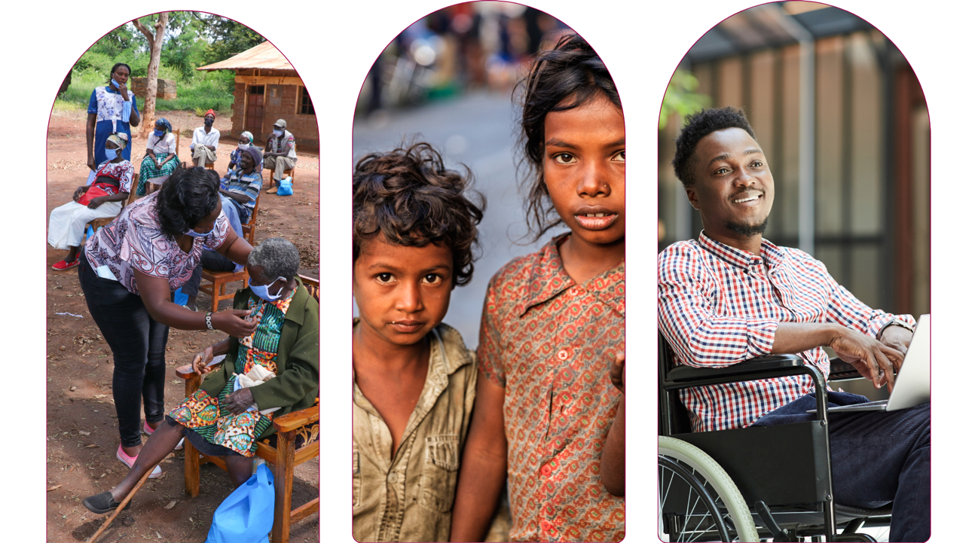

Australia’s International Disability Equity and Rights Strategy

Advancing Equity to transform lives
Easy Read 2025

About this document
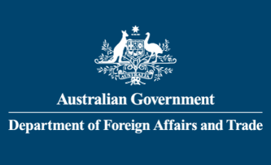 | This document is written by Australia’s Department of Foreign Affairs and Trade.  We are also called DFAT.  When you see ‘we’ it means DFAT.
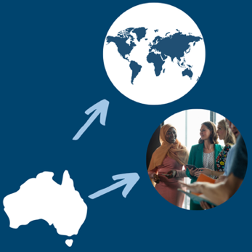 | DFAT is a part of the Australian Government.  It is DFAT’s job to:  - Help Australia work with other countries  - Help people and communities who need assistance in other countries.
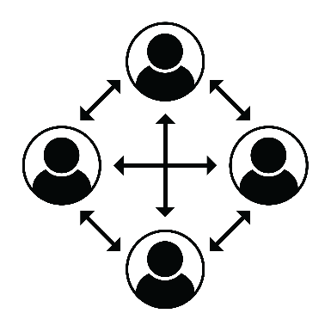 | Communities are a group of people who are all connected.
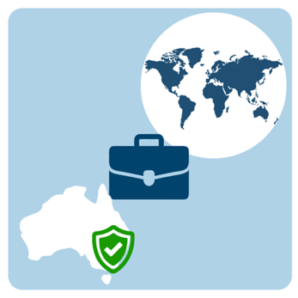 | - Help Australian people who are in other countries.

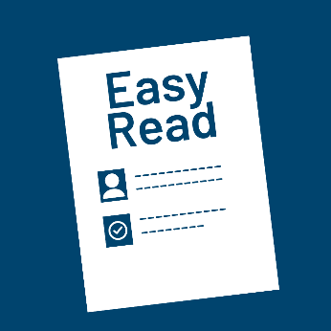 | This document is written so it is easy to read.  We call it Easy Read.
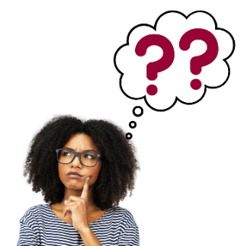 | You might not know some words.  The first time we use those words they are blue.  We tell you what they mean.
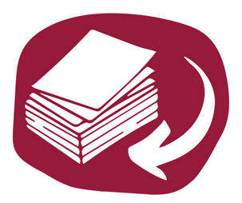 | Words in blue are in a Word list.  You can check what they mean there.
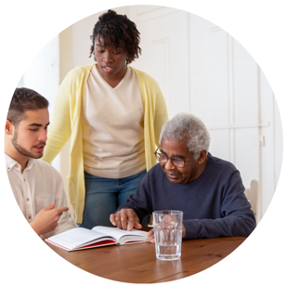 | You can ask for help to read this document.  You could ask:  - A family member  - A friend  - A support worker.
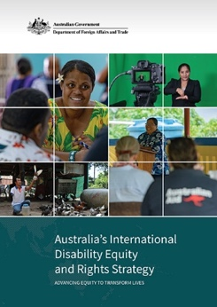 | In this document we talk about Australia’s International Disability Equity and Rights Strategy.  In this document we will call it the Strategy.
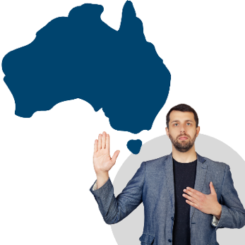 | A strategy says how we will change things.  The Australian Government makes commitments in this Strategy.  Commitments are things people say they are going to do.
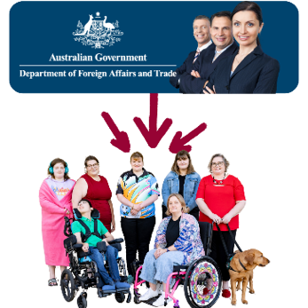 | This strategy was made after talking with lots of different people around the world.  This included many people with disability and their representative organisations.
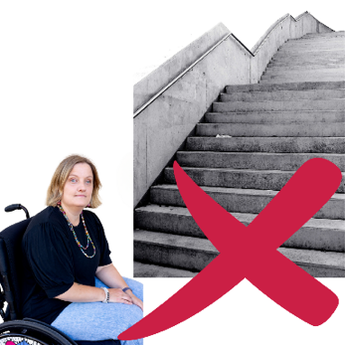 | Disability is when someone with an impairment cannot join activities because of barriers in the world.
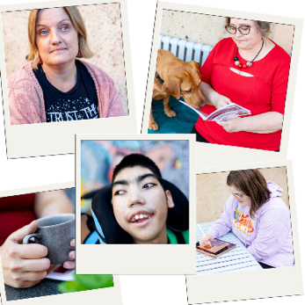 | An impairment may cause a person trouble with:  - Walking  - Seeing  - Hearing  - Speaking  - Learning  - And understanding.
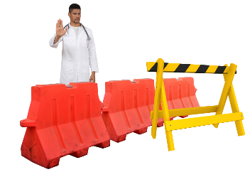 | Barriers are things that stop people doing the things they want or need to do.
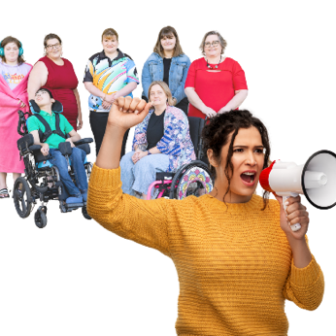 | A representative organisation is a group of people that speak or act on your behalf.

 | About the Strategy
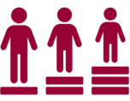 | The strategy focuses on promoting disability equity.  Disability equity is when someone with disability is treated with fairness and gets the help they need.  The help means they can do things they want or need to do.
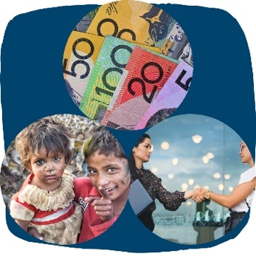 | Disability equity can:  - Help everyone  - Help people have enough money to live  - Help each country have enough money.
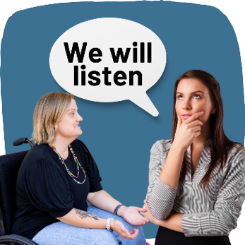 | Disability equity helps change the way governments work so people with disability are listened to and included.
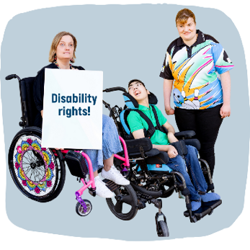 | The strategy says how we will promote disability equity and rights through our work with other countries.
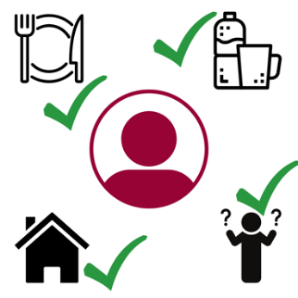 | Rights are things that every person should have.  Rights include:  - Enough food  - Clean water  - Fair and equal treatment  - A place to live  - Being safe  - Being allowed to make your own decisions  - Being included in the community.  Rights should be protected by law.
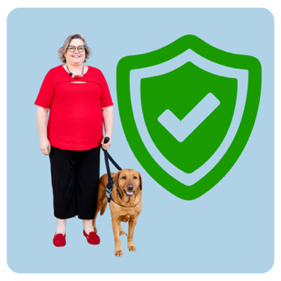 | Protected is when you are kept safe from something or someone.
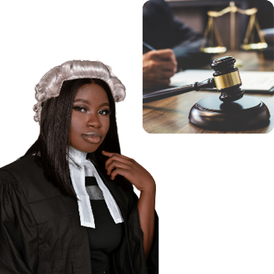 | The law is a set of rules that:  - Everyone must follow  - Keep people safe  - Make sure things are fair.
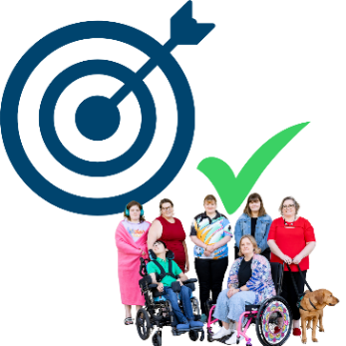 | The strategy that we created includes a target for disability equity in our international development program.  A target is something we try to do.
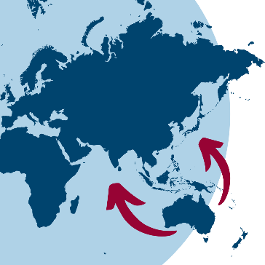 | The international development program is the work that Australia does to support other countries to have:  - Peace  - Stability  - Enough money to look after their people.
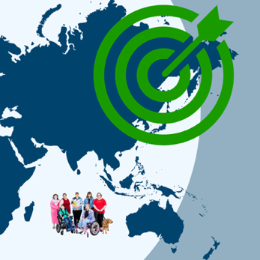 | The target is to make our international development better at supporting disability equity by 2030.
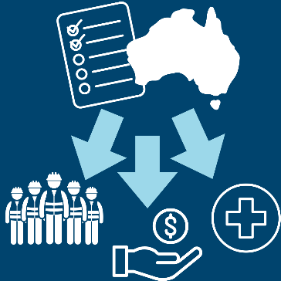 | We will reach our target by setting clear rules that our investments help people with disability.  Investments is the giving of resources to achieve targets.
 | Resources can include:  - Money  - Time  - People.

 | 4 Principles for the strategy.
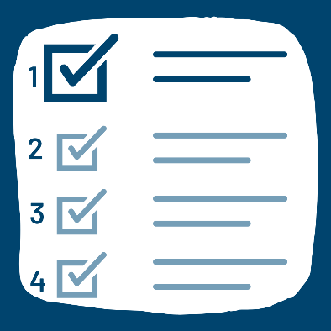 | We will follow 4 important principles to make sure our work is fair for people with disability.  Principles are something that we hold as true and important.
The 4 principles are:
- Disability rights are human rights.
People with disability have the same rights and freedoms as people without disability.
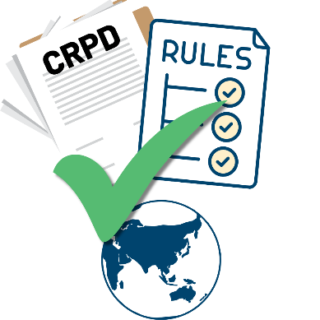 | Our work will be guided by the Convention on the Rights of Persons with Disabilities.  The Convention is also called the CRPD.  The CRPD explains the rights of people with disability.

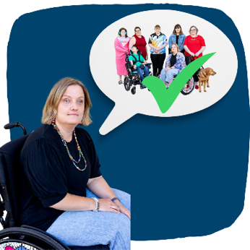 | - Nothing without us.  People with disability will be asked what they want and need.  They will be listened to.  They will be included in DFAT’s work.
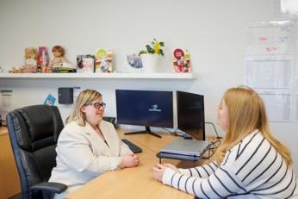 | We will help people with disability and their organisations to work with their governments and others.
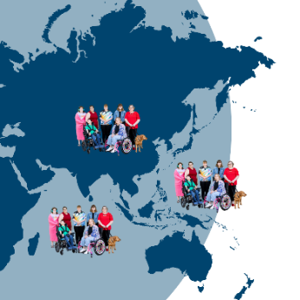 | - Valued members of the community.  People with disability live all over the world.  But they are often excluded from the communities they live in.
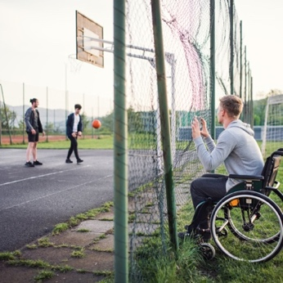 | Excluded means people are left out or not allowed to be included or do the things:  - They want  - They need.
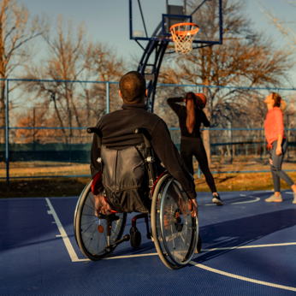 | We will help people with disability be included in the community they live in.

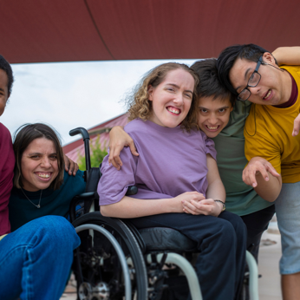 | - Support inclusion, equity and diversity.  Diversity means people from different backgrounds.
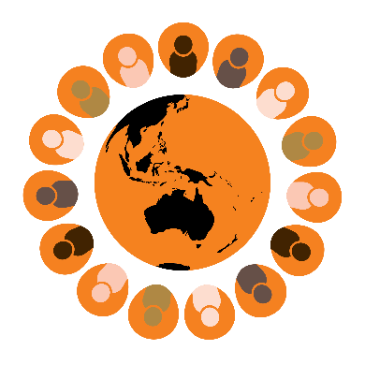 | For example:  - Countries  - Cultures  - Ages  - Beliefs  - Education  - Gender.
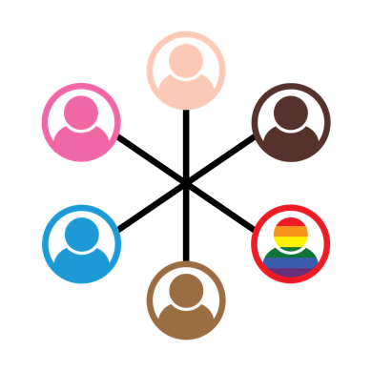 | Inclusion means when everyone  - Is valued  - Is welcomed  - Has what they need.
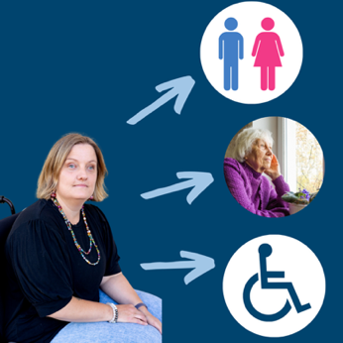 | Sometimes people with disability are treated differently because of their:  - Gender  - Age  - Impairment  - Other diversity.
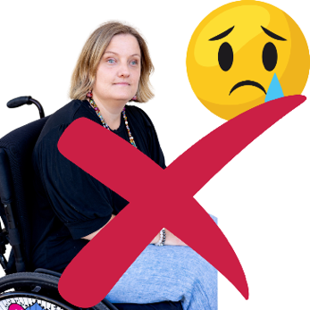 | This is called discrimination.  Discrimination is when you are left out or someone treats you unfairly because you are different.  We will work to help stop discrimination.

 | 5 strategy priorities.
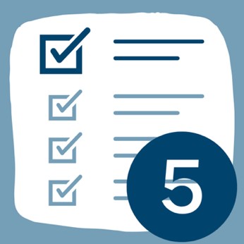 | We have 5 priorities that we want to meet in the Strategy.  Priorities are the most important things we need to do.  The priorities are:

Invest in partnerships and movements.
Partnership is when people or organisations work together.
A movement is when a group of people work together to create change.
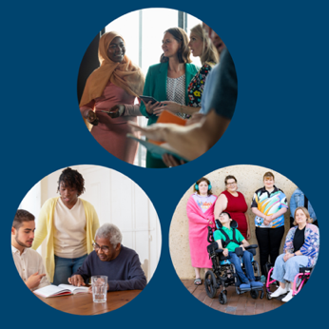 | The disability rights movement is a group of people who are working together for disability rights. These people are:  - People with disability  - Friends and family of people with disability  - Organisations and people who work for disability equity
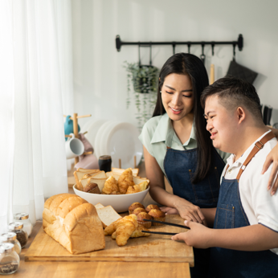 | - And disability allies.  Allies are people without disability who are supportive and working towards the same thing.
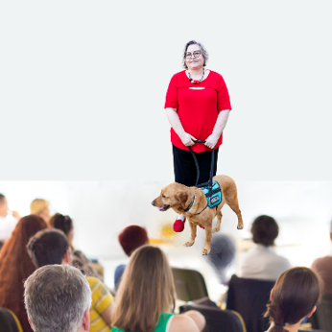 | We will:  - See people with disability as  - Leaders  - Experts  - And partners.
- Build strong partnerships with Organisations of People with Disability.
They are also called OPDs.
An OPD is:
- Run by people with disability
- For people with disability.
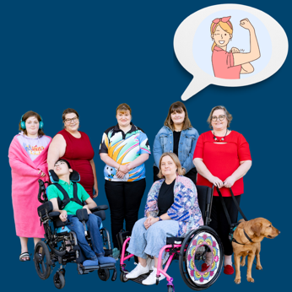 | We will act by:  - Making OPDs stronger through funding and capacity building.
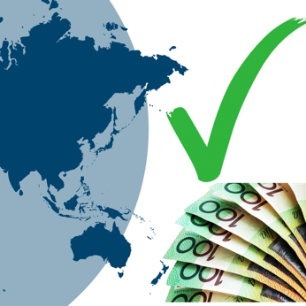 | Funding is when someone gives someone else money to help them.  Capacity building is improving the way people work. This is done by creating knowledge and skills.
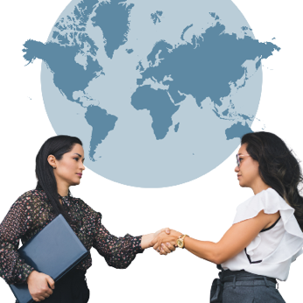 | We will:  - Work better with OPDs and learn from them  - Support people that experience multiple and intersecting discrimination.
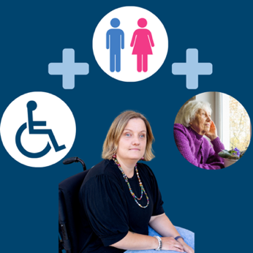 | Multiple and intersecting discrimination is when someone experiences more than 1 type of discrimination.  People may experience this because of their:  - Gender  - Age  - Disability  - Culture.
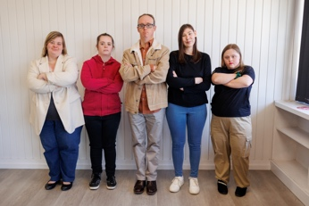 | We will create 2 new programs.  Program 1 is called Stronger Movements, Stronger Futures program.
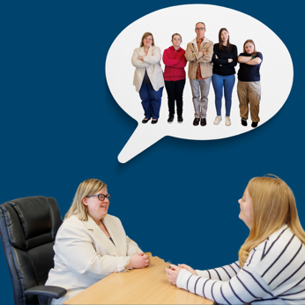 | - We will have better partnerships with disability organisations  - We will support and encourage OPDs to take part in talks with others around the world.
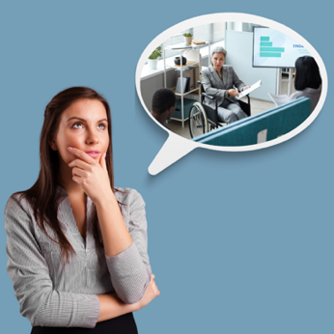 | Program 2 is called People with Disability Leading and Influencing program.
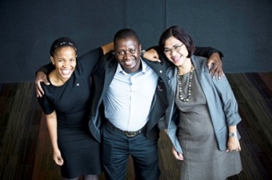 | We will support Australia Award Scholars with disability.  Australia Award Scholars are people who may have a disability. They are not from Australia.
They receive money to study in Australia. They often go to university to study.
This is called a scholarship.
This education helps them to be leaders and help their communities.
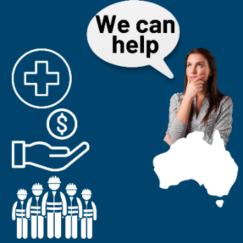 | Address discrimination and exclusion.  We will spend more money to help other countries include people with disability in:  - Health  - Education  - Work.
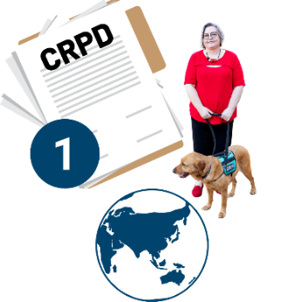 | We will ask other countries to:  - Follow the advice in the CRPD  - Make disability rights a priority  - Work with other countries to help each other
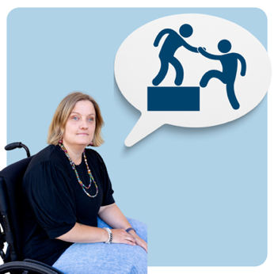 | - Give people with disability the things they need to take part in services and activities.  This may mean they need:  - Extra resources  - Support workers.
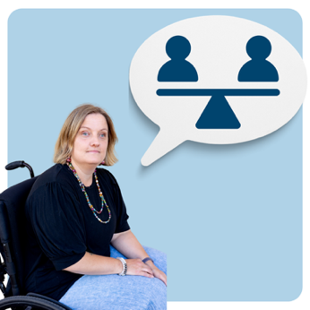 | These are called accommodations.  They make things fair for people with disability.
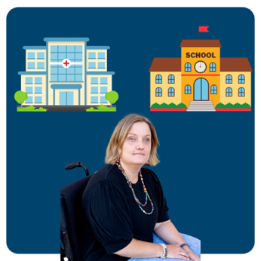 | We will do this by:  - Helping health and education services work better for people with disability
 | - Helping make sure people with disability can access legal help when they need to
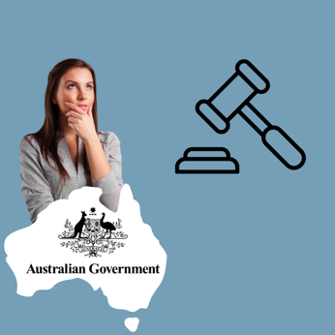 | Legal help is when the government or others give you support if you need help with the law.
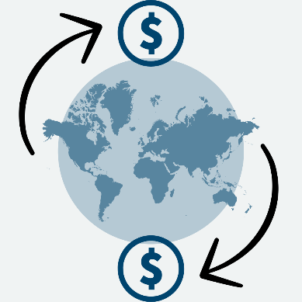 | - Making trade between countries more inclusive  Trade is when countries buy from and sell to each other.
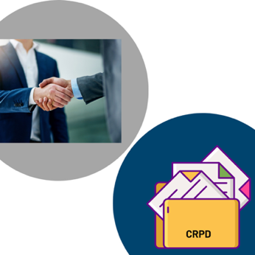 | - Working in partnerships  - Sharing how we have followed the CRPD
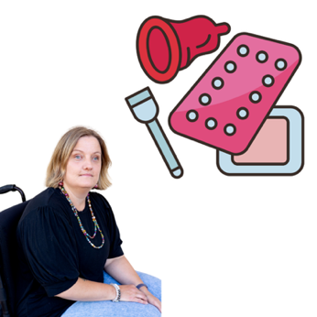 | - Making sure sexual and reproductive health services are inclusive for people with disability.  Sexual health is when you keep your body safe and healthy:  - During puberty  - And when you have sex.
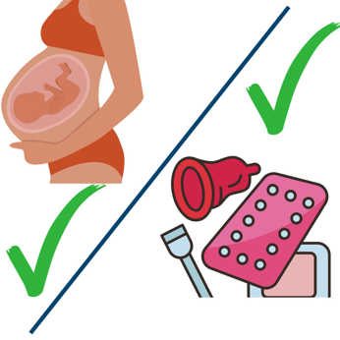 | Reproductive health is keeping your body safe and healthy in case you want or do not want to have children.
 | We will create a yearly International Disability Rights Dialogue.  Dialogue is when a group of people come together to talk.
 | It will help us to choose our priorities for disability equity in Australia’s international human rights advocacy.
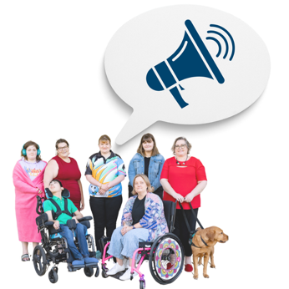 | Advocacy is when you or somebody else stands up for your:  - Rights  - What you want  - Or need.  Many OPDs advocate for themselves.

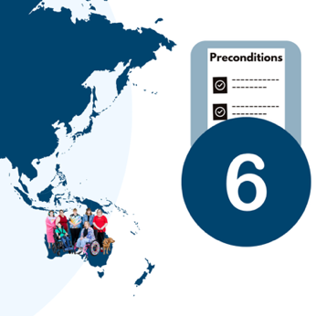 | Promote the preconditions for inclusion.  The Strategy has 6 preconditions.  Preconditions are things that countries need to have for people with disability to experience inclusion.
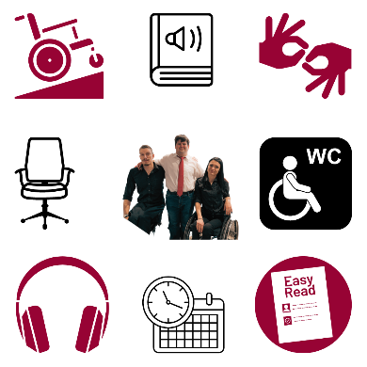 | The preconditions are:  - Accessibility  Accessibility means everyone should be able to:  - Use something.
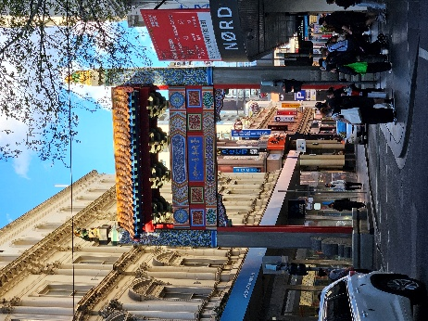 | This includes things like:  - Buildings  - Roads  - Communication  - And public transport.  We will help countries to change the way they work to be more accessible.
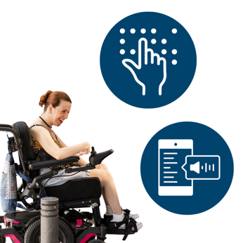 | - Assistive technology  Assistive technology is equipment that helps you do things easily or more safely and support to use this equipment.
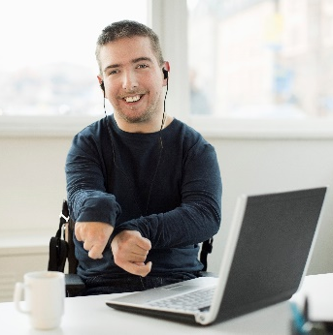 | We will invest more money in helping people with disability access assistive technology.
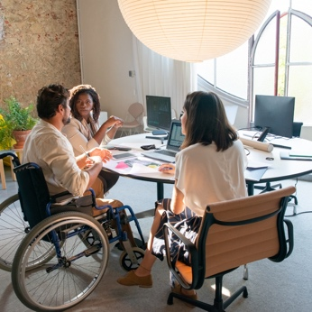 | - Support services which help people with disability participate in the community and have the choice to do what they want.  - Social protection
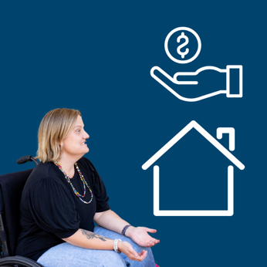 | Social protection is a set of policies and programs that stop:  - Poverty  - Social exclusion  - Vulnerability  Vulnerability means that someone needs extra help and protection.
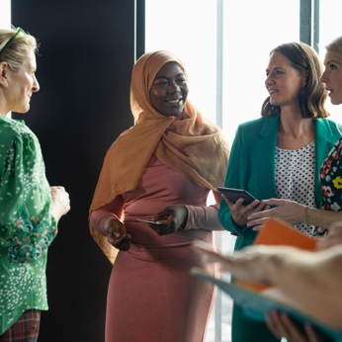 | - Community-based inclusive development  This is a group of programs that help people with disability and their families feel included in the community and get services they need.  The programs help educate people on disability rights and stopping discrimination.
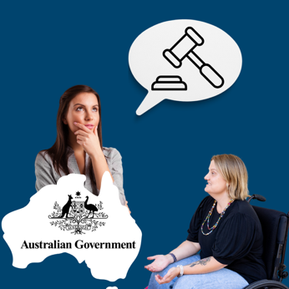 | - Non-discrimination.  Through non-discrimination work we will help make laws stronger.  Non-discrimination means that people with disability will have laws to help them when they experience discrimination.
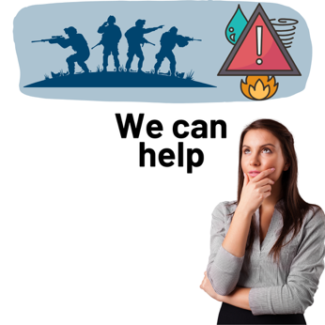 | Support equity in humanitarian help and climate action.  Humanitarian help is when people need help because of a disaster or war.
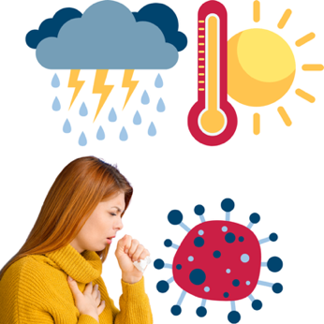 | A disaster can be a:  - Weather event  - A flood  - A fire  - An earthquake  - A volcano  - A medical event like COVID 19.
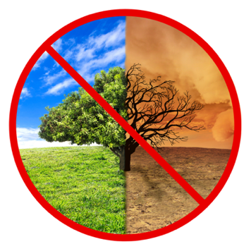 | Climate action includes taking steps to stop climate change from happening.  We will help countries and communities adapt to climate change as it happens.  Adapt means people change to meet the environment.
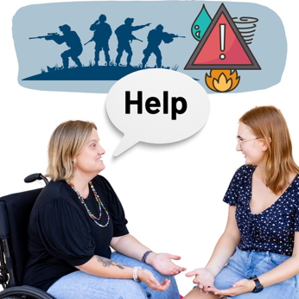 | We will make sure that people with disability are included when:  - Planning for disasters  - Dealing with climate change.
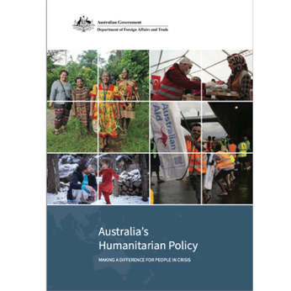 | We will do this through our commitments in our humanitarian policy.
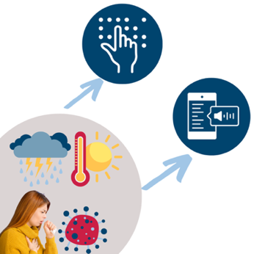 | We will be testing assistive technology in response to a humanitarian disaster.  We are working with OPDs and governments on how to do this.
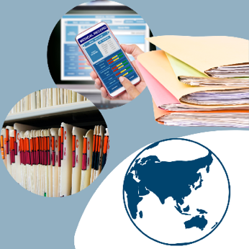 | Strengthen the evidence base.  Evidence is the proof of something.
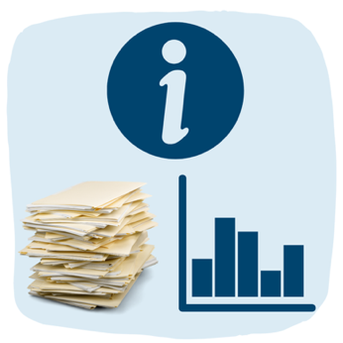 | We will help improve:  - Information  - Evidence  - And data on people with disability.  This will help people make better decisions.
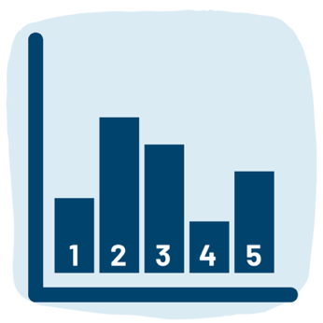 | Data is a group of numbers or other information that is used for evidence.  The number of people who live in Vanuatu with disability is an example of data.  Another example is information on what stops children with disability going to school.
 | We will use evidence for:  - Policy  - Programs  - Decision making.
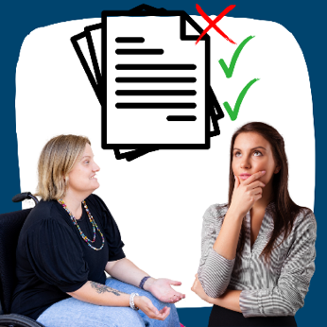 | We will use an international policy marker called the OECD DAC disability marker to guide our work.  The policy marker is a way to track which of our programs are designed to include people with disability.
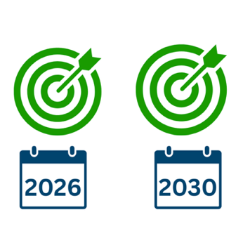 | Our targets for international development and humanitarian investments are:  - By 2026, 6 out of every 10 development and humanitarian investments will be doing a good job on disability equity.  - By 2030 this will increase to 7 out of every 10 investments.

Our approach to this work
Approach is how we will make something work.
Our approach has 5 parts.
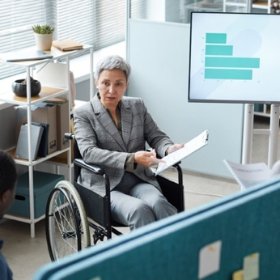 | - Supporting local leadership and decision making.  Local leadership is when someone in your community is in charge.
- Improving our impact by working in partnership with people with disability.
- Making sure we do not harm anyone.
This means we make sure that we do not hurt anyone in the work that we do.
Even by accident.
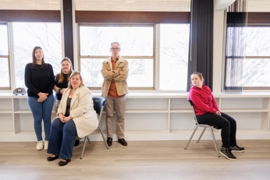 | - Making sure we leave no one behind.  This means all diverse groups of people with disability will be included in the development efforts.  This approach works with the United Nations Sustainable Development Goals.
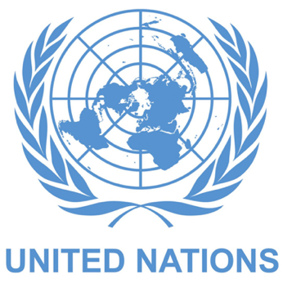 | The United Nations are called the UN.  The UN is a group of many countries that work together to make life better for people and the world.
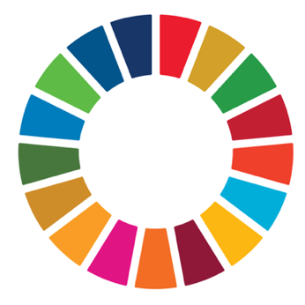 | Sustainable Development Goals are targets the UN developed to make the world:  - A safer place  - A fairer place  - And a welcoming place.
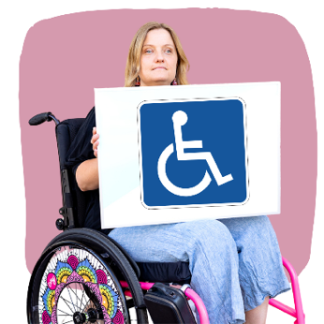 | - Using twin-track efforts.  Twin-track efforts are when we work to improve the inclusion of people with disability everywhere in 2 ways.
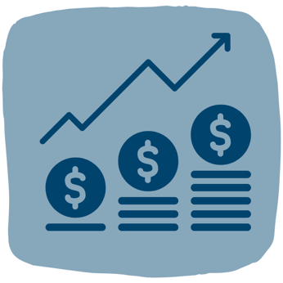 | We will invest in:  - Programs  - Services  - And actions that are designed especially for people with disability.
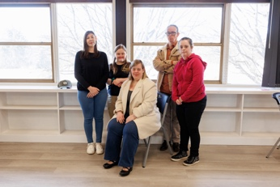 | And make sure people with disability are included in all other programs and services.

 | How we will keep our commitments
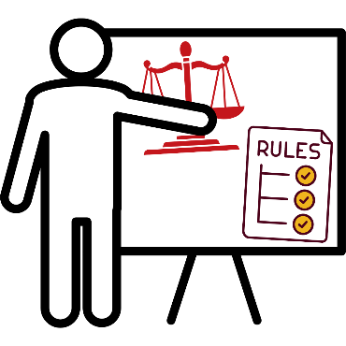 | We will meet the goals of this Strategy by trying to do our work better.  We will:  - Give people who work at DFAT more training
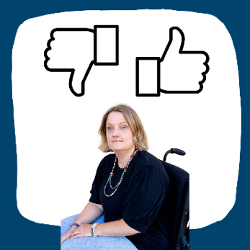 | - Help people to better include and support people with disability
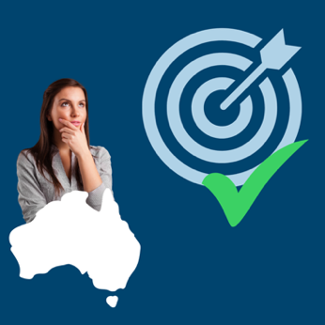 | - Check if we are doing a good job on meeting targets for disability equity.
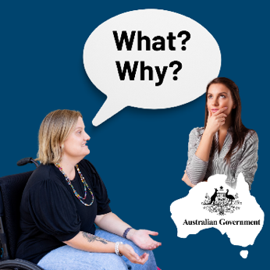 | - Be more transparent and accountable.  Transparent means that we do not hide what we are doing.  Accountable means that we are responsible for what happens through our work.

Word List

Accessibility
Accessibility means everyone should be able to:
- Use
- Read
- And understand something.

Accountable
Means that we are responsible for what happens through our work.
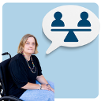 |  | Accommodations  They make things fair for people with disability.  This may mean they need:  - Extra resources  - Support workers.
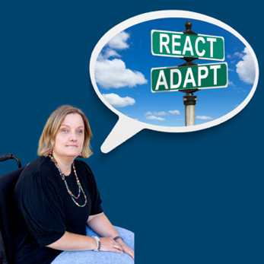 |  | Adapt  Means people change to meet the environment

Advocacy
Advocacy is when you or somebody else stands up for your:
- Rights
- What you want
- Or need.
Many OPDs advocate for themselves.

Allies
They are people without disability who are supportive and working towards the same thing.
 |  | Approach  This is how we will make something work.

Assistive technology
Assistive technology is equipment that helps you do things easily or more safely and support to use this equipment.
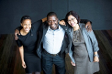 |  | Australia Award Scholars  Are people who may have a disability. They are not from Australia. They receive money to study in Australia.
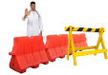 |  | Barriers  Barriers are things that stop people doing the things they want or need to do.
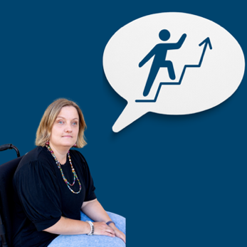 |  | Capacity building  Capacity building is improving the way people work. This is done by creating knowledge and skills.

Climate action
This includes taking steps to stop climate change from happening.

Communities
A group of people who are connected.
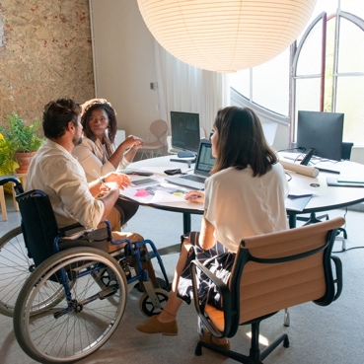 |  | Community-based inclusive development  This is a group of programs. They help people with disability and their families feel included in the community and services they need.
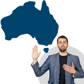 |  | Commitments  Commitments are things people say they are going to do.
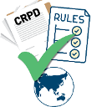 |  | Convention on the Rights of Persons with Disabilities  The Convention is also called the CRPD.  The CRPD explains the rights of people with disability.
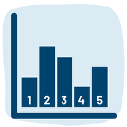 |  | Data  Data is a group of numbers or other information that is used for evidence.  The number of people who live in Vanuatu with disability is an example of data.  Another example is information on what stops children with disability going to school.
 |  | Dialogue  This is when a group of people come together to talk.
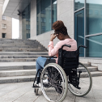 |  | Disability  Disability is when someone with an impairment cannot join activities because of barriers in the world.
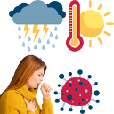 |  | Disaster  A disaster can be a:  - Weather event  - A flood  - A fire  - An earthquake  - A volcano  - A medical event like COVID 19.
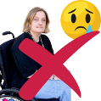 |  | Discrimination  This is when you are left out or someone treats you unfairly because you are different.
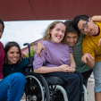 |  | Diversity  Diversity means people from different backgrounds.  For example:  - Countries  - Cultures  - Ages  - Beliefs  - Education  - Gender.

Disability Equity
Disability equity is when someone with disability is treated with fairness and gets the help they need.
The help means they can do things they want or need to do.
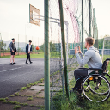 |  | Excluded  This means people are left out or not allowed to be included or do the things:  - They want.  - They need.
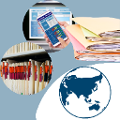 |  | Evidence  Evidence is the proof of something.

Funding
Funding is when someone gives someone else money to help them.

Humanitarian help
Humanitarian help is when people need help because of a disaster or war.
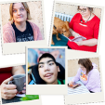 | Impairment  An impairment may cause a person trouble with:  - Walking  - Seeing  - Hearing  - Speaking  - Learning  - And understanding.
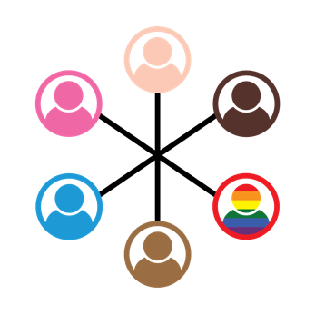 | Inclusion means when everyone  - Is valued  - Is welcomed  - Has what they need.
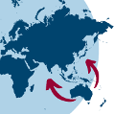 | International development program  This is the work that Australia does to support other countries to have:  - Peace  - Stability  - Money to look after their people.
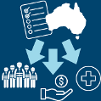 | Investments  Investments is the giving of resources to achieve targets.
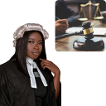 | Law  The law is a set of rules that:  - Everyone must follow  - Keep people safe  - Make sure things are fair.
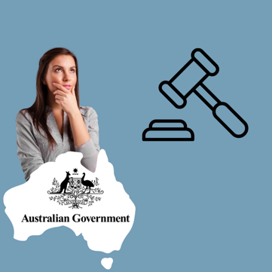 | Legal help  Legal help is when the government or others give you support if you need help with the law.
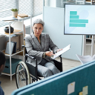 | Local leadership  This is when someone in your community is in charge.
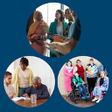 | Movement  A movement is when a group of people work together to create change.
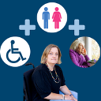 | Multiple and intersecting discrimination  Multiple and intersecting discrimination is when someone experiences more than 1 type of discrimination.  People may experience this because of their:  - Gender  - Age  - Disability  - Culture.
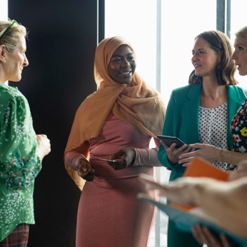 | Non-discrimination.  Non-discrimination means that people with disability will have laws to help them when they experience discrimination.
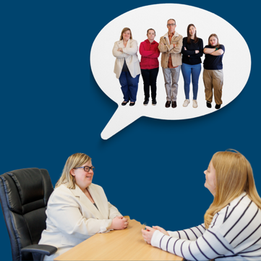 | Organisations of People with Disability.  They are:  - Run by people with disability  - For people with disability.
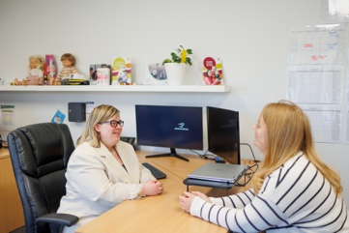 | Partnership  Partnership is when people or organisations works together.
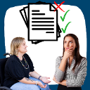 | Policy Marker  The policy marker is a way to track which of our programs are designed to include people with disability.
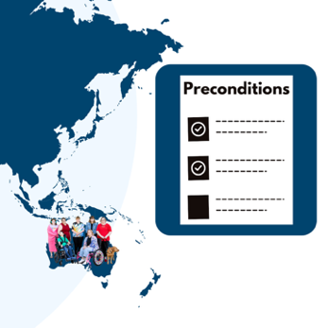 | Preconditions  Preconditions are things that countries need to have for people with disability to experience inclusion.

Priorities
They are the most important things we need to do.
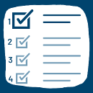 | Principles  These are something that we hold as true and important.
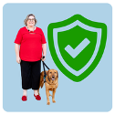 | Protected  This is when you are kept safe from something or someone.
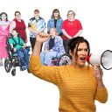 | Representative organisation  This is when a group of people speak or act on your behalf.

Reproductive health
Reproductive health is keeping your body safe and healthy in case you want or do not want to have children.
 | Resources  Resources can include  - Money  - Time  - People.
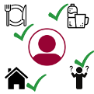 | Rights  Rights are things that every person should have.  Rights include:  - Enough food  - Clean water  - Fair and equal treatment  - A place to live  - Be safe  - Being allowed to make your own decisions  - Being included in the community.

Scholarship
A Scholarship is when someone is given money to study.

Sexual health
Sexual health is when you keep your body safe and healthy:
- During puberty
- And when you have sex.

Social protection
Social protection is a set of policies and programs that stop:
- poverty
- social exclusion
- vulnerability.
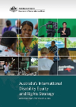 | Strategy  A strategy says how we will change things.
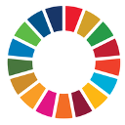 | Sustainable Development Goals  Sustainable Development Goals are targets the UN developed to make the world:  - A safer  - A fairer  - And welcoming place.

Target
A target is something we try to do.
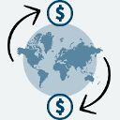 | Trade  This is when countries buy from and sell to each other.
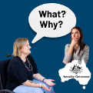 | Transparent  Transparent means that we do not hide what we are doing.
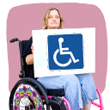 | Twin-track  Twin-track efforts are when we work to improve the inclusion of people with disability everywhere in 2 ways.
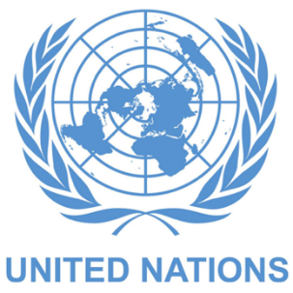 | The United Nations  They are also called the UN. The UN is a group of many countries that work together to make life better for people and the world.
 | Vulnerability  This means that someone needs extra help and protection.

Easy Read images by The Easy Read Toolbox or through Creative Commons (Microsoft 365, NLA photo attribution: Ryan Wick, Flickr).
Easy Read document written by The Easy Read Toolbox.

