

Country Case Study

TONGA

April 2021

Table of contents

1 The country program 1

1.1 Program description 1

1.2 Program performance: January 2018 to December 2020 1

1.2.1 Supporting our partners 2

1.2.2 Supporting our volunteers 4

2 Stakeholder perceptions 8

2.1 Program staff 8

2.2 DFAT staff 9

2.3 Government staff 10

2.4 Partner organisations 10

3 Case studies of partner organisations 12

3.1 Mango Tree Centre 12

3.1.1 Relevance of the program’s support 12

3.1.2 Impact on organisational capacity 12

3.1.3 Benefits to volunteers 12

3.1.4 Diplomatic benefit to Australia 12

3.1.5 Future directions of the program 13

3.2 Ministry of Meteorology, Energy, Information, Disaster Management & Environment 13

3.2.1 Relevance of the program’s support 13

3.2.2 Benefits to volunteers 13

3.2.3 Future directions of the program 13

4 Conclusion 14

Acronyms

| Acronym | Definition |
| --- | --- |
| AAD | Approved accompanying dependent |
| AIP | Aid Investment Plan |
| COVID-19 | Novel coronavirus |
| DFAT | Australian Government Department of Foreign Affairs and Trade |
| HR | Human resources |
| MEIDECC | Ministry of Meteorology, Energy, Information, Disaster Management & Environment, Climate Change and Communications |
| NGOs | Non-governmental organisations |
| POs | Partner organisations |
| SDGs | Sustainable Development Goals |

# The country program

## Program description

The program in Tonga partnered with 17 organisations and supported 34 volunteers to deliver 38 assignments in three years (2018-2020). Volunteers contributed to the delivery of the Australian government’s aid priorities in Tonga including supporting reforms to increase government revenue, strengthen control of government expenditure and promote private sector growth, strengthen the health system and reduce the burden of noncommunicable disease, support skills training to ensure local labour skills needs are met, promote gender equality and prevent violence against women and children, strengthen the legal system, improve resilience to the impact of disasters and climate change, and address the needs of people with disabilities.

Strengthening existing partner relationships and establishing new ones were two significant activities for the years 2020 and 2021. The program continued to engage with other international volunteer agencies in Tonga, participating in networking events including quarterly coordination meetings.

Partnership planning workshops were delivered to help organisations better understand the benefits of partnering with the program and entering longer-term assignment planning arrangements. As a result, Tonga completed or nearly completed 13 partnership plans, with eight more planned to be completed in 2021. Five new partners are in the process of completing due diligence requirements or are in discussion with the in-country team to develop assignments.

The most significant challenges affecting the program in Tonga to date, apart from COVID-19, were the last two cyclones Gita (2018) and Harold (2020). Cyclone Gita made landfall and Cyclone Harold passed to the south of Tonga in April 2020 after volunteers had been repatriated. Nonetheless these cyclones each caused pauses and delays in program implementation. In preparation for the first cyclone, Vava’u volunteers were evacuated to Tongatapu. Volunteers, partner organisations and Department of Foreign Affairs and Trade (DFAT) Post were regularly updated about the program’s preparedness and response activities during these events.

At the time volunteers were repatriated in March 2020 due to the COVID-19 pandemic, the program was on track to meet its annual assignment target of 24 for the first time since the program commenced in 2018. After repatriation, the program worked with partners to finalise partnership plans, complete due diligence and child protection policy requirements, complete end of assignment reports, and prepare partners for remote volunteering.

## Program performance: January 2018 to December 2020

The data presented here is based on a reporting period encompassing the first three years of the program, covering assignments that were active between 1st January 2018 and 31st December 2020. This timeframe falls outside the program’s normal annual data cleaning and reporting cycle, so some inconsistencies may exist with data as previously reported in Annual Reports.

### Supporting our partners

The program worked with 21 partner organisations across Tonga between January 2018 and December 2020, with largely excellent progress against assignment objectives as shown below.

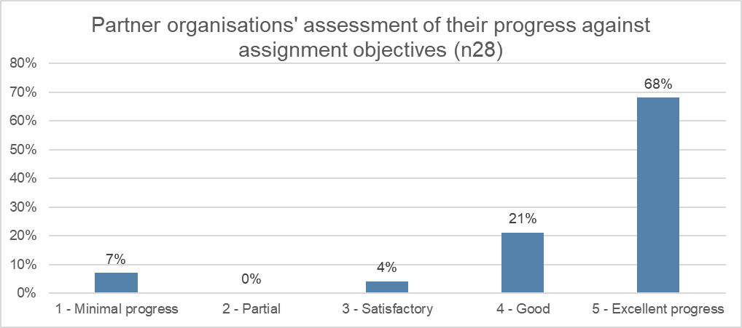

As shown below, the most common development sectors that volunteer assignments contributed to were health, government and civil society, agriculture, forestry, fishing, and education (18% each). The least was in the energy sector (11%).

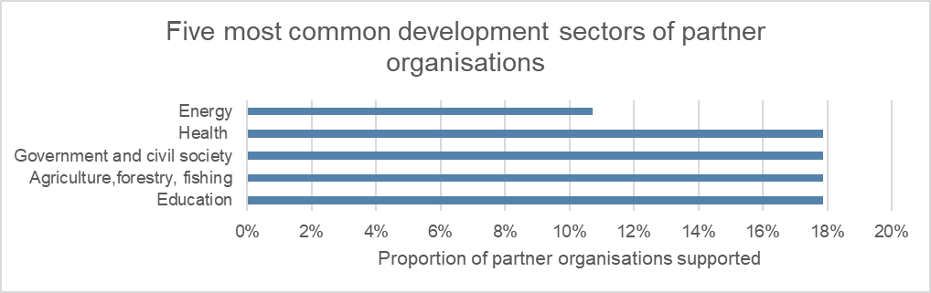

As shown below, the common type of partner organisations that volunteers have supported is government (43%), followed by the non-governmental organisations (NGOs) (19%) and academic institutions (14%). The least included was the private sector and international NGOs (5% each).

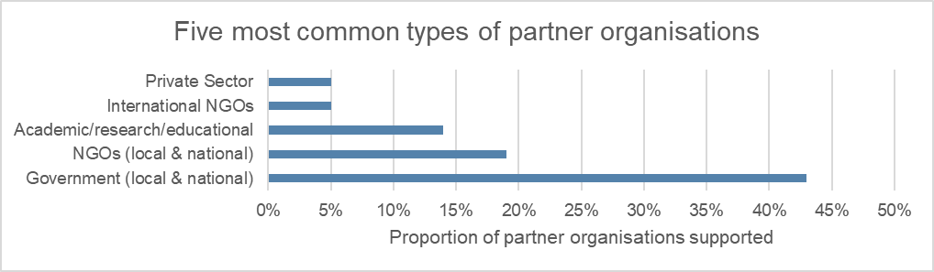

The following graph illustrates the most common Sustainable Development Goals (SDGs) contributed to by partner organisations. It shows Goal 3 of the SDGs ‘good health and well-being’ as the most common SDG that partner organisations contribute to (29%).

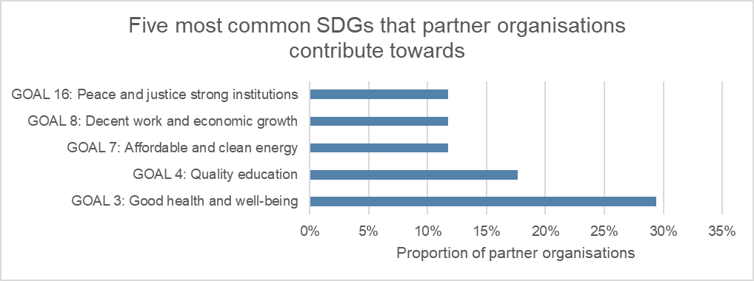

The graph below highlights the key impact areas that partner organisations contribute to. These are human rights (45%), followed by inclusive economic growth (39%), and climate change and food security (16%).

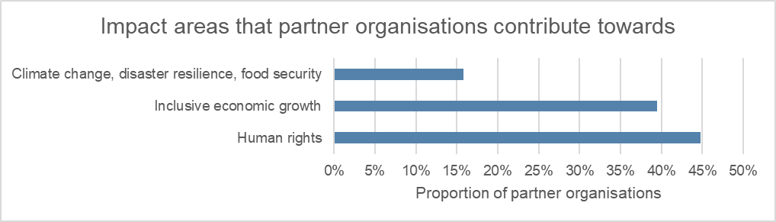

The following graph shows the most common cross-cutting themes addressed by partner organisations which were gender (16) and disability (9).

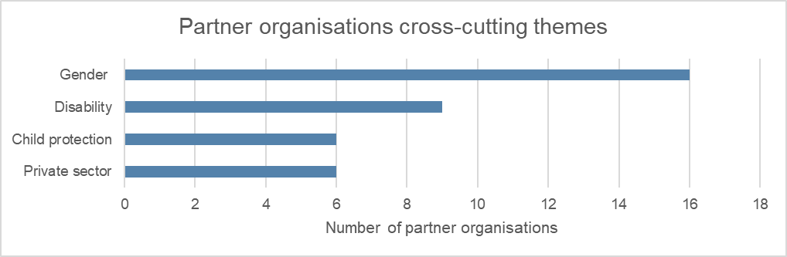

Ninety-three per cent of volunteers report that strengthening partner organisations, beneficiaries, and stakeholders (93%) more than individuals (78%) and far more than systematic change and networking (44%).

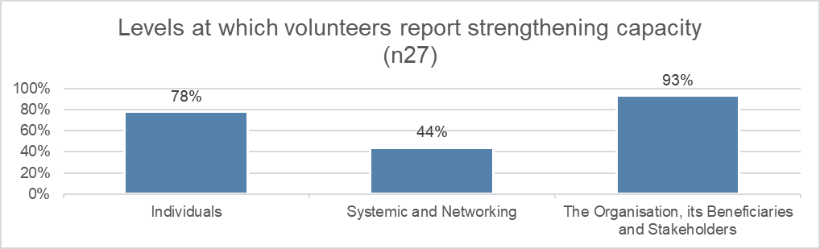

Ninety-six per cent of partner organisations are ‘very satisfied’ with the program’s in country management, 86% were ‘very satisfied’ with the assignment and 88% per cent were ‘very satisfied’ with the volunteer.

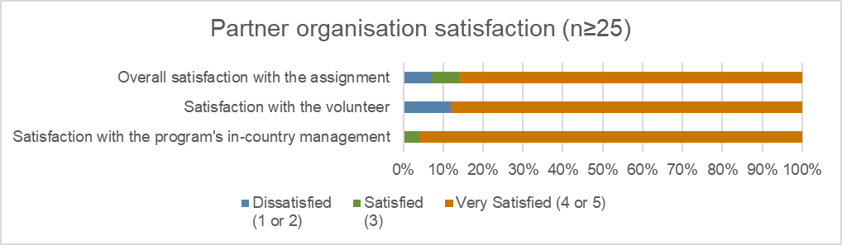

### Supporting our volunteers

Since the start of the program, 52 assignments were filled by 46 volunteers. The program supported eight approved accompanying dependents (AADs). Most volunteers ranged from 30-39 years old, with 11 females and only 1 male in this age range. Male volunteers dominated the 60+ age range as seen below.

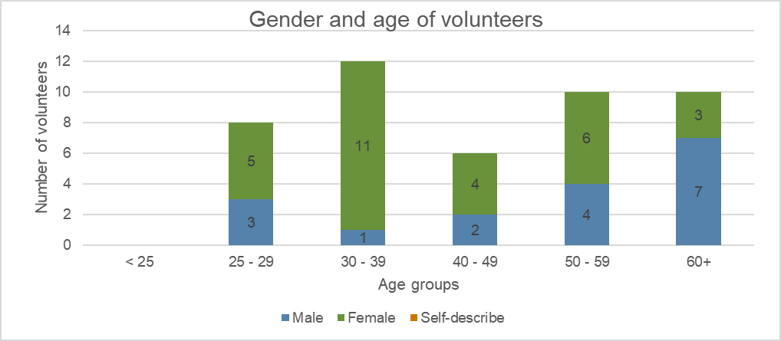

Fifty-five per cent of the assignments were between 7-12 months long, followed by short term assignments of 6 months and only a small percentage of assignments more than 12 months.

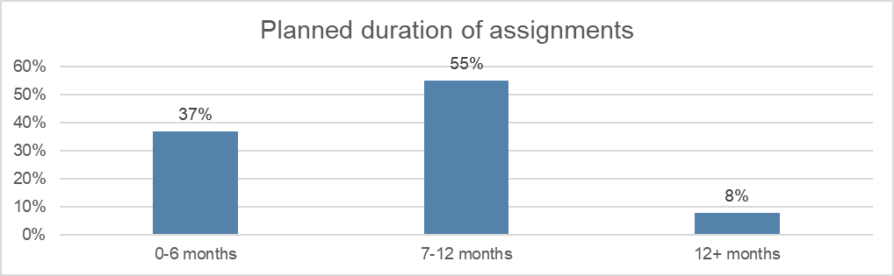

Twelve per cent of volunteers finished their assignments early. This excludes those repatriated due to COVID-19 as shown in the graph below. There were no assignment extensions.

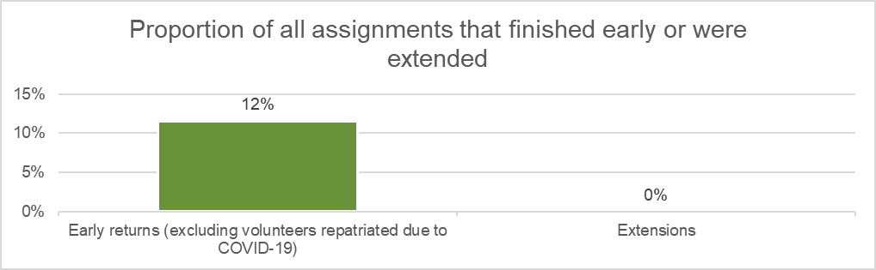

The largest percentage of assignments is based in the Nuku’alofa area (55%) followed by Neiafu (10%) and other villages. Six per cent of assignments were delivered remotely.

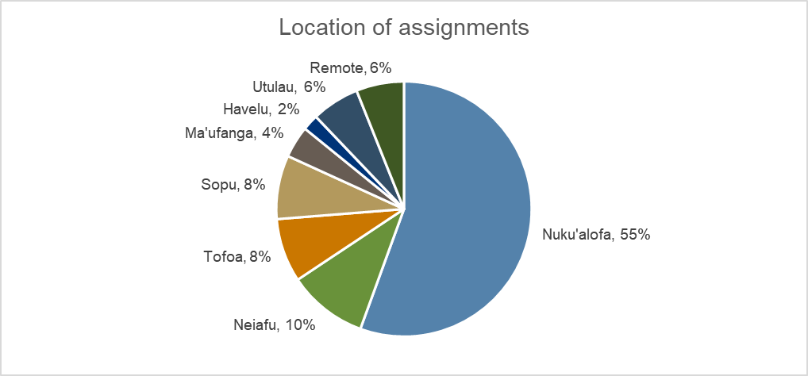

The graph below illustrates that the most common profession for volunteers is equally the education sector, community and social development, and health care and medical (20% each). This is followed by agriculture (18%) with the least common profession being business, finance, and human resources (HR) (8%).

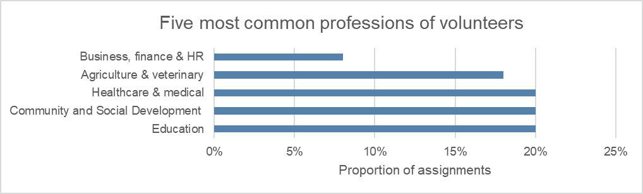

The following graph illustrates the alternative volunteering modalities and partnership assignments. It shows that most assignments were delivered through remote volunteering and open volunteering (three each).

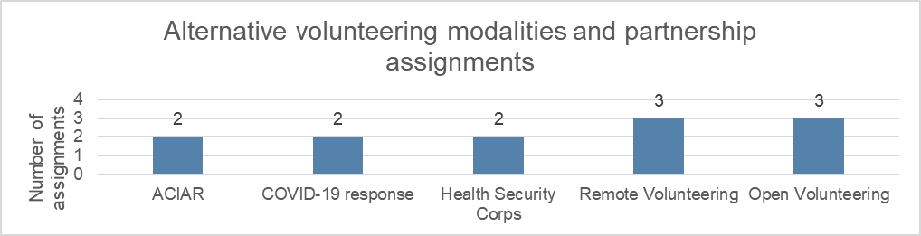

Most volunteers rated progress on their assignment objectives as good (50%) or excellent (23%), as shown by the graph below.

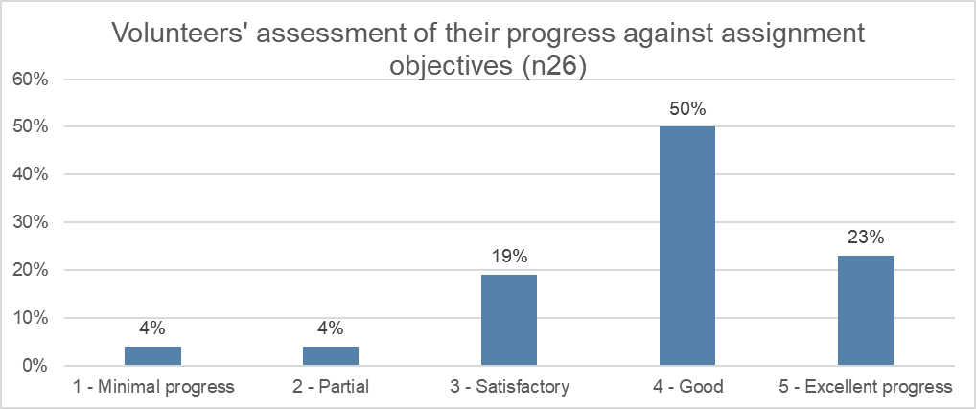

Eighty-three per cent of volunteers reported that they were ‘very satisfied’ with safety and security management. Seventy-two per cent of volunteers were ‘very satisfied’ with the overall program and 57% were ‘very satisfied’ with in-country management.

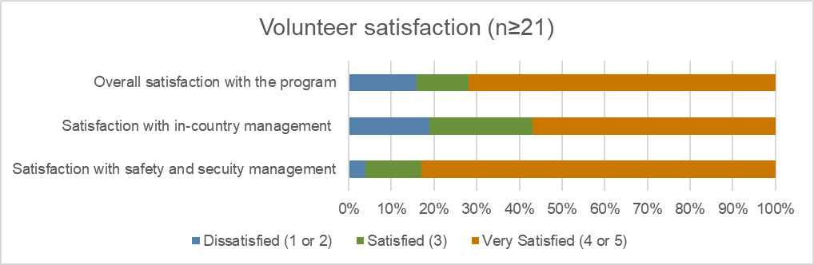

As shown in the graph below, 18 of volunteers and 1 AAD were repatriated due to COVID-19.

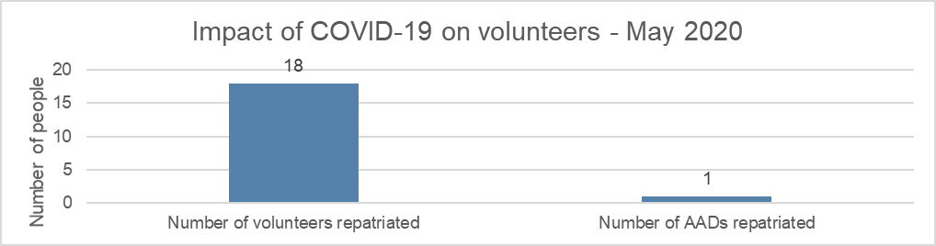

# Stakeholder perceptions

## Program staff

**The program’s activities and outcomes are very much aligned with the needs and priorities of DFAT and partner organisations in Tonga.** Program staff acknowledged that the program is fit for purpose and needs-specific, with volunteer assignments tailored to DFAT priority areas. They also described how the program has effectively filled the gaps for the beneficiaries of the program. This is due to effective negotiations by program staff to ensure that the right volunteers are being placed in the appropriate offices.

**The program strengthens the capacity of partner organisations.** Program staff indicated evidence of the benefits attributable to the program, with testimonies from program staff about how the program has made an impact on partner organisations. The program staff highlighted the view of partner organisations that the one–year timeframe for placement of volunteers is too short. The program staff used an example from one partner organisation, whose view was that volunteer assignments in the agriculture sector needed to be for a minimum of two years, and preferably for three years. This was considered the timeframe needed to understand the farmers needs in relation to such variables as climate, location, soil system and the effect of natural disasters, such as cyclones.

**The program is perceived to be contributing to Australia’s “soft” power**. The program staff said that the program is a form of soft power for Australia because the general perception is that volunteers represent Australia as ambassadors and advocates of issues that DFAT lobbies for, such as gender equality. Program staff said that Tonga has a strong history and ties with Australia in their bilateral arrangements and that this has diplomatic benefits.

**The program represents value for money.** Program staff said that the program has used resources wisely and volunteers have adapted well to the various working environments. Program staff said that partner organisations have acknowledged how volunteers’ technical skills have always been invaluable to them. Whilst there is high satisfaction with volunteer performance, program staff said that the current resourcing of their office is inadequate and needs financial support to better ensure staff are equipped to carry out their roles. They said they needed a vehicle to transport the volunteers around for their safety and security. They believe they have worked well to date with limited resources but said that the resourcing issues, including their remuneration, needed to be addressed if the program is to be sustainable.

**Corporate governance arrangements support efficient decision making and program management.** Program staff said that current decision-making and program management arrangements has worked well to date due to the effective coordination by the program staff and office. There has been great acknowledgement and appreciation shown towards program staff, who are working well to identify the key priorities from relevant partners and then aligning them to meet the overall DFAT priorities.

Program staff acknowledge that the effectiveness of the program is due to the clear and constant communications maintained over the years with the volunteers and partner organisations. The key to the effectiveness of the program is the close monitoring of the volunteer’s progress and also building a relationship so they feel they are engaged and included. Program staff expressed that this approach has helped the volunteers to adapt well to a new environment and feel less home sick during their time in-country.

## DFAT staff

**Design of the program remains relevant to the strategic objectives of Australia’s development assistance program and country strategy.** DFAT staff see the current program design as being in close alignment with DFAT priorities. This is done through negotiations and discussions with program staff, by having regular meetings to ensure the alignment of priorities. The current design process also ties in well to the Tonga Aid Investment Plan which details the areas focus in Tonga. Certain assignments address cross-cutting issues as well as thematic areas. For example, there are volunteers on placement in the gender division for the Ministry of Finance. Such placements provide an opportunity to help influence Australia’s gender equity policy agenda in the Tongan system.

DFAT staff said that sometimes an assignment is adjusted if it doesn’t match the partner organisation’s needs, however this is rare. DFAT staff stated that the main pillars of the program, for example human rights and food security, are not always main priorities in each country receiving volunteers. It varies in terms of relevance. For example, in Tonga, food security and human rights are not priority areas for DFAT.

**International volunteering is not really valued by the Australian public.** DFAT staff expressed that there is a mixed understanding of the value of international volunteering by the Australian public due to lack of awareness of how the program operates.

**DFAT acknowledged that the volunteers’ experience has supported their professional development**. DFAT remains up to date on volunteers and their progress through the Head of Mission hosting afternoon teas with volunteers at their residence where the volunteers feel safe to share both their personal and professional experiences. DFAT staff said that volunteers have mixed experiences with the progress they are making on their assignments, with some feeling like they are struggling to make change. Most volunteer agree, however, that the program has helped their career.

**The unified branding of the program under the Australian aid banner is not really delivering greater recognition of the program.** DFAT staff believe that the change in branding was not significant to many. DFAT staff agree that most people recognise the program as a DFAT-funded program, and the branding does not play a role in how they see the program.

**The program contributes to Australia’s soft power**. DFAT staff noted that the volunteers are excellent ambassadors for Australia and the assignments they undertake make some contribution to Australia’s influence in Tonga. As previously noted, this is considered particularly so in relation to furthering DFAT’s agenda on cross-cutting issues such as gender equality. The program has a record and profile for assisting neighbouring countries. This is perceived as something positive that also generates Australian soft power in Tonga.

**COVID-19 continues to be a key challenge.** DFAT staff believe that it is likely that the usual flow of volunteers into Tonga will not be seen until 2022, and that this will be a challenge for the program. They believe remote volunteering isn’t a substitute as it is difficult to build networks remotely, which has significantly impacted the partner organisations. DFAT staff expressed a view from partner organisations that there is now a gap with the lack of volunteers on the ground. One of the partner organisations shared to DFAT staff that a lack of volunteers has a financial impact on them given their dependence on volunteers for specific technical skills.

**There are some strategies to consider strengthening the program’s resilience and sustainability.** DFAT staff believe that building up longer term relationships between individual volunteers, partner organisations and Australian organisations can build resilience. The Royal Australasian College of Surgeons was noted as an example of an Australian partner organisation which the program could build a long-term relationship with to support regular, short-term (rather than one-off) assignments. DFAT staff stated this would work in the Tongan context to help build capacity in the long term.

It was emphasized by the DFAT staff that they feel it is very important to have Australians on the ground doing this work rather than having local volunteers as part of the program. This is because the value in building soft power is a large part of the program. DFAT staff recognised that the current design of the program has these positive impacts but having local assignments wouldn’t have these benefits. However, DFAT staff acknowledged the need to explore the modality of using local staff, using the Tongan-Australian diaspora and to consider how it will impact power dynamics and relationships.

## Government staff

**Government staff are not very familiar with the program.** The government representative consulted recognises that there is a gap in how information about the program is reaching government. This has caused lack of awareness with the government staff who coordinate Australian aid activities in Tonga. In addition, there is a lack of correspondence with the government staff and program staff on the management of the program which has been a great lesson learnt in moving forward to strengthen the relationships of these two key stakeholders.

**The government staff recognises that the program adds value to partner organisations.** Government staff recognised that volunteers add value through their technical skills and help fill the gaps within government ministries. The government staff said that they would need to know the scope of the program given that finance is the central unit. In addition, government staff expressed that they are aware that the volunteers support would be aligned with the needs from government priorities which is found in their strategic development framework.

Furthermore, the government staff were informed directly by partners that the program adapts well to under resourced environments**.** A key lesson learnt from the program is how volunteers adapt to the various working environments, particularly low-resource environments. It was commented by the government staff that some of the volunteers would want a specific term of reference, however it is hard to have one given the nature of the work that some of the partner organisations do. Flexibility and adaptability are important and is one of the key reasons partner organisations really value the program.

**Some contribution to Australia’s soft power and diplomatic relations.** Government staff recognise that any bilateral program such as the Australia Volunteers Program creates soft power and influence. This model has worked well in Tonga and reflects the history and relationship between Tonga and Australia.

**Preparing for unexpected events, like COVID-19, is a key challenge.** Government staff expressed that risk management is a major challenge for the program. It is very important for the program to foresee unplanned risks that could pose a threat to the program. COVID- 19 is a good example as no government had planned for this, and risk assessments must be aligned with DFAT. This will ensure that the program will operate effectively. Government staff stated that risks are important to discuss regularly to ensure everyone is on the same page. This will assist planning for uncertain times and managing unanticipated challenges in the future.

**Building a stronger relationship with the program Tonga office is key to the sustainability of program.** There was recognition by the government staff that there is a disconnect between their office, the DFAT office and the program office in-country. Government is willing to strengthen the relationship in moving forward and familiarise themselves with the program, including meeting the volunteers themselves.

## Partner organisations

**Program activities and outcomes are aligned with needs and priorities of partner organisations.** Partner organisations believe that to a large extent, the placement of volunteers in both government and non-Government organisations has been successful, fit for purpose and aligned with their key priorities. Most partners expressed their satisfaction with the process of matching volunteers to assignments in their organisations. They believe that this satisfaction is a result of the negotiation process when they express their priorities to the Tonga program office.

**The program contributes significantly and positively to strengthening the capacity of partner organisations.** Most partner organisations interviewed expressed that the program has strengthened their capacities. They believe that this has been done through the hard work and commitment of volunteers. One educational institution partner organisation said that volunteers have assisted them to develop standards to an international level, redesign the program of study and curriculum, provided training, and assisted in identifying other operational improvements that could be made. Another partner organisation said that their volunteers had gone beyond their terms of reference and provided support with time management, hygiene, and healthy eating.

**Volunteers benefit from their placements.** Partner organisations believe that volunteers gain both professionally and personally through learning exchange, gaining new knowledge about the culture, and learning the history of how their organisations work. One of the partners said that most of the volunteers show a great appreciation towards understanding the Tongan culture and way of doing things. They also start adopting the way things are done in their organisations. For example, the dress code for all workplaces is the ta’ovala or kiekie. Those volunteers who have adopted this dress code are showing a sign of respect.

**There is recognition that the program contributes to Australia’s soft power.** Most partners do not make specific links to how the program contributes to Australia’s soft power. However, they recognise the strong diplomatic relations that Australia has with Tonga and support provided through the program. They value the program and acknowledge that the volunteers are great ambassadors for Australia. Volunteers are seen to support Australia’s influence in smaller island countries such as Tonga.

**The program governance arrangements support efficient management and decision-making.** Partner organisations have been very happy with the support and work that the Tonga program office provides. The Program Manager was especially acknowledged for commitment to ensuring that the priorities of partner organisations are being met and the information is relayed clearly to the DFAT office. Partner organisations believe that the length of volunteer assignments needs review. They said that short term placements may not be adding value to their partner organisations.

**Partner organisations also suggested that governance arrangements could be strengthened by including them in the volunteer orientation program.** They believe that volunteers face challenges on arrival in country in terms of culture shock (e.g. food and dress-code) and adapting to their workplaces. They would like to participate in volunteers’ pre-departure orientation to brief volunteers on expectations and orient them to the Tongan culture. It was also suggested by one of the partner organisations that it might be good to have language a prerequisite, encouraging volunteers to learn some basic Tongan before arriving as this will also help them adapt faster.

**COVID-19 has significantly affected the program’s activities.** Most partner organisations said that the absence of volunteers had left a gap in their organisation and remote volunteering is not working for everyone.

* **Mixed views about the effectiveness of remote volunteering.** Only one partner organisation said that remote volunteering worked for them because they have the technology in place, and the new model is more task-oriented which meets their needs. An agricultural organisation felt that remote volunteering did not fill their need for technical support on the ground. Some partner organisations said that an assessment needs to be done to explore what resources they need to support remote volunteering.
* **Training needed to explain how remote volunteering works.** The partner organisations said that to transition to remote volunteering, the model needs to be discussed and the benefits explained. At present, the assumption has been made that everyone understands this new mode of volunteering. Partner organisations believe that this assumption has been made without understanding their needs in accommodating this new model.
* **Cost of internet connection, facilities, and equipment to accommodate remote volunteering.** It was noted that remote volunteering requires a good internet connection and facilities to work effectively. For example, educational institutions will need equipment such as speakers in place to ensure that audio is transmitted clearly for students. These facilities require funding support.

**COVID-19 remains the biggest challenge and risk for Tonga in future.** The partner organisations expressed their concern about the uncertainty of COVID-19 and how it is taking a toll on their organisations. They said that the repatriation of their volunteers has left a gap that needs to be filled. Most said they would prefer to have volunteers in country while they are exploring remote volunteering.

**It was suggested that local volunteering under the program is a modality worth exploring in the future.** Two options were suggested. One option involves volunteers sitting under a similar scheme to seasonal worker programs, where volunteers fly in and out to bring the technical support needed for the partner organisations. The second option is to utilise local expertise, funded through the program. This would involve local volunteers who could also operate as ambassadors for Australian aid.

# Case studies of partner organisations

## Mango Tree Centre

### Relevance of the program’s support

The needs of the Mango Tree Centre as a beneficiary have been met to a great extent and the support provided to the centre is very relevant. The Mango Tree Centre offers therapy services for people with physical and intellectual disabilities who live in Nuku'alofa, Tonga. The program supports the needs of the Mango Tree Centre by building and strengthening the capacity of their staff and providing technical support to those with intellectual disability.

The only concern raised by the Mango Tree Centre is the timeframe allocated for the volunteers, expressing that their placement should be more than a year. In addition, the new model of remote volunteering will not work well for them given the work at the centre is very much hands on and deals with people with disabilities.

### Impact on organisational capacity

The program has added value to the work of the Mango Tree Centre in supporting their services for people with a disability. The dispatch of volunteer therapists to the centre has supported them in their main rehabilitation programs. So far there have been five volunteers. These have included specialists in physiotherapy, occupational therapy and speech therapy. It was acknowledged by the Mango Tree Centre that the impact has been significant since their sudden departure in 2020 because of COVID-19. Now they are not able to provide physiotherapy or speech therapy for their clients.

### Benefits to volunteers

Volunteers felt that their perspectives had been broadened both professionally and personally when placed at Mango Tree Centre. Volunteers expressed how they valued the experience at the centre, strengthening their networks and relationship with community groups on the ground. Volunteers articulated how they learned to adapt to a new working environment and culture. One of the volunteers emphasised that, in Australia, there is easy access to everything, and some people come with special privileges. However, in Tonga, there is a severe lack of resources. The volunteers learn to make do with what is available.

Some volunteers felt they did not meet long term objectives of their assignment and address the priority needs of the organisation. They believe the partner organisation did not know how to properly leverage their skills. In addition, there were communication problems and it became evident that addressing the specific needs of the Mango Tree Centre did not facilitate long-term capacity development gains for local people. It was expressed by one of the volunteers that when the request comes into the Australian Volunteers Program office, it should be assessed thoroughly as too often the focus seems to be on the immediate needs of partner organisations rather than what is needed to build the long-term capacity of the organisation.

### Diplomatic benefit to Australia

The Mango Tree Centre has mixed views on how the program has linkages to diplomatic benefit in Australia. The centre focuses on working closely with the volunteers to get the support needed, rather than looking at Australia’s soft power. However, one staff member did share that the program is a form of soft power for Australia as the work of the volunteers builds influence.

### Future directions of the program

The biggest issue now is COVID-19 and how the Mango Tree Centre will continue to manage without the volunteers. The centre feels that they need to continue working with the program and must explore what model of remote volunteering works best for them.

The Mango Tree Centre suggested that the Australian and Tongan government negotiate a bilateral arrangement which allows skills-based volunteers to return to Tonga. This would mean prioritising returning volunteers to Tonga given the technical assistance they provide.

## Ministry of Meteorology, Energy, Information, Disaster Management & Environment

### Relevance of the program’s support

Ministry of Meteorology, Energy, Information, Disaster Management and Environment (MEIDECC) staff have made it clear that the program remains relevant and adapts to their needs. MEIDECC is the main regulating body for all communication services and has the role of lead communicator for government information in creating awareness of government policies, programs, and activities. MEIDECC staff expressed that the program is also value for money in terms of the benefit to and impact on the community.

MEIDECC staff acknowledged that the program adds value to their work through technical expertise and filling skills gaps. MEIDECC staff stated that the requests being made are more technical assignments. MEIDECC staff said that this is a key challenge, as the line is blurred between a volunteer and technical assistance.

MEIDECC staff added that they are very happy with the placement of volunteers as they continue to build a stronger relationship with them. They also said that the volunteers inevitably take a leadership position, motivating teams and taking on roles that stretch the boundaries of what their mentor role is.

### Benefits to volunteers

The volunteers expressed that they gained professional experience and sound knowledge from their active participation in the programs and activities they are engaged in at MEIDECC. MEIDECC expressed that the community outreach work of volunteers also strengthened the volunteers’ public relations and networking skills with the locals in the Pacific context. This has enhanced the volunteers’ knowledge and has led to better appreciation of the local communities in Tonga. Volunteers developed personally through interactions with local communities on assigned activities, as well as interactions with the staff in the office.

### Future directions of the program

MEIDECC staff acknowledged that no one knows how long COVID will last however, in terms of sustainability, a local model of volunteering could work for Tonga. MEIDECC suggested working with local organisations to develop a volunteering model tailored for the local community. In most Pacific countries, the retirement age is 50-55, so there is significant expertise among retirees in country. It is important to explore how to tap into that wealth of expertise. MEIDECC staff also suggested utilising the broader diaspora of Tongans living in Australia as volunteers to support the program in the future.

# Conclusion

Overall, the program in Tonga reflects that the program’s outcomes remained closely aligned with the objectives of the Australian Government’s aid priorities during the first three years of the program (2018-2020). There is great recognition of the program in Tonga and the value that volunteers add to partner organisations such as Mango Tree Centre and MEIDECC and the program office is acknowledged by partner organisations for its effective coordination.

Partner organisations agree that outcomes from the program have been positive and the program design remains relevant to their needs. One reservation expressed was that the timeframe allocated for the volunteer assignments was too short. They would like to see this reviewed. They would also like to see the remote volunteering model explored in terms of how it might be made more ‘fit for purpose’ given partner organisations have differing capacities in accommodating and supporting the model.

Like what has been outlined above, Tonga’s case study highlights the significant changes the program has made in supporting partner organisations through filling gaps in technical expertise. The volunteers value their experience in Tonga as they not only gain professionally but also personally. Volunteers acknowledged that they learned to adapt to a new working environment and culture. Partner organisations expressed great satisfaction with their experience of the program and volunteers said that they had adapted well to their Tongan workplace and community environments.

In addition, there were mixed views from stakeholders about how the program links to diplomatic benefits for Australia. The focus for partner organisations and government is about working closely with the program to get the support they need. Some stakeholders acknowledged that the volunteers become ambassadors and advocates on certain DFAT priorities, such as gender equality. Others thought that the program is a form of soft power for Australia and acknowledged that Tonga has a strong history and ties with Australia in their bilateral arrangements.

The benefits of the program have been significant due to the deep networks and relationships developed over the years. It was also acknowledged by stakeholders that there is room for improvement in strengthening the relationship between the program office and the government office that manages the Australian aid portfolio.

To improve sustainability and strengthen the program in Tonga, it was suggested that:

1. The Tongan and Australian governments explore a special arrangement that facilitates the return of volunteers who provide specific technical assistance (this would fill the immediate gap left by the repatriation of volunteers due to COVID-19)
2. The program explores the possibility of engaging local Tongan retirees with specialist skills who could add value to the program
3. The program taps into the Tongan diaspora in Australia as potential volunteers.