

Country Case Study

TIMOR-LESTE

April 2021

Table of contents

1 The country program 1

1.1 Program description 1

1.2 Program performance: January 2018 to December 2020 1

1.2.1 Supporting our partners 1

1.2.2 Supporting our volunteers 4

2 Stakeholder perceptions 8

2.1 Program staff 8

2.2 DFAT staff 8

2.3 Government staff 9

2.4 Partner organisations 10

3 Case studies of partner organisations 12

3.1 Engineers Without Borders 12

3.1.1 Relevance of the program’s support 12

3.1.2 Impact on organisational capacity 12

3.1.3 Benefits to volunteers 12

3.1.4 Diplomatic benefit to Australia 12

3.1.5 Future directions of the program 13

3.2 National Directorate of Veterinary Services 13

3.2.1 Relevance of the program’s support 13

3.2.2 Impact on organisational capacity 13

3.2.3 Benefits to volunteers 13

3.2.4 Diplomatic benefit to Australia 14

3.2.5 Future directions of the program 14

4 Conclusion 15

Acronyms

| Acronym | Definition |
| --- | --- |
| AVI | Australian Volunteers International |
| COVID-19 | Novel coronavirus |
| DFAT | Australian Government Department of Foreign Affairs and Trade |
| DNSV | National Directorate of Veterinary Services |
| ETDA | East Timor Development Agency |
| EWB | Engineers without Borders |
| GoTL | Government of Timor Leste |
| HR | Human resources |
| ICFP | Catholic Institute for Teacher Training |
| NGO | Non-governmental organisation |
| SDGs | Sustainable Development Goals |
| SEII | Secretary of State for Equality and Inclusion |
| TL | Timor-Leste |
| UPMA | Planning Monitoring and Evaluation Department |

# The country program

## Program description

The Australian Volunteers Program partnered with 59 partner organisations and supported 84 volunteers to deliver 105 assignments in Timor Leste during the first three years of the program (2018-2020). Assignments aligned with the Country Program Plan and the delivery of the Australian Government’s aid priorities in Timor Leste, including improving livelihoods, enhancing human development, and strengthening governance and institutions. The program operated in Dili, Baucau, Ermera, Aileu and Manufahi.

The program recruited 28 volunteers, representing 67% of the indicative volunteer target of 42 for FY19/20. Forty-two assignments were ready to be advertised before the suspension of recruitment and mobilisation due to COVID-19.

Four sessions were held for new partner organisations in Baucau, Aileu, Ermera and Manufahi, attended by 120 representatives from 55 partner organisations. The program conducted a child protection workshop attended by 22 existing partner organisations, and a partnership plan workshop attended by 27 partner organisations resulted in the development of 25 partnership plans. The program also facilitated a disability and inclusion workshop that was attended by 33 partner organisations and 27 volunteers. Three in-country orientation programs were held for new volunteers. These programs focused on educating volunteers on monitoring, evaluation and learning requirements.

The in-country team conducted monthly and quarterly meetings with volunteers to strengthen the relationship with the Department of Foreign Affairs and Trade (DFAT) Post. These meetings updated DFAT Post on assignment progress, shared partner organisation success stories, and provided an opportunity for volunteers to network with other volunteers, government officials and DFAT staff.

Timor-Leste declared COVID-19 a pandemic in March 2020. The program repatriated 31 volunteers while two volunteers remained in Timor-Leste as part of the COVID-19 response. The two remaining volunteers have continued to provide essential services to support national health systems, with a specific focus on COVID-19 prevention activities at partner organisation, Maluk Timor. Another volunteer returned to support the Alola Foundation, funding her own expenses.

## Program performance: January 2018 to December 2020

The data presented here is based on a reporting period encompassing the first three years of the program, covering assignments that were active between 1st January 2018 and 31st December 2020. This timeframe falls outside the program’s normal annual data cleaning and reporting cycle, so some inconsistencies may exist with data as previously reported in Annual Reports.

The following graphs are data for program supporting partner organisations and supporting volunteers.

### Supporting our partners

The program worked with 59 partner organisations across Timor-Leste during the 2018-2020 period. The program operated in Dili, Baucau, Ermera, Aileu and Manufahi.

As shown by the graph below the most common development sectors that volunteer assignments contributed to were government and civil society (40%), followed by other multisector (11%).

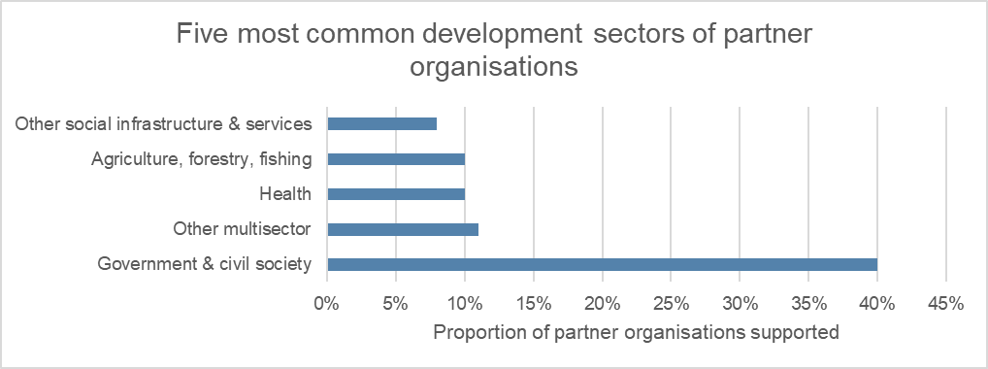

The following graph shows the most common types of partner organisations were local and national non-governmental organisations (NGOs) (51%) followed by local and national government (19%).

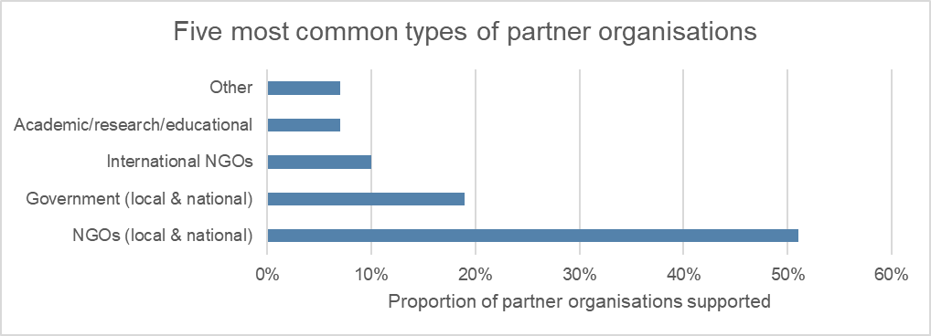

The following graph illustrates the most common Sustainable Development Goals (SDGs) contributed to by partner organisations, which were good health and well-being (20%), followed by peace and justice strong institutions (19%).

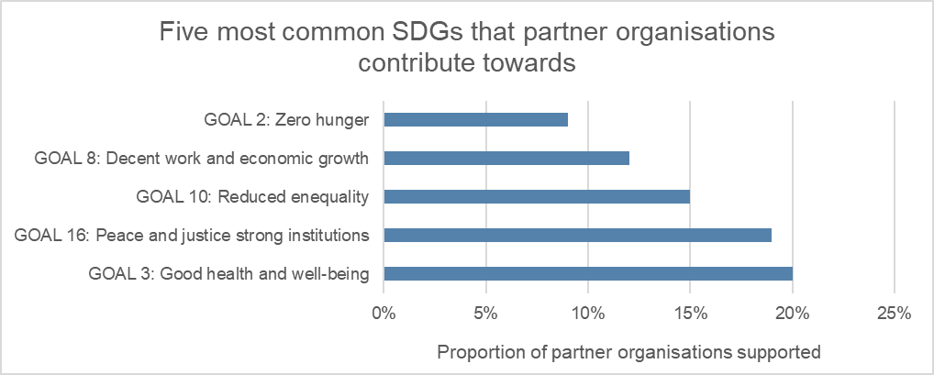

The following graph shows the most common cross-cutting themes addressed by partner organisations were gender (24%), followed by child protection (10%).

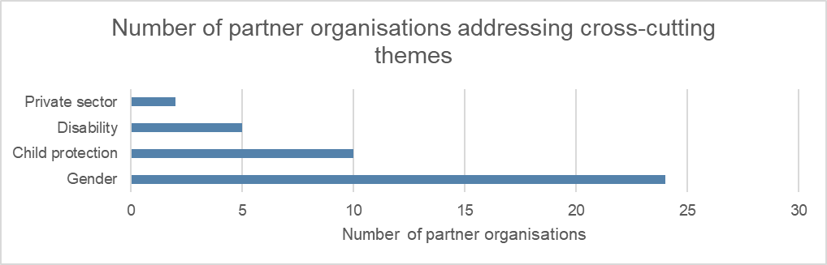

As shown below, 65% of partner organisations stated that volunteer progress towards achievement of the assignment objective was good or excellent.

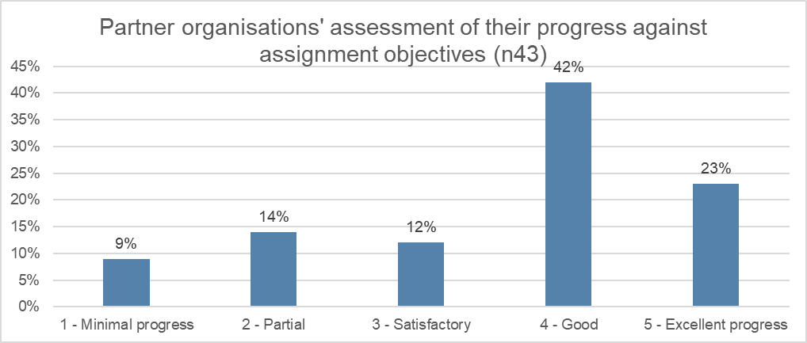

Eighty-three per cent of volunteers reported strengthening of partner organisation capacity at the individual level, 81% at the organisational level, and 57% of volunteers reported strengthening capacity at the systemic level.

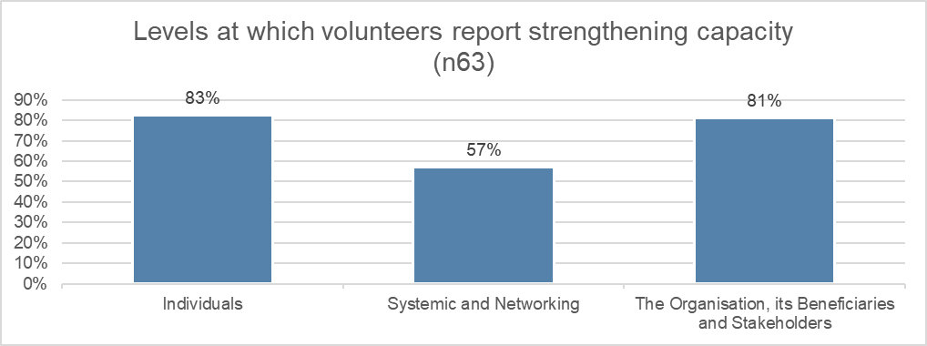

The following graph illustrates partner organisation satisfaction with assignments, their volunteers and the program’s in-country management. Sixty-eight per cent of partner organisations reported that they were ‘very satisfied’ with assignments, 66% with their volunteers and 72% with the in-country management.

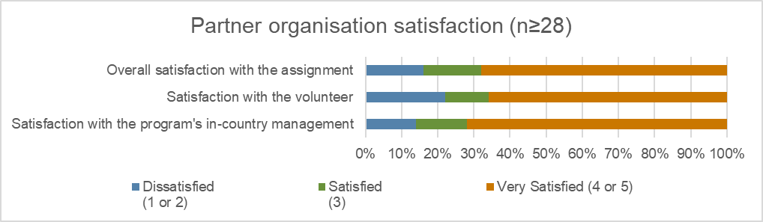

The following graph provides an overview of impact areas that partner organisations contribute towards, which were 60% towards human rights, followed by 22% towards inclusive economic growth.

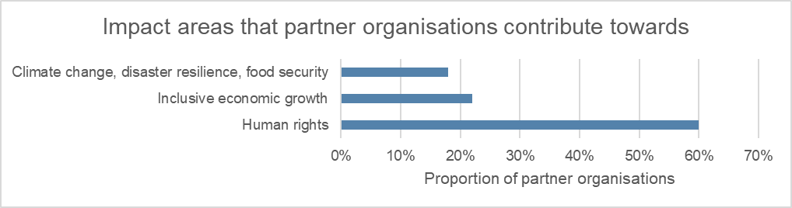

### Supporting our volunteers

Since the commencement of the program 84 volunteers have delivered 105 assignments. The program supported eight approved accompanying dependents. Sixty-five per cent of volunteers were female, 33% were male and 1% preferred to self-describe, with the majority aged 30-39 years old, followed by the 60+ age group and 50-59 age group, as shown by the graph below.

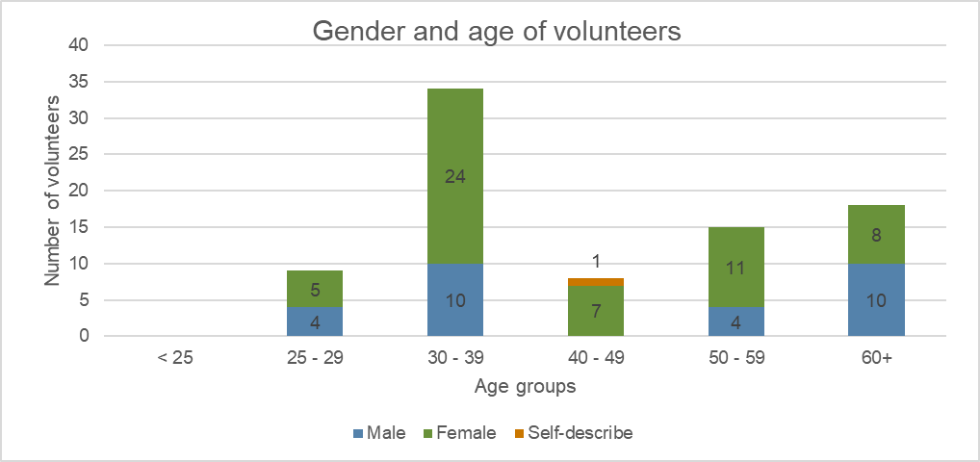

The following graph illustrates the duration of assignments. Most assignments were 0-6 months long (38%), followed by 12+ months (36%) and 7-12 months (26%).

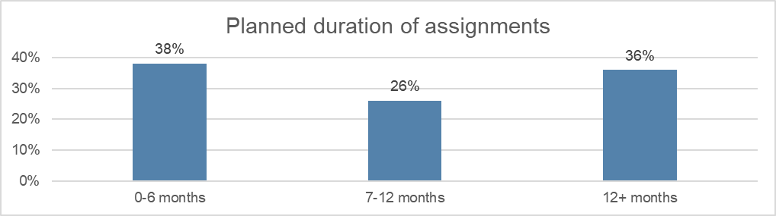

Eleven per cent of volunteers returned home early from their assignments. Reasons for early returns included health issues, family issues, dissatisfaction with assignments and personal issues. Seven per cent of volunteers had their assignments extended.

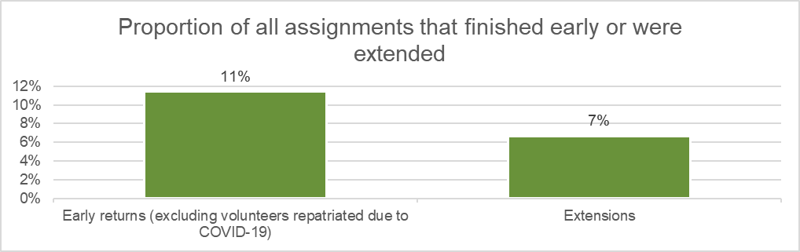

As shown in the chart below, most volunteer assignments were in Dili (82%) with the remaining in-country assignments taking place in Baucau (4%), Manufahi (2%), Aileu and Ermera (1% each). Ten per cent of assignments were delivered remotely.

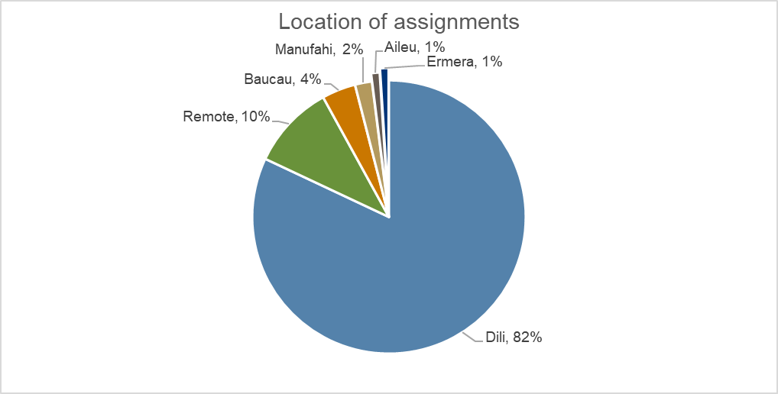

The following graph shows the most common professions of volunteers were community and social development (21%) and business, finance & human resources (HR) (also 21%), followed by media and design (18%).

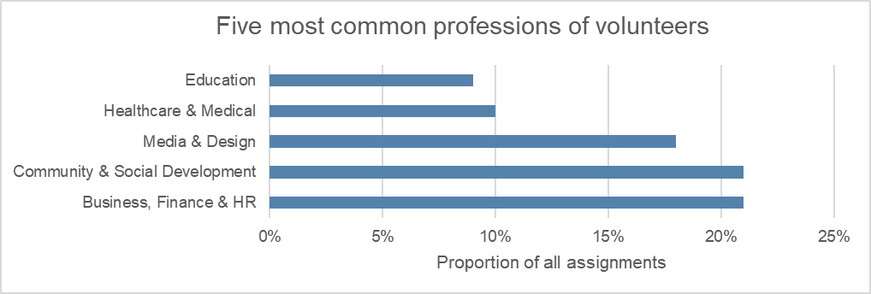

The following graph illustrates the alternative volunteering modalities and partnership assignments. It shows that most assignments were remote volunteering (10) and COVID-19 response assignments (10).

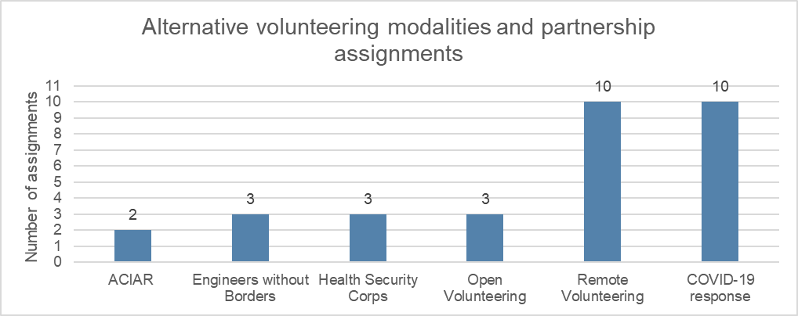

The graph below indicates that most volunteers (83%) reported that they were ‘very satisfied’ with program, 83% were ‘very satisfied’ with safety and security management and 80% were ‘very satisfied’ with the in-country management.

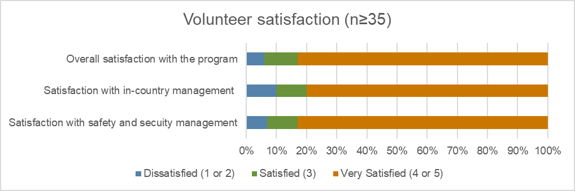

Thirty-one volunteers were repatriated because of COVID-19 and two volunteers remained after the COVID-19 pandemic was declared. One volunteer returned, self-funded, to support the Alola Foundation.

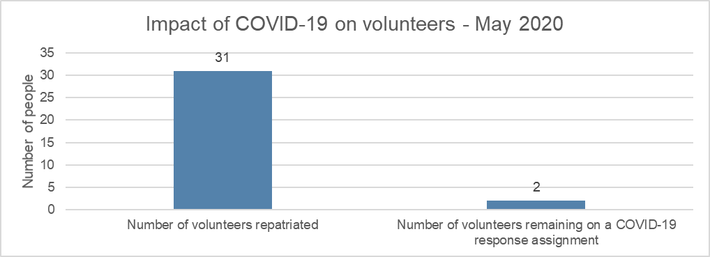

# Stakeholder perceptions

## Program staff

**The program’s activities and outcomes align closely with partner organisation needs and priorities**. Program staff believe the program supports partner organisations to meet their objectives. Activities are designed around the priorities and needs of the partner organisations and generally also align with the Government of Timor-Leste’s (GoTL) strategic plan and DFAT country priorities.

**The program’s logic remains relevant and is used to inform management of the program.** The country plan isrevised annually in line with the program logic and is agreed and confirmed with partner organisations and DFAT.

**The program has strengthened the capacity of partner organisations.** Program staff believe that capacity strengthening of partner organisations and government institutions has occurred, particularly in relation to technical skills and communications. They believe that the level of capacity development achieved varies according to assignment length, and that some assignments need to be longer to strengthen capacity development outcomes.

**The program contributes to Australia’s soft power.** Program staff stated that the program creates people to people connections and cultural awareness which they believe contributes to Australia’s soft power. Staff referenced the many volunteers who maintain contact with their partner organisations after the assignment has concluded. They also noted that a high proportion of volunteers return to Timor-Leste for a follow-up assignment and to maintain the friendships developed through their previous assignment, demonstrating lasting ties between the two countries.

**The program represents value for money.** Program staff noted that volunteers invest a high level of expertise in partner organisations and that, compared to the cost of technical assistance provided through other programs, this investment represents high value. They noted that engaging local staff in the program office is more cost effective than in previous times when expatriates managed the program in country.

**The corporate governance arrangements support efficient decision-making and program management**. Program staff noted that decision-making processes are efficient and effective. Regular meetings are held to monitor program progress, resolve issues and challenges, and ‘shape’ the program. The program staff said they receive good support from the regional office in terms of program implementation and other needs.

## DFAT staff

**The program is seen as the least strategic of all DFAT programs in Timor-Leste.** Staff at DFAT Post believe that program activities and outcomes could be better aligned with DFAT country priorities and GoTL development priorities. Staff attributed low levels of alignment to a lack of Post influence over the program and the broad nature of the strategic documents used to qualify assignments. Further, while the program is willing to be responsive to the needs of Post, staff felt that this is made difficult by the ‘structure’ of the program. Staff suggested that increased engagement between the program and GoTL would strengthen the program’s contribution to DFAT’s development agenda.

**DFAT post staff believe that the Australian public does not have a great deal of awareness of the program.** DFAT staff also offered views on awareness and perceptions of the program In Timor-Leste. They suggested that though the program is largely seen as just another part of the development ‘ecosystem’, the program’s reputation may occasionally be negatively impacted when an assignment doesn’t deliver anticipated outcomes or a volunteer is perceived as ineffective. It was noted that legacy issues related to past Australian development assistance to Timor-Leste may explain current perspectives.

DFAT staff are of the view that stakeholders in Timor-Leste are aware of the previous iterations of the program but have limited knowledge on the evolution of the brand or changes in branding. DFAT staff suggested little importance is placed on the changes to branding in Timor-Leste, with people seeing virtually no difference between Australian Volunteers International (AVI) and the Australian Volunteers Program. Brand recognition tends to favour AVI, however stakeholders are largely aware that the program is funded by the Australian government.

**The program’s contribution to diplomatic relations and Australia’s soft power is perceived as relatively minor.** DFAT post staff suggest that the soft power gains from the program are minor because of the low number of volunteers placed in government agencies. They believe that the design and structure of the program limits the potential for soft power benefits, as they see the program is not really promoting Australia’s identity with government stakeholders. However, it is important to note that the program aims to work through Post to achieve public diplomacy outcomes. Senior government officials, including the Prime Minister are very aware of the program and speak highly about the program’s contribution to the government of Timor Leste’s priority on capacity building.

**The program represents value for money.** DFAT staff praised the program office’s in-country location and efforts to recruit national staff. These decisions demonstrate good value for money. DFAT staff also praised the performance of the country and regional directors in this space.

**The program is effectively supporting Timor-Leste’s COVID-19 response.** The remobilisation of volunteers working in critical roles, particularly in the health sector, was an effective mechanism to support Timor-Leste’s COVID-19 response. Two volunteers remained in-country to support the implementation of triage and reporting processes within the health system. The program’s willingness to support this mobilisation in a high-risk environment was appreciated by Post and demonstrated a clear difference in responsiveness between the Australian Volunteers program and programs implemented by other delivery partners. DFAT staff reflected on a lack of visibility over and reporting on remote volunteering and so were unable to comment on the effectiveness of this new modality.

**DFAT staff encouraged a greater degree of targeting and competitiveness within the program to attract higher calibre applicants leading to improved reputation.** They suggested that this could be coupled with training and flow-on opportunities which reflect that of the Overseas Development Institute fellowship program. Moreover, staff described the branding of the program as ‘old school’ and highlighted that the use of the term ‘volunteers’ does not accurately reflect the reimbursement involved. Finally, DFAT staff again recommended that the program work more closely with GoTL.

## Government staff

**Program activities and outcomes align closely with the needs and priorities of Secretary of State for Equality and Inclusion (SEII).** By working collaboratively with partner organisations and SEII to develop assignment terms of reference prior to recruiting volunteers, the program is successfully responding to the key needs and priorities of SEII. Recent volunteer assignments have supported SEII to develop a gender integrated framework and gender-based violence database. SEII staff extended their appreciation to the program for the support afforded to them to date.

**The program supported SEII to build capacity.** SEII staff acknowledged that, through the support of the volunteers, SEII sustainably strengthened individual and organisational capacity. Examples included improving English language skills, developing guidelines, and enhancing monthly reporting mechanisms and standards. SEII noted that the latter has allowed them to provide accurate reporting on outcomes to the Office of the Prime Minister.

**Australian volunteers gain personally and professionally through diverse experiences.** SEII staff stated thatvolunteers benefit from the opportunity to learn about development in Timor-Leste, a post-conflict country. Volunteers gain insight into the lived experience of people living in a post-conflict society and develop an understanding of how to navigate diverse and difficult barriers to change. Government staff added that the volunteers learn cultural context and the local language which they can then share with Australian society when they return home.

**The program brings a significant contribution to Australia’s ‘soft power’ and diplomatic relations between Timor-Leste and Australia.** In general,staff stated that Australia has significant soft power influence due to wide-reaching development initiatives which engage with many government and non-government stakeholders. They felt that the people to people and government to government links forged through a focus on developing capacity and influencing partner government systems and strategies represented a long-term and sustainable commitment to engaging with Timor-Leste. SEII were cognisant of the direct influence Australia exercises on the Timor-Leste government’s policy decisions through aid investments which involve embedded technical support within government. They associated the presence of volunteers in Timor-Leste, both Australian and not, with increased foreign policy influence. Finally, SEII suggested that volunteers, and therefore Australia as a country, gain an understanding of Timorese culture and social contexts which in turn strengthens Australia’s capacity to build influence in the country.

**Proactive and timely support is a strength of the program.** SEII noted that the program is prompt to respond to requests and demonstrates efficient decision-making. They praised the program office for their willingness to support when issues arise.

**The continuation of COVID-19 and difficulties in volunteers adapting to the working environment form the key challenges to the program.** SEII staff stated that COVID-19 has prevented the implementation of their strategic plan, with the shift to working remotely forming a large barrier to its implementation. The program has provided remote support however this is felt to be largely inefficient as most staff are unfamiliar with the systems and processes required to successfully conduct remote work. Volunteer expectations and ability to adapt to working in Timor-Leste, including navigating language barriers, has and will continue to be a challenge.

**Government staff felt they have little say in the future of the program as it is largely dependent on Australian government foreign policy decisions.** SEII were eager to continue capitalising on the opportunities for skills and systems development that the program provides. They were conscious of the limited timeframe of the program and potential for support to be withdrawn. Suggestions for adjustments to the program included increasing the length of volunteer assignments and providing greater Tetum language training to volunteers prior to their assignment commencing. Finally, SEII were eager to expand their volunteer base and requested an additional volunteer be based at the municipality level.

## Partner organisations

**Partner organisations commented that the activities and outcomes of the program are well-aligned with their strategic plans and priorities.** Partner organisations noted that volunteers supported staff to amend critical skills gaps highly relevant to the work of their organisations. Volunteers also supported partner organisations to secure funding and develop key policy documents aligned to their strategic plans. Further, the program supported one partner organisation in their COVID-19 response.

**The program has strengthened individual and organisational capacity within partner organisations.** Partner organisations listed English language, computer literacy, finance, and proposal and report writing as key skills that volunteers helped their staff to develop. Partner organisations felt that capacity was strengthened sustainably. One partner organisation noted that skills developed through the organisation are being passed on from person to person, and several highlighted that they are now able to carry out many activities without volunteer support.

In a particular success story, one partner organisation described a care centre, set up with volunteer support, which is now considered the best care centre in the country. Two hundred patients receive regular treatment and 90% receive continued treatment, up 50% from the national average. While the volunteer has now returned to Australia the service continues to run.

**Volunteers gain both professionally and personally from their experience.** Partner organisations felt strongly that volunteers benefit personally by learning the local language, building their knowledge of local culture, and fostering strong personal relationships with Timorese people. Professionally, volunteers are exposed to a wide range of often unfamiliar tasks, building their technical skills and strengthening their professional experience.

**The program is part of the development ecosystem which contributes to both Australia’s ‘soft power’ and diplomatic relations between Australia and Timor-Leste.** Partner organisations stated that, as a neighbouring country, Australia has shown strong support to Timor-Leste through its aid investments following Timorese independence in 1999. Australia’s recent support to Timor-Leste’s COVID-19 response was particularly emphasised. Consequently, partner organisations believe that Australia holds a strong influence in Timor-Leste and enjoys strong diplomatic relations. The Australian Volunteers Program is seen as part of the larger aid program which maintains the friendly, neighbourly relationship between Australia and Timor-Leste.

**The program mostly manages queries and support efficiently**. Partner organisations described the program as communicative, pro-active, and quick to respond. Some delays were noted however satisfaction with program support remained high. Partner organisations commended the program’s performance in volunteer placements, managing volunteers, establishing remote volunteering COVID-19 and regular monitoring.

**COVID-19 significantly affected the program’s activities**. Most partner organisations see COVID-19 as a key barrier to the effectiveness and efficiency of the program. Many felt that COVID-19 had hindered the work of volunteers, with remote volunteering not seen as a viable alternative to in-country volunteers. Partner organisations who had retained in-country volunteers were grateful for the support.

**The recruitment timeframe and current COVID-19 pandemic are the key challenges and risks facing the program in the future.** Partner organisations acknowledged that COVID-19 will impede the redeployment possibilities of volunteers, and significant time will be required to source and mobilise new volunteers. One partner organisation located outside of Dili saw the process of recruiting appropriate and willing volunteers as difficult and time consuming. Another partner organisation flagged their current engagement with a volunteer who is self-funding. They worry that the volunteer’s support will cease if the program does not step in.

**Longer assignments would lead to greater gains in capacity development**. Partner organisations stated that the current program strategies work well however increasing the length of volunteer placements would do more to strengthen capacity development and lead to greater sustainability. Suggestions ranged from two to five years, with one organisation suggesting that volunteers remain for the entirety of the implementation of their strategic plan. Another organisation suggested the program work with universities to develop places for students, suggesting that this would lessen the time required to recruit and mobilise a volunteer.

# Case studies of partner organisations

## Engineers Without Borders

Engineers Without Borders (EWB) Australia has worked with Timor-Leste for over a decade to improve the quality of life of people living and working in disadvantaged communities. Their work focuses on building the capacity of the people who live and work in these communities to achieve positive, sustainable, and long-term change. In Timor-Leste, EWB work across a specific range of thematic programs, including [water, sanitation and hygiene,](https://www.ewb.org.au/project/wash/)[education & training,](https://www.ewb.org.au/project/education-and-training/) [professional skills development,](https://www.ewb.org.au/our-impact/our-community-approach/timor-leste/%20https:/www.ewb.org.au/project/professional-skills-development/) and women in engineering.

EWB have established partnerships with local organisations to ensure solutions are evidence-based, relevant and, importantly, approved by each community. This case study focuses on EWB’s partnership with Feto Enginhera. Feto Enginhera was formed in 2014 to support the technical and engineering careers of women in Timor-Leste. Less than one in five Timorese engineering graduates are women. Due to various cultural and family barriers, even fewer women continue to develop an engineering career.

### Relevance of the program’s support

The program’s activities are aligned with the needs and priorities of EWB. Like the Australian Volunteers Program, EWB focuses on building the capacity of the people who live and work in local communities in a manner that is sustainable and promotes long-term change. Both EWB and the volunteer stated that the program has addressed the needs and priorities of Feto Enginhera through the support to project management and provision of highly relevant technical expertise. The volunteer interviewed cited relevant work experience and a suitable academic background in gender equality and engineering which was directly applicable to her placement.

### Impact on organisational capacity

EWB feel that Feto Enginhera has sustainably strengthened capacity through their involvement with the program. Strategy development and implementation was a key focus of the relationship between Feto Enginhera and the program, including preparing for Feto Enginhera to transition away from EWB and become an independent NGO. To this end, the volunteer supported strategic planning and thinking, sharing tools, and holding capacity building workshops to ensure continuity once the assignment ends. She also helped staff build their English language skills to improve communication with international donors and agencies.

### Benefits to volunteers

Both EWB and the volunteer identified cross-cultural learning and the establishment of personal relationships as key benefits experienced by volunteers. People to people and institutional linkages were also referenced, as the volunteer works in a similar space in Australia. She built professional networks which enable sharing of best practice between Australia and Timor-Leste. Finally, by supporting Feto Enginhera in their strategy development, the volunteer further developed her strategic planning skills.

### Diplomatic benefit to Australia

EWB suggested that volunteers working with local NGOs, businesses, government, and institutions increases the visibility of the program and therefore the visibility Australian aid. The genuine and committed approach of the volunteers also creates positive perceptions of Australian people. The volunteer added that the increasing opportunities for collaboration established through the program further benefits the diplomatic relationship between Australia and Timor-Leste. EWB also argued that return volunteers sharing their experiences with the Australian public will promote the role of Australian aid on a national level.

### Future directions of the program

While both EWB and the volunteer commended the program for its flexibility and adaptability during COVID, EWB were concerned that remote support could not deliver the same level of capacity development outcomes for partner organisations as in-country assignments. EWB felt that the longer volunteers are not mobilised in-country, the more difficult it would be to restart the process in the future. They did however note that remote volunteering could help to keep volunteers interested in the interim.

Suggestions for improving the program included:

* Increased incentives for volunteers to undertake remote volunteering i.e. larger allowance
* Improved language training for volunteers
* Engaging with high schools to increase interest in the program
* Greater effort connecting volunteers in-country
* Greater clarity and communication around the programs processes.

## National Directorate of Veterinary Services

The National Directorate of Veterinary Services (DNSV) is a government department attached to the Ministry of Agriculture and Fisheries. The Directorate is responsible for managing policy and services in relation to animal welfare.

### Relevance of the program’s support

Both DNSV and their volunteers recognised that the program’s support is aligned with the needs and priorities of the partner organisation. As the directorate have limited staff with limited skills and knowledge in animal health, particularly in clinical examination and diagnostics, the ability of the program to fill these skills gaps directly aligned with their needs. DNSV staff in the field directly told one volunteer that the skills and knowledge she provided were helpful to them and their work. Despite COVID, the volunteers keep in touch through remote support and WhatsApp to assist the partner organisation on a regular basis.

### Impact on organisational capacity

DNSV acknowledged that program, through its volunteers, has sustainably strengthened the capacity of the staff in the technical skills of animal physical examination and disease diagnosis. Moreover, the technical staff have gained skills in recommending appropriate medical treatments. Staff also practice English daily, through conversations with the volunteers, and so DNSV staff have improved their skills in general English conversation and technical language.

One volunteer supported the organisation’s management to improve document drafting skills, as well as formal email correspondence with international organisations. Another noted that partner organisation staff can now manage their cattle facilities independently and know how to maintain the health and wellbeing of the cattle.

### Benefits to volunteers

Both DNSV and the volunteers stated that, as result of the program, the volunteer gained personally and professionally. All stakeholders reflected on the personal and professional friendships and relationships built between local co-workers and volunteers. As described above, one volunteer remains in contact with partner organisation staff through a WhatsApp group used to share information and support exchanging knowledge and ideas.

Volunteers also gained an understanding of the local cultural context and language. One volunteer described the opportunity the program provided to turn theoretical knowledge into practice. The volunteers also gained an understanding of Timor-Leste government office procedures, documentation, and correspondence.

### Diplomatic benefit to Australia

In general, DNSV said the relationship between Timor-Leste and Australia is strong, citing the Seasonal Worker Program and the Pacific Labour Scheme as important investments which strengthen the diplomatic relationship between the two countries. The Australian Volunteers Program is visibly supporting organisations in Timor-Leste, including government organisations, which helps to grow Australian influence in the country and create a positive impression of Australian people. Volunteers felt that Australia and Timor-Leste, due to long-running ties, have an amicable relationship.

### Future directions of the program

DNSV stated that the program’s support was working well, however both DNSV and the volunteers found that remote volunteer support was less efficient and effective than in-country support. Volunteers felt that their roles required an in-person presence, and technology issues were cited as a key pain-point in relation to remote support. DNSV also felt that staff would struggle to engage with volunteers via online correspondence. To support better outcomes, all stakeholders recommended that volunteers be on the ground to deliver support. Volunteers also suggested that more language training and longer assignments would benefit the program.

# Conclusion

In the three years from 2018-20, the program has operated in Dili, Baucau, Ermera, Aileu. The program is no longer operating in the special zone of Oecusse.

Overall, the program’s objectives and design are aligned with the Aid Investment Plan. The priorities are improving livelihoods, enhancing human development, and strengthening governance and institutions. The three thematic impact areas are aligned well with the Timor-Leste Country Program. The program’s activities and outcomes also cover the main needs of partner organisations. However, some activities were not implemented according to plan due to COVID-19. Partner organisations see the program positively as the program supports partner organisations in addressing the capacity gaps in their organisations through volunteer assignments.

The program has strengthened the capacity of partner organisations with the involvement of volunteers. The program has assigned 84 volunteers to 59 organisations across Timor-Leste to deliver 105 assignments. These assignments have delivered outcomes which partner organisations have found beneficial. Volunteers were able to adapt to the online platform and the program was flexible enough to meet volunteers’ and partner organisations’ needs through remote volunteering during the pandemic. While not all partner organisations were comfortable or familiar with working remotely, they were still eager to continue engaging with the program.

Program staff, partner organisations and government perceptions of the program are positive about the support provided to partner organisations in Timor-Leste. DFAT post staff however, are less positive and believe the program could be more strategic. One interviewee noted that the program does not have a good reputation in Timor-Leste.

Partner organisations and volunteers believe the program activities benefit the volunteers personally and professionally. There were learning exchanges between volunteers and partner organisations on new technical knowledge and skills, local language and culture, and social and life skills. The program creates opportunities for volunteers to gain international volunteering experience in a post-conflict, low-income country. Moreover, volunteers have created strong networks with Timorese friends and colleagues.

Generally, stakeholders felt that Australian diplomatic influence is built both by the program itself, and the program in the context of the wider aid investment landscape. The visibility of the program was key to its influence on Australian soft power. Stakeholders noted Australia’s influential investment in human resource capacity with partner organisations. They saw this as working two ways, with Australians also gaining an understanding of Timor-Leste to the benefit of diplomatic efforts. By forging people to people and institutional links, the program activities also strengthen government cooperation and maintain an amicable relationship between Australia and Timor-Leste.

Most stakeholders recognise that current the model works well. However, COVID-19 poses a key challenge and response and recovery efforts, particularly remote volunteering, have received mixed feedback. The need for in-country support to continue was near unanimously argued by stakeholders. Additionally, the case study identified the following key recommendations for future direction:

* Improved language training for volunteers prior to their assignment start date (suggested by partner government, partner organisations and volunteers)
* Longer assignments, sometimes over multiple years (partner government and partner organisations)
* Working with education providers in Australia to engage volunteers (partner organisations and volunteers).

Other recommendations were made to increase the attractiveness of the program, expand communication with government and partner organisations, and improve the volunteer experience