

Country Case Study

TANZANIA

April 2021

Table of contents

1 The country program 1

1.1 Program description 1

1.2 Program performance: January 2018 to December 2020 1

1.2.1 Supporting our partners 2

1.2.2 Supporting our volunteers 3

2 Stakeholder perceptions 6

2.1 Program staff 6

2.2 DFAT staff 6

2.3 Partner organisations 7

3 Case studies of partner organisations 8

3.1 Girls Livelihood and Mentorship Initiative 8

3.1.1 Relevance of the program’s support 8

3.1.2 Impact on organisational capacity 8

3.1.3 Benefits to volunteers 8

3.1.4 Diplomatic benefit to Australia 8

3.1.5 Future directions of the program 9

3.2 Step by Step Learning Centre 9

3.2.1 Relevance of the program’s support 9

3.2.2 Impact on organisational capacity 9

3.2.3 Benefits to volunteers 9

3.2.4 Diplomatic benefit to Australia 10

3.2.5 Future directions of the program 10

4 Conclusion 11

Acronyms

| Acronyms | Definition |
| --- | --- |
| COVID-19 | Novel coronavirus |
| DFAT | Australian Government Department of Foreign Affairs and Trade |
| ECHO | Educational Concerns for Haiti Organisation |
| HR | Human resources |
| NGOs | Non-governmental organisation |
| SDGs | Sustainable Development Goals |
| GLAMI | Girls Livelihood and Mentorship Initiative |

# The country program

## Program description

Poverty is a major problem in Tanzania, contributing to significant and complex development challenges. Almost a third of Tanzanians live below poverty line, and the country faces a number of barriers to development. The economy is largely restricted to agriculture, infrastructure is often insufficient, and local businesses are constrained by limited support and investment opportunities.

The Australian Volunteers Program is an Australian Government initiative that works across the Indo-Pacific region, supporting a broad range of partner organisations to achieve their development goals. In Tanzania, the program is aimed at supporting communities across a range of development priorities. These include women’s leadership, economic empowerment and eradicating violence against women and girls, agriculture, and food security, supporting people living with disabilities, and supporting socio-economic enterprises aimed at reducing poverty levels.

From January 2018 to December 2020 the program partnered with 27 organisations and supported 38 volunteers to deliver 43 assignments across Tanzania. The organisations that partner with the program are provided with skilled, well-prepared Australian volunteers who are committed to developing the capacity of those organisation. The program works collaboratively with partner organisations to develop partnership plans, which map how volunteer contributions will support local capacity development of the partner organisations and ensure assignments have a long-lasting impact. The program also offers opportunities such as partnerships with Australian organisations, networking with other partners and volunteers, and other support opportunities.

The volunteers contributed to the delivery of the Australian Government’s aid priorities in Tanzania including improving gender equality through women’s economic empowerment, reducing gender-based violence and building women’s leadership, supporting people living with disabilities though the delivery of inclusive education and other services, improving basic health services with a focus on maternal and child health, and enhancing the contribution of the agricultural sector to sustainable and inclusive economic growth and food security.

The program initially established partnerships with organisations from three regions (Arusha, Kilimanjaro and Dar es Salaam) and later developed partnerships with organisations in the new Tanzanian capital, Dodoma. A cluster of assignments focusing on disability inclusion were developed for Dodoma region to support the government of Tanzania's formal relocation there. Unfortunately, the temporary suspension of the program due to COVID-19 occurred before any of these new assignments could be implemented.

## Program performance: January 2018 to December 2020

The data presented here is based on a reporting period encompassing the first three years of the program, covering assignments that were active between 1st January 2018 and 31st December 2020. This timeframe falls outside the program’s normal annual data cleaning and reporting cycle, so some inconsistencies may exist with data as previously reported in Annual Reports.

### Supporting our partners

The most common development sectors that assignments contributed to were government and civil society, education, health, and other social infrastructure and services as shown in the graph below.

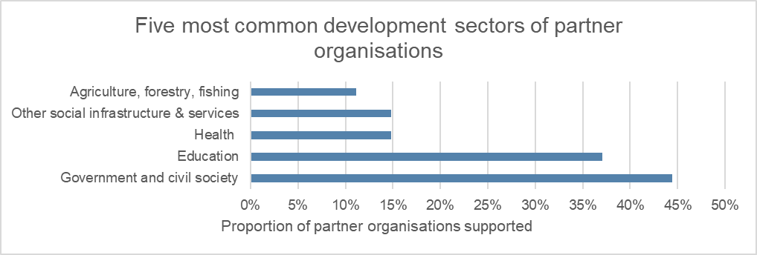

All partner organisations in Tanzania were non-governmental organisations (NGOs) apart from one educational institution and two private sector organisations. National and international NGOs comprised half of the program’s partner organisations in Tanzania, with five NGOs being local or regional in scope.

Complex images: Five most common types of partner organisations. Information above image.


The most frequent Sustainable Development Goals (SDGs) addressed by partner organisations in Tanzania were gender equality, good health and well-being, quality education, decent work and economic growth, and inequality.

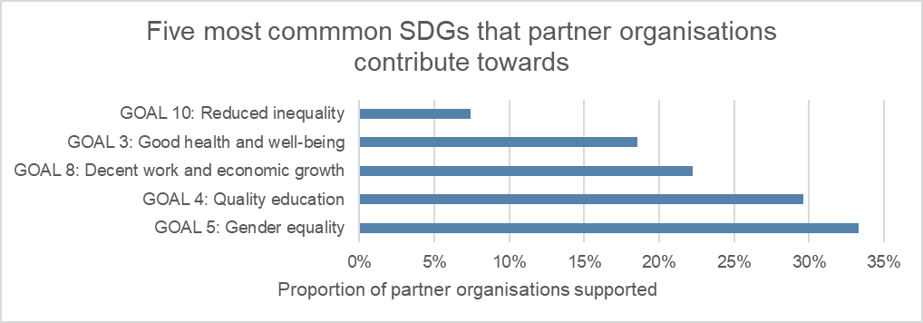

The most typical cross-cutting theme addressed by partner organisations in Tanzania was gender equality. Three partner organisations worked in the disability space, five had a primary focus on child protection and four had a primary focus on private sector as shown in the graph below.

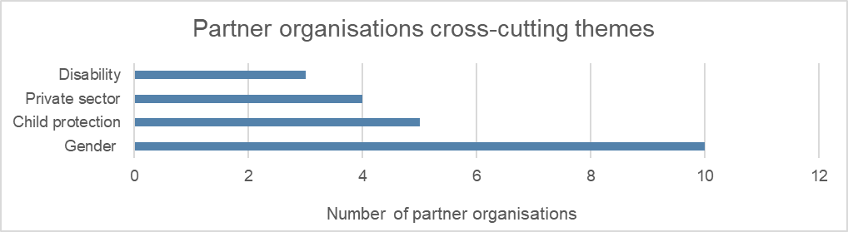

The most common impact area that partner organisations in Tanzania contributed to was human rights, which was due to most partners being NGOs that work in the field of women/youth rights.

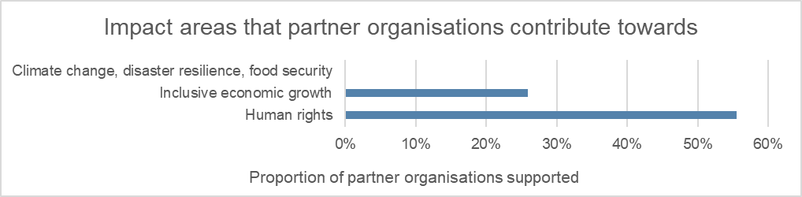

### Supporting our volunteers

Since the start of the program in January 2018, 38 volunteers filled 43 assignments. The program also supported eight approved accompanying dependents. Seventy-four percent of volunteers were female and 26% were male with age between 25 and above.

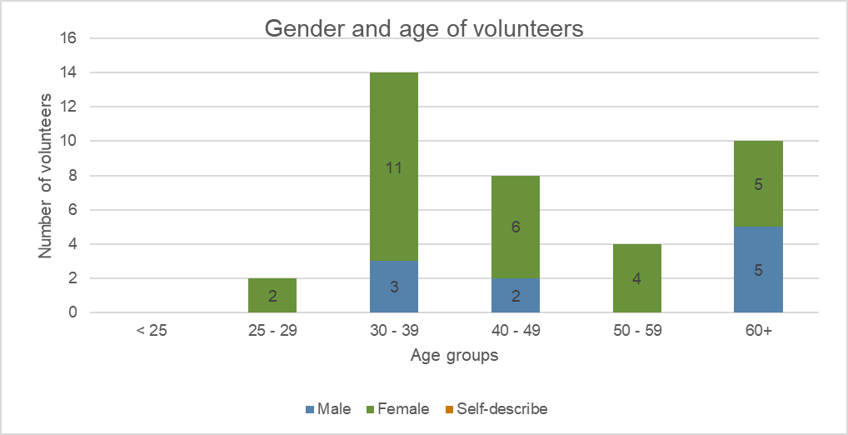

As demonstrated by the graph below, most assignments were 7-12 months long (42%), followed by over 12 months (33%) and 0-6 months (26%).

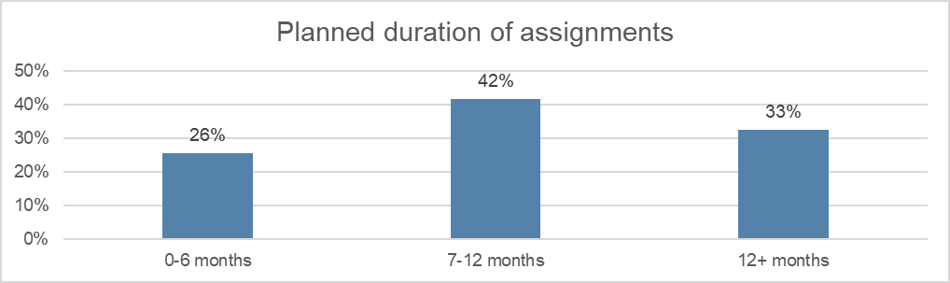

During the implementation of the program, 19% of the assignments finished earlier than planned. This occurred due to the assignment objectives being achieved sooner than anticipated or the volunteer leaving to take up paid employment.

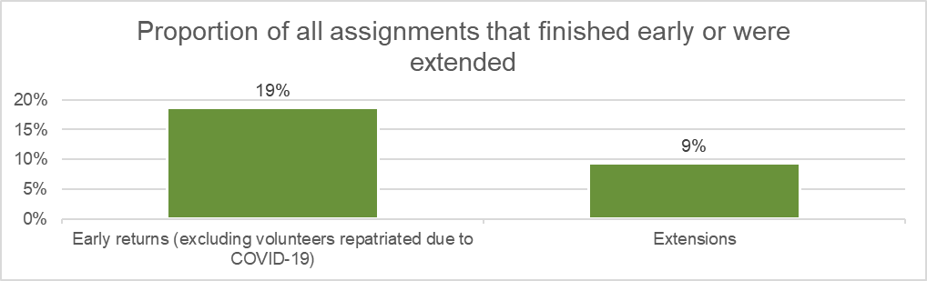

The majority of assignments were in Arusha (65%), Dar es Salaam (21%), and Kilimanjaro (5%) where only 9% of all assignments were located in the remote areas.

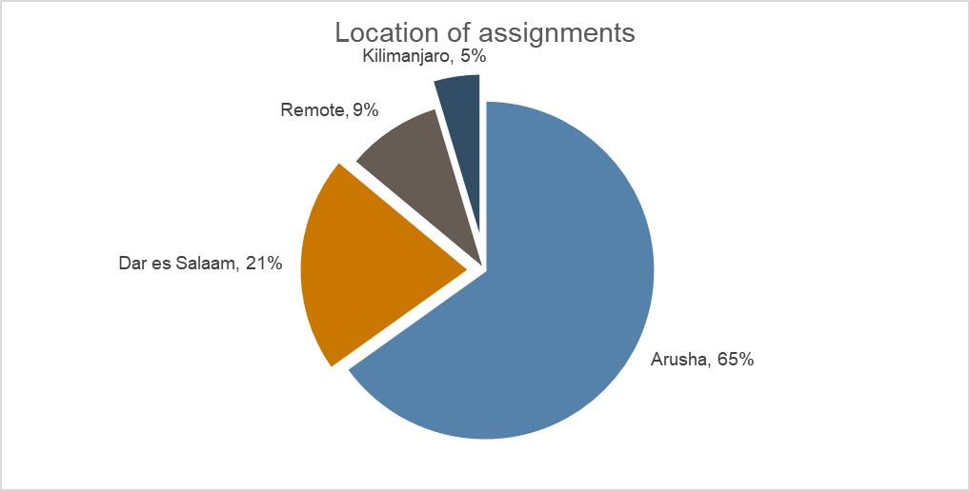

The most common professions of volunteers were media and design, business, finance, and human resources (HR), and education.

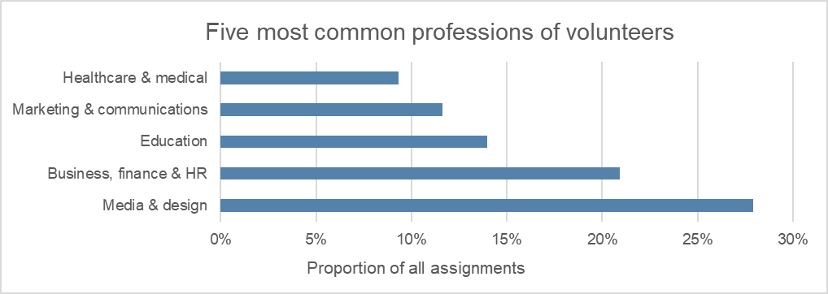

# Stakeholder perceptions

## Program staff

**The program aligns well with the needs and priorities of partner organisations**. Most program volunteers contributed to the overall organisational capacity development in several ways. Some assignments focused on individual capacity development as a result of the staff member working together with the volunteer, while other assignments contributed towards overall organisational capacity development by developing systems and processes or by conducting organisational capacity reviews.

One of the key areas that the Tanzanian government is focusing on is gender parity in governance structures to ensure women occupy the same level or same number of seats in decision making. One of the key focus areas of the program in Tanzania included women’s economic empowerment, women’s leadership, gender equality and eradication of gendered violence. The program in Tanzania also aligned and contributed towards government initiatives on gender equality as well as eradication of gender violence in the country.

**The program selected partner organisations whose focus areas and activities are aligned with the Department of Foreign Affairs and Trade (DFAT) Aid Investment Plan**. At implementation level, partner organisations and in-country program staff used partnership plans to guide their programming and measure partner organisation capacity development. Partner organisations were involved in the execution of the program strategic plan. The program country strategic plan reflects the key objectives of the Australian aid investment plan and the needs of the host country.

**Throughout the engagement, the program prioritised the aspiration and expectations of the partner organisations**. Partner organisations were always consulted whenever there are changes that may impact upon their needs, for example through the new iteration of the program. The program worked alongside individual partner organisations to orient them on some of the program policies and requirements, and make sure they align with their own program activities to contribute towards organisational capacity building. The program worked with a wide range of partner organisations, some were very well developed with systems in place and more confidence working with foreign volunteers. Other organisations were less confident in working with foreign volunteers the program’s support focused more on smaller organisations, building their capacity not only on managing foreign volunteers but also strengthening their internal systems and processes.

## DFAT staff

**The program was well designed to allow adaptation and response to changing strategic priorities.** Due to the COVID-19 pandemic, new needs and constraints emerged which led to the program offering remote support to key partner organisations. This flexibility is a major strength of the program, in that it has allowed the program to pivot in line with new and emerging needs.

**The program was well aligned to the needs and objectives of the partner organisations**. The partner organisations were heavily involved in the execution of the program, starting from the creation of volunteer positions. The existence of a local in-country program manager with extensive local experience and experience with the program benefited the program by creating a good working relation between the program and partner organisations.

**There is better understanding of the program in the urban settings and capital as most of the volunteers are placed in these locations.** Having volunteer stories in the local papers has helped to build the profile of the program in Tanzania and enhance professional development for partner organisations.

## Partner organisations

**The program activities and outcomes align with the needs and priorities of partner organisations**. From the initial crafting of the assignment partner organisations have being consistently supported to identify the skills or expertise they require. The program tried as much as possible to get volunteers who meet the objectives and needs of partner organisations.

**In Tanzania, program volunteers supported partner organisations in different areas and capacities.** One volunteer supportedEducational Concerns for Haiti Organisation (ECHO) in grant writing which helped them to secure one minor and one major grant. This enabled them to recruit another staff member specialising in agroforestry and bee keeping. The organisation was also able to co-present their work at international forums (with support from their volunteers) that provide new opportunities for staff and the organisation.

The program supported Sidai to construct a database of all the texts and external communication that they use for things like social media, website, press releases and engagement with magazines and bloggers. Furthermore, they were supported with successful grant proposals that allowed them to increase their activities e.g. conducting training program on various skills for Maasai women.

The program supported The Foundation For Tomorrow to establish a monitoring, evaluation, accountability and learning system and to review and update their teacher training program while incorporating best teaching practices. The program’s volunteer worked alongside the organisation to build their capacity on how to conduct monitoring and evaluation activities, how to develop tools for monitoring and evaluation, how to gather program best practices and success stories and how to communicate to supporters and other key stakeholders.

**The program strengthened the capacity of both staff and students at Arusha Technical College.** One program volunteer worked together with the college to review their research policies and project guidelines and assisted students on proposal writing and research. Also, the volunteer helped the college to write grant proposals. In addition, the volunteer helped the college to develop a curriculum for mechanical engineering to be used in the 2021–2022 academic year.

# Case studies of partner organisations

## Girls Livelihood and Mentorship Initiative

### Relevance of the program’s support

Since 2018 the program has focused on supporting partner organisations to reach their own development goals. The program has supported Girls Livelihood and Mentorship Initiative (GLAMI) in achieving their development objectives focussing on women’s economic participation and youth engagement.

AfricAid is a registered non-profit organisation based in Denver, Colorado. In 2010, AfricAid Tanzania was founded with the launch of the Kisa Project. In 2020, AfricAid Tanzania became GLAMI, a registered Tanzanian non-profit. AfricAid supports the work of sister organisation, GLAMI, in providing mentorship opportunities to secondary school girls in Tanzania to complete their education, develop into confident leaders, and transform their own lives and their communities. AfricAid is focusing on raising funds and awareness for robust, evidence-based mentorship programs that equip girls to overcome challenges and reach their full potential because educated girls create lasting positive change. Their desired outcome is proactive, resilient, and socially responsible girls who secure better jobs, raise healthier families, and increase the standing of women in society.

### Impact on organisational capacity

The support of the program has strengthened GLAMI capacity. The program has provided volunteer support in two major areas. The first area of focus was to build the capacity of AfricAid in fundraising and grant writing. Through this process GLAMI has gained the attention of large donors that have continued to support them over time. Through the grants received, GLAMI can expand their operation and reach more girls in Tanzania to help complete their secondary education, develop into confident leaders, and transform their own lives and their communities. The second focus area was on communication and media where volunteers helped GLAMI with writing blogs and sharing stories of their success.

### Benefits to volunteers

The program benefited volunteers professionally and personally. On the professional side, GLAMI have a culture of working as a team, meaning staff are not only aware of their area of operation but are also required to take a step further and learn about what other team members are doing. With this work culture, volunteers learnt new skills that were not part of their original assignments. For example, one of the volunteers was good at grant writing but had a limited capacity in writing the budget for the grant proposal. By learning and interacting with the GLAMI accounts department and organisation, the volunteer is now conversant enough to formulate and develop proposal comprehensive budgets for different grant proposals.

Personally, volunteers have benefited from learning about Tanzanian. Through their day to day engagement with the organisation’s female staff, female volunteers come to understand the Tanzanian lifestyle and values when it comes to family and friendship.

### Diplomatic benefit to Australia

There are opportunities to improve diplomatic relations between Australia and Tanzania. The program has faced challenges during the past two years in obtaining work permits for the volunteers to come to Tanzania. The difficulties in obtaining permits have delayed volunteers in providing their support to GLAMI. The organisation strongly believes that, if there was improved diplomatic relationships, and government understanding of why these volunteers are coming to Tanzania, the process of obtaining work permits would be more efficient.

### Future directions of the program

GLAMI believes that the program should use new strategies to strengthen the relationship with the government of Tanzania. The organisation still needs Australian volunteers’ support and intellect, so good relations between the program and the government are fundamental. The program should focus on increasing government awareness of volunteers’ work in Tanzania and their positive impact on country priorities.

Due to COVID-19 restrictions, the program should continue implementing and supporting remote volunteering to ensure the engagement between volunteers and partner organisations continues. However, GLAMI think that partner organisations will face challenges in implementing remote volunteering as some assignments will require the physical presence of volunteers to provide mentorship and training.

## Step by Step Learning Centre

### Relevance of the program’s support

Step by Step Learning Centre is a non-profit special needs educational program established in Arusha, Tanzania. It provides high quality special education for students with learning difficulties at all stages of their development. The program’s mission is to promote the physical, intellectual, psychological, and social development of each child through a holistic educational provision in an inclusive, empathetic, respectful, and stimulating environment. The partner organisation uses child-centred learning methods to encourage all children, including those experiencing learning challenges, to reach their maximum potential.

The program’s support is highly relevant and aligned to Step by Step Learning Centre’s needs and priorities. Step by Step’s vision is to build their own capacity to be able to serve the needs of children with an intellectual disability. The organisation is very much a grassroots NGO with limited funding or infrastructure. Hence, the Australian Volunteers Program is targeting grassroots organisations like Step by Step for professional development and for advocacy.

The organisation recently worked with a program volunteer who was a grant writer. This volunteer wrote grant proposals and raised significant funding for the organisation and created opportunities for the organisation to explore other sources of funding.

### Impact on organisational capacity

The grant writing volunteer strengthened organisation capacity in two ways. Firstly, she built fundraising capacity by engaging donors. In addition, the volunteer was very innovative and challenged the organisation to think through how to become sustainable.

Due to its active engagement in the program, the partner organisation now has more knowledge about what the Australian government is seeking to do in the region, and different Australian government funding opportunities. Step by Step, even after the COVID-19 pandemic and volunteers leaving Tanzania, was able to apply for the Direct Aid Program 2020 grant. The partner organisation thinks this is a great thing for them in the sense that the program is continuing to help strengthening their capacity remotely and working to promote sustainability.

### Benefits to volunteers

Personally, the volunteer learnt from the determination and the sheer resilience that is required from grassroots community-based organisations like Step by Step Learning Centre. The volunteer saw first-hand how difficult it is to strive through daily activities, dealing with unpredictability and the demand to be resourceful and innovative in solving problems.

Professionally, the volunteer benefited from learning the broader aspects of disability services. This included the different types of intellectual disabilities, their causes and treatment, and how these children can be supported in a holistic way.

### Diplomatic benefit to Australia

Step by Step Learning Centre sees the program as a bridge between the Tanzanian and Australian governments. The program supported and strengthened areas that the Tanzanian government could not manage itself due to limited resources. The program also provides a high-profile link between areas that need support and the Australian government. For example, the government of Tanzania is very appreciative of assistance from Australian community grants.

### Future directions of the program

In the future the program should practice longer term engagement of partner organisations to promote their sustainability. The program needs to commit to its vision and take a long-term perspective to capacity building. The program should consider using locals as volunteers especially during this period of COVID-19 and to ensure broader sustainability. However, Step by Step Learning Centre questions whether the program would be able to provide the same level of support to local volunteers as they offer to Australians.

# Conclusion

The program directly contributes to DFAT and Tanzania’s vision to reduce poverty, alleviate suffering and promote sustainable development. Program volunteers lend their expertise to local organisations to promote social and economic development. In Tanzania, the program works with partner organisations to improve equality and opportunity for people with disability, women, and other marginalised groups. The selection of partner organisations that received Australian volunteers was based on a range of factors including an assessment of how the objectives of the organisation align with the partner country’s development priorities, DFAT’s aid investment plans, the SDGs, and the program’s own country strategy.

The program ensures a close alignment between its strategies and activities and the needs and priorities of partner organisations. This contributed towards Tanzanian government initiatives in women’s economic empowerment, women in leadership, gender equality and eradication of gendered violence. Nevertheless, the program interventions in Tanzania were locally driven. Partner organisations themselves set key areas that the program can contribute towards in developing the capacity of their organisation. In addition, the program did not provide support in terms of funding, and this encouraged partner organisations to have a stronger sense of ownership of the program.

In terms of value for money, the program was economical given the limited amount spent in country. In 2019-20, the program spent $600k to support 11 volunteers to work alongside key partner organisations. The program governance arrangements in country ensure the program makes the most out of the dollar value received from the Australian government.

The program strengthened the capacity of partner organisations in three major areas. The first area was resource mobilisation where four organisations, ECHO, Sidai, GLAMI and Step by Step Learning Centre, were empowered to write grant proposals and received minor and major grants that they used to expand the scope of their operations. The second area was information and communication where one organisation, Sidai, put together a database of all external communication including social media, website, press releases, and engagement with magazines and bloggers. The third area was monitoring, evaluation, accountability and learning where one volunteer in the The Foundation For Tomorrow, established a monitoring, evaluation, accountability and learning system for the organisation.

The volunteers, in working with partner organisations, have also benefited both professionally and personally. Professionally, volunteers had a chance to improve their skills in writing grant proposals, working with marginalised groups (e.g. girls, children, and elderly people), budgeting and database development. From a personal perspective, volunteers have benefited by learning Tanzanian culture and traditions that have expanded their understanding of the Tanzanian way of life.

The program enhanced relationships between Tanzania and Australia largely due to the relationships developed at an individual level. Volunteers being able to go back and share their experiences, even the small things that they have learnt about other communities and another culture, has had a positive impact in Australia in terms of peoples’ perception and understanding of Tanzania. This is an entry point for strengthened government to government diplomatic relations in the future.