

Country Case Study
INDONESIA
April 2021

Table of contents
1 The country program 1
1.1 Program description 1
1.2 Program performance: January 2018 to December 2020 1
1.2.1 Supporting our partners 1
1.2.2 Supporting our volunteers 4
2 Stakeholder perceptions 8
2.1 Program staff 8
2.2 DFAT staff 8
2.3 Government staff 10
2.4 Partner organisations 10
3 Case studies of partner organisations 13
3.1 Nurani Perempuan Women Crisis Center 13
3.1.1 Relevance of the program’s support 13
3.1.2 Impact on organisational capacity 13
3.1.3 Benefits to volunteers 13
3.1.4 Diplomatic benefit to Australia 13
3.1.5 Future directions of the program 13
3.2 Asia Justice and Rights 14
3.2.1 Relevance of the program’s support 14
3.2.2 Impact on organisational capacity 14
3.2.3 Benefits to volunteers 14
3.2.4 Diplomatic benefit to Australia 14
3.2.5 Future directions of the program 15
4 Conclusion 16

Acronyms
Acronym | Explanation
AIP | Aid Investment Plan
AJAR | Asia Justice and Rights
BAPPENAS | Badan Perencanaan Pembangunan Nasional (Ministry of National Development Planning), Republic of Indonesia
DAP | Direct Aid Program
DFAT | Department of Foreign Affairs and Trade, Australian Government
GBV | Gender-Based Violence
NGOs | Non-Government Organisations
SDGs | Sustainable Development Goals

The country program

Program description
The program partnered with 117 organisations across Indonesia and supported 186 volunteers to deliver 232 assignments during the first three years of the program (2018-2020). The program successfully delivered a large number of partner organisation events, expanded into new regions, and developed long-term partnership plans.
The program faced significant challenges in meeting volunteer targets during the first half of 2019 due to a low number of applicants. During this time the country faced political turmoil due to presidential and parliamentary elections. There were also several natural disasters, including smoke haze in Kalimantan that led to the evacuation of four volunteers to Bali, and demonstrations about human rights violations against ethnic Papuans. The program responded to these challenges by continuing to develop a strong pipeline of new assignments and increasing engagement with several new partner organisations in new locations.
The program conducted a total of 10 partner organisation workshops and events, along with 11 information sessions between July 2019 and January 2020. These involved 266 staff from more than 90 existing partner organisations and 40 potential partner organisations. These workshops were conducted in Bali, Central Kalimantan, Jakarta, West Nusa Tenggara Timur (Eastern Islands), West Java and North Sumatera. In addition to this, the program also expanded to more remote regions in eastern Indonesia such as Selayar Island in Sulawesi Selatan and Sumba Island in Nusa Tenggara Timur.
In March 2020, Indonesia declared a state of emergency in response to the COVID-19 pandemic, with local and national governments implementing border restrictions and airport closures. Thirty-nine volunteers and six approved accompanying dependants were successfully repatriated by the end of March 2020.
The program continued to maintain and develop relationships with partner organisations and rapid assessments were introduced to better understand the needs and challenges faced by partner organisations. This enabled the delivery of remote volunteer assignments and provided organisations with access to apply for Impact Fund grants.

Program performance: January 2018 to December 2020
The data presented here is based on a reporting period encompassing the first three years of the program, covering assignments that were active between 1 January 2018 and 31 December 2020. This timeframe falls outside the program’s normal annual data cleaning and reporting cycle, so some inconsistencies may exist with data as previously reported in Annual Reports.

Supporting our partners
The program worked with 117 organisations across Indonesia during this period. Most of partner organisations are in Bali, DI Yogyakarta and DKI Jakarta.
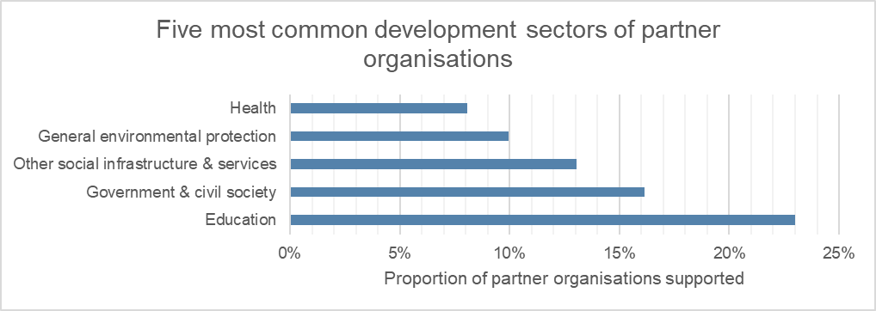
As shown by the graph above, the most common development sectors that volunteer assignments contributed to were education and other social infrastructure and services.
The following graph shows the most common types of partner organisations. These were non-governmental organisations (NGOs) (local and national), followed by academic/research/educational institutions and government (local and national).
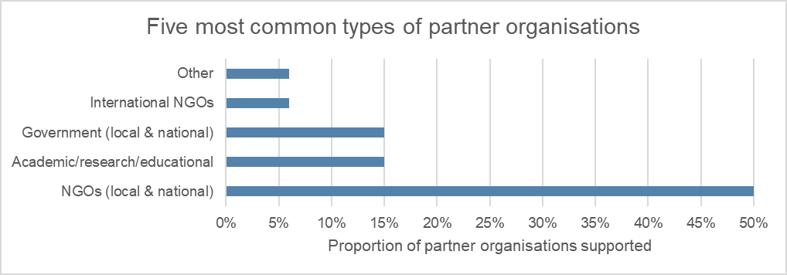
The following graph illustrates the most common Sustainable Development Goals (SDGs) contributed to by partner organisations. These were quality education, followed by good health and well-being.
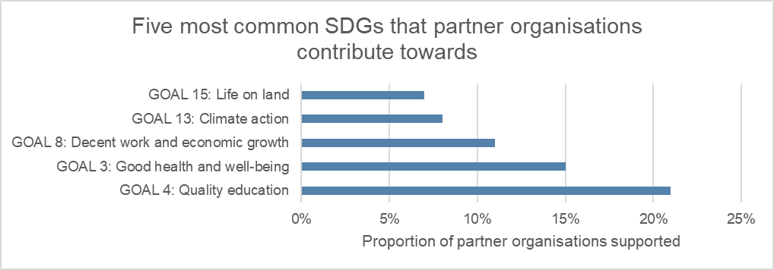

The following graph shows the most common cross-cutting themes addressed by partner organisations which were child protection and gender.
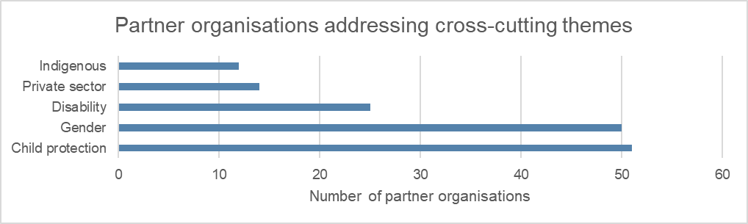
Seventy-one per cent of partner organisations stated that volunteer progress towards achievement of the assignment objective was good or excellent.
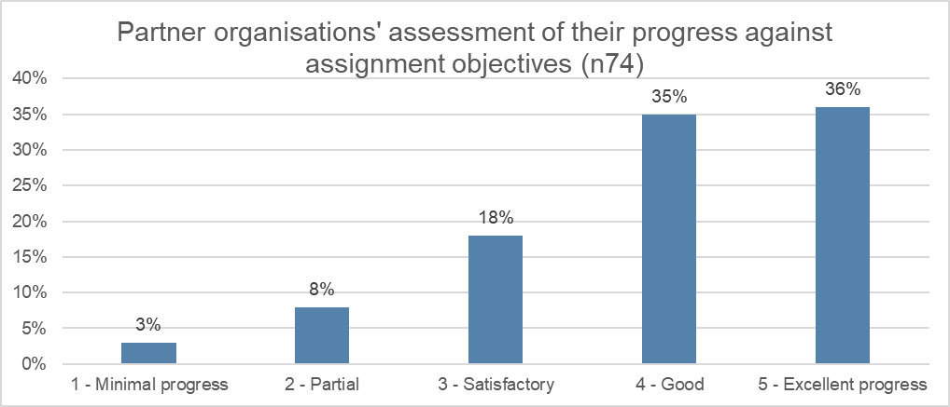
Eighty-five per cent of volunteers reported strengthening capacity at the organisation level, 76% of volunteers reported strengthening capacity at the individual level, and 50% of volunteers reported strengthening capacity at the systemic level.
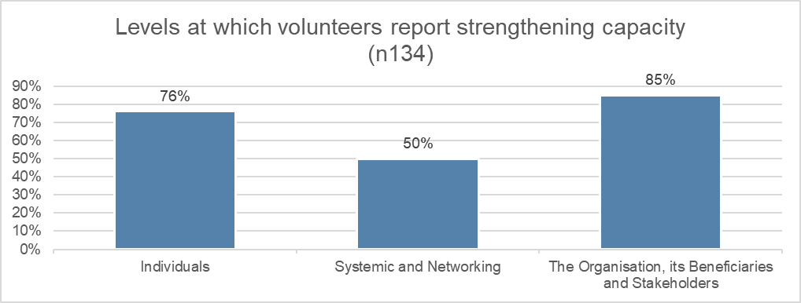
Eighty-three per cent of partner organisations reported that they were ‘very satisfied’ with the assignments, 92% with the volunteer and 92% with the program’s in-country management.
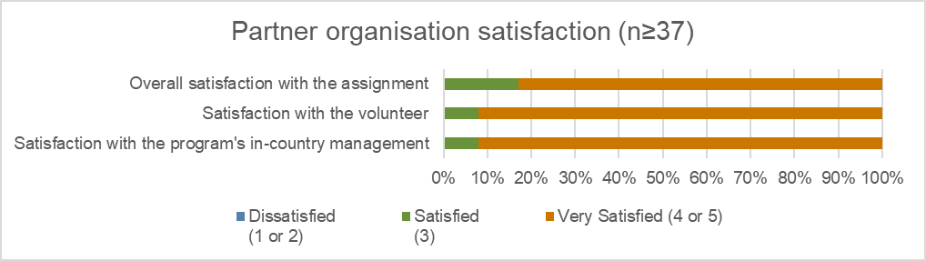
The following graph provides an overview of impact areas that partner organisations contribute towards, which were 38% towards human rights, followed by inclusive economic growth (35%).
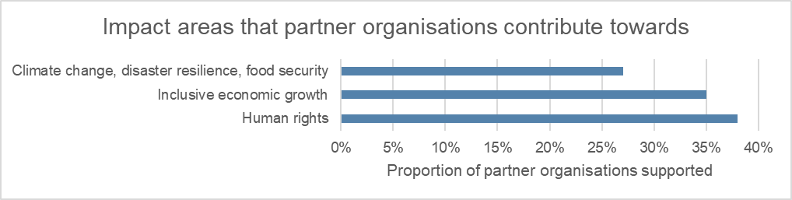

Supporting our volunteers
In total, the program supported 186 volunteers with 19 approved accompanying dependents to deliver 232 assignments. Fifty-nine per cent of volunteers were female, 40% were male and 1% preferred to self-describe, with majority of age group from 30 to 39 years old, followed by 25 to 29 years old, as shown by the graph below.
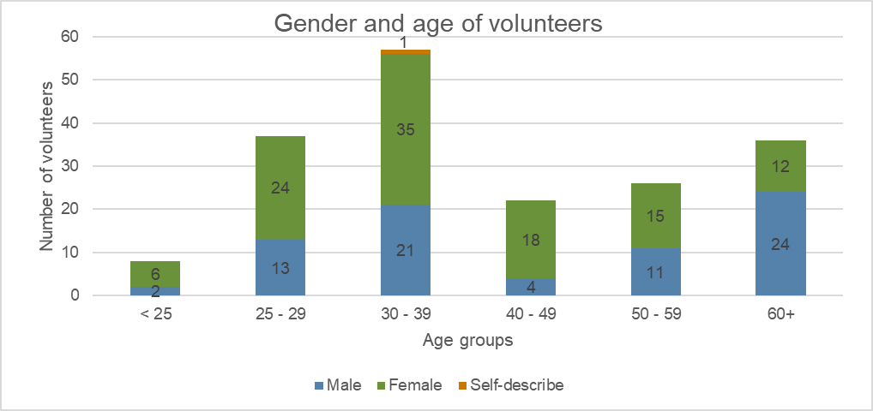
The following graph illustrates the duration of assignments. It shows that most assignments were over 12 months, followed by 7-12 months and 0-6 months.
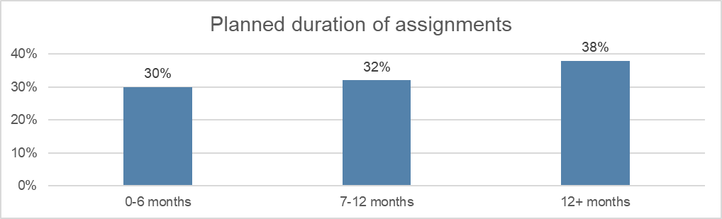
Eight per cent of volunteers returned home early from their assignments. Reasons for early returns included health issues, family issues, dissatisfaction with assignments and personal issues. Six per cent of volunteers had their assignments extended.
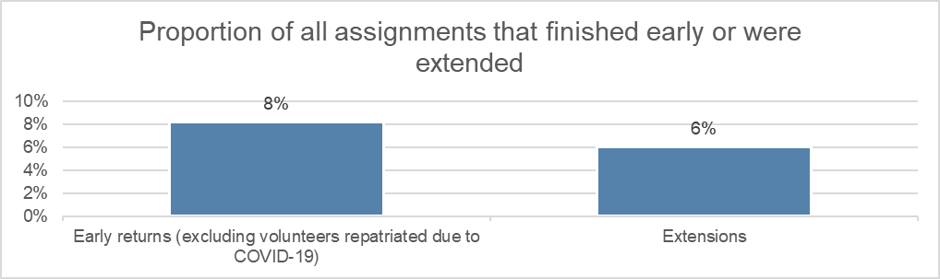
Most volunteer assignments were in Bali (22%), DI Yogyakarta (20%) and DKI Jakarta (11%), while 9% of assignments were delivered remotely.
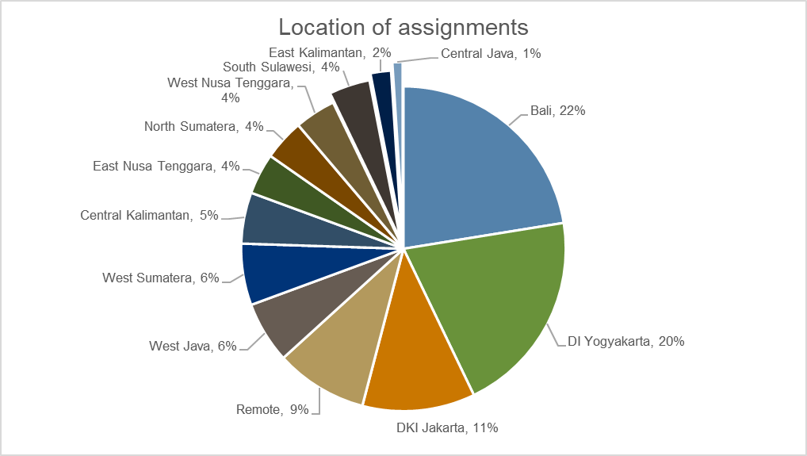
The following graph shows the most common professions of volunteers. The most common profession was media and design.
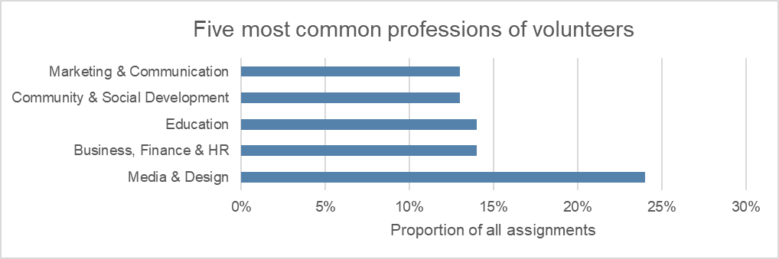
Most volunteers (60%) rated their progress on their assignment objectives as good or excellent, as shown by the graph below.
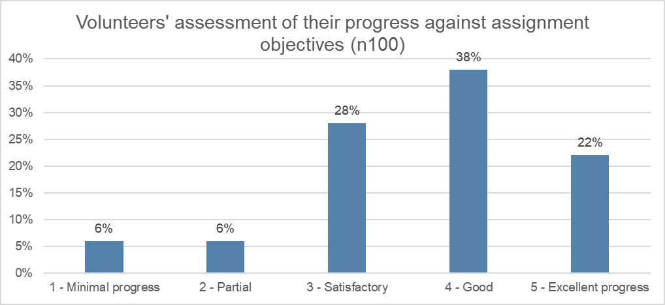
The majority of volunteers (88%) reported that they were ‘very satisfied’ with in-country management, 82% volunteers were ‘very satisfied’ with safety and security management and 81% volunteers were ‘very satisfied’ with the program.
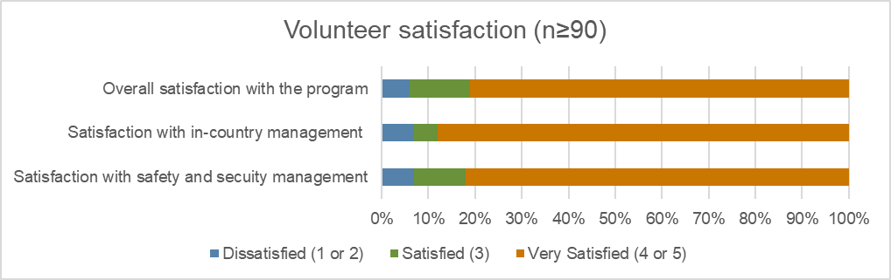
As shown by the graph below, the in-country team successfully repatriated a total of 39 volunteers in May 2020. Repatriation plans were given to program staff and volunteers to explain the situation, action was taken to prepare volunteers to return home, and guidance was given to contact Corporate Traveller to book flights. The repatriation was conducted in two batches (April 17 and April 25) and the main challenges related to changing border policies and significant flight reductions.
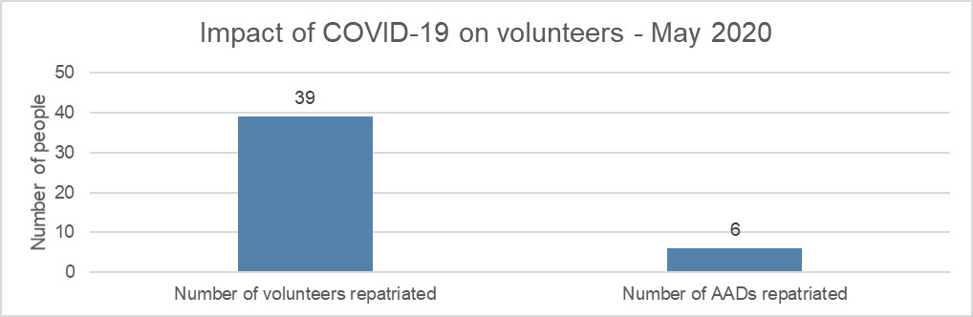
The following graph illustrates the alternative volunteering modalities and partnership assignments. It shows that most assignments were delivered through remote volunteering.
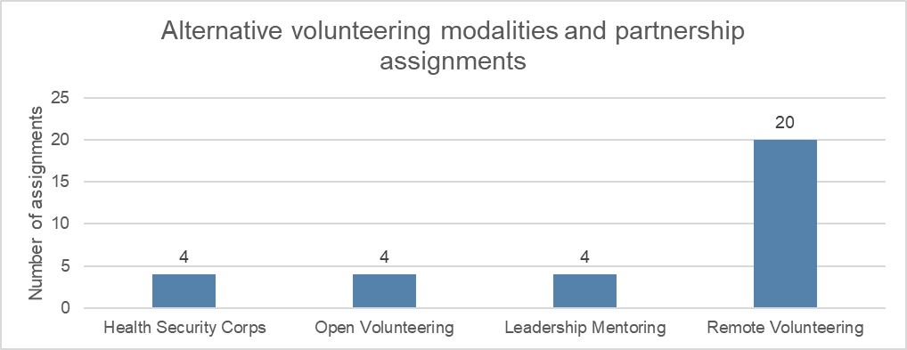

Stakeholder perceptions

Program staff
The program’s activities and outcomes support the main needs of partner organisations. Program staff mentioned partner organisations outlined their priorities and the needs of volunteers based on their organisational needs. However, program staff indicated that some partner organisations still need support in identifying and articulating their needs and priorities that could be supported through the involvement of volunteers. When the program introduced Partnership Plans to partner organisations to look at their capacity needs and how the program can support them to meet those needs, program staff acknowledged that some partner organisations had difficulty in completing the plans, because of the above reason.
The program’s actions are aligned with the program’s logic. Program staff indicated that procedures and frameworks put in place to support the implementation of program’s activities have ensured they correspond to the program’s logic and objectives. Program staff mentioned that the program has solid frameworks, such as the Australian Volunteers Global Program Strategy 2018-2022 and Australian Volunteers Country Strategic Plan, that allow the program to be transparent to ensure good governance applies at the managerial level.
The program strengthens the capacity of partner organisations. Program staff stated that the program supports partner organisations in addressing their capacity needs. It was pointed out through the program’s regular qualitative measurements, and the collection of success stories helps to documents the program’s impacts. However, it is difficult to claim the strengthened capacity of partner organisations is solely due to the involvement of volunteers as partner organisations also received funding from donors to undertake projects that might also contribute to their improved capacity.
The program is perceived to be contributing to Australia’s ‘soft’ power. Staff stated that Indonesian communities at the regional level see volunteers as the face of the Australian aid program. Mostly, volunteers represent Australia in a positive manner. Program staff felt that ‘soft’ power has not influenced national level government as they are not informed about the positive impacts of the program to Indonesian society.
The program represents value for money. Program staff indicated that the program has made the best use of the resources in implementing the activities. The program recruits skilled and well-experienced volunteers to support partner organisations in strengthening their capacity which is more valuable to the program than hiring foreign advisers who have the same skillset to volunteers. Although the program team and volunteers are working remotely during COVID-19, the program keeps running with all activities delivered through online platforms. It is cheaper to conduct webinars and workshops to partner organisations through online platforms and partner organisations are still be able to get support from volunteers through remote volunteering and share their experiences with others.
Corporate governance arrangements support efficient decision making and program management. Program staff believe that the program applies efficient decision-making process in relation to the program’s implementation as the program has regular meetings to discuss the progress, issues and challenges which is helpful in shaping the program. Program staff claimed that they are satisfied with the working relationships within the program team, including the monitoring and evaluation section and highlighted the importance of having efficient communication with the central program team.

DFAT staff
The program’s thematic impact areas are aligned with the Indonesia-Australia Program. The Department of Foreign Affairs and Trade (DFAT) staff stated that the Australian Volunteers Country Strategic Plan for Indonesia was very broad, capturing the diversity of Indonesia, and could be more strategic. Although the program is large and very broad, the three thematic impact areas are aligned well with the Indonesia-Australia program and it allows for flexibility to respond to new opportunities which are slightly outside strategic goals. The program also aligns with the needs and priorities of the Indonesia development program as the assignments of volunteers are based on these development issues.
While it is too early to see solid evidence of program’s impacts over the past three years, there has been some progress towards program’s results. The program provides NGOs in Indonesia with opportunities to learn from volunteers and other Australian organisations. Through support from volunteers, partner organisations can access funding from donors, such as funding from the direct aid program. It tends to be mutually beneficial for both partner organisations and volunteers as they are happy to work together and learn from each other.
The Australian public does not have a high awareness of the program. However, DFAT staff acknowledged that the program is a great opportunity to demonstrate to the Australian public what the aid program does. The program has many positive stories of Australian volunteers’ work with Indonesian community and local partners and provides evidence of Australian aid making a difference to local organisations. DFAT staff also mentioned that while the Australian public were somewhat aware of the program, the program does not get as much airtime as some of the other Australian aid investments.
The new brand of the program is not well known. DFAT staff stated that due to the constant name changes, the program’s brand isn’t well known. It is perhaps too early to know whether this new brand is going to deliver greater recognition, however it is a good start to bring all the different programs under the one name. DFAT staff thought that the change to the unified branding is a positive one and hoping this change has resulted in volunteers no longer identifying themselves as ‘Australian Volunteers International’ or ‘Scope’ but instead ‘Australian Government’ volunteers. One DFAT staff member suggested to call the program a ‘partnership’ than a volunteering program as DFAT is titling its programs ‘Australian-Indonesia Partnership’ since the programs are not just giving funding but working together, given there are also contributions from Indonesian partners. In relation to branding in the Indonesian Government system, the branding is not registered yet in the system as there are some sensitivities about volunteer’s issues and concerns in the past. DFAT staff recognised the difficulty to work with the Government of Indonesia because of the political sensitivities.
The program appears positively to be contributing Australia’s ‘soft’ power. DFAT staff stated that the soft power aspects are probably the greatest benefits of the program. It allows Australia to have a larger footprint in Indonesia which is so important on such a wide and diverse program. A lot of the aid program is delivered through influencing policy reform at the national and sub-national level and having the volunteer program complements this nicely as it sits at a different level and has a local presence through working with NGOs and a better understanding of what is happening on the ground. The program creates lots of links between both Australians and Indonesian community and the program brings a positive profile for Australia and builds stronger people-to-people links. DFAT staff mentioned that the program can tell a positive story about Australia’s international development assistance and the Program is an important vehicle to tell this story. However, there is still a challenge to engage Government of Indonesia due to some sensitivities of volunteers’ issues, and the program can start further discussion to ensure the Government of Indonesia sees the program as more a partnership program.
COVID-19 is still one of the key challenges. DFAT staff stated that due to COVID-19, not being able to have volunteers in country will change the entire program and it will likely affect the Government of Indonesia’s willingness to strengthen their engagement with and involvement in the program.
Strategies for the program’s sustainability. DFAT staff thought that one of the strategies to strengthen the program’ sustainability is the possibility of having local Indonesian volunteers working in country under the program. However, this would not provide any soft power opportunities which is a huge benefit of the program. DFAT staff also felt that having more volunteers working with government would have more development outcomes and potential to align more with the Indonesian government’s priorities. This prospect could be realised through an agreement with the government of Indonesia for the program. It is also worth considering two-way volunteering as this would strengthen ties with partner organisations and lead to more domestic exposure of volunteers. This would also help develop stronger relationships with organisations and countries, and support with resilience and sustainability of the program.
Suggestions for the future. DFAT staff thought that having strong and robust monitoring and evaluation to assess the performance of the program is needed. They believe the program’s reporting structure is not set up to address how the program is going in each country for the purposes of feeding into the global program’s direction.
DFAT staff noted that it is a significant challenge for Post when the program and DFAT have different approaches to how they wanted to handle certain issues, e.g. child protection reporting from a volunteer. They felt that both the program and DFAT could learn from previous experience in issues management in-country. This may indicate the need for a mutual clarification of policy and procedures as there should be no difference between DFAT post and program policy in most matters, and particularly in respect of the child protection example raised.
DFAT staff also thought that, for global programs, providing more flexibility to the people on the ground to deliver ideas which are more locally relevant is needed. They also said that more thinking was needed on how to use returned volunteers as assets of the program and how they can continue to be part of the program.

Government staff
The program’s objectives are aligned with Badan Perencanaan Pembangunan Nasional (Ministry of National Development Planning) (BAPPENAS)’s objectives. BAPPENAS, as partner country (government) representatives, stated the objectives of the program are well aligned with BAPPENAS’ priorities. The program had invited BAPPENAS to several meetings such as the annual reflection meeting in mid-2019.
Partner organisations benefitted from the program. BAPPENAS mentioned that they have not met with partner organisations to discuss the program but acknowledged that the program is useful as it addresses the capacity gaps in knowledge and skills of partner organisations, such as in managerial and technical skills. BAPPENAS also stated that partner organisations can get benefit from the program such as wider networking and increase confidence as the program can address the gaps of partner organisations in knowledge and skills. BAPPENAS also thought that the cooperation between the program and partner organisations should be in the context of knowledge transfer.
The program can penetrate formal diplomacy between two countries as the program focus on people-to-people relationships. BAPPENAS viewed that there are always certain considerations when having government to government relationships, and people-to-people relationships are more subtle in managing those considerations. BAPPENAS also believe that the impacts of the program at the community level have not been fully captured in program reporting.
The capacity gaps of partner organisations are a key challenge. BAPPENAS mentioned that the capability of partner organisations in absorbing the knowledge and skills from volunteers and their English language skills are challenges for the program in addressing the capacity needs of partner organisations. BAPPENAS stated that ensuring the impacts of the program are sustainable is also one of the key challenges.
Strategies for the program’s sustainability. BAPPENAS viewed that an assessment of supply (the availability of volunteers) versus demand (the needs of partner organisations) is needed, especially when the program expands its targets to Eastern Indonesia. BAPPENAS also thought that the program needs to monitor the impacts and use a snowballing approach to expand the impacts to the wider community, as well as create ownership in the community.
The lack of any formal agreement with the Government of Indonesia significantly impacts on the program’s capacity to both engage with government institutions and promote the work of the program. BAPPENAS noted a delay in finalising the Subsidiary Agreement on the program with DFAT. They said they have provided feedback to DFAT, including feedback on sensitivities, and related to past issues with volunteers and potential political risks. They also noted that there had been an organisational restructure within BAPPENAS which may have delayed matters. BAPPENAS proposed to follow up on the draft of the Subsidiary Agreement.

Partner organisations
The program addresses the capacity gaps of partner organisations. Partner organisations viewed the program positively as the program supports them to improve and addresses the capacity needs in their organisations through volunteers’ assignments.
The program contributes significantly and positively in strengthening the capacity of partner organisations. Partner organisations mentioned that the program strengthens the capacity of both volunteers and partner organisations. The program works well when both parties, which are partner organisations and volunteers, are in an equal position where they can learn from each other. For example, partner organisations are very capable in the community development space and volunteers can bring different perspectives to it while learning from the partner organisations.
Partner organisations stated that the involvement of volunteers helps them in networking with international organisations, promoting partner organisations to their networks and strengthening their capability in specific issues such as speech therapy, case management system and mental health.
Volunteers benefitted from the program. Partner organisations stated that the program offers volunteers opportunities for learning exchange and experience. Indonesia is diverse with many tribes and cultures. Volunteers learn a vast array of new knowledge, culture, social and life skills from the Indonesian community. Partner organisations mentioned that the program creates an opportunity to volunteers to implement their skills, actualise themselves and share those experiences with their peers.
The program positively contributes to Australia’s ‘soft’ power. Partner organisations acknowledged that the program can be a medium to introduce Australia to the Indonesian community in a more informal way as the relationship focuses on people-to-people links. It can strengthen the relationship of the two governments and create a significant impact on the diplomatic relations of both countries. However, partner organisations recognised that it is difficult for partner organisations at the grassroot level to see the direct contribution of the program to the diplomatic relations of Indonesia and Australia.
The program manages governance arrangement efficiently. The program performs a good job in program management, from volunteers’ placements and managing volunteers, to applying remote volunteering during COVID-19, as well as conducting regular monitoring to get reports on progress and feedback from both volunteers and partner organisations. However, partner organisations felt that extending the length of volunteers’ assignments to minimum of one year would contribute significantly to the achievement of the objectives of the assignments. Some partner organisations pointed out that there is a need for involving partner organisations in recruitment processes of the volunteers to ensure the right and suitable volunteers are chosen. Some partner organisations also identified a need for the program to communicate its strategic plans to partner organisations to give partner organisations more information on the program’s objectives and on how to achieve those objectives together.
COVID-19 has significantly impacted the program’s activities. Partner organisations claimed that COVID-19 affects the implementation of the program’s activities as partner organisations and volunteers carry out the program’s activities and assignments remotely and have had to adjust to online activities. Partner organisations also mentioned that remote volunteering has reduced the duration for volunteers in providing supports to partner organisations. Partner organisations acknowledged that there is a need for more support from the program for in-country volunteer assignments.
The program adapts well to changes in the external environment. Partner organisations acknowledged that implementing remote volunteering and moving all offline activities, including monitoring the progress, to online shows the program can adapt very well to the changes in the external environment. However, partner organisations found it difficult to obtain the full support of volunteers using online platforms as there is a time limitation for volunteers to deliver their assignments through remote volunteering. Partner organisations particularly valued face-to-face assignments of volunteers as one way to fulfill the objectives. They see direct contact with volunteers as preferrable as this results in a greater sense of cohesion with the volunteers.
COVID-19 remains big challenge. Partner organisations felt that COVID-19 remains the big challenge for the program for the next two years, as each country will focus their attention and resources on their countries’ COVID-19 response and recovery efforts. Helping other countries by providing grants for strengthening the capacity of local organisations will become less of a priority. Partner organisations also identified the need to manage both the supply and demand of volunteers to ensure the sustainability of the program and the availability of volunteers who can address the capacity needs of partner organisations. Partner organisations also believed that language barriers remain a significant challenge for volunteers and staff of partner organisations.
Strategies for the program’s sustainability. Partner organisations believe that the program needs to expand its work with partner organisations in Eastern Indonesia as they are the ones more in need of support from the program to strengthen capacity. Some partner organisations recognised that maintaining good communication with partner organisations would be beneficial for the program in ensuring the needs of both parties can be met. Some partner organisations pointed out that volunteers need to be culturally sensitive to be able to integrate well with partner organisations’ teams and communities.

Case studies of partner organisations

Nurani Perempuan Women Crisis Center

Relevance of the program’s support
The program’s activities are aligned with the needs and priorities of Nurani Perempuan. Nurani Perempuan has a focus on providing services for women victims of violence. The program supports Nurani Perempuan in outlining their capacity needs which are feasible to be address through volunteer assignments. The needs were primarily in building and strengthening the capacity of Nurani Perempuan staff and its volunteers on non-discriminative gender assessment, counselling, and healing sessions for both gender-based violence victims and Nurani Perempuan volunteers, mental health, database management and fundraising. However, volunteers pointed out that even though the program’s activities and outcomes are aligned with the needs and priorities of the partner organisation as stated in its Partnership Plan, there are unclear requirements or specifications of volunteers from Nurani Perempuan. Their needs are very broad and wide while the skills of volunteers are very specific.

Impact on organisational capacity
Nurani Perempuan felt that the program strengthens the organisational capacity of Nurani Perempuan through the involvement of program volunteers (up until now four volunteers). Nurani Perempuan mentioned that one of the volunteers helped them in getting a grant from DFAT through the direct aid program to implement a nine-month-long program on economic empowerment of women survivors of gender-based violence. However, volunteers stated that they only brought small impacts as an individual in strengthening the organisation’s capacity.

Benefits to volunteers
Nurani Perempuan recognised that volunteers have more knowledge on diversity of values in Sumatra Barat, such as religious values and women’s issues in relation to patriarchy’s values, from their volunteering experiences in Nurani Perempuan. Volunteers thought of international volunteering experience as one of the benefits gained from the program, and there is no specific benefit professionally, however they felt that they gained other benefits in soft skills such as patience, communication, and people-to-people skills.

Diplomatic benefit to Australia
Nurani Perempuan felt that the program contributes significantly to the strengthening the capacity of Indonesian communities and highlighted that the program also contributes to partner organisations by introducing new knowledge and approaches. However, it is difficult for Nurani Perempuan to see the direct diplomatic benefit to Australia from volunteers’ assignments in their areas. Volunteers recognised that the program is focussed on people-to-people relationships and brings a positive image of Australia in the Indonesian community.

Future directions of the program
COVID-19 has affected the implementation of the program. The program implements remote volunteering in response to the changing external environment, especially to COVID-19. However, Nurani Perempuan and volunteers found it difficult to deliver assignments using an online platform as the program is more to people-to-people relationships and there is a time limitation for volunteers to deliver their assignments to partner organisations.
As COVID-19 remains the big challenge for the program in the next two years, Nurani Perempuan viewed that helping other countries to strengthen the capacity of local organisations will become less of a priority as each country will put their attention and resources to their countries’ COVID-19 response and recovery efforts. While volunteers pointed out that it is a challenge to finding the right partner organisations that need support from the program, and so suggested promoting the program to wider audiences so that the right and qualified partner organisations know how to access the program.
In relation to future strategies, Nurani Perempuan recognised that volunteers’ awareness of specific issues that are critical to partner organisations, and as such that volunteers will be expected to assist on, is needed. Nurani Perempuan also felt that the program needs to expand its outreach as not many local organisations are aware of the program. Volunteers recognised that identifying qualified partner organisations and setting up the requirements for partner organisations that will receive support from the program is crucial. Volunteers also acknowledged the need for the program to expand the program’s outreach in Indonesia to get more qualified partner organisations participating in the program.

Asia Justice and Rights

Relevance of the program’s support
As an organisation whose aim is to contribute to the strengthening of human rights and the alleviation of entrenched impunity in the Asia-Pacific region, Asia Justice and Rights (AJAR) viewed that the program is aligned with the needs and priorities of AJAR. Volunteers thought that AJAR clearly identified and defined their needs and priorities as an organisation and successfully developed the assignment brief accordingly. However, the intended outcomes of the assignment were better suited to longer-term organisational goals, as there were many steps to be undertaken before these outcomes could be achieved.

Impact on organisational capacity
AJAR acknowledged that the program strengthens their capacity with the involvement of volunteers. AJAR stated that the program assigned senior volunteers to AJAR who share their expertise and practical skills to staff, such as operations and finance management as well as communication. Senior volunteers provide practical skills and build a foundation for partner organisation staff to improve their capacity, while junior volunteers are more focused on having the opportunity to learn something new from partner organisations, such as human rights issues.

Benefits to volunteers
AJAR viewed that the program benefits the volunteers as volunteers are being exposed to human rights issues while doing their assignments and can learn new knowledge and skills. Volunteers felt that the program offers benefits to volunteers to build their professional skills and learn cross-cultural as well as the program provides an opportunity for them to grow professionally and personally.

Diplomatic benefit to Australia
AJAR recognised that the program promotes understanding between two countries as the program is focusing on educational and learning exchanges between volunteers and partner organisations. Volunteers also recognised that the program focuses more on people-to-people relationships so that both parties are equal and power-balanced. The program can support formal diplomacy in a friendlier way as the program is more focussed on relationships between citizens of both countries.

Future directions of the program
COVID-19 has significantly impacted the program. The program responds to COVID-19 by implementing remote volunteering to ensure the support of volunteers to partner organisations continues. However, volunteers felt the limitations to travel moving forward due to COVID-19 will reduce opportunities for shared learnings. Online alternatives will become relatively faceless without the human connection first.
As COVID-19 will remain a challenge for the program in the next two years, AJAR viewed that each country will focus their attention and resources to their COVID-19 response and recovery efforts. Therefore, allocating funding of donors to strengthen local organisations of other countries will be on a low priority. Volunteers also acknowledged that due to COVID-19, conservative governments will take leadership across the region, and the program may shift assignments to align with partner organisations who better support their priorities. For instance, human rights organisations may see less support as part of the program, and instead, livelihoods projects may take the lead.
For future directions, AJAR found that expanding the networks of the program to many local organisations in Indonesia is needed as many local organisations in Indonesia are not aware of the program. Creating a larger footprint for the program is important to get more interest from the Indonesian community and government. Volunteers felt that strengthening the independence of the Indonesia recruitment and program team is needed as they have the best insights into the partner organisation needs and will be best placed to recruit individuals accordingly. Volunteers felt that having volunteer assignments of 12 months minimum with two months for learning Bahasa Indonesia would help them to fulfill their objectives’ assignments.

Conclusion
In general, the program’s objectives and design are aligned with DFAT’s Aid Investment Plan. Although the Australian Volunteers Country Program Plan for Indonesia is quite broad, the three thematic impact areas are well aligned with the Indonesia-Australia Program Partnership and it allows for flexibility to respond to new and emerging opportunities. The program’s activities and outcomes also support the main needs of partner organisations. Partner organisations see the program positively as the program supports partner organisations in addressing the capacity gaps in their organisations through volunteers’ assignments. While not all partner organisations were able to outline clear requirements and specifications of volunteers relevant to their needs, there was support from the program and volunteers to work together with partner organisations to redefine the requirements and the intended outcomes.
The program has strengthened the capacity of partner organisations with the involvement of volunteers. The program has assigned 186 volunteers to 117 organisations across Indonesia to deliver 232 assignments in 2018-2020. These volunteers’ assignments have delivered outcomes which partner organisations have found beneficial. Through volunteers’ assignments, partner organisations gained access to international networking, were able to strengthen their organisational messaging and communication, and secured more funding.
Volunteers see the program as a medium for learning exchanges between volunteers and partner organisations on new knowledge and skills, culture, and social and life skills. The program creates opportunities for volunteers to gain international volunteering experience. Volunteers were able to adapt to the online platform and the program was flexible enough to meet volunteers’ and partner organisations’ needs through remote volunteering during the pandemic. While not all partner organisations were comfortable with online assignments there was a willingness to learn and adapt.
The program is contributing to Australia’s diplomatic influence through local people to people linkages, which is a key benefit of the program. The program can be a medium to introduce Australia to Indonesian local communities in a positive way. The program also can strengthen the relationship of two governments and have a positive impact on the diplomatic relations of both countries. However, it is a challenge to engage the Government of Indonesia due to the lack of a formal agreement being finalised. It is also difficult for partner organisations at the grassroot level to see the contribution of the program to the diplomatic relations of Indonesia and Australia.
COVID-19 response and recovery was a key challenge identified through this case study. The program responds well to the changing of external environment, including to COVID-19.
Suggested future priorities and strategies for the program identified through this case study are:
- Follow up on the agreement with government to facilitate engagement with government and promotion of the program
- Create a larger footprint for the program to get more interest from the Indonesian community and government
- Expand the networks of the program to more local organisations in Indonesia
- Design longer assignments for volunteers i.e. a minimum 12 months, to allow for two months for learning Bahasa Indonesia to help volunteers and partner organisations to achieve their assignment objectives
- Assess of supply (the availability of volunteers) versus demand (the needs of partner organisations)
- Strengthen the independence and input of the Indonesia program team regarding recruitment and selection of volunteers to utilise their insights into partner organisation needs.

