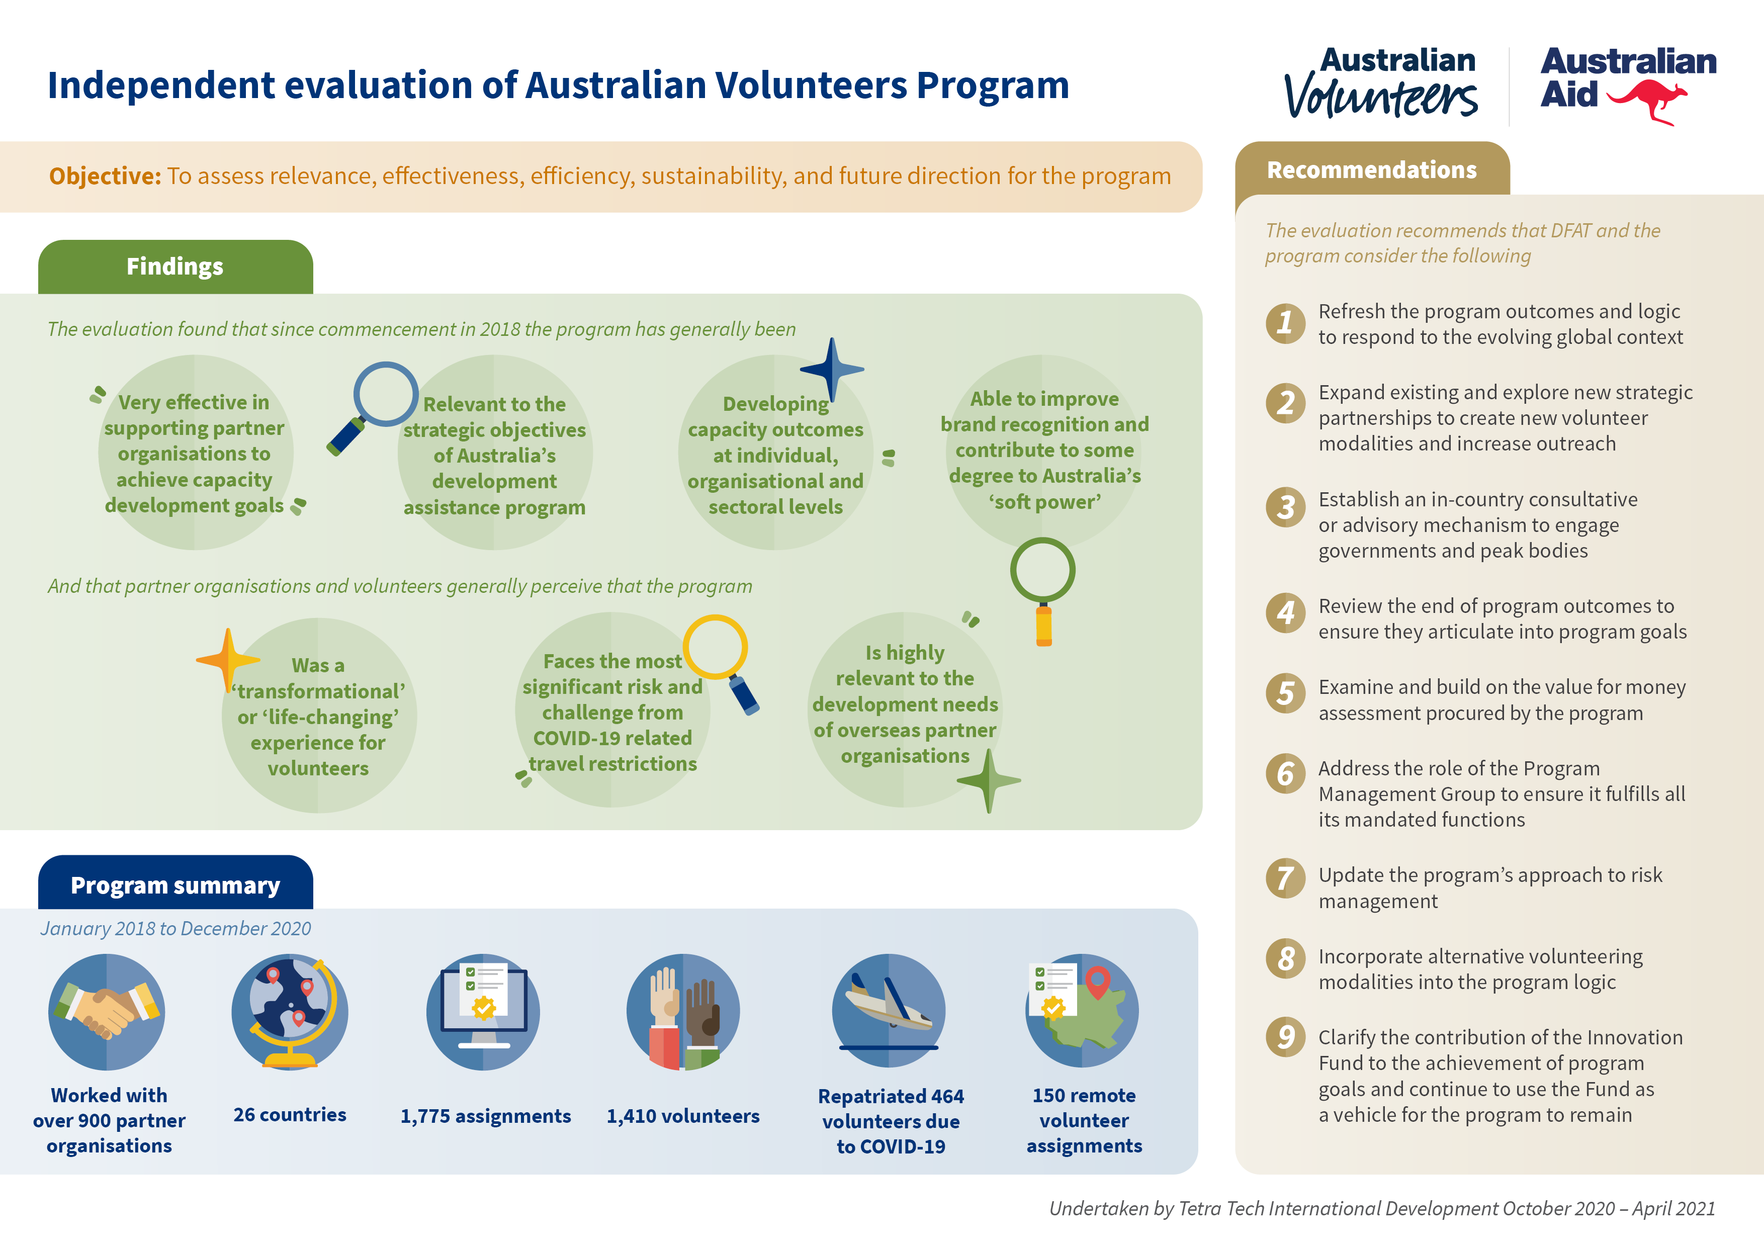

Infographic for Independent evaluation of Australian Volunteers Program. Image shows an infographic broken up into 4 sections: Objective, Findings, Program Summary and Recommendations:

Objective:
To assess relevance, effectiveness, efficiency, sustainability, and future direction for the program

Findings:
The evaluation found that since commencement in 2018 the program has generally been:
Very effective in supporting partner organisations to achieve capacity development goals.
Relevant to the strategic objectives of Australia’s development assistance program.
Developing capacity outcomes at individual, organisational and sectoral levels.
Able to improve brand recognition and contribute to some degree to Australia’s ‘soft power’.
And that partner organisations and volunteers generally perceive that the program:
Was a ‘transformational’ or ‘life-changing’ experience for volunteers.
Faces the most significant risk and challenge from COVID-19 related travel restrictions.
Is highly relevant to the development needs of overseas partner organisations.

Program summary:
January 2018 to December 2020
Worked with over 900 partner organisations
26 countries
1,775 assignments
1,410 volunteers
Repatriated 464 volunteers due to COVID-19
150 remote volunteer assignments

Recommendations:
The evaluation recommends that DFAT and the program consider the following:
1. Refresh the program outcomes and logic to respond to the evolving global context
2. Expand existing and explore new strategic partnerships to create new volunteer modalities and increase outreach
3. Establish an in-country consultative or advisory mechanism to engage governments and peak bodies
4. Review the end of program outcomes to ensure they articulate into program goals
5. Examine and build on the value for money assessment procured by the program
6. Address the role of the Program Management Group to ensure it fulfills all its mandated functions
7.Update the program’s approach to risk management
8. Incorporate alternative volunteering modalities into the program logic
9.Clarify the contribution of the Innovation Fund to the achievement of program goals and continue to use the Fund as a vehicle for the program to remain

Undertaken by Tetra Tech International Development October 2020 – April 2021

