Independent Evaluation

DFAT – Australian Red Cross Humanitarian Partnership 2015–2018

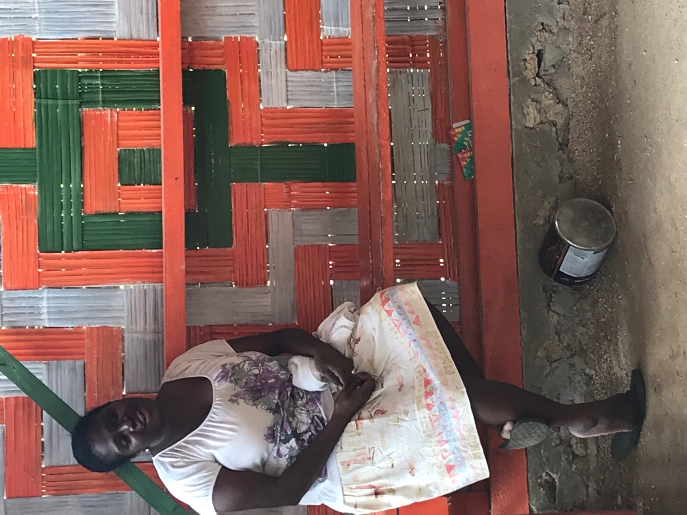

November 2018

# Aid activity summary

|  |  |
| --- | --- |
| Aid activity name | DFAT–Australian Red Cross Humanitarian Partnership |
| Aid initiative number | (INL893) |
| Period | 1 July 2015 – 30 June 2019 |
| Purpose of report | The purpose of the evaluation was to address, first, to what extent has the DFAT investment in the ARC humanitarian response and preparedness activities contributed to the anticipated results and outcomes during fiscal years 2015 to 2017? Second, to what extent has the DFAT–ARC Partnership demonstrated value added as an aid delivery mechanism and contributed to the anticipated results and outcomes for both partners? Third, what then are the implications for a new partnership design, recognising ARC’s ability to deliver against DFAT’s *Foreign Policy White Paper* commitments, DFAT’s *Humanitarian Strategy* and Australia’s commitments under the *Sendai Framework for Disaster Risk Reduction 2015–2030*, the *Agenda for Humanity* and the *Grand Bargain*? |
| Total Australian commitment | AUD28.8 million |
| Delivery organisation | Australian Red Cross |
| Location | Global with a priority focus on the Indo-Pacific region |
| Primary sector | Humanitarian |

*Acknowledgements*

The photograph on the front cover shows a Red Cross volunteer in the Community Disaster and Climate Change Committee in Chapui, a peri-urban community on Santo Island, Vanuatu. The photograph has been reproduced with the permission of the volunteer and the photographer (Graeme Storer).

The evaluation team comprised Graeme Storer (team lead), Donna Holden (partnership effectiveness), Isabelle Choutet (independent Vanuatu-based disaster risk reduction specialist), Veronica Bell (ARC representative) and Sharon Hicks (DFAT, contributions to field visit debriefs). The team brought to this evaluation humanitarian; program management; disaster risk management; gender equality and disability inclusion; partnership brokering; and monitoring and evaluation expertise along with a sound understanding of the national and international contexts and corporate knowledge of DFAT’s systems and processes.

The evaluation team would like to express sincere thanks to the staff of DFAT and ARC and their partners for their insights. The team is especially grateful to the Red Cross volunteers and partners in Vanuatu and Fiji who brought their passion and experience into the evaluation and welcomed the team into their communities. We are also thankful to the government officials and local civil society organisations who ‘squeezed’ time into their already busy work schedules, sometimes at quite short notice.

Thanks also go to National Society staff in Port Vila and Suva for facilitating the field visits in Vanuatu and Fiji. Finally, thanks are due to Red Cross staff and DFAT Post personnel in Mongolia and Myanmar who contributed to the case studies.

*Disclaimer*

This Evaluation Report has been prepared by the Independent Evaluation Team. As such, the report reflects the views of the Team and does not necessarily represent the views of the Government of Australia or the Australian Red Cross or bind them to action.

# Executive summary

The independent evaluation of the DFAT–Australian Red Cross (ARC) Humanitarian Partnership (2015–2019) was conducted between August and November 2018. Its purpose was to address three questions:

* 1. To what extent has the DFAT investment in ARC’s humanitarian response and preparedness activities contributed to the anticipated results and outcomes?
  2. To what extent has the Partnership demonstrated value added as an aid delivery mechanism and contributed to the anticipated results and outcomes for both partners?
  3. What then are the implications for a new partnership design?

Key findings and achievements against end-of-program outcomes

The evaluation finds that the Partnership provides strong visibility of the Australian Aid program domestically, and the window into the broader Red Cross Red Crescent Movement positions DFAT *and* ARC to:

* contribute to localised disaster risk management through support to National Red Cross Societies and their local government partners and, through them, to promote community-based disaster preparedness and first response capabilities;
* engage together in high-level dialogues on regional and global policy issues, so as to influence the uptake of good practice and to contribute to shaping the humanitarian reform agenda (including the localisation agenda and other soft power, joint action);
* promote innovation through pilot projects that can be amplified elsewhere; and
* provide a unique perspective and expertise on vulnerability and protection issues, including a gendered approach to inclusive disaster risk management.

Outcome area 1: *Humanitarian assistance is efficient, equitable, economical, effective and localised*

ARC and its Movement partners are laying the groundwork for localised surge response and strengthening sub-national capacity. Building on their auxiliary role with government, National Societies have been able to forge solid and mutually respectful partnership relationships with national and provincial-level Disaster Management Authorities and are active in relevant technical working groups and Cluster Meetings. Results are being demonstrated at output and outcome level. These results have been achieved in the face of major and recurrent disaster response events. Pre-positioned non-food item (NFI) supplies are reducing DFAT’s need for additional resource-intensive partnerships.

ARC and partner activities have contributed to achieving the desired gender equality and disability inclusion outcomes, supported by a cadre of passionate Red Cross women and men. There are opportunities for ARC to deepen this work and to develop a point-of-difference in its gender equality and disability inclusion programming (see also outcome area 3 below).

Outcome area 2: *National Societies are supporting communities to anticipate, prepare for and reduce risks from disasters and crises*

Working across National Disaster Management-approved structures and networks and maintaining localised readiness in the face of future emergencies is a focus for National Societies. Community-based disaster committees are foundational in improving community-led preparedness and include the preparation of village-led Disaster Activity Plans and Disaster Response Plans.

Linkages between community-based disaster committees and provincial authorities are laying the groundwork for localising and amplifying results. Whole communities are engaged in disaster risk management, preparedness and resilience activities. Community members are trained to conduct rapid assessments as soon as a cyclone or other emergency hits, which positions the Red Cross to respond within 48 hours.

Women are playing meaningful roles on women’s committees and, working through their volunteer network, are carrying forward messages about health and sanitation and gender-based violence to women in neighbouring villages. The needs of people with disabilities are also considered, though there is scope to deepen engagement, in particular around removing the barriers to their full engagement (from recipients of support to contributors of support).

Outcome area 3: *Key actors respect and advocate for humanitarian values, international humanitarian law, disaster law, gender equality and inclusion*

Through the Partnership, ARC has contributed to the understanding and uptake of International Disaster Law and International Humanitarian Law, is supporting governments to review and update national laws, and has contributed to the understanding of housing, land and property rights in humanitarian response.

Emerging priority investments have supported research and provided opportunities to pilot new ways of working. Joint research and policy work together strengthen soft power objectives and, in particular, complement DFAT’s focus on protection, gender equality and disability inclusion.

ARC is positioned to deepen its contributions on gender-based violence and to protection, gender and disability inclusion. This offers DFAT new touch points to extend its influence in these areas.

Outcome area 4: *National Societies are stronger, better functioning organisations*

Working collectively with Red Cross partners, ARC is promoting coherent and coordinated programming, aligned with National Society-driven strategies. Working collectively removes duplication and creates efficiencies and opens up opportunities to amplify impact. ARC is also promoting an approach to National Society capacity development that is fundamentally about localisation and sustainability.

ARC has been providing leadership on Gender & Diversity Networks in Asia and the Pacific and on a Pacific Finance Managers Network. These platforms are promoting south–south dialogue, the localisation of technical support and opening up a new way of learning. ARC also supported Violence Prevention and Response Pilots in Mongolia. There are opportunities to draw on the expertise of civil society organisations to expand these strands of work and to deepen the focus on gender equality and disability inclusion.

In the Pacific, the Fiji and Vanuatu Red Cross Societies have been able to secure funding other than that from the DFAT–ARC Partnership or from the International Federation of Red Cross and Red Crescent Societies (IFRC). This proxy indicator demonstrates that they are becoming more viable and stronger humanitarian organisations in their own right.

Overall, the evaluation concludes, first, that ARC has, in general, performed well against the Partnership outcome areas, but has fallen short in overall articulation of results. DFAT and ARC have thus been unable to tell a convincing performance story. Second, the Partnership has contributed to efficient and effective aid delivery. However, inefficiencies have been identified in the Partnership arrangements between DFAT and ARC.

Recommendations

*Presence and focus*

* 1. [DFAT and ARC] Before considering a future Partnership design, review and update the rationale for selecting focus countries (based on such criteria as program objectives, the potential to amplify results and to influence the humanitarian agenda, socio-economic and risk factors, existing capacities and comparative advantage) and communicate these across DFAT, Post and ARC.
  2. [DFAT and ARC] The Partnership outcomes should make explicit the linkages with the disaster risk management outcomes laid out in the AADMER (ASEAN Agreement on Disaster Management and Emergency Response) and the FRDP (Framework for Resilient Development in the Pacific), both of which reflect strong commitment to reduce disaster losses in the region and to joint response to disaster emergencies.
  3. [DFAT and ARC] The Partnership Design should avoid investments linked to long-term development outcomes by identifying ‘touch points’ to consider when to exit out of rehabilitation activities, something that could be achieved through partnerships with local stakeholders and Australian NGOs.
  4. ARC should make investments to (further) develop its ‘point of difference’ in the humanitarian space in relation to IFRC members and to Australian NGOs. This could include, for example, developing distinctive expertise in Health in Emergencies, Shelter in Emergencies or Gender in Emergencies, all of which also offer entry points for strengthening gender equality and disability inclusive practice.

*Promoting an enabling environment*

* 1. [DFAT and ARC] The Partnership should continue to allocate resources for joint, focused engagement and research to:
* influence the humanitarian reform agenda, including localisation, uptake of humanitarian law and other soft power objectives; and
* strengthen and influence the implementation of legal frameworks. This could include further strategic investments in the Asia-Pacific Disaster Law Program and support to National Societies and their partners to develop and/or update and implement disaster laws.

*Monitoring, evaluation, reporting and (adaptive) learning*

* 1. [ARC] The performance framework should be developed in parallel with the program design, blending output-level indicators with a select number of outcome-level indicators and a discrete set of partnership effectiveness indicators. (It goes without saying that the Monitoring, Evaluation, Research and Learning (MERL) system must be objective (see Recommendation 15d) and able to collect and report on disaggregated gender and disability inclusion data.
  2. [DFAT and ARC] The Partnership should adopt a ‘development evaluative’ approach to monitoring and evaluation, which focuses on adaptive program and partnership management and learning and allocate resources for regular joint evaluative tasks that will allow DFAT and ARC to tell compelling change stories.

*Protection, gender equality and disability inclusion*

* 1. ARC should expand support to strengthen National Society capacity to deliver on protection, gender equality and disability inclusion commitments. This should include continuing, first, to lobby Movement partners to ensure all National Societies have actionable gender equality and disability inclusion and gender-based violence standards in place; second, to provide technical support to operationalise these standards in organisational and programming practice; and third, to strengthen the capacity of National Societies to support government efforts related to gender-based violence in disasters.
  2. ARC should harness the localised power of the Asia and Pacific Gender & Diversity Networks. This could include action-focused learning and expanded dialogue about, for example, gender in emergencies and gender-based violence protection and response in emergencies, supported through expanded and formalised partnerships that draw in the technical expertise of local civil society and ‘local’ research organisations to build an evidence base for change. ARC could also consider supporting a mentoring program to accompany emerging gender equality and disability inclusion leadership.
  3. ARC should lobby within IFRC to strengthen gender equality and disability inclusion accountability mechanisms. ARC could consider, for example, lobbying with IFRC regional structures to have each National Society report on and discuss disaggregated gender and disability inclusion data, so as to increase their awareness of the importance of removing barriers to enable full participation of women and girls, people with disabilities and marginalised groups and to draw on these discussions to prioritise allocation of program resources.

*Commit stable and long-term resources to National Society development*

* 1. ARC should continue to invest in:
  2. maintaining National Society headquarter and branch-level readiness in the face of future emergencies (through, for example, relevant training, simulations and participation in regional networks of Emergency Response Teams); and
  3. consolidating and expanding sub-national network strength, sustaining the commitment of community-based disaster committees and encouraging volunteer motivation and retention. This might include, for example, harnessing technologies to engage youth volunteers and/or allocating resources to mentor emergent leadership within National Society teams.
  4. ARC should also continue to invest in supporting National Societies to put in place robust strategic and business planning, financial sustainability and accountable governance structures, as these are foundational for sustainable organisational development and for advancing the localisation agenda.
  5. ARC should expand efforts to invest in private sector partnerships and technologies (both as a mechanism to support cost-efficient preparedness and response capacities and to enhance the localisation agenda).
  6. [ARC] National Society organisational development outcomes should be linked to the Monitoring, Evaluation and Reporting System, with resources allocated to monitor learning application. There is potential to adopt the Core Humanitarian Standard as a complementary self-assessment and monitoring tool within the context of disaster risk management programming.

*Future-fit the Partnership management, governance and communication arrangements*

* 1. DFAT and ARC should engage partnership brokering/design expertise to work with DFAT and ARC ‘at design’ to develop a partnering framework (integrated within the design) that can:

1. move beyond ARC’s utility as a service provider to a more sophisticated relationship with articulates the shared value, common goals and draws upon ARC’s unique assets as in the humanitarian sector;
2. clarify how DFAT and ARC can best dedicate resources to manage the Partnership in a meaningful way, ensuring that a strong performance story is created and that strategic opportunities are identified and implemented by both agencies to their mutual benefit;
3. streamline contractual arrangements in order that these provide improved line of sight and linkages with the key policy and programming areas in DFAT and strengthen linkages and communication with Posts;
4. discuss the potential value of bringing forward an external and objective lens into the M&E framework (through, for example, positioning an external M&E Adviser or forming an M&E Reference Group that could support annual or bi-annual learning reflections); and
5. revisit financing arrangements including piloting a new arrangement for prepositioned funds for humanitarian crises, removing Australian NGO Cooperation Program funding from the Agreement and providing resources for humanitarian leadership and soft power joint action.