APO regulator performance

self-assessment report 2018-19 Financial year

March 2020

Introduction

The Australian Passport Office (APO) of the Department of Foreign Affairs and Trade (DFAT) issues Australian travel documents under a framework of legislation, policy and administration. Consistent with the requirements of the Australian Government’s *Regulator Performance Framework[1]*, this report sets out the results of the APO’s self-assessment of its performance during the 2018-19 financial year (Review Period).

The Framework includes six Key Performance Indicators (KPIs) against which all regulators must assess their performance. For each of these KPIs, the APO has assessed its performance in relation to 1-2 standard annual metrics.

It is important to note that the APO is not a regulator of business entities. However, we do require Australian citizens to provide information and documentation, required by legislation, to action passport applications. We also mandate the way in which passport applications can be lodged, and how and when passports may be delivered to, or collected by, our clients. The APO is continually reviewing the requirements we impose on our clients, with a number of initiatives underway to streamline the process whilst still meeting legislative requirements.

The APO is pleased to submit this self-assessment report on its 2018-19 regulator performance.

**KPI 1: REGULATORS DO NOT UNNECESSARILY IMPEDE THE EFFICIENT OPERATION OF REGULATED ENTITIES**

*Metric: Measures taken to improve and refine the APO’s regulatory footprint.*

During the reporting period the APO continued to analyse and review its business practices to improve our client experience. We implemented a number of initiatives to reduce the regulatory burden on clients, for example:

* We eliminated the requirement for applicants born overseas and adopted, or born in Papua or New Guinea prior to September 1975, to prove their citizenship if they were previously issued an Australian passport.
* Clients can now lodge a child alert form via email rather than be required to submit a completed hardcopy form at their closest passport office or authorised Australia Post outlet.

We continue to work on projects that will significantly reduce the need for clients to engage with multiple service providers in the course of preparing their applications or collecting passports. This includes work on the digital capture of passport application information directly from our online application form, and the development of an application to improve the quality of passport photos to reduce the need for clients to arrange to have new photos taken.

*Metric: APO performance in meeting targets for processing passport applications once all required information has been submitted (10-day turnaround for ordinary applications and 2-day turnaround for priority-processed passport applications) to ensure clients receive their passports in a timely and reliable manner.*

The Passport Issuance and Control System (PICS) records all data on Australian travel documents issued by the APO. During the reporting period, PICS data shows the APO produced a record number of passports - 2.12 million – and processed 86.2% of all applications received within 10 days, falling short of our 95% performance target.

The main contributor to this was an unexpected, and unprecedented, jump in applications in early 2019. The APO engages Deloitte Access Economics (DAE) to forecast our passport demand to assist with forward planning and resourcing. Any significant difference between the forecast and actual demand can impact production timeframes as it takes time to bring additional resources to address any unexpected demand. For instance, DAE forecasts indicated 6,800 applications per day in February 2019, however, the APO received nearly 10,000 passport applications per day, the highest level of demand in the APO’s history. This surge caused turnaround times to slip as demonstrated in the chart on the following page.

In relation to our benchmark for priority processed passport applications, the APO exceeded its performance target, finalising 97.7% of priority applications within two working days.



**KPI 2: COMMUNICATION WITH REGULATED ENTITIES IS CLEAR, TARGETED AND EFFECTIVE**

**KPI 5: REGULATORS ARE OPEN AND TRANSPARENT IN THEIR DEALINGS WITH REGULATED ENTITIES**

*Metric: APO public communications material is clear, current and responsive to client needs.*

The APO launched a campaign to encourage passport applicants to start their applications online, which resulted in a decrease in the use of hardcopy forms. 68.2% of applicants completed their applications online in 2018-19, a 7.1% increase on the previous year. Online application forms significantly reduce errors, reducing the need to reconfirm information with clients, in turn reducing rework.

Levels of satisfaction with the passport website is high with clients rating the helpfulness of information and the ease of navigating the site at 8.5 and 8.4 out of 10 respectively.

The APO also improved the email and letter applicants receive when their new passport has been printed. We have introduced visual graphics and reduced our messaging to succinct dot points. It is easier and quicker to read, and replaces a formal letter containing a full page of prose.

The APO has developed an APO Client Feedback Database, to allow us to track, monitor and action feedback efficiently. Being a client focussed department, we have taken steps to ensure we are responsive to clients, and endeavour to complete their complaints within 10 working days of receipt.

*Metric: Client feedback, as measured by the APIS Call Centre Feedback Management Survey and the Australian Passport Office Client Satisfaction Survey, shows a satisfactory experience with communication from the APO and its agents.*

During the review period, the APO resumed the practice of conducting Australian Passport Information Service (APIS) Call Centre Client Satisfaction Surveys and APO Client Satisfaction Surveys. The APO engaged ORIMA Research to conduct these surveys and we have increased their frequency from annually to quarterly.

Overall, 89% of survey participants rated their experience with the APO as satisfactory or highly satisfactory, exceeding our 85% target. However, results also showed that only 80% of clients who telephoned APIS were satisfied or highly satisfied with the call centre’s performance. This correlates to an increase in APIS call centre wait times during the reporting period.

APIS Call Centre Feedback Management Survey

ORIMA has completed two Interactive Voice Response (IVR) APIS surveys in 2018-19 (February and June 2019).

The results from these two surveys show that clients in June were more likely to indicate they were satisfied with the ease of accessing the service (73%) compared to February (46%).



While time to answer the call remained the lowest rated aspect of using the service, a much greater proportion of clients in June indicated they were satisfied with time taken (54%, up from 23% in February).



Historically calls to APIS were to clarify APO policy in regards to the submission of a paper application form. Since the introduction of the online passport application calls to APIS are now more technical, e.g. people seeking advice on online account creation, password resets, online form navigation or error message resolution. These calls take much longer to resolve, extending the waiting time for clients seeking assistance from APIS as demonstrated by the following graphs.

APIS data, May 2019.

The department is working closely with Services Australia (our outsourced partner managing APIS) to improve client satisfaction and encouragingly, call times were improving in the last quarter of the reporting period. The APO is continually reviewing the APO website ([www.passports.gov.au](http://www.passports.gov.au)) to improve the way we communicate our requirements to our clients, recognising this as a key information tool for many Australians and, where done right, a repository of information that reduces the number, and complexity, of calls made to APIS.

APO Client Satisfaction Survey

ORIMA Research undertakes quarterly client satisfaction surveys to measure client satisfaction for services provided by the APO, and our agents in Australia Post.

Overall satisfaction remained broadly stable over time across all Passport Office locations. Clients who lodged their application at a Passport Office reported higher satisfaction with aspects pertaining to security, privacy and confidentiality than those who lodged their application at an Australia Post outlet. Satisfaction with the conduct of passport interviews remained high and consistent with the previous waves across all measures.

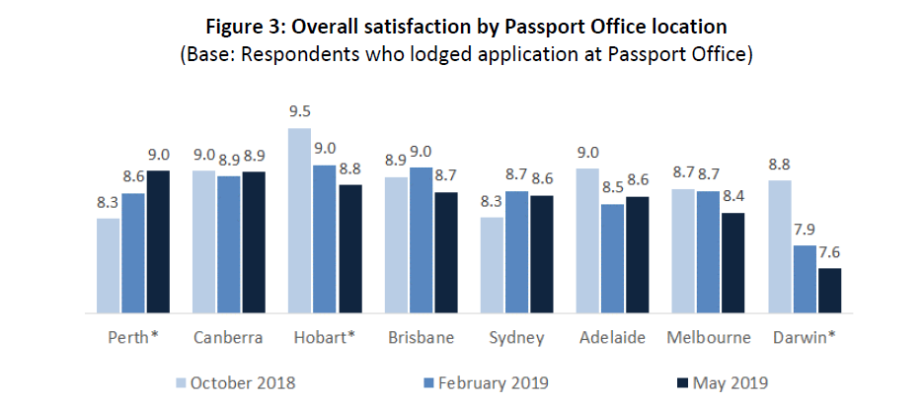



**KPI 3: ACTIONS UNDERTAKEN BY REGULATORS ARE PROPORTIONATE TO THE REGULATORY RISK BEING MANAGED**

*Metric: Measures/assessments the APO has undertaken to identify and reduce unnecessary requirements for Australian travel document applicants while maintaining the security, integrity and efficiency of the Australian passports system.*

Working with key partners such as Australia Post the APO is examining opportunities to deliver improved services by leveraging our existing IT capabilities. We are also looking at how to maximise our efficiency following the introduction of IT currently in development. The creation of the Passport Strategy and Innovation Section and the Automation Centre of Excellence will work to set the long-term strategic direction of the APO with a focus on client service and technological development.

The APO is making improvements to its online application, particularly for clients who have previously held an Australian travel document and already have existing data and documentation within our database. This is termed the Known Client model. We are already adopting practices where applicants do not need to provide documentation when we already have a copy in our records.

While we responded to strong demand, we continued efforts to improve identity verification and passport processing. In October 2018, the APO installed a new and more accurate facial recognition algorithm directing a greater proportion of renewal cases to a low-risk workflow with less manual handling.

**KPI 4: COMPLIANCE AND MONITORING APPROACHES ARE STREAMLINED AND COORDINATED**

*Metric: The extent that APO’s compliance and monitoring activities are streamlined and coordinated.*

Work on the APO Data Warehouse continued, with a view to ensuring more stable delivery of data, including daily updates. The Data Science Unit used raw data to develop a product suite, including Data Science Bulletins, forecasts of passport application volumes, and monthly reports and geospatial mapping related to the overseas network and passport fraud.

The latest monthly dashboards related to passport fraud are shown on the following page. They report on the activity levels of attempted frauds that have been detected during the passport application process, and report on the cancellation activities of Fraudulent Obtained Genuine documents (FOG) that have been detected in the community after they were issued.

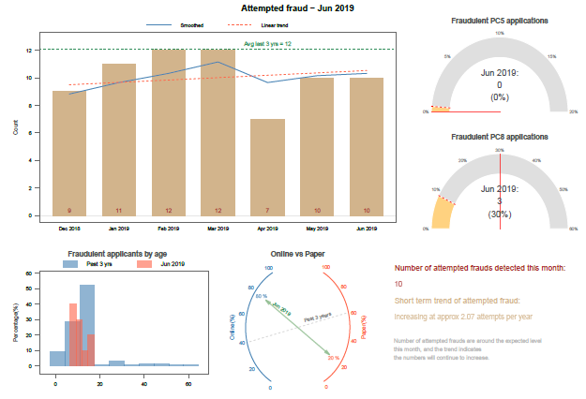

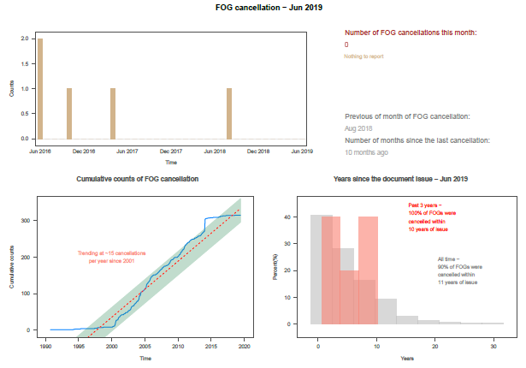

We do not allow our search for continued improvement to compromise the integrity of Australia’s passports. Specialist staff individually scrutinise 100 per cent of high-risk applications. In 2018-19 our systems referred 35,655 passport applications for manual assessment by face comparison experts in our Identity Resolution Unit.

We completed administrative investigations promptly, on average in less than a day. Nearly all these investigations related to forged parental consent for child passports, of which we confirmed 106 cases in 2018–19.

We referred six matters to the Commonwealth Director of Public Prosecutions (CDPP). Four were accepted for prosecution, one remains under consideration, and in the other case the CDPP decided not to proceed with a prosecution.

In May 2019, the APO implemented a new fraud triage process to ensure the consistent and objective evaluation of passport fraud referrals, and allow the most effective use of our investigative resources. This approach also enhances our compliance with the Australian Government Investigations Standards.

The Minister for Foreign Affairs cancelled 107 passports of reportable child sex offenders, bringing the total to 119 since the legislation commenced in December 2017. At 30 June 2019 competent authorities (usually State or Territory police) had requested that a further 2,784 offenders without passports be refused travel documents should they apply. These actions were taken under the Passports Legislation Amendment (Overseas Travel by Child Sex Offenders) Act 2017.

During the reporting period, the APO restructured its organisation so that all APO compliance and monitoring activities now sit within the Passport Policy and Integrity Branch (PIB). This aids coordination across sections with a single Assistant Secretary responsible for all APO compliance and monitoring activities.

**KPI 6: REGULATORS ACTIVELY CONTRIBUTE TO THE CONTINUOUS IMPROVEMENT OF REGULATORY FRAMEWORKS**

*Metric: Measures/assessments the APO has undertaken to identify and reduce unnecessary requirements for travel document applicants while maintaining the security, integrity and efficiency of the Australian passports system.*

By using automation to identify low-risk applications, the APO has put more resources into high-risk and complex applications. We anticipate our new biometric IT systems will provide opportunities for further improvements to identity verification and passport processing.

Facial biometrics are at the heart of Australia’s low incidence of passport fraud. Automated checks against the nearly 30 million passport photos in our database ensure that the identity of anyone who applies for a passport is verified, and that no one can obtain passports under multiple identities.

Uptake of our online application service is a key measure of its value as an alternative to paper forms. The proportion of clients using online passport applications increased from 61 per cent in 2017–18 to 68 per cent in 2018–19. This was just short of our ambitious 70 per cent target.

The APO works closely with other agencies including the Department of Home Affairs, the Attorney-General’s Department, Services Australia, the Digital Transformation Authority and the Australian Taxation Office to ensure our requirements are necessary, in line with legislation, and amended when legislation or government policies change. We are continually improving mechanisms to share information between departments in order to minimise repeat requests for information from our clients, and to improve the security and integrity of our passports.

1. Accessible at www.cuttingredtape.gov.au