APO regulator performance

– self-assessment report

September 2017

Introduction

The Australian Passport Office (APO) of the Department of Foreign Affairs and Trade (DFAT) issues Australian travel documents under a framework of legislation, policy and administration. Consistent with the requirements of the Australian Government’s *Regulator Performance Framework[1]*, this report sets out the results of the APO’s self-assessment of its performance during the 2016-17 financial year (Review Period).

The Framework includes six Key Performance Indicators (KPIs) against which all regulators must assess their performance. For each of these KPIs, APO has assessed its performance by reference to one or two metrics.

As part of the self-assessment, data was sourced from the Australian Passport Office Client Satisfaction Survey 2017, conducted by Ipsos/Winangali. Further, this report will be externally validated as required by the Framework.

KPI 1: REGULATORS DO NOT UNNECESSARILY IMPEDE THE EFFICIENT OPERATION OF REGULATED ENTITIES

*Metric: Measures taken to improve and refine the APO’s regulatory footprint.*

The APO is continuously striving to strengthen the passport systems and enhance client service. We introduced new policy to enable the use of APO records to identify known clients. Despite the policy being relatively new and can only be applied in very limited circumstances, it has been effective in managing client expectations and meeting service standards.

The APO also continues its work on releasing a new Online Application Form which will help streamline and simplify the process. This new platform will help to import cleaner data into our systems, which will reduce the need for rework and further requirements placed on the client.

*Metric: APO performance in meeting targets for processing passport applications once all required information has been submitted (10-day turnaround for ordinary applications and 2-day turnaround for priority-processed passport applications) to ensure clients receive their passports in a timely and reliable manner.*

99.5% of all applications received in 2016-17 were processed within 10 days, and 98.3% of applications where a priority processing fee was paid were completed within 48 hours.

|  |  |  |
| --- | --- | --- |
| **Table 1.1 APO Turnaround Times YTD 2016/17\*** | | |
| % of applications processed within 10 days for the month | All Offices  Australia  Overseas | 99.5%  99.7%  96.5% |
| % of priority passport applications processed within 48 hours | All Offices | 98.3% |

*\*Passport Issuance and Control System (PICS) data as at 30 June 2017, supplied by Business Assurance Section, APO*

KPI 2: COMMUNICATION WITH REGULATED ENTITIES IS CLEAR, TARGETED AND EFFECTIVE

KPI 5: REGULATORS ARE OPEN AND TRANSPARENT IN THEIR DEALINGS WITH REGULATED ENTITIES

*Metric: APO public communications material is clear, current and responsive to client needs.*

The APO launched a campaign to encourage passport applicants to start their applications online which resulted in a decrease in the use of hardcopy forms. Sixty three percent of applicants completed their forms online in June 2017, a 10 per cent increase on the previous year. Online forms significantly reduce errors through the import of cleaner data, reducing the need to reconfirm information with clients.

We also continue to review and make improvements on our communication products through our website materials, brochures and posters. We released a new photo poster which provides more clarity on our expectations from the client.

*Metric: Client feedback, as measured by the APIS Call Centre Feedback Management Survey and the Australian Passport Office Client Satisfaction Survey, shows a satisfactory experience with communication from the APO and its agents.*

Results from the 2017 APO client satisfaction survey showed high client satisfaction levels with average satisfaction with the APO rated at 8.5 (out of 10).

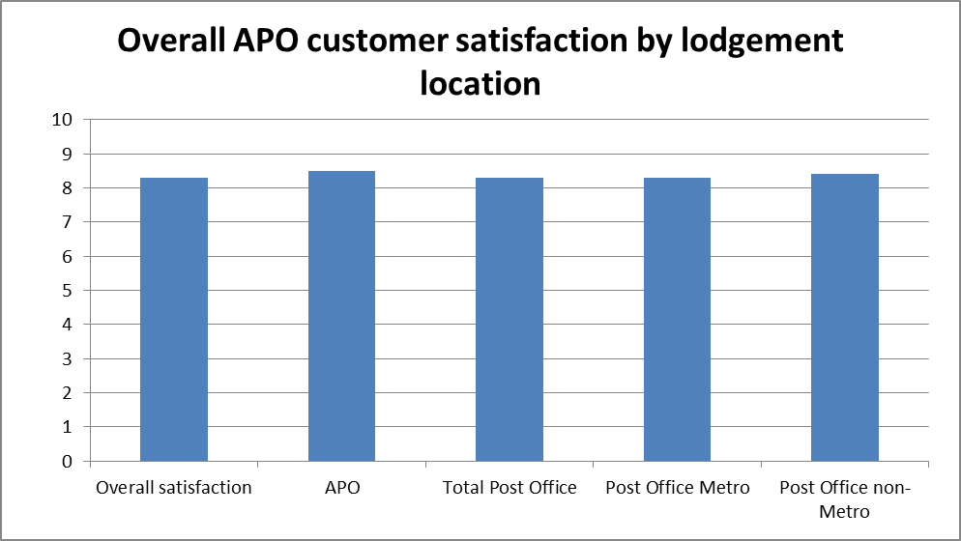

*Australian Passport Office Client Satisfaction Survey 2017, conducted from January to March 2017 by Ipsos/Winangali*

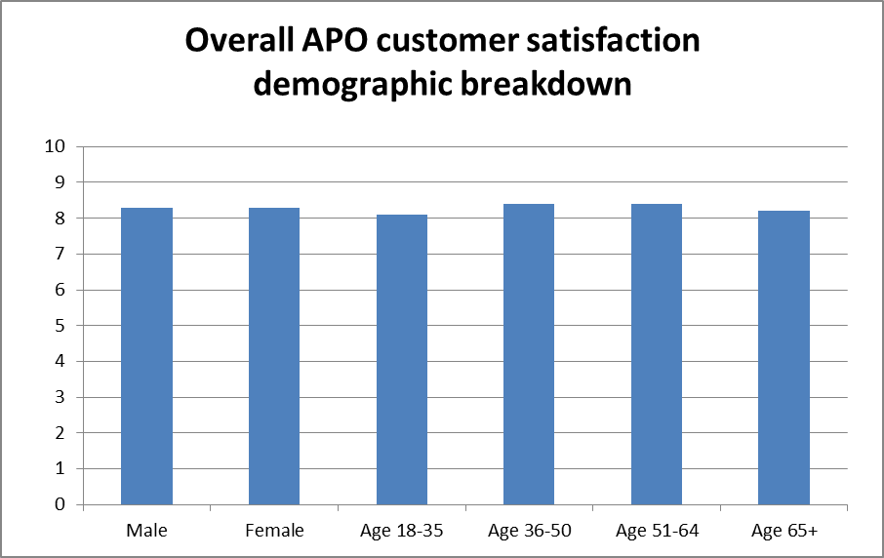

*Australian Passport Office Client Satisfaction Survey 2017, conducted from January to March 2017 by Ipsos/Winangali*

Results from the 2017 Australian Passport Information Service (APIS) surveys rated APIS very high with 93% overall customer satisfaction.

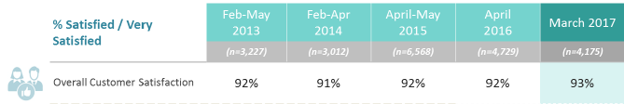

*APIS Call Centre Feedback Management Survey 2017, conducted March 2017 by Ipsos/Winangali*

KPI 3: ACTIONS UNDERTAKEN BY REGULATORS ARE PROPORTIONATE TO THE REGULATORY RISK BEING MANAGED

*Metric: Measures/assessments the APO has undertaken to identify and reduce unnecessary requirements for Australian travel document applicants while maintaining the security, integrity and efficiency of the Australian passports system.*

The APO is constantly looking at reducing unnecessary requirements on the client whilst maintaining the integrity of our decisions. We introduced policy which allows us to use APO records to identify known clients. Although the policy can only be applied in very limited circumstances, it has been effective in managing client service expectations and reducing the need to request clients to reconfirm details. We are also looking into expanding this policy more broadly.

KPI 4: COMPLIANCE AND MONITORING APPROACHES ARE STREAMLINED AND COORDINATED

*Metric: The extent that APO’s compliance and monitoring activities are streamlined and coordinated.*

The APO concluded the second phase of the Data Warehouse project to develop advanced analytics and improved business intelligence functionality for better evidence-based decision-making. The project also assists with fraud detection and management through the application of large scale data manipulation, advanced statistical algorithms and machine learning techniques.

Our participation in international standards bodies helped drive best practice in passport security and interoperability. We continued to lead the way in inter-agency data sharing initiatives. We worked closely with the Attorney-General’s Department to develop a capacity to interact with the National Facial Biometrics Matching Capability, including the Facial Verification Service. Security enhancements are a priority in design work for the next generation of Australian passports, due for release in 2020.

We worked closely with intelligence and law enforcement partners to detect passport misuse and take the necessary actions. In response to competent authority requests, the Foreign Minister cancelled 71 passports, refused six and suspended four on national security or law enforcement grounds.

The Business Assurance Section (BAS) reviews the APO’s internal controls, policies and procedures and provides the APO Executive with independent advice on integrity issues. BAS works to enhance accountability and transparency and to improve the security and probity of the passports issuing process.

KPI 6: REGULATORS ACTIVELY CONTRIBUTE TO THE CONTINUOUS IMPROVEMENT OF REGULATORY FRAMEWORKS

*Metric: Measures/assessments the APO has undertaken to identify and reduce unnecessary requirements for travel document applicants while maintaining the security, integrity and efficiency of the Australian passports system.*

The Department of Immigration and Border Protection (DIBP) undertook ‘contactless SmartGate trials’ under the Seamless Traveller Program in Canberra, Sydney and Brisbane international airports. The objective of the program is to streamline the passenger processing and improved facilitation without impacting the integrity of the passenger process.

To enable the trial, DFAT provided a million digital passports with are approximately six months of data spanning from September 2016 to February 2017. The trial was successfully concluded in July 2017

1. Accessible at www.cuttingredtape.gov.au