APO REGulator Performance – self-assessment report

December 2016

|  |
| --- |
| **KPI 1: Regulators do not unnecessarily impede the efficient operation of regulated entities.** |

*Metric: Measures taken to improve and refine the APO’s regulatory footprint.*

The APO undertook significant non-production activities to strengthen the passport system and enhance client service. Following a comprehensive review of passport legislation, relevant Acts were amended and Determinations were remade in late 2015. We adjusted our policies and procedures accordingly, promulgated them across our network of office and agencies, and informed the public.

*Metric: APO performance in meeting targets for processing passport applications once all required information has been submitted (10-day turnaround for ordinary applications and 2-day turnaround for priority-processed passport applications) to ensure clients receive their passports in a timely and reliable manner.*

Almost 90% of all applications received in 2015-16 were processed within 10 days, and over 99% of applications where a priority processing fee was paid were completed within 48 hours.

|  |  |  |
| --- | --- | --- |
| **Table 1.1 APO Turnaround Times YTD 2015/16\*** | | |
| % of applications processed within 10 days for the month | All Offices  Australia  Overseas | 88.6%  88.0%  97.1% |
| % of priority passport applications processed within 48 hours | All Offices | 99.09% |

*\*Passport Issuance and Control System (PICS) data as at 30 June 2016, supplied by Passport Workload Management Section, APO*

|  |
| --- |
| **KPI 2: Communication with regulated entities is clear, targeted and effective.** |
| **KPI 5: Regulators are open and transparent in their dealings with regulated entities.** |

*Metric: APO public communications material is clear, current and responsive to client needs.*

The APO re-launched the passport website – our key resource for communicating with the public – in December 2015. The new design has better pathways for clients to get the information they need about eligibility requirements and to start a passport application online. Along with updated content, we published new online application forms, and we used general and targeted outreach initiatives to give clients clear advice and guidance. We also reviewed the introductory script for our telephone helpline; this will be streamlined to address common inquiries more efficiently.

*Metric: Client feedback, as measured by the APIS Call Centre Feedback Management Survey and the Australian Passport Office Client Satisfaction Survey, shows a satisfactory experience with communication from the APO and its agents.*

Results from the 2016 APO client satisfaction survey showed high client satisfaction levels with average satisfaction with the APO rated at 8.1 (out of 10).

*Australian Passport Office Client Satisfaction Survey 2016, conducted March/April 2016 by Ipsos Loyalty/Winangali*

*Australian Passport Office Client Satisfaction Survey 2016, conducted March/April 2016 by Ipsos Loyalty/Winangali*

Results from the 2016 Australian Passport Information Service (APIS) surveys were also high with APIS rated at levels of 92% overall customer satisfaction.

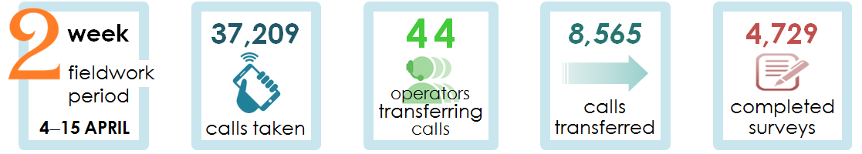



*APIS Call Centre Feedback Management Survey 2016, conducted April 2016 by Ipsos Loyalty/Winangali*

|  |
| --- |
| **KPI 3: Actions undertaken by regulators are proportionate to the regulatory risk being managed.** |

*Metric: Measures/assessments the APO has undertaken to identify and reduce unnecessary requirements for Australian travel document applicants while maintaining the security, integrity and efficiency of the Australian passports system.*

The APO drove and implemented changes to passport legislation to reflect contemporary circumstance and help manage problems with passport applications and misuse. For example:

* A new definition of persons with parental responsibility has simplified consent procedures for up to one-third of complex children’s passport applications;
* Child applicants aged 16 or 17 are now issued with 10 year passports instead of the 5 year passports issued to children under 16, a change that delivers deregulatory savings for families.

|  |
| --- |
| **KPI 4: Compliance and monitoring approaches are streamlined and coordinated.** |

*Metric: The extent that APO’s compliance and monitoring activities are streamlined and coordinated.*

Combatting passport fraud was a key priority in both processing and innovation aspects of the APO’s work. Every passport application was checked against identity records and facial images to prevent the issue of a genuine document in a false identity. We refused to process 80 passport applications that we suspected contained fraud, most commonly forged signatures. We worked closely with intelligence and law enforcement partners to detect and prosecute passport fraud. We investigated 146 allegations of passport fraud, referring 29 to prosecuting authorities.

The APO worked actively to maintain the reputation of the Australian passport as a world class identity document. Our participation in international standards bodies helped drive best practice in passport security and interoperability. We were among the first agencies to test the government’s proposed national facial biometric matching capability, a data sharing hub that will facilitate the validation of citizenship and image data of passport applications.

The Business Assurance Section (BAS) reviews the APO’s internal controls, policies and procedures and provides the APO Executive with independent advice on integrity issues. BAS works to enhance accountability and transparency and to improve the security and probity of the passports issuing process.

|  |
| --- |
| **KPI 6: Regulators actively contribute to the continuous improvement of regulatory frameworks.** |

*Metric: Measures/assessments the APO has undertaken to identify and reduce unnecessary requirements for travel document applicants while maintaining the security, integrity and efficiency of the Australian passports system.*

Progress toward delivery of a new passport issuance system under the Passport Redevelopment Program superseded the rollout of a new paper application form. Work continued toward the digital capture of passport applications, which will give the best prospect of importing clean data to our systems. A new high volume passport printing and despatch system has reached the final test stage and is scheduled to go live in September 2016.