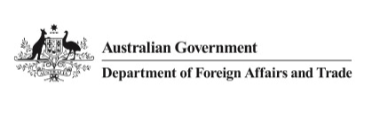

Australia’s Humanitarian Policy
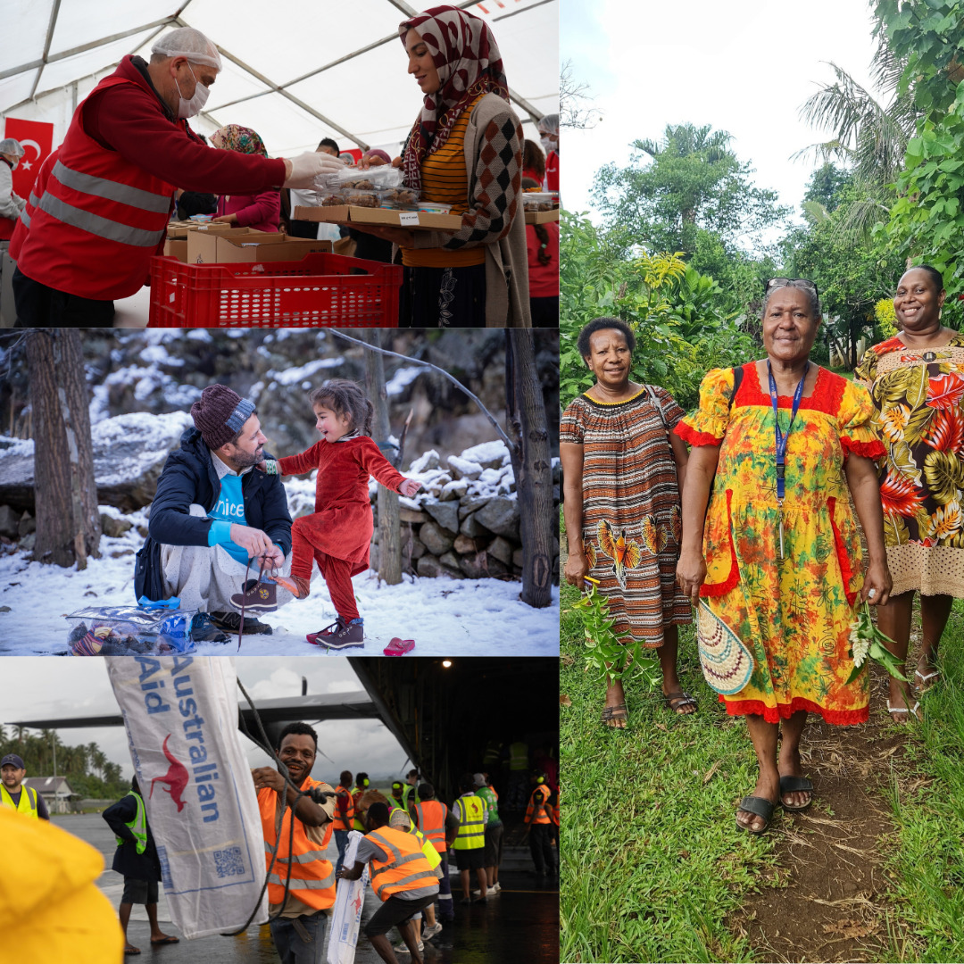
Easy Read
September 2025

About this document
 | Difficult Words
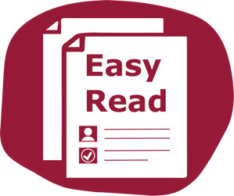 | This document is written so it is easy to read.
 | You might not know some words.  The first time we use those words they are blue.  We tell you what they mean.
 | We might use the words again later.  You can check the Word List at the back of this document.
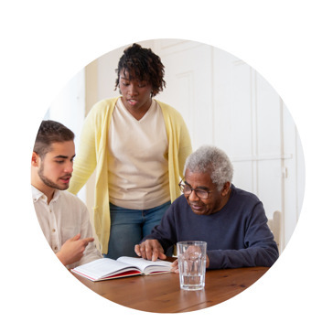 | You can ask for help to read this document.  You could ask a:  - Family member  - Friend  - Support worker.
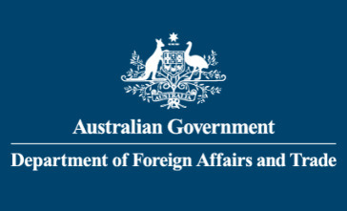 | This document is written for the Australian Department of Foreign Affairs and Trade or DFAT.  We are part of the Australian Government.
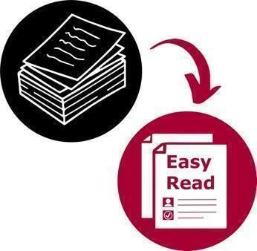 | This document is a summary of another document.  A summary is a shorter version of something.
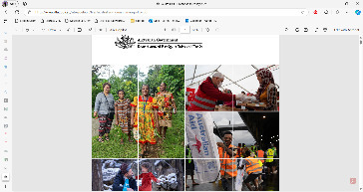 | To see the longer document visit the DFAT website.

Australia’s Humanitarian Policy
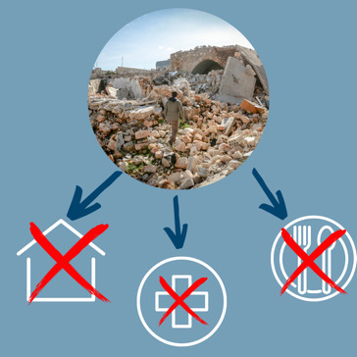 | In this document we talk about Australia’s Humanitarian Policy.  Humanitarian assistance is the help that is provided due to a disaster or conflict.  Australia helps other countries with humanitarian needs.
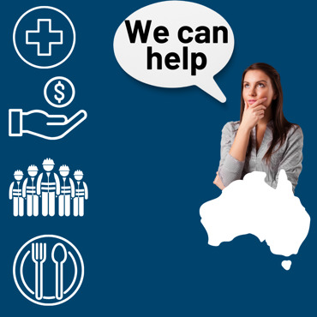 | Help can be:  - Medical supplies  - Money  - People  - Food.
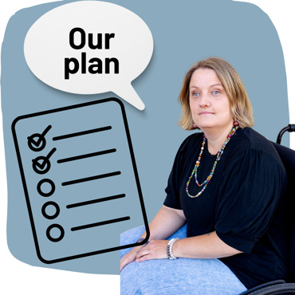 | This Policy is the Australian Government’s plan for how it will help other countries in humanitarian need.  In this document we call it ‘the Policy’.

Why do we need a humanitarian policy?
Australia wants to help people in crisis so we can live in a safer and more secure world.
Australia wants to take action that:
- Saves lives
- Reduces suffering
- Helps other countries prepare for crises

 | 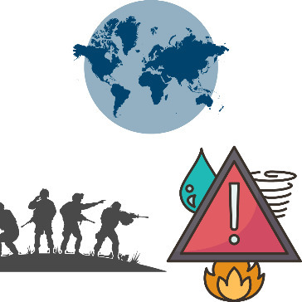 |  | This new Policy has been written as the world is changing and we are seeing:  - longer conflicts  - more intense disasters.  Conflict is when 2 or more people or groups do not agree on something.
 | 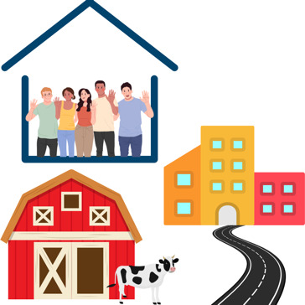 |  | An intense disaster is an event that causes a lot of harm to:  - People  - Buildings  - Homes  - Farms  - Roads
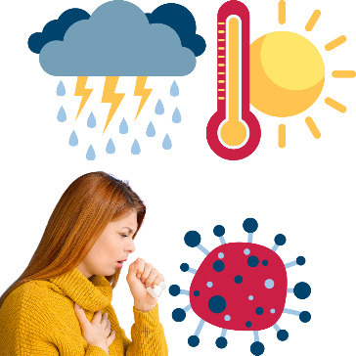 |  | A disaster can be:  - Flood  - Fire  - Earthquake  - Volcano  - Medical events like COVID-19.
 | 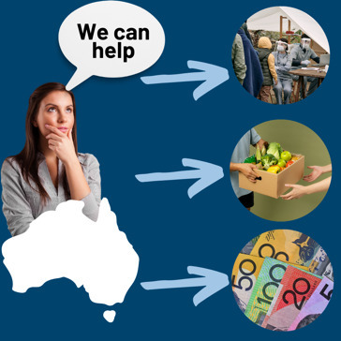 |  | People living in countries where there are conflicts and disasters can ask for humanitarian assistance from countries like Australia.
 | 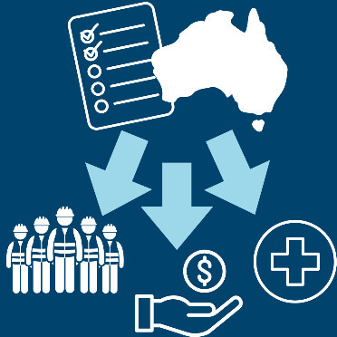 |  | The Policy shows how Australia will use its resources to help.
 |  |  | Resources can include:  - Money  - Time  - People  - Knowledge.
 | 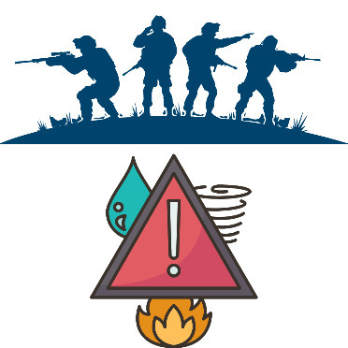 |  | The Policy will prepare Australia to help in a humanitarian crisis.  Crisis is when a something very bad happens and people need help.  We can help others to be ready to deal with crises too.
 | 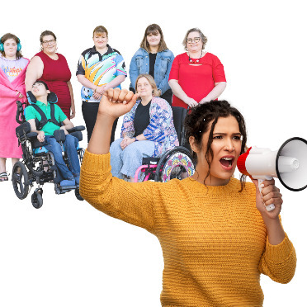 |  | The Policy says in a crisis, Australia will:  - Respond quickly  - Speak up for people who need help  - Protect people who need help
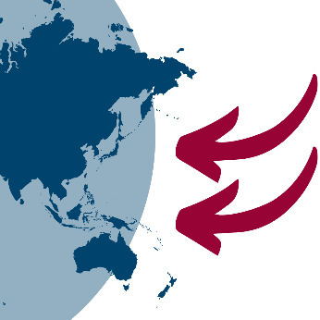 |  |  | - Focus on helping people in the Indo-Pacific region.  The Indo-Pacific region stretches from the Indian Ocean to the western Pacific Ocean.

About the Policy

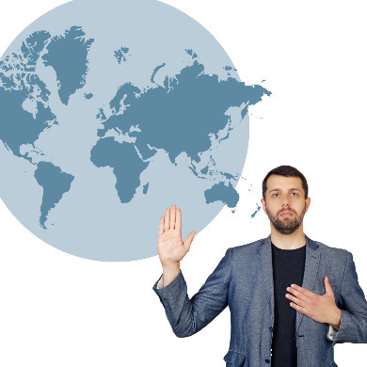 |  |  | The Policy shows Australia’s commitment to international humanitarian law.  Commitment is a promise to do something.
 |  |  | International humanitarian law is a group of rules that:  - Many countries agree to follow to protect people  - Helps countries work together peacefully.  Not every country is committed to international humanitarian law, but Australia is.
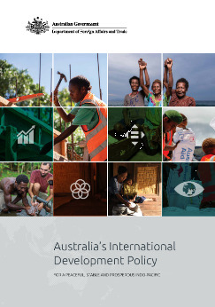 |  |  | The Policy helps Australia meet the promises it made in another policy called the International Development Policy.
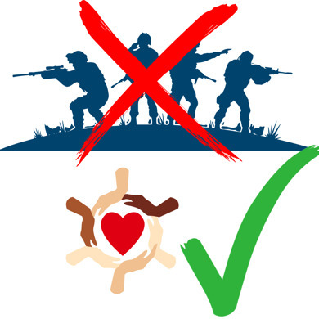 |  |  | The Policy guides how Australia supports other countries towards:  - Peace  - Stability  - A prosperous future.
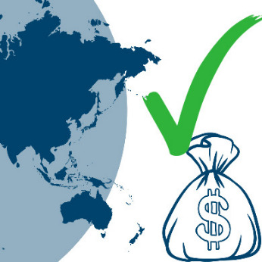 |  |  | Prosperous is when a country or person is wealthy and successful.
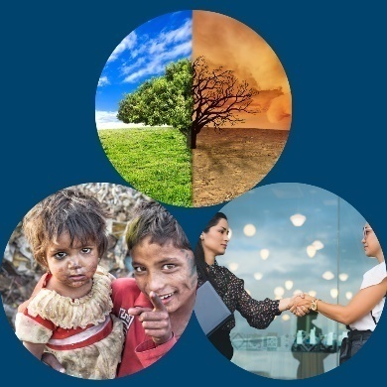 | Australia believes it is important to help our neighbouring countries to be prepared for disasters and be ready to act quickly so crises are easier to manage.
 | Approaches  To make sure Australia is ready to help others in a crisis we will focus on:  - Working in partnership  Australia partners with other countries so they are prepared for a crisis before it happens.  A partner is when 2 people, countries or organisations work together.  - Protecting those most in need  Australia is focused on helping those most in need, including women, children and people with disabilities.  - Being inclusive and equal so no one is forgotten  It is important to make sure everyone is welcome, valued and has what they need in a crisis.  - Supporting local leadership  Local leadership and decision making is important to make sure the humanitarian assistance provided has a better impact.  Local leadership is when someone in an affected community takes charge in the response.  - Building skills and expertise.  Australia invests in people and systems so the humanitarian assistance provided is as effective as possible.  Plan of action  The Australian Government has a plan for how to keep its promises from the Policy, this includes:
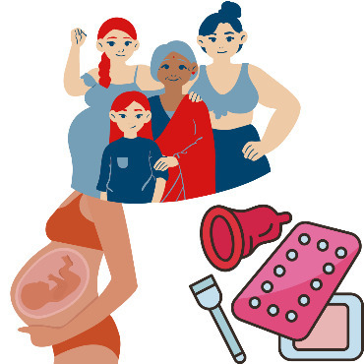 | Improving support for sexual and reproductive health services.
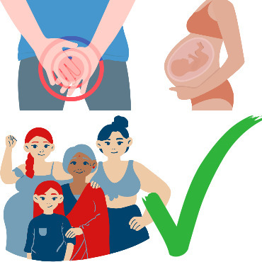 | Sexual health is when you keep your body safe and healthy when you have sex.
 | Reproductive health is keeping your body safe and healthy in case you want or do not want children.
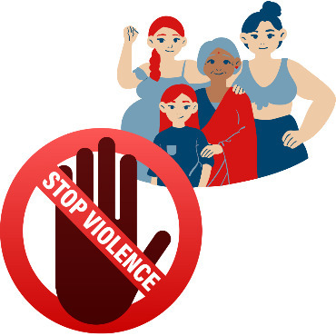 | Stopping gender-based violence.  Gender-based violence is when someone hurts or controls someone because they are:  - A man  - A woman  - Another gender.
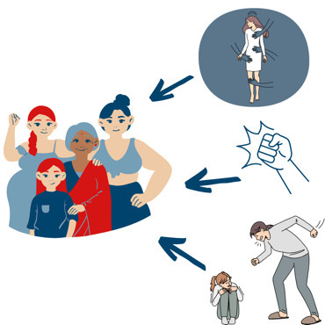 | There are many types of violence, including when someone:  - Hits you  - Touches you when you don’t want them to  - Gives you the wrong medicines.
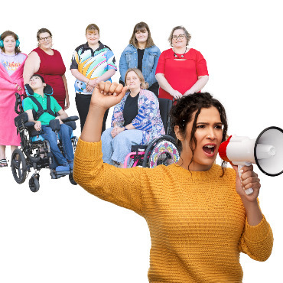 | Improving the humanitarian system so it will work better and more quickly after a disaster.  Australia will work to make the humanitarian system better now and keep getting better in the future.  - Improving advocacy to make international humanitarian law better for people who are in disasters and wars.
 | - Advocacy is when someone helps you speak up.
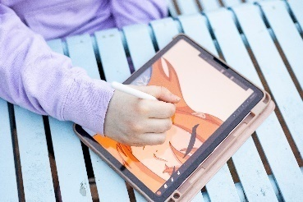 | Using innovation, science and technology to help in the future.  Innovation is when something new and exciting is created.  Technology includes devices like computers .
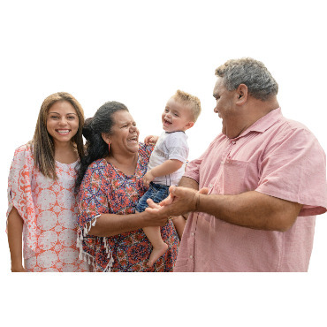 | Supporting diversity, inclusion and participation for disability equity and rights.  Diversity is including people from different backgrounds.
 | Participation is when someone takes part in an activity or event.
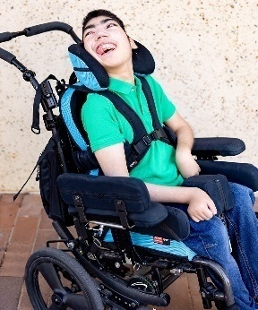 | Disability is when someone with a medical condition has trouble joining in with activities because the world does not meet their needs. Their medical condition may cause them trouble with:  - Walking  - Seeing  - Hearing  - Speaking  - Learning and understanding.
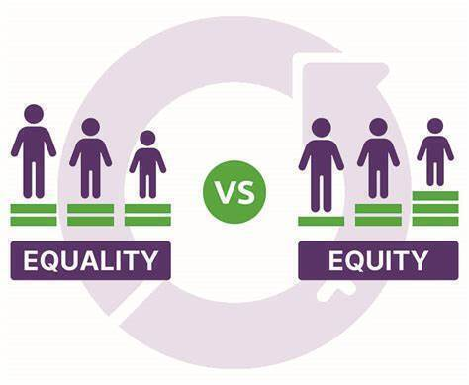 | Equity is when someone is treated with fairness.
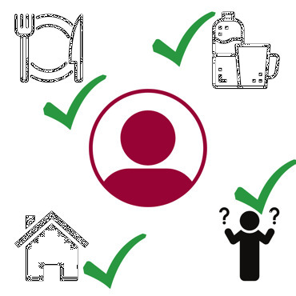 | Rights are things that every person should have. They include:  - Safety  - Enough food  - Clean water  - Fair and equal treatment  - A place to live  Being allowed to make their own decisions.
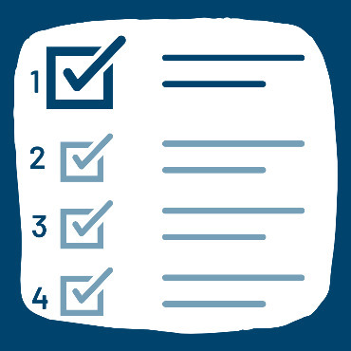 |  | The Policy has 3 priorities.  Priorities are the most important things we need to do first.
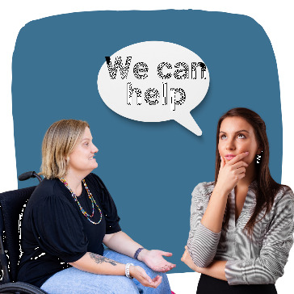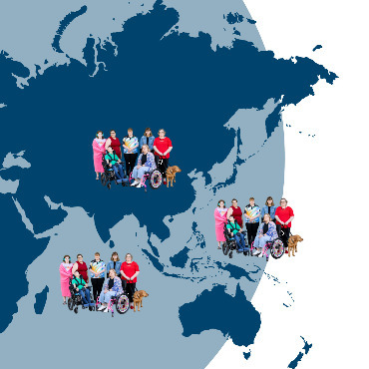 |  | - Make sure Australia and other countries in our region are always ready and prepared for disasters.  - Help quickly in a crisis or disaster.  - Support countries in the Indo-Pacific to prevent or respond to crises better, including by:  - supporting international humanitarian law  - helping to make the law better.

Accountable
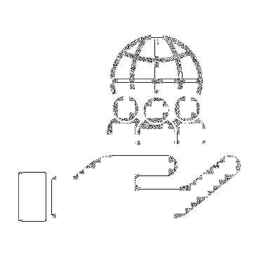 |  | The Australian Government is accountable to the Australian people and countries we choose to help.  Accountable is when someone takes responsibility for their actions.
 |  | Responsibility is taking charge of something and doing it properly.

Word List
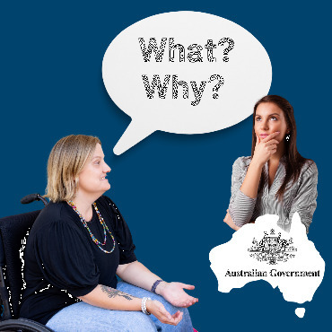 |  |  | Accountable  when someone takes responsibility for their actions.
Advocacy
when someone helps you speak up.
Aid
when we help other countries.
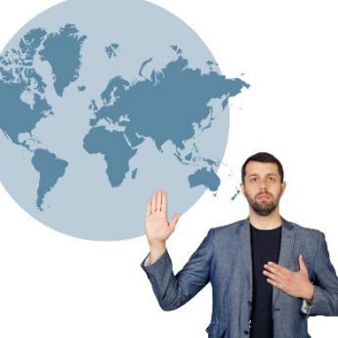 |  |  |  | Commitment  a promise to do something.
 | 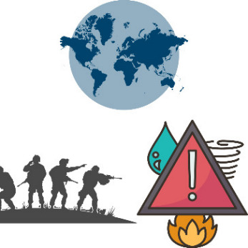 |  |  | Conflict  when 2 people or groups do not agree on something and fight about it.
 | 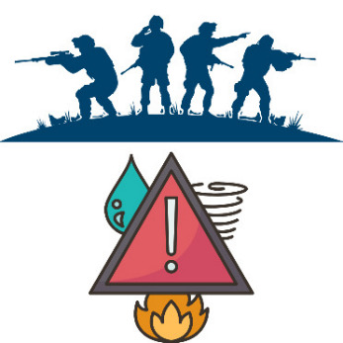 |  |  | Crisis  when something very bad happens and a large number of people need help.
Disability
when someone with a medical condition has trouble joining in with activities because the world does not meet their needs.
Their condition may cause them trouble with:
- Walking
- Seeing
- Hearing
- Speaking
- Learning and understanding.
Disaster
an event that causes a lot of harm to people and things. A disaster can be:
- flood
- fire
- earthquake
- volcano
- medical events like COVID-19.
Diversity
including people from different backgrounds.
Equity
treating someone with fairness.
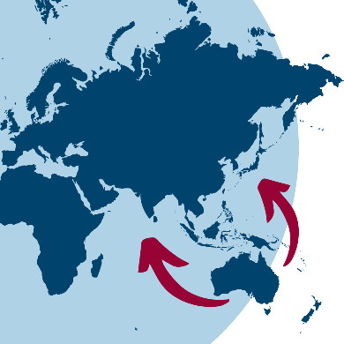 |  |  |  | Foreign policy  the way countries work with other countries to reach their.
Gender-based violence
Hurting or controlling someone because they are:
- A man
- A woman
- Another gender.
Humanitarian action
Helping people who are in need because of a disaster or war.
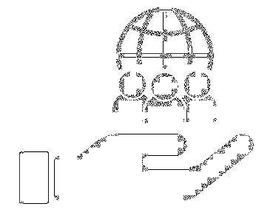 |  |  | Inclusion  Making sure everyone:  - Is welcome  - Is valued  - Has what they need.
Innovation
Creating something new and exciting.
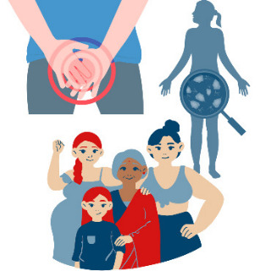 |  | Infections  Becoming sick, for example: a cold is an infection.
International Development Policy
This is a document that guides how Australia supports other countries to have:
- Peace
- Stability
- A prosperous future.
International humanitarian law
A group of rules that:
- Many countries agree to follow to protect people
- Helps countries work together peacefully.

Local Leadership
Local leadership is when someone in an affected community takes charge in the response.
Local leadership is when someone in your community knows what to do and takes charge.
Participation
Taking part in an activity or event.
Partner
Two people or countries agreeing to work together.
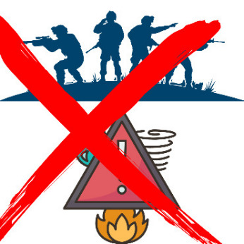 |  |  | Prevention  Stopping something before it happens.
Priorities
The most important things to focus on.
Prosperous
A wealthy and/or successful country or person.
Reproductive health
Keeping your body safe and healthy in case you want or do not want children.
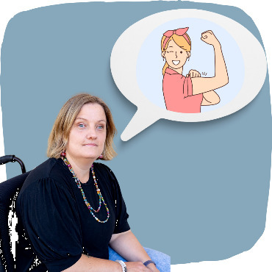 |  |  | Resilience  Having the strength to handle something that is hard.
Resources
This can be a variety of:
- Money
- Time
- People
- Knowledge.
 |  | Responsibility  Taking charge of something and doing it properly.
Rights
Things that every person should have, including:
- Safety
- Enough food
- Clean water
- Fair and equal treatment
- A place to live
- Being allowed to make your own decisions.
Sexual Health
Sexual health is keeping your body safe and healthy when having sex.
Summary
A summary is a shorter version of something.
Technology
devices, such as computers..

Easy Read images by The Easy Read Toolbox or Creative Commons. Equity image from International Women’s Day. Easy Read document written by Teigan Southwell.

