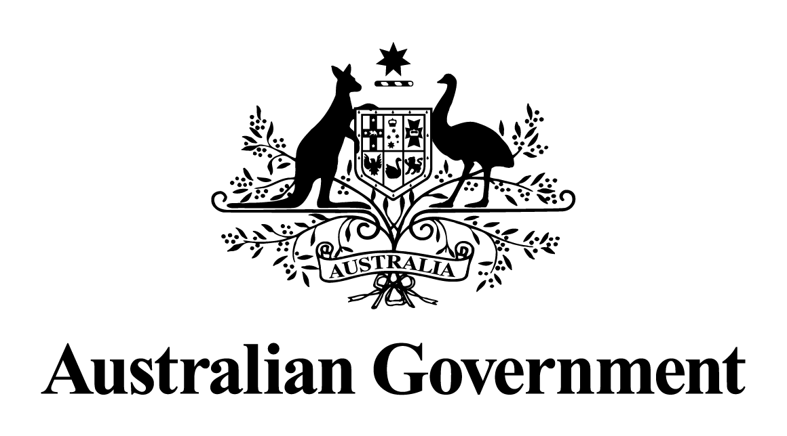

# Australian Government response

# to the Joint Standing Committee on Foreign Affairs, Defence and Trade report:

# **Supporting democracy in our region**

SEPTEMBER 2025

## Introduction

The Australian Government thanks the Joint Standing Committee on Foreign Affairs, Defence and Trade for its inquiry into supporting democracy in our region.

The Minister for Foreign Affairs, Senator the Hon Penny Wong, called on the Committee to establish a parliamentary inquiry into supporting democracy in our region in November 2022. The Committee delivered its report in November 2023, shortly after Minister Wong launched the Government’s International Development Policy in August 2023.

The Committee’s eight recommendations align well with the Government priorities set out in the International Development Policy and associated Performance and Delivery Framework, with some minor differences in implementation approach.

Australia is proud of its democratic system of government. We have a vibrant civil society, independent media, and robust institutions underpinned by the rule of law. Our independent institutions support effective government and, in turn, reinforce public confidence in government.

The Government recognises that our economy, our democratic institutions, and the connections and knowledge of all Australians, are powerful national strengths that will help shape our international development assistance in a way that benefits both our region and Australians.

The objective of Australia’s development program is to advance an Indo-Pacific that is peaceful, stable, and prosperous. We respect sovereignty and differing political and governance systems. The Government reaffirms its support for our partners to build effective and accountable states, and inclusive democratic processes through our development program.

Direct support for, and engagement with, civil society organisations will also continue to be an integral part of how Australia implements its development program, recognising that civic space is shrinking in many parts of the world, and that the nature and value of civil society in each country is distinct.

Effective states and their citizens benefit from transparent, accessible, and responsive governance. The Government is working with partner governments in the region to strengthen their public institutions, including as they mediate and manage disruptive influences and respond to the challenge of climate change.

The Government provides the following responses to the eight recommendations set out in the Committee’s report.

## Response to the recommendations

### Recommendation 1

*The Committee recommends the Australian Government appropriately fund the Australian Electoral Commission to develop long-term partnerships, appropriate resourcing and preparedness with countries in our region who request assistance with elections. This would involve a minimum commitment of three years, prior to the election, to enable Australia to work in partnership with the local workforce to assist with systematic and logistical challenges unique to each country.*

*Electoral assistance should support the planning, implementation, lessons- learned, and change management phases of the electoral cycle, noting that elections require significant planning and engagement before, during, and after polling day.*

#### Response:

The Government accepts this recommendation in principle.

The Australian Electoral Commission (AEC)’s best practice operations and long-standing relationships in the Indo-Pacific region position Australia as a trusted partner of choice for electoral assistance. In 2023-24, in collaboration with the Department of Foreign Affairs and Trade (DFAT), the AEC is providing support to fellow electoral management bodies in Papua New Guinea, Solomon Islands, Fiji, Republic of Marshall Islands, Tonga and Kiribati. This is in addition to its leadership role in the region as secretariat to the Pacific Islands, Australia and New Zealand Electoral Administrators Network.

The Government agrees that a ‘whole of electoral cycle’ approach strengthens the sustainability and effectiveness of Australia’s electoral assistance. Such an approach allows the AEC to develop programs targeting long-term issues, both with new partners and in countries where it has existing relationships. Under the International Development Policy, DFAT is working with whole-of-government partners, including the AEC, to prepare country and regional Development Partnership Plans (DPPs) by 2024. DPPs will set out shared priorities for Australian development assistance over the coming five years. This includes electoral assistance where appropriate, and as agreed with partner governments and informed by consultations with local, national, regional, and international partners.

### Recommendation 2

*The Committee recommends that the Australian Government develop a public policy on Australia’s long-standing precedent of providing election support for countries in the Indo-Pacific region, when invited to assist. This policy would outline partner countries with bilateral agreements which Australia assists with the running of independent and fair elections in our region.*

#### Response:

The Government accepts this recommendation in principle.

Section 7(1)(fa) of the Commonwealth Electoral Act 1918 directs the AEC to provide international assistance in matters relating to elections and referendums. The Government’s International Development Policy sets out its policy commitment to supporting effective and accountable states through Australia’s development program. This includes providing election support, where agreed as a priority across Australian government agencies and with local, national, regional, and international partners through country and regional Development Partnership Plans. To strengthen coordination and implementation of Australia’s election support across Government, DFAT will work with the AEC to:

* strengthen inter-departmental coordination on elections in the Indo-Pacific to support the effectiveness of Australia’s electoral assistance efforts, policy advice, and to anticipate emerging issues and ad-hoc requests
* revise the DFAT Elections Handbook, an internal guidance note, which sets out principles for DFAT (and relevant Australian government agencies) in developing policy approaches and/or delivering assistance relating to electoral processes
* disseminate the updated Elections Handbook across relevant Australian government agencies, including integrating content into the International Development Faculty curriculum in DFAT’s Diplomatic Academy.
* update information available online through their respective websites to outline Australia’s existing work on supporting elections.

The AEC publishes information about its international engagement annually in its Corporate Plan and Annual Report 2022-23, available on the AEC website.

### Recommendation 3

*Given Pacific nations have identified ongoing challenges of climate change the Committee recommends the Australian Government increase support for international communities in our region. This support may include adaptation and mitigation works to prepare for rising sea levels and extreme weather events given the adverse effect climate change has on institutions, national security, and civil society which negatively impacts democracy*

#### Response:

The Government accepts and is implementing this recommendation.

The Government recognises that climate change is the single greatest threat to the livelihoods, security and wellbeing of the peoples of the Pacific and an urgent global challenge.

The Government’s climate engagement aims to strengthen Pacific resilience, reinforce sovereignty and help sustain the Pacific’s tradition of global leadership on climate change. The Government has committed, as part of the International Development Policy, to ensure that 50 per cent of all new bilateral and regional investments valued at more than $3 million will have a climate outcome by 2024-25, increasing to 80 per cent by 2028. The Government has also increased Official Development Assistance to the region by $900 million over four years, including at least $250 million in new funding for climate change adaptation and resilience in the Pacific. Examples of these programs include the Pacific-led Weather Ready Pacific initiative to enhance crucial early warning systems, and the Pacific Resilience Facility, a Pacific-owned and led initiative for climate finance.

The Government has also joined with partners as part of the Pacific Islands Forum to respond to the challenges of sea-level rise. In 2021, Forum Leaders issued the ‘Declaration on Preserving Maritime Zones in the Face of Climate Change-Related Sea-Level-Rise’, to ensure that maritime zones, once established in accordance with the United Nations Convention on the Law of the Sea, continue to apply without reduction, notwithstanding climate change-related sea-level rise. In 2023, Forum Leaders issued the ‘Declaration on the Continuity of Statehood and the Protection of Persons in the Face of Climate Change-related Sea-Level Rise’ to declare that the statehood and sovereignty of Forum Members will continue, and the rights and duties inherent thereto will be maintained, notwithstanding climate change-related sea-level rise. The Declaration also expresses a commitment by Forum Members to protect persons affected by climate change-related sea-level rise. Forum Leaders also endorsed the Pacific Regional Framework on Climate Mobility, a high-level guide for Pacific governments in addressing the complex and wide-ranging issue of climate mobility.

The Government is committed to strengthening partnerships that will facilitate building a stronger, more resilient, and more peaceful Pacific. The Australia-Tuvalu Falepili Union Treaty entered into force on 28 August 2024, representing a momentous step in the elevated partnership between our two countries. The Falepili Union puts in place transformational arrangements to safeguard the future of Tuvalu against impacts of climate change and geostrategic challenges. Through the Falepili Union, Australia commits to establish a special visa arrangement to allow Tuvaluans to come to Australia to live, work and study, and we are upgrading our security partnership and enhancing our bilateral development partnership, including climate adaptation support for Tuvalu.

Initiatives such as the Pacific Island Forum declarations and frameworks, and bilateral agreements like the Falepili Union Treaty, can help the region navigate shared climate change challenges, address climate change as an emerging security risk, and in so doing, support democracy in the region.

### Recommendation 4-

*The Committee recommends the Minister for International Development and the Pacific report back to Parliament annually on Australia’s engagement and delivery of services to Pacific countries regarding its development initiatives to combat, mitigate and adapt to climate change.*

#### Response:

The Government accepts this recommendation in principle.

The Government submits that existing processes for briefing Parliament are sufficient, such as the Annual Climate Change Statement to Parliament, the publicly available Performance of Australian Development Cooperation Report, Senate Estimates Committee hearings, Question Time, and Budget processes.

### Recommendation 5

*The Committee recommends the Australian Government establish a comprehensive media broadcasting capacity and support program for the Indo-Pacific region that should include:*

*• a charter and accountability framework that guarantees support is provided for media skills and capacity building to enable independent reporting and analysis*

*• a flexible, independently administered fund to provide support for stronger partnerships, internships and work experience for local journalist and independent media in the Indo-Pacific region*

*• comprehensive training and development opportunities for journalists in the Indo-Pacific region*

*• support for Australian journalists to work in the Indo-Pacific region and for journalists from the Indo-Pacific to work in Australia and have the opportunity to report on and tell their own stories.*

#### Response:

The Government accepts this recommendation in principle.

The Government launched its Indo-Pacific Broadcasting Strategy (IPBS), Australia-Pacific Media and Broadcasting Partnership, Australia-Southeast Asia Media and Broadcasting Initiative, and Australia-South Asia Media and Broadcasting Initiative on 13 July 2024.

Under the IPBS, the Government provided $40.5 million over five years from 2022-23 to the Australian Broadcasting Corporation (ABC) to support the creation and distribution of compelling content for Indo-Pacific audiences, expand Radio Australia’s Pacific footprint, and strengthen regional media capacity. This includes a new online learning platform to deliver ABC training tailored for Indo-Pacific use, media support programs in Timor-Leste and Indonesia, and a network of ABC local Pacific reporters to tell stories for and about the region.

The Department of Foreign Affairs and Trade (DFAT) is developing an Indo-Pacific Media Fund to supplement existing efforts and flexibly respond to needs in the Pacific, Southeast Asia and South Asia. New investments underway include funding for Australian Associated Press to provide targeted training and access content in the Pacific, ABC International Development to support women sports journalists in India, and the Bhutan Centre for Media and Democracy to build media literacy and encourage civic engagement.

The Government also extended the PacificAus TV initiative, committing $28.4 million over five years from 2022-23 to continue and expand provision of Australian television programs to broadcast partners in the region.

These investments build on Australia’s history of supporting Indo-Pacific media, including the longstanding Pacific Media Assistance Scheme and Media Development initiative, foster stronger media partnerships, and offer opportunities for skills exchange and development.

The Government will continue to review its investments and work with partners, including other donors and the broader media sector, to amplify efforts to support Indo-Pacific media. All support is subject to existing government accountability and reporting processes. The ABC has operational and editorial independence from the Government and consults on IPBS activities under a Memorandum of Understanding with DFAT and the Department of Infrastructure, Transport, Regional Development, Communications and the Arts. The availability of future government funding will be subject to Budget processes.

### Recommendation 6

*The Committee recommends the Australian Government reinstate funding for a Women in Parliament program within the Australian Parliament. This program should provide support for building and strengthening partnerships in the Indo-Pacific region. The program would focus on supporting leadership skills for girls and women and should include:*

*• promoting women and girls’ voices in all levels of society such as schools, community organisations, public and private sphere at provincial and national levels*

*• building connections with feminist civil society groups already in the region*

*• ensuring women and girls’ have improved access to quality health care services, including reproductive health*

*• improving women and girls’ safety, especially for protecting women and girls’ from gender violence and ensuring services are readily available*

*• promoting gender mainstreaming within all aspects of society in the Indo-Pacific including intergovernmental policies that are agreed to and delivered.*

#### Response:

The Government notes this recommendation.

Gender equality is a key priority for the Australian Government’s international engagement. Australia’s International Development Policy commits to supporting all people to reach their full potential and notes that women, in all their diversity, are under‑represented in positions of leadership and decision‑making.

Australia supports a wide range of programs that help build leadership skills for girls and women. The Australia Awards Women Leading Influencing program supports women who are scholarship recipients from the Pacific to deepen their leadership skills, networks and capabilities for change at all levels of society - local, national, regional and international. Australia also supports work by partners such as the Pacific Community (SPC), Pacific Islands Forum Secretariat (PIFS), Women’s Fund Asia, Urgent Action Fund – Asia & Pacific, Women’s Fund Fiji, the Pacific Feminist Fund, Balance of Power and World YWCA to promote women and girls’ voice and leadership and support civil society networks.

Australia recognises that the realisation of universal sexual and reproductive health and rights (SRHR) and safety from all forms of gender-based violence (GBV) are critical to ensuring women and girls’ participation and leadership in all levels of society. DFAT is supporting SRHR through the Transformative Agenda for Women Youth and Adolescents in the Pacific, including by funding the UNFPA Supplies Partnership, as well as through renewed and increased core funding to the International Planned Parenthood Federation. Australia also funds programs to support essential GBV response services for survivors, GBV prevalence studies and data development, GBV prevention initiatives and assistance to local women’s organisations. This includes the UN Women Trust Fund to End Violence against Women, support to the Pacific Partnership to End Violence Against Women and Girls and the Fiji Women’s Crisis Centre.

Australia’s development assistance implements a twin-track approach to advancing gender equality. This supports both targeted programming to promote gender equality, and the mainstreaming of gender equality outcomes in development and humanitarian assistance. To support mainstreaming, the International Development Performance and Delivery Framework requires that all DFAT investments valued at $3 million and above must include a gender equality objective.

### Recommendation 7

*The Committee recommends the Australian Government establish a central Civil Society Organisation (CSO) Hub within the Department of Foreign Affairs and Trade to support the coordination of CSO development delivery in the region.*

#### Response:

The Government accepts this recommendation in principle.

The Government agrees with the Committee’s finding that civil society organisations (CSOs) have an important role to play in supporting a thriving democracy and recognises the valuable contribution that CSOs make to delivering the development program, alongside the private and public sectors. The Government has committed $35m over four years to establish a new civil society partnerships fund to address the challenges of shrinking civic space in many parts of the world.

This investment will also support the establishment of a new platform to be a focal point for Australia’s international civil society engagement. This new platform will bring together Australian expertise and ideas, providing direct support to local civil society actors, as well as feeding knowledge and insights back into the Department. It will be additional to but integrated with other centralised civil society focussed programs such as the Australian NGO Cooperation Program ($143m per annum).

### Recommendation 8

*The Committee recommends the Australian Government set an annual base- line funding target for the delivery of humanitarian and development programs, through Civil Society Organisations, in the Official Development Assistance budget.*

#### Response:

The Government does not accept this recommendation.

The Government recognises the value of NGOs and CSOs in achieving objectives under Australia’s International Development Policy. Country and regional DPPs will reflect respectful listening to local partners and set out shared development objectives over five years. DPPs will also outline approaches to ongoing dialogue, evaluation, and learning. This partnership approach requires flexibility to select the most appropriate implementing partner for the circumstance, context, and goal, while working with a range of local, bilateral and multilateral partners, and incorporating approaches to locally led development.

The International Development Performance and Delivery Framework identifies performance indicators to monitor Australia’s engagement with CSOs and NGOs. In particular, Tier 3 indicators monitor the involvement of local actors, including CSOs, in the design, delivery and evaluation of Australia’s development assistance. This includes their involvement in the delivery of humanitarian assistance through partnerships with Australian NGOs and the Australian Red Cross. Tier 2 indicators track the number of CSOs (international, regional, national and/or local) that Australia supports to strengthen accountability and/or inclusion. The policy also commits DFAT to establish a new development program transparency portal to provide access to financial and performance data on all DFAT-managed Official Development Assistance investments.