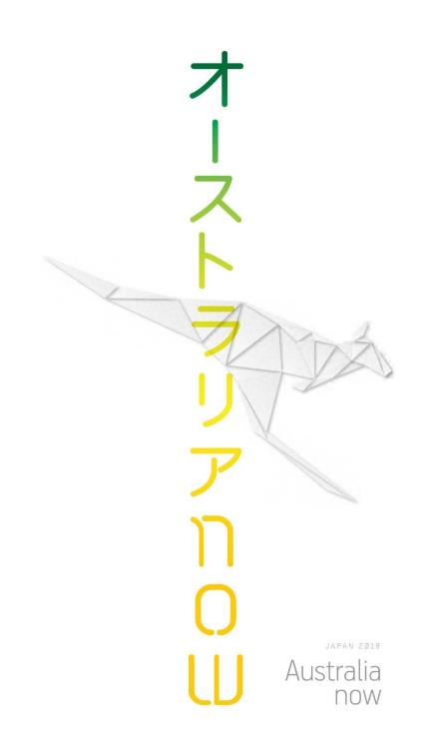

Japan 2018

Australia now

# We invite you to celebrate Australia with us in Japan



Arkaroola, Flinders Ranges, South Australia. Photo: Maxime Coquard, Tourism Australia

## Become an Australia now partner

Australia now is a celebration of Australian innovation, culture and lifestyle in Japan throughout 2018. Recognising our strong ties and people-to-people links, Australia now will promote Australia’s creative excellence, diversity and innovation and strengthen networks and collaboration. It’s all about building relationships for the future.

### Join the conversation

[ Australianow](http://facebook.com/AustraliaInJPN) [ AustraliaInJPN](http://www.twitter.com/Australianow) [](http://facebook.com/AustraliaInJPN)[japan.embassy.gov.au](mailto:nicole.murphy@dfat.gov.au)

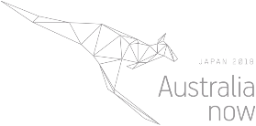

“Australia enjoys a strategic partnership with Japan, a country with which we have shared values and interests. Australia now will enhance our cultural connections and demonstrate contemporary Australia as a creative and innovative partner, strengthening economic collaboration between our two countries.”

Hon. Richard Court AC   
Ambassador to Japan

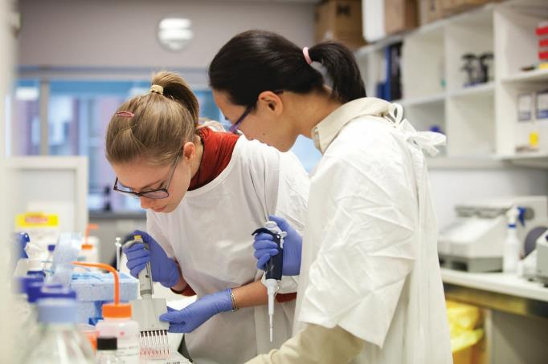

Scientists collaborating at Peter MacCallum Cancer Centre

“The trade and investment relationship between Australia and Japan has never been stronger. It is timely for our two business communities to celebrate these achievements and set our sights on building an even brighter future.”

Sir Rod Eddington AO  
President of the Australia Japan Business Co-operation Committee

# The moment is right for Australia to engage more deeply with Japan.

Australia now will engage Japanese society through three themes:

* **Innovation**  
  Science, research and innovation
* **Creativity**  
  Design and creativity
* **Australian lifestyle**  
  Sport, tourism and culinary excellence

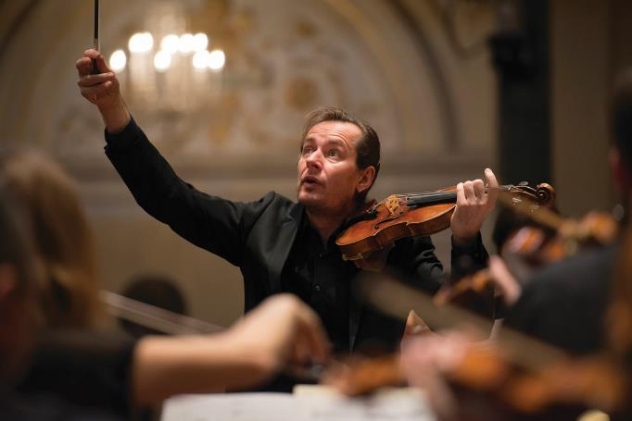

Richard Tognetti & the Australian Chamber Orchestra. Photo: Simon van Boxtel

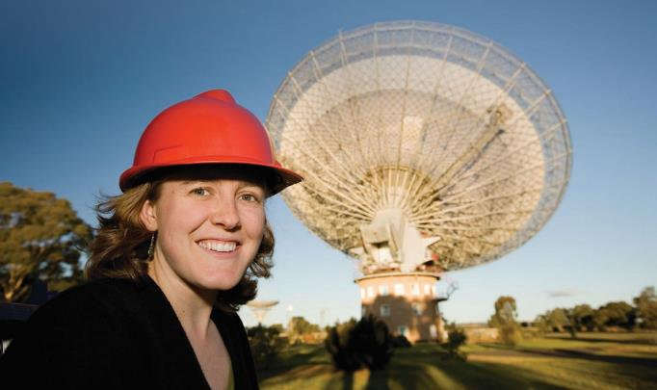

Astronomer Naomi McClure Griffiths at Parkes. Credit: CSIRO

Japan is a vital strategic and economic partner for Australia. With deep bilateral ties, Australia and Japan share a special relationship based on common values and strategic interests.

Japan is Australia’s second largest overseas source of foreign direct investment after the United States and remains our second-largest export destination.

Australia now will strengthen Australian – Japanese relations and promote Australia as a key destination for tourists, innovators, researchers and investors.

Highly successful promotions have already taken place in countries such as Germany, Brazil, Turkey, Indonesia, India and the United States.

Australia now – impress, connect and engage in the lead up to the Rugby World Cup 2019 and the Tokyo 2020 Olympics and Paralympics

Australia is a place of natural beauty, enviable lifestyle and offers world class opportunities in sport, the arts, culture, education, science, technology, finance and investment.

Japan is renowned as an innovation leader with a rich and unique culture.

Australia now will:

* **Promote Australia’s finest** entrepreneurs, artists, innovators and thinkers on a vibrant international platform
* **Raise Australia’s profile** as an innovative, contemporary and creative nation
* **Explore Australia’s liveable cities** and sustainable design culture to address challenges of the future such as energy and food security, healthcare and ageing

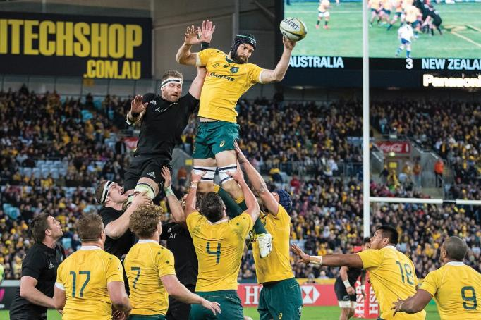

Bledisloe Cup Qantas Wallabies vs New Zealand All Blacks, ANZ Stadium, Sydney. Photo: Karen Watson, ARU Media

“The Australian love of sport will be on show at the Australia now festival in Japan throughout 2018. In the lead up to the 2019 Rugby World Cup and the 2020 Tokyo Olympics and Paralympics, Australia now will offer fantastic opportunities for players, sports fans and business people to enjoy world-class events whilst networking with an array of stakeholders in business and government.”

Bill Pulver  
CEO of Australian Rugby Union



Australian Rugby Sevens star, Ellia Green. Photo: Karen Watson, ARU Media

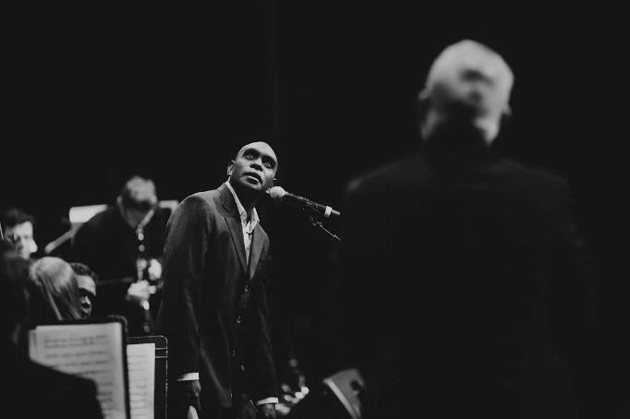

Monash Art Ensemble together with David and Daniel Wilfred, premier Paul Grabowsky’s Nyilipidgi at the 2015 Melbourne International Jazz Festival. Photo: Laki Sideris



Kunkun, 2008 by Nora Nangapa, Nora Wompi, Bugai Whylouter and Kumpaya Girgaba, Martumili Artists, acrylic on canvas, 124.5 x 294 cm. National Museum of Australia.

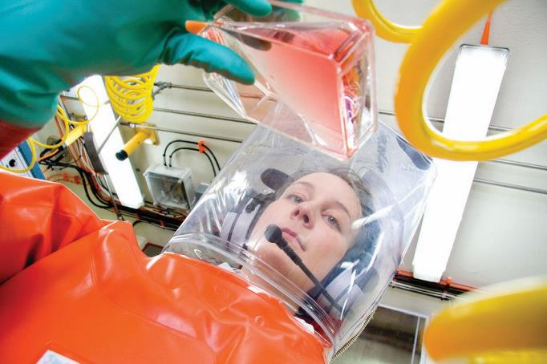

Elena Virtue, Photo: CSIRO

# Australia now – building relationships for the future.

Partners from government, business, cultural, education, sports, science and research institutions will join us to build these relationships.

* Demonstrating Australia’s capabilities in innovation, science and technology
* Promoting Australia as an attractive investment and tourism destination
* Highlighting Australia’s world-class arts, business, research and education sectors
* Presenting Australian excellence and capability in sport and sport integrity
* Reaching out to young and influential Japan
* Illustrating Australia’s culturally rich and diverse background, unique Indigenous history and vibrant art, architecture and design practice



Bondi Beach, Sydney, New South Wales. Photo: Jeremy Bishop

Demonstrating Australia’s cultural richness and diversity where, like Japan, contemporary society draws on its ancient past.

We will join with some of Japan’s best cultural festivals and venues to stage headline events in Tokyo along with smaller scale projects and collaborations in key locations across Japan.

## Australia now program

Offering exchange and engagement through inspired events, specially curated programs and dialogue to elevate interest and bring our respective communities together.

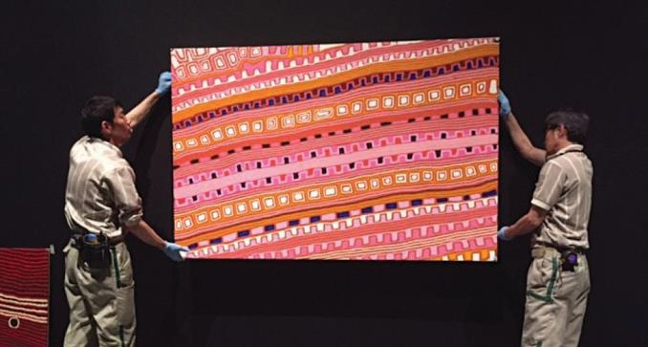

Patrick Tjungurrayi’s painting, Canning Stock Route Country, 2007, is installed at the National Museum of Ethnology, Osaka. Photo: National Museum of Australia

### Program Highlights

* High profile sporting events
* Contemporary visual art events
* Artist-in-residence programs
* Contemporary and classical music and theatre events
* Performing arts
* Australian architecture and design displays
* Outdoor film festivals
* Beach culture and surfing events
* Literature events
* Panel discussions and dialogue including innovation and science forums
* Premium Australian food and wine events and tasting opportunities
* Focus on youth leadership and participation
* Australian participation in key Japanese festivals such as the Echigo – Tsumari Triennale and Tokyo Jazz Festival

### And there are more surprises to come…

Follow us over the coming months for Australia now announcements and the Australia now program

[](http://facebook.com/AustraliaInJPN) [Australianow](http://japan.embassy.gov.au) [](http://www.twitter.com/Australianow) [AustraliaInJPN](http://facebook.com/AustraliaInJPN)

## Join the celebration in Japan

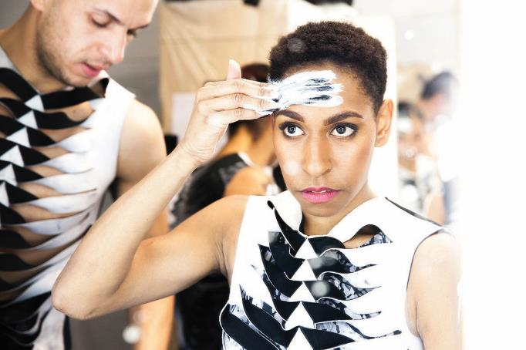

Yolanda Lowatta, lore, Bangarra Dance Theatre. Photo: Jacob Nash

As an Australia now sponsor you will have an unrivalled opportunity to join leading Australian thinkers, innovators, entrepreneurs and artists to promote your business on a highly visible international platform in one of the world’s most exciting cities.

Your logo on Australia now material and programmed events will speak to business leaders and audiences throughout Japan - one of the most populous and innovative countries in the world.

Above all, you’ll have helped to celebrate Australia, its diversity and creativity.

Australia now partners enjoy:

* Association with this major festival of Australian culture in Japan
* Partnership recognition on Australia now marketing collateral (including printed program information, website and advertising campaign)
* Increased brand exposure to existing and new international stakeholders
* On-site branding through signage and displays at Australia now events and recognition in media kits, releases and interviews
* Networking opportunities with government and business leaders, creative industry specialists, science and technology experts, leading architects, urban designers, innovators and sporting identities from Australia and Japan
* Invitation packages to the Australia now launch, official gala opening events and ticketed program events

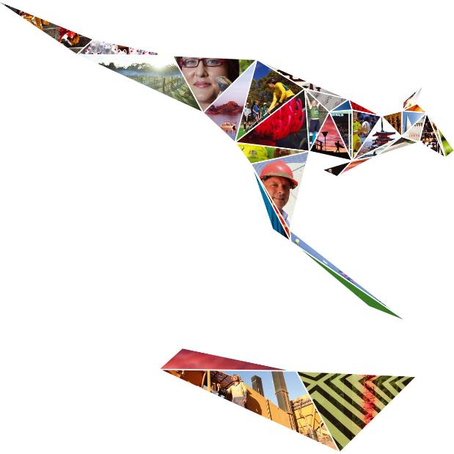

Celebrate Australia, its diversity and creativity.

“Australian jazz music symbolises the Australian culture of innovation and creativity. In 2018, we are excited to present a cross-cultural collaboration between Australian and Japanese musicians with jazz legend Paul Grabowsky. We are sure this will be one of the highlights of *Australia now*.”

Atsuko Yashima  
Tokyo Jazz Festival, Executive Producer

# Partner benefits and opportunities

Australia now offers a wide range of sponsorship opportunities.

The Australian Government is committed to working with Australia now partners to promote and elevate the best of Australia. Partners of Australia now will support the Australian Government to deliver a dynamic festival that will engage Japanese audiences, reach valued stakeholders and develop future networks.

To discuss sponsorship options for your company or organisation, please contact:

**Nicole Murphy**  
Cultural Diplomacy  
Department of Foreign  
Affairs and Trade, Canberra

P: +61 (0)2 62611228  
M: +61 (0)416635549  
E: [nicole.murphy@dfat.gov.au](http://facebook.com/AustraliaInJPN)

**Michael Hoy**Counsellor Public Affairs  
Australian Embassy Tokyo

P: +81 (0) 3 5232 4081  
M: +81 (0) 90 8443 7601  
E: [michael.hoy@dfat.gov.au](http://www.twitter.com/Australianow)

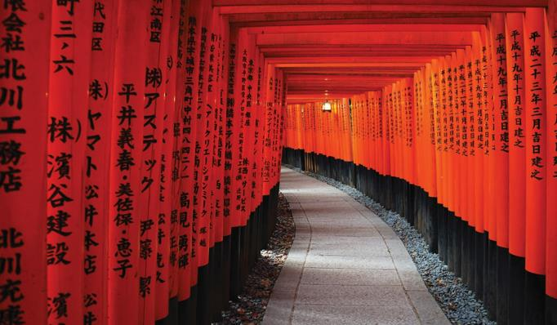

Fushimi Inari Taisha, shrine in Kyoto. Photo: Ms Haline Ly, Whale Design Co, Japan Tourism

We look forward to tailoring packages to your needs or facilitating sponsorship of a particular Australia now event.

| Amount (cash or in-kind) | **Platinum**  AUD 250K+ JPY 20M | **Gold**  AUD 100K+ JPY 8M | **Silver**  AUD 75K+ JPY 6M | **Bronze**  AUD 50K+ JPY 4M |
| --- | --- | --- | --- | --- |
| **Events** | | | | |
| Exclusive reception hosted by the Australian Ambassador to Japan at the Ambassador’s residence for the partner and 80 guests | **Platinum** |  |  |  |
| Exclusive dinner hosted by the Australian Ambassador at the Ambassador’s residence | **Platinum - 12** | **Gold - 8** |  |  |
| Exclusive dinner hosted by a senior embassy official for partner guests |  |  | **Silver – 12** | **Bronze – 8** |
| Guest appearance by the Australian Ambassador at a partner event | **Platinum** |  |  |  |
| Speaking opportunity at a specific program or associated event | **Platinum** | **Gold** | **Silver – as appropriate** | **Bronze – as appropriate** |
| Special venue hire rate for one event at the Embassy Reception Hall or Garden in 2019 | **Platinum** | **Gold** |  |  |
| VIP invitations to the Australia now Launch | **Platinum - 20** | **Gold – 14** | **Silver – 10** | **Bronze – 4** |
| Invitations to official Australia now opening and ticketed program events | **Platinum - 20** | **Gold – 14** | **Silver – 10** | **Bronze - 4** |
| Opportunity for exclusive tailored events | **Platinum** |  |  |  |
| For governments: guaranteed content from their state/territory | **Platinum** | **Gold** | **Silver** |  |
| **Branding & Promotion** | | | | |
| On-site branding at specific Australia now program events and official functions* | **Platinum** | **Gold** |  |  |
| Partnership recognition in speeches at select Australia now program events | **Platinum** | **Gold** | **Silver – as appropriate** | **Bronze – as appropriate** |
| Partnership recognition on all Australia now marketing collateral  *tiered subject to partnership level | **Platinum** | **Gold** | **Silver** | **Bronze** |
| Advertisement in official Australia now program | **Platinum** |  |  |  |
| Product placement opportunities at select events (to be agreed) | **Platinum** | **Gold** | **Silver** |  |
| Tailored promotion, including possibility of naming rights and signage for a stage, cinema screen or venue entrance (to be agreed) | **Platinum** | **Gold** |  |  |
| **Media Exposure** | | | | |
| Media exposure in traditional newspaper media | **Platinum** | **Gold** |  |  |
| Partnership recognition in media interviews | **Platinum – as appropriate** |  |  |  |
| Dynamic and sustained social media campaign via Facebook, Twitter and Instagram | **Platinum** | **Gold** | **Silver** | **Bronze** |
| Rights to content for own web and social media platforms | **Platinum** | **Gold** | **Silver** | **Bronze** |
| Feature on website or pinned social media post for a set time period | **Platinum** | **Gold** | **Silver** | **Bronze** |
| Trademarks, partner’s web links and testimonials included in Australia now digital media | **Platinum** | **Gold** | **Silver** | **Bronze** |
| **Exclusivity** | | | | |
| Exclusive right to industry sector within a partnership tier (available by negotiation) | **Platinum** | **Gold** |  |  |

* The above table is indicative and subject to any existing contracts or arrangements which may affect such privileges.

With deep bilateral ties, Australia and Japan share a special relationship based on common values and strategic interests.

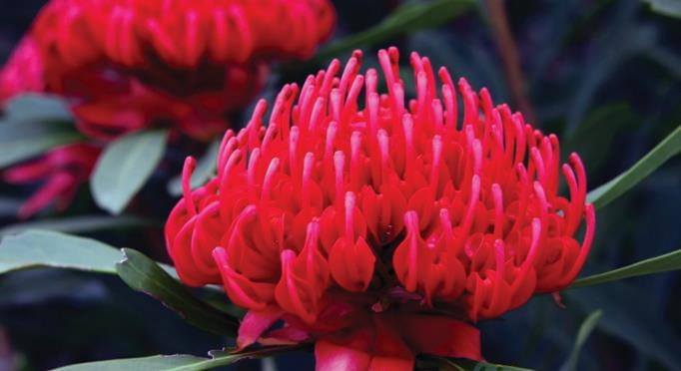

Waratah Photo: Ms Haline Ly, Whale Design Co, Japan Tourism

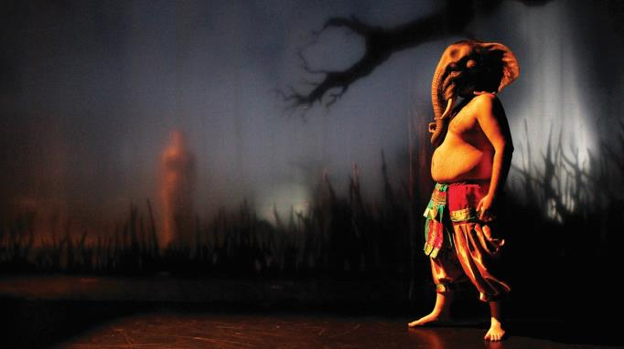

Back to Back Theatre’s Ganesh Versus the Third Reich, Photo: Jeff Busby

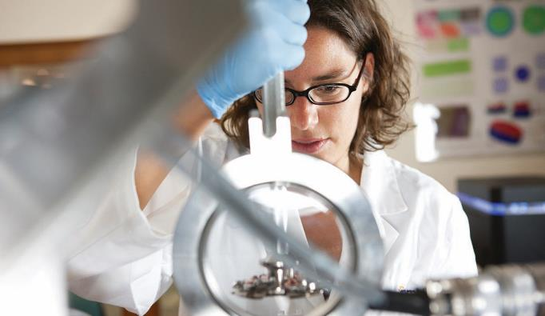

Cameca Local Electrode Atom Probe, University of Sydney

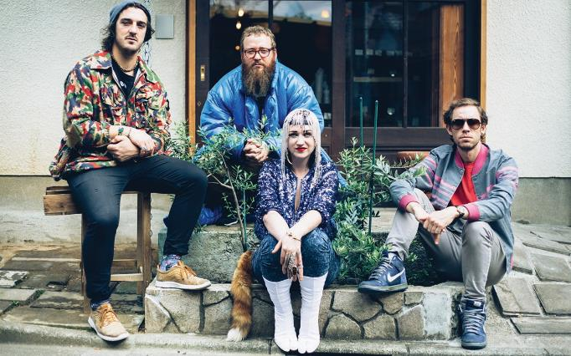

Hiatus Kaiyote in Japan. Photo: Wondercore Island

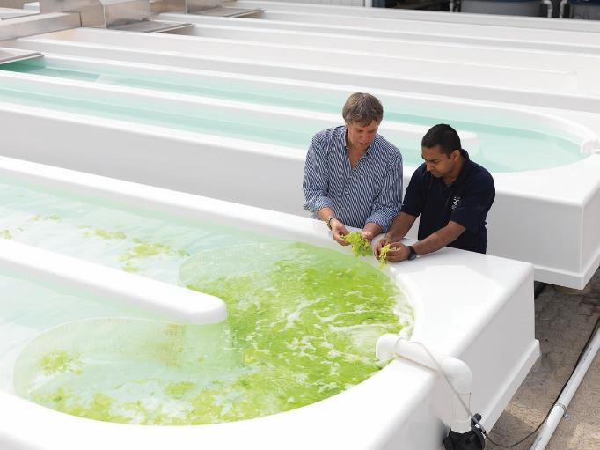

Two scientists inspecting algae. South Australian Research and Development Institute. Photo: Nick Bowers © The Kitchen 2010

# It’s all about building relationships for the future.

Australia now will promote cultural exchange and cooperation across a variety of fields.

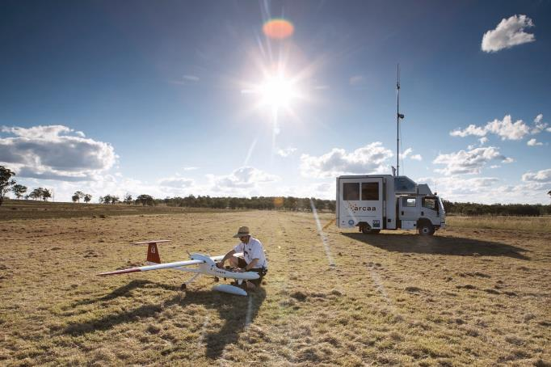

Data transfer and robotics mapping Australian Research Centre for Aerospace Automation (AARCA) Eagle Farm, Queensland. Copyright © The Kitchen 2010

# We invite you to celebrate Australia with us in Japan

Follow us over the coming months for Australia now announcements and the Australia now program

[](http://facebook.com/AustraliaInJPN) [Australianow](http://www.twitter.com/Australianow) [](http://facebook.com/AustraliaInJPN) [AustraliaInJPN](http://www.instagram.com/AusEmb_DA)

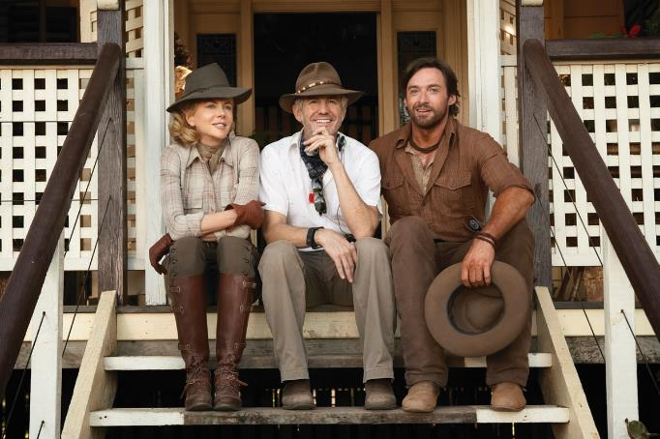

Australia Director Baz Luhrmann (centre), Actors Nicole Kidman (left) and Hugh Jackman (right), courtesy of Screen Australia



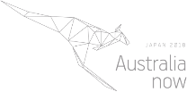

Join the conversation

[](http://japan.embassy.gov.au) [Australianow](http://www.instagram.com/AusEmb_DA) [](http://www.twitter.com/Australianow) [AustraliaInJPN](http://japan.embassy.gov.au/) [](http://facebook.com/AustraliaInJPN)[japan.embassy.gov.au](http://www.twitter.com/Australianow)