**Australia Indonesia Economic Cooperation Partnership (AIECO)**

**Investment Design Document 2017**

Index

Executive Summary ii

Overview of the Indonesian Economy 5

Inequality in Indonesia 8

Rationale for Continued Cooperation on Economic Development 9

Australia’s Policy Objectives 10

Indonesia’s Policy Objectives 11

Indonesia-Australia Comprehensive Economic Partnership Agreement (IA-CEPA) 11

Previous Australian Investments 11

Rationale for bringing AIPEG and GPF together 15

Stakeholder consultation 16

Investment description 17

Goals and High Level Objectives 18

Theory of Change 18

Gender 22

Institutional capacity building and reform 22

Other program-wide considerations 23

Delivery Approach 25

Implementation Principles 25

Investment Criteria 25

Assumptions 26

Monitoring and Evaluation Framework 26

Governance Arrangements 30

Annual Planning Process 33

Other DFAT programs and other Donors 36

AIECO Management and Staffing 36

Budget 37

Risk management 38

Annex A - Summary of lessons learnt from GPF and AIPEG 40

Annex B - Overview of the support provided under the existing GPF and AIPEG programs 42

Annex C – AIPEG Performance Indicators 48

Executive Summary

1. The Australia-Indonesia Economic Cooperation Partnership (AIECO) is a planned investment of up to AUD 145 million over five years (2017-2022). Its goal is to support the Indonesian Government to develop more effective institutions and policies that contribute to strong, sustainable and inclusive economic growth and improved public sector performance.
2. Indonesia's economy grew at 5-7 per cent between 1999 and 2014. This, coupled with prudent fiscal management, resulted in central government debt falling from a peak of close to 100 per cent of GDP to 27 per cent by 2014. Annual budget deficits stayed within the 3 per cent ceiling permitted by the State Finance Law despite very high spending on poorly targeted energy subsidies. The poverty rate declined from 23 per cent to 11 per cent over the period, although some 40 per cent of the population remained vulnerable to poverty, and income inequality increased.
3. The election of President Joko Widodo in 2014 brought renewed expectations of political change and further institutional and policy reforms. The new Government took office with a strong commitment to accelerating growth, improving the business environment and reducing regional, income and other dimensions of inequality. Its medium-term plan (RPJMN 2015-19) targets average growth of 6-7 percent, which is the level needed to absorb a rapidly growing workforce and reduce open unemployment from 6 per cent to below 5 per cent.
4. Strong external headwinds, fuelled (among other things) by China's slowdown and global financial volatility, caused growth to dip to 4.8 percent in 2015 before picking up again in 2016. Cabinet changes and a series of policy packages have helped restore confidence in the reform agenda, while the effectiveness of public spending has been improved by more targeted subsidies and tighter budget discipline. There are early indications that these measures are starting to reduce income inequality.
5. Significant domestic challenges remain, with the more visible symptoms including:
6. Slow productivity growth:
7. High transport logistics costs:
8. Lower-than-projected private infrastructure investment:
9. A persistently low tax ratio; and
10. Inefficiencies within the bureaucracy
11. Many of these challenges are attributable to institutional capacity constraints in core government agencies and to cumbersome and often inconsistent policies and regulations. Non-wage public expenditure remains low across all levels of government and rigid annual budgeting processes constrain investment in large multi-year projects.
12. Australia has been collaborating with Indonesia on economic governance reform since 1999. The initial focus, under the Australia Indonesia Partnership for Economic Governance (AIPEG), was on economic and fiscal stabilisation in the wake of the East-Asian financial crisis, but over time this evolved into a broader range of macroeconomic technical support.
13. In response to the 2004 Boxing Day tsunami, Australia’s Prime Minister and the Indonesian President agreed to establish the Australia Indonesia Partnership for Reconstruction and Development (AIPRD). As a part of this support, the Government Partnerships Fund (GPF) was established to support institutional partnerships between Commonwealth agencies in Australia and their counterparts in Indonesia.
14. The current GPF and AIPEG programs have been providing complementary technical assistance to a range of Indonesian Government agencies in the general areas of economic policy, regulation and public sector reform. The GPF program has also enabled cooperation in priority areas of mutual interest such as transport safety and financial tracking. Advice is provided through Australian Government agencies working with counterpart Indonesian Government agencies (on a mix of fly-in fly-out and long-term deployment arrangements) and through international and Indonesian advisers engaged by the AIPEG facility.
15. While much has been accomplished, significant work remains. Public sector reform and institution-building takes time and often faces resistance from vested interests. Changes already introduced need to be embedded and deepened while new reforms need very careful planning and implementation. But such efforts are essential if Indonesia is to enhance its capacity for formulating and implementing sound evidence-based policy. This need is clearly recognised by Government, the private sector and civil society.
16. The case for Australia to extend the current collaboration is compelling:

* National interest: A stable and prosperous Indonesia is good for Australia's security and trade and, more generally, for regional stability;
* Need: Despite being a G20 country, Indonesia would benefit from continuing external assistance to tackle the range of challenges listed above in a timely and effective manner;
* Positioning: Australia is well placed to provide effective high quality assistance given its position as a trusted and responsive partner over an extended period.

1. AIECO integrates Australia’s two previously separate economic governance programs – AIPEG and GPF – within a single facility structure to leverage their comparative advantages, create administrative and information efficiencies and promote opportunities for more effective collaboration and coordination between Australian Public Service (APS) agencies and private sector advisors. The agency partnerships and the overall thematic scope of the new program will be broadly similar to the existing programs. This approach reflects the resounding view expressed during consultations undertaken in Indonesia and Australia in 2016 that the new program should continue working on the same issues with a similar mix of Australian Government, Indonesian and international advisers.
2. The funding split for AIECO will be up to approximately AUD 95 million over 5 years to a managing contractor for the provision of international and Indonesian advisers. This will also include a range of support services. The managing contractor will also provide monitoring and evaluation support across the entire AIECO program including to Australian Government partners. The remaining up to AUD 50 million will be provided by DFAT to Australian Government partners to implement capacity-building activities with Indonesian Government partners in both Indonesia and Australia.
3. AIECO will build on the success of the GPF and AIPEG, drawing on the lessons learned from previous years and on the highly valued partnerships developed over a number of years between Australian and Indonesian agencies. AIECO will continue to support the long-standing government-to-government partnerships that have served the Australia-Indonesia bilateral relationship well.
4. AIECO will deliver advisory support through a range of mechanisms including workshops, training, mentoring, research, secondments, seminars and conferences. AIECO will employ a core of long-term advisors that have a deep knowledge of Indonesia and strong networks within the Indonesian system to provide both "just in time" advice and longer-term analysis to support the key economic reform objectives of the Indonesian Government. Long-term advisors will be supplemented by short-term technical advisers and other forms of advisory services as needed.
5. Reducing inequality, including gender inequality, will be a cross-cutting objective and addressed through a two track approach. This approach will consist of gender-specific interventions (track 1) and the mainstreaming of gender equality considerations (track 2) throughout AIECO activities to contribute to achieving end of program outcomes.
6. Flexibility and collaboration in the delivery of AIECO will be key principles to ensure that it remains fit for purpose and responds to Indonesia's evolving challenges and reform priorities. Strong institutional partnerships between Indonesian and Australian agencies will remain a core part of AIECO.
7. AIECO aligns with Objective 1 of DFAT's Indonesia Aid Investment Plan (2015-19), Effective Economic Institutions and Infrastructure and corresponds to several objectives of Indonesia's Medium-Term National Development Plan (2015-19) including improving competitiveness, achieving equitable development for all and playing an important role in the global community.
8. Once the framework for the IA-CEPA Economic Cooperation work plan has been settled by the Governments of Australia and Indonesia, AIECO should be equipped to participate in the design and implementation of Economic Cooperation activities as required and agreed under IA-CEPA, and if directed by DFAT.

Overview of the Indonesian Economy

1. Indonesia is the 8th largest economy in the world but still faces significant economic and development challenges.[1] Economic growth in the range of 5-7 per cent reduced poverty from 23 per cent in 1999 to 11 per cent of the population in 2016[2]. However, approximately 40 per cent of the population remain vulnerable to poverty as their incomes are only marginally above the poverty line, and they lack mechanisms to deal with a sudden shock to their finances. Worryingly, job creation has slowed in recent years and economic growth is likely to remain relatively constant at around 5% over the medium term; a rate that is unlikely to absorb the 2 million young people entering the labour force each year. Significant economic and public sector policy reforms are needed to spark greater job creation and promote more inclusive growth.
2. The election of President Joko Widodo in 2014 symbolised political change and raised hopes for significant economic reform. The long awaited cutting of energy subsidies in 2014 served to further boost these expectations. However, the end of the commodity boom revealed significant underlying imbalances. A widening current account deficit triggered stability concerns and the loss of budget revenues from commodities brought into relief Indonesia’s very low tax ratio. Spending on infrastructure development has been significantly outpaced by rising demand, weak educational outcomes are failing to deliver necessary labour market skills, health indicators have failed to make progress, and growing inequality is adding to spending demands.
3. Reform prospects were revived in the second half of 2015. The August 2015 cabinet reshuffle, renewed interest in bilateral and regional trade agreements, and the senior appointments to Cabinet, particularly the return of Dr Sri Mulyani Indrawati as Finance Minister and the appointment of Darmin Nasution as Coordinating Minister for Economic Affairs, helped strengthen the government’s reform credentials.
4. Progress is evident in a number of areas. Recent economic reform packages, while of mixed effectiveness, signal reform resolve and include important measures such as revisions to the negative investment list. In 2017, Indonesia was ranked 91st in the World Bank's Ease of Doing Business index, up 15 places from its 2016 ranking of 106, and among the top-ten best improvers. Infrastructure investment has picked up although efforts to involve the private sector, a critical need, have not been encouraging. Fiscal restraint with respect to the budget demonstrate a resolve to tackle fundamental issues while meeting commitments to investment in important areas like infrastructure, health and social protection.

* Strengthening Indonesia’s Competitiveness

1. Indonesian government plans envision achieving high-income status through an improved environment for doing business, supportive infrastructure, and stronger government budgeting. Strengthening Indonesia’s competitiveness - the set of institutions, policies and factors that determine its productivity - is imperative if this vision is to be realised.
2. Indonesia will need reforms that take advantage of all opportunities to reach its full potential. Productive potential is not being realised and foreign investment in many areas including infrastructure and services remains low. Barriers to entry, a reluctance to make users pay for goods and services once heavily subsidised, as well as regulatory uncertainty continue to constrain investment. Sectors where more efficient markets flourish – such as communications and air transport – have experienced sustained rapid growth.  However, across a broad range of sectors and by global measures, Indonesia’s competitiveness looks less robust.

* Rising production costs

1. In the manufacturing sector, the cumulative increase in Indonesia’s unit labour costs have been dramatic; costs are many times more than those of regional comparators. A major driver of this outcome is consistently higher Indonesian inflation that drives higher nominal wage growth than in trading partners. At the same time, productivity growth has been relatively weak reflecting regulatory and structural constraints hindering market effectiveness. Consequently, the volume of Indonesia’s non-commodity exports is not growing and Indonesia has seen a decline in its global market share of tradable goods.
2. Indonesia has become a high-cost economy. Firms maintain domestic market share through barriers to entry facing new competitors (domestic and foreign). Nonetheless, overall investment has been high and foreign investment has picked up, though remains low as a share of GDP. The domestic market is the focus of this investment, due in part to investor interest in avoiding the barriers associated with international trade. These barriers include legal, regulatory, structural (infrastructure challenges), and informal impediments.
3. Logistics accounts for approximately 25 per cent of the cost of manufactured goods in Indonesia, considerably higher than regional comparators with Malaysia’s logistics cost at around 13 per cent. This not only makes Indonesia less competitive but also less equitable with the higher costs of essential goods and services particularly in remote areas. As is often quoted, it is cheaper to ship a container of mandarins in Jakarta from Shanghai than ship the same container from Padang, West Sumatra even though it is one sixth of the distance.[3]

* Growth prospects cool

1. Growth is at risk. Indonesia’s competitiveness needs to improve not only to reach the government's growth and income goals but also to sustain recent growth performance. Growth has trended lower in recent years reflecting lagging productivity growth. The growth rate of the labour force will slow this decade due to demographic factors. Moreover, labour quality indicators are discouraging even though there have been increases in educational enrolment that hold promise for a more productive labour force provided the quality of education improves.
2. A pick up in investment could herald a stronger capital stock but analysis suggests that the investment is tied to the performance of the commodity sector, where the exceptional China-led commodity boom of a few years ago is not likely to be repeated. The IMF estimates that economic growth in Indonesia over the medium term will hover around 5-5.5 percent, compared to the 7-8 percent Indonesia is striving to achieve. However, even growth rates of this magnitude are at risk if there is policy inaction. Financing is an increasingly binding constraint and the pick-up in infrastructure investment is not keeping up with rising demand from economic growth and deterioration of existing infrastructure from a lack of maintenance.

* Risks to stability

1. Macroeconomic stability based on fiscal prudence was the anchor of Indonesia’s success in the 2000s. This anchor is at risk of slipping for several reasons, namely:

*The budget:* spending has trended up in recent years while revenue has remained flat, and leaving the budget deficit close to its legal limit of 3 percent of GDP. As a result, unlike 2008-2009, the government has limited scope to respond to an economic shock.

*External financing:* The current account deficit has been reduced to manageable levels through lower growth that is restraining imports rather than any improvement in export performance. Efforts to boost growth are likely to be stymied by a re-emergence of a larger current account deficit re-igniting stability concerns owing to reliance on portfolio flows.

*The financial sector:* the financial sector is small compared to Indonesia’s economic size and insufficient to finance necessary investment. The government faces a challenge in rapidly growing the financial sector while ensuring its stability.

1. Each of these policy challenges is interacting against the backdrop of an international environment that is likely to be more volatile in coming years. One concern is that Indonesia has limited options to address economic shocks, both domestic and external.

* The private sector

1. Securing strong, sustainable, and inclusive growth will require a much larger private sector contribution to the economy. This is essential to deliver the needed capital stock, increase government revenue, increase productivity, create jobs, and deepen markets to enhance resiliency.
2. The challenges facing the private sector in Indonesia are well-known; Indonesia ranked 91st (out of 190 economies) in the World Bank’s 2017 doing business index and 41st (out of 138 economies) in the World Economic Forum’s competitiveness rankings. The key areas of concern include issues around government policy settings (regulation, licensing, trade etc.); the implementation of policy (governance, lack of transparency and uncertainty); and the absence of effective public inputs (infrastructure, legal system, labour skills etc.).
3. State Owned Enterprises (SOEs) continue play a dominant role in key sectors, including infrastructure (in particular ports, airports, railways and toll roads), banking, energy and extractives, construction and heavy industry (e.g. steel, fertilizers and cement).  This has constrained competition and opportunities for private sector development, and partly explains why the Government’s expectations for private investment in public infrastructure have not been met.
4. However, modest progress has been made on SOE reform since the 1997-98 financial crisis. Many large enterprises have been partly privatised (e.g. Garuda, Jasa Marga [Toll Roads] and PGN [gas distribution]) while some major banks were returned to the private sector following the Asian crisis (Bank Mandiri and Bank BNI) and many are operating profitably.  Some have been partly privatised while others have been able to mobilise financing for their investments through the issuance of bonds on domestic international capital markets. While there is significant scope for broadening such reforms, including through mechanisms such as asset recycling, the near term prospects for radical changes are constrained by provisions of the Constitution which limit the opportunities for private participation in some sectors and by political opposition to further privatisation.

Inequality in Indonesia

1. Poverty and inequality remains a significant challenge in Indonesia. The poverty level has declined steadily in recent years, especially during the commodity boom, reaching 10.7% in September 2016 (27.8 million) from 13.3% in 2010. However, a large segment of the population remains vulnerable, living just above the poverty line of USD$2 per day. This group, estimated by the World Bank to be about 40% of the population or around 100 million people, is vulnerable to events, especially food price shocks, which occur in Indonesia on account of various factors and tend to be exacerbated by impediments to timely imports.
2. Inequality in Indonesia is high, particularly in urban areas. Aggregate data show that the Gini coefficient is 0.397, and 0.410 in cities compared to 0.327 in rural areas. Inequality increased during the commodity boom. The government budget has made little dent in this inequality however some progress has been made in recent years with the substantial removal of energy subsidies and the increasing adoption of cash grants for the poor.
3. An important element of inequality in Indonesia is its regional dimension. The per capita income in the poorest region (Eastern Indonesia) is just $1,955 and is as high as $4,188 in Kalimantan. There are large regional disparities in the poverty rate, ranging from 28% in Papua to 3.8% in Jakarta. The government has increased its focus on this element of inequality in shaping policy including on infrastructure investment and health insurance. This raises crucial policy choices in a constrained budget environment.
4. Strong growth is required to absorb those entering the workforce each year. Over the past five years the workforce has increased by an average 2 million persons per year. It is estimated that economic growth needs to be at least 6.7% to employ this growing workforce (about 300,000 workers for each percentage point of growth).
5. The next ten years is critical to make progress on poverty. Indonesia will see its dependency ratio begin to climb in the mid-2020s. The budgetary situation will begin to experience demographic pressure. Already, labour force growth is slowing and this will begin to cap the pace of economic growth.

* Gender equality

1. Indonesia currently ranks 110 out of 188 countries in UNDP’s Gender Development Index, reflecting high levels of inequality in the labour market, entrepreneurship, access to healthcare and legislation/ regulatory treatment. Female workforce participation rates in Indonesia have remained unchanged over the last two decades at around 50 per cent. This is lower than neighbouring countries at similar levels of development (e.g. Thailand and Vietnam). As a member of the G20, Indonesia has committed to reducing the gap between female and male labour force participation by 25 per cent by 2025. The gender wage gap is also significant at an average of 41 per cent and workplace discrimination against women is common. AIPEG analysis has also indicated that there are a range of barriers to women’s full participation in the economy such as access to finance, taxation treatment and difficulties starting a business.

* Disability

1. People with disabilities are often among the most disadvantaged and poorest groups within their communities and are often socially isolated within Indonesian society, remaining hidden by family or within institutions. For example, it is estimated that in Indonesia a child with disability is seven times more likely to be absent from school.
2. Indonesia has made a number of commitments, most notably ratifying the United Nations Convention on the Rights of Persons with Disabilities in 2011, and to ensure that people with disabilities are included in Indonesia’s Medium Term Development Plan (RPJMN). In 2015 there were 17 regulations that protected the rights of people with disabilities and, most importantly, in 2016 the Parliament endorsed the new Disability Law, Law No. 8/2016. The Law marks a significant movement in shifting national’s perspective towards persons with disabilities from social-based to human rights-based approach. The Law is also a significant reform, in a sense that it paves the way for reform of other regulations (including criminal and civil laws) and provides legal impetus for national and sub-national governments to budget for and implement services accessible to people with disabilities. The challenges of implementing the Disability Law are significant, however there is high-level political momentum, civil society pressure and knowledge to progress forward with regulations to implement the rights-based approach.
3. A key constraint to providing adequate and quality services to people with disabilities is the limit to and accuracy of statistics on people with disabilities. Improving the statistical collection of data on people with disabilities is critical to inform policy development and budget spending that responds to the needs of people with disabilities under Indonesia’s existing laws. Weak or limited data results in lower than required budget allocation to meet the needs of people with disabilities, particularly in health and education. Poor spending in services, health and education for people with disabilities leads to lower levels of participation in the workforce and as a result fewer economic opportunities for people with disabilities.

Rationale for Continued Cooperation on Economic Development

1. A prosperous and stable Indonesia is good for Australia’s stability, security, prosperity through trade and investment and cooperation in our shared region. Indonesia has reached middle-income status and achieved substantial development progress in recent years.
2. However, as outlined above, further developmental progress and continued cooperation is in our shared interests. The significant regional variability in poverty reduction is a case in point. Eastern Indonesia, the area closest to Australia, lags well behind the rest of Indonesia on key development indicators.
3. Indonesia’s economy also remains vulnerable to external shocks. The 1997-1998 Asian Financial Crisis exposed weaknesses in Indonesia’s economic and administrative policies and the pace of formal sector job creation and poverty reduction has not fully recovered. Australia, with an enviable track-record in economic and bureaucratic policymaking, is well placed to support Indonesia’s efforts to strengthen capacity and promote a stable economy that generates jobs and reduces poverty.
4. Australia’s expertise in opening-up and regulating efficient markets, and harnessing the benefits of trade liberalisation and open investment, makes this a logical area for ongoing cooperation and partnership. Indonesia’s participation in global value chains is relatively low compared to its ASEAN neighbours. A significant share of Indonesia’s integration with the world is through the extractive industries. Excluding this sector, Indonesia has the lowest total global value chain participation in ASEAN after Brunei. A more open, competitive economy will reduce poverty and create jobs in Indonesia. This will also creating a better environment for Australian business to participate in Indonesia’s rapid anticipated growth.
5. Safer air and sea transportation is another mutually beneficially area of cooperation. Australia and Indonesia are both more reliant on sea and air transportation to facilitate trade than many other nations. Australia is well placed to assist Indonesia in this area. Improved air and sea safety will help Indonesia gain access to overseas markets for which this poses a barrier and may help increase in-bound tourism, which generates substantial employment. This is also important for Australia, as a large share of air and sea transportation between Australia and the rest of the world passes through Indonesian territory.
6. The support provided by GPF and AIPEG is highly regarded by Indonesian senior officials and Ministers and there is a strong desire to see this work continue. Restrictions on the ability of Indonesian government agencies to contract expertise is a severe constraint on the formulation and implementation of economic policy. This adds to the value of expert advice and training provided through GPF and AIPEG to Indonesian agencies even further.
7. After many years of economic governance and public sector reform support through AIPEG and GPF, Australia is regarded as a trusted partner. This allows Australia and Indonesia to work closely together on economic issues of mutual interest and we should continue to capitalise on this. The design team confirmed this through extensive consultations in Jakarta, Canberra and Sydney.

Australia’s Policy Objectives

1. Australian development assistance aims to support positive change in developing countries to ensure sustainable economic growth, as specified in Australia’s aid policy: *Australian Aid: Promoting Prosperity, Reducing Poverty, Enhancing Stability*. The policy focusses Australia’s development assistant program in the Indo-Pacific region. Australian economic governance assistance to Indonesia has evolved over the past two decades from a traditional donor-recipient model towards a more mature economic partnership. Australia’s *Aid Investment Plan (Indonesia) 2015-2019 (AIP)* seeks to boost inclusive growth and productive jobs by improving Indonesia’s competitiveness through strengthening the impact of Indonesia’s own resources.

Indonesia’s Policy Objectives

1. Indonesia’s development goals are articulated in its National Medium-Term Development Plan 2015-2019 (RPJMN). Key focus areas of the RPJMN include improving domestic productivity and competitiveness internationally, including through; innovation and technology, accelerated economic growth, enlargement of trade capacity, and up-skilling the labour force. The RPJMN is part of Indonesia’s National Long-Term Plan 2005-2025 which sets the country’s strategic priorities.

Indonesia-Australia Comprehensive Economic Partnership Agreement (IA-CEPA)

1. Recognising the gains to be made from closer economic ties, Australia and Indonesia are working to address trade and investment barriers and capitalise on opportunities through trade agreements. This includes our existing trade agreement with Indonesia, the ASEAN-Australia-New Zealand Free Trade Agreement (AANZFTA), which is currently under review by parties, and ongoing negotiations for a plurilateral agreement, the Regional Comprehensive Economic Partnership (RCEP), involving the ten ASEAN countries and FTA partners, as well as a bilateral agreement, the Indonesia-Australia Comprehensive Economic Partnership Agreement (IA-CEPA).
2. IA-CEPA aims to go beyond a traditional free trade agreement (FTA) and to open new opportunities for the trade in goods, services and investment. IA-CEPA will liberalise the current trading environment through traditional free trade agreement components such as addressing tariff barriers, building more trade facilitative processes, and improve conditions for our services suppliers and investors. IA-CEPA also has the potential to provide a framework for a dynamic economic partnership with Indonesia, including by promoting mechanisms in the final agreement that build in cooperative activities immediately and into the long-term.
3. Economic cooperation under IA-CEPA is expected to boost the implementation of the agreement, facilitate trade and provide a pathway for future liberalisation.
4. The Prime Minister of Australia and the President of Indonesia have committed to the conclusion of IA-CEPA negotiations by the end of 2017. Subject to the outcome of these negotiations and decision making by the Governments of Australia and Indonesia, AIECO may be well placed to support the delivery of aspects of this cooperation. For this reason, AIECO should be equipped to participate in the design and implementation of Economic Cooperation activities.

Previous Australian Investments

1. Australia’s support for improved economic governance is highly valued and builds on more than 18 years of continuous assistance to Indonesia through the GPF and AIPEG, and AIPEG’s predecessor, the Technical Assistance Management Facility (TAMF). TTAMF was established in 1999 to support Indonesia’s recovery from the 1997-1998 Asian Financial Crisis. It evolved over successive phases to support financial sector stability, tax administration, trade facilitation, and debt management. Australia’s technical cooperation in its current form supports mechanisms to safeguard the financial sector against volatility, broaden the tax revenue base and promote sound fiscal management, as well as macroeconomic policy, infrastructure policy and bureaucratic reform. APS implementing agencies, AIPEG and the Indonesia Transport Safety Assistance Package (ITSAP) have strong brand recognition within Indonesia’s institutions.

##### The Government Partnerships Fund

1. The *Government Partnerships Fund* (GPF) is an important component of the bilateral relationship. GPF supports long-term institutional linkages between Australian and Indonesian Agencies. These linkages not only help build capacity, but strengthen connections between people and institutions which outlast the program cycle. These links can be drawn upon by both governments in support of the bilateral relationship and therefore have a value to governments that extend beyond traditional development outcomes.
2. GPF supports priority economic and public sector reforms through policy dialogue, the exchange of technical expertise and capacity building from APS agencies. GPF Phase I was from 2005 to 2010, with $50 million expensed. GPF Phase II started in 2011 and will expire on 30 June 2017, with an estimated expenditure of $60 million.
3. There are currently 13 partnerships supported under the GPF across the full range of economic and public sector performance and oversight agencies including the Indonesia Transport Safety Assistance Package (ITSAP), which supports a total of 5 sub-agency partnerships under the package. Each APS agency responsible for a partnership agrees a budget and set of activities with DFAT on an annual basis, which is approved by a Board comprising DFAT, Indonesia’s Coordinating Ministry for Economic Affairs (CMEA) and other representatives from the Australian Embassy, Indonesian ex-bureaucrats and private sector representatives.
4. GPF operates in a decentralised manner with priorities and activities determined by the APS agency in partnership with their Indonesian counterparts. DFAT manages GPF through the GPF Secretariat; a small team of DFAT staff based in the Australian Embassy, Jakarta. Two separate managing contractors support the GPF Secretariat: one supporting deployed APS staff in Jakarta with their living arrangements and another supporting the implementation of activities by APS agencies (AIPEG performs this role, which is separate from its primary economic governance activities).
5. The modalities used to deliver activities through the various partnerships include the long-term (2-4 years) deployment of embedded Australian officials in their Indonesia partner agencies, two-way high-level visits to support policy dialogue, short-term (2 weeks-6 months) internships of Indonesian officials embedded with their Australian partners and the delivery of training, seminars and workshops on technical matters. There are currently five Australian Government long-term deployees based in Indonesian Government agencies.
6. Monitoring and Evaluation of the program is conducted through self-assessments undertaken every six months by individual Australian partner agencies and reported to DFAT. These assessments use DFAT’s aid quality reporting criteria and contribute to the annual Aid Quality Check process, which feeds into DFAT’s Annual Program Performance Report (Indonesia). Some of the partnerships have undergone independent evaluations over the course of the program. The tone of the reviews conducted was largely positive and recommended limited changes be made to partnership arrangements. Consultations with Indonesian partner agencies highlighted that they would value the opportunity to review and or participate in the reporting process to assist them to plan their activities more effectively.
7. The role of DFAT’s GPF Secretariat is to manage the annual proposal and budget allocation process, manage the 13 activity schedules between DFAT and Australian GPF partner agencies and manage the contracts, finances, monitoring, evaluation and performance reporting of the program. The GPF Secretariat also manages the engagement of a logistics service provider responsible for deployment support services of Australian officials to Indonesia and a separate logistics service provider to support the delivery of activities.
8. To give an indication of current operating requirements: of the 13 participating Government Agencies in 2015, 4 had long-term deployees (total 6 deployed officers) and 9 engaged with partners on a fly-in/out basis.

##### The Australia Indonesia Partnership for Economic Governance (AIPEG)

1. The *Australia Indonesia Partnership for Economic Governance* (AIPEG) provides technical assistance to Indonesian Government agencies working in five key economic policy areas – revenue, spending, markets and financial sectors as well as emerging economic priorities. The goal of AIPEG is to improve the quality of Indonesia’s economic management to support and enhance broad based growth and poverty reduction. To date, the primary focus of support has been on capacity building, policy advice and institutional strengthening. Funding for AIPEG is currently $66 million over 6 years (*2011-2017*).
2. AIPEG addresses medium term policy challenges and informs current policy decisions by providing long-term advisors, technical experts, in-house analytical work, and a team of senior Indonesian policy advisors.
3. AIPEG has a director and two deputy directors. A lead advisor manages each policy thematic engagement area. It operates under a facility model, which enables a flexible work program where activities are judged on their expected contribution towards AIPEG’s strategic objectives. A Board providing strategic direction and oversight governs AIPEG. The Board comprises co-chairs (DFAT and its implementing partner CMEA), representatives from Indonesian and Australian government agencies, and non-Government representatives with expertise in economic governance.
4. To give an indication of current operating requirements: AIPEG staffing includes 85 full time long term staff and 44 short term staff who have been effective and last year delivered 40 workshops, 12 training programs, 5 seminars, 22 visits to Australia, 9 3rd country visits, more than 20 research reports and over 200 policy presentations.

##### Results

1. Both programs have demonstrated good results. GPF partnerships have strengthened and matured over time and their support is highly valued by their Indonesian partners. For example, the Australian Public Service Commission assistance has contributed to new initiatives by the Indonesian bureaucracy including merit based recruitment and capability reviews. The Australian Securities and Investment Commission assistance is improving the Indonesian Financial Services Authority capacity in risk-based supervision on market conduct. The Australian Transaction and Reports Analysis Centre assisted in the establishment of Indonesia’s Financial Intelligence Unit to combat money laundering and terrorism financing.
2. The influence of AIPEG technical analysis has been evident in a number of Indonesia’s recent economic policy packages. This includes policies that have reduced restrictions on hiring foreign workers, reduced cumbersome pre-shipment inspections, introduced a formula bringing certainty to employers and workers on minimum wage increases and eased investment restrictions on the real estate sector. AIPEG successfully conducted a number of collaborative studies with Indonesian partners that improved counterparts’ understanding of the constraints on investment and export growth. These highlighted the key investment climate concerns of firms, the negative impact of non-tariff measures on trade performance, the sensitivity of exports and imports to the exchange rate and the importance of global value chains for export development.

##### Gender focus of AIPEG and GPF

1. DFATs annual Aid Quality Check (AQC) process has shown that gender equality outcomes require improvement for both AIPEG and GPF[4]. AIPEG has treated gender equality as a cross cutting issue. Its first major piece of gender work was a study diagnosing the causes of Indonesia’s low female labour force participation. This research was useful for policymakers seeking to boost women’s participation in the workforce, which is low by peer country standards and a major constraint to economic growth. This piece of work has also led to follow up studies with IndII and KOMPAK (two other DFAT programs) studying transportation and childcare issues, respectively, as these were identified as major barriers to women’s workforce participation.
2. AIPEG has also made significant efforts to explore gender issues in each of its engagement (or thematic areas) as well as in transforming its organisation culture by actively recruiting women and changing its management and senior staff profile, which now features around one-third of female candidates, up from nil only a few years prior. GPF agencies have also made efforts to promote gender equality outcomes by mandating and promoting the participation of women in workshops and study visits to Australia. Two major issues have been a barrier to greater achievement of gender outcomes in AIPEG and GPF. Firstly, some AIPEG advisers and APS staff implementing GPF activities lack training and awareness on gender equality issues. Secondly, there is unconscious and conscious bias against women in the Indonesian bureaucracy. APS agencies have actively tried to counter this bias by requesting Indonesian counterparts increase their numbers of female candidates for training, visits and secondments.

##### Working with the private sector

1. AIPEG works through a range of modalities to support market reforms and achieve private sector development. This includes through the provision of technical advice to build the evidence base for policy change. To inform this technical advice, AIPEG engages with the private sector to provide local context and insights into the impact of public policy and regulatory constraints in Indonesia. An example is the Indonesia Services Dialogue (ISD). Established in 2015 through the help of AIPEG, ISD is a legal entity that brings together senior policy makers and private sector representatives and provides evidence-based discussion and potential solutions on critical issues in the services sector. ISD is an example where private sector engagement has been helpful to push reform in Indonesia’s service sector, notably helping to unify the voice of the private services sector to successfully lobby the government on specific issues (e.g. the repealing a planned requirement for foreign workers to speak Bahasa Indonesia and have quotas attached for local employment).
2. Another example of a dialogue forum that AIPEG helped establish is the Trade Policy Dialogue (TPD) Series. Initially a joint AIPEG-Ministry of Trade activity established in 2015, the TPD series is now almost completely organised by the Ministry of Trade. AIPEG has also recruited an ease of doing business adviser, who was previously the Georgian Minister of the Economy and Sustainable Development from 2010-2012 and oversaw a rapid improvement in the business environment. Indonesia is increasingly focused on improving the business enabling environment as part of its economic growth strategy.
3. Engaging with the private sector is not currently a major component of work under the GPF partnerships as these programs focus more on government to government linkages and policy support.

Rationale for bringing AIPEG and GPF together

1. GPF and AIPEG are active in a number of the same areas and, in some cases, contribute to a shared work program (See Annex B). The rationale for integrating AIPEG and GPF into a single facility is to improve the effectiveness and efficiency of the Australian Government’s investment in economic governance and public sector reform in Indonesia. Over the past two years collaboration has increased amongst GPF agencies and also between GPF agencies and AIPEG, leading to good outcomes. One example of this in action was the collaboration between AIPEG and the Department of Finance that played a major contribution towards the creation of a State Asset Management agency that will help the government to better utilise its large stockpile of idle assets.
2. A proposal to formally bring the two programs together was endorsed by the Governing Board at the first joint GPF-AIPEG board meeting on 26 November 2015. The Board supported a single program to increase effectiveness and in recognition that a high level of collaboration and cooperation exists between the two programs
3. There are high levels of complementarity between AIPEG and GPF activities with clear areas of comparative advantage which should be better leveraged. The technical capacities of AIPEG should be mobilised to better support the peer to peer exchanges between government officials. Likewise, experiences operating within the bureaucracy should inform the broad technical advice and policy discussions through AIPEG.
4. Independent reviews have highlighted that there is sufficient opportunity for improved coordination, information sharing, technical exchanges and on the ground activity support to improve the impact of both programs. There will be greater opportunity for collaboration between Australian Government officials working under the program and international and Indonesian advisers. Integrating the programs will also give effect to the GPF/AIPEG Board decision that both programs should be better aligned going forward.
5. DFAT also needs to ensure that the delivery of its development assistance is as efficient as possible. Efficiencies will be gained by using one Facility to provide the required logistics and monitoring and evaluation support to the combined program. A single program will also carry a lower administrative burden for DFAT, freeing up staff to focus more on strategic engagement.
6. There is also an opportunity to build in new technical capacities within the new facility to support emerging needs as well as develop fit for purpose coordination mechanisms for the delivery of the Facility. For example, a greater focus on trade liberalisation under the new program. These will be developed either prior to or during the implementation phase of the Facility in consultation with key stakeholders.

Stakeholder consultation

1. DFAT consulted with Australian and Indonesian stakeholders on the design of Australia’s economic governance support to Indonesia from November 2015 to August 2016. This included through a design mission in Australia (27 July – 5 August 2016) and in Indonesia (8 – 26 August 2016). The mission concluded with an aide memoire discussion in Jakarta on Friday 26 August 2016 at the Coordinating Ministry for Economic Affairs in which over 100 stakeholders attended with representation across all relevant Indonesian stakeholders. A summary of lessons learnt from GPF and AIPEG that were discussed during design consultations is at Annex A.
2. Stakeholders were consulted on their experience to date with GPF and AIPEG, and on the key design parameters of the new integrated program:

* operating under a single program logic and key program objectives;
* management through a facility model; and
* strengthened performance and evaluation to demonstrate outcomes more effectively.

1. Both Australian and Indonesian stakeholders were supportive of a new integrated program to build on the earlier success of the two programs. Stakeholders suggested enabling mechanisms to support further integrating GPF and AIPEG, for example, creating better networks among Australian agencies and mechanisms to communicate results and identify opportunities for collaboration.
2. In particular, Australian stakeholders welcomed a single program logic to support and guide activities. Indonesian stakeholders highlighted the importance and value of Australian government-to-government partnerships and its commitment to the new program. There was clear support for moving management of the integrated program to a single facility to realise efficiencies and an enhanced monitoring and evaluating system to support accountability, performance management and learning over the life of the new program.
3. Indonesian stakeholders highly value the flexibility of the two programs and confirmed that this should remain a key feature of the new program. For GPF, this included the different agencies and modalities employed, for example, long-term deployees in Jakarta, short-term secondments and senior officials meetings based on the individual Indonesian agency need. For AIPEG, this included the ability to respond quickly to requests from a credible and trusted source in priority and emerging reform areas.
4. During design consultations, partners cited examples where both programs worked together to leverage resources and that this should continue where appropriate. Partners that received support from only one program were interested to understand how they could be better supported by both programs. For example, Indonesia’s Civil Service Commission expressed interest in additional research expertise to support its major policy priority of reducing the size of its civil service. It is, however, important to maintain the complementary characteristics of the two programs and recognise that, in some cases, GFP-AIPEG collaboration is less appropriate. For example, the Australian and Indonesian Transaction Reports and Analysis Centre agencies cannot easily be supported by consultants given the sensitive operational information that is often exchanged. In all cases, Indonesian counterparts appreciated the special nature and comparative advantages of both programs.
5. DFAT consulted with a range of private sector parties with Australia – Indonesia interests seeking their views on Australia’s current and planned investments in the economic governance sector. There was great interest and appreciation for the long standing and extensive networks that have been cultivated over many years through the GPF and AIPEG programs. Private sector stakeholders were overwhelmingly interested in their specific industry sectors where likeminded institutions could work with the Australian development program, or other parts of the Australian embassy, to pursue areas of policy or regulatory reform. While opportunities for increased private sector collaboration will exist in AIECO, all parties are aware that these will need to be balanced against Australia’s broader partnership with the Indonesian Government to provide robust and credible evidence based policy advice through the development program.
6. There was strong interest in following up with key industry stakeholders in specific sectoral areas when AIECO becomes operational and when relevant opportunities for collaboration arise.

Investment description

1. DFAT will integrate AIPEG and GPF into a single facility called the Australia Indonesia Partnership for Economic Cooperation (AIECO). As a facility, the investment activities and pathways to change are not set or predetermined, which will enable AIECO to be responsive to Indonesia’s evolving priorities. This allows the implementing partner and APS agencies to develop activities that directly respond to the partner government’s agenda, needs and requests.
2. The outcomes, scope of work and modes of assistance under AIECO will remain largely unchanged from GPF and AIPEG on the basis that both investments have performed well. DFAT will continue to have strategic oversight and engagement with its Indonesian implementing partner (CMEA) and other Australian and Indonesian agencies. The integration of AIPEG and GPF under one investment is expected to create further opportunities for collaboration between the Australian and Indonesian government and achieve administrative efficiencies for DFAT.
3. The scope of AIECO should be structured to enable participation in the design and implementation of IA-CEPA Economic Cooperation activities as required and agreed by the Government of Australia and Indonesia. These will be options identified in the AIECO Statement of Requirements and are subject to the terms of the agreement.

Goals and High Level Objectives

1. The overall goal of AIECO is:

*“To foster more effective Indonesian economic institutions that contribute to strong, sustainable and inclusive economic growth”*

In support of this goal, the Program has three high level objectives:

1. Strengthened economic institutions
2. A more transparent and accountable public sector; and
3. Strengthened linkages between Indonesian and Australian government agencies.
4. AIECO contributes to DFAT’s Indonesia Aid Investment Plan (2015-19)*[5]* objective 1: *‘Effective Economic Institutions and Infrastructure’* and to Indonesia’s Medium-Term National Development Plan (2015-19) *[6]*, specifically *improving competitiveness, achieving equitable development for all and playing an important role in the global community*.
5. Reducing inequality, particularly gender inequality, will be a cross-cutting objective and addressed through a ‘twin-track’ approach. This approach will specific work to target (track 1) and a broader focus on mainstreaming (track 2) gender equality to contribute to achieving the high-level outcomes. Consideration will be given to gender issues at various stages of the activity lifecycle.
6. A specific goal for IA-CEPA-related assistance may be considered should the option for AIECO to participate in the design and implementation of Economic Cooperation activities be required. For the purposes of this document, IA-CEPA-related cooperation is considered an option that may be exercised to a) potentially design, and b) potentially implement support within this framework (under the ‘Market Efficiency’ Pillar) or in parallel to it.

Theory of Change

1. The facility-level Theory of Change for AIECO is outlined in Figure 1 below. This sets out the strategy for the investment and how it will achieve the end of facility goal. All investments funded under the facility will contribute to one of more of the end of facility outcomes based on their work in one or more of the five thematic areas. As the activities delivered through the facility are designed to support and influence policy change, it is acknowledged that the outcomes achieved by AIECO may not be evident during the life of the program and will be subject to broader external political and economic influences.
2. This facility is expected to evolve over time in line with changing Indonesian and Australian Government priorities or in response to external economic conditions. AIECO will incorporate gender equality in the planning, implementation, reporting and review stages and the facility will be expected to resource this appropriately with a full-time Gender and Social Inclusion Adviser that will report directly to the Facility Management team who will be appointed from inception.

***Figure 1 AIECO Facility-level Theory of Change***

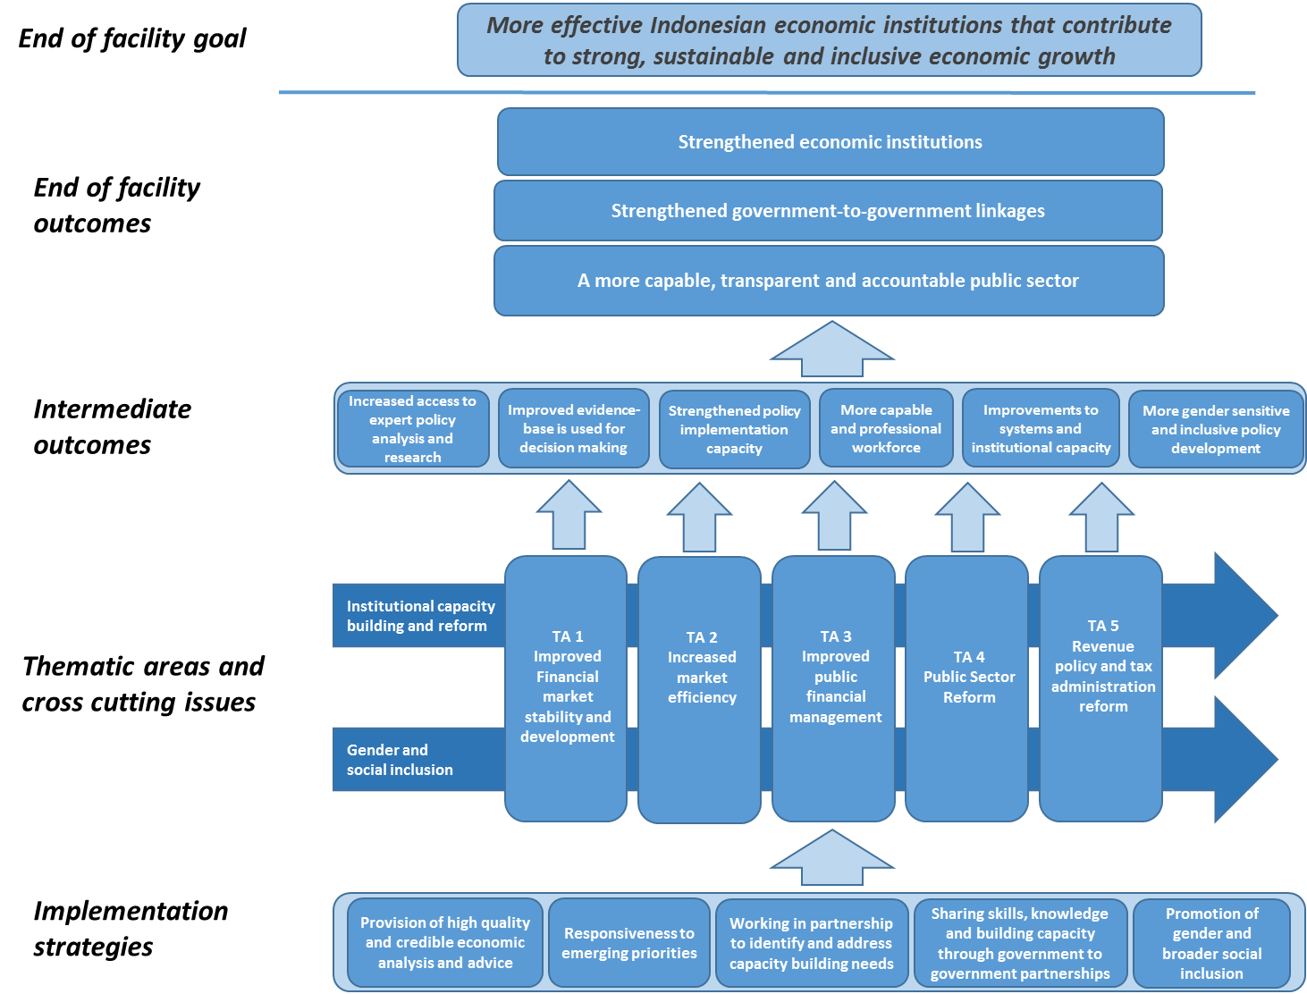

Thematic Areas

1. In line with the Program Logic there will be five key thematic areas as follows:

* Thematic Area 1. Improved financial market development and stability

1. Indonesia’s financial system does an inadequate job of intermediating high rates of savings towards productive lending for consumption and investment. The financial system funds only 10-15 per cent of investment, with corporations self-funding the rest. Access to finance for SMEs and women remain major constraints on growth. Only 36 per cent of adults have an account with a financial institution, 80 per cent of wage earners receive payments in cash and 99 per cent of adults use cash to pay utility bills. There is a major risk that these financial sector problems will mean the government’s ambitious targets for infrastructure investment and growth will not be achieved. The government is trying to promote innovation and rapid growth of the financial sector, but also needs to balance risks to the reputation and stability of the sector in developing regulation, as well as combat money laundering and counter-terrorism financing.
2. This thematic area will support financial sector stability and development through its work on a sound legal, regulatory and policy framework; financial market development; stronger supervision and regulation; and building capacity on anti-money laundering and counter-terrorism financing. Indonesia has strengthened its stability and regulatory environment. The passage of the Financial Crisis Prevention and Resolution Law is the result of many years of work developing capacity to prevent, manage and resolve problems in the financial sector. Effective implementation of this law along with an emerging consensus across agencies on financial development needs define the priorities for the finance sector.

* Thematic Area 2. Increased market efficiency

1. Indonesia has tremendous potential to compete in world markets, and attract growth-enhancing investment and trade. Indonesia can improve productivity and growth through more effective resource use. The high cost of establishing, operating and closing a business as well as the operational burden and uncertainty of the many regulatory restrictions stand in the way of realising economic potential. This applies across businesses of all sizes and in all markets. The challenge for international trade is amplified by the recent increase in non-tariff restrictions.
2. This thematic area will support an enabling environment for robust private activity, investment and trade. This includes work to support regulatory frameworks that are clear, stable and well designed; supporting reforms in targeted sectors to promote efficient markets; reducing barriers and costs to market entry and exit to enhance competition; and promoting global value chains.

* Thematic Area 3. Improved Public Financial Management

1. Indonesia faces several public financial management challenges including declining budget credibility (reflected by a widening gap in recent years between budget estimates and realised spending), a structural shift to local-level public service delivery and a large stock of poorly utilised state assets. The government has taken some positive steps in recent years, most notably through reducing and better targeting subsidies and transitioning from cash to accrual accounting, but faces a major challenge to meet its expenditure commitments and stay within the legislated deficit limit of 3 per cent of GDP.
2. This thematic area will support the quality of public spending. Enhancing links between budgets and defined outcomes can improve spending effectiveness, as do stronger frameworks to ensure and scrutinise the quality of spending, including through robust auditing of public accounts. The engagement is building on progress made by AIPEG and GPF, including in developing and institutionalising medium term-budgeting applications, the establishment of a state asset management agency and building performance auditing capabilities.

* Thematic Area 4. Public Sector Reform

1. Evidence-based policy development decision-making, and implementation require effective government agencies. The profile of Indonesian government agencies reflects the structure adopted some decades ago despite the passage of a civil service law and establishment of a civil service organisation. Moreover, there are critical constraints on the delivery of key policy-making inputs, such as statistics, as well as government agencies and/or business processes that are unable to support or deliver key reforms. The effectiveness of public institutions thus continues to be a significant challenge for Indonesia in realising its economic potential.
2. This thematic area will address improving the effectiveness of public institutions essential for growth and accountability. This will include improving the quality of statistics and public sector complaints handing. In addition, supporting reforms are needed to improve the performance of public sector institutions or the policy making process in each of the other thematic areas of the facility’s activities.
3. An assessment of the capacity of Indonesian institutions’ capability to support growth and their level of accountability will be conducted ahead of the implementation of new programs. Given the breath of public sector reform issues, the diagnostic should guide resources allocation so as to most effectively support the program’s objectives.
4. Australia and Indonesia have been cooperating for some time to improve the safety of Indonesian transport infrastructure and ensure that it is compliant with international standards. This Government to Government collaboration will continue under AIECO.

* Thematic Area 5. Revenue policy and tax administration reform

1. Mobilising revenue, without unduly impeding private activity, is central to achieving the government’s investment and development objectives. This challenge is mounting as expenditure needs grow along with income levels and urbanisation. Yet a narrow revenue base, the decline in commodity prices, and challenging tax administration issues have left revenue struggling to grow in line with the economy, let alone meet new demands. Resulting revenue pressures and the narrow tax base have triggered pressures on the business climate and undermined the legitimacy of the tax system.
2. This thematic area will focus on supporting government efforts to meet its revenue goals through improving capabilities to formulate evidence-based revenue policies, while moving towards a tax system based on voluntary compliance. It recognises that while fundamental reform of the tax administration is essential, this alone is insufficient to meet Indonesia’s revenue needs. Over time a multitude of “fixes” to the tax system, often to address administrative challenges, has resulted in revenue streams that are unresponsive to economic growth and ultimately even more difficult to administer. Along with key policy reform, a multi-year administrative reform of the tax agency’s core functions and business processes is required. Improving the capabilities of the government to formulate revenue and macroeconomic policies and coordinate implementation across different parts of government is also crucial.

Gender

1. Addressing Gender disparity and inequity is a core human development issue and fundamental to economic development. Gender inequity impacts on Indonesia’s potential for strong, sustainable, and inclusive growth. AIECO will treat gender as a central element of its economic agenda, including undertaking gender analysis and programming as core business, and supporting both economy wide and gender policy specific interventions. This analysis will be embedded across each of the thematic areas and in the activity selection criteria.
2. Specific examples of where AIECO may provide a gender specific policy focus are:
   * **Financial** market development involves boosting female access to financial services and credit to save, start businesses and build financial independence.
   * **Market** reforms can support the transition from informal to formal work, support jobs growth, consumer protection and trade opportunities.
   * **Spending** reform is critical to improving the prioritisation of spending in areas like social protection, education etc, as well as gender mainstreaming in the budget and policy development
   * **Revenue** policy can impede women’s participation, for example by assessing income based on households versus individuals.
   * **Economic policy** (cross-cutting team) provides analytical support for research on female labour force participation and other studies.
3. AIECO will recruit a Gender and Social Inclusion Adviser from inception to carry forward this work area and support APS agencies where there is demand and opportunity. This role will be included in the AIECO senior management team to ensure they are able to influence programming decisions effectively.
4. AIECO will continue the approach of AIPEG and GPF of advocating for equal numbers of men and women attending Facility-sponsored activities and sex disaggregated data will be collected for attendance. In addition, an active approach to recruitment of women within the Facility will continue.
5. All AIECO Board members, advisers, GPF deployees and AIECO managers will be provided with gender training and support as part of their induction and ongoing roles.

Institutional capacity building and reform

1. Supporting the Indonesian Government to reform its management systems and processes and building the capacity of public servants working on them are critical to enabling the government to be responsive to policy changes and for securing enduring institutional reform. These are also issues that cut across each of AIECO’s five thematic areas of support.
2. The support provided under AIECO will therefore have a strong focus on capacity building at both the organisational and at the individual skills development levels. At the organisational level, this will include procedural improvement, change management, systems strengthening and strategic planning. Capacity building at the organisational level may be provided through

* Analysis and advice across a range of economic issues
* High level policy dialogue between Australian and Indonesian Government agencies
* Technical assistance in the application of change management and business processes
* Technical assistance in the application of legislation and or reforms
* Joint planning on activity objectives and outcomes.

1. At the individual level, this will include civil service skills and key competencies development and improved technical expertise. Capacity building may be provided through:

* Short courses for Indonesian government officials
* Twinning arrangements with Australian Government agencies
* Australia awards education opportunities
* On the job training and capacity building
* Secondments

1. Australian Government officials deployed to Indonesia under AIECO will receive training in capacity development techniques prior to departure to ensure that their support is developing key competencies to achieve sustained performance and improvement at the organisational and skills development level.
2. The Managing contractor will also play an active role in ensuring that advisors are providing both technical assistance and capacity building expertise at the organisational and individual level. This includes the recruitment of advisors with expertise and or experience in capacity building in developing countries and undertaking performance management processes that require capacity-building outcomes as a result of their work.
3. The Managing Contractor will need to develop and apply a model to assess and track the performance of capacity development efforts – which should be fed into performance reporting and knowledge management processes.

Other program-wide considerations

* Disability

1. Both AIPEG and GPF have performed poorly on disability and there has not been any substantive achievement to date. DFAT has pushed AIPEG to place greater emphasis on disability issues by linking a performance based milestone payment to achievement on disability issues. Consequently, AIPEG undertook a diagnostic study investigating the economic and poverty linkages with disability.
2. AIECO will explore ways to address disability issues. However, this is a challenging space to address disability issues, with a quick review of DFAT’s other economic governance programs finding none had implemented activities addressing DID issues. The Economic Governance Unit at Post has been liaising with Disabled Persons Organisations to identify potential activities for AIPEG and GPF, and will continue to do so under AIECO.

* Private sector engagement

1. A dynamic and robust private sector is critical to delivering economic growth and reducing poverty in Indonesia. The role of the private sector and governments in supporting the private sector led economic growth cuts across all five thematic areas of AIECO. AIECO will support the private sector in three ways:
   * Seeking to understand the private sector’s perspective on policy issues and the implementation of policy in framing its views.
   * Encouraging and supporting the Indonesian Government to engage effectively with the private sector as a vehicle to foster better policy and service delivery.
   * Supporting the private sector to strengthen evidence-based policy debate and advocacy.
2. In this regard a number of existing AIPEG activities will continue. These include support to the Indonesia Services Dialogue to build its reputation and capacity to advocate for reform with the Indonesian Government on critical issues facing the services sector; Work on improving ease of doing business; and support to Indonesia’s Trade Policy Dialogue.

* Sustainability

1. Sustainability is an important consideration for AIECO. Australia’s investment in technical advice for economic governance dates back to 1999. Since then, with support from Australia, Indonesia has developed its in-house policy advice capabilities and relied less on donors. However, the high number of requests and significant ongoing achievements of AIPEG and GPF indicate there is still a gap between the government’s in-house advisory capacity and the level of advice decision-makers require. Bridging this gap will require overcoming barriers preventing the Indonesian government from procuring technical advice and strengthening the government’s in-house analytical capabilities. AIECO will continue to promote the gradual transition away from foreign-funded advisors.
2. Through Tim Asistensi, AIPEG has established a mechanism for key economic ministries to flexibly access just-in-time technical advice to meet their priorities. Tim Asistensi is part-funded, governed and chaired by senior officials from the Ministries of Finance, National Development and the Coordinating Ministry for Economic Affairs (DFAT also is on the governance board). For AIECO’s technical advice provision to be sustainable, Indonesia will need to increase funding and ownership of Tim Asistensi, while Australia will need to reduce its role.
3. An intended legacy of Australia’s economic governance program are partnerships between Australian and Indonesian government agencies that can be sustained in the absence of Australian aid funding. This will require strong ownership from both Australian and Indonesian agencies. All APS agencies participating in GPF reported in design consultations that they highly value cooperation with Indonesian partners. However, none could support activities from their own funds and are reliant on Australian aid for continued cooperation. Indonesian agencies also reported in design consultations that they value partnership activities and are increasingly self-funding participation for study-visits and workshops to Australia, though Australian aid funds the vast majority of participants.
4. All Partnership Strategies developed by APS agencies and Thematic Strategies developed by the managing contractor will need to expressly address mechanisms to encourage the sustainability of core elements of the work supported under AIECO.

Delivery Approach

1. As mentioned earlier, AIECO will be delivered through a facility arrangement. This arrangement reflects the facility model of AIPEG, the direction of GPF, and is the best approach for activities that are aiming to be responsive to Indonesian government needs and requests. A facility will enable the flexibility to procure diverse subject-matter and technical expertise to meet the range of work areas and the large number of implementing partners and stakeholders. A facility will also enable flexibility to adjust to changes in the Indonesian and Australian policy contexts.

Implementation Principles

1. The following principles inform the way in which the facility will be delivered:
   * Responsive to the Government of Indonesia requests – this is the key principle and drives the investment.
   * Flexible to ensure that AIECO remains fit for purpose and responds to Indonesia’s changing economic and bureaucratic priorities.
   * Based on partnerships between the Indonesian and Australian governments.
   * Evidence-based decision-making and management.
   * Inclusiveness – the investment will consider gender and disability in all aspects of the implementation of AIECO.
   * Understanding of the operating context and in particular the political economy where the program is providing support.

Investment Criteria

1. All facilities require clear investment criteria to guide and justify investment decisions. All AIECO activities will need to meet the following key criteria:
   * + The activity is based on a request from the Government of Indonesia
     + The activity aligns with Australia’s aid policy and Aid Investment Plan for Indonesia and the scope of AIECO’s thematic areas
     + AIECO can match the activity request with the needed expertise and support
     + The activity risk rating falls within an acceptable range
     + The activity cost falls within an acceptable range
     + The forecast activity results falls within an acceptable range
     + The gender and disability impact of this activity has been considered
     + The political economy and institutional environment settings are sufficient to reasonably expect reform being achieved and sustained.
2. Individual requests from GoI which are assessed as appropriate to AIECO may also be considered in relation to existing requests. For example the proportion of effort or funds invested in each pillar will differ.

Assumptions

1. The facility is underpinned by the following assumptions:
   * There will be a continued demand for Australian-funded support in the areas covered by AIECO.
   * A strong degree of trust between AIECO and the Indonesian government which is able to withstand any periods of turbulence in the bilateral relationship.
   * AIECO will have strong leadership able to maintain clear strategic direction for the program.
   * The benefits of AIECO for both the Australian and Indonesian governments will outweigh the opportunity cost of participating.
   * Local advisors with extensive Indonesian specific experience and local networks will continue to be available to AIECO.
   * The Australian aid budget will remain relatively stable.
   * The economic partnership remains a key focus for both governments.
   * GPF partners remain equally interested in international work.

Monitoring and Evaluation Framework

1. AIECO’s M&E framework must align to and enable reporting against DFAT’s Aid Quality Checks (AQC) and Performance Assessment Framework (PAF), which assess the performance of Australian aid against DFAT’s Indonesia Aid Investment Plan 2015-19.
2. The PAF strengthens the approach to measuring how development cooperation activities have improved Indonesia’s development policy settings. Most of Australia’s investments are seeking to contribute to the policy making process; consequently, policy improvement indicators now sit under each of the three country objectives. The M&E framework for the new facility will need to ensure overall alignment of reporting to the PAF as well as incorporating ongoing modifications as they may arise.
3. The PAF identifies evaluations, reviews and other significant monitoring and evaluation activities that could explain progress towards the objectives and outcomes – in effect, providing a bridge between the indicator-level data and the higher-level PAF goals. Terms of Reference, Aide Memoires, reports and presentations should reference the PAF and comment on progress.
4. The M&E framework for the AIECO program will cover the entire investment. The audience for M&E includes DFAT, GoI and implementing partners. The M&E Framework will support accountability to DFAT, performance management of AIECO, resource allocation decisions made by DFAT and learning across program stakeholders. It is also expected that the M&E outputs will contribute to the development of an evidence-base to support policy formulation in Indonesia.
5. Consultations during the design mission showed that in most instances 30-40 per cent of requests for assistance from the Government of Indonesia were not planned, but were instead opportunistic and exploratory. Flexibility to support these types of ad hoc requests for assistance should continue on the basis that the M&E system captures this work and is reported. The nature of the requests may also be useful to demonstrate the reality of how policy making and decisions are undertaken, which is important to better understand how Australia’s resources can be most effectively delivered.
6. AIECO will draw from the existing AIPEG M&E framework and develop a practical approach to incorporating the government to government partnerships which are not presently covered by the existing framework. The Contractor will also look at past approaches to M&E developed over the life of GPF to determine how best to include government to government activities.

* Key evaluation questions

1. The M&E framework will be strongly focused on the investment’s progress towards emerging and longer term intended outcomes. The framework will be guided by eight key evaluation questions. These are:
2. To what extent has the program contributed to developing effective economic institutions and broader public sector reform?
3. To what extent has the program contributed to increasing competitiveness and private sector development?
4. What impact has the program had on gender equality, disability, social inclusion and women’s economic empowerment?
5. To what extent have economic policies and reforms been formulated and implemented based on evidence and research?
6. To what extent is the Indonesian Government formulating its own economic policies?
7. How resilient and effective is the government to government partnership between Australia and Indonesia?
8. To what extent has the program contributed to improved transport safety in Indonesia?
9. To what extent has political economy and operating context changed, how has this impacted the delivery of the program, and how has the program responded?
10. Considering the complex transition process and the range of issues that are likely to arise as strategies and management process are developed, a ‘Formative’ evaluation will be undertaken at 12 months period into the program, focussed on AIECO’s relevance and effectiveness, to test whether the strategic direction is clear and that it is running well. This evaluation will be sourced outside the program and be independent of the current management structure.

* Structure of the M&E framework

1. AI- ECO will be assessed for overall performance at the facility level, as well as at the thematic and activity levels. Facility and thematic-level performance will be of interest to GOI, DFAT, APS agencies and the Managing Contractor and will cover all Key Evaluation Questions and the cross cutting themes. The Activity Level will be of interest to APS agencies, DFAT and the Managing Contractor and will covers activities, outputs and advice provided as part of annual work plans and through ad hoc requests for assistance. The focus will be on the quality and relevance of the activities and outputs.
2. The Managing Contractor will be required to prepare an M&E Framework in the first three months of implementation in consultation with DFAT, Australian Government partners and where appropriate the Indonesian Government. The M&E framework will include a facility program logic, refined key evaluation questions, key performance indicators, the cross cutting themes and a detailed methodology which includes baseline data. The M&E plan will be reviewed annually and will be supported by the Gender and Social Inclusion Adviser.

* Performance indicators

1. Under the AIECO M&E framework, performance indicators will be mapped to the thematic and activity levels. Performance indicators are expected to include a mix of qualitative and quantitative indicators. Common international indicators will be used as actual or proxy indicators where appropriate for long term tracking of Indonesia’s progress. At the Facility level, the indicators will need to enable reporting against the following performance areas which come from DFAT’s Performance Assessment Framework for the Indonesia Development program (the PAF):
   * Amount of additional funding directed towards more effective infrastructure and economic development.
   * Number of women and men who apply improved technical skills to improve economic governance.
   * Number of improvements to market efficiency, regulation and financial systems.
   * Number of improvements to public revenue and expenditure management
2. Performance indicators will be developed against the thematic level program logic and will focus on impact. At the Activity level the performance indicators will focus on the efficacy, quality and utility of outputs; and the effectiveness of capacity development activities. These will be standardised across AIECO to ensure that indicators can be aggregated across the facility.
3. To help inform the preparation of the M&E approach, the existing AIPEG Performance Indicators are at Annex C.

* Approach

1. At the **Activity** level, monitoring activities will focus on tracking the progress of work plan delivery and the efficacy, quality and utility of outputs. The effectiveness of capacity development activities (training, short courses, placements etc) will also be monitored in terms of the impact they have on group and institutional capacity[7] . Training effectiveness will be monitored through effectiveness surveys 3-6 months after training programs are completed.
2. The performance of **Advisers** will be continuously monitored to ensure effective delivery of support in line with their terms of reference. Performance will be formally assessed through a combination of annual performance assessments and ongoing performance management by the contractor. These assessments will conform to DFAT guidelines on managing adviser performance. Performance of Government-to-Government advisers will be monitored by their home agencies in consultation with DFAT.
3. At the **Thematic level** AIECO will monitor and document instances of policy influence and uptake using the Significant Policy Change (SPC) technique. AIECO will also monitor and record Government of Indonesia requests and supporting activities that are not pre-programmed but are an indicator of the need for flexibility and the ability of the investment to be responsive. Selected outputs will be evaluated in terms of the immediate outcomes they achieve (e.g. changes in work places, systems, business processes and use of information) and their contribution to higher level outcomes. Evaluations of pilot projects will be conducted to ascertain which have the potential to be scaled-up across Indonesia. The managing contractor will be responsible for aggregating APS agency output and outcome reporting against the five thematic areas to allow for whole-of-facility reporting at the thematic level.
4. M&E activities will supported by an online platform(s) with the following functions:
5. **Regular accountability reporting-** Annual reporting on activities, operational and administrative information (such as the status of procurements, financial information and information on advisers), progress, achievements, emerging patterns, critical issues, innovation, emerging risks,
6. **Tracking policy influence work-** For contracted advisers and APS agencies to record training or policy advice delivered, to log instances of influence and lessons and to facilitate communication across the facility.
7. The M&E activities will inform and enable reflections on the facility and the identification of lessons to inform the annual planning process.

* Knowledge Management

1. Developing, retaining and applying the knowledge gained by the program through its ongoing analysis, including the documentation and dissemination of the lessons which have been learned on what does and does not work to bring about change, will be an important element of the long-term impact and effectiveness of AIECO. The Contractor should develop a knowledge management approach which captures information and provides effective avenues for that information to be used by Governments, other donors and the wider community where it is appropriate to do so.
2. The Contractor will make use of the existing body of evidence accumulated since 1999, as well as draw from the well regarded mid-term and end-of-program reviews which have captured the breadth and depth of AIPEG’s engagement. These reviews have tested and evaluated the key ingredients of success through a case-study approach looking at what has worked, why and in what context. These documents will be transferred to the new facility as a part of the handover process.

Governance Arrangements

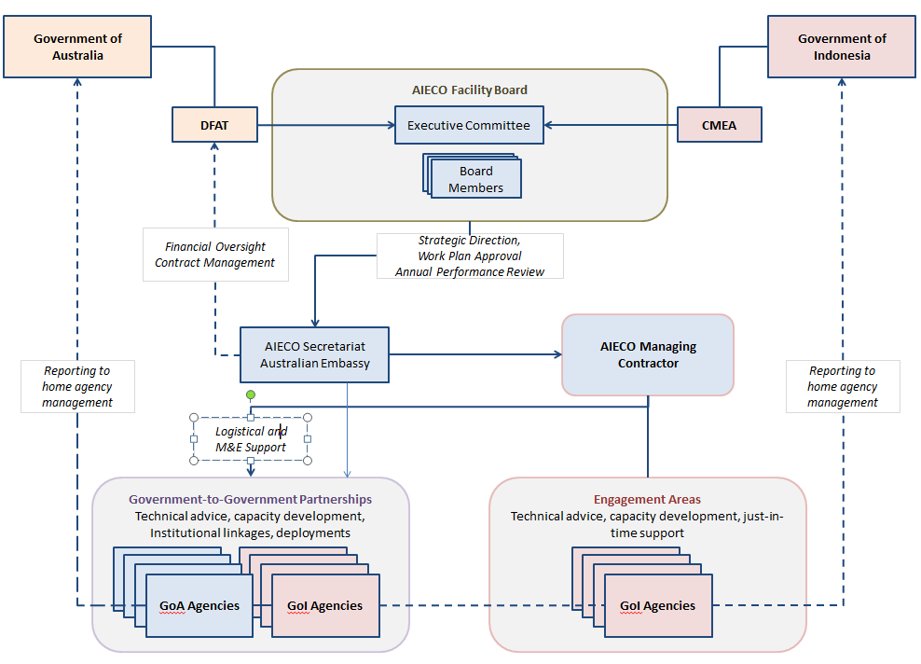

Figure : Proposed AIECO Governance Structure

*The AIECO Board*

1. AIECO will be governed under a Subsidiary Arrangement between DFAT and the CMEA under the General Agreement on Development Cooperation between Australia and Indonesia. The Subsidiary Arrangement covers all investments under AIECO and provides a legal basis for implementation of activities.
2. Strategic direction for AIECO will be provided by a Facility ‘Board’, led and co-chaired by an ‘Executive Committee’ representing the Governments of Australia and Indonesia. The Executive Committee will be guided by the advice of the Board.
3. The Executive Committee of the Board will be comprised of a senior official from DFAT (currently Minister-Counsellor (Economic) and from CMEA (currently Deputy Minister for International Economic and Financial Cooperation).
4. The Board will meet six monthly (or as required) and will:

* Provide high level guidance on priority areas for engagement
* Endorse the Facility’s Annual plan
* Consider APS-GOI Agency Partnerships
* Consider Thematic Strategies
* Consider the overall performance of AIECO

1. The Board’s role is to be strategic rather than to prescribe individual activities. This is in recognition that planning and implementation are decentralised and responsive to the needs of Indonesian agencies. The Managing Contractor, in consultation with DFAT, can make activity level changes without the need for Board approval, as long as those activities align with the approved strategic approach.
2. AIECO Board members will be invited by the Executive Committee.
3. With the exception of the co-chairs, board members will serve non-renewable terms of up to a maximum of three years. DFAT and CMEA will jointly approve the composition of the Board and length of membership. The fixed-term non-renewable requirement is designed to ensure that there is opportunity for new entrants to the Board while maintaining continuity in membership.
4. APS agencies and the Managing Contractor will be invited to Board meetings as observers.
5. Agreements between APS Agencies and counterparts will be informed by guidance from the Board and will be approved by the co-chairs. Each APS agency will agree with their Indonesian counterpart a multi-year partnership agreement which will outline objectives and outcomes expected to be achieved and which are in support of AIECO’s goal. The multiyear partnership agreements will be agreed to under a multiyear Record of Understanding between APS agencies and DFAT. An annual work plan, with a corresponding budget, will sit below the partnership agreement (Activity Schedule) and funded on an annual financial year basis. The managing contractor and APS agencies will have flexibility to implement activities and manage budgets based on objectives agreed in their respective annual work plans.

*Role of the Government of Indonesia*

1. Ensure senior representation on the AIECO Board and engagement in AIECO activities;
2. Contribute and coordinate Government of Indonesia resources agreed for implementation;
3. Monitor and report to the AIECO Board changes in the operating environment that may affect Facility delivery;
4. Regularly inform stakeholders of Government of Indonesia policy and practice, including reporting requirements;
5. Maintain productive working relationships with Australian government institutions and other stakeholders; and
6. Provide advice to the Contractor and DFAT on the performance and progress of the activities and technical assistance.

*Role of DFAT*

1. On behalf of the Australian Government, lead policy dialogue and relationship management with Government of Indonesia;
2. Regularly engage with key officials from the Government of Indonesia through formal and informal settings, for example outreach meetings and attendance at events;
3. Engage and coordinate with other Donors working on economic governance in Indonesia.
4. Responsible for the strategic, contractual, financial and performance oversight of the Facility as a whole and the Contractor;
5. Hold the Contractor responsible for all aspects of the management of the Facility through the nominated Contractor Representative;
6. Evaluate the Contractor’s Annual Report and Plans, Gender and Inclusion Strategies, Monitoring and Evaluation System, Activity Reports and other deliverables as identified in Schedule 1 and 2 of this Contract and where necessary approve for payment purposes;
7. Regularly communicate with the Contractor, including through regular management meetings. The purpose will be to discuss key Facility developments, both strategic and operational, and to negotiate any required responses and or decisions to changes in the program;
8. Provide proactive management of any issues that may arise in implementation.
9. Assist APS agencies to implement activities, including regular meetings to promote collaboration, coordination and address any broader issues across the Facility that DFAT should address;
10. Co-chairing the annual AIECO Board meeting and in consultation with CMEA, make decisions on when it meets, membership and any other matters related to Facility governance;
11. Responsible for communicating and bringing into effect any AIECO Board and Executive Committee decisions including adjustments to funding allocations, ROU’s or any other matters as directed.
12. Responsible for convening Government to Government partnerships to ensure alignment with overall bilateral and Facility objectives, as well as developing flexible formal and informal consultation and coordination mechanism for the effective alignment of economic government investments.
13. The secretariat will be made up of the combined personnel of DFAT’s Economic Governance teams from desk and post and will provide direct support to the Board and the Executive Committee. The Secretariat will be responsible for coordinating board papers and briefings as well as contractor management and financial oversight of the facility. The Secretariat will also communicate and bring into effect any Board and Executive Committee decisions including adjustments to funding allocations, ROU’s or any other matters as directed. The Secretariat will be supported by the Managing Contractor as directed by DFAT.
14. Consideration will be given to appropriate governance arrangements for the Economic Cooperation component of IA-CEPA, should the option to design and subsequent option to implement this component be exercised.

*Role of APS agencies*

1. APS agencies are responsible for preparing and periodically updating Partnership Strategies and drafting Annual Work plans.
2. Implementing activities in accordance with commitments agreed with their partners and through Records of Understanding with DFAT.
3. APS staff implementing activities will be accountable to their home agencies, but must conduct activities in compliance with Official Development Assistance (ODA) guidelines and the Public Governance, Performance and Accountability Act 2013.
4. APS agencies will provide the managing contractor with information on their AIECO-funded activities for monitoring and evaluation purposes in order to demonstrate accountability, efficiency and effectiveness.
5. APS agencies will not be responsible for procurement of goods or services outside Australia, which will be done by the managing contractor to ensure value for money and compliance with ODA procurement guidelines. The managing contractor may also assist with procurement of services within Australia. Any exceptions will be agreed with DFAT.
6. APS agencies with deployed officers will be responsible for providing pastoral care, which may, with the agreement of all parties, be provided by the managing contractor and/or DFAT.
7. APS agencies are accountable for the workplace health and safety of their staff. To support this commitment, DFAT and/or the managing contractor will facilitate Work Health and Safety (WHS) assessments, as well as assist with medical care and education for deployed APS staff and their dependents.
8. DFAT, through the Secretariat, will continue to manage budget allocation for activities implemented by APS agencies, which is subject to DFAT’s annual ODA budget appropriations.
9. To ensure regular exchange of views by APS agencies and reflect on Facility progress, DFAT will convene a whole of Australian government coordination meeting biannually in Canberra and Jakarta. This meeting is designed to promote awareness amongst APS agencies on AIECO activities, to create opportunities for collaboration and relay any issues or concerns to DFAT, which will inform the annual Board meeting in Jakarta. CMEA will be responsible for coordination of Indonesian government views on AIECO.

*Role of the managing contractor*

1. The Managing Contractor (MC) will be responsible for the day-to-day management of the facility. This includes, but is not limited to the following:
   * Mobilising a team to support, administer, manage and implement activities;
   * strategic engagement and oversight of thematic areas;
   * monitoring and evaluation of activities;
   * providing in-country logistics services to APS agencies to deliver activities;
   * assisting with the mobilisation/demobilisation of APS deployees in consultation with DFAT and APS agencies;
   * financial management and reporting;
   * maintaining and regularly updating a risk register; and
   * promoting collaboration among APS agencies and with contracted advisers.
2. Following commencement, the Managing Contractor will produce individual ‘Thematic Strategies’ for the five thematic areas of AIECO. These strategies will include objectives expected over the life of AIECO and must show how they contribute towards the overall goals and objectives of the program. The Thematic Strategies will include a section on opportunities for collaboration with Australian Government advisers engaged through AIECO. They will be approved by DFAT prior to submission to the Executive Committee and the Board.
3. The Managing Contractor will design and implement activities in each Thematic Area in collaboration with relevant Indonesian counterparts and participating APS agencies.
4. The Managing Contractor will have the capacity to participate in the design and implementation of trade-related Economic Cooperation activities that may be agreed under IA-CEPA in the event that the options to do so under the contract are exercised.
5. IA-CEPA-related support may draw on any capability within the scope of the contract, including (but not limited to): secretariat services; procurement; logistics and travel; deployment services; technical assistance; monitoring and evaluation; and program delivery.
6. The Managing Contractor will not direct APS agencies or manage their performance.
7. The Managing Contractor will identify opportunities for DFAT to engage and collaborate with GoI on policy and strategy.
8. The Managing Contractor will be proactive in identifying opportunities for collaboration, to collaborate with other DFAT supported programs and to identify potential new thematic areas, particularly those that strengthen G2G linkages.
9. The Managing Contractor will be responsible for developing a M&E framework, that corresponds to the Program Theory of Change, during the first three months of implementation and socialising this across the Facility.
10. The Managing Contractor will provide M&E support and guidance to APS agencies and synthesise results provided by APS agencies into readable reports.
11. The Managing Contractor will be responsible for providing the deployment and logistical support services related to APS deployed staff to Jakarta as required and directed by DFAT and/or APS Agencies. This may include:
12. Fleet management.
13. Undertake the in-country component of the induction program for all Australian government deployees to Indonesia in coordination with DFAT Jakarta.
14. Provide logistical support for Australian agencies to deliver activities in Indonesia, including but not limited to arranging accommodation, car hire and venue hire. Similarly to provide such assistance when Program activities are held in Australia.
15. Mobilisation and retainment of contracted advisers to support activities implemented by the managing contractor.
16. Equipment and IT support to ensure advisers and deployees have access to email services from home and office.
17. The Managing Contactor will be required to provide logistical support for implementation of activities (in 2016 over 200 separate activities were undertaken, 1700 days of training or cooperation and 4900 participants), including but not limited to:
18. Placement of short term and long term international and national advisers to work alongside government officials in partner government agencies on dedicated tasks.
19. Supporting study visits, workshops and secondments of Indonesian officials in Australia.
20. Supporting APS agencies to undertake activities in Indonesia, which may include booking venues, transportation and translation services.
21. Organising training events, conferences or seminars in line with thematic area design documents.
22. The Managing Contractor will be required to provide secretariat services to the Board and assist with organising Board meetings as directed by DFAT.
23. The Managing Contractor will prepare BAST and other reporting mechanisms required by the Government of Indonesia and seek DFAT verification and approval where necessary.

Transition Arrangements (Six months)

1. The Managing Contractor will prepare a transition plan, recognising the constraints and risks of a limited transition period. During transition the following activities are expected:
   * Establishment and opening of AIECO Offices
   * Recruitment and commencement of support staff
   * Recruitment and commencement of advisers
2. In addition to development and implementation of the transition plan, the facility start-up team will be responsible for the preparation of facility operational procedures and guidelines (e.g. finance, procurement, HRM, refinement of technical assistance processes and quality criteria, etc).
3. The transition sequencing should consider the contractual arrangements necessary to prevent the disruption of ancillary services, including accommodation leases. The transition plan should be developed as soon as possible after contracting and should include consultation with Australian Government agencies providing staff to the program. GoI counterpart agencies should also be included in the development of the transition plan to ensure they remain informed of the new program and our commitment to a seamless transition during this time. The transition plan should include a risk management plan to specifically manage the risks associated with the transition period. Consideration should be given to aligning the provision of deployee services to both private-sector and Australian Government advisers based in the same GoI agency.
4. Initiate an AIECO Transition Workshop with partner Ministries and Directorates General at commencement with the purpose to establish working relationships and identification of priorities for activity development. This workshop is expected to lead to identification of priorities for AIECO inputs for 6 months, leading to the generation of Terms of Reference and activity plans, as appropriate;
5. The Transition Plan, which should be developed in consultation with DFAT and APS agencies participating in the Facility, describing the set up for activity implementation, including key milestones, tasks, costs and deadlines for completion. Government of Indonesia counterpart agencies should also be included in the development of the Transition Plan;
6. Drafting of Thematic Strategies within 9 months of Facility commencement for each of the five thematic areas to be submitted to DFAT for approval. The Thematic Strategies must address issues of continuity delivered by AIPEG and re-evaluate implementation of priorities. They will detail the strategic engagement and oversight responsibilities and will be time-bound with expected outcomes. The Strategies need to demonstrate how they will support the relevant high level objectives and how they will inform the subsequent annual planning processes.
7. These documents will include a series of outcomes expected over the life of AIECO, which will contribute towards the goals and objectives. The Thematic Strategies will include a section on opportunities for collaboration with Australian Government deployees engaged through AIECO. The Strategies must be developed in collaboration with DFAT, APS Agencies and the Government of Indonesia. As Thematic Strategies are being delivered in the complex transition phase, they will be approved by DFAT before being put to the Executive Committee of the AIECO Board.
8. Annual Plan (covering the period 1 July 2018 to 30 June 2019) must be submitted to DFAT for approval and include both modes of implementation.
9. Prepare an AIECO Transition Report at the end of the transition period which reports on progress on setting up AIECO and against outlined scheduled.

Annual Planning Process

1. Strategic direction over the life of the facility will be provided by the board and detailed in Thematic Strategies. These documents, approved by the board, should be review and updated (if required) on an annual basis to reflect the changing priorities and context as considered by the board.
2. Annual Work Plans will be developed, guided by the thematic strategies, to provide the costed detail of activities for implementation in the year ahead. To the greatest extent possible, new activities will be considered as part of the Annual Planning process. Ad hoc activity proposals may be put to the Executive Committee as required. The Annual Work plan will be reviewed by the Executive Committee in advance of consideration by the full board.
3. The Annual Plan will be reviewed every six months to consider appropriate changes and ensure agility and flexibility is maintained in a complex and shifting context. This mid-year update will be approved by the Executive Committee of the Board.

Other DFAT programs and other Donors

1. AIECO will work closely with other DFAT programs and donors building on longstanding relationships between forerunner programs. AIECO will play a leadership role in economic governance, but in recognition of the privileged access it will have to staff in central government, AIECO will be expected to promote effective coordination and collaboration between donors and amongst DFAT funded programs.
2. AIECO management will meet regularly with relevant donors and programs and will convene coordination meetings as and when required (or directed by DFAT) to strengthen coordination and share insights.

AIECO Management and Staffing

1. Responsibility for Performance and Financial Management of AIECO will reside with the Managing Contractor who will report, through a designated contractor representative, to the Australian Embassy in Jakarta. That contractor representative should be nominated as part of the tender process.
2. A Transition Director will be appointed to oversee AIECO through the six-month transition phase. By the conclusion of the Transition Phase, a long-term management structure will be agreed in consultation with DFAT.
3. It is anticipated that the Managing Contractor will retain a number of specified personnel for a period of no less than 6 months to provide continuity and knowledge transfer during the transition period. Occupants of the following positions will be named as specified personnel in AIECO Request for Tender documentation:
   * Facility Director (Technical)
   * Deputy Director (Technical)
   * Lead Adviser Markets Area
   * Lead Adviser Revenue Area
   * Lead Adviser Spending Area
   * Lead Adviser Economic Support
4. The contractor will retain these specified personnel for a period of at least 6 months after the contract comes into force, after which responsibility for ongoing knowledge transfer and retention will be managed by the contractor in consultation with the DFAT AIECO Secretariat.
5. In addition to the specified personnel set out above, a Chief of Operations as well as Lead Advisers in Gender, Public Sector Reform, Finance and Knowledge Management should be included in senior management and should be nominated by bidders as part of the tender process.
6. All personnel will be managed by the Managing Contractor who, through the Contractor Representative, will be accountable to DFAT.
7. There are currently approximately 80 long-term and 40 short-term advisers providing technical assistance under AIPEG.

Budget

1. The Program has an anticipated budget of up to AUD 145 million over five years (2017-2022). Of this amount up to AUD95 million over five years will be tendered, with the remainder to be disbursed via Records of Understanding (ROU) between DFAT and Australian government agencies implementing activities under the Facility.
2. The M&E system will be resourced appropriately to enable the Integrated Program as a whole to report against the program logic and PAF indicators; and to inform stakeholders of progress against agreed outcomes.

##### Mid-Term Review

1. DFAT will commission an independent Mid-Term Review in year 3 of AIECO. The Review will address the key evaluation questions and will provide DFAT with an overview of Facility Progress against the Facility goal in order to inform the future direction of AIECO.

Risk management

1. Australia’s support to Indonesia is highly valued and demand driven. The major risks relate to development results, which are dependent upon Indonesia’s ongoing appetite for reform and Australia’s foreign aid direction as stated in Australia’s Aid Investment Plan for Indonesia. The Widodo Government has demonstrated a strong appetite for reform. This includes in de-regulation through the release of 14 economic packages since September 2015 and positive signals regarding trade liberalisation, for example announcing Indonesia’s intention to join the Trans Pacific Partnership. However, policy implementation remains a key challenge.
2. The nature of the Australia-Indonesia bilateral relationship is not assessed as a risk for Australia’s reputation on the basis that G2G cooperation has remained valued and utilised, including through difficult periods in the bilateral relationship. The long-term nature and trust developed over time through G2G partnerships can be drawn upon to mitigate operational issues, with DFAT well positioned to manage risks and respond to any facility related issues.
3. Fiduciary risks are low as funds are not disbursed through Indonesia’s systems. Annual program funds are dispersed to Australian Government agencies under a Record of Understanding and the managing contractor through performance payments and robust contracting requirements.
4. There is a risk of fraud by either the managing contractor or APS agencies. To mitigate this risk, the managing contractor should have a strong record of managing development cooperation programs and complying with DFAT’s fraud policy.
5. The flexibility involved in a facility heightens the importance of DFAT’s management role to provide strong oversight and strategic direction, as well as play a brokering role between the managing contractor and the Australian government agencies. DFAT will work closely with other parts of DFAT in Canberra and at Jakarta Post to leverage expertise and resources. A managing contractor to manage the Facility provides a number of advantages including delivering management efficiencies and improving coherence and M&E.
6. Key Facility level risks include:
7. Wavering interest of both governments in the Facility, mindful that there will be elections in both countries during the life span of this Facility.
8. APS agencies brands are diluted in Indonesia over time as assistance is increasingly blended with and supported by non-government advisors.
   * + As a result, government partnerships become devalued particularly in comparison to the relative size and depth of support provided through non-government advisors.
9. Non-government advisors are not seen as credible and ‘independent’ from Australian assistance as support is increasingly blended and associated with Australian agencies over time.
   * + As a result, non-government advisors become devalued particularly in comparison to government agencies that are able to draw on their institution to provide a diverse suite of support including secondments to Australia and high level policy dialogue. Delivering the program with a view to be flexible and responsive may lead to disparate activities that do not appear to promote cohesive results and are outside of the Facility’s strategic direction.
10. Lack of clarity around the content/scope/scale of IA-CEPA support in the design and early implementation stage.

* As a result the role and objectives of the program are confused among stakeholders, resources are drawn away from existing programs to focus on IA-CEPA and all of the above limits the effectiveness of AIECO.

1. Risks (a) and (b) will be mitigated by placing emphasis on the importance of G2G linkages and ensuring that this is effectively communicated and established as a measurable outcome. Conversely, the high quality, flexible and credible nature of technical advisors will be maintained through clear messaging with Indonesian counterparts and disseminating the progress and results achieved through this form of assistance.
2. Risk (c) will be managed through the robust monitoring and evaluation system to demonstrate a cohesive and contextualised narrative toward the Facility’s contribution to the strategic direction and outcomes, in particular where the Program is responding to Indonesia’s emerging economic priorities. For example, support for pilot studies that can be scaled up over time to demonstrate the catalytic impact a facility approach can achieve.
3. Risk (d) will be managed by a two-step process of options for design and implementation. Subject to the development of a robust design, DFAT (and other stakeholders) will retain the option to proceed with implementation under AIECO or manage IA-CEPA Economic Cooperation through alternative delivery mechanisms. These processes will ensure that governance and other support is given adequate resourcing to ensure minimal programmatic impact.

Annex A - Summary of lessons learnt from GPF and AIPEG

1. **Effective management is crucial.** A 2011 Mid-Term Review of AIPEG found the program lacked strategic direction and coherence, largely due to a lack of economic expertise and experience in the management team. The improvement of the programs performance since then is due to recruiting managers (Director and two Deputy Directors) with strong economic expertise, good knowledge of Indonesian government systems and access to senior officials and Ministers.
2. **Strategic direction is important to ensure implementing partners understand the sum of their activities.** Both programs are decentralised in nature, with DFAT largely a funder and coordinator of GPF agencies rather than providing strategic oversight, while AIPEG’s engagement areas are separate and up until the appointment of an effective management team, operated with a large degree of autonomy. Strategic direction is important in both programs so that each decentralised work stream and APS implementing partner are clear on the strategic outcomes they are working toward and what their activities sum up to. Consultations revealed it was not clear to APS agencies what their collective efforts summed up to and they were seeking DFAT to play a greater role on strategy and promoting coherence within GPF and with AIPEG. Specifically, agencies confirmed that DFAT should determine the priority areas of engagement in line with our Aid Investment Plan and Australia’s broader economic diplomacy agenda.
3. **It is critical to maintain flexibility in delivering activities to respond to Indonesia’s emerging economic and bureaucratic reform priorities.** This will be achieved through short-term responsive support, including ‘just in time’ advice through international and national advisors and long-term multi-year work plans under G2G partnerships. The different modalities are suited to Indonesia’s broad inclusive economic growth and reform objectives, which will take time to achieve. In addition to specific short term ‘wins’, such as the passing of specific regulations.
4. **G2G partnerships are mutually beneficial and have long-term value to both countries.** Both Australian and Indonesian government partners reported that the partnerships continue to mature over time creating mutual goodwill and understanding that facilitate effective cooperation both within and beyond the development partnership. The strength of these partnerships have led to opportunities to collaborate in key policy areas and have positioned Australia as Indonesia’s trusted partner in providing evidence based economic policy advice and capacity building. As a result, effective G2G development partnerships will remain a core element of Australia’s economic governance assistance to Indonesia.
5. **High quality technical expertise and meaningful relationships are equally important in achieving outcomes.** In many cases, international and local advisors employed by AIPEG have extensive experience operating in Indonesia and have extensive local networks. This enables provision of advice that reflects the Indonesian context and is seen by Indonesian policy makers as credible. The consultations showed that Indonesian officials highly value this type of experience and advisers have a genuine sense of commitment to the objectives Indonesia is working to achieve.
6. **Gender equality should be addressed explicitly in the design and implementation of economic programs.** DFATs annual AQC process has shown that gender equality outcomes through AIPEG and GPF requires improvement. To achieve this effectively, gender equality will need to be considered in activity design, resourced and reported against.
7. **The current governance arrangement, which is the same for both AIPEG and GPF, is an effective mechanism to provide strategic oversight and to promote coordination among implementing partners.** The AIPEG/GPF Steering Committee meets annually to consider and advise on both programs strategic direction and key engagement areas through the approval of thematic papers. The papers are a synthesis of the annual activities and corresponding budgets as developed and agreed by Indonesian counterparts. The Steering Committee comprises two co-chairs (DFAT and CMEA), representatives from relevant Indonesian and Australian government agencies and non-Government representatives with expertise in economic governance. At present the Steering Committee lacks expertise on bureaucratic reform and transport safety, which limits their ability to advise on these issues.
8. **Consideration needs to be given to the long term strategy and sustainability of Australia’s economic governance support to Indonesia and to shape this support over time.** Indonesia is considering how best to achieve its economic policy objectives through the support it receives from Australia. This includes Indonesia’s intentions to increase its own economic policy making capabilities. This work is already being progressed through Tim Assistensi. This is a sustainable approach and there is an important role for Australia’s continued support to play. Ongoing high level dialogue between DFAT, CMEA and key Indonesian officials will be necessary to consider how best to utilise the suite of support to be provided through the Program.
9. **APS agencies should share their experience in building and maintaining G2G partnerships.** DFAT (Canberra) should establish a Community of Practice among GPF agencies to meet every six months to promote information exchange and analysis, to share good practice in capacity development and to identify opportunities for collaboration. DFAT (Post) should continue its current practice of informal and frequent meetings between deployees and advisors to promote communication and to share analysis on current and emerging priorities. This outreach is important as G2G partnerships have long-term strategic value to both governments that can be leveraged over time. Management of the G2G relationships requires engagement of senior DFAT (Canberra and Post) staff. This includes engaging regularly with senior counterparts to better understand the strategic value of their G2G partnership and to take opportunities to restate the value of G2G cooperation to the bilateral relationship.
10. **A tailored induction program is required for all APS long-term deployed officials to enable them to better mobilise and respond to the operating environment.** The induction should include relevant trainings, briefings and introductions to key Australian and Indonesian government officials in Australia and Indonesia. Training should include gender and disability, cultural awareness, language proficiency and capacity building training. Briefings should focus on the operating environment (political, economic, security, organisational) and introductions to key Australian Embassy officials, relevant program staff and other relevant Australian agencies operating in Indonesia.

Annex B - Overview of the support provided under the existing GPF and AIPEG programs

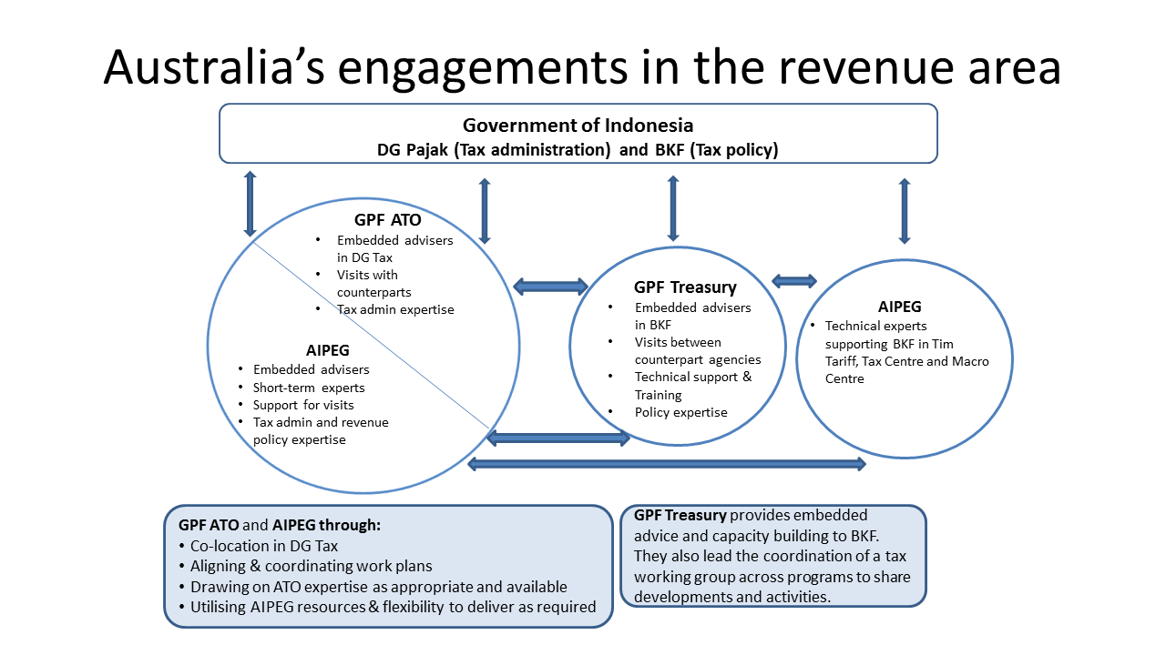

Revenue sector engagement involves work on tax administration and policy. AIPEG and GPF ATO work with the Directorate General of Taxation (DGT) to improve tax administration. There is one ATO embedded adviser in DGT, co-located with a team of AIPEG advisers. GPF also provides technical advice and capacity building on specific issues through fly-in fly-out missions, as well as providing secondments and study visits to Australia for Indonesian tax officials. GPF Treasury and AIPEG work with the Fiscal Policy Agency (FPA) on international engagement, revenue and macroeconomic policy. GPF Treasury have three deployed advisers in BKF, which provide technical advice and coordinate secondments of FPA staff to Australia, Treasury staff technical missions offering training and advice in BKF, and annual high-level exchange meetings in both Australia and Indonesia. AIPEG provide technical advice on selected matters to BKF.

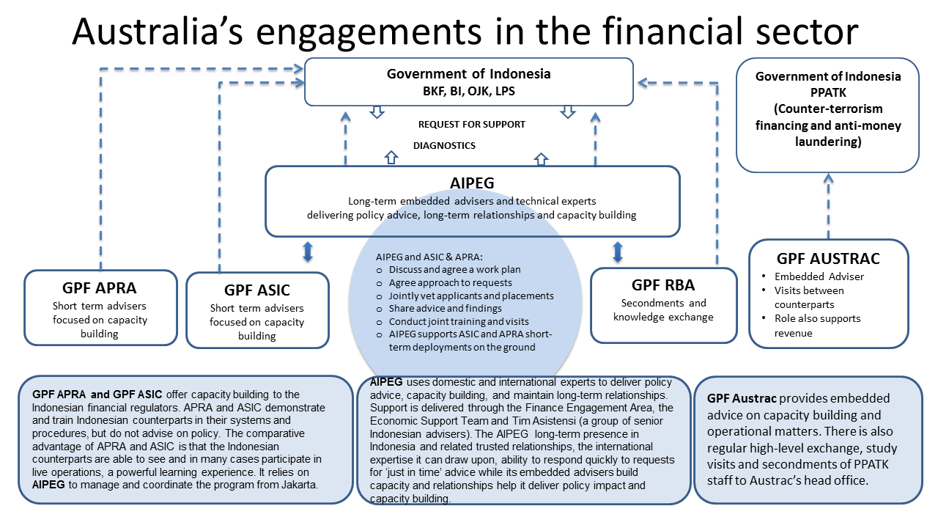

Engagement in the financial sector can be broken down into two components on financial market development and stability, as well as on counterterrorism financing (CTF) and anti-money laundering (AML). Work on financial market development and stability is with the Fiscal Policy Agency (BKF), Financial Services Authority (OJK), Bank Indonesia (BI) and the Deposit Insurance Corporation (LPS). GPF AUSTRAC partners with the Financial Transaction and Reports Analysis Centre (PPATK), the agency responsible for Counter Terrorism Financing (CTF) and Anti-Money Laundering (AML). AIPEG does not work with PPATK.

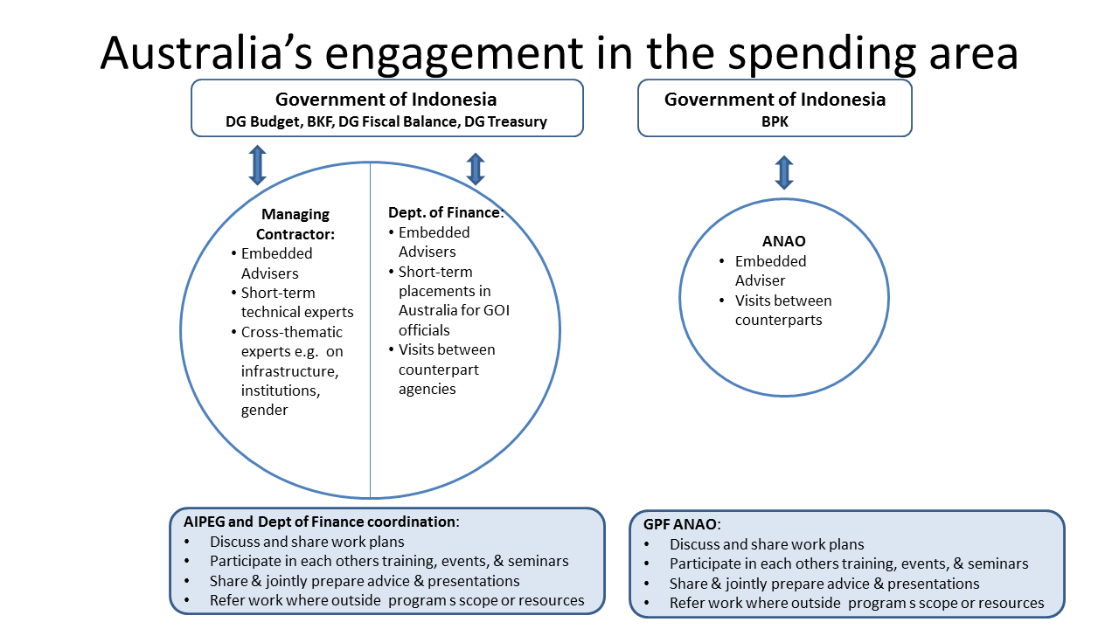

Work in the public financial management area can be disaggregated into two components. AIPEG’s spending engagement area and GPF Department of Finance work with Bappenas and the Ministry of Finance on budget frameworks, implementation and linking planning and budgeting for improved service delivery. The Australian National Audit Office works with the Audit Board of the Republic of Indonesia on improving performance and financial audit capabilities and organisational transformation.

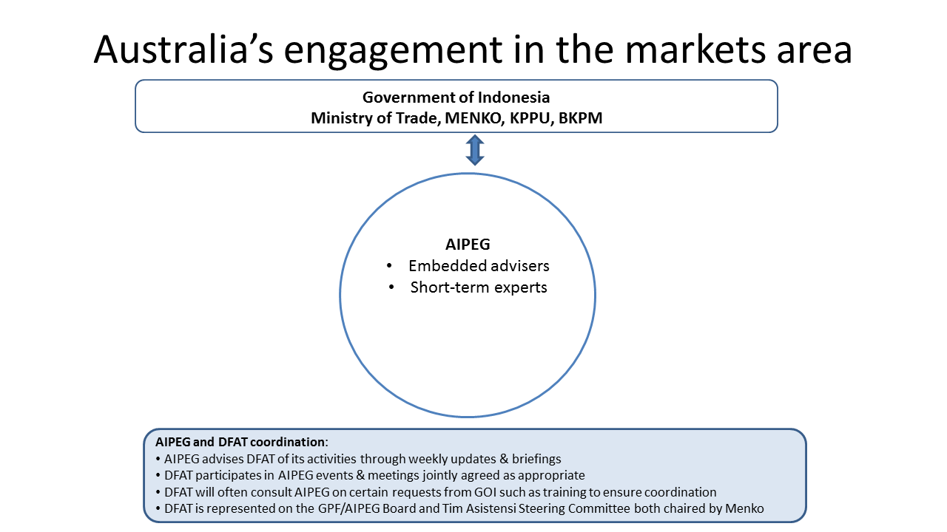

Engagement on trade, investment and competition is solely through AIPEG’s Markets Engagement Area. The Markets Engagement Area works with the Ministry of Trade, Investment Coordination Board, Business Competition Supervisory Commission and CMEA. There are three activity streams: participation in global value chains, improving the ease of doing business and increasing market efficiency. DFAT (trade area) temporarily had a GPF partnership with the Ministry of Trade during 2013. Recently mid-level officials from the Ministry of Trade requested this partnership be restored, which DFAT and the Ministry of Trade are considering.

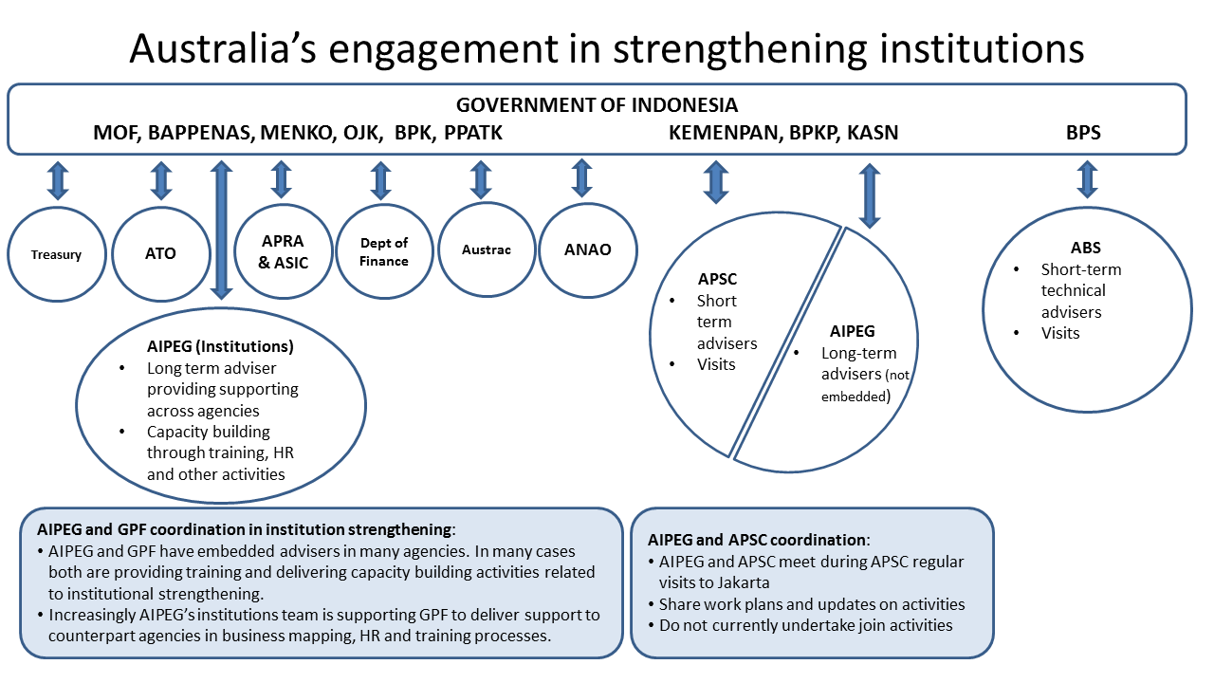

A broad area that encapsulates much of the work through AIPEG and GPF to strengthen performance and accountability in the bureaucracy. The APSC assists three Indonesian government agencies responsible for civil service reform and performance. The Commonwealth Ombudsman partners with the Ombudsman of Republic Indonesia on complaint handing. AIPEG treats bureaucratic reform as a cross cutting issue. The ABS works with the BPS on macroeconomic statistics.

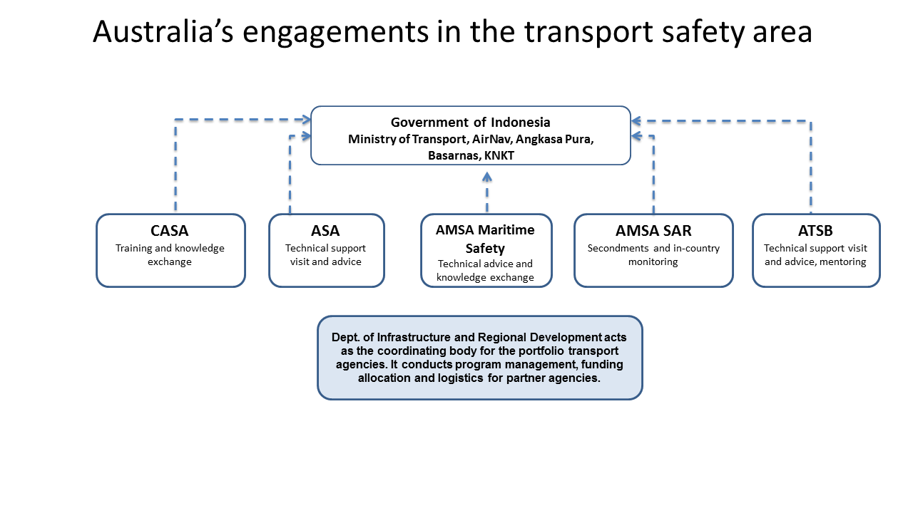

ITSAP was incorporated into GPF in 2015. ITSAP comprises six Australian government agencies supporting their Indonesian counterparts in relation to air safety, maritime safety and maritime search and rescue. ITSAP is coordinated and managed by the Department of Infrastructure and Regional Development, which oversees partnerships implemented by ASA, CASA, ATSB and AMSA. Indonesian counterparts are various areas of the Ministry of Transportation, as well as AirNav Indonesia, Angkasa Pura I &II, Indonesia Search and Rescue Agency (BASARNAS) and the National Transport Safety Commission.

Annex C – AIPEG Performance Indicators

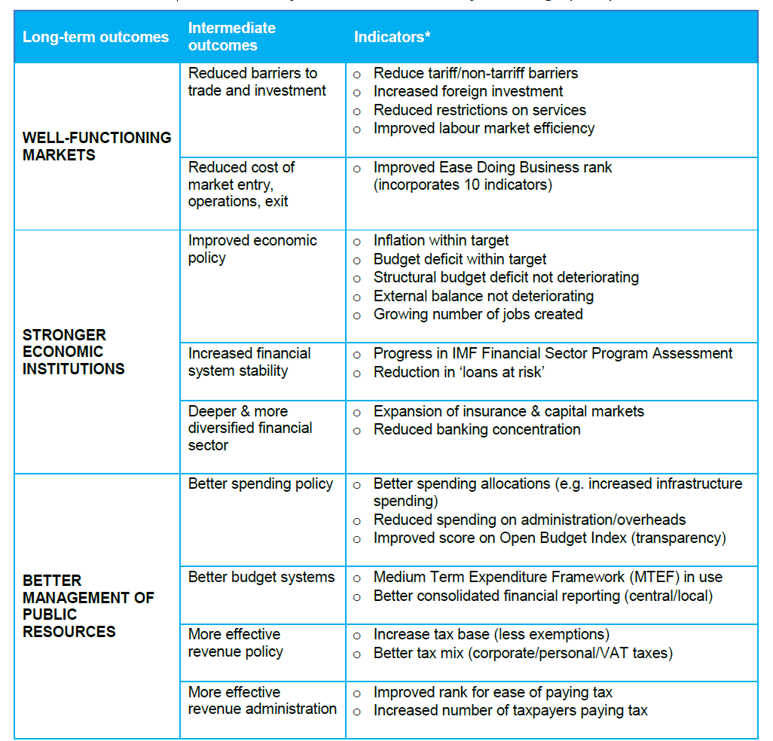

1. Using PPP exchange rates from IMF..
2. Based on the World Bank’s US$1.25 per person per day definition. Note that since these statistics were calculated the World Bank has lifted its poverty line definition to US$1.90 per day.
3. World Bank (2016) “Indonesia: $400 Million Approved for Logistics Reform” at <http://www.worldbank.org/en/news/press-release/2016/11/02/indonesia-400-million-approved-for-logistics-reform>, accessed on 28/1/17
4. For the 2016 Aid Quality Check for gender equality AIPEG scored 4 out of 6 while GPF rated 3 out of 6
5. DFAT (2015) Aid Investment Plan Indonesia: 2015-16 to 2018-19. Available from <http://dfat.gov.au/about-us/publications/Pages/aid-investment-plan-aip-indonesia-2015-16-to-2018-19.aspx> (accessed 21.12.2016)
6. Bappenas (2014) Rencana Pembangunan Jangka Menengah Nasional (RPJMN) 2015-2019 (Medium-term National Development Plan 2015-2019). Available from <http://www.bappenas.go.id/id/data-dan-informasi-utama/dokumen-perencanaan-dan-pelaksanaan/dokumen-rencana-pembangunan-nasional/rpjp-2005-2025/>
7. Procedures to undertake this type of workplace assessment are being implemented under the Australian Awards program. This practice can be extended to AIPEG and GPF activities.