# Australia and the Global Fund

**Fighting AIDS, Tuberculosis and Malaria to Save Lives March 2013**

### 

## The continuing fight against the three diseases

While there has been significant progress in the global fight against HIV, tuberculosis and malaria, the health burden associated with these three diseases remains substantial. In 2011 alone, these diseases claimed around 3.7 million lives: 1.7 million AIDS-related deaths, a further 1.4 million tuberculosis-related deaths, and 660,000 malaria-related deaths.

## What is the Global Fund?

The Global Fund is a public/private partnership and international financing institution that supports large-scale prevention and treatment against these life-threatening diseases. It also provides support to build stronger health systems in the world’s poorest countries.

The Global Fund has contributed significantly to global health since its inception in 2002. It currently provides around 80 per cent of international funding for tuberculosis, 50 per cent for malaria and about 20 per cent for HIV.

The Global Fund has saved an estimated 8.7 million lives through treatment and disease prevention. The Global Fund’s achievements are the result of collaboration with governments, donors, technical partners, private companies and civil society organisations.

## AusAID and the Global Fund

Australia, through AusAID, is supporting the Global Fund to address these life-threatening diseases in the world’s poorest countries. The Global Fund helps Australia to meet the aid program’s strategic objective of saving lives as well as achieve the Millennium Development Goals. Since 2004, Australia has contributed $310 million to the Global Fund.

|  |
| --- |
| **The Global Fund, with AusAID’s support, has contributed to:**   * saving 8.7 million lives * providing 4.2 million people with HIV treatment * providing 250 million people with HIV testing and counselling sessions * treating 9.7 million cases of tuberculosis * distributing of 310 million insecticide-treated bed nets * treating 290 million cases of malaria. |

## In our region

AusAID and the Global Fund are working together to improve health outcomes in the Asia Pacific. Around 21 per cent of the Global Fund’s grants are directed to Asia and the Pacific. These grants have resulted in more than 500,000 people on lifesaving HIV treatment; 46 million insecticide-treated bed nets distributed; and the treatment of 6.6 million cases of tuberculosis. Other results in Asia and the Pacific include:

* Over the past ten years, Cambodia has documented important declines in TB prevalence, incidence and mortality. Preliminary surveys found a 43 per cent decline in the prevalence of TB cases between 2002 and 2011—an average decline of 4.7 per cent per year.
* Cambodia also saw significant improvements in access to treatment for people with HIV, and currently 46,000 people are receiving Global Fund-supported treatment.
* In Bangladesh, 1.4 million insecticide-treated nets were distributed to protect families from malaria.
* In Papua New Guinea, Malaria prevention has also been strong, with 3.6 million insecticide-treated nets distributed.
* In Timor Leste, almost 3,500 people received HIV testing and counselling in 2011; and over 450,000 condoms were distributed to prevent the spread of HIV.
* In Indonesia, 23,000 people are currently receiving HIV treatment (the Global Fund finances 50 per cent of the national HIV program). Alongside support from AusAID and USAID, the Global Fund is also working to strengthen health systems to ensure better and sustainable access to services.

## The future

Over the next four years to 2016, the Global Fund aims to save a further ten million lives and prevent up to 180 million new infections from the three diseases.

The Global Fund Strategy 2012-2016 is all about investing for impact. The Strategy is focused on investing more strategically, improving the way funding is allocated and accessed and increasing support to countries applying for grants and those who have had grants approved. The Strategy is critical in accelerating achievement of the health Millennium Development Goals by 2015.

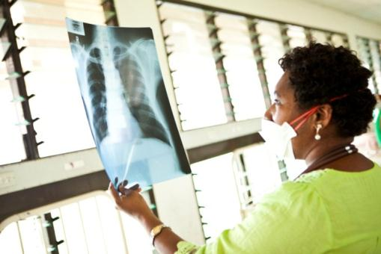

A doctor holds up an x-ray photo of a TB patient's chest in a hospital in Port Moresby, Papua New Guinea   
Photo: *© The Global Fund / John Rae*

[www.ausaid.gov.au](http://www.ausaid.gov.au) I [www.theglobalfund.org](http://www.theglobalfund.org)