Australia-Fiji civil society engagement strategy 2016- 2019

September 2016

#### Contact

Inquiries about this document should be directed to:

Department of Foreign Affairs and Trade  
RG Casey Building  
John McEwen Crescent  
Barton ACT 0221  
Australia

Phone +61 2 6261 1111  
Fax +61 2 6261 3111

Published by the Department of Foreign Affairs and Trade, September 2016

#### Photo credits

Cover image: Civil Society representatives attend a gender, equity and social inclusion training. Training CSOs in facilitation techniques enables them to help facilitate inclusive development planning processes in the communities they work. Credit: DFAT Fiji Community Development Program

Contents

Acronyms 2

introduction 3

about the strategy 5

OUR APPROACH 6

PRinciples of engagement 7

engagement objectives 10

strategy implementation 15

REFERENCES 18

# Acronyms

|  |  |
| --- | --- |
| AIP  AVID | Aid Investment Plan  Australian Volunteers for International Development |
| ANCP | Australian NGO Cooperation Program |
| CSO | Civil Society Organisation |
| DAP | Direct Aid Program |
| DFAT | Department of Foreign Affairs and Trade |
| DPO | Disabled Persons Organisation |
| FCDP | Fiji Community Development Program |
| LGBTQI | Lesbian, Gay, Bisexual, Transgender, Queer, Intersex |
| MOE | Ministry of Education |
| MOHMS | Ministry of Health and Medical Services |
| NDMO | National Disaster Management Office |
| NGO  WASH | Non-Governmental Organisation  Water, Sanitation and Hygiene |

# introduction

The Australia-Fiji Civil Society Engagement Strategy (the Strategy) outlines how the Australian Government, through its aid program, will work with civil society[1] to support development in Fiji. The purpose of Australia’s aid program, as outlined in ***Australian aid: promoting prosperity, reducing poverty, enhancing stability****,* is to promote Australia’s national interests by contributing to sustainable economic growth and poverty reduction. Australia’s aid program is implemented by the Department of Foreign Affairs and Trade (DFAT).

In Fiji, Australia’s aid program objectives, as articulated in our Aid Investment Plan for Fiji 2015-2019, are to support inclusive economic growth to reduce poverty under two strategic priorities:

1. Increased private sector development
2. Improved human development

The focus on private sector development recognises the private sector as the engine of economic growth. It recognises that people leave poverty when they have the opportunity to develop and use their skills productively through self-employment or securing a wage. Complementing this focus are investments in improving education, health, gender equality and women’s empowerment and participation of people living with disability, as foundations of strong human development.

Australia will work with the Fiji Government, regional organisations, the private sector and civil society to deliver its aid program. Civil society organisations (CSOs) remain important development partners and Australia has a long history of engaging with civil society across its global aid programs. Australia is the largest donor for civil society in Fiji[2] and currently supports CSOs in several ways. These include core funding and co-funding organisations, grant funding, capacity development, sector-specific support and funding small grassroots initiatives. Funding support is delivered through bilateral, regional and global initiatives.

The Fiji Community Development Program (FCDP) and Direct Aid Program (DAP) are bilateral initiatives that support CSOs to deliver social and economic benefits to the poor, disadvantaged and marginalised in Fiji. The Pacific Women Shaping Pacific Development (Pacific Women) program supports women focused CSOs in Fiji, to deliver programs that enable the social, economic and political empowerment of women.

FCDP is currently Australia’s most significant engagement with civil society in Fiji. It is a five year program that commenced in 2012 following Australia’s previous support to CSOs through the Australian Civil Society Support Program. FCDP is implemented by a managing contractor and ends in May 2017.

In order to work more efficiently, Australia will consolidate its bilateral implementation arrangements through the Fiji Program Support Facility (The Facility). The Facility will be established in late 2016 to provide technical assistance, manage funds and provide logistical and administrative services for programs across the breadth of the Fiji AIP. The Civil Society Engagement Specialist within the Facility will support implementation of the Australia-Fiji Civil Society Engagement Strategy.

# about the strategy

**Principles of Engagement**

**Common objectives**

**Open communication and dialogue**

**Strategic and holistic partnerships**

**Partnerships for results**

**Supporting existing local systems for sustainability**

**Diverse and innovative funding arrangements**

**Inclusive economic growth and reduced poverty**

**Improved human development**

**Increased private sector development**

**Promoting inclusive economic growth and opportunities**

**Promoting enhanced health outcomes**

**Promoting accountability, transparency and inclusive decision making**

**Promoting access to quality and inclusive education**

**Promoting gender equality and women’s empowerment**

**Promoting meaningful engagement with people living with disability**

**Promoting the rights and participation of children**

**Promoting disaster risk management and advocacy for resilience**

**Promoting people to people links for enhanced development outcomes**

**Funding Support**

**Capacity Development**

**Support**

**Supporting Strategic Opportunities**

**CSO Engagement Objectives**

**Strategy Implementation**

OUR APPROACH

There are two parts to this strategy. Part one outlines its purpose, principles of engagement and engagement objectives. Part two outlines how the strategy will be implemented.

**Purpose of the Strategy**

The primary purpose of the Strategy is to articulate how Australia will empower and engage with civil society as part of achieving its development cooperation objectives in Fiji. The Strategy sets the direction for aid investments across the Fiji Aid Investment Plan to foster strategic, results based and innovative relationships with CSOs.

Consistent with the Istanbul Principles for CSO Development Effectiveness[3], Australia will build relationships with CSOs that are based on shared values and objectives and include a commitment to addressing the structural causes as well as symptoms of poverty, inequality and marginalisation.

The Strategy is primarily meant for Australia’s use; however, where appropriate, to foster harmonisation and collaboration, other development partners, donors and interested stakeholders may use the Strategy.

A strong focus on monitoring, learning and sharing of best practice will underscore our engagement with CSOs.

The Strategy specifically aims to:

1. guide Australia’s overall approach to working with CSOs in Fiji in a predictable, transparent and harmonised way;
2. develop strategic and holistic partnerships with a diverse range of CSOs across Australia’s aid programs in Fiji;
3. encourage collaboration among CSOs and government and the private sector to maximise efficiency and to achieve sustainable results;
4. strengthen CSOs’ ability to deliver development outcomes to rural, remote, marginalised and vulnerable groups (women, girls and people living with a disability) in Fiji through funding and capacity building support;
5. support a diverse range of CSO programming and innovations including policy development and advocacy; and
6. guide DFAT to develop performance based partnerships with CSOs to track progress towards intended development outcomes

**Principles of Engagement**

**Common objectives**

**Open communication and dialogue**

**Strategic and holistic partnerships**

**Partnerships for results**

**Supporting existing local systems for sustainability**

**Diverse and innovative funding arrangements**

**Inclusive economic growth and reduced poverty**

**Improved human development**

**Increased private sector development**

**Promoting inclusive economic growth and opportunities**

**Promoting enhanced health outcomes**

**Promoting accountability, transparency and inclusive decision making**

**Promoting access to quality and inclusive education**

**Promoting gender equality and women’s empowerment**

**Promoting meaningful engagement with people living with disability**

**Promoting the rights and participation of children**

**Promoting disaster risk management and advocacy for resilience**

**Promoting people to people links for enhanced development outcomes**

**Funding Support**

**Capacity Development**

**Support**

**Supporting Strategic Opportunities**

**CSO Engagement Objectives**

**Strategy Implementation**

**Australia’s Development Objectives in Fiji**

# PRinciples of engagement

The following principles of engagement are informed by Australia’s overarching NGO framework[4]. These principles will guide Australia when we work with CSOs in Fiji. They apply to a range of development activities including knowledge sharing and policy dialogue, as well as program development and implementation.

Australia acknowledges civil society in Fiji is diverse. It includes a range of organisations, collectives, coalitions and groups with multiple competing and often conflicting interests. Our principles of engagement outline the types of CSOs Australia will work with. Australia recognises the distinct and independent nature of civil society actors – we will at times have divergent views, and we respect the important contribution of CSOs as independent voices to public debate.

Australia will work with CSOs that:

1. recognise and practice commitment to internationally recognised human rights principles;
2. demonstrate accountability to their constituents; and
3. have a proven track record to affect positive change in the communities where they work.

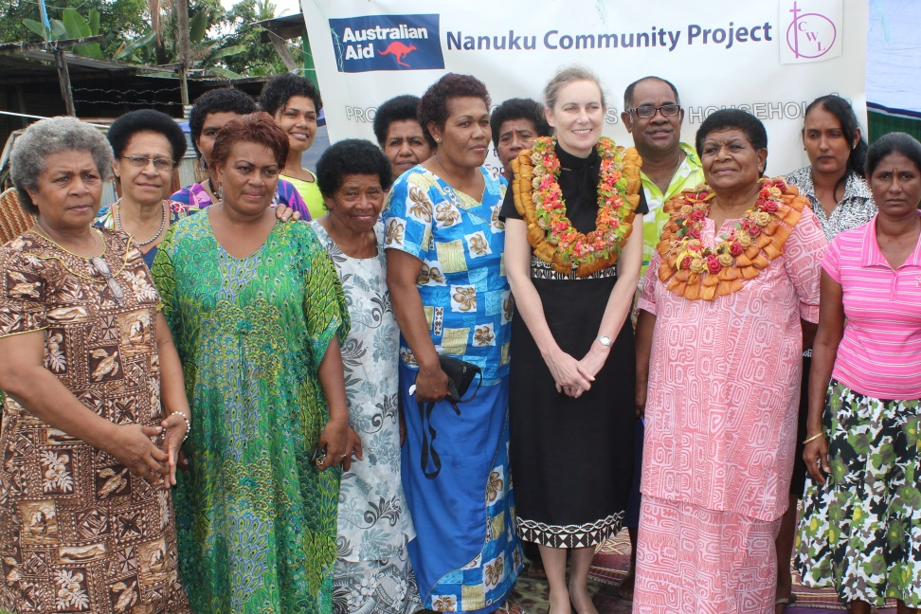

H.E. Margaret Twomey, Australian High Commissioner to Fiji, launching the Fiji Catholic Women’s League’s, community solar lighting project. Photo: DFAT FCDP

***Common objectives***

We will work with CSOs that share our objectives and interests. This includes alignment with the Fiji Government’s development objectives. When we partner with CSOs, it is based on the premise that we are collectively working towards common goals.

Australia recognises the added benefits that working with CSOs brings. These include reach to local, rural and remote networks, expertise in working with marginalised and vulnerable groups and the capacity to influence positive local change.

***Open communication and dialogue***

Promoting constructive dialogue will be a core part of our engagement with CSOs. Partnerships will be based on a genuine commitment to creating opportunities for CSOs to participate and influence our policies and programs in Fiji - opportunities that support both Australia’s and Fiji’s national interests to address development challenges.

Through their work with poor, vulnerable and marginalised communities, CSOs often represent the perspectives and needs of the poor, women and girls, people with disability and other marginalised groups. Bringing this perspective to development policies and programs is part of the value that CSOs can add.

***Strategic and holistic partnerships***

Australia will work with CSOs that have a comparative advantage in helping achieve Australia’s aid program objectives for Fiji — such as in health, education and governance. CSOs are not only implementing partners, but also important development actors that play a variety of roles.

Civil society plays an active role in the health and education sectors in Fiji, often in strong partnership with the Fiji Government. In education for example, more than 99 per cent of schools in the country are owned and managed by faith based organisations or other civil society groups.[5] In health, many civil society groups are active in providing health services particularly to vulnerable or disadvantaged groups. Through Australia’s investments in the education and health sectors in Fiji, we will support the role that civil society plays and find opportunities to further strengthen its partnership with the Fiji Government.

Beyond service delivery, CSOs are advocates and lobbyists, monitors of people’s rights and interests, innovators of new concepts and initiatives, and, shapers of government policies and programs. We will also partner with these CSOs and support their work in these areas, where doing so will help us achieve our development objectives.

Australia has a strong commitment to empowering women and girls. We will prioritise engagement with women focused organisations and coalitions for gender equality. Greater strategic engagement with and support to women’s networks and institutions is essential to our Strategy.

***Partnerships for results***

Australia is accountable to its taxpayers for the results achieved through its development assistance. We will work with CSO partners who share our commitment to demonstrating results and transparency. Our CSO partners should demonstrate the capacity to track progress towards change and measure outcomes and impact. This extends to our stakeholders and beneficiaries. To this end, our support to CSOs will be based on measurable performance frameworks. These frameworks will also support CSOs to employ learning approaches to improve their programs. Where CSOs have existing frameworks for reporting their results, we will seek to incorporate these into our accountability processes.

***Supporting existing local systems for sustainability***

We will support partnerships that are based on coalitions working together or where stronger CSOs are working to support smaller, less established CSOs. We will support existing or emerging structures that have demonstrated effectiveness and efficiency. When we work with Australian and international NGOs we expect them to demonstrate strong relationships with local partners, to build the capacity of local partners, and to increase the process of self-reliance and local ownership. We want to strengthen local systems and promote outcomes with a lasting impact on the poor.

***Diverse and innovative funding arrangements***

CSOs have different roles and varied capacities and because of this, there is a need to ensure appropriate assistance for CSOs to achieve the desired development results. This means we will provide CSOs access to flexible funding and support, such as core funding, project specific funding, capacity development, networking and learning opportunities.

It is important for us to have a mix of funding arrangements. This allows us to work with a range of partners. We recognise that predictability in funding facilitates CSO planning and long term commitments to poor communities. This can in turn enhance performance and results. We will strive to offer predictable funding where appropriate to context, program objective, and CSO capacity.

There will be clear selection criteria for CSOs we partner with. These include how the CSOs are connected to the communities they work with and other organisations in their sector; whether they are viewed and considered as trusted and legitimate actors within their community and sector; and if their method of delivery is strategic, transformative and able to demonstrate positive change.

# engagement objectives

The following section outlines Australia’s engagement objectives with civil society to progress mutual development policy priorities.

***Promoting inclusive economic growth and opportunities***

Inclusive economic growth and opportunities are important to helping the most disadvantaged to improve their livelihood potential and move out of poverty. Most private sector organisations operate within or near urban centres, limiting access for people in rural and remote communities. Within urban centres, poor and marginalised individuals also find it challenging to secure employment or engage in viable economic activities to meet housing, food, and other basic living needs.

CSOs have the potential to complement the work of the private sector through their connections to the most disadvantaged in Fiji. Disabled Persons Organisations, for instance, play an important role in supporting people with disabilities to obtain skills and confidence to seek formal employment. Many women’s groups enable unemployed women to gain skills and confidence to start their own businesses or find formal employment. Some CSOs support income generating activities in rural and remote areas where access to economic opportunities is limited. These activities create opportunities for communities and individuals to form or strengthen their income generating potential and get connected to businesses and markets.

We will support CSO activities that focus on improving the economic status and opportunities of disadvantaged groups in Fiji, as part of our commitment to supporting inclusive economic growth.

***Promoting accountability, transparency and inclusive decision making***

Transparent, accountable, inclusive decision making and democratic processes are essential for fair and equitable development. They are also important in promoting sustainable economic growth. We recognise the role CSOs have played in advocating for these with government, the private sector, donors, and within civil society.

CSOs are also helping people to claim their rights. These include women and girls’ rights, children’s rights, the rights of people living with disability, socio-economic rights, education, and civic rights. CSOs are also key actors in sustainable resource management and access to essential services through advocacy and strengthening of governance processes from community to national level.

We will support partnerships with CSOs that demonstrate the potential and capability to promote accountable, transparent and democratic processes and sustainable management of resources. We will ensure all CSOs implementing DFAT grants have accountability, transparency and inclusive decision making principles integrated into their program planning, implementation and reporting.

***Promoting enhanced health outcomes***

DFAT is committed to ensuring better alignment between CSOs and the Fiji Ministry of Health and Medical Services (MOHMS). Through our bilateral health program, DFAT will support CSOs delivering primary care and preventative health services to the most disadvantaged, marginalised and vulnerable groups, particularly those in rural and remote communities. These services will complement existing government services targeting a range of health issues including sexual and reproductive health, non-communicable diseases, mental health, psychosocial counselling, child health and adolescent health.

Access to consistent, cost effective and friendly primary health care and prevention can encourage individuals to adopt health seeking behaviours and lifestyles. Healthy individuals are important for economic productivity, improved quality of life and reduce cost and burden on mainstream health services. We encourage CSOs to use delivery methods that are efficient, link to existing service providers and contribute towards national health strategies. We also encourage CSOs to seek partnerships with private sector institutions to deliver their services in a sustainable way.

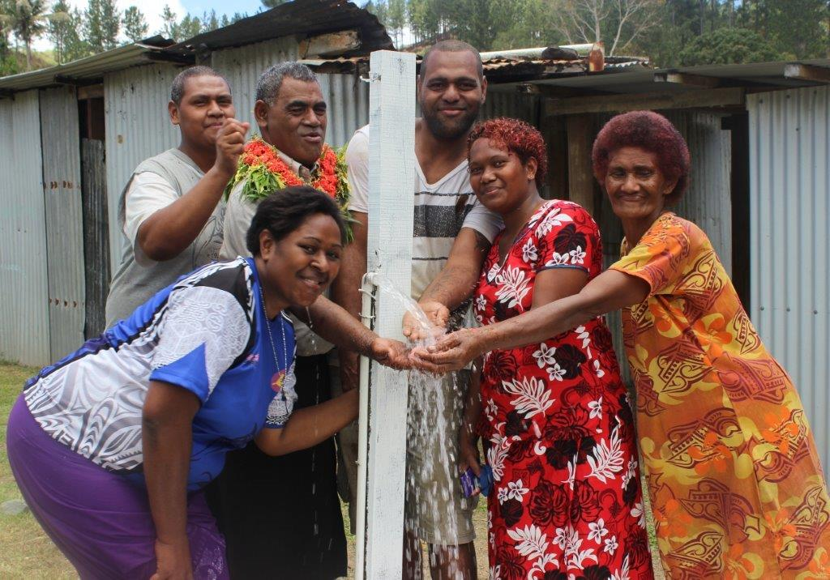

**Supporting CSOs to deliver WASH projects in rural communities has enabled communities to have consistent, safe water supply. Photo: DFAT FCDP**

***Promoting access to quality and inclusive education***

CSOs, particularly faith based organisations, contribute significantly to education in Fiji. Most schools in Fiji are owned and managed by communities or faith based organisations through their own fundraising and government grants. DFAT recognises the contribution of CSOs to building the skills and knowledge base that meets labour demands of Fiji’s government, as well as private and civil society sectors in Fiji.

Through our bilateral education program, we will support CSOs that work to improve education outcomes of the most disadvantaged individuals through service provision and advocacy. We will encourage better alignment, through partnership and collaboration, between CSOs and the Fiji Ministry of Education (MOE). Our scholarships program will work closely with the CSO sector to identify and address skill gaps within the sector by connecting them to local, regional and Australian training institutions.

***Promoting gender equality and women’s empowerment***

DFAT is committed to expanding opportunities for women and girls to participate in economic, social and political spheres. Fiji CSOs, particularly women focused CSOs, have been instrumental in progressing ideas and advocating for development strategies and policies for gender equality. Fiji is home to diverse women’s CSOs, coalitions and networks including LGBTQI and youth groups. Where possible and appropriate, we will partner with these groups to advance gender equality.

Through the Fiji Women’s Fund, an initiative under the Pacific Women program, we will support women focused CSOs and groups to implement initiatives that increase women’s economic empowerment, strengthen women’s roles in leadership and decision making, and address gender-based violence. Our Pacific Women program will also partner with women’s CSOs who meet a service delivery need for women. DFAT will support the Fiji Ministry of Women, Children and Poverty Alleviation’s Department of Women to implement its gender equality commitments. The Fiji National Gender Policy recognises the role of women’s groups and CSOs in promoting the full and equal participation of women and men in Fiji.

We will require CSOs implementing DFAT-supported activities in other sectors to promote and advocate for gender equality through their work, including the implementation of gender and social inclusion policies.

***Promoting the rights and participation of children***

Australia and Fiji have ratified the Convention on the Rights of the Child and have a duty to ensure that children are able to participate in decision making and development processes that benefit them. CSOs are playing a key role in promoting child participation and child rights in Fiji. We will support CSOs that demonstrate the capability to promote the rights and participation of children, particularly among disadvantaged populations.

We will require CSOs working across all our programs to promote and advocate for the rights and participation of children, including children with a disability, and to have relevant child protection policies and safeguards in place.

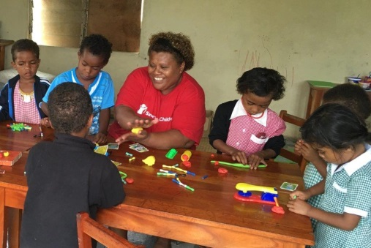

**Save the Children Fiji provides safe spaces for children to help them cope during times of disaster. Photo: Save the Children Fiji**

***Promoting meaningful engagement of people living with disability***

People with disability face multiple barriers which mean they often cannot take part in decision making and development processes. These barriers include stigma and attitudinal barriers as to their abilities and potential, physical and communication barriers.

We will support Fiji Disabled Persons Organisations (DPOs) to ensure people living with disability equally benefit from development initiatives. DPOs will benefit from targeted assistance to enable them to deliver their services and programs. We are committed to providing them with appropriate support as needed.

We will also require CSOs implementing DFAT-funded activities in other sectors to actively promote and advocate for the inclusion of people living with disability in development activities including the development of relevant disability inclusive development policies.

We encourage CSOs, in collaboration with DPOs, to explore partnerships with government, the private sector and within civil society to promote the meaningful engagement of people living with disability.

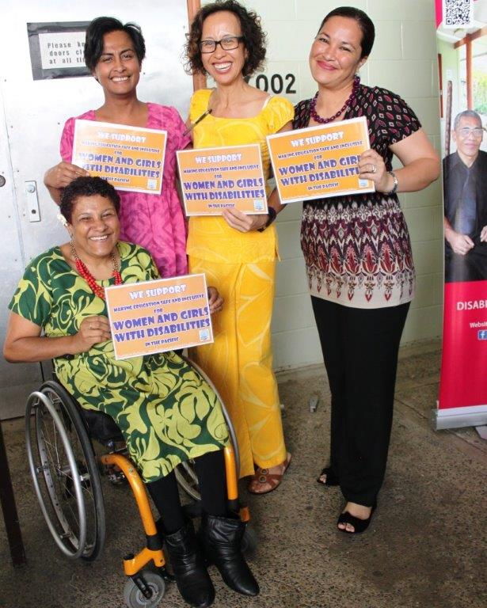

**Promoting the participation of women and girls with disability ensures they are included in all development activities. Photo: DFAT Suva**

***Promoting disaster risk management and advocacy for building resilience***

The Pacific region is one of the most disaster prone areas in the world and Fiji is particularly vulnerable due to its geographical location. Australia has partnered with Fiji to implement disaster risk management activities as well as to help build the resilience of communities affected by natural disasters and the negative impact of climate change.

Through our Pacific Risk Resilience Program, we will support CSOs to strengthen community resilience to climate change and to manage disasters effectively. We will develop partnerships with capable CSOs with experience in humanitarian response to quickly respond to disasters. CSOs will be required to work with the Fiji National Disaster Management Office (NDMO) as part of their response efforts.

We will require CSOs implementing DFAT-funded activities outside the disaster management and climate change sector to promote environmental protection and disaster preparedness in their activities.

***Promoting people-to-people links for enhanced development outcomes***

Australians value their links and connections with Fijians. People-to-people exchanges foster mutual understanding of our cultures, ideas, skills and knowledge. They also contribute to deeper understanding and appreciation of Australia-Fiji collaboration towards Fiji’s development outcomes.

We recognise there is specific technical expertise, readily available in Australia, which Fiji can benefit from. Where relevant and appropriate, we will support Australian NGOs and volunteers to work with Fiji’s CSOs to deliver effective and efficient programs. The focus will be on building the capacity and skills of local CSO personnel and improving organisational practices. Support will be based on the capacity gaps and needs of CSOs and their networks.

# strategy implementation

**Action Area 1: Funding support**

This Strategy will use different funding arrangements that Australia has in place for Fiji based CSOs as well as Australian or international NGOs working in Fiji. Funding will be based on the principles of engagement and engagement objectives outlined in this Strategy.

The current FCDP will continue supporting local CSOs to deliver services to rural, remote and marginalised communities in Fiji and to promote grassroots development. FCDP will end in May 2017, prior to which a handover process of grant management systems and functions, capacity building approaches and tools will be done with the forthcoming Facility.

The Facility will be the key mechanism to implement Australia’s engagement with CSOs across the Fiji Aid Investment Plan. CSOs will be able to access funding through competitive rounds or through direct engagement by the Facility where a CSO has a clear comparative advantage and value-add to achieving Australia’s aid objectives. All sector programs managed under the Facility will include a resource allocation for supporting CSOs. New programs under the Facility will be required to analyse and identify how CSOs can be supported to contribute to program objectives and outcomes. Program support to CSOs will differ for each sector, depending on program priorities and policies.

The Facility will also maintain a standalone, flexible pool of funding that CSOs can access to respond to priorities outside of the Facility’s sector programs but are considered innovative, strategic or respond to an emerging need. This pool of funding will also cater for humanitarian emergency response and building long term relationships with CSOs that have a humanitarian response focus. Funding guidelines and criteria will be established under the Facility and communicated to CSOs and stakeholders accordingly.

Funding opportunities will be complemented by programs delivered outside of the Facility, at a bilateral and regional level. These programs will help to capitalise on Australia’s engagement with civil society in Fiji. This includes support provided to:

1. Australian organisations to work with local CSOs through the Australian NGO Cooperation Program (ANCP) and volunteers through the Australian Volunteers for International Development (AVID) program;
2. CSOs in Fiji through the Pacific Women funded Fiji Women’s Fund, implementing activities that increase women’s economic opportunities, promote women’s leadership and decision making roles and address gender-based violence;
3. Key regional programs such as Australia’s Pacific Risk Resilience Program that engages with CSOs to strengthen resilience to the impacts of climate change and natural disasters;
4. Regional health and governance aid programs that also work with CSOs to deliver development outcomes in Fiji; and
5. The Direct Aid Program, administered by the Australian High Commission in Suva, that targets community based civil society groups working across a range of issues through the provision of small grants.

**Action Area 2: Capacity Development**

A strong focus on capacity development for CSOs will complement funding support. Australia values the wealth of technical knowledge, skills, experience and connections that CSOs possess. We recognise that there are varied capacities and capabilities among the CSOs we partner with. We also recognise that our development objectives in Fiji cannot be achieved if our CSO partners are not given the relevant support they need to effectively contribute towards these objectives.

We will work with our Fiji CSO partners to access the appropriate and relevant capacity development support they need to deliver quality programs that are cost effective. We will encourage CSOs to explore cross-organisational and cross-sectoral learning and partnerships with other CSOs (including Australian NGOs), the private sector, government and other development partners in Fiji. Our capacity development support will be delivered through our various sector programs, the Fiji Women’s Fund and the Facility. There will also be a strong connection to our scholarships and volunteers program to support knowledge and skills development.

Our support will include, but is not limited to:

***Strengthening organisational policies, systems and processes***

We will support our CSO partners to strengthen their policies, systems, processes and staff capacity to implement DFAT funded programs. This may include senior management and board development; policy development and training on financial management and procurement, gender equity and social inclusion, disability inclusion, child protection, environmental protection, advocacy and lobbying; resource mobilisation; knowledge management; program design and management.

***Ensuring quality and inclusive program delivery***

We will support our CSO partners to deliver quality and inclusive programs so that they are results based, relevant, appropriate, responsive to the needs of the most disadvantaged and demonstrate value for money. Assistance may be through engaging technical expertise, training, mentoring or learning exchanges between organisations.

***Fostering effective and sustainable partnerships***

We will support CSOs to partner with government, the private sector, regional and Australian based CSOs that demonstrate the potential to add value to program delivery and are aligned with Australia’s development objectives. Encouraging collaboration among these groups is a key approach to driving sustainability within the CSO sector.

**Other strategic opportunities**

We are committed to ongoing and open dialogue with our CSO partners to find innovative ways to enhance development outcomes and opportunities for those most in need. Collaboration is key to innovation and we will consult with CSOs to foster this shared learning. We will also support donor coordination in our engagement with CSOs.

Where possible, we will support initiatives that fall outside our sector programs but contribute to our objectives and foster innovation. These areas include but are not limited to:

1. Climate change and disaster risk reduction through regional and global initiatives. With Fiji’s focus on green growth and its vulnerability to natural disaster, Australia will work with CSOs working to address these issues through support from regional and global initiatives, drawing on CSOs’ extensive reach and networks, as first responders and key actors during rehabilitation and recovery efforts post-disaster.
2. Working with umbrella groups, networks and coalitions that implement initiatives contributing to outcomes across our sector programs.
3. Supporting knowledge management and good practice. Australia will use its role as a convener of partners and stakeholders to share experiences and facilitate learning and capacity building.

# REFERENCES

Commonwealth Foundation . (2014, December ). Civil Society Engagement Strategy .

European Union . (2015 , June 15 ). *EU-FIJI National Indicative Programmes for the period 2014-2020 .* Retrieved June 30 , 2016 , from European Commission: http://ec.europa.eu/europeaid/eu-fiji-national-indicative-programmes-period-2014-2020_en

OECD.org. (2016, 07 21). *OECD*. Retrieved from OECD.org: http://www2.compareyourcountry.org/aid-statistics?cr=1000&cr1=oecd&lg=en&page=1

The Australian Government. (2014, June). *Child Protection Policy*. Retrieved from Australian Government: Department of Foreign Affairs and Trade: http://dfat.gov.au/aid/topics/safeguards-risk-management/child-protection/pages/child-protection.aspx

The Australian Government. (2014, November). *Environmental Protection Policy for the Aid Program*. Retrieved from The Australian Government: Department of Foreign Affairs and Trade: http://dfat.gov.au/aid/topics/safeguards-risk-management/environmental-protection/Pages/environmental-protection.aspx

The Australian Government. (2015, February). *Agriculture, Fisheries and Water*. Retrieved from The Australian Government: Department of Foreign Affairs and Trade: http://dfat.gov.au/aid/topics/investment-priorities/agriculture-fisheries-water/Pages/agriculture-fisheries-water.aspx

The Australian Government. (2015, May). *Development for All 2015-2020*. Retrieved from The Australian Government: Department of Foreign Affairs and Trade: http://dfat.gov.au/aid/topics/development-issues/disability-inclusive-development/Pages/disability-inclusive-development.aspx

The Australian Government. (2015, March). *Effective Governance Strategy for Australia's Aid Investments*. Retrieved from The Australian Government: Department of Foreign Affairs and Trade: http://dfat.gov.au/aid/topics/investment-priorities/effective-governance/Pages/effective-governance.aspx

The Australian Government. (2015, June). *Health for Development Strategy 2015-2020*. Retrieved from The Australian Government: Deparment of Foreign Affairs and Trade: http://dfat.gov.au/about-us/publications/Pages/health-for-development-strategy-2015-2020.aspx

The Australian Government. (2015, September). *Strategy for Australia's aid investments in education 2015-2020*. Retrieved from The Australian Government: Department of Foreign Affairs and Trade: http://dfat.gov.au/aid/topics/investment-priorities/education-health/Pages/education-and-health.aspx

The Australian Government. (2015, October). *Strategy for Australia's aid investments in private sector development*. Retrieved from The Australian Government: Department of Foreign Affairs and Trade: http://dfat.gov.au/aid/topics/development-issues/private-sector-development/Pages/private-sector-development.aspx

The Australian Government. (2016, May). *Building Resilience: Humanitarian Assistance, Disaster Risk Reduction and Social Protection*. Retrieved from The Australian Government: Department of Foreign Affairs and Trade: http://dfat.gov.au/aid/topics/investment-priorities/building-resilience/Pages/building-resilience.aspx

The Australian Government. (2016). *Direct Aid Program*. Retrieved from The Australian Government: Department of Foreign Affairs and Trade: http://dfat.gov.au/aid/topics/development-issues/direct-aid-program/Pages/direct-aid-program.aspx

The Australian Government. (2016, February). *Gender Equality and Women's Empowerment Strategy*. Retrieved from The Australian Government: Department of Foreign Affairs and Trade: http://dfat.gov.au/aid/topics/investment-priorities/gender-equality-empowering-women-girls/Pages/gender-equality-empowering-women-girls.aspx

The Australian Government: Department of Foreign Affairs and Trade. (2014, Junr). *Australian aid: promoting prosperity, reducing poverty, enhancing stability*.

The Australian Government: Department of Foreign Affairs and Trade. (2014, June). *Making Performance Count: enhancing the accountability and effectiveness of Australian aid*.

The Australian Government: Department of Foreign Affairs and Trade. (2015, December). *DFAT and NGOs Effective Development Partners*.

The Australian Government: Department of Foreign Affairs and Trade. (2015). *Aid Investment Plan Fiji 2015-16 to 2018-19*.

The World Bank. (2006). World Bank- Civil Society Engagement Review of Fiscal Years 2005 and 2006 .

United Nations Development Program . (2012, October ). UNDP Strategy on Civil Society and Civic Engagement.

1. Civil society refers to a wide and growing range of non-government and non-market organisations through which people organise themselves to pursue shared interests or values in the public domain. Examples include community and village based groups, labour unions, indigenous groups, diaspora groups, charitable organisations, cooperatives, women’s’ organisations, faith-based organisations, professional associations, chambers of commerce, independent research institutes and the not-for-profit media.
2. http://www2.compareyourcountry.org/aid-statistics?cr=1000&cr1=oecd&lg=en&page=1 accessed 21 July 2016
3. Istanbul Principles for CSO Development Effectiveness can be found at http://cso-effectiveness.org/-istanbul-principles,067-.html
4. Department of Foreign Affairs and Trade . (December 2015). DFAT and NGOs: Effective Developement Partners
5. DFAT commissioned Fiji Civil Society Analysis Final Report, Hall, Buadromo and Laqeretabua, 2015