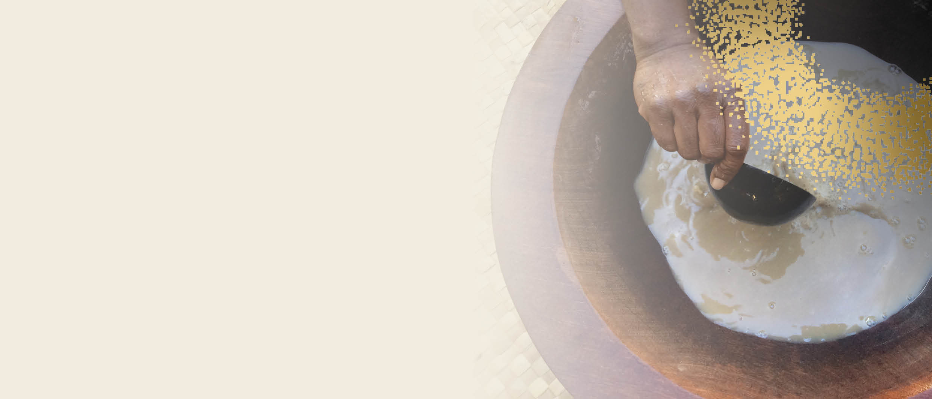 

**PERMITS &  
IMPORTING**

AUSTRALIA’S COMMERCIAL KAVA PILOT

In order to import kava for food use into Australia you must hold a permit issued by the Australian Government Department of Health. A permit is required for each consignment of kava imported. Importers must meet the following criteria when applying for an import permit.

* The importer must import kava as a food for the purposes of selling the kava as part of the importer’s business.
* The importer’s business which is selling the imported kava must be registered for the Goods and Services Tax (GST).
* The importer’s business which is selling the imported kava must have an Australian Business Number (ABN).
* The importer must comply with any State or Territory requirement to operate for the purpose of selling kava.

To apply for a permit, go to <https://www.odc.gov.au/application-forms>. A guidance document is available next to the application form to assist with the application process.

You must also satisfy biosecurity and imported food requirements.

** Forms of kava**

Kava powder, kava beverages (obtained by the aqueous suspension of kava (*Piper methrysticum*) root using cold water only, and not using organic solvent), washed and frozen raw kava roots or rhizomes (whole or sliced) and dried or raw kava roots or rhizomes (whole or sliced). See our Biosecurity requirements and Food import requirements fact sheets for more information.

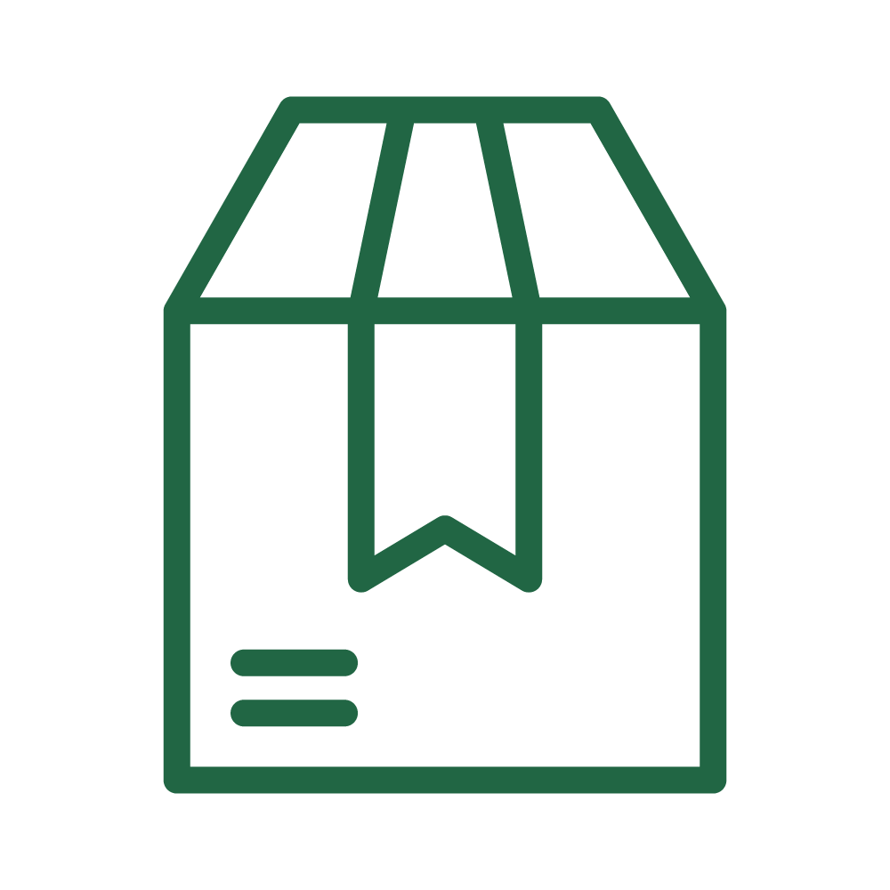 **Packaging**

* Kava powder must be packed in clean and new packaging and free of live insects and contamination with biosecurity risk material.
* The importer must present the goods for [inspection by a biosecurity officer](https://www.awe.gov.au/biosecurity-trade/import/arrival/clearance-inspection). The goods will be inspected to verify they are:
  + dried and ground,
  + packed in clean and new packaging, and
  + free from lives insects and other biosecurity risk material.
* Frozen raw kava roots and rhizomes (whole or sliced) must be commercially prepared and packaged in clean and new packaging. The goods must have been washed and continuously maintained at -18 °C or below for a period of at least seven consecutive days and must arrive frozen. Goods will be subject to random verification inspections to verify the frozen state of the goods.
* Dried kava roots and rhizomes (whole or sliced) must be commercially prepared and packaged in clean and new packaging and free of live insects and contamination with biosecurity risk material.

The importer must present the goods for [inspection by a biosecurity officer](https://www.awe.gov.au/biosecurity-trade/import/arrival/clearance-inspection). The goods will be inspected to verify they are:

* + thoroughly dried*,
  + commercially prepared and packaged in clean and new packaging, and
  + free from live insects and other [biosecurity risk material](http://www.awe.gov.au/biosecurity-trade/import/arrival/treatments/biosecurity-risk-treatment-guide).

*The goods must be dried to a moisture content of 12% or less.

* Please refer to the [Kava for human consumption](https://bicon.agriculture.gov.au/BiconWeb4.0/ImportConditions/Questions/EvaluateCaseByPK?elementPk=1584337) BICON case for further details.

** Labelling**

* Commercially prepared and packaged goods must include the name or description of the goods, importer details and the name of manufacturer or supplier.
* Kava product labels must be compliant with Australian food standards, including the following warning statements:
  + ‘Use in moderation’
  + ‘May cause drowsiness’.

For more information, see [Kava - DAWE](https://www.awe.gov.au/biosecurity-trade/import/goods/food/type/kava) and also the [Kava import labelling requirements fact sheet](https://www.awe.gov.au/sites/default/files/documents/kava-factsheet-april-2022.pdf).

**This factsheet is a general overview of Australia’s commercial kava pilot import requirements. Please refer to the Food Import Requirements and Biosecurity Requirements fact sheets for more information.**