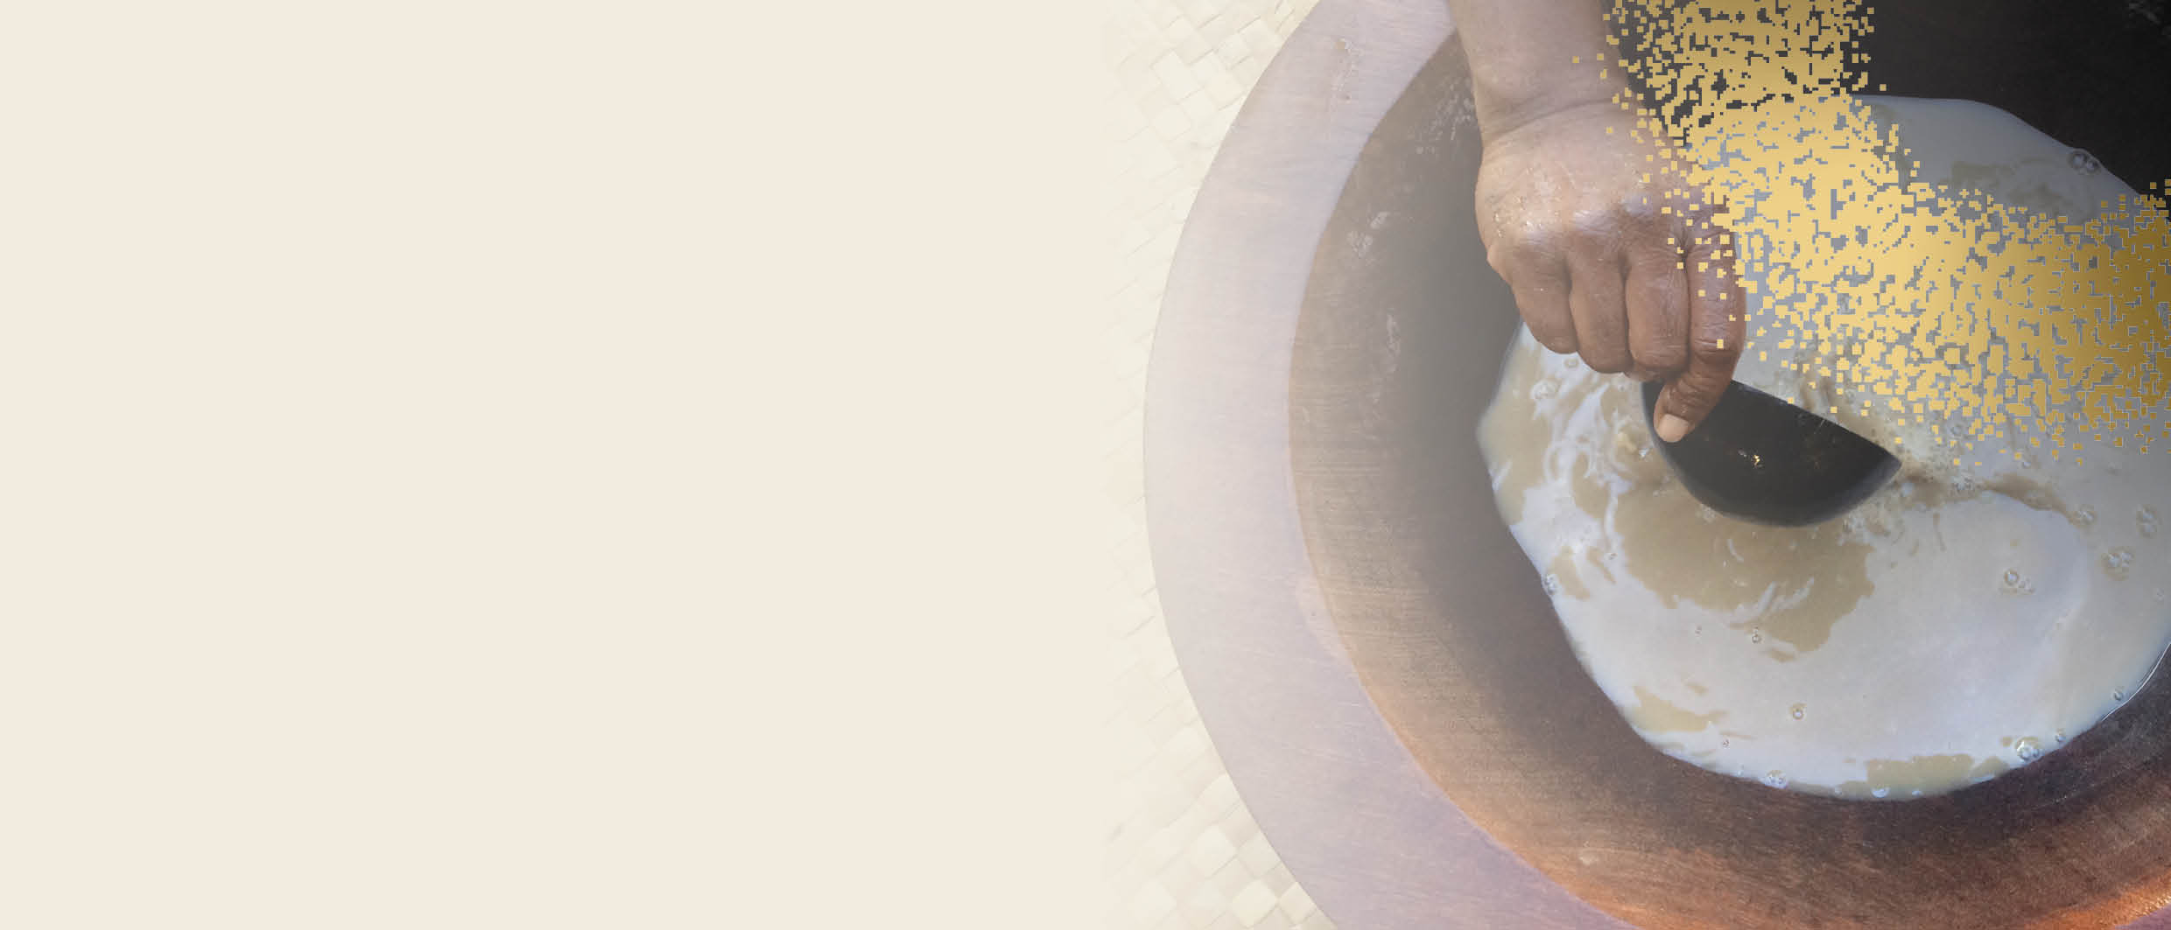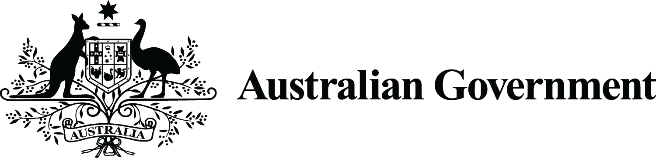

**FREQUENTLY   
ASKED QUESTIONS**

australia’s Commercial kavA Pilot

# What is the duration of the kava pilot?

Phase 2 of the kava pilot – commercial importation of kava into Australia – may run for a period of 2 years from 1 December 2021.

# How do I apply for a permit?

You can apply for a permit at <https://www.odc.gov.au/application-forms>. A guidance document is available next to the application form to assist with the application process.

# How many times can I import with a permit?

You must apply for a new permit each time you import a consignment of kava.

# Is there a limit to the amount of kava you can import?

There is no limit to the amount of kava that can be imported under Phase 2 of the pilot.

# What forms of kava can you import?

Kava powder, kava beverages (obtained by the aqueous suspension of kava (*Piper methrysticum)* root using cold water only, and not using organic solvent), washed and frozen raw kava roots or rhizomes (whole or sliced) and dried kava roots or rhizomes (whole or sliced). See our Biosecurity requirements and Food import requirements fact sheets for more information.

# The [Australia and New Zealand Food Standards Code](http://www.foodstandards.gov.au/code/Pages/default.aspx) for kava ([Standard 2.6.3](https://www.legislation.gov.au/Series/F2015L00466)) states that dried or raw kava (*Piper methysticum*) root is allowed. Why can’t I import raw kava root or rhizome?

Australia has biosecurity requirements in addition to the Australia New Zealand Food Standards Code. Under the current biosecurity import conditions, all kava must be dried, powdered, frozen or be an ingredient of a beverage. Raw unprocessed (fresh) kava root or rhizome poses an unacceptable biosecurity risk and is not permitted.

 **What are the packaging and labelling requirements?**

Kava powder must be packed in clean and new packaging and free of live insects and contamination with biosecurity risk material.

The importer must present the goods for [inspection by a biosecurity officer](https://www.awe.gov.au/biosecurity-trade/import/arrival/clearance-inspection). The goods will be inspected to verify they are:

* dried and ground,
* packed in clean and new packaging, and
* free from live insects and other biosecurity risk material.

Kava beverages must be commercially prepared and packaged and a full list of ingredients must be provided.

Frozen kava products must be commercially prepared and packaged in clean and new packaging. The goods must have been washed and continuously maintained at -18 °C or below for a period of at least seven consecutive days and must arrive frozen. Goods will be subject to random verification inspections to verify the frozen state of the goods.

Dried kava roots and rhizomes (whole or slices) must be commercially prepared and packaged in clean and new packaging and free of live insects and contamination with biosecurity risk material.

The importer must present the goods for [inspection by a biosecurity officer](https://www.awe.gov.au/biosecurity-trade/import/arrival/clearance-inspection). The goods will be inspected to verify they are:

* thoroughly dried*,
* commercially prepared and packaged in clean and new packaging, and
* free from live insects and other [biosecurity risk material](http://www.awe.gov.au/biosecurity-trade/import/arrival/treatments/biosecurity-risk-treatment-guide).

* The goods must be dried to a moisture content of 12% or less.

Please refer to the [Kava for human consumption](https://bicon.agriculture.gov.au/BiconWeb4.0/ImportConditions/Questions/EvaluateCaseByPK?elementPk=1584337), Biosecurity Import Conditions (BICON) case for further details.

As per [Australia and New Zealand Food Standards Code](http://www.foodstandards.gov.au/code/Pages/default.aspx) for kava ([Standard 2.6.3](https://www.legislation.gov.au/Series/F2015L00466)), kava product labels must include the warning statements:

* ‘Use in moderation’
* ‘May cause drowsiness’

See our [Biosecurity requirements](https://www.dfat.gov.au/sites/default/files/australia-commercial-kava-pilot-biosecurity-requirements.pdf) and [Imported food requirements](https://www.dfat.gov.au/sites/default/files/australia-commercial-kava-pilot-food-import-requirements.pdf) and [Labelling requirements](https://www.awe.gov.au/sites/default/files/documents/kava-factsheet-april-2022.pdf) fact sheets for more information.

# Do I need to be HACCP certified to export to Australia?

You do not need to be HACCP certified to export to Australia. However, you must meet the necessary biosecurity and imported food requirements. See our Biosecurity requirements and Food import requirements fact sheets for more information.

# Do I need phytosanitary certificates or do other product analysis testing before exporting?

Yes you do need phytosanitary certificates for the import of kava powder and dried kava roots or rhizomes (whole or sliced). Please refer to the [Kava for human consumption](https://bicon.agriculture.gov.au/BiconWeb4.0/ImportConditions/Questions/EvaluateCaseByPK?elementPk=1584337), BICON case for further details.

You do not need to conduct specific product analysis testing to export approved forms of kava to Australia. However, you must meet the necessary biosecurity and imported food requirements. See our Biosecurity requirements and Food import requirements fact sheets for more information.