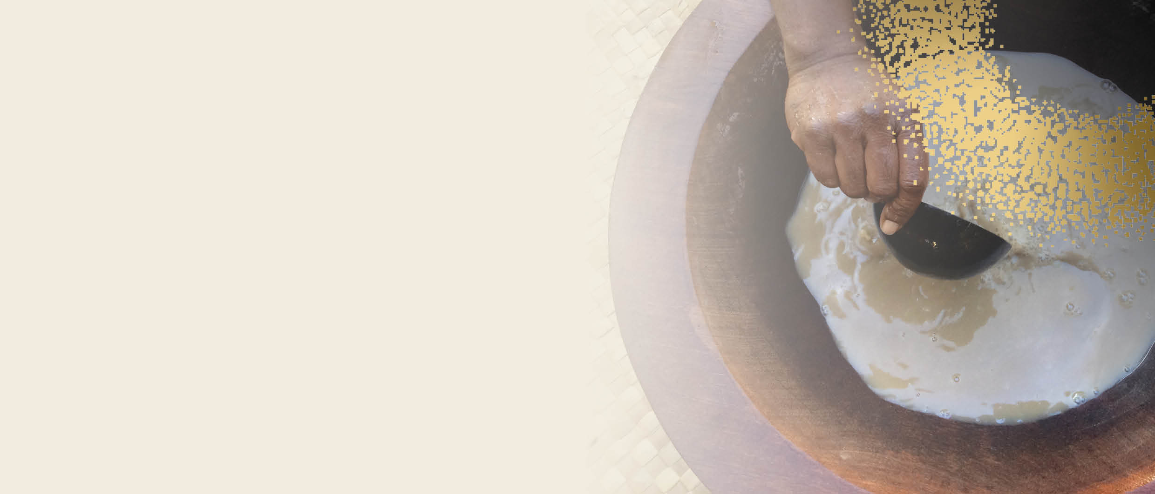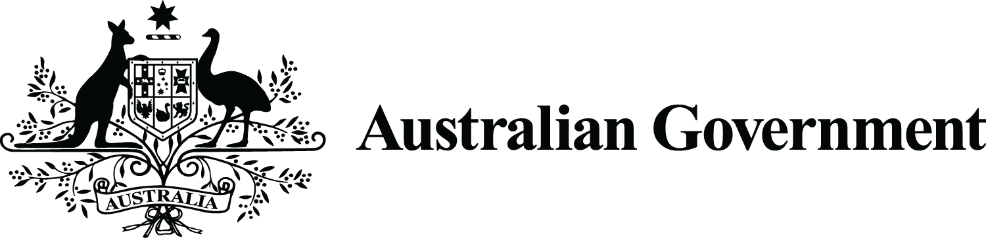

**Biosecurity   
Requirements**

australia’s Commercial kavA Pilot

Kava growers from across the Pacific need to comply with specific biosecurity requirements to be able to export kava to Australia.

Australia’s commercial kava pilot will allow the importation of **kava powder,** **kava beverages, frozen raw kava roots and rhizomes (whole or sliced), and dried kava roots and rhizomes (whole or sliced).**

# Import conditions for kava powder prior to arrival in Australian territory

Kava powder must be packed in clean and new packaging and free of live insects and contamination with [biosecurity risk material](https://www.agriculture.gov.au/import/arrival/treatments/biosecurity-risk-treatment-guide).

Kava powder in packages greater than 25kg arriving as other than mail, accompanied baggage1 or low value freight2 must be accompanied by a valid phytosanitary certificate with the additional declaration:

“*Representative samples were inspected and found free from evidence of any species of Trogoderma (whether live, dead or exuviae) in* [*Australia’s list of Trogoderma species of biosecurity concern*](https://www.awe.gov.au/biosecurity-trade/policy/legislation/list-trogoderma-species)*”.*

Please read the [Kava for human consumption](https://bicon.agriculture.gov.au/BiconWeb4.0/ImportConditions/Questions/EvaluateCaseByPK?elementPk=1584337) Australian Biosecurity Import Conditions (BICON) case for further information.

# Import conditions for kava powder on arrival in Australian territory

The importer must present the goods at an approved arrangement site for inspection by a biosecurity officer. The goods will be inspected to verify they are:

* dried and ground,
* packed in clean and new packaging, and
* free from live insects and other [biosecurity risk material](http://www.awe.gov.au/biosecurity-trade/import/arrival/treatments/biosecurity-risk-treatment-guide).

Goods meeting the above conditions may be released from biosecurity control by a biosecurity officer.

If live insects or biosecurity risk material are detected, the goods will require treatment (where appropriate) or be exported or disposed of. Any required action will be at the importer’s expense. Please read the [Kava for human consumption](https://bicon.agriculture.gov.au/BiconWeb4.0/ImportConditions/Questions/EvaluateCaseByPK?elementPk=1584337) BICON case for further information.

# Import conditions for kava beverages

Kava beverages must be commercially prepared and packaged and a full list of ingredients must be provided. Please read the [Kava for human consumption](https://bicon.agriculture.gov.au/BiconWeb4.0/ImportConditions/Questions/EvaluateCaseByPK?elementPk=1584337) BICON case for further information.

**Import conditions for frozen raw kava roots and rhizomes (whole or sliced)**

Frozen kava products must be commercially prepared and packaged in clean and new packaging. The goods must have been washed and continuously maintained at -18 °C or below for a period of at least seven consecutive days and must arrive frozen. The freezing process includes preparation, packaging and storing.

The importer must present relevant documentation to verify the goods have undergone an appropriate washing and freezing process. Goods will be subject to random verification inspections to verify the frozen state of the goods. Please read the [Kava for human consumption](https://bicon.agriculture.gov.au/BiconWeb4.0/ImportConditions/Questions/EvaluateCaseByPK?elementPk=1584337) BICON case for further information.

**Import conditions for dried kava roots and rhizomes (whole or sliced) prior to arrival in Australian territory**

Dried kava roots and rhizomes (whole or sliced) arriving as other than mail, accompanied baggage1 or low value freight2 must be accompanied by a valid phytosanitary certificate with the additional declaration:

“*Representative samples were inspected and found free from evidence of any species of Trogoderma (whether live, dead or exuviae) in* [*Australia’s list of Trogoderma species of biosecurity concern*](https://www.awe.gov.au/biosecurity-trade/policy/legislation/list-trogoderma-species)*”.*

 **Import conditions for dried kava roots and rhizomes (whole or sliced) on arrival in Australian territory**

The importer must present the goods at an approved arrangement site for inspection by a biosecurity officer. The goods will be inspected to verify they are:

* thoroughly dried*,
* commercially prepared and packaged in clean and new packaging, and
* free from live insects and other [biosecurity risk material](http://www.awe.gov.au/biosecurity-trade/import/arrival/treatments/biosecurity-risk-treatment-guide).

Goods meeting the above conditions may be released from biosecurity control by a biosecurity officer.

If live insects or biosecurity risk material are detected, the goods will require treatment (where appropriate) or be exported or disposed of. Any required action will be at the importer’s expense. Please read the [Kava for human consumption](https://bicon.agriculture.gov.au/BiconWeb4.0/ImportConditions/Questions/EvaluateCaseByPK?elementPk=1584337) BICON case for further information.

* The goods must be dried to a moisture content of 12% or less.

1‘Accompanied baggage’ means goods that are brought or imported into Australia as the accompanied personal effects of a passenger, or a member of the crew, of a ship or aircraft.

2’Low value freight’ means goods that are brought or imported into Australia as air or sea freight with a value not exceeding the amount prescribed for the purposes of subparagraph 68(1)(f)(iii) of the Customs Act 1901.

# Additional information

Cost recovery fees and charges are applied to the department’s import services, including document assessment and inspection of goods. Detail on how the department applies fees and charges may be found in the [Charging guidelines](https://www.awe.gov.au/about/fees/charging-guidelines).

Depending on the method of import, importers may also need to meet conditions for container cleanliness, packaging and destination concerns, and may be subject to inspection and treatment on arrival. Please refer to the [Non-Commodity Cargo Clearance](https://aus01.safelinks.protection.outlook.com/?url=https%3A%2F%2Fbicon.agriculture.gov.au%2FBiconWeb4.0%2FImportConditions%2FQuestions%2FEvaluateCase%3FelementID%3D0000088555%26elementVersionID%3D249&data=05%7C01%7CRob.McGregor%40dfat.gov.au%7Cece10f2117214760032608da28c2b3b3%7C9b7f23b30e8347a58a40ffa8a6fea536%7C0%7C0%7C637867113955393358%7CUnknown%7CTWFpbGZsb3d8eyJWIjoiMC4wLjAwMDAiLCJQIjoiV2luMzIiLCJBTiI6Ik1haWwiLCJXVCI6Mn0%3D%7C3000%7C%7C%7C&sdata=lMzi7yi0xb7dX%2BP83gTf%2BtEkRfcVtwLMmWBe0SuaeiU%3D&reserved=0) BICON case for further information.

*For more information please visit* [*https://www.awe.gov.au/biosecurity-trade/import/goods/plant-products*](https://www.awe.gov.au/biosecurity-trade/import/goods/plant-products)