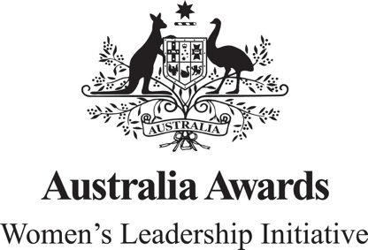

Australia Awards Women’s Leadership Initiative (2017-2022)

Independent Strategic Review—Snapshot

The Australia Awards Women’s Leadership Initiative (WLI) is a five-year, $5.4 million Australian Government initiative to promote women's leadership for development in the Pacific region and deepen Australia’s relationships with its Pacific neighbours. It is managed by Cardno Emerging Markets (Australia). The WLI provides women (and men) Australia Awards scholars from the Pacific a suite of offerings that collectively promote women’s developmental leadership. An independent strategic review, undertaken from April-June 2020, responded to three key questions relating to relevance, effectiveness and program improvements:
- How relevant is the WLI to Australia’s aid and foreign policy objectives – especially in the context of COVID-19?
- Focused on Pacific women and supporting their exercise of developmental leadership WLI is highly relevant to the Australian Government’s policy commitments to promote gender equality and women’s empowerment.
- With its Australia-Pacific links/focus WLI continues to support Pacific Step-up and is in lockstep with Australia’s Partnership for Recovery policy. Pacific recovery will require active coalitions of women (and men) committed to bringing women’s voice and agency to COVID-19 decision making. WLI actively promotes this agenda and is currently enabling 15 groups of women to address COVID-19 impacts in their home communities.
- How effective is the WLI and what have been the key drivers of effectiveness?
- The WLI is developing as a highly effective program. There is sound progress against intermediate outcomes, including WLI alumnae building and using networks to support women’s developmental leadership and the two-way value of mentor-mentee relationships for skills and confidence building.
- The pedagogical foundations, curated in the three-tier offering, are critical contributors to program effectiveness. The program backbone of developmental leadership is key. The tools of adaptive leadership, and ontological leadership and coaching scaffold the exercise of developmental leadership.

- Six supporting drivers of effectiveness are
- quality of the Cardno WLI Team and the strength of the partnership with DFAT;
- program architecture
- WLI’s focus on supporting participants to develop their own networks and coalitions, through teaching and learning infused with direct lived experience
- ability of WLI team to successfully adapt to changes in the operating context and the calibre of their innovation
- quality of the M&E system; and (6) partnership with the Australian National University’s Department of Pacific Affairs as the research and learning implementing partner and role as ‘critical friend.’
What improvements could be made to the WLI in the short term and/or for potential future iterations of the program?
The Review tables seven areas to strengthen existing strong practice and further increase the WLI’s yield:
- Scale out the number of cohorts per annum but reduce the cap on the participant numbers per cohort.
- Select subsequent Pacific cohorts to expressly support the COVID-19 recovery in the Pacific.
- Formalise mechanisms of support (and the WLI mandate) for the transition back home.
- Assess (and formally integrate) the WLI COVID-19 innovations of LeadershipConnect and the COVID-19 Leadership Fund.
- Standardise the framing and definition of fundamental WLI concepts and components, including developmental leadership and mentoring.
- Establish a mentors’ collective to drive a powerhouse of Australian expertise and connection in support of women’s exercise of leadership for development in the Pacific.
- Consider the naming of WLI to refine engagement but retain the initials for brand recognition.

