Australia Awards Scholarships - Partnership with Education Institutions

Background
- Australia Awards Scholarships have contributed to development and diplomacy in the Indo-Pacific and Africa for over 70 years. From the Colombo Plan of the 1950s, Australia has invested in supporting generations of emerging leaders to undertake tertiary education in Australia. More than 110,000 international students have received an Australian Government scholarship to study in Australia.
- Today, over 2,000 students from more than 55 countries are studying in Australia with an Australia Awards Scholarship. Of these, 58% are women and 4% are scholars with a disability,
- The Australia Awards are an Australia Government initiative delivered by DFAT. This paper outlines the role of the Australian based education institutions that DFAT partners with to deliver the Australia Awards Scholarships.

Strategic Intent and Rationale
- Australia Awards Scholarships aim to develop leadership potential and foster lasting change by equipping students with high quality education and the skills to drive change in their home countries.
- Australia Awards also builds invaluable connections between people, trust between nations, and understanding of one another’s cultures, politics, economy and society. Australians and awardees often create connections for life and are more likely to work together in the future to advance our shared interests.
- Australia’s education sector attracts international students, researchers and academics, and produces in-demand graduates. We also have rigorous quality assurance and student protection systems, supported by the Education Services for Overseas Students (ESOS) legislative framework. Australia is well placed to support international development through the education of future leaders.
- Australia Awards are primarily Official Development Assistance; however, support for scholars from non-ODA eligible countries such as Brunei, Singapore and the French Territories are increasing. Alternative delivery models, such as co-financed scholarships, split site degrees and degrees delivered under transnational education arrangements are also increasing.

Implementation Arrangements
- In FY2025-2026, it is estimated that $160 million will be invested by DFAT via 40+ education institutions for the delivery of Australia Awards Scholarships.
- DFAT’s contracting arrangements with education institutions needs refreshing to ensure they remain fit for purpose, provide value for money and effectively support Australia Awards objectives. This document provides an overview of arrangements to inform potential partners in preparation for a DFAT tender in 2026.
- Australia Awards Scholarships are for long-term tertiary study in Australia, or through Australian institutions overseas, including Bachelor, post-graduate, and Technical and Vocational Education and Training (TVET) scholarships. Fellowships, short courses and study at Pacific education institutions are also part of the Australia Awards; however, are delivered through different contracting arrangements to Scholarships.
- As well as DFAT, the Australian Centre for International Agricultural Research (ACIAR) supports international scholars to pursue postgraduate studies with a focus on climate change and agriculture.
- DFAT engages various contractors to support pre-award and post-awards services including scholarship promotions, selection of applicants, pre-departure training, alumni management and similar tasks. This is in addition to contracting education institutions for education (academic and student welfare) services for scholars.
- The below image shows how the Australia Awards Scholarships are delivered in partnership with education institutions. This may change as the program evolves.
- The services institutions will be required to provide to scholars enrolled at their institution are not less than the general requirements for the provision of services to international students embodied in the Education Services for Overseas Students Framework (ESOS Framework) which is comprised of the Education Services for Overseas Students Act 2000 (ESOS Act), Education Services for Overseas Students Regulations 2019 (ESOS Regulations) and the National Code of Practice for Registration Authorities and Providers of Education and Training to Overseas Students (The National Code) as updated and/or amended from time to time.

Next steps
- DFAT expects to conduct an open tender in accordance with the Commonwealth Procurement Rules for education institutions to provide tertiary education services to DFAT for Australia Awards scholars. The tender is expected to be released in 2026 via austender.gov.au
- To be eligible to partner with DFAT for the delivery of these services, institutions will need to be registered with the Commonwealth Register of Institutions and Courses for Overseas Students (CRICOS).
- For further information, see the Scholarships Policy Handbook which outlines the roles and responsibilities of each party in detail, including education institutions, the Australia Awards Global Strategic Framework and the Australia Awards Global Monitoring and Evaluation Framework. These documents are likely to be updated in the coming 12 months.

Image 1: Partnership with education institutions - process summary.
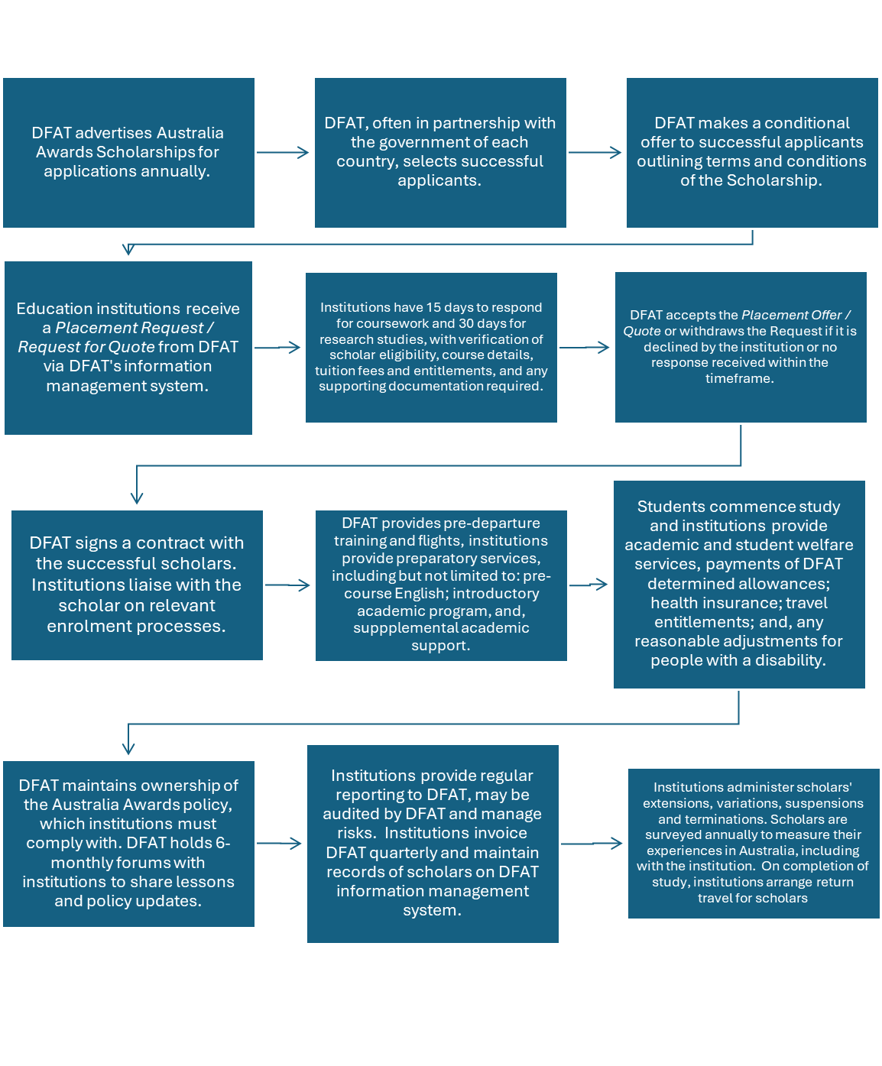
Annex 1: Partnership with education institutions - process summary.
- DFAT advertises Australia Awards Scholarships for applications annually.
- DFAT, often in partnership with the government of each country, selects successful applicants.
- DFAT makes a conditional offer to successful applicants outlining terms and conditions of the Scholarship.
- Education institutions receive a Placement Request / Request for Quote from DFAT via DFAT's information management system.
- Institutions have 15 days to respond for coursework and 30 days for research studies, with verification of scholar eligibility, course details, tuition fees and entitlements, and any supporting documentation required.
- DFAT accepts the Placement Offer / Quote or withdraws the Request if it is declined by the institution or no response received within the timeframe.
- DFAT signs a contract with the successful scholars. Institutions liaise with the scholar on relevant enrolment processes.
- DFAT provides pre-departure training and flights, institutions provide preparatory services, including but not limited to: pre-course English; introductory academic program, and, supplemental academic support.
- Students commence study and institutions provide academic and student welfare services, payments of DFAT determined allowances; health insurance; travel entitlements; and any reasonable adjustments for people with a disability.
- DFAT maintains ownership of the Australia Awards policy, which institutions must comply with. DFAT holds 6-monthly forums with institutions to share lessons and policy updates.
- Institutions provide regular reporting to DFAT, may be audited by DFAT and manage risks. Institutions invoice DFAT quarterly and maintain records of scholars on DFAT information management system.
- Institutions administer scholars' extensions, variations, suspensions and terminations. Scholars are surveyed annually to measure their experiences in Australia, including with the institution. On completion of study, institutions arrange return travel for scholars

