
Australia Awards

Global Tracer Facility

Tracer Survey

Year
3

201
8
-
1
9

Vanuatu

Country Report

Alumni of
2011

to
2016

Tracer Survey

Outcomes Summary: Vanuatu
This country report details the responses of alumni from Vanuatu to the Australia
Awards Global Tracer Facility Tracer Survey carried out in 2018-19. The Tracer Survey was conducted between November 2018 and February 2019 and targeted alumni who completed their award between 2011 and 2016.
Alumni were asked a range of questions via an online survey, focussed on exploring the long-term outcomes of the Australia Awards. In total 3,768 alumni in this cohort from more than 123 different countries participated in the survey. A 26 per cent response rate of the target cohort was achieved globally. This report focuses on the response data of alumni from Vanuatu.
For Vanuatu, there were 113 alumni included in the target population. Responses were received from 29, a response rate of 26 per cent. Among these respondents, 22 were scholarship alumni and seven were fellowship alumni.
The survey data provide a valuable quantitative insight into alumni use of knowledge and skills, development of networks and contribution to cooperation with Australia. The responses also offer rich examples from alumni of the types of contributions they are making, the way in which they are using their award, and the things that help and hinder them in reaching their potential.
The data detailed here are reported based on the four long-term outcomes of the Australia Awards as articulated in the Australia Awards Global Strategy: Investing in the next generation of global leaders for development 2016-2018 and the Australia Awards Global Monitoring and Evaluation Framework. In terms of responding to the long-term outcomes of the Australia Awards, the following summary offers findings based on the responses of alumni from Vanuatu. Further outcomes are included in the infographic following this summary.
Outcome 1: Alumni are using their skills, knowledge and networks to contribute to sustainable development.
- Most alumni from Vanuatu (93 per cent) indicated they have passed on their skills and knowledge to others in their country on return from their award.
- 90 per cent of alumni indicated they had introduced improved practices and innovations in their work on return from their award.

/ 1
Outcome 2: Alumni are contributing to cooperation between Australia and partner countries.
- 33 per cent of alumni from Vanuatu have maintained frequent contact with fellow alumni, while 44 per cent have frequent contact with friends in Australia and 37 per cent with Australian students/alumni.
- In terms of frequent contact with Australian organisations, 11 per cent of alumni have frequent contact with Australian institutions, 26 per cent of alumni have frequent contact with Australian businesses and 26 per cent with Australian Embassies, High Commissions or Consulates.
Outcome 3: Effective, mutually advantageous partnerships between institutions and businesses in Australia and partner countries.
- 41 per cent of alumni from Vanuatu indicated having had a professional link with an Australian organisation at some time following award.
- These links were with Australian universities, the government sector and non-government organisations.
Outcome 4: Alumni view Australia, Australians and Australian expertise positively.
- Most alumni from Vanuatu (96 per cent) indicated their experience in Australia positively influenced their perception of Australia.
- Most alumni (96 per cent) have provided advice to people in Vanuatu about pursuing opportunities in Australia.
The Tracer Survey represented the views of a range of alumni from Vanuatu. Of those who responded, 55 per cent were women and 79 per cent came from an urban location. The largest age group represented were alumni 30 to 39 years. Among all alumni, 86 per cent were employed full-time. Of those alumni employed, 73 per cent indicated that they hold a formal leadership role.
In addition to this Outcomes Summary, this report includes an infographic as well as data tables including the detail of respondents from Vanuatu to the Tracer Survey. The data tables correspond to each of the Australia Awards long-term outcomes and include benchmark data from the entire survey response population.
For further information about the Australia Awards Global Tracer Facility please visit the website: www.australiaawardstracerfacility.org
/ 2

I have built relationships with companies and datacentres in Sydney to allow me to host my servers within their datacentre. I built these relationships by personally approaching them and meeting with them in their offices.
I have showed them how to manage the eye clinic and conduct meetings in the clinic, organising outreach, implementation of work related activities, teamwork in the form of cooperation in implementing and providing services to the communities within the country.
I have promoted innovative cloud solutions for my countries internet users community. Instead of encouraging them to use the Cloud, I have started a business to offer affordable Cloud solutions including Voice over IP solutions and hosted email solutions.
Our country lacks human resources who are well educated in the Maritime Industry. We have managed to train many of our staff on the importance of safety in the Maritime Industry.
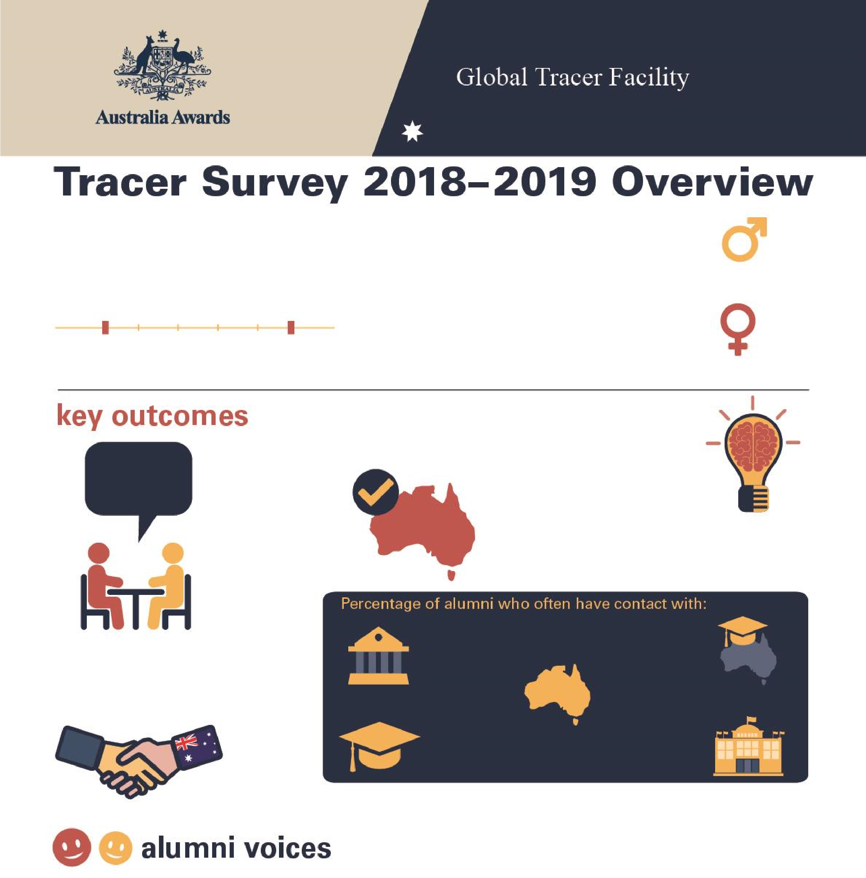
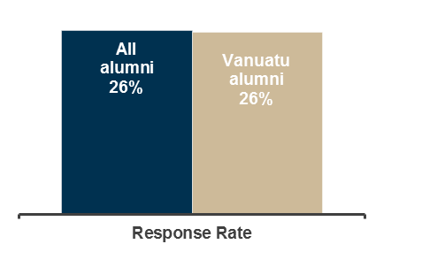

Tracer Survey 2018
–
2019

Vanuatu Overview

29

Alumni from
Vanuatu

Alumni who

completed a scholarship or

fellowship between
2011

and 20
16

2011

2016

Men
45
%

W
omen
55
%

%
93

of alumni

Passed on skills
and knowledge
to others

90
%

of alumni

Introduced improved
practices
and
innovations at work

41
%

of alumni

Developed professional
links with Australia

96
%

of alumni

Say their awards experience
positively influenced perception

of Australian skills and expertise

Host

institution

11
%

Other scholarship
alumni

33
%

Friends in
Australia

44
%

Australian
alumni

%
37

Australian
Embassy or

High Commission

26
%

Table 1: Tracer Survey Data for 2011 to 2016 alumni from Vanuatu and All alumni - Respondent characteristics
 |  | Alumni from Vanuatu
 |  | Scholarships |  | Fellowships |  | Alumni from Vanuatu |  | All Alumni
 |  | Count | Column N % | Count | Column N % | Count | Column N % | Count | Column N %
Age at time of survey | Under 20 years | - | - | - | - | - | - | - | -
Age at time of survey | 20 to 29 years | 5 | 22.7% | 1 | 14.3% | 6 | 20.7% | 111 | 3.0%
Age at time of survey | 30 to 39 years | 9 | 40.9% | 3 | 42.9% | 12 | 41.4% | 2134 | 56.8%
Age at time of survey | 40 to 49 years | 7 | 31.8% | 1 | 14.3% | 8 | 27.6% | 1144 | 30.4%
Age at time of survey | 50 to 59 years | 1 | 4.5% | 2 | 28.6% | 3 | 10.3% | 310 | 8.3%
Age at time of survey | 60 to 69 years | - | - | - | - | - | - | 52 | 1.4%
Age at time of survey | 70 and older | - | - | - | - | - | - | 6 | 0.2%
Year of graduation from award | 2011 | 1 | 4.5% | 2 | 28.6% | 3 | 10.3% | 382 | 10.1%
Year of graduation from award | 2012 | 3 | 13.6% | - | - | 3 | 10.3% | 546 | 14.5%
Year of graduation from award | 2013 | 2 | 9.1% | 2 | 28.6% | 4 | 13.8% | 631 | 16.7%
Year of graduation from award | 2014 | 9 | 40.9% | - | - | 9 | 31.0% | 657 | 17.4%
Year of graduation from award | 2015 | 3 | 13.6% | 3 | 42.9% | 6 | 20.7% | 881 | 23.4%
Year of graduation from award | 2016 | 4 | 18.2% | - | - | 4 | 13.8% | 671 | 17.8%
Have you received any other awards? | Yes | 10 | 45.5% | 1 | 14.3% | 11 | 37.9% | 956 | 25.4%
Have you received any other awards? | No | 12 | 54.5% | 6 | 85.7% | 18 | 62.1% | 2779 | 73.9%
Have you received any other awards? | Don't know | - | - | - | - | - | - | 27 | 0.7%
What is your current employment status? | Employed full-time | 20 | 90.9% | 5 | 71.4% | 25 | 86.2% | 3297 | 87.7%
What is your current employment status? | Employed part-time | 1 | 4.5% | 1 | 14.3% | 2 | 6.9% | 155 | 4.1%
What is your current employment status? | Not employed | - | - | - | - | - | - | 113 | 3.0%
What is your current employment status? | Retired | - | - | - | - | - | - | 15 | 0.4%
What is your current employment status? | Studying | 1 | 4.5% | - | - | 1 | 3.4% | 135 | 3.6%
What is your current employment status? | Other (specify) | - | - | 1 | 14.3% | 1 | 3.4% | 46 | 1.2%
Level of leadership in relation to current job | Formal leadership role | 15 | 71.4% | 4 | 80.0% | 19 | 73.1% | 2080 | 61.9%
Level of leadership in relation to current job | Informal leadership role | 3 | 14.3% | 1 | 20.0% | 4 | 15.4% | 1019 | 30.3%
Level of leadership in relation to current job | Do not have a leadership role | 2 | 9.5% | - | - | 2 | 7.7% | 203 | 6.0%
Level of leadership in relation to current job | Don't know/prefer not to say | 1 | 4.8% | - | - | 1 | 3.8% | 56 | 1.7%
Table 2: Tracer Survey Data for 2011 to 2016 alumni from Vanuatu and All alumni - Outcome 1
 |  | Alumni from Vanuatu
Q: To what extent do you agree with each of these statements:  I have… |  | Scholarships |  | Fellowships |  | Alumni from Vanuatu |  | All Alumni
 |  | Count | Column N % | Count | Column N % | Count | Column N % | Count | Column N %
Passed on new skills and knowledge to others | Strongly agree | 9 | 40.9% | 3 | 42.9% | 12 | 41.4% | 2298 | 61.1%
Passed on new skills and knowledge to others | Agree | 11 | 50.0% | 4 | 57.1% | 15 | 51.7% | 1367 | 36.4%
Passed on new skills and knowledge to others | Disagree | 2 | 9.1% | - | - | 2 | 6.9% | 44 | 1.2%
Passed on new skills and knowledge to others | Strongly disagree | - | - | - | - | - | - | 13 | 0.3%
Passed on new skills and knowledge to others | Don't Know | - | - | - | - | - | - | 38 | 1.0%
Introduced improved practices and innovations through my work | Strongly agree | 11 | 50.0% | 4 | 57.1% | 15 | 51.7% | 2023 | 53.9%
 | Agree | 8 | 36.4% | 3 | 42.9% | 11 | 37.9% | 1571 | 41.8%
 | Disagree | 2 | 9.1% | - | - | 2 | 6.9% | 69 | 1.8%
 | Strongly disagree | - | - | - | - | - | - | 12 | 0.3%
 | Don't Know | 1 | 4.5% | - | - | 1 | 3.4% | 81 | 2.2%
Built networks with Australians or Australian organisations | Strongly agree | 6 | 27.3% | 2 | 28.6% | 8 | 27.6% | 848 | 22.6%
Built networks with Australians or Australian organisations | Agree | 8 | 36.4% | 4 | 57.1% | 12 | 41.4% | 1892 | 50.4%
Built networks with Australians or Australian organisations | Disagree | 5 | 22.7% | - | - | 5 | 17.2% | 719 | 19.2%
Built networks with Australians or Australian organisations | Strongly disagree | - | - | - | - | - | - | 68 | 1.8%
Built networks with Australians or Australian organisations | Don't know | 3 | 13.6% | 1 | 14.3% | 4 | 13.8% | 226 | 6.0%
Built networks with other awardees | Strongly agree | 8 | 36.4% | 3 | 42.9% | 11 | 37.9% | 1683 | 44.9%
Built networks with other awardees | Agree | 12 | 54.5% | 2 | 28.6% | 14 | 48.3% | 1730 | 46.1%
Built networks with other awardees | Disagree | 1 | 4.5% | - | - | 1 | 3.4% | 251 | 6.7%
Built networks with other awardees | Strongly disagree | - | - | - | - | - | - | 21 | 0.6%
Built networks with other awardees | Don't know | 1 | 4.5% | 2 | 28.6% | 3 | 10.3% | 66 | 1.8%
Table 3: Tracer Survey Data for 2011 to 2016 alumni from Vanuatu and All alumni - Outcome 2
 |  | Alumni from Vanuatu
Q: How frequently are you in contact with the following groups: |  | Scholarships |  | Fellowships |  | Alumni from Vanuatu |  | All Alumni
 |  | Count | Column N % | Count | Column N % | Count | Column N % | Count | Column N %
Host Institution | Always | - | - | - | - | - | - | 168 | 5.0%
Host Institution | Often | 3 | 13.6% | - | - | 3 | 11.1% | 568 | 16.8%
Host Institution | Sometimes | 3 | 13.6% | 2 | 40.0% | 5 | 18.5% | 1279 | 37.8%
Host Institution | Rarely | 11 | 50.0% | 1 | 20.0% | 12 | 44.4% | 973 | 28.7%
Host Institution | Never | 5 | 22.7% | 2 | 40.0% | 7 | 25.9% | 364 | 10.8%
Host Institution | Don’t know | - | - | - | - | - | - | 34 | 1.0%
Fellow Australian Students | Always | 3 | 13.6% | 1 | 20.0% | 4 | 14.8% | 278 | 8.2%
Fellow Australian Students | Often | 6 | 27.3% | - | - | 6 | 22.2% | 850 | 25.1%
Fellow Australian Students | Sometimes | 6 | 27.3% | 2 | 40.0% | 8 | 29.6% | 1270 | 37.6%
Fellow Australian Students | Rarely | 4 | 18.2% | 1 | 20.0% | 5 | 18.5% | 611 | 18.1%
Fellow Australian Students | Never | 3 | 13.6% | 1 | 20.0% | 4 | 14.8% | 341 | 10.1%
Fellow Australian Students | Don’t know | - | - | - | - | - | - | 32 | 0.9%
Fellow Award recipients | Always | 4 | 18.2% | - | - | 4 | 14.8% | 488 | 14.4%
Fellow Award recipients | Often | 4 | 18.2% | 1 | 20.0% | 5 | 18.5% | 1219 | 36.1%
Fellow Award recipients | Sometimes | 9 | 40.9% | 3 | 60.0% | 12 | 44.4% | 1151 | 34.1%
Fellow Award recipients | Rarely | 4 | 18.2% | - | - | 4 | 14.8% | 389 | 11.5%
Fellow Award recipients | Never | 1 | 4.5% | 1 | 20.0% | 2 | 7.4% | 115 | 3.4%
Fellow Award recipients | Don’t know | - | - | - | - | - | - | 17 | 0.5%
Professional associations or  Australian businesses operating in  Australia/your home country | Always | 3 | 13.6% | - | - | 3 | 11.1% | 104 | 3.1%
 | Often | 3 | 13.6% | 1 | 20.0% | 4 | 14.8% | 359 | 10.6%
 | Sometimes | 1 | 4.5% | - | - | 1 | 3.7% | 834 | 24.7%
 | Rarely | 6 | 27.3% | 2 | 40.0% | 8 | 29.6% | 989 | 29.3%
 | Never | 9 | 40.9% | 2 | 40.0% | 11 | 40.7% | 984 | 29.2%
 | Don’t know | - | - | - | - | - | - | 105 | 3.1%
Australian Embassy, High Commission or Consulate | Always | 2 | 9.1% | - | - | 2 | 7.4% | 85 | 2.5%
Australian Embassy, High Commission or Consulate | Often | 4 | 18.2% | 1 | 20.0% | 5 | 18.5% | 251 | 7.4%
Australian Embassy, High Commission or Consulate | Sometimes | 7 | 31.8% | - | - | 7 | 25.9% | 775 | 23.0%
Australian Embassy, High Commission or Consulate | Rarely | 6 | 27.3% | 1 | 20.0% | 7 | 25.9% | 1119 | 33.2%
Australian Embassy, High Commission or Consulate | Never | 3 | 13.6% | 3 | 60.0% | 6 | 22.2% | 1092 | 32.4%
Australian Embassy, High Commission or Consulate | Don’t know | - | - | - | - | - | - | 50 | 1.5%
Friends in Australia | Always | 5 | 22.7% | - | - | 5 | 18.5% | 426 | 12.6%
Friends in Australia | Often | 7 | 31.8% | - | - | 7 | 25.9% | 921 | 27.3%
Friends in Australia | Sometimes | 3 | 13.6% | 2 | 40.0% | 5 | 18.5% | 1232 | 36.6%
Friends in Australia | Rarely | 5 | 22.7% | 1 | 20.0% | 6 | 22.2% | 551 | 16.4%
Friends in Australia | Never | 1 | 4.5% | 2 | 40.0% | 3 | 11.1% | 219 | 6.5%
Friends in Australia | Don’t know | 1 | 4.5% | - | - | 1 | 3.7% | 21 | 0.6%
Table 4: Tracer Survey Data for 2011 to 2016 alumni from Vanuatu and All alumni - Outcome 3
Q: As a result of your Australia Award, have you developed professional links with Australian organisations? |  | Scholarships  Count Column N % |  | Alumni from Vanuatu  Fellowships  Count Column N % |  | Alumni from Vanuatu  Count Column N % |  | All Alumni  Count Column N %
Professional links | Developed professional links | 10 | 45.5% | 1 | 20.0% | 11 | 40.7% | 1513 | 44.2%
Professional links | Did not develop professional links | 9 | 40.9% | 3 | 60.0% | 12 | 44.4% | 1583 | 46.2%
Professional links | Don't Know | 3 | 13.6% | 1 | 20.0% | 4 | 14.8% | 330 | 9.6%
Types of professional links with Australian organisations* | Public sector | 5 | 50.0% | - | - | 5 | 45.5% | 336 | 22.4%
Types of professional links with Australian organisations* | Private Sector | - | - | - | - | - | - | 150 | 10.0%
Types of professional links with Australian organisations* | Universities | 2 | 20.0% | 1 | 100.0% | 3 | 27.3% | 740 | 49.3%
Types of professional links with Australian organisations* | Non-Government Organisations | 3 | 30.0% | - | - | 3 | 27.3% | 137 | 9.1%
Types of professional links with Australian organisations* | Australian High Commission or Consulates | - | - | - | - | - | - | 30 | 2.0%
Types of professional links with Australian organisations* | Other or don't know | - | - | - | - | - | - | 108 | 7.2%
*Note these counts and proportions only include alumni who indicated that they had developed a professional link as well as providing information about their current employment in the survey.
Table 5: Tracer Survey Data for 2011 to 2016 alumni from Vanuatu and All alumni - Outcome 4
 |  | Alumni from Vanuatu
Q: To what extent did your experience during your award influence your perception of the following: |  | Scholarships |  | Fellowships |  | Alumni from Vanuatu |  | All Alumni
 |  | Count | Column N % | Count | Column N % | Count | Column N % | Count | Column N %
Australia as a country | Much more positive | 18 | 81.8% | 4 | 80.0% | 22 | 81.5% | 2825 | 84.6%
Australia as a country | Slightly more positive | 3 | 13.6% | 1 | 20.0% | 4 | 14.8% | 406 | 12.2%
Australia as a country | No change | 1 | 4.5% | - | - | 1 | 3.7% | 84 | 2.5%
Australia as a country | Slightly more negative | - | - | - | - | - | - | 13 | 0.4%
Australia as a country | Much more negative | - | - | - | - | - | - | - | -
Australia as a country | Don't know | - | - | - | - | - | - | 13 | 0.4%
Australian people | Much more positive | 15 | 68.2% | 2 | 40.0% | 17 | 63.0% | 2497 | 74.8%
Australian people | Slightly more positive | 6 | 27.3% | 3 | 60.0% | 9 | 33.3% | 626 | 18.7%
Australian people | No change | 1 | 4.5% | - | - | 1 | 3.7% | 152 | 4.6%
Australian people | Slightly more negative | - | - | - | - | - | - | 37 | 1.1%
Australian people | Much more negative | - | - | - | - | - | - | 1 | 0.0%
Australian people | Don't know | - | - | - | - | - | - | 26 | 0.8%
The knowledge skills and expertise of Australians | Much more positive | 13 | 59.1% | 3 | 60.0% | 16 | 59.3% | 2532 | 75.9%
The knowledge skills and expertise of Australians | Slightly more positive | 6 | 27.3% | 2 | 40.0% | 8 | 29.6% | 642 | 19.2%
The knowledge skills and expertise of Australians | No change | 1 | 4.5% | - | - | 1 | 3.7% | 118 | 3.5%
The knowledge skills and expertise of Australians | Slightly more negative | - | - | - | - | - | - | 19 | 0.6%
The knowledge skills and expertise of Australians | Much more negative | - | - | - | - | - | - | 2 | 0.1%
The knowledge skills and expertise of Australians | Don't know | 2 | 9.1% | - | - | 2 | 7.4% | 24 | 0.7%
Have provided advice to people from home country in relation to pursuing opportunities in Australia | Yes | 22 | 100.0% | 4 | 80.0% | 26 | 96.3% | 3245 | 97.3%
 | No | - | - | 1 | 20.0% | 1 | 3.7% | 74 | 2.2%
 | Don't know | - | - | - | - | - | - | 17 | 0.5%



