
Australia Awards

Global Tracer Facility

Tracer Survey

Year
3

201
8
-
1
9

Nigeria

Country Report

Alumni of
2011

to
2016

Tracer Survey

Outcomes Summary: Nigeria
This country report details the responses of alumni from Nigeria to the Australia
Awards Global Tracer Facility Tracer Survey carried out in 2018-19. The Tracer Survey was conducted between November 2018 and February 2019 and targeted alumni who completed their award between 2011 and 2016.
Alumni were asked a range of questions via an online survey, focussed on exploring the long-term outcomes of the Australia Awards. In total 3,768 alumni in this cohort from more than 123 different countries participated in the survey. A 26 per cent response rate of the target cohort was achieved globally. This report focuses on the response data of alumni from Nigeria.
For Nigeria, there were 174 alumni included in the target population. Responses were received from 57, a response rate of 33 per cent. Among these respondents, 35 were scholarship alumni and 22 were fellowship alumni.
The survey data provide a valuable quantitative insight into alumni use of knowledge and skills, development of networks and contribution to cooperation with Australia. The responses also offer rich examples from alumni of the types of contributions they are making, the way in which they are using their award, and the things that help and hinder them in reaching their potential.
The data detailed here are reported based on the four long-term outcomes of the Australia Awards as articulated in the Australia Awards Global Strategy: Investing in the next generation of global leaders for development 2016-2018 and the Australia Awards Global Monitoring and Evaluation Framework. In terms of responding to the long-term outcomes of the Australia Awards, the following summary offers findings based on the responses of alumni from Nigeria. Further outcomes are included in the infographic following this summary.
Outcome 1: Alumni are using their skills, knowledge and networks to contribute to sustainable development.
- Most alumni from Nigeria (98 per cent) indicated they have passed on their skills and knowledge to others in their country on return from their award.
- 98 per cent of alumni indicated they had introduced improved practices and innovations in their work on return from their award.
/ 1
Outcome 2: Alumni are contributing to cooperation between Australia and partner countries.
- 82 per cent of alumni from Nigeria have maintained frequent contact with fellow alumni, while 38 per cent have frequent contact with friends in Australia and 56 per cent with Australian students/alumni.
- In terms of frequent contact with Australian organisations, 34 per cent of alumni have frequent contact with Australian institutions, 22 per cent of alumni have frequent contact with Australian businesses and 20 per cent with Australian Embassies, High Commissions or Consulates.
Outcome 3: Effective, mutually advantageous partnerships between institutions and businesses in Australia and partner countries.
- 40 per cent of alumni from Nigeria indicated having had a professional link with an Australian organisation at some time following award.
- These links were with Australian universities, the government sector, the private sector, non-government organisations and the Australian High Commission or Consulate.
Outcome 4: Alumni view Australia, Australians and Australian expertise positively.
- Most alumni from Nigeria (98 per cent) indicated their experience in Australia positively influenced their perception of Australia.
- All alumni have provided advice to people in Nigeria about pursuing opportunities in Australia.
The Tracer Survey represented the views of a range of alumni from Nigeria. Of those who responded, 39 per cent were women and 91 per cent came from an urban location. The largest age group represented were alumni 40 to 49 years. Among all alumni, 84 per cent were employed full-time. Of those alumni employed, 88 per cent indicated that they hold a formal leadership role.
In addition to this Outcomes Summary, this report includes an infographic as well as data tables including the detail of respondents from Nigeria to the Tracer Survey. The data tables correspond to each of the Australia Awards long-term outcomes and include benchmark data from the entire survey response population.
For further information about the Australia Awards Global Tracer Facility please visit the website: www.australiaawardstracerfacility.org
/ 2

I am an active member of the Australia Awards Africa Alumni Association and recently on the 15th October, 2018 we organized a conference in collaboration with the Australian High Commission and the Women in Mining in Nigeria group and produced a roadmap towards more female participation in the mining sector. It was a huge success.
I delivered seminars at my workplace to my colleagues to improve our system. I contributed meaningfully in management meetings, by giving knowledge and information on effective working systems to improve public health.
I promoted the use of data for decision making in our practice of providing care for women with Obstetric Fistula. This enabled the Hospital to key into the Campaign to end Fistula within a generation which Nigeria is a signatory . Over time it would enable us to track the rate at which the burden of Fistula is being reduced in our region.
Post-harvest losses of farm produce is a big threat to food security in my country. I am involved in training the small holder farmers on management of their farm produce, this enhances food security in my country.
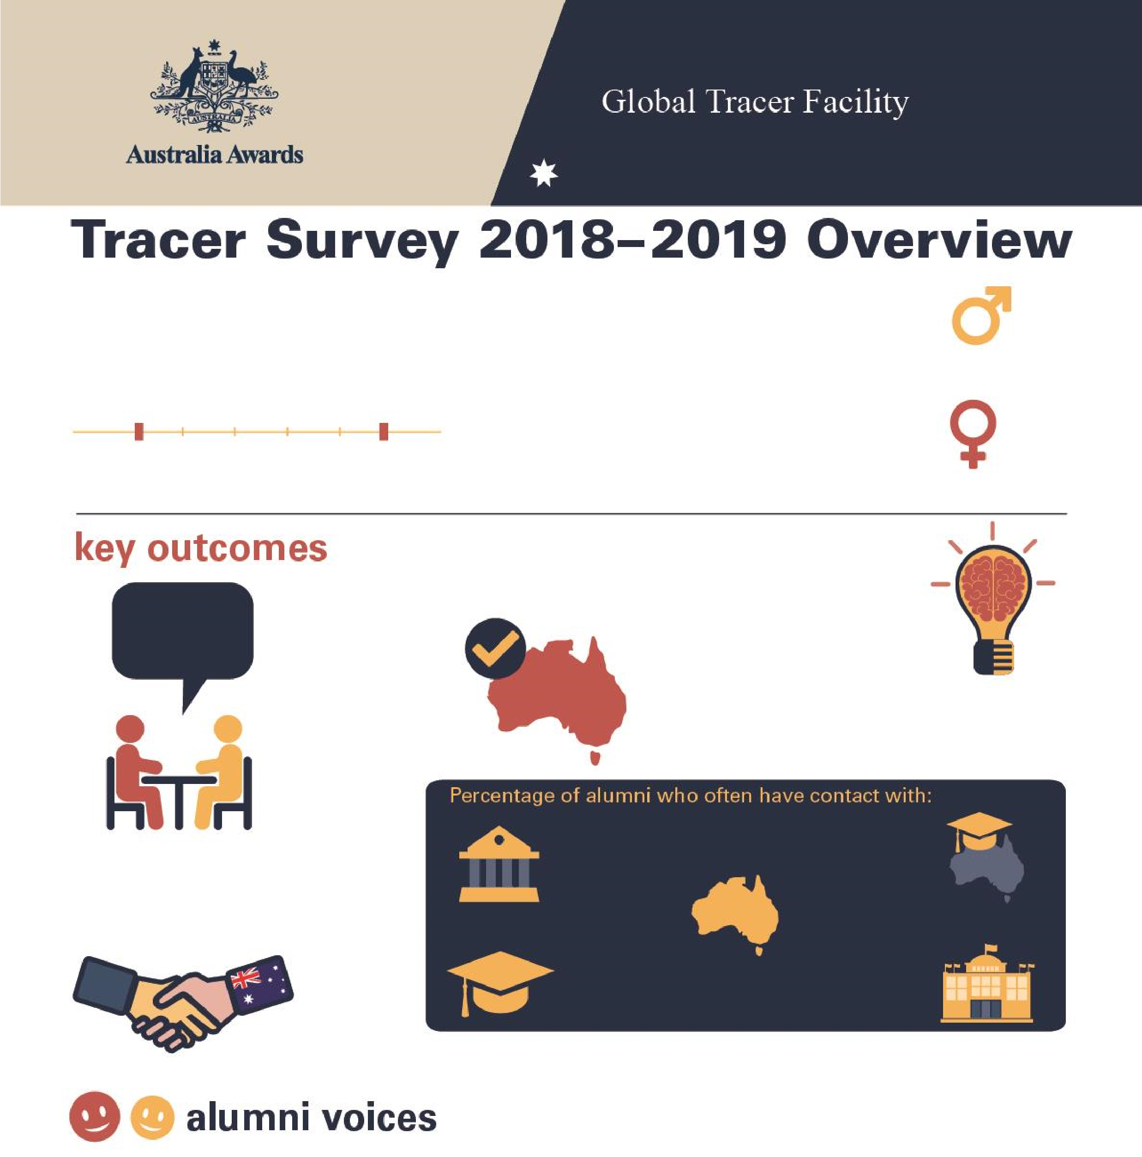
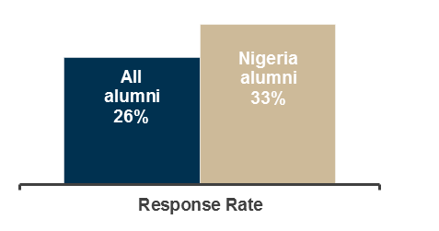

Tracer Survey 2018
–
2019

Nigeria Overview

57

Alumni from
Nigeria

Alumni who completed a scholarship or

fellowship between
2011

and 20
16

2011

2016

Men
61
%

W
omen
39
%

98
%

of alumni

Passed on skills
and knowledge
to others

98
%

of alumni

Introduced improved
practices and
innovations at work

%
40

of alumni

Developed professional
links with Australia

98
%

of alumni

Say their awards experience
positively influenced perception

of Australian skills and
expertise

Host

institution

34
%

Other scholarship
alumni

82
%

Friends in
Australia

38
%

Australian
alumni

%
56

Australian
Embassy or

High Commission

20
%

Table 1: Tracer Survey Data for 2011 to 2016 alumni from Nigeria and All alumni - Respondent characteristics
 |  | Alumni from Nigeria
 |  | Scholarships |  | Fellowships |  | Alumni from Nigeria |  | All Alumni
 |  | Count | Column N % | Count | Column N % | Count | Column N % | Count | Column N %
Age at time of survey | Under 20 years | - | - | - | - | - | - | - | -
Age at time of survey | 20 to 29 years | - | - | - | - | - | - | 111 | 3.0%
Age at time of survey | 30 to 39 years | 16 | 45.7% | 4 | 18.2% | 20 | 35.1% | 2134 | 56.8%
Age at time of survey | 40 to 49 years | 13 | 37.1% | 13 | 59.1% | 26 | 45.6% | 1144 | 30.4%
Age at time of survey | 50 to 59 years | 6 | 17.1% | 5 | 22.7% | 11 | 19.3% | 310 | 8.3%
Age at time of survey | 60 to 69 years | - | - | - | - | - | - | 52 | 1.4%
Age at time of survey | 70 and older | - | - | - | - | - | - | 6 | 0.2%
Year of graduation from award | 2011 | 1 | 2.9% | 2 | 9.1% | 3 | 5.3% | 382 | 10.1%
Year of graduation from award | 2012 | 6 | 17.1% | 3 | 13.6% | 9 | 15.8% | 546 | 14.5%
Year of graduation from award | 2013 | 4 | 11.4% | 2 | 9.1% | 6 | 10.5% | 631 | 16.7%
Year of graduation from award | 2014 | 5 | 14.3% | 10 | 45.5% | 15 | 26.3% | 657 | 17.4%
Year of graduation from award | 2015 | 9 | 25.7% | 2 | 9.1% | 11 | 19.3% | 881 | 23.4%
Year of graduation from award | 2016 | 10 | 28.6% | 3 | 13.6% | 13 | 22.8% | 671 | 17.8%
Have you received any other awards? | Yes | 8 | 22.9% | 7 | 31.8% | 15 | 26.3% | 956 | 25.4%
Have you received any other awards? | No | 27 | 77.1% | 15 | 68.2% | 42 | 73.7% | 2779 | 73.9%
Have you received any other awards? | Don't know | - | - | - | - | - | - | 27 | 0.7%
What is your current employment status? | Employed full-time | 28 | 80.0% | 20 | 90.9% | 48 | 84.2% | 3297 | 87.7%
What is your current employment status? | Employed part-time | 2 | 5.7% | 1 | 4.5% | 3 | 5.3% | 155 | 4.1%
What is your current employment status? | Not employed | 1 | 2.9% | - | - | 1 | 1.8% | 113 | 3.0%
What is your current employment status? | Retired | 1 | 2.9% | - | - | 1 | 1.8% | 15 | 0.4%
What is your current employment status? | Studying | 2 | 5.7% | 1 | 4.5% | 3 | 5.3% | 135 | 3.6%
What is your current employment status? | Other (specify) | 1 | 2.9% | - | - | 1 | 1.8% | 46 | 1.2%
Level of leadership in relation to current job | Formal leadership role | 27 | 87.1% | 19 | 90.5% | 46 | 88.5% | 2080 | 61.9%
Level of leadership in relation to current job | Informal leadership role | 4 | 12.9% | 2 | 9.5% | 6 | 11.5% | 1019 | 30.3%
Level of leadership in relation to current job | Do not have a leadership role | - | - | - | - | - | - | 203 | 6.0%
Level of leadership in relation to current job | Don't know/prefer not to say | - | - | - | - | - | - | 56 | 1.7%
Table 2: Tracer Survey Data for 2011 to 2016 alumni from Nigeria and All alumni - Outcome 1
 |  | Alumni from Nigeria
Q: To what extent do you agree with each of these statements:  I have… |  | Scholarships |  | Fellowships |  | Alumni from Nigeria |  | All Alumni
 |  | Count | Column N % | Count | Column N % | Count | Column N % | Count | Column N %
Passed on new skills and knowledge to others | Strongly agree | 24 | 68.6% | 21 | 95.5% | 45 | 78.9% | 2298 | 61.1%
Passed on new skills and knowledge to others | Agree | 10 | 28.6% | 1 | 4.5% | 11 | 19.3% | 1367 | 36.4%
Passed on new skills and knowledge to others | Disagree | - | - | - | - | - | - | 44 | 1.2%
Passed on new skills and knowledge to others | Strongly disagree | 1 | 2.9% | - | - | 1 | 1.8% | 13 | 0.3%
Passed on new skills and knowledge to others | Don't Know | - | - | - | - | - | - | 38 | 1.0%
Introduced improved practices and innovations through my work | Strongly agree | 26 | 74.3% | 14 | 63.6% | 40 | 70.2% | 2023 | 53.9%
 | Agree | 8 | 22.9% | 8 | 36.4% | 16 | 28.1% | 1571 | 41.8%
 | Disagree | - | - | - | - | - | - | 69 | 1.8%
 | Strongly disagree | 1 | 2.9% | - | - | 1 | 1.8% | 12 | 0.3%
 | Don't Know | - | - | - | - | - | - | 81 | 2.2%
Built networks with Australians or Australian organisations | Strongly agree | 12 | 34.3% | 3 | 13.6% | 15 | 26.3% | 848 | 22.6%
Built networks with Australians or Australian organisations | Agree | 13 | 37.1% | 15 | 68.2% | 28 | 49.1% | 1892 | 50.4%
Built networks with Australians or Australian organisations | Disagree | 9 | 25.7% | 3 | 13.6% | 12 | 21.1% | 719 | 19.2%
Built networks with Australians or Australian organisations | Strongly disagree | - | - | 1 | 4.5% | 1 | 1.8% | 68 | 1.8%
Built networks with Australians or Australian organisations | Don't know | 1 | 2.9% | - | - | 1 | 1.8% | 226 | 6.0%
Built networks with other awardees | Strongly agree | 20 | 57.1% | 14 | 63.6% | 34 | 59.6% | 1683 | 44.9%
Built networks with other awardees | Agree | 13 | 37.1% | 8 | 36.4% | 21 | 36.8% | 1730 | 46.1%
Built networks with other awardees | Disagree | 1 | 2.9% | - | - | 1 | 1.8% | 251 | 6.7%
Built networks with other awardees | Strongly disagree | 1 | 2.9% | - | - | 1 | 1.8% | 21 | 0.6%
Built networks with other awardees | Don't know | - | - | - | - | - | - | 66 | 1.8%
Table 3: Tracer Survey Data for 2011 to 2016 alumni from Nigeria and All alumni - Outcome 2
 |  | Alumni from Nigeria
Q: How frequently are you in contact with the following groups: |  | Scholarships |  | Fellowships |  | Alumni from Nigeria |  | All Alumni
 |  | Count | Column N % | Count | Column N % | Count | Column N % | Count | Column N %
Host Institution | Always | 5 | 16.7% | 1 | 5.0% | 6 | 12.0% | 168 | 5.0%
Host Institution | Often | 10 | 33.3% | 1 | 5.0% | 11 | 22.0% | 568 | 16.8%
Host Institution | Sometimes | 8 | 26.7% | 9 | 45.0% | 17 | 34.0% | 1279 | 37.8%
Host Institution | Rarely | 6 | 20.0% | 6 | 30.0% | 12 | 24.0% | 973 | 28.7%
Host Institution | Never | 1 | 3.3% | 3 | 15.0% | 4 | 8.0% | 364 | 10.8%
Host Institution | Don’t know | - | - | - | - | - | - | 34 | 1.0%
Fellow Australian Students | Always | 5 | 16.7% | 7 | 35.0% | 12 | 24.0% | 278 | 8.2%
Fellow Australian Students | Often | 10 | 33.3% | 6 | 30.0% | 16 | 32.0% | 850 | 25.1%
Fellow Australian Students | Sometimes | 7 | 23.3% | 5 | 25.0% | 12 | 24.0% | 1270 | 37.6%
Fellow Australian Students | Rarely | 7 | 23.3% | 2 | 10.0% | 9 | 18.0% | 611 | 18.1%
Fellow Australian Students | Never | 1 | 3.3% | - | - | 1 | 2.0% | 341 | 10.1%
Fellow Australian Students | Don’t know | - | - | - | - | - | - | 32 | 0.9%
Fellow Award recipients | Always | 11 | 36.7% | 11 | 55.0% | 22 | 44.0% | 488 | 14.4%
Fellow Award recipients | Often | 13 | 43.3% | 6 | 30.0% | 19 | 38.0% | 1219 | 36.1%
Fellow Award recipients | Sometimes | 5 | 16.7% | 2 | 10.0% | 7 | 14.0% | 1151 | 34.1%
Fellow Award recipients | Rarely | 1 | 3.3% | 1 | 5.0% | 2 | 4.0% | 389 | 11.5%
Fellow Award recipients | Never | - | - | - | - | - | - | 115 | 3.4%
Fellow Award recipients | Don’t know | - | - | - | - | - | - | 17 | 0.5%
Professional associations or  Australian businesses operating in  Australia/your home country | Always | 1 | 3.3% | 2 | 10.0% | 3 | 6.0% | 104 | 3.1%
 | Often | 5 | 16.7% | 3 | 15.0% | 8 | 16.0% | 359 | 10.6%
 | Sometimes | 10 | 33.3% | 2 | 10.0% | 12 | 24.0% | 834 | 24.7%
 | Rarely | 8 | 26.7% | 6 | 30.0% | 14 | 28.0% | 989 | 29.3%
 | Never | 6 | 20.0% | 7 | 35.0% | 13 | 26.0% | 984 | 29.2%
 | Don’t know | - | - | - | - | - | - | 105 | 3.1%
Australian Embassy, High Commission or Consulate | Always | 2 | 6.7% | - | - | 2 | 4.0% | 85 | 2.5%
Australian Embassy, High Commission or Consulate | Often | 4 | 13.3% | 4 | 20.0% | 8 | 16.0% | 251 | 7.4%
Australian Embassy, High Commission or Consulate | Sometimes | 11 | 36.7% | 5 | 25.0% | 16 | 32.0% | 775 | 23.0%
Australian Embassy, High Commission or Consulate | Rarely | 6 | 20.0% | 4 | 20.0% | 10 | 20.0% | 1119 | 33.2%
Australian Embassy, High Commission or Consulate | Never | 7 | 23.3% | 7 | 35.0% | 14 | 28.0% | 1092 | 32.4%
Australian Embassy, High Commission or Consulate | Don’t know | - | - | - | - | - | - | 50 | 1.5%
Friends in Australia | Always | 8 | 26.7% | - | - | 8 | 16.0% | 426 | 12.6%
Friends in Australia | Often | 9 | 30.0% | 2 | 10.0% | 11 | 22.0% | 921 | 27.3%
Friends in Australia | Sometimes | 9 | 30.0% | 8 | 40.0% | 17 | 34.0% | 1232 | 36.6%
Friends in Australia | Rarely | 2 | 6.7% | 5 | 25.0% | 7 | 14.0% | 551 | 16.4%
Friends in Australia | Never | 2 | 6.7% | 4 | 20.0% | 6 | 12.0% | 219 | 6.5%
Friends in Australia | Don’t know | - | - | 1 | 5.0% | 1 | 2.0% | 21 | 0.6%
Table 4: Tracer Survey Data for 2011 to 2016 alumni from Nigeria and All alumni - Outcome 3
Q: As a result of your Australia Award, have you developed professional links with Australian organisations? |  | Scholarships  Count Column N % |  | Alumni from Nigeria  Fellowships  Count Column N % |  | Alumni from Nigeria  Count Column N % |  | All Alumni  Count Column N %
Professional links | Developed professional links | 15 | 50.0% | 5 | 25.0% | 20 | 40.0% | 1513 | 44.2%
Professional links | Did not develop professional links | 15 | 50.0% | 13 | 65.0% | 28 | 56.0% | 1583 | 46.2%
Professional links | Don't Know | - | - | 2 | 10.0% | 2 | 4.0% | 330 | 9.6%
Types of professional links with Australian organisations* | Public sector | 2 | 13.3% | 2 | 40.0% | 4 | 20.0% | 336 | 22.4%
Types of professional links with Australian organisations* | Private Sector | 1 | 6.7% | - | - | 1 | 5.0% | 150 | 10.0%
Types of professional links with Australian organisations* | Universities | 7 | 46.7% | 2 | 40.0% | 9 | 45.0% | 740 | 49.3%
Types of professional links with Australian organisations* | Non-Government Organisations | 3 | 20.0% | - | - | 3 | 15.0% | 137 | 9.1%
Types of professional links with Australian organisations* | Australian High Commission or Consulates | - | - | 1 | 20.0% | 1 | 5.0% | 30 | 2.0%
Types of professional links with Australian organisations* | Other or don't know | 2 | 13.3% | - | - | 2 | 10.0% | 108 | 7.2%
*Note these counts and proportions only include alumni who indicated that they had developed a professional link as well as providing information about their current employment in the survey.
Table 5: Tracer Survey Data for 2011 to 2016 alumni from Nigeria and All alumni - Outcome 4
 |  | Alumni from Nigeria
Q: To what extent did your experience during your award influence your perception of the following: |  | Scholarships |  | Fellowships |  | Alumni from Nigeria |  | All Alumni
 |  | Count | Column N % | Count | Column N % | Count | Column N % | Count | Column N %
Australia as a country | Much more positive | 25 | 86.2% | 20 | 100.0% | 45 | 91.8% | 2825 | 84.6%
Australia as a country | Slightly more positive | 3 | 10.3% | - | - | 3 | 6.1% | 406 | 12.2%
Australia as a country | No change | 1 | 3.4% | - | - | 1 | 2.0% | 84 | 2.5%
Australia as a country | Slightly more negative | - | - | - | - | - | - | 13 | 0.4%
Australia as a country | Much more negative | - | - | - | - | - | - | - | -
Australia as a country | Don't know | - | - | - | - | - | - | 13 | 0.4%
Australian people | Much more positive | 25 | 86.2% | 20 | 100.0% | 45 | 91.8% | 2497 | 74.8%
Australian people | Slightly more positive | 3 | 10.3% | - | - | 3 | 6.1% | 626 | 18.7%
Australian people | No change | 1 | 3.4% | - | - | 1 | 2.0% | 152 | 4.6%
Australian people | Slightly more negative | - | - | - | - | - | - | 37 | 1.1%
Australian people | Much more negative | - | - | - | - | - | - | 1 | 0.0%
Australian people | Don't know | - | - | - | - | - | - | 26 | 0.8%
The knowledge skills and expertise of Australians | Much more positive | 25 | 86.2% | 16 | 84.2% | 41 | 85.4% | 2532 | 75.9%
The knowledge skills and expertise of Australians | Slightly more positive | 3 | 10.3% | 2 | 10.5% | 5 | 10.4% | 642 | 19.2%
The knowledge skills and expertise of Australians | No change | 1 | 3.4% | 1 | 5.3% | 2 | 4.2% | 118 | 3.5%
The knowledge skills and expertise of Australians | Slightly more negative | - | - | - | - | - | - | 19 | 0.6%
The knowledge skills and expertise of Australians | Much more negative | - | - | - | - | - | - | 2 | 0.1%
The knowledge skills and expertise of Australians | Don't know | - | - | - | - | - | - | 24 | 0.7%
Have provided advice to people from home country in relation to pursuing opportunities in Australia | Yes | 29 | 100.0% | 19 | 100.0% | 48 | 100.0% | 3245 | 97.3%
 | No | - | - | - | - | - | - | 74 | 2.2%
 | Don't know | - | - | - | - | - | - | 17 | 0.5%



