

Australia Awards

Global Tracer Facility

Tracer Survey

Year

3

201

8

-

1

9

Gambia

Country Report

Alumni of

2011

to

2016

Tracer Survey

# Outcomes Summary: Gambia

This country report details the responses of alumni from **Gambia** to the Australia

Awards Global Tracer Facility **Tracer Survey** carried out in 2018-19. The Tracer Survey was conducted between November 2018 and February 2019 and targeted **alumni who completed their award between 2011 and 2016**.

Alumni were asked a range of questions via an online survey, focussed on exploring the long-term outcomes of the Australia Awards. In total 3,768 alumni in this cohort from more than 123 different countries participated in the survey. A 26 per cent response rate of the target cohort was achieved globally. This report focuses on the response data of alumni from Gambia.

For Gambia, there were 42 alumni included in the target population. Responses were received from 11, a **response rate of 26** **per cent**. Among these respondents, 10 were scholarship alumni and one was a fellowship alum.

The survey data provide a valuable quantitative insight into alumni use of knowledge and skills, development of networks and contribution to cooperation with Australia. The responses also offer rich examples from alumni of the types of contributions they are making, the way in which they are using their award, and the things that help and hinder them in reaching their potential.

The data detailed here are reported based on the four long-term outcomes of the Australia Awards as articulated in the *Australia Awards Global Strategy: Investing in the next generation of global leaders for development 2016-2018* and the Australia Awards Global Monitoring and Evaluation Framework. In terms of responding to the **long-term outcomes** of the Australia Awards, the following summary offers findings based on the responses of alumni from Gambia. Further outcomes are included in the infographic following this summary.

**Outcome 1:** *Alumni are using their skills, knowledge and networks to contribute to sustainable development.*

* All alumni from Gambia indicated they have passed on their skills and knowledge to others in their country on return from their award.
* 82 per cent of alumni indicated they had introduced improved practices and innovations in their work on return from their award.

/ 1

**Outcome 2:** *Alumni are contributing to cooperation between Australia and partner countries.*

* 60 per cent of alumni from Gambia have maintained frequent contact with fellow alumni, while 20 per cent have frequent contact with friends in Australia and 40 per cent with Australian students/alumni.
* In terms of frequent contact with Australian organisations, 10 per cent of alumni have frequent contact with Australian institutions and 10 per cent of alumni have frequent contact with Australian businesses.

**Outcome 3:** *Effective, mutually advantageous partnerships between institutions and businesses in Australia and partner countries.*

* 20 per cent of alumni from Gambia indicated having had a professional link with an Australian organisation at some time following award. • These links were with Australian universities.

**Outcome 4:** *Alumni view Australia, Australians and Australian expertise positively.*

* Most alumni from Gambia (89 per cent) indicated their experience in Australia positively influenced their perception of Australia.
* Most alumni (89 per cent) have provided advice to people in Gambia about pursuing opportunities in Australia.

The Tracer Survey represented the views of a range of alumni from Gambia. Of those who responded, **55 per cent were women and all came from an urban location**. The largest age group represented were alumni 30 to 39 years. All alumni were employed full-time. Of those alumni employed, **91 per cent** indicatedthat they hold a **formal leadership role**.

In addition to this Outcomes Summary, this report includes an infographic as well as data tables including the detail of respondents from Gambia to the Tracer Survey. The data tables correspond to each of the Australia Awards long-term outcomes and include benchmark data from the entire survey response population.

For further information about the Australia Awards Global Tracer Facility please visit the website: [www.australiaawardstracerfacility.org](http://www.australiaawardstracerfacility.org/)

/ 2

|  |
| --- |
| *I am training farmers on the relationship environmental management and development and adoption of sustainable agriculture practices and/or options to mitigate impact of climate change.* |

|  |
| --- |
| *I helped with the development of the National Ebola Virus Disease Plan. Direct monitoring and supervision of key program areas where I had the opportunity to correct protocols, define policy and or explain the wisdom of doing things in a particular or more professional manner and this even includes report writing and PowerPoint presentations on slides.* |

|  |
| --- |
| *I have built networks with Australians who have been very supportive in linking me with international organizations and conferences which gave me the opportunity to gain more knowledge.* |

|  |
| --- |
| *I have passed on new skills such as new livestock technologies such as feed formulation techniques and strategies for the enhancement of food and nutrition.* |

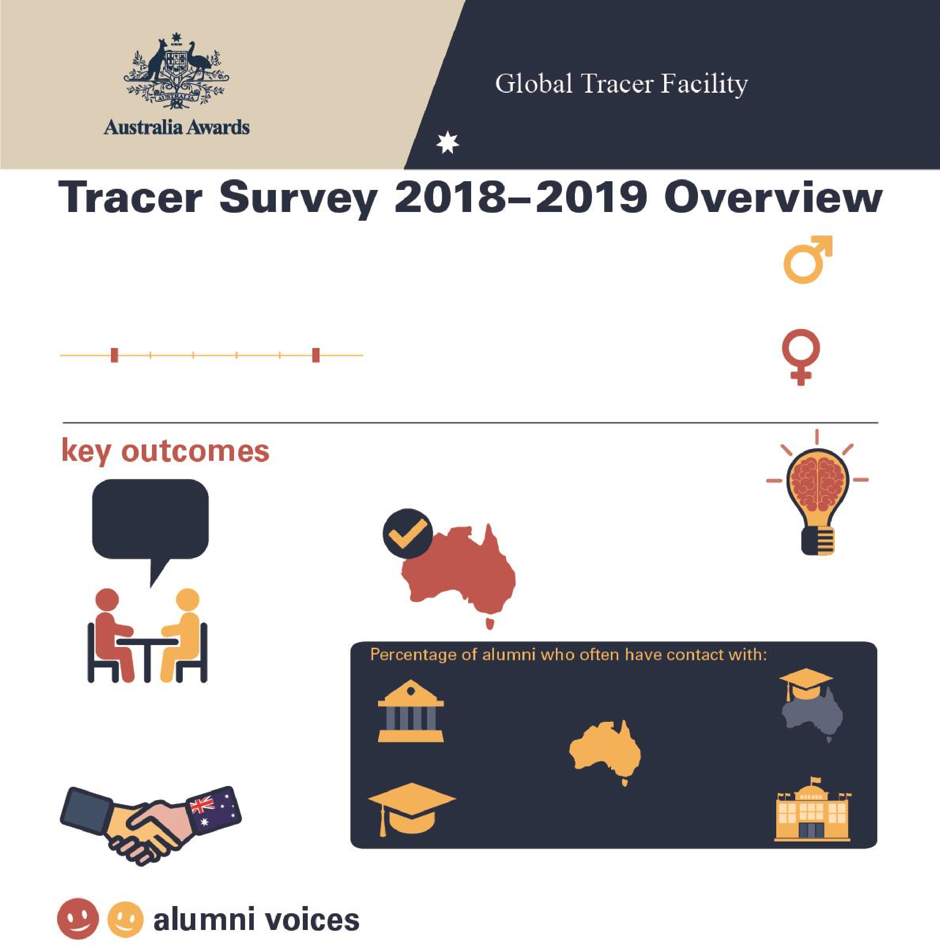

**Tracer Survey 2018**

**–**

**2019**

**Gambia**

**Overview**

**11**

**Alumni from**

**Gambia**

Alumni who completed a scholarship or

fellowsh

ip between

2011

and 20

16

**2011**

**2016**

**Men**

**%**

**45**

**W**

**omen**

**%**

**55**

**%**

**100**

**of alumni**

Passed on skills

and knowledge

to others

**82**

**%**

**of alumni**

Introduced improved

practices and

innovations at work

**%**

**20**

**of alumni**

Developed professional

links with Australia

**89**

**%**

**of alumni**

Say their awards experience

positively influenced perception

of Australian skills and expertise

Host

institution

**10**

**%**

Other scholarship

alumni

**60**

**%**

Friends

in

Australia

**20**

**%**

Australian

alumni

**%**

**40**

Australian

Embassy or

High Commission

**0**

**%**

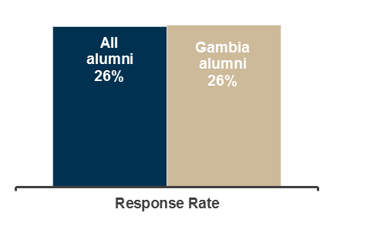

**Table 1: Tracer Survey Data for 2011 to 2016 alumni from Gambia and All alumni - Respondent characteristics**

|  |  |  |  |  |  |  |  |  |  |
| --- | --- | --- | --- | --- | --- | --- | --- | --- | --- |
|  |  | Alumni from Gambia | | | |  |  |  | |
| Scholarships | | Fellowships | | Alumni from Gambia | | All Alumni | |
| Count | Column N % | Count | Column N % | Count | Column N % | Count | Column N % |
| Age at time of survey | Under 20 years | - | - | - | - | - | - | - | - |
| 20 to 29 years | - | - | - | - | - | - | 111 | 3.0% |
| 30 to 39 years | 7 | 70.0% | - | - | 7 | 63.6% | 2134 | 56.8% |
| 40 to 49 years | 1 | 10.0% | - | - | 1 | 9.1% | 1144 | 30.4% |
| 50 to 59 years | 2 | 20.0% | 1 | 100.0% | 3 | 27.3% | 310 | 8.3% |
| 60 to 69 years | - | - | - | - | - | - | 52 | 1.4% |
| 70 and older | - | - | - | - | - | - | 6 | 0.2% |
| Year of graduation from award | 2011 | - | - | - | - | - | - | 382 | 10.1% |
| 2012 | 3 | 30.0% | - | - | 3 | 27.3% | 546 | 14.5% |
| 2013 | 2 | 20.0% | - | - | 2 | 18.2% | 631 | 16.7% |
| 2014 | - | - | 1 | 100.0% | 1 | 9.1% | 657 | 17.4% |
| 2015 | 4 | 40.0% | - | - | 4 | 36.4% | 881 | 23.4% |
| 2016 | 1 | 10.0% | - | - | 1 | 9.1% | 671 | 17.8% |
| Have you received any other awards? | Yes | - | - | - | - | - | - | 956 | 25.4% |
| No | 10 | 100.0% | 1 | 100.0% | 11 | 100.0% | 2779 | 73.9% |
| Don't know | - | - | - | - | - | - | 27 | 0.7% |
| What is your current employment status? | Employed full-time | 10 | 100.0% | 1 | 100.0% | 11 | 100.0% | 3297 | 87.7% |
| Employed part-time | - | - | - | - | - | - | 155 | 4.1% |
| Not employed | - | - | - | - | - | - | 113 | 3.0% |
| Retired | - | - | - | - | - | - | 15 | 0.4% |
| Studying | - | - | - | - | - | - | 135 | 3.6% |
| Other (specify) | - | - | - | - | - | - | 46 | 1.2% |
| Level of leadership in relation to current job | Formal leadership role | 9 | 90.0% | 1 | 100.0% | 10 | 90.9% | 2080 | 61.9% |
| Informal leadership role | - | - | - | - | - | - | 1019 | 30.3% |
| Do not have a leadership role | 1 | 10.0% | - | - | 1 | 9.1% | 203 | 6.0% |
| Don't know/prefer not to say | - | - | - | - | - | - | 56 | 1.7% |

**Table 2: Tracer Survey Data for 2011 to 2016 alumni from Gambia and All alumni - Outcome 1**

|  |  |  |  |  |  |  |  |  |  |
| --- | --- | --- | --- | --- | --- | --- | --- | --- | --- |
|  |  | Alumni from Gambia | | | |  |  |  | |
| **Q**: To what extent do you agree with each of these statements:  I have… | | Scholarships | | Fellowships | | Alumni from Gambia | | All Alumni | |
| Count | Column N % | Count | Column N % | Count | Column N % | Count | Column N % |
| Passed on new skills and knowledge to others | Strongly agree | 8 | 80.0% | 1 | 100.0% | 9 | 81.8% | 2298 | 61.1% |
| Agree | 2 | 20.0% | - | - | 2 | 18.2% | 1367 | 36.4% |
| Disagree | - | - | - | - | - | - | 44 | 1.2% |
| Strongly disagree | - | - | - | - | - | - | 13 | 0.3% |
| Don't Know | - | - | - | - | - | - | 38 | 1.0% |
| Introduced improved practices and innovations through my work | Strongly agree | 4 | 40.0% | 1 | 100.0% | 5 | 45.5% | 2023 | 53.9% |
| Agree | 4 | 40.0% | - | - | 4 | 36.4% | 1571 | 41.8% |
| Disagree | 2 | 20.0% | - | - | 2 | 18.2% | 69 | 1.8% |
| Strongly disagree | - | - | - | - | - | - | 12 | 0.3% |
| Don't Know | - | - | - | - | - | - | 81 | 2.2% |
| Built networks with Australians or Australian organisations | Strongly agree | 1 | 10.0% | - | - | 1 | 9.1% | 848 | 22.6% |
| Agree | 2 | 20.0% | - | - | 2 | 18.2% | 1892 | 50.4% |
| Disagree | 4 | 40.0% | - | - | 4 | 36.4% | 719 | 19.2% |
| Strongly disagree | 2 | 20.0% | 1 | 100.0% | 3 | 27.3% | 68 | 1.8% |
| Don't know | 1 | 10.0% | - | - | 1 | 9.1% | 226 | 6.0% |
| Built networks with other awardees | Strongly agree | 4 | 40.0% | - | - | 4 | 36.4% | 1683 | 44.9% |
| Agree | 4 | 40.0% | - | - | 4 | 36.4% | 1730 | 46.1% |
| Disagree | 2 | 20.0% | - | - | 2 | 18.2% | 251 | 6.7% |
| Strongly disagree | - | - | 1 | 100.0% | 1 | 9.1% | 21 | 0.6% |
| Don't know | - | - | - | - | - | - | 66 | 1.8% |

**Table 3: Tracer Survey Data for 2011 to 2016 alumni from Gambia and All alumni - Outcome 2**

|  |  |  |  |  |  |  |  |  |  |
| --- | --- | --- | --- | --- | --- | --- | --- | --- | --- |
|  |  | Alumni from Gambia | | | |  |  |  | |
| **Q**: How frequently are you in contact with the following groups: | | Scholarships | | Fellowships | | Alumni from Gambia | | All Alumni | |
| Count | Column N % | Count | Column N % | Count | Column N % | Count | Column N % |
| Host Institution | Always | - | - | - | - | - | - | 168 | 5.0% |
| Often | 1 | 11.1% | - | - | 1 | 10.0% | 568 | 16.8% |
| Sometimes | 6 | 66.7% | 1 | 100.0% | 7 | 70.0% | 1279 | 37.8% |
| Rarely | 1 | 11.1% | - | - | 1 | 10.0% | 973 | 28.7% |
| Never | 1 | 11.1% | - | - | 1 | 10.0% | 364 | 10.8% |
| Don’t know | - | - | - | - | - | - | 34 | 1.0% |
| Fellow Australian Students | Always | 1 | 11.1% | - | - | 1 | 10.0% | 278 | 8.2% |
| Often | 3 | 33.3% | - | - | 3 | 30.0% | 850 | 25.1% |
| Sometimes | 4 | 44.4% | 1 | 100.0% | 5 | 50.0% | 1270 | 37.6% |
| Rarely | - | - | - | - | - | - | 611 | 18.1% |
| Never | 1 | 11.1% | - | - | 1 | 10.0% | 341 | 10.1% |
| Don’t know | - | - | - | - | - | - | 32 | 0.9% |
| Fellow Award recipients | Always | 4 | 44.4% | - | - | 4 | 40.0% | 488 | 14.4% |
| Often | 2 | 22.2% | - | - | 2 | 20.0% | 1219 | 36.1% |
| Sometimes | 3 | 33.3% | - | - | 3 | 30.0% | 1151 | 34.1% |
| Rarely | - | - | - | - | - | - | 389 | 11.5% |
| Never | - | - | 1 | 100.0% | 1 | 10.0% | 115 | 3.4% |
| Don’t know | - | - | - | - | - | - | 17 | 0.5% |
| Professional associations or  Australian businesses operating in  Australia/your home country | Always | - | - | - | - | - | - | 104 | 3.1% |
| Often | 1 | 11.1% | - | - | 1 | 10.0% | 359 | 10.6% |
| Sometimes | - | - | - | - | - | - | 834 | 24.7% |
| Rarely | 5 | 55.6% | - | - | 5 | 50.0% | 989 | 29.3% |
| Never | 3 | 33.3% | 1 | 100.0% | 4 | 40.0% | 984 | 29.2% |
| Don’t know | - | - | - | - | - | - | 105 | 3.1% |
| Australian Embassy, High Commission or Consulate | Always | - | - | - | - | - | - | 85 | 2.5% |
| Often | - | - | - | - | - | - | 251 | 7.4% |
| Sometimes | 1 | 11.1% | - | - | 1 | 10.0% | 775 | 23.0% |
| Rarely | 4 | 44.4% | - | - | 4 | 40.0% | 1119 | 33.2% |
| Never | 4 | 44.4% | 1 | 100.0% | 5 | 50.0% | 1092 | 32.4% |
| Don’t know | - | - | - | - | - | - | 50 | 1.5% |
| Friends in Australia | Always | 1 | 11.1% | - | - | 1 | 10.0% | 426 | 12.6% |
| Often | 1 | 11.1% | - | - | 1 | 10.0% | 921 | 27.3% |
| Sometimes | 4 | 44.4% | - | - | 4 | 40.0% | 1232 | 36.6% |
| Rarely | 2 | 22.2% | - | - | 2 | 20.0% | 551 | 16.4% |
| Never | 1 | 11.1% | 1 | 100.0% | 2 | 20.0% | 219 | 6.5% |
| Don’t know | - | - | - | - | - | - | 21 | 0.6% |

**Table 4: Tracer Survey Data for 2011 to 2016 alumni from Gambia and All alumni - Outcome 3**

|  |  |  |  |  |  |  |  |  |  |
| --- | --- | --- | --- | --- | --- | --- | --- | --- | --- |
| **Q**: As a result of your Australia Award, have you developed professional links with Australian organisations? | | Scholarships  Count Column N % | | Alumni from Gambia  Fellowships  Count Column N % | | Alumni from Gambia  Count Column N % | | All Alumni  Count Column N % | |
| Professional links | Developed professional links | 2 | 22.2% | - | - | 2 | 20.0% | 1513 | 44.2% |
| Did not develop professional links | 7 | 77.8% | 1 | 100.0% | 8 | 80.0% | 1583 | 46.2% |
| Don't Know | - | - | - | - | - | - | 330 | 9.6% |
| Types of professional links with Australian organisations* | Public sector | - | - | - | - | - | - | 336 | 22.4% |
| Private Sector | - | - | - | - | - | - | 150 | 10.0% |
| Universities | 1 | 50.0% | - | - | 1 | 50.0% | 740 | 49.3% |
| Non-Government Organisations | - | - | - | - | - | - | 137 | 9.1% |
| Australian High Commission or Consulates | - | - | - | - | - | - | 30 | 2.0% |
| Other or don't know | 1 | 50.0% | - | - | 1 | 50.0% | 108 | 7.2% |

*Note these counts and proportions only include alumni who indicated that they had developed a professional link as well as providing information about their current employment in the survey.

**Table 5: Tracer Survey Data for 2011 to 2016 alumni from Gambia and All alumni - Outcome 4**

|  |  |  |  |  |  |  |  |  |  |
| --- | --- | --- | --- | --- | --- | --- | --- | --- | --- |
|  |  | Alumni from Gambia | | | |  |  |  | |
| **Q**: To what extent did your experience during your award influence your perception of the following: | | Scholarships | | Fellowships | | Alumni from Gambia | | All Alumni | |
| Count | Column N % | Count | Column N % | Count | Column N % | Count | Column N % |
| Australia as a country | Much more positive | 7 | 87.5% | - | - | 7 | 77.8% | 2825 | 84.6% |
| Slightly more positive | 1 | 12.5% | - | - | 1 | 11.1% | 406 | 12.2% |
| No change | - | - | - | - | - | - | 84 | 2.5% |
| Slightly more negative | - | - | - | - | - | - | 13 | 0.4% |
| Much more negative | - | - | - | - | - | - | - | - |
| Don't know | - | - | 1 | 100.0% | 1 | 11.1% | 13 | 0.4% |
| Australian people | Much more positive | 6 | 75.0% | - | - | 6 | 66.7% | 2497 | 74.8% |
| Slightly more positive | 2 | 25.0% | - | - | 2 | 22.2% | 626 | 18.7% |
| No change | - | - | - | - | - | - | 152 | 4.6% |
| Slightly more negative | - | - | - | - | - | - | 37 | 1.1% |
| Much more negative | - | - | - | - | - | - | 1 | 0.0% |
| Don't know | - | - | 1 | 100.0% | 1 | 11.1% | 26 | 0.8% |
| The knowledge skills and expertise of Australians | Much more positive | 8 | 100.0% | - | - | 8 | 88.9% | 2532 | 75.9% |
| Slightly more positive | - | - | - | - | - | - | 642 | 19.2% |
| No change | - | - | - | - | - | - | 118 | 3.5% |
| Slightly more negative | - | - | - | - | - | - | 19 | 0.6% |
| Much more negative | - | - | - | - | - | - | 2 | 0.1% |
| Don't know | - | - | 1 | 100.0% | 1 | 11.1% | 24 | 0.7% |
| Have provided advice to people from home country in relation to pursuing opportunities in Australia | Yes | 8 | 100.0% | - | - | 8 | 88.9% | 3245 | 97.3% |
| No | - | - | 1 | 100.0% | 1 | 11.1% | 74 | 2.2% |
| Don't know | - | - | - | - | - | - | 17 | 0.5% |

