

Australia Awards   
Global Tracer Facility

Social Network Analysis of an Australia Awards Leadership Program cohort

December 2021

The views expressed in this report are those of the authors and do not necessarily reflect the policy or position of the Australian Government, its agencies or representatives.

Australian Department of Foreign Affairs and Trade

With the exception of the Commonwealth Coat of Arms and where otherwise noted, all material presented is provided under a Creative Commons Attribution 3.0 Australia license.

**Acknowledgements:**

The authors would like to thank DFAT’s Australia Awards Section, in particular Hazel Lang, for supporting this case study. The team are also indebted to the support and insight to this provided by Dean Lusher and Peng Wang from SNAToolbox.

Most importantly, we thank the 129 alumni of the AALP from across the world who took their time to complete their survey and share their outcomes and post-award reflections with us.

Recommended citation: Buckley, S. & Clarke, L. (2021). Social Network Analysis of an Australia Awards Leadership Program Cohort, Australia Awards Global Tracer Facility, Australian Department of Foreign Affairs and Trade, Canberra. Retrieved from: https://www.dfat.gov.au/people-to-people/australia-awards/australia-awards-global-tracer-facility-year-6-results

1. Contents

Executive Summary 4

1. Introduction 8

1.1 Objectives 9

1.2 Social network analysis 10

1.3 Scope and alumni participants 10

2. Australia Awards long-term Outcomes 11

2.1 Introduction 11

2.2 Public diplomacy outcomes 11

2.3 Views of Australia, Australians and Australian expertise 13

3. Social network analysis of AALP alumni 14

3.1 Introduction 14

3.2 Alumni networks 15

3.3 AALP on-award network 16

3.4 Australian connections network 17

3.5 Job advice, information sharing and leadership guidance networks 19

3.6 Informal connections network 20

3.7 Combining networks - current connections 21

3.8 Networks and alumni characteristics 22

4. Conclusion and implications for enhancing targeted on-award program outcomes 25

4.1 Summary of findings 25

4.2 Implications 26

5. Abbreviations and Acronyms 27

Annex 1: Methodology 28

1. Executive Summary

This report explores the connections, networks and long-term outcomes of a group of alumni who were part of the Australia Awards Leadership Program (AALP) in 2013 and 2014. The AALP was offered to a select group of individuals participating in the Australia Awards from countries around the world. It was designed to build leadership skills and capacity to develop reform strategies through professional development and to promote cross-country partnerships through face-to-face opportunities for awardees to network with one another.

Using innovative social network analysis, this case study investigates whether the networking objectives of the AALP were met. Specifically, the research examined if AALP alumni in the target cohort: (1) developed connections with their AALP peers during their participation in the program; and (2) maintained connections with their AALP peers seven to eight years after being on-award. One hundred and twenty-nine alumni from this program responded to an online survey assessing their attitudes towards Australia, their AALP experience and their social networks with fellow AALP alumni.

AALP alumni long-term outcomes

This study explored two specific long-term outcomes of the Australia Awards: Outcome 2—cooperation—and Outcome 4—positive views of Australia. The data collected suggest that alumni in this case study are contributing to both outcomes through their ongoing networks and by recommending opportunities for study in Australia. Ongoing contact is mostly maintained with other students and other people alumni met on award, and occasional contact is being maintained with Australian businesses and organisations, lecturers or university staff, and the Australian High Commission. While nearly all AALP alumni regularly recommend Australia as a place to study and many provide advice about developing connections with Australia, fewer alumni regularly work with Australians or Australian organisations as part of their job.

Social network analysis of AALP alumni

Analyses of the social network data collected in the case study showed that almost 90 per cent of alumni reported developing connections with AALP peers during their participation in the program in 2013 and 2014. These interactions were measured in an *AALP on-award network* analysis. A further five types of interactions or networks were examined between AALP alumni that focused on current relationships including those relating to: developing connections with Australia (the *Australian connections network*); seeking job advice (the *job advice network*); sharing work-related information (the *information sharing network*); seeking leadership guidance (the *leadership guidance network)* andinformal connections like work and family (the *informal connections network*).

The network visualisation below illustrates all the current relationships reported by AALP alumni that were measured in the developing connections, job advice, information sharing, leadership guidance and informal connections networks. Seventy-eight per cent of alumni reported a current connection with at least one AALP peer, with these occurring more frequently for informal reasons (e.g., interactions linked to work or family) or when seeking to develop connections with Australia or Australian organisations. Findings suggest that many of the connections developed between alumni while on award were maintained seven to eight years later. Furthermore, investigation of networks in combination with alumni characteristics also showed that while many relationships between alumni were based around region location, there were also connections maintained between alumni who originated in different parts of the world.

Figure 1: Combined current relationships among AALP alumni in Australian connections, job advice, information sharing, leadership guidance and informal connections networks (orange=survey respondents, grey=non-respondents)



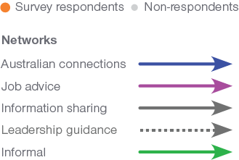

Implications for enhancing targeted on-award program outcomes

| **Key findings** | **Implications for future programming** |
| --- | --- |
| Alumni of the AALP are leaders in their organisations and communities. These alumni indicate that the AALP:   * enhanced their ability to contribute to development in their home country * improved their overall Australia Awards experience * helped to build leadership skills. | The inclusion of supplementary programs to the Australia Awards scholarships are valued by participants and are linked to successful long-term outcomes.  Future programs along these lines, whether ad hoc or consistently run, may be beneficial for some cohorts of Australia Awards scholars, providing an additional enhancement to their award experience and outcomes. |
| Almost 90 per cent of alumni reported developing connections with AALP peers during their participation in the program in 2013 and 2014. | In-person events and supplementary programs to the Australia Awards encourage connections to develop and should be more widely considered (perhaps at the beginning and the end of the award to help strengthen connections already developed). |
| Seventy-eight per cent of responding alumni maintain current connections with other AALP peers – up to eight years since completing their award. | Further to the suggestion above, the evidence here shows that fostering on-award connections do lead to on-going networks. |
| Approximately two-thirds of responding alumni network with fellow AALP alumni directly for the purpose of developing Australian connections. | Supplementary programs like the AALP are useful in not only connecting alumni to each other, they also directly help foster connections with Australia. Conferences involving industry and the Department of Foreign Affairs and Trade (DFAT), as well as mentoring programs are useful supplements to the Australia Awards and enhance cooperation with Australia (Australia Awards long-term Outcome 2. |
| Ongoing connections and alumni networks developed as part of the AALP are truly global, with social network analysis (SNA) showing their span across regions. | Future focus of supplementary programs that are offered to alumni from various parts of the world, can be pivotal in developing global networks for alumni. |

InfographicTitle: Social Network Analysis of an Australian Leadership Awards cohortText:Alumni of the Australia Awards Leadership Program (AALP) are leaders in their organisations and communities. These alumni indicate that the AALP:• enhanced their ability to contribute to development in their home country• improved their overall Australia Awards experience• helped to build leadership skillsTitle: A Network Map of AALP AlumniImage: Network mapCombined current relationships among AALP alumni in Australian connections, job advice, information sharing, leadership guidance and informal connections networks. In this figure, relationships between alumni for the Australian connections, job advice, information sharing, leadership guidance and informal connections networks are illustrated together in the same network map. The combined network map shows 246 circles spread out in a circular pattern where each circle represents an alumnus. One hundred and twenty-three of the circles/alumni are coloured orange to show that these alumni completed the social network survey questions. One hundred and twenty-three of the circles/alumni are coloured light grey, and are smaller in size than the orange circles, to show that these alumni did not respond to the survey but were nominated by one or more of the 123 respondent alumni in the social network survey questions.Lines between circles/alumni are used to illustrate relationships in the network and these are coloured blue for Australian connections relationships, pink for job advice relationships, grey for information sharing relationships, black and dotted for leadership guidance and green for informal connections relationships. Arrowheads on the end of the lines indicate the direction of the nominated relationship.The combined network map shows:• A group of circles/alumni in the centre of the map that are connected to each other by blue, pink, grey, dotted black and green lines. Many of these relationships/lines overlap and most of them are blue or green.• A few groups of alumni in pairs or triads who are tied to each other but that are separate from the larger group in the centre of the map. • 27 of the orange circles/alumni that responded to the social network survey questions are unconnected to any other alumni in the network.Title: AALP alumni networks Text:The social network map highlights the complexity of AALP alumni networks. Key findings from this analysis are: • Almost 90 per cent of alumni reported developing connections with AALP peers during their participation in the program in 2013 and 2014.• Seventy-eight per cent of responding alumni maintain current connections with other AALP peers – up to eight years since completing their award.• Approximately two-thirds of responding alumni network with fellow AALP alumni directly for the purpose of developing Australian connections.• Ongoing connections and alumni networks developed as part of the AALP are truly global, with social network analysis (SNA) showing their span across regions.Title: What can social network analysis offer that is different?Text:1. It determines the level of connectivity between people in a network. 2. It can identify enablers in a network (e.g. the people who are highly connected that may be better placed to spread new information or lead new initiatives).3. It can identify people who are isolated in the network and provides an opportunity to connect these people to others.Participants: Alumni who participated in the AALP while they undertook their Australia Award in Australia Case study participants: 129 alumni – 68 women, 61 men

1. Introduction

The Australia Awards Global Tracer Facility (GTF) analyses and reports on data collected from alumni of Australian development scholarships funded by the Australian Department of Foreign Affairs and Trade (DFAT). Research by the GTF helps DFAT to assess the development contributions, and public and economic diplomacy outcomes of Australia’s investment in the Australia Awards. Since 2016, the GTF has conducted an annual program of work including a Global Tracer Survey and other focused case studies to develop this evidence base and explore the long-term outcomes of alumni.

In 2020, a case study was conducted by the GTF designed to examine social interactions between Australia Awards alumni from Kiribati and the relationship between these interactions and the long-term outcomes of the Australia Awards.[1] This case study was the first implemented by GTF to use social network analysis (SNA) and this approach added valuable insight to the case study findings.

Building on this successful implementation of the social network approach, in 2021, a case study of alumni of the 2013 and 2014 Australia Awards Leadership Program (AALP) was undertaken. GTF researchers developed and implemented a new online survey using a social network approach in order to determine the impact of the AALP on connections developed between alumni. Fieldwork for the survey was conducted in October to November 2021. This research is the focus of this report.

The Australia Awards Leadership Program

The AALP was offered during 2013 and 2014 to a select group of individuals from around the world who were participating in the Australia Awards. The program provided opportunities for awardees to build their leadership skills, particularly in relation to creating strategies for development and reform in their home countries. Another objective of the AALP was to foster connections between participating awardees in order to build cross-country partnerships as well as strengthening links with Australia.

A key feature of the program were two compulsory in-person events held in Canberra – a reintegration workshop and a leadership conference. For the cohort investigated in this case study, these events were held on the 4th of June and the 5th to 6th of June 2014, respectively, and allowed AALP participants to meet face-to-face. The leadership conference offered awardees an opportunity to network with each other as well as national and international leaders of development reform (e.g. the Minister for Foreign Affairs, DFAT leaders, consultants, editors of international newspapers). The reintegration workshop invited awardees to reflect on the skills, knowledge and relationships they had developed during their participation in the AALP and to consider how these could be used when they reintegrated into their home countries and communities. These events provided a unique opportunity for awardees to meet and network with one another in a way that other Australia Award participants are often unable to do.

1.1 Objectives

The Australia Awards offer study, research and professional development in Australia to over 45 partner countries to progress their development goals and build links with Australia. The GTF generates high-quality information on Australia’s investment in international scholarships, with a focus on the outcomes of less recent alumni (three years post-graduation and later). This information provides a strong evidence base for Australia Awards country and regional programs and the Australia Awards Section (AAS) of DFAT to evaluate the impact of Australia Awards on alumni and their home institutions and countries.

As noted in the introduction, a particular objective of the AALP was to provide an opportunity for participants to develop networks with their program peers. Using a social network approach in this case study allowed for a unique way to investigate whether the program met this objective. Two aims were developed to guide the case study:

* To determine if AALP alumni in the target cohort (2013 and 2014) developed connections with their AALP peers during their participation in the program; and
* To determine if AALP alumni still maintained those connections with their AALP alumni peers in the current day.

In addition to the aims specific to this case study, all research conducted by GTF is framed within the overall objective of the Australia Awards: to help ‘partner countries progress their development goals and have positive relationships with Australia that advance mutual interests’. Four long-term outcomes to achieve this overall aim are outlined in the Australia Awards Global Strategy[2] and Australia Awards Global Monitoring and Evaluation Framework[3]. Briefly, these outcomes are:

* **Outcome 1:** Alumni are using their skills, knowledge and networks to contribute to sustainable development.
* **Outcome 2:** Alumni are contributing to cooperation between Australia and partner countries.
* **Outcome 3:** Effective, mutually advantageous partnerships between institutions and businesses in Australia and partner countries.
* **Outcome 4:** Alumni view Australia, Australians and Australian expertise positively.

This case study was designed to examine long-term Outcomes 2 and 4 in combination with its focus on investigating connections among AALP alumni using a social network approach. Findings from the case study are intended to inform DFAT and Australia Awards country and regional programs as well as helping to provide feedback about the efficacy of the AALP in achieving its objectives.

1.2 Social network analysis

Social network analysis (SNA) involves examining the patterns of interaction between people and studying how these patterns can influence the individual. A social network can be found in many different contexts, for instance, in a classroom, in a staff group or an alumni cohort.

The traditional quantitative approach used by Global Tracer Surveys conducted by GTF is important for examining data on alumni frequency of contact and links with Australia. The benefit of adding SNA to these findings is that it provides an additional perspective for understanding how relationships developed during alumni’s participation in the Australia Awards influence their award experience and long-term relationship with Australia. As well as contributing to the public diplomacy outcomes that are the intended outcome of the Australia Awards investment, SNA case studies can highlight opportunities where alumni networks could be leveraged to increase alumni engagement and support professional development activities run by DFAT posts and Australia Awards country and regional programs. This case study allows for mapping connections within the 2013 and 2014 AALP alumni cohort.

1.3 Scope and alumni participants

As detailed above, the focus population for this case study were Australia Awards alumni who had been part of the AALP as a supplementary part of their scholarship. Two cohorts of focus were chosen, those in the AALP in 2013 and 2014. Most alumni in these two cohorts participated in a conference as part of the AALP in June 2014. Many were also involved in a workshop that ran in the day prior to the conference.

In total, based on data provided by DFAT, the GTF identified 287 scholars who potentially fit this population. In the available data, the GTF were able to identify valid email addresses for 198 of this cohort. In total, of these ‘contactable’[4] alumni, 129 responded to the GTF’s SNA survey. This was a response rate of 65 per cent, which is very high compared to previous GTF surveys and comparable studies internationally.

1. 2. Australia Awards long-term Outcomes

Alumni in this case study are contributing to Australia Awards long-term Outcome 2—cooperation—and Outcome 4—positive views of Australia—through their ongoing networks and by recommending opportunities for study in Australia. Ongoing contact is mostly maintained with other students and other people they met on award, and occasional contact is being maintained with Australian businesses and organisations, lecturers or university staff, and the Australian High Commission. While nearly all AALP alumni regularly recommend Australia as a place to study and many provide advice about developing connections with Australia, fewer alumni regularly work with Australians or Australian organisations as part of their job.

2.1 Introduction

This chapter explores the public diplomacy outcomes (Australia Awards long-term Outcome 2), alumni’s views and attitudes towards Australia (long-term Outcome 4) and their attitudes around the effectiveness of the AALP as a program. The findings and discussion are based on the responses of 129 alumni to the survey developed for this case study. The insights from the AALP alumni surveyed assist in providing further understanding into the ways in which the alumni are linked to each other and Australia, and factors from the supplementary on-award program which are contributing to achieving the intended long-term outcomes of the Australia Awards.

Of the alumni who responded to the survey, 80 per cent attended the 2014 Leadership Conference, and 54 per cent attended the 2014 Reintegration Workshop. Nearly all of these alumni found these events useful (98% and 100%). Very few of the alumni completed an Australian work placement (4.1%) or were assigned a formal mentor (3.3%).

Furthermore, and importantly given the focus of the AALP, two-thirds of alumni responding to the survey reported being in a formal leadership role in their current employment, with just over one in five alumni having an informal leadership role. These results are similar to the GTF’s Global Survey in 2020[5].

2.2 Public diplomacy outcomes

Figure 2 explores alumni attitudes towards the AALP and how they feel it has helped develop their skills and networks. Most alumni felt the AALP was effective in improving their leadership skills through networking events, enhanced their ability to develop strategies for development and reform in their country, and enhanced their scholarship experience.

While 75 per cent agreed that the networking events they participated in improved their leadership skills, a smaller proportion (54%) responded the AALP helped them form strong networks with other AALP alumni.

Figure 2: Alumni attitudes towards the AALP (n=114)

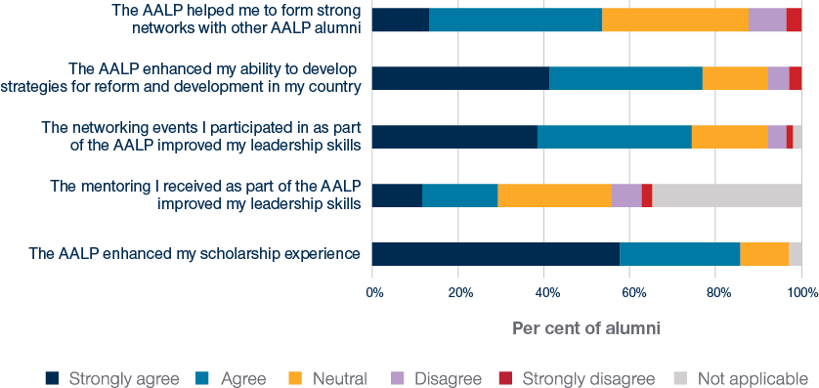

Figure 3 explores who alumni remained in contact with upon return from their award. Analysis of the survey suggests that the frequency of contact with connections alumni made in Australia due to the program is mostly occasional. Since returning from award, 43.4 per cent of alumni were ‘always’ or ‘often’ in contact with other students they met on award, and 38.1 per cent were in contact with other people they met on award. The figure also shows that almost all alumni remain in contact with other AALP alumni. While the alumni responses show that this contact is not ‘always’ happening, they nevertheless remain linked, with one in five ‘often’ or ‘always’ in contact with other AALP alumni they met in Australia, and more than two-thirds of alumni ‘sometimes’ in contact with them. However, maintaining contact with others met during the award is not as universal. For example, more than half of alumni surveyed were ‘never’ in contact with mentors and Australian professionals they met through the AALP.

Figure 3: Alumni contact with different groups on return from award (n=114)

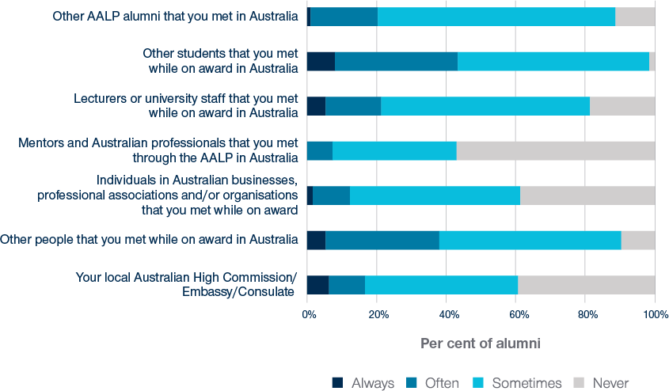

For ongoing engagement and targeted programming, it is useful to understand which groups alumni contact to find out about alumni engagement activities. Figure 4 shows alumni are most likely to reach out to other Australia Awards alumni to get information about these activities (25%). About one in five alumni find information through an AALP alumni group, including looking at relevant Facebook groups. A similar proportion of alumni indicated they get this information from their local Australian Embassy/High Commission. A small but notable group (13%) continue to seek information from their Australian university about alumni activities.

Figure 4: Sources alumni reach out to for information about alumni engagement activities (n=303)

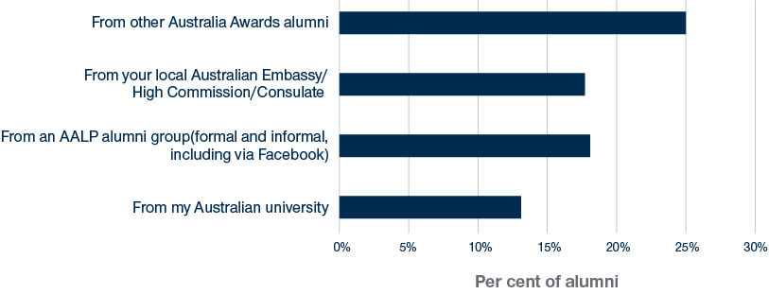

2.3 Views of Australia, Australians and Australian expertise

Alumni overall have very positive attitudes towards Australia, with most of them ‘often’ or ‘always’ recommending Australia as a place to study (96.5%) and two-thirds providing advice about developing connections with Australian businesses or professionals (Figure 5). A smaller percentage of alumni are currently working with Australians or Australian organisations as part of their job (42.1%). Most alumni also agree that the Australian Government supported their country (82.5%). Compared to the Australia Awards GTF 2020 Global Survey results, alumni from the AALP are more likely to have positive views of Australia. While they are only slightly more likely to recommend Australia as a place to study (96.5% for the AALP cohort compared with 94.3% for all alumni in the Global Survey in 2020), there is a larger jump for providing advice about developing connections with Australia (67.5% compared with 58.4%). This comparison suggests the leadership program may give alumni more resources and confidence to develop connections with Australia, and alumni are likely to benefit from extra engagement activities when on award.

Figure 5: Alumni views of Australia (n=114)

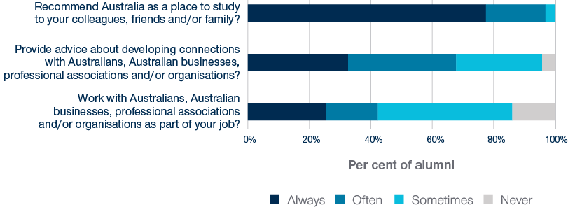

1. 3. Social network analysis of AALP alumni

Analyses of the social network data collected in the case study showed that almost 90 per cent of alumni reported developing connections with AALP peers during their participation in the program in 2013 and 2014. Seventy-eight per cent of alumni reported a current connection with at least one AALP peer, with these occurring more frequently for informal reasons (e.g. interactions linked to work or family) or when seeking to develop connections with Australia or Australian organisations. Investigation of networks in combination with alumni characteristics also showed that while many relationships between alumni were based around region location, there were also connections maintained between alumni who originated in different parts of the world.

3.1 Introduction

This chapter presents the results of the SNA undertaken in this case study. This analytical approach was used to determine:

1. if AALP alumni in the target cohort developed connections with their AALP peers during their participation in the program; and
2. if AALP alumni still maintained those connections with the AALP alumni peers in the present.

These two aims of the case study were designed to ascertain whether one of the key objectives of the AALP - to help alumni build connections with their fellow alumni peers in the program - was met.

**Social network terms**

**Ties**—Relationships in a network/between alumni

**Isolates**—Network members/alumni with no ties in a network

**Dyadic relationship**—A relationship between two people

**Clustered relationships**—Broader than a dyadic relationship, when relationships overlap with one another in a network

3.2 Alumni networks

Given the AALP was focused on connecting alumni with one another, the first network of importance for this case study was interactions between AALP alumni that developed from participation in the program. The next step was to identify interactions that still exist between AALP alumni that might be supporting their connection with Australia or career development. In total, six types of interactions or networks were investigated using the following six network questions in the alumni survey:

1. Which AALP alumni did you develop connections with (e.g. friendship or professional/collegial connections) during your participation in the program?

Alumni were then asked if they were still in contact with other AALP alumni. If they answered yes, they were asked:

1. Which AALP alumni do you contact *if you want to develop connections with Australians or Australian organisations*?
2. Which AALP alumni do you contact *for advice about job opportunities*?
3. Which AALP alumni do you contact *to share information or skills related to your field of work*?
4. Which AALP alumni do you contact *for leadership guidance or advice*?
5. Which AALP alumni do you interact with *for other informal reasons* (for example, friendship connections; family, church, other social groups)?

The data from these questions were used to create the six networks: the **AALP on-award network**, the **Australian connections network**, the **job advice network**, the **information sharing network**, the **leadership guidance network** and the **informal connections network**.

The results of the SNA are based on 123 alumni who responded to the social network section of the survey. In completing this part of the survey, an alum could nominate any of their 286 fellow AALP peers as someone they developed a connection with during their participation in the program.

To explore each network graphically, the program VPNet (SNA Toolbox Pty Ltd, 2021) was used to create network visualisations. In each visualisation, a circle is an alumni member, and a line between circles represents a tie or relationship between alumni. The arrowheads represented on the ties illustrate the direction of the relationship. For instance, if an arrowhead is shown on both ends of a tie between two circles/alumni, this indicates both alumni nominated one another in a network. However, if an arrowhead is only shown on one side of a tie, this indicates the relationship was only identified by one of the alumni.

3.3 AALP on-award network

Figure 6 shows a visualisation of the AALP on-award network. Alumni that responded to the survey are represented by orange circles. Alumni who did not respond but were nominated by others (non-respondents) are represented by grey circles.

Figure 6 and all network maps presented in this chapter show 246 AALP alumni. These alumni include the 123 alumni that responded to the survey’s social network section and an additional 123 alumni that did not respond to the survey but were nominated by others.

Figure 6: AALP on-award network: Relationships among alumni developed during their participation in the AALP (orange=survey respondents, grey=non-respondents)





Interactions in this network represent ties that alumni developed during their participation in the AALP in 2013 and 2014. Almost 90 per cent of alumni that responded to the survey nominated at least one other alumni peer as someone they connected with during their involvement in the program. Alternatively, 14 responding alumni (approximately 11 per cent of respondents) reported not developing connections with any of their AALP peers. These individuals are isolates in Figure 5, with no ties in the network. The AALP on-award network has the highest density and is the most clustered of all the networks studied in the case study. In the centre of the figure, a highly clustered group of connections are shown where relationships overlapped with each other in the broader network. Figure 5 clearly shows that the objective of the AALP to foster connections between alumni was met for most alumni that responded to the survey.

3.4 Australian connections network

Figure 7 shows the Australian connections network and is the first of five networks that represent current connections between AALP alumni rather than the retrospective connections identified in the AALP on-award network. This set of five networks were investigated to determine whether connections alumni made during their participation in the AALP have been sustained in the seven or eight years since they completed their scholarship

Figure 7: Australian connections network: Relationships among AALP alumni for developing connections with Australia (orange=survey respondents, grey=non-respondents)





Approximately two-thirds of alumni identified a fellow AALP alumni as an individual they would contact to develop connections with Australia (about 34 per cent were isolates). As the network maps show, there are some clustered interactions in the Australian connections network, with these relationships among alumni overlapping with each other. The Australian connections network is less dense than the AALP on-award network, with less ties identified between alumni.

Alumni were also asked who they contact outside of the AALP alumni network for developing connections with Australia or Australian organisations. Figure 8 presents the results for the 114 alumni that responded to this question.

Figure 7: People outside of the AALP alumni network alumni contact to develop connections with Australia or Australian organisations

Figure 7 is a blue-coloured horizontal bar chart that illustrates alumni responses to the survey question, outside of the alumni network, who do you contact if you want to develop connections with Australia or Australian organisations? 
Of the 114 alumni that responded to this question
• 30% contact Australia Award alumni from their country who did not participate in the AALP
• 18.8% contact Australia Award alumni from other countries who did not participate in the AALP 
• 16.2% contact the Australian High Commission, Embassy or Consulate in their region or country
• 25.1 % contact lecturers or university staff that they met while on Award in Australia
• 22.1 % contact Australian students they met while on Award
• 4.0% contact industry professionals who presented or mentored them at AALP events
• 20.1 % contact other Australians they met while on Award
• 0.3% contact no one and reported that they do not try to make links with Australia


Figure 8: People outside of the AALP alumni network alumni contact to develop connections with Australia or Australian organisations (n=114)

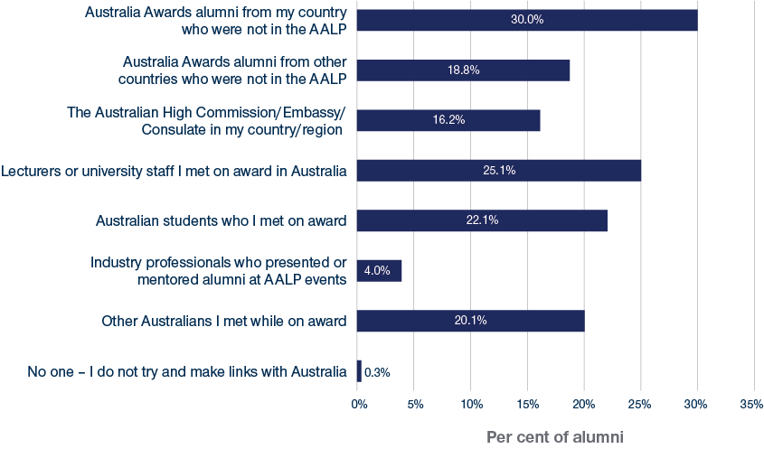

The figure shows alumni were most likely to reach out to other Australia Awards alumni from their own country (30%), and around a quarter of alumni reached out to lecturers or university staff and Australian students they met on award. Very few alumni said they would reach out to industry professionals who presented or mentored at AALP events. Only one alum responded saying they do not try to make links with Australia.

3.5 Job advice, information sharing and leadership guidance networks

In Figure 9 a visualisation of the job advice network, the information sharing network and the leadership guidance network is presented. These networks are illustrated in combination as these three networks had the lowest density or lowest number of ties of the networks researched in the case study.

Figure 9: Relationships among AALP alumni in job advice, information sharing and leadership guidance networks (orange=survey respondents, grey=non-respondents)





This network is characterised by more dyadic interactions between alumni. In other words, connections tend to occur between two alumni instead of being clustered or overlapping with other connections in the network. This finding fits with the type of interactions represented in Figure 9. For instance, it is more likely that people have a small number of trusted contacts who they go to for leadership advice rather than many relationships, which are overlapping within a larger network of people.

Fifty-seven per cent of responding alumni nominated a fellow AALP peer as someone they seek job advice and/or leadership guidance from and/or share information relating to their work, with approximately 43 per cent of responding alumni reporting no ties in the network. This result may suggest that some alumni are more active in seeking job advice and leadership guidance from or sharing work-related information with individuals outside the AALP alumni cohort.

3.6 Informal connections network

Figure 10 is a visualisation of the informal connections network – that is, the ties that alumni continue to have with each other on an informal level.

Figure 10: Informal connections network: Relationships among AALP alumni linked to family, church and/or other social groups (orange=survey respondents, grey=non-respondents)





The informal connections network is more clustered than the job advice, leadership guidance and information sharing networks. This aligns with the more social basis of informal connections, which are more likely to be interconnected like that seen in a network of friendships (i.e. people can often be friends with their friends’ friends). Approximately two-thirds of responding alumni reported having an informal connection with at least one other AALP alumni. These data, and those represented in the previous two network figures, suggest that the most common types of interaction currently occurring between alumni tended to be informal or interactions relating to developing connections with Australia.

3.7 Combining networks - current connections

To provide a combined picture of all current connections between AALP alumni investigated in the case study, Figure 11 visualises the five networks that focused on connections that alumni reported existing in the present.

Figure 11: Combined current relationships among AALP alumni in Australian connections, job advice, information sharing, leadership guidance and informal connections networks (orange=survey respondents, grey=non-respondents)





The combined data for the set of five current networks – the Australian connections, job advice, leadership guidance, information sharing and information connections networks – show a clustered structure with an interconnected group of alumni in the centre of the picture. Creating a collective picture of current interactions between alumni allows for a comparison between these connections and the connections in the AALP on-award network, where the focus was interactions between alumni that developed during their participation in the program from 2013 to 2014. Seventy-eight per cent of responding alumni identified current connections with other AALP peers compared with almost 90 per cent of alumni that noted they had developed connections with other AALP alumni during their participation in the program from 2013 to 2014. While it is possible that the networks investigated in the case study did not capture all the types of relationships where alumni interactions were currently occurring, these data suggest that many connections alumni developed in 2013 to 2104 on award were likely sustained into the present day.

3.8 Networks and alumni characteristics

In addition to mapping the structure of connections between individuals, SNA can also look at patterns between connections and the characteristics of individuals in a network. In this case study, this allowed for an exploratory investigation of the networks examined and alumni characteristics (e.g. region of origin and alumni views of the AALP) reported in Chapter 2 (Australia Awards long-term outcomes).

3.8.1 Networks by region

One of the implications of encouraging alumni in the AALP to build networks or connections with one another is that these links encourage cross-country partnerships and potentially strengthen alumni’s relationship with Australia. To explore whether connections were made during the program between alumni from different areas around the world, Figure 11 shows the AALP on-award network and illustrates alumni region of origin.

Figure 12: Relationships among AALP alumni developed on-award and alumni region

In Figure 12, relationships between alumni for the AALP on-award network are illustrated in a network map. The AALP on-award network map shows 246 circles where each circle represents an alumnus. One hundred and twenty-three of the circles/alumni are coloured light grey and are small in size to show that these alumni did not respond to the survey but were nominated by one or more of the 123 respondent alumni in the social network survey questions. The remaining 123 circles are different colours with each colour representing the alumni region of origin. Blue circles show alumni from the Caribbean, orange circles show alumni from East Asia, green circles show alumni from Latin America, yellow circles show alumni from the Pacific Islands, dark grey circles show alumni from Papua New Guinea, purple circles show alumni from South and West Asia, and red circles show alumni from Sub-Saharan Africa. Lines between circles/alumni are used to illustrate relationships in the network and these are coloured red in the AALP on-award network. Arrowheads on the end of the lines indicate the direction of the nominated relationship.The network map shows:• A large group of circles/alumni in the centre of the map that are connected to each other by red lines. Many of these relationships/lines overlap. • 6 groups of pairs are also represented and are separate from the larger group in the centre of the map.• The large group of circles/alumni in the centre of the map are different colours but they are predominantly purple, orange and red. Most circles of a specific colour are connected to other circles of the same colour (i.e. alumni from the same region are connected). There are some connected circles that are different colours (i.e. alumni from different regions are connected). • 14 of the multi-coloured circles/alumni that responded to the social network survey questions (i.e. not the smaller, light grey circles) are unconnected to any other alumni in the network. These circles, 5 light grey circles and 6 pairs of circles are spread out in a circular ring around the larger group of circles in the middle. • The 14 circles representing alumni that responded to the social network questions and were unconnected to any other alumni are orange, yellow, green, dark grey and red.

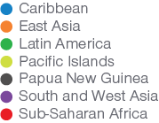

In Figure 12, alumni relationships developed during participation in the AALP in 2013 to 2014 are shown with the colour of the circles representing alumni’s region. Some of the connections between alumni in the clustered group in the centre appear to be region-based, particularly for alumni from South and West Asia and alumni from East Asia. However, the overlapping nature of the connections in this clustered group suggests connections were developed in 2013 to 2014 between alumni from different regions.

Figure 13 combines information about alumni region with the current networks investigated in the case study or those that alumni reported existing in the present.

In Figure 13, relationships between alumni for the Australian connections, job advice, information sharing, leadership guidance and informal connections networks are illustrated together in the same network map. The combined network map shows 246 circles spread out in a circular pattern where each circle represents an alumnus. One hundred and twenty-three of the circles/alumni are coloured light grey and are small in size to show that these alumni did not respond to the survey but were nominated by one or more of the 123 respondent alumni in the social network survey questions. The remaining 123 circles are different colours with each colour representing the alumni region of origin. Blue circles show alumni from the Caribbean, orange circles show alumni from East Asia, green circles show alumni from Latin America, yellow circles show alumni from the Pacific Islands, dark grey circles show alumni from Papua New Guinea, purple circles show alumni from South and West Asia, and red circles show alumni from Sub-Saharan Africa. Lines between circles/alumni are used to illustrate relationships in the network and these are coloured blue for Australian connections relationships, pink for job advice relationships, grey for information sharing relationships, black and dotted for leadership guidance and green for informal connections relationships. Arrowheads on the end of the lines indicate the direction of the nominated relationship.The combined network map shows:• A group of circles/alumni in the centre of the map that are connected to each other by blue, pink, grey, dotted black and green lines. Many of these relationships/lines overlap and most of them are blue or green.• A few groups of alumni in pairs or triads who are tied to each other but that are separate from the larger group in the centre of the map. • The large group of circles/alumni in the centre of the map are different colours but they are predominantly purple, orange and red. Most circles of a specific colour are connected to other circles of the same colour (i.e. alumni from the same region are connected), particularly purple and orange circles. There are some connected circles that are different colours (i.e. alumni from different regions are connected). • 27 of the multi-coloured circles/alumni that responded to the social network survey questions are unconnected to any other alumni in the network. These 27 circles are orange, yellow, green, dark grey, blue, purple and red.

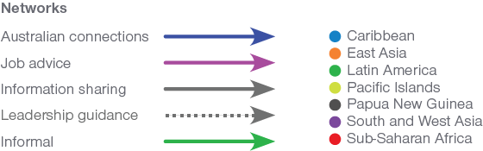

Figure 13: Combined current relationships among AALP alumni in Australian connections, job advice, information sharing, leadership guidance and informal connections networks, and alumni region

Again, many of the connections between alumni appear to be region-based, however, Figure 13 also shows that some of the connections currently maintained between alumni occur between individuals from different regions of the world.

3.8.2 Networks by perceptions of AALP

Examining alumni networks in conjunction with alumni views of whether the AALP helped them develop sustained connections with their AALP peers is useful for determining how effective the program was in achieving its networking objectives. Figure 14 shows the networks that alumni reported existing in the present along with identifying alumni (light blue circles) who agreed or strongly agreed that ‘the AALP helped me to form strong networks with other AALP alumni’.

Figure 14: Combined current relationships among AALP alumni in Australian connections, job advice, information sharing, leadership guidance and informal connections networks, and alumni that agreed (light blue circles) that the AALP helped them form networks with AALP peers



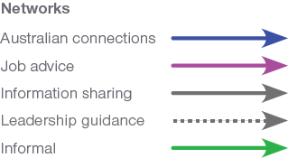

Many of the alumni that believed the AALP had helped them connect with other AALP peers are represented in the centre group of clustered relationships and are well connected in the network.

1. 4. Conclusion and implications for enhancing targeted on-award program outcomes

4.1 Summary of findings

The social network approach adopted in this case study provides insight into whether the objective of the AALP to build connections between alumni was accomplished. Responses from the alumni survey also illustrate if the Australia Awards long-term Outcome 2, encouraging cooperation, and Outcome 4, fostering positive alumni perceptions of Australia as a result of their award experience, are being achieved.

Conclusions drawn from this case study are based on the responses of the 129 alumni that completed the survey and are not necessarily representative of all alumni of the AALP in 2013 and 2014. However, findings from the case study do present an opportunity to better understand alumni award experience and the implication of this experience for their attitudes towards Australia, current contact with Australia and the maintenance of their relationships with other AALP in the seven to eight years after completing their scholarship.

4.2 Implications

Table 1 lists the key findings of this case study and links each to an implication for future programming.

Table 1: Key findings and implications for the AALP case study

| **Key findings** | **Implications for future programming** |
| --- | --- |
| Alumni of the AALP are leaders in their organisations and communities. These alumni indicate that the AALP:   * enhanced their ability to contribute to development in their home country * improved their overall Australia Awards experience * helped to build leadership skills. | The inclusion of supplementary programs to the Australia Awards scholarships are valued by participants and are linked to successful long-term outcomes.  Future programs along these lines, whether ad hoc, or consistently run may be beneficial for some cohorts of Australia Awards scholars, providing an additional enhancement to their award experience and outcomes. |
| Almost 90 per cent of alumni reported developing connections with AALP peers during their participation in the program in 2013 and 2014. | In-person events and supplementary programs to the Australia Awards encourage connections to develop and should be more widely considered (perhaps at the beginning and the end of the award to help strengthen connections already developed). |
| Seventy-eight per cent of responding alumni maintain current connections with other AALP peers – up to eight years since completing their award. | Further to the suggestion above, the evidence here shows that fostering on-award connections do lead to on-going networks. |
| Approximately two-thirds of responding alumni network with fellow AALP alumni directly for the purpose of developing Australian connections. | Supplementary programs like the AALP are useful in not only connecting alumni to each other, they also directly help foster connections with Australia. Conferences involving industry and DFAT, as well as mentoring programs are useful supplements to the Australia Awards and enhance cooperation with Australia (Australia Awards long-term Outcome 2. |
| Ongoing connections and alumni networks developed as part of the AALP are truly global, with SNA showing their span across regions. | Future focus of supplementary programs that are offered to alumni from various parts of the world, can be pivotal in developing global networks for alumni. |

1. 5. Abbreviations and Acronyms

AALP Australia Awards Leadership Program

AAS Australia Awards Section (DFAT)

DFAT Department of Foreign Affairs and Trade

GTF Australia Awards Global Tracer Facility

SNA Social network analysis

1. Annex 1: Methodology

This annex describes the methodological approach used in this case study, including the design, survey development and fieldwork implementation. It also discusses the limitations associated with carrying out a case study of this kind in relation to contacting alumni and response bias.

Case study design

As noted in the introduction, the core aims specific to this Australia Awards Leadership Program (AALP) Case Study are:

* To determine if AALP alumni in the target cohort developed connections with their AALP peers during their participation in the program; and
* To determine if AALP alumni still maintained those connections with their AALP alumni peers in the current day.

Alongside these specific aims, all research conducted by the Australia Awards GTF is framed within the overall aim of the Australia Awards: to help ‘partner countries progress their development goals and have positive relationships with Australia that advance mutual interests’. Further detail relating to this aim is articulated through the long-term outcomes of the Australia Awards and detailed in the Australia Awards Global Strategy[6] and Australia Awards Global Monitoring and Evaluation Framework.[7] At the time of conducting this case study, the long-term outcomes of the Australia Awards are:

* **Outcome 1:** Alumni are using their skills, knowledge and networks to contribute to sustainable development.
* **Outcome 2:** Alumni are contributing to cooperation between Australia and partner countries.
* **Outcome 3:** Effective, mutually advantageous partnerships between institutions and businesses in Australia and partner countries.
* **Outcome 4:** Alumni view Australia, Australians and Australian expertise positively.

The Australia Awards long-term outcomes and the specific aims developed for this case study provided the framework for the design of this research in terms of the survey instrument development and the analysis of outcomes.

Survey instrument development

The survey instrument used in this case study was designed to collect data on connections between AALP alumni developed during their program participation and those connections maintained now. Different types of connections between alumni were investigated. The survey instrument was also designed to capture information on some of the Australia Awards long-term outcomes, in particular Outcomes 2 and 4.

The final structure of the survey developed for the case study was:

Section 1—Introduction & Social Networks:

* Participation in the AALP and characteristics of that participation (e.g., mentoring and work placements)
* Networks among alumni developed during participation in the AALP
* Networks among alumni sustained in the present relating to:
  + Connecting with Australians or Australian organisations
  + Seeking advice about job opportunities
  + Sharing information and skills related to field of work
  + Seeking leadership guidance
  + Connections among alumni that exist outside of work, scholarships etc. (e.g., family, church, friends)
  + Other connections with Australia or Australian organisations.

Section 2—Australia Awards long-term outcomes:

* Views of the AALP
* Views of Australia and Australians
* Ongoing contact with people met on award
* Connections while in Australia
* Australian alumni engagement activities.

Section 3—Background information:

* Employment
* Leadership positions
* Award details
* Demographic characteristics.

Target population

The target population of this case study were Australia Awards alumni that participated in the Australia Awards Leadership Program (AALP), specifically the 2013 and 2014 cohorts. This cohort was targeted because of the in-person networking events they engaged in in Canberra in 2014. It was hypothesised that directors of the program designed these networking events as an opportunity for alumni to make connections with one another and develop their leadership skills. Thus, the case study investigation focused on determining whether these events succeeded in socially connecting alumni and whether these connections were still active seven years later.

Data relating to this target population was compiled via two means. First, DFAT’s AAS provided the GTF with its lists of alumni that participated in the AALP in the focus years. The GTF researchers supplemented this list with an extract of alumni contact information from the DFAT Global Alumni database.

In total, 287 alumni were identified as fitting in the target population for this research. Of this group, 271 had an email address listed in the database. However, once invited via email, 68 of these alumni had email addresses that were not current and ‘bounced back’. Furthermore, five alumni responded that they did not want to participate in the AALP and were removed from the target list. Thus, 198 alumni were successfully invited to participate in the survey.

Fieldwork

Survey data collection was conducted using an online survey platform. Each alum in the target population was provided with a unique URL to link to the survey via email invitation. The GTF employed an approach to survey collection which involved: having a clearly defined target population; identifying the extent to which the target population can be reliably contacted; and providing each member of the population with a unique access link to the survey. This approach helps to ensure accurate data collection, enables a clear understanding of response patterns, and provides a baseline for which to examine the validity of survey responses and findings.

Prior to full survey implementation, alumni in the target population were contacted to inform them of the upcoming survey and provide an opportunity for them to opt-out of participation.[8] Fieldwork commenced on October 18 and closed on November 11, 2021. Survey response data were collected and stored on servers in Australia. Throughout the fieldwork period, response data was routinely extracted by the GTF team and used for updating response lists. Alumni who had not responded to the survey were contacted via email with personalised reminders to complete the survey.[9] In total, four reminder emails were sent during fieldwork to encourage alumni to participate in the survey.

Of the 198 alumni successfully contacted via email and invited to participate, **129 responded to the survey and were included in the analysis for this report—a response rate of 65 per cent.** This rate of response is high in the experience of the GTF research and in relation to other alumni-based development surveys undertaken worldwide. For example, in the GTF Global Tracer Surveys, conducted in 2016–17, 2017–18 and 2018–19 across all Australia Awards recipient countries, achieved response rates of between 23 and 36 per cent.

Limitations

Positive response bias

It is probable that alumni who felt that they had a positive experience as an Australian Government scholarship recipient and/or had success in their career following their award are more likely to agree to participate in Case Studies. In a study by the Commonwealth Scholarship Commission in the UK,[10] recognition of positive response bias is highlighted:

…there is widespread recognition that a more pressing problem is nonresponse bias in which those who reply to sample surveys are likely to be engaged with alumni associations or tracing (e.g. Day, Stackhouse and Geddes, 2009) and disproportionately represent the ‘successful’ outcomes of scholarship programmes (p.9).

Accordingly, it is possible that the alumni in this study had a positive bias towards their experience, outcomes and views of Australia. It is also possible that those alumni who formed networks as part of their scholarship were also more likely to participate in the study. This overall potential for bias needs to be understood and taken into account when exploring the responses and outcomes of the work.

However, it is important to note that in the research design for this study, the GTF was conscious of this potential issue and put in place practices to better control and understand bias that may be present. Strategies in this regard include:

* being clear on the definition of the population involved and understanding the characteristics of the target population;
* linking alumni in the target population to a unique URL for accessing the survey, so as to have a clear understanding of alumni respondents and non-response;
* comparing the characteristics of alumni who responded to the survey and those who did not to identify any measurable differences in these groups (in particular, gender, region and year of participation);
* developing survey items focussed on avoiding leading questions and ensuring a wide range of response options;
* working carefully during fieldwork to provide tailored ‘reminder’ emails to alumni to encourage high levels of participation.

Social Network Analysis

SNA is more susceptible to issues of missing data than other traditional research approaches and therefore the higher the response rate of participants in the target population, the greater the reliability of conclusions made from the analysis. Importantly, in this case study, the response rate achieved (65%) is very high for alumni tracing surveys (especially given this cohort completed their scholarships seven or eight years prior to the survey). Given this, the data collected for this study provide SNA findings that are strong indications of the outcomes and interactions across the whole alumni network but need to be considered as indicative rather than definitive.

Even though the response rate obtained for this case study was better than many other GTF surveys, future SNA case studies would benefit from a greater response rate that makes it possible to obtain a more complete picture of the interactions between alumni in a network. For instance, a higher response rate would illustrate whether the 123 alumni that were included in the SNA but did not complete the survey would have reciprocated the nominations made by their alumni peers and/or nominated other alumni beyond the 246 that were included in the analyses.

1. https://www.dfat.gov.au/publications/people-people/kiribati-case-study-mapping-alumni-networks-and-links-australia
2. See: https://www.dfat.gov.au/sites/default/files/australia-awards-global-strategy.pdf
3. See: https://www.dfat.gov.au/sites/default/files/australia-awards-global-monitoring-evaluation-framework.pdf
4. ‘Contactable’ alumni are those where the GTF had an email address that did not ‘bounce-back’ when alumni were contacted. It is likely that among this ‘contactable’ group, some email accounts are no longer monitored, or not regularly monitored, and hence the actual number of alumni who read/received the invitations to participate is likely to be smaller than the population defined here.
5. See: https://www.dfat.gov.au/people-to-people/australia-awards/australia-awards-global-tracer-facility-year-5-results/australia-awards-alumni-global-tracer-survey-2020
6. See: https://www.dfat.gov.au/sites/default/files/australia-awards-global-strategy.pdf
7. See: https://www.dfat.gov.au/sites/default/files/australia-awards-global-monitoring-evaluation-framework.pdf
8. One aspect of participating in the SNA aspects of the survey included the use of a dropdown list of alumni participant names – designed to aid the listing of alumni for each of the network questions asked. Alumni were informed of this prior to fieldwork and asked to notify researchers if they did not want to participate. One alum requested their name not be included in the list of participants.
9. For example, alumni who had started the survey but not completed were encouraged to finish; and alumni who had been mentioned by others as members of their network were sent a tailored message.
10. Mawer, M. (2014). A study of research methodology used in evaluations of international scholarship schemes for higher education. Commonwealth Scholarships Commission. London.