Australia Awards Global Tracer Facility
Case Study in Pakistan in governance and leadership
June 2019

Table of contents
Acronyms and abbreviations 4
Executive Summary 5
1. Background of the Study 9
1.1 Objectives 9
1.2 Scope 10
1.3 Country context 10
1.4 Alumni and other interview participants 13
2. Development Outcomes 14
Summary findings 14
2.1 Introduction 15
2.2 Background 15
2.3 Skills developed on award 16
2.4 Alumni contributions 17
2.5 Enabling factors 24
2.6 Challenging factors 27
3. Economic and Public Diplomacy Outcomes 29
Summary findings 29
3.1 Introduction 30
3.2 Background 31
3.3 Networks and links developed on award 31
3.4 Examples of bilateral collaboration and institutional links 32
3.5 Enabling factors 37
3.6 Challenging factors 38
4. Views about Australia and Australian Expertise 41
Summary findings 41
4.1 Introduction 42
4.2 Examples of positive views of Australia and Australian expertise 43
4.3 Enabling factors 46
4.4 Challenging factors 47
5. Impact of Australia Awards on Addressing Equity Issues 50
Summary findings 50
5.1 Introduction 50
5.2 Gender Equality 51
5.3 Disability Inclusion 54
5.4 Economic disadvantage 56
6. Conclusion 58
7. Alumni Profiles 59
References 65
Annex 1: Methodology 69
Annex 2: Case Study Propositions 76
Annex 3: Key Participant Questions 78

Tables
Table 1 Pakistan Case Study alumni participants 71
Table 2 Key stakeholder and employer/colleague interviews 72

Acronyms and abbreviations
AAA-Pakistan | Australia Awards Alumni – Pakistan
ACIAR | Australian Council for International Agricultural Research
AusAID | Australian Agency for International Development (former)
CAO | Chief Accounts Officer
CBOs | Community-based organisations
CEO | Chief Executive Officer
CHIP | Civil Society Human and Institutional Development Programme
DFAT | Australian Government Department of Foreign Affairs and Trade
GDP | Gross Domestic Product
GM | Genetically modified
GNI | Gross National Income per capita
IELTS | International English Language Testing System
ILOs | Informal Learning Opportunities
LUMS | Lahore University of Management Sciences
MoU | Memorandum of understanding
NGOs | Non-government organisation
PIFRA | Project for Promotion for the Improvement of Financial Reporting and Auditing in Pakistan
SCB | Scholarships and Alumni Branch (DFAT)
TVET | Technical vocational education and training
UK | United Kingdom
UN | United Nations
USA | United States of America
WEF | World Economic Forum
WIL | Work Integrated Learning

Executive Summary
This report is based on interviews with six alumni and various stakeholders to examine the long-term outcomes of Australian Government scholarship alumni from Pakistan. The alumni of focus for this Case Study undertook scholarships in Australia in studies relating to governance and leadership, and graduated in the early 2000s. This research was conducted by the Department of Foreign Affairs and Trade’s (DFAT) Australia Awards Global Tracer Facility (the Facility).
The overall aim of the Australia Awards is to help ‘partner countries progress their development goals and have positive relationships with Australia that advance mutual interests’. This aim is extrapolated in four long term outcomes for the Australia Awards, which form the basis of the findings for the alumni from this Case Study.

Outcome 1: ‘Alumni are using their skills, knowledge and networks to contribute to sustainable development’
Alumni in this Case Study have used the skills and knowledge developed in Australia to make contributions in Pakistan to:
- strong governance – by reshaping the public sector governance model, developing transparent and efficient financial practices for ministries, and improving organisational infrastructure and capacity within local NGOs and community-based organisations (CBOs)
- effective leadership – through holding positions of leadership in the NGO and government sectors, advocacy for the rights of minorities, and facilitating gender mainstreaming across various projects
- capacity building – by rebuilding education systems and training teachers following significant natural disasters; teaching financial management, evaluation and development courses for public servants; and building skills in local NGOs and CBOs.
For the alumni in this Case Study, Australia Awards Outcome 1 – development contribution – is being achieved.

Outcome 2: ‘Alumni are contributing to cooperation between Australia and partner countries’
Alumni in this Case Study have maintained various relationships with Australians in the years following their scholarship. Ongoing connections highlighted by these alumni include:
- communication with Australian professors who have offered alumni technical assistance and collaborated on academic papers
- informal networks with classmates and other international students met on award
- events with the Australian High Commission and Australia Awards Pakistan, including workshops, and engagement through the Alumni Network.
For alumni in this Case Study, Australia Awards long-term Outcome 2 – cooperation with Australia – is being achieved.

Outcome 3: ‘Effective, mutually advantageous partnerships between institutions and businesses in Australia and partner countries.’
This outcome was not a specific priority of the scholarships in the early 2000s when these alumni were studying and as such there are relatively few examples among this group of alumni. However, one particular example of institutional partnerships being formed is a:
- formal research collaboration through a Memorandum of Understanding between the Lahore University of Management Sciences and the University of Melbourne.
For alumni in this Case Study, Australia Awards long-term Outcome 3 – partnerships with Australia – is partly achieved.

Outcome 4: ‘Alumni view Australia, Australians, and Australian expertise positively’
While almost two decades have passed since these Alumni studied in Australia, their enduring positive views of Australia remains strong. In particular these alumni strongly expressed positive opinions about:
- the high quality of Australian education – including the expertise of their professors, and the academic support provided on-award
- Australian lifestyle and culture based on their experiences living in Australia
These alumni continue to be important advocates of Australia, sharing their positive experiences with family, friends and colleagues, and recommending Australia as a study destination.
For alumni in this Case Study, Australia Awards long-term Outcome 4 – positive views of Australia is being achieved.

Addressing social inclusion
Australian scholarships in Pakistan have long held a unique position in the country, balancing merit with equity in the selection of awardees. The Australia Awards Pakistan and Australian High Commission demonstrate their commitment to social inclusion through their actions, policies and processes which emphasise gender equality, disability inclusion, and provincial representation. This has resulted in generating an impact by alumni contributing to enhancing equity in these areas.
The alumni of focus in this Case Study have made substantial contributions towards the empowerment of women in Pakistan and in their region through the design and delivery of education programs, and advocacy work in policy.

Factors contributing to these outcomes
Based on the evidence collected in this Case Study, the success of the scholarship for these alumni has been due to a number of important factors including:
- each individual’s motivation to make a difference
- the relevance and quality of the skills developed while on scholarship
- exposure to a different culture and different approaches to education and work
- support from employers – particularly for those in the government sector.
The continuation of these supports and policies for selection in the Australia Awards will increase the likelihood of successful outcomes for alumni in the future.

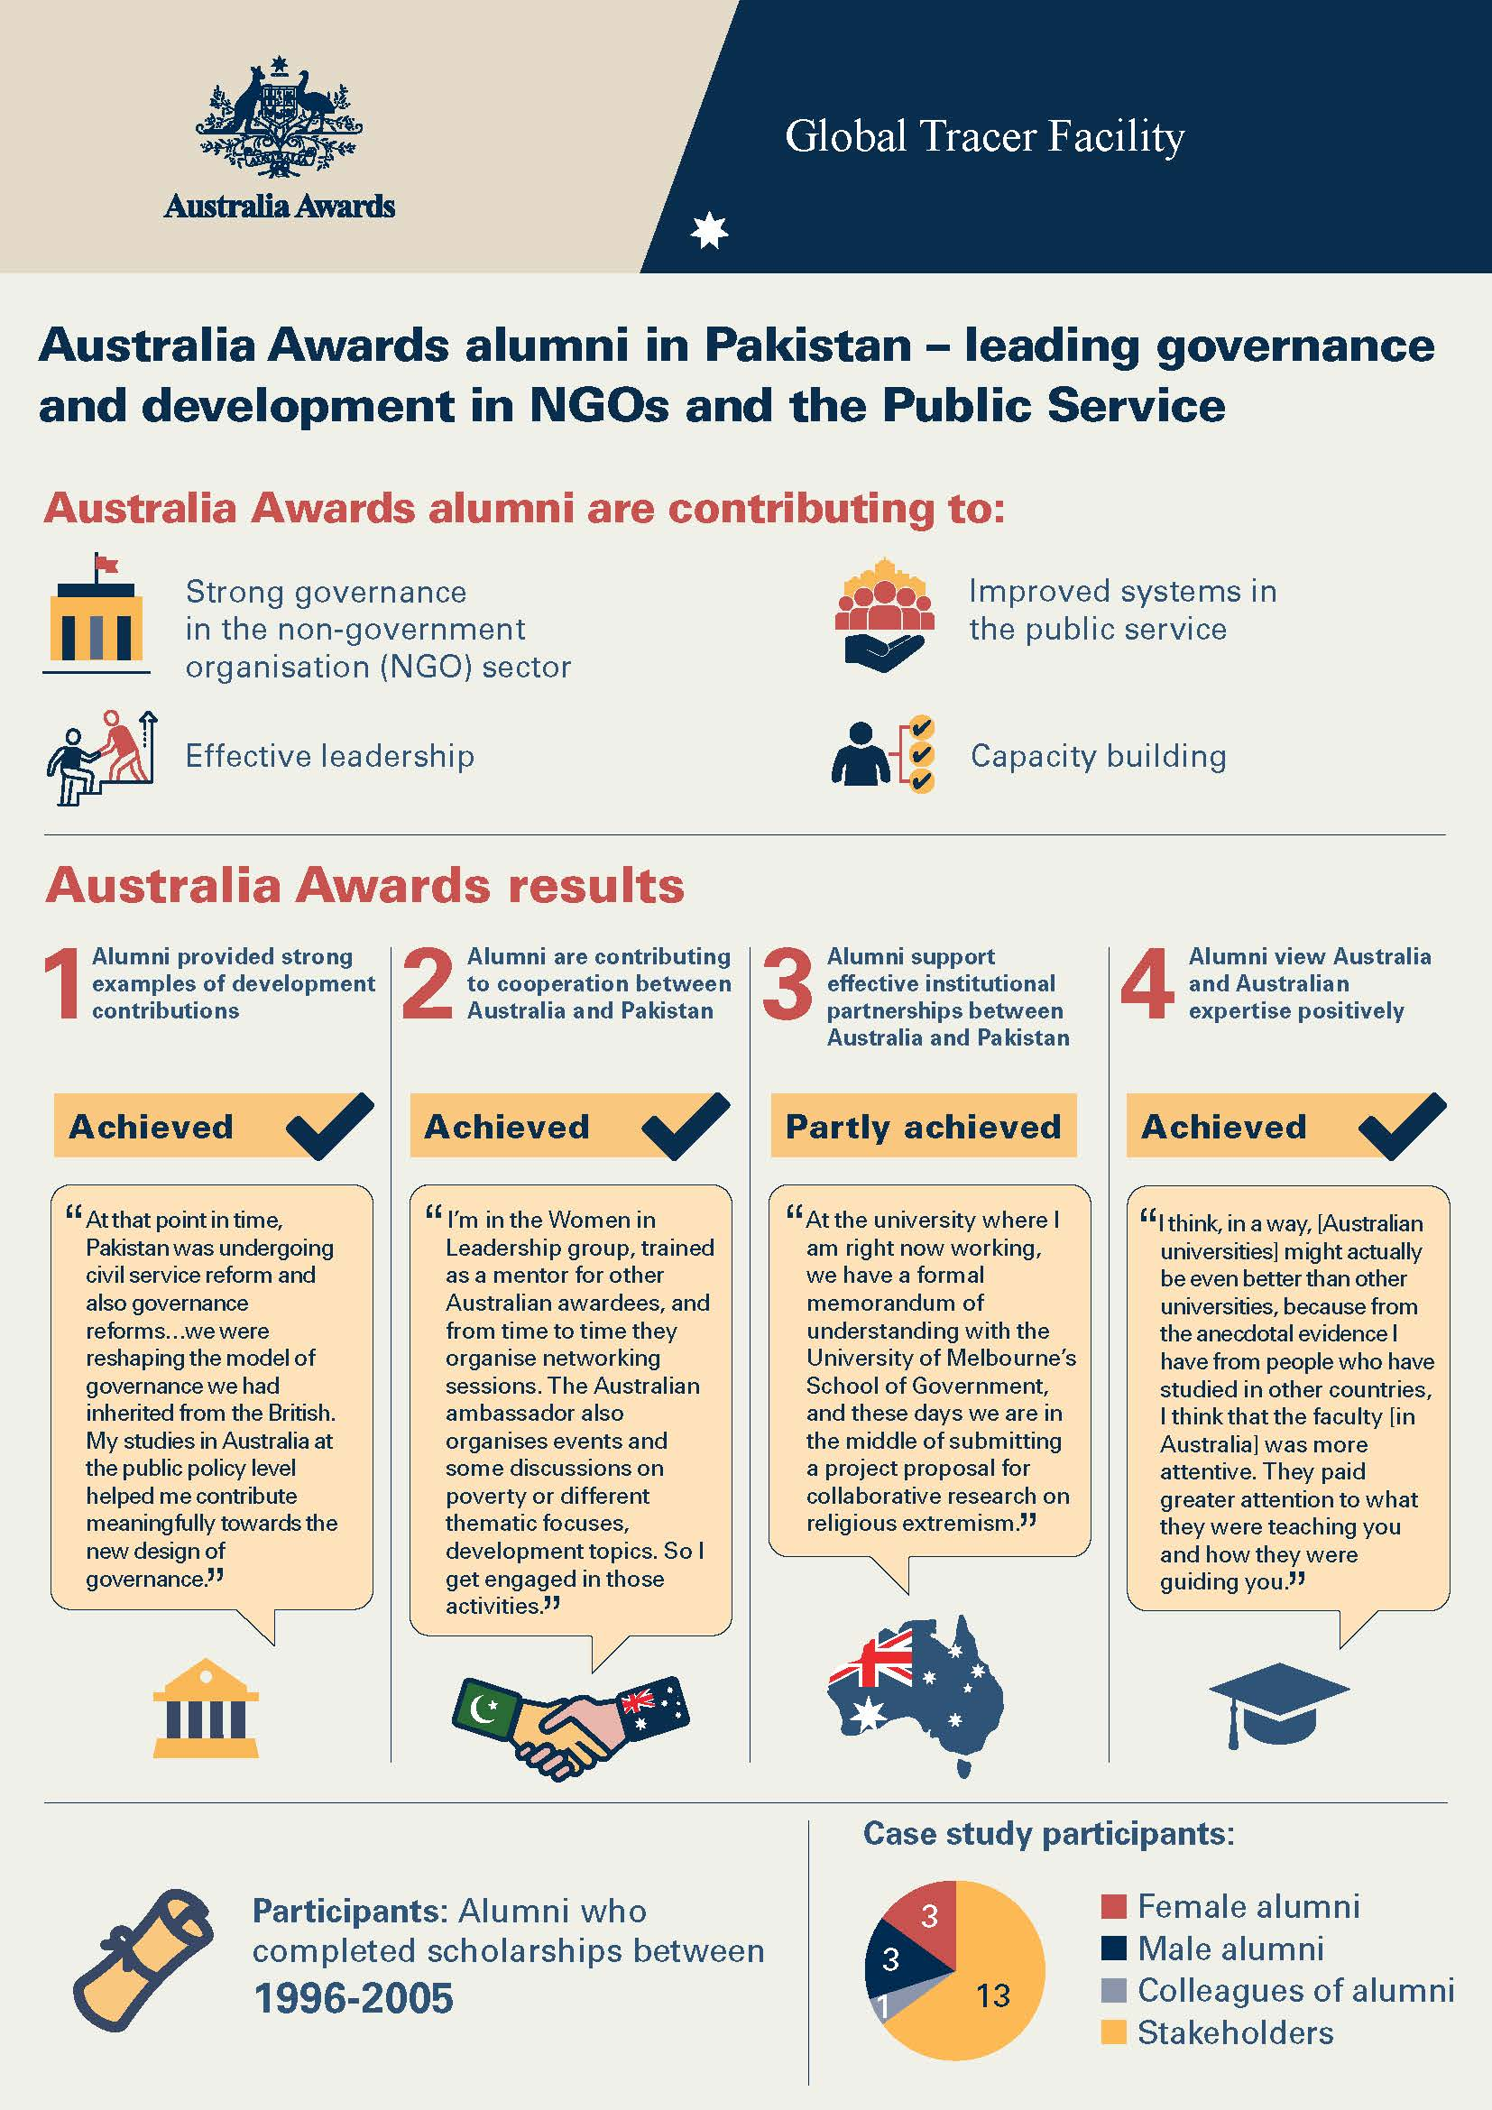

Background of the Study
The Australia Awards Global Tracer Facility (the Facility) is a four-year project funded by DFAT. Through this project, DFAT assesses the development contributions and public and economic diplomacy outcomes of Australia’s investment in the Australia Awards. The key research and reporting activities being undertaken are a quantitative Tracer Survey and qualitative Case Studies, which are prepared concurrently throughout the four years of the project.
This report gives the key findings of the Pakistan Case Study, which focussed on alumni who had studied under scholarship in the early 2000s in areas relating to leadership and governance. The majority of the data collection for this Case Study was undertaken by Facility researchers in Islamabad in late April and early May 2019.

Objectives
The Facility seeks to generate high-quality information on former scholarship holders, with a focus on less recent alumni. This information provides a strong evidence base for country programs and the Scholarships and Alumni Branch (SCB) of DFAT to evaluate the impact of Australia Awards on alumni and, by implication, on their home institutions and countries.
All research by the Facility is undertaken with close reference to the long-term outcomes of the Australia Awards. These outcomes underpin the interviews, surveys and the reporting of the Facility. The long-term outcomes are detailed in the Australia Awards Global Strategy: Investing in the next generation of global leaders for development 2016-2018 (the Strategy) and the Australia Awards Global Monitoring and Evaluation Framework (the Framework). These are:
- Outcome 1: Alumni are using their skills, knowledge and networks to contribute to sustainable development.
- Outcome 2: Alumni are contributing to cooperation between Australia and partner countries.
- Outcome 3: Effective, mutually advantageous partnerships between institutions and businesses in Australia and partner countries.
- Outcome 4: Alumni view Australia, Australians and Australian expertise positively.
In addition to these long-term outcomes, the Australia Awards aims to address issues of gender equality and disability inclusiveness. As such, the analyses and reporting of the Facility explores these cross-cutting issues, as well as other factors relating to disadvantage which impacts the ability of alumni to contribute to these outcomes following their award.

Scope
The Facility’s specific focus is on alumni of DFAT’s Australia Awards and previous DFAT-funded scholarships programs, awards and fellowships. For each Case Study undertaken by the Facility, this focus is further refined to a specific cohort of alumni based on the years they completed their scholarship and particular field of education or sector.
For this Pakistan Case Study, the research focus is on alumni who completed their scholarships in the early 2000s and studied a course that had an emphasis on building capacity relating to governance and leadership.

Country context
Pakistan is a country of 208 million people and is the second largest economy in South Asia (after India) (DFAT, 2019a). While its gross domestic product (GDP) is growing, Pakistan is a lower middle-income status country according to the World Bank (2019a). Nearly 30 per cent of the population live in poverty (DFAT, 2018) and Gross National Income per capita (GNI) for 2018 was US$1,580 (by comparison, Australia’s GNI was US$53,190) (World Bank, 2019b).
Current fiscal concerns for the country relate to its level of debt and an imbalance of trade. Other challenges facing Pakistan include a growing population (expected to double to 400 million people by 2050) and significant variation in services such as access to education across the different provinces in the country. Pakistan’s development is also curtailed by security concerns relating to violent extremism and ongoing instability due to conflict on its borders (Warner, 2018). While the security threat has been reducing in the past few years, the situation in this regard can change rapidly. A recent example of this volatility relates to tensions on the India-Pakistan border in early 2019.
The recent election of Imran Khan as Prime Minister of Pakistan has offered some optimism for the future of the country. Imran Khan was elected on a platform of anti-corruption, fighting poverty and increasing the provision and quality of health and education across the population (DFAT, 2018).
Australia established diplomatic links with Pakistan in 1947 when the country was partitioned from India. It has an ongoing interest in the country and contributes to its development. Australia is among the top ten donor countries to Pakistan. However, this contribution is relatively small compared to the larger donors, accounting for 0.8 per cent of total Official Development Assistance to Pakistan (DFAT, 2018). Key priority areas identified by Australia in relation to Pakistan include skills shortages, energy and infrastructure problems, low female workplace participation, and relatively small levels of trade. Australia also identifies illiteracy (45 per cent of adults are illiterate), and non-attendance at school (particularly for girls) as significant barriers to progress in Pakistan.
In response to these concerns, Australia’s engagement in Pakistan is focused on the following strategic objectives:
- generating sustainable, inclusive economic growth and employment
- investing in Pakistan's people with a focus on women and girls
- supporting stability and resilience.
These strategic objectives of Australian aid in Pakistan are developed to ‘align with and support Pakistan's development policy, Vision 2025’ as well as to link with Australia’s overall aid policy (Australian High Commission, Islamabad, n.d.). Further detail relating to Pakistan’s Vision 2025 is included in the following chapter.

Islamabad. Photo: Australia Awards Global Tracer Facility

Australia Awards in Pakistan
The Australia Awards in Pakistan has had an ongoing presence for many decades, and in 2018, 45 long-term Australia Awards scholarships were provided to applicants from Pakistan. Other aspects of the Australia Awards include alumni activities. In 2018, six major activities were undertaken, including a mentorship program for the Women in Leadership Network, and short courses (recently including a technical vocational education and training (TVET) focus). The Australian High Commission also uses ‘Informal Learning Opportunities’ (ILO) funded activities to support, and build capacity among Australia Awards alumni.

The unique position of the Australia Awards in the Scholarships Market in Pakistan
Australia Awards in Pakistan operate within a context of numerous donor country scholarship programs. Countries who are prominent in the ‘market’ include the United States of America (USA), the United Kingdom (UK), China, Japan, Germany and the Netherlands. Within this mix of scholarship offerings are significantly large programs, such as the USA and (increasingly) China, as well as smaller but highly prestigious programs such as the UK’s Chevening Scholarships.
Australia’s position in the scholarships market in Pakistan is notable for its uniqueness. This unique aspect comes from the balance of merit and equity in its approach to selection and support. No other scholarships mandate a 50 per cent quota for women, and few go out of their way to ensure inclusive policies exist to encourage participation by people with disability. At the same time, the scholarships maintain a competitive edge and offer access to high-quality educational institutions which maintain their strict entry hurdles for scholars.
Another aspect that differentiates the Australia Awards is its focus on postgraduate education and providing scholarships to applicants who have five years of work experience. The aim being to invest in people who have begun their careers and can identify specific fields in postgraduate education that will help them consolidate their existing experience and build their ability to contribute.
The awards also focus on development, with an important aspect of selection requiring submission of a development impact plan in which applicants explain how the skills acquired through the Australia Awards will be used to contribute to Pakistan.
This edge to the Australia Awards was highlighted in interviews during this Case Study by alumni, by Australia Awards Pakistan and by the Australian High Commission. All emphasised the positivity of this approach in enabling true differentiation in a crowded scholarship market, and all spoke about the way in which these elements of the scholarship attracted a high calibre of applicants who both wanted to learn in an international setting and wanted to return to make a demonstrable difference in the development of their country.
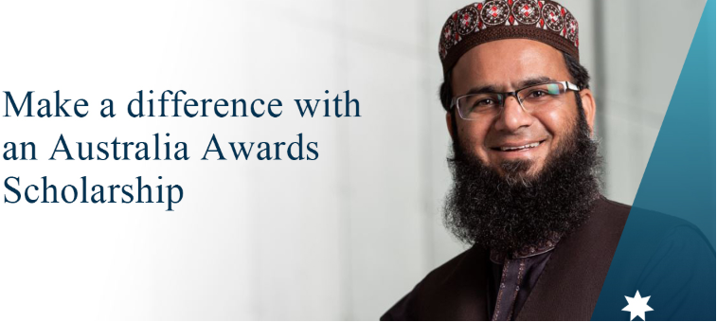
Image: Australia Awards Pakistan (2019)

Alumni and other interview participants
Six alumni were interviewed as part of this Case Study. Each had studied in Australia under scholarship in the early 2000s and had some specific governance or leadership elements built into their scholarship and qualification undertaken in Australia.
The six alumni of focus are introduced below. More detailed profiles are provided in Chapter 7.
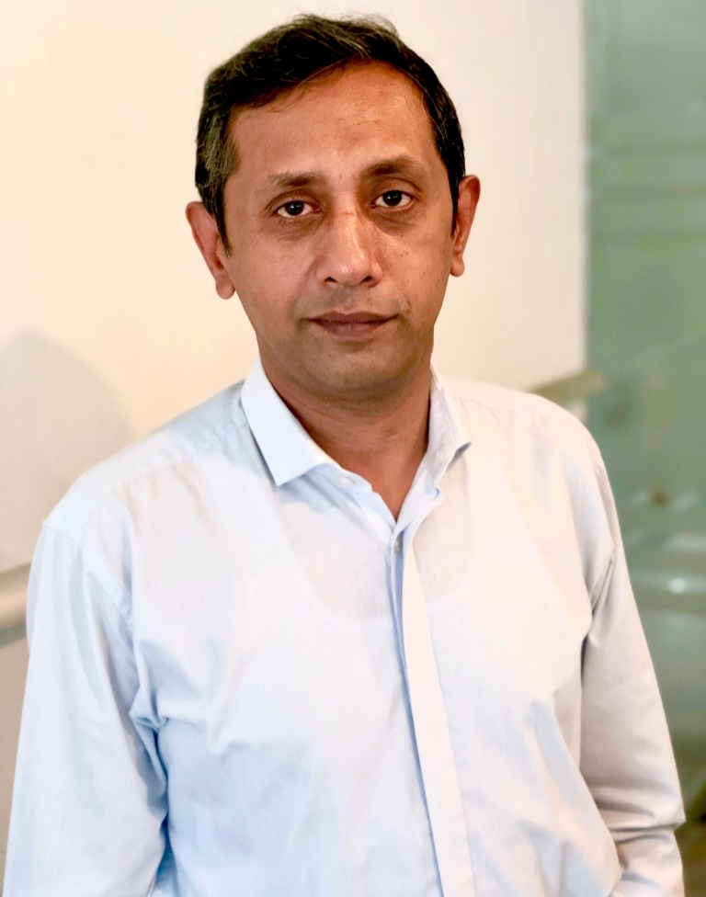 | Mr Malick Shahbaz Ahmad Tahir  Master of Education, Monash University, 2003 – 2004  Executive Director, Sungi Development Foundation | 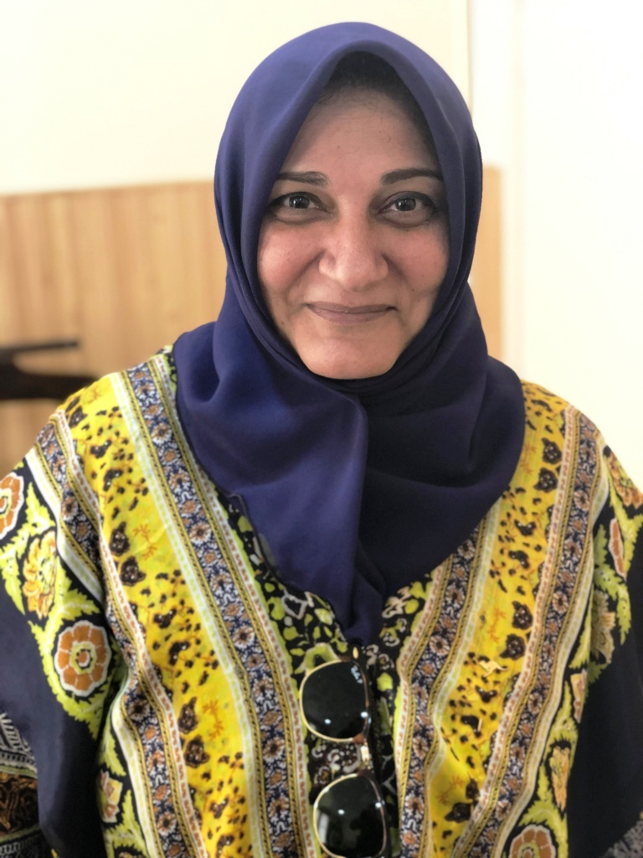 | Mrs Izzat Jahan Aqdus  Master of Financial Management, University of Queensland, 2000 – 2002  Chief Accounts Officer (CAO), Pakistan Post
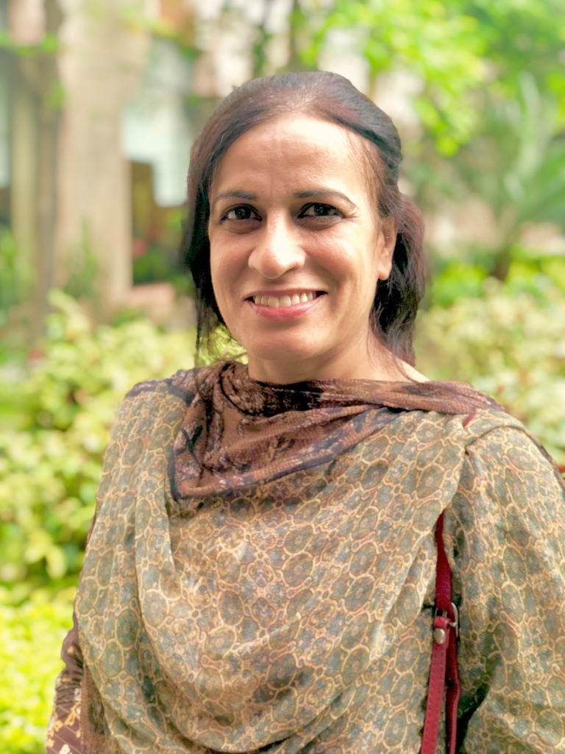 | Ms Shagufta Naz  Master of Arts in Development Studies, Murdoch University, 2000 – 2001  Independent Consultant | 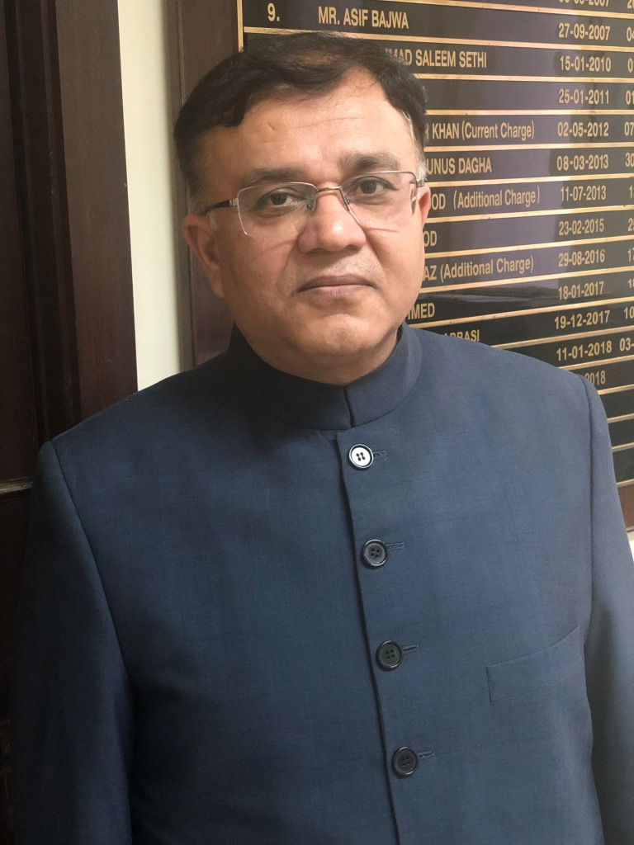 | Dr Kamran Ali Afzal  Master of Public Policy and Management, University of Melbourne, 2002 – 2003  Additional Finance Secretary, Finance Division, Pakistan Administrative Service
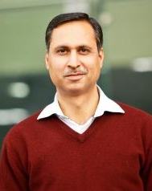 | Dr Muhammad Ahsan Rana  Master of Social Planning and Development, University of Queensland, 2002 – 2003  Associate Professor, Lahore University of Management Sciences (LUMS) | 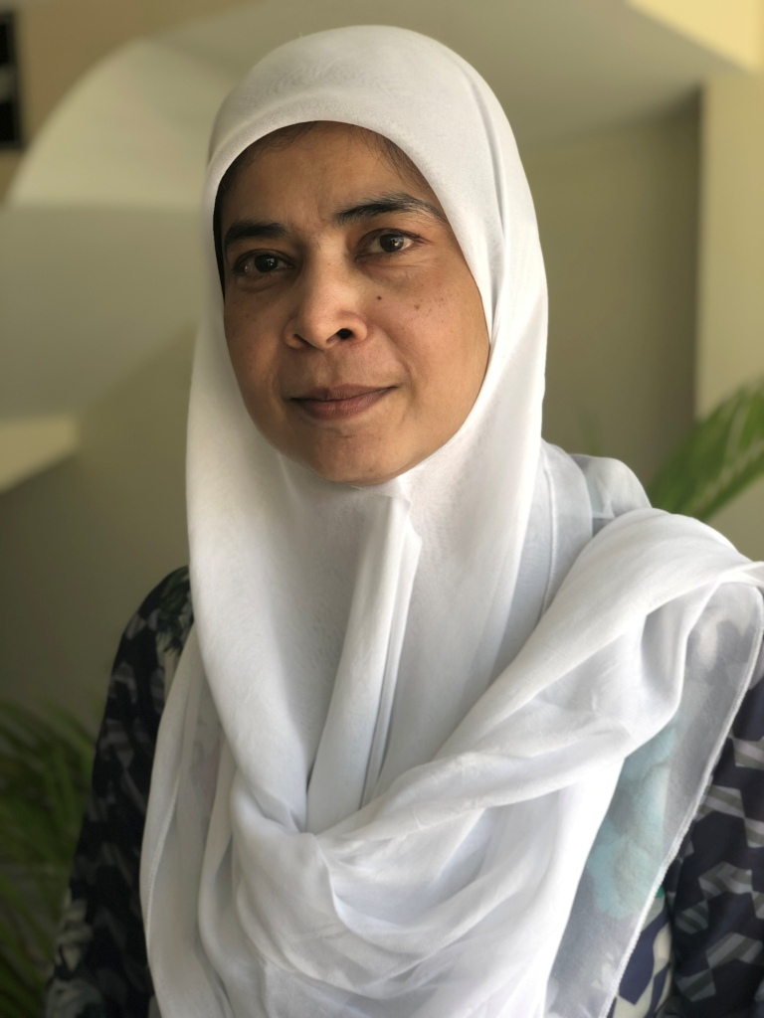 | Ms Lubna Hashmat  Master of Development Administration (Governance), Australian National University, 2000 – 2002  Chief Executive Officer, Civil Society Human and Institutional Development Programme (CHIP)

In addition to the six alumni, a further 14 interviews were carried out as part of this Case Study. These were designed to build an understanding of the Pakistan context, further explore the contributions of alumni, and better understand the Australia Awards in Pakistan. The 14 other participants included one employer, three members of the alumni association executive, two staff from Australia Awards Pakistan (managing contractor) and seven Australian High Commission staff. Further details on interview participants can be seen in the Methodology section (Annex 1).

Development Outcomes

Summary findings
Alumni interviewed in this Case Study are substantially contributing to strengthening governance, demonstrating effective leadership and building capacity in Pakistan. These contributions are being made at the local level, at the national level and across the region. They link to the development goals of Pakistan, specifically in relation to its underpinning focus on ‘quality of democratic governance and economic management’ (Pakistan Planning Commission, 2014, p.52).
For the alumni in this Case Study, Australia Awards Outcome 1 – development contribution is being achieved.
Examples of alumni contributions to development include:
- strong governance
- close involvement in the development of transparent and efficient financial practices across government ministries
- reshaping Pakistan’s model of governance in the public sector
- building a Pakistani-based non-government organisation (NGO) with a focus on assisting local organisations in developing critical organisational infrastructure
- effective leadership
- at the highest level in both the NGO and government sectors
- in upholding the rights of minorities
- in facilitating gender mainstreaming across various projects
- capacity building
- to rebuild education systems and train teachers following significant natural disasters
- through formal teaching of key financial management, evaluation, and development skills to a generation of public servants
- in local NGO and community-based organisations (CBOs).
Alumni highlighted the significant role that their Australian scholarship has played in helping to build the contributions they have made over the long-term in Pakistan. Alongside the fact that they were given an opportunity to further their studies through their scholarship, the alumni mentioned the following factors that enabled these contributions:
- motivation to make a difference
- support from employers both prior to leaving and on return from award – particularly for those within the public sector
- the relevance and quality of the skills and knowledge gained on award
- their exposure to different cultures and new experiences through the scholarship.
Challenges identified by alumni to making their contributions include:
- the uncertain employment situation faced by those working in the NGO sector
- increasing competition for employment in a growing labour market.

Introduction
This chapter details the development impact of alumni and explores the Australia Awards long-term Outcome 1: ‘Alumni are using their skills, knowledge and networks to contribute to sustainable development’. The analysis and discussion explore the following Case Study propositions:
- alumni use their skills, knowledge and networks to contribute to achieving partner-country development goals
- alumni develop skills, knowledge and networks on-award that enable and are used to contribute to achieving partner-country development goals
- alumni understand, value and want to contribute to partner-country development goals.
The alumni from Pakistan who are the focus of this Case Study have each made substantial contributions to the development of their country, using strong and effective leadership and contributing to the development of governance structures that are enabling growth. For the group of focus in this Case Study, there is clear evidence that long-term Outcome 1 of the Australia Awards is being achieved.

Background
This Case Study focusses on alumni who undertook their scholarships in an area of study that links to issues of governance and leadership. Strong governance and effective leadership are critical elements to the future success and development of Pakistan. These themes continue to permeate the development policies of Pakistan, as articulated through the Pakistan Vision 2025 strategic statement, as well as through the three development priorities of Australia for Pakistan (detailed in the previous chapter).
Pakistan Vision 2025 sets a goal for the country to reach middle-income status by 2025 (Pakistan Planning Commission, 2014). To do this, it recognises the need for a stable democracy, and strong systems of governance, noting:
Governance is the central pivot which underpins realisation of the key national objectives…Pakistan Vision 2025 affords special consideration to quality of democratic governance and economic management in the country. (Pakistan Planning Commission, 2014, p.52).
While permeating all facets of the strategy, governance is specifically highlighted as the third pillar of Pakistan Vision 2025 – ‘Democratic Governance, Institutional Reform and Modernisation of the Public Sector’. This pillar calls for institutional reform to be embedded in all elements of the public sector to improve accountability, transparency ‘from policy to strategy to implementation and delivery, encompassing all administrative levels’ (Pakistan Planning Commission, 2014, p.52).
In addition to these formal structures to underpin stability, the Vision also highlights the growing need for leadership and engagement of the broader populace in the development of Pakistan:
There is a growing and engaged civil society in the country, which is giving greater voice to citizens in shaping the future direction of the country (Pakistan Planning Commission, 2014, p.4).
As such, strong leadership in the non-government and civil society sectors, with the ability to work both with local government and international partners is another key to improving the development of Pakistan.
Furthermore, recognition of private sector-led growth (pillar 5 of the Vision), public-private partnerships, and the development of human capital (pillar 1) as critical enablers to the development of Pakistan is a theme throughout the Pakistan Vision 2025 strategy. Within this context and for Australia to achieve its development goals, the importance of established, strong and effective Pakistani partners is critical.

Skills developed on award
This chapter highlights examples of a range of skills that alumni have developed and utilised on their return from Australia. While these skills are implicit throughout the analysis that follows, a list of skills identified by the alumni is provided here to highlight the breadth in knowledge gained by alumni on award.
Generic/broad/’soft’ skills include:
- leadership
- critical thinking
- communication
- problem solving
- English language
Practical/technical/’hard’ skills include:
- finance and auditing
- international development theory and practice
- evaluation research
- governance and accountability frameworks
- econometric modelling
- policy development
- program development
- technology integration

Alumni contributions
The alumni in this Case Study have all made significant contributions to the development of Pakistan and in some cases, the region more broadly. Of the six alumni discussed, three currently work in the public sector, while three are in the non-government sector. As such, the information collected for this research enables a wide perspective for exploring alumni contributions. The key contributions discussed in this section are organised into three key themes:
- governance
- leadership, and
- capacity building.

Strengthening governance
Governance typically involves structures relating to administration, ethics, compliance and risk management. While application varies depending on the context, common to most governance structures are the principles of accountability, transparency, integrity and efficiency.
In an international development setting, the United Nations (UN) Development Programme has adopted the following definition of governance:
Governance refers to the exercise of political and administrative authority at all levels to manage a country’s affairs. It comprises the mechanisms, processes and institutions, through which citizens and groups articulate their interests, exercise their legal rights, meet their obligations and mediate their differences. (Committee of Experts on Public Administration, 2006, p.3).
In a public service setting, the Australian Public Service Commissioner (n.d.) uses the following definition of governance:
…the set of responsibilities and practices, policies and procedures, exercised by an agency’s executive, to provide strategic direction, ensure objectives are achieved, manage risks and use resources responsibly and with accountability.
The alumni in this Case Study have each been involved in contributing to the strengthening of governance in Pakistan.
In the public sector context, two alumni, Mrs Izzat Jahan Aqdus, and Dr Kamran Ali Afzal, have built their careers improving finance and accountability systems within Pakistan’s highest levels of government.
Mrs Aqdus is currently the Chief Accounts Officer at Pakistan Post, having recently taken a secondment from the Auditor General’s office. She has been appointed to this position to ‘take care of the challenge’ of ensuring the accounts of the Pakistan Post are properly audited and accounted – essentially to ensure that the financial state of the authority is accurate, transparent and that Pakistan Post is sustainable and secure in the future.
This example is one of many contributions to stronger governance in Pakistan by Mrs Aqdus, who applied for an Australian Development Scholarship to build her skills and qualifications in financial management. Since her return to Pakistan in 2002, Mrs Aqdus has been a key Financial Advisor embedded within numerous government departments and authorities, including the ministries of Energy, Water, Religious Affairs, Kashmir Affairs, Gilgit Baltistan Province, Food, the Board of Investment in the Ministry of Finance and the Supreme Court. In the Auditor General’s office, Mrs Aqdus was the Director General (Federal Audit Operations).
A core aspect of these roles was Mrs Aqdus’ membership on the boards of autonomous and semi-autonomous bodies that sit under various government authorities. Given her strong financial background, Mrs Aqdus’ played a significant governance role on these boards – ‘I was on eight different boards of directors…that was an acknowledgement that I can add value’. Mrs Aqdus is in no doubt that her studies at the University of Queensland were instrumental in reaching this level, highlighting the link between the knowledge gained and her role on these boards. She is enthusiastic in her praise for the scholarship: ‘thank you very much for teaching me some good stuff!’
In addition to these governance roles, shortly after her return, Mrs Aqdus was closely involved in the Project for Promotion for the Improvement of Financial Reporting and Auditing in Pakistan (PIFRA). A World Bank funded project, commencing in 2005, the aims of this work focussed on key aspects of governance, including accountability and transparency, and supported system-wide improvement to significantly improve efficiency (World Bank, 2005). Mrs Aqdus played a role in developing and adapting financial systems: ‘I was able to contribute because I could help them create the blueprints that they wanted for the system to work.’ The impact of this project on Pakistan’s financial and accounting processes is ongoing. The project has been used as a case study example by the World Bank, which notes: ‘Transparency has been improved due to the strengthening of internal controls and access of stakeholders to financial information’ and that financial statements that previously took up to 21 months to complete are now submitted within 8 months (Dener, Watkins & Dorotinsky, 2011, p.65).
Dr Afzal, like Mrs Aqdus, returned to Pakistan after completing his Masters to find that the context was perfect for applying the knowledge he had developed while studying at the University of Melbourne:
At that point in time, Pakistan was undergoing civil service reform and also governance reforms…we were reshaping the model of governance we had inherited from the British. My studies in Australia at the public policy level helped me contribute meaningfully towards the new design of governance.
The redesign envisaged in Pakistan at the time followed the new public management models, in which, according to Dr Afzal, Australia was ‘at an advanced level’. In parallel with the later strategic policy for the country articulated in Pakistan Vision 2025, Dr Afzal’s work in the first decade of this century helped to rethink the interactions between the public and private sectors away from ‘an adversarial role…to more of a cooperative and collaborative role’.

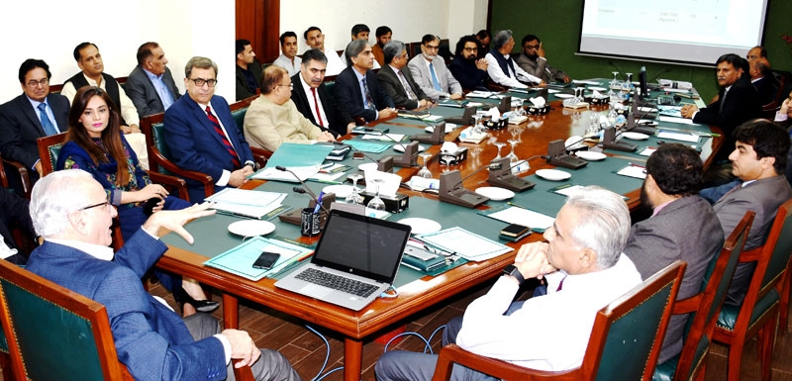
Senior members of the Ministry of Finance, including alumnus Dr Afzal, Islamabad October 2018.
Photo: Pakistan Ministry of Finance.
Dr Afzal’s contribution to strengthening governance in the public service also came to the fore in his five years working in the Prime Minister’s Office. During this time, Dr Afzal was responsible for advising on key government appointments. He was involved in ‘setting up systems to select people’ which was important because ‘things begin to improve when you have appointed the right people to the right positions’. Dr Afzal saw this as a critical element in enabling long-term improvements to processes and governance for Pakistan; when you change the systems to ensure ongoing improvement, then, in the long run, you can ‘change the paradigm of governance’.
In the non-government sector, a key example of an alumni helping strengthen governance can be seen through Ms Lubna Hashmat’s work developing a Pakistani NGO - Civil Society Human and Institutional Development Program (CHIP). The goal of CHIP is to build the capabilities of other civil society organisations and NGOs within the region to contribute to development.
On her return from Australia, Ms Hashmat helped transform her organisation from a Swiss-funded development programme to a locally registered organisation that is owned and operated in Pakistan, is financially sustainable and has strong governance structures. CHIP is now regarded as a strong example of a well-planned NGO in Pakistan, and is featured in a Harvard Business school case study which emphasises that: ‘CHIP became successful by maintaining high standards of management practices’ (Saqib & Khattak, 2015).
Ms Hashmat, who is now the Chief Executive Officer (CEO) of CHIP, describes it as ‘a Pakistani institution that can strengthen Pakistan’s other institutions’, particularly NGOs and CBOs. She credits her scholarship, through which she studied a Master of Development Administration (Governance) at the Australian National University as essential in building her ability to ‘articulate the strategic perspective’ necessary to build CHIP into the organisation it is today.
The contribution Ms Hashmat now makes through CHIP has a strong focus on governance. By working with local NGOs and CBOs, CHIP undertakes many projects which are designed to ensure continuity of service to projects once the funding from international donors has finished. Ms Hashmat’s colleague and Chairman of CHIP, Mr Amjal Malik, highlighted this critical role as essential to maintaining momentum in a development context:
Bilateral projects come to an end…there was no organisation to follow it, take it up…the government departments would close down. We wanted to start civil society associations in those areas because there were none…We get all this specialised work in helping NGOs, CBOs to build systems, build management, the implementation side and so on.
This critical organisational infrastructure is contributing to the sustainability of aid to Pakistan, and the commitment of Ms Hashmat and her colleagues has been pivotal to the longevity and success of the organisation.

Effective leadership
There is a clear link between strong governance and effective leadership – in many ways, one can’t be achieved without the other. The Australian Public Service Commissioner (n.d.) highlights this fact, noting there is an ‘important role of leadership in ensuring that sound governance practices are instilled’.
Leadership-building is a hallmark of the Australia Awards and its predecessor scholarships. In all Case Studies undertaken by the Facility, the theme of leadership is strong. There are many different types of leadership explored in the research. In this Case Study, the thematic focus specifically examines leadership – and many of the alumni focused here were selected due to the specific relevance of their studies and their current positions to leadership. As such, the emphasis is on examples of leadership in professional contexts and the respective contributions of alumni in these roles.
A particularly important role in development for Pakistan has been the idea of driving change through the involvement of ‘civil society’. Khan and Khan highlighted this emerging area of influence in the Pakistani context in the early 2000s, noting that the public service and government alone was not likely to bring about effective and positive change, especially in regard to development indicators. The authors argue that strong civil society organisations, such as NGOs and CBOs in Pakistan can help promote ‘a more equitable distribution of power and resources among all members of society, that protect the fundamental rights of citizens of the state, and that empower state and other institutions to protect those rights’ (Khan & Khan, 2004, p.ii).
Among the alumni in this Case Study, three, in particular, are leading change through civil society organisations. The example above of Ms Hashmat’s organisation, CHIP, provides evidence of leadership in this area by building the capabilities of civil society organisations (NGOs and CBOs). In addition to this example, Mr Malick Shahbaz Ahmad Tahir, as Executive Director of Sungi Development Foundation, one of the largest national rights-based organisations in Pakistan, is another change leader among the alumni. Ms Shagufta Naz’s work in dozens of contexts with a focus on gender mainstreaming also highlights the leadership contributions of alumni in this important sector of Pakistan.
Through his work, Mr Shahbaz helps his NGO to influence change by being ‘an effective civil society member that plays its role for democratic governance practices, and improving citizen and state relationships’ (Sungi Development Foundation, 2019). Through his organisation, Mr Shahbaz actively builds awareness of the rights of marginalised workers, women, children and the poor.
Mr Shahbaz’s work has also involved leading key disaster recovery initiatives. For example, not long after returning from his scholarship, he was involved in significant projects dealing with the aftermath of an earthquake in Kashmir in 2005, which killed more than 80,000 people and forced millions from their homes (Earthquake Engineering Research Institute, 2006). Mr Shahbaz led a team working in refugee camps to establish schools and implement emergency education. His contribution in this particular project was recognised with an award from the President of Pakistan. He credits elements of his scholarship, a Master of Education from Monash University, as being pivotal in equipping him with the skills to make this contribution. ‘[My contribution] is related to my academic career…I am very proud that I studied in Australia…that helped me a lot’.
Ms Naz is another alumni driving change through leadership. She completed her scholarship in 2001, returning from Murdoch University with a Master of Arts in Development Studies, to lead a range of development projects in Pakistan and Afghanistan in the subsequent years. In particular, Ms Naz has shown her leadership capacity in her contributions to gender rights and gender advocacy within a range of local and international NGOs. As an international expert in gender issues, Ms Naz has been able to ‘influence policy towards gender-responsive planning and development’ across the region.
Given the context of the region in which she works – where patriarchal and religious traditions can challenge the ability of women to participate in the workplace – Ms Naz’s ability to lead change in a considered, culturally sensitive and effective manner has been critical to her success. Ms Naz has led gender initiatives in more than twenty projects over the period since completing her scholarship, embedding principles of access, equality, participation and training in a range of provinces across Pakistan and Afghanistan. Ms Naz has overseen the implementation and evaluation of programs with the lens of ‘mainstreaming gender considerations in planning and reporting’, and the breadth of this contribution is substantial. Projects to which she has applied this ‘gender lens’ include disaster recovery and response in flood and earthquakes, analysis of house construction programs, sanitation initiatives, the workforce in cotton growing industries, conflict zone recovery, organic farming practices, refugee relocation, trade competitiveness, and capacity building of teachers.
While Ms Naz’s influence has included being at the forefront of gender mainstreaming policy across a range of high-level ministries, Ms Naz highlighted a particular ‘small’ example that provides insight into her leadership approach to facilitating change. Within workplaces she has evaluated or worked in through her career, Ms Naz has advocated the implementation of bathroom facilities, improving the accessibility of workplaces for women in Pakistan. In challenging the status quo, Ms Naz approached this by asking workplaces: ‘”if you have two places, why are they both for men?”…it seems very silly, and a very small thing, but that makes a big difference’.
The facilitation of dialogue and negotiation between the government and private sectors is also essential in the development of Pakistan. Dr Muhammad Ahsan Rana offers a unique leadership example of this. Dr Rana received an Australian Development Scholarship to study a Master of Social Planning and Development at the University of Queensland in the early 2000s. Following graduation, Dr Rana was able to lead development in Pakistan by acting as a conduit between the Government of Pakistan and the private sector.
Dr Rana was undertaking his Doctorate on the commercialisation of genetically modified (GM) crops when he was contacted by the Government to assist in the negotiation with a multinational corporation for the purchase of licenced GM cotton seeds. As one of the few people in the country with the requisite knowledge to assist, Dr Rana joined a number of committees involved in the negotiations. Here, he was able to demonstrate to the Government that the claims of the company were not commercially tested and unlikely to be viable. Reflecting on this experience, Dr Rana stated:
I was probably the one person who was not ready to accept these claims on face value and have the intellectual resources to deconstruct these claims and get to the bottom of them.
In order to assist, Dr Rana wrote policy papers and briefing notes for the negotiation team and ‘according to estimates, saved the Government of Pakistan $USD350million.’
Dr Rana continues to write and advise on this topic through his current work at the Lahore University of Management Sciences (LUMS). He recently revisited this topic as negotiations between the Punjab Government and the same multinational corporation were underway (Rana, 2017). Writing in a national newspaper on the risks in committing to commercial crop licenses, Dr Rana emphasised limited benefit to farmers could result because:
[Previous licenses were] expected to give a substantial boost to cotton production, but it failed to yield the expected results, due to low quality of seed containing toxins.
Dr Rana links his contributions at the time of the negotiations to the skills and confidence he had developed on award – ‘I think the analytical ability that I was able to deploy can be largely ascribed to the skills and education that I had acquired’.

Capacity development
Five alumni in this Case Study have specifically been involved in human capacity development in Pakistan.
For example, Dr Rana is playing a significant role in building capacity within Pakistan, through his work with LUMS, a leading Pakistani university. He has ‘trained professionals [in NGOs in particular], trained academics, trained civil servants’ and strongly believes that human resource development ‘is what Pakistan needs more than anything else’. In his current role as an Associate Professor, Dr Rana is teaching various courses relating to public and agricultural policy, where he is passionate about developing the mindset of his students to improve the progress of his country. Dr Rana states that his aim in teaching is ‘to transport some of the knowledge, understanding, skills, also the type of attitudes that I have acquired during higher studies in Australia’. Reflecting on his role, and the role of alumni from the scholarship program in general, Dr Rana believes that the transfer of skills and capacity building by alumni ‘has been a beneficial thing for the country and the society at large as well.’
The contributions of other alumni are confirmation of Dr Rana’s assertion, with Ms Naz, Mr Shahbaz, Ms Hashmat and Mrs Aqdus each contributing to capacity development in their fields since returning from their scholarship.
Ms Naz and Mr Shahbaz (discussed above) have undertaken capacity building through their work in disaster response zones – both in earthquake and flood-affected areas of Pakistan over the past near-decade. Following the 2005 earthquake affecting Pakistan’s Kashmir region and destroying many of the schools, Ms Naz coordinated the training of teachers in order to ‘bring back students…and motivate parents to send their children’ back to school. In the area Ms Naz was working, there were no trained teachers, and her role was to build capacity in people not only to be teachers, but also to pass on their skills and knowledge in order to be trainers of teachers themselves. In one year, her team developed 100 ‘Master Teachers’ and facilitated the training of 9,800 teachers for the region.
Ms Hashmat’s organisation’s core operation stems from the motivation to develop human and institutional capacity within NGOs and CBOs to ensure the continuation and high quality of services in Pakistan as part of and following aid-funded programs. In her leadership role in the organisation, Ms Hashmat emphasises her desire to ensure that she passes on the things that she learnt in Australia. This capacity building mindset is embedded in her life:
The immediate difference I realised in Australia was that in every assignment we were rated for innovation, logical argument, the way we present. So, these are three skills I feel are very crucial…After graduating in Australia I have invested a lot in my colleagues, and my social circle, my community where I work…I’m one of the facilitators…I started facilitating others in articulating ideas.
In the public sector, Mrs Aqdus has played an integral role in the teaching of public servants in the years following her scholarship. In 2014, Mrs Aqdus was the Chief Instructor at the National School of Public Policy, through which all public servants are required to undertake training in order be able to qualify for promotion: ‘the institute would give them the green card [to promote someone]…so that was quite a strong post’.
Mrs Aqdus’ contribution to capacity development in Pakistan also goes beyond the National School of Public Policy. She has taught various courses and workshops across Pakistan as a visiting faculty member. In these positions, she has either worked within Pakistan universities or been embedded in public service training academies in various government departments, providing specialist teaching in the areas that her scholarship built up her skills: auditing, change management and human resource development.

Enabling factors
In exploring the different contributions made by alumni since returning from scholarship, a range of themes emerged that illustrate the factors that helped to facilitate these contributions. While the nuances of the enablers differ between individuals, in the section below the broad enabling factors are outlined with examples from alumni.
These factors include the self-motivation within these individuals to contribute; support from employers; the relevance and quality of the skills and knowledge gained on award; the exposure to new cultures and experiences while on award; and the generous conditions of the scholarships.

Motivation to contribute
Central to the discussion with alumni about their reasons for applying for a scholarship is the idea that they wanted to use the opportunity as a platform to help them make a significant contribution to their organisation, province or country. Three of the alumni mentioned that they were encouraged to articulate this motivation when applying for the scholarship. This is an ongoing aspect of the current application process, with the Australia Awards Pakistan highlighting that selecting individuals who are motivated to make a difference to their country was an important characteristic instilled in the Australia Awards.
Among the alumni in this Case Study, Mrs Aqdus strongly emphasised her motivation for making a difference:
Even if I have not reached the “top-notch” position, even if I am not making a million dollars – that really doesn’t bother me. My idea of success [is that I] only increase my position to the extent that I can be of benefit to more people.
Furthermore, among these alumni, there was a clear understanding of the role that education and learning play in their plans to contribute. For example, Mr Shahbaz noted:
My motivation was only that I thought that the sort of work I was doing, which was education planning and all that…I thought; if I get further education, if I enhance my capabilities, maybe I could do better than what I was doing.
Likewise, Ms Naz highlighted how the idea of life-long learning permeates her mind-set and enables her to continue to make contributions: ‘I still have to adapt…to keep my career going, I have to learn new skills, always’.
Other alumni also demonstrated this life-long learning approach to improvement. Dr Kamran and Dr Rana both went on to complete Doctorate degrees at Australian universities within the decade following their initial scholarship, and Mrs Aqdus took up further study in the United States through a Fulbright fellowship.
From the perspective of Australia Awards Pakistan, the objectives and approach of Australian development scholarships appeal to and attract people with this intrinsic motivation to contribute broadly. As the Country Program Manager in Pakistan highlighted, ‘people think that, yes, if we are committed to doing something for the country, this is the scholarship which is going to help’. In contrast, they noted that other scholarships offered in Pakistan might be more appealing to people just looking to derive personal, professional benefits.

Employer support
For the alumni working in the public sector, the support they received in applying for the scholarship and on return, was highlighted as a critical element that ensured they have been able to convert their education and experience into strong contributions in the public service.
Support for public servants to take up the scholarship came in many forms. One of the most helpful aspects was the fact that their place was ‘held’ for them for the period they were away; this eliminated the challenge of returning to unemployment after two years away, which is the common experience of alumni from the NGO and private sector. In addition to this, government employees continue to receive a base level salary while on award, and have the time spent on award counted towards their service (particularly important in a system in which time served is a factor for promotion).
As noted above (and discussed further in the next section), most awardees from outside the public sector take a risk by going on scholarship without a guarantee of employment on return. One alumni from the NGO sector who had an alternative experience was Ms Hashmat, who was in a unique position of having her organisation plan for her time away on scholarship. Ms Hashmat’s employers saw this opportunity as an organisation-wide investment in someone who was ultimately to become their CEO. As noted by the Chair of CHIP (who had previously been CEO), the idea of the scholarship and giving Ms Hashmat time to develop these skills ‘was pre-planned, it was with a long-term vision that it was done…[when she returned] she was given a free hand…she had that atmosphere and environment to work in.’

Relevance and quality of skills and knowledge
Each of the alumni spoke about the value of the skills they gained in Australia and their ability to apply key learnings on return to Pakistan. The contributions section above details some examples of this transfer of skills in the areas of governance and leadership, as well as highlighting how alumni have shared these skills in capacity building on return.
Dr Rana encompasses this overall sentiment in the following quote in relation to work he undertook when he returned home:
Having studied at the University of Queensland improved my articulation abilities and my analytical abilities. My language skills got a little better, so I could write better. I could structure my argument better. And of course, I had been exposed to different development theories, I have been exposed to different development practices…all these modern trends helped me to understand the development context [in which I worked when I returned to Pakistan].
For Mrs Aqdus, the relevance of her Master of Finance to her work was paramount. She entered the public service in Pakistan at age 28, when the youngest of her two children was eight years old, and was placed in a finance position despite not having a relevant qualification in this field. As such, she sought out scholarship options that would help establish her skills, noting ‘I didn’t want to be like a dud in the government service, serving audit and accounts and knowing [nothing] about it!’ While other scholarship programs declined her application based on not having prior education in the field she chose, the Australian scholarship program at the time recognised this need and enabled Mrs Aqdus to study a Master of Financial Management. ‘[They listened, and] came up with a plan themselves to make me what I am today.’ Expressing her gratitude and surprise, Mrs Aqdus exclaimed, ‘Nobody does that!’

Exposure to different cultures and new experiences
Not only did the coursework learning enable alumni to make contributions when they returned home, but the experience itself also had a profound positive influence. In this regard, alumni spoke about ‘broadening my mind’, ‘exposure to different thinking’, and a ‘changed understanding of the world’ from their time on scholarship in Australia.
Quotes from two alumni highlight this aspect of the awards. Ms Naz noted:
It’s not only the education which helped me, it’s the confidence I got from there – that I can live anywhere, I can do anything. I am capable of doing something. That is the confidence I learnt.
Similarly, Dr Rana said:
As an individual, I also think that I got the ability to grow emotionally…living in a different country, talking to different people; everything is different. It is very important for one to get used to understanding and appreciating that things can be done – and are done in different parts of the world – very differently. That normalises several things.

Scholarship conditions
As alluded to in some of the discussion above, the unique scholarship conditions and design offered by Australia were also a factor that enabled alumni to accept their scholarship, embrace the opportunity and utilise their skills when they returned.
In particular, alumni highlighted the balancing of merit with other factors such as recognising potential, targeting equity (especially gender), and generous support while on award. Alumni, and Australia Awards Pakistan and the Australian High Commission also identify these as elements that uniquely place the Australian scholarship offering in Pakistan (this is further discussed later in this report).
Three of the alumni specifically mentioned that the bursary and the full-fee coverage offered by Australia, unlike other scholarships, made the difference for them in terms of whether they were able to go or not. Australian scholarships were generous enough for alumni to consider taking their family and realistically being able to support them while there. For the alumni who chose this option, they mentioned the flow-on benefits to their children and partner were an important outcome of their scholarship experience.
The equity aspects of the scholarship are also an important condition. Among the female alumni interviewed in this Case Study, all noted that the Australian scholarships targeting of women’s participation were central to their confidence in applying. For Mr Shahbaz, despite being from a ‘very humble background’ the Australian scholarship was seen as attainable due to the emphasis on potential and it’s equity considerations: ‘I believe that if not for the Australian scholarship, I would not have been abroad…there were very few opportunities’ especially for those not from privileged backgrounds.

Challenging factors
The alumni in this Case Study have made remarkable contributions to the development of Pakistan, and while their long-term outcomes demonstrate success overall, each has faced different challenges along the way in utilising their skills and knowledge to its full extent. During interviews, alumni were asked to reflect on the barriers they have faced in being able to make these contributions. The common themes that emerged from these discussions relate to the job uncertainty faced by those working in the NGO sector, and competition for employment in a growing and increasingly competitive labour market.

Employment uncertainty in the NGO sector
Four of the six alumni work or have worked in the NGO sector. Each of them highlighted that taking a scholarship (and at least two years out of the workforce) was a significant career risk. This decision was risky due to the uncertainty of the NGO sector. These organisations face two major challenges in Pakistan.
First, most NGOs depend on project/program-based aid funding that is often short term, hence the ability to ensure ongoing work for employees is limited, let alone guaranteeing a job on return for someone leaving for two years. Mr Shahbaz and Ms Naz experienced challenges when they returned to work in the NGO sector in Pakistan. Mr Shahbaz explained his experience returning to the continually changing sector:
When I came back after two and a half years…everything had changed, even the people [in my former organisation] who gave me commitments, they were changed. It was beyond my control.
It took about six months following his return for Mr Shahbaz to secure ongoing work in the sector – ‘It was not about my education. It was about the local conditions that were here.’ Ms Naz had a similar experience, ‘it took me some time, applying and looking for a job…I went back to my old organisation as well, that was a very small NGO, so they didn’t have any positions…but eventually I found one’ about five months after returning.
Second, there is volatility within the NGO and civil society sector within Pakistan, because registration to operate can be subject to cancellation by the Ministry of the Interior. For example, in late 2017, 29 international NGOs were ordered to close in Pakistan, and the appeals by 18 of these organisations against this order were rejected in later 2018 (Stacey and Bokhari, 2017; Mukhtar, 2018). One of these NGOs was at the time working directly with the Australian Government on an aid-related investment, with the impact of this decision noted in the Pakistan Aid Program Performance Report for the year (DFAT, 2018). This reflects earlier analysis by the Asian Development Bank (2009) of the non-profit sector in Pakistan in which foreign-funded organisations are ‘sometimes viewed less positively’ by the authorities (ADB, 2009).
As one alumni noted ‘honestly speaking, the political circumstances and the security circumstances of Pakistan are such that you never know who will be here, which organisation will be here for the next year.’

Increasing competition in the job market
Pakistan has a booming population, with its 2017 population of 207 million expected to double by 2050. There is wide recognition that one of the challenges that Pakistan faces in the coming decades is in securing employment for the growing working-age population. DFAT notes that one of the most critical challenges for the country is that with the current level of growth, ‘Pakistan needs to create approximately 1.5 million jobs a year for young people entering the labour market’ (DFAT, 2019b).
The alumni who were the focus of this Case Study – those studying in the early 2000s – noted that there is a need to consistently upgrade skills and qualifications so as to ‘compete’. Ms Naz mentioned that while she was quite unique in her sector a decade or more ago:
Every third person [I meet at alumni events] is now in development studies…for a person like me, I have to adapt to keep myself going…the competition is now tougher than when I was competing with my own generation.
As noted by Australia Awards Pakistan, this competition also stems from a range of other related factors:
The job market in Pakistan, there’s the war on terrorism…if you look at the bigger picture, it has taken a toll on the economy. So when you look at the job market here in Pakistan, there aren’t many opportunities. You have a foreign degree, and you return to Pakistan, you’ve got certain aspirations. You don’t want to settle for something which you don’t think is right for you.

Economic and Public Diplomacy Outcomes

Summary findings
A benefit of focusing on less recent alumni is the opportunity to more fully understand the nature and lifecycle of links developed on award, and the long-term needs of alumni regarding engagement and maintaining or building their links with Australia.
Alumni in this Case Study have provided insight into the numerous ways in which they have contributed to Australia Awards long-term Outcome 2 – cooperation and Outcome 3 – partnerships over the 15 to 20 years since their graduation. Links established on and post award include fellow alumni, international and Australian students, university staff and supervisors, Australian organisations and institutions, and the Australian High Commission and Australia Awards Pakistan.
For alumni in this Case Study, Australia Awards long-term Outcome 2 – cooperation – is being achieved.
Alumni have demonstrated contributions to enhancing cooperation between Australia and Pakistan through:
- ongoing people-to-people links
- contribution to international and multilateral projects
- Australia Awards Pakistan alumni engagement
- Australian High Commission events and engagements
- Australian alumni associations
- advocacy/promoting study and experience in Australia.
For alumni in this Case Study, Australia Awards long-term Outcome 3 – partnerships – is partly achieved.
One alum has developed an institutional-level partnerships between Australia and Pakistan, indicating partial achievement and that broader challenges exist for this group of alumni to develop formal partnerships. The partnership developed is a:
- memorandum of understanding (MoU) with Australian universities – collaborative research.
Key enabling factors
The factors which enabled alumni and have largely contributed to the achievement of Outcome 2 include:
- alumni motivation to build networks and exposure in Australia,
- positive on-award experiences, and
- Australian High Commission and Australia Awards Pakistan interest and valuing of alumni engagement.
Key challenging factors
Factors that challenged alumni in developing, maintaining, or broadening networks and partnerships with Australia and Australians are listed below. In particular, these challenges are limiting the achievement of Outcome 3:
- access and opportunities to build professional links and partnerships
- relevance and interest in professional links and partnerships
- the loss of contacts over time.

Introduction
This chapter explores the extent to which alumni and their organisations are contributing to two of the Australia Awards long-term outcomes:
- Outcome 2: ‘Alumni are contributing to cooperation between Australia and partner countries’
- Outcome 3: ‘Effective, mutually advantageous partnerships between institutions and businesses in Australia and partner countries.’
The Australia Awards Global Monitoring and Evaluation Framework (the Framework) describes activities under these outcomes as facilitating business or trade links, participating in international or regional bodies, or advocating the relationship between Australia and partner countries (e.g. promoting study in Australia).
The Framework outlines Outcome 2, cooperation, as the connections and networks between alumni and Australia which represent the people-to-people links, such as alumni associations, friendships, or professional connections with former lecturers. Whereas Outcome 3, partnerships, ‘looks beyond the individual links’ and ‘articulates Australia’s intention to see organisational links’ occur as formal partnerships.
These outcomes are intended to have been developed on award, during which time scholars ‘build relationships with Australians, other awardees, and Australian organisations and businesses’ and act to catalyse or enhance links between organisations. Alumni engagement and support then assist as a post-award mechanism to maintain alumni’s links with Australia.
However, the Australia Awards long-term outcomes post-date the scholarships which the alumni in this Case Study undertook – the Australian Development Scholarships. Under the Australian Development Scholarships, there was an implied assumption that ‘Personal and professional ties that scholars develop with Australian academics and the broader community last a lifetime’ (AusAID, 2002).
At the time of their award, the alumni did not have embedded opportunities or focus on developing professional relationships while in Australia. However, the experiences of this group of alumni can still provide relevant insight into the longer-term trajectory of links developed on-award and the enabling factors which sustain them.
All alumni in this Case Study provided examples supporting bilateral cooperation which have been significantly enabled by alumni engagement initiatives by Australia Awards Pakistan and the Australian High Commission. In addition, one alumni is also contributing to an institutional partnership between Australia and Pakistan.
The findings from this Case Study suggest achievement of Outcome 2 – cooperation, and partial achievement of Outcome 3 – partnerships. These findings reflect the observations of the Australian High Commission and Australia Awards Pakistan, as well as the experiences of alumni themselves.

Background
Australia-Pakistan relations officially began following the 1947 partition from India and cover the areas of security cooperation, political and democratic governance, development, economic reform, and trade (Col. Kenny, 2015; DFAT, 2019a). However, ties can be traced back to the 1800s when cameleers from Balochistan helped to open up Australia’s interior (Australian High Commission Islamabad, 2019).
In the years leading up to the period of focus in this Case Study (2000 to 2005), the Australia-Pakistan bilateral relationship was constrained in response to Pakistan’s nuclear testing program in 1998 and a military takeover in 1999. These events respectively resulted in the suspension by Australia of both non-humanitarian aid and the defence relationship (DFAT, 2000; ABS, 2001; AusAID, 2002). However, Australian business efforts in Pakistan continued to be supported, and bilateral trade continued to improve during this period (AusAID, 2002). Following the September 11 Attacks in 2001, Australia lifted the suspended defence relations with Pakistan to demonstrate support for their stand against terrorism, along with the reinstatement of non-humanitarian aid (Australian Government, 2001).
Today, trade between the two countries is worth $1.83 billion (2017) supported by a bilateral trade agreement signed in 1990 (DFAT, 2019a). Australia is Pakistan’s sixth-largest bilateral donor (DFAT, 2019a), with Australian Government scholarships viewed as ‘a highly-valued form of assistance and a significant aspect of the Australia-Pakistan development cooperation relationship’ (AusAID, 2009).
People-to-people links are centred on the Pakistan Diaspora in Australia and described as the most sustaining link between the two countries (High Commission for Pakistan in Canberra, 2019). In 2017, more than 64,000 Pakistan-born people were living in Australia, and more than 13,000 Pakistani students enrolled at Australian higher education institutions (DFAT, 2019a).

Networks and links developed on award
Both DFAT and partner-countries recognise fostering links as a significant output of the Australia Awards in contributing to the achievement of development and bilateral goals. It is intended that during their time in Australia scholars are able to ‘build relationships with Australians, other awardees, and Australian organisations and businesses’ which will enable them to contribute to Outcomes 2 and 3.
The following list describes the range of networks and links alumni of focus in this Case Study developed on award and as a result of their scholarship.
On-award networks developed in Australia:
Informal  - International students  - Australian/domestic students | Formal/professional  - Volunteering with Oxfam  - University staff and lecturers
Post-award networks developed:
Formal/professional
- Australia Alumni Association – Pakistan
- Australian High Commission in Islamabad
- Australia Awards Pakistan
- Australian universities

Examples of bilateral collaboration and institutional links
This section outlines examples of how networks developed in Australia and post award have contributed to cooperation (Outcome 2) and partnerships (Outcome 3) between Australia and Pakistan. All alumni in this Case Study provided examples supporting cooperation, with one alumni also contributing to an institutional partnership. The limited examples of partnerships occurring amongst this group of alumni indicates there are challenges in achieving Outcome 3, which are identified as access, opportunities and interest to build formal links with Australian organisations. These are outlined in further detail below. It is also important to highlight that this outcome was not a specific priority of the scholarships in the early 2000s when these alumni were studying and as such, the limited number of partnerships among these alumni also reflects this.
The following table outlines the examples of alumni contribution to cooperation and partnerships developed as a result of their scholarship, with the impact of these examples detailed below.
Outcome 2 - Cooperation | Outcome 3 - Partnerships
- Ongoing people-to-people links  - Contribution to international and multilateral projects  - Australia Awards Pakistan alumni engagement  - Australian High Commission events and engagements  - Australian alumni associations  - Advocacy/promoting study and experience in Australia | - Memorandum of understanding (MoU) with Australian universities – collaborative research

Memorandum of understanding (MoU) with Australian institutions – collaborative research
The Australian High Commission observed that the most common type of institutional link developed by alumni are from those working in academia in Pakistan. This reflects the finding for this Case Study, in which one alum, Dr Rana, described a partnership to which he is contributing.
Established through a fellow Pakistani scholar in the School of Government at the University of Melbourne, a MoU has been formalised with Dr Rana’s institution, LUMS. Through this partnership, Dr Rana is currently contributing to a submission to the Australian Research Council for a collaborative research grant, focusing on religious extremism. Dr Rana stated that this partnership is a high-level university-to-university collaboration, as well as something that is enacted by individual academics: ‘we do collaborate on an institutional basis, as well as an individual basis with the associate [there]’.

Ongoing people-to-people links
Alumni in this Case Study have described the on-award links they made, with some continuing nearly 20 years since graduation. Below are examples provided by alumni of the types of people-to-people links they have continued post award.
Formal/professional networks:
Two alumni, Mrs Jahan and Dr Afzal, described their continued links with teaching staff at their Australian universities who they have remained in touch with and sought guidance from on occasion for their work or studies.
Mrs Jahan described being ‘constantly in touch by email’ with two professors, who have since retired, but whom at the time she could seek advice relating to her work in auditing and financial management. Dr Afzal similarly maintained contact with his supervisor at the University of Melbourne for his Masters thesis and subsequent Doctoral degree, with whom he also jointly published chapters for the SAGE Handbooks on Governance, and Public Administration.
Informal networks:
Dr Rana and Ms Naz shared fond memories of the friends they had formed in Australia, and Dr Afzal described the social aspect of the relationship with his supervisor and university faculty members with whom he remains in touch.
The friendships and the opportunity to meet new people was an aspect of the award experience Dr Rana embraced. He stated that he ‘made a conscious effort to be friends with people from other nationalities’, which has resulted in ongoing contact. Ms Naz similarly described the bond created with her housemates over their mutual love of food, and the chat group they remain connected through is named after the area they lived in together in Perth.
I was living off campus, sharing accommodation with other students, which was another lovely experience…Living there was so much fun. We were four, from all different countries: Japan, Indonesia, Malaysia, and Pakistan.

Contribution to international and multilateral projects
Alumni contribution to international and multilateral projects relates to the concept of cooperation outlined under Outcome 2, which includes technical input (using skills and knowledge), and participation in bodies relevant to the bilateral relationship. The examples of three alumni, Mr Shahbaz, Ms Naz and Dr Rana, offer insight into such contributions.
During his time in Australia, Mr Shahbaz undertook a self-sought professional volunteer role with Oxfam Australia to ‘see an international organisation work’, and build on his development sector experience. During his time, he supported research on local communities in Indonesia regarding their rights and interests in negotiating a land settlement with two major Australian mining companies.
Dr Rana contributed to an Australian Council for International Agricultural Research (ACIAR) project involving 12 institutions from 4 countries – Pakistan, Australia, Saudia Arabia and China. For the study ‘Policy and Institutional Reforms to Improve Horticultural Markets in Pakistan’, Dr Rana was commissioned by Monash University to produce a published working paper on legal and institutional frameworks of Pakistan’s produce market (CDES, 2018).
Further research elucidated the following three examples of contribution reflecting the less obvious bilateral link that can occur in the development and humanitarian sectors due to donor funding approaches such as pooled funding. Dr Rana is the Faculty Lead for the ‘Pakistan@100: Shaping the Future project’, which is jointly funded by DFAT and the UK Department for International Development (World Bank, 2019c). Similarly, Ms Naz and Mr Shahbaz contributed to the humanitarian response for the 2010 floods, working with international NGOs to which Australia delivered over $75 million in assistance (DFAT, 2012).

Australia Awards Pakistan alumni engagement
During interviews with Australia Awards Pakistan, the team explained that their strategy seeks to engage alumni throughout the scholarship cycle. This involves a range of activities including participating in Australia Awards selections, speaking at pre-departure events for new awardees, as formal mentors for awardees and recent alumni, and Australia Awards alumni workshops.
Ms Erum Ayub Rabbani, Australia Awards Country Program Manager, highlighted that the purpose of these activities is to maintain links with alumni who are ‘our best ambassadors, and advocates for our scholarship’, and their participation benefits both Australia and the Australia Awards.
Three alumni have participated in such engagements with Australia Awards Pakistan. Mrs Jahan has contributed to pre-departure briefings for new awardees, sharing her experience of life and study in Australia. Ms Naz and Ms Hashmat have both participated in Australia Awards selection panels and applicant shortlisting, as well as members of the Australia Awards Women in Leadership Network in Pakistan.
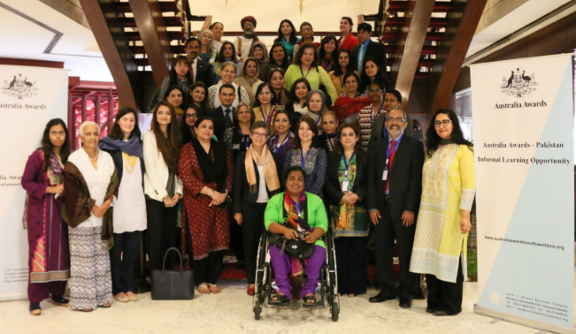
The Network is part of the regional initiative under Australia Awards South and West Asia and seeks to provide alumnae opportunities to network, collaborate, build leadership skills, and promote Australia Awards to other women (Australia Awards Pakistan, 2018). As part of the activities implemented, Ms Naz, in 2016, was selected to attend a regional roundtable event exploring the role of entrepreneurship and leadership in peace-building (Australia Awards South and West Asia, 2016).
2016 Australia Awards Informal Learning Opportunity: Entrepreneurs, leadership and peace roundtable
Photo: Australia Awards South and West Asia
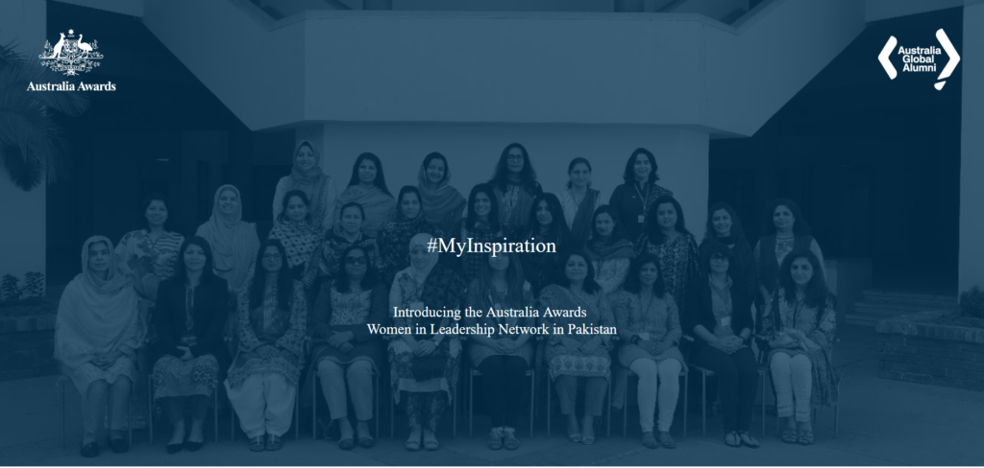
Ms Hashmat is one of 24 Network members in Pakistan profiled in the 2018 campaign #MyInspiration as part of the Mentorship Development Program which highlights alumnae contributions and aspirations (Australia Awards Pakistan, 2018). This gathering of fellow alumnae from across Pakistan and the region promoting peer learnings was felt by Ms Hashmat to be a motivating experience - ‘when we interact with these forums, we get new ideas’.
Australia Awards Women in Leadership Network in Pakistan, 2018 #MyInspiration Campaign
Image: Australia Awards Pakistan

Australian High Commission events and engagements
The Australian High Commission is committed to building meaningful alumni engagement to support continued links and promotion of the Australia Awards.
Mr Jeeven Nadanakumar (Third Secretary) stated one means of engagement is participation in workshops and conferences, particularly focusing on alumnae to promote female participation in typically male-dominated spaces:
It’s a real issue here – getting women on panels…we use our female alumni as a way to put women on those panels, who are highly competent, and then the signals that represents can be quite important.
Ms Jahan is one such alumna who has been invited to attend as a keynote speaker on three occasions at alumni events and described the opportunity to provide a ‘Pakistani viewpoint’ on how Australia can be engaged in development and policy. Ms Hashmat similarly shared her keen interest in attending Australian High Commission events and thematic discussions – ‘most of the time, I try my best to attend those sessions. Mr Ajmal Malik, a colleague of Ms Hashmat and Chairperson of CHIP, also sees the benefits of these events in generating exposure to other organisations. This is an indication of how Australian High Commission engagement with alumni can contribute to broader bilateral cooperation through such networking opportunities.
The Australian High Commission also highlighted the interlocutor role alumni and privately-funded scholars have provided in bilateral engagement:
When you engage [alumni] at this level, they absolutely are willing to engage, are more inclined to engage with us.
One such example is an Australia Awards alum who was able to guide the Australian High Commission through the accreditation process to enable Australia to participate as an observer during the 2017 Pakistan general election. This has since evolved into a bilateral exchange through the Australia Awards, with the Secretary of the Electoral Commission of Pakistan then attending as an observer during the 2019 Australian federal election.

Australian alumni associations
The Australia Awards Alumni – Pakistan (AAA-Pakistan) engages with alumni, offering a platform to remain connected with each other and Australia. The Alumni Executive Committee noted that its purpose is to contribute throughout the scholarship cycle; from promoting the Australia Awards, to pre-departure briefings, welcoming and reintegrating new alumni, and continuing networks for less recent alumni.
With a geographically diverse membership, AAA-Pakistan engagement with alumni is primarily through social media. A number of activities have been conducted, with a focus on charity and volunteering, including a book drive and a tree planting initiative.
Common amongst Australia Awards alumni associations in previous Facility Case Studies, two key challenges experienced are: the time constraints in balancing full-time work with volunteering time with AAA-Pakistan; and developing activities to engage the vast range of alumni interests.
All alumni in this Case Study are members of AAA-Pakistan, with varying degrees of active participation. Ms Jahan stated she attends events regularly, and Ms Hashmat is similarly involved. Other alumni stated time was a constraint to their involvement, as well as relatability of events as less recent alumni. However, all remain engaged through online communications.
One alumni also stated they were also an alumni member of their Australian university.

Advocacy/promoting study and experience in Australia
The Australia Awards Pakistan identified through their applications that at least 80% of applicants were recommended by alumni to apply, indicating the significant contribution by alumni in recommending the Australia Awards to their networks.
In confirmation of this overall trend, alumni who feature in this Case Study have promoted study and their positive experiences in Australia to others interested in undertaking higher education abroad. In particular, Ms Hashmat and Ms Naz mentioned having provided advice to those interested in the Australia Awards.

Enabling factors
The key enabling factors identified in this research as contributing to the above examples of bilateral cooperation and institutional links are 1) Alumni motivation to build networks and exposure in Australia, 2) positive on-award experiences, and 3) proactive and meaningful engagement by the Australian High Commission and Australia Awards Pakistan. These factors have predominantly enabled the continued achievement of Outcome 2, cooperation, by this group of alumni.

Alumni motivation to build networks and exposure in Australia
Most alumni described the range of friends they made, particularly with fellow international students. Two alumni stated that they intentionally sought to meet a diverse range of students. Dr Rana described this as a ‘conscious effort’, and Mr Shahbaz perceived this to be an important part of the international study experience:
The idea was not just to get an education. My intention was to go and live with so many different people just to see things…because it’s not only about studies; it’s also about the culture because there are so many things you learn from others.
Mr Shahbaz’s motivation to learn from others was also the reason for his interest in volunteering with an Australian NGO while on award.
This motivation contributes to the ongoing people-to-people links and involvement in international and multilateral projects.

Positive on-award experiences
The Australia Awards M&E Framework assumes Outcome 2 would include the existence of a more intangible connection with Australia based on alumni having ‘a positive view of Australia and Australians which can contribute to an improved general perspective of Australia in their communities’. Over the long-term, this perception may positively influence Australia’s relationship with a partner country.
The positive on-award experiences (both in their study and in life in Australia) of alumni have had multiple flow-on effects. Ms Hashmat and Ms Naz recommending the Australia Awards and study in Australia to others on return is one such example. Living in Australia with other students, and the related cultural experiences with friends have also contributed to ongoing links.
Another example is Dr Rana’s decision to undertake his Doctorate in Australia following his Masters degree at the University of Queensland, choosing the University of Melbourne scholarship offer over a UK institution scholarship:
Since we had been in Australia, we had enjoyed living there. So other things being more or less equal, I had absolutely no reason to prefer going to Nottingham. So we happily moved to Melbourne.
Dr Rana’s Doctoral degree led to the subsequent opportunities to contribute to international and multilateral research projects with the University of Melbourne and Monash University.

Valuing alumni engagement: Australian High Commission in Islamabad and Australia Awards Pakistan
The whole-of-mission approach to utilising Australia Awards and other funding mechanisms for short courses reflects a strategic soft power approach to achieving broader bilateral aims. Alumni are identified by the Australian High Commission and by Australia Awards Pakistan as one of the key strengths of the Australia Awards. As such, the post-award opportunities offered to alumni, in particular, the use of Informal Learning Opportunities, is a key factor enabling continued links with Australia.
All alumni in this Case Study spoke enthusiastically about the events and workshops they have been invited to by the Australian High Commission. The inclusion and involvement of alumni in opportunities such as keynote speakers and mentoring programs enables the Australian High Commission to remain connected with alumni with mutual benefit.
The Australian High Commission in Islamabad is currently (2019) developing a Pakistan-oriented alumni engagement strategy, which will include all Australian graduates, both those from scholarships and those privately funded. The strategy will aim to enhance relationship building with alumni further to contribute to the bilateral relationship and reflects the deep commitment of Australia to these alumni.

Challenging factors
Alumni in this Case Study identified a number of factors that made it challenging for them to build and maintain networks with Australians and Australian organisations. These include barriers to access and opportunities, relevance and interest in professional links and partnerships, and the loss of contacts over time. These factors have limited the opportunities for alumni in this Case Study to build formal partnerships at an institutional level, limiting achievement of Outcome 3 – partnerships.

Access and opportunities to build professional links and partnerships
In general, the connections made by alumni in this Case Study do not extend beyond their universities, the alumni association, and informal social networks. This finding is consistent with the observations by Australia Awards Pakistan and the 2018 Australia Awards South and West Asia Case Study focusing on private sector alumni:
Unfortunately, very few alumni are maintaining the professional and academic networks they made with their Australia Awards institution following their return to their home country. However, many are maintaining social links with institutional staff and fellow students (globally).
One recommendation for improving trade and business partnerships put forward by the 2018 case study is to develop work placements and internships on or immediately following the award. The Australia Awards Pakistan team has seen the positive effects of on-award professional engagements, which have been increasing, in recent years. Ms Rabbani stated:
I’ve seen in the last two years, people who return to Pakistan, they’ve got a lot of practical skills with them, a lot of professional knowhow also…international exposure to different sorts of professional bodies and interacting with international professionals, that makes a difference.
These engagements include attending conferences, and Australian university work integrated learning (WIL) opportunities such as internships and shadowing placements.
With the increasing focus within Australian universities for WIL embedded as part of courses, the challenges expressed by one alumni may likely be reduced. One alum perceived information access to be a barrier in navigating and identifying internship opportunities, particularly in a less familiar setting, and as a result, did not undertake the internship option for their course. This alum felt this was a missed opportunity to gain professional exposure.
In addition, support for less-recent alumni to establish links with Australian organisations is needed. This could be particularly effective for those alumni who are now in leadership positions within their organisations.
Mr Shahbaz, who was successful in self-sourcing a professional volunteering opportunity, has experienced challenges in accessing Australian organisations and developing collaborative opportunities. Since returning from award, Mr Shahbaz has tried to initiate collaborations for joint research and custom training programs in Pakistan with Australian counterparts, which he stated, unfortunately, did not materialise.
Similarly, an alum suggested greater support in this regard to be beneficial. They highlighted Australia Awards alumni events could include more collaboration in planning alumni activities and opportunities for ongoing engagement following events:
These are not challenges as such, but there is no effort to facilitate joint planning, but the events are conducted. We go to dinners and parties with alumni. We interact and coordinate, but after that, there is nothing jointly as such.

Relevance and interest in professional links and partnerships
In contrast, for some alumni working in the public sector, professional links and partnerships are not a necessity or are not within their mandate in their workplace. Dr Afzal stated ‘I have not needed to approach [my Australian networks] for any professional requirement, utilising my contacts for the advancement of the work that I do’. Dr Rana similarly stated that at the time of his award, he was working in the public sector:
Back home in Pakistan, I was already part of a very strong network of public servants, and when I returned to Pakistan, I readily fitted into that. So I was not looking for opportunities to become part of any formal networks which would help me professionally or academically in the years to come.
This aspect of relevance and interest may indicate that a different approach to building engagement may be more meaningful for public sector awardees and alumni.

The loss of contacts over time
Many of the links alumni mentioned have continued. However, reflecting similar findings for less recent alumni in previous Case Studies, two challenges to the longevity of links is when their networks in Australia have retired, and the gradual loss of contact over time.
One alum mentioned they were once very close with some of their university professors, but that this discontinued when these academics retired. Another had remained in contact with their supervisor for nearly ten years, which faded due to the time and number of students they meet:
Once my supervisor told me, “Yes, we have some students from India.” So then I thought, “Oh, this is the time. Now she forgets me; that I’m from Pakistan, not from India.” But that was after maybe 10 years or some time because they have so many students.
This fading of links is not unexpected but does emphasise the need for a holistic approach to post-award engagement with differing focus and opportunities as needs and relevance will change over time.

Views about Australia and Australian Expertise

Summary findings
Alumni in this Case Study hold enduring positive views about Australia, Australians and Australian expertise. Based on this, the Australia Awards long-term Outcome 4, that ‘Alumni view Australia, Australians and Australian expertise positively’ is being achieved.
The alumni emphasised that the support they received on award facilitated their positive experiences, assisted in overcoming challenges and were the foundation for their ongoing positive views of Australia.
For the alumni in this Case Study, Australia Awards long-term Outcome 4 – positive views is being achieved.
- Australian education quality is highly valued. Alumni were impressed by the expertise, teaching quality, and services at their Australian universities
- alumni reflected positively on Australian people and Australian culture and lifestyle based on their experiences on award
- both the Australian scholarship experience and alumni contribution to development in their country generates positive views of Australia.
Key enabling factors
The principal factor which enabled positive views was the support provided on award, this encompassed:
- social interaction
- wellbeing activities
- engagement from academics.
Key challenging factors
Factors that challenged alumni in developing, maintaining, or broadening networks and partnerships with Australia and Australians were:
- culture shock
- integration
- geopolitics
- cultural differences.

Introduction
The final long-term outcome of the Australia Awards, Outcome 4, seeks ‘alumni view Australia, Australians, and Australian expertise positively’. This outcome is also a significant basis for the achievement of Outcome 2 – cooperation. Long-lasting positive personal and professional attitudes to Australia are seen as ‘fundamental to alumni contributing to cooperation between Australia and their home countries, and more broadly to the bilateral relationship’ (DFAT, 2016).
To achieve Outcome 4, the Monitoring and Evaluation program logic (DFAT, 2016) identifies three key components for building a positive view of Australia:
- alumni were able to establish links within Australia
- alumni had positive experiences on award in Australia
- alumni and their families had positive experiences of life in Australia
- alumni completed good quality, relevant education, training, other professional development and research activities
- alumni continue to have positive experiences in their interactions with Australia and Australians post award.
The alumni in this Case Study all expressed overwhelmingly positive views of Australia, Australians and Australian expertise, demonstrating achievement of Outcome 4. These positive views have manifested in alumni contributions to Outcome 2 – cooperation through ongoing people-to-people links, participation in Australia Awards Pakistan and Australian High Commission events and activities, and advocacy/promoting study in Australia (as discussed in the previous Chapter).
Positive views of alumni developed largely as a result of their experiences on award, particularly in relation to the quality of their education and the lifestyle aspects of their time in Australia. This reflects one of the three key components in achieving Outcome 4.
The other two factors, links established within Australia, and continued positive experiences with Australia and Australians post award were less relevant in this Case Study. As discussed in the previous chapter, this may also be a reflection of the intention of the Australian scholarships at the time, which did not hold the same emphasis for building networks on award and alumni engagement as today’s Australia Awards.
The key factor that has led to enduring positive views of Australia, Australians and Australian expertise is that alumni feel they were supported by the Australian scholarships team and their institutions.
In the examples of positive views and the challenges to positive views, support is the principal factor in building alumni’s positive views or helping them to overcome difficult situations. The support they describe includes elements relating to social, wellbeing, and academic support.

Examples of positive views of Australia and Australian expertise
Overall, all six alumni had positive experiences during their time on award in Australia, which are reflected in their positive views of Australia, Australians and Australian expertise. These views are encompassed in three aspects: 1) the quality of education in Australia, 2) Australian people and culture, and 3) the scholarship experience.

Australian education quality
Four alumni emphasised the quality of their educational experiences in Australia, particularly the expertise of their supervisors and lecturers, the teaching quality, Australian university resources and Australian schools.
Expertise
Mr Shahbaz and Dr Afzal spoke of their admiration for the staff they interacted with at their Australian universities. These sentiments, which have remained strong for over 15 years, demonstrate the lasting impression this has had on their views of Australia.
For example, Mr Shahbaz regarded his teachers as ‘exceptionally good’, drawing distinction also from their career trajectories as leaders in the sector - ‘My supervisor, he teaches in Harvard now. One of my [other] teachers is a dean, I think, in New South Wales’.
Mr Shahbaz also highlighted the integral role of non-academic staff in support, mentioning one staff member responsible for supporting international students with academic writing and assignments:
Even the people who were not on the academic side, they were excellent, beautiful. They knew what they were doing. I still remember Rosemary…I never saw such a polite woman and such an expert person in my life. I never saw her say to anyone, ‘I don’t have time’. And she was an extremely, extremely busy woman. She was so good.
Teaching quality
Three alumni stated the teaching approach was an aspect they felt had a positive impact on their learning, particularly in their relationships with supervisors and lecturers. Dr Afzal thought that this feature was a comparative advantage to universities in other countries:
I think, in a way, [Australia] might actually be even better than other universities, because, from the anecdotal evidence I have from people who have studied in other countries, I think that the faculty [in Australia] was more attentive. They paid greater attention to what they were teaching you and how they were guiding you.
There was a one-to-one personal sort of touch. And from that, I might say that the quality of the education, both in terms of learning and the methodology through which I was learning and the personal touch that was through, it may have been an experience which would have been much better than the experience I may have had in any other country.

Australian university resources
The service provision in Australian universities was a highlight for Dr Rana and Ms Naz. Dr Rana was impressed by the library services, including the quantity of books and the online resources available, but also the readiness of the librarians to assist with requests.
Ms Naz’s positive views of her Australian university focused on the support for student wellbeing available, which she felt was important to her education experience:
There were support structures like if you have some late classes, they would escort you from the university to the house on campus or off campus. So no issue at all. You just spent some time in the library, and then you tell those volunteers, “I’m going home”, they would escort you. That helped a lot.
Australian schools
Dr Rana stated he and his family have ‘nothing but praise for our experience with studying in Australia’. This was a key reason in his decision to accept a doctoral scholarship to study in Australia over the UK, which then resulted in his subsequent international research engagements with Australia. In particular, his experience of the Australian school system stood out for him. In his reflections of his family’s time in Australia, Dr Rana perceived that his son was ‘the biggest beneficiary of the Australia Awards’ receiving a ‘very solid’ foundation to his education in Year 1.

Australian people and culture
Alumni reflections about Australian people and culture included both their ongoing people-to-people links, and also their broader experience of life in Australia.
Ongoing people-to-people links
One alum referred specifically to their ongoing friendships in Australia and enthusiasm to meet Australians since his time in Australia. Mr Shahbaz stated ‘I have so many friends in Australia. I love to interact with them. When I see some Australians [now, I say] ‘Let’s talk about…’ it’s endless [the things about Australia we can talk about]’.
Life in Australia
Three alumni particularly highlighted the lifestyle, cultural and environmental aspect of living in Australia. These perspectives demonstrate the intangible facet of positive personal attitudes towards Australia that can foster goodwill towards a strong bilateral relationship.
A commonly emphasized bond between Australia and Pakistan is the shared passion for cricket. Mrs Aqdus enthusiastically described the ‘bonus’ of her time in Australia was attending a One Day International between Australia and Pakistan at the Gabba (Brisbane Cricket Ground).
Pakistan won that day. So that day also is fixed in my mind. And what a beautiful stadium…I think you’ve got one of the best stadiums in the world. The Gabba Stadium is beautiful…So Australia, very good memories.
For Ms Naz, her experience in Australia was highlighted by the food and the environment.
The time I spent there is my wonderful time, my memories. Every dish I cook, every restaurant, every park, every beach, that’s a memory for me, an asset for me. And the vegetable market, those weekend / Sunday markets, flea markets. I’m still keeping those little things which I bought from those places – so many memories. I wish I could go again!
Dr Rana also described how he enjoyed the infrastructure of his Australia institution and the city of Brisbane with access to beaches and nearby amusement parks. In particular, Dr Rana gave a powerful testament of his experience of Australian culture through his observations in the impact life in Australia had on his son:
I consider [my son] to be a good human being. He’s a fine man; he’s a fine boy, he’s a gentle boy, his feelings towards others – not only human beings but also animals and plants. Part of this change or part of this development can be attributed to the cultural experiences that he had in Brisbane and then in Melbourne.

Support from the Australian scholarship program
The Australia Awards Pakistan team stated that ‘Australia is seen as a positive development contributor in the country’ – and the Australia Awards themselves are a significant aspect of this development contribution. Recognition of Australia’s contribution can be observed through the alumni who work in ministries and sectors important for the Government of Pakistan. Ms Rabbani emphasised the role of alumni as ambassadors for Australia’s investment:
If [alumni] had not been making those contributions [through their work], I think the program would not have this sort of recognition, reputation and respect also, [that is] so important here.
Alumni also recalled their scholarship experience, pre- and post-award, positively. At the application stage, two alumni specified the helpfulness of the Australian scholarships team, demonstrating a lasting recollection. For Mrs Aqdus, the approach of the Australian scholarships staff laid a foundation for her positive views of Australia. Mrs Aqdus describes her ‘first endearment towards Australia’ was the way in which her scholarship was offered to her:
Generally, when a person is out there offering something to you, they generally come from a high pedestal…But these Aussie guys were out there telling me, “Congratulations, madam. Can we do anything more for you?” So it was like they were not being haughty about it. They were trying to help. That was my first endearment towards Australia.
Dr Rana similarly stated, ‘I found the people handling the scholarships in Pakistan were very helpful. I still remember a couple of people who steered the process.
Mrs Aqdus is an actively engaged alumni as a result of her overwhelmingly positive Australian scholarship experience. Mrs Aqdus describes her Australian scholarship as a ‘gift’ due to the support provided to develop a tailored study pathway and family accompaniment on award. To display her pride in being an Australian alumni, Mrs Aqdus had a kangaroo pin specially-made so that she ‘could wear it permanently’.
All alumni in this Case Study are members of the alumni association AAA-Pakistan, a demonstration of their enthusiasm to continue to be connected with Australia. Mrs Aqdus, in particular, shared her positive views of Australia from the events she has attended:
I attend all the functions that the Australian Embassy invites me to. You have a very happening ambassador, Madame Margaret. She’s very happening; she’s very good. She’s worked a lot on women’s issues in Pakistan. And we’re very thankful to her for raising awareness on many fronts. So whenever she invites some there, that’s all I can do. I keep in touch.

Enabling factors
The examples of positive views above provide a rich depiction of the underpinning enabling factors in alumni developing positive views of Australia, Australians and Australian expertise. These enabling factors can be summarised as the social, wellbeing, and academic support alumni were able to access through their Australian universities and networks:
- Social
Activities and social events, either formal or informal, have helped alumni to become settled into their new environment and to meet others.
- Wellbeing
Regarding safety and feeling safe, campus escorts in the evening and care in finding suitable accommodation for individual needs were particularly appreciated by the female alumni.
- Academic
Support from both academic and non-academic staff were highlighted by alumni as beneficial for their learning outcomes. Alumni discussed the different teaching methods in Australia required some adaption, and adjusting to this was aided by their Australian universities.
These support mechanisms are likely to be helpful in achieving two of the three key components identified by the Australia Awards in scholars building a positive view of Australia on award. These components are 1) building links within Australia and 2) having a positive experience of study and life in Australia (DFAT, 2016). More recent alumni could be expected to have further insights regarding on-award social activities and events as a result of the increased attention by the Australia Awards to support on-award networking opportunities.
Recent alumni may also be likely to have further insight regarding the impact of support for the third key component – ‘Alumni continue to have positive experiences in their interactions with Australia and Australians post award’. With the increasing emphasis of the Australia Awards on alumni engagement and support for reintegration, this is also likely to generate further positive views for more recent alumni.

Challenging factors
Two of the six alumni discussed aspects of their time in Australia which they found challenging.
Culture shock, integration, global events relating to the geopolitical situation of Pakistan, and cultural differences were raised as challenging aspects alumni had to navigate on award. These experiences did not overwhelm the positive aspects of their time in Australia, but rather demonstrate the spectrum of international student experiences and views.
Considering the well-documented challenges international students experience, and which Australian scholarship students are also like to face, these insights are not surprising, although not always aspects shared by alumni in the Facility’s other Case Studies. This is could be due to the positive response bias that exists in the nature of scholarships studies (discussed in Annex 1).

Culture shock
The experience of culture shock raised by a female alum brings to the fore the importance of on-award support structures which are a predominant feature of the Australia Awards. Difficult transitions into life and study in Australia can have a jarring effect on scholars and their perspective of their Australian experience. The alumna described experiencing ‘very tough’ moments and culture shock settling in and feeling insecure in her accommodation with a number of incidents in her first three days. Coming from a traditional village and lifestyle in Pakistan, and going straight into summer holidays in Australia was understandably a significant change, as was emphasised by this alumna:
What happened on the [second] night, four or five boys, they were on the floor up from me, and they were celebrating New Year’s Eve, they were drinking, they were shouting, and they started breaking stuff and throwing it out from the window. Another night of disaster. I was so scared at first. I was again crying, “Please send me back to Pakistan. I’m not going to stay here. This is not a good country”.
It was the assistance of other international students from Bangladesh and Pakistan who helped the alumna to navigate finding alternate accommodation through the Graduate Hall on campus – ‘They accommodated me in one day, they provided me with an excellent space and that space was like heaven…So my life really started excelling after three days.’

Integration
An alum discussed feeling isolated in their first semester in connecting with other students:
I had a different dressing style, and I used to wear my traditional clothes, so during the first semester, reception by my fellow students was a little different. I was very isolated, but I was very welcomed by all faculty members.
Moving to a foreign country can be an isolating experience. For Ms Naz, who prior to her scholarship had spent all her life in rural Pakistan, moving to Australia was ‘a very big challenge’.
My family was unsure that it was worth the effort [applying for a scholarship]. No mother, only my father, and I was very homebound. So going away was a very big challenge for me. I spent all my life in Peshawar until the scholarship.
Consider the context, where everyone is supporting you in everything; everyone comes with you and helps you wherever you were. But when I got to Australia all on my own, I didn’t know what it would be like. I was going for two years and took everything I thought I would need.
The social activities at Ms Naz’s institution helped her to get to know Australia and Australian people, particularly gatherings hosted by her supervisor and teachers helped her to become settled in as a student.
They would invite us at the end of the course for some sort of party, sometimes for a drink at their own places, something for us, like an evening, inviting students for a dinner. That was a quite good setup for people like me to settle down.
And there were some social organisations, like some women’s groups who would invite us for their weekend chat or something. So it’s like getting to know Australia and getting to know, living with those people.

Geopolitics
Three alumni were on award in Australia at the time of the attacks on 11 September 2001 in the United States of America. One alum raised their experience of being a Pakistani Muslim in Australia at that time. This experience provides a small insight into the exposure risk that may arise for international students in Australia, particularly during times of significant events. However, this alum’s experience demonstrates how vocal support for tolerance in response to 9/11 was helpful, but also, significantly, their own generosity of tolerance in dealing with negative confrontations.
A difficult moment was created when 9/11 happened when I was there. I had a wonderful experience in the university. The moment 9/11 occurred, the Vice Chancellor issued a note to all students and faculty members: do not mistreat any of the Muslim students; which was very encouraging and very good moments. Some reactions happened by a bus driver or any common people, but these exceptions exist in all countries. I don’t blame any of the factors. But I had a wonderful experience, people smiled, people said ‘Hello’.

Cultural differences
One alumna expressed their perspective of both the positive and negative aspects of their time in Australia, describing how her time in Australia broadened her cultural views and understanding, but emphasised that this did not necessarily change her values and traditions. In other words, the change that occurred for her is one where she appreciates the ‘other’ but retains her identity:
You [Australia] made me different. If I had not had your experience, I would have been a person pretty much pegged in an environment, maybe not open or maybe not accepting or maybe not understanding why the world is the way it is. I understand all that now. I understand you for what you are and what you signify. I love it. But if tomorrow you expect me to be you, uh-uh [no].
Change happens in the mind. That’s happened. We are all now very open to this new world order and how things happen and how things have changed and why things have changed and that we should align ourselves with change. But you can’t expect us to now start looking like you, no.
These insights provide a valuable perspective of how cultural differences can be bridged and understanding fostered through the opportunity to live and study in Australia.

Impact of Australia Awards on Addressing Equity Issues

Summary findings
A key aspect of the Australia Awards is its emphasis on equity. In this Case Study, the contribution to enhancing equity in Pakistan is apparent through both the actions, policies and processes of the Australia Awards Pakistan itself, as well as through the contributions of the alumni of focus in this study. Three particular areas of equity are explored here – gender equality, disability inclusion and economic disadvantage.
For gender equality, the Case Study finds:
- the Australia Awards focus on 50 per cent of scholarships for women is a unique feature in the ‘scholarship market’ and is having success in building capacity of women in Pakistan
- alumni from this Case Study have made significant contributions in the area of gender equality and advocacy for women’s empowerment.
For disability inclusion:
- Australia Awards Pakistan has put in place numerous initiatives to lift participation of people with disability, resulting in four scholars with disability in the most recent intake
- one alumna from this Case Study has worked to improve governance and accountability systems in Pakistan that help develop equitable opportunities for people with disability.
For economic disadvantage:
- the Australian High Commission works widely across the different provinces of Pakistan to ensure its aid funding supports inclusive growth and development – and the Australia Awards is no exception
- alumni from this Case Study would not have been in a position to gain an international postgraduate qualification had it not been for their scholarship.

Introduction
The Australia Awards specifically aims to address cross-cutting issues relating to equity and social inclusion. This emphasis is stated in the Australia Awards Global Strategy, Principle 2: equity of access (DFAT, 2016). Equity of access is encouraged at the promotion, application, on-award and post-award stages by:
- maintaining equal numbers of Awards for women and men at the global level
- ensuring Australia Awards opportunities are promoted widely across government, civil society and private sectors
- designing appropriate interventions to address barriers to participation and provide on-award/post-award support where participation by women, people with disability and other disadvantaged members of society is low
- ensuring equitable access to on-award and alumni engagement opportunities.
This chapter describes the impact of the Australia Awards in addressing equity and disadvantage in Pakistan. It explores how the scholarships contribute to ‘address barriers to participation and provide on-award/post-award support where participation by women, people with disability and other disadvantaged members of society is low’ (DFAT, 2016).
The discussion below explores three areas of disadvantage in Pakistan: gender equity, disability and economic disadvantage. In examining these areas, the chapter focuses on the impact that Australia’s development scholarships have on improving opportunities, access and recognition, and the impact of the alumni of focus in this Case Study.

Gender Equality

Context
On global metrics relating to the inclusion and equality of women, Pakistan’s record suggests significant room for improvement. The Pakistan Vision 2025 development policy itself acknowledges this, specifically highlighting:
Pakistan ranks 123rd in the world on the Gender Development Index, even lower than its Human Development Index ranking, indicating that the access to opportunities, resources and benefits between men and women are skewed (Pakistan Planning Commission, 2014, p.38)
More recent data in the World Economic Forum’s (WEF) 2018 Gender Gap Report, measuring women’s economic participation and opportunity, educational attainment, health and survival, and political empowerment, lists Pakistan as the second lowest country globally (148th of 149 countries included) (WEF, 2014).
The WEF report, the Pakistan Vision 2025 policy, and the interviews for this Case Study each highlight that Pakistan’s patriarchal society and cultural traditions have contributed to the inequitable access for women to education and led to economic disempowerment.
Drawing on these themes, one alumna explained the idea of liberation in Pakistan’s context:
What I’m trying to tell you is that the liberation is much slower in an environment where you have to deal with the backward people who have influence, and influence also in such an extreme way because the society is not as literate as your society.
Another alumna provided an illustration of the issues facing women in relation to autonomy. She noted that in many areas of the country, women are not allowed to travel on their own. For example, on public transport from Peshawar to Islamabad, an alumna mentioned that women are not allowed to sit next to men – ‘a woman can sit only with a woman. But if there is no other woman, you have to pay for two seats. That is still going on.’
In recognition of the broad issues facing Pakistan, the Pakistan Vision 2025 ‘Pillar 1’ has a focus on ‘Developing social and human capital, and empowering women’ (Pakistan Planning Commission, 2014). Similarly, the importance of this is highlighted by the Australian High Commission, which has elevated addressing gender equality to be one of its three overriding priorities: ‘investing in Pakistan's people with a focus on women and girls’ (DFAT, 2019c).

Impact of the Australia Awards
During interviews in Islamabad, the Australian High Commission highlighted the strong role that the Australia Awards play in achieving the priority focus on gender equality. The Australia Awards was said to be a key ‘entry point’ for the Australian High Commission to make an impact in promoting gender equality.
Most prominent for the Australian High Commission, is the Australia Awards are the only international scholarship program in Pakistan that mandates a strict gender quota in the allocation of places. This is supported with a policy to offer 50 per cent of scholarships to women, with gender equality a focus at every stage of the scholarships cycle. This impact was best summed up by the Australia Awards Pakistan office, which noted:
I think that has been one of our strengths here in Pakistan, not just saying that, “Okay, our programme says that at least 50% of the scholarships or any opportunity created through the platform of this programme would go to women.”
… But it’s at every stage that we consciously make sure that whatever we are doing, be that promotions, selection processes, short course designs, alumni engagement activities, or any other opportunities…gender, women empowerment, is something which remains a priority and our programme is recognised for it.
The Australian High Commission and the Australia Awards Pakistan also noted a range of activities supporting women and alumnae to contribute further within their communities. These include:
- short courses with a gender focus. For example, Women in Leadership, Women in Policing (with a gender-based violence awareness emphasis)
- a mentoring program for women alumni in partnership with a high calibre local university to build their skills and enable them to mentor other women to become emerging leaders in their workplaces
- profiling of women alumni – through the championing by the Australian High Commissioner; by engaging alumni in events such as International Women’s Day; and by using social media platforms to highlight outcomes.

Alumni contributions
A number of the alumni have made notable contributions towards the progression of equality for women in Pakistan. Ms Hashmat and Ms Naz have both undertaken specific development projects focusing on gender equality, while Mrs Aqdus is a strong example of women in leadership in the Pakistan public service. In addition, Mr Shahbaz’s organisation has a strong emphasis on advocating ‘Gender Justice’ through their projects.
As highlighted in Chapter 2, Ms Naz has forged her career in the pursuit of promoting gender equity. Through her development work, she has assisted private and public organisations across the region. Her work has built policies and improved practice relating to the inclusion of women in the workplace, and helped develop the capacity of women through education.
The Sungi Development Foundation, which Mr Shahbaz leads, is direct in its advocacy for women and has undertaken projects in recent years such as the AAWAZ Voice and Accountability Program which aims to ‘enhance women’s safe political participation’ (DAI, n.d.). The Foundation also strongly highlights on its website what it sees are important issues to address:
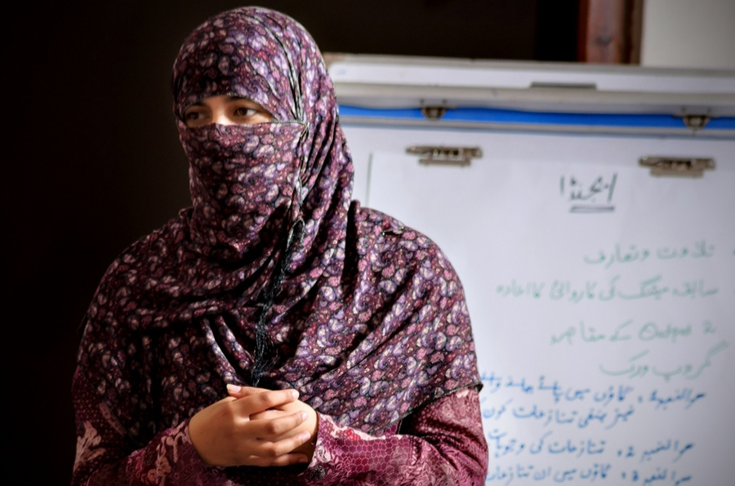
Violence against women and girls, is a violation of fundamental human rights, a barrier to women’s active citizenship, and hence, a fundamental constraint to them actualising their full potential and to a life with dignity.
Participant in AAWAZ Voice and Accountability Programme planning session, 2014.
Photo: DAI https://dai-global-developments.com/articles/supporting-active-citizenship-across-pakistan
Ms Hashmat’s organisation, CHIP, is also a national leader in development activities focussed on enhancing the rights of women in Pakistan. In particular, Ms Hashmat spoke in her interview about a project she developed that helped to raise awareness of, and change attitudes towards domestic violence.
Working with survivors of domestic violence in this project, Ms Hashmat spoke of how she designed the program by beginning from a positive perspective of ‘Happy Families’. By taking this approach, she was more easily able to gain buy-in to the program from men, who participated in the project which involved asking them to articulate the factors that made a happy family. They successfully ran the project across a number of villages and Ms Hashmat noted:
When you talk about negative things in a positive manner, it helps. We created a lot of community support within the villages where we used to have women survivors of violence...[We helped emphasise] this is possible when you love, when you respect, when you care, when you provide basic services.
Mrs Aqdus’ ideas and experience in providing leadership as a woman in Pakistan also draw on the idea of adapting messages and approaches to this context of Pakistani culture and society. During her interview, she emphasised this, saying ‘you need to operate within the cultural and traditional belief system of the country to come up with a solution’ for supporting and promoting women. She expressed some frustration at the way in which international NGOs or governments have attempted to create change in this area by ‘coming up with a solution from your own environment’.
As a leader in the Pakistan public service, where she noted only about five per cent of leaders are women, Mrs Aqdus emphasised that she is able to make change within the cultural setting in which she works:
I feel that women are making a dent and contributing in a way where they are being recognised. But yes, a woman has to work twice as much as a man to make a place for herself, no doubt about it. In a patriarchal society, change happens slowly. But that slow change has happened and is happening.

Disability Inclusion

Context
A comprehensive report in 2014 by the British Council details the context and challenges faced by people with disability in Pakistan (The Economist Intelligence Unit, 2014, p.4). It highlights:
- there is no clear understanding of the number of people in the country with disability – with estimates varying from 3.3 million to 27 million depending on the source
- Pakistan ratified the UN Convention on the Rights of Persons with Disability in 2011, ‘but progress around building an inclusive society has been slow’
- people with disability ‘have difficulty exercising their civil and political rights, attending quality schools and finding gainful employment’.

Emphasising this, the Australian High Commission, Islamabad noted that:
Entrenched social stigma towards people with disability in Pakistan is a major barrier to participation in education, work and society more broadly. The most affected are children, women and girls, because here in Pakistan women are primarily looking after their family members with disability – they are the primary carers.
Despite these issues, there is some potential for change in this area in Pakistan. In the last couple of years, progress has been made. For example, in 2017, a Bill was drafted in the National Parliament titled – Pakistan Rights of Person with Disability Bill. It was designed to improve the rights of people with disability and legislate for change to ensure equity in access. This Bill was interrupted by the national election in Pakistan in 2017.
However, this momentum has not been entirely lost. The Australian High Commission noted that the new Government, led by Imran Khan ‘have taken some really good steps and intentions to expand the social safety for people with disability, and conduct nationwide services to get quality and reliable data on people with disability’.

Impact of the Australia Awards
The Australia Awards in Pakistan emphasises participation for people with disability by ensuring that advertisements for the scholarships are accessible to all people in Pakistan and specifically promoting and encouraging applications from persons with disability.
In addition to the promotion within networks for people with disability, the Australia Awards has adapted application processes to enable more people from this group to apply for the scholarships. In particular, the policy relating to English language requirements (through the International English Language Testing System (IELTS)) has been adapted for people with disability at the scholarship application stage.
For this, the focus of the initial application is on criteria other than IELTS, and if a person is successful in these other criterion they are supported by the Australian High Commission to study for and reach the IELTS requirements set by Australian universities.
The Australia Awards also provides significant financial support to ensure people with disability who are selected for a scholarship have the requisite support and care to effectively participate and complete their studies in Australia. This can include funding for specific equipment or a carer.
These efforts have increased applications from people with disability in Pakistan. Since 2011, 18 scholarships have been awarded to people with disability in Pakistan, of which nine have been in the past two intakes (2018 and 2019) (Australia Awards South and West Asia, 2018b).

Alumni contributions
Ms Hashmat has been involved in a range of projects focussed on the empowerment of people with disability. In particular, she designed the first model for social inclusion of persons with disability for Pakistan, a UK-funded project undertaken during 2007 and 2008.
This project involved developing governance and accountability systems, and was implemented at the local level and included in training for public service staff:
We rolled it out in the community; we made sure that we conducted self-growth sessions for persons with disability. We conducted family training and community support system training at the community level so that we created a conducive environment to rehabilitate a person with disability.
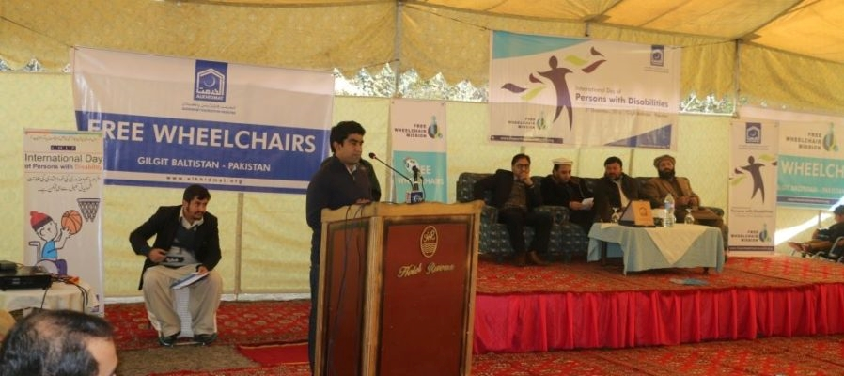
We also developed inclusive development guidelines at the end of the project, which was endorsed by the Government of Pakistan, and they were asked to include this in their formal training programme for their government staff members. So I really feel that that contribution was very helpful.
International day of persons with disability event involving CHIP, led by alumna Ms Hashmat.
Photo: CHIP

Economic disadvantage

Context
Economic-disadvantage in Pakistan is a serious impediment to accessing education and employment opportunities. A significant study into disadvantage in Pakistan, Multidimensional Poverty in Pakistan, was published in 2016 (OPHI & UNDP, 2016). ‘Multidimensional poverty’ is a measure encompassing three dimensions – education, health and living standards, each with a number of distinct indicators being measured. The research highlights that nearly 40 per cent of the Pakistan population are living in multidimensional poverty. Further to this, within the elements of poverty examined, the greatest factors predicting poverty are years of schooling, access to healthcare facilities and child school attendance rates (OPHI & UNDP, 2016, p. xi).
Within the context of Pakistan, perhaps most significant is the finding that there are substantial disparities in disadvantage between the regions of Pakistan. For example, poverty in Balochistan province was found to affect 71 per cent of the population, while in Punjab province the rate was 31 per cent. Stark differences were also apparent for rural populations – where 55 per cent of the population were in poverty, compared with urban areas (nine per cent).

Impact of the Australia Awards
The Australian High Commission is conscious of the significant divide in equality of opportunity across the different provinces of Pakistan. Many of Australian aid projects are specifically focussed on the areas of most need in the country, including Balochistan and Khyber Pakhtunkhwa.
Advertising, selection processes and support targeted at communities in disadvantaged areas are built into the work undertaken by Australia Awards Pakistan. As a result, people from across the provinces of Pakistan are selected each year. Recognising the different access to opportunity in the country, Program lead Ms Erum Rabbani noted the attitude of the Australia Awards towards inclusion:
‘It’s important for a programme like ours where we don’t only look at the really polished and elite…You look at our cohort each year and you see a very diverse group’.
As a result of this emphasis (and alongside parallel emphases on gender equality and disability inclusion), Australia Awards is able to stand out from the scholarship programs of other countries and ensure a more diverse group of Pakistan society have the opportunity to participate. In particular, Mr Shahbaz and Mrs Hashmat both came from what they described as ‘humble backgrounds’, and Ms Naz grew up in a rural town in Balochistan, right on the Pakistan-Afghanistan border. Each of the alumni in this Case Study indicated that the scholarship offering – which covered tuition fees as well as a living expense – removed the financial barrier to their participation in international education.

Alumni contributions
As noted above, the alumni themselves have benefitted from gaining the scholarships – and have had the opportunity to access the scholarships despite not coming from the elite classes of Pakistani society. Each alumni’s contributions have in turn helped to develop their country and in many cases have focussed on lifting the outcomes for people in marginalised communities. These contributions are detailed in Chapter 2.

Conclusion

The Australia Awards plays an influential role in the Australia-Pakistan bilateral relationship. It is unique in a competitive international scholarships market because of its focus in selecting a diverse and representative group of high-quality awardees and offering support and professional development to alumni. The Australia Awards in Pakistan helps the Australian High Commission to meet its bilateral objectives and contribute to the development objectives of Pakistan.
This Case Study demonstrates the leadership and governance contributions of six alumni in the public and NGO sectors in achieving the overarching goal of the Australia Awards which is to: ‘support partner countries progress their development goals and have positive relationships with Australia that advance mutual interests’ (DFAT, 2016a).
For the alumni featured in this research, their Australian Development Scholarship and Australia-Pakistan Scholarships enabled them to attain international postgraduate qualifications and progress in their careers in the public service and NGO sectors.
The skills and knowledge gained in Australia have been utilised by these alumni over the 15 to 20 year period since graduation to contribute to the development of Pakistan in a range of areas from governance restructures to the coordination of disaster relief missions. Their experiences in Australia have also positively shaped their personal and professional perspectives of Australia, Australians and Australian expertise. The ongoing links with Australia and positive experiences at their Australian universities have been the basis for their continued enthusiasm to remain engaged with Australia through the Australia Awards Pakistan and Australian High Commission.
The commitment of the Australia Awards to social inclusion has seen it successfully meet its target for 50 per cent of female awardees, and select 18 awardees with disability between 2011 and 2019. The focus on selecting high-quality candidates who demonstrate a motivation to contribute to the improvement of their country has resulted in contributions by these alumni to gender equality in the workplace and community and implementing government-level social inclusion policies.
The Australian High Commission’s increased focus on Australian alumni and upcoming renewed alumni engagement strategy is likely to further embed the successful contributions and long-term outcomes of Australia Awards alumni.

Alumni Profiles
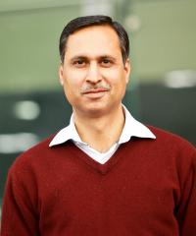
Dr Muhammad Ahsan Rana
I am really grateful to the Australian Government and to the Australian Development Scholarships programme for giving me the opportunity for, first, doing a Masters and then doing a PhD. It really changed the course of my life, and through me, I hope it has also changed the course of life of several of the people in Pakistan.
Scholarship | Australian Development Scholarship
Years | 2002-2003
Degree | Master of Social Planning and Development
University | University of Queensland
Current position | Associate Professor, Suleman Dawood School of Business, Lahore University of Management Sciences (LUMS).
Brief biography | Dr Rana is an Associate Professor, at the Lahore University of Management Sciences (LUMS), in the Suleman Dawood School of Business. Commencing his career as a public servant, Dr Rana was eager to further his education and saw an opportunity to study internationally through a development scholarship. He gained an Australian Development Scholarship to study a Master of Social Planning and Development at the University of Queensland, commencing in 2002. After his scholarship, Dr Rana worked in an NGO building philanthropy in Pakistan and following this, in the Government of Punjab in the Human Resources Department. In 2006, Dr Rana returned to Australia to undertake his Doctorate degree at the University of Melbourne, on a university-based scholarship. Since returning, Dr Rana has worked at LUMS, building the capacity of the next generation of Pakistanis by teaching public policy, social policy and agricultural policy.
Location at the time of field research: Lahore, Pakistan
Date of interview: 13 February, 2019

Ms Lubna Hashmat
I now very strongly believe that if I benefit human beings, change their attitudes, bring in some changes, these development indicators are just the most valuable financial compensation for me.

Scholarship | Australian Development Scholarship
Years | 2000-2002
Degree | Master of Development Administration (Governance)
University | Australian National University
Current position | Chief Executive Officer, Civil Society Human and Institutional Development Programme (CHIP)
Brief biography | Ms Hashmat is Chief Executive Officer of Civil Society Human and Institutional Development Programme (CHIP), a Pakistani-based NGO. CHIP seeks to enable other local NGOs and community-based organisations to strengthen their governance and management processes to work in their local contexts effectively. Ms Hashmat undertook an Australian Development Scholarship, studying a Master of Development Administration, specialising in governance at the Australian National University in the early 2000s. On return, Ms Hashmat helped to guide CHIP from being a Swiss-aid funded program to becoming an independent, sustainable Pakistani NGO, taking on the role of CEO in 2007. Ms Hashmat’s involvement in the development of Pakistan is substantial, contributing to projects in the region, facilitating disaster relief efforts, educating about domestic violence, and developing policies for the inclusion of people with disability. Ms Hashmat is a mentor in the Australia Awards Mentorship Program and is part of an Australia Awards regional Women in Leadership Network.
Location at the time of field research: Islamabad, Pakistan
Date of interview: 1 May, 2019

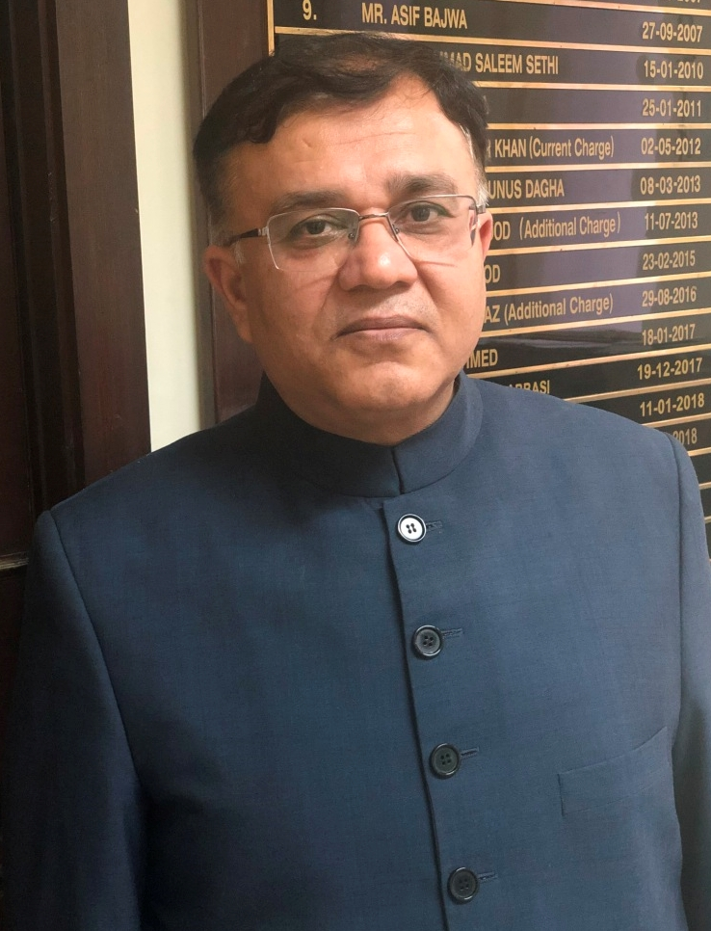
Dr Kamran Ali Afzal
[I have] used all my skills to contribute to decisions that were taken at the highest of levels, especially when I was in the Prime Minister’s Office… I can say with reasonable confidence, this would have been of a more limited quality and impact had I not had this exposure in Australia with my two degrees that I studied, my living over there; it was a different thing.

Scholarship | Australia Pakistan Scholarships Program
Years | 2002-2003
Degree | Master of Public Policy and Management
University | University of Melbourne
Current position | Additional Finance Secretary (External Finance), Finance Division, Pakistan Administrative Service
Brief biography | Dr Afzal is the Additional Finance Secretary (External), in the Finance Division of the Government of Pakistan. He joined the Pakistan public service in 1993 as a means of contributing to public policy. Dr Afzal received an Australia Pakistan Scholarship in 2003 and undertook his Master of Public Policy and Management at the University of Melbourne. Since his scholarship, Dr Afzal has utilised the experienced gained through his studies to help introduce a new model of governance and accountability across the Pakistan public service. Dr Afzal has worked in numerous departments including the Prime Minister’s Office. Building on the networks developed while on award, Dr Afzal returned to the University of Melbourne and completed his Doctorate in 2011.
Location at the time of field research: Islamabad, Pakistan
Date of interview: 30 April, 2019

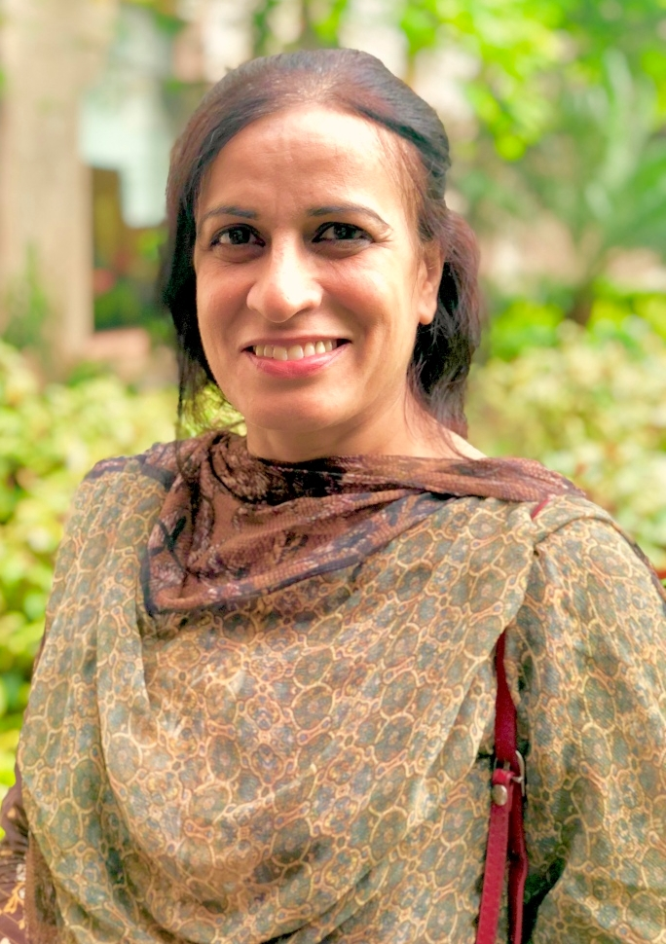
Ms Shagufta Naz
I’ve reached the international level. I [am] an expert… It’s not only the education which helped me; it’s the confidence I got from [Australia], that I can live anywhere, I can do anything, I am capable of doing something. That is the confidence I learnt from there... life skills which I learned is helping me a lot, and that will help me always.

Scholarship | Australian Development Scholarship
Years | 2000-2001
Degree | Master of Arts in Development Studies
University | Murdoch University
Current position | Independent Consultant
Brief biography | Ms Naz is an independent consultant and specialises in helping organisations in Pakistan and Afghanistan improve policy and practice in the inclusion of women. Ms Naz grew up with her father in a rural area near the Pakistan-Afghanistan border. Her Australian Development Scholarship took her to Murdoch University, where she completed her Masters in 2001, specialising in Development Studies. Since her return to Pakistan, Ms Naz has developed an international profile, contributing to dozens of development projects in Pakistan and the region. She has been involved in supporting and advocating for the rights of women through capacity-building, policy development and program evaluation. Ms Naz has also contributed to the Australia Awards in Pakistan, working as part of the selection team in 2012.
Location at the time of field research: Islamabad, Pakistan
Date of interview: 30 April, 2019

Mrs Izzat Jahan Aqdus
Thank you very much, Australia. If you hadn’t been so beautiful, I probably would not have reached here. Look at me. I am so well placed and everybody now looks up to me for advice. I have served in many high government forums. But I would not have been even one-fourth of what I am today if this hadn’t happened.

Scholarship | Australian Development Scholarship
Years | 2000-2002
Degree | Master of Financial Management
University | University of Queensland
Current position | Chief Accounts Officer (CAO), Pakistan Post
Brief biography | Mrs Aqdus is the Chief Accounts Officer of the Pakistan Post, recently taking a secondment to this position from her previous role as Director General in the Auditor General’s Office. Mrs Aqdus commenced her career in her late 20s after her two children started school. Joining the public service, she was posted to a role in finance and accounting. Looking to build skills in this area, Mrs Aqdus successfully applied for an Australian Development Scholarship, and undertook a Master of Financial Management at the University of Queensland, completing in 2002. Mrs Aqdus has since contributed significantly to building capacity in finance, auditing and management through roles in various government training programs, has undertaken a Fulbright scholarship, worked directly with several Chief Justice’s and served on the boards of numerous government authorities.
Location at the time of field research: Islamabad, Pakistan
Date of interview: 2 May, 2019

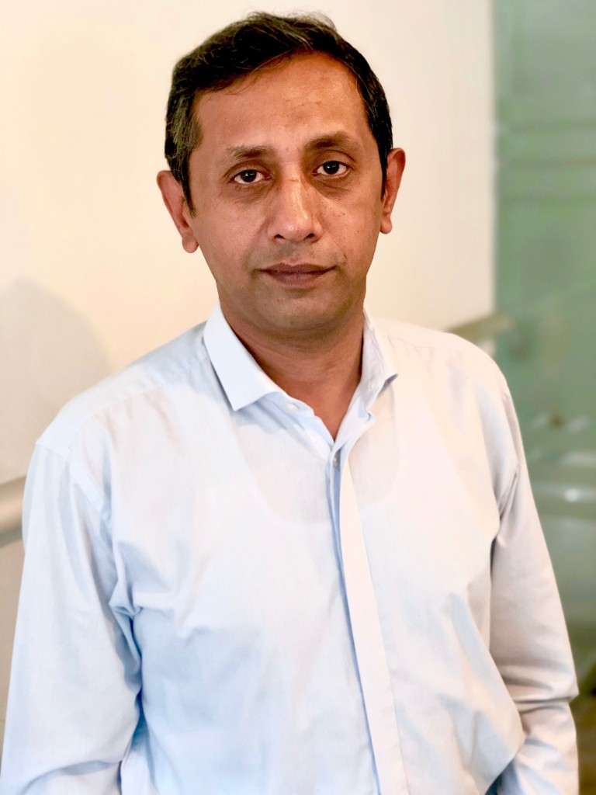
Mr Malick Shahbaz Ahmad Tahir
I thoroughly enjoyed my studies in Australia and the reason is, it’s not that I’m very exceptional. The thing is, I’m good in relating things. Whatever I’ve been studying in the class, I’ve been able to relate it with my work back home. So I learn in terms of being able to theorise what I’m doing here. I think Monash or my education in Australia is indebted for this. Now I see things differently.

Scholarship | Australian Development Scholarship
Years | 2003-2004
Degree | Master of Education
University | Monash University
Current position | Executive Director, Sungi Development Foundation
Brief biography | Mr Shahbaz is the Executive Director of the Sungi Development Foundation – a Pakistani rights-based NGO. Mr Shahbaz grew up in Pakistan, attending his local school, supported by his father who was a driver for a government agency. In 2003, Mr Shahbaz was awarded a scholarship to study his Master of Education at Monash University. Since his return, Mr Shahbaz has been a strident advocate for the rights of minorities in Pakistan. His work with Sungi Development Foundation has included rebuilding schools and education systems following the 2005 earthquake in Kashmir, and advocating for minority groups in Pakistan through rights-based education and capacity building.
Location at the time of field research: Islamabad, Pakistan
Date of interview: 2 May, 2019

References
AusAID (2002). ‘Australian Agency for International Development Annual Report 2001-2002’. https://dfat.gov.au/about-us/publications/corporate/annual-reports/australian-agency-for-international-development-annual-report-2001-2002/ar01_02.html.
AusAID (2009). ‘Pakistan Scholarships Program: Design Document’. https://dfat.gov.au/about-us/publications/Documents/pakistan-scholarships-design.doc.
AusAID (2012). ‘Pakistan Annual Program Performance Report 2011’. https://dfat.gov.au/about-us/publications/Documents/pakistan-annual-prog-perf-report-2011.pdf.
Australia Awards Pakistan (2018). ‘Promoting women in leadership in Pakistan’. https://australiaawardspakistan.org/promoting-women-in-leadership-australia-awards-in-pakistan-launches-myinspiration-campaign/.
Australia Awards South and West Asia (2016). ‘Alumni playing a role in entrepreneurship and peace’. https://australiaawardssouthwestasia.org/australia-awards-alumnae-from-south-and-west-asia-play-their-role-in-securing-leadership-entrepreneurship-and-peace/.
Australia Awards South and West Asia (2018). ‘Case Study: Private Sector Alumni Contributions’. Unpublished.
Australia Awards South and West Asia (2018b). ‘Case Study: Contributions of Alumni with Disability August 2018’. Unpublished.
Australian Bureau of Statistics (ABS) (2001). ‘2001 Year Book Australia’. https://www.ausstats.abs.gov.au/Ausstats/subscriber.nsf/0/7B268DE64F791420CA2569DF00012F05/$File/13010_2001.pdf.
Asian Development Bank (ADB) (2009). ‘Overview of Civil Society Organizations: Pakistan’. https://www.adb.org/publications/overview-civil-society-organizations-pakistan.
Australian Government (2001). ‘Joint Media release from the Australian Minister for Foreign Affairs and the Minister for Defence’. Commonwealth of Australia: Canberra. https://foreignminister.gov.au/releases/2001/fa143a_01.html.
Australian High Commission, Islamabad (2018). ‘Australia Celebrates 70 Years in Pakistan’. https://pakistan.embassy.gov.au/files/islm/180319_PR_English_ADS2018_Islamabad.pdf.
Australian High Commission, Islamabad (2019). ‘Celebrating Australia Day in Spring’. https://pakistan.embassy.gov.au/files/islm/190226_PR_ADIS2019.pdf.
Australian High Commission, Islamabad (n.d.). ‘Development Cooperation’. https://pakistan.embassy.gov.au/islm/cooperation.html.
Australian Public Service Commission (n.d.). ‘Building better governance’. https://www.apsc.gov.au/building-better-governance.
CDES (Centre for Development Economics and Sustainability, Monash University) (2018). ‘Horticulture and Market Reforms in Pakistan’. https://www.monash.edu/business/cdes/research/horticulture-and-market-reforms-pakistan.
Col. Kenny, S. (2015). ‘Instability in Pakistan: why and how should Australia contribute to counter the causes of instability?’ Indo-Pacific Strategic Papers. The Centre for Defence and Strategic Studies. http://www.defence.gov.au/ADC/Publications/IndoPac/Kenny_Indo_Pacific_Strategic_Paper2.pdf.
Committee of Experts on Public Administration (2006). ‘Definition of basic concepts and terminologies in governance and public administration (E/C.16/2006/4)’. United Nations Development Programme, New York. http://unpan1.un.org/intradoc/groups/public/documents/un/unpan022332.pdf.
Dener, C., Watkins, J., & Dorotinsky, W. L. (2011). ‘Financial Management Information Systems: 25 Years of World Bank Experience on What Works and What Doesn’t’. World Bank Publications.
DAI (n.d.). ‘Pakistan – AAWAZ Voice and Accountability Programme’. https://www.dai.com/our-work/projects/pakistan-aawaz-voice-and-accountability-programme.
DFAT (2000). ‘Department of Foreign Affairs and Trade Annual Report 1999-2000’. https://dfat.gov.au/about-us/publications/corporate/annual-reports/annual-report-1999-2000/contents.html.
DFAT (2015). ‘Aid Investment Plan Pakistan: 2015-16 to 2018-19’. https://dfat.gov.au/about-us/publications/Pages/aid-investment-plan-aip-pakistan-2015-16-to-2018-19.aspx.
DFAT (2016a). ‘Australia Awards Global Strategy: Investing in the next generation of global leaders for development 2016–2018’. https://dfat.gov.au/about-us/publications/Documents/australia-awards-global-strategy.pdf,
DFAT (2016b). ‘Australia Awards Global Monitoring and Evaluation Framework’. https://dfat.gov.au/about-us/publications/Documents/australia-awards-global-monitoring-evaluation-framework.pdf.
DFAT (2016c). ‘Public Diplomacy Strategy 2014-2016’. https://dfat.gov.au/people-to-people/public-diplomacy/Documents/public-diplomacy-strategy-2014-16.pdf.
DFAT (2018). ‘Aid Program Performance Report 2017-18: Pakistan’. September 2018. https://dfat.gov.au/about-us/publications/Documents/pakistan-appr-2017-18.pdf.
DFAT (2019a). ‘Pakistan country brief’. https://dfat.gov.au/geo/pakistan/Pages/Pakistan-country-brief.aspx.
DFAT (2019b). ‘Overview of Australia's aid program to Pakistan’. https://dfat.gov.au/geo/pakistan/development-assistance/Pages/development-assistance-in-pakistan.aspx.
DFAT (2019c). ‘Investing in Pakistan's people with a focus on women and girls’. https://dfat.gov.au/geo/pakistan/development-assistance/Pages/investing-in-pakistans-people-with-a-focus-on-women-and-girls.aspx.
Earthquake Engineering Research Institute (2006). ‘The Kashmir earthquake of October 8, 2005: Impacts in Pakistan’. 28 February 2006. https://reliefweb.int/report/pakistan/kashmir-earthquake-october-8-2005-impacts-pakistan.
High Commission for Pakistan, Canberra (2019). ‘Message from H.E. Mr. Babar Amin, High Commissioner for the Islamic Republic of Pakistan on the occasion of Pakistan National Day 23rd March 2019’. https://www.pakistan.org.au/media-center/press-releases/.
Khan, A. & Khan, R. (2004), ‘Civil Society and Change in Pakistan’, Institute of Development Studies and the Collective for Social Science Research, Department for International Development (DIFID), United Kingdom. http://www.researchcollective.org/Documents/Civil_Society_And_Social_Change_In_Pakistan.pdf.
Mawer (2014). ‘A study of research methodology used in evaluations of international scholarship schemes for higher education’. Commonwealth Scholarship Commission, UK. http://cscuk.dfid.gov.uk/wp-content/uploads/2014/06/evaluation-research-methodology-study.pdf.
Mukhtar, I. (2018). ‘Govt ‘expels’ 18 int’l NGOs’. The Nation. 5 October, 2018. https://nation.com.pk/05-Oct-2018/govt-expels-18-int-l-ngos.
Oxford Poverty and Human Development Initiative (OPHI) & United Nations Human Development Programme (UNDP) Pakistan (2016). ‘Multidimensional Poverty in Pakistan’. Pakistan Ministry of Planning and Reform. https://www.undp.org/content/dam/pakistan/docs/MPI/Multidimensional%20Poverty%20in%20Pakistan.pdf.
Pakistan Planning Commission, (2014). ‘Pakistan 2025, One Nation – One Vision’. Ministry of Planning, Development and Reform, Government of Pakistan. https://www.pc.gov.pk/uploads/vision2025/Pakistan-Vision-2025.pdf.
Rana, A. (2017). ‘On buying technology from Monsanto’. DAWN. 6 March 2017. https://www.dawn.com/news/1318668.
Saqib, Z., & Khattak, N. (2015). ‘Management Costs at CHIP: A Way Forward for a Pakistani NGO’. Harvard Business Publishing. https://hbsp.harvard.edu/product/W15204-PDF-ENG.
Stacey, K. and Bokhari, F. (2017). ‘Pakistan orders expulsion of 29 international NGOs’. Financial Times. 14 December 2017. https://www.ft.com/content/15d38124-de54-11e7-a8a4-0a1e63a52f9c.
Sungi Development Foundation (2019). ‘Sungi at a glance’. http://sungi.org/History.html.
The Economist Intelligence Unit (2014).’Moving from the Margins: Mainstreaming persons with disability in Pakistan’. British Council. https://www.britishcouncil.pk/sites/default/files/moving_from_the_margins_final.pdf.
Warner, B. (2018). ‘Pakistan Economic Growth Portfolio Evaluation’. 12 November 2018. https://dfat.gov.au/about-us/publications/Documents/pakistan-economic-growth-portfolio-evaluation.pdf.
World Bank (2005). ‘Pakistan - Second Improvement to Financial Reporting and Auditing Project’. Washington DC, http://documents.worldbank.org/curated/en/615261468285588689/Pakistan-Second-Improvement-of-Financial-Reporting-and-Auditing-Project.
World Bank (2019a). ‘World Bank list of economies (June 2019)’. http://databank.worldbank.org/data/download/site-content/CLASS.xls.
World Bank (2019b). ‘GNI per capita, atlas method (current US$)’. https://data.worldbank.org/indicator/ny.gnp.pcap.cd.
World Bank (2019c). ‘Pakistan@100: Shaping the Future’. https://www.worldbank.org/en/region/sar/publication/pakistan100-shaping-the-future.
World Economic Forum (WEF) (2018). ‘The Global Gender Gap Report, 2018’. Geneva. http://www3.weforum.org/docs/WEF_GGGR_2018.pdf.

Annex 1: Methodology
This chapter includes an overview of the Case Study design, development and implementation. This is the 14th Case Study of the Facility. Pakistan was one of five Case Study countries proposed in the Year 3 Facility Annual Plan. Pakistan was selected as a Case Study country on the basis there was a core group of alumni identified who had studies which explored areas of governance and leadership, which have clear alignment with investment priorities.

Overall Case Study design
The purpose of the Facility Case Studies is to collect detailed qualitative data on the impact and benefits of the Australia Awards. The Case Study methodology proposed is based on the Facility Case Study Approach, which was developed in the inception phase of the Facility and reported in the Annual Plan for Year 1.
The Global Strategy and Australia Awards Global Monitoring and Evaluation Framework (the Framework) form the basis for the Case Study design. The research questions, propositions, data collection instruments, and report template are built around these frameworks. Findings reported by alumni are triangulated with relevant stakeholders such as employers and colleagues, and industry bodies thereby strengthening findings by providing further evidence to support or refute propositions. This methodology was developed by the Facility and SCB.
The overarching theory that has guided the design of this Case Study methodology is based upon the goal of the Australia Awards that ‘… partner countries progress their development goals and have positive relationships with Australia that advance mutual interests’.
The Case Study research questions are framed by the intended long-term outcomes of the Australia Awards as guided by the Framework:
1 How do alumni use the skills, knowledge and networks gained on award to contribute to achieving partner-country development goals?
2 How are Australia Awards contributing to Australia’s economic and public diplomacy outcomes?
3 How has being an Australia Award alumni impacted alumni?
4 Are the benefits of receiving a scholarship experienced equally by all groups who have received them?
The primary unit of analysis for this Case Study is the alumnus or alumna. Case Studies seek to explore how alumni of Australia Awards have acted to contribute to the achievement of the goal and objectives of the Australia Awards.
The Case Studies are being conducted via an iterative approach whereby the qualitative phase can be designed based on what is learned from the initial quantitative phase. In essence, the Facility implements this by drawing on data collected through a Global Tracer Survey and using this data as one of the means of developing the focus and scope of a number of Case Studies carried out in the following year.
As such, the planning and initial scoping of this Case Study was undertaken on the basis of the Facility’s Year 2 Tracer Survey, which surveyed alumni who completed their scholarships between 1996 and 2005.

Methods
The data collection method used for this Case Study was through interviews. A set of questions were developed for each key participant group, namely alumni, colleagues and employers (both of alumni and generally), alumni associations; and the DFAT staff, managing contractors, and coordinating authorities working on the Australia Awards in partner countries. Questions for each key participant group align with the research propositions (located at Annex 2) and long-term outcomes of the Australia Awards. This ensures that data collected directly relate to the key questions the Case Studies are seeking to answer and that there is consistency across each Case Study.

Sample
The alumni selected for this Case Study were chosen based on two key criteria: 1. that they had undertaken study in areas relating to governance and leadership; and 2. that they completed their study between 1996 and 2005. Within the sample selected for the research, the Facility also took into account where possible – gender representation, the inclusion of persons with disability, a variety of employment types (e.g. sector and level of seniority) and spread across provinces of Pakistan.
The Global Alumni Database and the Year 2 Tracer Survey were the key means for identifying the potential sample for this Case Study. The research team looked at these sources, and focussed on alumni who had completed their studies in either the fields of Management and Commerce, or Society and Culture in order to narrow in on the overall thematic aim of the Case Study.
In total, based on analysis of the Global Alumni Database, 23 alumni were determined to have potential ‘fit’ within the population of focus. Of these alumni, seven had also completed the Year 2 Tracer Survey.
Within this sample, alumni where additional information was available – i.e. the development sector of focus from their scholarship, their current employment, contact details – were selected to participate in the Case Study. The Facility contacted 10 alumni, and as per the table below, secured interviews with six – three women and three men.

Table 1 Pakistan Case Study alumni participants
Interview Date (2019) | Gender | Name | Scholarship years | Scholarship | Course & University | Current Position
13/2 | M | Dr Muhammad Ahsan Rana | 2002 - 2003 | Australian Development Scholarship | Master of Social Planning and Development, University of Queensland | Associate Professor, Suleman Dawood School of Business, Lahore University of Management Sciences (LUMS).
01/05 | F | Lubna Hashmat | 2000 - 2002 | Australian Development Scholarship | Master of Development Administration (Governance), Australian National University | Chief Executive Officer, Civil Society Human and Institutional Development Programme (CHIP)
30/04 | M | Dr Kamran Ali Afzal | 2002 - 2003 | Australia Pakistan Scholarships Program | Master of Public Policy and Management, University of Melbourne | Additional Finance Secretary (External Finance), Finance Division, Pakistan Administrative Service
30/04 | F | Shagufta Naz | 2000-2001 | Australian Development Scholarships | Master of Arts in Development Studies, Murdoch University | Independent consultant
02/05 | F | Izzat Jahan Aqdus | 2000 - 2002 | Australian Development Scholarship | Master of Financial Management, University of Queensland | Chief Accounts Officer (CAO), Pakistan Post
02/05 | M | Malick Shahbaz Ahmad Tahir | 2003 - 2004 | Australian Development Scholarships | Master of Education, Monash University | Executive Director, Sungi Development Foundation

In addition to the alumni who participated in the Case Study, fourteen other people were interviewed in order to provide context, triangulate alumni perspectives and better understand the impact of the Australian scholarships on the outcomes for Pakistan and Australia. These additional interviews included stakeholders such as the Australian High Commission in Islamabad, Australia Awards Pakistan and the Australia Awards Alumni – Pakistan and the colleague of one alum.
The table below lists these participants. In total, 20 people were interviewed for the Pakistan Case Study.

Table 2 Key stakeholder and employer/colleague interviews
Interview context | Date (2019) | Name | Position
Alumni employers or colleagues | 01/05 | Mr Ajmal Malik | Chairperson - Board of Directors, Civil Society Human and Institutional Development Programme (CHIP)  Colleague of alumni Ms Hashmat
Australian High Commission, Islamabad | 01/05 | Jeeven Nadanakumar | Third Secretary (Development/Political), Australian High Commission Islamabad, DFAT
 | 01/05 | Brek Batley | Acting High Commissioner / Deputy Head of Mission, Australian High Commission Islamabad, DFAT
 | 01/05 | Saad Sultan | Program Manager (Australia Awards), Australian High Commission Islamabad, DFAT
 | 01/05 | Aadia Asghar | Senior Program Manager (Gender), Australian High Commission Islamabad, DFAT
 | 01/05 | Sara Bano | Program Assistant (Disability), Australian High Commission Islamabad, DFAT
 | 01/05 | Hugh Boylan | Second Secretary (Political), Australian High Commission Islamabad, DFAT
 | 01/05 | Bushra Zia | Research Officer (Political), Australian High Commission Islamabad, DFAT
 | 01/05 | Azhar Shah | Country & Regional Manager (Pakistan & Afghanistan), Australian Trade Commission
Other stakeholders | 29/04 | Erum Ayub Rabbani | Country Program Manager – Pakistan, Australia Awards South West Asia, Scope Global
 | 29/04 | Faizia Mahmood | Program Officer, Australia Awards South West Asia, Scope Global
 | 29/04 | Faiza Rahman Syed | President, Executive Committee, Australia Awards Alumni – Pakistan (AAA-Pakistan)
 | 29/04 | Tahseen Zeb | Vice President, Executive Committee, Australia Awards Alumni – Pakistan (AAA-Pakistan)
 | 29/04 | Kaiyan Yousaf | Member, Executive Committee, Australia Awards Alumni – Pakistan (AAA-Pakistan)

Exclusions
As noted in the section above, all Case Study alumni were selected from the Year 2 Tracer Survey and the Global Alumni database. These sources only include those who have successfully completed their degree. Accordingly, this study excludes anyone who did not complete their scholarship.

Data collection
The Facility piloted all Case Study instruments with Australia Awards alumni who resided in Australia. This process validated the instruments and adaptions to questions were made. In addition, an interview guide template for researchers to record all data collected was developed and utilised. Following a review of Year 1 Case Study data, questions were adjusted for clarity.
This Case Study was conducted by Ms Amanda Taylor and Dr Daniel Edwards, core Facility staff who bring relevant expertise in qualitative research and international development. Case Study researchers worked together to undertake data collection and report writing: one conducted the interview and the other recorded and took notes. This enabled high-quality reliable data to be gathered. At the conclusion of interviews, the researchers discussed and verified the data to ensure completeness and accuracy.

Process
The Case Study field research was undertaken in Islamabad, Pakistan from 29 April to 2 May 2019. One interview was conducted via video conference online due to the fact the alum was unable to be in Islamabad during the time of interview.
Alumni were requested to provide their resume to researchers where available for further background information. Participants were provided with background information relating to the research and the Facility, and all provided written informed consent to their participation and identification in reporting.

Data management and reporting
Interviews were voice recorded (with approval granted to do so). In addition, the Case Study researchers annotated responses during the interview. A transcription specialist transcribed all interview recordings. After the completion of the interview and transcription process, the Case Study researchers consolidated the written and oral recordings into a single near-verbatim transcript (with restarting of sentences and fillers excluded).

Coding and review
Interview scripts were subsequently coded using computer-assisted qualitative data analysis software, NVivo. This enabled emerging themes to be identified and links to be made between participants that supported or refuted the research propositions, as aligned with the long-term outcomes of the Australia Awards.
Analysis of the Case Study data involved a strategy that was guided by the theoretical proposition developed under the conceptual framework for the Case Study and by the techniques identified in the Facility’s Case Study Approach document.
Case Study participants were sent segments of the report where clarification or review and approval were necessary – for this Case Study, this primarily involved cross checking with the Australian High Commission interview participants. Review by participants is not consistently used in qualitative research but was done so here to ensure the validity of the data and avoid errors.

Limitations
There were a number of limitations of this research that were inherent to both the nature of the research and the research process, as discussed below.

Positive response bias
It is probable that alumni who felt that they had a positive experience as an Australian Government scholarship recipient and/or had success in their career following their award are more likely to agree to participate in Case Studies. In a study by the Commonwealth Scholarship Commission in the UK, ‘A study of research methodology used in evaluations of international scholarship schemes for higher education’ (Mawer, 2014) recognition of positive response bias is highlighted:
…there is widespread recognition that a more pressing problem is nonresponse bias in which those who reply to sample surveys are likely to be engaged with alumni associations or tracing (e.g. Day, Stackhouse and Geddes, 2009) and disproportionately represent the ‘successful’ outcomes of scholarship programmes (p.9).
Accordingly, it is likely that the alumni in the Pakistan Case Study had a positive bias towards their experience, outcomes and views of Australia. The Facility has developed interview questions and analyses approaches to reduce the impact of this bias – these are applied consistently across all Case Studies. Through this approach, leading questions are avoided and alumni are offered opportunities to reflect on their outcomes at the beginning and at the end of the interview without specific questions to guide their answers.

Nature of the research
Outcome 1 of the Global Strategy is: ‘alumni are using the skills, knowledge and networks gained on award to contribute to achieving partner-country development goals’. However, some alumni have shaped development goals rather than contributed to them, and while it may be outside the purview of partner-country development goals that this research is being evaluated against, such contributions are still significant.
The Case Study researchers experienced difficulty in evaluating Outcome 2 ‘alumni are contributing to cooperation between Australia and partner countries’, and Outcome 3 ‘effective, mutually advantageous partnerships between institutions and business [have been developed] in Australia and partner countries’. These two outcomes are aligned with the second research question for the Case Study ‘How are Australia Awards contributing to Australia’s economic and public diplomacy outcomes?’ There is an overlap and difficulty in differentiating ‘cooperation’ and ‘partnerships’. The research team delineated them by determining that Outcome 2 relates to people-to-people links including informal relationships; whereas Outcome 3 specifically relates to institutional links between the partner country and Australia, which alumni have contributed to establishing.
No issues were encountered by the research team in collecting, collating, coding or analysing data related to Outcome 4 of the Australia Awards - ‘Alumni view Australia, Australians and Australian expertise positively’.

Research process
The ability to code the interview transcripts effectively is dependent on understanding the partner-country development goals, at the time these alumni were awarded their scholarships. Researchers involved in the Case Study made concerted attempts to identify relevant secondary data such as policy documents, papers, books and digital resources to provide background and insight into development plans, policies and changes over the time span of 1996 to 2005, the years of focus for Year 3 when these alumni completed their scholarship.

Annex 2: Case Study Propositions
Explanatory Case Studies require the development of propositions that are intricately linked to the original research questions. A proposition is a statement that helps direct attention to something that should be examined in a Case Study. The researcher has to make a speculation, on the basis of the literature and any other earlier evidence, as to what they expect the findings of the research to be. When a Case Study proposal includes specific propositions, it increases the likelihood that the researcher can limit the scope of study and complete the project. The researcher can have several propositions to guide the study, but each must have a distinct focus and purpose. The data collection and analysis can then be structured in order to support or refute the research propositions.
For the Facility, propositions were formed using the Global Strategy outcomes as the basis. Sub-propositions were formulated by speculating on the underlying assumption or enabling factors that realise the proposition. In alignment with the methodology, instruments will be designed to collect data that both support and refute the propositions.
- Alumni use their skills knowledge and networks to contribute to achieving partner-country development goals.
  - alumni develop skills, knowledge and networks on award that enable and are used to contribute to achieving partner-country development goals
  - alumni understand, value and want to contribute to partner-country development goals.
- Alumni are contributing to cooperation between Australia and partner countries
  - alumni possess and are able to leverage their useful networks and relationships.
- Effective, mutually advantageous partnerships between institutions and business [have been developed] in Australia and partner countries
  - alumni possess and are able to leverage their useful networks and relationships
  - partnerships that are developed are effective and mutually advantageous to participating countries.
- Alumni view Australia and Australian expertise positively
  - alumni’s views are underpinned by their experiences in Australia.
- The benefits of receiving an Australia Award or scholarship are experienced equally by all recipients.
  - receiving an Australia Award or scholarship positively addresses, rather than reinforces, imbalances that are associated with gender and disability.

Annex 3: Key Participant Questions
Alumni
[Validation question]
We understand you received an Australian Government Scholarship to study [level, field, years], is this correct?
Could you please confirm your current role and organisation?
- Can you please tell us why you applied? What was your motivation?
- Were there any barriers to accepting a scholarships and coming to Australia? [e.g. employer support, family responsibilities]
- Can you tell me about your time in Australia experience as a student?
a Did you make any professional networks?
b Thinking about the networks that you might have developed during your scholarship, were there any that were long lasting; that resulted in working together or connecting other people?
3. After you returned, what was your job?
a What skills and knowledge gained during your time in Australia have been applicable in your work?
b What are some of the things that made it possible for you to apply your skills and knowledge after you returned home?
c What were some of the things that made it difficult to apply the skills and knowledge you gained after you returned home?
d What do you think is needed to assist alumni to use their skills and knowledge when they return home?
- What do you believe are the greatest benefits of the Australian Government scholarship program?
- Throughout your career, in what ways have you used Australian expertise in your work?
a Can you give an example of this, such as Australian-developed practices, equipment, ways of working, processes, theory/theorists, consultants, journals, models, etc.?
6. Are you currently or have been a member of an alumni association? (University/Australian Government scholarship recipient/ADS)
a What was the name of the association?
b What do you get out of it?
c What more could alumni associations do for alumni?
d If not (a member of an association) why not?
7. Can you describe an achievement that you are most proud of, in your work or community?
8. Compared with the males/females who have received a scholarship from (country x), how has your career progressed since returning home?
9. Have there been any barriers you have had to overcome to progress in your career?
10. Compared to peers similar to you but did not receive an opportunity to study overseas, do you believe there are any differences in how your careers have progressed?
11. (Supporting Interviewer) did you have any questions you would like to ask of (alumni X)?
Employers/colleagues – For interviews regarding an individual alumni
[Validation question]
Could you please confirm your role and organisation?
- Could you please tell us how long have you known [Alumni X] and in what capacity?
a Did you know [Alumni X] before s/he received the scholarship?
b Were you his/her manager?
2. To your knowledge, what new skills and knowledge did [Alumni X] use [in the workplace following their studies in Australia]?
a Could you provide examples of how this was applied?
3. How did the organisation support X to use his/her new skills and knowledge after returning from Australia?
a Did you have a role in supporting [alumni X] to reintegrate following their scholarship?
i If so why? What did this involve?
ii If not, why?
iii Developing a reintegration/return to work plan?
b Did X return to the same role following their scholarship?
c Did they receive additional responsibilities after their scholarship?
4. In your view, how did studying in Australia impact [Alumni X’s] career?
5. Have you or your organisation benefited from any networks or friendships between [country X] and Australia created by the [Alumni X] as a result of receiving an Australian Government scholarship?
a Please explain further; who and what?
b What about any other countries?
6. Are you aware of any other links [Alumni X] has created between people in [country X] and Australia as a result of receiving an Australian Government scholarship?
a Please explain further; who, what why?
b What about between people in [country X] and any other countries?
7. What more could be done to increase opportunities to create institutional links between Australia and your country?
8. How has having an Australian Government scholarship recipient in your organisation impacted how you view Australia and Australian expertise?
9. Do you draw on Australian expertise for your work?
Employers/stakeholders – For interviews regarding alumni generally
[Validation question]
Could you please confirm your role in (X organisation)?
- How familiar are you with the Australia Awards?
[If YES; a suggested probe if needed]
a Estimated, how many Australian scholarship recipients have worked for your [ministry/organisation/sector/field]?
[If NO; probe further with]
b Do you know of anyone who has received an Australian Government scholarship in your [ministry/organisation/sector/field]?
- Has your (ministry/organisation/sector/field) benefitted from any links or networks developed by Australian Government scholarship alumni?
a Do you have any examples?
b What have been the results of this?
- Has having Australian Government scholarship recipients in your (ministry/organisation/sector/fiel) influenced the way you view Australia and Australian expertise?
- Have Australian Government scholarship recipients established any links between your [ministry/organisation/sector/field] and organisations in Australia?
a If yes what has been the result of these links?
b Benefits to you?
c Benefits to your workplace?
d Benefits to your country?
e If no, why not?
5. Are you aware if alumni have presented any opportunities on return to link your workplace or any other organisation in your country with an organisation in another country?
a If yes what has been the result of these links?
b Benefits to you?
c Benefits to your workplace?
d Benefits to your country?
e If no, why not?
- What more do you think could be done to support links with Australian organisations?
- In your view, what has been the overall long-term impact of having Australian Government scholarship recipients in your [ministry/organisation/sector/field]?
a How has having a number of Australian Government scholarship recipients over a number of years influenced your department’s ability to achieve its goals and /or objectives?
b With regards to skills and knowledge; i.e. changed practices, processes or systems?
8. What are some of the things that make it easy or difficult for women to progress in their careers in your country?
9. What are some of the things that make it easy or difficult for those with disability to progress in their careers in your country?
10. Comparing Australian Government scholarship recipients to their peers who did not receive an opportunity to study overseas, do you believe there are any differences in how their careers have progressed?
DFAT
[Validation question]
Could you please tell us about yourself and your role with the Australia Awards Program?
- In your own words, what is the purpose of the Australia Awards Program?
a In your own words how does the Program achieve [points stated in the previous response]?
2. Based on your experience what would you say are the strengths of the Australia Awards Program?
3. How do you think alumni participation in the Australia Awards Program contributes to [Country X’s] development goals?
a What evidence have you seen of this either personally or professionally?
b How do you think the program lead to benefits for both Australia and [Country X]?
4. In your opinion, how do you think an alumni’s participation in the Australia Awards Program contributes to a positive relationships between [Country X] and Australia?
a What factors/events have informed this opinion?
5. How do you think the Australia Awards contributes to gender equality and disability inclusiveness?
6. What other barriers do you think Australia Awards alumni have to overcome to progress in their careers in [Country X]?
7. What do you think are the barriers to achieving gender equality and disability inclusiveness?
a Do you feel [barriers stated in the previous response] have changed over time?
b In what way?
c Any other barriers?
8. If you had the power to change things about the Australia Awards what would you make different?
9. That covers the things I wanted to ask. Anything you would like to add?
Alumni Association
[Validation question]
Could you please tell us about yourself and your role with the alumni association?
- In your own words, what is the purpose of the alumni association?
a What sort of services does the association provide?
2. What is the most valuable contribution the association provides for alumni?
3. What are some of the challenges involved in running an alumni association for alumni who have studied in Australia?
4. What activities does the alumni association provide to support women to progress in their careers in your country?
a What have been the outcomes of the program/s?
5. What activities does the alumni association provide to support those with disability to progress in their careers in your country?
a What have been the outcomes of the program/s?
6. In what ways does the alumni association enable alumni to form new professional and personal networks?
7. What activities does the alumni association provide to help alumni remain connected to each other through face-to-face activities and social media?
8. How does the alumni association support alumni to remain connected to Australia?
9. What role does the alumni association play in fostering cooperation between your country and Australia?
10. What do you think should be done to assist your alumni association to contribute to greater cooperation between Australia and [Country X]?
11. Is the alumni association partnered with any institutions and businesses in Australia?
a If yes, what has been the result of these links?
i Benefits to you/association?
ii Benefits to alumni?
b If no, why not?
12. What more could be done to increase opportunities to create institutional links between Australia and your country?
13. How does the alumni association promote Australia and Australian expertise?
Gender Equality and Disability Inclusiveness Experts
Gender Equality
1. How does gender impact career?
2. What barriers are there to achieving gender equality?
3. What could or should be done to improve gender equality?
4. Compared with males who receive a scholarship to study overseas, how do you feel women’s careers progress? [for DFAT or those with knowledge of scholarships]
Disability Inclusion
- How does disability impact career?
- What barriers are there to achieving disability inclusion?
- What could or should be done to improve disability inclusion?
- Compared with others who receive a scholarship to study overseas, how do you feel people with disability career’s progress? [for DFAT or those with knowledge of scholarships]

.

See http://dfat.gov.au/people-to-people/public-diplomacy/Documents/public-diplomacy-strategy-2014-16.pdf and http://dfat.gov.au/trade/economic-diplomacy/pages/economic-diplomacy.aspx
Dr Rana initially worked for an NGO on return from scholarship, but subsequently returned to the public sector and then into university. Ms Hashmat, Ms Naz and Mr Shahbaz have spent their careers in NGOs.
This proposition differs from the Australia Awards Program Logic long-term outcome number 1 in order to link this proposition to the Goal of the Australia Awards Program. The use of the term ‘partner-country development goals instead of ‘sustainable development’ makes the proposition and ensuing questions more relevant and relatable to alumni.

