

# Australia Awards

Global Monitoring and   
Evaluation Framework

February 2022

## Contents

Introduction 3

Executive Summary 4

Document Summary 5

Purpose 6

Guiding Principles 6

Components 6

Section A: Global Program Logic 7

Section B: Monitoring and evaluation across the Australia Awards cycle 8

Section C: Global Assessment, Learning and Reporting 12

## Introduction

Australia Awards are a whole of Australian government initiative bringing together international scholarships and short courses. For more than 70 years Australian Government scholarship programs have supported our foreign, trade and economic objectives around the world. Since the 1950s, over 100,000 people from partner countries have received an Australian Government Scholarship to study in Australia. In an ever changing and increasingly competitive world, investing in human capital has never been more important.

The Australia Awards are a key pillar of the development program, accounting for 5 per cent of Australia’s total ODA budget for the 2021–22 FY and featuring in nearly all of Australia’s bilateral development programs. Australia Awards support the development of human resource capacity of partner countries within mutually agreed sectors and development priorities. They complement Australia’s other ODA investments in infrastructure, institutional strengthening, food security, health and education. Australia Awards, offered to emerging leaders from across the Indo-Pacific region are prestigious and transformational. Australia Awards alumni have often gone on to become leaders in government, the private sector, academia and their communities throughout the Indo-Pacific. The rich evidence base generated over decades through impact evaluations and tracer studies demonstrates the power of Australia Awards to build stronger agents of change, and strengthen our people-to-people links with key policy and decision makers in partner countries.

Australia Awards are guided by the *Australia Awards Global Strategic Framework – Investing in the next generation of global leaders for development 2021–2024 (the global strategic framework).* DFAT administers the Australia Awards through a devolved architecture whereby overseas Posts are responsible for managing their own budgets for Australia Awards activities. A number of different actors are involved in the implementation and management of the Australia Awards, and all collect, hold and use a range of information (data) about the Australia Awards and its performance. Collectively, this data enables the Australian Government to demonstrate the impact of the Australia Awards, and showcase how Australia’s world-class education sector supports alumni to make substantial contributions within their own countries, strengthen our diplomatic access, and build networks of influence that are invaluable to Australia and our interests.

The purpose of this global monitoring and evaluation framework (MEF) is to provide an overarching framework and process for aggregation and analysis at the global level. The MEF will enable the Global Education and Scholarships Section to obtain, analyse and aggregate country and regional level data at a central level to tell a global performance story. It will guide program learning and analysis, communication of results and impact, inform strategic management, and meet the requirements of the *Making Performance Count: enhancing the accountability and effectiveness of Australian Aid* framework and associated aid performance benchmarks.

The framework is designed to provide high level guidance for staff of DFAT and implementation partners (mainly managing contractors, but also academic institutions), in line with the *Global Strategic Framework*. It is intended to sit alongside, and inform, other, more detailed methodological and implementation plans, including the monitoring and evaluation plans of each country or regional program. It complements more technical guidance provided by the DFAT Monitoring and Evaluation Standards.

## Executive Summary

|  |  |
| --- | --- |
| Key Audience | |
|  | The primary audience for the MEF are users and with roles and responsibilities for monitoring, evaluation and reporting across the Australia Awards. The MEF seeks to provide Posts, Managing Contractors and the DFAT Global Education and Scholarships Section with clear and detailed information that supports them to meet global data collection and reporting requirements. |
| Purpose | |
|  | The MEF seeks to support the capture and analysis of a range of information that enables Australia to tell the Australia Awards performance story, communicate its impact, and support ongoing adaptation and decision making for improvement. |
| Targets | |
|  | Six performance targets will form the basis for systemically tracking, assessing, learning and reporting on the Australia Awards at a global level. These are related to:   1. Promotion and Selection 2. Inclusion 3. Influencing Development 4. Alumni Network 5. Bilateral Collaboration 6. Women’s Leadership   Country and regional programs are required to report against a linked set of Core Indicators on an annual basis. This seeks to ensure consistency of data collection across the global program and enable DFAT to tell the global performance story of the Australia Awards. |
| Importance | |
|  | The Australia Awards has delivered significant impact over several decades. It is critical that we continue to engage with and communicate across whole-of-government, to the public and to partner countries, providing key messaging on why the Australia Awards is important, what it has achieved and ensure accountability for the use of program resources and the achievement of outcomes. |
| Use | |
|  | The MEF will inform on the development of a range of products. This includes a wealth of rich data gathered and used at a country and regional level. This information will also be used by the DFAT Global Education and Scholarships Section to communicate its value and impact to a wider audience, produce an  annual performance investment report, and feed into decision making across the Australia Awards. |

## Document Summary

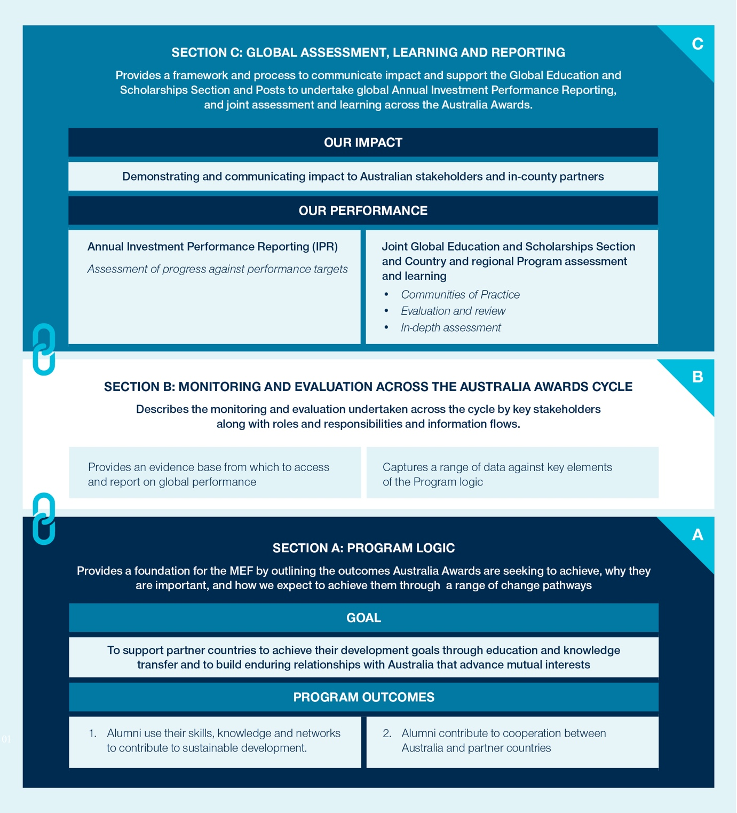

## Purpose

The purpose of this MEF is to:

* enable DFAT to tell the Australia Awards **performance story** in annual reporting and to communicate impact through an evidence base, supporting accountability to stakeholders about the use of program resources and the achievement of program outcomes;
* **provide clear information and guidance** that enables Posts, Managing Contractors and DFAT to meet global data collection and reporting requirements, and make day-to-day and strategic management decisions about Australia Awards;
* guide assessment, analysis and learning related to the effectiveness of the Australia Awards global strategic framework and modality to support **strategic management and ongoing adaptation.**

## Guiding Principles

The key principles underlying the Australia Awards MEF are to:

* **balance the The Global Education and Scholarships Section’s role** and obligations to meet annual reporting requirements, make overarching policy, strategy and management decisions relating to the global program, **with the role of Posts** in delivering and managing Australia Awards investments tailored to country and regional context;
* **provide an overarching framework and process for aggregation and analysis at the global level** that enables the Global Education and Scholarships Section to draw on the wealth of data and insights at the country and regional levels, in a way that value-adds to, rather than burdens Posts;
* **ensure the participation and ownership of Posts** in the global MEF including through sharing of information and insights that helps the Global Education and Scholarships Section to adapt the global architecture to foster an enabling environment for Posts that contributes to strong performance and achievement of outcomes;
* **provide a balanced picture of progress** by outlining challenges as well as achievements, and using both quantitative and qualitative data.

## Components

The MEF is structured in the following sections:

* **Section A: The Program Logic –** outlines the overarching logic of the global Australia Awards, including outcomes and how Australia Awards expects to bring these about.
* **Section B: Monitoring and evaluation across the Australia Awards cycle –** describes the monitoring and evaluation undertaken across the cycle by key stakeholders along with roles and responsibilities and information flows.
* **Section C: Global assessment, learning and reporting –** provides a framework and process to communicate impact and support the Global Education and Scholarships and Posts to undertake global Annual Investment Performance Reporting, and joint assessment and learning across the Australia Awards.

## Section A: Global Program Logic

The *Global Strategic Framework* sets out objectives and two Long-term Program Outcomes. These are shown in Figure 1 below along with three Intermediate Outcomes, which are building blocks to the achievement of Long-term Outcomes. Every country or regional program will implement Australia Awards in a way that is tailored to the specific context and its relevant priorities. This may mean that individual outcomes are accorded greater or lesser priority, and receive greater or lesser allocation of resources within country or regional programs. Furthermore, some modalities may be more or less closely associated with particular outcomes.

Figure 1: Australia Awards Program Logic

Goal:  to support partner countries to achieve their development goals through education and knowledge transfer and to build enduring relationships with Australia that advance mutual interests
Long-term outcomes: 
1: Alumni use their skills, knowledge and networks to contribute to sustainable development
2: Alumni contribute to cooperation between Australia and partner countries
Intermediate outcomes: 
i) Alumni view Australia, Australians, and Australian expertise positively
(ii) Alumni have necessary skills and knowledge to contribute to development 
(iii) Alumni have relevant and useful networks and relationships 
Objectives: 
1. To integrate Australia Awards into Australia’s whole-of-government country and regional programs, contributing to country and regional program objectives, including COVID-19 Development Response Plans in the intermediate term. 
2. To utilise Australia’s world-class education system to support sustainable and equitable growth in development partner countries, contributing and showcasing our expertise.
3. To maintain the prestige and quality of Australia Awards, ensure awards are targeted to recipients and partner countries, while enabling strong equity of access.
4. To establish enduring connections, as awardees develop personal and professional connections and networks, that are drawn on throughout their careers.

The full Australia Awards Program Logic can be found in **Guidance Note 1: Program Logic**, which can be accessed [here](https://www.dfat.gov.au/about-us/publications/Pages/australia-awards-global-strategy).

## Section B: Monitoring and evaluation across the Australia Awards cycle

A range of groups and organisations collect, hold and use information about the Australia Awards   
to support day to day decision making, accountability and communication to a range of stakeholders. This includes:

* Country and regional programs that manage Australia Awards – mainly Posts, but in some cases also DFAT Desks in Canberra
* Managing Contractors – most Australia Awards country or regional programs are supported by a contractor
* DFAT Global Education and Scholarships Section
* Academic Institutions in Australia
* Academic Institutions in the Pacific region
* The survey contractor engaged by DFAT to undertake regular Arrival and On Award surveys of scholarship awardees across all country and regional programs
* The Australia Awards Global Tracer Facility
* Other specialist contractors engaged to support M&E
* Australian Host Organisations
* Alumni Associations

The section provides information about:

* *How* monitoring and evaluation will be undertaken at key points in the cycle of scholarships and short courses (and the program logic);
* *Who* is responsible for M&E tasks;
* *How* the evidence generated by M&E will be shared and used at each point in the cycle/logic, and by whom;
* *How* information will flow throughout the Australia Awards cycle.

### Bilateral and regional programs corporate performance monitoring and reporting

Bilateral and regional programs are also required to meet a number of corporate performance monitoring and reporting requirements. The M&E tools and approaches set out in this MEF are designed to ensure programs can utilise the necessary data to complete these planning and reporting requirements, which include:

* Whole of Government COVID-19 Development Response country and regional plans setting out expected outcomes, key results and supporting investments. These instruments set out the direction for a country or regional program and link objectives, aid programming and results. They describe where, why and how Australian aid will be delivered and the expected results to be achieved in a country or region, and present a line of sight from Australia’s national interests, strategic priorities and objectives, as well as current and planned investments to expected results. DFAT COVID-19 Response Plan (CRP) and Performance Assessment Framework (PAF) assists effective aid planning, transparency and accountability and guide country and regional monitoring and evaluation.
* Annual Investment Monitoring Reports (IMRs) assess and report how individual aid investments are performing against six recognised aid quality criteria: efficiency, effectiveness, gender equality, M&E, sustainability and relevance. Full IMRs are required for high risk investments or those of more than $10m funding; Streamlined IMRs are required for smaller or low risk investments. Thus Australia Awards investments will be reported through a mix of IMRs and Streamlined IMRs, but both must utilise the data collected through the tools described below. Programs can refer to specific guidance on completing IMRs for Australia Awards investments (IMR Supplementary Guidance for Australia Awards Programs).
* All country and region aid programs prepare annual Performance Reports, which report progress towards aid objectives. Annual Performance Reports should make full use of data collected through the tools described below when reporting the performance of Australia Awards.

In order to meet these reporting requirements, and any additional reporting required in future, country and regional programs should use this MEF to ensure the M&E arrangements for Australia Awards in their program are adequate. Managing contractors should be required to review their M&E systems for alignment; programs managed by Posts should do the same and seek additional support from the Global Education and Scholarships Section if necessary.

The MEF will be reviewed and updated as necessary to ensure it remains relevant and useful, and further guidance is detailed in the *Global Strategic* Framework.

### Australia Awards Monitoring and Evaluation tools

This MEF relies on a set of M&E tools – activities and sources of information – to provide the evidence necessary for management and reporting. A number of these are already established and providing the necessary data. Others require further systematisation, are in development, or must be developed in order to fulfil the requirements of effective monitoring, evaluation and management of Australia Awards at the global level. Within this set of M&E tools, several should be understood as the minimum requirements for all programs implementing Australia Awards; others are optional and should be included when relevant and possible for specific investments.

Table 1: Australia Awards data collection tools

| Tool | Required/Optional | Status |
| --- | --- | --- |
| **Awardee information (including application, academic progress and pastoral care data), stored  in OASIS** | Required by all programs | Established |
| **On Award Surveys** | Required by all programs | Established |
| **Alumni information** | Required by all programs | Stored on country program level databases |
| **Managing Contractor M&E** | Required by all outsourced programs | Established |
| **Tracer Studies** | Required by all programs | Global Tracer Facility established in 2016 |
| **Short Course Awards M&E** | Required by all programs[1] |  |
| **Media Monitoring** | Required by all programs | Requires systematisation across Posts |
| **Post-managed Program M&E** | Required by all programs | Requires development |
| **Other Evaluation studies** | Optional |  |

A more detailed description of the above listed tools is provided is provided in **Guidance Note 2: Monitoring and evaluation across the Australia Awards cycle**, which can be accessed [here](https://www.dfat.gov.au/about-us/publications/Pages/australia-awards-global-strategy).

### Information Flows

Information is drawn from a number of sources throughout the cycle of Australia Awards planning, implementation, monitoring and evaluation, and is stored in several different ways. Figure 2 below provides an overview of the main sources and repositories of this information, to assist programs to understand where to draw from in seeking to ensure good quality monitoring and evaluation for their implementation of Australia Awards.

Further detail on: Capture and use of evidence generated by M&E in relation to the program logic; Responsibilities and Timeframes for Monitoring and Evaluation Activities; and a list of M&E Language and Terminology is outlined in **Guidance Note 2: Monitoring and evaluation** across the Australia Awards cycle which can be accessed [here](https://www.dfat.gov.au/about-us/publications/Pages/australia-awards-global-strategy).

Figure 2: Australia Awards information sources and databases

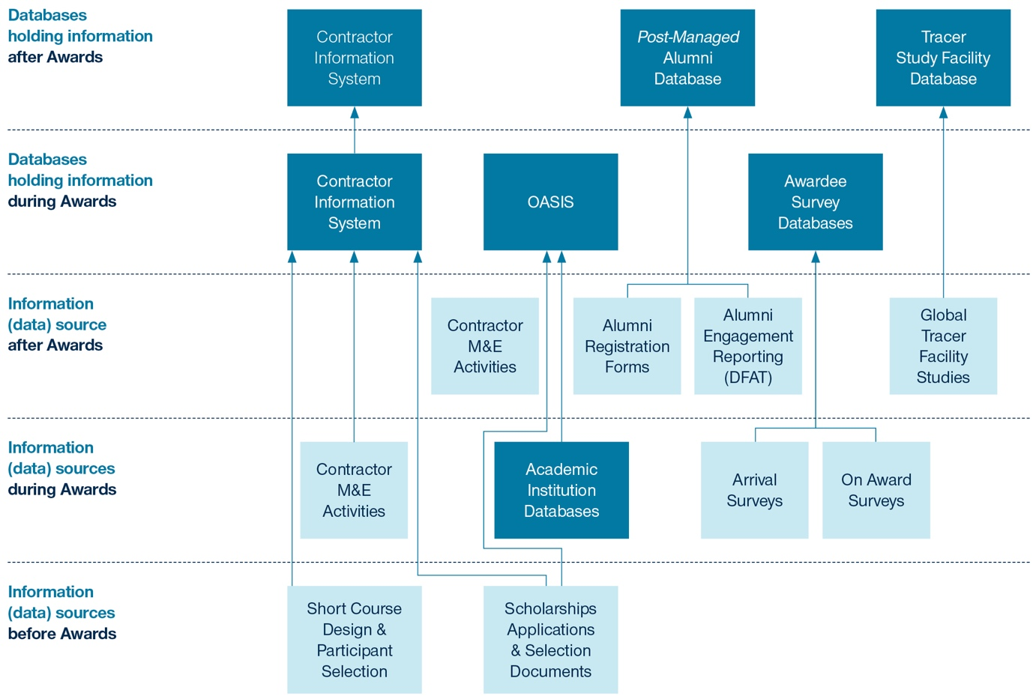

## Section C: Global Assessment, Learning and Reporting

The DFAT Global Education and Scholarships Section holds responsibility for demonstrating and reporting its impact and performance to a range of stakeholders. Figure 3 below presents the Australia Awards global overarching assessment, learning and reporting framework. It contains two central elements: i) demonstrating and communicating **impact**; and ii) assessing, analysing, learning and improving **performance**.

### Demonstrating and communicating our impact

Australia Awards has generated an extensive and rich evidence base over decades that demonstrates its impact. This includes a range of longitudinal studies, impact evaluations, case studies, and surveys carried out at country, regional and global levels by Managing Contractors and the Global Tracer Facility. These products result from the implementation of country and regional programs, which have their own contextualised Monitoring and Evaluation (M&E) frameworks and use a range of robust mixed-methods approaches to capture data as outlined in Section C.

This data enables Australia to **demonstrate the impact of the Australia Awards, and showcase how Australia’s world-class education sector supports alumni to make substantial contributions to development within their own countries, and strengthen our diplomatic access, networks of influence and bilateral development cooperation in line with Australia’s national interests.** These products are used in country by Posts in communications with country partner governments and stakeholders. The Global Education and Scholarships Section also draws on this wealth of data to communicate its impact to Australian government departments, the public and other key stakeholders including universities and the private sector. In addition, the Global Education and Scholarships Section produces its own communications materials drawn from Australia Awards related activities, events, along with the capture of awardee and alumni experiences.

DFAT is seeking to capture and communicate information about how Australia Awards has benefited alumni and partner countries, and advanced Australia’s national interest, both currently and over the long term. Over the 2021 – 2024 strategic framework period, the Global Education and Scholarships Section will work with Posts to stay abreast of the range of evidence-based M&E products produced by DFAT and Managing Contractors that tells a story of impact. The Global Education and Scholarships Section is interested in information spanning from individual alumni stories, to in-depth studies such as how investment in cadres of alumni over decades has impacted across particular sectors or partner countries.

The Global Education and Scholarships Section is seeking evidence-based information on Australia Awards contribution to:

* building **agents for change**, with alumni **contributing to development outcomes;**
* building **networks of influence** in the Indo-Pacific that advance Australia’s national interests;
* impacting and influencing across partner countries, sectors and emerging markets;
* providing a **transformative Australian study experience**, with alumni viewing the world differently, embrace new ways of thinking, new technology and innovative approaches to problem solving.

The Global Education and Scholarships Section will work with Posts to stay abreast of the range of studies and M&E products, and explore ways to communicate findings and results to a broader range of stakeholders in Australia and globally.

Figure 3: Global assessment, learning and reporting

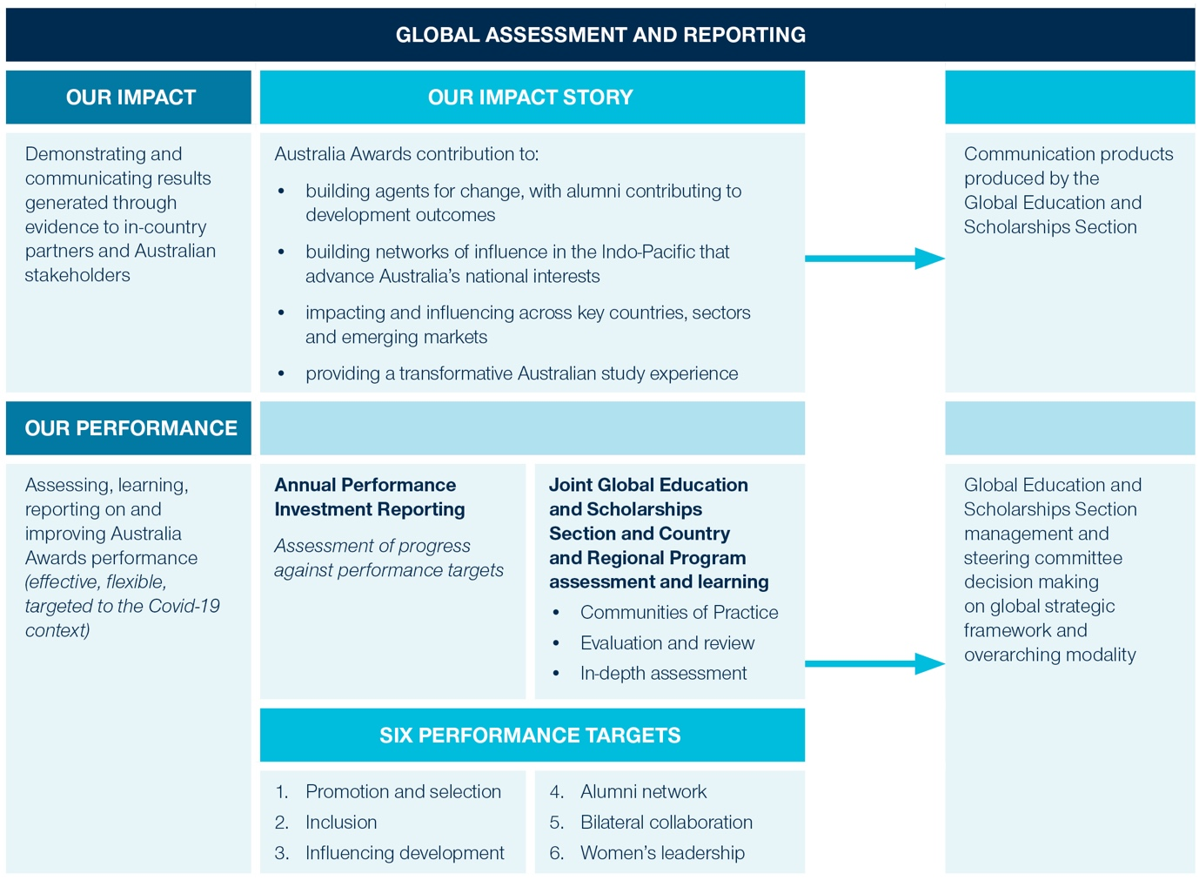

### Our performance: Assessing, analysing, learning and improving

Australia Awards is a long-standing initiative with an overarching strategic framework that guides country and regional programming. Other DFAT Official Development Assistance (ODA) funded initiatives typically have a set of End of Program Outcomes that are expected to be achieved at the end of a time-bound investment. Australia Awards are an ongoing investment, whereby the overarching investment logic and long-term outcomes have and are likely to remain relatively unchanged over time. The design, implementation and performance of Australia Awards does not however remain fixed. This global assessment, learning and reporting framework has been designed to ensure the Australia Awards continues to be agile and adaptive. Rather than simply reporting on the achievement of outcomes and activities each year, this framework seeks to build a cumulative picture that supports an assessment of Australia Awards performance over time.

### Measuring and reporting on outcomes and performance

Country and regional programs obtain, analyse and report on performance and the achievement of Australia Awards outcomes in accordance with their own M&E frameworks and systems. The global MEF will draw on this information to examine and communicate results in addition to data managed centrally by the Global Education and Scholarships Section.

To provide a **basis for systemically tracking, assessing, learning and reporting on the Australian Awards at a global level**, six performance targets are introduced. These progress markers are framed as targets to emphasise Australia Awards strive for continuous improvement and adaptation, noting that the Program Logic and associated outcomes are expected to remain relatively unchanged over time.

The targets are aligned to the global strategy framework, the program logic and encompass elements of Gender Disability and Social Inclusion (GEDSI). With regards to the program logic, Long-term Outcome 1 is included in Target 3[2], and Long-Term Outcome 2 in included in Target 5[3]. Intermediate Outcome 1 sits within target 5[4]. Intermediate Outcome 2 sits within Target 3[5]. Intermediate Outcome 3 sits within Target 5[6]. GEDSI is reflected in Targets 2 and 6. Enabling outcomes have not been integrated into the framework[7]. In addition to supporting data collection, analysis and reporting on outcomes, the targets seek to support assessment of how well the Global Education and Scholarships Section, country programs and other stakeholders are working to facilitate outcomes. Collectively, they provide a framework that enables DFAT to tell the global performance story.

#### Six Performance Targets:

1. **Promotion and Selection:** Country programs attract and select increasing proportions of diverse, high-calibre, eligible applicants, placing them in Awards that align with DFAT priority areas;
2. **Inclusion:** Country programs effectively promote the Australia Awards to vulnerable and minority groups, have demonstrated capacity and processes in place to support inclusion, and strive to strengthen systems and practice if standards are not met;
3. **Influencing Development:** Australia Awards is an effective mechanism which contributes to an increasing number of alumni better equipped to influence development outcomes in their home countries across a diversity of sectors;
4. **Alumni Network:** Country / regional programs build a bigger, stronger network of active alumni by creating meaningful opportunities for quality engagement that contributes to alumni advancement in their home country;
5. **Bilateral Collaboration:** Australia Awards and alumni engagement increasingly contribute to enduring relationships and mutual cooperation between Australia and the partner country;
6. **Women’s Leadership:** The Australia Awards contributes to a growing cohort of women leaders who are increasingly able to participate, influence and lead across a diversity of development sectors.

The performance targets guide **Annual Investment Performance Reporting** led by the Global Education and Scholarships Section, and **assessment and learning** across the global Australia Awards. Additional detail and definitions related to performance targets are provided **Guidance Note 3: Core Global Indicators.**

#### Annual Investment Performance Reporting

The Global Education and Scholarships Section undertakes global investment reporting annually, through the production of an annual Progress Report. The report aggregates, synthesises and analyses quantitative and qualitative data a range of sources to provide a global picture of reporting. This includes: country and regional program data; the OASIS database, On-Award Surveys (ORIMA); and Global Tracer Facility surveys and studies.

An Annual Investment Reporting Content Guide has been developed to support streamlined investment reporting. It outlines the data that the Global Education and Scholarships Section is seeking to obtain from country and regional programs, as well as data held centrally. The annual performance reporting framework centres around the six performance targets. The Global Education and Scholarships Section will work with Posts to establish a system to obtain the required data. In some instances, Country and Regional programs will be required to submit data to the section, and in other instances the section will take the lead on accessing and drawing from the wealth of country and regional level data available.

As of 2022, all country and regional programs are required to report directly to the Global Education and Scholarships Section against a set of Core Indicators on an annual basis. Core Indicators are linked to the six performance targets. They support consistency of data collection across the global program and enable DFAT to tell the global performance story of the Australia Awards. The list of Core Global Indicators and associated guidance is provided in **Guidance Note 3: Core Indicators,** which can be found [here](https://www.dfat.gov.au/about-us/publications/Pages/australia-awards-global-strategy). This guidance document outlines the full set of information to be reported against each indicator, and explains terminology and data collection methods to ensure consistency of data capture and reporting by Regional and Country programs, many of which are supported by Managing Contractors.

While the annual reporting process seeks to communicate progress for accountability purposes, the process will also be used to inform management and decisions and program improvements. As such, the reporting framework is designed to capture information to enable the analysis of both positive and negative trends in performance. The annual reporting process will be linked to internal Global Education and Scholarships Section management and decision making.

Global Assessment and Learning

In addition to synthesising information and reporting on outcomes and performance annually as described above, in-depth analysis and learning will also be facilitated. This will enable DFAT to undertake critical enquiry, reflection and a deeper-dive on critical elements than afforded through annual reporting.

DFAT administers the Australia Awards through a devolved architecture, encompassing the Global Education and Scholarships Section, country and regional programs, and Posts. Country and regional Australia Award programs have their own M&E frameworks and capture a wealth of data to track progress and impact. This MEF seeks to facilitate cross-country and regional learning, as well as learning between the Canberra-based Global Education and Scholarships Section and Country and regional programs (inclusive of Posts and associated Managing Contractors)[8].

To support this process, a Monitoring and Evaluation Community of Practice (COP) will be convened by the Global Education and Scholarships Section. The purpose of the COP is to reduce silos and enable DFAT Canberra, Posts, Managing Contractors and the Australian Council for Education Research (ACER), which manages the Global Tracer Facility, to share and discuss their work, explore a range of in-depth issues determined by members, and inform Global Education and Scholarships Section decision making.

The Monitoring and Evaluation COP will:

* be **co-designed and led by members**, who will determine areas, issues and topics to be discussed and examined;
* enable DFAT and Managing Contractor staff to further refine core indicators discuss and navigate M&E approaches and methodologies associated with implementation and reporting;
* enable members to **share and discuss insights and learnings** from impact studies, evaluations and other learning processes;
* support members to **discuss what is and is not working across the Australia Awards**, and explore a range of in-depth issues and solutions;
* **provide a two-way feedback mechanism** between the Global Education and Scholarships Section and country and regional programs that prompts changes and improvements to the global architecture (systems, policies and guidelines) to ensure flexible and responsive delivery, particularly in the COVID-19 context.

The Global Education and Scholarships Section may commission other more in-depth assessments of the Australia Awards such as independent reviews and evaluations, meta-evaluations and analysis of country and regional data, and other research pieces. These will be strongly informed by the COP.

To support joint learning and assessment at the global level, a set of guiding questions are presented below. This tool is intended to provide a light-touch guiding framework linked to the Performance Targets. The majority of questions seek to prompt reflection on the role of the Global Education and Scholarships Section.

Table 2: Australia Awards Performance: guiding questions for learning and assessment

| **Global Performance Targets** | **Guiding Questions** |
| --- | --- |
| **Promotion and Selection** | |
| 1. **Country programs attract and select increasing proportions of diverse,  high-calibre, eligible applicants, placing them in Awards that align with DFAT priority areas** | * Do Australia Awards enable sufficiently tailored and flexible delivery options to meet Awardee study preferences and remain competitive against other international awards programs?[9] * Are global strategic framework investment priorities, requirements and delivery options enabling sufficient diversity of awardees? * Are Australia Awards eligibility requirements enabling selection of the right candidates[10] most able to influence change? |
| **Inclusion** | |
| 1. **Country programs effectively promote  the Australia Awards to vulnerable and minority groups, have demonstrated capacity and processes in place to support inclusion, and strive to strengthen systems and practice if standards are not met.** | * Are Country Programs increasing efforts[11] to enhance GEDSI, including identifying and addressing barriers to inclusion and which approaches are successfully fostering equal inclusion and benefit? * To what extent have investments actively involved people with disabilities and/or disabled people’s organisations in planning, implementing, monitoring and evaluating? * Are there unintended consequences[12] for minority groups on return and how can Australia Awards minimise harm? * Are global strategies[13] to encourage equity of access[14] sufficient and are country programs adequately supported to implement strategies and dedicate sufficient resources and inputs towards inclusion? |

| **Influencing Development** | |
| --- | --- |
| 1. **Australia Awards is an effective mechanism which contributes to an increasing number of alumni better equipped to influence development outcomes in their home countries across a diversity of sectors.** | * Are Australia Awards getting the right people into the right placements and how well is the Global Education and Scholarships Section communicating information to support country programs and student to support decision making in this area[15]? * To what extent are courses equipping awardees with the knowledge and skills (soft and technical) and networks they need, and how can the Australia Awards better support country programs to strengthen outcomes? * What lessons do country program impact studies and evaluations hold for how the Australia Awards can garner optimal impact[16]? |
| **Alumni Network** | |
| 1. **Country / regional programs build a bigger, stronger network of active alumni by creating meaningful opportunities for quality engagement that contributes to alumni advancement in their home country.** | * What are the successful characteristics underpinning alumni engagements and networks? * Are DFAT Posts and the Global Education and Scholarships Section strategically connecting with alumni events and networks to maximise soft power outcomes? * In what ways are DFAT Posts and the Global Education and Scholarships Section strategically connecting with alumni events and networks to maximise soft power outcomes? * How effectively are the Global Education and Scholarships Section, Posts and / or contractors managing alumni programs working together to create quality alumni opportunities that garner strong alumni participation? |

|  |  |
| --- | --- |
| **Bilateral Collaboration** | |
| 1. **Australia Awards and alumni engagement increasingly contribute to enduring relationships and mutual cooperation between Australia and the partner country** | * What success factors underpin positive awardee experiences, perceptions and connections with Australia, and how can Australia Awards nurture these on-award? * Which strategies and modalities are most effective in facilitating links that endure over time, and what learnings does this hold for the Australia Awards Linkages Framework? * What lessons do Country Program impact studies and evaluations hold for how the Australia Awards can garner alumni participation in mutual collaborations[17]? |
| **Women’s Leadership** | |
| 1. **The Australia Awards contributes to a growing cohort of women leaders who are increasingly able to participate, influence and lead across a diversity of development sectors.** | * Are Australia Awards increasingly targeting development sectors where women’s participation is most needed[18] and how can gender-targeted placements best be supported? * In what areas are country programs achieving and not achieving progress in effectively implementing strategies to promote gender equality and women’s empowerment’[19]. * What lessons can be learned for how Australia Awards can best enhance women’s leadership, career advancement, and ability to contribute to outcomes at rates equal to male alumni[20]? |

### For more information and key resources

#### Website

Australia Awards Scholarships | Australian Government Department of Foreign Affairs and Trade ([dfat.gov.au](https://www.dfat.gov.au/))

#### Enquiries

enquiries.canberra australiaawards.org

 @AustraliaAwards

 @australiaawards

 @AustraliaAwards

1. Short course M&E must be in place to support reporting against mandatory Core Indicators.
2. Long term outcome 1 ‘Alumni use their skills, knowledge and networks to contribute to sustainable development’ is directly captured by indicator 3.3 ‘Number and percentage of alumni able to provide valid examples of contributions to country objectives, using the skills, knowledge or networks gained from their award’.
3. Long term outcome 2 ‘Alumni contribute to cooperation between Australia and partner countries’ is directly captured by indicator 5.2 ‘Number and percentage of alumni able to provide valid examples of participation in mutual collaborations between their country and Australia, after their completion of the Australia Award’.
4. Intermediate Outcome 1 ‘Alumni view Australia, Australians, and Australian expertise positively’ is not captured by indicators that country programs are required to report against on an annual basis as this data is captured centrally.
5. Indicator 3.1 ‘Number and percentage of awardees who report satisfaction with their award’ seeks to capture data on the role of the Award in building skills, knowledge and networks. Indicator 3.2 seeks to capture data on whether alumni are in roles that are relevant to the study.
6. Intermediate Outcome 3 ‘Alumni have relevant and useful networks and relationships’ is captured by indicator ‘1 Number and percentage of alumni who have drawn on bilateral links, established through the Australia Awards’.
7. The targets seek to build on data that has historically been captured by Country Programs and seek to capture priority aspects, rather than measure all components related to outcomes and performance.
8. Country programs engage partner country representatives and alumni themselves in country-led M&E processes. In some instances, the COP may seek the inclusion of in-country stakeholders in CoP sessions and global M&E and reflection processes.
9. The global strategic framework seeks to achieve flexibility through diversification of delivery options including remote, online and hybrid delivery options, a pivot towards long- and short-term awards in-country and provision of broader opportunities beyond face-to-face and in-country completion to achieve people to people links, exposure to Australia, and soft power benefits. This is expected to contribute to the competitiveness and inclusivity of Australia Awards.
10. Australia Awards assumptions on ‘the right candidates’ are outlined in Principle 2: Merit-based selection of the global strategic framework.
11. As per Core Indicator 2.2, efforts are defined at: development or enhancement of GESDI Policies, strategies, guidelines or procedures; research or analytical work; staff capacity development that has resulted in strengthened practice; provision of support to individuals.
12. For example, people with disability make experience a high level of accessibility on Award in Australia, and return to their home country where access is limited and they are unable to apply their knowledge and skills and become despondent.
13. Global strategies are outlined in Principle 3: Equity of access of the global strategic framework.
14. Equity of access includes across the stages of promotion, application, on-award and post-award.
15. Providing the best placements requires optimal matching of students. This does not mean placing students in the four most expensive universities, as other institutions may offer better courses and internships targeted to areas of study, or having all Awardees from one country attend the same universities. AAS could explore options to enhance this, such as establishing a DFAT university ranking (i.e. student satisfaction, racism etc).
16. For example, selecting awardees from workplaces committed to helping alumni apply skills, and building cadres of alumni in the same institution or sector)
17. Examples of levels of participation include: professional - joint projects or partnerships, either development or business / private sector related; research – including engagement in a joint research project with an Australian university or research institute; and community initiatives – including bilateral collaborations supported by community grants or initiatives such as with Australian groups (such as rotary, schools or universities or ANGOs).
18. The Global Strategic Framework supports the targeting of development sectors where women’s tertiary skills and increased participation in policy development, decision-making and technical implementation aspects of development are most needed in each country.
19. Progress in this area is measured through Indicator 6.2 which is derived from IMR reporting.
20. It is acknowledged that different enabling environments will afford higher or lower levels of women’s empowerment, and that the Australia Awards may be a relatively limited or significant factor in women’s advancement. However,