Aid Program Performance Report

FULL APPR 2018-19

Australia Awards – A Global Picture

September 2019

Australia Awards Aid Program Performance Information 2018-19

Key Messages

This is the second Australia Awards Performance Report. It provides an overview of the Australia Awards investments across DFAT from July 2018 to June 2019.

***Australia Awards - overview***

Australia Awards offered 3,161 awards to individuals from over 55 developing countries in the 2019 intake at a cost of $290.5 million. This included 1,203 Australia Awards Scholarships (38 per cent), 331 Australia Awards Pacific Scholarships (10 per cent), 12 ACIAR awards (<1 per cent) and 1,615 Short Course Awards (51 per cent).

***Independent evaluation***

An independent evaluation of the *Australia Awards Global Strategy* found that the Strategy had **succeeded in establishing a global framework** that is guiding individual investments. The evaluation recommended clarifying the goal of Australia Awards and improving consistency of monitoring and evaluation across the global program.

***Performance***

Australia Awards performance continues to achieve **strong results,** withevidence of progress towards the four long-term outcomes.

* Alumni are using their **skills, knowledge and networks** to contribute to sustainable development (Outcome 1). For example, 97 per cent of students surveyed reported that their study experience will help them make a positive impact on the community in their home country.[1]
* Alumni are contributing to **cooperation between Australia and partner countries** (Outcome 2), with Global Tracer Facility Studies building the qualitative and quantitative evidence of positive people-to-people links.
* There is anecdotal evidence that **effective, mutually advantageous partnerships** are being developed and maintained between institutions and business in Australia and partner countries (Outcome 3) – however this outcome is difficult to track, measure and attribute to Australia Awards.
* Alumni **view Australia, Australians and Australian expertise positively** (Outcome 4). Almost all surveyed alumni respondents agreed they would recommend Australia as a good place to study (98 per cent) and that they would recommend others apply for an Australia Award (99 per cent).[2]

The Awards continued to support DFAT’s approach to **gender equality** and **disability inclusive development -** 54 per cent of long and short-term awards went to women and 3 per cent were awarded to those who identified as having a disability.

***Key delivery partners***

Managing contractors and Australian universities and tertiary institutions have generally **performed well** and in some cases better than expected. They have undertaken considerable work to ensure the Awards are efficiently run, students and alumni receive a better experience, and that Australia continues to benefit from the cooperation and engagement that the Awards generate. It also is a reflection of the effective management and engagement by posts in the performance of the managing contractors.

Context

Australia Awards are prestigious international scholarships and short courses funded through Australia’s Official Development Assistance program. They offer the next generation of global leaders an opportunity to undertake study, research and professional development in Australia. The Awards contribute to the long-term objectives of promoting growth and stability in the region, as well as strengthening links between people and organisations to enhance mutual understanding and cooperation. They aim to equip recipients with the skills and knowledge to drive change and contribute to the economic and social development of their own countries.

The overarching goal of Australia Awards is to support partner countries progress their development goals and have positive relationships with Australia that advance mutual interests. The *Australia Awards Global Strategy: Investing in the next generation of global leaders for development 2016-2018* sets the strategic framework and priorities for the Australia Awards program. It outlines the five principles which guide the four long term outcomes against which the program is being assessed in this APPR. The *Global Strategy* was evaluated in early 2019 and will be revised in 2019-2020.

The Strategy identifies four-long term outcomes:

Outcome 1: Alumni are using their skills, knowledge and networks to contribute to sustainable development.

Outcome 2: Alumni are contributing to cooperation between Australia and partner countries.

Outcome 3: Effective, mutually advantageous partnerships between institutions and businesses in Australia and partner countries.

Outcome 4: Alumni view Australia, Australians and Australian expertise positively.

The Strategy is complemented by the *Australia Global Alumni Engagement Strategy 2016-2020[3]*.

The program is managed in a decentralised way. In broad terms - policy, training and financial payments are managed centrally in Canberra. Selection of students, funding and financial decisions sit with the geographic area, and may be managed from Canberra, a regional area or Post including through the use of an outsourced managing contractor.

This Performance Report reports against the four long-term outcomes and five cross-cutting principles[4] of the Australia Awards. It draws on a number of sources[5], including:

- the 2018-19 Australia Awards Statistical Profile[6] ;

- annual surveys of Australia Awards scholars on-award in Australia (‘on-award surveys’);

- 14 Aid Quality Checks (AQCs) related to individual country and regional investments[7];

- monitoring and evaluation (M&E) information collected at individual investment level[8]; and

- the Australia Awards Global Tracer Facility (the Global Tracer Facility) – in particular, findings from Year 3 of the Tracer Facility Survey focusing on alumni from the 2011 to 2016 cohort.

Most of the data referred to in this APPR relates to long-term scholarships, not short courses or informal learning opportunities. The on-award surveys only include those on long-term scholarships. The Global Tracer Facility includes alumni from long-term scholarships and fellowships.

Expenditure

In the 2018-19 financial year, DFAT spent $290.5 million on Australia Awards, down from $300.5 million in 2017‑18. Of the $290.5 million expenditure in 2018-19, 70 per cent was spent on long-term scholarships for study in Australia and the Pacific (AAS, AAPS and ACIAR schemes) and 9 per cent was spent on short courses.

In 2019, DFAT offered 3,161 Australia Awards scholarships and short courses to individuals from over 55 developing countries, compared with 3,871 from over 60 developing countries in 2018[9]. Between 2018 and 2019, the number of long-term scholarships remained relatively stable, the number of short courses increased, and the Australia Awards Fellowships program was discontinued.

Of the scholarships offered in 2019, 44 per cent were offered to South-East and East Asia, followed by South Asia (18 per cent), Papua New Guinea (15 per cent), Sub-Saharan Africa (13 per cent) and Pacific Island countries (10 per cent).

Figure 1: Source: *Information Brief: Australia Awards* 31 January 2019 Figure 2: Source: *Information Brief: Australia Awards* 31 January 2019

*excludes 12 ACIAR (unallocated) and Brunei, Singapore 10 ASEAN awards

Figure 3: Source: *Information Brief: Australia Awards* 31 January 2019 Figure 4: Source Australia Awards worksheet September 2019

Progress towards Objectives

In 2018-19 the Australia Awards again demonstrated progress towards achieving each of its four long-term outcomes. The program continues to be a cornerstone of Australia’s aid and diplomacy efforts.

**Table 1** provides a rating of progress towards each outcome, where each rating is based on an extensive review of the available data sources. Global performance data and information for the Australia Awards program is available from a range of sources. In 2018-19 the Global Tracer Facility undertook one survey report and five case studies. DFAT prepared 14 AQCs related to individual country and regional investments for Australia Awards (see Annex C for list). ORIMA Research conducted annual on-award student surveys, at the beginning and during their award. The response rates for this survey were high (91 per cent) for new students and have been consistent (70-78 per cent) for ongoing students since 2009. These surveys reported overall high levels of satisfaction for students and alumni and highlighted some minor areas where DFAT or delivery partners could improve or change.

An **independent evaluation** of the Australia Awards Global Strategy was completed on 4 April 2019. A number of posts also undertook evaluations to inform their future programming (Annex B).

Australia Awards continues to perform strongly.

Progress under Outcome 3 needs to be closely monitored due to the difficulties in tracking and annually measuring outcomes and because its success is dependent on factors outside the scope of the program. The results from the annual on-award surveys, the Global Tracer Facility surveys and case studies, and the AQCs provide strong evidence to support the green ratings of the program’s progress and achievements for the other outcomes.

In 2019 the **Australia Awards Fellowships** program were discontinued. The Fellowships were a small part of the overall Australia Awards program and the funding has been redirected across the aid portfolio. Australia Awards scholarships for long-term study remain the highest priority.

The Australia Awards are also contributing to DFAT’s **disability inclusion and gender equality** efforts. In 2019 approximately 55 per cent of all awards went to women and 3 per cent to people who identify as living with a disability. The Australia Awards Women’s Leadership Initiative is supporting over 200 Pacific women to develop leadership skills and capabilities, including matching 35 women with Australian mentors.

**Table 1 Rating of the Program's Progress towards Australia Awards Long-term Outcomes**

|  |  |  |
| --- | --- | --- |
| Outcome | Previous Rating | Current Rating |
| 1. Alumni are using their skills and networks to contribute to sustainable development. | Green | Green |
| 1. Alumni are contributing to cooperation between Australia and partner countries. | Green | Green |
| 1. Effective, mutually advantageous partnerships between institutions and business in Australia and partner countries | Amber | Amber |
| 1. Alumni view Australia, Australians and Australian expertise positively. | Green | Green |

Note:

⬛  Green. Progress is as expected at this stage of implementation and it is likely that the objective will be achieved. Standard program management practices are sufficient.

⬛  Amber. Progress is somewhat less than expected at this stage of implementation and restorative action will be necessary if the objective is to be achieved. Close performance monitoring is recommended.

⬛  Red. Progress is significantly less than expected at this stage of implementation and the objective is not likely to be met given available resources and priorities. Recasting the objective may be required.

OUTCOME 1: alumni are using their skills and networks to contribute to sustainable development

This section explores alumni’s use and application of skills, knowledge and networks. Examples of monitoring and evaluation measures to demonstrate impact include the number or percentage of:

|  |  |  |  |
| --- | --- | --- | --- |
| … awardees by sector and field of study | Awardees achieving a qualification (completion rates) | Alumni with increased knowledge and skills | Awardees/alumni with a job to return to upon completion of their course |

The Australia Awards provide cross-cutting support to Australia’s work under each of the Sustainable Development Goals. Participants’ studies can address any of the SDG goals. Australia Awards continues to make strong progress against Outcome 1 with the surveys and feedback clearly showing that a great strength of the investment is the extent to which Alumni contribute to development in their home countries.

At a global level, the on-awards surveys found that:

* 98 per cent of ongoing students surveyed reported that they were positioned well to use their skills, knowledge and networks to contribute to sustainable development
* 97 per cent of respondents reported that their study experience would help them make a positive impact on the community in their home country
* 91 per cent of respondents reported that their course/curriculum was well aligned with the learning and development outcomes they were seeking.

Relevance of studies and employment outcomes

In 2018-19, there was considerable effort to ensure that applicant and awardee profiles were consistent with the objectives and principles of the Australia Awards. In 2019, the top fields of study for Australia Awards Scholarships were education, governance, health, infrastructure, rural development and food security (see Figure 2).

In 2018 on-awards global surveys, 97 per cent of respondents reported that the Australia Awards had motivated them to support development initiatives in their home countries. Of the 890 students who reported being close to completing their studies, 71 per cent had work arrangements in place (either returning to the same organisation they left or moving to a different organisation). Country programs reported that climate change and disaster management were areas of interest for students. For example, Australia Awards in **Indonesia** reported that 13 of its scholars, including four women, were studying these areas in Australia and that five of its short courses focussed on managing water in urban settings and better climate services.

Applying skills, knowledge and networks

The 2019 Global Tracer Survey Report [10] found that 95 per cent of scholarship alumni surveyed and 97 per cent of Fellowship alumni reported that they had **introduced improved practices and innovations** as a result of their Australia Awards scholarship or fellowship. This experience is repeated at a country program level and was consistent when disaggregated by region, sex and field of study.

In 2019 the **Indonesia** program conducted a study to assess the alumni contribution to the private sector, focussing on the food industry. It found that since 2012, 442 Indonesians (42 per cent women) with scholarships from Australia Awards had completed food-related courses in Australia and that they had made an impact in food sectors including strengthening policy, improving food products and reducing production costs.

**Case Study – Australia Awards Women’s Leadership Initiative**

|  |  |
| --- | --- |
| Australia Awards Women’s Leadership Initiative participant Malia Vaka'uta from Tonga is a registered nurse who recently completed her Masters of Education in Management and Leadership at the University of Sydney. Malia identified women’s health and wellbeing as a key development issue she wanted to address on her return to Tonga. Through the Women’s Leadership Initiative she was paired with Australian mentor Anita George, Manager of Prevention at the McCabe Centre for Law and Cancer in Melbourne. With support from Anita, who advises developing country governments on legislative approaches to tackling cancer, diabetes and other non-communicable diseases (NCDs), Malia is encouraging her fellow nurses in Tonga to become ‘models of wellness’ and healthy lifestyle advocates in Tonga. | Australia Awards Women's Leadership Initiative participant, Malia Vaka'uta and mentor, Anita George |

Malia returned to Tonga in early 2019. With continued guidance from Anita, she has initiated a wellness project with the Nursing Institute in Tonga. Malia is committed to using her newfound leadership and the opportunities provided by WLI to make a positive impact on her country’s development. “Actions speak louder than words…this project will allow me to talk confidently to the student nurses and the people of Tonga about health issues  . . . (and to be) a role model of health.”

**Vanuatu** post’s AQC identified an ongoing challenge as a lack of impact beyond major provincial centres and that a third of alumni identified workplace restrictions, i.e. inefficient processes, lack of resources and technology and outdated policy frameworks as barriers to them applying their newly acquired skills and knowledge.

In 2019 in **Tanzania**[11], more than 500 staff, contractors and truck drivers have been trained on occupational health and safety as a result of an initiative of one alumnus. Through his efforts and despite a quadruple growth in staff, his company has had zero recordable injury rates and loss of containment, fire incidents, truck accidents and pollution for the past 12 months. The alumnus completed an Australia Awards Master of Health, Safety and Environment at the Queensland University of Technology in 2016. The program equipped him with skills in work safety, occupational safety, process safety, ergonomics and environmental management, all crucial pillars of health and safety management.

Overall progress towards achieving Long-term Outcome 1

The available data suggest that alumni are using their skills, knowledge and networks to contribute to sustainable development. Again in 2019, while on-award, scholars reported that the knowledge and skills provided by their course or research would be useful for working on development issues in their home countries. On return, alumni overwhelmingly agreed that they were passing on skills and knowledge and introducing improved practices and innovations through their work. Based on the available evidence, progress is as expected at this stage of implementation.

OUTCOME 2: alumni are contributing to cooperation between australia and partner countries

This outcome addresses the breadth of contributions alumni make to the relationship between partner countries and Australia ranging from the use of technical skills and knowledge and trade linkages to facilitating other beneficial relationships. It is measured using information collected through the annual on-award surveys, Global Tracer Facility reports, AQCs, and alumni activities and anecdotal reports from posts. Measures used included frequency of contact, and the types of people and organisations with whom alumni were maintaining contact. It also examined the types of cooperative relationships that alumni have made with Australians, using a range of examples provided by alumni. This information and data indicate that this long-term objective is on track.

Cooperation, Social and Professional Links

Examples of monitoring and evaluation measures to demonstrate the impact of cooperation and professional links between Australia and alumni include the number and percentage of:

|  |  |  |  |
| --- | --- | --- | --- |
| Alumni reporting continued social contact with friends in Australia | Frequency of alumni contact with Australian businesses | Frequency of contact with Australian embassy/high commission/consulate | Frequency of contact with alumni Australian host institutions |

In the 2018 on-award surveys, 77 per cent of ongoing students who responded to the survey reported that they were well positioned to contribute to cooperation between Australia and partner countries. The survey findings also suggested there were further opportunities for improvement to broaden the **social interactions** between Australia Award students and their Australian counterparts and wider Australian community. As has been the case for the last six years, students reported that, apart from their family, they were most likely to spend time in a social setting with other international students (81 per cent) and students from their own country (74 per cent). Only 34 per cent of respondents reported spending time with Australian students and 38 per cent with Australians who weren’t students.

Figure 5: Source Australia Awards Global Tracer Facility Survey Report Year 3, Alumni of 2011 to 2016

**Figure 5** illustrates a number of the measures available in the 2019 Global Tracer Survey Report [12] to assess the levels of social and professional links reported by alumni. The 2019 survey found that 40 per cent of all alumni surveyed reported that they sometimes, often or always had **contact with professional associations or Australian businesses** (30 per cent of fellowship alumni, 41 per cent scholarship respondents). The ongoing levels of social contact were marginally higher with 77 per cent sometimes, often or always having contact with friends in Australia (63 per cent of fellowship alumni and 81 per cent of scholarship alumni). Contact with an Australian embassy, high commission or consulate was reportedly less frequent with only 33 per cent sometimes, often or always having contact (23 per cent of fellowship alumni and 36 per cent of scholarship alumni). The study found no major differences across region, sex or field of study.

Of all the links identified by alumni through the Tracer Survey, by far the most common link was with an Australian university - 49 per cent of all partnerships (Figure 6).

Figure 6: Source Australia Awards Global Tracer Facility Survey Report Year 3, Alumni of 2011 to 2016

On-award experiences

Students’ on-award experience is highly valuable in developing strategic networks and linkages with Australians and Australian organisations. Country programs have supported a range of activities to strengthen people-to-people links with Australia while students are on-award.

For example, in October 2018 DFAT brought together 58 scholars from the region to Canberra for the inaugural Australia Awards – **South and West Asia** Scholars Forum. It attracted over 100 participants, including Australia Awards scholars and alumni, senior diplomats from the South and West Asian region, representatives from Australia’s education institutions, and senior DFAT officers. The event deployed innovative technologies—including real-time photo-sharing and polling systems—to facilitate high levels of engagement and generate linkages. Media coverage included three SBS interviews with scholars.

Australia Awards - **Africa** organised for 19 scholars (male 12, female 7) and one alumnus to participate in Australia Africa Week during August 2018. Throughout the week, participants engaged with business and government delegates from Australia and African countries. African journalists interviewed some scholars as part of DFAT’s international media visits program.

Australia Awards **Indonesia**’s On Award Enrichment program works with universities and key public and private organisations to contribute to the development of strategic networks and linkages. For example, in 2018 it held an interactive Professional Linkages Workshop to assist new scholars establishing a professional network in Australia. Activities ranged from how to navigate a room at a networking event to developing an effective ‘elevator pitch’.

Alumni activity

The Australia Global Alumni Engagement Strategy 2016-2020 seeks to grow a global alumni community that engages and promotes Australia and advances our national interests, especially in the Indo-Pacific. It aims to:

* strengthen diplomatic access and influence
* grow trade, investment and business linkages
* promote capabilities in education, science, research and innovation
* showcase Australia as a contemporary, innovative, open society.

As part of their routine reporting processes, many Australia Awards investments report on alumni events held during the year. For example, in **Indonesia** in 2018, the program delivered 90 alumni engagement activities (10 fewer compared to 2017) across Indonesia involving over 11,772 participants (a 59 per cent increase in participants compared to 2017) and the Indonesia alumni database increased from 12,800 members in January 2018 to over 14,500 members in January 2019 (a 14 per cent increase). The Indonesia program also reported that it held specific alumni networking events to promote gender equality.

In 2018-19, the Alumni Strategy continued to guide the building of a strong global alumni community. For example, in **Papua New Guinea** the 2018 alumni activities included five regional professional development workshops for 146 alumni from 20 provinces and 26 activities. It provided secretariat support for the nine provincial alumni chapters across PNG and launched two new chapters, in Milne Bay and National Capital District. It provided small grants to seven alumni for activities that included supporting alumni to deliver published research on their work in PNG at international conferences.

The **South and West Asia** program conducted an extensive program of engagement, initiatives and events with Australia Awards alumni throughout 2018. Approximately 2,000 alumni attended one or more of the regional and country-level engagement events conducted during the year. These included: a blood donation drive organised by the **Bhutan** Australia Alumni Association that attracted over 100 donors; a Research Forum organised by **Maldives** Australia Alumni covering a range of topics, including sustainable development, security, agriculture, health and the environment; and an event in **Kathmandu**, ‘Celebrating Partnerships and Diversity’, the keynote address of which was signed in Auslan by 2015 Young Australian of the Year, Drisana Levitzke-Gray.

The **African Women in Leadership Network** is a voluntary network of Australia Awards alumni and scholars who commit to promoting the awards to eligible women from their countries, to mentor women and girls, and to lead inclusive change through the Alumni Association, workplace and community levels. In 2018 the Network connected all of the 209 scholars who had requested mentors before they started their scholarship. In 2018, Australia Awards Africa funded 15 projects through its Small Grants Scheme, which provides funds for alumni development projects and professional development activities; 90 per cent of the alumni projects funded included members from the Women in Leadership Network. Training workshops for the Network members were held in four African cities in March 2019 and included participants from 19 African countries.

Overall progress towards achieving Long-term Outcome 2

The available data and case studies being collected by the Global Tracer Facility, AQC reporting and other sources suggest that alumni are making a sound contribution to the cooperation between Australia and partner countries. The ongoing work under the *Australia Global Alumni Engagement Strategy 2016-2020* is providing a useful framework for increased engagement with alumni. More work is needed to build robust and standardised measures of global performance against this outcome. This is being addressed as part of the revision of the Australia Awards Global Strategy and its monitoring and evaluation framework.

Outcome 3: effective, mutually advantageous partnerships between institutions and business in Australia and partner countries

This section assesses how alumni contribute to positive relationships between their countries and Australia. It does this by reporting on partnerships and links developed over time, drawing mainly on case studies and data related to long-term Australia Awards scholars and alumni. Monitoring and evaluating their impact over time, however, is problematic. In particular, for short courses there are limited comparable global data on performance towards achieving Outcome 3. The main sources of evidence for Outcome 3 are case studies which are difficult to aggregate and analyse to determine trends or to assess whether partnership building is increasing or decreasing. It also makes it difficult to capture the full picture of alumni-driven activities and to attribute links and partnerships solely to Australia Awards.

The 2019 evaluation of the Australia Awards Global Strategy noted a number of concerns with Outcome 3. The evaluation noted that this was the only Outcome that did not focus on alumni. It raised the question as to whether resources should be invested in actively achieving Outcome 3 or whether it is just a by-product of the Global Strategy. It noted that in its analysis of ten country program monitoring and evaluation plans, Outcome 3 had been problematic for all. One program had omitted the Outcome, one had merged it with Outcome 2, and others had no identified inputs that would facilitate this outcome. While the evaluation noted that the Outcome 3 was raising awareness so posts were identifying and reporting on activities that “occasionally ‘fall out’ of the Australia Awards process”, there was little, if any information in the 2017-18 AQCs on how any investment is tracking towards achieving the outcome.

Institution-to-institution partnerships

The on-award surveys continued to find that ongoing students were well-positioned to **establish effective, mutually advantageous partnerships** between institutions and partners. The 2019 Global Tracer Survey[13] found that 44 per cent of scholarship and 44.5 per cent of fellowship alumni had developed professional links.

Figure 7: Percentage of Alumni Surveyed in the 2019 Global Tracer Facility Study who reported having networks with Australians or Australian Organisations, *Source: Australia Awards Global Trace Facility Year 3 Tracer Study*

There is evidence at the country program level that partnerships continued to be identified and developed. For example, the Australia Awards in South West Asia investment reported[14] that in **Pakistan**:

* two alumni are working on the Australian Government-funded Market Development Facility;
* an MOU had been signed between the College of TAFE, Brisbane and the National Vocational & Technical Training Commission (NAVTTC) in Pakistan as a result of a Short Course: ‘Supporting the Strengthening of TVET: Policy and Management’;
* an MOU had been signed between Queensland University of Technology and NAVTTC;
* the curriculum for ‘ilab’s Germinate Program’ from the University of Queensland had been replicated by the Institute of Space Technology (IST) in Pakistan, as a result of continued collaboration between ilab and IST; and
* an alumna-brokered collaboration between the Bangladesh Police College and Macquarie University for an Australia Awards Fellowship in the field of Countering Violent Extremism, had resulted in the signing of an MOU between the two organisations.

|  |  |
| --- | --- |
|  | **Case Study – Vietnam Women in Finance and Banking**  Ms To Minh Huong is a banking and finance specialist, and the current Chief Executive Officer (CEO) of Morgan Stanley Gateway Securities in Hanoi. She was one of the first alumnae from Vietnam to go on scholarship and completed a Bachelor of Banking and Finance at the University of South Australia (1997). |
| Ms To is actively facilitating trade links with Australian industries in her role as the CEO of Morgan Stanley Gateway Securities, a company with interests in investment banking, capital raising and merger and acquisition transactions for local and international clients.  Ms To is also on the board of the Vietnam Securities Association and is facilitating investment opportunities in Australia for Vietnamese investors. She is using her networks in Australia and Vietnam to facilitate bilateral trade partnerships, noting: “When we talk with the securities association, there’s a demand from the clients of some of the securities companies to make investments in Australia. I told the contacts in Australia that there’s this kind of event, so now they started to send out the opportunities that they have in Australia and then we [share] the idea with the companies in Vietnam. So, I think it is just like a two-way communication. So, we try to match the need from both sides.”  **Source**: *Australia Awards Global Tracer Facility: Case Study in Vietnam women in finance and banking* December 2018 | |

In 2019, Australia Awards **Cambodia** launched its first Australia Awards Short Course. Fifteen senior officials from Cambodia’s economic ministries attended the trade and development short course, to complement DFAT’s broader focus on supporting Cambodia’s prosperity and commitment to rules-based trade and investment. Taking place in Australia and Cambodia over three months, the course focused on trade policy and the importance of an open and rules-based trading system to foster sustainable economic growth in Cambodia and across Southeast Asia. The course also deepened DFAT’s links with the Ministry of Economy and Finance and the Ministry of Commerce.

The 2018 Outcomes Study for the Australia Awards in **Africa** found alumni linkages with Australian individuals and institutions were relatively weak with only nine of the 63 alumni surveyed reporting they maintained a partnership with Australian organisations or networks. However, where there were links, these linkages were regarded as strong and included exchange visits between staff of an Australian extractives company establishing branches in Uganda. Similarly, an alumni-driven partnership between Zambian and Australian environmental health institutions was voted the best example of organisational twinning at the 2018 International Federation of Environmental Health World Congress.

Overall progress towards achieving Long-term Outcome 3

There are positive examples of effective mutually advantageous partnerships between institutions and businesses in Australia and partner countries. Nevertheless, it remains difficult to measure progress towards this outcome as it arises indirectly or as a by-product of other outcomes and is generally anecdotal. For these reasons, progress is not what is expected at this stage of implementation and review and continued attention to its progress is recommended. Monitoring of this outcome will be addressed as part of the revision of the Australia Awards Global Strategy and its monitoring and evaluation framework.

OUTCOME 4: alumni view australia, australians and australian expertise positively

Alumni and their personal experiences and professional attitudes to Australia can make a positive contribution to cooperation between Australia and their home countries and to the long-term bilateral relationship. Outcome 4 is measured through the Global Tracer Facility surveys and case studies, *2018 Australia Awards Scholarships Survey*, case studies, alumni impact assessments and other in-country assessments. The Australia Awards Global Monitoring and Evaluation Framework notes that this outcome will be achieved through experiences on-award, including completing ‘good quality, relevant education, training, other professional development and research activities’ and positive experience of life in Australia’ for alumni and their families. There is strong longitudinal survey data to indicate that the progress in on-track for achieving this Long-term Outcome.

Examples of monitoring and evaluation measures to demonstrate the impact of cooperation and professional links between Australia and alumni include the number and percentage of:

|  |  |  |  |
| --- | --- | --- | --- |
| … awardees who report positive perceptions of Australia while on-award | … awardees satisfied with their course while on-award | … alumni who report positive perceptions of Australia at return/ 18 months following return | … awardees/alumni reporting significant negative perceptions of Australia on or after return |

Awardee satisfaction with Australia Awards

The 2019 Global Tracer Facility Survey of alumni who graduated between 2011 and 2016 found over 97 per cent of respondents reported providing advice to other people from their countries about study in Australia.

The 2018 on-award surveys reported continued strong results for students viewing Australians and Australian expertise positively (98 per cent). There was an increase in the proportion of highly positive students compared to the 2017 results. The same level of respondents agreed that they would recommend Australia as a good place to visit and also as a good place to study. Ninety-five per cent of respondents reported that their Australia Awards experience had helped them to better understand Australian culture. As can be seen in Figure 8, the overall level of satisfaction reported by awardees while they are “on-award”, has had a positive trend since 2013.

Overall satisfaction with the Australia Awards

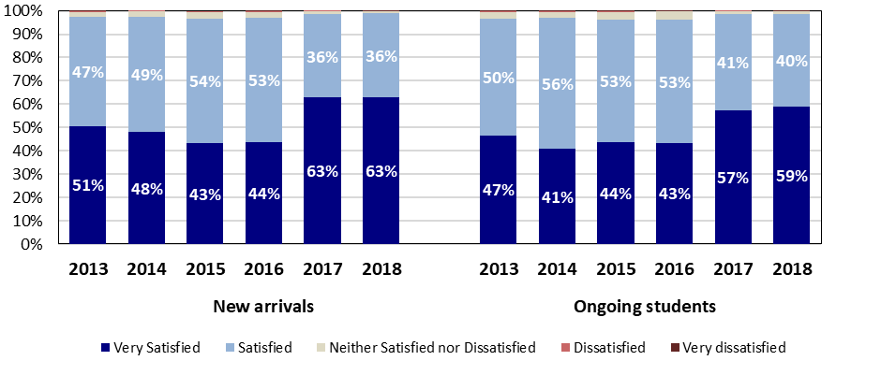

Figure 8 Source: Australia Awards Scholarship Surveys 2018 Executive Summary Report

The 2018 on-award surveys revealed that overall satisfaction with the Australia Awards had remained high and steady since 2013, including for ongoing students. In 2018, almost all of the students who responded to the survey reported that they were likely to recommend Australia as a good place to visit and to study (98 per cent for ongoing students and 99 per cent of new arrivals).

**Case Study – Mozambique**

The Australia Awards Global Tracer Facility *Case Study in Mozambique in the fields of agriculture, food security and natural resources* revealed the high regard in which alumni hold Australian scholarships. The alumni reported that they felt that the Australian scholarships were very well organised, transparent, merit-based and impartial. As a result, the alumni were champions of the scholarships, encouraged others to apply and spoke generously about Australian expertise.

Alumni mentioned the support and careful planning from when they applied for the scholarship until their return and reintegration. It was described as “professional”, with ongoing support even before applying: “you could phone somebody and talk, you could get answers, and it just went very smoothly”. The transition into life in Australia was facilitated by the social support, travel logistics and welcoming received on arrival in Australia: “Simple things, like being met by two Mozambicans at the airport! I didn’t expect that, but someone at UNSW had organised for that’. Another said: “It was so organised before you arrive, they would write a letter explaining where you are going, what kind of people you will find there, the size of the city, the diversity they have there…just after our arrival we had we had a meeting to introduce ourselves.”

**Source**: *Australia Awards Global Tracer Facility: Case Study in Mozambique in the fields of agriculture, food security and natural resources*, January 2019

Alumni perceptions of Australia Awards

The 2019 Global Tracer Facility Survey of alumni who graduated between 2011 and 2016 found that 97 per cent had a positive perception of Australia, and 95 per cent had positive perceptions of Australian skills and expertise. These are consistent with the Year 2 Tracer Study Survey which surveyed alumni who completed their studies between 1996 and 2005.

Figure 9: Source: 2019 Global Tracer Facility Survey Report of Alumni of 2011-2016

Overall progress towards achieving Long-term Outcome 4

The overwhelming majority of alumni agree they would recommend Australia as a good place to study, and agree that their Australia Awards experience has helped them to better understand Australian culture. Based on the available evidence, progress is assessed as being as expected at this stage of implementation and it is likely that the objective will be achieved.

## Mutual obligations

Mutual obligation is handled by the country programs which are responsible for ensuring that their Australia Awards investments align with partner country objectives and complements the overall country program.

EQUITY OF ACCESS

Equity of Access is an underpinning principle of investment decisions in the Australia Awards Global Strategy. The Strategy encourages equity of access throughout the Awards stages and alumni participation, maintaining equal numbers of Awards for women and men at the global level, and addressing the barriers faced by people who are disadvantaged to support their participation in the Awards. The performance of the Awards has again shown significant efforts and success in this regard.

The Australia Awards continues to meet its commitment to maintain equal numbers of awards for women and men at the global level. As shown in figure 10 below, among students currently studying long-term scholarships in Australia, 53 per cent are women. In general terms, this breakdown is repeated at a regional level, as shown in figure 11 below.

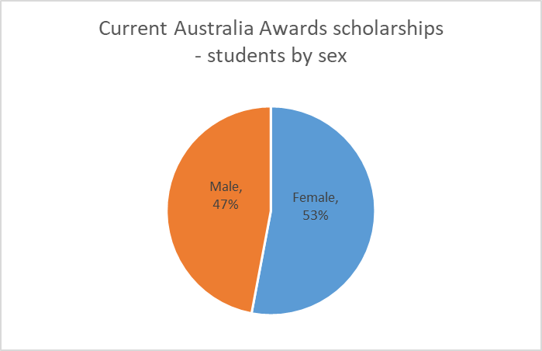 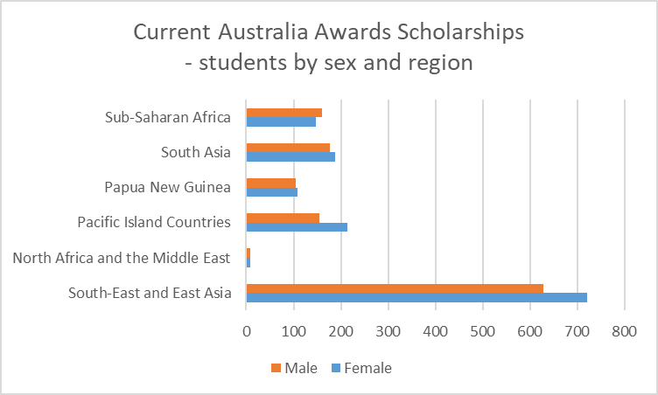

Figure 10 Source: OASIS, as at 7 August 2019 Figure 11: Source: OASIS, as at 7 August 2019

*Note: one student did not identify as male or female Note: one student did not identify as male or female*

There was not a significant variation in the ages of male and female scholars on long-term scholarship (figure 12). There was more variation in terms of sector of study – with notably more women studying education and health courses compared to men (figure 13).

This finding on occupational segregation was repeated in the 2019 Global Tracer Facility study of alumni who graduated between 2011 and 2016. The study found that there was a distinct gender gap in occupations with substantially fewer female alumni in STEM and an under-representation of men in areas such as education, health and society, and culture and creative arts. It also found female alumni were younger and slightly more likely to be employed part-time.

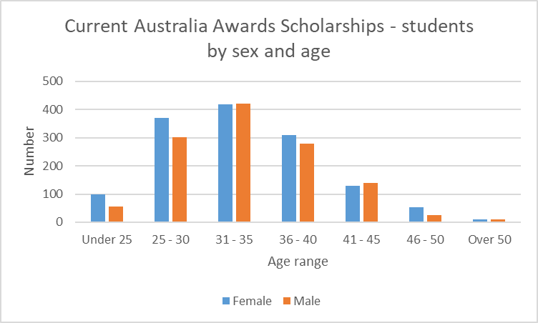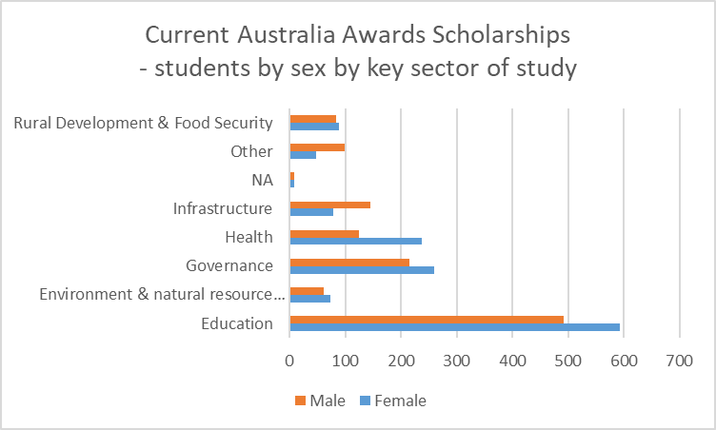

Figure 12 Source: OASIS, as at 7 August 2019 Figure 13 Source: OASIS, as at 7 August 2019

*Note: one student did not identify as male or female Note: one student did not identify as male or female*

Country programs report a range of activities to support equity of access to scholarships for men and women. For example, in 2018, the **Papua New Guinea** program conducted an assessment of the impact family and sexual violence had on Papua New Guinean awardees and found that it was adversely affecting the learning experience of the awardees and in some cases resulted in scholarship suspension or withdrawal. In response, the program now provides clearer and consistent messaging on family and sexual violence. It has also emphasised gender equality across all levels of the program and is mobilising resources to respond to instances of violence, and maintaining and implementing privacy and child protection across the whole program.

A range of activities supported the goal of equity of access to the Awards for women and men. **Africa** reported that all new female scholars who responded to a survey were linking to alumni from their institutions or states. In addition, five Women in Leadership Networks (WILN) (Ghana, Kenya, Uganda, Zambia and Mauritius) are collectively engaging in gender equality and social inclusion initiatives and two have started the process to register as associations (Kenya, Uganda). The managing contractor Palladium found that a unifying leader seemed to be a critical factor in the active WILN chapters and that further work around formalising support and expectations was needed.

The **Laos** program reviewed and updated its gender equality, disability and social inclusion strategy and action checklist for 2018, trained staff on these issues and had them included in their performance agreements. They also implemented an M&E system which collects and analyses sex disaggregated data, and have identified actions for the next reporting period. As a result of their work in this area, the program exceeded its equity targets. It also used feedback from the new M&E system to identify that it was mainly female awardees who needed additional language support and is planning to improve this in 2019.

Around three per cent of scholarship recipients identified as having a disability. Those students come from all regions, with the majority from South-East and East Asia. Scholars with a disability were studying courses across a range of sectors, with the largest numbers in education, health and governance.

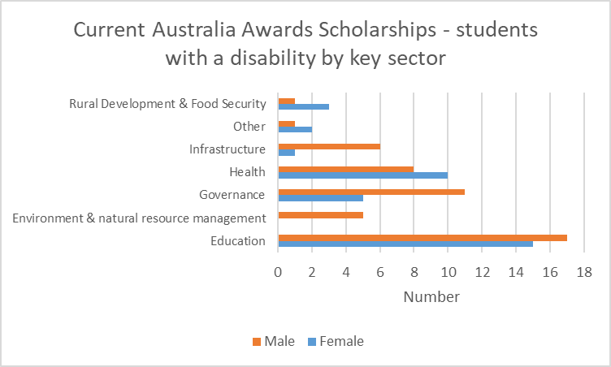 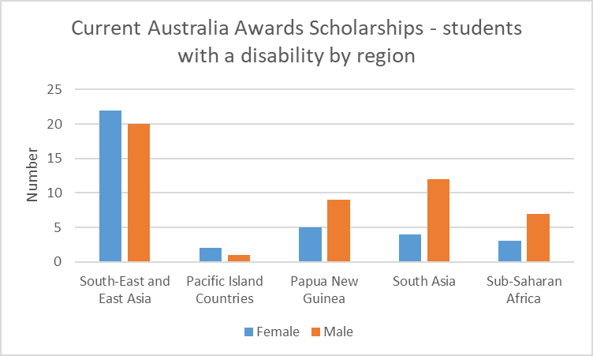

Figure 14: Source: OASIS, as at 7 August 2019 Figure 15: Source: OASIS, as at 7 August 2019

The Global Tracer Facility study of alumni who graduated between 2011 and 2016 found that alumni with disability had similar response patterns to the overall alumni group in terms of the long-term outcomes of the Australia Awards. In the Year 3 Tracer Survey, 125 alumni identifying as having disability and they indicated they have been able to share their knowledge and skills with others (98 per cent of alumni with disability indicate they have done this), introduce improved practice and innovation at work (98 per cent) have maintained and built connections with Australia (42 per cent), and have very positive views of Australians (97 per cent) and Australian expertise (97 per cent). Alumni with disability tended to be more likely than other alumni to hold a leadership position, with almost all these alumni in leadership, and 66 per cent holding formal leadership positions and a further 33 per cent in informal leadership positions.

Country programs were also active in attracting and supporting scholars with a disability. For example, Australia Awards **Papua New Guinea** reported that in 2018-19 it used technological advances, different scholarship modalities and new approaches for disability inclusion. For example, it arranged for a deaf/hard of hearing awardee to have a homestay with a deaf/hard of hearing family in Australia.

## Program Quality and Partner Performance

Overview

In addition to administrative and survey data sources, the performance of individual country/regional Australia Awards program was assessed and reported on through a number of mechanisms, including:

|  |  |  |  |
| --- | --- | --- | --- |
| Aid Program Performance Reports | Aid Quality Checks | Partner Performance Assessment | monitoring and evaluation activities |

Although there are a number of reporting mechanisms in place, again in 2019 it has not been possible to create a comprehensive global picture of performance. This is due to a range of factors, including the proliferation of non-standardised data and measures, a lack of visibility of Australia Awards information in high-level reporting and, in some instances, the fact that there is no requirement to report.

Aid Quality Checks (AQCs)

In 2018-19, 14 Australia Award investments completed AQCs. Between 2018 and 2019, a number of investments improved their AQC ratings. Nine of the 14 AQCs received an overall rating of 5 (the highest possible rating) for the Gender Equality criterion, with the Australia Awards Fellowships Round 17 receiving the lowest rating of a 3.

**Gender equality** is a key focus for the investments and this is quantitatively measured through equal participation of women and men in the Awards. The AQCs, however, indicate that the Awards are achieving more than just equity of participation but are making a contribution to gender equality in partner countries. In addition, there are examples of some programs looking beyond equity to address gender equality in how the Awards themselves are implemented. For example, **Papua New Guinea** reports that its pre-departure information continues to focus on healthy relationships and included a “man haus” session which shifted the men-only participants’ views about their wives going to Australia on a scholarship.

The Aus4Skills investment in Vietnam is also taking a broader approach to promote gender equality. It has supported activities such as: embedding gender equality practices in the curriculum of the Centre for Gender Studies and Women’s Leadership at the leading political training institution in Vietnam; gender mainstreaming training for a range of local partners; integrating gender equality into strategic plans for two universities; establishing an alumni group working in the field of gender equality; and having gender equality as a priority field of study for the Awards.

Figure 16 Source: DFAT Aid Quality Check assessments for Australia Award investments 2018-19 cycle (n=14)

Figure 16 compares the three rated criteria in 2018 and 2019. It shows a marked increase in the number of investments with higher ratings across the board. The improvement in ratings in relation to gender equality appears to be as a result of programs paying specific attention to improving their performance in this area.

The AQCs also include two rated criteria to measure the performance of investments in addressing **disability inclusion**. As shown in Table 2, the majority of investments were performing satisfactorily in terms of actively involving people with disabilities and disabled people’s organisations (86 per cent) and in terms of identifying and addressing barriers to inclusion (93 per cent).

**Table 2 Aid Quality Check – Disability Criteria Ratings**

|  |  |  |  |  |  |  |
| --- | --- | --- | --- | --- | --- | --- |
|  | **Number of AQCs** | | | | | |
| **AQC Criteria** | **1** | **2** | **3** | **4** | **5** | **6** |
| Investment actively involves people with disabilities/ disabled person's organisations in planning, implementing and monitoring and evaluation | 0 | 0 | 2 | 7 | 5 | 0 |
| Investment identifies and addresses barriers to inclusion and opportunities for participation for people with disabilities | 0 | 0 | 1 | 5 | 7 | 1 |

Table 2: Source: DFAT Aid Quality Check assessments for Australia Award investments 2018-19 cycle (n=14)

Global Tracer Facility

The Global Tracer Facility continued to be a key feature of the Australia Awards’ approach to monitoring and evaluation in 2018-19. The Global Tracer Facility was established in 2016 to provide a consistent, standardised mechanism to generate high quality information on Australia Awards alumni, especially less recent alumni. The Tracer Survey is undertaken annually, focusing on a different cohort of alumni each year. Over its first three years of implementation, the Facility has completed three annual Global Tracer Surveys, each focusing on a different time cohort of Australia Awards alumni and ultimately compiling a dataset of 6,370 alumni from as far back as the 1950s. It has also produced country reports which are providing individual Australia Awards programs with Global Tracer Survey data for their country. In addition, the Facility has produced 14 case studies examining small cohorts of alumni in specific sectors and individual countries, with a further five case studies planned for 2019-20 (year 4).

In 2019, the Global Tracer Facility was also reviewed, with the review finding compelling reasons for DFAT to continue to invest in the Facility as the main mechanism evaluating post-award outcomes at the global level. The review found that while the Facility was mostly achieving its objectives, the main gap in the Facility’s implementation had been the extent to which DFAT used the research outputs, particularly at the bilateral and regional levels. The review recommended that the Facility be extended for a further four years, with the new phase to be developed through a consultative scoping process.

Performance of key delivery partners

The key delivery partners for the Australia Awards in Australia are universities and other tertiary education institutions and at post are managing contractors. Overall, the key delivery partners performed well and DFAT was pro-active in resolving performance issues as they arose.

Managing Contractors

A number of different managing contractors are engaged across the program and the arrangements are tailored to suit local requirements.

The managing contractor for the Australia Awards **Africa** program is Palladium International Pty Ltd. The program’s 2018-19 ACQ reported that Palladium had developed strong relationships with stakeholders and strived to demonstrate flexibility and responsiveness to meet DFAT’s expectations, including by assisting Posts with ad-hoc requests regarding alumni engagement activities. A mid-term evaluation of the Africa program found the managing contractor had delivered against the expected number of Awards in a timely manner.

During the year the Australia Awards in **Mongolia** changed its managing contractor to Scope Global, reporting that Scope Global had ensured a smooth transition and improved co-ordination and communication channels.

The **Laos** program reported that Coffey International had improved its overall staffing profile to ensure the efficient delivery of outcomes, however their resourcing for communications, HRD and M&E were somewhat insufficient for most of the performance period.

The program in the **Solomon Islands** reported it was taking steps to outsource more of the day-to-day management of the program to achieve efficiencies.

Australian Universities and Institutions

Annex F provides details of the universities and institutions where Australia Awards students are studying. The annual reports from the universities and institutions reflect an overall positive and committed approach to the success of Australia Awards students. One university noted that the achievements and performance of the Australia Awards students was significantly higher than that of the overall international student cohort.

DFAT provides participating institutions with an *Australia Awards Scholarship Surveys Institution Report*. This report contains the results of the annual Arrival and Ongoing Surveys conducted in the previous calendar year. It gives the institutions the results across four key performance measures for which the educational institutions are required to receive at least an 80 per cent satisfied/very satisfied rating. The report provides institutions with detailed data on their students’ responses to the survey questions.

In response to the Survey Report, the institutions provide to DFAT an annual report in which they address the survey results, outline Awardee achievements, institution initiatives and provide DFAT with suggestions to improve the program. This is a valuable source of information about the achievements, outcomes and areas for improvement with the program. The quality and high level of achievement of awardees is reflected in these reports with many students receiving university awards and acknowledgement for their results. Many of the institutions have actively promoted the achievements of these students.

The Australian universities and institutions which have Australia Awards students tend to be quite proud of the students’ achievements and continue to explore ways to engage the students within the university and the wider community. A number of universities collaborate on the delivery of their Australia Awards programs with the aim of widening the students’ networks and experiences.

The *2018 Australia Awards Scholarships Survey* indicated high satisfaction levels with the facilities and services at their Australian educational institution. Satisfaction levels were 90 per cent or higher in relation to library, Student Contact Officer support services, computer skills, international student support services, and academic skills services. Students reported being least satisfied with childcare facilities (62 per cent for new arrivals and 70 per cent for ongoing students), legal advice (77 per cent and 72 per cent) and disability services (83 per cent and 75 per cent).

## Risks

**Table 3: Management of Key Risks to Achieving Objectives**

|  |  |  |  |  |
| --- | --- | --- | --- | --- |
| **Key risks (emerging and ongoing)** | **What actions were taken to manage the risks over the past year?** | **What further actions will be taken to manage the risks in the coming year?** | **Provide a Risk Rating (low, medium, high, very high)** | **Are these same risks in in Post’s Risk Register (Yes/No)\*** |
| Decentralised management of Australia Awards risks the integrity of the global Australia Awards investment due to inconsistent processes and policies. | Australia Awards Global Strategy, MEF and Policy Handbook seek to ensure consistency of the Australia Awards cycle and application of policies and procedures.  Evaluation of the Australia Awards Global Strategy, Review of the Global Tracer Facility | Implementation of the recommendations from the Evaluation of the Australia Awards Global Strategy  Development of management response to review of the Global Tracer Facility | Medium | N/A |
| Inadequate budget is available to fund the number of scholarships offered. | SCB clearly communicates with country and regional programs about their annual allocation.  Close monitoring of annual allocation and expenditure | Continue to provide advice.  Continue to monitor and forecast expenditure | Low | N/A |
| Selection process for Australia Awards are compromised | Selection processes and interview panels are overseen by an appropriate DFAT delegate | Continue to update and strengthen guidance and advice | Low | N/A |
| Lowering of eligibility requirements such as academic preparedness or English language competency represents a risk to a scholar’s chance to succeed and their overall wellbeing | SCB liaised with posts and universities regarding the requirements for English language.  Maintained requirement for minimum English language competency and English language proficiency testing. | Continue to provide advice | Medium | N/A |

The overall risk profile for the program has not changed in 2018-19. DFAT is strengthening its risk management of the Australia Awards in 2019-20.

## Management actions

In 2017-18, two management actions for Australia Awards were identified:

* + 1. **Global Strategy evaluation**: an independent evaluation of the Australia Awards Global Strategy and MEF to be undertaken to identify lessons learned on their implementation and to provide a basis for a refresh of these documents.

In April 2019 the Australian Council for Educational Research completed the independent evaluation of the Australia Awards Global Strategy. The Evaluation Report and the DFAT management response were published on the DFAT website on 25 June 2019. The report included nine recommendations, of which one was agreed, six agreed in principle and one partly agreed. All of the recommendations will be incorporated into the new strategy when it is developed in 2019-20.

* + 1. **Broadening the on-award experience**: DFAT will consider ways to increase people-to-people links for Australia Award recipients (Outcome 2) and to support the building of partnerships between institutions and businesses in Australia and partner countries (Outcome 3). This will build on examples of on-award support for students such as the Indonesia On-Award Enrichment Program and the Pacific focussed Women’s Leadership Initiative.

Australia Awards country program areas continue to lead on the delivery of On-Award Enrichment activities. DFAT and its partners continue to share good examples of on-award enrichment across the global program leveraging lessons and experience to increase opportunities for a broader cohort of students. Most of the universities reported on-going and new enrichment program activities designed to enhance the student experience and build their connection with both the university and wider local community.

Management actions for Australia Awards at the global level for 2019-20 are:

**1. Australia Awards Global Strategy**: DFAT will refresh theAustralia Awards Global Strategy by June 2020.

**2. Australia Awards Global Tracer Facility**: DFAT will consider and respond to the *Review of the Australia Awards Global Tracer Facility* by June 2020.

**3. Risk Management:** Australia Awards Section will review and implement the risk management planning for the Australia Awards globally and develop a specific detailed risk register for the Australia Awards by June 2020.

**4. Australia Awards Monitoring and Evaluation Framework:** DFAT will update the global M&E framework as part of the revision of the Australia Awards Global Strategy, by June 2020. This is in line with the findings of the independent evaluation.

Annex A - Progress in Addressing Management actions

|  |  |  |
| --- | --- | --- |
| **Management responses identified in 2017-18 APPR** | **Rating** | **Progress made in 2018-19** |
| **Global Strategy evaluation**: an independent evaluation of the Australia Awards Global Strategy and MEF will be undertaken to identify lessons learned on their implementation and to provide a basis for a refresh of these documents. | Achieved | The report *Australia Awards Global Strategy Evaluation and Performance Report* and DFAT’s management response was published on the DFAT website on 25 June 2019. All the recommendations were either agreed or agreed in principle and will be incorporated into the new strategy. |
| **Broadening the on-award experience**: DFAT will consider ways to increase people-to-people links for Australia Award recipients (Outcome 2) and to support the building of partnerships between institutions and businesses in Australia and partner countries (Outcome 3). This will build on examples of on-award support for students such as the Indonesia On-Award Enrichment Program and the Pacific focussed Women’s Leadership Initiative. | Partly Achieved | Australia Awards country program areas continue to lead on the delivery of On-Award Enrichment activities. DFAT and its partners continue to share good examples of on-award enrichment across the global program leveraging lessons and experience to increase opportunities for a broader cohort of students. Most of the universities reported on-going and new enrichment program activities designed to enhance the student experience and build their connection with both the university and wider local community. |

**Note:**

**⬛  Achieved. Significant progress has been made in addressing the issue**

**⬛  Partly achieved. Some progress has been made in addressing the issue, but the issue has not been resolved**

**⬛  Not achieved. Progress in addressing the issue has been significantly below expectations**

ANNEX B - EVALUATION PLANNING

List of evaluations completed in the reporting period

|  |  |  |  |  |  |
| --- | --- | --- | --- | --- | --- |
| Investment number and name  (if applicable) | Name of evaluation | Date completed | Date Evaluation report Uploaded into AidWorks | Date Management response uploaded into AidWorks | Published on website |
| Australia Awards | Australia Awards Global Strategy Evaluation and Performance Report: Evaluation Report | 4 April 2019 | 25 June 2019 (DFAT Website) | 25 June 2019 (DFAT Website) | Yes |
| Australia Awards | Review of the Australia Awards Global Tracer Facility | 5 June 2019 |  |  |  |
| INM023 Australia Awards Papua New Guinea | AAPNG Assessment of Exposure to Family and Sexual Violence and Child Abuse | 6 June 2018 | 22 November 2018 |  | No |
| INM023 Australia Awards Papua New Guinea | Historical and Situational Review: Australia Awards Scholarships Disability Inclusion 2013-2017 | 24 August 2018 |  |  |  |
| INM023 Australia Awards Papua New Guinea | Alumni Development Impact Survey - Assessing the effectiveness of the different scholarship modalities of Australia Awards in Papua New Guinea | 3 July 2018 |  |  |  |
| INM023 Australia Awards Papua New Guinea | Alumni Development Impact Survey - Assessing the effectiveness of the Australia Awards Short Courses for APEC in Papua New Guinea | 3 July 2018 |  |  |  |
| INL420 Australia Awards Africa 2015-2020 | Mid Term Evaluation of Australia Awards in Africa Evaluation Report | 22 February 2019 | 10 April 2019 |  | No |
| INL420 Australia Awards Africa 2015-2020 | Outcomes Study 2018: Australia Awards in Africa | 7 March 2019 | 12 April 2019 |  | Yes |
| INL129 Education Sector Program 2 (Solomon Islands) | ESP2 Basic Education Component Mid-Term Review | 1 October 2018 | 7 March 2019 | 29 April 2019 | Yes |
| INL129 Education Sector Program 2 (Solomon Islands) | Annual Independent Assessment (of 2017 Performance) | 1 July 2018 | 10 August 2018 | 10 August 2018 | Yes |
| INL129 Education Sector Program 2 (Solomon Islands) | Independent Review of S4EG | 30 January 2019 | 12 March 2019 | 12 March 2019 | No |
| INL588 Australia Awards in South and West Asia | Alumni Development Impact Survey 2018 | 1 September 2018 | N/A | N/A | No |

|  |  |  |  |  |  |
| --- | --- | --- | --- | --- | --- |
| Investment number and name  (if applicable) | Name of evaluation | Date completed | Date Evaluation report Uploaded into AidWorks | Date Management response uploaded into AidWorks | Published on website |
| INL487 Human Resource Development Facility (Vietnam) | Mid-term review | 24 December 2018 |  |  |  |
| INL131 Australia Awards in Indonesia | AAI Contribution to Private Sector Development in the Food Industry | 13 July 2018 | 14 March 2019 |  | No |
| INL131 Australia Awards in Indonesia | Maluku and North Maluku GFA Pilot Review | 24 August 2018 | 14 March 2019 |  | No |
| INL131 Australia Awards in Indonesia | Australia Awards Indonesia contribution to Australia’s Gender Strategy | 13 December 2018 | 4 April 2019 |  | No |
| INL131 Australia Awards in Indonesia | The Annual Program Review and Reflection Workshop | 14 September 2018 | 14 March 2019 |  | No |
| INL092 Workforce Development Program (Timor-Leste) | Independent Review of the Workforce Development Program | 1 May 2018 | 22 January 2019 | 22 January 2019 | Yes |
| INL092 Workforce Development Program (Timor-Leste | Private Sector Development Review | 15 December 2018 | 22 January 2019 | 22 January 2019 | Yes |
|  |  |  |  |  |  |
|  |  |  |  |  |  |

Annex c – Aid Quality Check ratings

AQC ratings 2018

AQC investment performance over the previous 12 months

|  |  |  |  |  |  |  |
| --- | --- | --- | --- | --- | --- | --- |
|  | **Name** | **Country/Region** | **Allocation $** | **Effectiveness** | **Efficiency** | **Gender Equality** |
| INM023 | Australia Awards Papua New Guinea | PNG | 185,000,000.00 | 5 | 5 | 5 |
| INL131 | Australia Awards in Indonesia | Indonesia | 166,021,548.00 | 5 | 5 | 4 |
| INL420 | Australia Awards Africa 2015-2020 | Africa | 67,685,812.03 | 5 | 4 | 5 |
| INL588 | Australia Awards in South and West Asia | South Asia | 45,793,351.94 | 6 | 5 | 5 |
| INL487 | SO1 Human Resource Development Facility | Vietnam | 40,000,000.00 | 5 | 4 | 5 |
| INK562 | Laos Australia Institute | Laos | 30,069,827.05 | 4 | 4 | 5 |
| INM528 | Australia Awards Scholarships Cambodia | Cambodia | 18,456,319.03 | 5 | 5 | 4 |
| INM162 | Australia Awards Fellowships Round 17 | Global | 17,528,857.70 | 4 | 3 | 3 |
| INL092 | Workforce Development Program | Timor-Leste | 17,073,878.99 | 5 | 4 | 5 |
| INM313 | Philippine Australia Scholarships Alumni Program | Philippines | 15,550,000.00 | 5 | 5 | 5 |
| INH654 | Australia Awards - Vanuatu In-Country Costs | Vanuatu | 7,375,730.95 | 5 | 4 | 4 |
| INM467 | Australia Award in Mongolia | Mongolia | 6,650,000.00 | 4 | 4 | 5 |
| INL129 | Education Sector Program 2 | Solomon Islands | 4,200,000 | 4 | 5 | 4 |
| INL832 | Global Tracer Facility | Global | 3,809,720.06 | 5 | 6 | 5 |

ANNEX D – MONITORING AND EVALUATION Framework

| **Long-term Outcomes** | **Data Source** | **Responsibility** | **M&E Use** |
| --- | --- | --- | --- |
| 1. Alumni are using their skills, knowledge and networks to contribute to sustainable development | Tracer Studies  Case Studies  Fellowship Evaluation/Tracer Study | Global Tracer Facility | DFAT report outcomes of Australia Awards at global and country levels as well as by sector  Well-informed management decisions at global and country levels  DFAT and contractors build understanding of what enables and constrains achievement of outcomes  Public communication about Australia Awards  Corporate/aid program reporting requirements e.g. AQCs and APPRs |
| Case Studies, Alumni Impact Assessments, other Outcomes Evaluations | Posts and/or Managing Contractors |
| Media Monitoring | Posts |
| 2. Alumni are contributing to cooperation between Australia and partner countries | Tracer Studies  Case Studies  Fellowship Evaluation/Tracer Study | Global Tracer Facility |
| Alumni Impact Assessments, other Outcomes Evaluations | Posts and/or Managing Contractors |
| Media Monitoring | Posts, AWB |
| Post Staff Survey | AWB |
| 3. Effective, mutually advantageous partnerships between institutions and businesses in Australia and partner countries | Tracer Studies  Case Studies | Global Tracer Facility |
| Alumni Impact Assessments, other Outcomes Evaluations | Posts and/or Managing Contractors |
| Post Fellowship Evaluation | Global Tracer Facility or AWB |
| Post Media Monitoring | Posts |
| Periodic Linkages Evaluation | AWB |
| 4. Alumni view Australia, Australians and Australian expertise positively | Tracer Studies  Case Studies  Fellowship Evaluation/ Tracer Study | Global Tracer Facility |  |

ANNEX E – AUSTRALIA AWARDS SCHOLARSHIPS STUDENTS

|  |  |  |  |  |
| --- | --- | --- | --- | --- |
| **Current Australia Awards Scholarship by Country and Sex as at 7 August 2019** | | | | |
| **Region/Country** | **Female** | **Male** | **Other** | **Total** |
| **East Asia** | **721** | **629** | **1** | **1351** |
| CAMBODIA | 41 | 54 |  | 95 |
| INDONESIA | 353 | 328 |  | 681 |
| LAO PEOPLE'S DEMOCRATIC REPUBLIC | 40 | 33 |  | 73 |
| MALAYSIA | 3 | 2 |  | 5 |
| MONGOLIA | 42 | 27 |  | 69 |
| MYANMAR | 58 | 42 |  | 100 |
| PHILIPPINES | 54 | 51 |  | 105 |
| THAILAND | 3 | 2 |  | 5 |
| TIMOR-LESTE | 22 | 26 |  | 48 |
| VIET NAM | 105 | 64 | 1 | 170 |
| **North Africa and the Middle East** | **9** | **8** |  | **17** |
| PALESTINIAN TERRITORY, OCCUPIED | 9 | 8 |  | 17 |
| **Pacific Island Countries** | **214** | **154** |  | **368** |
| FIJI | 46 | 49 |  | 95 |
| KIRIBATI | 34 | 12 |  | 46 |
| MARSHALL ISLANDS | 1 |  |  | 1 |
| NAURU | 9 | 8 |  | 17 |
| NEW CALEDONIA | 2 | 1 |  | 3 |
| SAMOA | 46 | 30 |  | 76 |
| SOLOMON ISLANDS | 35 | 27 |  | 62 |
| TONGA | 17 | 9 |  | 26 |
| TUVALU | 7 | 5 |  | 12 |
| VANUATU | 17 | 13 |  | 30 |
| **Papua New Guinea** | **108** | **104** |  | **212** |
| PAPUA NEW GUINEA | 108 | 104 |  | 212 |
| **South Asia** | **188** | **176** |  | **364** |
| BANGLADESH | 57 | 60 |  | 117 |
| BHUTAN | 20 | 23 |  | 43 |
| MALDIVES | 9 | 6 |  | 15 |
| NEPAL | 30 | 28 |  | 58 |
| PAKISTAN | 40 | 28 |  | 68 |
| SRI LANKA | 32 | 31 |  | 63 |
| **Sub-Saharan Africa** | **148** | **161** |  | **309** |
| BOTSWANA | 13 | 11 |  | 24 |
| COTE D'IVOIRE |  | 1 |  | 1 |
| GHANA | 21 | 18 |  | 39 |
| KENYA | 24 | 20 |  | 44 |
| MADAGASCAR | 7 | 6 |  | 13 |
| MALAWI | 12 | 14 |  | 26 |
| MAURITIUS | 4 | 5 |  | 9 |
| MOZAMBIQUE | 11 | 20 |  | 31 |
| NIGER |  | 4 |  | 4 |
| NIGERIA | 21 | 18 |  | 39 |
| SEYCHELLES | 1 | 1 |  | 2 |
| SIERRA LEONE | 2 |  |  | 2 |
| SOUTH AFRICA | 4 | 6 |  | 10 |
| SWAZILAND | 4 |  |  | 4 |
| TANZANIA, UNITED REPUBLIC OF | 9 | 17 |  | 26 |
| UGANDA |  | 1 |  | 1 |
| ZAMBIA | 14 | 18 |  | 32 |
| ZIMBABWE | 1 | 1 |  | 2 |
| ***TOTAL*** | ***1,388*** | ***1,232*** | ***1*** | ***2,621*** |

Source: OASIS, as at 7 August 2019

ANNEX F – UNIVERSITIES AND TERTIARY INSTITUTIONS

|  |  |  |  |  |  |  |  |
| --- | --- | --- | --- | --- | --- | --- | --- |
| **Current Australia Awards scholarships by region and tertiary institution** | | | | | | | |
| **University** | **South-East and East Asia** | **North Africa & the Middle East** | **Pacific Island Countries** | **Papua New Guinea** | **South Asia** | **Sub-Saharan Africa** | **Total** |
| Australian Catholic University |  |  | 7 | 1 |  |  | 8 |
| Aviation Australia |  |  | 1 |  |  |  | 1 |
| Bond University | 1 |  | 5 | 4 |  | 2 | 12 |
| Canberra Institute of Technology | 2 |  |  |  |  |  | 2 |
| Carnegie Mellon University | 2 |  |  |  |  | 1 | 3 |
| Central Queensland University | 5 |  | 4 | 2 | 2 |  | 13 |
| Charles Darwin University | 3 |  | 6 |  |  | 1 | 10 |
| Charles Sturt University | 2 |  | 1 | 4 | 3 | 6 | 16 |
| Curtin University | 24 |  | 4 | 11 | 3 | 29 | 71 |
| Deakin University | 11 |  | 5 | 4 | 6 | 4 | 30 |
| Edith Cowan University | 2 |  | 1 |  | 9 |  | 12 |
| Federation University |  |  | 1 |  | 1 |  | 2 |
| Flinders University | 128 | 1 | 1 | 15 | 30 | 28 | 203 |
| Griffith University | 28 | 1 | 26 | 5 | 3 | 2 | 65 |
| Holmesglen Institute of TAFE | 1 |  |  |  |  |  | 1 |
| James Cook University | 12 |  | 8 | 27 | 1 | 9 | 57 |
| La Trobe University | 12 |  | 4 | 5 | 3 |  | 24 |
| Macquarie University | 19 |  | 7 | 3 | 9 | 2 | 40 |
| Monash University | 108 | 1 | 25 | 6 | 37 | 12 | 189 |
| Murdoch University | 20 |  | 2 |  | 5 | 19 | 46 |
| Queensland University of Technology | 18 | 1 | 17 | 11 | 3 | 4 | 54 |
| RMIT University | 47 |  | 20 | 1 | 19 | 8 | 95 |
| Southern Cross University | 8 |  |  | 3 | 1 |  | 12 |
| Swinburne University of Technology | 14 |  | 2 | 2 | 4 |  | 22 |
| TAFE SA |  |  |  | 1 |  |  | 1 |
| The Australian National University | 154 | 1 | 30 | 5 | 41 | 16 | 247 |
| The University of Adelaide | 90 | 1 | 9 | 6 | 13 | 8 | 127 |
| The University of Melbourne | 215 | 4 | 11 | 9 | 82 | 30 | 351 |
| The University of New England | 16 |  | 2 | 2 |  | 8 | 28 |
| The University of New South Wales (including ADFA) | 54 |  | 17 | 9 | 13 | 11 | 104 |
| The University of Newcastle | 21 |  | 13 | 1 | 1 | 5 | 41 |
| The University of Queensland | 103 | 2 | 33 | 23 | 21 | 51 | 233 |
| The University of Sydney | 76 | 3 | 39 | 8 | 22 | 8 | 156 |
| The University of Western Australia | 40 |  | 1 | 6 | 11 | 23 | 81 |
| University of Canberra | 18 |  | 8 | 2 | 4 | 2 | 34 |
| University of South Australia | 18 | 1 | 2 | 6 | 6 | 9 | 42 |
| University of Southern Queensland | 2 |  | 10 | 7 | 1 | 2 | 22 |
| University of Tasmania | 7 |  | 7 | 1 |  | 2 | 17 |
| University of Technology Sydney | 20 |  | 8 | 3 | 4 | 4 | 39 |
| University of The Sunshine Coast | 2 |  |  | 6 |  |  | 8 |
| University of Wollongong | 7 |  | 9 | 5 | 2 | 2 | 25 |
| Victoria University | 35 | 1 | 17 | 6 | 4 |  | 63 |
| Western Sydney University | 6 |  | 5 | 2 |  | 1 | 14 |
| **TOTAL** | **1351** | **17** | **368** | **212** | **364** | **309** | **2621** |

Source: OASIS, as at 7 August 2019

Annex G – Data Sources

*Acknowledgement: this report was prepared with input from Helen McDermott, Onpoint 365*

The main data (2017-18 financial year) sources used in this APPR are:

Information Brief: Australia Awards: 2017-18 – A regularly updated statistical profile on the Australia Awards data. The current profile is available at: <https://dfat.gov.au/about-us/publications/Pages/australia-awards-statistical-profile.aspx>

Online Australia Awards Scholarships Information System (OASIS) – DFAT’s internet-based data management system. OASIS enables DFAT, managing contractors and institutions to access a centralised database to electronically enter and store data, process applications and manage the Australia Awards Scholarships.

On-award surveys of Australia Awards scholarship – Funded by DFAT, these comprise annual surveys of new starters (one for Semester One and one for Semester Two, known as the *Arrival Surveys[15]*) and an annual survey of students who have completed at least one semester of study (known as the *Ongoing Survey[16]*). This Performance Report draws on findings from the 2017 survey. The two Arrival Surveys were conducted in May/June 2017 for semester one (a 94 per cent response rate) and in September 2017 for semester two (a 91 per cent response rate). The Ongoing Survey was conducted in September 2017 (a 79 per cent response rate).

The Australia Awards Global Tracer Facility (the Global Tracer Facility) – Funded by DFAT, the Facility assesses the development contributions and public and economic diplomacy outcomes of Australia’s investment in the Australia Awards. The key research and reporting activities being undertaken are a Tracer Survey and qualitative Case Studies, which are prepared concurrently throughout the four years of the project.

This Performance Report draws on findings from the second Tracer Survey by the Facility and the second-year alumni case studies conducted in China, Indonesia, Mongolia, Solomon Islands and Vanuatu. This second Tracer Survey involved the engagement of 1,072 alumni from the 1996 to 2005 cohort from 36 countries[17].

Aid Quality Checks (AQCs) – Data from AQCs are used to report to the public and Government on the performance of the aid program. AQC reporting is mandatory for all aid investments valued $3 million and above (see Annex C for list of ACQs).

Global/Country/Regional Program Monitoring and Evaluation (M&E) documents are prepared by some but not all Australia Awards investments.

1. 2018 Australia Awards Scholarship Surveys *2018* Executive Summary Report p11.
2. 2019 Global Tracer Facility Survey Report Alumni of 2011-2016
3. The [*Australia Global Alumni Engagement Strategy 2016-2020*](https://dfat.gov.au/about-us/publications/Pages/australia-global-alumni-engagement-strategy-2016-2020.aspx) aims to grow a global alumni community that actively engages and promotes Australia and advances national interests. A summary report highlights available data and profiles of Australia’s alumni. The documents are available at: https://dfat.gov.au/about-us/publications/Pages/australia-global-alumni-engagement-strategy-2016-2020.aspx
4. There are five principles: Principle 1: Alignment with Australia’s development, economic and public diplomacy priorities; Principle 2: Equity of access; Principle 3: Merit-based selection; Principle 4: Value for money and evidence-based decision making; Principle 5: Promote the Australia Awards
5. *A description of data sources is included in Annex E*
6. *The current profile is available at:* [*https://dfat.gov.au/about-us/publications/Pages/australia-awards-statistical-profile.aspx*](https://dfat.gov.au/about-us/publications/Pages/australia-awards-statistical-profile.aspx)
7. A full list of the AQCs is included in Annex C.
8. Monitoring and Evaluation (M&E) documents are prepared by some but not all Australia Awards investments.
9. Note that the expenditure and number of scholarships offered data should not be conflated, as the expenditure includes expenses from scholarships granted in previous years, not just those offered in 2018-19.
10. Year 3 surveyed alumni who completed their studies between 2011 and 2016
11. <https://globalalumni.gov.au/Australia-Awards/Alumni-Stories/Details/ArticleId/3155>
12. Year 3 surveyed alumni who completed their studies between 2011 and 2016
13. Year 3 surveyed alumni who completed their studies between 2011 and 2016
14. Pakistan Factsheet Australia Awards in 2018, October 2018
15. The two Arrival Surveys are aimed at gathering information on: the application process for an Australia Awards; pre-departure preparation; experience on arrival and living experiences so far; initial thoughts on study programs, institution services and facilities; and satisfaction with the scholarship entitlements received so far.
16. The Ongoing Survey is aimed at gathering information on: living and studying experiences; assessments of facilities and services at Australian academic institutions; entitlements and assistance provided by the Australia Awards; and arrangements for returning home.
17. This involved 1,072 alumni from 36 different countries who completed scholarships as part of the Australia Awards or predecessor scholarship programs between 1996 and 2005 (a 23 per cent response rate). Of the online respondents, 522 participated in the telephone follow-up interview.