

Australia Awards Alumni  
Global Tracer Survey 2022

Australia Awards Global Tracer Facility

The views expressed in this report are those of the authors and do not necessarily reflect the policy or position of the Australian Government, its agencies or representatives.

Australian Department of Foreign Affairs and Trade

With the exception of the Commonwealth Coat of Arms and where otherwise noted, all material presented is provided under a Creative Commons Attribution 3.0 Australia license.

**Acknowledgements:**

The Australian Council for Educational Research is the managing contractor for the Australia Awards Global Tracer Facility, and staff from the GTF thank our colleagues at Wallis Social Research for managing the survey and data collection elements of this research. The authors would like to thank DFAT’s Global Education and Scholarships Section, for supporting this research.

Most importantly, thank you to the thousands of alumni who gave their time in completing the GTF Global Tracer Survey, without your insight, feedback and accomplishments, the research we do would not be possible.

**Acknowledgement of Country:**

In the spirit of reconciliation, the authors would like to acknowledge the Traditional Custodians of Country throughout Australia, including the Wurundjeri People of the Kulin Nation, where this report was written, and their connections to land, sea and community. We pay our respect to their elders past and present and extend that respect to all Aboriginal and Torres Strait Islander peoples. We acknowledge the Aboriginal and Torres Strait Islander people who continue to contribute to our work to improve learning, education and research.

**Recommended citation:** Hsien, M., & Edwards, D. (2023). *Australia Awards Alumni Global Tracer Survey 2022*. Australia Awards Global Tracer Facility, Australian Department of Foreign Affairs and Trade. https://www.dfat.gov.au/publications/people-people/australia-awards-global-tracer-facility-year-7-results

**Published Research Reports by the Australia Awards Global Tracer Facility**

**2016/17 - Year One**

* [Australia Awards Global Tracer Facility Tracer Survey: Alumni of 2006-2010](https://www.dfat.gov.au/people-to-people/australia-awards/Pages/australia-awards-global-tracer-facility-tracer-survey-alumni-of-2006-2010.aspx)
* [Fiji Alumni Case Study](https://www.dfat.gov.au/people-to-people/australia-awards/Pages/australia-awards-global-tracer-facility-fiji-alumni-case-study.aspx) - Education
* [Sri Lanka Alumni Case Study](https://www.dfat.gov.au/people-to-people/australia-awards/Pages/australia-awards-global-tracer-facility-sri-lanka-alumni-case-study.aspx) - Engineering
* [Kenya Alumni Case Study](https://www.dfat.gov.au/people-to-people/australia-awards/Pages/australia-awards-global-tracer-facility-kenya-alumni-case-study.aspx) – Agriculture & Environmental Management
* [Nepal Alumni Case Study](https://www.dfat.gov.au/people-to-people/australia-awards/Pages/australia-awards-global-tracer-facility-nepal-alumni-case-study.aspx) – Public Service

**2017/18 – Year Two**

* [Australia Awards Global Tracer Facility Survey: Alumni of 1996-2005](https://www.dfat.gov.au/people-to-people/australia-awards/Pages/australia-awards-global-tracer-facility-tracer-survey-alumni-of-1996-2005.aspx)
* [China Alumni Case Study](https://www.dfat.gov.au/people-to-people/australia-awards/Pages/australia-awards-global-tracer-facility-china-alumni-case-study.aspx) – Public Health & Environment
* [Indonesia Alumni Case Study](https://www.dfat.gov.au/people-to-people/australia-awards/Pages/australia-awards-global-tracer-facility-indonesia-alumni-case-study.aspx) - Education
* [Mongolia Alumni Case Study](https://www.dfat.gov.au/people-to-people/australia-awards/Pages/australia-awards-global-tracer-facility-mongolia-alumni-case-study.aspx) – Management & Commerce
* [Solomon Islands Alumni Case Study](https://www.dfat.gov.au/people-to-people/australia-awards/Pages/australia-awards-global-tracer-facility-solomon-islands-alumni-case-study.aspx) - Health
* [Vanuatu Alumni Case Study](https://www.dfat.gov.au/people-to-people/australia-awards/Pages/australia-awards-global-tracer-facility-vanuatu-alumni-case-study.aspx) – Law

**2018/19 – Year Three**

* [Australia Awards Global Tracer Facility Survey: Alumni of 2011-2016](https://www.dfat.gov.au/people-people/australia-awards-global-tracer-facility-tracer-survey-alumni-2011-2016)
* [Cambodia Alumni Case Study](https://www.dfat.gov.au/people-to-people/australia-awards/australia-awards-global-tracer-facility-cambodia-alumni-case-study) – Public Health
* [Mozambique Alumni Case Study](https://www.dfat.gov.au/people-to-people/australia-awards/Pages/australia-awards-global-tracer-facility-mozambique-alumni-case-study.aspx) – Food Security & Agriculture
* [Pakistan Alumni Case Study](https://www.dfat.gov.au/people-to-people/australia-awards/Pages/australia-awards-global-tracer-facility-pakistan-alumni-case-study.aspx) – NGOs and Public Service
* [PNG Alumni Case Study](https://www.dfat.gov.au/people-to-people/australia-awards/australia-awards-global-tracer-facility-papua-new-guinea-alumni-case-study) – Information Technology & Communications
* [Vietnam Alumni Case Study](https://www.dfat.gov.au/people-to-people/australia-awards/Pages/australia-awards-global-tracer-facility-vietnam-alumni-case-study.aspx) – Women in Finance

**2019/2020 – Year Four**

* [Bangladesh Case Study](https://www.dfat.gov.au/people-people/australia-awards/australia-awards-global-tracer-facility-case-study-bangladesh-economic-development) – Public Sector Finance
* [Costa Rica Case Study](https://www.dfat.gov.au/people-people/australia-awards/australia-awards-global-tracer-facility-costa-rica-alumni-case-study) – Environment & Agriculture
* [Samoa Case Study](https://www.dfat.gov.au/people-people/australia-awards/australia-awards-global-tracer-facility-samoa-alumni-case-study) – Engineering & ICT
* [Timor-Leste Case Study](https://www.dfat.gov.au/people-people/australia-awards/australia-awards-global-tracer-facility-timor-leste-case-study) – Disability & Development
* [Global Impact of Australian Aid Scholarships: Long-term Outcomes of Alumni](https://www.dfat.gov.au/sites/default/files/global-impact-australian-aid-scholarships-long-term-outcomes-alumni.pdf)

**2020/21 – Year Five**

* [Philippines Case Study](https://www.dfat.gov.au/people-to-people/australia-awards/australia-awards-global-tracer-facility-year-5-results/australia-awards-global-tracer-faciltiy-philippines-case-study-peace-security-and-inclusive-development) – Peace, Security and Inclusive Development
* [Kiribati Case Study](https://www.dfat.gov.au/publications/people-people/kiribati-case-study-mapping-alumni-networks-and-links-australia) – Social Network Analysis of alumni connections
* [Mobile Alumni Case Study](https://www.dfat.gov.au/publications/people-people/mobile-alumni-case-study) – Outcomes of alumni no longer in their home country
* [Alumni Contributions to COVID-19 Response](https://www.dfat.gov.au/people-to-people/australia-awards/australia-awards-global-tracer-facility-year-5-results/alumni-contributions-covid-19-response)
* [Global Tracer Survey Report 2020](https://www.dfat.gov.au/people-to-people/australia-awards/australia-awards-global-tracer-facility-year-5-results/australia-awards-alumni-global-tracer-survey-2020)

**2021/22 – Year Six**

* [Alumni Case Study – Insights into Short Course Capacity Building](https://www.dfat.gov.au/people-to-people/australia-awards/australia-awards-global-tracer-facility-year-6-results/alumni-case-study-insights-short-course-capacity-building)
* [Australia Awards Pacific Scholarships Alumni Survey 2021](https://www.dfat.gov.au/people-to-people/australia-awards/australia-awards-global-tracer-facility-year-6-results/australia-awards-pacific-scholarships-alumni-survey-2021)
* [Social Network Analysis of an Australia Awards Leadership Program Cohort](https://www.dfat.gov.au/people-people/social-network-analysis-australia-awards-leadership-program-cohort)
* [Australia Awards Exemplary Partnerships: The South Pacific Centre for Central Banking](https://www.dfat.gov.au/people-to-people/australia-awards/australia-awards-global-tracer-facility-year-6-results/australia-awards-exemplary-partnerships-south-pacific-centre-central-banking)
* [Alumni Growth: Tracking Australia Awards Alumni Over Five Years – Longitudinal Tracer Survey 2021](https://www.dfat.gov.au/people-to-people/australia-awards/australia-awards-global-tracer-facility-year-6-results/alumni-growth-tracking-australia-awards-alumni-over-five-years-longitudinal-tracer-survey-2021)

**2022/23 – Year Seven**

* [Australia Awards Alumni contributing to civil society: supporting development through volunteerism](https://www.dfat.gov.au/people-people/australia-awards-alumni-contributing-civil-society-supporting-development-through-volunteerism)
* [Women’s Leadership and Career Progression: Insights from Indonesian Australia Awards Alumnae](https://www.dfat.gov.au/publications/people-people/womens-leadership-and-career-progression-insights-indonesian-australia-awards-alumnae)
* [Outcomes of Australia Awards Fellowships: Sport for Development in Fiji](https://www.dfat.gov.au/publications/people-people/outcomes-australia-awards-fellowships-sport-development-fiji)
* [A Social Network Analysis of Australia Awards Alumni Workshops](https://www.dfat.gov.au/publications/people-people/social-network-analysis-australia-awards-alumni-workshops)

**Further information and all research published by the Australia Awards Global Tracer Facility can be found on the DFAT website here:** <https://www.dfat.gov.au/people-to-people/australia-awards/australia-awards-global-tracer-facility>.

Contents

Executive Summary 5

1. Introduction 7

2. Scope, Approach, and Alumni Participants 9

2.1 Scope 9

2.2 Approach 9

2.3 Alumni population and participants 10

2.4 Characteristics of participants 12

3. Coming Home from Award: Experiences, Programs & Support 15

3.1 The experience of returning from award 15

3.2 Factors enabling reintegration 16

3.3 Participation in programs for reintegration 17

3.4 Suggestions for future support programs 23

4. Alumni Contributing to Development 24

4.1 Sharing new skills and knowledge 24

4.2 Impact and reach of alumni contributions 25

4.3 Contributions through paid work 26

4.4 Contributions outside of work 29

5. Connections, Networks, and Relationships from Award 32

5.1 Connections and contacts *while on award* 32

5.2 Connections and contacts *post award* 33

6. Helping Alumni Make an Impact 35

6.1 What helps alumni succeed? 35

6.2 What prevents alumni success? 37

7. Conclusion 38

8. References 40

Acronyms and Abbreviations 41

Appendix A: Awards included in the GTF Global Tracer Survey Population 42

Appendix B: Response rates by region and gender 44

Executive Summary

**This report details the findings of the Global Tracer Survey 2022 of alumni from the Australia Awards and predecessor development scholarships. The research was undertaken by the Australia Awards Global Tracer Facility (GTF), which is managed by the Australian Council for Educational Research (ACER). The survey was administered online between November 2022 and January 2023 to alumni from 114 countries who had studied in Australia as part of a scholarship or fellowship. In total, 5116 alumni participated in the survey (a 24% response rate globally). Among this group were alumni who completed their award during the 1980s through to alumni who completed their award in the 2010s.**

These alumni responses provide insight into the core outcomes of the Australia Awards; contributions alumni have made using the knowledge and skills gained while on award in Australia and the connections and partnerships developed as a result of their award. The survey also explored alumni experiences of returning to their home country after award, offering a global perspective on the different reintegration experiences, pathways and programs alumni have used in the years following their study in Australia.

The results from the survey are discussed in this report with reference to the current long-term program outcomes of the Australia Awards. Highlights from the findings are outlined in the summary below:

**Outcome 1:** Alumni are using their skills, knowledge, and networks to contribute to sustainable development.

Findings show that alumni are drawing on the knowledge and skills developed in Australia to contribute to development on their return home, with strong evidence that they are able to contribute to improvements and initiate change in their communities and workplaces, as well on a national and global scale. Results show that almost all (97%) alumni indicated their award has been of benefit to their work and career opportunities, and over 75 per cent noted that they were able to contribute to national, regional or global development as a result of their award.

This survey collected new information from alumni to specifically understand their contributions to development through unpaid work or volunteering as well as their contributions through paid work. The survey collected thousands of examples of alumni contributions through unpaid community service, outreach, and education activities.

Collectively, alumni of Australian development scholarships are contributing to each one of the United Nations (UN) Sustainable Development Goals (SDGs) through their paid and unpaid work. These contributions were most significant towards SDGs relating to improving education, health and wellbeing, gender equality and reducing poverty.

Alumni highlighted that the contributions they have made since their award can be attributed to the improved skills and knowledge acquired as a result of their award, increased confidence developed through their scholarship experience and support within their workplace when they returned home.

**Outcome 2**: Alumni are contributing to cooperation between Australia and partner countries.

Survey results show that alumni are developing and maintaining connections with individuals they met while on award in Australia. As shown in previous surveys by the GTF, the majority of alumni maintain connections with fellow Australia Awards alumni, other international students, Australian students, university academics and other people from Australia they met on award. The survey also shows that the majority of alumni continue to have some contact with the Australia Awards program in their country and most alumni remain in contact with the Australian Embassy or High Commission in their country or region.

Alumni are also working alongside Australians as part of their work – more than one in five indicate that working with Australians was something they ‘often’ or ‘always’ do, and a further 40 per cent indicating they too, have ‘some’ contact with Australians professionally.

The survey results clearly highlight that opportunities to connect with Australian businesses while on award result in greater likelihood of ongoing long-term connections with Australia for alumni. Nearly half of alumni who were engaged with Australian businesses in their field while on award continue to have ongoing and frequent contact, years after their study in Australia. In contrast, alumni who did not have opportunities to connect with Australian organisations while on award are very unlikely to have developed ongoing links following their award.

New insight: Returning home – programs and support after award

This Global Tracer Survey included a specific focus on increasing understanding of alumni experience on return from award. Almost two thirds of alumni indicated that their experience in adapting back to life in their country after award was ‘easy’. However, the survey did show discrepancies by gender – with women less likely to have had an easy reintegration – and region, with those from Latin America, and from North Africa and the Middle East more likely to indicate there were difficulties for them on return.

More than a quarter (28%) of all alumni had participated in formal reintegration programs following their award. These programs were predominantly run by the Australia Awards program or by the Australian Embassy or High Commission in their country. For most participants these programs ran for about 6 months post-award, but for one in five of the alumni in a reintegration program, the initiative continued for two years or more after returning home.

While the survey collected some strong qualitative data about the positive impact of some of these programs, overall the quantitative data from the survey shows that perceptions of the experience of adapting to life back home after award were not demonstrably different for alumni whether they had participated in one of these programs or not. However, the data did offer some important suggestions from alumni for ensuring reintegration activities are helpful in the future and these ideas focussed strongly on helping ensure alumni are embedded in networks with other alumni in their country and region to share experiences, connections and opportunities.

# Introduction

This report details the findings of the Global Tracer Survey 2022 of alumni from the Australia Awards and predecessor development scholarships. The survey was administered online from November 2022 to January 2023 to alumni from 114 countries who had studied in Australia as part of a scholarship or fellowship. More than 5000 alumni participated, and their responses provide insight into contributions to development using their new knowledge and skills, their experience of returning home after their award, and their connections and partnerships with Australians.

The Global Tracer Survey 2022 was conducted by the Australia Awards Global Tracer Facility (GTF), a research program established by the Department of Foreign Affairs and Trade (DFAT) and managed by the Australian Council for Educational Research (ACER). The focus of the GTF is to collect and analyse information from alumni to assist DFAT to better understand the long-term outcomes of Australian development scholarship alumni. This survey is the fifth Global Tracer Survey undertaken by the GTF since 2016.

The goal of the Australia Awards is ‘to support partner countries to achieve their development goals through education and knowledge transfer and to build enduring relationships with Australia that advance mutual interests’. The results of this survey are discussed in this report with reference to the long-term program outcomes and intermediate outcomes of the Australia Awards, which each contribute to the above-mentioned goal. The goal and related outcomes are shown in Figure 1.

Figure 1 shows the Australia Awards Program Logic, outlining its overarching goal and intended outcomes. 

The overarching goal for the Australia Awards is to support partner countries to achieve their development goals through education and knowledge transfer and to build enduring relationship with Australia that advance mutual interests. 

There are two program outcomes:
1. Alumni use their skills, knowledge and networks to contribute to sustainable development;
2. Alumni contribute to cooperation between Australia and partner countries..

There are 3 intermediate outcomes:
1. Alumni have the necessary skills and knowledge to contribute to development
2. Alumni have relevant and useful networks and relationships
3. Alumni view Australia, Australians, and Australian expertise positively.



Figure 1: Australia Awards overall goal and intended outcomes (DFAT, 2022) [1]

In addition to exploring the overall outcomes of the Australia Awards and supplementing findings from previous research into alumni outcomes undertaken by the GTF, the 2022 survey also gathered information, insight and views of alumni in relation to the *‘returning home’ experience* (or reintegration) for alumni following their time on award in Australia. Specific to this the survey asked alumni about:

* experiences on return home from award;
* factors that helped alumni to ‘successfully settle back into life’ in their home country; and
* participation in programs specifically designed to support their return home.

The following chapter provides a brief insight into the survey itself, the approach to fieldwork and the alumni population included in the survey. The report then details the outcomes of the ‘returning home’ aspects of the alumni experience. Following this, it explores the two long-term outcomes of the Australia Awards, and issues that help and hinder the achievement of these outcomes for alumni. The report concludes with a brief summary of findings and recommendations.

# Scope, Approach, and Alumni Participants

## Scope

The purpose of the GTF is to enable DFAT to assess the long-term development contributions and public diplomacy outcomes of Australia’s investment in the Australia Awards. The GTF has been doing this since 2016, primarily through the collection of data from alumni of the Australia Awards and predecessor scholarship programs, from colleagues and employers of alumni and from stakeholders such as partner governments. This data is collected and presented in various ways (background and reports can be found [here](https://www.dfat.gov.au/people-to-people/australia-awards/australia-awards-global-tracer-facility)). The focus of this report is on the GTF’s Global Tracer Survey 2022.

The overall purpose of the Global Tracer Survey is to capture high-level data from alumni across the world in relation to the outcomes, views and connections resulting from their experience gained through their scholarship or fellowship. The survey aims to collate data that is reliable, comparable across regions, and consistent, offering a global perspective of the Australia Awards. The survey data is also used to generate Country Reports with data specific to individual countries that help supplement existing country-level monitoring and evaluation being undertaken by Australian Embassies and High Commissions, and by managing contractors of the administration and support for the Australia Awards.

## Approach

This Global Tracer Survey was conducted online between November 2022 and January 2023. Fieldwork was administered by GTF partners, Wallis Social Research, using their online survey platform. Each alum was emailed a unique link to the survey and responses were monitored in real-time, with reminder emails sent at appropriate intervals during fieldwork. Following the survey period, data was coded, cleaned, and prepared for analysis and reporting.

### Survey instrument

Questions in the Global Tracer Survey 2022 were structured around the two long-term outcomes of the Australia Awards (listed in the Introduction chapter of this report), as well as a set of ‘focus questions’ designed to build a better understanding of alumni experiences and supports on return home.

The Global Tracer Survey instrument for 2022 was developed using existing questions and approaches used by the GTF in surveys from 2016 to 2021, while also revising and adapting the approach to reflect DFAT’s new Australia Awards Monitoring and Evaluation Framework. Following the review, the survey instrument was redrafted for the 2022 fieldwork, with the inclusion of different question types, but maintaining an overall consistency with prior collections. Feedback on the redrafted survey was sought from DFAT and some country Australia Awards programs to ensure that questions were relevant and applicable to alumni cohorts across different regions.

The survey was structured as follows:

* Alumni are using their skills, knowledge, and networks to contribute to sustainable development. (Outcome 1)
  + Impact of award on knowledge and skills,
  + Use of new knowledge and skills,
  + Sharing of new knowledge and skills,
  + Examples of contributions, including contributions to UN SGDs, and
  + Factors enabling and challenging ability to contribute.
* Alumni are contributing to cooperation between Australia and partner countries (Outcome 2)
  + Networks established while on award,
  + Frequency of contact post award,
  + Examples of a connection/relationship,
  + Opportunities to develop partnerships while on award,
  + Extent to which alumni have formed a partnership post award,
  + Examples of partnerships, and
  + Factors enabling and challenging the development of partnerships.
* Alumni experience of returning home (or reintegration)
  + Perceptions of the return home experience,
  + Programs accessed to support returning home, and
  + Factors enabling and inhibiting participation in programs supporting reintegration.

In addition to this, demographic and other characteristics data were collected from participating alumni.

The full survey instrument can be accessed at the following url: <https://research.acer.edu.au/cgi/viewcontent.cgi?article=1037&context=tracer>

### Survey analysis

Data were cleaned to remove incomplete responses from analysis. Cleaned data were assigned numerical codes for the analysis and reporting of close-ended responses. Opened ended responses added depth to the responses and were coded thematically according to the different areas of focus.

## Alumni population and participants

The population of focus for the Global Tracer Survey 2022 was comparable to prior global tracer surveys implemented by the GTF: *alumni of scholarship and fellowships funded by the Australian Government through development funding, who studied in Australia as part of their award.*

A full list of the relevant scholarships and fellowships that fit the population for the survey is included in Appendix A.

Alumni data was compiled by the GTF from a number of DFAT sources, this included databases developed by the GTF for surveys from 2016 to 2021; extracts from the DFAT Global Alumni database; and supplementary data provided by DFAT Canberra from the OASIS database and the DFAT Data Warehouse. All alumni for which the GTF had valid email details were invited to participate.

As shown in Table 1, of an identified potential population of 47,826, a total of 21,275 alumni had a ‘valid’ email address and were invited to participate in the survey in 2022. During the fieldwork period, 5,116 alumni responded to the Global Tracer Survey, giving a response rate of 24 per cent.

This response rate is similar to that achieved in previous surveys of the GTF and is considered relatively strong given the breadth of the population being covered in this survey. Detail on response rates by region and by gender can be found in Appendix B.

Overall, the data collected for this report provides detailed and accurate representation of the alumni population at a global, regional, and sub-group level. Specifically, analysis of the characteristics of the respondents in relation to the total target population suggest that at the global level, we are 95 per cent confident that the estimates are within +/-1.2 per cent of the reported figures. Confidence intervals are larger for sub-populations, but still maintain a relatively high level of accuracy. For most regions the interval ranges from between +/-2 and +/-7 per cent. The smallest regions, Caribbean, and North Africa and the Middle East have higher confidence intervals (at about +/-12 per cent). By gender, at the global level, confidence intervals are +/-1.75 per cent. However, by gender and region, these intervals are larger, especially in smaller regions. Analyses in this report has focussed on data where confidence intervals are relatively small.

Table 1: GTF Global Tracer Survey 2022 (Year 7) Population, Fieldwork and Response Summary

| **Selection** | **Details** | **All alumni** |
| --- | --- | --- |
| Entire alumni Population | All alumni of Australian development-funded scholarships or fellowships who studied in Australia and are identified in GTF databases | 47,826 |
| Target Population for Global Tracer Survey 2022 | All alumni who fit the population definition and have a ‘valid’ email address[2] | 21,275 |
| Survey Fieldwork | Survey start date | 23/11/2022 |
| Survey end date | 31/01/2023 |
| Response to Survey | Total number of alumni responding to the survey | 5,116 (as at 31/01/23) |
| Response rate[3] | 24% |

## Characteristics of participants

The 5,116 alumni who responded to the Global Tracer Survey 2022 came from 108 different countries and represent all the regions in which the Australia Awards have operated. Of the alumni who have responded, 35.6% were new respondents (i.e. those who have not responded to previous GTF surveys). The data summarised in this section provide insight into the characteristics of alumni who have responded to the survey, beginning with participant demographics in Figure 2 which explored alumni region of origin, age, gender, disability, and current residency status. Figure 3 provides course and award information, and employment and leadership characteristics are summarised in Figure 4.

Figure 1 shows the Australia Awards Program Logic, outlining its overarching goal and intended outcomes. 

The overarching goal for the Australia Awards is to support partner countries to achieve their development goals through education and knowledge transfer and to build enduring relationship with Australia that advance mutual interests. 

There are two program outcomes:
1. Alumni use their skills, knowledge and networks to contribute to sustainable development;
2. Alumni contribute to cooperation between Australia and partner countries..

There are 3 intermediate outcomes:
1. Alumni have the necessary skills and knowledge to contribute to development
2. Alumni have relevant and useful networks and relationships
3. Alumni view Australia, Australians, and Australian expertise positively.



Figure 2. Demographic information for respondents to the Global Tracer Survey 2022

Figure 3 shows the course and award-related characteristics of alumni who responded to the Global Tracer Survey 2022.

79% of respondents completed a Masters course, and 62% spent between 1 to 2 years in Australia. Over  70% of respondents completed their Award in the 2010s.

Figure 3: Course and award-related characteristics for respondents to the Global Tracer Survey 2022 (n= 5116)

Figure 4. Employment and leadership characteristics for respondents to the Global Tracer Survey 2022 (n= 5116)

# Coming Home from Award: Experiences, Programs & Support

A new area of interest explored in the Global Tracer Survey 2022 was to understand the reintegration experience of alumni returning home their award and time in Australia. Data from the Global Tracer Survey 2020 showed that alumni experiences of reintegration; or having reintegration plans in place before their return home, tended to be correlated with their ability to contribute post-award. This section aims to build on those initial findings and explores the overall alumni experience of adapting to life back in their home country. This section includes further findings and data on the following:

* how alumni perceived their reintegration experiences
* things that made returning home easier
* the types of programs and supports alumni accessed to facilitate their return to life back home
* suggestions for programs and initiatives that support future returning alumni.

## The experience of returning from award

Alumni were asked to assess their overall exeprience of adapting to life in their home country upon completion of their award time in Australia . As shown in Figure 5, nearly two thirds of alumni considered their returning home experience to be easy, and only a small proportion (1.9%) of alumni reported extreme difficulty with adapting to life in their home country.

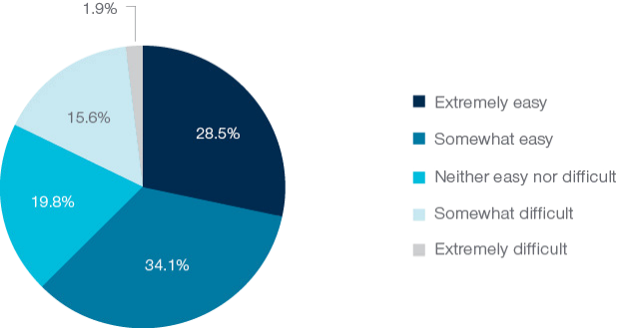

Figure 5: Alumni perception of experience of 'adapting back to life' following award (n=4331)

Interestingly, the survey showed that male alumni were more likely than women to indicate their experience adapting back to life after awards was easy (Figure 6). This finding points to dispararties in reintegration by gender and is an area where further work is needed to better understand the reason for these differences.

Figure 6 is a column graph showing alumni experience of returning home by Gender. 

67% of male respondents reported their experience of returning home to be easy, and 20% of females reported their experience to be difficult.

Figure 6. Alumni experience of returning home by gender (n= 4264)

By region (Figure 7), alumni from Latin America were more likely than others to indicate their experiences of reintegration were difficult, with those from the North Africa and the Middle East region reporting extreme difficulty with reintegration. Given the relatively small presence of the Australia Awards in these regions (especially more recently), this outcome is perhaps to be expected. Conversely, in regions where Australia Awards have a much larger presence, such as Pacific Island Countries and East Asia, alumni rated their reintegration experiences to be relatively easy.

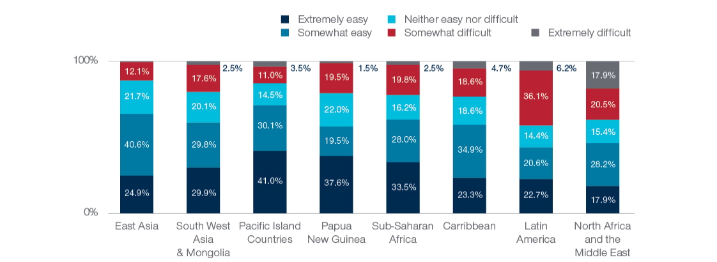

Figure 7. Reintegration experiences of returning alumni by region (n=4282)

## Factors enabling reintegration

Factors enabling reintegration were also explored as part of understanding the experiences of alumni on their return home following their time and award in Australia. Figure 8 shows response to the survey question ‘What factors have enabled you to successfully settle back into life in your home country after your award and time in Australia?’. Alumni selected as many factors as relevant to their situation. Results show that the support from family, community and workplace were deemed the most significant factors by alumni, and that the fact that they were able to use their newly acquired skills to contribute to their community and find work were also important in helping on return. Support from home government, Australia Awards and the Australian Government were also among the eight most important factors mentioned by alumni, as were reintegration programs (which are detailed further in the following section).

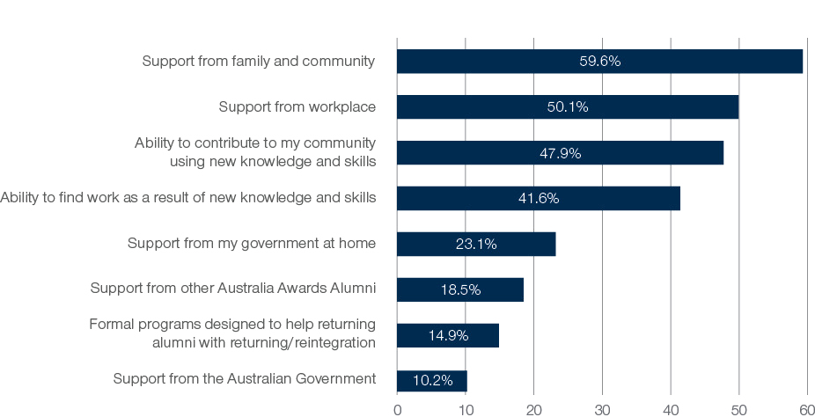

Figure 8. Factors enabling alumni reintegration (n= 5116)

Verbatim responses from alumni further cited personal characteristics, such as self-confidence and character traits, as well as the guarantee of current and future work opportunities and employment as factors that enabled them to settle back into life back home with relative ease.

*Personal mindset and surrounding myself with like-minded people in my local community such as young working professionals who are going through the same seasons in life [made it easier to adapt on return home].* (Alum from Samoa)

*I was still in a permanent role of my workplace during the award. Promoted to a more senior role after completion of the award. Family & friends were always connected before, during and after the award.* (Alum from Vietnam)

## Participation in programs for reintegration

Across the survey participants, more than one quarter (28.4%) of alumni indicated that they had accessed some form of reintegration support on return from their award (Figure 9). Of the alumni who had participated in reintegration support programs, over half (60.1%) reported that accessing support programs was a required component of their award.

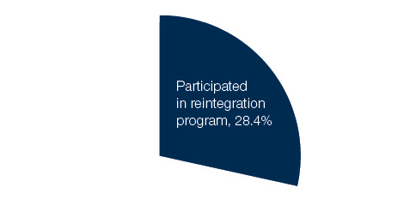

Figure 9: Proportion of all alumni who indicated they participated in a formal program designed to help with return to home country/reintegration (n= 4282)

Regional data (Figure 10) show that alumni from Sub-Saharan Africa reported the highest rates of participation in reintegration support programs (38.1%), followed by slightly less than a third of alumni from the Caribbean, Papua New Guinea, and East Asia regions. Analysis by gender and length of award did not show any demonstrable difference in whether an alumni had participated in a reintegration program.

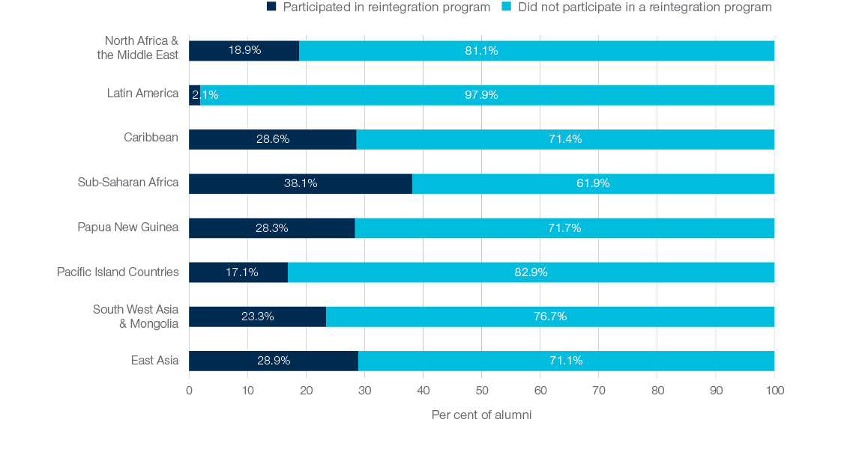

Figure 10: Alumni participation in reintegration support program, by region (n= 4244)

### Types of programs and providers

Alumni were asked about the type, duration, and providers of the reintegration programs they accessed. They reported that the programs supporting reintegration were conducted mostly by the Australia Awards program, Australian High Commissions or Embassies and host institutions (Figure 11), as exemplified in the following quotes:

*Program conducted by AusAID Office in Bhutan to help us get in touch with other alumni, it helped us to learn from other alumni on how they adjusted after they finished their studies in Australia.* (Alum from Bhutan)

*The Australian High Commissioner or a local representative hosted a few sessions with award alumni to share experiences, offer support, and build comradery.* (Alum from Jamaica)

Interestingly, as Figure 11 shows, about one quarter of the programs mentioned by alumni involved their employer – either in collaboration with Australia Awards (10.4%) or on their own (15.9%). Overall, this new data does show a relatively wide spread of different Australia Awards stakeholders that are involved in these kinds of programs.

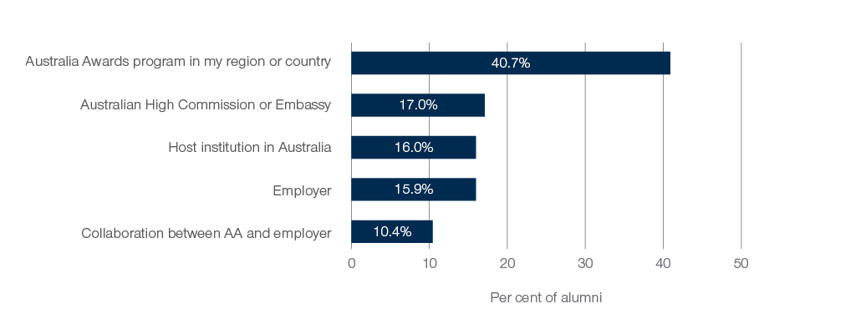

Figure 11: Providers of alumni reintegration workshops – percentage share by provider type (n= 1758)

When asked about what best describes the kind of support program/s that alumni participated in, workshops relating to professional development were the most commonly experienced activity, with about a quarter of alumni mentioning a single workshop (26.7%) and another quarter a series of such workshops (26.6%). As Figure 12 shows, about one in five (21.3%) alumni reintegration programs involved projects undertaken on return home, or a program that spanned both the on- and post-award aspects of the award lifecycle (18.1%). A smaller proportion of programs involved grants (8.8%), specific reintegration seminars (2.3%) or alumni gatherings (1.0%).

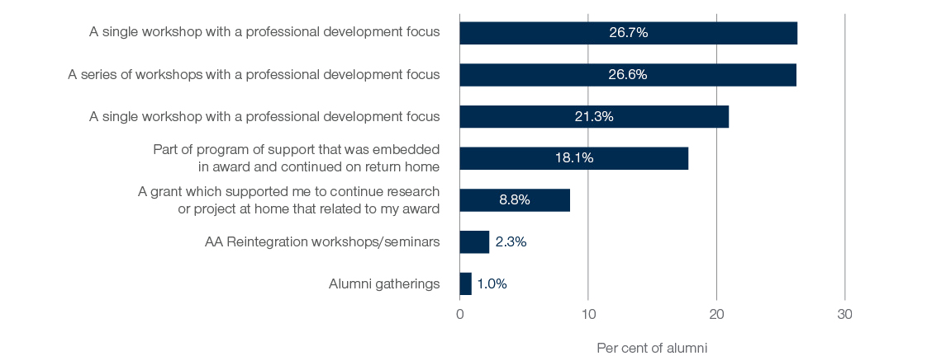

Figure 12: Type of reintegration activities undertaken by alumni - percentage share of all activities (n= 1218)

Descriptions of the types of programs and the providers are offered based on the qualitative responses from alumni below.

Workshops for professional development and support:

*I had the privilege to participate in the Personal Development Workshops run by PNG AAA [Australia Alumni Association]. These included, financial management, project management, trainer of trainers, research proposal writing, only to name a few. Whenever I attend one of these personal development workshops, as well as meeting my fellow alumnae, I am reminded of my responsibility to give back to my community and to contribute to the development of the country as a whole.* (Alum from Papua New Guinea)

*With the support of DFAT and Australia Awards, my organisation was able to host its first colloquium that helped project the knowledge acquired during the award. Thereafter, the Australia Awards Africa Alumni in Nigeria and the Australian Embassy has been supportive of our programs.* (Alum from Nigeria)

A handful of alum further described grants and funding being provided to support their returning home.

*I was awarded one-year project from Small Grant Fund and I participated in different workshops organised for alumni to improve our skills and knowledge on different fields e.g. equality, agriculture, partnership development.* (Alum from Vietnam)

*I received 2 small grant funds from AAV [Australia Awards Vietnam] for research about development in the field of organic agriculture and one grant from ACIAR [Australian Centre for International Agricultural Research] to study food loss in the catfish value chain in the Lower Mekong Region.* (Alum from Vietnam)

More than half of the alumni (58.9%) reported participating in support programs that were less than six months in duration (Figure 13). These were described to be one-off workshops organised by host institutions or Australia Awards, that focused on the potential challenges of resettling back in their home country, such as managing reverse culture shock and employment.

*A one-time support program was organized for all completed award recipients at my university. It was on how to become good cultural detectives, with the objective of reintegrating successfully upon return back home.* (Alum from Ghana)

*It was a workshop by UQ [University of Queensland] on ways to adapt back home. Understanding the reverse culture shock and ways to go about it.* (Alum from Indonesia)

*I engaged with one workshop that organised by AAI [Australia Awards Indonesia] related to personal development and was reintegration focused.* (Alum from Indonesia)

Interestingly, 17 per cent of alumni involved in reintegration activities noted that their program went for more than two years following their return home. Grants, project-based programs and those that included a series of professional development workshops tended to be the types of programs more likely to have lasted for two years of more.

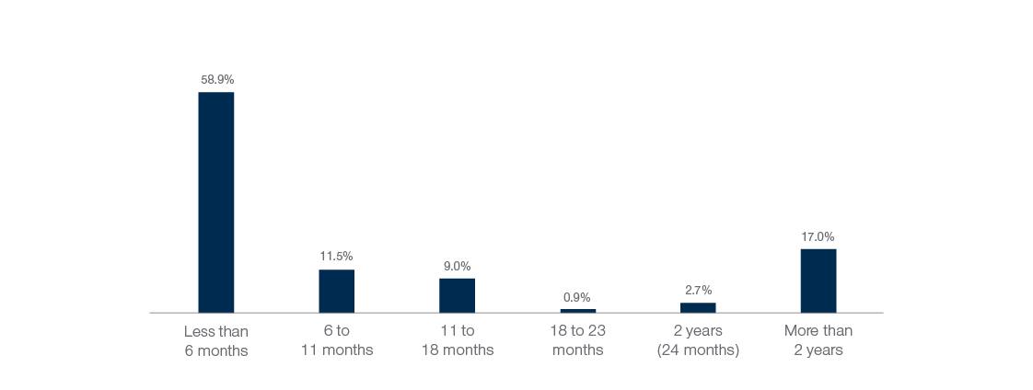

Figure 13. Duration of reintegration support programs - percentage share across all activities (n= 1162)

### Barriers to participation in reintegration programs

Alumni were asked if they faced any barriers to accessing programs to support their return home. Figure 14 shows that the most common barrier to participation was lack of knowledge about these kinds of support programs (36%). Further education, information and reminders about these kinds of opportunities would likely help increase participation among alumni in the future. Exploration into the alumni open-ended comments in the survey corroborated this finding with many alumni describing the lack of information on reintegration programs made available to them. The other key barriers identified were that the relevant programs were not available locally (20%), and that alumni did not have time to participate due to work commitments (17%).

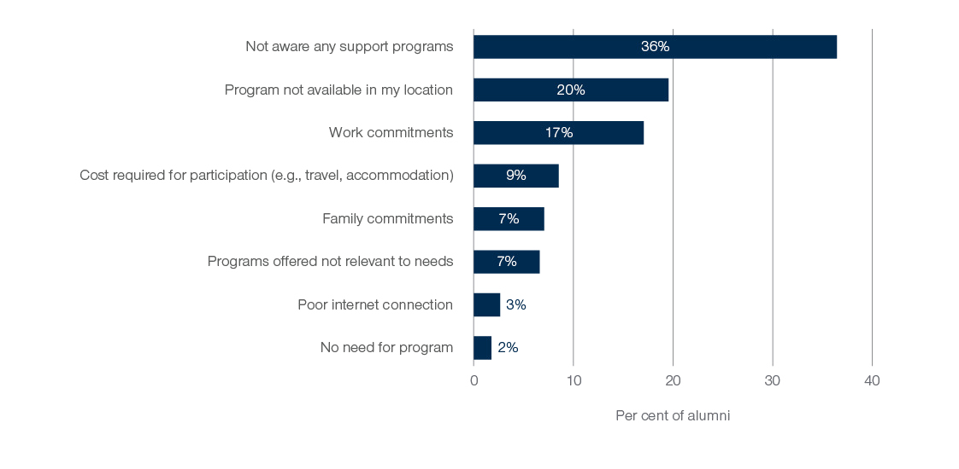

Figure 14. Barriers to participating in reintegration programs – percentage of alumni mentioning selected barriers (n=3064)

### Do these programs help to ease return from award?

Some of the qualitative evidence collected through the survey and highlighted below shows that for many alumni, reintegration programs were helpful in their return to their country following their award.

Alumni noted these support programs provide a medium for them to share their experiences with each other, as well as share employment opportunities and share connections back to their communities:

*The reintegration program informed me well enough to understand the reverse cultural shock that I could expect and prepare myself to smoothly transition into my country's workplace setting. The program also helped to prepare my own plan to integrate, especially from student's lifestyle to the employee's. It also reminded me of the potential contributions I can make with the knowledge and skills I gained from my course.* (Alum from Bhutan)

*[The program was] very useful and it needs to be conducted on regular basis not only to share best practices but also learn about the challenges faced the Alumni of Australia Awards Pakistan. It also refreshes the memories of Australia Awards Pakistan Alumni. It can play a good role in further strengthening the relationship between the two countries.* (Alum from Pakistan)

Opportunities that supported alumni professional learning, particularly in employment were also highly valued:

*The program helped me revise and market my skills through my CV. After this I was able to secure my first consultancy with an international organisation. The program helped me to gain skills – interpersonal communication and teamwork – which I have successfully applied to deliver my consultancy assignments.* (Alum from Cameroon)

However, overall the quantitative data collected through the survey suggests that there were no demonstrable differences in experiences of return from award between those who participated and those who did not participate in a reintegration-type program. Among survey respondents, 60.9 per cent who participated in a reintegration program indicated their return home experience was ‘extremely easy’ or ‘somewhat easy’, while 63.2 per cent or those who were not involved in such a program indicated their reintegration was easy. This overall finding was similar for alumni in each region, but there was some difference notable in terms of the length of time the reintegration program ran.

As shown in Figure 15, alumni in reintegration programs that ran for at least 6 months were more likely to indicate an easy return home than those who participated in a program that lasted less than 6 months. The longer term program alumni had a marginally higher rate of ‘easy’ reintegration than those who did not participate in any program, although this difference is not statistically significant.

In general, this data does not strongly suggest that reintegration programs are central to the successful return home of alumni following their study in Australia. However, the data also don’t suggest these programs are not useful. Suggestions pointing to ways in which such programs could be improved or designed for greater impact are explored in the section which follows.

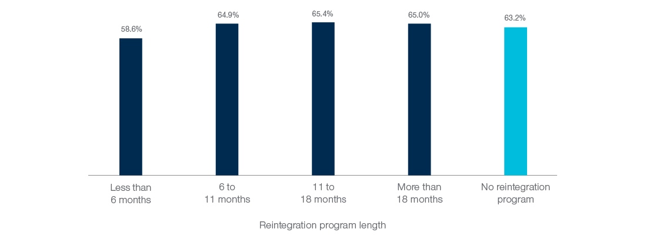

Figure 15. Per cent of alumni who found their return home experience 'easy', by participation and length of reintegration program (n (reintegration participation) =1218; n (non-participation in reintegration) = 3064)

## Suggestions for future support programs

The survey collected a large amount of qualitative data from alumni (more than 2000 responses) providing suggestions for future reintegration support programs to better help returning alumni settle upon their return from award. This information was coded and examined, with an overview of these ideas provided below. Suggestions largely focused on providing alumni with support from the local or regional alumni associations, including organised opportunities for support to be provided through alumni gatherings, workshops, and networking events in regions.

*The alumni network and support could be better. It is difficult to create network when we don't see each other or have any networking activity.* (Alum from Nepal)

*I think there is already a national Australian-Filipino Alumni Association here, but it would be good to have a regional alumni association, to maintain connection and to be able to consult them on how to make the students relevant to the community using their field of study.* (Alum from Philippines)

Outreach programs by embassies and/or host institutions were also suggested to be valuable in terms furthering professional learning and development, and maintaining connections with other alumni, and Australia.

*Australian Embassy should support alumni to have more chances to attend workshops, and international conferences to improve ability in working in Vietnam context.* (Alum from Vietnam)

*Regular support, monitoring and evaluation on how we are putting into use the knowledge and skills we gained from the scholarship…I needed help for the continuity of my skills but it seemed help was far away. No support system is reachable and available.* (Alum from Philippines)

Targeted support to help alumni find employment was another key area suggested for reintegration programs to work towards. Suggestions to Australia Awards programs include the development and training of soft skills, job search and application, particularly for alumni without guaranteed employment on their return.

*Introducing labour market opportunities, building capacity in development of CV and application for job, building capacity in teamwork, skills in interview for new jobs, etc.* (Alum from Vietnam)

Related to the absence of guaranteed employment post-award, alumni have also suggested the introduction of a reintegration package for returning scholars to support them financially as they get back on their feet.

*Students returning from studies usually struggle with new job placement and reintegration into the workplace. In most cases, previous jobs held before studies are not readily available and will take time before returnees are integrated into the workplace and mostly at lesser jobs. This waiting period usually poses financial strain on returning students. A reintegration package is necessary to fill in the gap during these circumstances. Additionally, alumni associations need to be strengthened in order to provide support to returning students in the area of counselling, experience sharing, etc.* (Alum from Liberia)

Programs targeted at supporting the employers of returning alumni were also suggested by some alumni.

*I think programs should look at supporting employers rather than alumni. Because most of the resistance or inability to enhance impact is minimised by their lack or limited engagement and participation.* (Alum from Mozambique)

# Alumni Contributing to Development

A key outcome desired by the Australia Awards is that alumni contribute to sustainable development following their award. As specified by the Australia Awards Monitoring and Evaluation Framework, Outcome 1 envisages alumni using their skills, knowledge, and networks they gained while on award to contribute to sustainable development.

This chapter explores the responses of alumni to questions in the Global Tracer Survey that focussed on understanding the extent to which alumni are sharing their new skills with others, the types of contributions they make, and the impact of these contributions.

## Sharing new skills and knowledge

Transfer of knowledge is a critical aspect for development contribution and capacity building within the countries the Australia Awards has supported. The Global Tracer Survey 2022 asked alumni about whom they have shared their new skills and knowledge with since returning from award. A range of potential groups that could benefit from such knowledge transfer were listed in the survey and shown below.

As shown in Figure 16, almost every alum involved in the survey indicated that they have shared new skills and knowledge with their colleagues, their community, their families, and friends, and with people involved in projects and programs they work on. For alumni who are teaching professionals (13 per cent of all respondents work in either schools, vocational providers, or universities), almost all (99.1%) noted that they have transferred their new knowledge to their students, highlighting the power that these particular alumni have in helping to transfer this knowledge to the next generation in their country. Across all groups of alumni, these very strong positive findings were consistent regardless of gender or region. This provides strong evidence of the contribution alumni are making in transferring knowledge within their country after returning from their award.

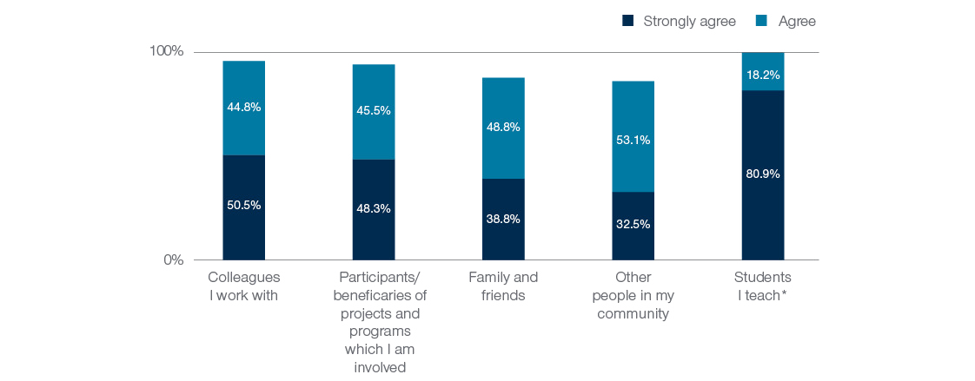

Figure 16. Alumni passing on knowledge and skills from award, by recipient groups (n= 4717; and *n=639 for teaching item)

## Impact and reach of alumni contributions

Large-scale surveys like the Global Tracer Survey are useful for understanding the broader picture of alumni contributions and building evidence about the extent to which strategic outcomes are being achieved. However, it is often difficult to objectively assess the overall impact of the contributions made by alumni by collecting information from a large population with a vast range of backgrounds.

To develop greater insight into the relative impact of alumni contributions, the GTF has been using a ‘magnitude of impact’ approach to data collection, analysis and reporting. As detailed in previous work of the GTF (see Edwards et al., 2020) and elsewhere (Mawer, 2018), this approach has been used effectively to explore the outcomes of development scholarships. As with the Global Tracer Survey 2020 instrument, the three levels of impact used for analysis in this report are Micro, Meso and Macro.

Questions were developed for the survey to gain an understanding of the extent to which the alum is benefiting personally (micro impact), whether they are helping to improve the organisations and communities they work and live in, (meso impact), and whether they are contributing to development at a national, regional, or global level (macro impact) – see Figure 17. Each of these levels of impact are important – there is not a linear, values-based assumption that macro is ‘better’ than micro impact. In fact, the three levels are interdependent; an individual who has personally benefited from a scholarship can then be in a position to share, contribute and broaden their impact in their work or beyond, depending on the context and enabling environment in which they live (Boeren, 2018).

Figure 17 shows the the three levels of impact used for analysis in this report. These are Micro, Meso and Macro, where Micro refers to the impact scholarship/fellowship on an individual alumni and their family, Meso refers to the impact of the scholarship(s)/fellowship(s) on an organisation, institution or group of people, and Macro refers to the impact of scholarship(s)/fellowship(s) on a society, country, region or internationally.

Figure 17. Levels of impact used in Global Tracer Facility analyses

Alumni who participated in the survey were asked to respond to a set of statements exploring the impact and contributions they have had since returning from award. The proportion of alumni who responded as strongly agreeing, or agreeing with each of these statements is shown in Figure 17.

Almost all alumni (96.5%) either strongly agreed (69.6%) or agreed (26.9%) that they have benefited from their award personally, through improved work and career opportunities. This highlights the micro-level impact of the Australian development scholarships. Meso-level impacts were explored in relation to improving the organisations in which alumni work in, where 96.8% of alumni indicated they have contributed, and within local communities, where 88.6% of alumni felt they had contributed to improvements. At the macro level, alumni were asked about whether they have been able to contribute at a national level and at a global or regional level. A large majority, (87.6%) identify having contributed to national development, and more than three quarters 75.9% indicate they have been able to contribute internationally.

Further data detailing micro to macro levels of impact of the Australia Awards are presented in the following sections (4.3 and 4.4).

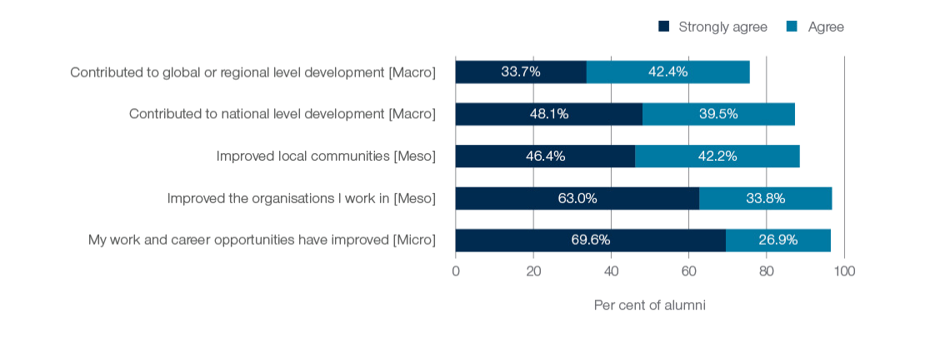

Figure 18. Alumni outcomes and contributions, by perceived level of impact as a result of their award (n=4708)

## Contributions through paid work

### Overview

The contributions that alumni were able to make through their paid work were collected in the survey as a means of examining Program Outcome 1 of the Australia Awards. Alumni were asked to describe the kinds of contributions they made through their paid work using open ended text in the survey form and 3774 alumni provided such examples. These responses were coded in a number of ways to elicit insight into the range of ways in which alumni are making a difference in their work. Figure 18 provides an overview of the areas of contribution alumni mentioned through the examples they shared. Overall, the most commonly mentioned contributions were activities related to sharing knowledge or content expertise that had been gained on award (28.2% of examples were related to this). Other areas with a large number of examples included research and innovation (13.6%), involvement in development projects (12.4%) and organisational improvement or reform (12%). These data further reinforce the well-established links between the skills and knowledge from a scholarship to the ongoing contributions alumni make through their paid work.

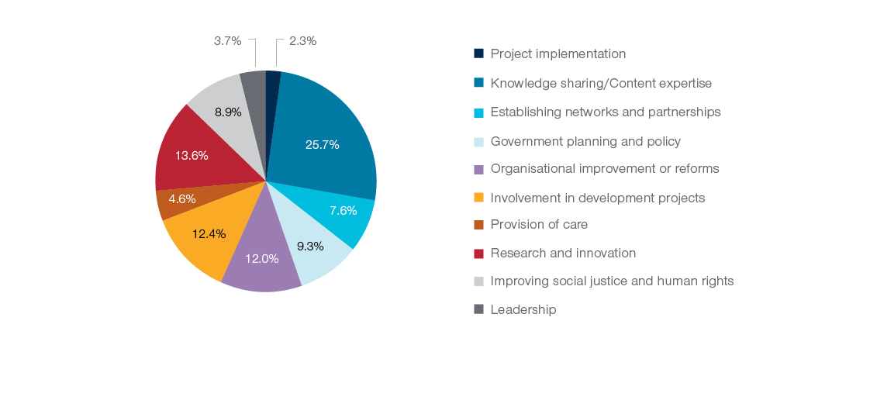

Figure 19. Alumni contributions through paid work by types of contributions mentioned by alumni (n=3774)

### Examples of alumni contributions through work

**Macro, Meso and Micro examples**

To further illustrate the types of contributions alumni have highlighted in their work, a series of quotes from the survey are provided below. The first set of these examples are organised to show the breadth of contributions across the micro, meso and macro impact measures. The second set of examples focus more specifically on particular areas of work and types of skills.

Contributions that demonstrate alumni using and sharing their knowledge, skills or content expertise to colleagues at a micro level include:

*I used my knowledge and skill on project management and business process reengineering for my performance audit work which has significantly improved the efficiency of the team and quality of the work.* (Alum from Bhutan)

*I use my knowledge and life experience when I studied there especially during my work after graduation. During my job after MBA, I felt more confident during discussion with my colleagues around the world as I work in multinational company. Also, I was able to implement better decision making/analytical skills as I practiced a lot during my MBA.* (Alum from Indonesia)

*I have been a consultant for the past few years and focus on the Investment promotion and facilitation; I am very proud that I am able work in this field with my knowledge I got from my course such as International Business, Marketing and management.* (Alum from Timor-Leste)

At the meso level of impact, examples that alumni provided show that they have been able to contribute to organisational improvements in their workplaces as a result of their award. Similar to earlier GTF surveys, the ability of alumni to contribute to organisational improvements also corresponded with improved work and career opportunities related to their studies on award. Alumni were also able to contribute to their communities through sharing of knowledge and skills as detailed in the following quotes:

*I have made contribution when I was appointed as a Vice Director of Academic Affairs, Head of Postgraduate Program and Head of Senate in our State Polytechnic. I also made contributions in several projects at the Ministry of Education and Culture as Expert team and Team leader.* (Alum from Indonesia)

*I have been providing community development training to empower the village people; mentoring university students on field placement; providing Pre-service Orientation Training for volunteers for placement in the communities; providing financial literacy training for the village mothers; and providing adult literacy training.* (Alum from Fiji)

*I used the knowledge from my scholarship course specifically on positive education and how to engage my campus and my community and the community I work with.* (Alum from Indonesia)

For contributions through work at the macro level, alumni responded that they have contributed to initiatives focused on the improvements of national policy and influenced change in their home country, as well as at a regional or global level. For example:

*I have formulated various policies and plans that helped to integrate environmental issues in the industrial development of the country.* (Alum from Nepal)

*As I have been working for Education Desk of Bangladesh National Commission for UNESCO under Ministry of Education (MoE), I got the opportunity to contribute in bridging the relationship between UNESCO education sector and MoE in terms of policy advocacy, consultation, reporting in general. In particular, I contributed in framing the SDG4 Strategic Framework for Bangladesh, National Curriculum Framework, conducting workshop, seminar & consultation on Global Citizenship Education, Education for Sustainable Development, Higher Education, Early childhood & care Education, TVET & ICT in Education. My knowledge and skills were applied in preparing the country position and reporting on UNESCO education related conventions.* (Alum from Bangladesh)

*My knowledge and skills learned from my studies had equipped me in initiation, organization and development of Agri Tourism enterprises in my province of work. This organization is working and helping the province in achieving its vision to be the Agri Tourism capital of the region.* (Alum from Philippines)

**Specific skills and capabilities**

Supplementing the micro to macro examples provided above, the survey data also allows for illustrative examples of key areas and skills that alumni are contributing to. This selection of quotes from alumni highlight three of the more noteworthy themes that were identified within the examples provided by alumni: *education systems*, *technical skills*, and *leadership*.

Alumni are working at all levels of the **education systems** in their countries, from early childhood settings through to higher and vocational education. We know that other alumni are also contributing to education even if teaching is not their core job. More than one third of respondents provided an example of a contribution that included some form of educating others. The example below shows the way in which an alum is contributing to higher education:

*As I am working in the higher education sector I am able to apply the knowledge I have gained during my degree in my teaching and management aspects I undertake with regards to higher education. I am involved in overseeing governance aspects of the HE Institution I am currently working and the data management and record management aspects I learnt during my programme is immensely beneficial and have used to improve the processes, which ultimately improve the services we give to our students.* (Alum from Maldives)

The data presented in Figure 3 earlier showed that the alumni responding to the survey had studied in a broad range of fields. Alumni use of skills and knowledge gained in Australia is evidenced by the types of contributions and skills described in the survey. These **technical skills** included many areas of research and innovation, including areas of science and technology, medicine and farming and agriculture. An example of how technical skills and knowledge are used is illustrated below:

*In my role as Country Coordination Officer in the UN System, I planned and developed strong and effective partnerships and networks with key Government and Development Partners by utilising knowledge and skills such as organisational management, planning, leadership, critical thinking, stakeholder mapping and analysis, research and analysis of issues etc. which I had developed during my award. The key concepts of sustainability, social impact and seeking to make a difference and positive change in people's lives also provided a solid foundation and overall guide in my decision making, planning and engagement with my colleagues and key stakeholders - which include Government, UN Agencies, Civil Society, Private Sector, and Development Partners.* (Alum from Vanuatu)

As shown earlier (Figure 4) almost three quarters (71%) of alumni surveyed hold a formal **leadership** position within their work, and a further one in five (18%) alumni hold an informal leadership role at work. In addition, approximately a third of alumni who responded to this survey reported as having leadership roles within their community. The example below highlights the developmental way in which the Australia Awards has built leadership among scholars that is then used through work contributing to development:

*Through my employment and my current position as the Director of the National HIV/AIDS, Dermatology and STD (NCHADS) of the Ministry of Health, I have the opportunities to apply my knowledge, leadership and management skills, public health, health systems, community engagements and participants in responding to HIV/AIDS epidemic in the country, through chairing the different technical working groups, trainings, workshops and conferences.* (Alum form Cambodia)

## Contributions outside of work

Alumni were asked to describe their contributions outside of their paid work. This is a new area in which the GTF is collecting global data. A total of 3,012 alumni provided examples of contributions made outside of their paid work. The evidence presented in this section suggests that the Australia Awards Program Outcomes are not only being achieved through the paid work contributions of alumni but are also being achieved through alumni volunteer contributions, often at the grassroots, community level. This corroborates findings from the Australia Awards case study on alumni volunteerism ([Doyle & Edwards, 2022](https://www.dfat.gov.au/people-people/australia-awards-alumni-contributing-civil-society-supporting-development-through-volunteerism)), which showed in detail how alumni are helping to build capacity, transform societal attitudes and behaviours within their communities through sharing of technical expertise to improve practices and train others.

Figure 20 shows the broad areas alumni have been contributing, showing a different variety of contributions to those identified through paid work contributions. The most common type of contribution in this regard was to do with providing education and teaching (28% of all examples cited this), followed by participating in community development projects (20.9%). Alumni were also involved in a voluntary capacity through work with Non-Government Organisations (NGOs), in other community service activities and in faith-related roles.

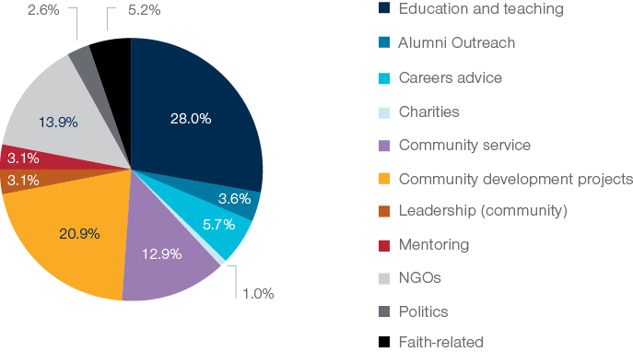

Figure 20. Alumni contributions through unpaid/voluntary work by types of contributions mentioned by alumni (n=3774)

The analysis of examples provided by alumni for unpaid work showed a range of contributions at the meso and macro impact levels. At the meso level, the following quotes illustrate some of the ways alumni indicated they were improving communities through aspects of community service:

*I have been working as a volunteer researcher for the Center for Knowledge Cocreation in Central Vietnam to carry out social planning and sustainable development projects which empower the disadvantaged communities. Projects that CKC focuses on include impact assessments (social, gender and human rights), community development, gender equality, social planning and surveys, corporate social responsibility (CSR), project management, and sustainable development research.* (Alum from Vietnam)

*I provide various training to high-school and university students including: leadership and management, research skills, report writing, essay writing, how to write job applications, how to prepare for job interviews. I also help NGOs with how to undertake budget analysis, strategy for policy advocacy.* (Alum from Timor-Leste)

*I actively get involved in community development programmes, especially the ones associated with enhancing local communities' financial literacy and financial wellbeing.* (Alum from Indonesia)

**Making a difference to the SDGs**

The survey asked alumni to indicate whether the example of their contribution following award was influencing one or more of the UN Sustainable Development Goals.[4] This data provides insight into the way in which alumni of Australian development scholarships are contributing to development. As the diagram below shows, alumni are making contributions in all 17 of the SDGs.

In particular, more than half of all alumni indicated they had made a difference in SDG 4 – Quality Education, and approximately half of alumni had contributed to Gender Equality (Goal 5) and to Good Health and Well-being (Goal 3). More than a third indicated they had made an impact in Goal 17 relating to partnerships, and more than one quarter in Decent Work and Economic Growth (Goal 8), Reduced Inequality (Goal 10), No Poverty (Goal 1) and Industry, Innovation and Infrastructure (Goal 9).

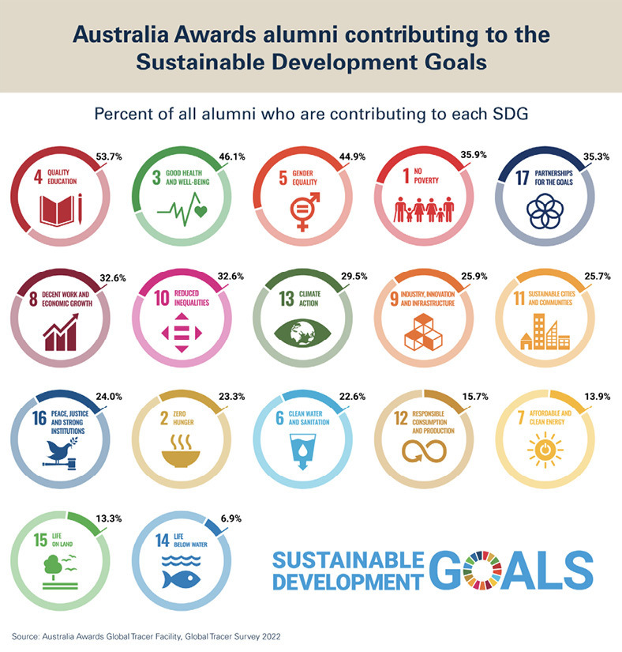

Figure 21: Alumni contributing to the UN Sustainable Development Goals, percent of alumni indicating contributions, but SDG (n=5116)

# Connections, Networks, and Relationships from Award

The second Program Outcome of the Australia Awards is that the experience helps facilitate ongoing relationships between individuals in Australia and other countries. The focus of this outcome is on the individual as well as professional connections that are made while on award and continued after returning from award. This chapter explores the findings from the questions in the Global Tracer Survey that explored the networks, relationships and connections alumni developed while on award and the extent to which these continued post award.

## Connections and contacts *while on award*

Alumni were asked to reflect on how frequently they had interacted with different individuals while on award in Australia. As shown in Figure 22, the groups with which alumni were most likely to report frequently interacting with while on award included other Australia Awards students and other international students. Alumni were least likely to report frequently interacting with individuals in Australian businesses, organisations, or professional associations in their field while in Australia on award. Around a third of alumni reported never interacting with businesses or professional associations while on award.

Included in the analyses here is a small cohort of alumni who undertook the Women’s Leadership Initiative (WLI) as an enhancement activity in parallel with their Australia Awards scholarship. Interestingly for this small cohort, the likelihood of being active with connections (for example businesses, mentors, and others in the WLI program) while on award was relatively high in comparison to the overall average for connections with businesses, professional associations etc among the broader group involved in the survey.

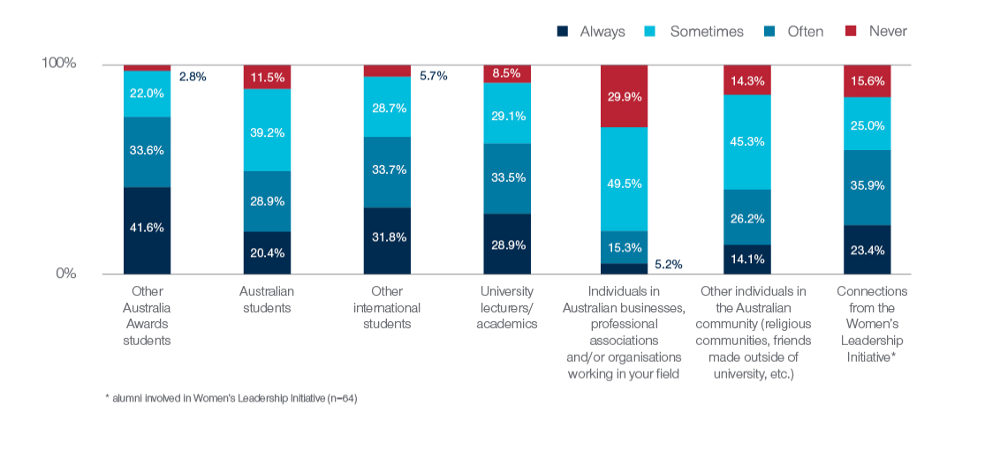

* alumni involved in Women's Leadership Initiative (n=64)

Figure 22. Frequency of contact with selected individuals and groups while on award in Australia (n=4091)

## Connections and contacts *post award*

The extent to which the interactions established on award are continued when alumni return home is important to know in relation to achieving the aims of the Australia Awards. As shown in Figure 23, alumni are staying in touch with many of the personal connections they made while on award. The majority of alumni indicated that they are at least ‘sometimes’ in contact with other Australia Awards alumni, other international students, Australian students, university academics and other people from Australia they met on award. The strongest relationships (that is, those where alumni are ‘always’ or ‘often’ in contact) were with fellow Australia Awards alumni. More than half alumni indicated they have no ongoing contact with individuals in businesses or professions related to their field. Although as shown below, this outcome differs among alumni depending on whether they made such connections while on award.

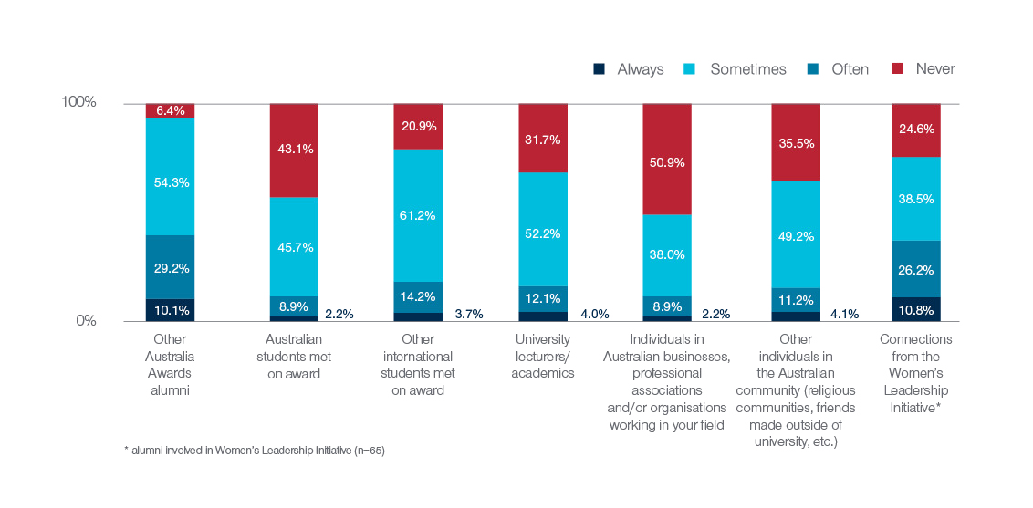

* alumni involved in Women's Leadership Initiative (n=65)

Figure 23: Frequency of contact with selected individuals and groups since returning from award (n=4034)

The importance of connections made on award for maintaining ongoing connections post-award has been shown in GTF research in the past (for example, [Edwards & Radloff, 2021](https://www.dfat.gov.au/people-to-people/australia-awards/australia-awards-global-tracer-facility-year-5-results/australia-awards-alumni-global-tracer-survey-2020)). This current survey again confirms these previous findings, emphasised below by exploring the extent of contact with Australian businesses, professional associations and Australian organisations in similar fields to alumni. Figure 24 shows that for those who ‘never’ or only ‘sometimes’ had interaction with Australian businesses on award, the likelihood of having frequent connections on return home are very small, but those who ‘often’ or ‘sometimes’ interacted with Australian businesses or professionals in their field while on award, have far more success in maintaining connections.

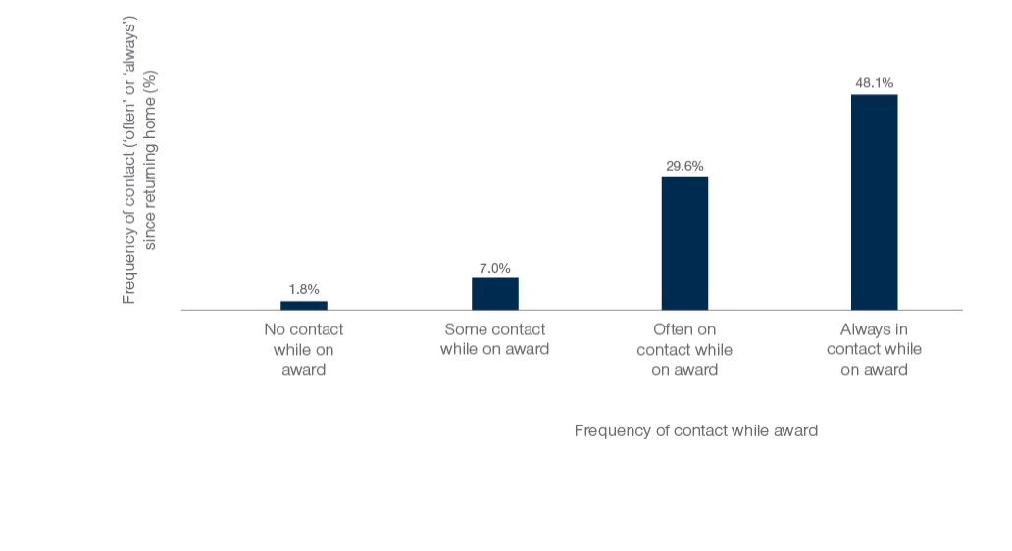

Figure 24: Alumni maintaining contact with Australian businesses or professionals in their field since returning home from award, by frequency of contact with these groups while on award (n=3904)

The survey also shows that the majority of alumni continue to have some contact with the Australia Awards program in their country (more than one quarter are ‘often’ or ‘always’ in contact) and most alumni remain in contact with the Australian Embassy or High Commission in their country or region. Alumni are also working alongside Australians as part of their work – more than one in five (20.1%) indicate that working with Australians was something happening ‘often’ or ‘always’, and a further 40 per cent do have some contact with Australians professionally.

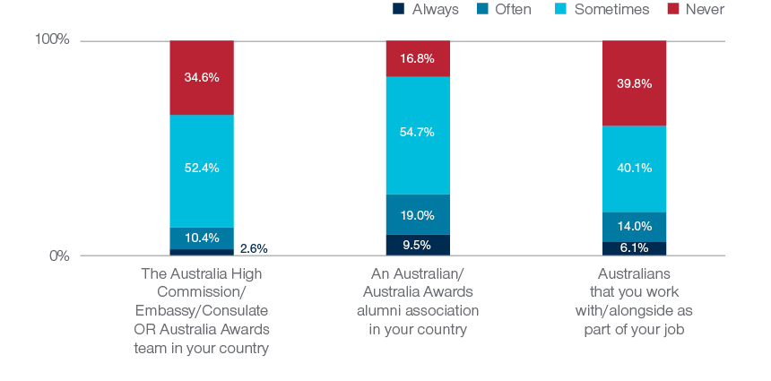

Figure 25: Frequency of contact with Australians in home country since returning from award (n=3916)

# Helping Alumni Make an Impact

## What helps alumni succeed?

The survey explored the issues and factors that alumni identified as helping them make the contributions described in the previous chapters. The survey measured both factors that were related to the elements gained by the individual themselves, as well as external factors helped in the time since they have returned from award.

### ‘Personal’ factors

Alumni were asked to identify the four most important *personal factors* that have influenced their ability to contribute since returning from their award – that is factors that have equipped them personally to contribute when they returned home. The proportion of alumni to include specific factors in their ‘top two’ responses to this question are detailed in Figure 26. The responses show that the most critically important elements identified by alumni were to do with their own development while on award. New skills developed on award were identified by almost half (47.4%) of alumni as one of the most important factors helping them to make contributions on return to their home country. Increased confidence from time on award (36.6%) and broadened mindset developed as a result of award (34.4%) were the next two most commonly noted ‘personal enabling factors’ for alumni.

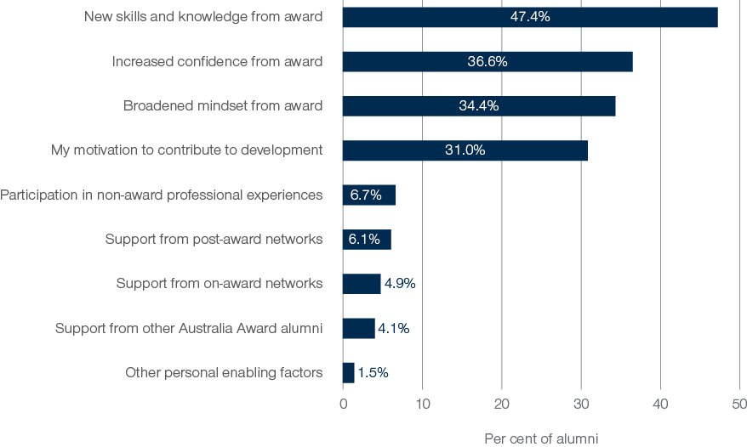

Figure 26. Personal factors enabling alumni contributions, per cent of alumni identifying listed factor in ‘top two’ personal enabling factors (n=5116)

Alumni tended to attribute increases in their levels of confidence to implement change as a result of new knowledge and skills acquired, as illustrated in the following quote:

*I gained confidence after I completed my study in Australia. Moreover, I became more driven to prove that I am capable of doing more with all the knowledge, skills and network that I achieved during my time in Australia.* (Alum from Indonesia)

Several alumni described personal motivations as impetus for contributions to their workplaces and their local communities.

*Seeing a gap in income between the poor and the rich as well as social injustice for the poor motivated me to contribute to improve these.* (Alum from Cambodia)

The networks alumni have built with fellow alumni and other students and staff during their time and award in Australia have also been influential factors in assisting on return to their home country.

*Have been connected with the network of Australia Award Alumni and getting updates from the network group mail and Facebook page as well.* (Alum from Bangladesh)

### ‘External’ factors

The second type of ‘enabling factors’ measured in the survey relates to *external factors* – or elements that are less personal or attributable to individual alum, but nonetheless important to facilitating success of alumni on return home. As with the question analyses above, alumni were asked toidentify the four most important external factors in the survey.

The outcomes in Figure 27 show the percentage of all alumni who listed each factor in the ‘top 2’ most important to their situation. The data from these alumni show that having support in the workplace on return from award is central to their success, with more than half of all survey participants indicating this particular element was critical. Another factor, and one that is likely beyond the control of individual alumni, is the presence of a strong and relevant job market for alumni to use their skills in on return. The fact that more than one third of alumni mentioned the need for their skills in the local market facilitating their contributions suggests there is some success in selection and alignment of the Australia Awards with the overall needs of the countries they are designed to support. Of particular interest here to Australia Awards is that the third most commonly cited enabler in this group was the presence of a reintegration plan. Also of relevance to country programs and DFAT Posts is the proportion of alumni that noted the support received from the Australia Awards in country (13.2%) and local alumni associations (11.6%) as being important in enabling their post-award contributions.

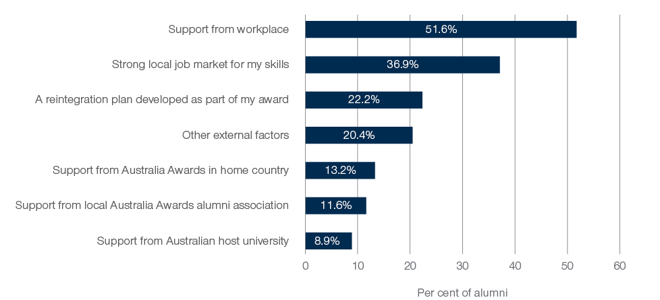

Figure 27: External factors enabling alumni contributions, per cent of alumni identifying listed factor in ‘top two’ external enabling factors (n=5116)

Further thematic analysis of open-ended survey responses addressing enabling factors found that factors such as community awareness and support for change, opportunities for knowledge sharing, other awards and future study, other’s perception of Australia Awards and support from supervisors tended to influence the extent of contributions alumni can make.

## What prevents alumni success?

The survey also canvassed alumni perception of issues that have prevented or challenged their ability to make contributions since returning from award. Just over half of alumni (52.4%) indicated that they have faced challenges in being able to contribute since returning home. There was no difference in the pattern of this response by gender, although some differences were apparent by region, with alumni from North Africa and the Middle East, Caribbean and PNG more likely to have indicated they have faced challenges.

Alumni who had experienced challenges were asked to identify and rank up to four significant factors that have impacted negatively on their ability to contribute. A range of factors, and the proportion of alumni who indicated these factors in their ‘top 2’ as having inhibited their contributions are shown in Figure 28. The most significant barriers encountered by alumni were the lack of resources or funding, where about half (51.3%) of those who had experienced challenges listed this factor, resistance to change in the workplace (44.6%) and corruption or nepotism (24.2%).

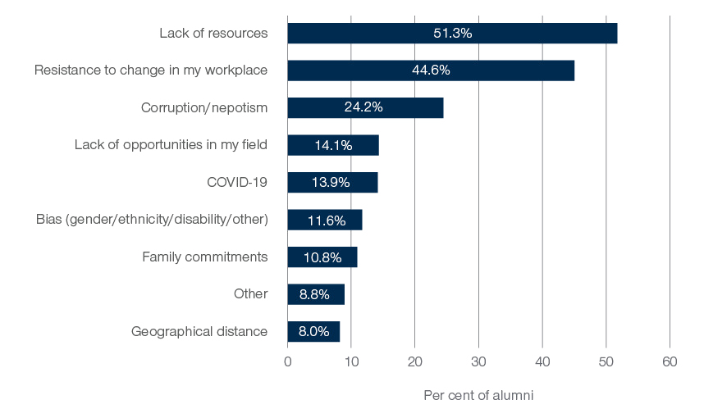

Figure 28. Barriers to alumni contributions, per cent of alumni identifying listed factor in ‘top two’ external enabling factors (n=2355)

Other challenges alumni highlighted include bureaucracy, societal challenges, lack of workplace support or openness to change as key reasons, as well as from commitments to full-time work and family, as expressed in the quotes below:

*Patriarchal society has its challenges, one has to be able to read the room to be able to better engage and contribute.* (Alum from Fiji)

*Bureaucracy is still promoted in government institutions I have for years worked in. This retards one's innovation and ability to contribute effectively to the achievement of the Ministry’s set goals and objectives.* (Alum from Malawi)

*Culture in the workplace and lack of opportunity given to me to share my knowledge gained from my AAS experience [has been a barrier].* (Alum from Philippines)

# Conclusion

This report details the findings of the Global Tracer Survey 2022 of alumni from the Australia Awards and predecessor development scholarships. This online survey was administered between November 2022 and January 2023 to alumni who had studied in Australia as part of a scholarship or fellowship. Data from these alumni responses provided insights into the core outcomes of the Australia Awards; *contributions* alumni have made using the knowledge and skills gained while on award in Australia, and the *connections and partnerships* developed as a result of their award.

The findings of this large, global study consolidate previous work of the GTF, and offer comparable and consistent evidence relating to the long-term outcomes of alumni from Australian development scholarships. In examining survey responses relating to the two long-term outcomes of the Australia Awards, the findings show very strong and positive achievement in Outcome 1: Alumni are using their skills, knowledge, and networks to contribute to sustainable development. Evidence presented show that Outcome 1 is being achieved through alumni contributions to their workplace, country and region through both paid work and volunteering at various levels of civil society. The data collected by the GTF helps to show that the contributions of alumni are being made with the new skills and knowledge they gained as part of their scholarships or fellowships to study in Australia.

Similar to the Global Tracer Survey in 2020, evidence from this survey show that alumni are maintaining the connections and partnerships developed while on award, and contributing to cooperation between Australia and partner countries; therefore helping to achieve Outcome 2 of the Australia Awards. The survey helps to show that increased engagement of alumni with Australians and Australian organisations while on award is important in enabling ongoing partnerships and networks. However, the ongoing strength of these relationships often relied on the efforts of individual alumni to maintain connections in the years following completion of the award. Given the challenges that some alumni face on their return home, it is perhaps useful to consider putting further support in place to ensure that alumni have opportunities to connect or reconnect with persons or businesses in Australia to be able increase the extent to which this outcome is achieved.

A new aspect of the survey in 2022 was the detailed exploration of alumni experiences of returning to their home country after award. A new section of the survey was developed to explore a global perspective on the different pathways and programs alumni have used in the years following their study in Australia. While the data show little overall difference between alumni participating in a formal reintegration program and those who did not when it came to ‘settling in’ on return home after award, many participants highlighted benefits of such programs to alumni. Overall, the data collected here indicates that well-developed and targeted programs to facilitate the return home experience is beneficial and particularly that opportunities to interact and network with fellow alumni is something alumni are looking for. Based on these findings, the GFT suggests the following ideas are pursued in coming years in relation to reintegration.

## Facilitating strong reintegration programs

### Issues for Australia Awards Programs and Posts to consider:

* Clear promotion and communication about reintegration support programs available to scholars while on award, and in the year following award.
* Organised opportunities for support provided specifically through alumni gatherings, workshops, and networking events in regions for the purpose of building links among alumni and facilitating ways to connect with Australian organisations. [alumni want access to each other]
* Provision of outreach programs by Posts, Australia Awards country programs and/or host institutions to facilitate professional learning and development, including training of soft skills.
* Targeted development opportunities relating to job search and career skills, tailored for alumni without guaranteed employment on their return.

### Further insight into reintegration programs for GTF to consider:

* Supplement this initial insight into participation in reintegration with further nuance to better identify the elements of reintegration programs that improve the ease of returning home. This might be type of program, delivery mode, length of program, delivery partner etc.
* Further explore the relationship between the types of enrichment programs alumni participated in and:
  + their ability to lead or contribute to their community in the years following their award.
  + their ongoing networks among other alumni and with Australia.

# References

Boeren, A. (2018). Relationships Between Scholarship Program and Institutional Capacity Development. In J. R. Dassin, R. R. Marsh, & M. Mawer (Eds.), International Scholarships in Higher Education: Pathways to Social Change (pp. 23–42). Palgrave MacMillan.

DFAT. (2019). The Australia Awards Linkages Good Practice Guide: Enrichment support for delivery partners and scholars. Department of Foreign Affairs and Trade. https://www.dfat.gov.au/sites/default/files/australia-awards-linkages-good-practice-guide.pdf

Doyle, J. & Edwards, D. (2022). Australia Awards Alumni Contributing to Civil Society: Supporting development through volunteerism, Australia Awards Global Tracer Facility, Australian Department of Foreign Affairs and Trade, Canberra. Retrieved from: https://www.dfat.gov.au/people-people/australia-awards-alumni-contributing-civil-society-supporting-development-through-volunteerism.

Doyle, J., & Clarke, L. (2021). Australia Awards Global Tracer Facility: Alumni Case Study – alumni contributions to the COVID-19 pandemic response. Australia Awards Global Tracer Facility, DFAT. https://www.dfat.gov.au/people-to-people/australia-awards/australia-awards-global-tracer-facility-year-5-results

Edwards, D., Doyle, J., Haddow, A., & Radloff, A. (2020). Global Impact of Australian Aid Scholarships: Long-term outcomes of alumni. Australia Awards Global Tracer Facility, DFAT. <https://www.dfat.gov.au/sites/default/files/global-impact-australian-aid-scholarships-long-term-outcomes-alumni.pdf>

Edwards, D. & Radloff, A. (2021). Australia Awards Alumni Global Tracer Survey, 2020, Australian Department of Foreign Affairs and Trade, Canberra. Retrieved from: https://www.dfat.gov.au/people-to-people/australia-awards/australia-awards-global-tracer-facility-year-5-results/australia-awards-alumni-global-tracer-survey-2020

Edwards, D., & Taylor, A. (2019). Global Tracer Survey Report Year 3, Alumni of 2011 to 2016. Australia Awards Global Tracer Facility, DFAT. https://www.dfat.gov.au/sites/default/files/australia-awards-global-tracer-facility-survery-alumni.pdf

Mawer, M. (2018). Magnitudes of Impact: A Three-Level Review of Evidence from Scholarship Evaluation. In J. R. Dassin, R. R. Marsh, & M. Mawer (Eds.), International Scholarships in Higher Education: Pathways to Social Change. Palgrave MacMillan. DOI 10.1007/978-3-319-62734-2_13

# Acronyms and Abbreviations

|  |  |
| --- | --- |
| ACER | Australian Council for Education Research |
| DFAT | Australian Department of Foreign Affairs and Trade |
| GTF | Australia Awards Global Tracer Facility |
| SDG | Sustainable Development Goals |
| UN | United Nations |

Appendix A: Awards included in the GTF Global Tracer Survey Population

Table 2. Scholarships, fellowships and other awards included in population for the GTF Global Tracer Survey 2020

|  |
| --- |
| **Awards in Scope** |
| ACIAR John Allwright Fellowships |
| Asian Development Bank |
| Association of South East Asian Nations |
| AusAID Centre for Pacific Development and Training |
| AusAID Private Sector Category |
| Australia - APEC Women in Research Fellowship |
| Australia Awards Fellowship |
| Australia Awards Scholarship |
| Australia Iraq Agricultural Scholarships |
| Australia Pakistan Scholarships Program |
| Australia Partnership Scholarships |
| Australian Development Cooperation Scholarships |
| Australian Development Scholarships |
| Australian International Development Assistance Bureau |
| Australian Leadership Awards |
| Australian Leadership Awards (ALA) Fellowships |
| Australian Sponsored Training Assistance Scheme |
| Carnegie Mellon University AusAID Scholarships |
| Centre for Trans-national Crime Prevention |
| Colombo Plan Scholarships |
| Commonwealth Scholarship and Fellowship Program |
| Eduka Scholarships |
| Equity and Merit Scholarship Scheme |
| International Monetary Fund |
| John Crawford Scholarship Scheme |
| Kiribati Australia Nursing Initative |
| Prime Minister's Australia Asia Incoming Postgraduate Scholarship |
| Prime Minister's Australia Asia_PG PhD Incoming |
| Project |
| Short Course Award |
| Sponsored Training Program |
| Teaching English to Speakers of Other Language |
| United Nations Development Programme |
| Unspecified Development Award |
| Winrock |

Appendix B: Response rates by region and gender

Table 3. Target population, responses and response rates by region and gender, Australia Awards Alumni Global Tracer Survey 2022

|  |  |  |  |  |  |  |  |  |  |
| --- | --- | --- | --- | --- | --- | --- | --- | --- | --- |
| Region | Total Target Pop^ | Achieved responses | Response Rate all | Female target pop.^ | Male target pop.^ | Female achieved responses | Male achieved responses | Female Response Rate | Male Response Rate |
| East Asia | 11979 | 2523 | 21.1% | 6135 | 5838 | 1235 | 1285 | 20.1% | 22.0% |
| South West Asia & Mongolia | 3790 | 996 | 26.3% | 1754 | 2032 | 431 | 563 | 24.6% | 27.7% |
| Pacific Island Countries | 1111 | 213 | 19.2% | 573 | 536 | 111 | 102 | 19.4% | 19.0% |
| Papua New Guinea | 1118 | 240 | 21.5% | 586 | 532 | 130 | 110 | 22.2% | 20.7% |
| Sub-Saharan Africa | 2432 | 884 | 36.3% | 1139 | 1292 | 408 | 476 | 35.8% | 36.8% |
| Caribbean | 127 | 46 | 36.2% | 73 | 54 | 26 | 20 | 35.6% | 37.0% |
| Latin America | 322 | 114 | 35.4% | 176 | 146 | 65 | 49 | 36.9% | 33.6% |
| North Africa and the Middle East | 190 | 46 | 24.2% | 43 | 147 | 12 | 34 | 27.9% | 23.1% |
| Other | 51 | 15 | 29.4% | 18 | 33 | 3 | 12 | 16.7% | 36.4% |
| Total* | **21120** | **5077** | **24.0%** | **10497** | **10610** | **2421** | **2651** | **23.1%** | **25.0%** |

^contactable population

*of the total 5116 GTS respondents, 39 do not have a country/region listed & 5 did not specify gender. In the target population 13 alumni did not have a gender specified.

1. See <https://www.dfat.gov.au/sites/default/files/australia-awards-global-strategy.pdf> and <https://www.dfat.gov.au/sites/default/files/australia-awards-global-monitoring-evaluation-framework.pdf> for detailed information about the long-term outcomes.
2. Alumni with email addresses that were invalid (i.e. the GTF received a ‘bounce-back’ message when invitation for survey was sent) are excluded from this number. It is possible some of these ‘valid’ emails are unmonitored email accounts, but verifying this is not possible. As a result the actual *contactable* alumni population for this survey is probably lower than the number listed here and used to calculate response rates.
3. The response rate is calculated as the number of responses divided by the total number of alumni in the target population, expressed as a percentage.
4. In 2015 the United Nations Member States adopted the 2030 Agenda for Sustainable Development, a shared blueprint for peace and prosperity for people and the planet. For more information: https://sdgs.un.org/goals