Australia Awards Scholarships Surveys

2020 Executive Summary Report

Contents

Background and methodology 3

Overall satisfaction with the Australia Awards 5

Key Australia Awards outcomes 9

2020 student experiences at a glance 12

Focus on discrimination, gender, disability and family composition 17

Coping with COVID-19 and overall wellbeing 20

Appendix A: Drivers of overall satisfaction with the Australia Awards

## Background and methodology

The Department of Foreign Affairs and Trade (DFAT) undertakes a research program of the Australia Awards scholarship recipients on an annual basis. The annual process involves two surveys of new arrivals (one for Semester One and one for Semester Two, known as the Arrival Surveys) and a survey of students who have completed at least one semester of study (known as the Ongoing Survey). The three surveys are conducted online by ORIMA Research using a census design methodology.

* The two **Arrival Surveys** are aimed at gathering information on the following topics:
* the application process for the Australia Awards
* pre-departure preparation
* on-arrival and living experiences
* initial thoughts on study programs, institution services and facilities, and
* satisfaction with the scholarship entitlements received so far.

Two Arrival Surveys (AS1 and AS2) are conducted each year; however, due to travel restrictions resulting from COVID-19, only one (AS1) was conducted in 2020, in June/July. The 2020 AS1 also included some questions on the transition to online learning and how students were faring in the COVID environment.

* The **Ongoing Survey** is aimed at gathering information on:
* living and studying experiences
* assessments of facilities and services at Australian academic institutions
* entitlements and assistance provided by the Australia Awards, and
* arrangements for returning home.

The 2020 Ongoing Survey (OS) was conducted in September/October. The 2020 OS also included some questions to assess student health and wellbeing.

This Executive Summary Report provides the results of the student surveys conducted in 2020 and provides comparisons with previous survey cycles for key measures.

### Response rates

The response rates for the Arrival Surveys and the Ongoing Survey have remained high and steady in comparison with previous years (back to 2009), with response rates of 88% amongst new arrivals and 80% amongst ongoing students. As shown in the figure below, the total number of ongoing students fell from 2013 (its historical high) to 2017, and has remained at a similar level to 2017 since.

The following chart tracks the response rates and total number of ongoing students since 2009, and the tables below provide details on the response numbers for the Australia Awards Scholarships Surveys conducted in 2020.

Tracking of survey response rates

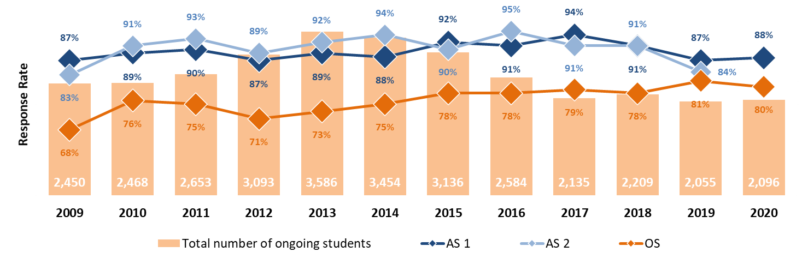

Details of surveys conducted in 2020

| Survey cycle | Student population | Survey responses | Response rate |
| --- | --- | --- | --- |
| Arrival Survey Semester One 2020 | 751 | 659 | 88% |
| Ongoing Survey 2020 | 2,096 | 1,559 | 80% |

### Demographic profile

The high-level profile of new arrival and ongoing students who responded to the Australia Awards Scholarships Surveys in 2020 is provided in the table below.

Profile of students who responded to the Arrival and Ongoing Surveys in 2020

| Demographic profile | Proportion of new arrivals | Proportion of ongoing students |
| --- | --- | --- |
| **Male** | 45% | 46% |
| Female | 55% | 54% |
| 25 and below | 11% | 8% |
| Aged 26 - 30 | 27% | 22% |
| Aged 31 - 35 | 31% | 31% |
| Aged 36 - 39 | 18% | 23% |
| Above 40 | 13% | 16% |
| Single (without children) | 46% | 41% |
| With family (spouse/partner and/or children) | 54% | 59% |
| With disability | 4% | 4% |
| In last semester of study | N/A | 61% |
| Experienced discrimination | 18% | 19% |

## Overall satisfaction with the Australia Awards

Overall satisfaction with the Australia Awards has remained high and steady, ranging between 96% and 99% satisfaction since 2013, for both ongoing and new arrival students (see the figure below). This is even more impressive for ongoing students, whose satisfaction levels have been sustained well after the excitement of commencing their scholarship. Correspondingly, levels of dissatisfaction have remained consistently very low (0-1%) since 2013.

The research identified positively correlated relationships between aspects of the Australia Awards and overall satisfaction, namely:

* the usefulness of the knowledge and skills provided by course for working on development issues in ongoing student’s home country
* ongoing student’s inclination to recommend Australia as a destination for study or travel and to recommend the Australia Awards, and
* ongoing student’s satisfaction with entitlements and other assistance.

New arrival’s preparation for coming to Australia tended to have a larger correlation with overall satisfaction in previous years. However, this was less so in 2020, possibly due to some of the large, unexpected changes that occurred as a result of COVID-19.

Overall satisfaction with the Australia Awards

Base: All survey respondents

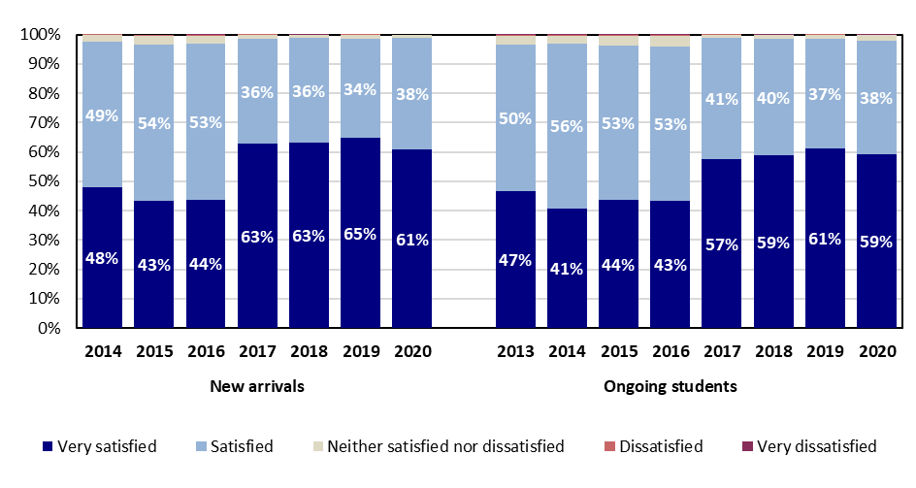

### Drivers of overall satisfaction

The research applied regression modelling techniques to identify a range of attributes that had a strong influence (correlation) on how satisfied students were with their Australia Awards in 2020.

As shown in the following image, the Arrival Survey model identified nine ‘drivers’ of overall satisfaction and the Ongoing Survey model identified seven ‘drivers’. Four of these were common to both models.

* As with previous survey cycles, the most important driver of overall satisfaction among ongoing students was the level of satisfaction with the entitlements and/or other assistance provided by the Australia Awards.
* However, two factors were found to have higher importance among new arrivals: overall studying experience, institutional services and support, and overall satisfaction with the preparation to come to Australia. The relatively higher importance of these three factors is unique to 2020, and may be related to the unusual circumstances of COVID-19.

As with previous cycles, allowances and entitlements continues to be the most significant driver of overall satisfaction amongst both new arrivals and ongoing students.

A detailed description for each regression model is provided in Appendix A.

Overlap in key drivers of overall satisfaction for new arrivals and ongoing students

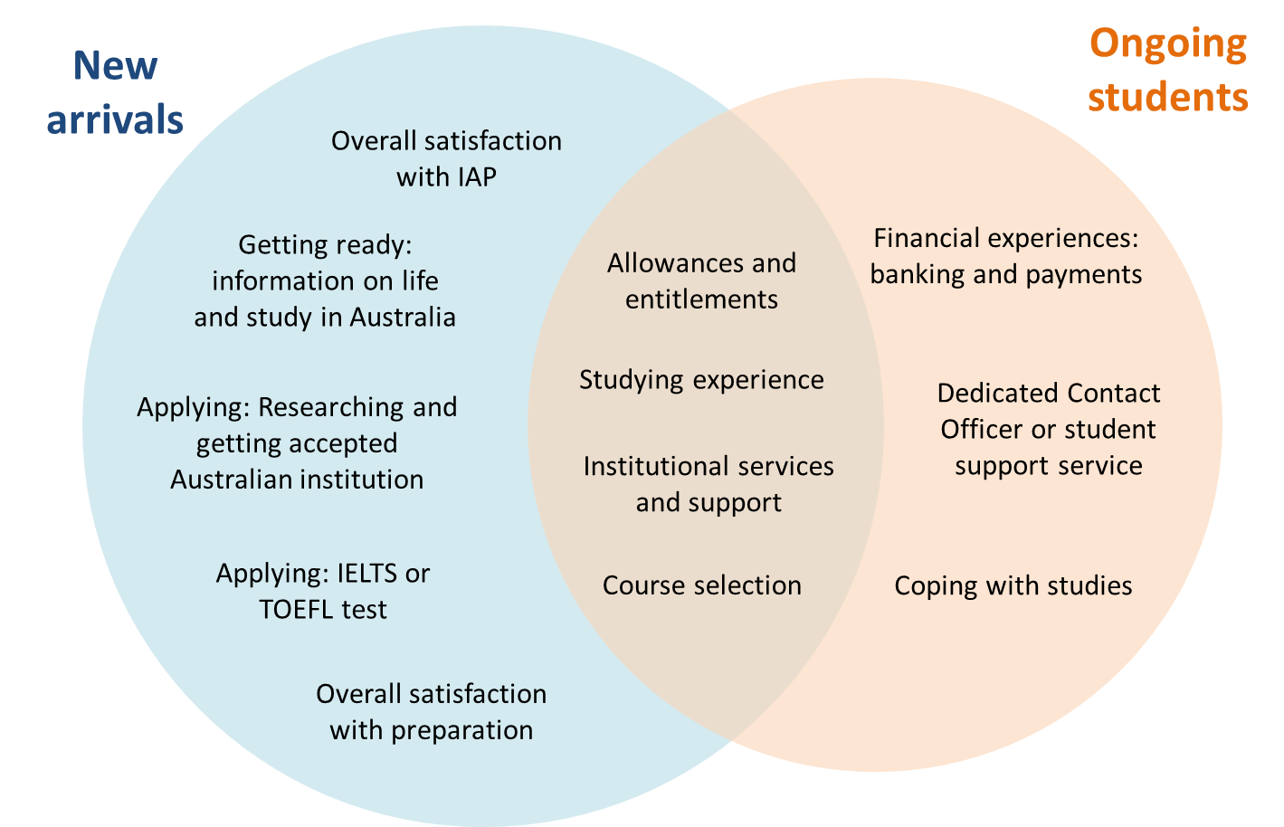

### Priorities for improving/maintaining overall satisfaction

#### This section highlights the attributes that contributed most towards improving or maintaining overall satisfaction with the Australia Awards for students based on the regression analysis. While this section highlights the high-level priorities across Australia Awards students, it is important to note that priorities may be differ across demographic cohorts.

#### 2020 new arrivals

As shown in the diagram below, the most important driver of overall satisfaction with the Australia Awards, as identified by new arrivals, was in relation to how they rated their studying experience. Performance on this measure has declined in 2020 (potentially affected by remote learning instituted in response to COVID-19).

* The next three most important drivers were institutional services and support, satisfaction with pre-scholarship preparation, and allowance and entitlements.
* Performance for all other comparable key drivers (i.e. apart from studying experience) was broadly in line with 2019 results.
* Among key drivers, new arrivals gave their lowest ratings to the preparatory information they received on life and study in Australia.

Drivers of overall satisfaction amongst new arrivals  
2019 performance result shown where comparison is possible

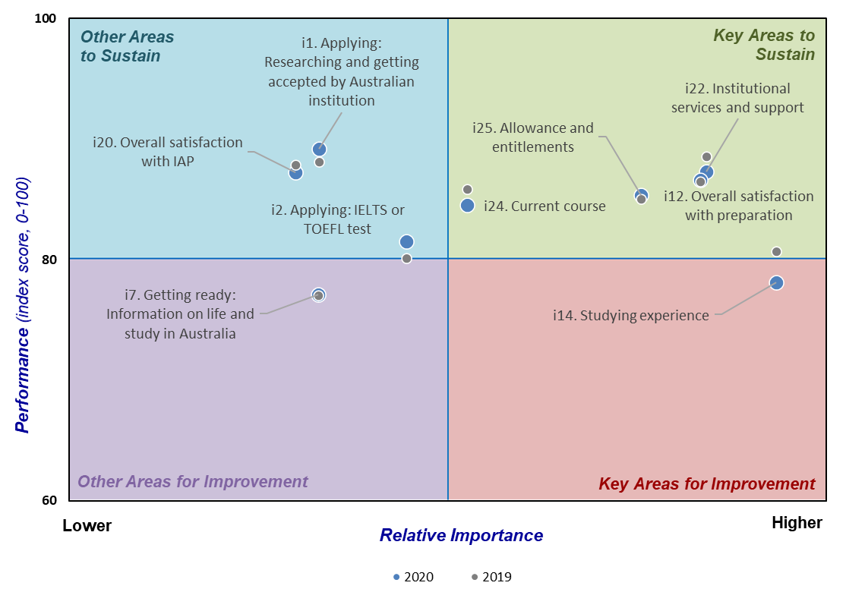

While most new arrivals were very positive in relation to the key drivers above, there were some small cohorts where the positive sentiment was lower, potentially requiring further attention. Unless otherwise indicated, those reported here are those with significant deviation from overall results, as well as populations of five or more, to avoid spurious conclusions (so for example, references to ‘all countries’ below refers to all countries with five or more students responding to the survey). Among all demographic breakdowns of new arrivals, variation in performance on key drivers was greatest across countries (of student citizenship).

#### 2020 ongoing students

As in previous years, the most important driver was in relation to satisfaction with award entitlements. Satisfaction on this measure was 92% in 2020, broadly consistent with previous years.

* Performance of all other comparable key drivers was similar with 2019 results, with the exception of the dedicated contact officer or student support services, which saw a small decline.
* As in 2019, satisfaction with financial experiences relating to banking and payments was the most highly rated key driver (there was an average positive sentiment of 98% across the component measures).

Drivers of overall satisfaction amongst ongoing students  
2019 performance result shown where comparison is possible

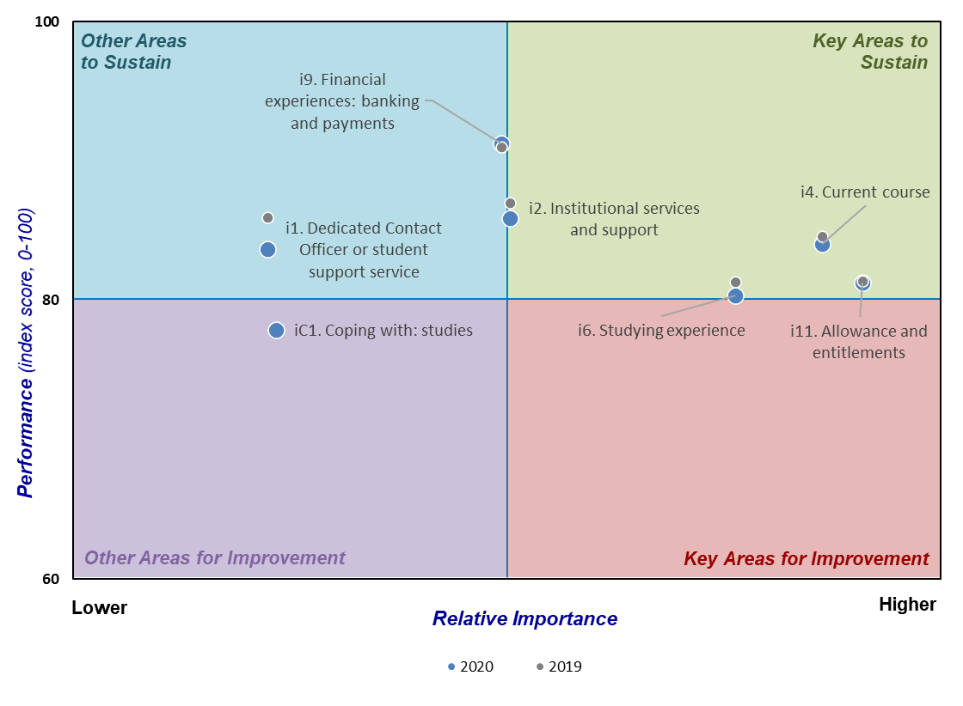

As with new arrivals, most ongoing students were very positive in relation to the key drivers above, however there were some small cohorts where the sentiment was slightly lower, possibly requiring further attention. The most significant factor affecting performance in key drivers was country of citizenship.

## Key Australia Awards outcomes

The goals of the Australia Awards are to support partner countries in progressing their development goals and to foster positive relationships with Australia that advance mutual interests. To realise these goals, the Australia Awards seeks to achieve the following outcomes:

* Outcome 1: Alumni using their skills, knowledge and networks to contribute to sustainable development.
* Outcome 2: Alumni contributing to cooperation between Australia and partner countries.
* Outcome 3: Effective, mutually advantageous partnerships between institutions and businesses in Australia and partner countries.
* Outcome 4: Alumni viewing Australia, Australians and Australian expertise positively.

Given the long term and multi-faceted nature of these strategic outcomes, results from the Australia Awards surveys can provide an indication as to the attitudinal disposition of current students in contributing to these four outcomes. The key outcomes have been assessed using results from the Ongoing Survey only, as the greater length and depth of ongoing students’ experiences are better suited to provide insights into the long-term outcomes of the Australia Awards.

The 2020 results across each of these four strategic outcomes were very similar with the results achieved in 2019 (with a marginal drop in measures relating to Outcome 2). Overall, these outcomes indicate that 90% of ongoing students are well positioned to achieve positive outcomes due to their participation in the Australia Awards. Measures for each strategic outcome are presented in greater detail below.

Position of ongoing students to achieve outcomes

(Chart shows average positive sentiment across component questions relevant to each outcome)

**90% overall average positioned to achieve positive outcomes**

***(91% in 2019,***

***92% in 2018)***

This chart shows all four key Australia Awards  outcomes and the percentage rates of surveys conducted in 2020 and 2019

### Outcome 1: Alumni using their skills, knowledge and networks to contribute to sustainable development

Unchanged since 2019, 97% of ongoing students are positioned well to use their skills, knowledge and networks to contribute to sustainable development. The 2020 results also show that majorities of students *strongly agree* with component questions of this outcome measure, with these proportions generally stable across recent years.

Students participating in the Australia Awards agree that the knowledge and skills provided by their course or research will be useful for working on development issues in their home country (98%, with 65% strongly agreeing, in line with 66% in 2019).

Other related metrics indicate that more than nine-in-ten students agree that:

* they value the skills and knowledge gained through their studies and experience in Australia (99%, with 73% strongly agreeing, the same as in 2019)
* their study experience will help them make a positive impact on the community in their home country (99%, with 67% strongly agreeing, the same as in 2019)
* the Australia Awards have motivated them to help support development initiatives in their home country (98%, with 64% strongly agreeing compared to 65% in 2019)
* their study experience has improved their ability to better manage projects to meet specified goals (97%, with 57% strongly agreeing compared to 56% in 2019), and
* their course/curriculum is well aligned with the learning and developmental outcomes they are seeking (92%, with 43% strongly agreeing, the same as in 2019).

### Outcome 2: Alumni contributing to cooperation between Australia and partner countries

Just under three in four ongoing students (73%, down slightly from 76% in 2019) are positioned well to contribute to cooperation between Australia and partner countries. The result for this outcome has also been relatively low in previous years, reflecting the difficulty some students have experienced in forming friendships outside their own country group or institution. These difficulties appear to have been exacerbated by COVID-19 conditions with lower levels of socialisation reported with students not from the home country.

Nonetheless, the majority of ongoing students agreed that:

* other students have been inclusive towards them (81%, the same as in 2019—with 24% strongly agreeing, down from 27% in 2019)
* they have found it easy to make friends with other students (not from their own country) whilst in Australia (76%, with 26% strongly agreeing—compared to 82% and 29% respectively in 2019), and
* they have found it easy to make friends with other people (outside their institution and not from their own country) whilst in Australia (61%, with 19% strongly agreeing—compared to 67% and 22% respectively in 2019.

Students continue to socialise primarily with students from their home country (75%) and other international students (77%). Additionally, students remain more likely to socialise with other people (non-students) from their home country (43%) than with either Australian students (28%) or Australian non-students (34%). While some of these figures have fallen in 2020 (for instance, socialisation with Australian non-students declined from 34% to 28%), this overall pattern of interaction has remained broadly consistent since 2013.

### Outcome 3: Effective, mutually advantageous partnerships between institutions and businesses in Australia and partner countries

A large majority of ongoing students (93%, similar to 94% in 2019) are well positioned to establish effective, mutually advantageous partnerships between institutions and businesses in Australia and partner countries, with a marginal decrease in the proportion of highly positive students regarding one statement.

Students agree that participation in the Australian Awards has been beneficial for developing their professional credentials at home (98%, with 67% strongly agreeing, similar to 99% and 67% in 2019) and useful professional networks in Australia (87%, with 50% strongly agreeing, similar to 89% and 50% in 2019).

Related to this outcome:

* Just under half of students returning home in the next nine months at the time of the Ongoing Survey expect to return to the same organisation that they left to engage in the Australia Awards. This proportion has remained around or above one-half across previous years, but the 2020 result (48%) is the lowest recorded level.
* The most common barriers ongoing students expected to encounter in using their qualifications when they return home were identified by between 2-12% of students. Home countries lacking the required infrastructure to support implementation of the students’ qualifications was the most commonly cited barrier in 2020 (11%), as in previous years.

### Outcome 4: Alumni view Australia, Australians and Australian expertise positively

Through their Australia Awards experience, 98% of ongoing students view Australia, Australians and Australian expertise positively. This overall figure has not changed since 2019, although there have been small shifts in positive sentiment (both up and down) on the individual questions that form part of this metric.

Nearly all students agreed that they would recommend Australia as a good place to visit (99%) and study (99%), and the same proportion indicated they would recommend others to apply for the Australia Awards (99%). These overall proportions were in line with 2019 results (98-99%) and the proportion who *strongly agreed* has also remained broadly the same since, with some signs of gradual increase since 2019.

Related to these outcomes, but with some small decline in strong positive sentiment:

* 97% of students agreed that their study experience has had a positive impact on their lives (with 64% strongly agreeing, compared to 66% in 2019 and 67% in 2018)
* 95% of students agreed their Australia Awards experience has helped them better understand Australian culture (with 55% strongly agreeing, compared to 57% in 2019 and 58% in 2018), and
* 19% of students had personally experienced discrimination in Australia, while 25% had witnessed an act of discrimination. The latter figure was in line with previous years, but the proportion of ongoing students *experiencing* discrimination has gradually declined over time (from 29% in 2013).

# 2020 student experiences at a glance

This section outlines the overall experiences that students had in 2020 regarding their Australia Awards scholarship.

### Overall satisfaction

Overall satisfaction with the Australia Awards was high for both new arrivals (99%) and ongoing students (98%), consistent with previous years. The proportion of ongoing students ‘very satisfied’ (59%) remained broadly in line with 2019 (61%), the proportion of very positive new arrivals showed signs of decline (61%, down from 65% in 2019).

The research identified positively correlated relationships between aspects of the Australia Awards and overall satisfaction, namely:

* the usefulness of the knowledge and skills provided by course for working on development issues in ongoing student’s home country
* ongoing student’s inclination to recommend Australia as a destination for study or travel and to recommend the Australia Awards
* ongoing student’s satisfaction with entitlements and other assistance, and
* new arrival’s satisfaction with preparation for coming to Australia.

### Obtaining an Australia Award

Among new arrivals, the most common reason for **applying for an Australia award** (cited by 79%) was to contribute to their country’s development. The same was true for students’ **choice of course** (84%), followed by compatibility with career plans (77%). Most students **chose their educational institution** based on the availability of desired courses (75%) and the institution’s international reputation and the availability of desired courses (73%).

All these reasons were also the predominant reasons provided by new arrivals in 2019.

**Top Three motivating factors in applying for and choosing course.**

| Reasons for applying for an Australia Award | Reasons for choosing course | Reasons for choosing institution |
| --- | --- | --- |
| The education I receive will help me contribute to my country's development (79%) | It is appropriate for my country's development needs (84%) | It offered the course I wanted to do (75%) |
| Good universities, research facilities and other educational resources are available in Australia (48%) | It is the most appropriate course for my future career plans (77%) | It has a good international reputation (73%) |
| The education I receive will help me do my job better (33%) | It matched my personal area of interest (53%) | I met the entry requirements (21%) |

Over one third (35%) of students had **applied for another scholarship program** within the past two years. Student interest was mostly in relation to a government scholarship from:

* the New Zealand Development Scholarship (28%, with 27% of these being successful)
* the British Chevening Scholarship (27%, with 2% of these being successful)
* their home country (26%, with 34% of these being successful), and/or
* a Fulbright Scholarship (12%, with 4% of these being successful).

New arrivals were generally positive in relation to their experiences in selecting and applying for an education course, as well as obtaining their Australia Award, with at least 79% giving a positive response on each application-related metric. New arrivals were most positive about their experiences in relation to:

* finding useful information about courses and educational institutions in Australia (95%)
* getting accepted (an offer letter) into an Australian educational institution (92%), and
* attending an IELTS or TOEFL test (91%).

As with previous years, the least positive components of this experience were in relation to paying for (79%) and preparing for (82%) an IELTS or TOEFL test.

### Preparing to come to Australia

Most students (95%) were satisfied with their preparation for coming to Australia (in line with 96% in 2019).

* Most students found the resources they accessed in preparation for living and studying in Australia useful. Specifically, 86% of new arrivals found Australia Awards website and institution website useful, while 79% found the relevant DFAT website and/or speaking to alumni useful.
* Students were most likely to have found these resources useful for providing information relating to conditions of the Australia Awards (95%), visa requirements (92%), course information (84%) and campus location (84%), and least likely to find them useful regarding employment opportunities for either themselves (47%) or their spouse (51%).
* Attendance at the Australia Awards Pre-Departure Briefing remained high in 2020 (97%), as did the proportion of students who reported using a copy of the Scholarships Policy Handbook (94%), Australia Awards Pre-Departure Guidebook (87%). Students were less likely to use the Australia Awards Pre-Departure DVD (40%, lower than in any previous year, and down from 57% in 2019). Less than 1% of students did not use any of these resources.
* For each of these resources, 95-97% of those who used them found them useful. Further, 92% of students agreed that the information provided by these resources reflected their experiences on arriving in Australia.
* Students were more likely to have found the Pre-Departure resources useful as sources of information relating to their Australia Awards entitlements, responsibilities and obligations (95%), Australia Awards contract (94%), and their arrival in Australia (94%).

Students had positive experiences preparing to come to Australia, especially in obtaining a visa (92%), making travel arrangements to come to Australia (90%) and making financial arrangements (85%).

### Studying and living in Australia

Students were asked to indicate their living and studying experiences whilst in Australia by rating their level of agreement with a range of statements relating to general living experiences, studying and financial components. Appendix B provides a more detailed overview of these topics by region, post, country and institution.

* In terms of students’ **general living and studying experience**, the majority of new arrivals and ongoing students (95% and 92% respectively) agreed that they have been able to cover their basic needs, with a lower proportion reporting that they have been able to achieve a reasonable standard of living (74% for each cohort). Aside from being marginally less positive regarding their ability to meet basic needs, ongoing students were more positive regarding all facets of their general living and studying experiences.

Satisfaction with general living and studying experiences

This chart shows the percentage rate in terms of all students surveyed with general living and studying experience. More detail is provided in the paragraph above.

Both new arrivals and ongoing students viewed their **studying experiences** positively, specifically in relation to understanding or using English, the academic requirements of their course, and approaching teachers and other staff. Ongoing students were more positive regarding all aspects of their studying experiences.

**Satisfaction with studying experiences**

This chart shows the satisfaction with studying experiences matching the description provided in the above paragraph.Despite variation in values, new arrivals and ongoing students ordered the quality of their top **financial experiences** similarly, with both groups viewing particularly positive their experience obtaining correct and timely payments of their Australia Awards allowance, navigating Australian financial and banking systems and finding affordable contracts for services. Ongoing students found all aspects of their financial experiences either equally or more positive than new arrivals, except for the cost of living in Australia.

**Satisfaction with financial experiences**

This chart provides a visual image of the satisfaction with financial experiences as detailed in the above paragraph.

Around one in five new arrivals (18%) and ongoing students (19%) indicated they had experienced discrimination. Instances of discrimination have been generally decreasing since 2013 (when rates of discrimination were 19% and 29% respectively), although the reported rate among new arrivals represents a reversion from the historical low of 14% in 2019. In additions, 22% of new arrivals and 25% ongoing students indicated they had *witnessed* discrimination.

Of students who had experienced discrimination, 6% of new arrivals (similar to 7% in 2019) and 10% of ongoing students (up from 7% in 2019) indicated this affected them ‘a lot’.

While most ongoing students who experienced and/or witnessed discrimination reported that it had no adverse effect on their attitude towards Australia (74%, compared to 70% in 2019), one in five (20% compared to 21% in 2019) reporting that it has disheartened their views about Australia. New arrivals were less likely to report no adverse effect (66%) and more likely to indicate being disheartened (24%)—in both cases, less positive results than in 2019 (71% and 20% respectively).

### Facilities and Services at Australian educational institutions

Consistent with 2019 findings, nearly all students were satisfied with most of the facilities and services provided at their institution. Levels of satisfaction were broadly similar between new arrivals and ongoing students. The greatest difference (five percentage points) related to the least-used service, legal advice.

Satisfaction levels were 90% or higher amongst new arrivals and ongoing students across five of the facilities/services listed: library, computer facilities, computer skills, academic skills services, international student support services, and Student Contact Officer; and a sixth service (health) received 90% satisfaction among ongoing students only (89% among new arrivals). Least well-rated services were childcare (64% new arrivals, 66% ongoing students) and legal advice (69% new arrivals, 74% ongoing students).

**Satisfaction with educational facilities and services**

This chart provides a visual image of the satisfaction with educational facilities and services by ongoing and new students. This is provided in more detail in the paragraphs following.

Amongst ongoing students, 95% were satisfied with the quality of their institution, and 90% were satisfied with the quality of their course/research supervision.

* 93% of ongoing students agreed that they had chosen the right educational institution, and the same proportion felt that they had chosen the right course or research topic.

As in 2019, students were highly satisfied with their course, agreeing that their course was:

* current (96% of both new arrivals and ongoing students)
* well designed (91% of new arrivals and 92% of ongoing students), and
* aligned with the learning and development outcomes they sought (91% of new arrivals and 92% of ongoing students).

New arrivals were less likely than in previous years to feel that their course had a good balance of theoretical and practical components (81%, down from 91% in 2019), although among ongoing students this had fallen only marginally (85%, similar to 87% in 2019).

Most new arrivals (rounding to 100%) participated in an Introductory Academic Program (IAP); and of these, 95% were satisfied with the program. The three topics found most useful in IAPs were:

* plagiarism and referencing (96%)
* introduction and orientation to the educational institution’s campus (95%), and
* study skills and general academic skills (93%).

### Entitlements and other assistance

Most new arrivals (93%) and ongoing students (92%) reported that they were satisfied with the **entitlements and other assistance** they received from the Australia Awards. Student satisfaction with the Establishment allowance (a special on-arrival payment to help students settle in Australia) was the highest with 96% of both new arrivals and ongoing students satisfied. High satisfaction was also recorded for the fortnightly scholarship living allowance, with 82% of new arrivals and 80% of ongoing students satisfied.

Ongoing student satisfaction with the other types of entitlements/assistance remained high, with the exception of the fieldwork entitlement where satisfaction was marginally lower, at 68% (down from 73% in 2019, but similar to previous years).

**Satisfaction with entitlements and other assistance**

This chart provides a visual image of the satisfaction with entitlements and other assistance by ongoing and new students. This is provided in more detail in the paragraphs following.

Only 11% of new arrivals reported that they would have been likely to study in Australia without a scholarship of any type, the smallest proportion so far recorded (previous years’ results range from 14% in 2019 to 23% in 2013). This result highlights the importance of scholarship entitlements in enabling students to study in Australia.

### Returning home

Of the 932 students who reported that they were close to completing their studies within the next nine months:

* 66% had work arrangements in place (either returning to the same organisation they left or moving to a different organisation);
* Of the students that had work arrangements in place, 56% reported that their employer had a Reintegration/Re-entry Plan in place (up from 49% in 2019 and also above all previous years), with 20% indicating there was no Plan in place, and 24% unsure.
* 30% were looking for a job or were intending to look for a job on return to their home country.
* 3% planned to undertake further studies, and
* 1% had another type of arrangement in place.

Students were asked to identify the extent to which they expect to encounter a range of barriers to using their qualifications when they return home. The four most common potential barriers, rated as ‘major’ or ‘severe’ by around one in 10 returning students, were:

* their home countries may not have the required infrastructure, systems or funding to support implementation of their new qualifications (11%)
* there will be a lack of work opportunities / career development for candidates with their new qualifications (10%), and
* their employer may not be able (8%) or may be reluctant (8%) to make full use of their new qualifications.

# Focus on discrimination, gender, disability and family composition

This section provides information on the experiences of students who have experienced discrimination or sexual harassment, female student experiences, the experiences of students with disabilities and the experiences of students with different family compositions.

### Discrimination

Consistent with previous years, the longer students have been in Australia, the more likely they are to have witnessed or experienced **discrimination**. However, due a small increase in perceived rates of discrimination among new arrivals, but *not* among ongoing students, the difference between the two groups was marginal in 2020: 18% of new arrivals indicated they had personally **experienced** discrimination (compared to 19% of ongoing students), and 22% of new arrivals indicated they had **witnessed** discrimination (compared to 25% of ongoing students). The rate of experiencing discrimination among new arrivals was at its highest since 2013 (19%), while among ongoing students it was at a historical low (down from 29% in 2013).

* While 89% of students who had experienced or witnessed discrimination reported that this experience affected them to some degree (i.e. at least 'slightly'), only 6-10% reported that it affected them 'a lot'.
* New arrival students who experienced discrimination, *particularly* those who experienced it personally but did not witness it occur to others, were less likely to find it easy to make friends with other students outside their host country (60%, compared to 77% of those who did not experience or witness discrimination), and were also less likely to easily make friends with other non-students (31%, compared to 56%).

This may reflect deeper vulnerabilities that may make them more susceptible to indicating experiencing instances of discrimination. Nonetheless, this is an issue that should be continually monitored.

### Gender

As in other recent years (form 2018 onwards), a slight majority of respondents were female (55% of new arrivals and 52% of ongoing students).

Satisfaction with the overall scholarship experience was the same for both male and female new arrivals (both 99%) and ongoing students (both 98%), and male and female students had similar ratings across most measures covered by the survey.

As in past years, ongoing female students were marginally more likely to experience discrimination (22%, compared to 16% of males) and to witness it (27%, compared to 23%), and this discrimination tended to have a stronger impact on them (for instance, 25% of female students who experienced or witnessed discrimination indicated it affected them at least ‘moderately’, compared to 13% of males). Female students were also more likely to feel the discrimination disheartened their views of Australia (25%, compared to 14% of males).

### Disability

Among both new arrivals and ongoing students, 4% indicated they had a disability, similar to 3% in 2019 and in line with 2-4% across previous years.

A health assessment was introduced into the ongoing survey in 2019 and retained in 2020, with closely similar rates of health-related difficulties being recorded in both years. The 2020 survey found that, of ongoing students:

* 28% memory or concentration problems (36% of those with a disability)
* 20% difficulty seeing, even with the help of glasses (29% of those with a disability)
* 17% had difficulty communicating in their usual language (also 17% for those with a disability)
* 6% difficulty climbing steps (37% of those with a disability)
* 4% had difficulty with self-care such as washing and dressing (12% of those with a disability), and
* 2% had hearing issues, even with the help of a hearing aid (14% of those with a disability).

New arrivals with disabilities were generally more positive than other new arrivals about all aspects of **preparing to come to Australia**, apart from making financial arrangements (78%, compared to 86%).

New arrivals in this cohort were also more positive about their **studying and living** experiences relative to other students in most respects, although they were less likely to feel that other students were inclusive towards them (64%, compared to 77%) and that they were able to make friends easily with non-students not from their home country (45%, compared to 53%). However, these differences appear to lessen with time, as ongoing students were no less positive than other students in either regard.

Ongoing students with disabilities were more likely to experience **discrimination** during their time in Australia (30%, compared to 19% of ongoing students without disabilities). The impact of this discrimination also tended to be stronger on ongoing students with disabilities (22% indicated the discrimination they experienced or witnessed affected them ‘a lot’, compared to 9% among students without disabilities).

### Family composition

Just under half of respondents to the ongoing survey had child dependents (46%, a total of 42% partnered with children and 4% single with children). The remaining 54% of students (with no dependents) consisted of 13% partnered and 41% single. These proportions have followed the same broad outlines since 2017, although in this time the proportion partnered with children has steadily declined (from 50% to 42%), while the proportion single without children has correspondingly increased (from 34% to 41%).

Ongoing students with children were marginally less likely to be satisfied with the entitlements and assistance they received from Australia Awards overall (88% if single, 89% if partnered, compared to 95-96% of students without children). Single students with children recorded the lowest levels of satisfaction with particular aspects of their entitlements, such as their fieldwork entitlement (53%, compared to 66% for partnered students with children and 71% for students without children).

Single-parent ongoing students were also:

* least positive regarding the cost of living in Australia (50%, compared to 55% of partnered parents and 70-75% of students without children);
* most likely to have made use of several their institution’s advisory services, such as counselling, information about accommodation, and financial advice—with their satisfaction levels higher than average for counselling (91%, compared to 85% overall), but lower for financial advice (73%, compared to 79%)’
* least likely to feel they were fully or mostly coping with a variety of aspects of their life in Australia, including personal relationships, their studies, and their ability to deal with challenges and stress (see next section).

# Coping with COVID-19 and overall wellbeing

This section covers questions introduced to the surveys conducted in 2020 to gauge the impact of the COVID-19 pandemic on students’ education, experiences of Australia, and overall wellbeing.

### Impact of COVID-19

The majority of new arrivals felt that the COVID-19 pandemic had an impact for the worse on their mental health (62%) and/or on their studies (54%), and just under half also felt there had been an impact for the worse on their feeling part of their community (47%) and feeling safe (43%).

However, in most respects, new arrivals generally felt that the pandemic had had no effect—particularly regarding:

* how well their accommodation meets their needs (84% indicating this was about the same as pre-COVID, with 4% indicating an improvement)
* feeling welcome in Australia (74% no change, and 8% improved), and
* feeling supported (63% no change, 16% improved).

Aspects of life and study in Australia affected by disruptions brought about by the pandemic (new arrivals)

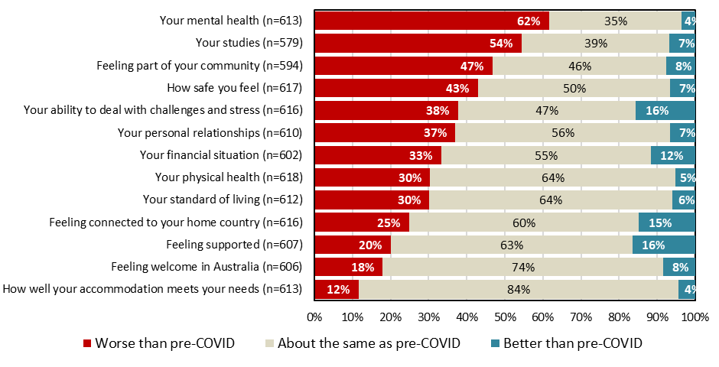

### Transition to online learning

New arrivals were generally positive about those aspects of the transition to online learning most under institutions’ control, such as the range of online learning resources (84%), lecturers being accessible and responsive (81%) and making it easy to access their online learning resources (81%). Despite this, only a minority agreed that the transition to online learning was easy (38% agreed, while 33% disagreed), and overall, a majority found online learning inferior to the pre-COVID delivery of their course (57% considered online delivery worse, 28% thought there was no significant difference, and 15% considered it better).

The least satisfactory aspect of online learning was interaction with other students, with only 25% agreeing (and 59% disagreeing) that this worked just as well in an online environment.

Transition to online learning (new arrivals)

Chart



### Coping

At least seven in 10 ongoing students felt they were at least ‘mostly’ coping with a range of aspects of their current circumstances, from feeling welcome in Australia (90%) to their mental health (70%), as shown in the figure below. Across all aspects of their life, 2-7% of students felt they were doing no better than ‘barely coping’, and a maximum of only 1% indicated they were ‘not coping at all’.

Extent of coping with aspects of life and study in Australia (ongoing students)

Chart



### Wellbeing

Ongoing students were asked to rate their current overall level of life wellbeing on a scale from 0 to 10 (expressed here as an index score from 0 to 100), as well as their wellbeing in several life aspects, chosen so as to be comparable with Australia-wide baseline measures captured by Deakin University in 2018. As shown below, students’ results were either in line with or above the Australia-wide, pre-COVID averages.

Students were most positive regarding their personal safety (85 out of 100, compared to the baseline result of 79), and least positive regarding community connectedness and future security (both 78, compared to a 71 baseline).

The youngest student cohort (25 and under) had the lowest level of global life satisfaction (74, compared to 81 for ongoing students overall). These younger students also had lower-than-average results regarding what they are achieving in life, their community connectedness, and their future security.

Ongoing students were also asked to express their *degree of control* over their life. Expressed on the same 0-100 scale, their average degree-of-control index was 75, stronger than an Australia-wide average of 62 (the April-November 2020 average of ORIMA Research’s COVID recovery tracker).

Wellbeing indices[1]

Chart, bar chart





1. Overall Australian indices based on Australian Unity Wellbeing Index (AUWI) results (Deakin University, School of Psychology, 2018).