**Australia Africa Development Program Summary**

***Design Background***

The Australian Government’s development policy *Australian aid: promoting prosperity, reducing poverty, enhancing stability* introduces a sharper geographic focus on the Indo-Pacific region. Australia’s aid program to Africa is undergoing consolidation, with the bulk of a revised budget envelope directed towards Eastern and Southern Africa. At the same time, Department of Foreign Affairs and Trade (DFAT) officers in Canberra are increasingly taking on greater role in activity management from staff deployed at Post. Together, this has stimulated exploration of mechanisms to deliver the two largest proposed bilateral programs to Sub-Saharan Africa, Australia Awards and Extractives for Growth (E4G), in ways that allow both programs to operate in a mutually beneficial manner, leverage wider synergies and realise resource efficiencies.

This document should be read in conjunction with the separate design documents for Australia Awards and E4G.

**Australia Awards:**Australia Awards are prestigious international scholarships offered by the Australian Government to the next generation of global leaders. Australia Awards provide opportunities for long-term (Masters) and short course study and professional development, aiming to develop capacity and leadership skills so that individuals can contribute to development in their home country.

Scholarships have been a key part of Australia’s aid program to Africa since the 1960s, providing over 5,000 scholarships across the continent. Australia Awards are an important development and public diplomacy tool in Sub-Saharan Africa. In addition to building critical skills and knowledge, they foster an engaged and influential network of leaders, reformers and advocates driving development across the continent, contributing to Australian economic diplomacy objectives and promoting valuable links between Australia and African countries.

**Extractives for Growth:** A well-managed mining, oil and gas sector can help drive sustainable growth and poverty reduction in Africa. The McKinsey Global Institute estimates that 540 million people in resource-driven countries could be lifted out of poverty by effective development and use of extractive reserves. However, the extent to which benefits are achieved depends heavily upon how countries meet the various economic, social and governance challenges that the extractive sector can present.

Australia is a leader in mining practice, actively promoting sustainable development and industry self-regulation. Australia has a mature domestic extractives sector, effective institutions and structures in place to manage the sector and the wealth it creates. Australia, through this experience and expertise, has a great deal to offer African countries seeking to develop their extractives sectors. Australian governments, extractives industry and communities have experience of both the good and bad of managing resources cycles. These lessons can be shared with African governments and communities as they look to minimise the potential risks associated with the extractives sector and maximise the economic and employment opportunities.

***Design Considerations***

Key considerations in bringing Australia Awards and E4G into one overarching program are to:

* leverage new partnerships between government, private sector and communities to increase the impact of the two programs, wider economic and social benefits and maximise Australia’s visibility and profile in Africa;
* identify potential synergies and efficiencies in delivering the two programs, including testing the feasibility of a combined delivery and management model;
* identify the transition to a single service provider or consortium that could engage across six DFAT Posts, with a reduction in posted development staff and activity management transitioning to DFAT Canberra;
* remain flexible and able to respond to budget or policy changes; and
* incorporate aid effectiveness and best practice design principles.

More focussed and coordinated implementation is expected to increase the efficiency of the Australian Government’s aid investments in Africa. Proactive identification of innovative and strategic opportunities to leverage results from both Australia Awards and E4G through a common delivery platform will also help increase effectiveness. This is expected to present DFAT with resourcing and value for money benefits.

***Description of the Investment***

The Australia Africa Development Program (AADP) is an umbrella program that brings Australia Awards and E4G into one delivery platform. The AADP’s structure will consist of:

* an Australia Awards component;
* an Extractives for Growth (E4G) component; and
* a Program Implementation Unit (PIU), responsible for management, results monitoring and provision of strategic advice.

AADP will comprise the bulk of Australia’s aid program to Africa. Australia Awards and E4G will remain complementary, but essentially separate mechanisms, sharing overarching strategic and performance management through the PIU. Wherever possible, synergies and efficiencies in implementation will be exploited, resulting in a streamlined management model requiring moderate DFAT activity management resources at Post and in Canberra.

AADP is expected to be implemented over four years (July 2015 – June 2019) with the option to extend for up to another four years. The proposed total financial envelope for AADP is $280 million over the initial four year term. Approximately 70-80 per cent of this total envelope will be delivered through a single service provider contracted to implement the Program.

**Australia Awards**

Over the next four years, Australia Awards will offer a Masters’ education or short course training to around 2,000 mid-senior level professionals, delivered by institutions showcasing Australian expertise. Awards will be offered primarily in the extractives, agricultural productivity and public policy sectors, where Australia is an acknowledged world leader. The program will build on and expand the existing network of around 5,000 alumni, providing professional development and women’s leadership opportunities, capitalising on public diplomacy and relationship benefits. The program will pilot innovative ways to engage private sector interests in Africa and foster delivery partnerships between Australian and African institutions. Australia Awards will capitalise on existing Australian investment in the agricultural, public policy and extractives sectors, and be closely aligned with work supported through E4G.

Australia Awards will be comprised of:

* *Australia Awards Scholarships*: demand-driven Masters undertaken at Australian universities, to be offered to approximately 11 Sub-Saharan African countries.
* *Australia Awards Africa Short Courses*: tailored short (two-three months) post-graduate courses in sectors where Australia has recognised expertise and which are areas of priority to partner governments (agriculture, extractives and public policy). Offered to approximately 22 Sub-Saharan African countries, short course awards will be delivered through Australian registered training organisations, in partnership with African institutions to promote relevance.
* *Australia Award Fellowships*: short-term opportunities for study, research and professional attachment in Australia, delivered by Australian organisations. Currently available across Africa to nominated fellows from eligible countries. Delivered through a global program external to the AADP.

**Extractives for Growth**

Through E4G, Australia will focus its assistance in three areas where the greatest potential for generating shared value between governments, communities and industry exists: skills development; extractives and communities; and the enabling environment. These are areas that: represent major risks for the private sector; are key to governments leveraging maximum development value from their extractives resources; will determine the employment and livelihood benefits that flow to communities; and require (and provide opportunities for) partnerships between governments, industry and communities to find solutions. The new program will harness Australia’s extractives-related expertise (private sector, government, non-government organisation, research and training).

E4G will focus on three target countries (Tanzania, Zambia and Mozambique) where Australia can maximise development benefits, and where there is a commitment by the government and private sector to improve the social benefits and economic growth opportunities from a well-managed and transparent extractives sector.

In addition, ‘enabling environment’ activities will be conducted in 8-10 countries in Sub-Saharan Africa. These countries are likely to include Madagascar, South Africa, Ethiopia, Ghana and Nigeria, with the remainder yet to be determined.

For more detail on activities, please refer to the designs for Australia Awards and E4G.

***Program Outcomes***

The goal of the Australian Government’s aid program to Sub-Saharan Africa is *to assist African people to achieve more equitable access to the benefits of economic growth*. The AADP will directly contribute to this goal and to the objectives articulated in the Africa program’s Aid Investment Plan that are directly relevant to the Australia Awards and E4G programs:

* *contribute to African leadership and human capacity development and education in areas of critical skills shortages;* and
* *improve extractives sector management and its contribution to inclusive economic growth through developing skills, increasing government capacity and empowering local communities.*

Four AADP-level program outcomes, bringing together the anticipated outcomes of Australia Awards and E4G, will contribute to the achievement of the above Africa program objectives:

* Improved capacity of African men and women to undertake higher skilled roles in, or deriving improved livelihoods from, priority sectors (primarily agriculture, extractive and public policy);
* Improved enabling environments which encourage, attract and support quality investments in targeted sectors by the public, private and civil society sectors;
* Women and men are using their skills and knowledge to achieve more inclusive development in target sectors; and
* Enhanced relationships, partnerships and links between Australia and Africa.

The program will pursue innovation through piloting and feasibility studies of selected activities, particularly providing opportunities for increased private sector engagement and women’s economic and social empowerment.

***Monitoring and Evaluation (M&E)***

An overarching Program Monitoring and Evaluation System (MES) will be comprised of two levels:

* Program-level Monitoring and Evaluation Framework (MEF) that describes the key features of AADP and maps out the outcomes expected and the outputs needed to achieve them in the two components. The Program-level MEF is designed to contribute to achievement of the overarching goal of the Australian aid program to Africa.
* Component-level MEFs (Australia Awards and E4G), which are included in the design annexes. These will generate relevant data which will be used for the strategic assessment of the combined Program’s results.

***Design Intent (draft)***

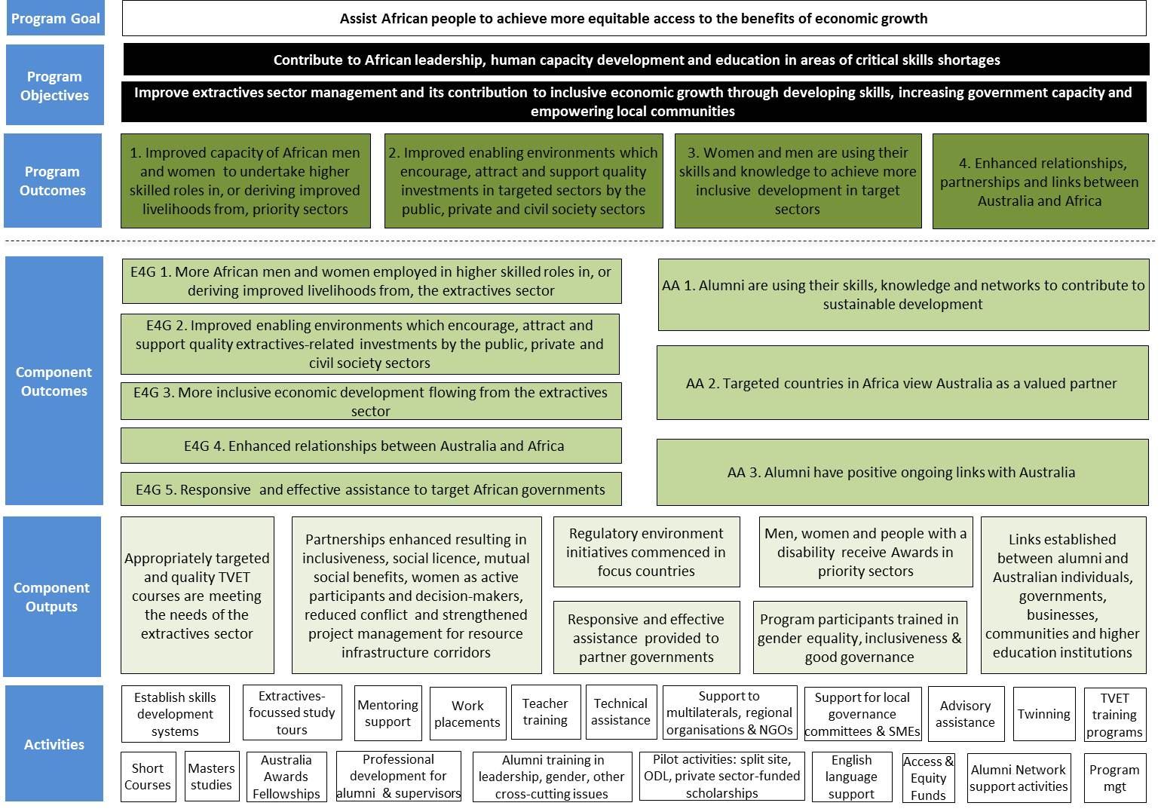

***Governance and Resourcing***

DFAT’s Africa Branch (AFB) will manage the program from Canberra, in close cooperation with Heads of Mission (HOMs) and Posts.It is envisaged there will be a single contract manager (focused on contractual and financial management of the overall AADP) with dedicated E4G and Australia Awards teams focussed on policy and program management of those components.

A single service provider or managing contractor (MC) will deliver the AADP on behalf of DFAT. Given the different approaches required for Australia Awards and E4G, a consortium which can call upon the necessary technical and logistical capacity to deliver the combined program may be appropriate. Ultimately, this is a question for the market to determine and for tenderers to propose in their responses to the request for tender (RFT). A key element will be the capacity of the PIU to provide high quality administrative / logistical support for and leverage synergies between the two programs.

Program governance and oversight will be centred on DFAT AFB management processes, and complemented by a MC-facilitated annual planning process. DFAT has proposed a non-prescriptive RFT for this program. This will provide opportunities for tenderers to propose innovative approaches to program management structures and implementation.

Some staffing efficiencies are anticipated through combination of extant Australia Awards and E4G programs under joint management of a single service provider. This design does not describe resourcing requirements and positions. Tenderers would be expected to propose staff numbers and positions, ensuring they meet functional requirements.

***Risk Management***

Individually, Australia Awards is a high value / low risk program; E4G is lower value / high risk. Combined, the AADP is nominally high risk, with additional risks associated with one service provider delivering the bulk of the Africa program in forward years.

However, AADP is building on two successful, existing programs and is not a ‘greenfields’ proposal. Extensive risk identification, mitigation and management has already been undertaken over the decades of Australia Awards delivery in Africa, and more recently (since 2011) in the extractives sector by the Australia Africa Partnerships Facility (AAPF) and pilot E4G activities. These are articulated in detail in the risk matrixes in the Australia Awards and E4G design annexes.

Overall, the risks at the AADP-level are considered to be manageable and in proportion to the scale of the program.