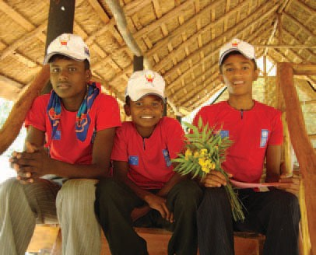


Australian Community Rehabilitation Program
An integrated approach to community rehabilitation
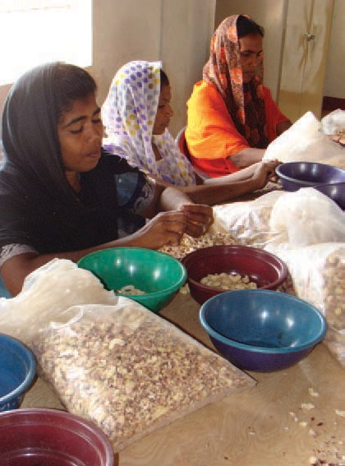
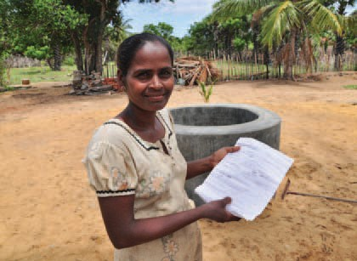

Sri Lanka is recovering from 26-year conflict, which ended in
2009. While the country is tracking well against most MDGs at the national level, these achievements sometimes mask disparities between provinces, particularly areas affected by conflict and tension like the Northern, Eastern and Central Provinces.

The Australian Community Rehabilitation Program Phase 3 is working to generate economic opportunities, strengthen existing livelihoods and support the development of peaceful societies in regions where development achievements lag behind the rest of the country.

Australia’s support

Australia’s five-year, $45 million Australian Community Rehabilitation Program supports and strengthens local government and community-based organisations to ‘increase the number of conflict-affected communities across Sri Lanka able to live a secure and productive life’.

The program focuses assistance in several areas:

> improving socio-economic development in vulnerable and disaster-affected communities

> resettlement and rehabilitation support to people displaced and affected by natural disasters conflict

> improving local governance structures and strengthening the skills of local government officials

> strengthening the role of community-based organisations in socio-economic development and community reconciliation.

The program works through the International Organization for Migration (IOM), Oxfam, the UN International Labour Organization (ILO), the United Nations Development Programme (UNDP), the Asia Foundation, the Dutch based non-government organisation ZOA, the German aid agency GIZ and World Vision.

The program is providing opportunities for the communities where it is being delivered through a wide range of activities. Some of these include:

> Through the IOM, we are strengthening dairy production in northern Sri Lanka by introducing new breeds of cows that produce higher quantities of milk, working with private sector to improve milk storage, and providing training to 2500 farmers on improved dairy techniques.

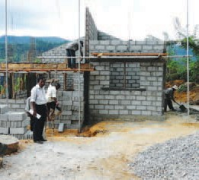
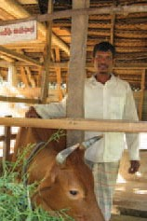
> IOM is also continuing long-term support to communities affected by landslides in the Central Province, where environmental degradation is leading to land destabilisation of many areas. This includes assisting people to move from high-risk areas to safer locations by supporting housing construction, water facilities and repairs to small rural roads to connect farmers to local markets.

> We are partnering with GIZ to help local government authorities improve their responsiveness to their communities by implementing systems for receiving and acting upon requests for better service delivery.

> We are supporting GIZ to provide English language training for 1200 bureaucrats and secondary school teachers to build basic, intermediate and advanced English language skills.

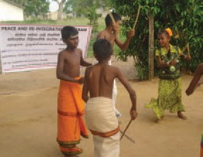
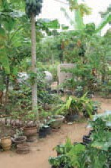
> Our partnership with World Vision is identifying water and sanitation needs and building small-scale water and sanitation infrastructure. Around 120,000 people in rural communities in the Central Province will have improved water security by the end of the initial three-year program (2010–13), and will have a positive impact on the health of those communities.

> We are supporting The Asia Foundation to work with
Sri Lanka’s local governments to improve the regulatory environment for business. This will, for example, increase transparency through helping the Government to publish its charges and taxes, as well as assistance to Government to implement a ‘performance card’ to enable citizens to better advocate for the services they want and need.

> One of the activities Australia is funding through ZOA and Oxfam over is improved food security. Both programs will provide assistance for regeneration of home gardening
for around 200,000 households in northern and eastern
Sri Lanka. Both organisations are working with vulnerable communities which experienced displacement during
the conflict.

> In partnership with the ILO, we are working to support integrated economic recovery plans for northern communities that link training opportunities with market labour requirements and support job placements. It is one
component of our work under ACRP to increase employment and income opportunities.

A number of the programs through IOM provide assets and training to communities to help them develop economically. In Mannar district, ACRP has helped to restore assets for fishing industries, which provides the sole source of income for many. In the Central Province, the program is helping
to improve the dairy industry by improving cattle stock and management.

The story of Ouvahkelle—turning on the taps

After the installation of a water treatment plant, storage tanks and individual taps for each household, 63 families living on the Ouvahkelle 3rd Division now have direct access to clean water.

AusAID, in partnership with World Vision, is providing sanitation and water supply to areas in the Central Province which often experience droughts and suffer from illnesses caused by lack of access to safe water.

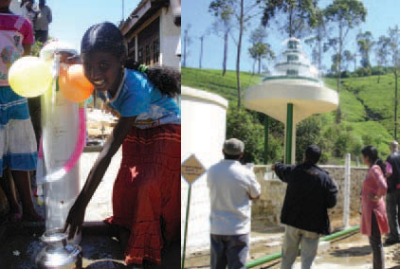

The story of Mathagal—fishing again

The Mathagal fishing community in the Jaffna district has experienced displacement multiple times due to the long-term conflict. Fishing, which is a major part of the local economy, has often been disrupted by the conflict. This has resulted in loss of assets and under-investment in infrastructure meaning many fisherman catch less fish and earn less for the haul they have.

But that is changing, through a program delivered by IOM. More than 700 fishing families are benefiting from the construction of new facilities including a new market/auction centre, resting hall, toilets, retaining wall and renovation of
a well at the Mathagal Anchoring Point.

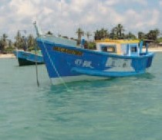
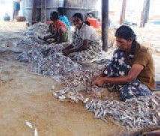
These facilities will help fishermen to earn more income by providing a centre that will prevent spoilage of fishing hauls, and provide safe storage for fishing assets. The centre is being administered by an interfaith committee representing all the religions of people in the area, bringing people together to work for a common goal.
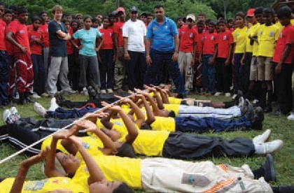

Under the Australian Community Rehabilitation Program, the UNDP is implementing the ‘Communities for Peace’ program. One of the initiatives of this program brings school children from different communities together to participate in sports, arts and cultural activities with the aim of creating linkages between participants who, in the past, had had little or no opportunity
to interact with each other.

The prospects for sustained peace and reconciliation can be strengthened by working with children to help break down mistrust and suspicion between communities. The program works in 11 districts of the country with 34 school teams taking part in a staggered program of peace-building exercises that brings the children and parents together to play and interact.

Australia in Sri Lanka

Australia’s long-term development objective for its aid program in Sri Lanka is for a stable, economically resilient and peaceful nation.

AusAID’s inclusive development framework that gives particular attention to lagging regions and vulnerable people, the program’s key priorities include:

> recovery of conflict-affected areas and providing of essential infrastructure

> access to sustainable livelihoods and income generating opportunities

> social protection for excluded and vulnerable people which includes better access to government services.

The program’s key priorities are aligned to the Government of
Sri Lanka’s development vision.

In delivering the aid program, Australia works closely with the Government of Sri Lanka, established and experienced partners including the United Nations, multilateral development banks, international and local non-government organisations and
like-minded donors.
©AusAID 2011

For further information:

Australian Agency for International Development (AusAID) Australian High Commission

21 Gregory’s Road
Colombo 7

Tel: + 94 11 2463228
Fax +94 11 2696468

