australia and timor-leste MARITIME BOUNDARIES

Rules-based order in action

On 6 March 2018, Australia’s Minister for Foreign Affairs, the Hon Julie Bishop MP, and Timor-Leste’s Minister in the Office of the Prime Minister for the Delimitation of Borders and the Agent in the Conciliation, His Excellency Mr Hermenegildo Pereira, signed the Treaty Between Australia and the Democratic Republic of Timor-Leste Establishing Their Maritime Boundaries in the Timor Sea.

This occasion marks a new chapter in the longstanding and deep ties between Australia and Timor-Leste. The Treaty is also milestone as it was reached through the first conciliation conducted under the United Nations Convention on the Law of the Sea (UNCLOS). As Australia identified in its 2017 Foreign Policy White Paper, the Treaty is a testament to the way in which international law reinforces stability and allows countries to resolve disputes peacefully. It is an example of the rules-based order in action.

As Australia’s Minister for Foreign Affairs, the Hon Julie Bishop, announced after signing the treaty:

*This is an historic day for both our nations. We recognise that it is a particularly important day for Timor-Leste and another step forward in Timor-Leste’s journey as a sovereign nation. By signing this Treaty, both governments have judged it has delivered a fair and equitable outcome.*

*Our treaty reflects the value and importance of those rules and institutions, and the benefits for states in abiding by those rules. In particular, our treaty reflects the importance of the United Nations Convention on the Law of the Sea – UNCLOS.*

Timor-Leste’s Minister in the Office of the Prime Minister for the Delimitation of Borders and the Agent in the Conciliation, His Excellency Mr Hermenegildo Pereira, said:

*The treaty we have signed is a good treaty, it is equitable and forward-leaning.*

*Appreciate that where we have arrived is owing to the tremendous leadership of both countries and the immense efforts of the Conciliation Commission.*

*This is an important new beginning, I look forward to both our two countries working together to advance the prosperity of our peoples, nations and region.*

Timor-Leste's Chief Negotiator Kay Rala Xanana Gusmão said:

*History is made today as Timor-Leste signs a treaty on permanent maritime boundaries that establishes, for the first time, a fair border between our two countries, based on international law.  We thank the Commission for their patience, wisdom and trust, and the Australian representatives for their constructive engagement and spirit of cooperation. This moment also provides hope for the peaceful resolution of disputes around the world.*

The Secretary-General of the United Nations, His Excellency António Manuel de Oliveira Guterres, said ‘*the martime boundary and the Greater Sunrise Special Regime puts Australia and Timor-Leste in a better position to exercise their rights under UNCLOS*’.

# What is in the treaty?

The Treaty consists of a number of inextricably linked elements which are part of the overall agreement, including:

* The Treaty establishes permanent maritime boundaries between Australia and Timor-Leste in the Timor Sea.
* The Treaty recognises both states’ sovereign rights and creates the Greater Sunrise Special Regime for the joint development, exploitation and management of the Greater Sunrise gas fields.
* The Treaty includes transitional arrangements to provide regulatory certainty and continuity for affected investors in the oil and gas sector in the Timor Sea.

As in any negotiation, both sides made compromises. The Treaty makes clear that the outcome represents a mutual accommodation which is without prejudice to either side’s legal position. Both sides, and the Conciliation Commission, consider it is a fair and balanced outcome.

## When does it start?

While Australia and Timor-Leste signed the Treaty on 6 March, it will not enter into force until each party has notified the other that its internal requirements for bringing the Treaty into force have been completed. Australia requires that any necessary implementing legislation has been put in place. Each country has its own processes for bringing a treaty into force. The Australian Government is aiming to complete of all its requirements to bring the Treaty into force as soon as possible.

## WHAT ARE THE MARITIME BOUNDARIES?

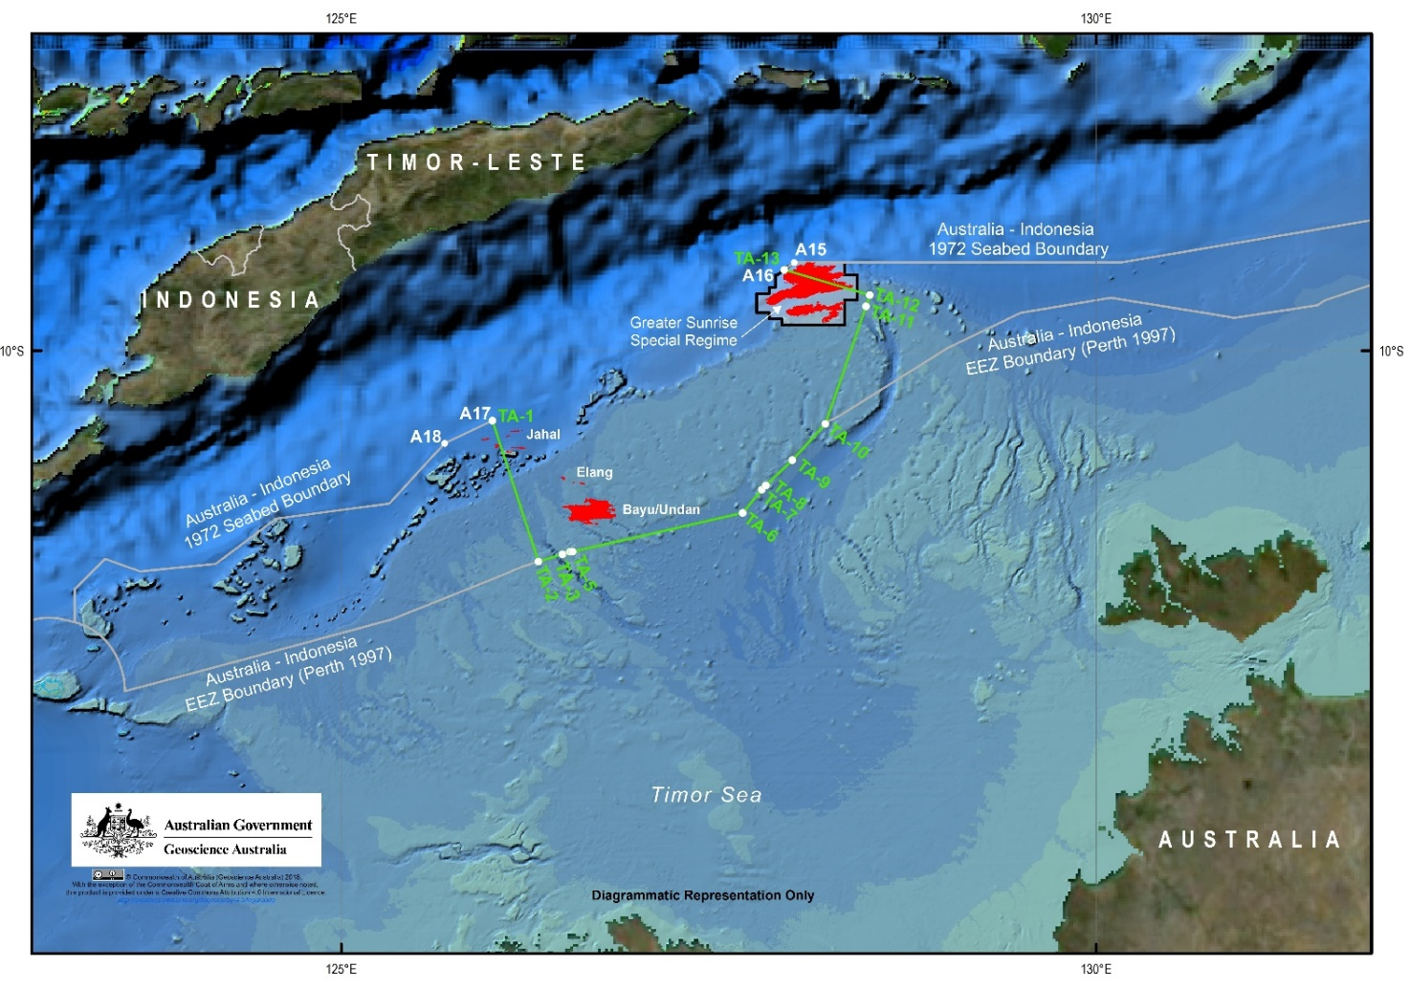

The maritime boundary includes a southern horizontal boundary and eastern and western lateral boundaries. The Southern boundary is a seabed and water column boundary (from points TA-5 to TA-10). The western segment of the southern boundary line (TA5 to TA-6) runs slightly above the median line, while the eastern segment of the southern boundary (TA-6 to TA-10) runs along the median line.

The eastern and western lateral boundaries are seabed boundaries only (from points TA-1 to TA-5, and TA-10 to TA-13). These boundaries contains scope for adjustment should Indonesia and Timor-Leste delimit their boundaries in the future to a point other than TA-1 and TA-13 (which correspond to points A17 and A16 on the 1972 Australia-Indonesia seabed agreement). Any adjustment could only take place after the commercial depletion of relevant resources near the lateral boundaries (Greater Sunrise in the east and Laminaria and Corallina in the west) to ensure certainty for investors.

# Existing oil and gas projects

Oil and gas fields currently shared between Australia and Timor-Leste in the Joint Petroleum Development Area will transition to Timor-Leste’s exclusive jurisdiction. The Treaty provides that the security of title and any other rights held by the titleholders previously under the Timor Sea Treaty and the International Unitisation Agreement will be preserved through ensuring conditions and terms equivalent.

In the case of Bayu-Undan and Kitan fields, Australia and Timor-Leste have agreed that the companies which hold the production sharing contracts will be subject to the same fiscal and regulatory regimes although under Timor-Leste’s jurisdiction not joint Australian and Timorese jurisdiction as is the case under existing treaty arrangements. This is outlined in an Exchange of Correspondence. Timor-Leste will derive 100 percent of future upstream revenue from these fields.

The Treaty also provides that the Buffalo field will transfer from Australian exclusive jurisdiction to Timor-Leste’s exclusive jurisdiction under conditions equivalent.

# Greater Sunrise Fields

The Treaty recognises Australia and Timor-Leste’s shared sovereign rights over the Greater Sunrise resource. The Treaty establishes the Greater Sunrise Special Regime to jointly manage and develop this resource and to share revenue.

Australia and Timor-Leste have agreed to share upstream revenue:

* In the ratio of 30 per cent to Australia and 70 per cent to Timor-Leste in the event that the Greater Sunrise fields are developed by means of a pipeline to an LNG processing plant in Timor-Leste.
* In the ratio of 20 per cent to Australia and 80 per cent to Timor-Leste in the event that the Greater Sunrise fields are developed by means of a pipeline to an LNG processing plant in Australia.

Australia and Timor-Leste will establish a Designated Authority and a Governance Board to oversee Greater Sunrise. Australia and Timor-Leste have agreed that the Designated Authority will be Timor-Leste’s Autoridade Nacional do Petróleo e Minerais (ANPM).

Australia wants Greater Sunrise to be developed in a commercially sound way that maximises the return for the parties, and therefore contributes to Timor-Leste's economic development priorities. Provided these conditions are met, Australia is genuinely neutral as to whether Greater Sunrise gas is processed in Timor-Leste or Australia.

The Conciliation Commission has worked extensively with the parties to broker a way forward on Greater Sunrise. We have made good progress in the conciliation towards this goal. Australia looks forward to building on the Commission’s efforts and analysis and will continue to discuss the development concept for Greater Sunrise with Timor-Leste and the Sunrise Joint Venture.

# The Conciliation

In 2016, Timor-Leste commenced conciliation proceedings under Article 298 and Annex V of UNCLOS to resolve differences with Australia on maritime boundaries in the Timor Sea. Australia engaged in the conciliation in good faith, in accordance with our international obligations.

Conciliation is one of the methods available under UNCLOS to resolve disputes. The function of the conciliation was to assist parties to reach an amicable settlement.

The conciliation was conducted by a five-person Conciliation commission, an ad hoc body formed solely for the purpose of the conciliation. The conciliation spanned 15 months and involved regular meetings.

# What happens to Australia and Timor-Leste’s previous maritime treaties?

When the new Treaty enters into force, it will replace earlier treaties: the *2002 Timor Sea Treaty* and the *2003 International Unitisation Agreement for Greater Sunrise*. These treaties will terminate upon entry into force of the Treaty. On 10 April 2017, Timor-Leste terminated the the 2006 Treaty on Certain Maritime Arrangements in the Timor Sea as part of the conciliation process.