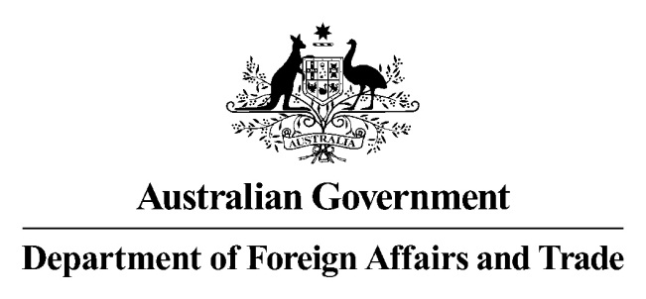

08 September 2015

**Australia notifies it has completed its internal requirements to enter the First Protocol to Amend the AANZFTA into force**

On 1 September 2015, Australia notified the Parties to the Agreement Establishing the ASEAN-Australia-New Zealand Free Trade Area (AANZFTA) that it had completed its internal requirements to enter the First Protocol to Amend the AANZFTA (First Protocol) into force.

The notification has triggered Article 5.2 of the First Protocol, which states, in part:

This Protocol shall enter into force 30 days after the date on which Australia, New Zealand and at least (4) ASEAN Member States have made such notifications.

Australia is the last of this group to notify. As a result, the First Protocol will **enter into force on 1 October 2015**.

It is expected that the First Protocol will enter into force for 10 countries on 1 October 2015: Australia, New Zealand, Brunei, Burma [Myanmar], Laos, Malaysia, the Philippines, Singapore, Thailand and Vietnam. It is expected that the First Protocol will enter into force for Cambodia and Indonesia on 1 January 2016. Information on entry into force will be confirmed on the DFAT website.

The First Protocol builds on the existing AANZFTA Agreement and aims to further enhance opportunities for business to utilise the agreement. More details can be found in the attached – [AANZFTA First Protocol [PDF 60 KB]](http://dfat.gov.au/trade/agreements/aanzfta/Documents/aanzfta-first-protocol-additional-information.pdf).

The key changes affect the implementation of the rules of origin and the AANZFTA Certificate of Origin (CoO) used to claim AANZFTA preferential tariff rates.

* The original General Rule and partial product specific rules (PSR) schedule has been replaced by a full PSR schedule – i.e. a specific rule for each and every product
  + this is a presentational change intended to make it easier for business to find the rule relevant to products of interest to them.
* The nomenclature in which the PSR is written has been updated from the Haromonized Commodity Description and Coding System (HS) 2007 to HS 2012
  + and introduces practices which will make it easier to move to new nomenclature in the future.
* There is a new CoO form with the main changes being to Boxes 7 and 9
  + Box 7 makes more explicit the requirement to add the name of the company issuing a **Third Party Invoice**
  + Box 9 only requires the inclusion of **FOB** when regional value content is used to claim an AANZFTA concession
    - Australian and New Zealand companies can continue the current practice of including an “**Exporter Declaration**” stating the FOB value
    - for exports to **Cambodia and Burma** (Myanmar), the FOB value is required for all CoOs for two (2) years from date of entry into force of the First Protocol.
  + the **Overleaf Notes** have changes to
    - paragraph 4 – **Origin Criteria** – and the box immediately underneath, reflecting the move from a general rule and partial product specific rules (PSR) schedule to a full PSR schedule and no general rule
    - paragraph 7, which details the changes to the **FOB requirement**; and
    - paragraph 9, which makes clearer the requirement to include the name of the company issuing the **Third Party Invoice** on the CoO.
* The continuation sheet reflects the changes to Box 9.

The Issuing Bodies (Australian Chamber of Commerce and Industry and Australian Industry Group) are working to update their systems to be ready for the First Protocol’s entry into force. They, along with the Department of Foreign Affairs and Trade, are **targeting a 5 October 2015 start date** for the new requirements.

There will be a six month transition period where import authorities will allow for greater flexibility to provide business time to familiarise themselves with the changes. DFAT is working closely with the Department of Immigration and Border Protection and with Australia’s two CoO Issuing Bodies, Australian Industry Group and the Australian Chamber of Commerce and Industry, on preparations for the 1 October 2015 implementation date.

Detailed information will be placed on the DFAT website in coming weeks, including a guide for businesses using the First Protocol.

Enquiries can be directed to the DFAT AANZFTA enquiry point [[asean.fta@dfat.gov.au](mailto:asean.fta@dfat.gov.au)]. The Issuing Bodies will also be providing information on their arrangements for implementing the First Protocol.