DFAT Management Response

Review of Australia’s Assistance to the Thai-Burma Border (2014)

Summary

Around 120,000 people live in nine refugee camps along the Thai-Burma border in one of the world’s most protracted refugee situations. Recent reforms in Burma, and the signing of ceasefire agreements between the Burmese Government and most major ethnic armed groups, have improved the prospects of durable solutions for refugees and internally displaced persons. However conditions are not yet right for the large-scale return of refugees to Burma and in the meantime humanitarian needs in the camps remain.

Australia’s aid program provides humanitarian assistance to internally displaced persons in Burma and refugees on the Thai-Burma border. Australian aid also aims to support durable solutions for displaced persons contributing to the broader goal of peace and stability in Burma and the region. Australia has been a long-standing provider of humanitarian assistance to refugees on the Thai‑Burma border, contributing over $28.5 million in assistance from the Burma aid program since 1999. Australia’s assistance aims to ensure Burmese refugees are healthy, educated and are informed, engaged and prepared for potential voluntary repatriation in safety and dignity when conditions are conducive and people are ready.

Australia currently provides $8 million in aid assistance (2013-2015) to five main partners:

* The Border Consortium provides food assistance to the most vulnerable households, nutrition, shelter and livelihoods activities to build refugees skills and self-reliance
* International Rescue Committee provides access to health, mental health and water and sanitation services to refugees in three camps and training for health workers based on a curriculum that will be recognised if they return to Burma
* Premiere Urgence-Aide Medical Internationale provides access to health and mental health services in three camps
* Save the Children supports education for more than 30,000 children in the camps and is working to support students to be able to continue their education if they return to Burma
* ADRA Thailand provides vocational training for over 2,100 refugees and coordination with Thai and Burmese government vocational education agencies to recognise qualifications.

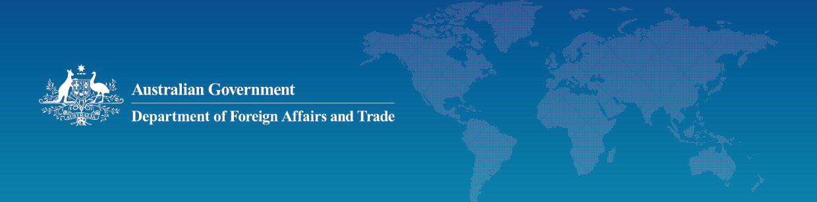Recommendations

In October 2014, DFAT commissioned an independent review of Australia’s aid assistance to the Thai-Burma border. Overall, the evaluation found that Australia’s aid assistance was relevant, effective and efficient. It concluded that the needs in the border camps would likely continue for some time and recommended that Australia continue to provide assistance. Australian assistance was addressing real needs in a difficult environment.

The evaluation made the following recommendations:

1. DFAT should extend assistance in a flexible manner to the border camps for at least a further year and ideally until June 2017, with an option to re-program part of the funding in the event of large-scale returns
2. DFAT’s partners should begin to monitor the outcomes of their assistance rather than only activities and outputs, so that they can better determine which types of assistance are likely to have the greatest positive impact
3. DFAT’s partners should increase the labour mobility of trainees and students in the camps to ensure their skills are transferable outside of the camps
4. DFAT’s partners should continue to mainstream protection and promote inclusion of vulnerable groups
5. Noting some disadvantages of using ethnic organisations for program implementation, make no changes to this model as to do so would not be a worthwhile investment.
6. Future DFAT evaluation of support to the camps should take a broader two-country approach to look at both support in potential areas of return in Burma as well as in the border camps.

Next Steps

In response to the evaluation findings, DFAT will undertake the following actions:

* Continue Australia’s aid to the refugees on the Thai-Burma border by extending support to DFAT’s five partners until 30 June 2016 through flexible funding arrangements to allow funds to be re-programmed in the context of large-scale return
* Continue the deployment of an Australian Civilian Corps Humanitarian Advisor to oversee Australia’s aid investment on the Thai-Burma border, including to ensure flexibility to respond to potential future durable solutions scenarios and the evolving context on the Thai-Burma border and in South-East Burma
* Work with DFAT’s five partners to: strengthen their measurement of program outcomes; improve the ability of their programs to increase the labour mobility of trainees and students; and ensure greater focus on social inclusion of vulnerable groups and mainstreaming of protection in programs
* DFAT will also strengthen preparedness for return activities and build linkages between the Australia’s Thai-Burma border assistance and assistance within Burma, including taking a two-country approach to future program evaluation and design.