FUNDING AGREEMENT DEED

BETWEEN

COMMONWEALTH OF AUSTRALIA

represented by the Australian Agency for International Development

ABN 62 921558 838

and

The University of Queensland

ABN 63 942 912 684

FOR

APMEN Establishment Support Program

AUSAID AGREEMENT53365

Agreement 53365

DEED made  day of 2009

BETWEEN:

COMMONWEALTH OF AUSTRALIA represented by the Austnilian Agency for International
Development ("AusAJD"), ABN 62 921 558 838, of the Department of Foreign Affairs and Trade,

AND

The University of Queensland, ABN 63 942 912 684 of The University of Queensland Sir Fred
Schonell Drive St Lucia QLD 4072 (the "Organisation").

RECITALS:

A. AusAID wishes to provide the Organisation with Funds to undertake an Activity.

B. The Organisation wishes to accept the Funds subjectto the terms and conditions in this
Deed.

OPERATIVE:

AusAID and the Organisation promise to carry out and complete their respective obligations in accordance with this Deed including the Deed Conditions, schedules and any annexes contained herein.

11
Agreement 53365

IN WITNESS whereof this Deed has been executed by the Commonwealth, by an authorised officer, and has been executed by the Organisation by its authorised officer.

SIGNED

for and oh behalf of the

COMMONWEALTH OF AUSTRALIA
represented by the Australian Agency for International Development (AusAID) by

Murray Proctor, DDG Prograni. Enabling Division


Name and Position
FMA Act s.44 Delegate

in the presence of


Name of Witness 
(Print)

SIGNED

for and on behalf of

The University of Queensland by


Maurie McNarn, AO
Executive Director (Operations)

Name and Position
(Print)

By executing this Deed the signatory warrants that he/she is duly authorised to execute this Deed on behalf of the Organisation.

in the presence of

Ann Tilbury


Name of Witness
(Print)

ll1
Agreement 53365

DEED CONDITIONS

1. INTERPRETATION

L1 Definitions
In this Deed, including the recitals unless the context otherwise requires:

"Activity" means the activityAPMEN Establishment Support Program described in the
Activity Proposal for which the Funds ,are provided.

"Activity Proposal" means the specific tasks and budget associated with the Activity included as Schedule 1to this Agreement.

"Agreement" means thi$ Deed including. all Parts and any schedules and annexes.

''Agreement M.aterial" means all material created or required to be developed or created as part of, or for the purpose of undertaking the Activity, includjng documents; equipment, information data, sounds and images stored by any means.

' Business Day" means a day on which AusAID is open for business. "Commonwealth"means Commonwealth of Austtalia orAusAID, as appropriate.
nneed" means this Agreement comprising these Deed Conditions, schedules and any annexes.

'"Fraudulent Activity'', "Fraud" or "Fraudnlent" means dishonestly obtaining a benefit by deception or other means.

"Funds" mea,ns the amot1nt of money as specified in clause titled 'Funds and Payment' of this Agteementthat has been approved by Au AID and pad to the Organisation subject to the conditions outlined in this Agreement for the Activity. ·

"'Independently Audited" means financial records audited by a certified financial professional 'that is in no Way linked or associated with the Activity or the Parties to this Agreement.

''Partner Governmentn means the Government of the Partner Country.

'"Partner Cou.ntry'' means the country or countries in which the Activity is to he undertaken in whole or in part.

"Party''meansAusAID or.the Organisation;

"Personnel" means including Personnel, whether employe(} by the Organisation or engaged by the Organisation on a sub-contract basis or agents or volunteers of the Organisation, engaged in the provision of the Activity,

"Prior Material'' mearis all material developed by the Organisation or a third party independently ftom the Activity whether before or after commencement ofthe Activity.
Agreement 53365

"Relevant List' means the lists of terrorist organisations made UI1der Division 102 of the Criminal Code Act 1995 (Cth) and the Charter of the United NatiOnsAct 1945 (Cth) posted at:htip://wwvv.nationalsecurity.gov.aulagd/www/nationalsecurity.nsf/AllDocs/95FB057CA3
DECF30CA256FABOO lF7FBD?OpenDocurnent and
·http://www;dfat.gov.au/icat!UNSC financial sanctions.html#3

"Similar List'' means· any $imi1list to the World Brulk List maintained by any other donor ofdevelopment funding.

"World Bank Lisf; means a list ofo:rganisations tnaintained by the World Bank in its
''Listing ofineligible Firms" or '"Listing$ of Firms, Letters of Reprimand" posted at:
http;//web.woddbank.org/externalldefaulthnain?theSitePK=84266&contentMDK=6406984
4&rnenuPK=116730&pagePK=64148989&piPK=641489S4

1.2 Deed prevails

If there is any inconsistency (whether e;x:pressly referred to or to be implied from this Deed or otherwise) between the provisions of the Deed Conditions and those ofthe schedules and any annexesthe schedules and any annexes are to be read subject to the Deed Conditions and the provisions ofthe Deed Conditions prevail to the extent of the inconsistency.

2. TERM OF THE AGREEMENT

2.1 The term of this Agreement commences upon execution by both parties being the date indicated at the front oftHis Agreement and continues until all obligations have been fulfilled under tl:).is Agreen1ent, unless terminated earlier in accordance with this Agreement.

2.2 The Organisation 111\,tst commence the Activity nolater than30November2009 and must complete the Act:ivity by 30 June 2011.

3. NOTICES

3.1 Forthe pu:rpose of serving notices to either Party of this Agreement, a notice must be in
Writing and shall be treated as having been duly given and received:

(a) when delivered (if left at that Party's address);

(b) on the third Business Day after posting (if sent by pre-paid mail); oi'

(c) on the Business Day· of transmission (if given by facsimile and sent to th.e facsimile receiver nun1ber· of tHat Party and no intimation Having been received that th:e notice had not been received, whether that intimation comes from that Party or from the operation of facsimile machinery or otherwise),
Agreement 53365

3.2 For the purposes ofthis Agreement, the address of a Party is the address set out below or another address ofwhich that Party may give notice in writing to the other Party,:

AusAlD:

To:

Postal Address:

Street Address: Facsimile:

'0rgani$aJion: To:

Postal Address:

Street Address:

Facsimile:
Asia Pacific Malaria Elimination Network Agreement Manager
Health & HIV Thematic Group '

Australian Agency for International Development
GPO Box887
CANBERRA ACT 2601 AUSTRALIA

255 London Circuit
CANBERRA ACT 2601 AUSTRALIA

+612 6206 4880
0

ProfMaxine Whittaker
Prot: International & Tropical Health

The University of Queensland
Sir Fred Schonell Drive
St Lucia QLD 4072

The University of Queensland
Sir Fred Schonell Drive
St Lucia QLD 4072

073365 5599
fJ

4. GENERAL CONDITIONS

4.1 The Organisation must carry out the Activity in accordance with the Activity Proposal and the terms and conditions of this Deed.

4.2 The Organisation must advise A11sAID immediately of any difficulties or delays in implementation of the Activity.

4.3 The Organisation shall acknowledge in writing to AusAID receipt of the Funds immediately on its receipt.

Agreement 53365

4.4 The Funds and any interest earned or exchange rate gains must be used diligently and for the sole purpose ofthe Activity outlined in Schedule lof this Agreement. Any interest earned
or exchange rate gains mad, on the Funds must ,only be expended on the Activity.

4.5 The Organisation acknowledges that Funds provided by AusAID to the Organisation for this
Activity does not entitle the Organisation to any other or further funding.

4.6 The Organisation shall acknowledge AusAID funding assistance provided under this Deed where appropriate and advise AusAID of matters relating to any publicity and media relations, prior to any publication or media rele&Se.

4.7 The Organisation must :not represent itself and m\Ist ensure that its Personnel participating in the Activity do not represent themselves as being employees, partners or agents ofthe Commonwealth of Australia.

4.8 The Organisation will use its best endeavours to ensure that in its peifonnance of the Activity all Personnel and their dependents, while in the recipient country, respect the laws and regulations in force i:ri the recipient country.

4.9 The. Organisation is responsible for the security ofal1 of its Personnel and for taking-out and maintaining all appropriate insurances.

4,10 The Organisation must not assign its interest in this Agreement without first obtaining the consent in writing of AusAID.

4.11 No delay, neglect or forbearance by either Party in enforcing against the other any term or condition of this Agreement shall be deemed to be a waiver or in any way prejudice any right of that Party.

4.12 This Agreement is governed by, and is to be construed in accordance with, the law of the Australian Capital Territory and the Parties submit to the exclusive jurisdiction ofthe courts of the Australia:n Capital Territory and any court hearing appeals front those co1lrts.

5. DEED AMENDMENTS

5.1 AusAID or the Organisation may propose amendments tQ this Agreement at any tirneJor the purpose of improving the delivery ofthe Activity, the efficiency, cost-effectiveness and development impact ofthe Activity.

5.2 Changes to this Agreement (including to Schedule 1 and any annexes) shall only be effected if agreed in writing ands gned by both Parties in the form of a Deed of Amendment.

6. PROCUREMENT OF GOODS

6.1 The Organisation must not use the Funds to acquire any asset, apart from those detailed in the Activity Proposal without obtaining AusAID's prior writte.n approval. Subject to the requirements of this clause;the Organisation shall own the assets acquired with the Funds unless specified otherwise. in the Activity ProposaL

6.2 If the Funds are being used to procure goods, the Organisation must ensure in its procurement of the goods that:

(a) the goods to be procured are of a satisfactory quality;
Agreement 53365

(b) the goods shall be delivered in good order and condition and in accordance with the - Activity timetable;

(c) the price paid for goods procured represents value for money;

(d) there is open and effective competition in the purchasing process to the extent practicable; and

(e) a professional approach is reflected in the purchasi.ng process including ethical behaviour and fair dealing,

6;3 If the Funcis are being used to procure goods, the Organisation must maintain a Register of Activity Assets. The Register shall re_cord non consumable items funded under this Agreement or supplied by AusAID to theActivity which have a value of AUDl,OOO (or equivalent) or moreIn addition non-consumable items of a portable and attractive nature with a value of less than AUDl 000 (or equivalent) shall also be recorded. The Register shall show date ofreceipt ofthe asset at the Activity site, the cost, the p:utchase/payment document date and reference number, a description and identific(,ltjo;n number, and the
location ofthe asset. Disposal or write-off of AusAID funded or provided assets shall be as agreed in Writing by AusAID. The Register .and other relevant documents such as import papers and manufacturers' warranties relating to the assets shall be available for audit as required by AusAID. The Register shall be recouciled with Activity assets at least every· twelve- months and the results of that reconciliation included in the Annual Reports required in clause titled 'Reports' in this agreement.

7. MONITORING AND EVALUATION

7.1 The Organisation must, if required by AusAID, permit AusAID to monitor and/or evaluate the Activity and/or use of the Funds. AusAID shall give the Organisation at least two (2)
weeks notice ofits intentions prior to commencing such a reviewIn that event, the
Organisation must cooperate fully vvith any request for assistance pursuant to any such
study.

8. INDEMNITY

&.1 The Organisation must at all times indemnifY AusAID, its employees, agents and contractors (except the Organisation) ("those indemnified") from and against any loss or lhibility whatsoever sl,lffered by those indemnified or arising from any claimsuit, demand
action or proceeding by any person against any of those indemnified Where such loss ot
liability was caused or contributed to in any way by any wilfully wrongful, unlawful or
negligent act or omission of the Organisation, or any ofthe Organisation's Personnel in
connection with this Agreement.

8.2 The Organisation agrees that AusAID may enforce the indemnity in favour of the persons specified in Clause 8.1above for the benefit of each ofsuch persons in the name of AusAID or of such persons.

8.3 The indemnity in this Clause 8 is reduced to the extent that the loss. or liability is directly caused by AusAID, its employees, agents or contractors (except the Organisation), as substantiated by the Organisation.

8.4 This indemnity shall sur\rive termination or expiration of this Agreement.

9. INTELLECTUAL PROPERTY RIGHTS

9.1 In this Agreement unless the context otherwise requires:
Agreement 53365

(a)

(b)
"Contract Material" means all material created during the course ofthe Activity;

"Contractor Personnel" means personnel either employed or engaged by the Organisation on a sub.:.coritract basis or agents of the Organisation engaged in the Activity;

(q) ''ln elledul PrQ;petty'' means business names, copyrights, patents, trade marks, service markstrade names, designs and similar iml\tstri:al, commercial and intellectual property;

(d)
"Prior Material" means allmaterial developed by the Organisation or a third party independently of the Activity whether before or after commencement of the Activity.

9.2 Subject to clause 9.3, the title to all Intellectua1Ptoperty rights in or in relation to Contract
Material shall vest upon its creation in the, Organisation.

9.3 The Organisation grants to AusAib a permanent, irrevocable, royalty-Jree worldwide, non
exclusive licence to:

(a) use;

(b) reproduce; and

(c) with the prior written consent of the Organisation,. adapt:

, the ContractMatetialinclu<fing any Prior Material in conjunction with Contract Material for non.,.commercial purposes. The licence granted under this clause 9.3 includes the right of AusAID to sub..lic.ence any of its employees, agents or contractors to:

(d) use;

(e) reproduce; and

(f) with the prior written consent of the Organisation, adapt:

the Prior Material incorporated into the Contract Material for non commercial purposes of perfonningfunctions, responsibilities, activities ot senrices for, or on behalfo:f; AusAID.

9.4 The Organisation will use its best endeavours to obtain frorn each Contractor Personnel who may ptod.1Jce Contract Material, a moral rights waiver to use of the Contract Material by AusAID or others in accordance with clause 9.3.

10. COMPLIANCE WITH LAWS, GUIDELINES AND POLICIES

10.1 The Organisation andits Personnel must have regard to and c'omplywith, relevant and applicable laws, guidelines, regulations and policies, including those.in Australia and in the Partner Country. A list.as amended from time to time, of Australian laws and guidelines
that may apply to the delivery of developmental aid to foreign countries can be found on the
AusAID website: http://www.ausaid.gov.au/business/contracting.c:fin. this list is not

Agreement 53365 ·

exhaustive and is provided for infonnation only. The provision of this list does not :relieve the Organisation from complying with the obligations contained in this clause headed
'Compliance with Laws, Guidelines and Policies'.

10.2 The Organisation must have regard to and comply with the Statementoflntemational
Development Practice Principles located at Schedl!l2 to this Agreement.

10.3 The Organisation must comply with:

(a) AusAID's Child protection policy.
(http i!www.ausaidgov.aulpubHcationslpubs.cfin?Type::::;:PubPolicyDocuments) and pl:lliicUlarly the child protection compliance standards at Attachment 1to the policy.
AusAID may audit the Organisation's cotnplian.Ce with AusAID's Childprotection
policy and child protection coll1pliance r;tandards. The Organisation must participate cooperatively in any reviews conducted by AusAII);

(b) The strategy 'Development for All: Towards a Disability-Inclusive Australian Aid
Program 2009.;2014'
(:!!www.ausciidgov.au/publicationslpdf/FINAL%20AusAI Disabilitv%20for%
20All.J2d[), and in patticular the strategy's six guidg principles.

10.4 The Organisation must Ul)ehs best endeavours to e11sure.:

(a) that inciividuals or organisations involved in iniplementing the Activity are in no way linked, directly or indirectly,to organisations and indhriduals associated with terrorism; and

(b) that Funds provided under tlus Agreement are not used in any way to provide direct or indirect support or resoilrces to organisations and individuals associated with terrorism.

10.5 The Organisation must have regard to the.Australian Government guidance ''Safeguarding your organisation against terrorism fmancing: a guidance for non-profit organisations," available at http://www.nationalsecuTitv;gov.au/npo.

10.6 If, during the course of this Agreement; the Organisation discovers any link whatsoever with any organisation or individual listed on a Relevant Listitmust infonnAu$AlD immediately.

10.7 If, during the course of this Agreementthe Organisation is listed on a World Bwk List or
Similar List it must infonn AusAID immediateiy.

10.8 The Organisation agrees that:

(a) The Organisation and its employees, agents, representatives or its subcontractors must not engage in any Fraudulent Activity. The Organisation is responsible for preventing and detecting Fraud.

(b) The Organisation must report in writiQg within five (5) working days to AusAID any detected, suspected, or attempted Fraudulent Activity involving the Activity. Aus.AII) may direct the Organisation to investigate the alleged Fra 1d and the Organisation must undertake an investigation at the Organisation's cost and in accordance with any directions or standards required by AusAID.
AgteellJ.elit 53365

(c) Following the conclusion of any investigation which identifies acts of a Fraudulent nature, the Organisation shall:

(i) make every effort to recover any AusAID Funds., the subject of Fraudulent
Activity;

(ii) refet the matter to the relevant police or other authorities responsible for prosecution of Fraudulent A tivity; and

(iii) be liable for the repayment of any Funds amounts misappropriated by the
Organisation, its agents; representatives or sU:bcontr :J.ctors

(d) (e)
The obligations oftheOrganisationunder paragraphs (b) and (c) above shall S!Jrvive the expiration of this Agreement.

The Organisation warrants that the Organisation shall not make or cause to be made, nor shallthe Organisation receive of seek to receive, any offer, gift or payment, consideration or benefit of any kind, whi.ch would or could be construed as an illegal or corrupt practice, either directly or indirectly to any party, as anindu.cement or reward in relation to the execution of this Agreement. In addition, the Organisation shall not bribe public officials .and shall ensure that its delivery organisations comply With this provision. Any breach of this clause shall be grounds for immediate termination ofthis Agreementby notice from AusAID.

11. TEJWINA':{ION

11.1 If the Organisation:

(a)

(b) (c)

(d) (e)

(f)
becomes.or AusAID considetsthete is ateasonaltle prospect of the Organisation becoming bankrupt, insolvent; deregistered or no longer able to undertake the ACtivity to a standard acceptable to AusAID;.

makes. an assignment of its estate for: the benefit of creditors orenters into any arrangement or composition with its creditors;

fails to commence, or in the. opinion of AusAID, fails to make satisfactory progress in canying out the Activity and suchfailure haS not been remedied within the time specified in a writtenrequestfromAusAID to remedy the failure;

assigns its interest in this Agreem n:t without the consent in writing ofAusAID;

is, during the term of this Agre menr, listed on a World Bank List, Relevant List or
Similar List; or ·

breaches any term of this Agreement and such breach has not been remedied within the time stipulated in a written request notice from AusAID to remedy the breach;

then in every such ca:Se AusAID shall be entitled to temJ.inate tllis Agreement forthWith but without prejudice to atty of its other tights.

11.2. ln addition, either Party may terminate this Agreement by giving to the other a notice to terminate iiJ. writing stating the reasons for termination.

Agreement 53365

11.3 A.usAID.may terminate this Agreement immediately by notice in writing to the Organisation
it'the Organisation breaches any of its obligations under Clause 10.

l L4 IIl the event of any termination, the Organisation must provide an Independently Audited statement of expenditure of the Funds within thirty (30) days of the date ofthe notice to terminate, signed by the head of the Organisation, and return any unco01111itted unspent Funds to. AusAID.

11.5 In the event that a. notice to terminate is given by either Party the Organisation must:

(a) immediately and forthwith do everything possible to prevent and mitigate all losses, costs and expenses arising in consequence of the tertnination of this Agreement and shall in a prompt and orderly manner cease expenditure of any uncommitted Funds for the Activity; and ·

(b) · refund any uncommitted part of any tranche or Funds already paid by Al1sAlD, together with any uncommitted or unspent interest, within thirty (30) days of the date of the notice to terminate. ·

11.6 In the event that a notice to terminate is given by either party AusAID shall not be liable to pay compensation in an amount which,. inaddition to any afl:lotints paid or due or becoming due to the Organisation under this Agreementtogether would exceed the amount of the total
. finan.cial limitation ofthis Agreement, as specified in clause headed 'Funds and Payment'.

12. ACCOUNTS AND RECORDS

12.1 The bank account used by the Organisation must be in the name of the Organisation and must not be a personal bank account

12.2 The Organisation must maintain a sound administra:tive and financial system capable of verifying all statements of acquittaL In addition, the Organisation must:

(a) keep proper and detailed accounts, records and assets tegisters along with adequate Activity management records providing clear audit tm:ils in relation to expenditure under this Agreement;

(b) afford adequate facilities for audit and inspection of the financiaLrecords referred to in this Agreement by AusAlD and its authorised representatives at all reasonable times and allow copies and extracts to be taken;

(c) the accounts an:d records must be held by the Organisation for the term of this Agreement and for a period of seven (7) yeats trom the date· of expiry or termination ofthis Agreement;

(d) if requested by AusAID, provide an acquittal,. certified by the senior financial officer or the head of the Organisation; ofFunds spent to date against the budget in the Activity Proposal; and

(e) ifreasonably requested by AusAID, provide art Independently Audited statement of
Activity e?Cpenditure by all auditor nominated by AusAIDat no cost to AusAID.
Agreement 53365

13. AnsAID USEOF AGREEMENT INFORMATION

13.1 AusAlD may disclose m tters relating to this Agreement, hicluding this Agreement, and other relevant information, except where such information may breach the Privacy Act 1988 (Cth), to Commonwealth govemmental departments and agencies, Commonwealth Ministers and Parliamentary Secretaries, and to the Commonwealth Parliame11t, including
responding to requests for information from Parliamentary committees or inquiries; In addition;. AusAID may publicly repot:tinfonnation regarding. this Agreement. This clause shall survive termination or expiration of this Agreement

14. REPORTS

14.1 The Organisation shall submit an annual report, on the anniversary ofthe Activity Start
Date, which should not exceed five (5) pages and which has two basic parts: (a) A review of implementation progress to date; and
(b) An implementation strategy and work program for the coming period that:

(i) incorporates any lessons from the· assessment of Activity progress;

(ii) outlines the expected outputs and development results of the proposed program ofwork;and ·

(iii) desci'ibes the inputs, work and outputs of both the Organisation and any other key stakeholders,

14.2 Within thirty (30) days of completion of the Activity the. Organisation shall submita final report which proVides an outline of the completed Activity and in more detail covers key outcomes compared with objectives, development impact, sustainability and lessons learned.

14.3 Attached to the final .report will be a statement acquitting all of the Funds ('final Funds acquittal'), The statement must acquitthe Funds against the budgetreferred to in the Activity Proposal and must be signed by the senior financial officer or the head of the Organisation, indicati!lg that the Funds have been spent in accordance with the terms of this Agreement. Any unspent Funds1. interest earned or exchange rate gains· must be epaid to AusAID with the final report and final Funds acquittal. The final Funds.acquittal must include details ofany interest earned or exchange rate gains on the Funds. J11e final Funds acquittal acquitting all Funds shall be subject tothe intemal and external auditing procedures laid down in the ru1es and regulations applicable. to the Organisation and must also be Independently Audited and certified. The cost ofan independent external audit reqUired by tllis clause may be payable from the Funds.

14.4 The annual .report and final report with attached statement acquitting all Funds should be sent to:

Asia Pacific MaliDi.a Elimination Network Agreement Manager
Health & HIV Thematic Group
Australian Agency for Intemational Development
GPOBox887
CANBERRA ACT 2601 AUSTRALIA
LucyPhillips@ausaid.gov au
Agreement 53365

in the following format:

(a) one bound hard copy; and

(b) one electronic version in PDF (Portable Docu111ent Fornl,:oi.t).

15. FUNDS AND PAYMENT

15.1 Funds up to a maxitrrum ofAUD3,000,000,001 plus GST if any up to a maximum amount of AUD30Q,OOO shafl be payable as anacquittable. grant by AusAID iu annual tranches divh1ed as follows:

Indjcatlve :Date | Tranche  Npmber | Amount of Funds (AUD)
R fer to Clause 15 2  ofthis.Agreement | 1 | 700,000
Within 30 days of AusAID and APMEN Assembly approval of  2010 work plan (Jan- Dec) and budget | 2 | 700,000
Within 30 days of  AusAID acceptance of  . the Acquittal Report for the first and second funding tranches and the Six-monthly  Acquittal Repmt for the first half of the 2010 year (Jan-June) | 3 | 800,000
Within 30 days of AusAID acceptance of the Six.-mornhly Acquittal Report for the second half of2010 (July-Dec)and AusAID and APMEN Assembly approval of2011 work plan (prior to 30 June  2011) and budget and Final Funds Acquittal refer to Clause 14.3 | 4 | 800;000
Total |  | ,000,000

15.2 Tranche 1 shall be payable by AusAID within thirty (30) days of the date of this Agreement and receipt of a valid invoice. Subsequenttranches shall be payable subject t() the provisi()n
Agreement 53365

of a statement of acquittal, a valid invoice and subject to satisfactory progress as determined by AusAID. The statement of acquittal must be signed by the seni<>t financial officer or the head of the Organisation indicating that the Funds being acquitted have been expended, in accordance with the terms of this· Agreement.

16. CLAIMSFORPAYMENT

16.1 Invoices tnust be submitted when due in accordance with this Agreement, in a form identifyingthis Agreement title and AgreementnUm.ber 42721/9·. Invoices must also contain the PaymentEventnumber(s) notified by AusAID.
16.2 All invoices must be made to: Chief Finance Officer
Australian Agency .for International Development
GPO Box 887
CANBERRA ACT 2601 AUSTRALIA

16.3 Invoices should be sent to the above address. Altematively AusAID will acceptelectronic invoices. These can be sent to accountsprocessing@ausaid.gov;au

16.4 Where AustraliGST applies to this Agreementall invoices n::mst be in the form of a valid tax invoice:, Invalid tax invoices will be returned to orggnisations. Information .on.what constitutes a valid tax invoice can be found at http://www.ato.gov.aulbusinesses/content.asp?doc=/content/50913.htm

12

SC$DULE 1- ACTIVITY PROPOSAL

TO FUNDING AGREEMENT DEED NUMBER 53365

ACTIVITY PROPOSAL

APMEN EstablishmentSupport'Prog:ram

Following the inaqgural APMEN meeting in February 2009and the subsequent consultation with Network members and with AusAID on the objectives, structures @.nd the processes of APMEN, AusAID and the University of Queensland (UQ) have agreed to tdesign, doctJment (Asia Pacific MalatiaElimination Network Establishment Support Program (APMEN -ESP) Draft Activity Design DoctJment; 28 September 2009) that will form the basis for AusAID support to APMEN through UQ. While AusAID
recognises that the detail ofNetwotk operations is subject to agreefr1entby members at the
February 2010 APMEN Assemblythis Activity Proposal outlines UQ's role anq
AusAib's expectations in relation to the funding to be provided to UQ for APMEN.

The overall responsibiHtie's ofUQ are to undertake the Secretariat functions as outlined in this Schedule, following the direction of the APMEN Assembly and Advisory Board and adhering to the processes and conditions of this agreement

Goaland Objectives

1. Goal of the Asia Pacific Malaria Elimination Network

The goal of the Asia Pacific MalariaElimination Network (APMEN) is to dev lop and sustain a network of partner countries and institutions to work collaboratively to address the challenges of malaria elimination in th.eAsia Pacific Region, withparticularfocus
on the unique challeuges for the region such as P.vivax.

2. Primary Objectivs of the Asia Pacific Malaria Elimination Network

The objectives of APMEN are to:

a) Share information and develop expert consensus on issues relating to malaria elimination, in order to support policy and decision making at the country level.

' '
b) Support country decision making through building of the evidence base for
111ll.Iaria elimination, with a particW.ar focus on Pll::lsmodium vivax.

c) Increase expertise and capacity to carry out elimination activities through guidance, training, and sharing of experiences.

d) Provide leadership and advocacy for malaria elimination in the region by expanding international and domestic awareness, funding, and st1ppoi1:. ·

e) Facilitate support for emerging priorities for malaria eliJ.hint3,tion especially in the Asia Pacific Regions.

f) Provide develop a governance structure suitable for the network and provide Secretariat support of governance inftastructqre and smooth c.oordination and to enable efficient work ofNetwork.

Program Components

3. Details of the current program components are outlined in Annl;!:x;e 0 of the APMEN ADD. The work plan commences with an Inception Phase setting up and establishing work plans, governance structures and processes, and the Secretariat; and identifying priority needs on the focus areas of work identified by APMEN I meeting. The remaining workplan activities 2010-2014 focus on priority areas in:-

1. Information sharing and consensus building
o Website
o Reviews of technical strategies for elim.ination
o Annual meeting

2. Building the evidence bases for decision support
o Documenting evidence on elimination,
o P vivax diagnosis, treatment, control and elimination strategies and tools,
o Vector control;

3. Tecbnieal guidance anq capacity IJUilding
o Study tours · ·
o Fellowships
o Training
o Technical assistance

4. LeaderShip knowledge management and advocacy

5. Facilitating emerging priorities
o Cross border issues
o Community Mobilization (The full program of community mobilization work was not defined at the .APMEN I meeting- and will be developed at APMEN II after the review activities are completed.. Funding will be sought form the emerging priority :ti;!volving fund and other donors),
o Modeling
o Economic analyses

6. Governance and Secretariat functions.

4, APMEN activities are intended to be implemented by all APMEN members, and other appropriate qualified partner institutions aJ.J.d individuals Within the region and broader internationally.

Program Budget

5. The APMEN Program has been designed as a. five year rolling vrogr m,. with the
Annual Work plan to be approved ai1d funded by the. APMEN Assembly.

6. The current five-year Program aJ.J.d may change as a result of consultation, with the Network and the decisions of the APMEN Assemblies{voting decisions will be made by the country representatives). The Inception Phase Work plan and 2010/2011
Program are attached as Annex 0 "APMEN Inception Period, 2009 - Detailed Workplan/ Cost Estimates/ Funding Needs";. and 0 "APMEN YEAR l, 2010- Detailed Workplan/ Cost Estimates/ Fl,lllding Needs".

7. During the period to January 2010 (Inception Phase) major priorities are to:

• develop the founding documents and achieve consensus an1ongst APMEN
participants;

• submit these foundation documents to the APMEN Advisory Board forreview and fmalisation;

• after finalisation, presentthe documents to the Network;

• establish Network processes and fratnework within six to nine months of the first year of the five year period offoundation; and

• use processes a11d framework to identify important performance measures which will inform the approach to Section4b, "Monitoring and Evaluation."

8. The development and endorsement of the APMEN Annual Work Plan is a central pillar of the Network's responsibilities. All research activities proposed in the APMEN Annual 'Work Plan Will be referred to the APMEN Advisory Board for assessment and to res0lve any apparent conflicts of interest.

APMEN Governance

9. In order to develop the ,governance. and ma}lagetnent structures needed to sustain long term support to participating countries pursing elimination programs, it is important for there to be both an independent APMEN Advisory Board (Board) and an effective APMEN Joint-Secretariat (Secretariat). These governance bodies are the {'glue'' that will guide and manage implementation of Al'MEN Annual Work Plans as the majority of APMEN participants go about t!J:eir daily work.

10. The develepment and endorsement of the APMEN Al1ll:ual Work Plan is a central pillar ofthe Network's responsibilities. The creation of the Wo.rk Plan must be a transparent process in order to avoid a situation in which agencies fund and undertake research that is not relevant or not supported by the Member Countries.. To avoid conflicts of interest
in identification and funding of Network activities, the Joint-Secretariat and individual

Work Groups will need to develop clear. decision making and budget allocation processes. All research activities. proposed in an APMEN Annual Work Plan for APMEN funding will be referred to an independent APMEN Advisory Boarwhich is an nbjective way for APMEN to assess and resolve @Y apparent conflict of interest
matters that arise. • ·
11. The three elements comprising the governance structure of APMEN - the Network,
Advisory Board, and Joint-Secretariat- are described iii Figure 1.

APMEN O:rganogram

APMEN Network
and co-chairs


Decisicm making



IJoint-Secretariat
Coordfnat:io
n
Advisory Board

<Si!idcmce,advising" and conflict resolution


Figure 1: TheAPMENNetwork

Members: A majQr principle of APMEN is to maintain a focused and efficient network. Thus, membership islimited and consists of recognized representatiVes ofAPMEN participating countries and partner institutions (Annex 6) formalized by popular consensus. at the APMEN I Meeting in February 2009. Additional individuals or institutionsmay be invited to atteild 1neetings as.Observers.

12. APMEN members and participants are expected to. consist of three groups.

1. PartiCipating Countries- are those in. the Asia Pacific region, (defined as those countries within the World Health Organization's South-East Asia and Western Pacific Regions). which have decl ed (within their' national malaria plans or similar national plan document) a gqof emhatki11g Oill1lalaria elimination at the national or sub.,national level; and in whose national jurisdiction APMEN participants may propose both resear.ch and elimination activities.

The fo11nding ten participating countries are Bhutan, China. Democratic Peoples
Republic of Korea (DPRK.);, Indonesia, Malaysia, Philippines, Republic of Korea
{ROK). Solomon IslandsSri Lanka, and Vanuatu. Participating Cou;ntries are represented in the Network by a maximum of two representatives per country,
seLected by the country's Ministry Of Health or National Malaria Control Progran1. Procedures for induction of new members are outlined below. Decisions on work programs and budgets will be made by pmticipating country members.

2. Partner I;nstitutions - are dt wn from public health, academic, and private sector institutions in the Asia Pacific region that have & strong focus on malaria and malaria elimination. They have indicated their willingness to participate in, fund, support (e.g. through technical assistancehannonisation of their activiti s), an<.l/or undertake joint or complementary research and elimination activities. These
partners are expected to provide inpUt and feedback to Network work plans and activities at and in between 1neetings. Representatives are selected for their individual contributions to the Network

3. Observers- may be repres ntatives from other institutions from the region, an<.llor malarious Asia Pacific countries that have not yet established nFJ.tional elimination policies and targets, but are considering doing so as part of their National Malaria Control Program. Observers may be invited by theAPMEN Network co-chairs to attend and/or p(lrticipate in APMEN proceedin.gs or activities, but participation by
Observers is not binding em APMEN ex¢ept by consensus amongst APMEN
members. Observers are not eligible to vote on any APM.EN matters and have no
rights ofveto orparticipationin any APMEN proceedings or activities.

13. Role: A general list of anticipated roles and responsibilities of APMEN Network members is described below:

1. Represent their couritry or institution;

2. Support development and approval of the APMEN Annual Work Planincluding providing input on prioritization of Work Plan activities;

3. Provide input, and endorse or object to govemancestnlcture issues;

4. Engage in and support or mru1age implementation of the APMEN·Work Plan, including activities in APMEN countries;

5. Attend and participate in annual Network meetings (substitutes are heavily discou,raged);

6. Review progreSS' reports and petfonnance reports of the Network;

7. Communicate and advocate for the Network; and

8. Share information and communicate progress anc!. lessons learned within own country or institution.

·14. APMEN Co-Chairs: The network wi.Il }lave co-ch s; one country representative <ind one partner institution representative each selected by their constituency within the Network. Between meetings, the chairpersons will play a decision-making role in consultation with the Advisory Board and Joint-Secretariat. Co-chairs will als.o be responsible for fielding recommendations or requests to join the network by countries and partner institutions. Co chairs will be selected at the annual meeting by two-thirds vote of the APMEN membership (both countries and partner institutions), and will serve ternis of at least two years.

15. Approval of New Network Members: As other malarious countries in the APMEN · region fotrnally endorse elil:nination as part of their national malaria programs, they Will be invited to attend the next Network meeting as an Observer, and be proposed to the
Network as a future member. No.minated eountries will be in. vi. ted to become full

membe:rs upon approval by the Network. New part:iler institUtions will. be approved by consensus of the Network co-,c]lairs, paying heed to the APMEN principle of maintaining a. focused and efficient network. The Network co-chairs invite these people to member meetings.Full election will be at the 2010 Assembly.

16. Voting Rights: To ensure that APMBN's goals and activities support country priorities, only Member Countries will have tights to vote on the final approval of the APMBN Work Plan, governance arrangements, reviews and progress reports. Out of respect for sovereignty, it is further. proposed that APMEN Member CQtmtrle.s have the tig]lt to Veto any activity in an APMEN Ai:mual Work Plan. prop0sed for their national jurisc:lictiol1 which they "cannot live with.;j Upon applying their Veto, the APMEN activity may be adjusted to implement in other jurisdictions, but not in that of the vetoing Member Country. Partner Institutions and Observers are encouraged to provide
input on theAnnual Work Plan and.Progress Reports but are ;ttot able to cast the final vote in the final approval of the Work Plan.

17. Annual Network Assemblies: The Network will meet once annually ii;l a member country, hosted by the country or member institution.·n1is will be a. combination of the technical meeting G2 day$) and annual Assembly (l day).. The, Technical meeting is a venue for information sharing and knowledge exchange about malaria elimination
activities. The Assembly will serve as the planning and decision-making body. The Network co-chairs will present the proposed annual Work Plan to the Network at the Assembly with the assistance of the Joint-Secretariat. If there are concerns about the Joint-Secretariat, the Joint Secretariat may·be asked to step out of the room to facilitate candid discussions. Agreement by consensus is required for .&11 decisions presented during the meeting. Unresolved conflicts will be forwarded to the Advisory Board for investigation and· resolution. Minutes will be taken by the Joii;ltiSecretariat and
approved via email by Network members. Following approval, an annual communique will be released to all members and posted on the Network website, by the Joint Secretariat host responsible for the website.

The APMEN Advisory Board

18, Membership: The Advisory Board will.representthe diversity ofAPMEN members, in background and expertise.The Board will have up to eleven voting members.

a) Five positions dra\Vn from the APMEN Network rnernbershipj comprised of:

• three. Country Member representatives; and

• two Partner Institution ;epresentatives.

b) Two WHO representatives, one each from SEARO and W:PRO;

c) Two Secretariat positions, one from each of the two organisations comprising the
Joint-Secretariat; and ·

d) MaJor do11ors to APMEN may also be invited to become ex-officio members of the
Board.
19. The Board chair, selected by the Board members, will have an administrative .and leadership role while coordiilating with the Joint-Sectetariat. Board members will be requested not to send a substitute ifthey are not able to attend a meeting. A quorum will be three members, with at least one Country Member and one Partner Institution
\F\lE\ l;;l

representative ptesep.t. Any Bo rd tn;errtber may be asked to absent themself from discussion of any tQpic for which there inl:l:Y be a perception of conflict of interest.
Annual Network Assemblies may make decisions that vthe membership, role and operating rules for the Advisory Board.

20. Process for selection: Candidates for country and institution seats will be proposed by Netwqrk membership. Country members will nominate both country member representatives and ouj:side Network agencies, Member partner institutions will nominate partner ip.stitution representatives. To establish the initial Board_, the Joint Secretariat called for nominations in September 2009; which were due in October. Candidates With the top number of nominations will be proposed as board members, sqbject to final confirmation at the following Network meeting; At least 25% of APMEN members must submit nominations for process to be considered valid. The Secretariat will callfor additional rounds of nominations until this threshol<i is achieve<!. The Joint-Secretariat will liaise with nominated Board memb.ers to review roles and responsibilities, Nominated Board members will be asked to make a written statement asc.ettainin$.anY potential conflicts·.ofinterest If the nominated Board member accepts the nomination, he or she will join. the Interim Board. This interim Board membership will operate until the February 2010 APMEN II meeting, when Interim 'Board will obtain formal appointment pending ratification by the Network, the Interim 'board will provide guidance to the Joint-Secretariat..

21. Teri11s of Service: Board members will serve staggered terms of three years after which they may be re-nominated to serve another term. there: is no limit to the number of tenus, members may nominate, Among the first Board members, 50% will he. two years terms and 50%3 years tem1s, split across membership categories.

22. Role: The Board will work with both the Network and the Joint..Secretariat to 1\Jlfil its main role - to stay informed of current initiatives, monitor progress of Work Plan activity implementation, and provide input and insight: it is considered to be an expert consultative mechanism. The Board. is expected to facilitate and support the implementation ofthe Assembly's decisions by the co-Secretariats, and is responsible for resolving any conflicts that rnay arise. The Board's decision-making powers will be as delegated by the Assembly. The Boaxd n1ay seek the advice of additional outside experts as needed.

23. Specific Board member responsibilities in $upporting the implementation of Assembly decisions may include the following: ··· ·

a) Attend yearly meetings of the Board, one face to face and one held by phone, email or videoconference; ·

b) Provide advisory input on APMEN strategy ap:d implementation;

c) Provide an expert review process of the Annual Work Plah and additional proposals;

d) Resolve conflicts that aiise between or among members or working groups, including mediation of potential conflicts of interest, through investigation and resolution (see clause 24 below);

e) Oversee the activities of APMEN programs and the distribution of funding among worki11g groups;

t) Provide peer revieW for APMEN activities, and related progress reports and reviews, assllring the quality, cost effectiveness and timely implementation of APMEN research and programmatic activities


g) IdentitY and network with potential APMEN donors while communicating and coordinating these efforts with thNetwork and Joint-Secretariat;

h) Use appropriate processes $4.proced:u,res to Q0l1duct out ef sessien processes)
including effective communication anci networking;

i) Approve the record of proceedings the APMEN Annual Meeting prepared by the Secretariat,

j) Preside over possible transitions ofJoint·Secretariat from one institution to the next; and setve as or ensui'e appropriate interim Secretariat as needed.

24. Conflict Resolution:lf.conflicts arise, network members will alert the Joint-Secretariat, which will investigate and prepare information for the Advisory Board. The Board chair
will de.cide whether to convene a special session or communicate the details to the
Board for the next scheduled meeting. A consensus on the matter will be reached, but if
there is no consensus, decisions will be made by a two-thirds vote. The Bol:(rdwill hand down the decision to the Joint-Secretariat, which is tasked with commwncating the results to individual and Network members as appropriate, APMEN network members,
individually ()t as a group, may approach rnerobers of the Board directly ifthey see fit _:
this will allow members to raise issues or concerns about the. Joint-Secretariat. A
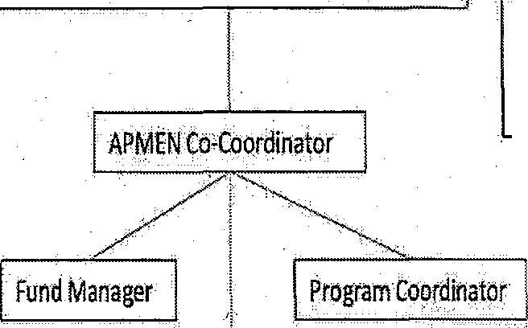
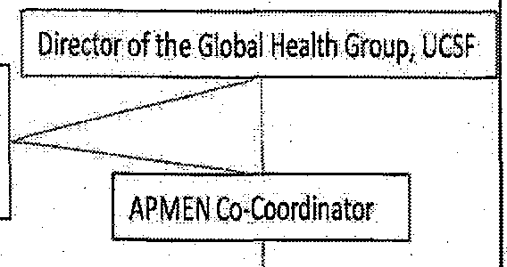
proposed organizational chart for the Joint-Secretariat is found at Figure 2.

APMEN Joint secretariat Organizational Chart

Uni ers!ty of Queensland Secretariat
{Brisbane}
UCSF.GHG.Secretariat
(SanFrancisco}

Head of the Schoolof PopulationHealth,UQ

Chief Operating Officer of the Global Health Group & FulldM11nager for APMEN





Figure 2 -Proposed APMEN Joint-Secretariat Q:rgan,isati<»nal Chart

25. The inception ph!lse will seek the development of discussion papers to the APMEN Assembly and Board members for review and approval on governance structures of

APMEN, website development and use, facilitation of discussions and proposals for APMEN f)upport and the process of support to vivax and vector control working groups, process ofthe fellowships, research support and study tour programmes.

26. The Joint-Secretariat roles and the hosting of the Secretariat will need to be independently appraised and evaluated by APMEN during and at the end of the initial five year term; after which, the University may be engaged to continue, and/or share the Joint-Secretariat role with other candidates; and be funded in this role by AlJsAID, andlot other instiWtions.

The APMEN Joint-Se.cretariat

27. The APMEN Jqint-SecretEu;iat consists of representatives from the University of
Queensland; Brisbane and the Global Health GroupUniversity of California, San
Francisco.

28. The APMEN Joint-Secretariat is responsible for supporting, facilitating and harmonizing all APMEN activities, and works with the Advisory Board to guide and manage the implementation of all activities. The Joint-Secretariat will ensure transparent decision making and allocation of APMEN funds in accordance with Assembly and Board advice, and provide for advance dialogue on all major proposals during the lead-up preparations to any annual Work Plan and meeting. A key role for
. the Board and Secretariat is to ensure that volunteer APMEN participants are properly briefed: and already engaged in the process of consultation well before being asked to provide their consensus views.

29. The general allocation ofroles within the Joint-Secretariat will be as follows:

• The University of Queensland will provide lead coordinat.ibn and fund :management for activities and subcontracts funded by AusAID and coordination of meetings, working groups, and capacity building work.

• The UCSF . Global Hea:lth Group co Secretariat will do the same for activities funded by the Gates FoundatiOIJ,.

• Funds from other donors .will be managed through either Secret at, as felt to be appropriate by the donor.

• Both members of the Joint-Becrefariat play key roles in ensuring implementation of evidence building and information sharing activities;

30. Strong communication will be critical to avoid duplication of efforts or conflicts between the Joint...Secretariats. Secretariat staff will jointly develop annrtal work plans
. assigning responsibilities and timel:ines, and will meet regularly through monthly planning meetings and frequent email and phone contact, and will meet annually in
person. likely at a Network meeting. The Advisory Board will provide support in resolving any potential conflicts between the Joint-Secretariats. The Joint-Secretariat will also develop its own clear work plaris and coordinate amongst itself through quarterly planning calls and annual in•person meetings,

31. Joint Co...Secretariat duties specifically include the following:

i Develop guiding principles, governance stmcture, and procedures for APMEN to be reviewed and endorsed by the Network;

ii Coordinate meetings in partnership with country or institution co-host; ensure strong meeting preparation, oversee contracts and b(ldget, and eJ1Sure all bills Paid on timely basis (GHG and tTQ);
iii Pr.epare =annu·al Work Plan in .c·onsultatiOn with Network member ., Advisory.
Board and Working GrQups and ensll,I'e accordance with APMEN Activity Criteria
(listed below); ensure regular communication; facilitate Work Plan review and
approval process (UQ);

iv Coordinate and support implementation of Work Plan through 1) management and allocation. of funds in accordance with ali agreements; 2) implementation and management of contracts or ,sU;b;.awards; 3) approval of expenses and bill paying;
4) provision of administrative support to meetings and working ,groups (each member of the Joint- Secretariat will manage' according to the activity group and related funding agency) (GHG- for BMGF and UQ for AusAID);

a) The University of Queensland Will take the. lead responsibility for the following activities in the wotk plan:

• managing funds provided to t1:re University as the APMEN Secretariat for research grants, fellowships, study tolli's, Annuri) Assembly and. scientific meeting and Secretariat management functions;

o training program management;

o knowledge management including maintenance of an
APMEN website;

• contracts management related to rese&rch grants;and

• mfrinteuance of in-house management capacity at the UQ
SPHincluding reporting functions,

b) The GI:IG will take the lead responsibility for:

• advocacy;

• case study documentation and document translation; and

• funding for GHG related activities will be sought from a separate Foundation donor/s;

v Manage relationships with other malaria agencies and partnerships by developing and formalizing terms of reference depicting the scope. of work and details ofthe relationship - these contracts (if finances are involved) or agreements will be ratified by the Network at the annual meeting ( each me1J.1ber of the Joint Secretariat Will manage according to the activity group and related funding agency) (GHG- for BMGF and UQ for AusAlb); .

v1 Support culture of knowledge management during and in between meetings, acco:tnplished through a weh..·based learriing community that will serve to keep the

APMEN Network, Observers, and Board. informed and up to date on current activities and decisicms. Decisions made by the Network or Board will be posted on Network websites and distributed to each intere ted party by UQ as one of its functions as Joirit-Secretariat; (UQ); · ·

vii Manage reporting of APMEN-approved activities.Prepare and present the Joint Secretariat Annual Report at the APMEN Network Annual Meeting ( each member of the Joint- Secretariat will manage according to the activity group and related funding agency);

viiiAnnual APMEN meeting organisation (with host country) and n1anage:tnent; and provide secretariat support APMEN Assembly and Co-Chairs; (UQ);

ix Investigate cases of conflict and forward to Board for resolution (GHG);

x Support Advisory Board (e.g. prepare materials for regularly scheduled and special session Advisory Board meetings, etc.) (UQ); and

xi Seek qngoing donor funding and manage relationships and contracts With new donorsincluding but not limited to: 1) along with the Advisory Board and Network me111bers, encourage involvement with new donors; 2) coordinate with
Network partners who successfully identify new funding to receive funds and establish clear tel11ls, fund management and responsibilities, and track the success or failures of these efforts; 3) ·analyse risks and benefits of forging new
relationships with donors and communicate these results with Network and
Advisory Board; 4) sign off on all new donor agreements (lead taken by GHG).
32. During the inception phase oversee the development of discussion papers to the APMEN Assembly and Board for review and approval on governance structures of APMEN, website development and use, facilitation of discussions and proposals for
APMEN support and the process of support to vfvax·and vector control working groups, process of the fellowships, research support and study tour programmes. ·

33. The Joint Secretariat roles and the hosting of the Secretariat will need to be independently appraised and evaluated by APMEN during and at the end of the initiaJ five year tel111; after which, the.University may be engaged to continue, .and! or share the Joint Secretariat role with other candidates; and be funded in this role by AusAID, and!or other institutions.

APMEN Work Groups

34, At the inaugural APMEN meeting in 2009, APMEN members identified the need for one or more workgroups to meet regularly and oversee decision making and implementation of key activitiesparticularly operational research. .

35. Roles and responsibilities for a work group include:

L Develop Terms ofReferencewith input and guidance from the Advisory Board; these terms will be approved by the Network; and

ii. Develop processes for identification apd approval of work plan and funded projects; these processes and decisions must be reviewed and approved by the N"etwork and Board, and thework group will operate under the principle oftransparen{!y in order to avoid conflicts ofinterest and concerns.

36. Conflicts pertaining to a Work Group will be forwarded to the Boardfor resolution.


Annual consultafic>rt process

37. the annual consultation and approval timelinefor2010- 2011 will be as follows:

• July annually .. review of Annual Work Plan and update. Circulate review_and update document to Network members via emaiL Terms of Reference for Advisory Board developed;

• August annually- I:niti'al terms of reference for Advisory Board drculated to Network members; call for nominations for members;

• September annually - Comments received, final documents developed. Nominations for Board members due September 1; initial Board establishe'Q; and first meeting planned;

• November annually -Circulate to Vil::tuBoard who will meet and hold discussions
on the Work Plan, processing of discussion papers, position papers', annual report
drafts, and other reports according to the Work Plan;

• December annually -All documents and reports.are finalised considering Board feedback;

• January annually- circulate final documents to Network with board recommendations;

• February annually -Annual Network Meeting and scientific meeting/s; arid ·

• March annually -'- final Work Plan established for the year,

Management Structure

38. The Joint-Secretariat, with gttidance from the Advisory Board, will develop the following documents to guide the long..:term functiOn of APMEN. These will be circulated among the Advisory Board at its first .meeting, and presented to the Network for approval at its 2010 annual meeting:

• APMEN Governance TORs;

• APMEN Guiding principles;

• APMEN Activity criteria;

• APMEN fraud, cotruption and con±1ict of interest principles;

• APMEN Discrimination and Harassment Principles; and

• APMEN Assembly standing.otders.

Financial arrangements

39. AusAID funding will be received and :managed by The University of Queensland, on behalf of the APMEN, in accordance with the terms of this agreement. The University

will in tum provide funding to other agencies in accordance with the de.cisions of the APMEN Assen1bly and Advisory Board. The University will develop Standard Funds Management clauses for inqotpotation into individual funding agreements. These
clal1Ses will enable the Secretariat to manage all APMEN funds received using its
. existing accounting systems and internal controls, and allow consistentreporting to the
APMEN Assembly and Advisory Board and to funding agencies. Each APMEN Activity will be established as an individual cost centre in the Secretariat•s Chart of Ac ounts.
40. The University bas confirmed :that these requirements are within the scope of existing
University financial management capacities.

41. The University will provide (as an in-kind contribution to APMEN)·an experienced academic and programme .manager as Director at 20% of£t Full-Time Equivalent (0.2
PTE) position.

42. APMEN will utilise a cale1ldar fiscal year (January to December). The Secretariat will provide audited1 financial statements to fi.mding organisations and the APMEN Assembly to be held in February/March of each year. The Secretariat will also provide financial progress reports six-monthly to the Board which will also be able to meet development partners reporting cycle. needs,

43. Monitoring of all APMEN fi.mds will be in the form of Six Monthly Acquittal R ports that are submitted by ihe Secretariat to the Board, AusAID, relevant funding bodies and all other stakeholders via the Website.

44. . The following documents will make up the SLx monthly Acquittal Report:

i. Cash flow estimates of APMEN receipts and payl)lents for the next 6 months;

ii. APMEN monthly bank account reconciliations for the six months;

iii. APMEN expenditure details for each Activity from the Implementer; and

iv. Secretariat letter making a fonnal request for further AusAID funding based on AusAID funds received to date, AusAID funds expended and forward cash flow estimates based on the approved annual work plans and progress.

45. These reports will be submitted within 30 days ofthe end,.of..,quarter to the Board and as required to funding agencies, noting that non reporting Activities and their Implementers will be identified and followed up by the Secretariat. Repeat non· reporting Activities and their llJlplementers will he referred to the Boatd for furthe;r consultation.

Monitoring and Evaluation

46. The Sectetadat will monitor and report on the attainment of Activity performance indicators and Secretariat Management performance indicators in its reports to the Board (at the end of the Inception phase and 6 monthly thereafter) and its Reports to the

1 The University is externally audited by independent auditors in February of each year. The avajlability of Audited financial statements for APMENwill depend on timing of the Assembly, but statements will be completely audit-ready, ifnot.auditedin most.cases.

APMEN Annual Meetings. Activity and Secretariat Management performance indicators for the first APMEN Work plan are .set OJ:Jt in APMEN ADD AJ)nex 0 ("APMEN Inception Period, 2009 - Detailed Workplan/ Cost Estimates/ Funding Needs".)

47. AusAID will nndertake an independent Progress Review (currently proposed for November 2010) at):d annual Independent Financial Reviews. This and any additional monitoring and evaluation activities or tevfews will be undertaken at the funding agencies' costs. ·

48. The following Progtam level outcomes are expected for APMEN and its Joint Secretariat at the condusiort of the five-year Fonndation period:

(i) Ten Asia Pacific malarious countries that ate currently formally embarking on malaria elimination programs can provide empirical eVidence of progress towards malaria elimination;

(ii) The remaining ten Asia Pacific malarious countries are informed by both ·the technical research underta.ken and the elimination processes adopted and. make public health policy commitments towards sustained aggressive l11a1atia control and potentially elimination as part of their national malaria strategy;

(iii) Member Countries ihrough the APMEN Assembly wiU approve five APMEN Annual Work plans for the years 2002-2010 to 2012•2014 and commit funding to these at Annual APMEN Assemblies; and

(iv) The APMEN will endorse and operate under the Guidh:lg Principles for transparently and inclusively selecting and implementing research and country elimination activities; and sharing information to the APMEN membership.

49. In addition the following WPRO Regional Strategic Plan 2010-2014 and Roll Back
Malaria indicators will be measured by the APMEN as a whole-of-work plan M&E
framevvork ·

(i) % countries with multi-sectoral and inter-agenci es partnerships established;

(ii) % countries having a policy of universal coverage for all with basic pl ing including relevant malaria control activities;

(iii) Number of malaria drugs ( particularly for vivax) to level of phase III testing;

(iv) % countries with established official linkages establishedand research agenda of public health interest with research institutions and Ministries ofHealth;

(v} %countries with established Prevention and control ofepidemics; (vi) %countries with established early and prompt treatment ofrnalaria;
(vii) Bto1:1d red1.1ction in Crude. death rate, API and economic burden of malaria; and

(viii)Percentage of countri.es with functional sentinel surveillance for efficacy of first and second line anti-malarial drugs.

Cross...cutting issues

50. The APMEN will maintain a strong focus on both the strategic relationships of gender . l:lnd nwlaria as w¢11 as practically integtating gender into its activities,

51. The University of Queensland and APMEN will maintain an eqUitable, systematic and consistent approach to recruitment and selection in order to attract select, and retain the most capable staff through open competition on merit.
'
52. All stages of the recruitment and selection process must conform with the provisions of
relevant legislative. ftamewotk in the countty hosting the Secretariat Tiiese• are likely to include prohibiting discrimination on the basis of:

53. sex, relationship status, pregnancy or potentipregnancyparental status or family responsibilities, breastfeeding; age; race, colournational or ethnic origin, impairment or disability, religious belief ot religious activity, political belief or activity, trade union activity, law:ft!lsexual activity, gender identity, sexuality and family responsibilities or
$SOciat on with, ot relation to, a person identified on the basis of any of the above attributes.

54. The APMEN will therefore encourage and facilitate equal access of women and men to all training, fellowship and other professional development opportunities supported through the network. Research teams will be encouraged to support opportunities for
male and female scientists, especially younger members of the team. All committees,
working groups €lnd pqsitions within APMEN will be supportive and male and female
participation.

55. The APMEN will develop and endorse an Environment(ll Management Polj:¢y demonstrates a commitment to conducting its activities in accordance with the broad environmental protection principles, informed hy the host secretariat .county and funding agencies requirements.

56. F:Urther, all APMEN Activity Proposa,ls wiU be required to state their policies in the area of both gender equality and environmenprotection,

CriticF:tl Risks and Risk Management Strategies

57. A range of risks has been identified as part of the design of support for APMEN, and these are outlined in Annex 0 of the APMEN ADD. The University of Queensland will ensure that the Secretariat undertakes its :responsibilities with an awareness of these risks and manages risks accordingly, updating and a:rnending the Risk Matrix as necessary.

ANNEXES



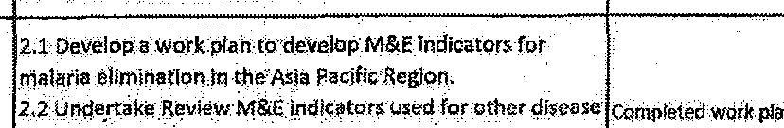
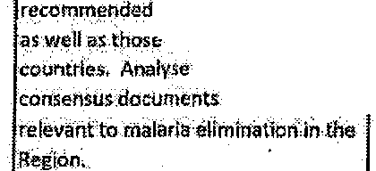
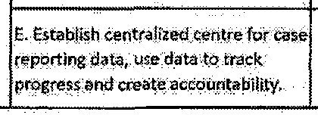
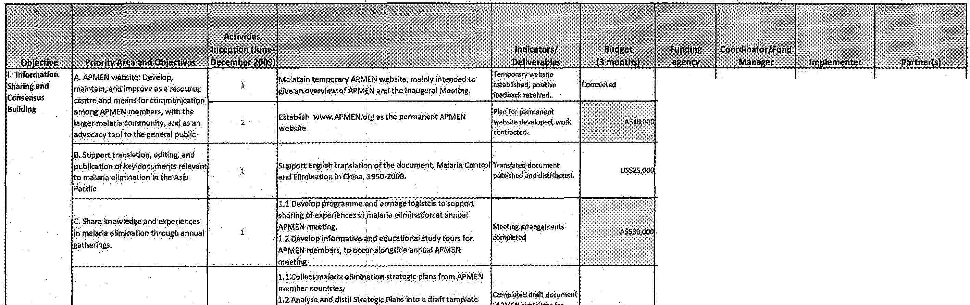
APMENinception Period, 2009 "Detailed Workplanl Cost Estimat /Futtding Needs.

BMGF GHG GHG UQiMEG

AUsA!D UQ (IQ Gt!G, ACTMof<irlo;USAI!l,
Ml£,WP o.SEARO.

5MGf GkG 'GllG Ni!Uonal M>laria
I I I
Programmes,ME-G
-

AusAID I OQ I 00, GHG, host country 1 WPRo,SE,>.i\0.Asl Vivax.
· .network

I
D. Review technical Strategies
by maJor im,titutlons
I I
,i rd set of guidelines lo.r otintrlesthal.are r orienliog(helr ld ;o,;;;;;;;;;;;;;tari>l BMGF
Prosrams from controlto, elimination, or modifying eidstlilg llrilf atio·Strategy•
U$$1·
I
elimination strategies.
13Dl<tribute draft for review

:GHG

Wt<p;.$HG
I

AOMataria, member
countries
I

utilized by APMEN
and dfutlllnto
andguidelines j lcontmi•Umination 'Completed working paper U$1 I I WHO,MERG,Macro
2 2;3'0raftwotkin ·OBoer on·M aitd E lor elimination In the on M&lndiralurs for AuSAID LIQ IJQ 'lnt mational, M
bercul(lSJsand. relevance CDC
ma1a:rra eliminati(:m,

\P\ll 'hv\hlif'

SMGF GHG WHO, MEG

"'!"studie* on partleular
ortoplt$,

B;VIvax workinggroup:perform re_vifM's,. perational r search.. and develop·guidelines for P.vivax
diagnosis·tr.,.tment,

BMGf,AosAID

BMGE

lw<AlD

AusAIO

GHG,UO.

GHG

Menzie!> {Subc:onlratf
througl; Ua)

Menzies (Subcontract
through UQ)

·GHG,UQ

GHG

Menzies

Vlwx: workinggroup
members·

member couh.tHes

Mt-Gmember-countries:

tnfill\'bcr-.GOLI:N.ries;wHO,
-Eijkman ifotd,Ciirtical k.e.searth Ufttt,AMt, W'/iARN, WRAIR;M>lERA, Aiia V/\m)!:.ne Otk

memb.er rountrles

AU<AID nties: (:SubCQ.!llrad
throu&hUQI
Vi'(.Jworklng gro Jp
members:
· u;;AA.memb.ef

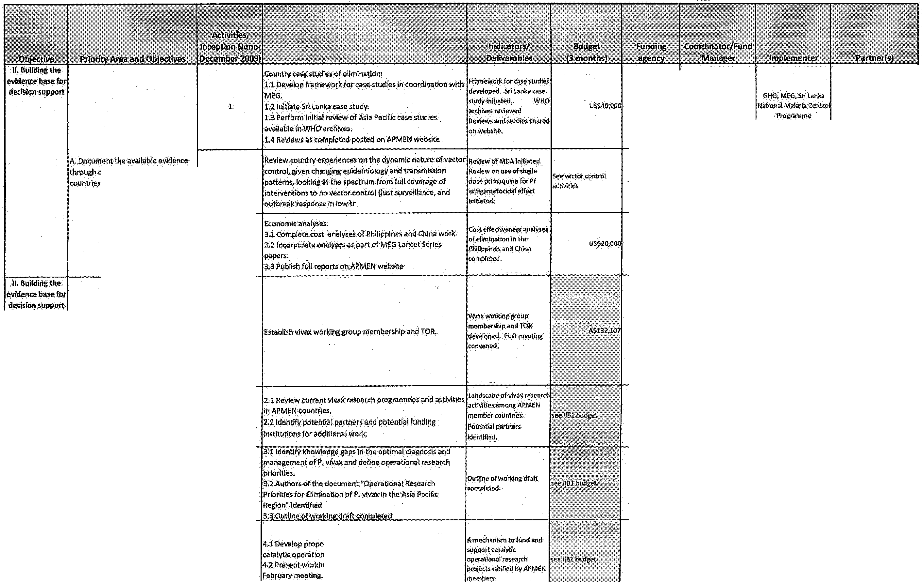
De e_lop.pro al for·a mec nlsm to furni:arid.stlPfidrt - - n'k_m.t?
(catii!yt!Coperatiollal research projeCts. '"'pportcatalvllc
4 AusAID
working ]:faperfor ratificotlc>n atAPMEN 11

.uo.

·Vfv;;anvofkiS e,rol.lp m mb rs
member ccurttrJeh WHO.
ij"""'n-Ol<fo,d CHolia(
Res tth Unit;. ANu;
WWARNWAA.tR# MatERA,
· A if- ivaiotfletw rk


AusAID | Menzle (Subr.ontract  Lhroil£hUQ) | V1vax worklog group nieinbe:tS | ·m5 filberr:ountri.s... WHO.  Eif m n»Dxford.Clinical  Re earc:h.,tJ ;-AMI,.  •WwARN, WRAIR; Mai(AA,  As!• Vwax rietworli
.1\UsAIO  AusAJD'  AusAID | Menzies (Sttbeontract  through UQ)  Mll'o.tie5 !SIJbc:Onlrac:t  lhroughUQ)  Moinfos (S.hcontfllct througb UQ)· | ViVax working group  members:  Vfva workfngYP!:JP  members  ViY:worldng·gn up.  m•mll<lrs | mPmbercountrle5-', WHOt fij man.OldOrd Clio«:$I ResearCh Uriif:, MI,  WWAFtN,WRAIRMateRA  Asiil Vivax netw91:k,AP.  WWARN.as-ifbove  WHO

 | 8. Vivax. wor ryg group;perfarm reviewsoper.ati"Omtl.researcht and developguidelii>es.for'P.vivax dlagno isand treatment, | 6
 |  | &



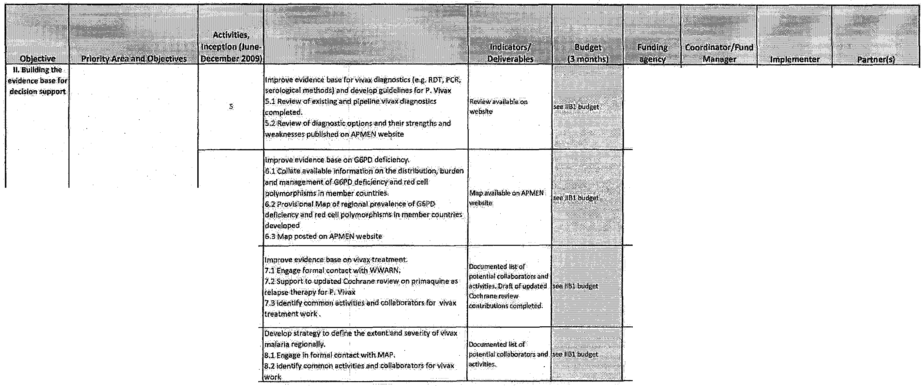

AiJsAIO UQ

AusAlD (JQ

.CO_Ull rfes

c.Vector control working group;Set I 3 ID&ter..ri'Jinpper ti?n&l.res¢arch-prlor.itres for Vector ccntrbl - -. ·' - ·"····.· . . f IS.•IIC1buQg"t I AusAID I UQ IVoootr<OntrolwokifgMaiEAA,WfiO,:CDC,.?C,
p!'ioritles, perform reviews. a d · fn_enmlmtiiOn .ttlngS, : .::::.:. :. sA ; cm:umembers membe:ccuntrle.s


operational research. develop
gUidalJrtP.S for ve:Ctor control·tiSue_s:
reievant to malaria C.llmir.;i:ion in the
Region.

4 JrO!ili>n.arJevelHoi montiorh>g the poten.tlallntensity of J Urve i i- re i luding. . lsceild ru<hmt
I I
AusAID UQ Vetotr tontr ok og :I· 'wH9;cpct.SP_C,- !lJber
gan.wmetnben. coiJntri s

s ID.evel!lp crlterifor mi>niti!llng the ef(oe:tlveness of \lector

AusAID
UQ V.e<otr controlwokring IS<.h.eool fTrOj> l
g.orup me:mhors WHO*.coc,. SPCm.erober
c6U1Rrles

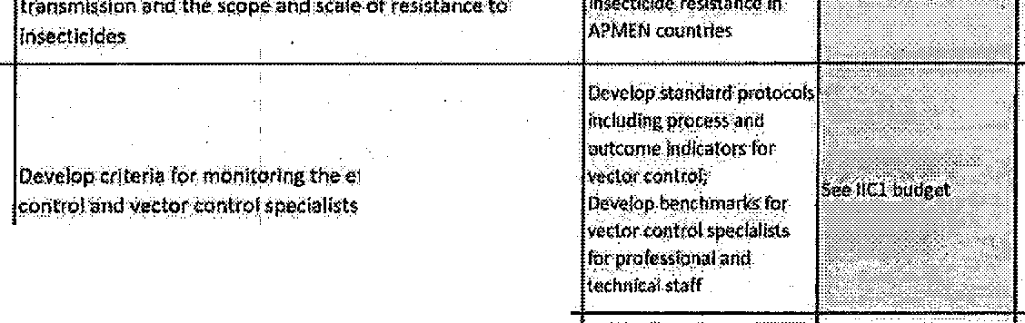
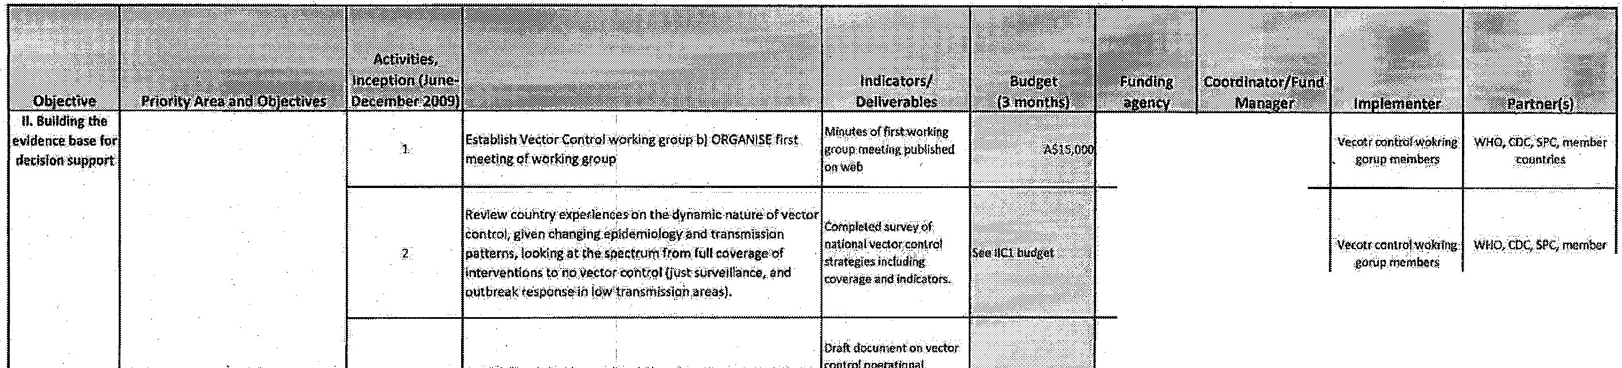
·,


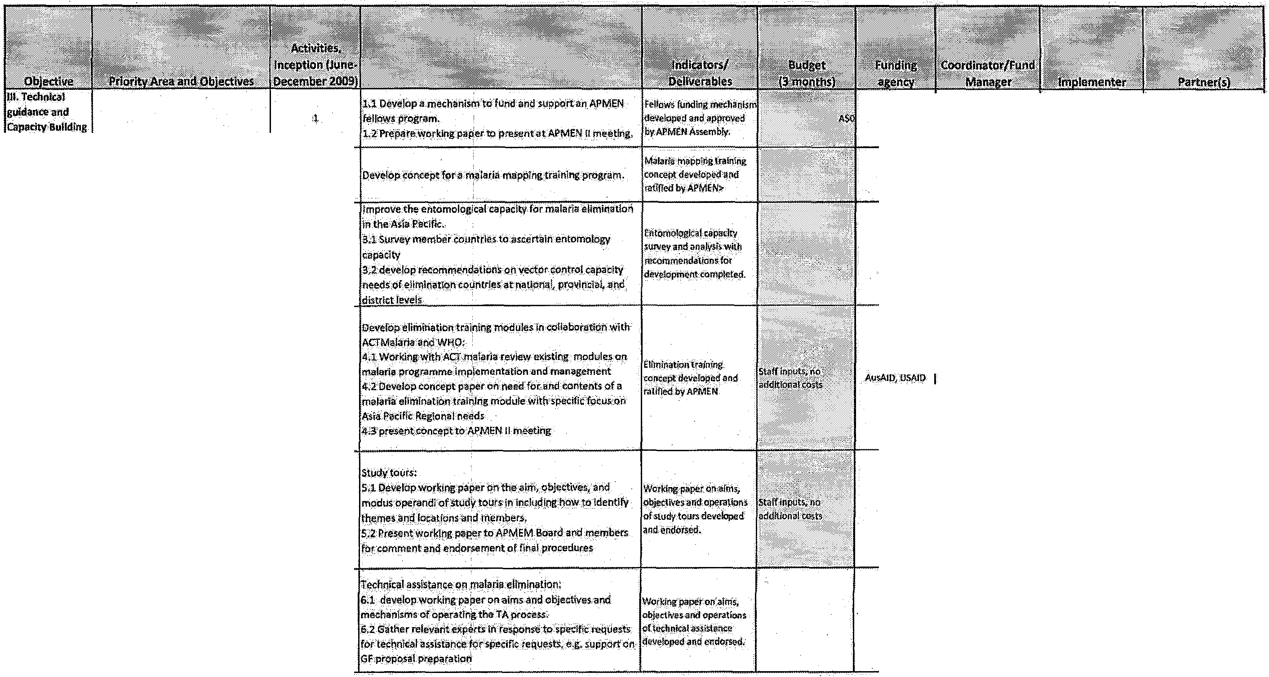
Au<AJ() | UQ | ACTMalaria,WH.O | m mbers.cqunttres.:
Au<AID  AusAIO | UQ  UQ | UQ  APMEN<W O | MAP  rnen'!berstountfres-
Au>AID  WHO | uo, AClMal.lr;a  ug,  WHO | AtlMa!a:ria.WHo·  !.JQ | members countlrea  rriem r!itountlres
Au>AID  WHO | uo, AClMal.lr;a  ug,  WHO | WHO •IIAPMEN Mmbors



a

.,
1"'\il.'  

BMGF GHG GHG
R!J.M, Malara No Mor
Consulling/PR firm (TBD), UO,M•ntie>

BMGF GHG

f..ri:.rnxf',_l",....Hhil.-. . ·GarmWn61itk<rl and
BMGF
GH.G
GHG UQ

eg\Onal!\i,: lntefriationally.

GHQ, UQ
GHG,UQ
APMEN Chair and lloat

5 .GHG,.UQ GHG,UQ
WHO.APECiA5EAN

Fa Uitate crqss-border and r ional

MGF

Au>AIIl

GliG

lJQ.

GHG,WHO.

bei:lfrteirriined
GFA!M


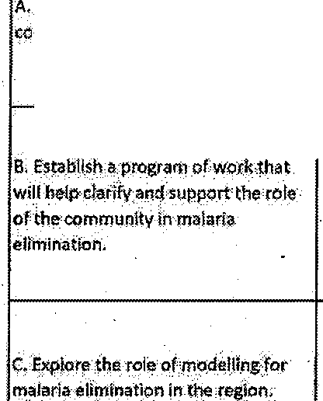
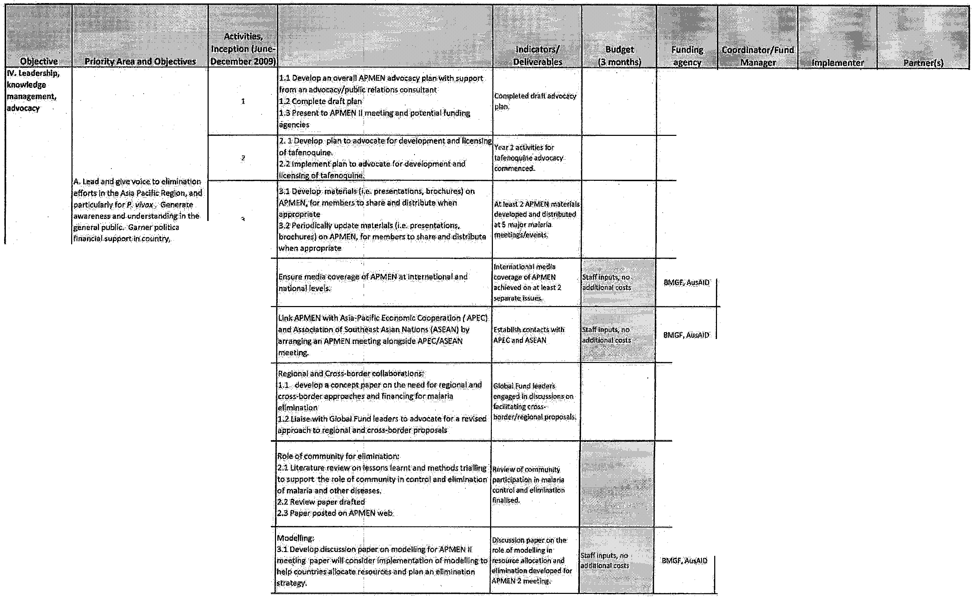

3 UO,.GHG be determined

\J'\{f '<lahibti!Y\C!l! Sup·1 ·•oi'l S;

UQ,Gt!G
UQ.GHG

1\u>AIO,6MGF
UQ.GHG
UQ. GHG

1 l. , -- ----- -- r:, ;,i_ .J_.,_,i. I I AS£®111 Au!AID I UO, IUQ; GHG,.ho.t <l!uri&y Srfl nlol

·t 1:-•- :-.-'-'""'r - -··--·.- -.f'I: --:':" f..-- --·-w · -· • •• •··-·• 1-.-·-.--· ·-r-- _,_ c::.:··r-:-'··- I AusAIO,SMGf UQ.GiiG UQ.GHG.

'o" high evelWilton ?ark meeting, rneet!ng.s.
tc.)

regional efforts-l.ilekong Malaria Formalcomrnunit:aUons
BMGf -GH_G: GHG,WHO MEG


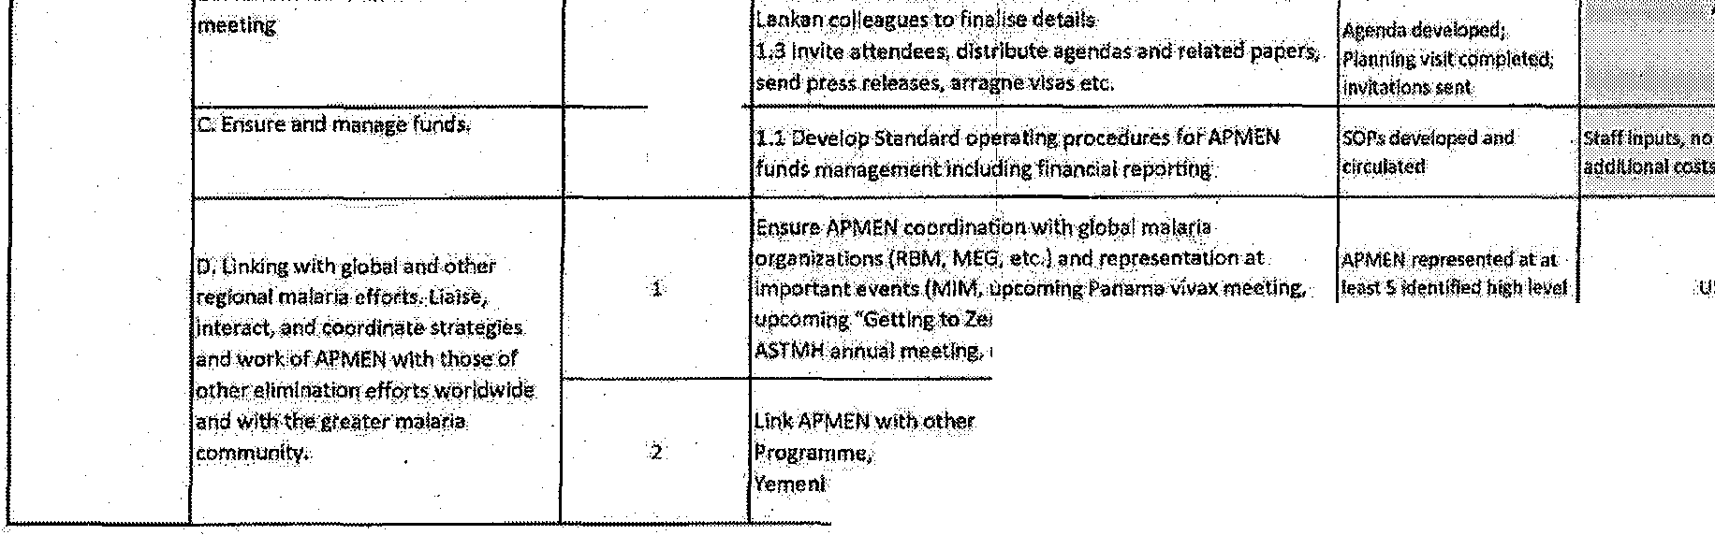
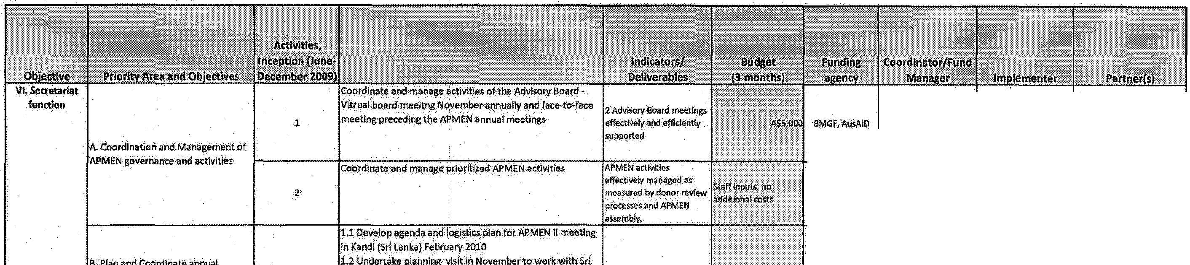
EUminatioJl"S-o:·a)Tashkent Oec;iarationl saudi- : : d- : -'---t :: t: aM.Gr GI;Si I GHG,WHO I MEG
Partnership, efforts in latin Ametka, etc.

LslahlishtrH'Jl1 1r1 1;<;tdW 'idwdulv ;

UQ;GHG·. \!O.GHG

UQ.GHG \JO.,GHG

UQ.GHG UQ,GHG

F Pfanningw<xess
IDavelpp.draftannualworplanand budgets and business

·2

.3

'4

5

!Prepare annual report draftevery.Oei: mber

AusAID,SMGf UQ.GHG UQ.SHG

AusA1t>,BMGF UQ.GijG I UQ;GHG
UQ;GHG I UQ,GHG
--
uQ.iiHii UQ,.GHG

UQ.GHG uo,iiHG·

UQ.GHG .tJQ,GHG

UO, GHG Ufl>GHG

UO,G!Jil UQ; GHG

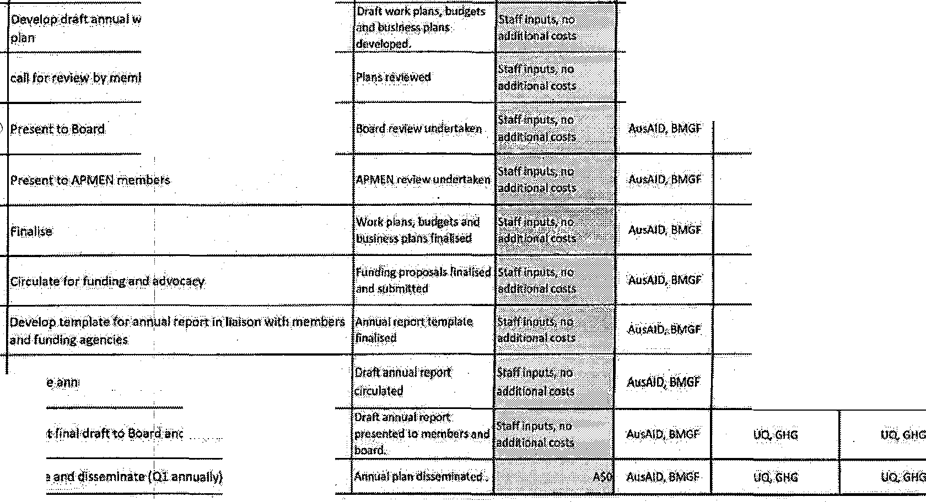
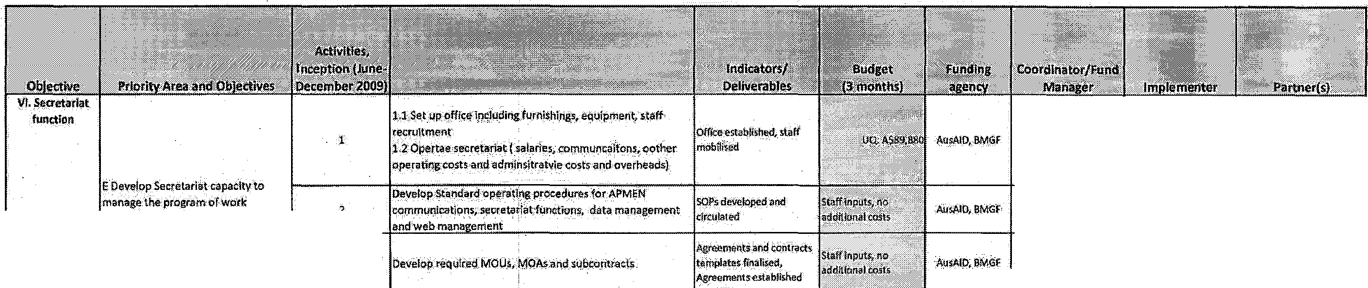
IPt entJinal·draftto aoal.d.imd Members

4

Fro >,r,ml

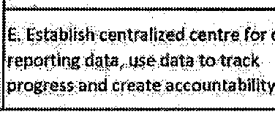
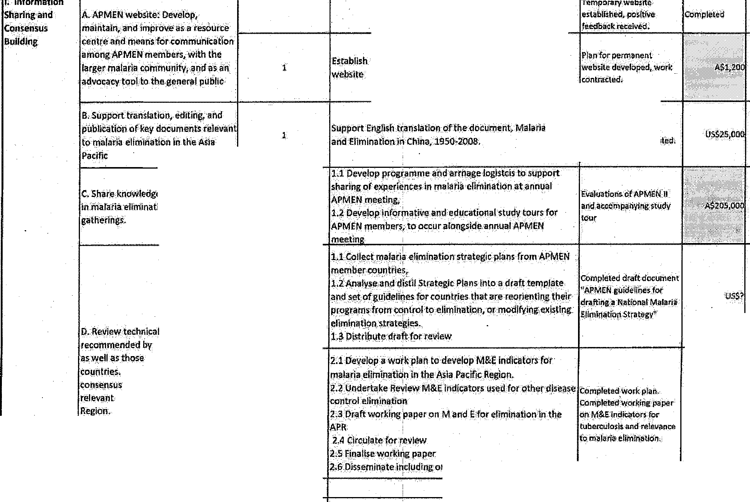
APMEN YEAR 1, 2010 - Detailed Workplanl Cost Estimates/ Funding Needs

BMGF GflG ·GH
Uo; MEG

C.Share l<nowledge and. exp rierices
I
ininaJaiia·ellminatlon through a.Mual

s rat gies
major in<tlt.utiOilS
utilizedbyi\,PMEN Analyse and distil into docurl\i>Jits anguidelines.
to malaria eliminatfon in the
2
www.APMEN.orgas the·permanentAPMEN

Co lrotlr,.nslatsdocument

ftijSJl,IO

8MGF

AusAlD

SMGF

AusA.lD

UQ.

GHG liO. GHG

uo.

u.a

GHG

UQ, GHG, host
country.

WHO,GHG

Uo.
Gf:IG; ACTMal rl
USAJO,MEG

Na.Uonal Mafarta
Prqgr mes;MEG

ACTMaiariarl'len1brir
tount ie!.

WHOMERG, MacrQ lntet"ll' ion t Measure5val

12.6.Disseminate including on w bslte activities

L,

l!MGf

GHG WHO

GHG,UQ
GHG UQ. member co ntrf!!s

3 SMGF

G>IG
GHG MEG,m.,..l;>er
-countries

activity, Updfte memQ:etsh1p and reviewTOR»
AusAID M Oi!IC$.
1h<ough UQI

Merufe

M•IERA

6.Viva•working group; perform reviews, operational research.t and d•v lopguideli•es for P.vtvq diagnosis and treatment.

AusAlD
Men2ii!5· fSUb orrt.r,dctJ Vivax wotkii'lg_,grottp
members

member countries

AusAIO

{sunconuactt Vfvnworklnegroup I MQl RA.• member mrunhers .ccuntri£<S

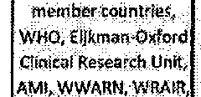

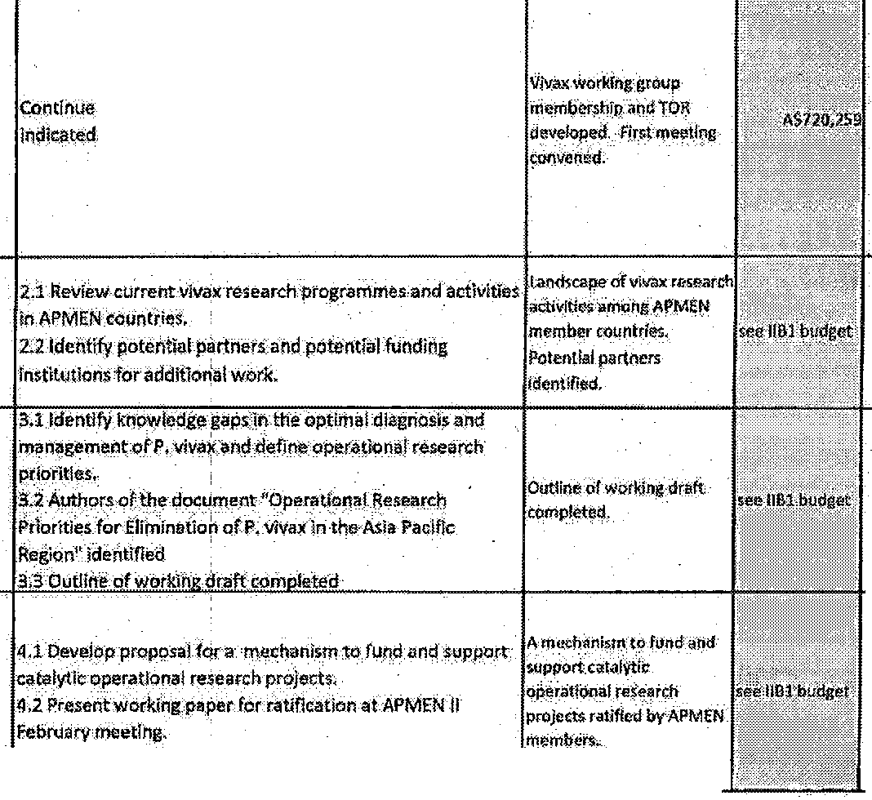
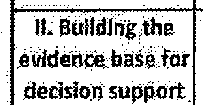
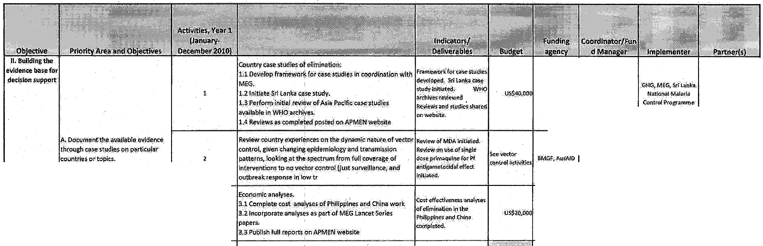
·4 lw•AIO
UQ UQ.
M•o<ios, WHO TOR


\r!J'nluk \

AiJ!.A.IQ
 | B. Vivaworkinggroup;perform  r vlews, operational research,and develop guid lioes for P:viilox diagnosi• arid treatment. | s
 |  | 6
 |  | 8

Meo2ies {Subcontr.actl
throughUI:l)

Au$AIO Memles (Subtontr< <tl through

MAP

AosAID
Mimzies (Sobcont<IJCrt:l
·through Ul:l)

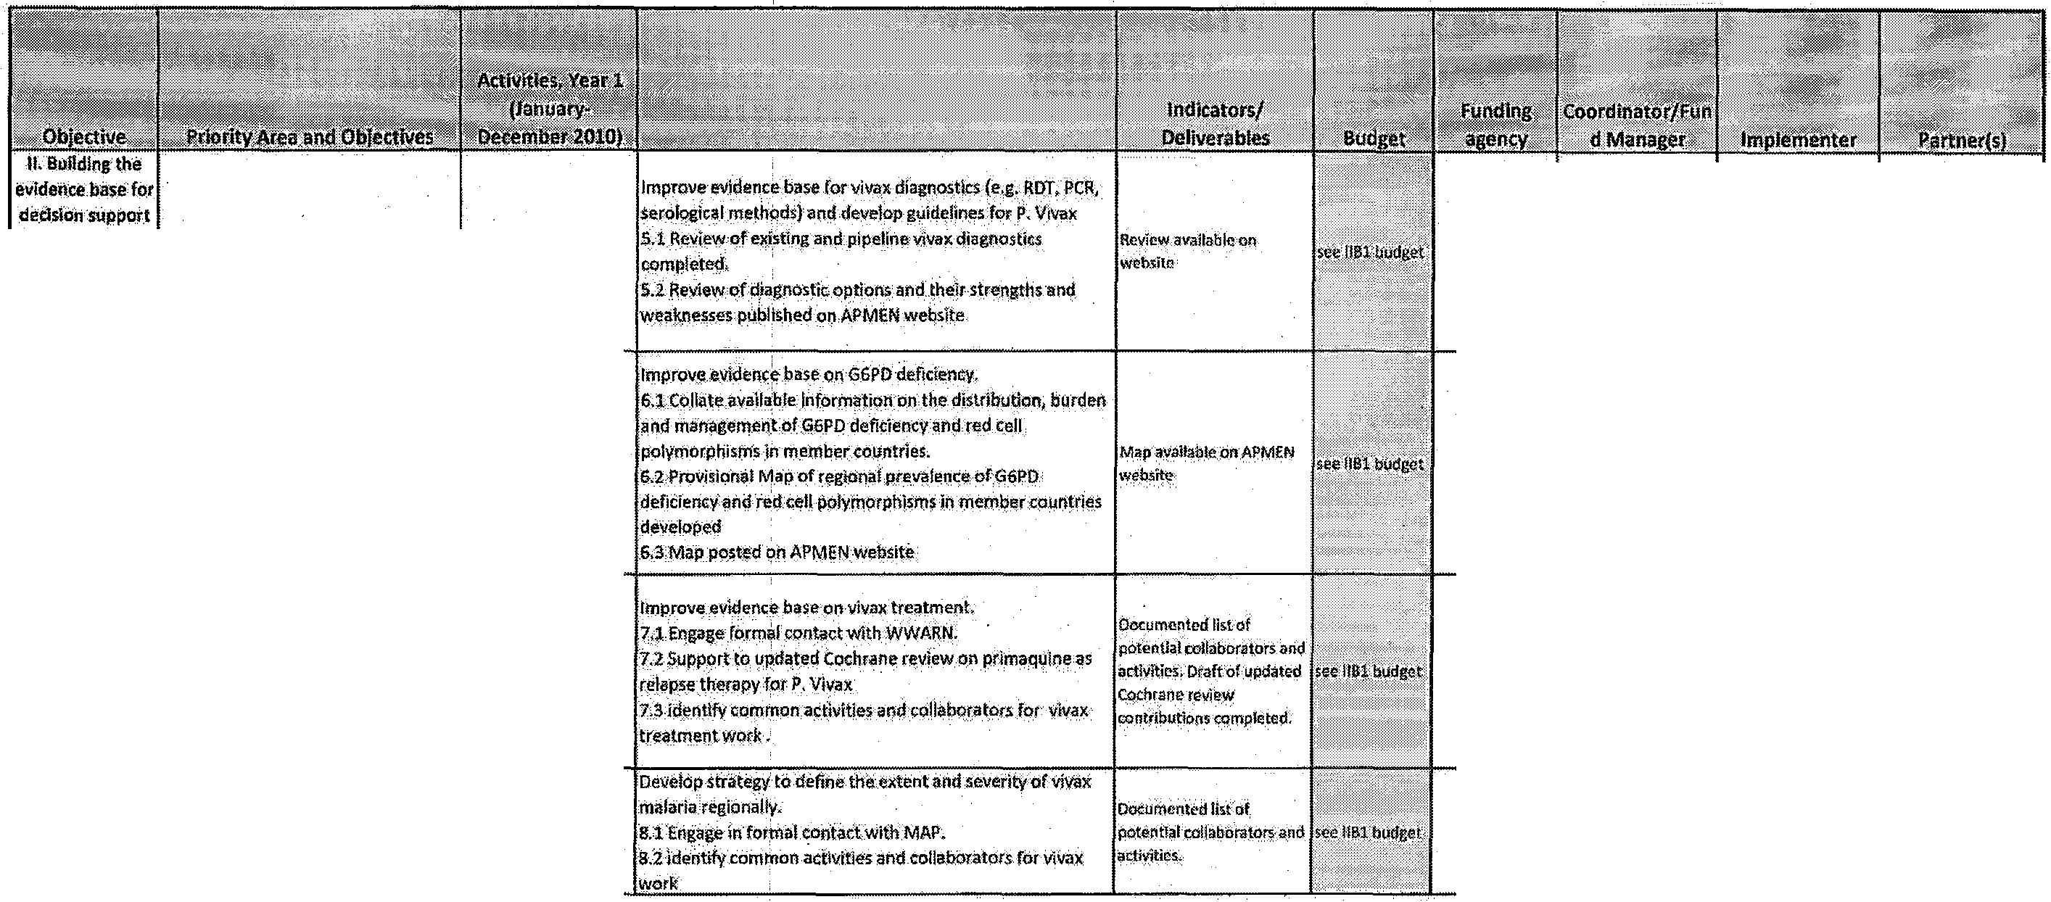
M•Aill Menlies (Sub,Ol1tra tl
throuh UQ)

WHO'

UQ
I I



lv•m• I
el(J)erientes on the dynafuid\alureOfVE
jtiven changing e!'idemiologyand tron$i\ii iion
h UG+li d

y.rHO,COt.
I
$PC,m.,u;,r
o:uotrie!i
I

looking atthe spectrum.from full coverageof to no vector control (justsurveillance, and
response in low transmission areas).
lnatlona_l veclo!control strateg1e_s indvding
AusAIP I UQ
I wtto.coc
.SPC..membt r
t:ouotri(!S
I

C:Vector control workinggroup: Set 3 Det:r h1,oper :: · n-• '... .;> ...... , ,.•• t"' .............. '""'' ......,.. ,.., .......,..,,.... Jrcscarh priOdUcs fQr !Sow I!Cbudget; I M>A.IO ! UQ I WHO,.COC I M loRA
priorlties,.!!erform reviews and
operattonlresearch, develop guidelins for vector control issues relevimtto malaria ellmlnatlon in the
_ •--···-''-- I I
Region. •.:. -'-""'-' ·-··-·.;, ·-- ..... _..._ ,_...... ............... .,:.,, -..........."'·-- ·- ·-·-'"'----
AusAID UQ .Wfib;COC I mcmbr countries

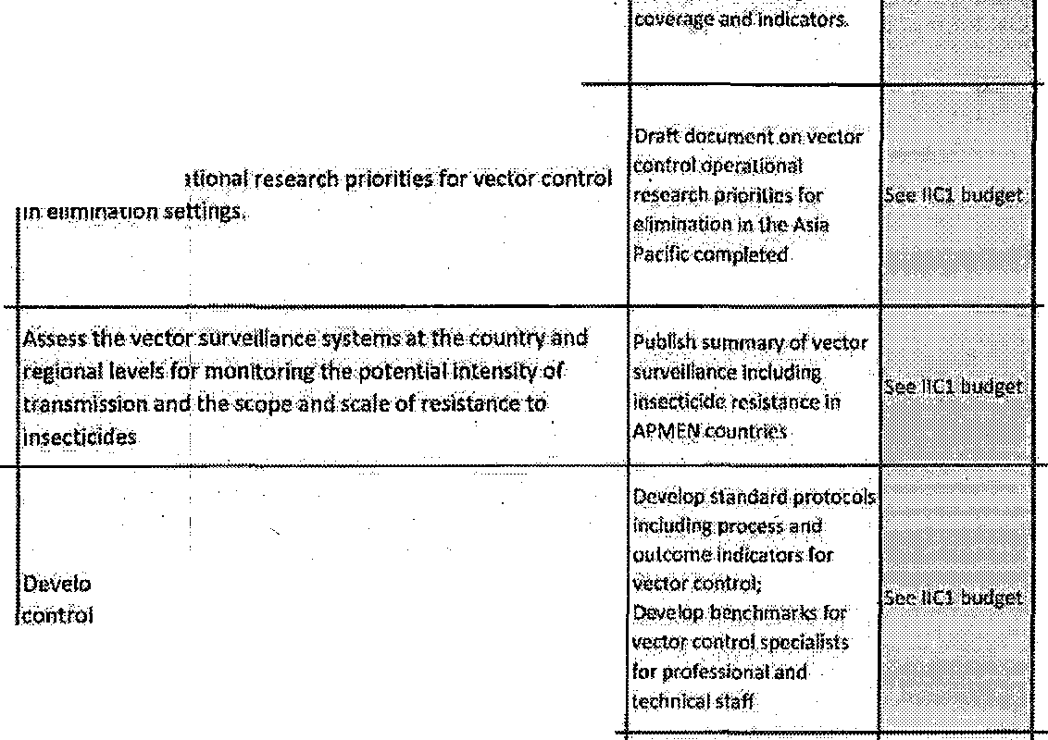

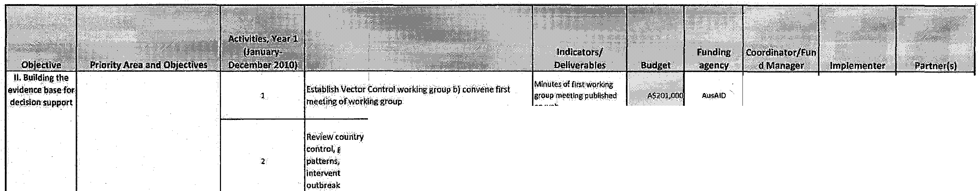
Develop criteria for monitoring the effectiveness of vector
and vector control specialists

AusAID tid. WHO;COC
member.countrie.st Uv rpoo!School of Tropkal Modicine

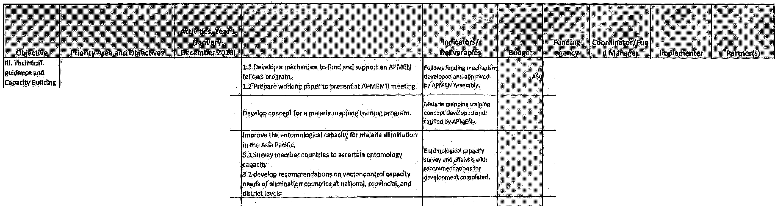
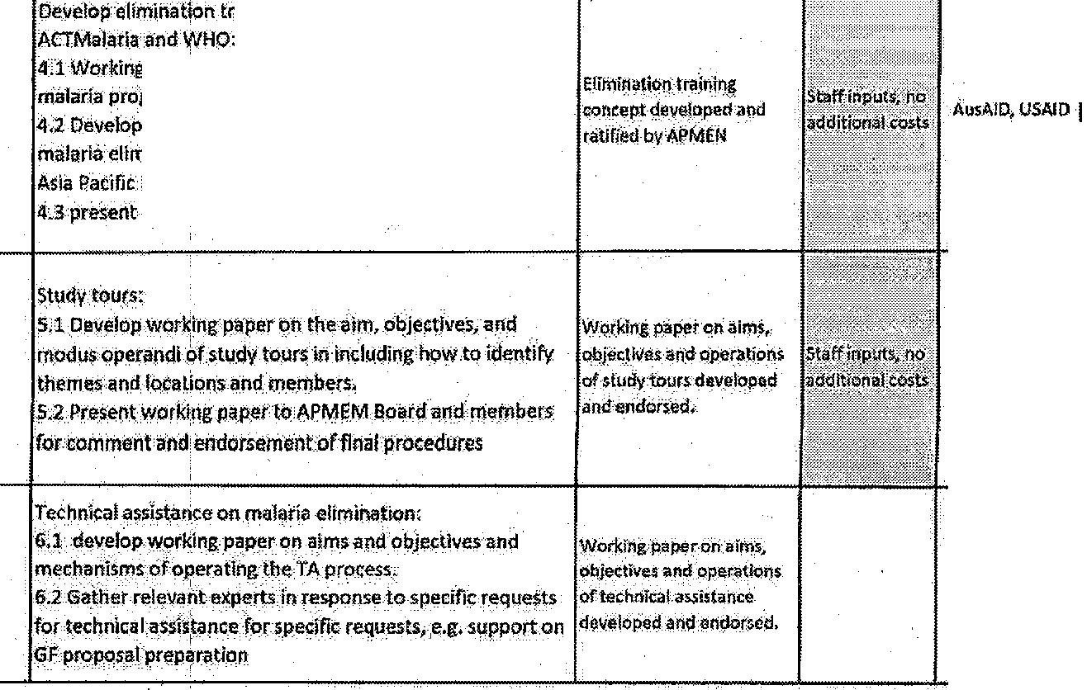
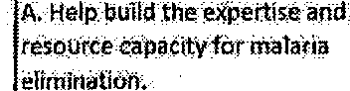
\P\Il'\, \clH duh' i

' AUsAIO UQ
ACTMa1aria, WHO

AUSI\ID UQ
UQ lyi)\P

' AusAIO UQ UQ

foevelop,alimihatjon training modules Jf!,col!aboratlonwitll

W&king with, ACT malaria review eXIsting modQie• on
programmeimplemeritatlonand managem.,nt
4 concept paperon need for<Jnd contehts of a
eliminatl\m trainingmodule with $peoilidocus oo
?atific Regiorat needs
present conceptto APMEN II meeting

5 ,AusAlP

uo, ACTMalaria

,UQ

ACTMalaria, WHO

UQ

6 WHO WHO WHO all APMEN mombeh

BMGF

'GHG

GHG
RBM,Mala(No
Mote, Consulting/PR firm (tao), uo, Menties·

aMGr
MMV,,:vivax focw
GHG group

3 BMGf GHG GHG UQ

4 GHG;UQ
GHG;UQ

s GHG1 UQ

GHG,UQ

WHO;APEC,ASoAN

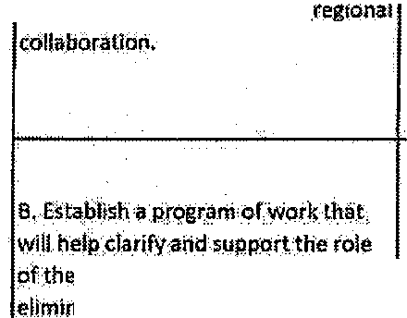
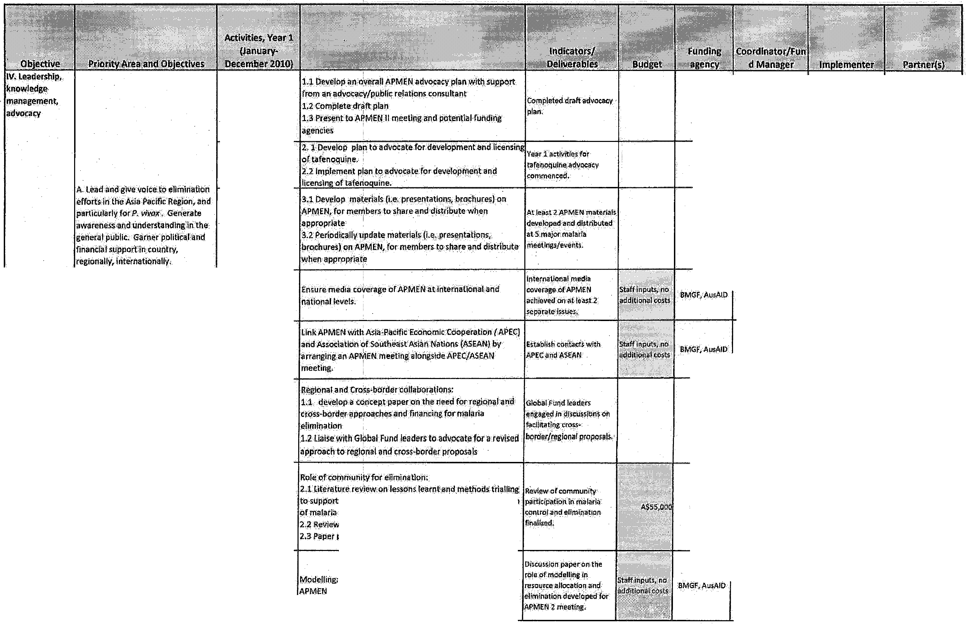
lA·Facilitate cross-l!order and.

oommunitV in.mat.lr.ia

c. Explor!hl!role. of modelllng for
malaria elimination in the region.

the role of community!n.<ontroJ aMeflmination lp;irticipati.onin
z
and other diseases.
Review paper drafted
2.3 Paper posted.on APMEN web

dependent on wokrplan develope<! at
IImeeting

BMGf

AusAID

GHG

UQ

IJQ,GHG

GHG,WHO

be dlsuc;sed at APMEN II

IJO.,GHG

GFATM






.?

', i'_:,Ld;!l:-,tHJl\'Ji'i

1 n)J.U U.H

ilnlLk I

governanceand activities
UQ.GHG
 |  | UQ,GHG
AU<AID | UQ,<li'IG  UQ: | liQ.{;HG  UQ, GliG,,host  ·colmtry | SrilAnka
 | UQ,Gfl(j | UQ,GHG
l!MGf  6MGF | GHG  GHG | GHG,WHO  GHG;·WJ-10 | MEG
l!MGf  6MGF | GHG  GHG | GHG,WHO  GHG;·WJ-10 | MEG

2

s, Plan and Coonlinate annual

Llnl<APMENwitbiother regional.efforts-Mekong Malarla
I
2 Ptogramme,,Eihnlnation 8 (E·ll);_, Tashkent Declaratipll,

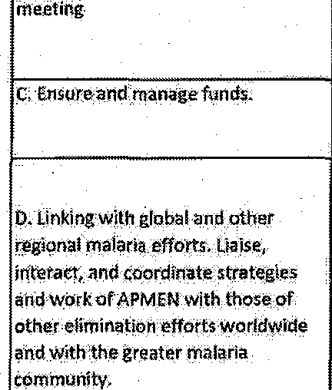
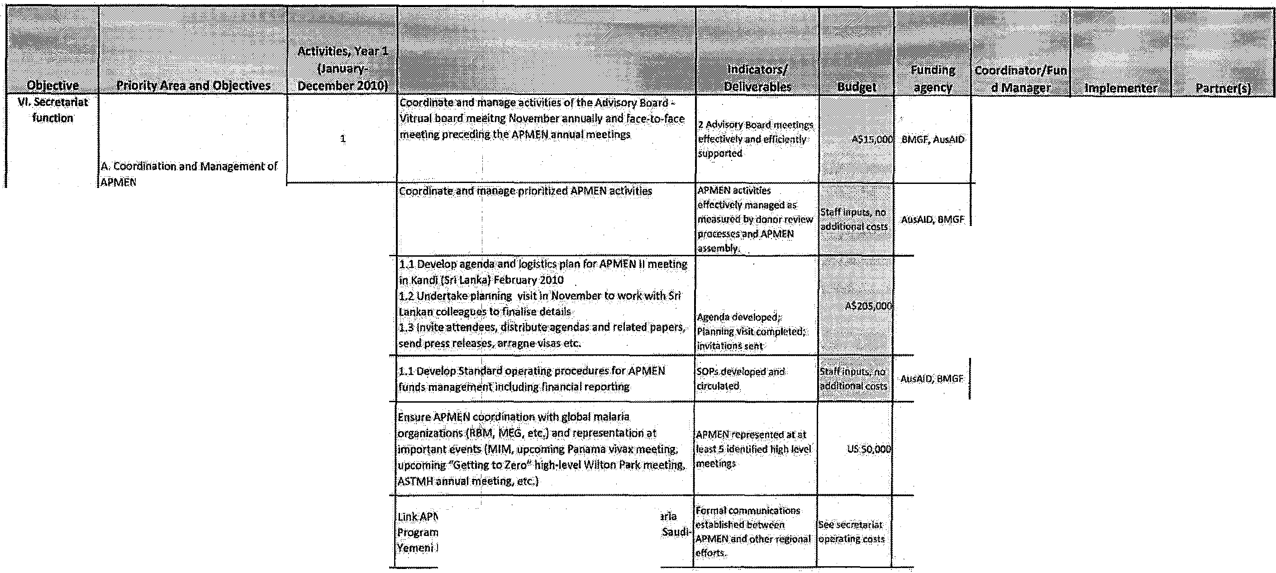
Parw,rship; efforts in
Latin Ametica, etc,

l' r \ii\hllc;!mwli1 l'ro;. rJm lwduk

UQ,GflG VO,GHG

2 communications!secretar!a.tJunctions, data management .,._,- --·-·-...-.,. -··- A\ISI\10, SMGF UQ.GHG. liO.GHG
circulated

and 'Neb mana emeht·

Aar.eGments and cont

3 DevelODi.eouired MOU!i.MOAs imd:subcontracts templatesffh•ll•••· AUsAJP.BMGF UQ,GHG UQ.GHG.
Agreements estal>llshed
draftan ualwork: plan and:budgets and business P,afl;work plans, budgets
I andbusiness plans Au.A!O,!!MGF UQ,GI;G. I UQ.GHG

2 [t.rorreview bv:memben Pfans: reviewOO UQ,GHG

Planning proceso
. I
3 rresentto Board SOard revH:wtt.ll'ldertaken UO,GHG
I

i
Pr. .sent to APMEmembers UQ.GHG I uO.GHG

s IFinallse
WQtk plans, sets;.nd
'-----• - :., -- -- ··--- :.

UO,GHG I I.ICliGI!G
-
UQ.GHG Uci..GHG

Gil¥ "IUU\.11..I_I:IJ!jt:'f t.il · llUDII11 U
UQ.GHG UQ,GHG

lieporting
l Prepareannual r port diaft eveP{J:lecember O:roft annual report I




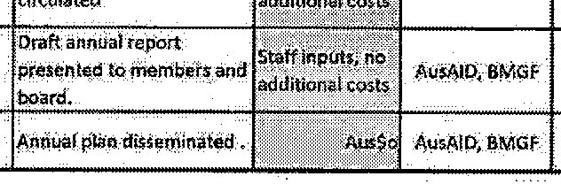
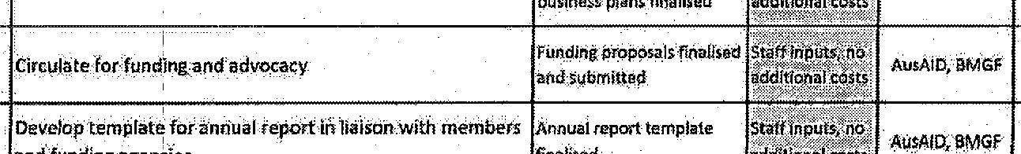


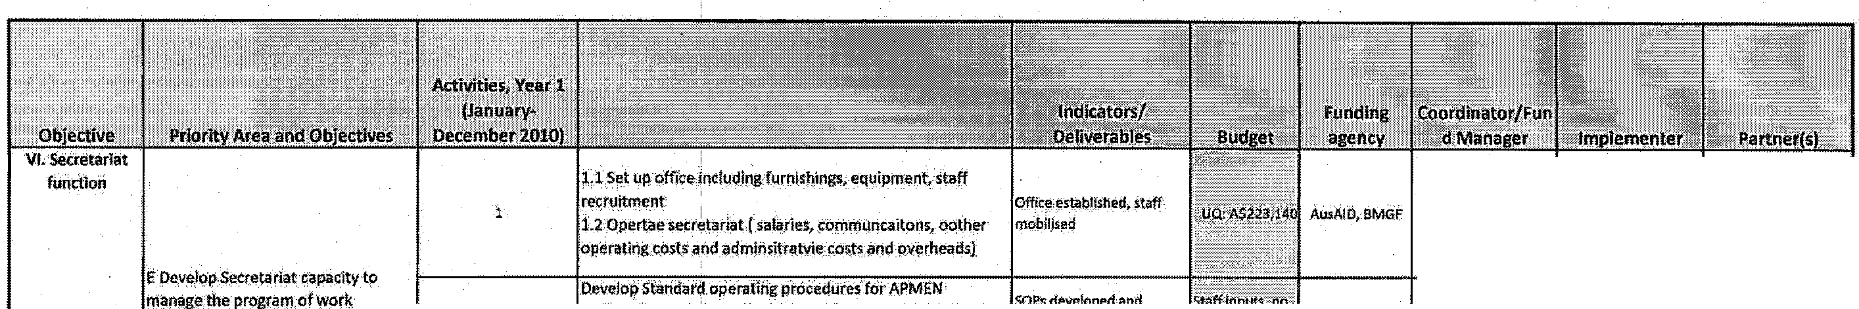
!
...t..;..,,j"..;....:. !)Q.GHG UO.t>HG
s Present final draft to Soard and M<fml!ers· Jpr•••nted to memb•t> and[;;:.:··"'>"''·'I !Mi\ID, BMGF I IJQ,GHG. IJQ.Gt!G

IJQ.GHG UQ,GHG

['\ ",';ih! 1 hrn n1


· APMEN $ets ACtiVIty gUJoeunes,
Secret riat reviews design arid [ , Secretariat
Development I support APMEN I Goal is not achieved. Low I High 2 monitors. quarterly ·Assembly
Risks aoals. or data sets
· APME:N Assembly approves
Activities

APMEN Activities reduced Board engagement with Funding
and impact on elimination. Low High 2 Agencies I Board
Goal is diminished
r

Intervention Activities extend · Ser::retariat quarterly reporting to
Risks beyond the monitor implementation / ·Secretariat planned time APMEN Goalis realised too Medium Medium 3 · APMEN out-of session consultations · Board frame, e.g. slowly. by Board
resistance
increases

Activity costs Activities cannot be B.oard·and Secretariat to mo·nitor j · Secretariat
'exceedthe completed without further Medium Medium 3 closely and consult widely with

funding and delays while
approved budget. APMENParticipants. .
,.._..,.._t U,.,......._ ..... .......... .................... i· ,...,;.a
I Board

Confusing or conflicting
agendas and Difficulty targeting Activities
I
Management messagesfrom and reaching consensus if1
Risks various agencies the Assembly, APMEN Go.al I Medium . I Medium 1 3 ! Board advocacy and communications I Board
supporting m laria mqy be challenge<! or ··
in general and realised too slowly malaria
imination er se

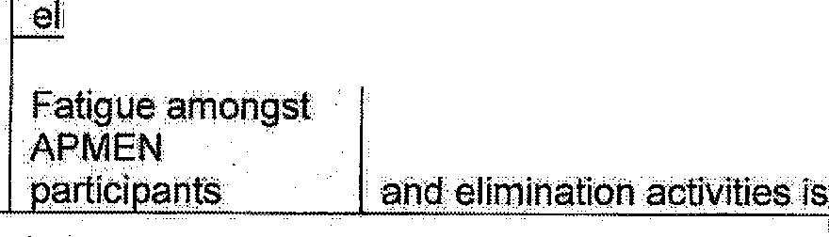
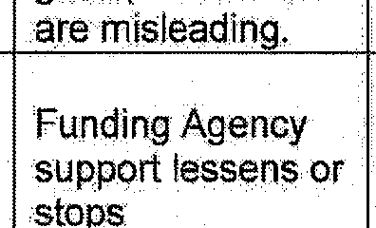
Long-term ability to suppol]f
Member Co1,1ntry research· I Medium I High

I 4 I Board. advocacy and communic;: tions I Board


Fatigue among key stakeholders during Member Country elimination

Incomplete funding and/ or execution of the strategy, APMEN elimination activities are compromiseq

Medium High 4

Board and Secretariat to monitor closely and consult widely with APMEN Participants, .

· Secretariat
·Board

Agree ent 53365

Schedule 1

APMEN Fouf1dation F®ding AusAID -Five Year Estimate of Resources and Costs
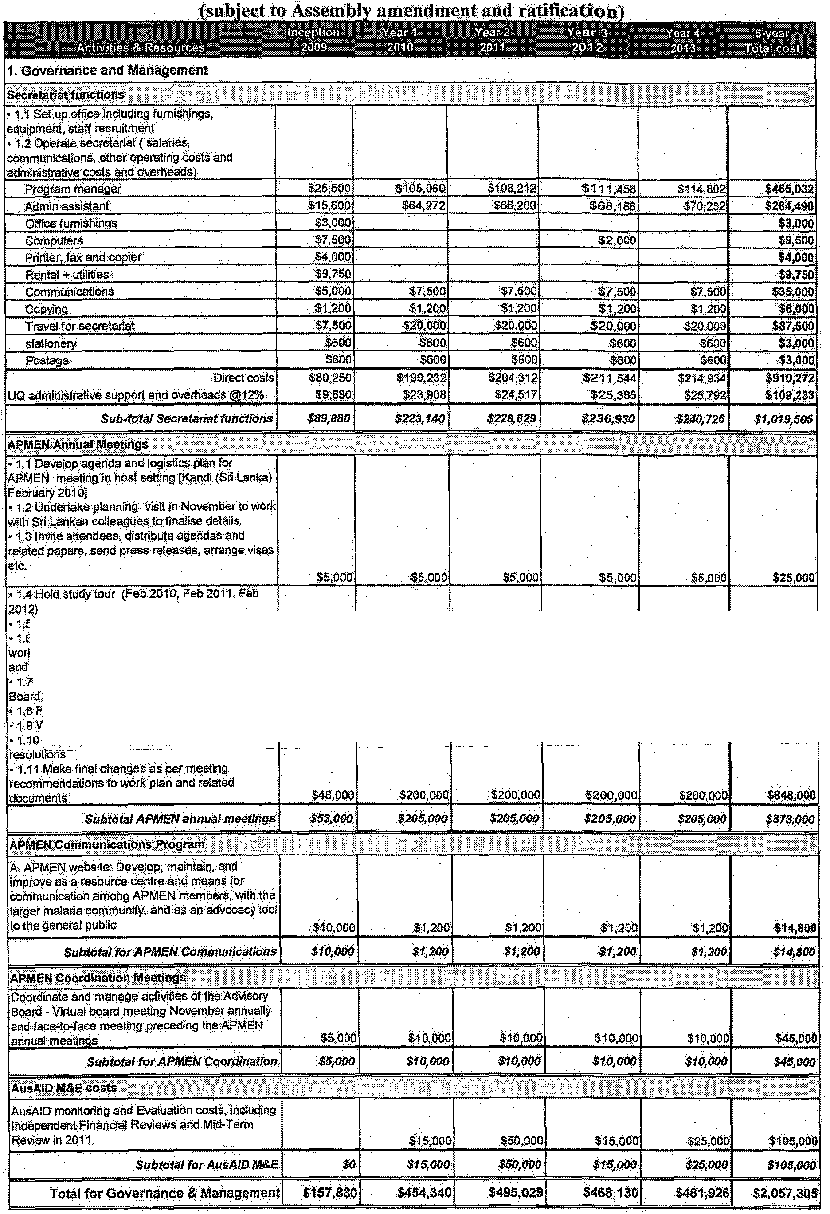
Agreement 53365

Schedule 1

• 1.5 Hold. 2 clay scientific meeting (Fel:l2010)
• 1.6 Hold APMEN members meeting lo review
·· plans, concept papers. procedural manuals
governance issues
Hold 1day satefli!e meetings (vector control,
Vlvax)
1;8 Finalise reporting
. {g Write Up meeting evaluations
1.10 Circulate minutes of meetings and
Agreement 53365

Schedule I

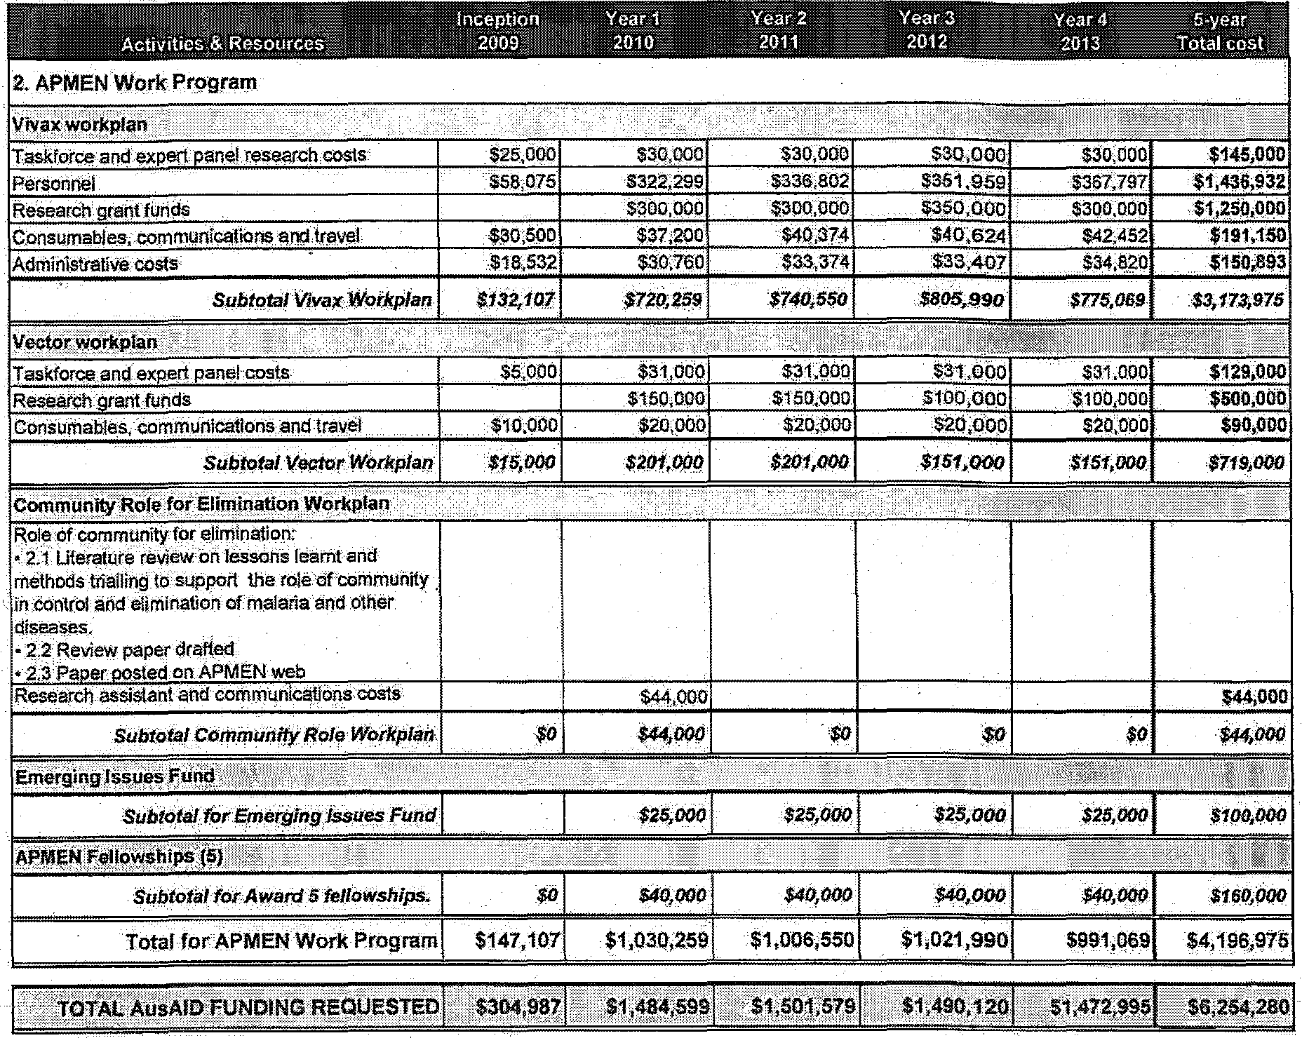

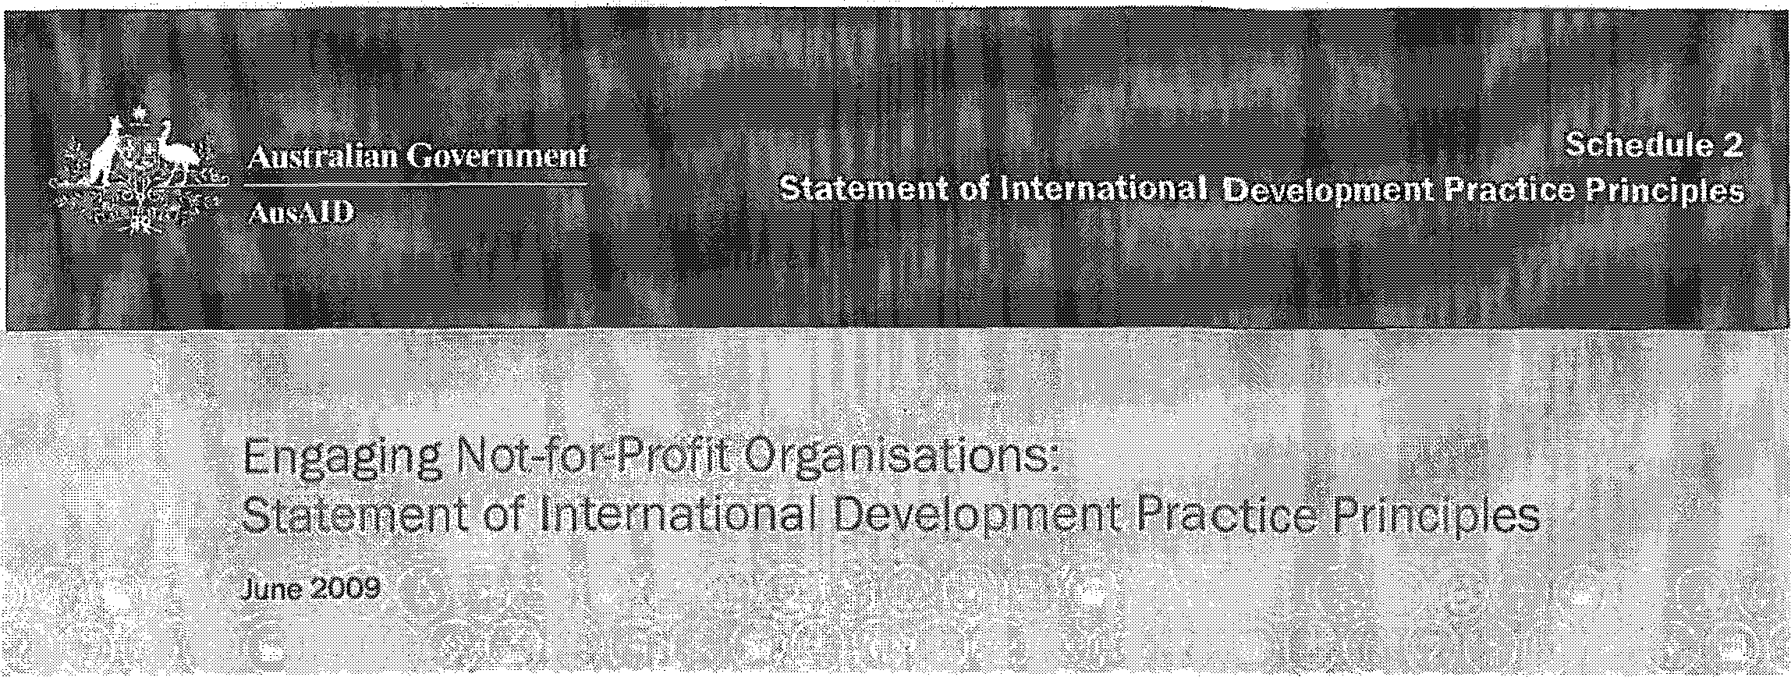

The Statement o:finternationaLDevelopment Practice Principles (Attached) has been developed in consultation with the Australian Council for International Development (ACFIP). It is founded on, the good development practice and experlence·ofaccreditedAustralian
Non-Government Organisations (NGOs) and other international development agencies over the last three decades.

The Statement takes account of the Accra Action Agenda on Aid Effectiveness, and in particular; encouragesa participatory approach to deveiopri1ent. 'Notfor profit'organisationsare strongly encMtaged to work in partnership with others thereby reducing the burden on com ll;tn ties and govermnents with whom they work. The Statement seeks to articulatetheJ.rtinimum standards and cotnmitment th&t AusAID expects from all 'not- for- profit' organisationsthat it.funds. It will form an annex to funding agreements with not-for-profit organisation$ that are not accr ditedwith:Au.sAID.

The Principles are not aimed at accredited Australian N.GOs which have already undergone a rigorous accreditation process.

Thi'sStatentent of International Development Practice Principles (The Prindples)promotes theactive commititt'ent of all non-aceredited1not -for -profit organisations funded by Au.s.AID to the fundamentals of good development practice, and to conducting their activities With integrity, transparency and accountability,

The Principles are founded Clrt a premise .of'd() noharm' and dravm frori1good practice principles in the international development not4or-profit sector and international development community more l;>roadly. In line with Aid Effectiveness principles>when planning interventions, not-fur-profit organisations are encouraged to consider:what other agencies are doing in the chosen ?rea offocus; where tbeir organisation
.can add value; and how they can join with others to increase the impact.and sustainability of their activities.

Where relevant, AusAID enco1.1rages eligibleAustralian 0rg$Jisations to work towards becoming Australian
Council for International Development (ACFID) Code of Conduct si'gnatorie5.

International Development Principles

lessons drawn.from best practice NGO and civils()dety programs recognise the importance of working in partnerships, building creative and trusting relationships with-people of developing countries a11d supporting pasic program standards which: ·

> give priority to the needs and interests of the people they serve and hivoWe beneficiary groups to the maximum extent possible in the design, implementation and evaluation;
> promote an approach that includes all people in a community and ensures the mostvb.Jnerable, inch1ding people with disability, women and children, are able to access, and benefit equally, from1• intem tiona1 development assistance;
> encourage self help !!lnd selfreliance among beneficiaries;
> avoid creating dependency throll1?;h the facilitation of active participation and contributions (as
!!lPPropriate) bythe mostvulnerable;
> respect and fqster alluniversa]ly agreeifil1terna.tional liutn:an rights, including socialeconomic, cultural,
·civil and political rights;
> · are cultuta11y appropriate and accessible;
> seek toerihance gender equality;
> recognise and put in place processes to mitigate against the vulnerability of not for profit organisations to potential exploitation by organised criJ:rie and terrorist organisations;
> have appropriate: mechanisms in place to active1y prevent, and protect children from;harm and abuse;
> integrate environmental considerations and mWgate against adverse environmental impacts; and
> promote collaborative t:J:Pproaches to development challenges including through workingin partnerships and avoiding dliplication of effort.

All qon-accredit¢d, not for profit organisations receiving funding from AusAID commit to apply these

Organisational Integrity. and Accountability for Development
AusAID fund$. and r¢Sourcecs are designated for the purposes of internatitmal :aid and developrilel1t{including developrhentaV.·aren s). They can notbe used to promote a particular religious adherence, missionary activity or evangelism, or to support partisan political objectives, or an individ,ua] candidate or organisation affiliated to a particular political movement.. AusAID reserves the right to undertake an indepe}ldent audit of an organisation's accounts, records and assets related to a fundedactivity, at :all reasonable times.
In all of its activities and particularly in its communications to the public, AusAID ects not for.c.proi1:!: organisations itwgrks with to accord dire respect to tbe dtgnity, values, history, religion, and Ctllture of the people it supports and setv:es; consistent With priJ1ciples of)>asic l)umanrigljt::;.

Not.jor-profit organisations working with AusAID should:
> not be a willing party to wrongdoing, corruption.bribery, or other financial impropriety in any way in any of its activities;
> take prompt and firm corrective action whenever and wherever wrongdoing is found among its Governing
Body, paid staff, contractors:, volunteers and partner organisations;

> have internal control procedures which minimise the riskofmisuse of funds and processesand,sy(ltems that:ensure funds are used effectively to maximise development results;
> establish reporting mechanisms that facilitate accountability to members, donors ru1d the public;

> b.ave adeqqate proceduresfor the review and monitoring of income and expenditure and fur assessing and reporting on the effectiveness oftheir a'id;
> have a policy to enable staff confidentially to bring to the attention of the Governing Body evidence of misconduct on the part of anyone associated with the Organisation, including misconduct related to the harm and abuse of children;
> be aware of terrorism related issues and use their best endeavours to ensure that funds do not provide direct or indirect support or resources to organisations and Individuals associated with terrorism and/or organised crime; and
> ensure that individuals or organisations involved in implementing activities on behalf ofthe Organisation are in no way linked, directly or indirectly, to organisations and individuals associated with terrorism andfor organised crime.

AusAlD Funding Agreement Req ii'ements
Each AusAID funding agreement also comeswith obligations for both AusAlD and the Organisation being ftinded. These are spelt out in detail in the fUnding agreement. the Principles will not affect or diminish tbe
obligations or liabilities of tl)e Organisi;itio11 und.er the funding agreel1lent as outlined in the funding
agreement conditions
Broadly speaking, any Organisation funded by theAusttalian Govermneht, thr!;mgh AusA1D, is required to comply with relevant and applicable laws, regulatiO'ns and policies, including those in Australia and in the country/ countries inw}lidi they are operating. In particular, the Organisation needs to observe the contractual requirement<> regaj"diug Chikl Protection and Counter Terrorism,

Additicmal  and  Links

Further infol"tnation onAusAID's Ch:ild Protectio:n. :Policy,.· Co1mter Terrorism and other applicablelaws and policies can befound onAusAID's website att

htin:l/www.a:usaid.qov.au/business(pdf/Lists of Laws and Guidelines for Contractors.p df . . . http:/fW'.vw.ausaid.gov.au/ptrblicationsjpdf/child_protecfion.pdf·

Further informa on on t(!rrorist or isati()ns1istt'!d under Division 1.02 of the Criminal Code Aeti,95 (Cth) and the DFAT Consolidated LiSt ofpersons and e:ntities.subjeetto UN sanctions regimes maintainedin accordaneewiththe.Charter ofthe United Nati()nsAct1945 (Cth) can be found at:

u'jwww.itfa.t.qov.au/.;icat/VNSC financial sanctions.html# http:/fwvvvv,natiorialsecutity:gov.aufagd/vvww/nationalsecurity.m;fjAllDor.s/95FBos?CA3DECFsoCA2s6FA Boo1F7FBD?OpenDocument

Further information onAusAID Accreditation and the ACFID Code of Conduct can also be found at:

hifill:l/www.ausaid.qov aufnqos/accreditation.etm
http:I fW'.VW.aclid.asn.auf code-of conduct

FUrther information on Aid Effectiveness can be found at:

http:ljwww.oecd.ore,ldepartmcntlo.a::ms.en 2649 .:ws6sg8 t :1.. 1. t t.oo.htrnl
http:/ jww;,v;oecd.org/doeument/18/o,3343,en_z649-3236398_"$5401554-1_1:.._l_l,oo.html



Please attach the apprQpriate EFT Di'rect CreditPayment Form to the enct of the Funding
Agreement

Domestic/International EFT Forms are available tit http://intranet!C] 9fforms/defaulLaspx

