**Case Study #1 – Mr Domingos Augusto Ducg**

Domingos Augusto Ducg is a 40 year old elementary school teacher living in Terilolo village near the district town of Baucau. At 10 years old, young Domingos began to suffer from a painful discharge from his right ear. At that time, there were no doctors in Baucau that could correctly diagnose or treat him and he was left with no choice but to wait until the condition subsided. It was only last year that Domingos began to experience sharp and severe pain in the same ear.

As an elementary school teacher in Biology, the pain started to reach such a level where it began to affect his teaching. The pain made it difficult to hear his students or maintain concentration and once the noise levels of the classroom exceeded anything beyond a normal discussion, the pain became so overwhelming that he was forced to leave the classroom and retreat into a quiet space. Often, he avoided family and friendly gatherings and payed additional costs to travel in private taxis in order to avoid places where the high noise levels would trigger his painful condition.

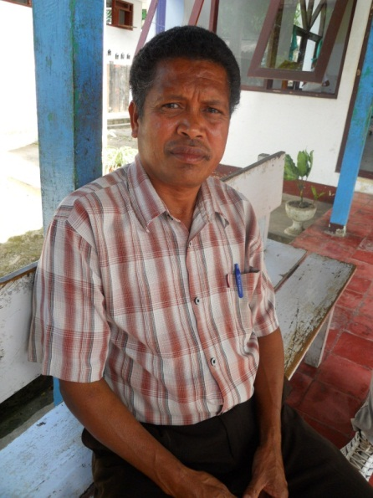An ATLASS specialist visiting team to Baucau identified a cholesteatoma in Domingos’ right ear, a common ear disease in poorer developing countries. A cholesteatoma is a cyst-like mass that grows inside the ear and if left untreated, can erode the small bones of the middle ear and cause hearing loss. As the cholesteatoma grows, it can erode the bony coverings over the inner ear, causing dizziness, loss of balance and occasionally total deafness. It can cause facial paralysis or allow infection to spread to the brain and cause a life threatening brain abscess or meningitis.

Through surgery provided by the ATLASS team, Domingos was able to have the potentially life threatening growth removed and was able to move forward with his life and teach his students without having to worry about the debilitating pain again.

Domingos waiting for surgery

**Case Study #2 – Ms Cintiliana Binsai**

Cintiliana Binsai is an 18 year old high school student living in Terilolo village near the district town of Baucau. At five years old, Cintiliana began to suffer from a painful discharge from her right ear. Similar to Domingos Augusto Ducg, there were no specialist doctors available to correctly diagnose and treat her ear condition. She was prescribed a general antibiotic which helped temporarily with the discharge, but it returned quickly along with the pain.

In 2011 the pain became so unbearable that her migraines were accompanied by nausea, vomiting and a bleeding ear. When the pain became too agonising, she was forced to take time off from her high school studies. When the pain became bearable again, she could return to school but sometime struggled to catch up on missed lessons.

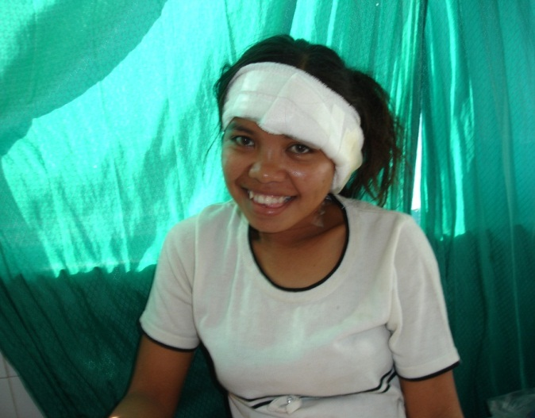The visiting ENT identified a cholesteatoma in Cintiliana’s right ear. Through the visiting team’s surgery, Cintiliana was able to have the potentially life threatening condition removed and did not have to miss another class at high school due to her condition again.

Cintiliana recovering after her operation

**Case Study #3– Mr Thome Ramos**

When Thome Ramos decided to get on the back seat of his friend’s motorcycle, he did not expect a 4WD truck to hit them, killing his friend and leaving him with severe injuries to his entire left leg and groin. The accident left the twenty year old with a broken left thigh bone, a large section of the skin and the underlying tissue from his groin torn off, thus severing the blood supply, and a broken lower left leg with significant skin loss and substantial damage to a central nerve leading to loss of movement and sensation in the foot and leg.

Given the severity of his injuries and the limited resources available to effectively treat the case, amputation was the recommended solution. However, Thome Ramos and his family refused amputation, preferring to return to their village and seek traditional methods of treatment. The ATLASS LTA Orthopaedic surgeon convinced the family to stay in hospital and promised not to amputate until everything else had been tried.

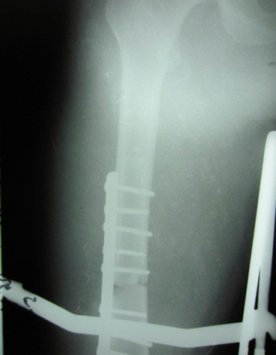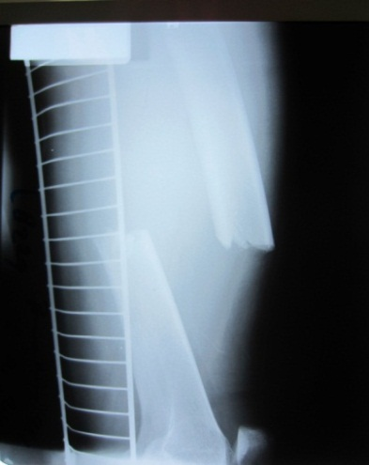Thome’s first surgery went for five hours as implants were inserted to repair his left thigh bone (see below). Without any image intensifier equipment available to assist the surgeon to accurately position implants to the bone, the orthopaedic surgeon had to call on all his practical expertise to position the implants.

Thome’s groin laceration was also repaired, dead skin and leg muscle and free bone fragments removed and a surgical instrument was installed to ensure alignment of the bone fracture during the healing process. In addition to the lack of equipment available, the surgery was further complicated by a lack of blood products available for transfusion.

After

Before

Days later, Thome returned to the theatre to have the deteriorating tissue from his leg removed, however early signs of infection began to appear. Thome returned to the theatre again shortly afterwards for further removal of deteriorating tissue in order to control the spreading infection.

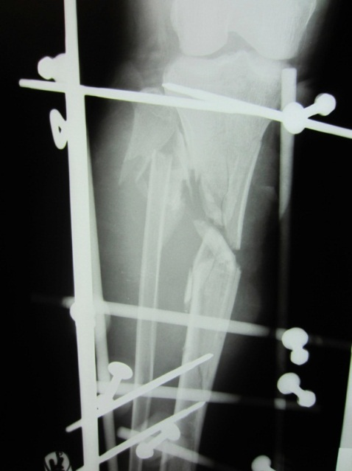With no pathology unit available at the hospital, antibiotics were selected based upon best judgement rather than laboratory test results. However, the antibiotics prescribed were not powerful enough to fight the infection quickly and there were no appropriate intravenous lines available for long-term antibiotic delivery. The possibility of forced amputation became increasingly likely.

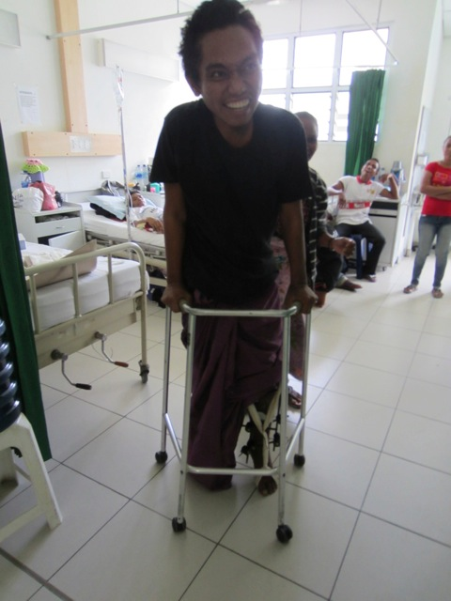During Thome’s second week in the hospital, he returned to the theatre where muscles from his lower back leg were transferred to the front in order to reconstruct the large dead space left from the removal of his dead muscles. Soon after, he returned to the theatre for further removal of deteriorating tissue due to the ongoing infection. His third time in the theatre that week involved a skin transplant over the front wound.

X-ray of external fixators

Despite all these challenges and lack of resources, the skin graft took well and the infection subsided. At a later stage, Thome will need to return to the operating theatre in order to replace missing bone and receive a tendon transfer to improve the movement in his ankle. But while Thome lost a friend, the tragedy was not further worsened by losing his leg and changing his entire life. When Thome was strong enough to move from his bed, he smiled for the first time since the accident.

Thome smiling

**Case Study #5 – Jorge Bernardo De Yesus Soares and Jose Fernando De Yesus Soares**

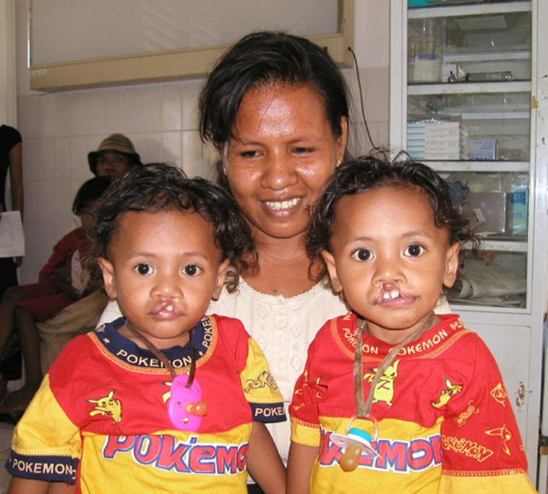Jorge Bernardo De Yesus Soares and his twin brother Jose Fernando De Yesus Soares are twelve years old and live in Audian, Dili. They were born with cleft lip deformity and when they were 14 months of age received life changing cleft lip repair surgery by visiting ATLASS-funded specialist Plastic and Craniofacial surgeon Mr Mark Moore from Adelaide.

10 years on, Mr Moore met the boys again to do a follow up repair on the initial surgery. As he keeps complete documents and photos of all his cases, Mr Moore was able to show the boys photos of themselves before the initial surgery. They were surprised when they saw the photos of themselves as babies. They asked their mother if it was true – she first lied to them as she was concerned about the impact of this knowledge on her children. She was worried that they would be ashamed of how they looked in the past. However she eventually told them the truth and they accepted it well – albeit with some disbelief.

Jorge (left) and Jose (right) pre-op

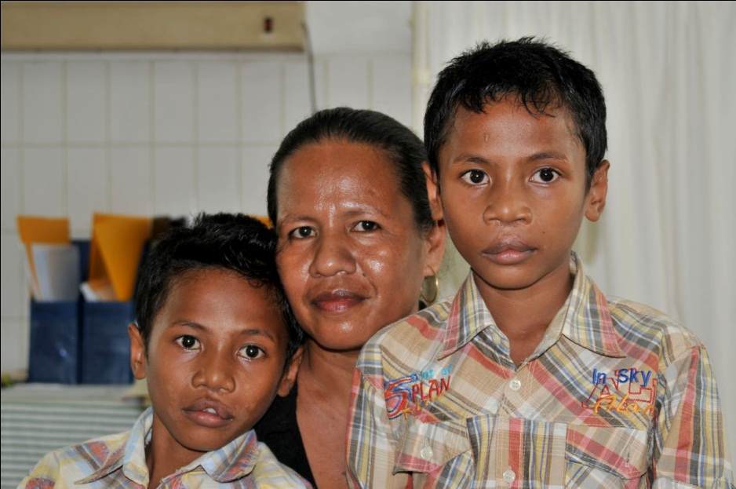The boys today shyly acknowledge that they are happy, attending school and living normal lives - because they received the surgery so early in their lives they were never subject to the reaction of other people to their birth deformities and do not carry the mental scars of being ostracised or vilified for their appearance.

Jorge (left) and Jose (right) ten years on

**Case Study # 6 - Joao Colimalae Coimbra**

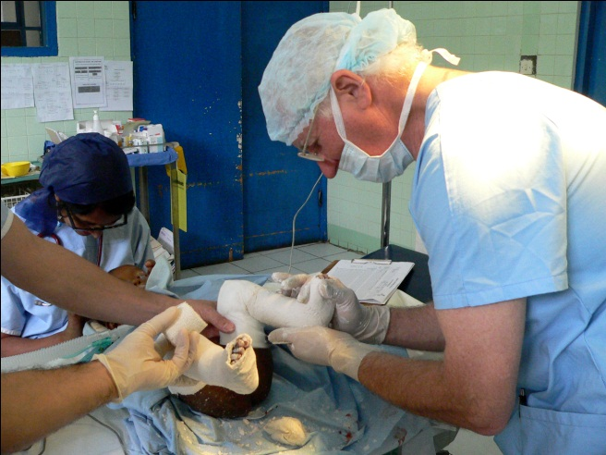Joao Colimalae Coimbra was born with the common birth defect of club foot. The specialist who delivered the baby advised her mother, Odete Colimalae, to take her newborn to disability rehabilitation organisation ASSERT for treatment as soon as possible. At 3 days old, baby Joao was taken there for diagnosis and treatment. Unfortunately a stomach ailment took him back to hospital and he wasn’t able to recommence his treatment until 7 months old. However this early diagnosis prevented a lifetime of disability for Joao. Today, at 2 years 8 months he is a healthy looking child proudly wearing sneakers and kicking a football with poise and force. His mother and older siblings Nivio and Franco watch on as he displays his walking technique. Odete explains that at exactly the right time of his development he was able to walk and was not at all hindered by the birth deformity, thanks to the treatment known as the Ponseti method.

Dr McNicol performing the Ponseti method

The Ponseti method, introduced into Timor Leste by ATLASS in collaboration with the Ministry of Health and ASSERT, treats club food through early intervention with serial plasters and (commonly) a tenotomy of the Achilles tendon. During his treatment, Joao was fitted for a splint of boots and a bar which was worn continuously for 12 weeks following serial plaster treatment for six weeks. This was followed by two years of night time wear only.

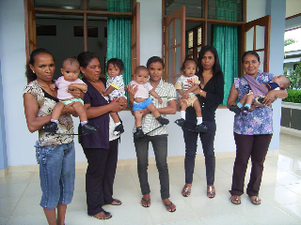At the end of the process Joao had a flat flexible foot. Odete feels that the foot can be straightened even further, so she has been given shoe inserts for Joao to wear until he is four years old. She says he is not bothered by the inserts which easily slip inside his sneakers. In the meantime she has become an advocate for ASSERT’s work and has counselled two other members of her extended family to seek treatment there. “It’s important that the community know about the services available to them because they will not have a normal life if they are not diagnosed early.”

Children wearing Splints and Bars