The AusAID-NGO Cooperation Program—working together to make a difference for the world’s poor
Contents
Working with non-government organisations 2
AusAID’s global NGO support program—the AusAID-NGO Cooperation Program (ANCP) 2
ANCP Expenditure By Region FY 2011–12 2
Delivering results 3
NGOs working with communities to provide quality education 3
NGOs providing services to vulnerable and marginalised communities 4
NGOs providing access to financial services 4
Maximising the impact and reach of Australian aid 5
Civil Society Engagement Framework 5
Accreditation of Australian NGOs 5
Monitoring, Evaluation and Learning Framework 5
More information 5
AusAID accredited NGOs funded under the ANCP (as at June 2012) 6

Working with non-government organisations
Last year over two million Australian households contributed approximately $1 billion to support Australian non-government organisations (NGOs) involved in international aid and development. They do so because NGOs have a strong track record and unique capacity for working directly with communities to help people overcome poverty.
NGOs have the ability to provide innovative responses to the needs of the poor through their strong on-the-ground links. Many NGOs raise awareness about issues impacting the poor and are frequently the main providers of basic services to the most vulnerable and marginalised communities. NGOs empower communities to deliver sustainable development programs and often have expertise in humanitarian emergency situations, where rapid and flexible responses are critical.
Australian NGOs are key partners for AusAID in its work to help people overcome poverty.

AusAID’s global NGO support program—the AusAID-NGO Cooperation Program (ANCP)
Delivering effective aid means using mechanisms and partnerships that achieve the best results in each situation. Australian aid is delivered through a strategic mix of funding to NGOs, government-to-government activities and multilateral support (funds provided to institutions such as the World Bank, the Asian Development Bank and various United Nations agencies).
For nearly 40 years the AusAID-NGO Cooperation Program (ANCP) has supported Australian NGOs to alleviate poverty by supplementing their own fundraising efforts. In 2011–12, approximately $98 million has been provided to 43 Australian NGOs to deliver over 600 projects in more than 50 countries.

ANCP Expenditure By Region FY 2011–12
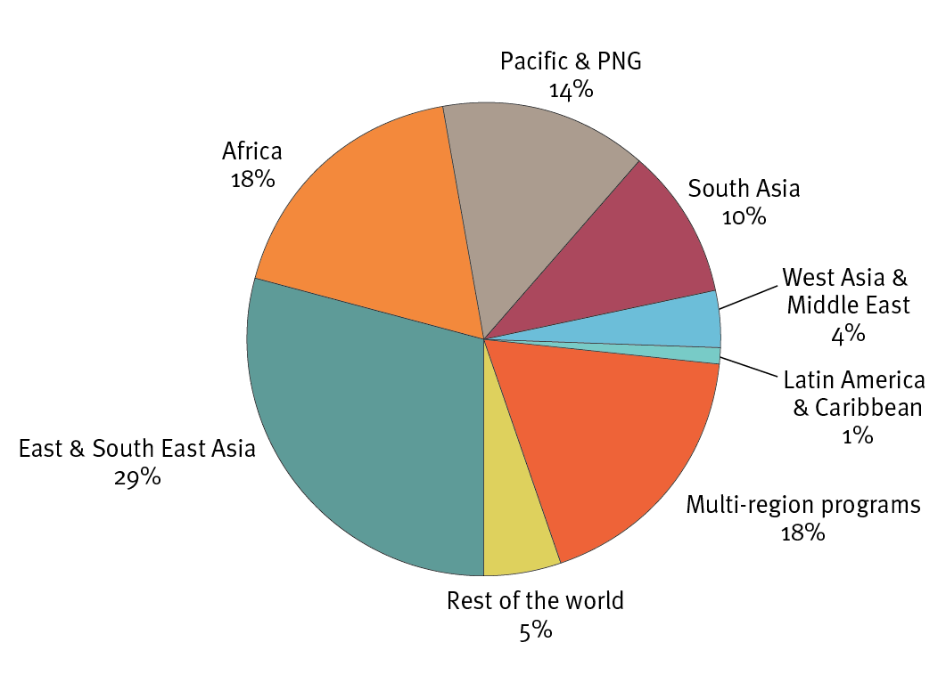

Delivering results
The ANCP delivers projects across a range of areas including education, health, water supply and sanitation, civil society and food security. AusAID estimates that from 2011–12 to 2015–16, more than four million poor and disadvantaged people in Asia, the Pacific, Africa and beyond will be assisted through the ANCP.
In 2011–12, the ANCP is expected to*:
- help 350 000 people access new or refurbished water supply facilities, with 60 000 of
these people accessing sanitation services for the first time
- train 2000 midwives and other community professionals, helping an estimated
275 000 people to benefit from community approaches to health and well-being
- provide more than 125 000 poor farmers in vulnerable and fragile areas with access
to new agricultural technology, support and training
- provide facilities and education policies to help 35 000 children in poor
and disadvantaged communities
- benefit more than 10 000 poor and disadvantaged children including those with
a disability with early childhood development and pre-primary education
preparation including support for more than 500 early childhood centres.
*Based on development activity plans submitted by the accredited NGOs for the 2011–12 financial year.
The following are some examples of the ANCP described through individual stories. While illustrating the work being done through the ANCP, these stories provide merely a glimpse of the work that is being carried out across the world by AusAID’s ANCP partners.

NGOs working with communities to provide quality education
Many NGOs funded through the ANCP contribute to improving the quality of and access to education, the Australian aid program’s flagship sector.
For example, in Cambodia a CARE Australia education program operating since 2009 has dramatically improved access to primary education through the introduction of a consistent language teaching policy. The program is developing a model on the country-wide adoption of bilingual education, addressing many of the language and cultural barriers to education for Cambodian children. The photo above shows students attending a CARE bilingual primary school in Ratanakiri where they have been learning Khmer, the national language, and their local indigenous language so they can transition to the state-run secondary school system.
This CARE program has also focused on expanding the local capacity of students, teachers and school administrators as well as the broader community. From 2009 to 2011, the program has directly benefited 1 405 students, 73 teachers, and 53 school support committee members, with a specific focus on girls and women. Each year the school completion rate for students has increased—from 75 per cent in 2008–09 to 84 per cent in 2010–11.
This program is now focusing on the underlying causes of poverty that affect educational access—including by developing livelihood and health activities—and is expanding into secondary schools.
The close NGO-community partnership has meant local communities have taken ownership of the program and responsibility for these schools will be transferred to the Royal Government of Cambodia.
The results from this program are consistent with the Australian aid program’s strategic goals—promoting opportunities for all and sustainable economic development.

NGOs providing services to vulnerable and marginalised communities
People with a disability and their families are often the most marginalised and vulnerable. It is estimated at least 80 per cent of people with a disability live in developing countries. One-third of people with a disability are children, two-thirds of whom have preventable disabilities.
Australia’s aid program leads the world in its support for development that includes and benefits people with a disability. Through projects funded under the ANCP in 2010 and 2011, Leprosy Mission Australia (LMA) has worked with people with a disability and their families and communities in Nepal, Nigeria, Papua New Guinea and Timor Leste.
LMA worked in communities and in partnership with people with disabilities to improve their access to health, education and employment services. Through the formation of 123 self-help groups and cooperatives, over 1 000 people with a disability now have access to micro-credit loans, employment schemes, pensions and health services.
Disability awareness and advocacy training was also carried out with over 3 000 participants from other NGOs, community leaders and members of self-help groups, promoting better understanding of disability rights and issues. Joel Fernandes (left, below) is a Disability Awareness Officer at LMA’s Community Based Rehabilitation project in Timor Leste. The project focuses on the integration of people with leprosy and other physical and mental disabilities into the broader community. The project’s activities include forming groups of community members (with or without disabilities) to increase the capacity of those with a disability to participate in community affairs and be involved in business initiatives.
Another example of an ANCP project helping children is the Australian Foundation for the Peoples of Asia and the Pacific’s Walk for Life training program in Bangladesh. In the township of Tongi, baby Hamin was born with both feet turned inward. Hamin’s mother Yasmin, took her to a hospital but was told an operation to treat her feet would cost Yasmin more than 20 times her weekly wage and there was no guarantee that the surgery would be successful. Yasmin later found out about the Walk for Life training program. The program, with ANCP support, provides intensive training to orthopaedic surgeons, physiotherapists, and medical assistants to increase their capacity to recognise people with clubfoot conditions and provide appropriate treatment. In 2010, Hamin was chosen to participate in the Walk for Life program and now, with non-surgical treatment, her feet have been corrected.

NGOs providing access to financial services
Microfinance helps individuals and communities overcome poverty by improving access to financial services and market opportunities. Australia helps poor people to access financial services by working with NGOs to provide microfinance and other financial services for the poor.
In 2011, the ANCP assisted an Opportunity International Australia project in the Philippines to develop more flexible loans enabling people to grow their businesses and improve their standard of living.
In this project, Opportunity International Australia partnered with three local microfinance institutions to collect information about clients’ preferences and needs. The partners developed new loan products to better serve the needs of their clients and reduced the waiting time for loans from weeks to days. In early 2011 the microfinance institutions provided the new loan products to more than 600 000 clients with more than 89 per cent of them being women.
The project also ran leadership and microfinance technical training for 500 senior managers from nine microfinance institutions on various topics including client protection, financial training and management.
Teresita Dacara (above) is a recipient of the Ok Ka! graduation loan, a new loan product designed for clients who have repaid previous loans and are ready to graduate to a higher loan. Teresita, now in her second loan cycle of the Ok Ka! program, has been able to buy school supplies for her sari-sari store (convenience store). She has also been able to buy a pig and vegetable farm and has significantly increased her family’s income—enabling her two daughters to go to school.

Maximising the impact and reach of Australian aid

Civil Society Engagement Framework
AusAID’s Civil Society Engagement Framework sets out how Australia will work more effectively with civil society organisations (CSOs), in Australia and overseas, to increase the impact of aid for the world’s poorest. The framework was developed in consultation with the Australian Council for International Development (ACFID). It sets out 19 practical actions for strengthening the effectiveness and impact of AusAID’s support for CSOs. These actions include better tracking and reporting of the results and impact of the work of CSOs; greater support for locally-based CSOs; and linking AusAID’s funding for CSOs more closely to their performance in delivering results and providing value for money.

Accreditation of Australian NGOs
To receive funding under the ANCP, NGOs undergo a rigorous accreditation process which assesses their governance and organisational structures, financial systems and development approaches. This ensures our NGO partners are professional, well managed and accountable.

Monitoring, Evaluation and Learning Framework
AusAID and NGOs are committed to improving the information available to demonstrate how ANCP funded projects are reducing poverty. To this end, AusAID has introduced a new Monitoring, Evaluation and Learning Framework which includes more in-depth reporting requirements, biennial evaluations and learning workshops so AusAID and NGOs can share lessons and build better programs.

More information
To access the Civil Society Engagement Framework and for more information about the ANCP and other funding for NGOs please visit www.ausaid.gov.au/ngos
For queries about the ANCP, please email: ancp@ausaid.gov.au
For queries about NGOs, please email: ngoengagement@ausaid.gov.au

AusAID acknowledges the work of all ANCP funded NGOs and their efforts in alleviating poverty. AusAID appreciates the assistance of the NGOs in providing information for the case studies in this publication. The selection of these case studies does not represent the endorsement of a particular organisation over another.

AusAID accredited NGOs funded under the ANCP (as at June 2012)
- Act for Peace—National Council of Churches Australia
- ActionAid Australia
- Adventist Development and Relief Agency
- Anglican Board of Mission Australia
- Anglicans Cooperating in Overseas Relief and Development
- Archbishop of Sydney’s Overseas Relief and Aid Fund
- Assisi Aid Projects
- Australian Foundation for the Peoples of Asia and the Pacific
- Australian Lutheran World Service
- Australian Red Cross
- Baptist World Aid Australia
- Burnet Institute
- CARE Australia
- Caritas Australia
- CBM Australia
- ChildFund Australia
- Credit Union Foundation Australia
- Every Home Global Concern
- Habitat for Humanity Australia
- International Needs Australia
- International Nepal Fellowship Australia
- International Women’s Development Agency
- Interplast Australia and New Zealand
- Marie Stopes International Australia
- NTA—East Indonesia Aid (Nusa Tenggara Association)
- Opportunity International Australia
- Oxfam Australia
- PLAN International Australia
- Quaker Service Australia
- Reledev Australia Limited
- Salvation Army International Development
- Save the Children Australia
- Sexual Health and Family Planning Australia
- TEAR Australia
- The Fred Hollows Foundation
- The International Centre for Eyecare Education
- The Leprosy Mission Australia
- Union Aid Abroad—APHEDA
- UnitingWorld
- WaterAid Australia
- World Education Australia Limited
- World Vision Australia
- World Wildlife Fund—Australia

Australian Council for International Development, http://www.acfid.asn.au, accessed 8 June 2012

