

Australian NGO Cooperation Program (ANCP)

Program Narrative (August 2020)

This document presents the Program Logic for the Australian NGO Cooperation Program (ANCP). It will be used as a management tool during annual reflections, and reviewed in 2023. The Program Logic reflects the experience of both DFAT and ANGO stakeholders.

### Rationale

The ANCP in a unique global program that supports trusted Australian NGOs through flexible annual grants for effective development projects overseas. It is the key partnership between Australian‑based international development NGOs (ANGOs) and the Department of Foreign Affairs and Trade (DFAT). The ANCP enables 59 accredited ANGOs to deliver locally-led development projects in over 50 countries. Projects are delivered across a range of sectors including education, health, water and sanitation, food security and civil society strengthening and where it may be difficult for bilateral and regional programs to be delivered. This allows Australia to build relationships in new areas and to be involved in long-term programming.

The Program Logic identifies the pathways along which the ANCP, as a Program, is expected to contribute to Australia’s efforts to sustainable economic growth and poverty reduction. It articulates the ‘value add’ of the ANCP to the Australian aid and development effort where ANCP extends and complements bilateral and regional programs. The Program Logic informs the assessment of Program performance, including a Performance Assessment Framework (PAF), terms of reference for monitoring and engagement visits and facilitates compliance with DFAT corporate reporting.

### Principles of Engagement

These principles are intended to guide the relationship between DFAT and NGOs participating in the ANCP. These principles were developed in collaboration and consultation with ANCP NGOs and build on those endorsed following the 2017 ANCP Annual Reflections Workshop.

* ANCP works in partnership with a diversity of ANGOs
* Respect for Independence
* Transparency: Open Communication & Dialogue
* Commitment to Value for Money
* Mutual Accountability for Results
* Continuous Improvement: Shared Learning, Cooperation and Innovation

### ANCP Goal

The ANCP **goal** connects the Program to the purpose of the broader Australian aid program, which is to contribute to Australia’s national interest through strengthening global prosperity, stability and resilience. The overarching **objective** of the ANCP is to progress Sustainable Development Goals (SDGs) through supporting inclusive development, and open and transparent civil society.

### Outcomes

The ANCP is an ongoing program, so the program outcome (usually termed ‘end of program’) should be considered ‘ongoing’, and is stated as: “*in partnership, ANCP seeks to contribute to Australian Government and partner country priorities to reduce poverty and promote sustainable and inclusive development*”. To realise the ANCP outcome, there are three inter-related outcome pathways that ensure the Program is positioned to deliver towards its final outcome, and contribute to the overarching goal:

|  |  |
| --- | --- |
| **Outcome Pathway 1** | **ANCP Modality** – flexible funding to ANGOs to deliver outcomes |
| **Outcome Pathway 2** | **Development outcomes** – ANGOs work with in-country partners |
| **Outcome Pathway 3** | **Public Diplomacy** – communicating the impact of the ANCP in partner countries and in Australia |

These pathways, when combined, explain how the ANCP works with ANGOs through an on-going flexible funding modality to deliver value-for-money development outcomes. The ANCP supports accredited ANGOs to work with in-country partners, to deliver effective and inclusive development programs with a focus on Gender Equality and Social Inclusion (GESI). The ANCP also supports Australia’s public diplomacy efforts through communicating the program’s impact in partner countries and in Australia, and supporting people‑to-people links.

### Outcome 1: ANCP Modality

The outcome pathway centres on the modality of the ANCP program as well as DFAT’s management of the program, emphasising clear, transparent and efficient program management systems. It enables outcomes through supporting coalitions of Australian civil society for collective action. With a foundation of **inclusive practices**, the ANCP support **continuous improvement and learning** in program delivery through sharing evidence and lessons with DFAT colleagues, other ANGOs and the broader sector through the engagement of ACFID. The joint efforts of ANGOs and DFAT aim to bring about improved effectiveness across the program cycle and includes **flexibility to trial new ideas**.

ANCP, through its transparent and rigorous accreditation process, represent **value for money[1]** in program delivery. ANCP, though supporting ANGOs to deliver inclusive community development, **complements Australia’s bilateral and regional programs and priorities**. ANCP projects do not need to align with individual Aid Investment Plan priorities and extend and complement the Australian Aid Program.

Outcome 2: Development Outcomes

This outcome pathway involves two domains. The first domain involves ANGOs, with in-country partners, **delivering effective development programs with a focus on Gender Equality and Social Inclusion.** This will enable, ANGOs, with ANCP funding, to **progress selected SDGs, with a particular focus on groups whose needs are greatest**.

The second pathways involves ANGOs **building and maintaining quality, often enduring, relationships with in‑country partners** to establish appropriate foundations for working with marginalised communities and facilitate collective action through locally-led development processes. These partners bring intimate knowledge of the local context and both deep and wide networks. NGOs can be powerful agents for change, and play a crucial role in preserving and advancing human rights around the globe. Ensuring this knowledge and learning is shared through consultation enhances the effectiveness of this engagement by **strengthening the capacity of in-country partners and civil society more broadly**.

The ANCP promotes transformational change in areas such as access to information and services, building knowledge and skills, making informed decisions, and building trust and respect. The sum of these pathways yields more complete and sustainable improvements to the living standards and well-being of individuals and communities in developing countries.

Outcome 3: Public Diplomacy

This pathway focuses on ANCP supporting DFAT’s objectives through engaging with a wide variety of accredited organisations with different origins, public support bases, missions, organisational sizes and structures, skills, technical capacity and partnerships and **promotion of people-to-people links** in partner countries and in Australia.

This enables ANCP to communicate **shared values** including political, economic and religious freedom, democracy, the rule of law, racial and gender equality and mutual respect, as well as the **program’s impact** to the **Australian public, communities and in-country partners**. It does this by tapping into and supporting existing linkages of ANGOs with the Australian public, global networks and in-country partners allowing the Australian Aid Program to have a broader reach. It also recognises the importance of engagement with DFAT Posts and thematic areas to facilitate increased awareness of ANCP and draw on these areas of expertise.

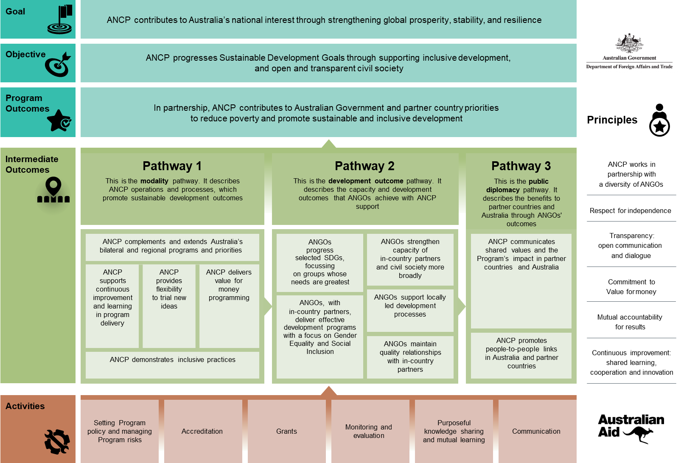

1. [DFAT’s Value for Money](https://dfat.gov.au/aid/who-we-work-with/value-for-money-principles/Pages/value-for-money-principles.aspx) principles are Economy, Efficiency, Effectiveness and Ethics