2023-24 Australian NGO Cooperation Program Performance snapshot

The Australian NGO Cooperation Program (ANCP) supports accredited Australian-based development NGOs through flexible annual grants to progress sustainable and inclusive development. In 2023-24, the ANCP supported 59 NGOs to deliver 382 projects in 51 countries. This snapshot presents aggregated data on 2023-24 program-wide performance, against agreed and common indicators, which is drawn from annual progress reporting by ANCP NGOs. It also provides an overview of how the ANCP continues to respond to Australian development program priorities, including gender equality, disability inclusion and locally led development.

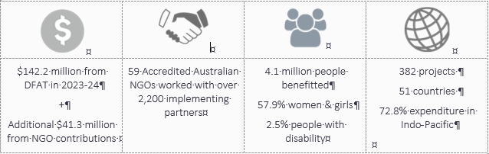

Figure 1: 2023-24 expenditure by region

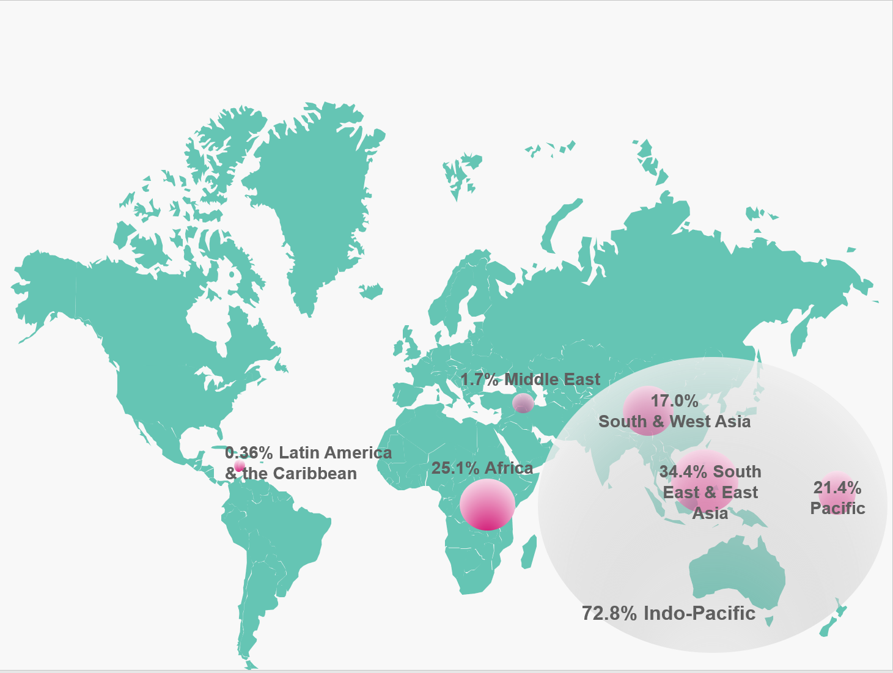

In 2023-24, ANCP grants amounted to $142.2 million. This included $7.5 million as part of the Government’s election commitment of an additional $30 million for ANCP over four years.

The ANCP modality requires an NGO contribution, typically at least 20 per cent. In 2023-24, the total NGO contribution to the ANCP was $41.3 million (29 per cent), compared to $40.1 million in 2022-23 (28 per cent). In addition, 16 per cent of projects received funding from other sources, down from 23 per cent in 2022-23. These funds were largely leveraged from other Government sources (including local, provincial and national governments in-country and other Government donors such as Irish Aid, USAID, MFAT), other International NGOs and CSOs, private sector, multilateral organisations and faith-based organisations.

## Key development results

In 2023-24, the ANCP reached 4.1 million people and achieved the following development results:

* Over 3 million people received improved health services (65.7 per cent women and girls, 1.2 per cent people with disabilities).
* Over 600,000 people benefitted from household-level access to improved drinking water sources and/or sanitation facilities (60.8 per cent women and girls and 5.1 per cent people with disabilities).
* Over 200,000 people received increased access to sufficient food (51.7 women and girls and 1.8 per cent people with disabilities).
* Over 50,000 people reached with new or improved social protection programs (54.1 women and girls and 3.5 per cent people with disabilities).
* More than 45,000 women supported to assume leadership roles (3.2 cent women with disabilities).
* Over 30,000 additional girls and boys enrolled in school (48.6 per cent girls and 5.4 per cent people with disabilities).

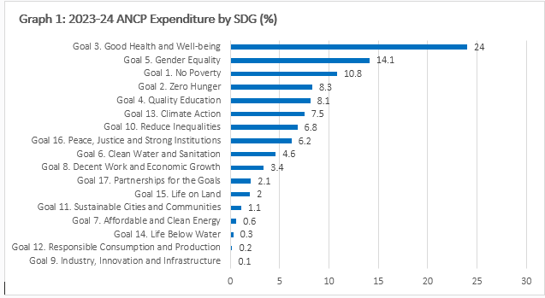

The objective of the ANCP is to progress Sustainable Development Goals (SDGs) through supporting inclusive development, and open and transparent civil society. Graph 1 shows ANCP expenditure (percentage) in 2023-24 against each SDG. The largest expenditure related to: Good Health and Wellbeing (Goal 3); Gender Equality (Goal 5); No Poverty (Goal 1) and Zero Hunger (Goal 2).

## Locally led development

DFAT is exploring how locally led approaches can be strengthened through the ANCP and the development program more broadly. This has been reinforced by the commitment in Australia’s International Development Policy to support local leadership, solutions, and accountability, including channelling funding to local actors. Graph 2 shows implementing partner type across the ANCP, which reflects the prevalence of working with local implementing partners.

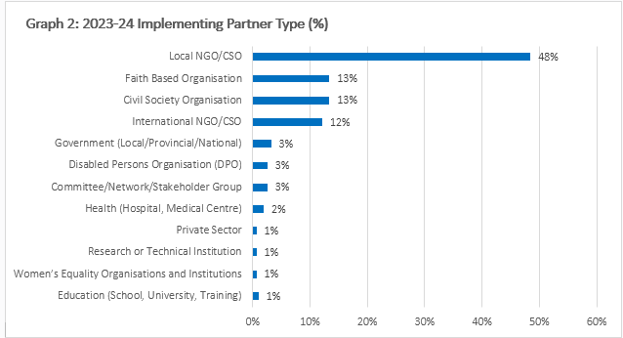

In 2022-23 DFAT piloted a funding pass-down to local partners, where ANGOs were required to allocate a minimum of $5,000 of their annual ANCP grant to local implementing partners for administration and overheads costs. In 2023-24, the local pass down value increased to $10,000 and included funding flows to local partners for implementing project activities. Over $1.3 million was passed down in 2023-24, up from $465,000 in 2022-23.

## Gender equality and disability inclusion

Social inclusion is an integral part of ANCP’s Program Logic. DFAT accreditation verifies that ANCP NGOs have appropriate policies, systems and capacity to promote gender equality and incorporate disability inclusive practices in development programming. Of the 4.1 million direct participants, 58 per cent were women or girls (down from 61 per cent in 2022-23) and 2.5 per cent were people with disabilities (up from 2.4 per cent in 2022-23). Overall and in line with previous reporting, inclusion of gender equality approaches in ANCP are stronger than those for disability inclusion.

In 2023-24, the ANCP supported the following indicator results for gender equality:

* 376,292 people participated in sessions on gender issues and women's equal rights (64.3 per cent women and girls, 2.4 per cent people with disabilities), up from 368,421 people in 2022-23 and 354,680 people in 2021-22 (Indicator G.02).
* 47,512 women were supported to assume leadership roles (3.2 per cent women with disabilities), up from 30,029 women in 2022-23 and 31,509 women in 2021-22 (Indicator G.04).
* 44,766 female entrepreneurs were provided with financial and/or business development services (2.7 per cent women with disabilities), up from 14,043 in 2022-23 and 10,239 in 2021-22 (Indicator G.05).
* 3,453 women’s groups, organisations and coalitions were actively involved across projects, compared to 3,490 in 2022-23 and 3,213 in 2021-22 (Indicator G.06).

Table 1 shows 69 per cent of 2023-24 ANCP projects explicitly targeted gender equality (demonstrated through the selection of the principal and significant DAC gender equality markers), up from 63 per cent of projects in 2022-23 and 61 per cent of projects in 2021-22. Gender equality data for 2023-24 reflects the removal of the mainstreaming approach to gender equality in the ANCP. Table 1 reflects this transition phase with an increase in the proportion of projects in the not targeted category compared to 2022-23.

**Table 1: Project-level approach to gender equality**

| **Gender marker** | **# of projects 2022-23** | **% of projects 2022-23** | **# of projects 2023-24** | **% of projects 2023-24** |
| --- | --- | --- | --- | --- |
| Principal | 69 | 17 | 70 | 18 |
| Significant | 185 | 46 | 196 | 51 |
| Mainstream | 102 | 25 | 45 | 12 |
| Not Targeted | 46 | 12 | 71 | 19 |

ANCP reporting collects information on whether people with disabilities or organisations of people with disabilities (OPDs) are involved in project planning, implementation and review processes. In 2023-24, 636 OPDs were engaged across all projects with a principal or significant disability focus, compared to 527 in 2022-23 and 643 in 2021-22.

Beyond quantitative parameters, there is limited systematically collected evidence and analysis on which to report disability inclusion outcomes. Examples of inclusive approaches included participation by OPDs in needs assessments, strengthening of disability inclusion awareness and resources and participation by people with disabilities in project governance.

In 2023-24, the ANCP supported the following indicator results for disability inclusion:

* 17,756 people received disability support services specific to their needs (51.4 per cent women and girls), up from 11,721 people in 2022-23 (Indicator G.7).
* 138,509 people trained in disability awareness and inclusion, up from 105,891 people in 2022-23 (Indicator G.09).
* 6,534 people were trained in delivery of disability support services (58.9 per cent women and girls), up from 4,667 people in 2022-23 (Indicator G.10).

Table 2 shows five per cent of 2023-24 ANCP projects had a principal focus on disability inclusion, 70 per cent had a significant focus (including both twin track or mainstream approach) and 25 percent did not target disability inclusion.

**Table 2: Project-level approach to disability inclusion**

| **Disability marker** | **# of projects 2022-23** | **% of projects 2022-23** | **# of projects 2023-24** | **% of projects 2023-24** |
| --- | --- | --- | --- | --- |
| Principal | 16 | 4 | 19 | 5 |
| Significant | 276 | 69 | 267 | 70 |
| *Twin tracked* | 90 | 22 | 98 | 26 |
| *Mainstream* | 186 | 47 | 169 | 44 |
| Not Targeted | 110 | 27 | 96 | 25 |

In 2024, DFAT commissioned a review to explore barriers and opportunities for integrating disability equity and inclusion across the ANCP. The review found that accredited ANCP NGOs are largely demonstrating strong and active commitment to disability equity within projects and are working to promote inclusive practice. Most agencies are showing moderate and improving performance on disability equity. Reflecting the wider sector, disability equity is integrated into the thinking and practice of ANCP NGOs. Some are engaging with OPDs; however, this remains an area of weakness.

While core principles required for disability equity should be consistent across projects, the diversity within the ANCP means the practices needed to implement these can differ widely across projects. What works for large agencies may be impractical for small agencies; what is effective in densely populated urban contexts may not be effective in remote and sparsely populated islands. Coupled with this is the fact that best practice in disability equity is still emerging – the sector is to some extent ‘learning as we go’. Other key factors impacting achievement on disability equity include the availability of funding, resources and technical advice; the need to address multiple cross-cutting issues within projects; support from DFAT Posts; and capacity gaps on disability equity.

In 2025, DFAT will work with ACFID to ensure capacity building on disability inclusion programming remains a priority for ANCP NGOs. This aligns with the commitment in Australia’s International Development Policy to support all people to fulfil their potential, which is reflected in Australia’s International Disability Equity and Rights Strategy, published in November 2024.

## Climate change

ANCP NGOs are playing an increasing role in climate change action in the Australian development program. This is reflected in increasing ANCP contribution to climate finance over time (Graph 3)[1].

In 2023-24, 35 ANCP NGOs implemented climate change activities across 131 projects (34 per cent of all projects), compared to 33 NGOs across 130 projects in 2022-23 (32 per cent of all projects) and 27 NGOs across 79 projects in 2021-22 (20 per cent of all projects). Forty per cent of climate funding supported adaptation activities, 16 per cent supported mitigation activities, and 44 per cent supported activities that included both adaptation and mitigation where the split could not be determined.

Climate change was most often a secondary objective at the project level (25 per cent of all projects), with activities supporting sectors such as livelihoods and economic development, disaster risk reduction and food security. In 2024, DFAT worked with ACFID and ANCP partners to further strengthen climate change programming in the ANCP, in line with the commitment in Australia’s International Development Policy to increase climate investments and better address climate risk.

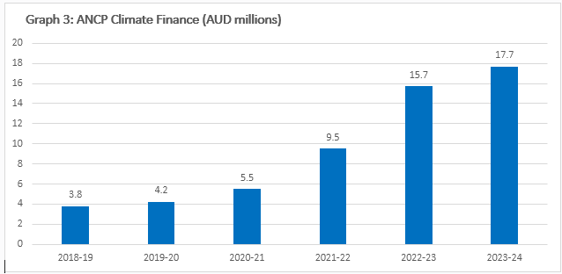

## Accreditation

Fifteen accreditation reviews were undertaken in 2023-24. Seven were completed as part of the five-year re-accreditation cycle, with all re-accrediting at the same level. There were no applications for upgrades. There were five new applications, three at base level and two at full level.

* Of the seven applications for re-accreditation, six ANGOs were re-accredited at full level and one ANGO was re-accredited at base level.
* Of the five new applications, two withdrew and three were unsuccessful.
* Three subject-to reviews were successfully completed.

1. **Note: 2021-22 was the first year that reporting on ANCP climate finance expenditure was mandatory.**