2021-22 Australian NGO Cooperation Program

Performance snapshot

The Australian NGO Cooperation Program (ANCP) supports accredited Australian-based development NGOs through flexible annual grants for effective international development projects. In 2021-22 the ANCP supported 57 NGOs to deliver 392 projects in over 50 countries. This snapshot presents aggregated data on 2021-22 program-wide performance, against agreed and common indicators[1], as well as an overview of how the ANCP continued to respond to Australian development program priorities including COVID-19 recovery and gender equality.

**Table 1: ANCP overview statistics for the last three COVID-19 impacted years**

|  |  |  |  |
| --- | --- | --- | --- |
|  | **2019-20** | **2020-21** | **2021-22** |
| ANCP grants to NGOs (AUD million) | 131.8 | 132.9 | 132.8 |
| NGO contributions (AUD million) | 30.15 | 21.44 | 34.7 |
| NGO contribution percentage | 23 | 16 | 26 |
| External contributions (AUD million) | 25.6 | 21.47 | 21.65 |
| Number of accredited NGOs | 57 | 57 | 57 |
| Number of implementing partners | Over 2,000 | Over 2,500 | Over 2,200 |
| Number of direct participants (million) | Over 11.8 | Over 9.0 | Over 5.4 |
| Participants: women and girls (%) | 57 | 52.36 | 56.13 |
| Participants: people with disabilities (%) | 8.0 | 5.82 | 2.6 |
| Number of projects | 424 | 406 | 392 |
| Number of countries | 58 | 50 | 52 |
| Indo-Pacific expenditure (%) | 83 | 75 | 74 |

**Map 1: 2021-22 expenditure by region**

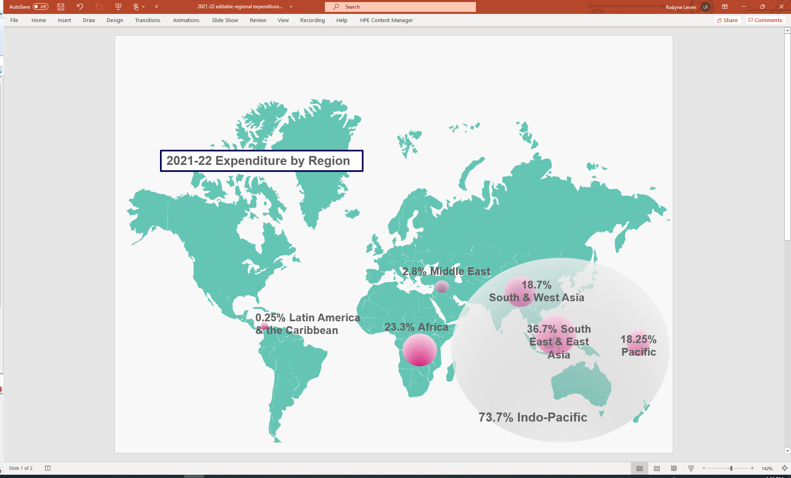

## **ANCP COVID-19 Development Response**

In 2021-22 ANCP NGOs and their partners delivered programs that responded to the impacts of the pandemic, in line with the then *Partnerships for Recovery: Australia’s COVID-19 Development Response*. The top five countries for 2021-22 COVID-19 expenditure[2] were Timor-Leste, Nepal, Solomon Islands, Cambodia and the Philippines. All projects aligned with one or more *Partnerships for Recovery* pillar: 38 per cent supported health security, 35 per cent supported stability and 27 per cent supported economic recovery. There was a reduction in COVID-19 specific programming in 2021-22, reflecting the mainstreaming of COVID-19 activities and a return to ongoing programming priorities. For example, in 2021-22 $4.3 million of Australian Government ANCP funding was used to support COVID-19 activities, down from $7.9 million in 2020-21. Similarly, 875,095 people were reached through specific COVID-19 activities in 2021-22, down from over 4 million in 2020-21.

### **Partnerships for Recovery Pillar 1: Health Security**

In 2021-22, 149 ANCP projects supported communities and governments to address health security risks and impacts of COVID-19. COVID-19 specific health security indicator results were generally lower than the previous two years of the pandemic. In 2021-22 the ANCP supported the following:

* 844,081 new or improved therapeutics, diagnostics, vaccines and additional equipment was made accessible in partner countries up from 668,916 in 2020-21 (ANCP Indicator H.04, Tier 2 Indicator)
* 1,747,360 people were targeted through one-way messaging on COVID-19 prevention and access to services (45.27 % women and girls and 6.35% people with disabilities) down from 6,979,396 in 2020-21 and 4,171,431 in 2019-20 (ANCP Indicator H.12)
* 289,445 items of PPE were distributed, down from 1,175,725 in 2020-21 and 630,948 in 2019-20 (ANCP Indicator H.14)
* 178,011 people were provided household access to handwashing facilities (50.46% women and girls, 3.58% people with disabilities) down from 309,295 people in 2020-21 and 267,601 in 2019-20 (ANCP Indicator W.03)

**Partnerships for Recovery Pillar 2: Stability**

In 2021-22, ANCP NGOs continued to address the social impacts of COVID-19 by supporting activities focussed on social cohesion, social protection, improved food security, education and resilience to threats such as climate change. In 2021-22 the ANCP supported the following:

* 7,984 women survivors of violence received services such as counselling (17.79% women with disabilities) up from 4,249 women in 2020-21 and 3,196 in 2019-20 (ANCP Indicator G.03, Tier 2 Indicator)
* 46,046 additional children enrolled in school (46.46% girls, 6.33% girls with disabilities) down from 63,062 in 2020-21 and up from 40,279 in 2019-20 (ANCP Indicator E.01, Tier 2 Indicator)
* 425,412 people participated in sessions on prevention, reduction and response to violence, abuse and exploitation of children (55.59% women and girls and 2% people with disabilities), down from 660,028 in 2020-21 and 442,749 in 2019-20 (ANCP Indicator CP.01)
* 201,033 people had improved access to sufficient food (52.2% women and girls, 2.59% people with disabilities), down from 215,075 in 2020-21 and 321,174 in 2019-20 (ANCP Indicator F.01)

**Partnerships for Recovery Pillar 3: Economic Recovery**

In 2021-22, economic recovery efforts were supported under the ANCP through training and support for improved livelihoods and rural development and improved access to financial services and social transfers. In 2021-22 the ANCP supported the following:

* 10,239 female entrepreneurs were provided with financial and/or business development services (3.99% women with disabilities) down from 41,980 in 2020-21 (ANCP Indicator G.05, Tier 2 Indicator)
* 115,180 people increased their incomes (57.94% women and girls, 4.07% people with disabilities), down from 133,503 in 2020-21 and up from 108,746 people in 2019-20 (ANCP Indicator L.02)
* 24,356 people accessed social transfers (such as cash & voucher assistance) (58.61% women and girls, 6.88% people with disabilities) down from 39,585 in 2020-21 and 35,887 people in 2019-20 (ANCP Indicator L.04)

## **2021-22 ANCP Highlights**

In 2021-22 programming in Myanmar continued to be impacted by the coup while other projects, particularly those focussed on education and other public services, remained impacted by COVID-19 restrictions. The ANCP-wide direct participant totals dropped significantly since the start of the pandemic from over 11.8 million in 2019-20 to just over 5.4 million in 2021-22. The drop reflects pandemic-related implementation challenges.

The objective of the ANCP is to progress Sustainable Development Goals (SDGs) through supporting inclusive development, and open and transparent civil society. Graph 1 shows ANCP expenditure (percentage) in 2021-22 against each SDG. In both 2020-21 and 2021-22 expenditure against Goal 3 increased by 25 per cent from 2019-20, reflecting the COVID-19 response pivot.

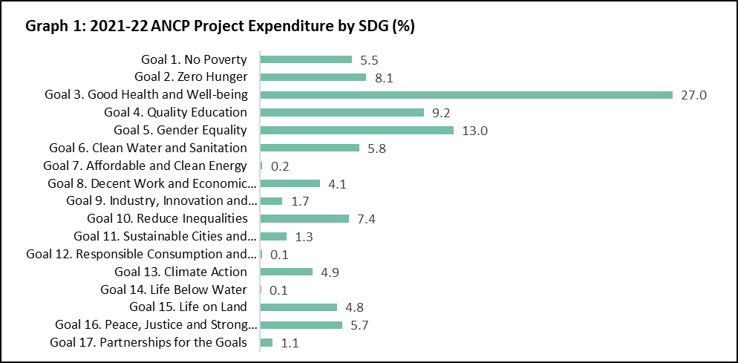

### Financial co-contributions

The ANCP modality requires an NGO contribution, typically at least 20 per cent. In 2021-22 the total NGO contribution to the ANCP was $34.7 million, a significant recovery from 2020-21 (NGO contribution of $21.4 million) when the co-contribution requirement was temporarily set at 10 per cent. In addition to the NGO co-contributions, 19 per cent of projects received funding from other sources, up from 8 per cent of projects in 2020-21. These funds included:

* $7.2 million from Government sources (including local governments in-country and other Government donors including Irish Aid, MFAT, UK FCDO)
* $6.9 million from International NGOs & CSOs
* $3.7 million from the private sector
* $1.7 million from faith-based organisations
* $0.9 million from multilateral organisations

### Innovation, locally led development and Indigenous engagement

### The ANCP includes examples of innovative practice in priority areas for the Australian development program including health systems strengthening and livelihoods support. The flexibility of the ANCP has long enabled the trialling of new approaches. In 2021-22 over 40 per cent of projects reported some innovation, including electronic solutions, remote monitoring and data capture and usage. DFAT acknowledges this innovation could be better leveraged to inform projects across the development program. The learning agenda will support this going forward.

Locally led development is an area of growing focus in the ANCP and the Australian development program more broadly. Graph 2, which shows the implementing partner type across the ANCP, reflects the prevalence of working with local implementing partners. In 2021-22 ANCP NGOs voluntarily reported their organisational approaches to locally led development. Several themes emerged from the summaries provided by 42 ANCP NGOs:

* Commitment to locally led development in organisational governance: some NGOs reported their commitment to locally led development in Strategic Plans or similar. Others reported recent revisions to program logics or the development of specific policies to help guide approaches to locally led development.
* Partner-led design and implementation: many NGOs reported their design and needs assessments are led by local partners and communities, drawing on deep contextualised knowledge of the implementing environment.
* Mutual accountability partnership models: some NGOs are using partnership models that include mutual accountability frameworks, decision making autonomy and shared objectives.
* Local partner institutional / capacity strengthening: NGOs noted the importance of long-term capacity development to enable locally led development. Long-term capacity building of local partners contributed to the early and effective response by ANCP partners to the pandemic. Graph 3 summarises development and capacity building outcomes in the ANCP. The most reported development outcome under Program Logic Pathway 2[3] focussed on strengthening capacity. Capacity building efforts included skills and knowledge exchanges and long-term partnership building. For example, several ANCP NGOs reported long-standing relationships with local partners that draw on and leverage off professional networks or faith-based alliances.

Barriers to locally led development reported by ANCP NGOs included compliance requirements, contractual limitations to risk sharing and management arrangements, and the capacity of local NGOs. In 2023 the ANCP will look to how locally led development can be better supported as part of program reforms recommended in the 2022 ANCP Independent Evaluation.

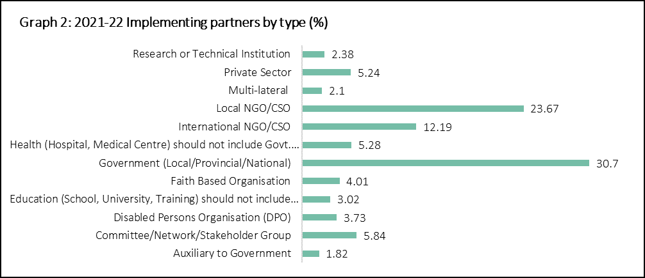

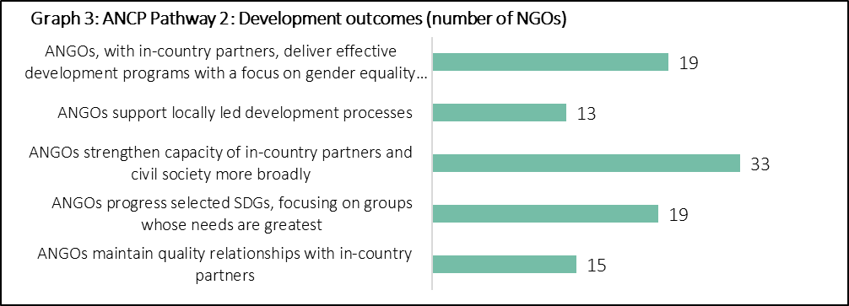

2021-22 saw an increased focus on Indigenous engagement in the Australian development program. More recently the government has announced it will apply a First Nation’s approach to Australia’s foreign policy, further lifting the profile of programs engaging with Indigenous and ethnic minorities, including in the ANCP. About one quarter of ANCP projects, implemented by 34 NGOs, reported active involvement with Indigenous peoples or ethnic minorities in 2021-22. Many NGOs reported on how barriers to participation were addressed to support greater engagement in all aspects of the program cycle from design to evaluation. Some common practices to reduce barriers to participation included the use of local languages in project communications and meetings, fostering of long-term relationships between local implementing partners and Indigenous peoples or ethnic minorities, and targeted promotion of the project in remote communities.

### Gender Equality and Disability Inclusion

Social inclusion is an integral part of ANCP’s Program Logic. Accreditation verifies that ANCP NGOs have appropriate policies, systems and capacity to promote gender equality and incorporate disability inclusive practices including analysis of barriers for people with disability, opportunities to enable inclusion and targeted M&E. In 2021-22 results were mixed at the highest aggregation of participant data. Of the 5.46 million direct participants reached, 56.13 per cent were women or girls (up from 52.36 per cent in 2020-21) and 2.58 per cent were people with disabilities (down from 5.82 per cent in 2020-21 and 8 per cent in 2019-20).

In 2021-22 the ANCP supported the following indicator results for gender equality:

* 354,680 people participated in sessions on gender issues and women's equal rights (60.26% women and girls, 1.66% people with disabilities) down from 669,114 people in 2020-21 and 431,828 people in 2019-20 (Indicator G.02)
* 31,509 women were supported to assume leadership roles (2.29% women with disabilities), up from 21,599 women in 2020-21 and down from 66,698 in 2019-20 (Indicator G.04)
* 10,239 female entrepreneurs provided with financial and/or business development services (3.99% women with disabilities) down from 46,424 in 2020-21 (Indicator G.05)

The Australian Government has reconfirmed its commitment to improving gender equality across its development program. As Table 2 shows, 61 per cent of 2021-22 ANCP projects explicitly targeted gender equality (demonstrated through the selection of the principal and significant DAC gender equality markers), similar to the 62 per cent of projects in 2020-21. Also consistent with 2020-21 results, in 2021-22 ANCP NGOs reported that 13 per cent of project expenditure contributed to SDG Goal 5 (Gender Equality). While data aggregated to program-wide performance indicates activities focussed on gender equality has held steady between 2020-21 and 2021-22, the qualitative data supporting this summation is varied and evidence of the impact of gender equality measures is often limited. In 2023, DFAT will work with ANCP NGOs to apply its revised gender equality requirements, taking a nuanced approach in recognition of the flexible and decentralised nature of the ANCP modality.

**Table 2: project-level approach to gender equality**

|  |  |  |  |  |
| --- | --- | --- | --- | --- |
| **Gender marker** | **# of projects 2021-22** | **% of projects 2021-22** | **# of projects 2020-21** | **% of projects 2020-21** |
| Principal | 71 | 18 | 78 | 19 |
| Significant | 169 | 43 | 176 | 43 |
| Not Targeted | 78 | 20 | 98 | 24 |
| Mainstream | 74 | 19 | 54 | 13 |
| Total | **392** | **100** | **406** | **100** |

Disability inclusive practice across the ANCP is varied and it remains an acknowledged area for improvement. Disability inclusion will be a focus of the 2023 ANCP learning agenda. ANCP reporting collects information on whether people with disabilities or organisations of people with disabilities (OPDs) are involved in project planning, implementation and review processes. In 2021-22, 66 projects (17 per cent of the total) reported engagement with at least one OPD. This is an increase from 11 per cent of projects in 2020-21 and 7 per cent of projects in 2019-20.

Beyond quantitative parameters, there is limited systematically collected evidence on which to report disability inclusion outcomes. Examples of inclusive approaches included participation by OPDs in needs assessments, strengthening of disability inclusion awareness and resources and participation by people with disabilities in project governance. In 2021-22 the ANCP supported:

* 180,407 people trained in disability awareness and inclusion, up from 120,161 people the previous year (Indicator G.09)
* 6,401 people received disability support services specific to their needs (46% women and girls), down from 22,349 people the previous year (indicator G.10)

In 2021-22 the ANCP disability markers were adjusted to align with DFAT’s OECD DAC reporting requirements. As a result, comparisons with earlier years are not valid. Reflecting the opportunity for better disability inclusion, Table 3 shows less than five per cent of projects had a principal focus on disability inclusion and almost one third of projects did not target disability inclusion.

**Table 3: project-level approach to gender equality**

|  |  |  |
| --- | --- | --- |
| **Disability marker** | **# of projects 2021-22** | **% of projects 2021-22** |
| Principal | 18 | 4.6 |
| Significant | 246 | 62.8 |
| Not Targeted | 128 | 32.6 |
| Total | **392** | **100** |

### Climate finance data 2021-22 (estimate)

ANCP NGOs are playing an increasing role in climate change action in the Australian development program. This is in part reflected in the increasing ANCP contribution to climate finance over time (Graph 4)[4]. In 2021-22 27 ANCP NGOs implemented climate change activities across 79 projects. 58 per cent of expenditure supported adaptation activities, 34.5 per cent supported mitigation activities and the remainder supported activities that included both adaptation and mitigation where the split could not be determined. Climate change was most often a secondary objective at the project level, with common activities supporting sectors including livelihoods and economic development, disaster risk reduction and food security. DFAT looks forward to working with ANCP partners to further strengthen climate change programming under the ANCP.

### Graph 4: ANCP climate finance AUD millions (estimate). 2016-17: 1.8 AUD million. 2017-18: 0.8 AUD million. 2018-19 3.8 AUD million. 2019-20: 4.2 AUD million. 2020-21 5.5 AUD million. 2021-22 9.5 AUD million.

### Accreditation

Twenty accreditation reviews were done in 2021-22. Half were completed as part of the five-year accreditation cycle, two were applications for upgrades and eight were new applications:

* Of the ten applications for re-accreditation, eight were re-accredited at Full and two at Base
* Of the two applications for upgrades, one was successful, and one was re-accredited at Base
* Of the eight new applications, three applications were withdrawn, two applications failed (both applied for Base) and three were successful at Base (one had applied for Full accreditation).

DFAT provided four NGOs with Technical Assistance to help prepare for accreditation.

1. **The data provided in the Annual Snapshot is drawn from annual progress reporting by ANCP NGOs. The ANCP captures both quantitative and qualitative data in its annual progress reporting. Quantitative data is reported under 48 program indicators.** 
2. **COVID-19 expenditure is the amount of DFAT grant funding used for activities in response to COVID-19 such as public health messaging.** 
3. **In 2021-22 NGOs were required to report one to three of the five Intermediate Outcomes under ANCP Pathway 2. Therefore, not all ANCP NGOs reported against the capacity strengthening outcome.**
4. **Note: 2021-22 was the first year in which reporting on ANCP climate finance expenditure was mandatory.**