Australian NGO Cooperation Program (ANCP)

Partnerships for recovery & 2019-20 Highlights

## ANCP COVID-19 Development Response

The ANCP is a unique global program that supports trusted Australian-based international development NGOs (ANGOs) through flexible annual grants for effective development projects overseas. The inherent flexibility in the ANCP model facilitated the timely adaptation of existing projects to focus on [*Partnerships for Recovery*](https://www.dfat.gov.au/publications/aid/partnerships-recovery-australias-covid-19-development-response) and COVID-19 activities.

NGOs’ established relationships with local partners provided a crucial base for ANCP to respond to emerging issues through adaptive programming. With international travel and resource mobilisation severely limited, the long‑standing partnerships between Australian NGOs and local partners were invaluable for the Program to react quickly to local needs and contexts. Between March and June 257 ANCP projects (60% of all ANCP projects) pivoted to respond to emerging challenges of COVID‑19. In 2019-20, ANCP supported:



$131.8 million in grants to NGOs + additional $30.15 million from NGO contributions +  
$25.6 million in leveraged funds

57 Accredited Australian NGOs worked with over 2000 local partners

11.8 million project participants. 57% women and girls and 8% people with disability[1]

 424 projects in 58 countries. 83% expenditure in Indo-Pacific

Australian NGOs are working directly with local partners across the Indo-Pacific region to prevent the spread of COVID-19 and implement ANCP programs to respond to the social and economic impact of the pandemic, in line with [*Partnerships for Recovery*](https://www.dfat.gov.au/publications/aid/partnerships-recovery-australias-covid-19-development-response).

### A map of the world showing the percentage of ANCP funds spent in each Region. The breakdown is: 0.1% Latin America and the Caribbean; 22.1% Africa and the Middle East; 6% African East Coast; 24% South and West Asia; 49% South East and East Asia; and 21% Pacific.

### Health Security

In 2019-20, 219 ANCP projects supported communities and leaders to understand the risk of COVID-19 and health and hygiene measures that can reduce its spread. NGOs engaged creatively through traditional and social media, ensuring information is accessible to people with disabilities, and translated into language for ethnic minorities. Many rural and remote communities report that information disseminated by ANCP NGOs was the only advice received. In 2019-20:

* 1,048,423 people reached through interactive events or sessions related to COVID-19 public health measures (68.3% women and girls and 3.8% people with disabilities)
* 630,948 items of personal protective equipment (PPE) distributed
* 267,601 people were provided household access to handwashing facilities (40.9% women and girls, 1.6% people with disabilities)
* 1,769 public buildings provided with hand washing facilities (including 611 schools, 490 health care facilities, 88 markets and 65 places of worship)
* 38,152 health workers received training and development (68.2% women and 0.1% people with disabilities)

##### A health worker in PPE is preparing some medical equipment. A child is sitting beside her. Case Study: Strengthening PNG Rural Health Services

Australian Doctor’s International (ADI) partners with PNG Provincial Governments and other partners to improve health and well-being in rural areas through regular outreach health patrols and professional development of healthcare workers and key community leaders.

Beginning in March 2020, ADI pivoted its activities to respond to COVID-19 through the delivery of PPE, training of health workers and raising awareness on preventative measures through distribution of information, education and communication (IEC) material and soap, buckets and sanitiser. ADI worked alongside each Provincial Health Authority and their COVID-19 taskforce for the delivery of COVID-19 activities to ensure alignment with national and provincial guidelines, recommendations and needs. Over 63,000 individual pieces of PPE have been delivered in Western Province, West New Britain and New Ireland.

Additional equipment such as sanitiser and digital thermometers were also distributed to assist health facilities and schools with their COVID-19 response. 85 health workers participated in remote training via webinar on COVID-19 preparedness. Awareness trips to 61 communities, 36 health facilities and 28 schools were conducted to educate about COVID-19 transmission, including messages on social distancing and hygiene.

### Stability

In 2019-20, ANCP projects contributed to stability through activities that supported social protection, education and resilience to threats such as climate change with a particular focus on protecting the most vulnerable. In 2019-20:

* 442,749 people participated in sessions on prevention, reduction and response to violence, abuse and exploitation of children (59.6% women and girls, 1.1% people with disabilities)
* 431,828 people participated in sessions on gender issues and women's equal rights (60.9% women and girls, 1.6% people with disabilities)
* 66,698 women were supported to assume leadership roles (2.9% women with disabilities)
* 40,279 additional children enrolled in school (51.6 girls, 3.4% children with disabilities) and an additional 42,230 children participated in non-formal education and alternative education pathways (49% girls and 3.1% children with disabilities)
* 151,635 people participated in sessions on climate related hazards and disasters (climate change mitigation, adaptation, preparedness, resilience and early warning) (53.1% women and girls, 1.6% people with disabilities)

##### Case Study: Nepal’s school of the air ensuring school children continue their education

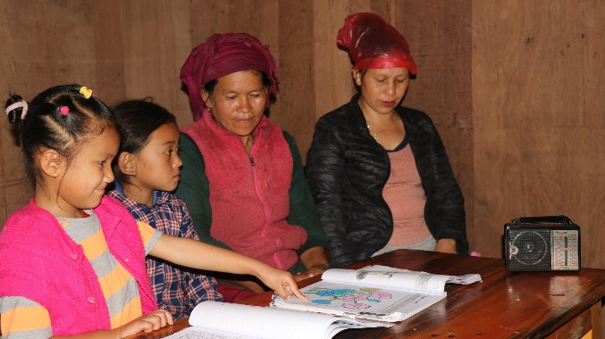ANCP funded Teacher Training and Quality Education Program (TTQE) project by the Australian Himalayan Foundation (AHF) responded creatively to continue education for children in mountainous villages in Nepal during lockdown.

Most households do not have internet and often no electricity either. AHF worked with their local implementing partner REED Nepal to record lessons to be broadcast via FM radio daily to over 23,000 households in the Solukhumbu region.

The broadcasts also include general COVID-19 awareness and prevention information, and other social and protection messages. Access to ongoing education via Himal FM Radio broadcasts during the COVID-19 crisis in the Solukhumbu region of Nepal has allowed children to keep learning

### Economic Recovery

In 2019-20 economic recovery efforts were supported through training and support for improved livelihoods and rural development, access to financial services and improved food security. In 2019-20:

* 108,746 people were supported to increase their incomes (55.6% women and girls, 4.3% people with disabilities)
* 103,348 people adopted improved agricultural and fisheries practices (55.6% women and girls, 4.2% people with disabilities)
* 95,335 people were reached with livelihoods support interventions (56% % women and girls, 4.4% people with disabilities)
* 35,887 people accessed social transfers (such as cash and voucher assistance) (56.3% women and girls, 14.2% people with disabilities)
* 321,174 people had improved access to sufficient food (54.7% women and girls, 2.4% people with disabilities)

##### A women is bottling some handwash. Case Study: Economic recovery in response to COVID-19

Credit Union Foundation Australian (CUFA) rapidly adapted its Cambodia Livelihoods Project to work with community social enterprises (CSEs) to produce liquid handwashing soap to ensure communities in Kampong Cham had access to affordable and safe hand-washing soap, to practice good hygiene to prevent the spread of the COVID-19 virus. CSEs produced, packaged and sold the liquid soap to wholesalers, retailers, and households generating profits in the process.

## ANCP 2019-20 program Highlights

Australian NGOs’ ongoing ANCP programming supports health, livelihoods, food security, inclusion and education is in line with *Partnerships for Recovery*. Table 1 shows ANCP expenditure in 2019-20 against the Sustainable Development Goals (SDGs)[2] .

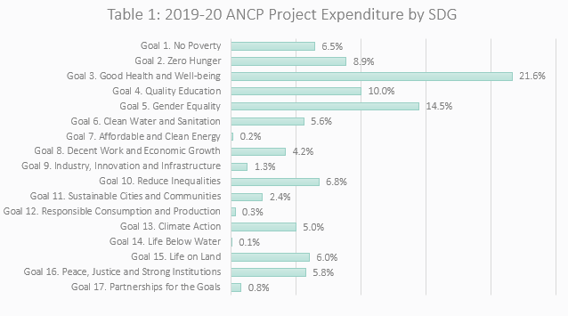

### NGO Financial Contributions

NGO contributions far exceeded the minimum requirement of 10% (reduced from 20% in 2019-20 to account for disruptions caused by COVID-19) - on average NGOs contributed a 38.5% match to the grant funds they received.

In addition to the co-funding contributions from ANCP NGOs, 66 projects received in-kind contributions and an additional $25.6 million was contributed to ANCP projects in 2019-20 from other sources including:

* $10.2 million from International NGOs & CSOs
* $5.6 million from Government sources (including local governments in-country and other Government donors such as Ireland, EU, NZ, France etc).
* $3.6 million from faith-based organisations
* $3.5 million from multilateral organisations
* $2.5 million from the private sector

Australian NGOs have strong links with local implementing partners in the ANCP, the majority of which are local NGOs, disabled peoples’ organisations (DPOs) faith based organisations and the private sector (see Table 2). ANGOs and their partners are identifying community needs in areas such as water and sanitation, food security and livelihoods, in an inclusive way to ensure responses meet the needs of women, children and people with disability.

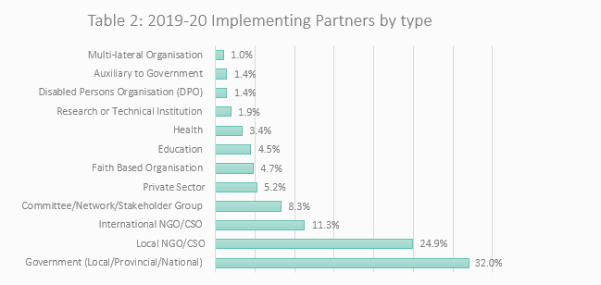

Another key strength of the ANCP is a commitment to building the capacity of in-country implementing partners and communities. By improving the technical and non-technical performance of local partners, ANGOs can assist them to achieve their objectives, become more financially and technically independent, and sustain their activities beyond the cessation of ANCP and ANGO assistance. Table 3 outlines the number and type of capacity building projects in the ANCP in 2019-20.

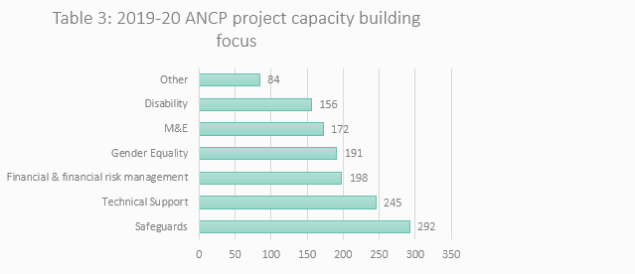

### 2019-20 ANCP Gender and Disability Data

ANCP NGOs have strong, inclusive practices to ensure response activities address the needs of women, children and people with disability reaching 11.8 million project participants, of which 57% women and girls, 8% people with disabilities. They are delivering hygiene messaging in local languages, the provision of soap and protective equipment to health clinics, and helping to ensure basic food security and livelihoods continue during this time. NGOs are coordinating with other local actors and different levels of government in-country to maximise efforts to address the pandemic.

* 431,828 people participated in sessions on gender issues and women's equal rights (60.9% women and girls, 1.6% people with disabilities)
* 227,052 people trained in disability awareness and inclusion
* 66,698 women supported to assume leadership roles (2.9% women with disabilities)
* 22,485 people received disability support services specific to their needs (44.6% women and girls)

In 2019-20, ANCP NGOs have indicated that 14% of ANCP grant funds contributed to SDG goal 5 - Gender Equality. Disability is integrated into a number of SDGs so it’s hard to determine the corresponding amount of ANCP expenditure in this space. However, 5% of ANCP grant funds were for projects that selected disability as the primary sector.

In 2019-20 more than half of ANCP projects explicitly targeted gender equality (demonstrated through the use of the principal & significant policy marker). There remains some room for improvement - in 2019-20, 29% of projects did not target gender equality (see table below). 2019-20 was the first year results are available since the category of mainstreaming was introduced. This was to capture projects that are doing good gender mainstreaming work but that do not explicitly target gender equality and women’s empowerment outcomes required to meet the principal or significant markers. It is anticipated that the number of projects identifying as mainstreaming will increase in future years as NGOs become familiar with the new category.

In the disability inclusion space, the data also shows us that there are significantly less projects that actively targeted disability inclusion in comparison to those that target gender equality outcomes. This is also evident in annual reporting and visit findings which show that there is more confidence and routine inclusion of gender equality approaches in ANCP programming but that this is still emergent when it comes to disability inclusion. This was also reflected in the [*Data Systems Validation Review*](https://www.dfat.gov.au/about-us/publications/Pages/aus-ngo-cooperation-program-ancp-data-systems-validation-review) completed in 2018 which found disaggregation by disability to be less robust than disaggregation by gender.

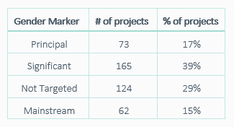

### A table showing the number and percentage of ANCP projects that target disability. 262 projects (62%) used the Mainstream Disability Marker; 16 projects (4%) used the Targeted Disability Marker; 77 projects used the Twin Track Disability Marker; and 69 projects (16%) used the Not Targeted Disability marker.

### Accreditation

Eight accreditation reviews were undertaken in 2019-20.  DFAT provided two NGOs with Technical Assistance to help prepare them for accreditation – both NGOs were new applicants.

* Four scheduled re-accreditations: one full and three base – two were re-accredited at base, one applicant for full was downgraded to base and one withdrew following the Desk Assessment (DA).
* Four new applicants for accreditation: one applicant successful at base, two applicants withdrew following the DA and one applicant was unsuccessful.

1. Data as provided by ANCP NGOs based on their M&E systems for FY 2019-20
2. Based on NGO self-reporting project expenditure against SDGs.