Australian Multilateral
Assessment
March 2012

Abbreviations and explanations
ADB | Asian Development Bank
AF | Kyoto Protocol Adaptation Fund
AfDB | African Development Bank
AMA | Australian Multilateral Assessment
AusAID | Australian Agency for International Development
CGIAR | Consultative Group on International Agricultural Research
CIFs | Climate Investment Funds
COMSEC | Commonwealth Secretariat
CSO | Civil Society Organisation
FAO | Food and Agriculture Organization
GAVI | GAVI Alliance
GCDT | Global Crop Diversity Trust
GEF | Global Environment Facility
GFATM | Global Fund to Fight AIDS, Tuberculosis and Malaria
GFDRR | Global Facility for Disaster Reduction and Recovery
GPE | Global Partnership for Education
ICRC | International Committee of the Red Cross
IDB | Inter-American Development Bank
IFAD | International Fund for Agricultural Development
IFC | International Finance Corporation
IFI | International Financial Institution
ILO | International Labour Organization
IMF | International Monetary Fund
IOM | International Organization for Migration
LDCF | Least Developed Countries Fund
MAR | Multilateral Aid Review
MDB | Multilateral Development Bank
MDG | Millennium Development Goal
MLF | Multilateral Fund for the Implementation of the Montreal Protocol
MOPAN | Multilateral Organization Performance Assessment Network
NGO | Non-Government Organisation
ODA | Official Development Assistance
OHCHR | Office of the High Commissioner for Human Rights
PBF | United Nations Peacebuilding Fund
PIDG | Private Infrastructure Development Group
UN | United Nations
UNAIDS | Joint United Nations Programme on HIV/AIDS
UNCDF | United Nations Capital Development Fund
UNDP | United Nations Development Programme
UNEP | United Nations Environment Programme
UNESCO | United Nations Educational, Scientific and Cultural Organization
UNFPA | United Nations Population Fund
UN-Habitat | United Nations Human Settlements Programme
UNHCR | United Nations High Commissioner for Refugees
UNICEF | United Nations Children’s Fund
UNISDR | United Nations International Strategy for Disaster Reduction
UNMAS | United Nations Mine Action Service
UNOCHA | United Nations Office for the Coordination of Humanitarian Affairs
UNODC | United Nations Office on Drugs and Crime
UNRWA | United Nations Relief and Works Agency for Palestine Refugees in the Near East
WFP | World Food Programme
WHO | World Health Organization

4. Component-level findings
This section outlines major findings for each of the seven components in the AMA. Average ratings for the criteria within each component are presented in Figures 7–13. Major factors that affected average rating scores within each component are noted, as are the potential implications of these factors for Australia’s future priorities.
A. Component 1: Delivering results on poverty and sustainable development in line with mandate
The average of each organisation’s criteria scores for component 1 is presented in Figure 7.
Figure 7: Delivering results on poverty and sustainable development in line with mandate
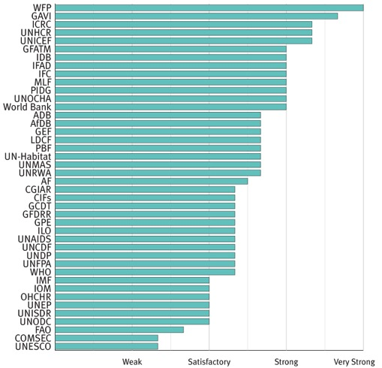

Within this component, the lowest scores were for criterion 1b (monitoring and reporting results) which received the second-lowest average rating of all 24 criteria. As outlined in the previous section, one major AMA finding is that almost all multilateral organisations are now focused on improving their monitoring and reporting of results. If these efforts are successful, the average rating of this criterion will increase over the next few years.
Weaknesses in monitoring and results reporting made it difficult in some cases to make accurate assessments on criterion 1a (delivering results). All multilateral organisations could point to tangible results from their activities. But generally, it was difficult to make an accurate overall assessment of the extent to which results represent value for money at the institution level. With improved results reporting, these assessments should become easier in the future. Further improving results reporting is a potential priority to pursue through the multilateral engagement strategy.
The methodology for assessing criterion 1c (targets poorest) took account of organisational mandates. Nevertheless, the multilateral development banks tended to only rate as ‘Satisfactory’ against this criterion, with feedback from Australian overseas missions and Australian NGOs suggesting that attention to targeting the poorest was inconsistently applied in planning and implementing activities at country-level.

B. Component 2: Alignment with Australia’s aid priorities and national interests
The average of each organisation’s criteria scores for component 2 is presented in Figure 8.
Figure 8: Alignment with Australia’s aid priorities and national interests.
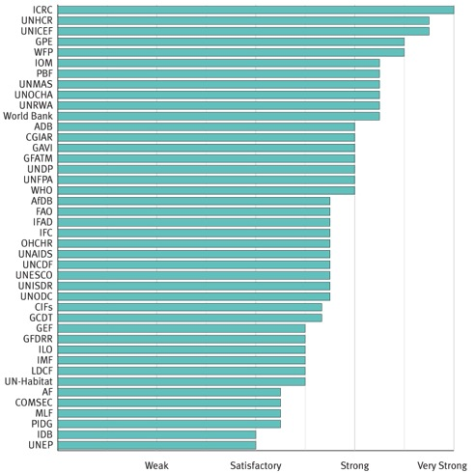

The average rating for this component was the highest of all seven components. The reason is that the ratings for criterion 2a (supports Australia’s objectives) and criterion 2b (aligns with the strategic goals of the aid program) were the two highest of the 24 criteria. The ratings for these components are reasonably highly correlated with existing funding levels.
Ratings for criterion 2c (focuses on crosscutting issues) and criterion 2d (effective in fragile states) were heavily bunched in ‘Satisfactory’ and ‘Strong’. The shortage of ‘Very strong’ ratings for these two components suggests that most organisations have scope to improve their attention to crosscutting issues and effectiveness in fragile states. Crosscutting issues and effectiveness in fragile states are potential priorities to pursue through the multilateral engagement strategy.
On crosscutting issues, most organisations focus quite prominently on gender in their policies and operations, although with varying degrees of success in terms of impact on programs. The AMA found less evidence in many organisations of attention to disability, the environment and climate change as crosscutting issues, at either policy or program level.
On fragile states, some organisations, such as the World Bank, received credit for their strong policy framework and analytical work in engaging in fragile states, despite mixed results in effectiveness at country-level.
C. Component 3: Contribution to the wider multilateral development system
The average of each organisation’s criteria scores for component 3 is presented in Figure 9.
Figure 9: Contribution to the wider multilateral development system
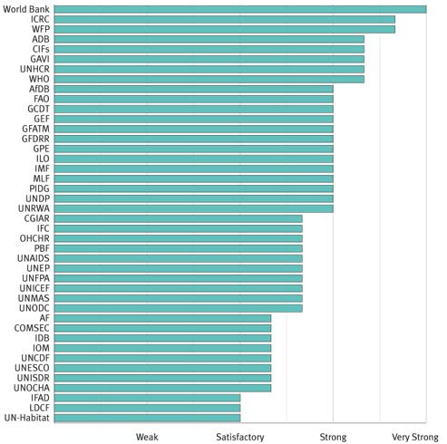
The average ratings for this component were the second highest in the AMA.
As previously discussed, these ratings were complicated by the decision in the methodology to rate organisations on the development aspects of their stated mandates.
In retrospect, ratings under this component could have usefully been separated from the general principle of assessing organisations in relation to their stated mandate. This would have enabled a first-principles assessment of the value of each organisation’s mandate and the extent to which it adds to the overall multilateral system and to aggregate development efforts.
Any changes to the methodology for assessing this component will be considered as part of development of the ongoing ratings system discussed in Section 6, which will be taken forward through the multilateral engagement strategy.
D. Component 4: Strategic management and performance
The average of each organisation’s criteria scores for component 4 is presented in Figure 10.
Figure 10: Strategic management and performance
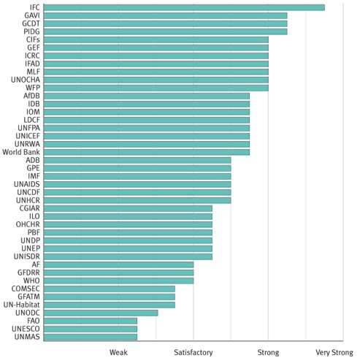

Of the 42 multilateral organisations in the AMA, only the International Finance Corporation received an average rating of very strong on this component, suggesting that most have scope to improve their strategic management and performance.
Criterion 4c (using monitoring and evaluation systems) received the lowest average ratings of all 24 criteria. While almost all multilateral organisations have monitoring and evaluation systems, the AMA found mixed results on the extent to which these systems inform decision making. In particular, there was a shortage of evidence across many organisations of examples where monitoring and evaluation systems were used to promptly realign or amend programs that were not delivering results. Ineffective monitoring and evaluation systems also represent a constraint to organisations improving monitoring and reporting of results (criterion 1b).
Ratings for criterion 4d (leadership and human resource policies) were below the average of the 24 criteria in the AMA. This is a concern given the finding on the importance to effectiveness of high-calibre staff at country-level.
Thus improving the effectiveness of monitoring and evaluation systems and human resource policies are potential priorities to pursue through the multilateral engagement strategy.
There was a wide spread of ratings on criterion 4b (governing body effectiveness). The effectiveness of the governing body is obviously a key consideration in determining whether it provides a useful vehicle to pursue improvements in effectiveness.
E. Component 5: Cost and value consciousness
The average of each organisation’s criteria scores for component 5 is presented in Figure 11.
Figure 11: Cost and value consciousness
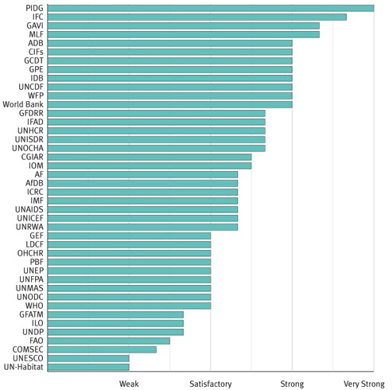

The average rating for this component was the lowest of the seven components in the AMA. It was also the component in which the AMA found the least amount of evidence; and therefore where levels of confidence in the ratings are lowest.
The relatively low ratings and lack of evidence in this component suggests that cost and value consciousness is not a high priority for most multilateral organisations, their governing bodies or donors. This may change over the coming years as multilateral organisations and donors focus more on achieving and demonstrating value for money.
Addressing some of the weakness or lack of evidence in areas related to cost and value consciousness is a potential priority to pursue through the multilateral engagement strategy.
The highest rating organisations under this component engage with the private sector or involve the private sector in their governing bodies. While this is not appropriate for all multilateral organisations, there may be some lessons from this that can be shared across the multilateral system. This may be an issue worth further analysis.
F. Component 6: Partnership behaviour
The average of each organisation’s criteria scores for component 6 is presented in Figure 12.
Figure 12: Partnership behaviour
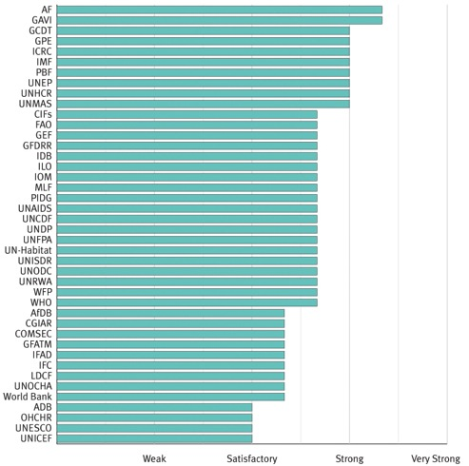

Ratings for this component were bunched in the middle. None of the 42 organisations in the AMA received an average rating of ‘Very strong’ or ‘Weak’.
These ratings suggest that almost all multilateral organisations now focus on partnerships, many no doubt prompted by the increased emphasis on aid effectiveness over the past decade. The scores for criterion 6a (working effectively with others) are generally quite high, although feedback from Australian overseas missions suggests that for some organisations, partnership behaviour remains variable at country-level and relies heavily on the quality of in-country teams.
Ratings were much lower for criterion 6b (aligning with partner priorities and systems). In most cases this related to frequent use of parallel structures to government such as project implementation units.
Ratings were also relatively low in relation to providing voice for partners and other stakeholders in decision making. Determining ratings for this criterion was difficult because in several cases multilateral organisations provided adequate voice for partner governments but not for civil society or beneficiaries.
Thus greater alignment with partner government systems and greater voice for civil society and beneficiaries in decision making are potential priorities to pursue through the multilateral engagement strategy.
G. Component 7: Transparency and accountability
The average of each organisation’s criteria scores for component 7 is presented in Figure 13.
Figure 13 : Transparency and accountability
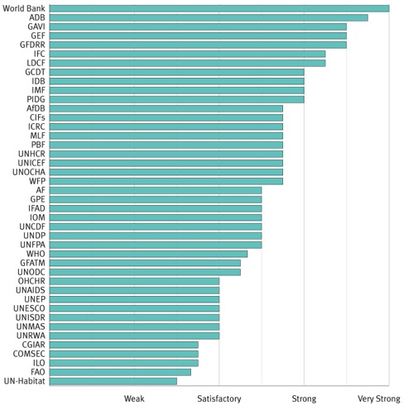

Average ratings were quite variable across the four criteria in this component.
Ratings were quite high for criterion 7a (routinely publishing information). In a large number of cases this reflected recent improvements in information disclosure, probably due to the positive impact of initiatives such as Publish What You Fund and the International Aid Transparency Initiative.
Ratings were also quite high for strong accountability mechanisms. This is reassuring from a development effectiveness perspective. It is also a critical element in considering which multilateral organisations have systems that can safeguard and effectively use Australian taxpayer funds.
Average ratings were much lower for criterion 7b (clear process for resource allocation). In many cases this reflects the heavy dependence of multilateral organisations on earmarked funds. Some organisations, including several that rated very highly, rely almost entirely on funds from donors that are tied to a specific purpose. For these organisations, the lack of funds available for discretionary purposes makes it impossible to allocate resources on the basis of objective criteria. This reliance on earmarked funds raises broader concerns on the capacity of organisations to prioritise based on development impact rather than donor preferences. The impact of this heavy reliance on donor funds, and potential remedies, may be a consideration in budget decisions and an issue worthy of further analysis.
Average ratings were also low with regard to criterion 7d (promoting transparency and accountability of partners). The AMA found relatively little evidence on this issue and this is a potential priority to pursue through the multilateral engagement strategy.

