Australian Multilateral
Assessment
March 2012

Abbreviations and explanations
ADB | Asian Development Bank
AF | Kyoto Protocol Adaptation Fund
AfDB | African Development Bank
AMA | Australian Multilateral Assessment
AusAID | Australian Agency for International Development
CGIAR | Consultative Group on International Agricultural Research
CIFs | Climate Investment Funds
COMSEC | Commonwealth Secretariat
CSO | Civil Society Organisation
FAO | Food and Agriculture Organization
GAVI | GAVI Alliance
GCDT | Global Crop Diversity Trust
GEF | Global Environment Facility
GFATM | Global Fund to Fight AIDS, Tuberculosis and Malaria
GFDRR | Global Facility for Disaster Reduction and Recovery
GPE | Global Partnership for Education
ICRC | International Committee of the Red Cross
IDB | Inter-American Development Bank
IFAD | International Fund for Agricultural Development
IFC | International Finance Corporation
IFI | International Financial Institution
ILO | International Labour Organization
IMF | International Monetary Fund
IOM | International Organization for Migration
LDCF | Least Developed Countries Fund
MAR | Multilateral Aid Review
MDB | Multilateral Development Bank
MDG | Millennium Development Goal
MLF | Multilateral Fund for the Implementation of the Montreal Protocol
MOPAN | Multilateral Organization Performance Assessment Network
NGO | Non-Government Organisation
ODA | Official Development Assistance
OHCHR | Office of the High Commissioner for Human Rights
PBF | United Nations Peacebuilding Fund
PIDG | Private Infrastructure Development Group
UN | United Nations
UNAIDS | Joint United Nations Programme on HIV/AIDS
UNCDF | United Nations Capital Development Fund
UNDP | United Nations Development Programme
UNEP | United Nations Environment Programme
UNESCO | United Nations Educational, Scientific and Cultural Organization
UNFPA | United Nations Population Fund
UN-Habitat | United Nations Human Settlements Programme
UNHCR | United Nations High Commissioner for Refugees
UNICEF | United Nations Children’s Fund
UNISDR | United Nations International Strategy for Disaster Reduction
UNMAS | United Nations Mine Action Service
UNOCHA | United Nations Office for the Coordination of Humanitarian Affairs
UNODC | United Nations Office on Drugs and Crime
UNRWA | United Nations Relief and Works Agency for Palestine Refugees in the Near East
WFP | World Food Programme
WHO | World Health Organization

1. Introduction
A. Purpose
The AMA is designed to:
> provide a firm base of information about the effectiveness and relevance of multilateral organisations, from the perspective of the Australian aid program
> inform decisions on funding allocations in the 2012–13 budget
> design a rating system that can be used on an annual basis to inform decisions on subsequent funding allocations and policy engagement.
The AMA is not the final word on how the Australian aid program views multilateral organisations. Australia will use the findings of the assessment as a platform to build greater evidence over time on multilateral effectiveness to guide policy and funding decisions.
B. Overview
The AMA delivers on a commitment in An Effective Aid Program for Australia: Making a real difference—Delivering real results to assess the effectiveness of Australia’s key multilateral partners.
An Effective Aid Program for Australia states Australia will increase its support for multilateral organisations found to:
> be effective and achieving results for the poorest people
> operate in line with Australia’s development objectives and priorities
> represent value for money.
The assessment looks at 42 multilateral organisations for how well they meet the principles that guide Australia’s aid program.
Section 2 of this report outlines the methodology and approach used for the assessments, including the criteria used to assess, how stakeholders were engaged, how evidence was gathered and how ratings were determined. The full methodology for the assessment and the terms of reference are on the AusAID website (www.ausaid.gov.au).
Section 3 provides an overview of the assessment ratings and findings, including:
> a scattergram that summarises the ratings in relation to ‘results and relevance’ and ‘organisational behaviour’
> major findings from the report in relation to:
– coordination across the multilateral system
– the UN Delivering as One approach
– scope for strengthening joint assessments of multilateral organisations
– the prevalence of reform
– the focus on monitoring and reporting of results
– variations in performance at country-level.
> the implications of the ratings and findings for funding decisions
> how the ratings and findings will help inform future policy engagement.
Section 4 presents the findings for each of the seven components of the AMA. Areas for improvement are highlighted as areas for potential focus in the future.
Section 5 summarises the assessment findings for each of the 42 multilateral organisations and their ratings against the 24 criteria. The full assessment findings for each multilateral organisation are available on the AusAID website.
Section 6 recommends a proposed approach for the ongoing monitoring of multilateral effectiveness. This includes publishing an annual scorecard on effectiveness and addressing performance concerns through a formal process.
C. Australia’s current multilateral engagement
In recent years Australia has channelled a growing proportion of Official Development Assistance (ODA) through multilateral organisations, including UN agencies, global funds and the multilateral development banks. In 2010–11, total funding to the 42 multilateral organisations included in the AMA was $1.6 billion, or around 37 per cent of ODA.
The large and growing amount spent through multilateral organisations reflects the value that Australia assigns to working in partnership with these organisations. By working with multilateral organisations, Australia increases the overall impact of its aid program. Multilateral organisations add value through:
> the legitimacy they bring and weight they add to addressing challenging development issues through their wide membership
> the leadership role they play in international development efforts, for example by championing the Millennium Development Goals
> their expertise and global reach which brings a wealth of information and lessons learned
> the global standards they set in sectors such as health, education, food security, human rights, humanitarian assistance and labour standards
> their lead in coordinating donor efforts at global-, sector- and country-levels and in response to trans-boundary challenges such as epidemics or climate change
> mobilising large-scale investments with financing leveraged from capital markets and the private sector.
The breakdown of the $1.6 billion channelled through the 42 multilateral organisations included in the AMA is shown in Figure 1.

Figure 1: Official Development Assistance Provided by Australia to Multilateral Organisations in 2010–11
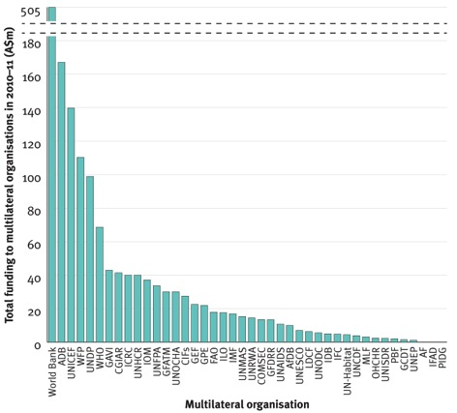

* GCDT and MLF represent average yearly contributions
Australia’s largest multilateral partner, by far, is the World Bank, with total funding of $505 million in 2010–11. The four next largest multilateral partners in 2010–11 were the Asian Development Bank (ADB), the UN Children’s Fund (UNICEF), the World Food Programme (WFP) and the UN Development Programme (UNDP). Funding to these five organisations totalled over $1 billion in 2010–11, 60 per cent of the funding to the multilateral organisations included in the AMA.
Of the 42 multilateral organisations included in the AMA, 30 received core funding in 2010–11 as shown in Figure 2. Core funding is defined as money that is not earmarked (tied) for a particular purpose. Core funding can either be provided on a voluntary basis, with the amount determined by Australia, or through ‘assessed contributions’, in which case the amount is based on a determination of each member’s capacity to pay (generally linked to the size of the economy). Figure 2 shows voluntary core contributions in blue and assessed contributions in red.
Aggregate core funding in 2010–11 to the organisations included in the AMA was $642 million.

Figure 2: Core Funding Provided by Australia to Multilateral Organisations in
2010–11
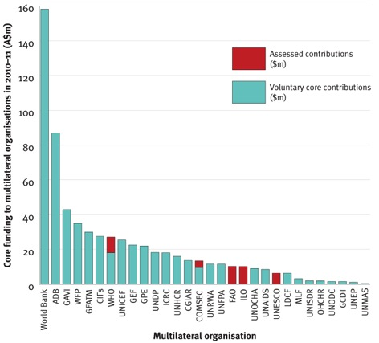

Again the World Bank is the largest recipient of core funding, although the differential between it and other organisations is much lower.
Australia has been increasing core funding to a range of multilateral organisations over recent years, recognising that they need secure, long-term funds for strategic planning and reform, and to be able to respond to developing country priorities.
Since 2008, Australia has entered into formal partnerships with 11 multilateral organisations. Most partnerships specify increases in core funding over a multi-year period, in addition to outlining joint priorities and how success will be measured.
For those multilateral organisations that receive core funding through the Australian aid program, there are considerable variations in the proportion that core funding represents of total Australian funding. This is shown in Figure 3, which shows core funding as a percentage of total funding through the aid program in 2010–11.

Figure 3: Core Funding as a Proportion of Total Funding Provided by Australia to Multilateral Organisations in 2010–11
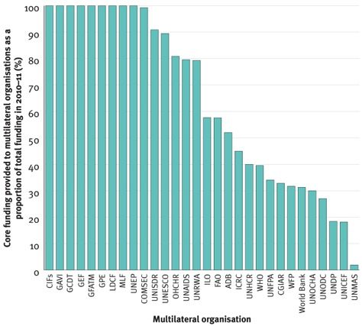

Of the 30 multilateral organisations that receive core funding, 15 receive more than 75 per cent of their funding through the Australian aid program as core funding (nine of these organisations do not accept non-core funding).
For most of the Australian aid program’s largest multilateral partners, however, the majority of funding is provided as non-core. This reflects the collective decisions of managers of country and sector programs to enter into funding arrangements with these multilateral partners. For example, in the case of the World Bank, the non-core funding in 2010–11 comprised some 83 separate funding agreements across various countries and sectors of the aid program.

Figure 4 shows the provision of assessed contributions, voluntary core contributions, and non-core funding to the 42 multilateral organisations.

Figure 4: Official Development Assistance Provided by Australia to Multilateral Organisations in 2010–11 by Type of Funding
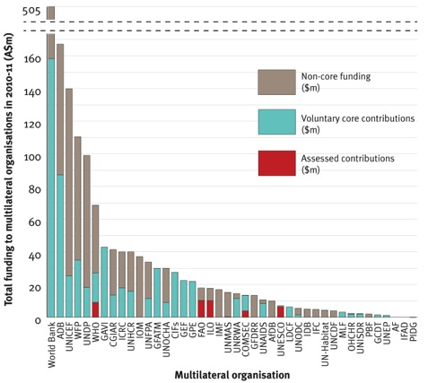

Figure 5 shows the alignment of the $1.6 billion in funding provided through multilateral organisations in 2010–11 with the five strategic goals the Australian aid program. This shows both core funding (which is divided across the goals in accordance with the overall funding allocations of organisations) and non-core funding earmarked for specific purposes.

Figure 5: Official Development Assistance Provided by Australia to Multilateral Organisations in 2010–11, Allocated by Strategic Goal
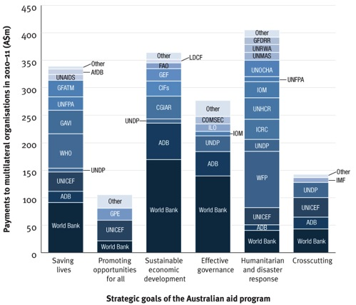
* Contributions of less than $7.5m are attributed to ‘Other’. In some cases this category includes organisations listed elsewhere on the graph.
The strategic goal of ‘humanitarian and disaster response’ receives the largest amount of funding through multilateral organisations, approximately $400m in 2010–11. Of the 42 organisations assessed in the AMA, 17 received funding in support of this goal.
‘Sustainable economic development’ received the second largest amount of funding, with over half of the funding for this strategic goal is allocated to the World Bank and Asian Development Bank.
The goals of ‘saving lives’, ‘effective governance’ and ‘promoting opportunities for all’ also receive substantial support through Australia’s multilateral contributions.
Funding categorised as ‘crosscutting’ spans across multiple strategic goals.

2. Methodology and approach
The AMA’s terms of reference were approved by the acting Minister for Foreign Affairs and published on AusAID’s website in late August 2011.
The terms of reference included the rationale for determining which multilateral organisations would be included in the AMA. Forty-two met this definition and were included in the assessment.
A methodology for the AMA was developed based on the terms of reference. The methodology was refined through discussions with Australian Government departments and representatives of Australian non-government organisations (NGOs). It was published on AusAID’s website and provided to relevant multilateral organisations in early September 2011.
An important aspect of the methodology is that organisations are assessed against their effectiveness in delivering the development-related aspects of their mandate.
A. Assessment framework
The framework includes seven components comprising 24 criteria. The first three components relate to results and relevance (‘why we fund’) and the other four components relate to organisational behaviour (‘how they perform’).
The full set of components and criteria are outlined in Appendix 1. They are summarised below.
Results and Relevance (Why we fund)
Component 1: Delivering results on poverty and sustainable development in line with mandate (Criteria: Delivers results; Monitors and reports results; Targets poorest)
Component 2: Alignment with Australia’s aid priorities and national interests (Criteria: Supports Australia’s objectives; Aligns with strategic goals of aid program; Focuses on crosscutting issues; Effective in fragile states)
Component 3: Contribution to the wider multilateral development system (Criteria: Promotes coordination; Makes a critical difference; Promotes knowledge, policy or innovation)
Organisational behaviour (How they perform)
Component 4: Strategic management and performance (Criteria: Clear strategy and plans; Effective governing body; Uses monitoring and evaluation systems; Effective leadership and human resource policies)
Component 5: Cost and value consciousness (Criteria: Management scrutinises costs; Cost effectiveness a focus of programs; Challenges partners on value for money)
Component 6: Partnership behaviour (Criteria: Works effectively with others; Aligns with partner priorities and systems; Provides voice for stakeholders)
Component 7: Transparency and accountability (Criteria: Routinely publishes information; Clear process for resource allocation; Strong accountability mechanisms; Promotes transparency of partners)
B. Ratings
Ratings of Very strong, Strong, Satisfactory, Weak or Not applicable were given for each organisation against each criterion. The average of the criteria ratings within each component was used to form the component rating. All criteria were weighted equally. Scores of ‘Not applicable’ were not included in the computation of the component rating. The benchmarks used to determine criteria ratings are outlined in Appendix 1.
The ratings are evidence-based, and so do not reflect reform efforts that have been initiated but have not yet had time to prove their impact. The implications of this are discussed in Section 3.
C. Evidence
The AMA used the following sources of evidence to inform assessments and ratings (further details are provided in Appendix 1):
1. Publicly available documentation, including reporting of the multilateral organisations themselves and assessments by others
2. Engagement with the headquarters of multilateral organisations, including meetings at headquarters level with 38 multilateral organisations
3. Consultations with partner governments, civil society and other donors, including through field visits to Indonesia, Solomon Islands, Vietnam, the Philippines, Sri Lanka, Kenya and Ethiopia
4. Analysis and reporting from within the Australian government, including outcomes from recent high level consultations and recent reviews of the African Development Bank and the International Fund for Agricultural Development
5. Response to a survey by 26 Australian overseas missions
6. Consultations with Australian stakeholders, including Parliamentary associations and Australian NGOs
7. Public submissions (the 11 submissions received are listed in Appendix 2).
D. Peer Review
The AMA report was subject to three separate peer review processes:
1. a peer review panel comprising a representative of the Australian development NGO community, an independent consultant and a senior AusAID official with no other engagement in the AMA
2. an Inter-Departmental Committee comprised of representatives from all Australian government departments that have engagement with the multilateral organisations included in the AMA
3. a cross section of AusAID officials.

Of note, UN Women (which did not meet the definition for inclusion because it did not exist in 2010–11) was not included in the assessment because it is too early to make judgements in relation to many of the criteria.

