# Australia’s new development policy and performance framework: a summary

The Australian Government’s new development policy ***Australian aid: promoting prosperity, reducing poverty, enhancing stability*** and new performance framework ***Making Performance Count: enhancing the accountability and effectiveness of Australian aid*** introduce key shifts in our aid program. These reforms will build an aid program that is effective in promoting economic growth and reducing poverty, and that projects and protects Australia’s broader interests in the Indo-Pacific region. They will ensure a stronger focus on performance, results and value-for-money.

## The need for change

The world has changed—and our aid program must change too. Today, many developing countries are growing rapidly, with aid representing an increasingly small proportion of development finance. To be effective in this new context, our aid needs to be more innovative and catalytic, leveraging other drivers of development such as private sector investment and domestic finance. Our aid needs to support economic growth as the most sustainable way to reduce poverty and lift living standards. We need to recast our aid program in light of this new development paradigm.

## Changing where we work

The Australian aid program will have a sharper geographic focus. It will be directed to the Indo-Pacific region, particularly South East Asia and the Pacific—our immediate neighbourhood.

## A new strategic framework for the aid program

This new strategic framework will guide a re-shaping of Australia’s aid program over coming years.

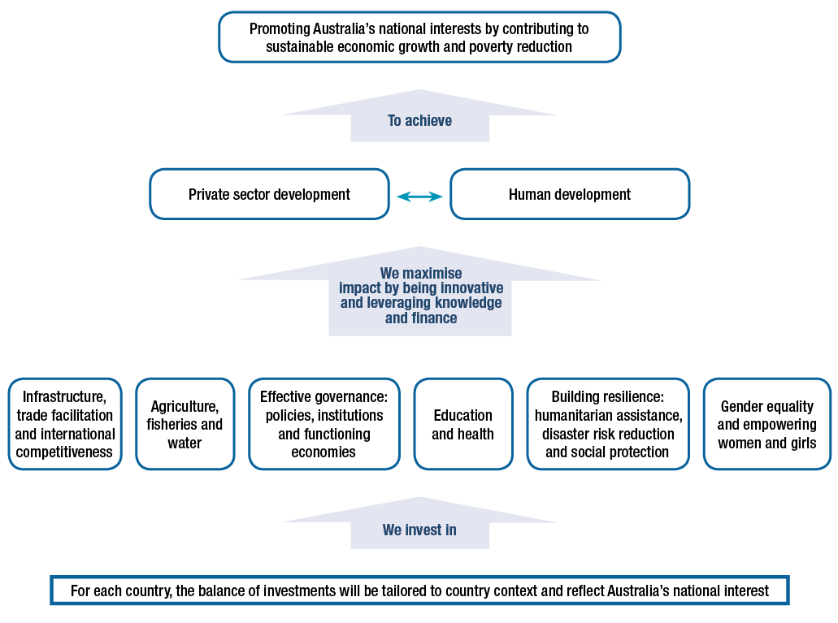

## Changing what we do: re-shaping the aid program

The purpose of the aid program is to **promote Australia’s national interests by contributing to sustainable economic growth and poverty reduction.**

We will pursue this purpose by focusing on two development outcomes: supporting private sector development and strengthening human development.

Our focus on private sector development reflects the fact that it is the private sector that is the engine of economic growth. It recognises that people leave poverty when they have the opportunity to develop and use their skills more productively and get a job or a better paid job. With nine out of 10 of these jobs created by the private sector, we will support our partner countries to improve their business enabling environments. To ensure our aid dollars are used as effectively as possible we will pursue innovative development solutions, including by harnessing the capabilities of the private sector to support development.

We will capitalise on the high returns from aid for trade investments by increasing our aid for trade expenditure to 20 per cent of our aid program funding by 2020. Aid for trade will include support for infrastructure to increase productivity, connect people to markets and improve the flow of goods across borders.

We will also focus on human development to drive improvements in education, health and gender equality outcomes in our partner countries. Significant benefits flow to whole communities when women can fully participate in economic, social and political life. Healthier, better educated populations are critical to building skilled and competitive workforces and lifting living standards.

We will assist the most disadvantaged, including people with disability, find pathways out of poverty. Australia will continue to be a generous humanitarian donor, and support our partner countries and communities to strengthen their resilience to future disasters.

## Changing how we deliver

Four tests will guide strategic choices across the aid program, translating this new development policy into practice. We will ensure that Australian aid:

(1) pursues our national interest and extends Australia’s influence

(2) impacts on promoting growth and reducing poverty

(3) reflects Australia’s value-add and leverage

(4) makes performance count.

A balanced assessment against these four tests will guide aid allocations as part of the Government’s annual aid budget process, and at the country and regional program level. We will become more selective about what we do, and who we work with in our country and regional programs.

In search of innovative solutions to development challenges, we will actively engage with risk. A robust approach to safeguarding Australian funds from fraud and corruption risks will continue. We will be transparent and accountable in managing the Australian aid program—this is important to drive further performance improvements. The aid program will be delivered through partnerships with the private sector, multilateral organisations, non-government organisations, volunteer organisations, philanthropic organisations and partner governments. We will seek out the most effective partners to deliver our aid. And we will implement a new value-for-money framework. We will measure our effectiveness, learn from experience and adjust or cancel programs that are not achieving results.

We will also actively manage risk by mitigating adverse environmental and social impacts in the aid program through the application of mandatory safeguard policies in environment, resettlement, and child protection.

The Government’s decision to integrate management of Australia’s aid program into the Department of Foreign Affairs and Trade (DFAT) strengthens our platform to deliver an improved aid program.

## Making Performance Count

To reinforce efforts to re-shape the aid program, a new performance framework ***Making Performance Count: enhancing the accountability and effectiveness of Australian aid*** will strengthen the way we assess performance at all levels of the aid program.

At a strategic level, there will be 10 high level targets to ensure the aid program is effectively managed and delivering on key Government priorities.

**1. Promoting prosperity:** Promote economic development by increasing Australia’s aid for trade investments to 20 per cent of the aid budget by 2020.

**2. Engaging the private sector:** All new investments will explore innovative ways to promote private sector growth or engage the private sector in achieving development outcomes.

**3. Reducing poverty:** By July 2015, all country and regional programs will have Aid Investment Plans that describe how Australia’s aid will promote economic growth in ways that provide pathways out of poverty.

**4. Empowering women and girls:** More than 80 per cent of investments, regardless of their objectives, will effectively address gender issues in their implementation.

**5. Focusing on the Indo–Pacific region:** Increase the proportion of country program aid that is spent in the Indo–Pacific region to at least 90 per cent from 2014–15.

**6. Delivering on commitments:** From July 2015, progress against mutual obligations agreed between Australia and its key partner governments and organisations will form part of program performance assessments.

**7. Working with the most effective partners:** By July 2015, design and apply new systems to assess the performance of the aid program’s key delivery partners and ensure stronger links between performance and funding.

**8. Ensuring value-for-money:** Deliver high standards of value-for-money in at least 85 per cent of aid investments. Where standards are not met and improvements are not achieved within a year, investments will be cancelled.

**9. Increasing consolidation:** Reduce the number of individual investments by 20 per cent by 2016–17 to focus efforts and reduce transaction costs.

**10. Combatting corruption:** Develop and implement new fraud control and anti-corruption strategies for all major country and regional programs by July 2015.

At the country program level, we will set rigorous performance benchmarks tailored to country circumstances to provide a sharper basis for assessing program performance. At the project level, we will ensure that funding is directed to projects making a difference. When projects don’t deliver the results we expect, we will cut our losses. When they do well, we will look for ways to expand or replicate them.

The new performance framework will ensure that funding is linked to performance at all levels of the aid program. This will ensure that taxpayers’ money spent through Australia’s aid program is achieving the greatest possible development impact.