Australia – Indonesia Basic Education Program
SMALL INDEPTH STUDY OF EARLY IMPACT OF AIBEP ON SCHOOL FINANCING AND SCHOOL MANAGEMENT

December 2009
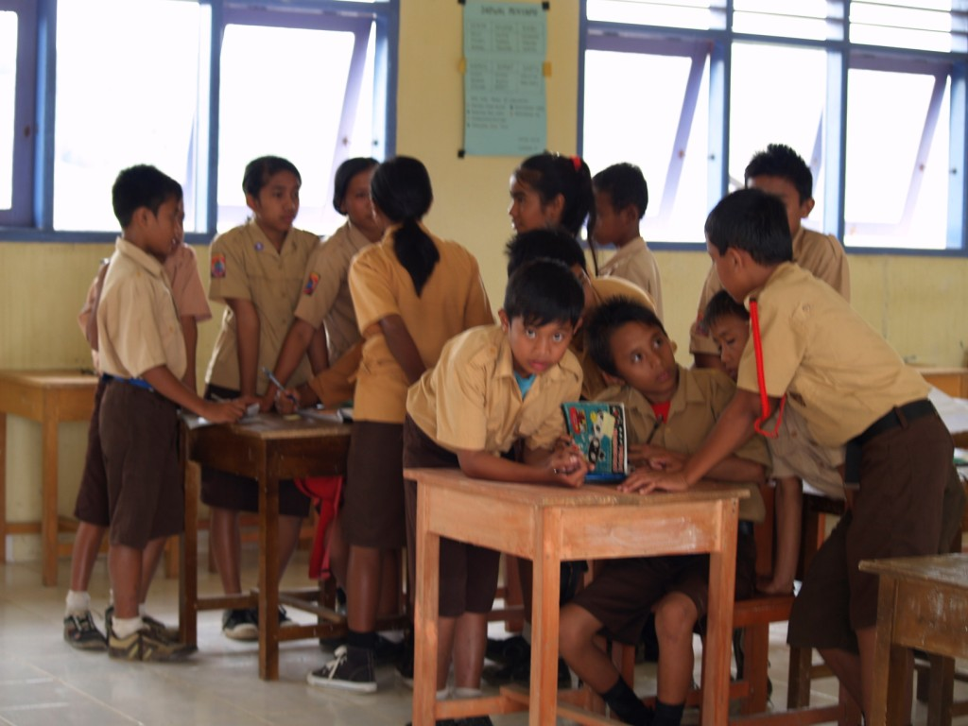

Students discussing their response to one of the study’s questions


KEY FINDINGS AND RECOMMENDATIONS

Key Findings
- AIBEP schools appear to have provided significantly improved access to post-primary education for students in remote areas of Indonesia.
On most indicators of school management and school financial management AIBEP schools perform better than non-AIBEP schools. On the remaining indicators their performance is at least equal.
- AIBEP schools appear to be generally better managed than their counterparts. On most indicators of school management and school financial management AIBEP schools perform better than non-AIBEP schools. On the remaining indicators their performance is at least equal to that of larger, more established non-AIBEP schools in the area.
- Key indicators of better performance include AIBEP teachers and school committees having a more positive view of how their school funds are being spent.
- AIBEP teachers are more satisfied with their ability to influence class, subject and school budgets.
- AIBEP students have better access to text books, and although the data is not conclusive, they may have lower student absenteeism rates and may suffer less from teacher absenteeism.
- Despite such positive signs, school management and financial management in both AIBEP and non-AIBEP schools need substantial improvement.
- Many schools do not have current annual plans or budgets, and consequently both planning and budgeting tends to be un-strategic and short term in those schools.
- The management and financial management of most of the sample schools is not yet shared between the schools’ professional staff and school committees.
- Many of the schools’ budgets appear to have a high degree of financial probity and transparency, but this may not be known or appreciated by their broader school communities.
- The roles, recruitment and training of school supervisors need substantial changes to strengthen the supervision of and support for school management.

Recommendations
- Improving the functionality of school committees requires continuing and long-term commitment of GOI and development partners, including appropriate training programs and mechanisms for delivery.
- A standardised format for annual budgeting in junior secondary schools should be developed and mandated. This format should be informed by a detailed, on-site study of a sample of schools’ actual expenditure patterns.
- The compulsory and public display of school budgets should be mandated by national and district legislation.
- National and district strategies are required to address the continuing problem of lack of student textbooks in remote and isolated junior primary schools.
- The roles, recruitment and training of school supervisors must be strengthened in order to provide better supervision of and support for school management.

INTRODUCTION
The Australia–Indonesia Partnership is a whole of government aid program encompassing an expenditure of around $2 billion over five years. This expenditure includes the $1 billion Australia Indonesia Partnership for Reconstruction and Development (AIPRD), the single largest aid package in Australia’s history, of which the Australia Indonesia Basic Education Program (AIBEP) is a key element.
The objective of AIBEP is improved equitable access to higher quality and better governed basic education services, especially in targeted disadvantaged areas. Support is delivered through a programmatic approach based on the three pillars of the government’s strategic plan, the RENSTRA: improved access through construction of junior secondary schools, improved quality and internal efficiency and improved governance. For AIBEP, a fourth pillar is enhanced resource mobilisation, including policy advice, research and sector monitoring.
Recognising the scale of the policy reform agenda being adopted by Government of Indonesia (GoI), the Strategic Advisory Services (SAS) component of AIBEP has been designed primarily to advise on the overall strategic direction of the BEP and to implement activities under pillar four.
This small in-depth research study is part of the Monitoring and Evaluation Framework for the AIBEP and complements the extensive monitoring and evaluation activities conducted by the Managing Contractor Program Management (MCPM). The research was conducted for CSAS by Mr Chris Majewski, an independent consultant who led a team of four national staff: Lalu Sahabuddin (Coordinator), Revyani Sjahrial, Wandy Nicodemus Tuturoong and Madekhan. The document has been reviewed by CSAS team members Hetty Cislowski and Adam Rorris. CSAS extends a sincere expression of gratitude to Mr Majewski and the four national team members. CSAS also wishes to thank senior members of the AIBEP team whose cooperation in establishing the sample of schools and in providing support through the program’s regency-based Coordinators was invaluable.

EXECUTIVE SUMMARY

Background
This study of school financing and school management was undertaken for the Contractor, Strategic Advisory Services (CSAS) of the Australian Indonesian Basic Education Partnership (AIBEP). The objective of the study was to examine school resourcing and management of a sample of 30 AIBEP schools built in 2006, and of a comparative sample of 15 non-AIBEP schools. In total, 15 regencies were involved with two AIBEP and one comparative non-AIBEP school visited in each of the regencies. The research team also interviewed officers of the Dinas Pendidikan (regency education departments) in each of the regencies. A small study of Madrasah (Islamic) schools was conducted at a later stage.
The schools in the sample were remote, and many required difficult and long land and/or sea travel to reach. Despite these difficulties, all the sample schools were successfully visited and structured interviews were conducted with principals, teachers, school committee representatives and representatives of the Dinas Pendidikan. School planning and budgeting documentation was also collected and subsequently analysed.
It is recognised that the non-AIBEP schools in the study do not provide an ideal comparative sample. Some of them may have been influenced by AIBEP’s whole-of-district programs, and in addition to being longer-established, they tended to be less remote and larger. The average enrolment of the AIBEP schools was 121 as opposed to 185 in the comparative schools.
Although it is recognised that a three-year timeframe is generally too short to measure the impact of a major educational program, it was hoped that at least some preliminary impacts of AIBEP would emerge.

School Planning and Financial Management
The study found that although the AIBEP schools have been operating for a relatively short period of time, there are encouraging signs that their management and financial management is developing along sound lines. Among AIBEP schools, 87% have a current long-term strategic plan, twice the rate of non-AIBEP schools. Most of these plans were produced as a result of the AIBEP training program. In around a third of the schools, the school committees are making an important contribution to whole-school planning and budgeting. The AIBEP training program has resulted in nearly 80% of school committee chairs in AIBEP schools being trained, twice the level of those in non-AIBEP schools, and on the whole, the capacity and calibre of committee chairs is high.
Significant challenges remain to increase the rate of school committee participation in planning and budgeting. The capacity of many community members sitting on school committees is limited by their educational background and experience, and almost none of the general membership has received any training in their roles. Despite this limitation, around a third of the schools in the sample have significant committee involvement in school planning and budgeting. The same proportion of school committees can demonstrate at least a basic knowledge of key financial matters such as the nature and quantity of their schools’ funding. The committee members are largely parents, and most committees still see their roles as limited to organising parental support. The large-scale publicity about “free schooling” means that even in regencies where formal decisions on free schooling have not yet been made, most of the committees do not feel free to raise funds from parents. Only a third of the schools raised any funds at all, and in general, these were small amounts. The committees do not hold formal meeting often: on average, about 2.7 times a year.
The limited role of most of the committees is a concern, as their potential is high. Although their membership has a strong gender bias towards males and all school committee chairs are male, the committees have strong legitimacy, being elected at annual general meetings with large-scale parental participation. At present, committees do not receive effective guidance and support in relation to their roles from local education authorities, and it is unlikely that this will change without a significant national-level initiative.
On the whole, the schools’ professional staffs have adequate capacity to contribute to planning and budgeting, but an examination of the schools’ documentation indicates that planning is generally not of high quality. There has been significant attrition in schools’ annual planning processes from the time that AIBEP delivered its training program. Two thirds of AIBEP and a half of non-AIBEP schools provided copies of what were described as current annual plans, but a number of these were either out of date or of poor quality and not well linked to budgeting. All schools deal conscientiously with the financial requirements of Dana BOS and similar regency funding which generally require three-monthly budget proposals and associated acquittal processes. Where annual planning and budgeting is not functioning effectively, this reduces planning and budgeting to short-term, three-monthly cycles, reducing capacity for more strategic use of available funds.
Of the sample schools, 13 AIBEP and eight non-AIBEP schools had current annual budgets which could be analysed. Their quality varied considerably. Very different formats, inconsistency in assigning items of expenditure to expenditure lines and lack of transparency of some of the lines made the analysis and comparisons between AIBEP and non-AIBEP schools difficult, but the available data indicates that there are not large differences in practice between these two groups of schools. On average, BOS funds represent 78% of the schools’ budgets with regency funding providing most of the rest. In both AIBEP and non-AIBEP schools, around a third of the budget is spent on teacher salaries, although in some cases this is spent on additional income for permanent teachers who already receive wages from the national budget, and in others it is used to pay the only wages available to non-permanent staff. Extra-curricular activities consume some 10% of AIBEP schools’ budgets and 12% of the budgets of the comparative schools. This expenditure, and the approximately 8% which schools spend on examinations and tests appears large when key educational areas such as purchase of student text books (around 3% of the budgets) are clearly under-resourced. Around 20% of the budgets go on administrative costs and another 10% could not be categorised.
It would be helpful to standardise budget formats and to increase their transparency. This would not only assist the schools in their work, but would also allow more meaningful aggregation, comparison and evaluation of schools’ use of funds at all higher levels of the education system. It is also clear that systemic support for school planning and budgeting needs to be strengthened by improved recruitment, roles and training of school supervisors.
An important and positive finding of the study is that although many school committees have limited involvement with school budgeting, school staffs are much more involved and have a generally positive opinion of how their schools’ funds are used. One a scale from 1 to 10, AIBEP teachers rate the effectiveness of their schools’ use of funds as 6.7, and non-AIBEP as 6.3. Both groups of teachers also give a pass rating for their ability to influence their class or subject budgets (6.3 for AIBEP and 5.7 for non-AIBEP) and for their ability to influence their school budgets in general (6.4 and 5.1 respectively). The data appear to demonstrate better staff participation and empowerment in the AIBEP schools. Given the opportunity to safely and anonymously inform the study of any areas of expenditure in their schools where they thought money was spent poorly or inappropriately, more than 90% of the teachers did not report any malpractice. Those who did provide information identified staff wages and false costs of bought goods as the main areas of concern. This generally positive view of financial probity in the sample schools was shared to an even greater degree by those school committees which did have significant involvement in budgeting. They provided ratings of 8.3 for AIBEP and 7.5 for non-AIBEP schools.
The apparently high level of financial probity and transparency in the sample schools is not generally known outside the schools’ professional staffs. As already indicated, most school committees have no knowledge of their schools’ budgets and even those which are involved do not have a program of actively disseminating the information. Only two of the schools in the sample – one AIBEP and one non-AIBEP - publicly display their budgets. This is a regrettable situation as public service financial probity and transparency are a high national priority in Indonesia. It is clear from this study that schools have the potential to be influential examples of transparency and good practice in their communities.

Educational Management
Educational management in the schools was also examined by the study. It was found that although more than two-thirds of schools were able to show copies of the current required curriculum documents, Kurikulm Tingkat Satuan Pendidikan (KTSP) 1 and KTSP 2, those documents tended to be produced through “shortcuts” including photocopying finished products from other schools or other sources, and have been produced primarily for accountability purposes. Several of the principals confided that the task of developing the documents was too difficult for their schools. On the other hand, many schools were able to show hand-written teacher lesson plans. Teachers regularly use teacher texts to guide their instructional work, and often use general subject teaching guidelines as well as their own lesson plans. They also report often using group-work and student discussions as a part of their methodology, though it was noted that group-work arrangements were frequently forced on classes by students having to share text books. An area of practice which did not show up well was the use of teaching aids, which were reportedly used only “sometimes”. There was an evident lack of such resources in the schools.
Professional supervision and guidance tended not to be systematic in most of the schools. While on average teachers met with their school-based superiors between four and five times a year, 15.6% of AIBEP teachers and 20% of non-AIBEP teachers had not had such a meeting in 2009. At least half of the AIBEP schools and two-thirds of non-AIBEP schools had teachers who had not had such a meeting. Around a half of AIBEP and non-AIBEP teachers had not had a professional meeting with any superior outside of their school in 2009.
Professional development opportunities for teachers showed wide variation. Although on average, teachers attended between two and 2.5 days of professional development which fell on school days and half a day outside of school days, in nearly all schools many teachers had attended nothing while some colleagues, admittedly on the far end of the range, had been gone from school for up to 20 training days. These longer absences from school were not all caused by the current training programs associated with teacher certification.
Teacher supply and teacher quality were reported by school principals to be significant issues in many of the sample schools. Remoteness of the schools means that they find considerable difficulties matching teacher skills to subjects, and in some cases, the match is reportedly poor. Student absenteeism rates are high – around 20% in the Year 7 and Year 8 classes visited by the interviewers. These are not caused by interference of professional development activities, and are more closely related to problems of distance of teachers’ homes from their schools, and of varying levels of professional discipline.
The problems of teacher supply, quality and absenteeism are accompanied by inadequate availability of student text books. Fewer than half the students in an AIBEP school are likely to have a textbook in an average lesson, and that is also the case for fewer than a third of students in non-AIBEP schools. Two-thirds of the books available have been provided free by the schools, and one third has been bought by parents. It is noted that teachers and school committee members tend to regard the purchase of student text books as a higher budgetary priority than do the school principals.
When asked on what they would most like to spend any additional money, principals, teachers and committee members in AIBEP schools identified additional specialist facilities like laboratories and sports ovals. Teacher salaries and additional library books were identified as priorities by stakeholders in all schools, and in AIBEP schools there was strong support for additional professional development of teachers. Teachers and committee members also prioritised the purchase of student textbooks.
When asked to identify and prioritise non-financial barriers to their schools’ development, all stakeholders focussed on community support for education. The effect of local culture, economic imperatives and parents understanding of the value of education were frequently mentioned as presenting difficulties.

Table of Contents

I. KEY FINDINGS AND RECOMMENDATIONS i
Key Findings i
Recommendations ii
II. INTRODUCTION ii
III. EXECUTIVE SUMMARY iii
Background iii
School Planning and Financial Management iv
Educational Management vii
IV. BACKGROUND 12
V. METHODOLOGY AND FIELDWORK 13
The Sample 13
Comments on the Sample 15
Difficulty of Access and Communication 16
The Welcoming Schools 17
The Methodology 18
Quality Assurance 19
VI. FINDINGS 21
Membership, Background and Capacity of School Committees 21
School Committee Involvement in Planning 22
School Committee Involvement in Budgeting 24
School Planning 26
School Budgeting and Financial Management 27
Dinas Role in School Planning and Budgeting 30
Financial Probity 31
Financial Transparency 33
Educational Management 34
Curriculum Management 34
Professional Development 35
Professional Supervision 36
Teacher Supply, Quality and Absenteeism 37
Student Textbooks 38
VII. FUTURE NEEDS 41
VIII. CONCLUSIONS AND RECOMMENDATIONS 43

List of Tables
33HTable 1: Student Enrolments in the Sample Schools 87H14
34HTable 2 : Student Numbers Present on Days of School Visits 88H15
35HTable 3: Membership of School Committees 89H21
36HTable 4: Training of School Committees 90H22
37HTable 5: School Committee Involvement with School Budgeting 91H24
38HTable 6: School Committees’ Knowledge of BOS Funding 92H25
39HTable 7: Schools with Current Annual Budgets 93H27
40HTable 8: Education Program Related Costs 94H28
41HTable 9: Education Administration Related Costs 95H28
42HTable 10: Other Costs: Average Among 13 AIBEP and 8 Non-AIBEP Schools 96H29
43HTable 11: Teachers’ Perceptions of Elements of their Schools’ Teaching Practices 97H34
44HTable 12: Average Number of Professional Development Days During 2009 98H35
45HTable 13: Average Number of Professional Meetings with School-based and Non-School-based SUPERIORS DURING 2009 99H36
46HTable 14: Percentage of Teacher Absenteeism in the Sample Schools 100H38
47HTable 15: Priorities for Use of Additional Money in AIBEP Schools 101H42
48HTable 16: Priorities for Use of Additional Money in Non-AIBEP Schools 102H42

Table of Figures
49HFigure 1: Teachers’ Ability to Influence their Class or Subject Budgets 103H31
50HFigure 2: Teachers’ Ability to Influence their Schools’ Budgets 104H32
51HFigure 3: Teachers’ Assessment of How Well their Schools are Using Funds 105H32
52HFigure 4: Availability of Text Books for Year 7 Students 106H39
53HFigure 5: Availability of Text Books for Year 8 Students 107H40

APPENDICES
Appendix I: List of the Sample Schools
Appendix II: Frequency of School Committee Meetings
Appendix III: School Committee Involvement in School Budgeting
Appendix IV: Qualifications and/or Experience of School Committee Treasurers
Appendix V: Teacher Opinions about What Needs to Be Sustained in their Schools
Appendix VI: Teacher Absenteeism in the Sample Schools
Appendix VII: Distribution of Teacher Opinions in AIBEP Schools about How Often Teachers in their Schools Use Teacher Reference Books and Lesson Plans Written Specifically for the Lesson Being Taught
Appendix IX: Study of Six Madrasah
Appendix X: Interview Instruments

IV. BACKGROUND

The Australia Indonesia Basic Education Program (AIBEP) is a three-year program partnering the governments of Australia and Indonesia in a major initiative to improve equitable access to higher quality and better governed basic education services in Indonesia. AIBEP commenced work in 2006 and is scheduled to cease operations in mid 2010. As a part of the program, a total of 2015 new schools were built in 147 regencies in targeted and disadvantaged areas of the country. These schools were either new Junior Secondary (Junior Secondary) schools built on sites which did not previously accommodate a school, or One Roof schools. One Roof schools were built as junior secondary additions to existing primary schools, creating an educational facility catering for the full span of basic education – Years 1 to 9. In all cases the newly built schools were intended to facilitate access to junior secondary education for students who previously faced difficulties in accessing post-primary education services.
In addition to building the facilities and providing basic school furniture, the AIBEP program also provided a specialist training program on school management involving principals, school committee chairs, treasurers and teacher representatives from the new schools. A more limited district capacity building program was also delivered.
AIBEP was implemented by Program Management Units located in the Ministry of National Education and the Ministry of Religious Affairs. A comprehensive monitoring and evaluation program formed a part of the implementation strategy, generating large quantities of data about the progress and achievements of the program. In addition to MCPM’s own program monitoring and evaluation, contractor Strategic Advisory Services (CSAS), is responsible for two qualitative evaluation studies: Reality Check, an immersion study in AIBEP communities and this study of school resourcing and management. An independent consultant, Mr Chris Majewski, was contracted by CSAS to undertake this in-depth study of school management and school financial management in AIBEP and comparative non-AIBEP schools.

V. METHODOLOGY AND FIELDWORK

The Sample
The sample was developed in collaboration with MCPM to include a stratified random sample of 45 schools from 15 regencies. In each regency two AIBEP schools were to be chosen, and a comparative non-AIBEP school was to be found as equidistant as possible from the two AIBEP schools. Each of the three schools in a regency were to be of the same kind – Junior Secondary or One Roof, and the AIBEP schools had to be among those built in the early stages of the program – preferably in 2006.
It was agreed to select one regency from each of the 14 provinces in which AIBEP had operated, and to choose the 15th regency from the province with the largest AIBEP program. Both the regencies and the AIBEP schools were subsequently randomly chosen by the joint CSAS/AIBEP representatives. The comparative non-AIBEP schools were subsequently chosen on the advice of the AIBEP District Coordinators (DCs) in each of the selected regencies. The list of the sample schools is provided as Appendix I.
The sample was originally designed to include 16 AIBEP and 8 non-AIBEP Junior Primary schools, and 14 AIBEP and 7 non-AIBEP One Roof schools. It was found that five of the regencies chosen for their One Roof schools did not have comparative non-AIBEP One Roofs. One Roof schools turned out not to have been common in Indonesia prior to the AIBEP program, with only a limited number having been built. It became necessary to find additional regencies which had both AIBEP and non-AIBEP One Roofs. This was done by working in line with the methodology originally used to select the regencies and schools. Though the process was long and difficult, involving the assistance of DCs who were not originally planned to be involved in the study, it appeared that a sufficient number of One Roof regencies had been found. In the field, however, it was discovered that two of the AIBEP schools initially identified as One Roof were actually Junior Secondary schools. The schools involved were SMPN 8 Ganteran and SMPN Kajang in the regency of Bulukumba, South Sulawesi. This error was discovered only when the interviewer visited the schools – too late to try to find and schedule visits to another regency. Consequently the sample of AIBEP schools originally intended to be composed of 16 Junior Secondary and 14 One Roof schools changed to 18 Junior Secondary and 12 One Roof schools. The non-AIBEP sample remained unchanged at 8 Junior Secondary and 7 One Roof schools. Although regrettable, the change in sample is not considered to significantly affect the findings of the study.
The AIBEP schools averaged an enrolment of 121 students, while in non-AIBEP schools the average was 185.
Table 1: Student Enrolments in the Sample Schools
 | AIBEP | Non-AIBEP
Average Enrolment in Junior Secondary Schools | 146 | 263
Average Enrolment in One Roof Schools | 80 | 96
Average in Both | 121 | 185

The range of student numbers in AIBEP schools was from 28 to 234 and in non-AIBEP it was 47 to 575. The medians of the two groups were similar: 110 non for AIBEP and 115 for non-AIBEP, the difference in averages being due to a small number of schools with much larger enrolments in the non-AIBEP group.
In general, where AIBEP schools had small enrolments, this was caused by geographic factors – for example, schools on small islands. In at least one instance, however, the school had started with a larger enrolment but now accommodates only 28 students, all others having transferred to other schools. The principal explained that poor teacher supply in the early stages of the school’s operations was the main factor, together with a belief prevalent in the area that One Roof schools are inferior in quality to stand-alone Junior Secondary schools.
School committee members who were present on the days of interviews averaged five people in AIBEP and four in non-AIBEP schools. In two cases no committee members were available for interviews. One was in an AIBEP school which had not been notified of the study (see below), and its committee members were working in distant fields on the day of the interviewer’s visit. At the non-AIBEP school, the principal’s request for members to attend did not result in anyone coming.
Groups of teachers were interviewed in all 45 schools, with the average group comprising six teachers in both AIBEP and non-AIBEP schools.
The study also worked with two classes of students in the sample schools – Year 7 and Year 8.

Comments on the Sample
There were concerns that the comparative schools may have been affected by the AIBEP whole-of-district program, and that data from these schools would not provide the best contrast between AIBEP and non-AIBEP schools. These concerns were acknowledged, but it was decided that taking comparative schools from non-AIBEP regencies would potentially distort the comparison even more, as in the context of regional autonomy different regencies have different professional development, management, funding and financial priorities. The broader context, including socio-economic characteristics, could also be significantly different.
A small number of madrasah was included in the study for interest, but the data was integrated with the larger AIBEP and non-AIBEP sample. The madrasah findings are reported in Appendix IX.
AIBEP District Coordinators proved highly cooperative in supporting the study and were helpful in nominating the non-BEP comparative schools. It should be noted however that despite their best efforts, the DCs were not always able to find comparative schools which were closely similar to those of the sample AIBEP schools in their districts. Apart from having been established for longer, and sometimes much longer periods of time, the comparative schools were generally somewhat less remote than their AIBEP counterparts, and as Table 1 (above) indicates, they had larger enrolments.
The student sample consisted of those present in Year 7 and Year 8 classes on the days of the visits. Table 2 (below) summarises this information.
Table 2 : Student Numbers Present on Days of School Visits
 | Average Nos of Students Present in Year 7 | Average Nos of Students Present in Year 8
AIBEP Junior Secondary | 26 | 26
AIBEP One Roof | 17 | 18
AIBEP All | 22 | 22
Non-AIBEP Junior Secondary | 28 | 31
Non-AIBEP One Roof | 16 | 15
Non-AIBEP All | 23 | 24
The table shows only small differences between the numbers of students present on the day in AIBEP schools and in the comparative sample of non-AIBEP schools, yet the differences in enrolments in those schools is significant – AIBEP schools had only 65% of the enrolment the non-AIBEP schools. This raises the presumption that AIBEP schools may generally have lower rates of student absenteeism, but that conclusion cannot safely be drawn without further exploration of this issue.

Difficulty of Access and Communication
All the schools in the sample were in remote parts of Indonesia, but some were extremely remote even by local standards. For instance, SMP 2 Bungku Utara in the Regency of Morowali, Central Sulawesi Province, could only be reached by a 12-hour car journey from the nearest airport (Palu) and a subsequent five-hour boat trip.
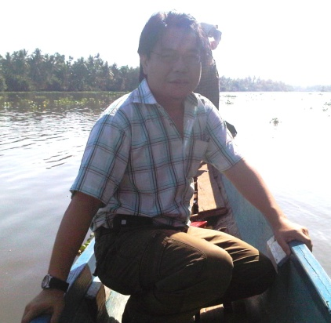
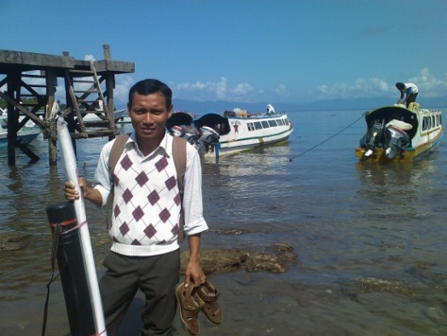

The interviewing team members frequently had to undertake long trips on very poor dirt roads. In one case, the interviewer had to ride a borrowed motor-bike for the last hour of a very steep climb to the targeted village, because four-wheel access was impossible for that last part of the trip. In another instance a boat engine broke down, and the interviewer and boat driver drifted in the open sea in their very small boat for most of the day before the engine was repaired.
An interviewer’s boat broke down at sea, resulting in his arrival at the school at 3 pm rather than the planned 9 am. The school had been dismissed for the day. The principal called the school back and the interviews proceeded until completed at 9 pm that night.
Nearly all the school principals were able to be contacted to arrange the interviewer’s visit, but in two cases, this proved impossible. Where no mobile phone coverage was available, the study had to rely on person-to-person contact between the DC and the principal of the school, with the DC trying to get word to the school via people who could be travelling to the area. In two cases, this method did not succeed, and in one instance, this resulted in no committee members being available for interview. One school which the team had not been able to contact prior to the visit was found to have a local holiday on that day. The good will of the principal and his community ensured that the interviews were able to go ahead, with the principal gathering some teachers, school committee members and students despite their not being scheduled to be at the school on that day.

The Welcoming Schools
The example provided above is not the only time when extraordinarily good will was extended to the study and its team members. All the schools in the study made the interviewers welcome, and the AIBEP schools and principals in particular went out of their way to be helpful. In nearly all cases, special lunches were put on by the school for the interviewers, staff and school committee members. Some interviewers were even met with special ceremonies, including traditional dancing.
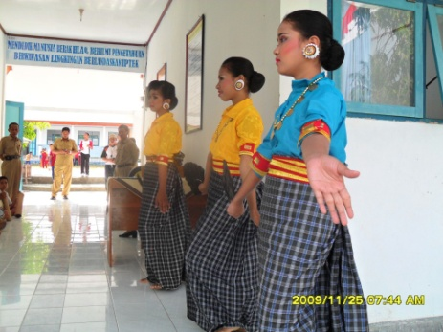
All the communities served by AIBEP schools have a strong sense of gratitude to the program. Many school principals and school committee members expressed this view, pointing out that without the program, their communities would still be without a viable junior secondary option. The interviewers recorded many stories of how difficult, and in some cases impossible, access to post-primary education had previously been for many children. While for some students attending AIBEP schools distance is still a problem (see Section x below) the situation was much more difficult previously. The study is not able to indicate how much the situation has improved in terms of percentages of children who now access junior secondary education in AIBEP areas and in drop-out and absenteeism rates. Neither the schools nor their Dinas Pendidikan have such data, although the anecdotal information gathered leaves little doubt about significant improvement.
The high value of the AIBEP schools was stressed by the officers of the regencies’ Dinas Pendidikan, who also often noted that the design and quality of the schools built by AIBEP was better than that of other schools recently built in their areas. This assessment of the buildings’ quality was also conveyed by members of the AIBEP school communities, who often expressed pride at having the best school facilities in the area.

The Methodology
The study’s methodology comprised six key elements:
- Structured interviews with school principals of the sample schools.
- Structured interviews with randomly chosen groups of teachers from the sample schools (where possible, a group of six teachers was preferred).
- Structured interviews with members of school committees of the sample schools (as many school committee members as could be available).
- Data collection from students in one Year 7 and one Year 8 class in each of the sample schools.
- Structured interviews with the Dinas Pendidikan officers responsible for approval and monitoring of schools’ expenditure of Dana BOS.
- An analysis of planning and budgeting documents collected from the schools.
The interviewers used a number of techniques. These included:
- noting and later summarising comments provided by school principals and Dinas officers;
- rating some of the responses provided by principals and school committees against a pre-determined scale; and
- using brainstorming, prioritising and evaluating techniques with groups of teachers and school committee members.
The methodology generated large amounts of qualitative data, and large amounts of data in a form which was able to be quantified.
The key objective of the study was to examine the quality of management and financial management practices of the sample schools and wherever possible, to establish the impact of AIBEP by drawing comparisons of practice between AIBEP and non-AIBEP schools. The study was also intended to provide lessons which would be useful to future planning of AusAID education programs in Indonesia.

Quality Assurance
In addition to the Team Leader, the interviewing team consisted of one national Coordinator who took primary responsibility for scheduling of the visits and for initial contacts with the AIBEP District Coordinators (DCs). Three other national staff were also recruited for the team. Each member of the team including the Team Leader were competent in both Bahasa Indonesia and English, ensuring clarity and ease of communication. The Coordinator assisted the Team Leader by checking the draft interview questionnaire for local sensitivities and by translating the document into Indonesian. CSAS team members checked the draft instruments, which were also provided for comment to senior staff of AIBEP. AIBEP did not suggest any changes to the draft questionnaires.
The Team Leader and Coordinator trialled the draft research instruments and processes in a government Junior Secondary school in Bogor prior to the instrument’s finalisation, making a number of necessary adjustments. For example, the teachers in the sample school requested that their written input in relation to where the school’s funds may be not well used not be displayed to the group, even though it was anonymous. They were concerned that handwriting could identify individuals. This request was incorporated in the methodology and the input was not displayed.
Each of the three national team members had 12 schools to visit: three schools in each of four regencies. The Coordinator had nine schools to visit: three schools in each of three regencies.
The team was trained for three days by the Team Leader prior to commencing field work. The training was undertaken in Indonesian and each team member was accompanied on their fist school visits by either the Team Leader (two team members) or the Coordinator (one team member). During the first week of fieldwork, the Team Leader spoke each evening with each of the team members, checking their experience. He accompanied team members on visits to a total of six schools, including two schools visited in the last week of the fieldwork, confirming that the methodology had been appropriately used throughout the study.

VI. FINDINGS

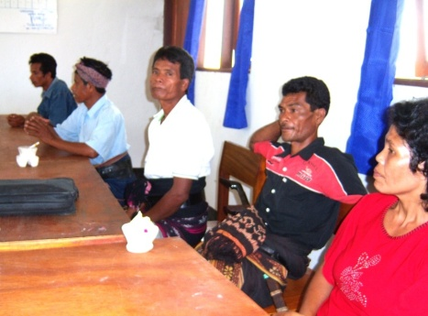

Membership, Background and Capacity of School Committees
The management of Indonesian schools is expected to be a joint responsibility of the schools’ education professionals and school communities represented by school committees. Apart from being predominantly male (see Table 3, below), the committees can be said to be broadly representative of their school communities. As illustrated in Table 3 (below), the committees comprise a high proportion of parents, and in the remote, poor communities served by the sample schools, most of the parents, and most of the committee members, are poor farmers. Their educational backgrounds, experience and communication skills make the task of involving them in school management challenging.
In 80% of the cases in both AIBEP and non-AIBEP schools, the process of forming the school committee and electing the officials was of a high quality, with a large proportion of the schools’ parents making those decisions at the schools’ annual general meetings. In only one of the 45 schools was the process seriously breached, with the principal of a non-AIBEP school dismissing his committee and himself nominating other individuals to take their places.
Table 3: Membership of School Committees
 | Average no of Members | Chair (% Male) | Secretary (% Male) | Treasurer (% Male) | % of Parents | % of Females
AIBEP | 8 | 100% | 77% | 33% | 71% | 23%
NON-AIBEP | 9 | 100% | 85% | 36% | 77% | 23%
Nearly all of the committees were headed by chairs who had the background, skills and confidence to play a positive role in deliberations and decision making. The chairs were also much more likely to have received training on their roles than had other members of the executive or general committee members (see Table 4, below). In the case of AIBEP schools, this was because their chairs had been included in the program’s training. The 21% of AIBEP chairs who are not trained are comprised mostly of newer appointees to the positions. None of the regencies have a comprehensive program for inducting new school committee chairs, or for training other members of school committee executives.
Table 4: Training of School Committees
 | % of Chairs Trained | % of Secretaries Trained | % of Treasurers Trained
AIBEP | 79% | 13% | 23%
NON-AIBEP | 43% | 21% | 7%

Of all general committee members in the sample schools, only six individuals from AIBEP schools and one person from the non-AIBEP schools had ever received training in their role.
The interviewers rated 43% of the AIBEP committees and 20% of the non-AIBEP committees as having a climate which encouraged members to contribute to and participate in discussions. In most of the other schools there was a tendency, sometimes very strong, for the chair to be dominating to the point of disenfranchising other members. In at least one case in a non-AIBEP school it was noted that the committee was under very strong domination of the school principal. Around 10% of the school committees were not rated on this scale, when the interviewer did not feel confident of making a judgement. It is recognised that traditional hierarchical relationships are likely to be reflected in the operations of the committee, and that trying to empower a larger percentage of committee members would not be easy.

School Committee Involvement in Planning
After holding discussions with school committee members, the interviewers rated the degree of the committees’ involvement in school planning on a three-point scale – “high”, “medium” and “low”. Among AIBEP schools, only two schools were scored “high”. 59% were rated as “low”, meaning that those committees had little or nothing to do with school planning. None of the non-AIBEP schools scored a rating of “high” and 64% received a rating of “low”.
It should be noted that at the time of the study, the AIBEP schools have been operating for only three years and that the AIBEP communities feel themselves to have been strongly involved in the original planning of the building of their schools. Often when planning was raised, this is what they wanted to relate. Committees of all the schools in the study had a tendency to see school development planning as relating strongly, and sometimes exclusively, to infrastructure. The fact that the verbs “to build” and “to develop” are covered by the one word in Indonesian may be a confounding factor.
AIBEP school committees were twice as likely as non-AIBEP committees to have an atmosphere encouraging participation and contribution of all members.
It was clear from the interviewers’ experience that on the whole, school committee members had not previously been involved in structured processes which would help identify whole-school needs, and prioritise them.
When school committees did talk about plans, they most often referred to the work plan of the committee itself – their plan of activities for the year. In general, these plans were modest. On average, both AIBEP and non-AIBEP committees met an average of 2.7 times per year (see Appendix II), with around half the members present. Close to two thirds of the AIBEP and somewhat fewer of the non-AIBEP committees had records of agendae and minutes of their meetings. Apart from organising some in-kind support which most of the committees offered, less than a third of the schools in the sample were involved in additional fund raising activities. Knowledge of “free school” policies was found to be very widespread, even in regencies where such decisions had not yet been formally made. Many school principals and school committees related that it is no longer possible to seek funds from parents. Where the committees do engage in fund raising, the contributions are generally sought on a voluntary basis. Community support for such levies is usually sought at the school’s annual general meeting. Only two AIBEP and two non-AIBEP schools were found to exert significant pressure for parents to comply with such levies, referring to sanctions like withholding of students’ end of year reports until the payments were made. Although there were a small number of schools where fundraising decisions were effectively made by the principal and staff, usually where fundraising was conducted it was done with strong involvement of the school committee. The funds raised were used for a wide range of purposes. Sometimes they were earmarked for general school needs, but more commonly they supported specific activities including competitions, extra-curricular activities and support for students from poor families.
When asked if their committees were pro-active in getting support for their activities from other government or non-government organisations, 23% of AIBEP schools and 13% of non-AIBEP schools reported that they were attempting to do so. Those committees had sought support from organisations ranging from non-education government departments to local businesses like mines. The success rate was limited.

School Committee Involvement in Budgeting
The situation with school budgeting was similar to that with school planning. Only two AIBEP schools scored a ranking indicating that the committee had a good level of involvement with the schools’ budgeting, indicating that many committee members played a significant role in the process. 62% of the committees scored a “low” rating indicating little or no involvement by the committee. Among non-AIBEP schools none had a good level of involvement and 57% scored a “low” rating (see Appendix III). Committees scoring a middle ranking had a small number of members who were more knowledgeable, e.g. chairs or teachers who were also the school treasurers, or had limited involvement by more members.
Table 5: School Committee Involvement with School Budgeting
 | Good | Medium | Low
AIBEP | 7% | 31% | 62%
NON-AIBEP | 0% | 43% | 57%

Most of the school committees in the sample perceive their roles in very limited ways. Even some of the potentially most competent chairs are yet to fully take on their mandated functions and responsibilities. In one case, a chair who was also a village head expressed it succinctly – he would not get himself involved in the details of the school’s budgets. He would help the school by lobbying authorities, and by organising community support. But budgeting was the school’s, not the committee’s business. Such views are still common in both AIBEP and non-AIBEP schools.
In examining the capacity and role of the school committee, the study also looked at the qualifications and experience of the treasurers. As has already been foreshadowed, most of the committees in the sample have no need for a treasurer because they have no funds of their own and are not involved in managing the school’s funds. In some cases, the position of school committee treasurer is filled by the teacher who is also the school’s treasurer, and there are other holders of that office whose qualifications or previous experience make them suitable for the position of treasurer. Around a third of committee treasurers in AIBEP schools and nearly half of those in non-AIBEP schools have neither the qualifications nor the experience which would stand the committee in good stead if the treasurer had a significant function to perform (see Appendix IV).
The interviewers discussed with school committees the national per-enrolment goods and services grant (Dana BOS) paid into each schools bank account, and assessed the committees’ knowledge of this funding focusing on rules governing the use of the funds and on the amount received per student. It should be noted that BOS funding provides the bulk, and in some cases all of the funding over which the sample schools have decision-making powers. The table below shows that only a minority of the school committees had even a basic knowledge of BOS funding. The others had either poor or very poor knowledge.
Table 6: School Committees’ Knowledge of BOS Funding
 | Basic Knowledge of BOS | Good Knowledge  of BOS | Very Good  Knowledge of BOS
AIBEP | 13.8% | 17.2% | 3.4%
NON-AIBEP | 28.6% | 7.1% | 0%

BOS funds are received by schools every three months and the regulations require signatures of the principal, the school treasurer and the chair of the school committee on the relevant documentation before the local Dinas Pendidikan authorises banks to release the schools’ funds. The study found that the requirement for the chair’s signature is often met only to the letter of the law. Some chairs of school committees know little about the contents of the budget documents they are signing, and general members of the committee know even less about what is signed on their behalf.

School Planning
As indicated above, most of the planning and budgeting activities in the sample schools are undertaken without significant involvement of the school committees, with the consequence that the responsibility falls on the schools’ professional staffs, and particularly school principals. All principals and most of the teachers included in the sample had post-secondary education qualifications. Although many of the schools, in particular the more newly established AIBEP schools, have to rely on part-time and non-permanent teachers to deliver some of the curriculum, in general the schools have sufficient professional capacity to be able to engage in sound planning and budgeting. Where this is not yet happening, the problem is judged to be related to a lack of appropriate training and particularly to lack of appropriate on-going support and supervision rather than to an inherent lack of capacity.
Nearly all of the 45 principals interviewed by the study appeared to be effectively in control of their schools. In two cases, the principals had delegated their leadership responsibilities to their deputies. There is a wide gender gap: only four of the AIBEP and three of the non-AIBEP principals are female, and it was noted that the female principals presented as among the more competent of the sample’s school leaders.
Twice as many AIBEP as non-AIBEP schools had a long-term strategic school plan (87% and 47% respectively).
The study found that 87% of AIBEP schools, as opposed to 47% of non-AIBEP had a long-term strategic school plan. The influence of AIBEP training was clearly evident in this outcome, and the principals and school committee chairs made references to it. It is less clear to what extent most of those documents, now usually two years old, still have a meaningful life in current school planning. Many of the strategic plans were rather generic, and while they were generally conscientious in descriptions of the schools, their staffs and communities, there was often a lack of a sharper developmental focus. In some cases, the plans had significant sections photocopied from other documents, and these may not have been written locally.
Although two-thirds of AIBEP schools and half of non-AIBEP schools claimed to have current annual school development plans, an examination of the documents did not support the claims. In several cases, the documents were copies of previous years’ plans, with a change of date superimposed. Other plans consisted mostly of photocopies of documents not originating from that school. It appears that the training on planning originally delivered by AIBEP may not be receiving adequate on-going support from regency authorities.
To be effective, school planning and particularly annual planning, needs to be tied to budgeting. While not all developmental activities require funding, most do. The study therefore made a detailed analysis of the schools’ budgeting practices and documentation.

School Budgeting and Financial Management
As previously indicated, financial management in most of the sample schools is undertaken primarily by the schools’ professional staff, usually with strong leadership of the principal.
It was found that many schools are able to operate without annual budgets. When asked for their current annual budgets, some schools offered copies of older documents with just a change of date. In several instances the interviewers were given plans for the 2008-09 school year. Given that the interviews were conducted in late November – early December 2009, this meant that those schools had no effective financial planning for their current school year, despite it being nearly half over.
Of the 21 schools which did have current annual budgets, 15 had them arranged in the format of a school year (2009-10), and six used the Indonesian financial year (2009).
Table 7: Schools with Current Annual Budgets
 | 2009 Budget | 2009-2010 Budget
AIBEP Junior Secondary | 1 | 6
AIBEP One Roof | 2 | 4
Non-AIBEP Junior Secondary | 2 | 3
Non-AIBEP One Roof | 1 | 2

As a rule, principals do not prepare a written report on the use of the previous year’s budget to their schools’ annual general meetings. The principals usually deliver only a verbal report on those occasions.
The quality of the 21 schools’ budget plans varied considerably, from a six-item plan to multi-page, detailed documents.
Accurate comparisons between the schools are difficult, as schools use different categories to describe budget items, and attribute similar items to different categories. For example, some budgets have all photocopying grouped together as office expenses, regardless of whether the copying was done for administrative or educational purposes. In some cases, what is termed “consumption” meaning snacks and provision of meals for teachers, committees and visitors is itemised separately, whereas in other cases, it is included in items such as “examinations”. A few schools show very poor skills in categorising their expenditure, e.g. one budget line advises that Rp 5.5 million was spent on, “student activities, inventory book, daily record books, photocopying and sugar”.
Tables 8, 9 and 10 (below) provide a breakdown of budgets of the 21 schools. Some of the budget categories used by schools have been aggregated to reduce their number. The data below should be considered indicative rather than precise. Some of the categories like “teaching and learning” used by many schools are not transparent, and could involve additional payments to staff. The same applies to the category of “student and extracurricular activities”. The tables below are arranged in three categories of expenditure: Education Program Related, Education Administration Related and Other.
Table 8: Education Program Related Costs
Average Among 13 AIBEP and 8 Non-AIBEP Schools
 | Wage | Class consum. & teaching aids | Teaching and learning | Student and extracurricular activities plus celebrations | Books (mostly student texts) | Teacher PD & associated travel costs | Exams & tests (national and local) | Support for poor students | Total
AIBEP | 30.7% | 6.8% | 3.8% | 9.9% | 2.9% | 1.7% | 7.7% | 3.5% | 67%
Non-AIBEP | 31.4% | 9.2% | 3.4% | 12.0% | 3% | 4.0% | 8.7% | 1.% | 72.7%

Table 9: Education Administration Related Costs
Average Among 13 AIBEP and 8 Non-AIBEP Schools
 | General administration costs | Administration travel | Utilities | Minor repairs | Total
AIBEP | 12.9% | 1.1% | 2.8% | 3.5% | 20.1%
Non-AIBEP | 8.1% | 2.7% | 1.5% | 5.2% | 17.5%
Table 10: Other Costs: Average Among 13 AIBEP and 8 Non-AIBEP Schools
 | Consumption | Unspecified goods | Unspecified other | Total
AIBEP | 1.4% | 7.3% | 3.1% | 11.8%
Non-AIBEP | 2.9% | 2.7% | 4.4% | 10.0%

The varying methods of and clarity in categorising the expenditure made it difficult to aggregate and accurately compare expenditure patterns between schools and groups of schools. Given this caveat, and in the absence of large variations in the expenditure patterns of AIBEP and non-AIBEP schools, no analysis of differences between these groups of schools is provided. It should also be noted that public service salaries are not paid from school budgets and that proportions of staff who are public servants very considerably. As very few teachers in the sample schools are paid directly as provincial or regency employees, the proportion of school staffs needing to be paid from BOS or similar discretionary funds varies also widely.
Some observations pertaining to the 21 schools can, however, be made.
- On average BOS funds represent 76.8% of the schools’ budgets, with regency funding providing most of the rest.
- Five of the schools had no source of funding apart from BOS.
- Only five of the 21 schools (23.8%) had any money raised by the school committees, averaging Rp 6.6 million. This is lower than the practice in the 45 schools, where 37% of the committees engaged in raising some, mostly small amounts of, funding.
- The cost of examinations and tests appears to be a particularly large component of educational expenditure. These costs are mostly incurred in funding the committees
- which set the tests, and in supervision costs on the days of testing. School supervisors are sometimes paid to attend schools on days of tests.
- How the money spent on wages is used varies considerably. In some schools, it is spent only on staff who are not public servants while in others considerable incentives are provided to public servants undertaking a range of additional responsibilities such as being a class teacher or even as a reward for punctuality. There are also cases of principals and vice-principals receiving incentive funding for unspecified duties.
- There are some schools well provided with permanent teaching staff whose salaries are not a part of the school budgets but which nevertheless spend more than average proportions of their discretionary funds on incentives and other subsidies for teachers. One such non-AIBEP school spent at least 54% of its funds in this way, while apparently dedicating nothing to professional development and only 3.5% to the purchase of books.
- Extra-curricular activities are a significant budget item, even in schools which cannot resource basic core-subject needs such as student textbooks.
- In some schools, celebrations of holidays, especially religious holidays, consume significant funds.

Dinas Role in School Planning and Budgeting
The study found that there appears to be little Dinas support for school planning and budgeting. Every three months, schools submit to Dinas their proposals for spending their BOS allocations. With rare exceptions, the Dinas officers responsible for approving the release of these BOS funds have little personal knowledge of what happens in the schools. Their visits to schools, and especially to remote schools, are rare and their checking of the documentation is generally desk-bound, focusing on ensuring that the proposed expenditure does not breech the regulations. In one case, it was found that an officer was approving the release of BOS funds even though the documentation did not have the required signature of the school committee chair – it had the signatures of the principal and school BOS treasurer only.
At the end of each three-monthly BOS period, schools submit detailed evidence of their expenditure. These documents can be large tomes, containing numerous receipts. It is not known how carefully they are scrutinised by the Dinas. Where the regencies provide some of their own funds for schools’ goods and services budgets, the accountability processes are similar to those of the BOS program.
The only position in the education structure which has the potential to support school planning and budgeting is that of the school supervisor. The fact that many of the sample schools do not have current annual plans or annual school budgets demonstrates that in many areas, supervision and support are not yet functioning well.

Financial Probity
AIBEP teachers give a higher rating for their ability to influence their class or subject budgets, their school budgets, and to the degree to which their schools use their budgets well.
The study used a methodology which allowed each of the teachers in the sample groups to provide confidential and anonymous ratings of the quality of their schools’ financial management. On a scale from one to ten, they were asked to rate their ability to influence their class or subject budgets, and their schools’ general budgets. They were also asked to rate how well in their opinion the schools were using the available funding. Figures 1, 2 and 3 (below) show the responses of teachers.
Figure 1: Teachers’ Ability to Influence their Class or Subject Budgets
Averages of 30 AIBEP and 15 Non-AIBEP Schools
AIBEP Average: 6.3; Non-AIBEP Average 5.7
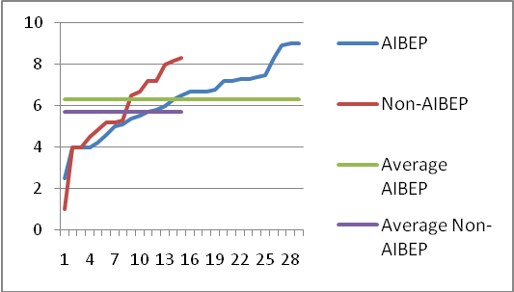
Figure 2: Teachers’ Ability to Influence their Schools’ Budgets
Averages of 30 AIBEP and 15 Non-AIBEP Schools
AIBEP Average: 6.4; Non-AIBEP Average 5.1
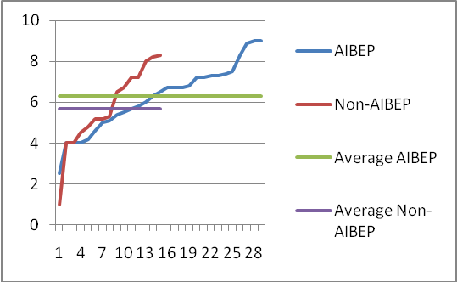

Figure 3: Teachers’ Assessment of How Well their Schools are Using Funds
Averages of 30 AIBEP and 15 Non-AIBEP Schools
AIBEP Average: 6.7; Non-AIBEP Average 6.3
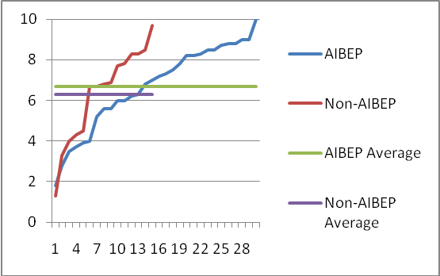

Teachers were also given the opportunity to provide confidential and anonymous advice on where they thought their schools’ money was not used well or was misused. Less than 10% of teachers recorded any such concerns, which is consistent with their generally positive perception of how schools funds are used. Teachers from schools which scored lower in Figure 3 (above) were much more likely to report issues of concern. Responses to this question differed somewhat between AIBEP and non-AIBEP schools. In AIBEP, administrative costs and staff wages were the main areas of concern, with each mentioned nine times. False costs of bought goods were cited five times. In non-AIBEP schools, false cost of goods was identified five times, with staff wages and administrative costs both mentioned three times.
If a new principal was coming to this school, I would tell him to make sure he keeps the school’s finances very transparent. Otherwise he may not be safe in his home at night. (AIBEP principal talking about what needs to be sustained in his school)
Those school committees which demonstrated at least a basic knowledge of BOS funding (around one-third of both AIBEP and non-AIBEP schools) were also asked their opinion of how well they thought those funds were used by their schools through an anonymous and safe process. The committee members’ average ratings were higher than those of the teachers: 8.3 for AIBEP and 7.5 for non-AIBEP schools.

Financial Transparency
When asked which current good practice in their schools most needed to be sustained, teachers in AIBEP schools identified financial transparency as the second most important factor, just behind the area of in-school and school-community relationships. In non-AIBEP schools financial transparency took third place, behind relationships and extra-curricular activities. Ten of the AIBEP and six of the non-AIBEP school principals also stressed the importance of financial transparency when asked what good practice in their current schools most needed to be sustained. One offered the opinion that a principal who was not seen to have a transparent budget process “would not be safe in his house”.
It is noted, however, that despite most of the schools reporting good financial practice and this being generally evident to their staffs, only a minority of school committees are able to confirm that this good practice is happening. They don’t know their school budgets. In addition, there is little evidence that when school committee members know their schools’ budgets, and trust their school administrations’ probity, this knowledge is transmitted more widely to the school community at large. Only five of the 45 schools, two AIBEP and three non-AIBEP, have their budgets on display and in three of these five schools they are displayed only in staff rooms, where they are not accessible to the school community at large.

Educational Management
The study looked at several areas which are indicative of the quality of the sample schools’ educational management. These areas include curriculum management, staff supervision, professional development, availability of student text books and teacher absenteeism.

Curriculum Management
In all the visited schools, the interviewers asked to be shown the schools’ current curriculum documentation. This should consist of two key documents forming the school’s curriculum framework: Kurikulm Tingkat Satuan Pendidikan (KTSP) 1 and KTSP 2. More than two-thirds of the schools in the sample were able to produce both documents: in AIBEP schools 80% had KTSP 1 and 73% had KTSP 2, while in non-AIBEP schools the figures were 73% and 67% respectively. A closer inspection of the documents, revealed that while the documents were generally very impressive in size, they usually contained documentation photocopied from other sources, and apart from descriptive information about the particular school contained little site-produced curriculum framework material. Some of the principals reported that they found the task of producing the documents too difficult, and were obliged to take short-cuts. In one school, where the documentation was produced in hand-written form, the school had taken many months to produce only a part of KTSP 1. Nevertheless, many AIBEP and non-AIBEP schools were able to demonstrate teacher-produced, hand-written lesson plans, demonstrating that teachers do often take care in planning the presentation of their lessons, even if they may not always be using the latest version of the curriculum.
The teachers interviewed for the sample were asked to provide information about five elements of teaching practice in their schools. Each teacher provided their individual judgement of the situation in their school on a five-point scale:
Never | Rarely | Sometimes | Often | Always

Table 11: Teachers’ Perceptions of Elements of their Schools’ Teaching Practices
ELEMENTS OF TEACHING PRACTICE | Median AIBEP | Median Non-AIBEP
1. Frequency of teachers using teacher text books in lessons | Always | Always
2. Frequency of teachers using teaching aids in lessons | Sometimes | Sometimes
3. Frequency of teachers using subject teaching guidelines | Often | Often
4. Frequency of teachers preparing specific lessons plans for particular lesson | Often | Often
5. Frequency of teachers using group work and student discussions | Often | Often
The table indicates that there are no large differences between AIBEP and non-AIBEP schools. It must be noted that teachers’ perceptions of the situations within their schools varied considerably, and it was possible to find a wide range of opinions in the same school, and on the same topic. Appendix VII provides examples of a “tighter” and a “looser” pattern of responses, the “tighter” one being data about use of teachers’ reference books, and the “looser” one dealing with use of lesson plans written specifically for the lesson being taught. Using the median as a measure reduced the influence of the outriders on the data, and it is noted that the data broadly correlate with interviewer observations from the schools. For example, the interviewers were told by students that teachers used textbooks in lessons, there was an evident lack of teaching aids in the schools, and schools were able to show the existence of teachers’ lesson plans.

Professional Development
As has already been noted above, the sample schools commit little, and sometimes no funds, to external professional development of their teachers. In addition, the study found only rare examples of school principals arranging internal professional development activities for their staffs. In the couple of cases where this did happen, the principals themselves were the deliverers of the program. Most commonly, schools’ financial contributions to professional development involved paying for transport for teachers to attend programs in regency and provincial capitals. These programs were mostly of two kinds: subject-specific workshops and sessions on the KTSP.
The interviewers asked the participating teachers to identify how many days of professional development activities they had undertaken since the start of 2009. The answers were provided in two categories: number of school days, and number of non-school days. Table 12 (below) lists the teachers’ responses.
Table 12: Average Number of Professional Development Days During 2009
 | AIBEP | Non-AIBEP
School Days | 2.1 days | 2.5 days
Non-School Days | 0.4 days | 0.4 days

It should be noted that professional development opportunities were not distributed equally among the teachers. More than half of those in the sample received no professional development training at all during 2009.
Where teachers did get an opportunity to attend professional development, they valued it highly. AIBEP teachers rated the usefulness of the training at an average of 7.9 out of 10, while in non-AIBEP schools the rating was 8.6.

Professional Supervision
The teachers in the sample schools were asked to identify how many times during 2009 they had had a formal meeting with a superior from the school or from outside the school to discuss professional matters or their performance. Table 13, below, lists the results:
Table 13: Average Number of Professional Meetings with School-based and Non-School-based SUPERIORS DURING 2009
 | AIBEP | Non-AIBEP
School-based superior | 4.8 times | 4.3 times
Outside of school superior | 2.5 times | 2.1 times

There was considerable variation in the supervision patterns recorded. In two of the AIBEP and one non-AIBEP schools, no teacher in the sample group had had a professional meeting with their school-based superiors. Overall, 15.6% of AIBEP teachers and 20% of non-AIBEP teachers had not had such a meeting in 2009. On the other extreme, an AIBEP teacher reported having such meetings 26 times and a non-AIBEP teacher, 20 times. There may have been good reasons why such close supervision of those individuals was needed, but it is also clear that the needs of many teachers are being overlooked, and that the level of professional supervision remains low in many of the schools. Most school principals are yet to develop and implement regular professional supervision processes for their staffs.
In AIBEP and non AIBEP schools, about half the teachers received no professional visits from outside the school. The patterns again varied considerably, with two AIBEP teachers reporting 10 visits each, and in one non-AIBEP school, the pattern was highly unusual with three of its six teachers reporting 13, 15 and 15 visits each.

Teacher Supply, Quality and Absenteeism
Based on national information, the study anticipated that teacher supply and teacher quality would be significant issues in remote junior high school classrooms, and this was born out in the field work. Many of the principals talked of the difficulty of matching teacher skills to the needs of their schools and of the problems with teacher supply. Schools with high proportions of non-permanent teachers, many of whom are paid very low salaries from BOS funds, were particularly concerned about this issue. AIBEP principals identified teacher professional development as the second most important area on which they would spend any additional budget allocations which they could secure for their schools. Principals and school committee members also mentioned problems related to teachers living a long way from the schools, with attendant problems of absenteeism and lateness, particularly in bad weather. Near-to-school accommodation for teachers and principals was identified by AIBEP principals as the third top priority on which any additional budget allocations should be spent.
In the Year 7 and 8 classes which were visited, the students were asked about teacher absenteeism. No teachers were present during those class deliberations. The interviewer first counted and listed with the class the number of lessons the class has in a normal full week. The students were then asked to discuss in groups how many lessons during their last full week of school were without teachers, that is, the teacher was out of the room for the entire lesson, or for more than half of the lesson time. If a substitute teacher was present, this was not regarded as teacher absenteeism. In general, it was not difficult for the classes to come to a consensus about the total.
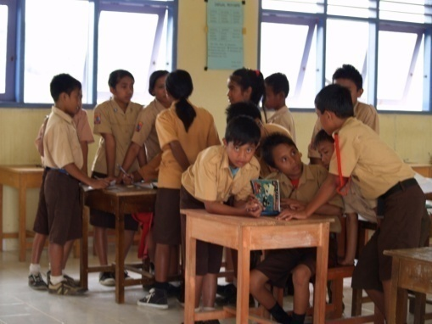
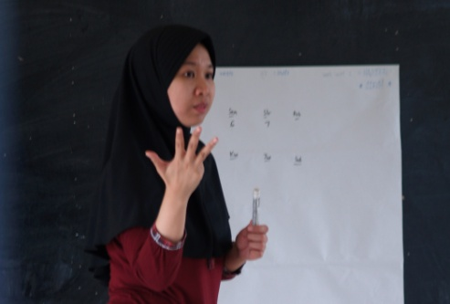

Table 14: Percentage of Teacher Absenteeism in the Sample Schools
 | Year 7 | Year 8
AIBEP | 18.8% | 17.9
Non-AIBEP | 21.4% | 19.9%

The incidence of teacher absenteeism recorded spanned a very wide range. Seven of AIBEP schools’ Year 7 and ten of the Year 8 classes recorded no teacher absenteeism while in the non-AIBEP schools only one class at each year level recorded this result (see Appendix VI). Two of the AIBEP schools recorded absenteeism rates of over 88% while the highest rating for a non-AIBEP school was 50%. It should be noted that the extreme values generated by the two AIBEP schools were caused by the requirement for teachers from remote island schools to travel to a district capital to participate in the process of selection of teachers for permanency in the public service.

Student Textbooks
In a situation where neither the presence of the teacher in the classroom, nor the skills of the teacher to teach a specific subject are certain, the availability of student text books becomes a highly significant factor in relation to the quality of education being offered by a school.
Although they are new, and did not have access to BOS BUKU funding, the AIBEP schools provide more student textbooks for their students. AIBEP parents are also more willing to buy textbooks for their children.
Availability of student text books in both the AIBEP and comparative schools was found to be limited. The Government of Indonesia has undertaken a range of measures to improve students’ access to suitable textbooks. Its web-based free-textbook downloading program has been and continues to be available to all schools, but the study found no evidence of any the schools in its sample making use of this resource, almost certainly due to lack of fundamental Information and Communication (ITC) infrastructure. The national program of direct grants to schools specifically for the purchase of text books (BOS Buku) was no longer available for AIBEP schools, but it had been available to the comparative schools, which had been operating before 2006. This raised the expectation that students in non-AIBEP schools would have better access to text books. Data gathered by the study shows this was not the case.
In the sample schools, one Year 7 and one Year 8 class were used to check the availability of student textbooks. The classes were the same as those which had been used to establish teacher absenteeism. The interviewer obtained from the students a list of all subjects taken by the class, and listed these subjects on a sheet of butcher’s paper displayed at the front of the class. The students were then asked to affix a coloured sticky dot against each of the subjects – one colour for a book they obtained free from the school, and a different colour if they had a book or photocopy which they had bought.
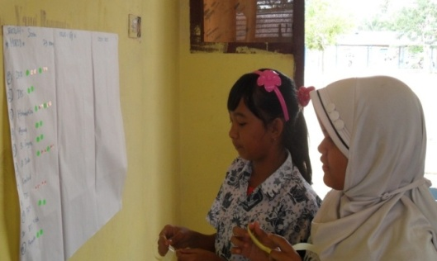
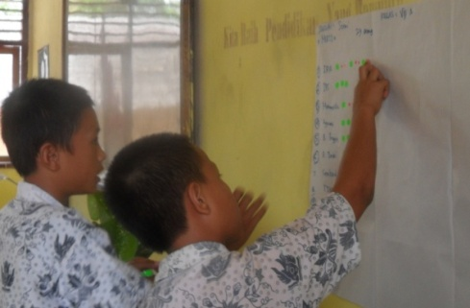

Sets of books which teachers had brought from the library for use during the lesson were classified as free books, even though they were not available for student use outside of the classroom.
The number of subjects studied by Year 7 and Year 8 students ranged from 10 to 17 with an average for both year levels of 12 subjects.
Figures 4 and 5 (below) show the availability of student textbooks, expressed as a percentage, across all subjects.
Figure 4: Availability of Text Books for Year 7 Students
In 28 AIBEP and 15 Non-AIBEP Schools
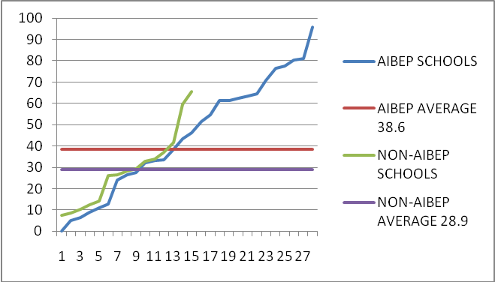

Only 28 of the 30 AIBEP schools provided data about availability of student text books for Year 7 students. The study had anticipated that One Roof schools would have a combined school committee and a combined school budget for the primary and junior secondary sections. It was therefore originally intended to collect data from a primary class and from Year 8. The assumption proved to be wrong, as first two AIBEP One Roof schools visited were found to have separate budgets and separate school committees. It was therefore decided, from that point, to collect data from Year 7 and Year 8 classes from all schools. The data from the two One Roof schools’ primary grades was discarded.
Figure 5: Availability of Text Books for Year 8 Students
In 30 AIBEP and 15 Non-AIBEP Schools
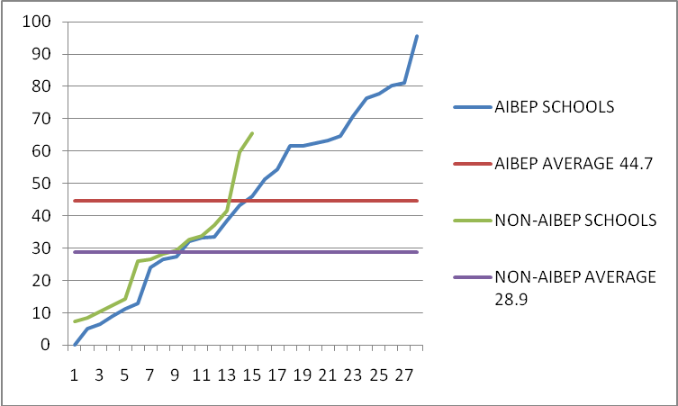
Figures 4 and 5 demonstrate that on the whole, students in AIBEP schools have better access to text books than do students in non-AIBEP schools. The likelihood of a student in an AIBEP school having a textbook in any subject is 44.4% in Year 7 as opposed to 28.9% for a student in a non-AIBEP school. In Year 8 the situation in AIBEP schools is also better: 42.4% against 31%. Several AIBEP schools are close to having all students with textbooks in all subjects, and others are approaching this situation whereas in none of the non-AIBEP schools do two-thirds of the students, on average, have a textbook in a subject. In both AIBEP and non-AIBEP schools more than two-thirds of the available books were those provided free by the schools. One Roof schools in both categories were much less likely to have students buy their own books than were Junior Secondary schools. This could be indicative of the generally less favourable economic condition of the communities served by One Roof schools. It is noted that while in general most of the books are those made freely available to students, parents of AIBEP schools’ students were more likely to buy books for their children.
In most schools, there is a marked lack of books even in core subjects like Mathematics and Indonesian. Schools try to overcome this difficulty by asking students to share books during lessons. This has the coincidentally positive effect of facilitating group rather than row seating in classes where there is less than one book per two students but that is not adequate compensation for the fact that very few students in the sample schools have a text book to which they can refer at home. The free books provided by the school are library sets removed to the library at the end of a lesson.
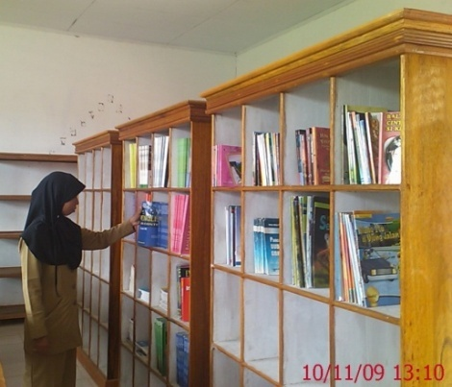
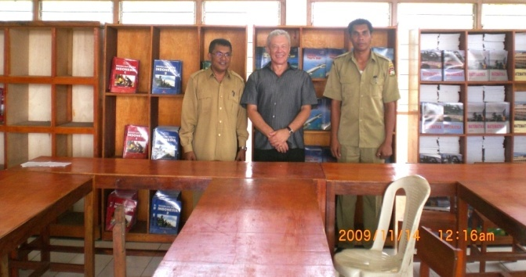
In general, all schools in the sample tend to look well after the books which they do have. The AIBEP schools expressed gratitude for the set of supplementary reading books provided by the program (some of the sets are visible in the pictures below). Although on the whole the AIBEP schools have newer and better library facilities, the non-AIBEP libraries were also generally kept clean and dry. Security can be a problem – one of the AIBEP schools had recently had its entire (though still small) library collection stolen in a break in.

VII. FUTURE NEEDS

As a part of their interview, school committee members, teachers and principals were asked to brainstorm ideas about how the school should use an imaginary additional large amount of money. In the case of school committees and teachers, the brainstorm-produced ideas were listed on butcher’s paper and the list was prioritised by each member distributing a total of four sticky dots among the items.
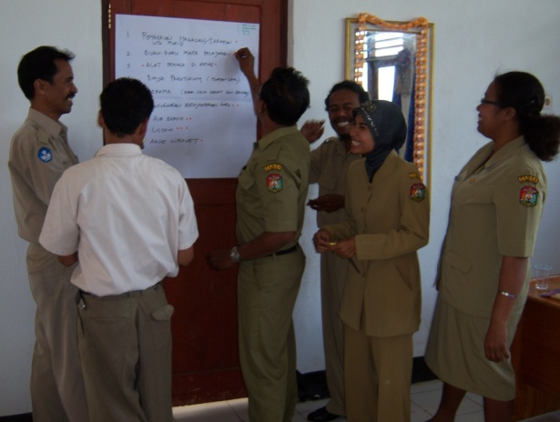
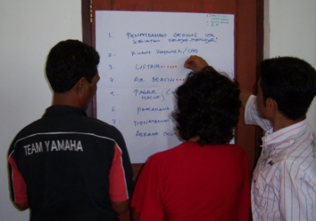
School principals, being interviewed alone, prioritised their ideas individually.
A summary of the results of the brainstorming and prioritising sessions is provided in Tables 14 and 15 (below) and a full listing of the principals’ priorities is provided in Appendix VIII.
Table 15: Priorities for Use of Additional Money in AIBEP Schools
 | AIBEP principals | AIBEP teachers | AIBEP committees
Ideas for use of additional money in order of priority | 1. Additional specialist facilities | 1. Additional specialist facilities | 1. Additional specialist facilities
Ideas for use of additional money in order of priority | 2. Professional development for teachers | 2. Student textbooks | 2. Professional development for teachers
Ideas for use of additional money in order of priority | 3. Additional classrooms | 3. Teachers’ wages | 3. Principal, teacher accommodation
Ideas for use of additional money in order of priority | 4. Teachers’ wages | 4. Additional library books | 4. Additional library books
Ideas for use of additional money in order of priority | 5. Additional library books | 5. Professional development for teachers | 5. Student textbooks

Table 16: Priorities for Use of Additional Money in Non-AIBEP Schools
 | Non-AIBEP principals | Non-AIBEP teachers | Non-AIBEP committees
Ideas for use of additional money in order of priority | 1. Furniture and equipment | 1. Teachers’ wages | 1. Additional specialist facilities
Ideas for use of additional money in order of priority | 2. School environment including fencing | 2. Additional specialist facilities | 2 Student textbooks
Ideas for use of additional money in order of priority | 3. Electricity | 3. Student textbooks | 3. Teachers’ wages
Ideas for use of additional money in order of priority | 4. Wages for teachers and administrators | 4. Professional development for teachers | 4. Professional development for teachers
Ideas for use of additional money in order of priority | 5. Additional student activities | 5. Additional classrooms | 5. School environment including fencing
There are some differences between the priorities of categories of respondents, and differences between AIBEP and non-AIBEP schools. All stakeholders in the AIBEP schools have a strong desire to add more specialist facilities to the high-quality basic infrastructure provided for them by the program. Non-AIBEP principals did not report this as a high priority, and did prioritise teacher professional development as highly as did all other groups of respondents.
It is clear that teachers and school committees in both types of schools see a greater need for the purchase of student text books than do the principals. The other priority which gets support from at least two types of stakeholders in both AIBEP and non-AIBEP schools is increasing teacher wages.
The three categories of stakeholders (principals, teachers and committee members) were also asked what they saw as major non-financial blocks to their schools’ development. Both AIBEP and non-AIBEP schools identified the area of school-community relationships as by far the most important. This particularly included factors such as the degree of support given by parents to the school in ensuring student attendance and diligence and the parents’ valuing of education. The prioritisation of local cultural needs such as ceremonies and celebrations over school attendance was frequently mentioned, as was parents’ seeking assistance from children in the fields at key times of the agricultural year. The other factor identified frequently, though not nearly as frequently as school-community relations, was teacher capacity.

VIII. CONCLUSIONS AND RECOMMENDATIONS

The building of the AIBEP schools has been a most positive development for their communities, which have a very high degree of ownership of their new education facilities. The AIBEP communities, their neighbouring schools and the local education authorities regard the infrastructure provided by the program as superior to that of other schools in the area. There is a strong sense of gratitude to Australia for the program, both explicitly expressed and demonstrated by the schools’ and their communities’ openness and generosity in their treatment of the study’s interviewers. The Dinas Pendidikan based AIBEP District Coordinators also proved most helpful and supportive.
Although the AIBEP schools in the sample were built in 2006 and are therefore quite new, there are encouraging early signs of their developing some good school management practices. The AIBEP schools appear to have a more open and more participative management culture. Their teachers report having more influence in the formulation of their schools’ budgets than do the teachers in the comparative schools and AIBEP school committees give their members a much better opportunity to contribute to discussions and decision making. More than 80% of AIBEP committee chairs have been trained in their roles by the program. There appears to be a high degree of budgetary probity and transparency in the expenditure of the schools’ funds and AIBEP schools are twice as likely as the comparative schools to have long-term strategic plans. Their students have better access to textbooks and there are indicators that both student and teacher absenteeism may be lower in AIBEP schools. Principals, teachers and committee members report that the establishment of the new junior secondary facilities has resulted in improved access to post-primary education in their areas, reducing drop-outs, absenteeism and lateness.
As well performing better than the comparative schools on some of these important indicators of quality of school management, AIBEP schools perform at least as well as the comparative schools on all the other indicators used by the study. This is a significant result given the newness of the schools and the relative lack of experience of their school committees.
Despite these positive indicators, much work remains to be done to further improve the schools’ management and financial management processes. It was found that in general, the capacity of most school committee members is rather low, and apart from those committee chairs who were trained by AIBEP, few current members have received any formal induction into or training in their role.
In this context, it is not surprising that their involvement in school planning is not high, and that most school committees continue to focus on their traditional role of mobilising parent support for the schools and their activities. Given the current favouring of “free school” policies, most of the committees don’t do any fund raising of their own, effectively having a lesser role in school life than they did several years ago. School committee involvement in school budgeting is also low, with only a minority of school committees having at least a basic knowledge of the main component of their school budgets – Dana BOS. In many cases, the signature of the committee chair on school budgetary documents is symbolic only, and does not indicate any significant input of the school committee. This situation is not highly surprising, given that the enhanced role of school committees is still relatively new, and that in Indonesia, there is limited precedent for public sector budgets being genuinely open and transparent. It is nevertheless not desirable that this situation should remain as is. The committees are highly democratic structures. Even though they have a poor gender balance and this needs to be addressed over time, in nearly all cases the committees are elected by a high proportion of the parent body, and have a high degree of legitimacy. It would require a significant and sustained effort to make most of the committees meaningful partners in school management, but the investment would be repaid by more participative and more effective school management, and increased community support for and understanding of education. It is unlikely that the regencies in remote areas of Indonesia will do much in the near future to achieve this outcome, though there may well be exceptions to this generalisation. Some national policy guidance and accountable budgetary support appears necessary to progress the work.
Recommendation 1
- Improving the functionality of school committees requires continuing and long-term commitment of GOI and development partners, including appropriate training programs and mechanisms for delivery.
In addition to examining the role of school committees in school planning and budgeting, the study also examined the quality of these processes in the sample schools. Schools staffs including school principals and teachers undoubtedly possess the potential to engage in sound school planning and budgeting. Where this is not yet happening, the problem is not intrinsic capacity but lack of appropriate support through training and sound supervisory and accountability processes.
In relation to planning, one of the effects of the AIBEP training program can be seen in that a large proportion of the AIBEP schools have a current long-term strategic plan, the production of which was one of the foci of the program. There is, however, attrition over time in the production of annual school plans, and currently even where these are produced, they tend not be of high quality and not to link well to budgeting.
Less than half the schools, both AIBEP and non-AIBEP, could provide the study with current annual budgets. In many cases, the schools appear not to have to submit annual plans and budgets, and provide their Dinas Pendidikan only with the obligatory three-monthly Dana BOS financial documentation, and where they get additional regency-based funding, with similar documentation pertaining to those funds. The Dinas checking of the documents is often perfunctory and focuses only on formal compliance with regulations. There is little useful regency-level support to improve the effectiveness of school planning and budgeting. In many schools, therefore, this results in planning and budgeting being done only on the short-term, three-month cycle.
An analysis and comparison of the 21 available annual school budgets was made difficult by the wide range of formats used by the schools and by a lack of clarity of what some of the budget lines contained. It does appear, however, that the sample schools generally find it difficult to adequately fund the purchase of educational resources like student textbooks and of teacher professional development despite these items being key to a delivery of quality education. From the results of this study alone, it is not possible to conclude whether this is an inevitable consequence of inadequate school budgets, or whether it is at least partially the result of poor choices of expenditure priorities. It can certainly be noticed that patterns of expenditure vary significantly across schools. For instance, some schools provide substantial additional payments to their permanent teachers, while others appear not to do so. On the whole, schools appear to devote surprisingly large proportions of their funds to testing and examinations. There is also substantial expenditure in areas like extra-curricular activities and celebrations in schools which appear to lack the basic resources to deliver sound education in key subject areas. It would be very useful conduct a specialist, detailed, on-site study of the expenditure patterns of a sample of schools which could be used to guide the development of standardised budget formats to enable a more effective analysis and comparison of school use of funds. Without the ability to accurately examine comparative patterns of school expenditure, it is very difficult to make judgements about the appropriateness of the expenditure.
Recommendation 2
- That a standardised format for annual budgeting in junior secondary schools be developed and mandated. This format should be informed by a detailed, on-site study of a sample of schools’ actual expenditure patterns.
Despite shortcomings in many schools’ planning and budgeting identified by the study, there appears to be a high degree of financial probity and transparency. Most teachers in most of the sample schools are satisfied with how their schools use available funds, and with their own ability to influence both their classroom or subject budgets and whole-school budgets. This positive perception of the effectiveness and transparency of use of school funds is shared by those school committees which have at least basic knowledge of their schools’ budgets.
The fact that most schools’ expenditure is seen as broadly effective and appropriate by their staffs should not be underestimated. When given the opportunity to provide confidential, anonymous and safe information about any poor or inappropriate use of money in their schools, few teachers reported having such concerns. This knowledge of a high level of financial probity of school budgets is, however, largely confined to the schools’ teachers.
Attempts to effectively convey knowledge of this laudable level of probity to the broader school community are rare. Only two of the 45 schools in the sample display their annual budgets publicly. In a country where enhancing public sector financial transparency is a nominated government priority, this opportunity should not be overlooked. Opening school budgets to the scrutiny of their school and village communities would not be difficult for most schools, and the benefits of such examples across all Indonesian school communities would be substantial.
Recommendation 3
- That the compulsory and public display of school budgets be mandated by national and district legislation.
In addition to examining school management by analysing planning and budgeting processes, the study also looked at the educational management in the sample AIBEP and non-AIBEP schools.
Only two principals in the sample schools were not active and involved educational leaders of their schools. While the level of skills varied, it was clear that on the whole, the principals are dedicated to their schools and to the communities they serve. Where their work can be subjected to some criticism, as in the areas of planning and budgeting, the lack of training, supervision and support systems must be taken into account.
Nearly all the schools are making efforts to comply with the requirements of the curriculum framework, the KTSP. It is noticeable, however, that true compliance with these requirements may be beyond the capacity of many if not most of the schools. The framework documents which the schools were able to show consist largely of photocopies rather than of documents produced by the schools themselves. A number of the principals confided that the task the framework sets their schools is too demanding for their capacities, and that their schools’ documentation is largely designed to meet formal requirements. On a positive note, however, the schools were often able to show teachers’ individual lesson plans, often hand-written. Information gathered from teachers confirms that they often use lesson plans and general subject guidelines, and that nearly all of them make regular use of teachers’ text books. They also report a frequent use of group work and discussions in the course of lessons, but this indicator of a more participative and student-centred teaching methodology needs to be tempered by the fact that the group arrangements often appear to be forced on the teachers by students having to share an inadequate supply of text books.
Teacher absenteeism continues to be a problem: around every fifth lesson does not have a teacher present in the class. The study did not explore the issue of teacher absenteeism in detail, but a number of factors appear to contribute to this situation. It is clear that professional development is not a major disruptor of classes – in 2009, teachers in the sample schools spent an average of only between two and two-and-a-half school days on professional development. But many of the teachers are not residents of the schools’ villages and have to travel substantial distances on difficult roads to reach them. In bad weather, such as during the wet season, this can cause both lateness and absenteeism. There also appear to be problems with teacher supply, with teachers’ self-discipline and with principals’ management of staff. These problems have been documented by previous Indonesian studies and projects, as have the shortcomings in Dinas responses to address them.
Data gathered about performance management of teachers shows varying patterns of meetings between teachers and their school-based superiors. Very few principals appear to have processes requiring regular performance management meetings with teachers. Some teachers have professional meetings with their superiors frequently, while many have them rarely or never. There appears to be little local guidance for principals in relation to effective performance management.
The study found that despite recent attempts by the national government to improve the availability of student text books, the chances of an AIBEP student having a book for a subject are a little under a half, and of a non-AIBEP student, under a third. The study is not able to draw conclusions as to why AIBEP students are more advantaged in access to student text books than their non-AIBEP counterparts. It is possible that some of the training provided as a part of the AIBEP program has had an impact on this area. The parental enthusiasm for educational opportunity generated by the establishment of the new schools could also be a factor. The AIBEP parents are certainly more prepared to buy their children books when these are not available free from the schools.
The lack of student text books is a serious matter, and one which needs to be addressed as a matter of urgency. In remote junior primary classes where teacher supply, teacher quality and teacher absenteeism are all significant problems, it is vital that students at least have access to the information through books. It is clear that most of the sample schools have not been able to build up the required stock of books. This is not difficult to understand in the case of some of the AIBEP schools – they are new, and some operate exclusively with BOS funds from which they have to pay their non-permanent teachers, leaving little for the purchase of resources. Such schools urgently require additional funds to optimise the return on the large investment in new infrastructure. But it is not clear that all schools are in this position – the study found some large non-AIBEP schools, longer-established, and with more generous budgets, which still had a poor supply of student text books. It was also found that in prioritising schools’ needs for additional funding, teachers and school committees placed a higher value on purchase of student text books than did the principals. A single approach to solving the problem of text books may not be appropriate, and solutions may best be designed only after a careful study of detailed school budgeting, as per Recommendation 3 (above). It is nevertheless recommended:
Recommendation 4
- That national and district strategies are required to address the continuing problem of lack of student textbooks in remote and isolated junior primary schools.
The fact that many of the sample schools are able to operate without current annual school
development plans and without current annual school budgets indicates that the system of supervising and supporting schools in their management practices is not working well enough at the local level. School supervisors are the only education professionals who can be tasked with this function, but there is substantial evidence that this group of education professionals is not currently able to fulfil the required role. Problems persist with the quality of the appointees to the positions, with the nature of their roles, and with the on-induction and on-going professional training available to the supervisors.
Recommendation 5
- The roles, recruitment and training of school supervisors must be strengthened in order to provide better supervision of and support for school management.
In summary, it can be said that there are some signs that the AIBEP schools may, on the whole, be somewhat better managed than the schools in the comparative sample. Teachers’ perceptions of the level of their participation in school budgeting and their approval of how the schools’ funds are being used are all higher in AIBEP schools. Student absenteeism appears to be lower in AIBEP schools and there are some indicators that teacher absenteeism may also be lower. There is generally a more participative and open atmosphere in the discussions of AIBEP school committees. Although there do not appear to be major differences in some patterns of educational management, the supply of student textbooks, although far from desirable, is much better in AIBEP schools. Finally, although annual planning and budgeting processes need improvement in both groups of schools, the AIBEP schools are twice as likely as their counterparts to have current long-term strategic plans and the chairs of their school committees are much more likely to have received training in their roles.
APPENDIX I
LIST OF THE SAMPLE SCHOOLS

 | School Name | Regency | Province
AIBEP JS
 | SMPN 5 Paguyaman | Boalemo | Gorontalo
 | SMPN 2 Paguyaman Pantai | Boalemo | Gorontalo
 | SMPN 2 Lamboya | Sumba Barat | Sumba Barat
 | SMPN 3 Loli | Sumba Barat | Sumba Barat
 | SMPN 7 Batu Licin | Tanah Bumbu | Kalimantan Selatan
 | SMPN 4 Sungai Lomban | Tanah Bumbu | Kalimantan Selatan
 | SMPN 11 (4) Bulik | Lamandau | Kalimantan Tengah
 | SMPN 2 Delang | Lamandau | Kalimantan Tengah
 | SMPN 1 Puriala | Konawe | Sulawesi Tenggara
 | SMPN 5 Sampara | Konawe | Sulawesi Tenggara
 | SMPN 4 Sanana | Kepulauan Sula | Maluku Utara
 | SMPN 9 Sanana | Kepulauan Sula | Maluku Utara
 | SMPN 5 Pamboang | Majene | Sulawesi Barat
 | SMPN 6 Sendana | Majene | Sulawesi Barat
 | SMPN 2 Bungku Utara | Morowali | Sulawesi Tegah
 | SMPN 3 Mori Atas | Morowali | Sulawesi Tengah
 | SMPN 8 Gantaran | Bulukumba | Sulawesi Selatan
 | SMPN 5 Kajang | Bulukumba | Sulawesi Selatan
AIBEP OR
 | SDN Tenis (Satap) | Kupang | NTT
 | SD Impres Sahraen (Satap) | Kupang | NTT
 | SMPN 3 Boncani (Satap) | Bone | Sulawesi Selatan
 | SMPN 3 Cenrana (Satap) | Bone | Sulawesi Selatan
 | SDN Sekat (Satap) | Buru Selatan | Maluku
 | SDN Liang (Satap) | Buru Selatan | Maluku
 | SPDT 29 Lombok Barat (Satap) | Lombok Barat | NTB
 | SPDP 14 Lombok Barat | Lombok Barat | NTB
 | SD SMP Negri Kaburan di Pangeran | Kepulauan Talaut | Sulawesi Utara
 | SD Imp. Essang (Satap) | Kepulauan Talaut | Sulawesi Utara
 | SMPN (Satap) Batu Lubang | Seram Bagian Barat | Maluku
 | SMPN (Satap) Buriya | Seram Bagian Barat | Maluku
Non-AIBEP JP
 | SMPN 3 Wonosari | Boalemo | Gorontalo
 | SMPN 1 Lamboya | Sumba Barat | Sumaba Barat
 | SMPN 1 Batu Licin | Tanah Bumbu | Kalimantan Selatan
 | SMPN 1 Delang | Lamandau | Kalimantan Tengah
 | SMPN 4 Lamboya (Sonai) | Konawe | Sulawesi Tenggara
 | SMPN 3 Sanana | Kepulauan Sula | Maluku Utara
 | SMPN 4 Pamboang | Majene | Sulawesi Barat
 | SMPN 2 Mori Atas | Morowali | Sulawesi Tengah
Non-AIBEP OR
 | SD Takari (satap) | Kupang | NTT
 | SMPN 2 Bontocani (Satap) | Bone | Sulawesi Selatan
 | SDN Keyali (Satap) | Buru Selatan | Maluku
 | SPDT 13 Lombok Barat (Satap) | Lombok Barat | NTB
 | SMPN 1 Roinis Bi Sabang (Satap) | Kepulauan Talaut | Sulawesi Utara
 | SMPN (Satap) Masikajaya | Seram Bagian Barat | Maluku
 | SMPN 1 (satap) Bontotiro | Bulukumba | Sulawesi Selatan

Appendix II
FREQUENCY OF SCHOOL COMMITTEE MEETINGS 2008-9
 | AIBEP | Non_AIBEP
 | 2 | 3
 | 4 | 3
 | 5 | 3
 | 4 | 3
 | 2 | 2
 | 2 | 2
 | 4 | 3
 | 1 | 7
 | 2 | 2
 | 3 | 2
 | 3 | 2
 | 3 | 3
 | 2 | 2
 | 2 | 1
 | 1 | ?
 | 3 | 2.7 | Non-AIBEP Average
 | 3
 | 2
 | 2
 | 3
 | 3
 | 4
 | 4
 | 4
 | 0
 | 5
 | 2
 | 3
 | 1
 | ?
AIBEP Average | 2.7

APPENDIX III
SCHOOL COMMITTEE INVOLVEMENT IN SCHOOL BUDGETING
AIBEP |  |  |  | NON-AIBEP
 | low | mid | good | School No | low | mid | good
 |  | 1 |  |  |  | 1
 |  | 1 |  |  | 1
 | 1 |  |  |  | 1
 | 1 |  |  |  | 1
 | 1 |  |  |  |  | 1
 |  | 1 |  |  |  | 1
 |  | 1 |  |  | 1
 | 1 |  |  |  | 1
 | 1 |  |  |  |  | 1
 |  | 1 |  |  |  | 1
 | 1 |  |  |  | 1
 | 1 |  |  |  | 1
 | 1 |  |  |  |  | 1
 | 1 |  |  |  | 1
 | 1 |  |  |  | ?
 |  | 1 |  | Average | 57.1% | 42.9% | 0.0%
 |  | 1
 |  |  | 1
 | 1
 | 1
 | 1
 |  |  | 1
 | 1
 | 1
 | 1
 | 1
 |  | 1
 |  | 1
 | 1
 | ?
Average | 62.1% | 31.0% | 6.9%

APPENDIX IV
QUALIFICATIONS AND/OR EXPERIENCE OF SCHOOL COMMITTEE TREASURERS
AIBEP |  |  |  |  | NON-AIBEP
 |  | Poor | Medium | Good |  | Poor | Medium | Good
 |  |  |  | 1 |  |  |  | 1
 |  |  |  | 1 |  | ?
 |  |  |  | 1 |  | 1
 |  | 1 |  |  |  | 1
 |  |  |  | 1 |  |  | 1
 |  |  |  | 1 |  | 1
 |  |  |  | 1 |  |  |  | 1
 |  | 1 |  |  |  | 1
 |  | 1 |  |  |  |  |  | 1
 |  |  |  | 1 |  | 1
 |  | 1 |  |  |  | ?
 |  | 1 |  |  |  |  |  | 1
 |  |  |  | 1 |  |  |  | 1
 |  | 1 |  |  |  | 1
 |  |  |  | 1 |  |  |  | 1
 |  |  | 1 |  |  | 46.2% | 7.7% | 46.2% | Average
 |  |  |  | 1
 |  |  |  | 1
 |  |  |  | 1
 |  |  | 1
 |  | 1
 |  | 1
 |  | 1
 |  | ?
 |  |  |  | 1
 |  |  | 1
 |  | 1
 |  |  |  | 1
 |  |  |  | 1
 |  | ?
 | Average | 35.7% | 10.7% | 53.6%

APPENDIX V

TEACHER OPINIONS ABOUT WHAT NEEDS TO BE SUSTAINED IN THEIR SCHOOLS
Prompting question was, “If a new principal was appointed to your school tomorrow, what would you tell them must not be changed in this school because it’s already working well”.
Tables below indicate how often the items listed were prioritized to be one of the top three issues identified by the teachers (1 to 3) , and how often they were found in positions 4 to 6 (4 to 6).
AIBEP Schools |  |  |  | 1 to 3 | 4 to 6
Relationships (in school and community) |  |  |  | 17 | 3
Financial transparency |  |  |  | 11 | 1
Discipline of school staff and students |  |  |  | 6 | 0
Extra-curricular activities |  |  |  | 5 | 0
Community & parent support |  |  |  | 4 | 1
Clean green school |  |  |  | 4 | 4
Special help for year 9 students (exam) |  |  |  | 4 | 0
Use of lesson plans and syllabus |  |  |  | 3 | 1
Student creativity |  |  |  | 2 | 0
Teac com to work in remote school |  |  |  | 1 | 0
School development progam |  |  |  | 1 | 0
Local culture |  |  |  | 1 | 0
Increasing professionalism of teachers |  |  |  | 1 | 0
Joyful learning |  |  |  | 1 | 0
Library management |  |  |  | 1 | 0
Semester planning |  |  |  | 1 | 0
Remedial lessons |  |  |  | 1 | 0
Students free to ask questions & discuss |  |  |  | 0 | 1
Study groups at home |  |  |  | 0 | 1
Non-AIBEP Schools |  |  |  | 1 to 3 | 4 to 6
Relationships (in school and community) |  |  |  | 7 | 1
Extra-curricular activities |  |  |  | 7 | 1
Financial transparency |  |  |  | 7 | 0
Discipline of school staff and students |  |  |  | 6 | 1
Principal's management |  |  |  | 3 | 0
Subject P&D |  |  |  | 2 | 0
Student creativity |  |  |  | 2 | 0
Special help for year 9 students (exam) |  |  |  | 1 | 0
Teachers coming to remote school |  |  |  | 1 | 0
100% pass rate |  |  |  | 1 | 0
Non-AIBEP Schools (cont) |  |  |  | 1 to 3 | 4 to 6
Library management |  |  |  | 1 | 0
Scholarships for poor stud |  |  |  | 1 | 1
Clean green school |  |  |  | 0 | 2
Following the curriculum |  |  |  | 0 | 1
School development program |  |  |  | 0 | 1
Creative teachers |  |  |  | 0 | 1

APPENDIX VI

TEACHER ABSENTEEISM IN THE SAMPLE SCHOOLS
 | AIBEP |  |  | Non-AIBEP
 | Class 7 | Class 8 |  | Class 7 | Class 8
 | ? | 88.2% |  | 16.7% | 22.2%
 | ? | 58.3% |  | 18.8% | 0.0%
 | 88.2% | 50.0% |  | 12.2% | 12.2%
 | 80.6% | 45.7% |  | 11.1% | 10.3%
 | 44.4% | 44.1% |  | 23.5% | 50.0%
 | 38.7% | 33.3% |  | 22.2% | 22.2%
 | 32.4% | 33.3% |  | 25.6% | 7.7%
 | 31.6% | 25.0% |  | 22.0% | 20.0%
 | 28.6% | 22.2% |  | 28.9% | 25.0%
 | 25.0% | 22.2% |  | 17.6% | 29.4%
 | 23.1% | 17.1% |  | 15.8% | 13.2%
 | 18.8% | 16.7% |  | 46.7% | 44.4%
 | 16.7% | 16.7% |  | 0.0% | 8.8%
 | 16.7% | 12.5% |  | 50.0% | 27.8%
 | 16.7% | 11.4% |  | 10.5% | 5.3%
 | 13.9% | 11.1% |  | 21.4% | 19.9% | Average
 | 12.0% | 11.0%
 | 11.8% | 7.9%
 | 8.7% | 7.3%
 | 5.6% | 2.6%
 | 4.9% | 0.0%
 | 4.2% | 0.0%
 | 2.9% | 0.0%
 | 0.0% | 0.0%
 | 0.0% | 0.0%
 | 0.0% | 0.0%
 | 0.0% | 0.0%
 | 0.0% | 0.0%
 | 0.0% | 0.0%
 | 0.0% | 0.0%
Average | 18.80% | 17.9%

APPENDIX VIII

PRINCIPALS’ PRIORITIES FOR USE OF ADDITIONAL FUNDS
Tables A and B (below) list the areas which the sample schools’ principals considered to be most in need of additional funding. “Frequency” refers to the number of principals who identified the area as one of their top three priorities.
30 AIBEP PRINCIPALS
Area requiring funding | Frequency
Specialist facilities (such as labs and sports ovals) | 20
Professional development for teachers | 8
Additional classrooms | 8
Teacher wages | 7
Additional library books | 6
Additional student activities (extra-curricular) | 6
Additional teachers | 5
Remedial and extension programs | 4
Furniture, minor equipment | 4
Provision of electricity | 3
Teaching aids | 2
Life skills training | 1

15 NON- AIBEP PRINCIPALS
Area requiring funding | Frequency
Furniture, minor equipment | 12
Improved school physical environment (plantings, fences, etc) | 6
Wages for teachers and admin staff | 4
Provision of electricity | 4
Additional student activities (extra-curricular) | 3
Additional library books | 3
Professional development for teachers | 2
Remedial and extension programs | 2
Life skills training | 2
Specialist facilities (such as labs and sports ovals) | 1
Teaching aids | 2
Life skills training | 1
Additional teachers | 1
Provision of water | 1
Additional lessons for Year 9 (to improve external exam results) | 1

APPENDIX IX

STUDY OF SIX MADRASAH
The study conducted interviews with six madrasah: four AIBEP and two non-AIBEP. The schools involved are listed below.
AIBEP
SCHOOL NAME | REGENCY | PROVINCE | ENROLMENT
- Pondok Pesantren Al – Azhar MTs Al-Azhar | Kebumen | Jawa Tengah | 134
4. Pondok Pesantren Mambaul Hisan MTs Mambaul Hisan | Kebumen | Jawa Tengah | 55
- Pondok Pesantren As-Azhariah MTs – (Pondok Pesantren Satu Atap) PSA Al-Azhariah | Tasikmalaya | Jawa Tengah | 169
3 Pondok Pesantren Al – Mubarokah MTs – (Pondok Pesantren Satu Atap) PSA Al-Mubarokah | Tasikmalaya | Jawa Tengah | 139

NON-AIBEP
SCHOOL NAME | REGENCY | PROVINCE | ENROLMENT
6. Pondok Pesantren Makomul –Muttaqin MTs KHR. Iliyas | Kebumen | Jawa Tengah | 366
5. Pondok Pesantren As-Salam MTs – (Pondok Pesantren Satu Atap) PSA Budisartika | Kebumen | Jawa Tengah | 111

The methodology and instruments used in this study were the same as those used in the larger study of government schools.

The small number of schools involved make it necessary to treat all results with caution, and the data presented below cannot be said to be representative.
The madrasah are significantly different from the government schools. The six schools in this study are all privately owned and provide boarding facilities for at least some of their students. They draw on a more widely dispersed population than do the government schools, and their school committees draw on a different membership base. Unlike government schools where parents from the local community comprise the bulk of school committee members, the madrasah committees include fewer parents than non-parents and some members are representatives chosen by the foundations which operate the schools. The committees also tend to be much larger, averaging 16 members. Because the schools are private, they all charge fees, with provisions for exempting families which are too poor to pay.
The different membership of the committees appears to have an effect on their capacity. Madrasah committees report a higher level of knowledge of their schools’ funding and budgeting and all six of them have at least some level of involvement in the schools’ budgeting. The committees’ manner of operation was, however, judged to be more top-down than that of the AIBEP government schools – perhaps a consequence of both the large membership and the presence of members nominated by the owners.
Three of the four AIBEP and both of the non-AIBEP schools provided the study with current annual budgets. Only two of the schools, however, had current annual school development plans, and these same two schools, both AIBEP, also had long-term strategic plans. None of the schools had their budgets or plans on public display.
Teachers in the madrasah schools are more positive about their ability to influence their subject, class and school budgets than are their colleagues in government junior secondary schools. Only two of the schools had anyone reporting areas of expenditure where they thought money was spent not well or inappropriately. In both of these schools, facilities were identified as one of those areas. Other areas were costs of travel for meetings at the Dinas, student activities, and purchase of music equipment. In one case, a teacher objected to the school leaving too much money in its reserve funds.
Of the five schools which provided annual budgets, none relied exclusively on BOS funding for their income. In most of the schools BOS funding accounted for between 70% and 80% of the budgets, but one AIBEP school and one non-AIBEP school showed a large proportion of their income to be independent of government grants. In these schools BOS accounted for only 49.5% and 58.1% respectively of the budgets.
The income raised by their committees varied widely. Table 1 (below) shows the percentage of the schools’ total income raised by school committees.

Table 1: % of School Budget Raised by Committee
 | % of school budget raised by committee
AIBEP School | 8.2%
AIBEP School | 21%
AIBEP School | 4.9%
Non- AIBEP School | 10.2%
Non- AIBEP School | 41.3%

The small sample of the madrasah study restricts the drawing of general conclusions, but it does appear that many madrasah generate significant income additional to government grants. This is most likely to come from fees. By comparison, most of the government schools in the study’s sample did not have any funds raised by their committees, and where such funds were raised, they tended to be much smaller amounts.
A break-down of the budgets of the five madrasah budgets is provided in Tables 2, 3 and 4 (below). Is should be noted that, as with the budgets of government schools, the budget formats used by the schools varied considerably, and some budget lines were not transparent. The data provided in the tables should be regarded as indicative rather than exact.
Table 2: Education Program Related Costs: 3 AIBEP and 2 Non-AIBEP Schools
 | Wage | Class consumption and teaching aids | Student and extra curricular activities plus celebrations | Books (mostly student texts) | Teacher PD and associated travel costs | Exams and tests (national and local) | Total
AIBEP | 67.5% | 16.6% |  |  | 0.5% |  | 84.6%
AIBEP | 33.8% | 4.1% | 13.8% | 8.6% | 3.8% | 17.5% | 81.6%
AIBEP | 59.3% | 5.8% | 8.8% |  | 1.4% | 7.7% | 83%
Non-AIBEP | 53.8% | 12.4% | 5.8% | 6.7% | 1.1% |  | 79.8%
Non-AIBEP | 57.4% | 8.1% | 11.8% | 1.8% | 1.8% | 6.7% | 87.6%

Table 3: Education Administration Related Costs: 3 AIBEP and 2 Non-AIBEP Schools
 | General administration costs | Utilities | Minor repairs | Total
AIBEP | 6.6% | 1.9% | 2.7% | 9.7%
AIBEP | 8.4% | 3% | 8.1% | 19.5%
AIBEP | 4.0% | 2.5% | 8.4% | 14.9%
NON-AIBEP | 5.8% | 4% | 9% | 18.8%
NON-AIBEP | 5.9% | 2.4% | 3.1% | 11.4%

Table 4: Other Costs: 3 AIBEP and 2 Non-AIBEP Schools
 | Consumption | Unspecified | Total
AIBEP | 1.5% | 4.8 | 6.3%
AIBEP |  |  | 0%
AIBEP | 2% |  | 2%
NON-AIBEP |  | 1.1 | 1.1%
NON-AIBEP | 1.1% |  | 1.1%

When asked to identify areas where they thought it important to spend more money, the principals and teachers nominated areas broadly similar to those chosen by their government school counterparts: specialist facilities were most strong supported, followed by additional wages for teachers and professional development. One point of difference was that prayer rooms and boarding facilities for students were also identified, and these items were also often requested by school committees. Student text books, which were given a high priority by government school teachers and school committees were rated lower in the madrasah.
The religious base of the schools was also reflected in response to the question about what good practice needed to be sustained in the schools. Religious ethos and maintaining good relations with the school’s foundation was frequently identified in these responses, in addition to areas such as community support and good relations between all stake-holders which were similar to those identified in the government schools.
Parental understanding of and attitudes to education and problems of access were offered as factors blocking the development of the schools, like they were in government schools. But parents’ preference for nearby government schools was mentioned by teachers and committee members in three of the six schools. None of the principals identified competition with government schools as an issue.
Educational management has a somewhat different context in the madrasah schools, with more subjects being studied because of the addition of subjects like Arabic and Koran, and longer schools days.
Table 5 (below) presents the data about availability of student text books in the six schools. The percentage indicates the likelihood of a student having a textbook for a subject.
Table 5: Availability of Student Textbooks
School | Year 7  Free | Year 7 Bought | Year 7 Total | Year 8 Free | Year 8 Bought | Year 8 Total
AIBEP | 8% | 25.4% | 33.4% | 5% | 34.6% | 39.6%
AIBEP | 29.3% | 9.2% | 38.5% | 33% | 10.5% | 43.5%
AIBEP | 34.5%% | 10.2% | 44.7% | 33% | 0 | 33%
AIBEP | 72.1% | 15% | 87.1% | 44.8% | 19.8% | 64.6%
NON- AIBEP | 18.2% | 0 | 18.2% | 18.2% | 0 | 18.2%
NON- AIBEP | 9.1% | 4.5% | 13.6% | 11.3% | 0 | 11.3%

The sample in the study cannot be generalised, but the data does raise questions. If the availability of text-books in non-AIBEP madrasah is similar to that evidenced by the two schools in the study, the situation is very concerning.
In relation to student absenteeism, the situation is as outlined in Table 7 (below). The percentage indicates the rate of a teacher not turning up to take the class for a subject during the last full week of the class, and no relief teacher being provided.
Table 6: Teacher absenteeism
Schools | Year 7 | Year 8
AIBEP | 12.5% | 25%
AIBEP | 20.5% | 31.1%
AIBEP | 21.2% | 7.1%
AIBEP | 16.3% | 4.7%
NON- AIBEP | 19.6% | 13%
NON- AIBEP | 8.7% | 0

In relation to other areas of educational management examined by the study, the picture presented by the madrasah is broadly similar to that of the government schools, with the exception that teachers report a lower likelihood of their students engaging in group work and discussion than is reported by teachers in government schools. Patterns of professional supervision by senior school staff and by officers outside the schools, like school supervisors, also appear to be broadly similar.
Conclusions
The conclusions and recommendations provided in the report of the study of government junior secondary schools also apply to the madrasah. Even though the madrasah committees in the sample schools exhibit a higher level of capacity in relation to school financing and budgeting, the schools in the sample are still likely not to have long term strategic plans or annual school development plans, and the size and structure of their committees are likely to inhibit effective participation by all members. They would be assisted by a national focus on the improvement of functioning of school committees.
The analysis of the budget documentation shows the same difficulties as those exhibited by the budgets of government schools: the formats are very different, and budget lines can be insufficiently transparent. It will also be helpful for the budgets to be publicly displayed.
It appears that the support and supervision provided by the inspectorate of the Ministry of Religious Affairs also requires strengthening and development plans focusing on improvement of this area of the education structure would also be useful in the madrasah context.

APPENDIX X

INTERVIEW INSTRUMENTS
Introduction for Dinas Officers, Principals, School Committees and Teachers
I am a member of a team undertaking a study of Basic Education Program schools. BEP is a large program funded by Australia to improve access to and quality of basic education in Indonesia. The program works as a partnership between the government of Australia and government of Indonesia. Since 2006 the program has built 2015 new schools in 147 kabupaten. These schools are junior secondary and one-roof schools, and they are built mostly in remote areas where children and families have had difficulties accessing junior secondary education.
This stage of the BEP program will finish in the middle of 2010. The program has collected much information from its schools through its own monitoring and evaluation processes. The task of our team is to provide some additional, independent, quantitative and qualitative information to inform work in the future. We are visiting 30 BEP schools and 15 non-BEP schools in 15 districts as well as holding discussions with the Dinas Pendidikan of those districts. Information from the non-BEP schools will be used for comparison with BEP schools.
All the information gathered will be treated confidentially, and no person or school’s data will be identified. The study is not evaluating the work of any individual school; it is looking for broad patterns and for insights which will be helpful for future work. Comparisons will be made between groups of schools only, for instance, between BEP and non-BEP schools, and between junior secondary and one-roof schools.
Information gathered from a school will not be shared with that district’s Dinas. Aggregated information will be provided to MoNE and to the Australian government.

SECTION A
INTERVIEW WITH PRINCIPAL AND DOCUMENT GATHERING

SCHOOL INFORMATION
BEP Site IDs: | ⁪SMP ⁪SATAP
Name of School
Road/Village
Sub-district (Kecamatan)
District (Kabupaten)
Province
Head Teacher Name | ⁪ Female  ………………………………..⁪ Male  …………………………………..No HP  Enrol SD……..Enrol SMP………

DOCUMENTATION
(Undertaken with school principal)
- Ask the school principal to talk about their perception of how the Indonesian education system is working in relation to junior secondary and one-roof schools. What do they think of the funding and support available from national, provincial and district authorities?
  - For BEP schools, ask what the principal thinks about the AIBEP program. What has been good about it, and what needs to be improved if the program is to be implemented in other areas.
- Discuss with the principal the professional development activities funded under BOS for this school year and record all significant information. (How many participants, how many days, where, who is the presenter, where are they from?
- If there is documentation of the membership of the school community, record the following information: | Total membership: …………….  …….No male;………No female  …….No parents  Chair: ⁪ Female  ………………………………..⁪ Male  ⁪ Parent: Yes/No  ……………………………………  Identify community position if the person has one  Secretary: ⁪ Female  ………………………………..⁪ Male  ⁪ Parent: Yes/No  ……………………………………  Identify community position if the person has one  Treasurer: ; ⁪ Female  ………………………………..⁪ Male  ⁪ Parent: Yes/No  ……………………………………  Identify community position if the person has one
- Are there agendas of this calendar year’s school committee meetings? |  | ⁪ Yes  ⁪ No
- Are there minutes of this calendar year’s school committee meetings? |  | ⁪ Yes  ⁪ No
- If yes, to what extent do they show that the school committee deals with major school management issues?  To rate above a, these documents have to refer to planning an budgeting. To rate c, these must have been discussed at at least two meetings. |  | - ⁪ Little or none  - ⁪ Some  - A lot
- Does the school have a KTSP 1 for the 2009-10 school year signed off by the principal and school council? (Verify, but don’t copy) |  | ⁪ Yes  ⁪ No
- Does the school have a KTSP 2 for the 2009-10 school year signed off by the principal and school council? ( Verify, but don’t copy) |  | ⁪ Yes  ⁪ No
- If the budget includes items of revenue raising by the school and/or school committee, discuss with principal and record the nature of these revenue raising activities.

- In the principal’s opinion, what is needed to sustain and enhance good management practice at this school? What is being done to ensure that this happens?
- If the principal received some additional funds which they could use for whatever they liked to improve the school’s performance, what would the funds be used for? List up to three ideas in order of the principal’s preference.

- Apart from money, what are the major factors impeding improvement of quality of education at this school?

School plans and budgets
- Does the school have a current long-term strategic plan? | ⁪ Yes  ⁪ No
- If yes, was a copy obtained? | Yes  No
- Does the school have a current annual school development plan? | ⁪ Yes  ⁪ No
- If yes, was a copy of school development plan obtained? | ⁪ Yes  No
- Is the school development plan displayed on a display board? (Verify) | ⁪ Yes, in public area  ⁪ Yes, in non-public area  ⁪ No
- Does the school have a document reporting against the 2007-8 school development plan? | ⁪ Yes  ⁪ No
- Does the school have a school budget for the 2009-10 school year? | ⁪ Yes  ⁪ No
- If yes, was a copy of the school budget obtained? | ⁪ Yes  No
- Is the school budget displayed on a display board? (Verify) | ⁪ Yes, in public area  ⁪ Yes, in non-public area  ⁪ No
- Check whether the principal has any documentation of committee meetings

SECTION B
INTERVIEW WITH SCHOOL COMMITTEE

These questions to be administered to the school committee as a whole
- If items in question 3 of Document Analysis were not completed from documentation, obtain the information by discussing with the whole committee.

- Ask participants to describe the process by which the school committee was formed and office bearers selected in 2009. Then rate the described process on a scale as per on the next box:  Jot down a brief note describing the process | - no effective community participation, done behind closed doors  - some community involvement  - significant community involvement; process is formalised with nominations and voting either at large parent meeting or through another process open to all parents and used by a substantial number of them.
- How many school committee meetings were held in the 2008-9 school year?
- On average, approximately how many school committee members attended those meetings?
- Have the executive members of the council received any training specific to their positions? (Note the nature of the training) | - Chair Yes/No  - Secretary Yes/No  - Treasurer Yes/No
- What experience does the treasurer have in book keeping?
- What number of general school committee members received training on the role of the committee?
- Ask participants to describe the process of establishing the school development plan and then rate this processes on the scale below: | - little if any effective participation and influence of general council members  - some participation and influence of general council members  - general council members played an important role in the formulation of these documents
Briefly record the above process

- Ask participants to describe the process of establishing the school budget and then rate this processes on the scale below: | - little if any effective participation and influence of general council members  - some participation and influence of general council members  - general council members played an important role in the formulation of these documents
Briefly record the above process

- Is your school BOS budget used to pay for personal needs of students, e.g. school uniform, shoes and bags? | ⁪ No ………………………………………….  ……………………………………………..  ⁪ Yes ………………………………………...  ……………………………………………..
- Are there any fees, charges or voluntary contributions which the school or school committee gets from parents? If so, list: | - what kind:……………………………………  - how much per family or per student  - any differences (e.g., poor parents pay less):…………………………………………....  - number of parents who are exempted:……………………………………  -----------------------------------------------------
- If there are such charges, what happens if parents don’t comply? | - lot of pressure to comply  - some pressure to comply  - little pressure to comply  - no pressure to comply
- If there are such charges, lead a discussion about the process which was used to establish them, then rate as per on the next box: | - Council members strongly involved in setting and administering the charges  - Council members had some involvement  - Council members had little involvement
- In the 2009 calendar year, has the school applied to any outside organisations for funding? Note details if there have been such applications.

- If the school had some additional money which it was free to spend on anything, how would you like to spend that money to improve the school’s performance?

- Apart from shortage of funds, what other factors block the development of your school? (Butchers paper, brainstorm, sticky dot process)
- Lead a discussion of the use of the school’s BOS funds, then rate the following: Council members’ knowledge of the use of BOS funds is? | 1 – very poor  2 –  3 –  4 –  5 - very good
Explain that for the following questions, you want to use a new process and you want to give an example of this process.
Use the question “How satisfied are you with your role as a member of the school committee”?
Explain brainstorm and process, then proceed. Do not record results on this form.
- To what extent are school committee members satisfied with the use of the BOS funds (use a sticky note process) | 1 – very poor  2 – poor  3 – basic  4 – good  5 – very good
- Which is the most appropriate description of the dynamics of the school committee? (Judgement of the interviewer) | - strong top down domination by chair or other member of executive  - some participation by members, but a sizeable proportion not able to participate effectively  - reasonably open atmosphere, with many members able to contribute to discussion and/or decision-making  - not enough information to make a judgement

SECTION C
TEACHER INTERVIEW

(For questions 1 to 10 sticky note processes will be used to gather the answers)
- To what extent are teachers in this school able to influence the budget which determines their classroom resources? (Sticky note process, value from 1 to 10.) | 1 –Not at all  2 –  3 –  4 –  5 –  6 –  7 –  8 –  9 –  10-Very strongly
- To what extent are teachers able to influence the school budget as a whole? (Sticky note process, value from 1 to 10) | 1 – None (never)  2 –  3 –  4 –  5 –  6 –  7 –  8 –  9 –  10-Very strongly influence
- From your perspective, how effectively is the school using its funding? (Sticky note process, value from 1 to 10) | 1 – Not effectively  2 –  3 –  4 –  5 –  6 –  7 –  8 –  9 –  10-Very effectively
- In which areas do you think more money needs to be spent? (Brainstorm and sticky dot process).
- In which areas, if any, do you think school funds are being wasted, not used appropriately or not used well? (Collect notes but do not display)
- If the school had some additional money which it was free to spend on anything, how would you like to spend that money?
(Brainstorm and sticky dot process)
- Apart from lack of funding, what other factors work against raising the quality of education in this school? (Butchers paper, brainstorm, sticky dot process)
- In the 2009 calendar year, how many days of professional development training have you had on school days? (Sticky note process)
- In the 2009 calendar year, how many days of professional development training have you had on non-school days? (Sticky note process)
- If you have received professional development training, how useful, on average, have you found it to your work as a teacher? (Sticky note process, value from 1 to 10) | 1 –Not useful  2 –  3 –  4 –  5 –  6 –  7 –  8 –  9 –  10-Very useful
- During the 2009 calendar year, how many times has someone senior in your school formally met with you to discuss professional matters or your performance? (Sticky note process)
- During the 2009 calendar year, how many times has anyone from outside the school met with you to discuss professional matters? (Sticky note process)
- What is most needed to sustain and enhance good teaching practice at this school? (Brainstorm and sticky dot process)
- In a typical lesson, teachers in this school use:  - a textbook  - teaching aids  - a lesson plan written by the teacher especially for that lesson  - a more general teaching program  - small group work and discussion among students | - Never  - Rarely  - Sometimes  - Often  - Always
- If you would like to make any further comment related to the matters we have discussed, please write a note and hand it to me. If you don’t need to write anything, you may go. Express thanks and appreciation.
SECTION D
STUDENTS

Introduce yourself to the students.
  - The Australian government in partnership with the government of Indonesia has a large project to assist Indonesian education. It has built 1510 new SMP and Satu Atap schools. The project has also trained teachers, principals and school committees.
  - I am a member of a team which is undertaking a study of these schools, and comparing them to schools which were not in the project. We are talking to school principals, teachers, school committees and students.
  - The information we are collecting is confidential, and we will combine the information you provide with information from other schools.
  - I would like to ask this class some questions, and the way you will give answers will be a bit different.
1. Question about books.
  - Attach butchers paper to suitable place on a wall.
- Label the butchers paper with the school name, date and class.
- Count the numbers of students present in the class and record it on the butchers paper.
- Ask which subjects the students in this class are studying.
- List these one under the other on the left side of the butchers paper. (Note that in SMP this can be around 15 subjects, so write small enough to fit them all under each other.)
- Make sticky dots with two different colours available near the butchers’ paper.
- Explain to the students that they are to place a green dot against each of the subjects if they have a book for that subject and they have received it free from the school, and a red dot if they have had to pay for the book.
- If there is a deposit which is refunded at the end of the year if the book is returned, this counts as a free book.
- It does not matter if they have the book at home, or at school. If the students don’t have a book for a subject, they don’t place a dot.
- If they had a book but have lost it, they should use a dot which is appropriate for how that book was obtained.
  - Ask for a volunteer student to repeat the instructions, and allow other students, in an orderly fashion, to correct or add to the information until it is complete.
  - Fold up the butchers’ paper and take out of the class, making sure you take it with you when you leave the school.
  - When you are sure students understand the instructions, ask them to file to the front in groups of maximum of 7, select their dots and place them on the butchers paper. Keep checking the accuracy of the students’ postings by asking confirming questions such as “so this means you have a free science book?”
  - Fold up the butchers’ paper and take out of the class, making sure you take it with you when you leave the school.
  - In your hotel, count and record the totals of the dots for each subject, and using a calculator, record the percentages against each subject.

Total students:----------------------------------------------------
Subject 1.....................No free and (%)......No bought and % No without and %

2. Teacher absences
  - Place another butchers’ paper on the wall and label it with school name, date, and the class.
  - Establish how many lessons this group of students has in a week, and record that on the butchers’ paper.
  - Explain to the students that you are interested to find out what happens when a teacher does not come to take a class.
  - Ask them to have a think about the following. In a typical week, from Monday to Friday, in how many lessons does a teacher have a teacher not come into the class until more than half way through the lesson. If another teacher comes in instead of the regular teacher, that does not count.
  - Ask for a volunteer student to repeat the instructions, and allow other students, in an orderly fashion, to correct or add to the information until it is complete.
  - When you are sure the instructions are understood, distribute a sticky note to each student and ask them to write on their sticky note the number of such classes in a typical week. Warn them not to write on the sticky side. Explain that if they write a 6 and 9 they should underline the number.
  - Walk around the room collecting all the notes.
  - Place the sticky notes on the butchers’ paper making vertical bars out of notes with similar numbers, with lowest numbers on the left and highest on the right.
As you do this, if there are teacher absences, ask the class what they do when there is no teacher in the room, and record responses.
  - Fold up the butchers’ paper and take with you.
  - In your hotel, use a calculator to determine the average and median of the responses. If appropriate, do not include extreme outriders – it’s possible some students will not take the process seriously and write very large numbers which are clearly not consistent with the class trend.

SECTION E
WALK AROUND AND OTHER PROCESSES
- Storage of books and other educational resources to ensure their longevity is: | - - very poor  - –  - –  - –  - - very good  To be very good, the resources will be stored in a secure, dry and clean place, which shows that they are valued.
- Lesson plans?

SECTION F
INTERVIEW WITH DINAS

(This information should be sought from Dinas staff who have responsibility of approving and monitoring school BOS budgets)
- Lead discussion about Dinas perception of schools’ use of BOS funds, and record perceptions. Key areas to note are:
    - how effectively schools utilise BOS funding, both general and Buku
    - whether there is any difference between BEP and non-BEP schools in this regard
    - how effective is financial management in the schools
    - whether there is any difference between BEP and non-BEP schools in this regard
- Does the district have a free basic education policy? What if anything are school committees allowed to charge for?
- BEP has provided significant resources to the schools in the project to encourage better governance and better use of resources. Do you think these improvements will be sustained? If so, why do you think so, and if not, why not? Does the kabupaten have any future plans particularly for BEP schools?

