AUSTRALIA INDONESIA BASIC EDUCATION PROGRAM (AIBEP)

SUMMARY REPORT OF AIBEP SCHOOL AND DISTRICT SURVEY 2009-2010
(Part 4, Chapter 5 - 9)

TABLE OF CONTENTS

Table of Contents
Chapter 5 – The Teachers 51
5.1 Profile of BEP Teachers 51
5.2 Academic and Pre-Service Teaching Qualifications 52
5.3 Teaching Hours 53
5.4 Teacher:Student Ratio 54
5.5 The Distance Teachers Travel to School 55
5.6 A Summary Comment 56
Chapter 6 – Improving Quality through WSD and WDD 56
6.1 Whole School Development Program 56
6.2 Whole District Development 57
Chapter 7 – BEP District Survey 59
7.1 Governance 59
7.2 On Decentralisation 59
Chapter 8 – Lessons Learned 61
8.1 The organisation of the survey 61
8.2 About the program 61
Chapter 9 – Conclusions and Recommendations 64

Chapter 5 – The Teachers

  - Profile of BEP Teachers

- The average number of teachers in the BEP junior secondary schools is 13 for USBs, 10 for SATAPs and 14 for MTs. Overall, the figures are well below the average number of teachers nationally, which is currently 24 teachers per government junior high school, and 20 teachers per MTs. This reflects the larger student numbers in the more established schools and more densely populated regions of Java and Sumatra and the early stage of development of the new BEP schools.

- Figure 44 shows that currently the proportion of female teachers in BEP MoNE schools is 47.9%, much closer to the National rate for female teachers (49%) than the proportion of female teachers in the BEP MTs (39.5%).

Figure 44: BEP Teachers

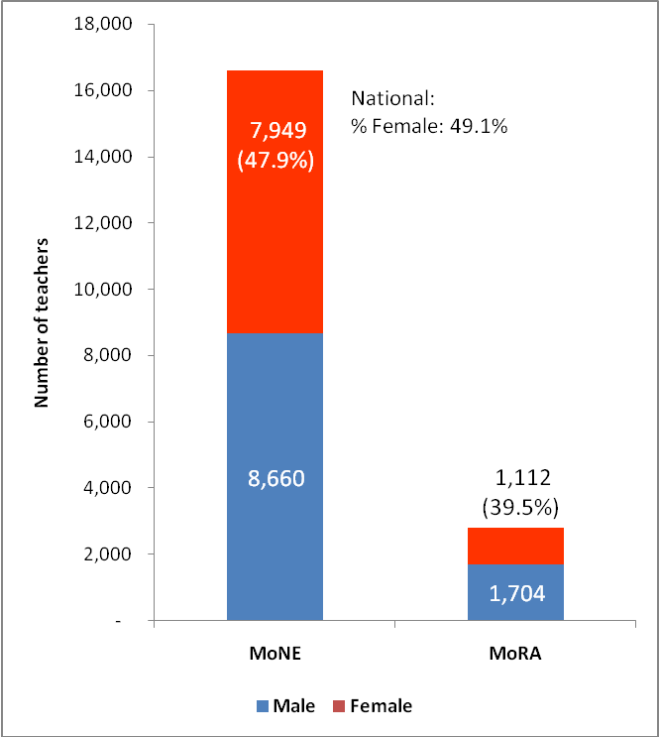

- Figure 45 shows that 56% of teachers in BEP MoNE schools are full-time teachers, which is lower than the national level of 62%. In BEP schools, a full time teacher is not necessarily a civil servant. As noted, 56% of teachers are full time but only 44% have civil servant (CS) status, the rest (56%) are contract teachers. For some new BEP schools (operational in 2009), the percentage of teachers with CS status is even less than 10% (see Text Box 8). Nationally, 52% of teachers have CS status. Hopefully, this potential problem will be addressed in the near future as in terms of qualifications, as teachers in BEP schools are similar to other teachers nationally.

- In the MoRA schools, most of which are private/Foundation owned schools, the employment status of the teachers is different from that of state schools. A permanent teacher for a MoRA school is defined as either a civil servant seconded to the school or as a Foundation teacher who has been working full-time for more than one year at that school. Teachers in some MoRA schools often have no legal employment contract with the Foundation but are considered as permanent teachers because they are the relatives of the owner. Therefore, the BEP MTs only reported 15% of full time teachers and only 4% were reported as being civil servants. On average, every MoRA school or MTs employed 13 non civil servant-teachers and only two civil servant teachers.

- There is no information on the length of service of current teachers, but it seems that many of BEP teachers are in the early stages of their professional careers, 57% of them are younger than 30 years with the average age being 34 years. Nationally, only 18.5% of JSS teachers are below 30 years.

Figure 45: Characteristics of BEP teachers

  - Academic and Pre-Service Teaching Qualifications

- In accordance with BSNP standards, the minimum academic qualification for a junior secondary teacher is an S1-degree or D-4 from an accredited university and for Indonesia as a whole some 72% of teachers meet this standard. For BEP USBs and MTs, the percentage of teachers holding the minimum required academic qualification is 77% and 68% respectively. BEP SATAPs fall below the national averages with only 58% of teachers holding an S1 degree, probably because a number of teachers in the junior secondary school are from the primary school teaching staff.

- A background in pedagogy or teacher education is an essential component in a teacher’s pre-service preparation and certification (Ministry of National Regulation No. 16 2007). As shown in Figure 45, on average 73% teachers in BEP government schools have completed a formal program in pedagogy, similar to the national rate of 72%. Only 65% of MTs teachers had such pedagogical qualifications.

- As shown in Figure 46, in terms of both academic and pre-service teaching qualifications, female teachers in BEP government schools are more qualified on average than the male teachers, however there is a smaller proportion of female teachers with certification compared to male teachers.

- According to Law No 14 Year 2005, teacher certification is a process through which teachers are issued a professional certificate by a university or pedagogical institute selected by MoNE. The Ministry of National Education has selected 31 universities to manage this certification process. These universities are called LPTK (Lembaga Pelatihan Tenaga Kependidikan).

- During the interviews, some teachers, especially female teachers, mentioned that the distance to the LPTK (generally located in the provincial capital) is often a barrier preventing them from applying for certification since they have to make frequent visits to follow the process.

Figure 46: Teachers’ qualifications

  - Teaching Hours

- According to the UNESCO Database 2007, the average range for the number of teaching hours per week in Indonesia is 18 to 27 hours. By comparison, in the non BEP schools surveyed teaching hours averaged 16-17 hours per week. The average for the BEP schools is well below this level (see Figure 47). BEP MTs teachers are teaching about 8 hours per week, teachers in BEP SMP are teaching between 10 and 12 hours depending on whether they are employed in a SATAP or USB. On average, few BEP teachers are teaching more than 2 hours per day. Theoretically this should allow teachers a great deal of time to prepare lessons and lesson materials and so develop an improved learning environment and improved learning experiences for students, but the anecdotal evidence is that such improvement is only happening in a few schools. Teaching hours will increase as student numbers increase and the Grade 8 and 9 teaching loads increase.

- On average, female teachers teach more hours than male teachers as more female teachers teach additional subjects like local language, religion and life skills.

Figure 47: Teaching Hours per Week in BEP Schools

Text Box 7:
Contract Teachers: The Backbone of School

In all AIBEP schools, about half of the teachers are contract/honorary teachers. For example, SMP SATAP Raulo, Gowa, South Sulawesi, has only 1 person (namely the Principal) who is a permanent teacher, while the other 13 are temporary and voluntary teachers.

Teaching in other schools

- However 55% of contract teachers were also teaching in other schools to earn enough income to cover their living costs (see Text Box 8). The high proportion of part time teachers has also contributed to a high rate of absenteeism (10% among both female and male teachers). Such absences, which disturb the day to day operations of the schools and also diminish the unity of the staff, are potentially a major disadvantage to the long term success of the school as a learning institution.
Text Box 8:
Contract teachers’ salary
“Being a contract teacher for years is not easy. Sometimes payment of my salary (around IDR 400,000/month) is postponed for three months. All the USB in Central Sulawesi only depend on BOS fund to pay the contract teachers.
(A contract teacher in Central Sulawesi)

- SATAP schools are the most disadvantaged as nearly all teachers of SATAP are ‘temporary borrowed teachers’ from other elementary schools. This strategy is considered appropriate in the early stages of new school operation, but as soon as the schools are operational, more qualified full-time teachers should be assigned to the new schools. It seems that the staffing strategy for new schools is different from one district to another. Some districts already have staffing plans for their new schools, some have not.

  - Teacher:Student Ratio

- In general, the survey found that BEP schools have enough teachers. If teachers are counted as Effective Full-time Teacher – counted on basis of hours in school, the teacher:student ratios in BEP schools is about 1 teacher to 7 pupils in SATAPs and 1 teacher to 12 pupils in USBs. As most of BEP schools are newly operational with more than half of the enrolments are at Grade 7, this ratio will increase as the enrolment increases at Grades 8 and 9 and fewer new teachers are appointed. In other words, the ratios today probably mean that many teachers are being under-utilised at present. This will change as demand at Grades 8 and 9 increases. The schools are well staffed by national standards where the ratio is closer to 1:14 (see Figure 48) and the classes are small enough to allow teachers to adopt more student centered, activity based, and investigative methods of learning, if they have the skills and commitment to do so.

Figure 48: Teacher:Student Ratio

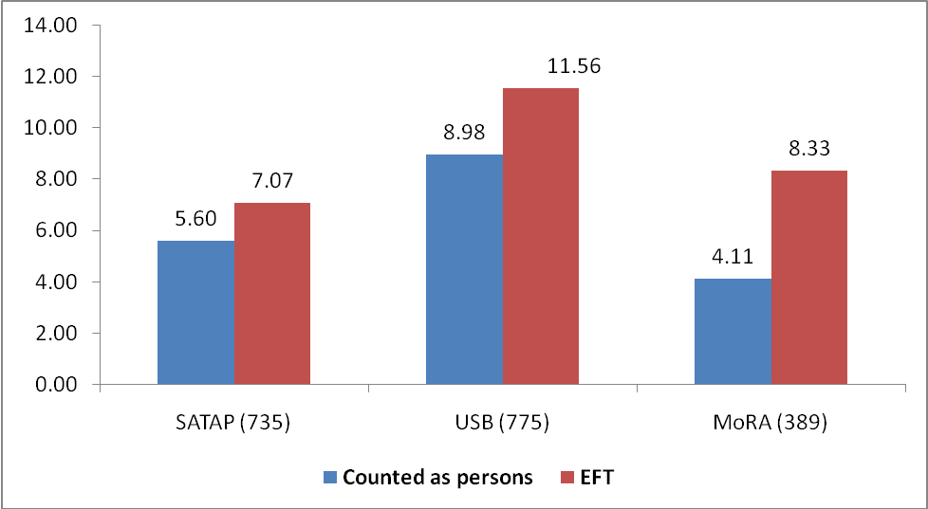

  - The Distance Teachers Travel to School

- There is no data on the average distance most teachers travel to come to schools each day but the interviews in all regions suggest that BEP has brought the school closer to the students, but not always for the teachers (see Text Box 9).

Text Box 9:
Distance to school: Teachers’ perspective

“Almost all teachers teaching at this school live far around 10 km” (Mr. David, Nagekeo, NTT)

“I go through 30 kilometres by motorcycle everyday to go teaching. The road to this school is not good, surrounded by woods. Once, I had flat tire and it was raining heavily. I came late to school and the students received late lesson, too. There is nothing can be done in such situation.” Kurnia Hadi, Ranumeeto, Sultra

“My home to the school is about 7 km. In addition to the distance, sometimes I have to spend extra time in the evening to prepare the teaching materials and provide extra classes without any payment, but I like it.” Ms. Rahmah, Tanah Laut, Kalsel

  - A Summary Comment

- Understandably, given the fact that the BEP schools are very new and comparatively small, the average number of teachers in BEP schools is lower than the national average. Nevertheless, teacher:student ratios are excellent by international standards and the majority of teachers are well qualified with 75% of teachers having an S1 qualification or higher and 73% having done pedagogical training while pursuing their academic and pre-service teaching qualifications.

- Teaching hours are still below the average range for Indonesia but are expected to increase as the number of students and teaching loads increase through the years. More full-time teachers are needed to be assigned in new schools and with better remuneration to decrease teacher dependence on ‘second’ jobs.

- There is no quantitative survey information on whether teachers who were in the 2007 schools when they first became operational are still in the same schools. However, interviews with BEP WSD training participants reported that about 12% of the participants have been moved to other schools.

Chapter 6 – Improving Quality through Whole School Development and Whole District Development

  - Whole School Development Program

- The survey reported that 56% of the schools (1,128) had participated in the Whole School Development (WSD) program in 2009. The program will reach all of BEP schools by the end of May 2010. More than a half of the principals reported that BEP was the main training provider in 2009. Overall response to the WSD program is exceptionally favourable.

- The three (3) subjects in the WSD program mentioned by the participants as being the most interesting and relevant - i.e. educational leadership, school based curriculum development and teacher quality assurance – reflect the initial and primary concerns of all school leaders. A similar pattern of results was reported in the 2008 Survey.

- On the question “what did you like best about the WSD program”, respondents mentioned (i) that the methodology encourages and facilitates them to interact with other participants (see Text Box 11); (ii) the importance and comprehensiveness of the subject matter; (iii) that the WSD training explores “the know-how” in school management.

- However, on the question of what parts of the WSD program provided least benefit, respondents most frequently mentioned discussion about Inclusive Education because they consider it will be very difficult and perhaps unrealistic to implement. In contrast to to the above responses, some respondents indicated that there were many repetitions of topics and a lack of opportunity for them to exchange experiences.

Text Box 10:
WSD facilitates Linking and Learning
“When we met in a WSD workshop in Makassar, an idea to form a communication forum was raised. The Communication Forum of Sidrap Soppeng One-Roof Islamic Boarding Houses (FKP2S3) was then founded. The next meeting was in Banua Hotel; it was a provincial scope meeting held by MoRA and AIBEP. In the meeting the forum suggested to expand the membership scope of the Communication Forum, from schools in Sidrap Soppeng district to those in the whole province. Many participants joined the organisation. The functions of FKP2S3 are, first, as the communication forum and second, media to share programs held in each school.
In addition, the organisation also concerned to increase the quality of member schools. It will be easier for AIBEP to organise trainings if the Forum holds the trainings, because the forum has lists of its members, which are all newly established pesantrens. The overall number of the forum member was 42 plus MoRA.”
Mr. Kaswad Sartono, Principal, Sindenreng Rappang, South Sulawesi.

- In a follow-up WSD program, the participants want to see more opportunity for inter-district cooperation in the education sector and want to be linked with university or other organisations for possible capacity building. Overall, 69% of the participants considered the WSD program to be very useful and 53% rated the WSD program as “much better” when compared to the other programs in which they have participated.

- In the 2008 AIBEP Survey, respondents proposed several trainings to equip them to better meet the requirements of their daily work, and a year later AIBEP assessed which topics were still relevant for future training. Figure 49 summarises the principals’ views on the level of usefulness of each topic discussed in the WSD training. About 84% participants ranked the two subjects of School based Curriculum and Educational Leadership & Management as the most useful, clearly reflecting their immediate needs as school leaders. School Quality Assurance, BSNP standards and School Asset Management were among the next group of very useful topics. Less favoured topics were those related to quality of teaching materials (68%); gender equality (63%) and inclusive education (52%) even though the latter two topics are key mainstreaming issues to be included in all school planning documents.

Figure 49: Perceived value of WSD trainings

- WSD has also helped teachers to design innovative teaching and learning tools. Mr. Ridwan, a principal from West Sulawesi for example, told the interviewer that he learned also about setting up the seats to manage the group dynamics,

“In class, students are not required to sit beside the other who has the same sex. They are free to mingle so that they experience healthy interaction. In addition, the students’ chairs are not monotonously arranged to face front. Sometimes the arrangement changes particularly during group work. This is to create normal environment for the students to interact. If they are categorised according to their sexes, male and female, we are afraid that they are shocked and sneak out when any opportunities come. Thus, we release them but watch them at the same time.”

  - Whole District Development

- While parents and 78% of Principals had raised asset and maintenance management as one of the valuable topics (Figure 49), this was not a specific topic that district officials seemed to value quite so highly, as indicated in Figure 50. Perhaps this is an area which district officials see as being of only marginal interest for them while it is clearly a key concern for school managers.

- 54% of district office respondents found the study of educational and school management to be the most useful or valuable topic in the WDD Whole District Development (WDD) program, followed by curriculum (16%) and evaluation in education (15%).

- Three topics already in the WDD program that the MoNE district staff would like to see further developed in a follow-up program are (1) School based supervision and quality assurance (2) Effective policy making in education, and (3) Curriculum development. Three new topics that district staff would like to see in a follow-up WDD program are (1) Inter-district cooperation in education sector, (2) Networking with universities for teacher quality improvement and (3) effective in-house training for themselves.

Figure 50: Most useful subjects in WDD program

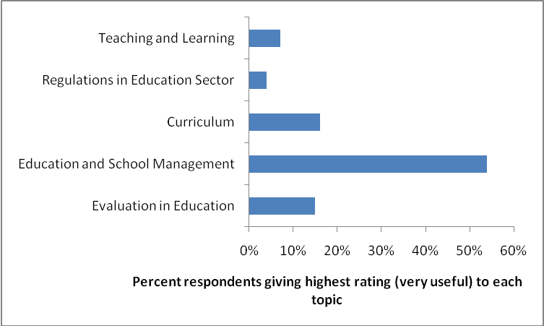

- WDD is a highly valued part of the AIBEP program and is especially valued by district officials (Figure 51). Most respondents wanted more follow-up programs of this type and were disappointed at the few follow-up activities conducted by the local government (district and provincial coordinators). A high level of value was attributed to the interactive and participative methodology, to the relevance of subject matter, the coverage of key topics and to the significance of the WDD approach as strategy to improve education quality at district level.

Figure 51: Perceived Value of WDD training

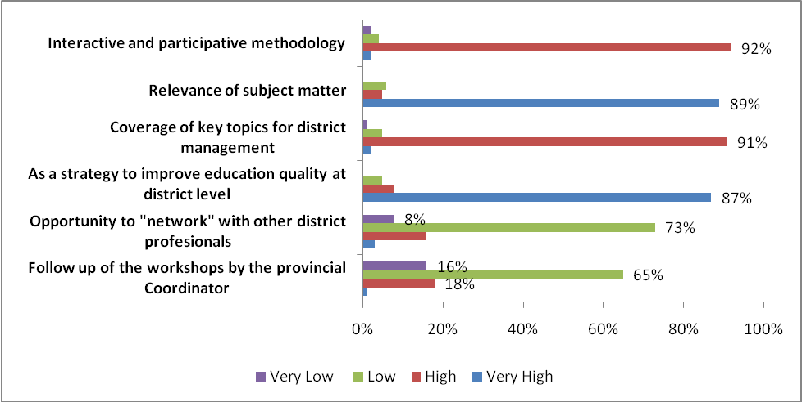

Chapter 7 – BEP District Survey

- The results reported in this chapter are drawn from the survey of the 197 BEP districts where new government junior secondary schools were constructed.

  - Governance

- A positive development in district governance is reflected by the fact that for all districts where the WDD program was delivered, they now have (i) an increased proportion of annual budget allocated to education; (ii) Strategic Plans (RENSTRA) and (iii) Annual Work Plans. In fact, 70% of BEP MoNE districts have now reached the level of 20% budget allocation to education as required by law.

- Sector performance tracking systems have been operational at district levels. While the survey indicates that most of these systems – in 138 districts (70%) – worked for MoNE schools, it is only in 59 districts (30%) that these systems were reported as functioning for both MoNE and MoRA schools.

- 80% of districts reported having a Gender Mainstreaming policy whilst 35% of districts have a policy on Inclusive Education as part of their sector development plans.

  - On Decentralisation

- In pursuing a policy of sustainable programming, decentralisation was acknowledged by majority of District Officials (66%) as having had a positive impact on funding. However, they were less confident that decentralisation would also have a positive impact on the quality of education, with only 30% being positive in their views. (see Figures 52 and 53) and approximately 27% being very unsure as to the quality outcome.

Figure 52: Perceived impact of decentralisation on education funding in the district

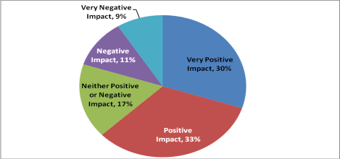

Figure 53: Perceived impact of decentralisation on education quality

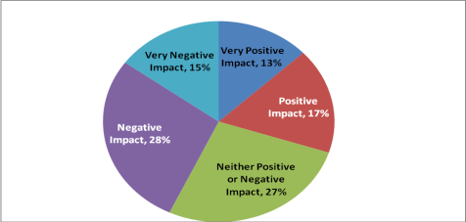

- Figure 54 shows the major district priorities for the next five years to 2014. Having all students accessing basic education is the main priority for 45% of districts followed by the need to open new SSS (14%), all schools meeting minimum standards (1%), teachers receiving continuing professional development (12%) and improving the employment status of contract teachers (8%).

Figure 54: District Education Priorities 2010-2014

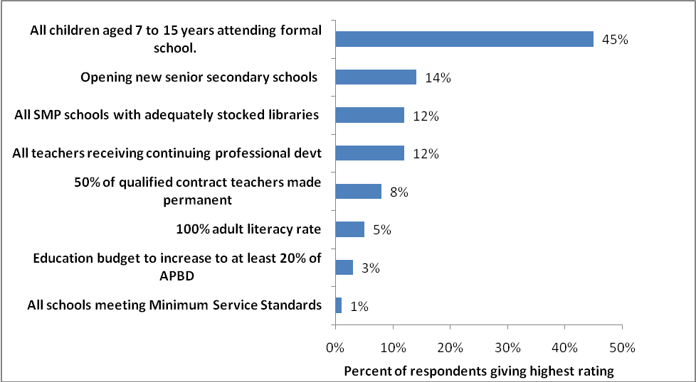

- The following topics were also mentioned, but the number is not highly significant. They are: (i) Early Childhood Education Centres, (ii) Women appointed as Head Teachers or Principals to at least 40% of schools by 2014, (iii) Women occupying at least 30% of senior positions in district education office, (iv) No schools in district still needing major renovation by end 2014, and (v) All schools meeting ‘key’ BSNP standards. None of them selected “All children disadvantaged by physical or intellectual disability or poverty able to attend Basic education (Grades 1-9) by 2014”.

Chapter 8 – Lessons Learned

  - The organisation of the survey

- The experience of the 2009 BEP Survey has revealed or reinforced the following key lessons:

- In the development of survey instruments (questionnaires), it is important to get inputs from relevant stakeholders to ensure a comprehensive structure of data, but it is important also to keep the questionnaire as short and as simple as possible. To assess this simplicity and to eliminate ambiguities, trials should be undertaken in selected sites. The BEP trials did enable considerable improvement from the original survey design although weaknesses were still present. A number of problems arose as a result of weaknesses in the translation from English to Bahasa Indonesia.

- Good survey instruments need a strong field team (the enumerators). Training of the enumerators is an essential element in the preparation stages. Besides the need for them to understand the survey instruments, the enumerators need to know also the nature and the logic of the program as they will be the people interacting directly with the respondents. There are areas in which the enumerators may become a ‘filter’ for the information received and it is important that such information does not lose meaning through that filtering process.

- Most of essential data about the schools have been collected through the survey using questionnaires and interviews but another technique (observation) is needed to complement these data with information about the schooling process (e.g. classroom interaction) and information about the quality of relationships between the various actors in the educational process.

- A Validation survey focused on checking for non sampling errors is a powerful method to ensure that the quality of school census is of the highest standard. Additional interviews and observations are other methods to confirm and to complement the census data.

- However, while every effort was made to streamline the Questionnaires, there is subjective evidence that the data collection process should be refined considerably so as to reduce the volume of data collected and the time taken to collect and analyse it.

  - About the program

- Many new BEP schools in Gorontalo, Kotawaringin, Kendari, and elsewhere have provided more school choices to parents, apart from just providing access for children who would otherwise have been unable to access JSS.

- During the discussions with MoNE and MoRA district staff in some districts, there was a recognition that the organisation of district education offices, both MoNE and MoRA, needs to be improved in the context of decentralisation. The need to strengthen planning, monitoring and financial management and accounting capacity was highlighted, especially in the context of assessing the management and impact of the school operational budgets.
.
- Respondents to the district survey also highlighted the need for orientation and familiarisation for district Parliaments, Bupati and MoNE and MoRA officials regarding the results and lessons learned through AIBEP and to discuss the way ahead. This will enable proper planning and the continuation of what AIBEP has achieved. This was a very successful addition to the WSD and WDD program in March 2010.

- Another key finding was that parents are not particularly well informed of student performance, but are increasingly consulted on the use of BOS funds. The introduction of the BOS was unanimously seen by district education staff, school principals, teachers and parents as a major step in helping to provide better schooling and help poorer families, but parents especially would like to see increased attention given to learning and to learning outcomes.

- Interviews with parents highlighted ideas on how to improve the role of school management committees in facilitating communication between parents and the school. For example, facilitating School Management Committee (SMC) meetings with the focus on factors contributing to student learning as main purpose, instead of the regular agenda focus on the school plan and budget.

- The analysis also noted the wide variation in education standards from one school to another, whether they be MoNE schools or Madrasah. A key recommendation from most of the reports was to help standardise approaches and financing in order to move towards achieving minimum service standards and subsequently national standards across all the districts and all the schools and to reduce performance disparities to a minimum. A related finding was the recognition of the under-utilisation of the potential of contract teachers to address many of these constraints. For example, the interviews identified that many of the principals in MoRA schools have difficulties in development of KTSP (Educator Integrated Curriculum) as they usually they ask the permanent teacher to develop it. Contract teachers were considered only qualified to implement the KTSP, not to develop it. WSD training has helped the principals in MoRA on how to manage all teachers to develop KTSP.

- Another lesson learned is that any WSD and WDD strategies and approaches need to take account of the specific circumstances of individual districts, especially the additional problems facing more rural and remote areas. Discussion with the respondents highlighted the need for more targeted pro-poor initiatives to overcome barriers that poor families face in sending their children to school. For example, a WSD type program can take benefits from government poverty reduction program (such as PNPM - National Program on Community Empowerment) implemented in the same target districts in addressing the enrolment problems associated with poverty. On the other hand, WSD type programs can also increase the effectiveness of a PNPM program through providing inputs and sharing experiences.

- Students, parents, teachers, principals and members of school committee in selected schools were asked different questions about advantages, impacts, community involvement, and sustainability relevant to the AIBEP approach. Some of their responses are as follows:

- Various approaches introduced by AIBEP have enhanced the understanding among school management, district officials and the community of their roles in achieving fully integrated education development programs that are linked effectively each other. WSD and WDD have contributed to the improvement of procedures, mechanisms and institutional capacities through shared analysis and tools between schools and districts and ensuring coordinated policy agendas and support to enhance the model of linkage between district capacity building and school development. For example in the development of district education Strategic Plans (RENSTRA), AIBEP has facilitated the linkage between District RENSTRA, the School Development Plan and the community through introducing a participatory/bottom up approach. School managers, the parents and the community discuss the school development plan and based on the needs and opportunities identified through this process at school level, across all the schools in the district, then the district RENSTRA is developed. This approach aims to ensure that the content of district RENSTRA reflects the schools’ needs and priorities. Of course, collaboration between all these stakeholders is only in a very formative stage and time is required to see what the flow-on impacts will be at school, community and district levels.

- AIBEP has supported an approach to school construction where the community is involved in the planning, construction and maintenance stages. This engagement and implicit empowerment of communities has then extended more broadly into school management and planning.

- Attention to detail as well as a flexible strategy was vital in the design and implementation of WSD and should be applied in all training programs. For example there is a minimum standard in terms of the training curriculum, but it should be adjusted closely to the characteristics of the participants who may be very different from one district to another. Understanding of the characteristics of the participants is vital in the implementation of the training design. In the interviews, parents, teachers, and principals gave high appreciation to the AIBEP training team(s) that gave them space and time to share their unique needs.

- As suggested by a principal in Kupang, although the program should focus on institutional change, people are always at the heart of change. It is therefore important to understand what motivates, what constrains, and what is required to move from change at the level of a few individuals or communities to larger shifts in norms and behaviour, whether by individual teacher/staff, schools/institutions, or amongst the public more broadly.

- Almost one out of five BEP schools has fewer than 20 children at Grade 7, suggesting that the basic feeder school criteria for site selection has either not worked or has been ignored. It is also apparent that some BEP schools have been constructed in locations where access to JSS is already adequate. BEP schools have become a competitor to the existing JSS instead of filling the gap or meeting a strong local demand. These weaknesses in the selection criteria and methodology may lead to wastage of resources today and to increased operational inefficiencies over time.

“The positive impact of the establishment of this school is that more children go to school because now school is located in shorter distance. The negative impact is that the other school (the old school which is located farther) sees us as their rival in gaining students. By the establishment of this school, of course, the number of students going to their school will be less. Both of the schools attempt to persuade the community and parents to send their children to each of the school. This is also related to the interest of the school to gain BOS fund, of which amount depends on the number of students they have.”
Muhammad Darwis (teacher), Ranumetto, South East Sulawesi

- In the end, buildings are just that – they are buildings not schools. More works to be done to bring those buildings to be comparable to the established schools in Java and western Indonesia. There can be a strong case made for positive discrimination in the provision of national and local government funding to new schools in poor and remote areas.

Chapter 9 – Conclusions and Recommendations

- At the time of finalising this report, 2,014 schools have been completed and made operational for the school year beginning in July 2010, The enrolment increase in 2009 was approximately 53,000 over the level reported in the October 2008 BEP school survey. Cautious projections based on current data indicate that by the beginning of the school year 2012-2013 the enrolment in the BEP schools will be between 250,000 and 300,000 and could be greater as the existence of the new schools becomes more widely known.

- 48% of those students currently enrolled are from families qualifying for Government support under the Keluarga Miskin (GAKIN) scheme which has a family income criterion of only IDR 600,000/month or about USD 60/month or USD 2/family/day. These really are the ‘poorest of the poor’ with their income level well below the World Bank’s poverty figure of USD 2/person/day.

- The vast majority (more than 75%) of students now travel less than 2km to school – reducing time and cost – transport costs having been a major factor in previously limiting access - and enabling children to attend school and still participate as required in family chores.

- While many BEP schools lack electricity, laboratories and computers, they do have teachers and with teacher:student ratios of about 1 teacher to 7 pupils in SATAPs and 1 teacher to 12 pupils in USBs the schools are well staffed by national standards where the ratio is closer to 1:14. The classes are small enough to allow capable and skilled teachers to adopt more student centered, activity based, and investigative methods of learning.

- Furthermore, the majority of teachers are well qualified in terms of their base qualifications. 69% of teachers have an S1 qualification or better and 73% have had pedagogical training. These figures are comparable with the national figures.

- The teachers are also young - their average age is 34 years- and in many cases, probably as many as 1 in 3, are at the beginning of their professional careers. But, while experience is important so too is the energy and flexibility of youth. These teachers are likely to be the ones who can bring change to the nature of classroom interaction between teachers and students and who can find ways and means to overcome the lack of other resources.

- Perhaps the most telling statistics at this stage of development of the BEP schools are those relating to the destination of students leaving the schools at the end of Class 9 in June 2009. Nearly 90% of students leaving BEP schools in June 2009 went on to attend senior secondary school (SMA, MA or SMK) compared to less than 80% of students leaving Class 9 in non BEP schools in the same districts.

- WSD has improved teaching methodology for BEP schools. The teacher’s capacity has improved in organising lesson plans, classroom methodology, using and developing media and the evaluation system. The most obvious change is the shift of the school activity from process of 'teaching' (teacher oriented) into process of 'learning' (student oriented).

- Another important change has occurred in the school management. The school principal has improved his/her capability and motivation to arrange for and develop more effective school management. Almost all activities at school are recorded. Discipline amongst teachers is improving. The schooling process itself is getting more efficient and teachers know how to spend their time more productively in class. Cooperation between the school principal and teachers has improved. Transparency and accountability at the school and community levels have improved, especially with regard to public financial reporting and accountability. School Management Committee meetings for example, are now not only about raising funds from the parents, but are slowly embracing educational issues, including the sharing with parents of the school curriculum plan and other education related topics. The impact is that parents are more enthusiastic and motivated to take active roles in school management.

- We recommend a different approach in the selection of sites for new schools. It is important to know exactly the area where the children who are not making the transition from primary to JSS and the reasons why they do not make the transition. One of the effective strategies to get this information is by involving school leaders, district education officials and the wider public during the site selection process to triangulate and consolidate the enrolment information they have. Also there needs to be a new process at District level of integrated planning - planning where all new schools should be - including Pre-School and Senior Secondary schools - building on the existing infrastructure distribution. Currently, the process is one of "infill" and that can lead, as BEP data suggests, to wastage of scarce resources. Such a process of integrated planning will require significant capacity building at all levels.

- Perhaps, in addition to constructing new schools, the Indonesian government needs to look at the issue of potential for refurbishment and upgrading of existing SMP and to the need to increase use of double shifts and whether communities should be given more choice – a new school nearby, or an upgraded one with better facilities just a little further away. This approach may make for enormous savings through efficiency in use of teachers and other resources. At the moment, the focus is on the new school because that is where the money flows.

- It is recommended to conduct ongoing tracking of the BEP schools, building on the data already collected, to monitor their progress and ensure that any emerging problems are appropriately addressed.

Indonesia Educational Statistics in Brief 2007-2008, MoNE 2008, Jakarta
According to the Ministry of National Education Decree No.057/O/2007, there were 31 universities selected to manage the certification process. They are spread from Universitas Syiah Kuala in Aceh to Universitas Cenderawasih in Papua. On average, there is one LPTK in each province in Indonesia.
The Whole School and Whole District Development (WSD/WDD) was a strategy to ensure that the principals of the BEP funded schools, members of their school communities and staff of the District Education Offices had improved capacity for district and school-based management under the decentralised system. Topics covered included strategic and annual planning, budgeting, HR management, school maintenance, etc. Over time, WSD/WDD grew, not only to support the new BEP schools and the districts, but also to become a proactive part of the overarching Quality Assurance System and be responsible for developing and refining key EQAS elements such as Supported School Self Evaluation (SSSE) and District Self Evaluation (DSE).

